State of Florida   |  | Public Service Commission  Capital Circle Office Center ● 2540 Shumard Oak Boulevard  Tallahassee, Florida 32399-0850  -M-E-M-O-R-A-N-D-U-M-
DATE: | April 2, 2015
TO: | Office of Commission Clerk (Stauffer)
FROM: | Division of Economics (Ollila)  Office of the General Counsel (Barrera)
RE: | Docket No. 150073-GU – Petition for approval of revised flexible gas service tariff by Florida Division of Chesapeake Utilities Corporation.
AGENDA: | 04/16/15 – Regular Agenda – Tariff Filing – Interested Persons May Participate
COMMISSIONERS ASSIGNED: |  |  | All Commissioners
PREHEARING OFFICER: |  |  | Administrative
CRITICAL DATES: |  |  | 05/04/15 (60-Day Suspension Date)
SPECIAL INSTRUCTIONS: |  |  | None

Case Background
On March 5, 2015, the Florida Division of Chesapeake Utilities Corporation (Chesapeake) filed a petition for approval to revise its Flexible Gas Service (FGS) tariff. Chesapeake’s FGS tariff was initially approved in Order No. PSC-98-1485-FOF-GU. In 2014, the Commission approved similar FGS tariffs for Florida Public Utilities Company (FPUC), FPUC – Fort Meade, and FPUC – Indiantown Division. Chesapeake and the FPUC companies are subsidiaries of Chesapeake Utilities Corporation. The Commission has jurisdiction in this matter pursuant to Section 366.06, Florida Statutes.
Discussion of Issues
Issue 1:1
Should Chesapeake's revised FGS tariff be approved?
Recommendation:
Yes. The Commission should approve Chesapeake’s revised FGS tariff as shown in Attachment 1. When Chesapeake executes an FGS service agreement, notice of such agreement should be filed within 30 days with the Office of Commission Clerk. (Ollila)
Staff Analysis:
Customers, especially large industrial customers, have multiple fuel options available to them. These options include the ability to bypass Chesapeake’s distribution system and connect directly to interstate or intrastate pipelines, or replace natural gas with fuel oil or electricity. Chesapeake provides transportation service only. In a transportation service environment, the utility such as Chesapeake only transports the gas to the customer using its distribution system. The customer is responsible for purchasing gas from other parties, such as shippers or gas marketers.
Chesapeake’s revision to its FGS tariff is intended to create consistency in the FGS tariff language between Chesapeake and the FPUC companies. The FGS tariff enables Chesapeake to negotiate competitive rates with customers who can provide verifiable documentation of a viable energy alternative and places Chesapeake’s shareholders at risk, not the general body of ratepayers. All incremental capital costs, expenses, and revenues associated with this tariff are placed below-the-line in earnings surveillance reports and future rate cases. Chesapeake will not attempt to recover the difference between the applicable tariff and the negotiated lower FGS rate from other customers through cost recovery clauses or in future rate cases. In its recent order approving FGS tariffs for the FPUC companies, the Commission found that the FGS tariffs contained adequate safeguards to protect existing customers from being adversely affected by or subsidizing FGS customers.
Chesapeake’s current tariff includes a provision requiring it to file each confidential service agreement and related documents with the Office of Commission Clerk so that staff can review the documents. This provision does not require Commission approval of each FGS contract; it is strictly a reporting requirement. When recently approving the FGS tariffs for the FPUC companies, the Commission found that the filing of each agreement was not necessary; instead, a notice filed with the Office of Commission Clerk, within 30 days of the execution of an FGS service agreement, would be sufficient since any executed agreements would be available for review by staff if necessary.
Staff recommends that Chesapeake’s revised tariff as shown in Attachment 1 be approved. As with the tariffs approved for the FPUC companies, staff recommends that when Chesapeake executes an FGS service agreement, notice of such agreement should be filed within 30 days with the Office of Commission Clerk.

Issue 2:2
Should this docket be closed?
Recommendation:
Yes. If Issue 1 is approved, the tariff should become effective on April 16, 2015. If a protest is filed within 21 days of the issuance of the order, the tariff should remain in effect, with any revenues held subject to refund, pending resolution of the protest. If no timely protest is filed, this docket should be closed upon the issuance of a consummating order. (Barrera)
Staff Analysis:
If Issue 1 is approved, the tariff should become effective on April 16, 2015. If a protest is filed within 21 days of the issuance of the order, the tariff should remain in effect, with any revenues held subject to refund, pending resolution of the protest. If no timely protest is filed, this docket should be closed upon the issuance of a consummating order.

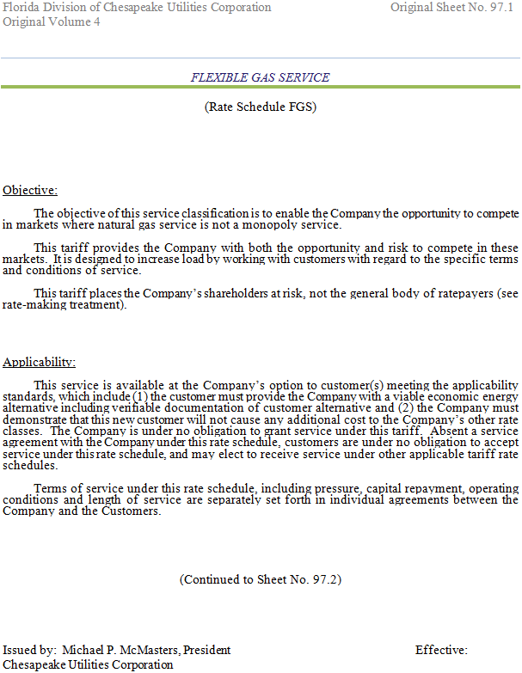
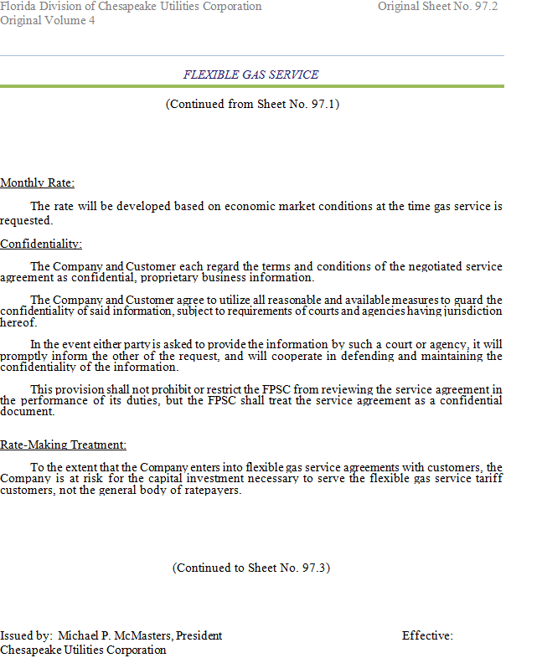
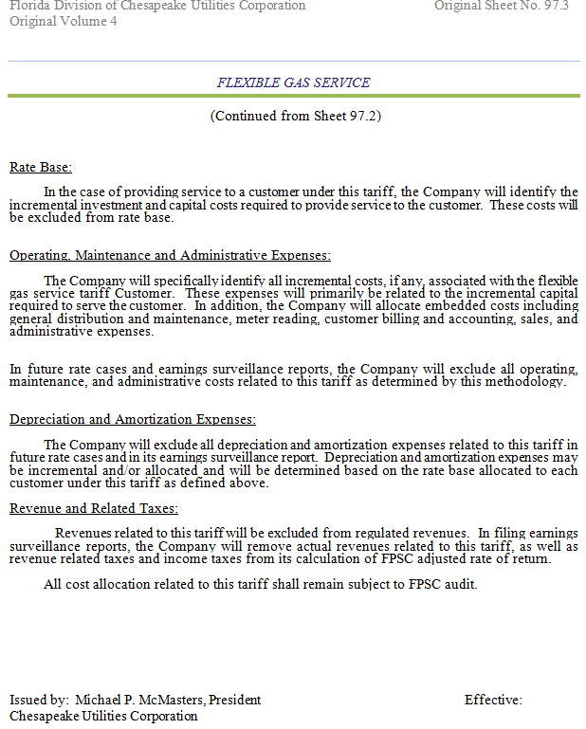

Order No. PSC-98-1485-FOF-GU, issued November 5, 1998, in Docket No. 980895-GU, In re: Petition by Florida Division of Chesapeake Utilities Corporation for authority to implement proposed flexible gas service tariff and to revise certain tariff sheets.
Order No. PSC-14-0710-TRF-GU, issued December 30, 2014, in Docket No. 140204-GU, In re: Joint petition for approval of flexible gas service tariff by Florida Public Utilities Company, Florida Public Utilities Company – Fort Meade, and Florida Public Utilities Company – Indiantown Division.

