|  |  |  |  |
| --- | --- | --- | --- |
| State of Florida  pscSEAL | | Public Service Commission  Capital Circle Office Center ● 2540 Shumard Oak Boulevard Tallahassee, Florida 32399-0850  -M-E-M-O-R-A-N-D-U-M- | |
| DATE: | March 24, 2016 | | |
| TO: | Office of Commission Clerk (Stauffer) | | |
| FROM: | Division of Economics (Rome, Guffey)  Office of the General Counsel (Barrera) | | |
| RE: | Docket No. 160028-GU – Petition for approval of Amendment No. 1 to transportation service agreement with the City of Lake Worth, by Florida Public Utilities Company. | | |
| AGENDA: | 04/05/16 – Regular Agenda – Proposed Agency Action – Interested Persons May Participate | | |
| COMMISSIONERS ASSIGNED: | | | All Commissioners |
| PREHEARING OFFICER: | | | Graham |
| CRITICAL DATES: | | | None |
| SPECIAL INSTRUCTIONS: | | | None |

Case Background

On February 2, 2016, Florida Public Utilities Company (FPUC) filed a petition to amend its gas transportation service agreement (agreement) with the City of Lake Worth (City). FPUC is a gas utility subject to the regulatory jurisdiction of the Commission pursuant to Section 366.06, Florida Statutes (F.S.). The City is a Florida municipality that is developing a compressed natural gas (CNG) station.

The Commission approved the agreement between FPUC and the City in 2003 for a 30-year term.[1] The proposed amendment to the agreement is limited in nature and consists solely of a modification to Section 4.8 of the agreement to allow the City to resell natural gas provided by FPUC to the City’s CNG station for compression and resale as CNG fuel. The proposed amendment is shown in Attachment A.

During its evaluation of the petition, staff issued a data request to FPUC for which a response was received on February 18, 2016. The Office of Public Counsel requested interested party status in the docket on February 9, 2016. The Commission has jurisdiction over this matter pursuant to Section 366.06, F.S.

Discussion of Issues

Issue 1:

 Should the Commission approve the amendment to the agreement between FPUC and the City?

Recommendation:

 Yes. The Commission should approve the amendment to the agreement between FPUC and the City. (Rome, Guffey)

Staff Analysis:

 In accordance with the agreement, FPUC is obligated to transport gas through its pipeline and appurtenant facilities (Lake Worth Lateral or LW Lateral) from the gate station interconnected with Florida Gas Transmission’s facilities to the City’s generation and water utility complex (project site). The proposed amendment reflects a modification to a limitation in the agreement. As currently written, Section 4.8 of the agreement prohibits the resale of gas transported through the LW Lateral:

4.8 Resale Prohibited. Natural gas transported through the LW Lateral shall be used solely at the Project Site by CITY or the other Project Parties, and shall not be offered for resale to any third party.

However, the City is developing a CNG station at the project site and will require deliveries of natural gas to that station for compression and subsequent resale to the public. FPUC and the City have reached agreement to eliminate the resale prohibition as applicable to natural gas supplied by FPUC for delivery to the City’s CNG station. The revised Section 4.8 as shown in Attachment A would allow resale by the City only to customers of the CNG station.

Cost of Service Considerations

The proposed amendment would not alter either the term or the pricing under the agreement. In the joint petition filed in 2003 by FPUC and the City, the parties provided a cost of service study as Exhibit A to the joint petition. The transportation charge derived from the cost of service study is paid monthly by the City to FPUC and was designed to enable FPUC to recover its investment in the LW Lateral, provide a rate of return on that investment, and recover the costs of operating and maintaining the facilities. In addition, the City pays FPUC the actual delivered cost plus 25 percent for the cost of odorant for the LW Lateral. Based on analysis of the cost of service study and a requirement that the City provide a letter of credit under specified contingent circumstances, the Commission approved the agreement between FPUC and the City.[2]

In the instant petition, FPUC states that as amended, FPUC will continue to recover its cost to serve under the agreement. In response to staff inquiries, FPUC provided information to indicate that approval of the proposed amendment would have a de minimis impact on the cost of service. First, Section 3.2 of the agreement allows the City to transport up to 4,070 thousand cubic feet (MCF) per hour through the LW Lateral.[3] At present, the City is transporting approximately 75 MCF per hour. In response to a staff inquiry, FPUC estimated that it would be necessary to transport an additional 80 MCF per hour to meet the needs of the CNG station at the project site. Therefore, through the transportation charge paid by the City each month to FPUC, the City has been paying, and will continue to pay, for a significant amount of unused capacity.

Secondly, the cost of service study provided as Exhibit A to the 2003 joint petition indicated a 2003 net plant value of $4,195,556 for FPUC’s LW Lateral facilities. This amount was one of the factors used to develop the transportation charge payable by the City to FPUC. In response to a staff inquiry, FPUC estimated that the cost of adding additional facilities (tap, meter, and regulator) to serve the CNG station should not exceed $30,000. This amount is approximately one percent of the 2016 remaining net plant value of the LW Lateral facilities used in the development of the transportation charges payable to FPUC under the current agreement.[4] As such, staff believes that the costs of adding the additional facilities to serve the CNG station would have a de minimis impact on FPUC’s cost of service under the agreement.

Based on the foregoing, staff believes FPUC’s assertion that it will continue to recover its cost to serve under the proposed amended agreement is reasonable and that FPUC’s ratepayers will continue to benefit. The City would benefit from the proposed amendment by having additional quantities of gas available to compress and sell to customers at its CNG station.

Conclusion

FPUC represents that the agreement, as amended, is to the benefit of both the City and FPUC, and is in the public interest. Based on its review, staff believes FPUC’s representation to be reasonable and recommends that the Commission approve the amendment to the agreement between FPUC and the City.

Issue 2:

 Should this docket be closed?

Recommendation:

 If no protest is filed by a person whose substantial interests are affected within 21 days of the issuance of the Order, this docket should be closed upon the issuance of a Consummating Order. (Barrera)

Staff Analysis:

 If no protest is filed by a person whose substantial interests are affected within 21 days of the issuance of the Order, this docket should be closed upon the issuance of a Consummating Order.

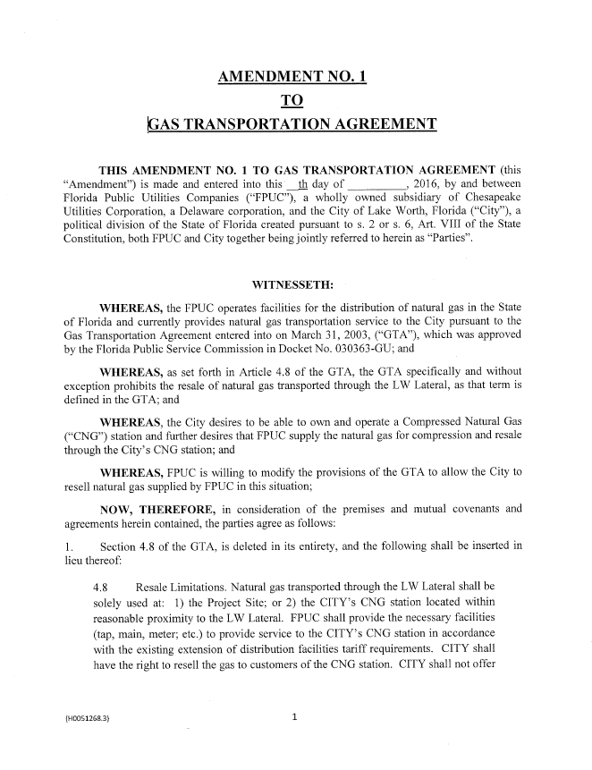

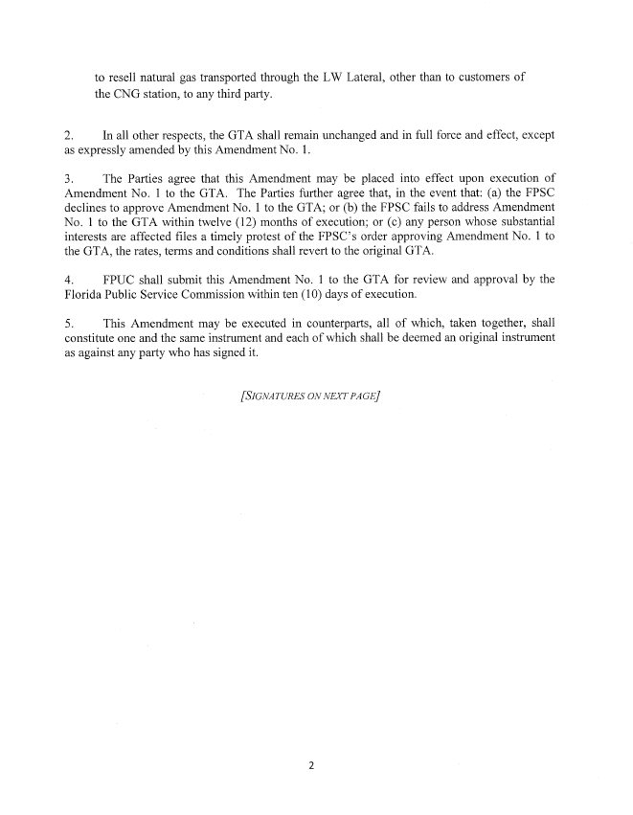

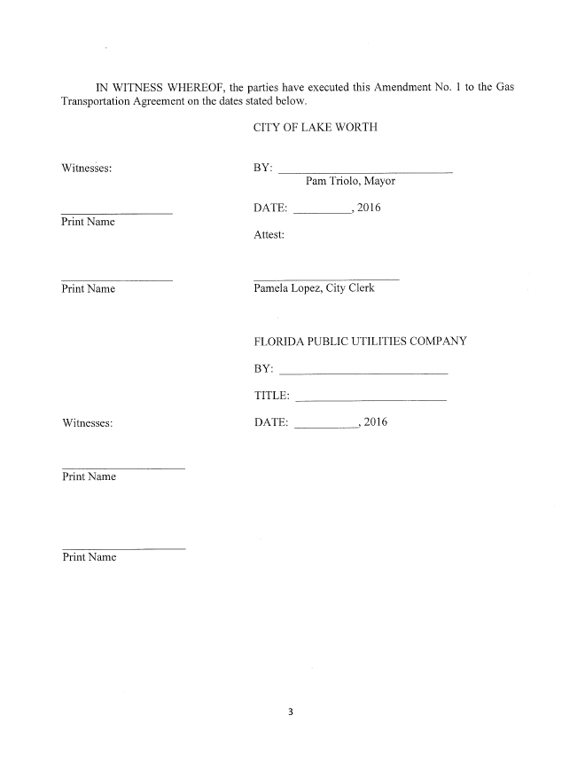

1. Order No. PSC-03-0846-PAA-GU, issued July 21, 2003, in Docket No. 030363-GU, *In re: Joint petition for approval of gas transportation agreement between Florida Public Utilities Company and City of Lake Worth, and request for expedited treatment.*
2. Id., pp. 3-4.
3. 1 MCF equals 1 million British thermal units (Btu).
4. Cost of service study included as Exhibit A to the joint petition filed in Docket No. 030363-GU.