State of Florida |  | Public Service Commission  Capital Circle Office Center ● 2540 Shumard Oak Boulevard  Tallahassee, Florida 32399-0850  -M-E-M-O-R-A-N-D-U-M-
DATE: | October 20, 2016
TO: | Office of Commission Clerk (Stauffer)
FROM: | Division of Economics (Ollila)  Office of the General Counsel (Trierweiler)
RE: | Docket No. 160201-GU – Petition for approval of 2015 true-up, projected 2016 true-up and 2017 revenue requirements and surcharges associated with cast iron/bare steel pipe replacement rider, by Peoples Gas System.
AGENDA: | 11/01/16 – Regular Agenda – Tariff Filing – Interested Persons May Participate
COMMISSIONERS ASSIGNED: |  |  | All Commissioners
PREHEARING OFFICER: |  |  | Administrative
CRITICAL DATES: |  |  | 8-Month Effective Date: 05/01/17 (60-day suspension date waived by the utility)
SPECIAL INSTRUCTIONS: |  |  | None

Case Background
On September 1, 2016, Peoples Gas System (Peoples or Company) filed a petition for approval of its projected 2016 true-up and 2017 revenue requirements and surcharges associated with the cast iron/bare steel pipe replacement rider (rider). The rider was originally approved in Order No. PSC-12-0476-TRF-GU to recover the cost of accelerating the replacement of cast iron and bare steel distribution pipes through a surcharge on customers’ bills. The program is expected to be complete in 2022. Peoples’ current surcharges were approved in Order No. PSC-15-0572-TRF-GU.
In the 2012 order, the Commission found that the “replacement of these types of pipelines is in the public interest to improve the safety of Florida’s natural gas infrastructure, and reduce the possibility of loss of life and destruction of property should an incident occur.” As provided for in the 2012 order, the filing includes a final true-up for 2015, an actual/estimated true-up for 2016, and the projected revenue requirement for 2017.
In its filing, Peoples waived the 60-day suspension deadline pursuant to Section 366.06(3), Florida Statutes (F.S.). Peoples filed its responses to staff’s first data request on September 28, 2016. The proposed tariff page is contained in Attachment 2. The Commission has jurisdiction over this matter pursuant to Sections 366.03, 366.04, 366.05, and 366.06, F.S.

Discussion of Issues

Issue 1:
Should the Commission approve Peoples' proposed rider surcharges for 2017?

Recommendation:
Yes. The Commission should approve Peoples’ proposed 2017 rider surcharges for each rate class commencing with bills rendered for meter readings taken on and after January 1, 2017. (Ollila)

Staff Analysis:
The rider surcharges have been in effect since January 2013. Peoples’ replacement program continues to identify and target the replacement pipelines in the Company’s more urban and high consequence areas. Peoples uses a risk-based prioritization to determine the replacement order, which is primarily identified by the Distribution Integrity Management Program (DIMP). Other factors considered include leak incident rates, the pressure under which the pipeline is operating, areas of significant construction, and the pipeline’s age. In response to a staff data request, Peoples stated that its 2016 replacement activity has been in Ocala, Sarasota, Daytona, Jacksonville, Eustis, Orlando, St. Petersburg, Miami, and Tampa, with the larger concentration of replacements in the Orlando, Tampa, and St. Petersburg areas.
Attachment 1 displays Peoples’ pipe replacement progress, both actual and forecasted. Staff notes that in prior years this table was based on plant accounting records. Peoples determined that reporting replacement numbers from its Geographical Information System (GIS) provides more current information than the plant accounting records, since there is a lag associated with plant accounting records. The table in Attachment 1 uses GIS reporting numbers.

Audit
The 2015 order required staff to work with the Office of Public Counsel (OPC) and Peoples to conduct an audit of the rider program. Staff asked for input from OPC for the audit service request, which OPC provided. The audit was designed to ensure that costs were properly stated, recoverable through the surcharge, and incremental to base rates where appropriate. The final audit report was issued on August 31, 2016, and filed in Docket No. 150203-GU; no audit exceptions were noted.

Savings
The 2012 order stated that Peoples agreed to identify and report any operations and maintenance (O&M) and depreciation savings in its annual petition, beginning in the second year. In this filing, Peoples reported depreciation expense savings for 2015 ($153,747), 2016 ($109,580), and 2017 ($108,000). Peoples stated in response to a staff data request that no O&M savings have been identified since the filing of the 2015 docket.

One-time Credit
Order No. PSC-16-0205-AS-GU required Peoples to add a one-time credit of $2,000,000 to customers subject to the rider and to clearly identify the inclusion of the $2,000,000 one-time credit in its rider petition. Peoples has complied with that order.

True-ups by Year
Peoples’ calculations for the 2017 revenue requirement and surcharges include a final true-up for 2015, an actual/estimated true-up for 2016, and projected costs for 2017.

Final True-up for 2015
Peoples stated that the revenues for 2015 were $3,463,088, compared to a revenue requirement of $3,537,028. The resulting under-recovery is $73,941. After adding interest of $253 and the final 2014 over-recovery of $36,203 and subtracting the 2015 over-recovery amount ($61,277) that was already collected in the 2015 surcharges, the final 2015 true-up is an under-recovery of $98,762.

Actual/Estimated 2016 True-up
Peoples provided actual revenues for January through July and forecast revenues for August through December, totaling $5,684,028. The actual/estimated revenue requirement for 2016 is $5,127,130 and includes a return on investment, depreciation expense (less savings), and property tax expense. The forecast over-recovery for 2016 is $556,899. After adding interest of $5,082, subtracting the final 2015 under-recovery of $98,762, and subtracting the 2015 over-recovery amount ($273,526) that was already collected in the 2016 surcharges, the total 2015 true-up is an over-recovery of $189,693. Pursuant to Order No. PSC-16-0205-AS-GU, Peoples added a one-time credit of $2,000,000, for a total 2016 over-recovery of $2,189,693.

Projected 2017 Costs
Peoples projects capital expenditures of $10,875,000 for the replacement of cast iron/bare steel infrastructure in 2017. This compares with final 2015 expenditures of $11,361,478 and actual/estimated 2016 expenditures of $12,385,955. After subtracting the total 2016 over-recovery of $2,189,693, the 2017 revenue requirement is $4,596,953. Table 1-1 displays the true-up calculation.
Table 1-1
True-up Calculation for 2017
2017 Projected Replacements | $10,875,000
Return on Investment | $4,512,722
Depreciation Expense (less savings) | $1,503,918
Property Tax Expense | $770,007
2017 Revenue Requirement | $6,786,646
Less 2016 True-up | ($2,189,693)
Total 2017 Revenue Requirement | $4,596,953
Source: Exhibit C, page 1, of the Petition,

Proposed Surcharge
As established in the 2012 order, the total 2017 revenue requirement is allocated to rate classes using the same methodology that was used for the allocation of mains and services in the cost of service study used in Peoples’ most recent rate case. After calculating the percentage of total plant costs attributed to each rate class, the respective percentages were multiplied by the 2017 revenue requirement resulting in the revenue requirement by rate class. Dividing each rate class’s revenue requirement by projected therm sales provides the rider surcharge for each rate class.
The proposed 2017 rider surcharge for residential customer is $0.02309 per therm (compared to the current surcharge of $0.02137 per therm). The monthly bill impact is $0.46 beginning January 1, 2017 for a residential customer who uses 20 therms. The proposed tariff page is provided in Attachment 2.

Conclusion
Staff believes the calculation of the 2017 rider revenue requirement and the proposed rider surcharge for each rate class is reasonable and accurate. Therefore, staff recommends approval of Peoples’ proposed 2017 rider surcharge for each rate class commencing with bills rendered for meter readings taken on and after January 1, 2017.

Issue 2:
Should this docket be closed?

Recommendation:
If Issue 1 is approved and a protest is filed within 21 days of the issuance of the order, the tariffs should remain in effect, with any revenues held subject to refund, pending resolution of the protest. If no timely protest is filed, this docket should be closed upon the issuance of a consummating order. (Trierweiler)

Staff Analysis:
If Issue 1 is approved and a protest is filed within 21 days of the issuance of the order, the tariffs should remain in effect, with any revenues held subject to refund, pending resolution of the protest. If no timely protest is filed, this docket should be closed upon the issuance of a consummating order.

Peoples’ Pipe Replacement Program Progress

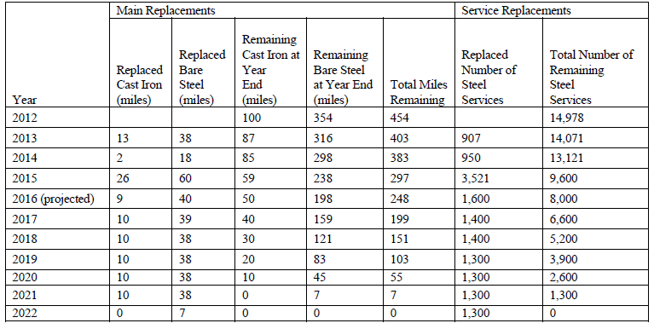

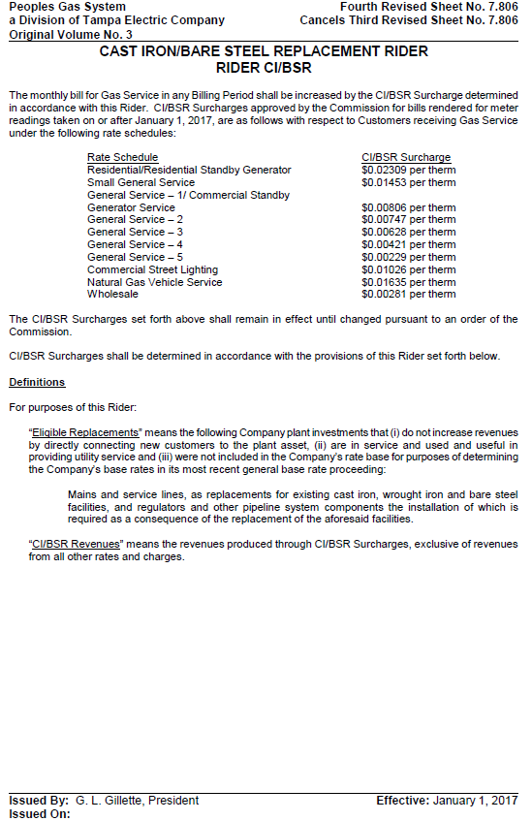

Order No. PSC-12-0476-TRF-GU, issued September 18, 2012 in Docket No. 110320-GU, In re: Petition for approval of Cast Iron/Bare Steel Pipe Replacement Rider (Rider CI/BSR), by Peoples Gas System. (2012 order)
Order No. PSC-15-0572-TRF-GU, issued December 18, 2015, in Docket No. 150203-GU, In re: Petition for approval of 2014 true-up, projected 2015 true-up and 2016 revenue requirements and surcharges associated with cast iron/bare steel pipe replacement rider, by Peoples Gas System. (2015 order)
Order No. PSC-16-0205-AS-GU, issued May 19, 2016, in Docket No. 150259-GU, In re: Initiation of show cause proceedings against Peoples Gas System for apparent violations of Sections 368.01 – 05, F.S., and Chapter 25-12, F.A.C.

