State of Florida |  | Public Service Commission  Capital Circle Office Center ● 2540 Shumard Oak Boulevard  Tallahassee, Florida 32399-0850  -M-E-M-O-R-A-N-D-U-M-
DATE: | September 21, 2017
TO: | Office of Commission Clerk (Stauffer)
FROM: | Division of Economics (Guffey, Doherty, Draper)  Office of the General Counsel (Taylor)
RE: | Docket No. 20170176-GU – Petition by Florida Division of Chesapeake Utilities Corporation for approval of special contract with Sebring Gas System, Inc.
AGENDA: | 10/03/17 – Regular Agenda – Proposed Agency Action – Interested Persons May Participate
COMMISSIONERS ASSIGNED: |  |  | All Commissioners
PREHEARING OFFICER: |  |  | Polmann
CRITICAL DATES: |  |  | None
SPECIAL INSTRUCTIONS: |  |  | None

Case Background
On August 14, 2017, the Florida Division of Chesapeake Utilities Corporation (Chesapeake) filed a petition seeking Commission approval of a Special Contract (Contract) with Sebring Gas System, Inc. (Sebring). Pursuant to the Contract, Chesapeake will construct a gas pipeline in DeSoto County near the City of Arcadia. The pipeline is referred to as the Arcadia Pipeline on the map shown in Attachment A to the recommendation and as the Sebring Pipeline in the Contract. Chesapeake and Sebring both own and operate natural gas distribution facilities in Florida and are subject to the regulatory jurisdiction of the Commission pursuant to Section 366.06, Florida Statutes (F.S.).
The Contract between Chesapeake and Sebring was executed on June 30, 2017, has an initial 20-year term, and can be extended for additional one year periods unless given notification by either party to terminate the Contract. The proposed Contract is shown in Attachment B to the recommendation. During the evaluation of the petition, staff issued two data requests to Chesapeake for which responses were received on August 28, 2017 and on September 5, 2017. The first data request was also forwarded to Sebring, for which responses were received on September 19, 2017. In its response to staff’s first data request, Chesapeake filed certain revisions to the Cost of Service Study that was included in the petition. There have been no public comments regarding this petition. The Commission has jurisdiction over this matter pursuant to Sections 366.04, 366.05, and 366.06, F.S.

Discussion of Issues

Issue 1:
Should the Commission approve the Contract between Chesapeake and Sebring?

Recommendation:
Yes. The Commission should approve the Contract shown in Attachment B between Chesapeake and Sebring. The Contract should be effective as of the date of the Commission’s vote. (Guffey, Doherty, Draper)

Staff Analysis:
At present, Chesapeake and Sebring both have customers in DeSoto County; however, neither utility has facilities capable of providing gas service to the City of Arcadia. In May 2017, by Order No. PSC-2017-0205-PAA-GU, the Commission approved a territorial agreement between Chesapeake and Sebring. Pursuant to the territorial agreement, Sebring’s service area includes customers within Arcadia’s municipal boundaries and two specifically identified customers just outside Arcadia’s municipal limits. Chesapeake’s service territory is defined as DeSoto County, except for customers within Arcadia’s municipal boundary and the two specifically identified customers who are located outside of the Arcadia municipal limits.
The proposed Contract is designed to allow Sebring to provide gas service to the City of Arcadia. Sebring will construct and own the distribution system to serve customers within the City of Arcadia and Chesapeake will construct, own, and maintain a pipeline connecting the Florida Gas Transmission (FGT) interstate transmission pipeline with Sebring’s distribution system. Chesapeake will provide transportation service only; the gas delivered to the City of Arcadia via FGT and the Sebring Pipeline is purchased by Sebring. The Contract contains the terms and conditions under which Chesapeake will provide transportation service and the negotiated rate allowing Chesapeake to recover its investment in the Sebring Pipeline. Rule 25-9.034, Florida Administrative Code, and Chesapeake’s tariff require that special contracts be approved by the Commission.
In accordance with the Contract, Chesapeake is constructing approximately one mile of four-inch coated steel pipeline extending from the FGT facilities in Hardee County to the interconnection point with Sebring’s distribution system. Chesapeake will connect the pipeline with FGT at the Arcadia gate station, an existing delivery point. Chesapeake will install a new custody transfer station at its interconnection point with Sebring’s distribution system that will serve the City of Arcadia. Chesapeake anticipates construction of the pipeline to be complete in October 2017. The Contract contains language stating that Sebring is relying upon Chesapeake’s expertise in operating and providing transportation service over the Sebring Pipeline.
Chesapeake stated that it has obtained approvals from the Department of Transportation and the Department of Environmental Protection for the pipeline. Additionally, Chesapeake stated it is currently working to receive approval from the Seminole Gulf Railroad for the railroad crossing.

Cost of Service Considerations
The cost of service study provided by Chesapeake in its response to staff’s first data request shows total annual operating cost of $128,183 for the Sebring Pipeline. The cost of service includes a return on the investment, operation and maintenance cost, depreciation, and taxes. Chesapeake’s investment for the Sebring Pipeline totals $821,384 and includes the main installation, custody transfer meter, and skid mount (a prefabricated frame that holds the meter and pressure regulation equipment). The return included in the cost of service is 5.67 percent, based on the midpoint rate of return shown in Chesapeake’s December 2016 year-end surveillance report.
The negotiated annual fixed rate contained in the Contract of $135,812 is designed to enable Chesapeake to cover its cost of service. The contract amount is paid by Sebring to Chesapeake in monthly reservation charges that are fixed and do not vary based on actual usage. The largest daily quantity of gas Chesapeake is obligated to transport to Sebring is 720 Dekatherms.
Based on the cost of service study provided, staff agrees with Chesapeake’s assertion that the monthly reservation charge recovers its cost of service and, therefore, will provide benefits to Chesapeake’s general body of ratepayers, as well as Sebring’s customers in the City of Arcadia.

Conclusion
Based on the review of the petition and responses to staff’s data requests, staff believes Chesapeake’s representations to be reasonable and recommends that the Commission approve the Special Contract between Chesapeake and Sebring as shown in Attachment B. The Contract should be effective as of the date of the Commission’s vote.

Issue 2:
Should this docket be closed?

Recommendation:
If no protest is filed by a person whose substantial interests are affected within 21 days of the issuance of the Order, this docket should be closed upon the issuance of a Consummating Order. (Taylor)

Staff Analysis:
If no protest is filed by a person whose substantial interests are affected within 21 days of the issuance of the Order, this docket should be closed upon the issuance of a Consummating Order.

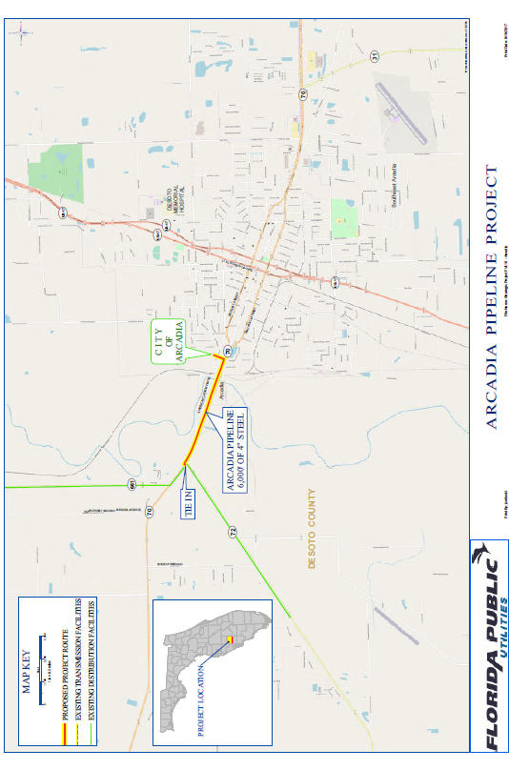
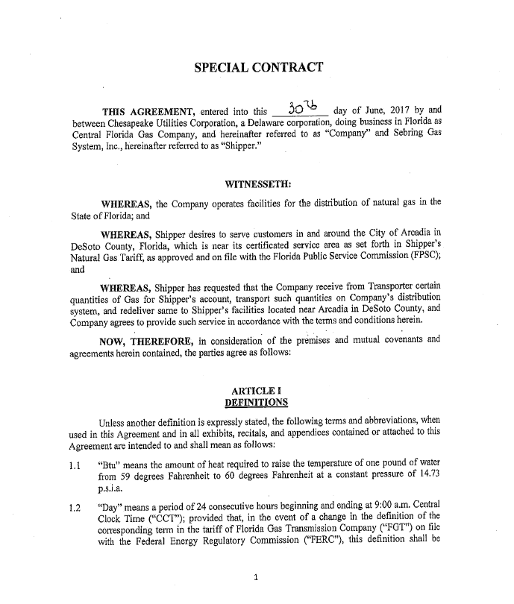

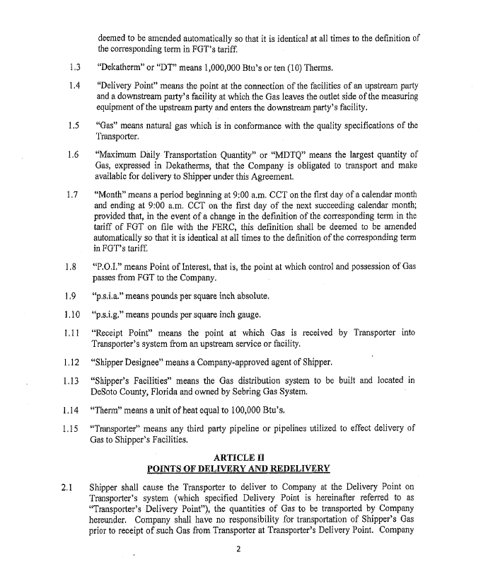

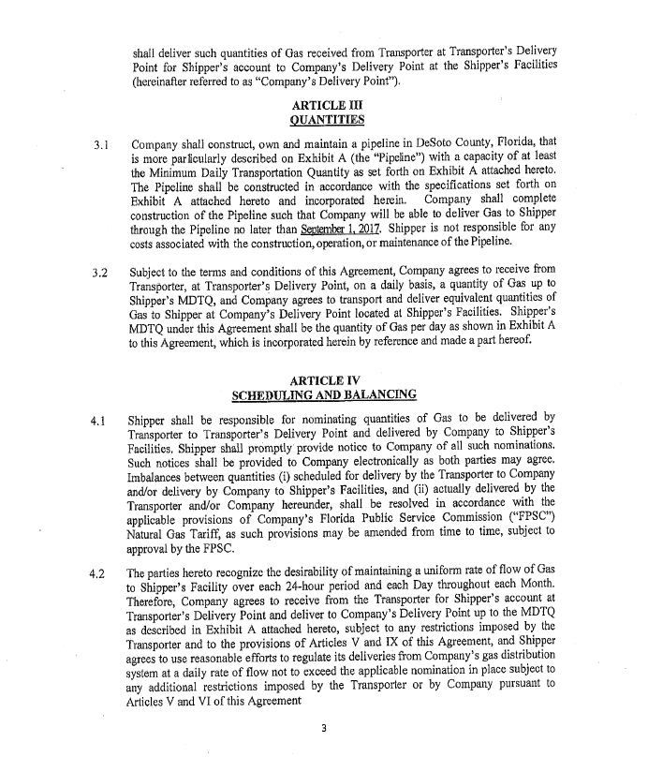

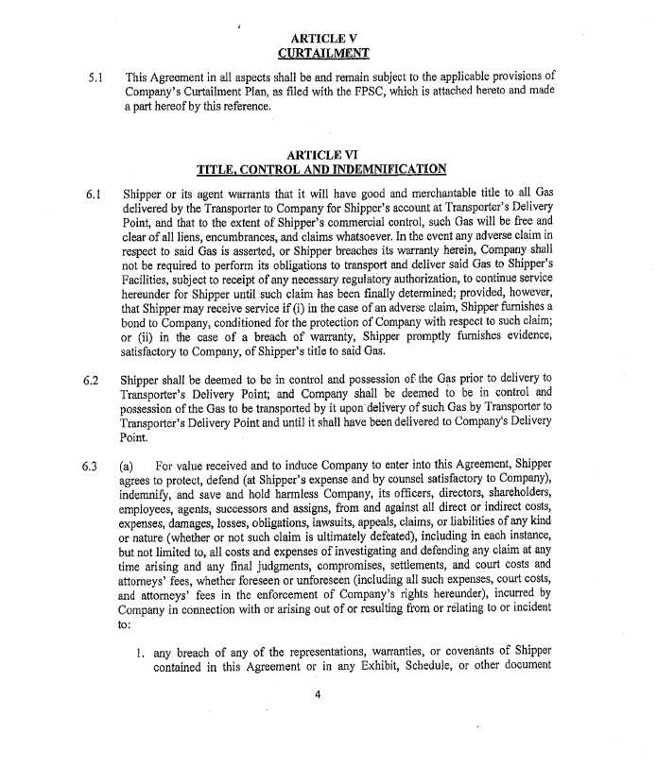

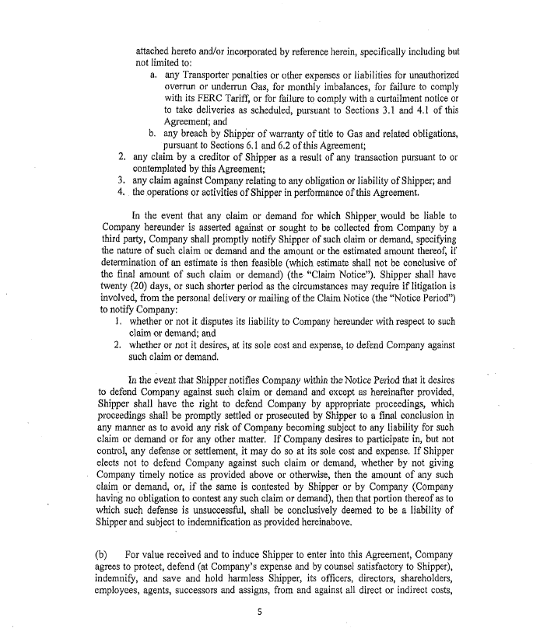

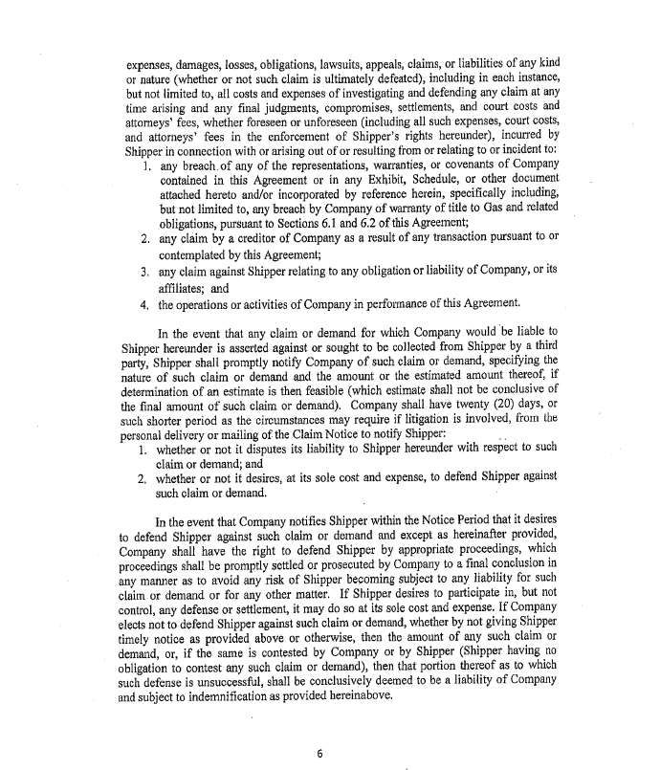

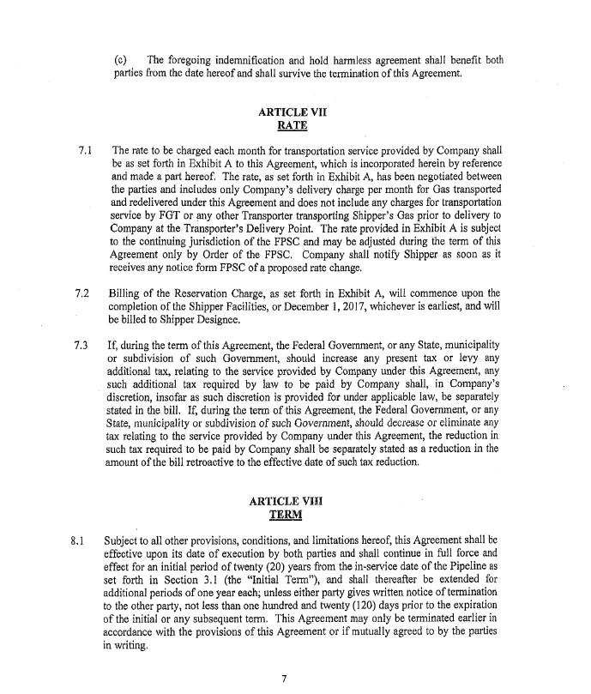

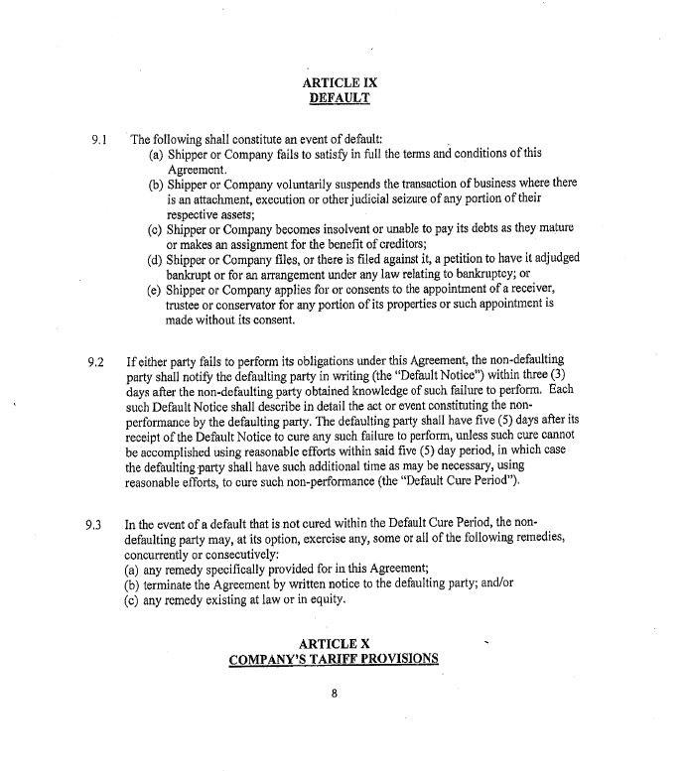

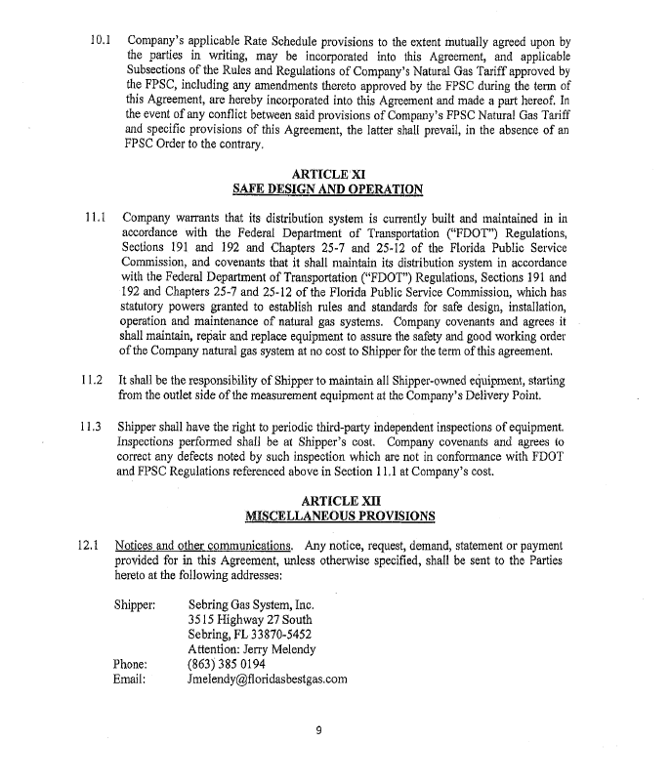

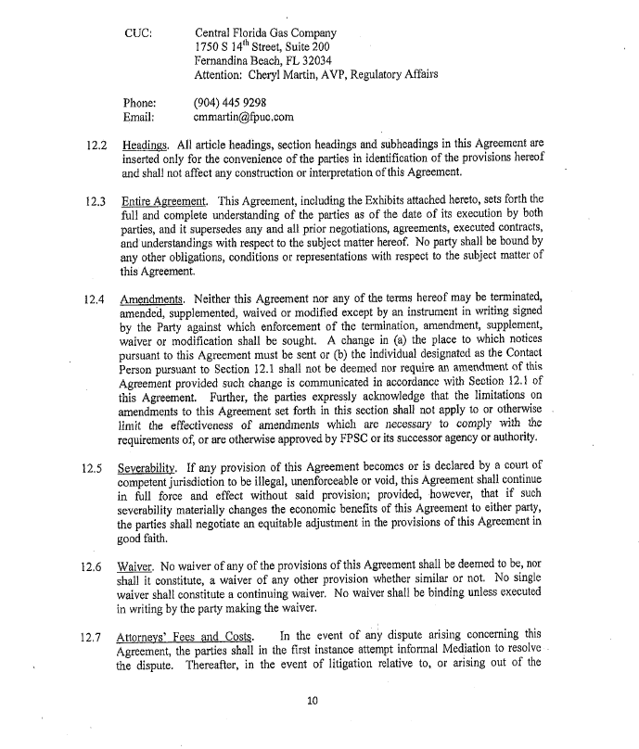

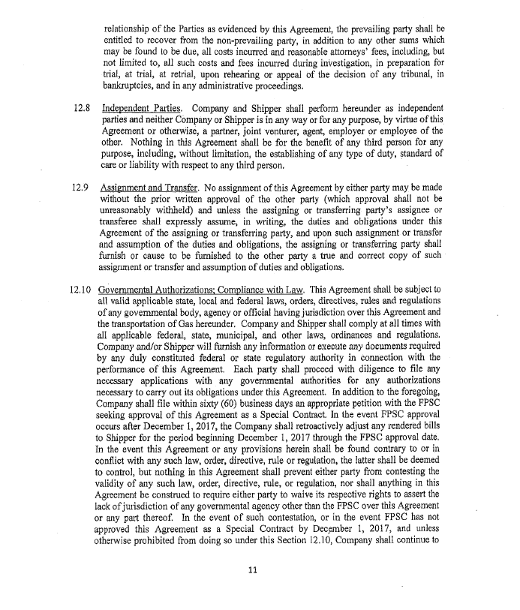

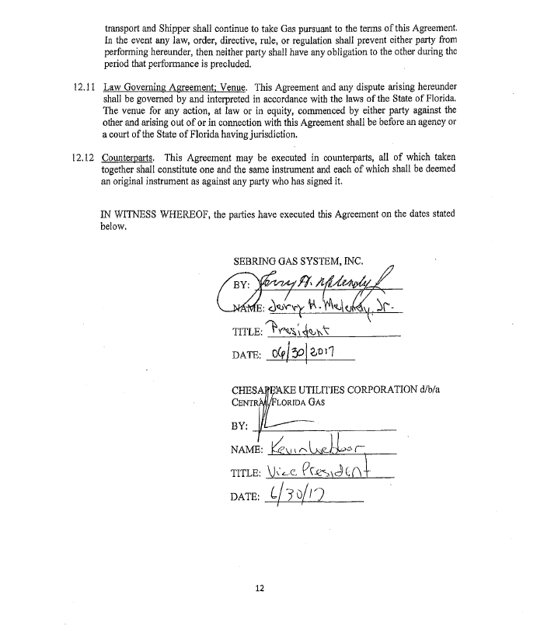

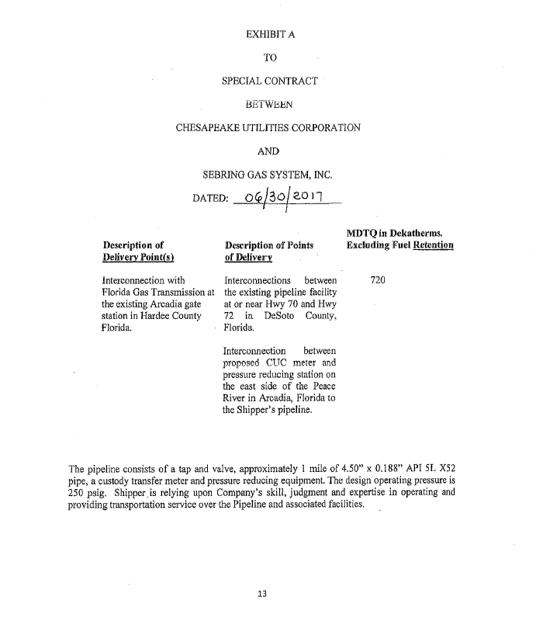

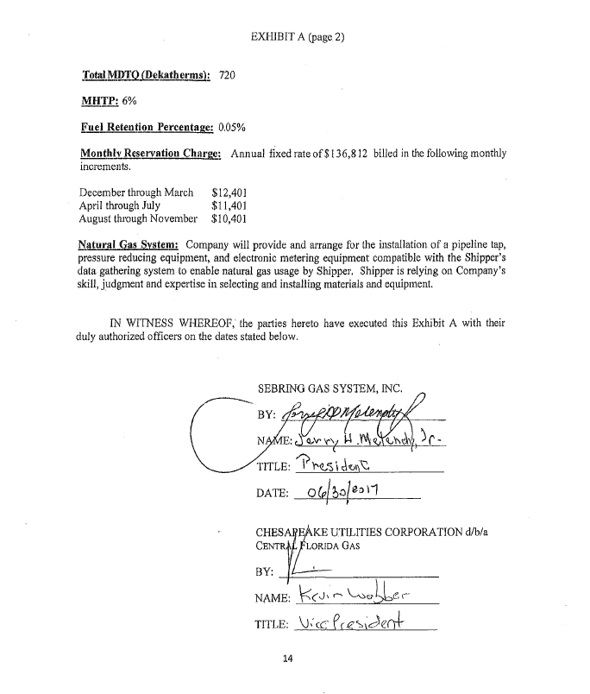

Order No. PSC-2017-0205-PAA-GU, issued May 23, 2017, in Docket No. 20170036-GU, In re: Joint petition for approval of territorial agreement in DeSoto County by Florida Division of Chesapeake Utilities Corporation and Sebring Gas System, Inc.
Monthly Reservation Charge: The annual fixed rate of $136,812 is billed in the following increments: December through March $12,401 April through July $11,401 August through November $10,401

