State of Florida |  | Public Service Commission  Capital Circle Office Center ● 2540 Shumard Oak Boulevard  Tallahassee, Florida 32399-0850  -M-E-M-O-R-A-N-D-U-M-
DATE: | January 23, 2020
TO: | Office of Commission Clerk (Teitzman)
FROM: | Division of Economics (Ward)  Office of the General Counsel (Brownless)
RE: | Docket No. 20190200-GU – Petition for approval of tariff modifications to Natural Choice Transportation Service Rider, the Gas Service Agreement, and the Natural Choice Transportation Service letter of authorization, by Peoples Gas System.
AGENDA: | 02/04/20 – Regular Agenda – Tariff Filing – Interested Persons May Participate
COMMISSIONERS ASSIGNED: |  |  | All Commissioners
PREHEARING OFFICER: |  |  | Administrative
CRITICAL DATES: |  |  | 60-day suspension date waived by the utility until February 4, 2020
SPECIAL INSTRUCTIONS: |  |  | None

Case Background
On November 7, 2019, Peoples Gas System (Peoples or utility) filed a petition for approval of tariff modifications to the Natural Choice Transportation Service (NCTS) Rider, the Gas Service Agreement (GSA), and the NCTS Letter of Authorization. Peoples’ NCTS Rider program was approved in July 2000. The program allows qualifying customers to purchase natural gas directly from a pool manager, while paying Peoples for the transportation of natural gas on its system. The NCTS Letter of Authorization is the formal request by the customer for gas transportation service pursuant to Peoples’ NCTS Rider. The GSA is a standard form, completed by the customer, to initiate natural gas service with Peoples. The GSA is found on Tariff Sheet No. 8.102.
The proposed tariff sheets are shown in Attachment A to the recommendation. The utility waived the 60-day file and suspend provision of Section 366.06(3), Florida Statutes (F.S.), until the February 4, 2020 Agenda Conference. On January 22, 2020, Peoples filed a minor correction to Tariff Sheet No. 8.102. The Commission has jurisdiction over this matter pursuant to Sections 366.03, 366.04, 366.05, and 366.06, F.S.

Discussion of Issues

Issue 1:
Should the Commission approve Peoples' proposed tariff sheet modifications as shown in Attachment A?

Recommendation:
Yes. The Commission should approve Peoples’ proposed modifications as shown in Attachment A to the recommendation. The revised tariffs should become effective with the Commission’s vote on February 4, 2020. (Ward)

Staff Analysis:
Rule 25-7.0335, Florida Administrative Code (F.A.C.), requires local distribution companies (LDCs) to make gas transportation service available to non-residential customers. The rule also allows LDCs to offer transportation service to residential customers. Transportation service is a voluntary program that allows customers to purchase natural gas from a third-party marketer, or pool manager.
Peoples functions as a traditional LDC, providing gas service for sales customers, while also providing optional transportation service as required by Rule 25-7.0335, F.A.C. There are currently 27,000 customers participating in Peoples’ NCTS program, along with 15 approved pool managers. The transportation customers pay the pool manager’s charges for natural gas and are not subject to the utility’s Commission-approved Purchased Gas Adjustment (PGA) rates, whereas sales customers are subject to PGA rates. The Commission does not approve or review natural gas prices pool managers charge their customers.
The NCTS Rider (Tariff Sheets Nos. 7.803-7.803.3) and associated tariffs provide the terms and conditions under which Peoples allows participating commercial and large residential customers to use a pool manager to purchase their natural gas. In the instant docket, the utility seeks to modify Tariff Sheet Nos. 7.803-2 and 7.803-3 to change the date by which the pool managers enroll a customer in the NCTS program. Peoples seeks to change the enrollment date from the twentieth day of the month to the fifteenth day of the month. Peoples states that this change would provide pool managers additional time to complete their therm usage forecast for the upcoming month, resulting in more timely and accurate gas supply nominations by the pool manager. The utility also seeks to modify Tariff Sheet No. 7.803-3 to change the deadline by which the pool manager may submit a request to terminate a customer to the sixteenth day of the month prior to termination. The current deadline is 30 days prior to the first day of the month that the termination is to take place. Peoples states that this requested modification would provide pool managers with more flexibility, by reducing the time frame for notification to Peoples when shifting customers between marketers, or returning customers to system supply.
Second, Peoples seeks to modify its NCTS Letter of Authorization, contained in Tariff Sheet Nos. 8.118-8.118.2. The utility is proposing to streamline the process by modernizing the terminology, allowing for electronic signatures, and making the form more compatible with its internal information systems. Peoples states that the modified form would simplify the enrollment process and de-enrollment process in the NCTS program. Peoples also modified Tariff Sheet No. 8.118-2 to allow a pool manager to complete one Letter of Authorization for a customer with multiple meters at one location.
Finally, Peoples seeks to modify its Gas Service Agreement, contained within Tariff Sheet No. 8.102, which was last modified in 2003. The utility states that modification is required to simplify the terminology, allow for electronic signatures, and generally make the form and the information it provides more compatible with their internal information system supporting the NCTS program. The utility states that in October 2019, it provided pool managers with an overview of the Gas Management System and an update on the proposed changes contained in the instant petition. Peoples asserts that none of the pool managers have expressed any concerns with the proposed modifications.

Conclusion
Staff notes that the requested tariff revisions are intended to provide the pool managers with additional time each month to complete their therm usage forecasts, while also allowing more flexibility in their time frame to submit a request to terminate a customer. The modifications would also modernize the terminology and allow for electronic signatures on the NCTS Letter of Authorization and the GSA. Staff believes that the proposed modifications are reasonable and would meet their intended purpose.
In light of the foregoing, the Commission should approve Peoples’ proposed modifications as shown in Attachment A to the recommendation. The revised tariffs should become effective with the Commission’s vote on February 4, 2020.

Issue 2:
Should this docket be closed?

Recommendation:
If Issue 1 is approved and a protest is filed within 21 days of the issuance of the order, the tariffs should remain in effect, with any revenues held subject to refund, pending resolution of the protest. If no timely protest is filed, this docket should be closed upon issuance of a consummating order. (Brownless)

Staff Analysis:
If Issue 1 is approved and a protest is filed within 21 days of the issuance of the order, the tariffs should remain in effect, with any revenues held subject to refund, pending resolution of the protest. If no timely protest is filed, this docket should be closed upon the issuance of a consummating order.

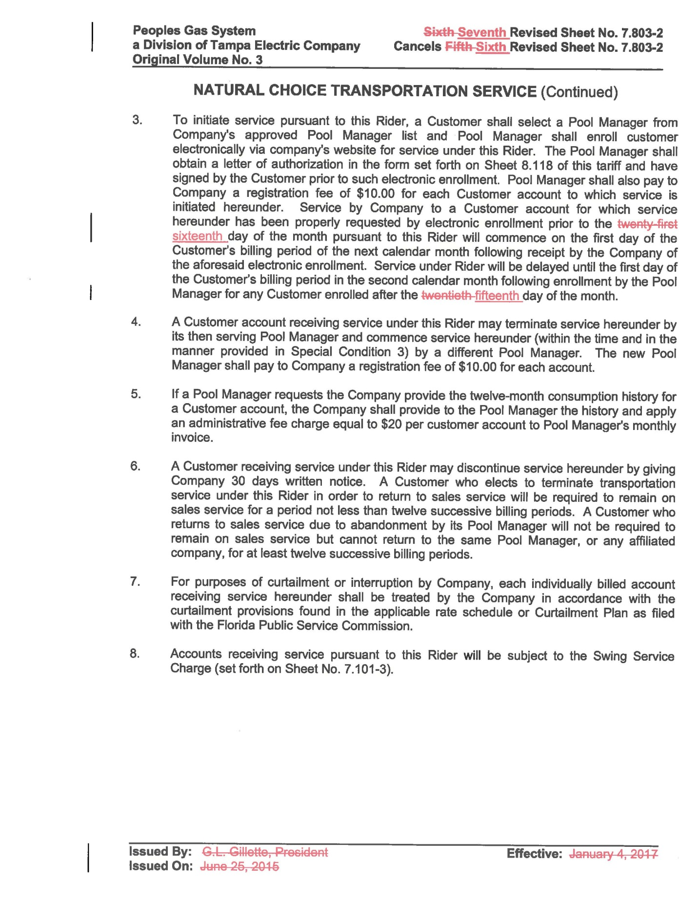

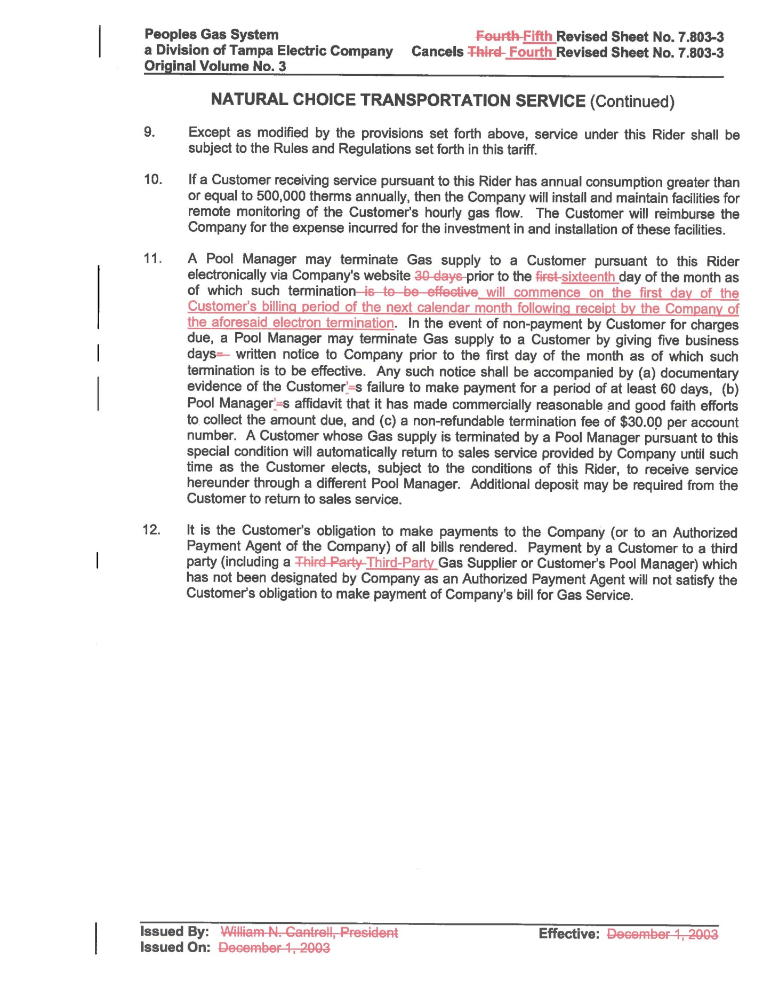
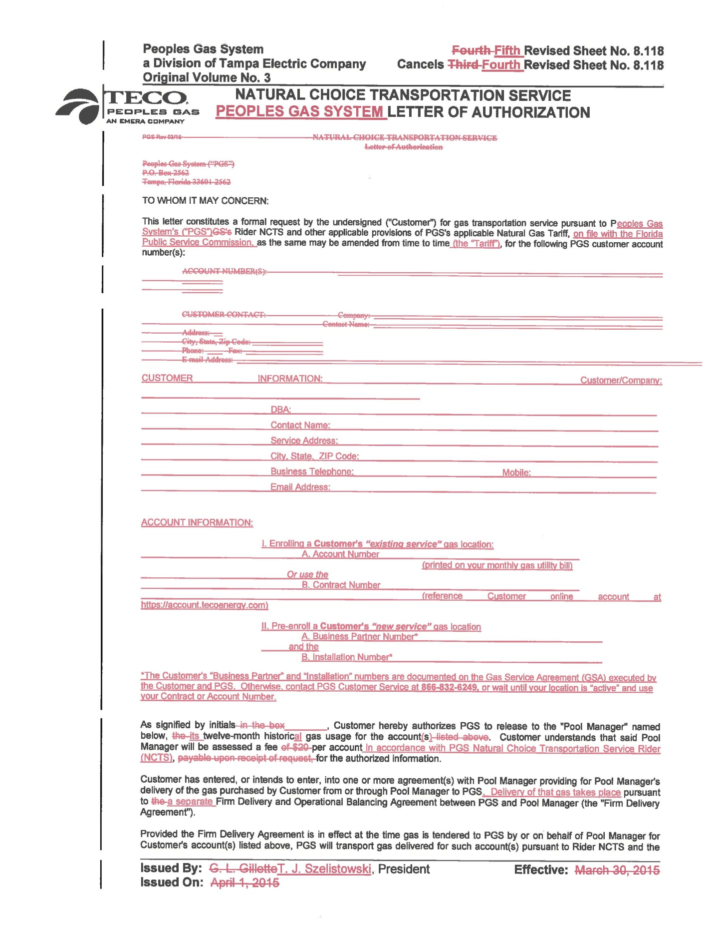
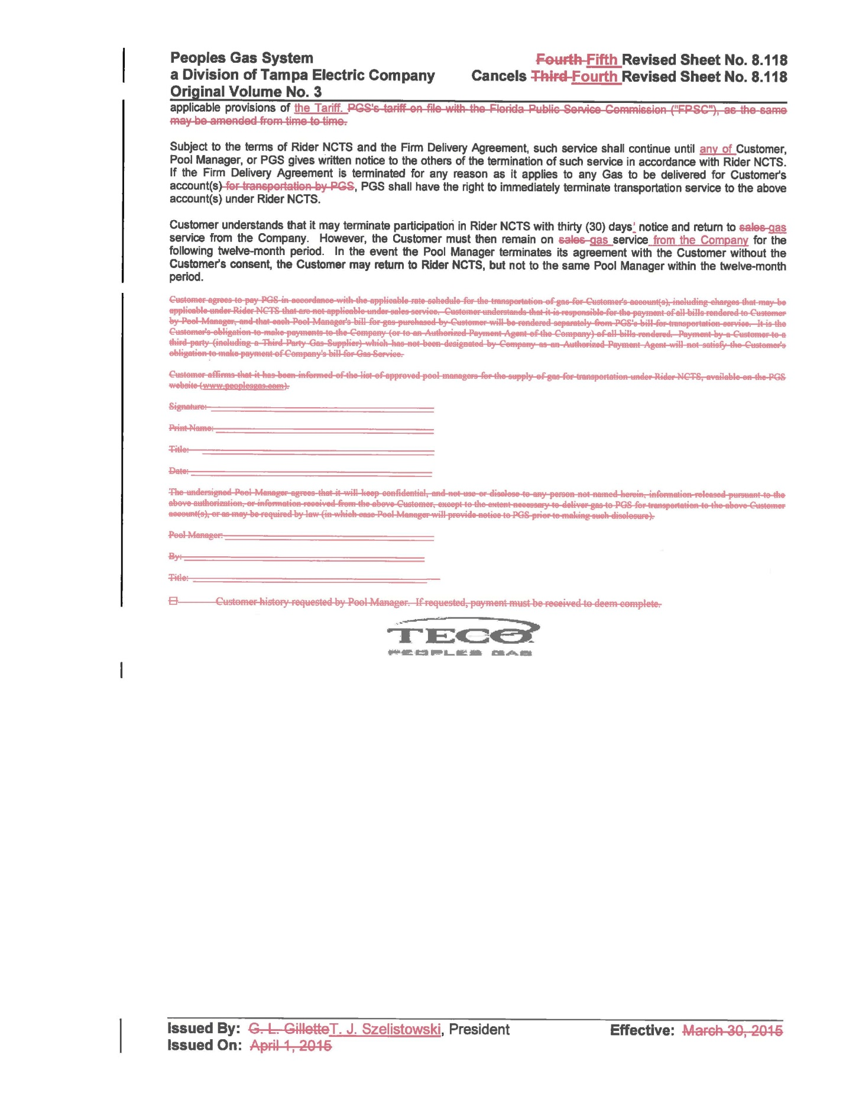
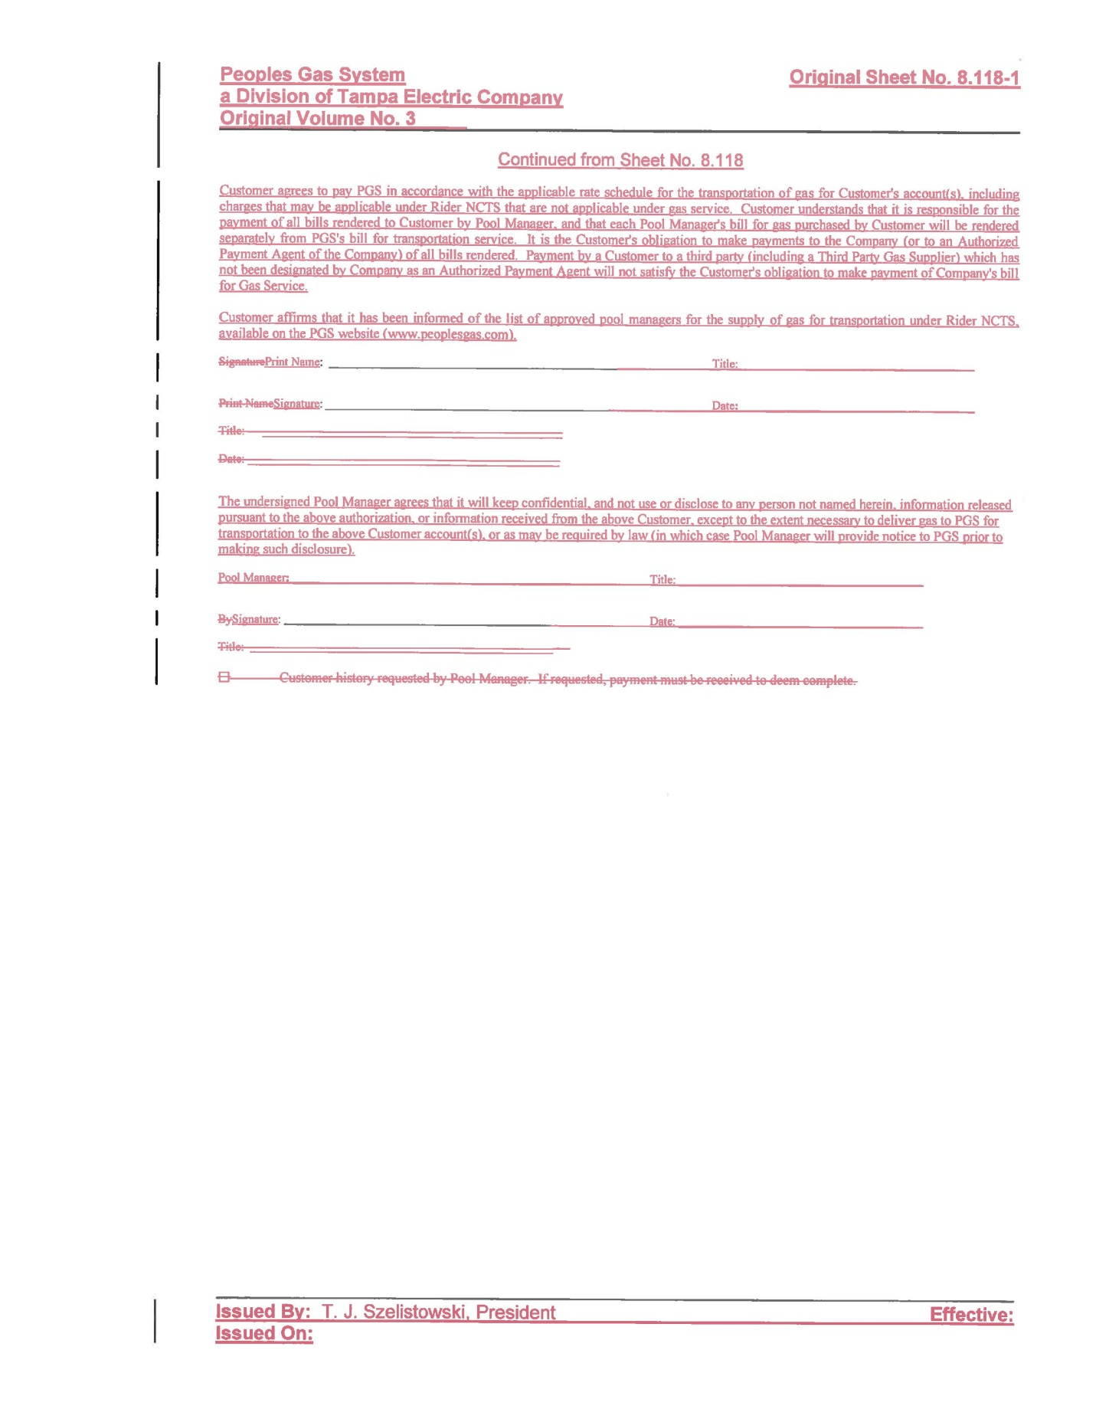
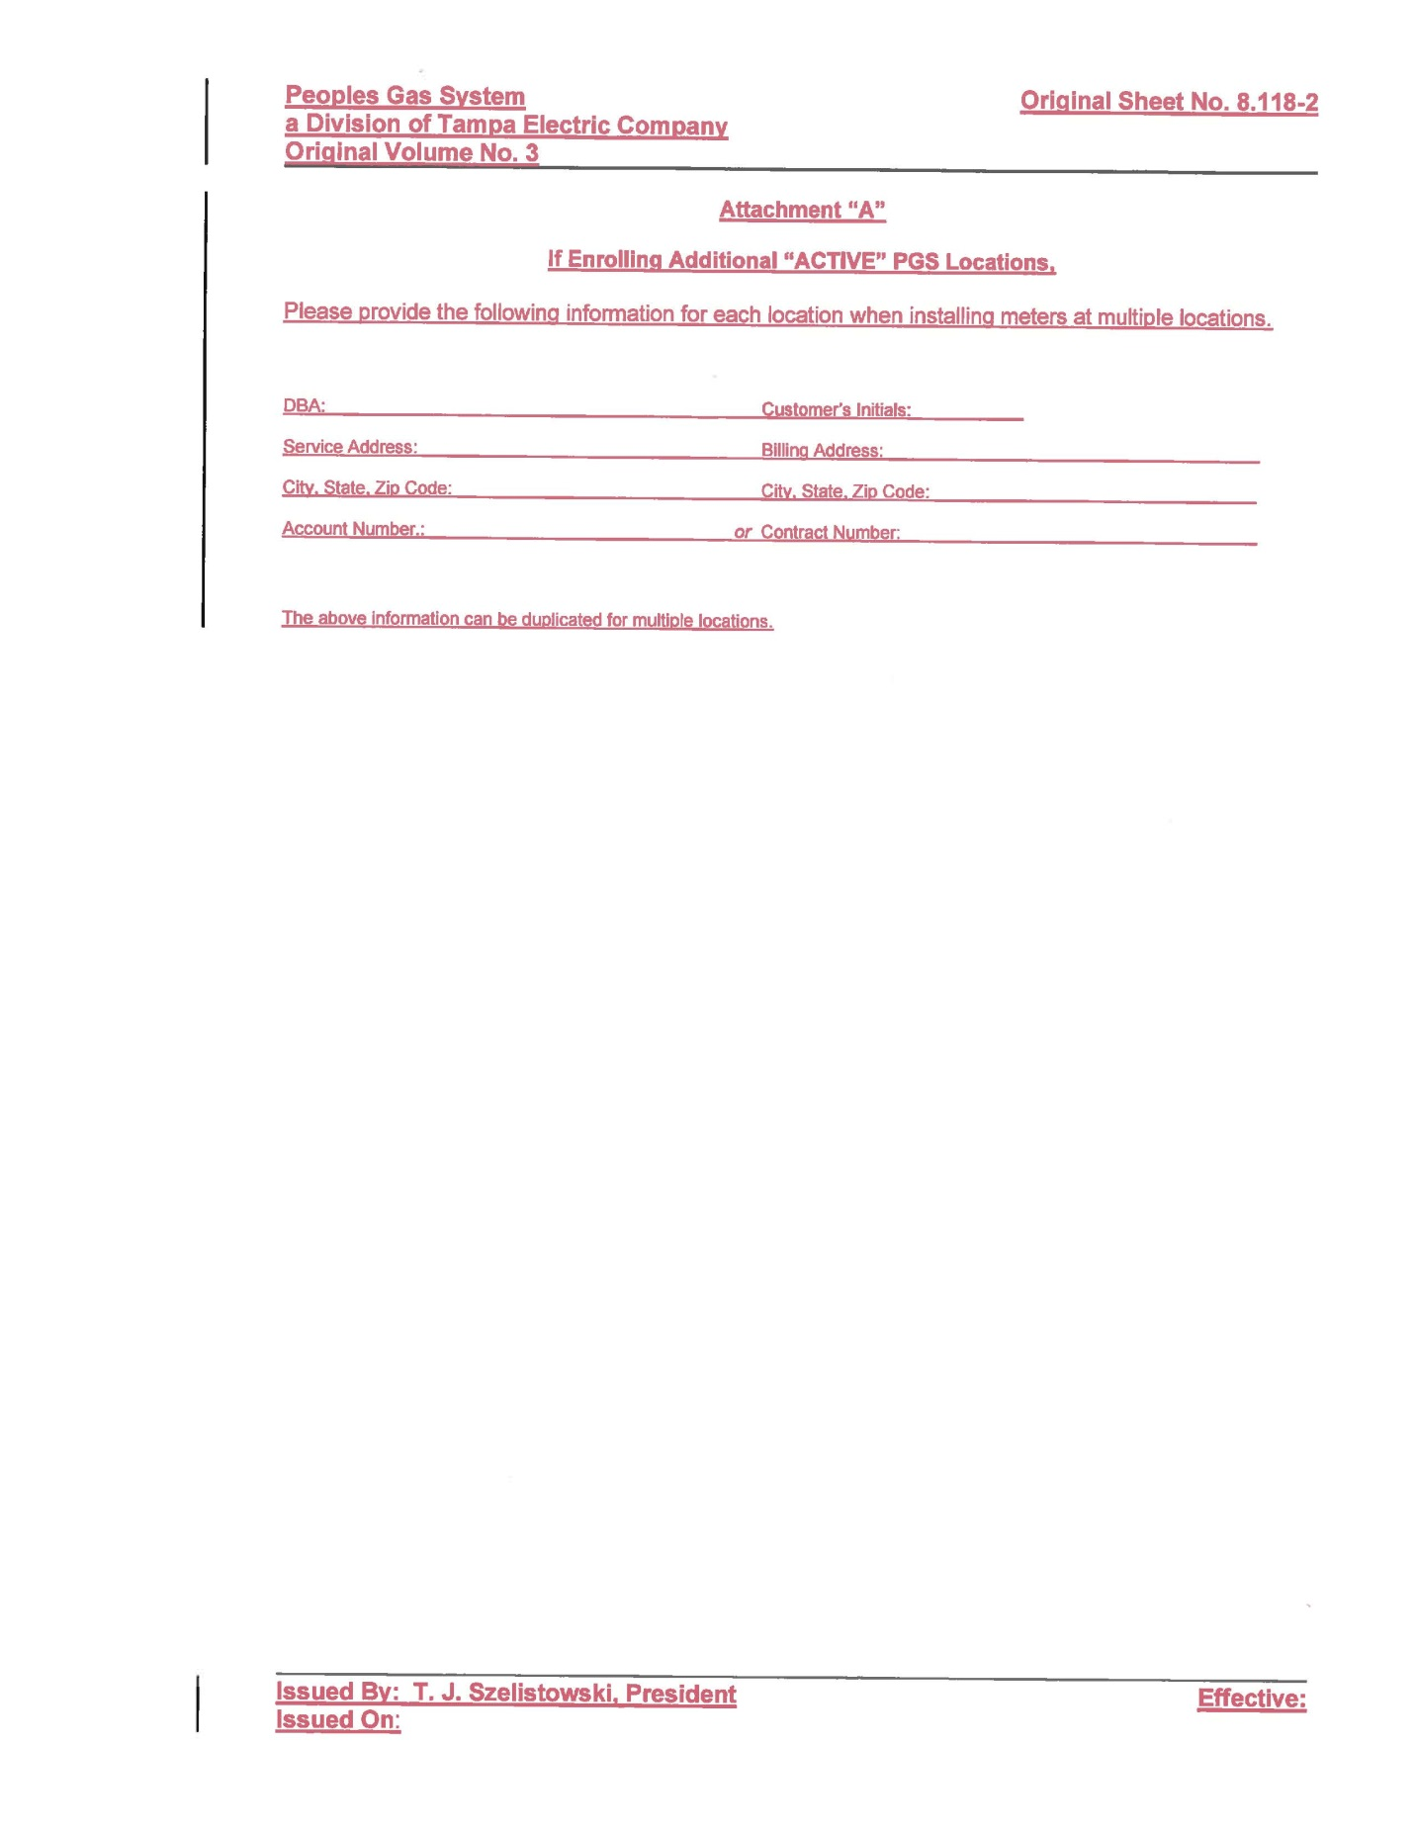
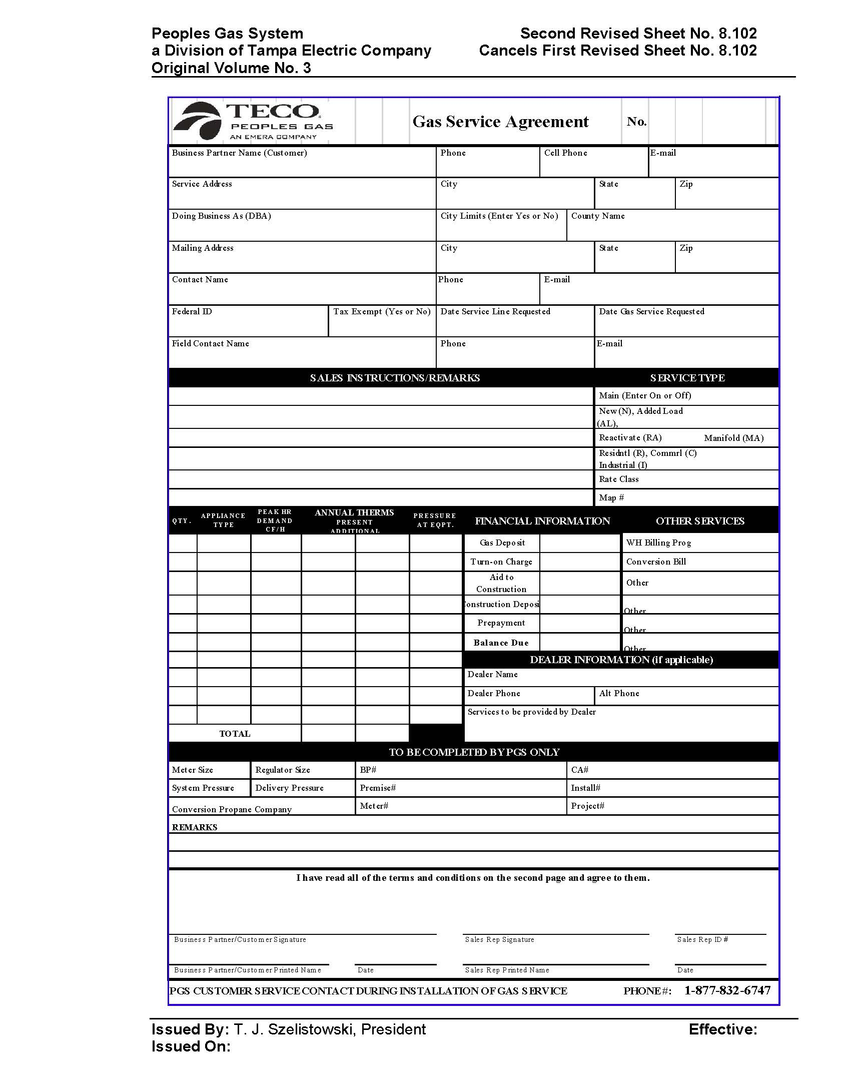

Order No. PSC-00-1814-TRF-GU, issued October 4, 2000, in Docket No. 2000810-GU, In re: Petition for approval of modifications to tariff provisions governing transportation of customer-owned gas and tariff provisions to implement Rule 25-7.0335, F.A.C.
Staff has included the proposed clean version of the GSA (in Attachment A, Tariff Sheet No. 8.102), rather than the legislative version, to more accurately reflect the changes, as the table is being replaced entirely.

