BEFORE THE FLORIDA PUBLIC SERVICE COMMISSION

In re: Petition for approval of FPL SolarTogether program and tariff, by Florida Power & Light Company. | DOCKET NO. 20190061-EI  ORDER NO. PSC-2020-0084-S-EI  ISSUED: March 20, 2020

The following Commissioners participated in the disposition of this matter:

GARY F. CLARK, Chairman
ART GRAHAM
JULIE I. BROWN
DONALD J. POLMANN
ANDREW GILES FAY

APPEARANCES:

MARIA JOSE MONCADA and WILLIAM P. COX, ESQUIRES, 700 Universe Boulevard, Juno Beach, Florida 33408
On behalf of Florida Power & Light Company (FPL).

J. R. KELLY, Public Counsel, CHARLES J. REHWINKEL, Deputy Public Counsel, and STEPHANIE MORSE, Associate Public Counsel, ESQUIRES, 111 West Madison Street, Room 812, Tallahassee, Florida 32399
On behalf of the Citizens of the State of Florida (OPC).

JOHN C. MOYLE JR. and KAREN A. PUTNAL, ESQUIRES, 118 North Gadsden Street, Tallahassee, Florida 32301
On behalf of Florida Industrial Power Users Group (FIPUG).

GEORGE CAVROS, ESQUIRE, 120 E. Oakland Park Boulevard, Suite 105, Fort Lauderdale, Florida 33334
On behalf of Southern Alliance for Clean Energy (SACE).

MARSHA E. RULE, ESQUIRE, 119 South Monroe Street, Suite 202, Tallahassee, Florida 32301;
RICHARD A. ZAMBO, ESQUIRE, 2336 South East Ocean Boulevard, #309, Stuart, Florida 34966; and
KATIE CHILES OTTENWELLER, QUALIFIED REPRESENTATIVE, 151 Estoria Street SE, Atlanta, Georgia 30316
On behalf of Vote Solar (Vote Solar).

STEPHANIE U. EATON, ESQUIRE, 110 Oakwood Drive, Suite 500, Winston-Salem, North Carolina 27103 and
DERRICK PRICE WILLIAMSON, ESQUIRE, 1100 Bent Creek Boulevard, Suite 101, Mechanicsburg, Pennsylvania 17050
On behalf of Walmart Inc. (Walmart).

WALT L. TRIERWEILER and KRISTEN B. SIMMONS, ESQUIRES, Florida Public Service Commission, 2540 Shumard Oak Boulevard, Tallahassee, Florida 32399-0850
On behalf of the Florida Public Service Commission (Staff).

MARY ANNE HELTON, ESQUIRE, Deputy General Counsel, Florida Public Service Commission, 2540 Shumard Oak Boulevard, Tallahassee, Florida 32399-0850
Advisor to the Florida Public Service Commission.

KEITH C. HETRICK, ESQUIRE, General Counsel, Florida Public Service Commission, 2540 Shumard Oak Boulevard, Tallahassee, Florida 32399-0850
Florida Public Service Commission General Counsel.

FINAL ORDER APPROVING STIPULATION AND SETTLEMENT AGREEMENT

BY THE COMMISSION:

Background
On March 13, 2019, FPL filed a petition (Petition) for a new voluntary community solar program (SolarTogether Program or Program) and associated tariff. The proposed SolarTogether Program is designed to allow FPL customers to subscribe to a portion of new solar capacity built through the Program (subscription charge) and to receive a credit of a portion of the system savings produced by that solar capacity (subscription credit). Phase 1 of the Program consists of five projects comprising a total of 20 individual solar photovoltaic (PV) power plants. Each power plant is rated at 74.5 megawatts (MW) for a total of 1,490 MW that would provide electricity to all of FPL’s customers.
OPC, Walmart, SACE, Vote Solar, and FIPUG were granted intervention in this docket. In June of 2019, Vote Solar and OPC both filed motions requesting that this matter be set for an administrative hearing. FPL objected to both motions. After considering the arguments made by the parties, we set this matter for an administrative hearing.
FPL filed its direct testimony on July 29, 2019. Commission Staff, SACE, Walmart, Vote Solar, and OPC filed direct testimony on September 3, 2019. FPL filed its rebuttal testimony on September 23, 2019, which included a revised tariff. On September 27, 2019, OPC filed a motion for continuance of the hearing, or in the alternative, a motion to strike portions of FPL’s rebuttal testimony, arguing that there was insufficient time and opportunity to address the tariff revisions filed with FPL’s rebuttal. FPL filed a response in opposition to OPC’s motion. In response to OPC’s motion, new controlling dates, including a new hearing date, and discovery response times were established.
On October 9, 2019, FPL, SACE, Vote Solar, and Walmart filed a Joint Motion to Approve Settlement (Joint Motion), with the Stipulation and Settlement (appended to this Order) and Tariff STR (Attachment A to the Settlement Agreement). OPC filed a response in opposition to the Joint Motion on October 16, 2019. In response to the new filings, the parties were allowed additional discovery and an opportunity to file additional testimony with respect to the proposed Settlement Agreement. Subsequently, both Commission staff and OPC filed supplemental testimony on November 15, 2019, with FPL filing supplemental rebuttal testimony on November 27, 2019. On December 5, 2019, FPL filed a Notice of Superseding Proposed Tariff, stating that Tariff STR supersedes the prior proposed tariffs in this docket.
On January 2, 2020, Duke Energy Florida, LLC (DEF) filed a motion for leave to file amicus curiae comments, with comments attached, in support of FPL’s Petition. DEF stated that the SolarTogether Program would allow customers the opportunity to support universal solar expansion, which is already cost effective for all customers. DEF also stated that a voluntary option like the SolarTogether Program provides all customers with the benefits of utility-owned universal solar. DEF noted that while the Program may result in a policy shift, approving the Program would continue this Commission’s strong tradition of supporting public interest programs that utilize creative regulatory outcomes in a consistent, measured manner. OPC filed a response in opposition to DEF’s motion on January 9, 2020. By Order No. PSC-2020-0017-PHO-EI (Prehearing Order), DEF’s motion was granted.
The administrative hearing was held on January 14-15, 2020. All parties, except FIPUG, filed briefs on January 30, 2020. Because FIPUG did not file a brief, it has waived all issues pursuant to the Prehearing Order (page 20). We have jurisdiction over this matter pursuant to Sections 366.03, 366.05, 366.06, and 366.92, Florida Statutes (F.S.).
The Settlement Agreement
The Settlement Agreement includes the principle features of the Program, the capacity allocation to low income customers, and FPL’s recovery of the Program costs.
Program Features
The Program size (Phase 1) is 1,490 MW, consisting of 20 individual solar power plants sized at 74.5 MW each. The 1,490 MW capacity is allocated 75 percent (1,117.5 MW) to commercial, industrial, and governmental customers and 25 percent (372.5 MW) to residential and small business. Customers may elect a subscription level equivalent to the capacity that would generate up to 100 percent of their previous 12 months’ total kilowatt-hour usage, subject to capacity availability.
Participation in the Program is voluntary. Participants may terminate or reduce their subscription level at any time without penalty. Increases in subscription level will be limited to once per year based on available Program capacity.
Participants will pay a monthly subscription charge and will receive a subscription credit for each kilowatt of capacity subscribed. The subscription charge reflects the revenue requirement associated with constructing the power plants built for the Program, net of avoided generation. The subscription credit reflects the estimated economic value of the Program’s solar power plants on FPL’s system, which consists of reduced fuel, purchased power, and carbon emission costs. Paragraph 5 of the Settlement Agreement states that Tariff STR sets out the pricing for the subscription charge and the rate for the subscription credit for standard and low income customers.
Participants may elect to have FPL retire on their behalf all renewable energy certificates (RECs) associated with their subscription. FPL will not utilize RECs generated by the Program.
The 1,490 MW of solar generation that comprises Phase 1 is projected to save customers $249 million. FPL will allocate 55 percent of the projected benefits to participants and 45 percent to the general body of customers. Of the 45 percent benefit allocated to the general body of customers, approximately $56 million is a fixed base benefit. Unsubscribed capacity, including the associated energy and resulting savings, will flow to the general body of customers.
Low Income Customers (Paragraph 4)
Phase 1 of the Program will reserve capacity for low income customers. FPL will allocate 10 percent of the residential capacity, or 37.5 MW, to low income customers. For purposes of this Program, low income customers are those whose income falls at or below 200 percent of the federal poverty level. At the time of enrollment, FPL will advise low income participants that they also have the option to participate in a free home energy efficiency survey. For low income participants, the subscription charge will not exceed the subscription credit in any month. Provisions for the low income participants will begin with Project 3 (expected billing start month February 2021).
In the event FPL intends to propose a Phase 2, it will engage in outreach to groups that advocate solar access for low income populations, including SACE and Vote Solar, and will seek input regarding the low income component for Phase 2. This provision does not constitute an obligation to make any changes to the Program.
Cost Recovery
FPL is authorized to recover the $1.79 billion Program cost. FPL will record the revenue received from the participants for their subscription charge as revenues received from the sales of electricity. The revenue will be included as base rate revenues in FPL’s monthly earnings surveillance report. The subscription credit will be recovered through FPL’s fuel cost recovery clause, partially offsetting system savings resulting from the addition of the Program’s solar power plants.

Decision
The standard for approval of a settlement agreement is whether it is in the public interest. A determination of whether a settlement is in the public interest requires a case-specific analysis based on consideration of the proposed settlement taken as a whole.
The Settlement Agreement aligns with the Florida Legislature’s intent in Section 366.92, F.S., and provides ample system-wide benefits, including: promoting the development of renewable energy, encouraging investment within the state, diversifying the types of fuel used to generate electricity, lessening the state’s reliance on fossil fuels, and decreasing carbon emissions. In addition, the Settlement Agreement comports with Section 366.06, F.S., by providing fair, just, and reasonable rates without undue preference.
Having carefully reviewed the Settlement Agreement, the exhibits entered into the record, and the testimony provided, we find that, taken as a whole, the Settlement Agreement provides a reasonable resolution of all issues raised in this docket. We note, however, that our decision is not based on customers’ desires for the Program. Further, we note that any future phases of the Program will require further consideration of the Commission on a stand-alone basis. We find that the Settlement Agreement establishes rates that are fair, just, and reasonable, is supported by the record evidence, and is in the public interest, and we hereby approve it. The Program is approved as described in the Petition filed by FPL on March 13, 2019, as modified in FPL’s rebuttal testimony and exhibits filed on September 23, 2019, and in Paragraphs 4 and 5 of the Settlement Agreement. The Settlement Agreement and Tariff STR are effective upon the issuance date of this Order.
Based on the foregoing, it is
ORDERED by the Florida Public Service Commission that the Joint Motion to Approve Settlement is hereby granted. It is further
ORDERED that the Stipulation and Settlement and Tariff STR, filed on October 9, 2019, attached hereto and incorporated by reference, are hereby approved and effective upon the issuance date of this Order. It is further
ORDERED that in the event no timely appeal is filed, Docket No. 20190061-EI shall be closed.
By ORDER of the Florida Public Service Commission this 20th day of March, 2020.

/s/ Adam J. Teitzman
ADAM J. TEITZMAN
Commission Clerk
Florida Public Service Commission
2540 Shumard Oak Boulevard
Tallahassee, Florida 32399
(850) 413-6770
www.floridapsc.com

Copies furnished: A copy of this document is provided to the parties of record at the time of issuance and, if applicable, interested persons.

KBS

NOTICE OF FURTHER PROCEEDINGS OR JUDICIAL REVIEW

The Florida Public Service Commission is required by Section 120.569(1), Florida Statutes, to notify parties of any administrative hearing or judicial review of Commission orders that is available under Sections 120.57 or 120.68, Florida Statutes, as well as the procedures and time limits that apply. This notice should not be construed to mean all requests for an administrative hearing or judicial review will be granted or result in the relief sought.

Any party adversely affected by the Commission's final action in this matter may request: 1) reconsideration of the decision by filing a motion for reconsideration with the Office of Commission Clerk, 2540 Shumard Oak Boulevard, Tallahassee, Florida 32399-0850, within fifteen (15) days of the issuance of this order in the form prescribed by Rule 25-22.060, Florida Administrative Code; or 2) judicial review by the Florida Supreme Court in the case of an electric, gas or telephone utility or the First District Court of Appeal in the case of a water and/or wastewater utility by filing a notice of appeal with the Office of Commission Clerk, and filing a copy of the notice of appeal and the filing fee with the appropriate court. This filing must be completed within thirty (30) days after the issuance of this order, pursuant to Rule 9.110, Florida Rules of Appellate Procedure. The notice of appeal must be in the form specified in Rule 9.900(a), Florida Rules of Appellate Procedure.

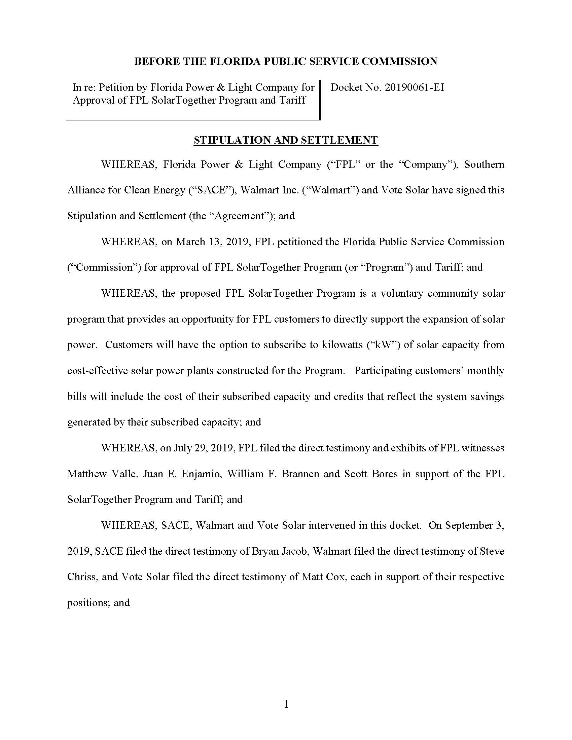

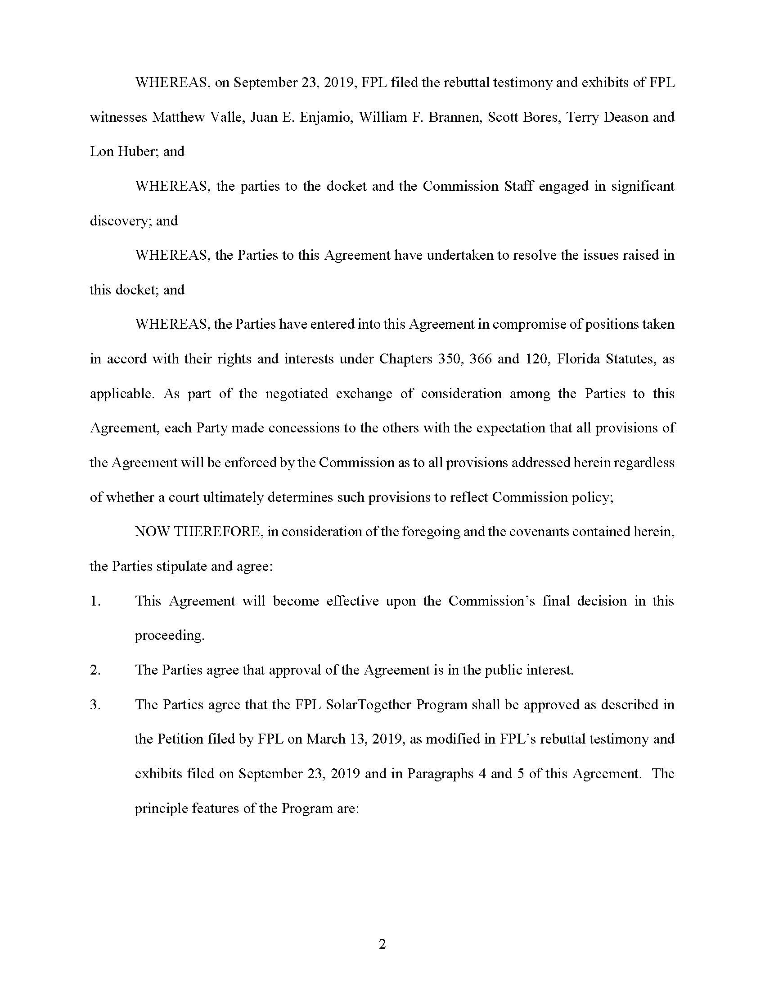

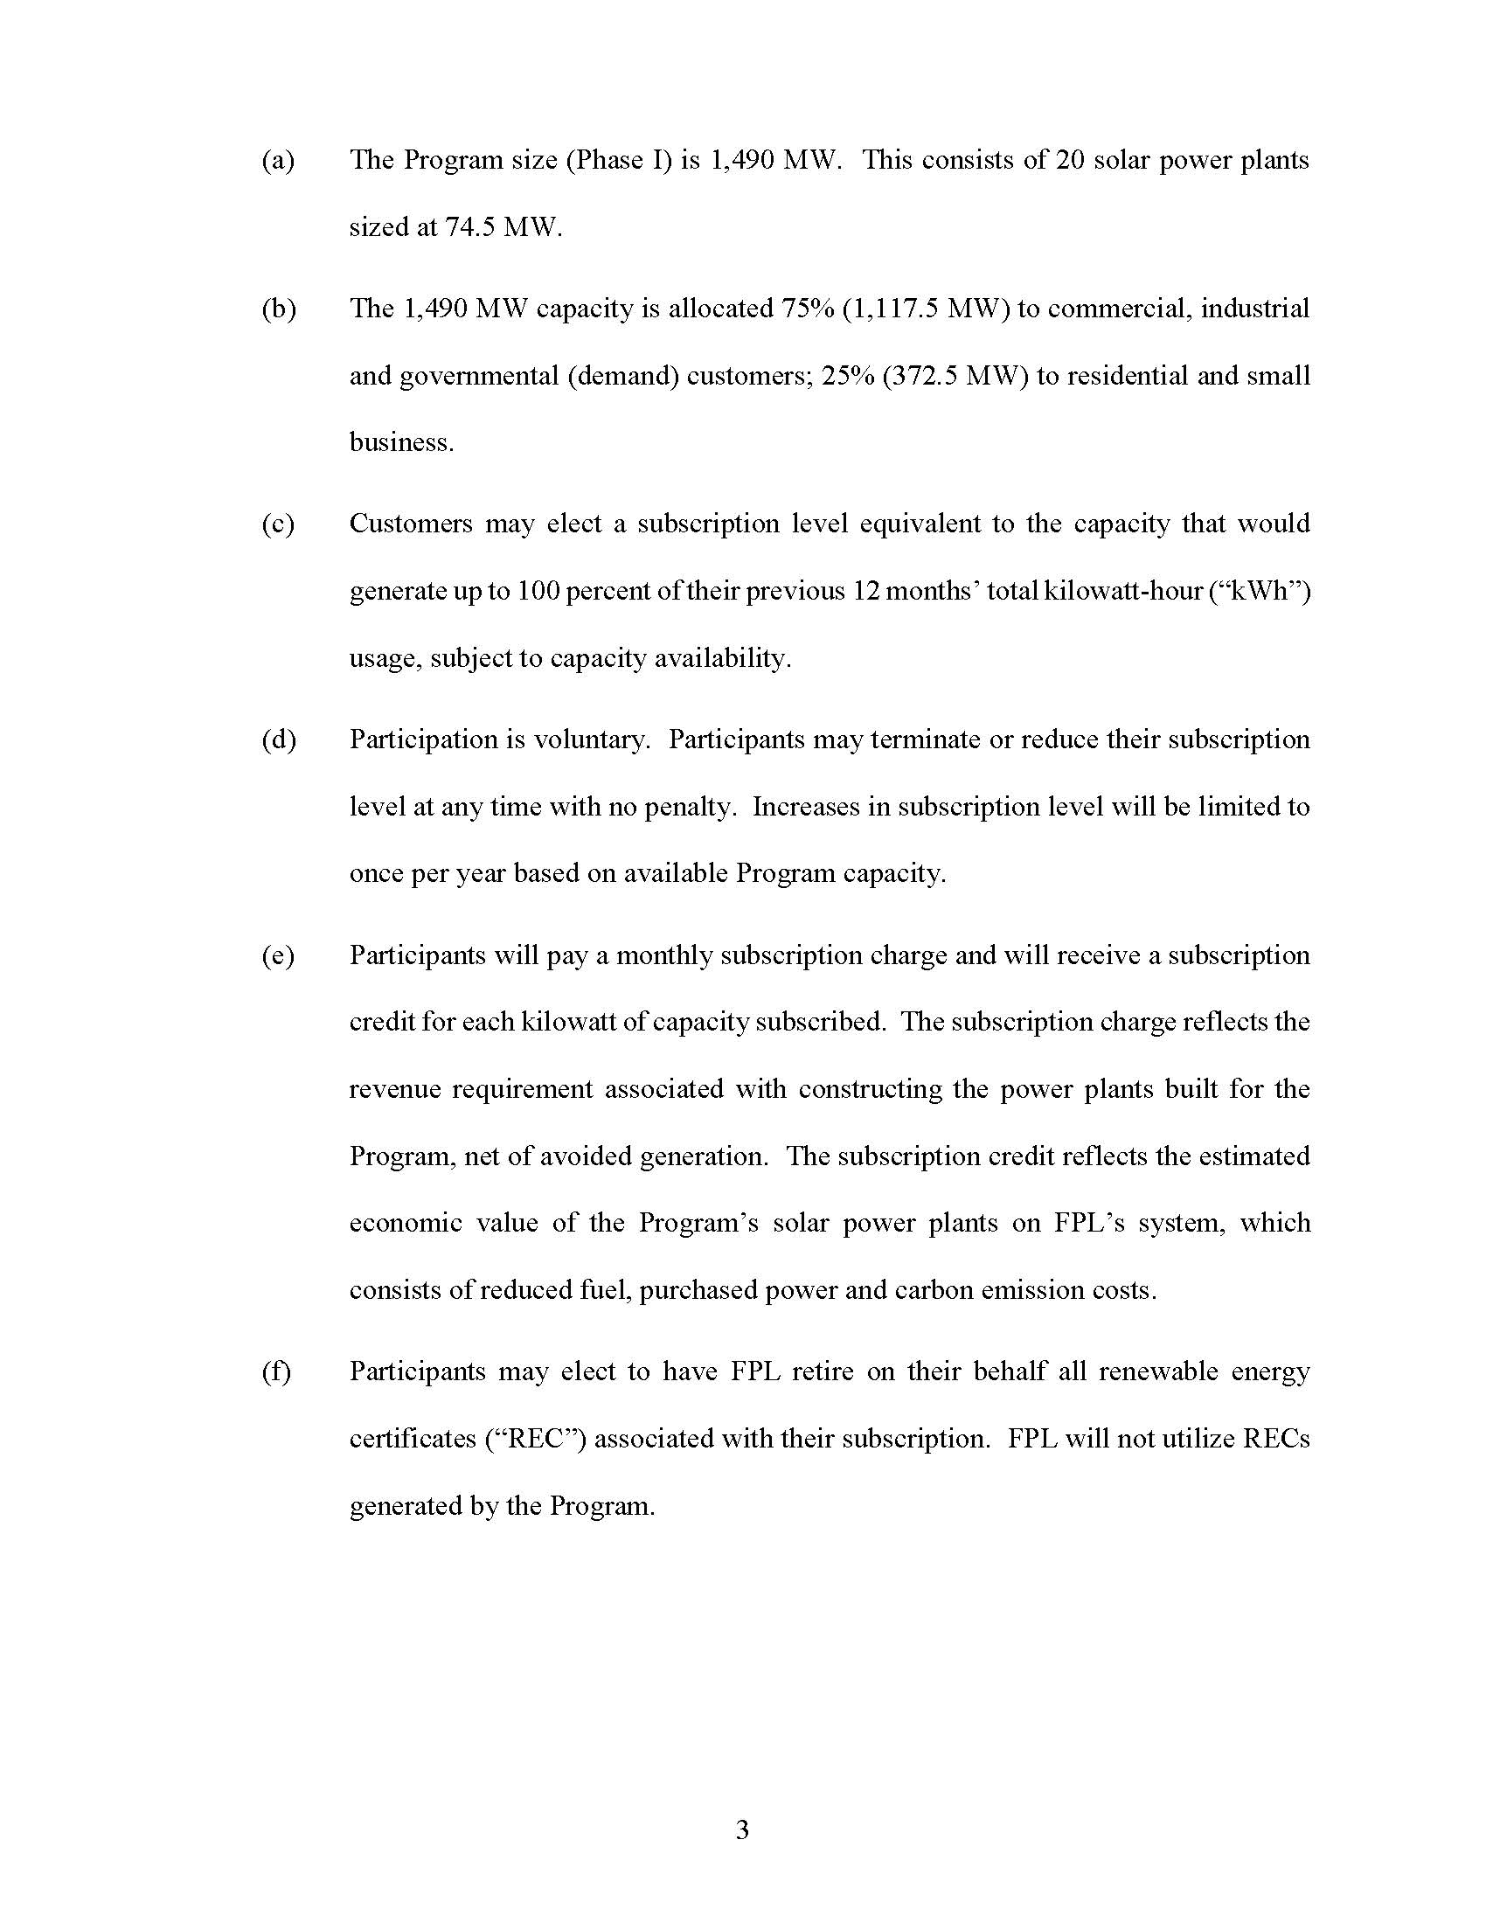

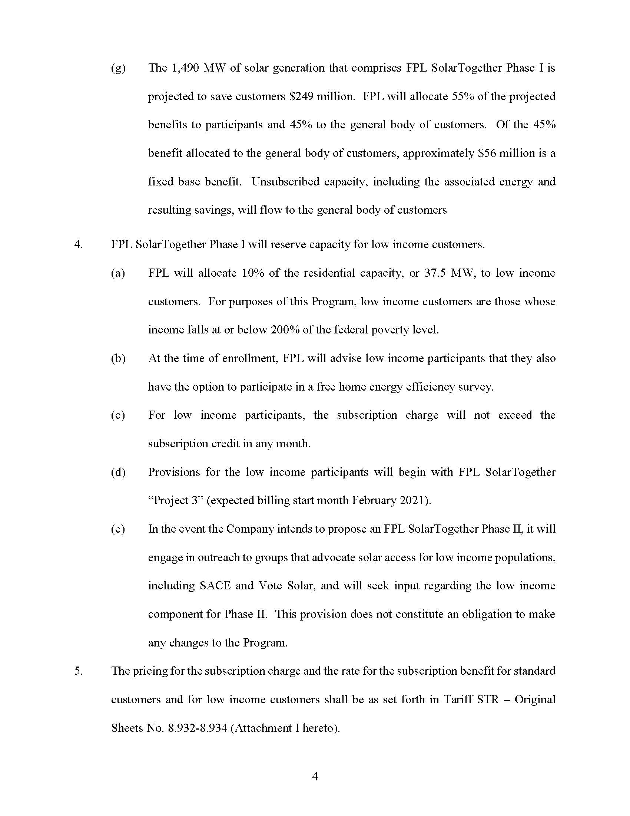

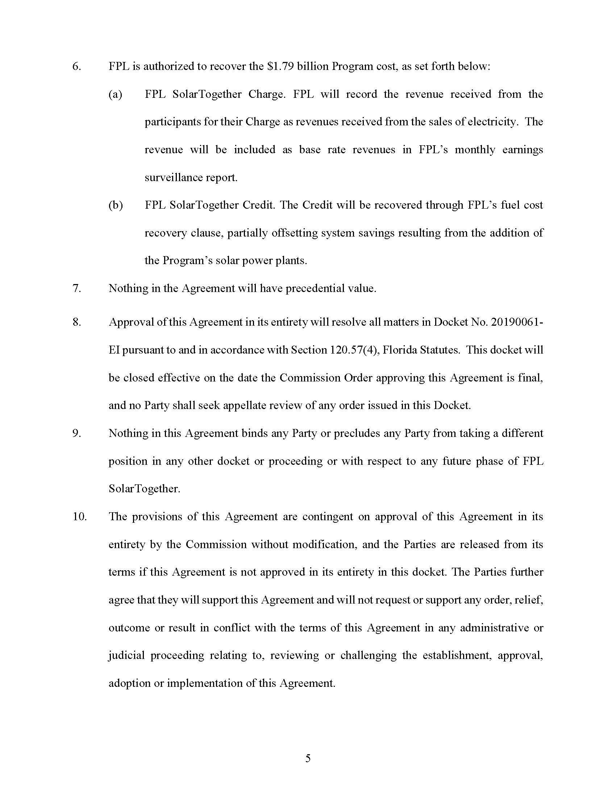

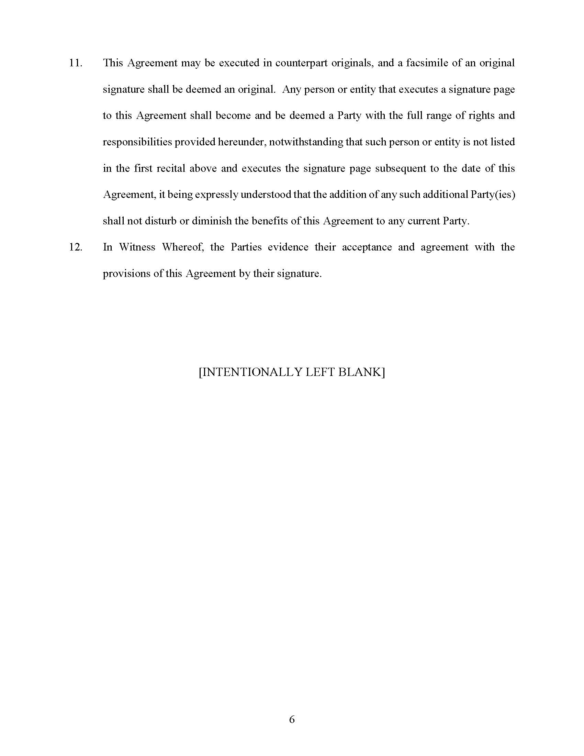

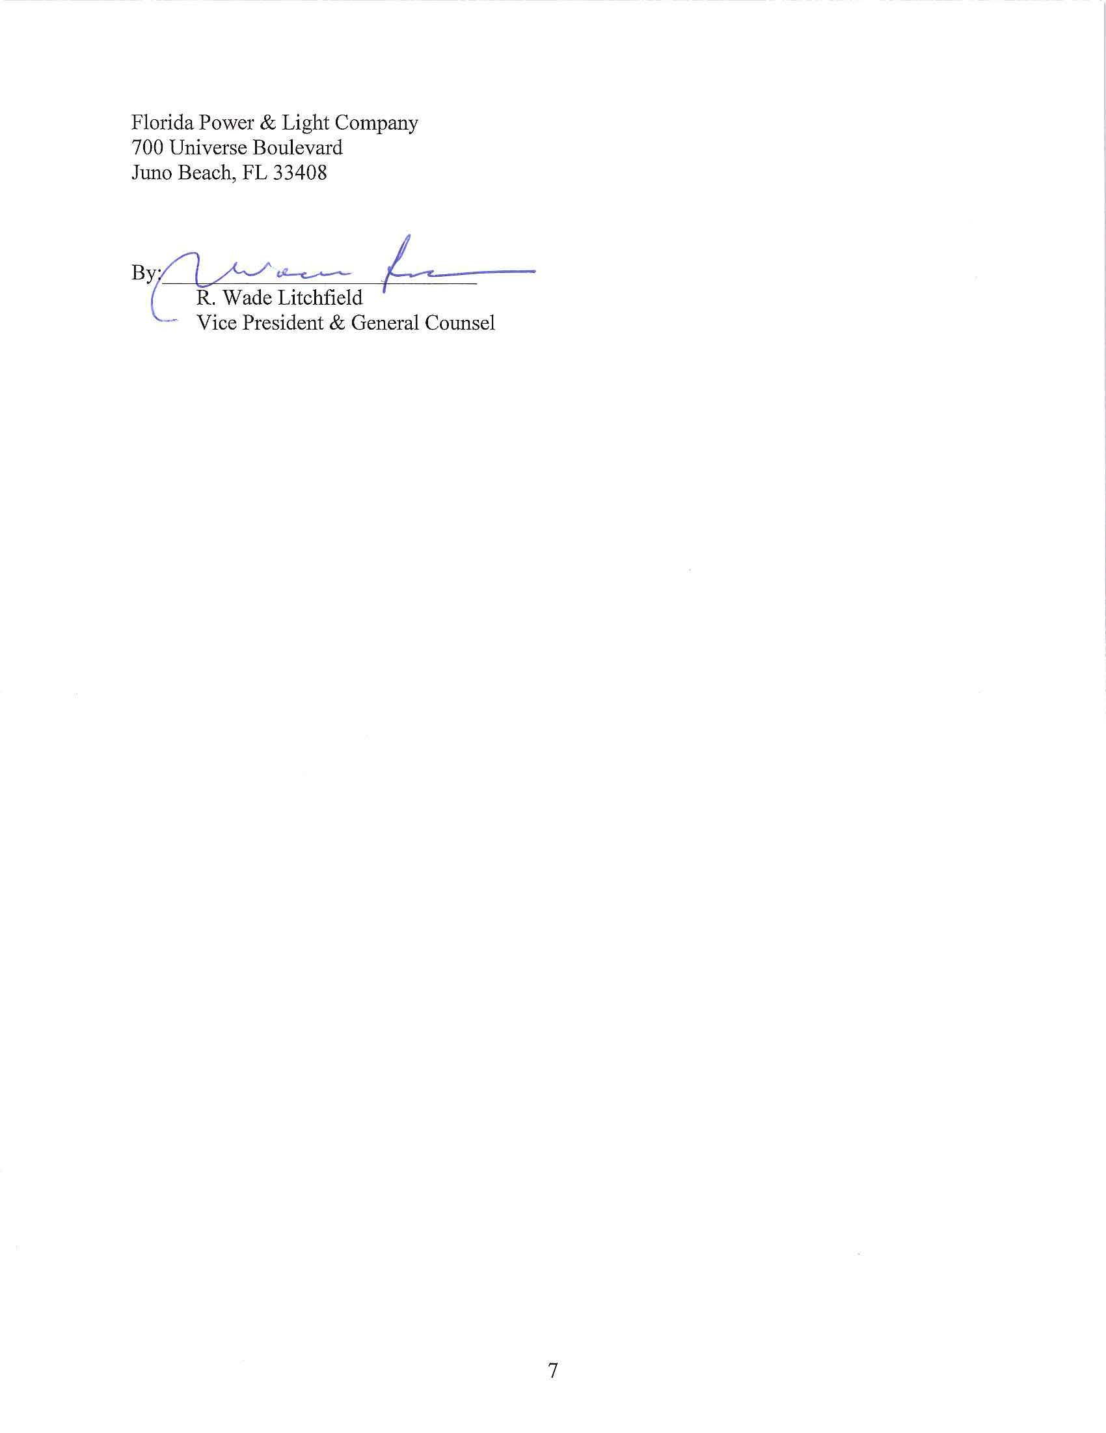

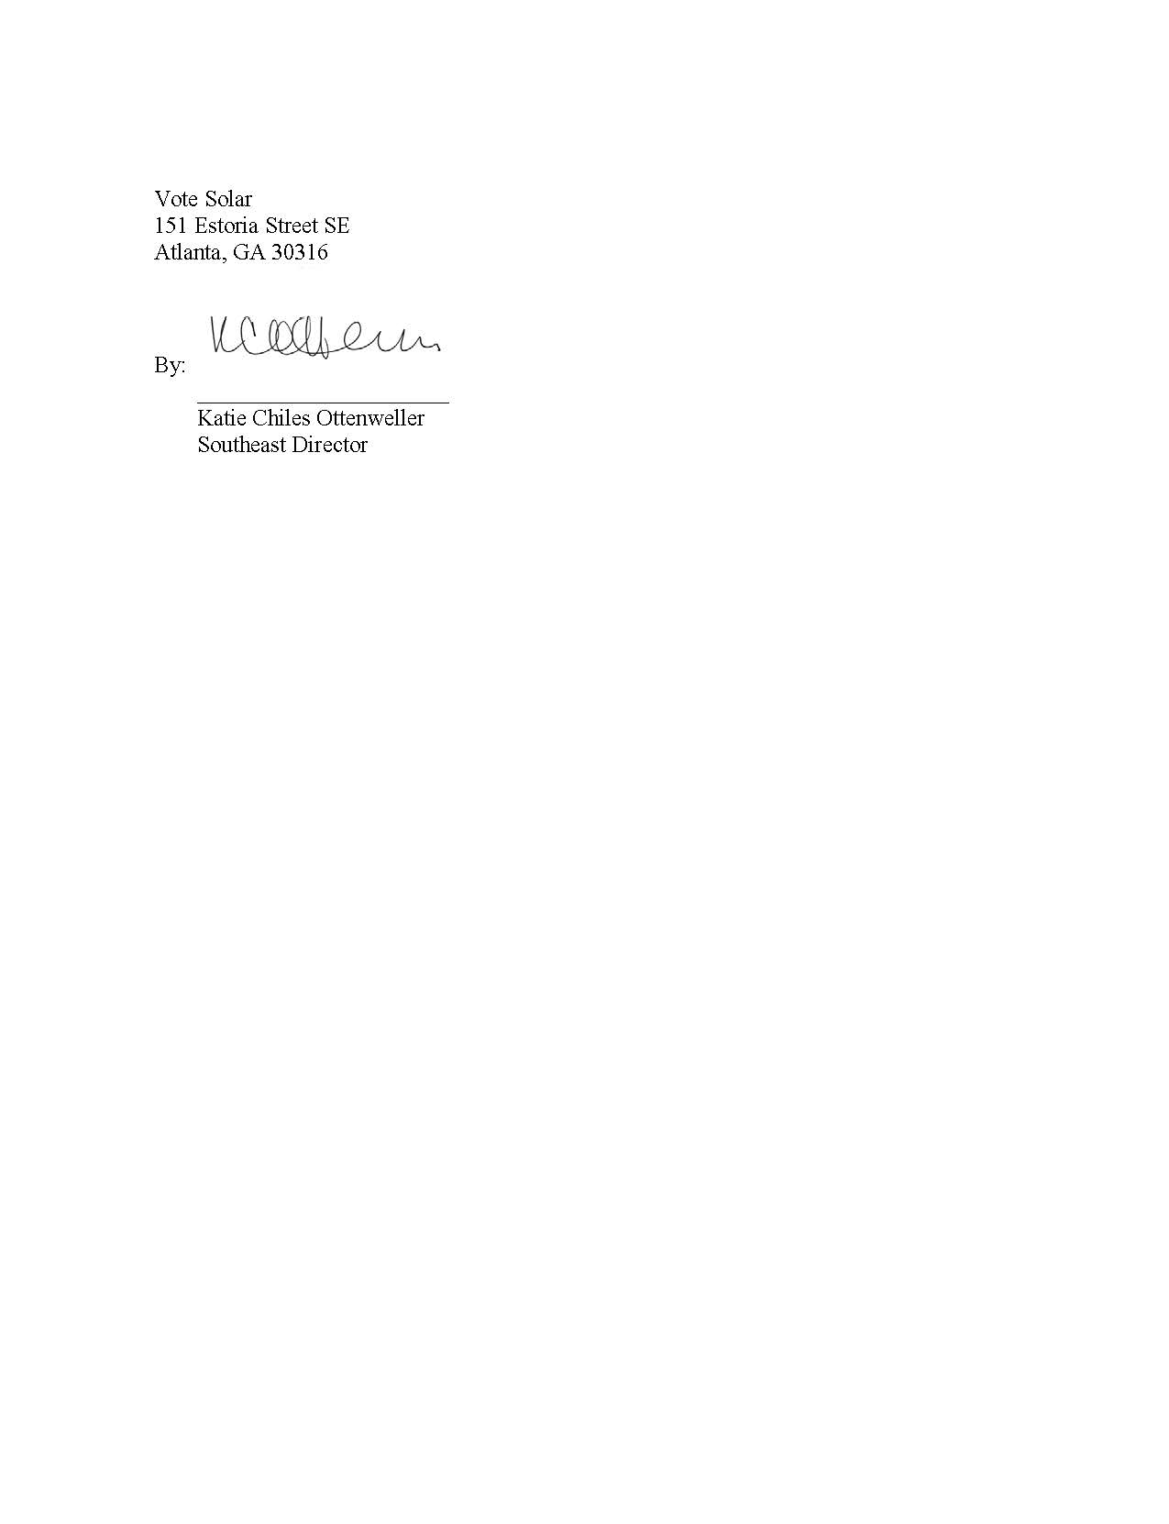

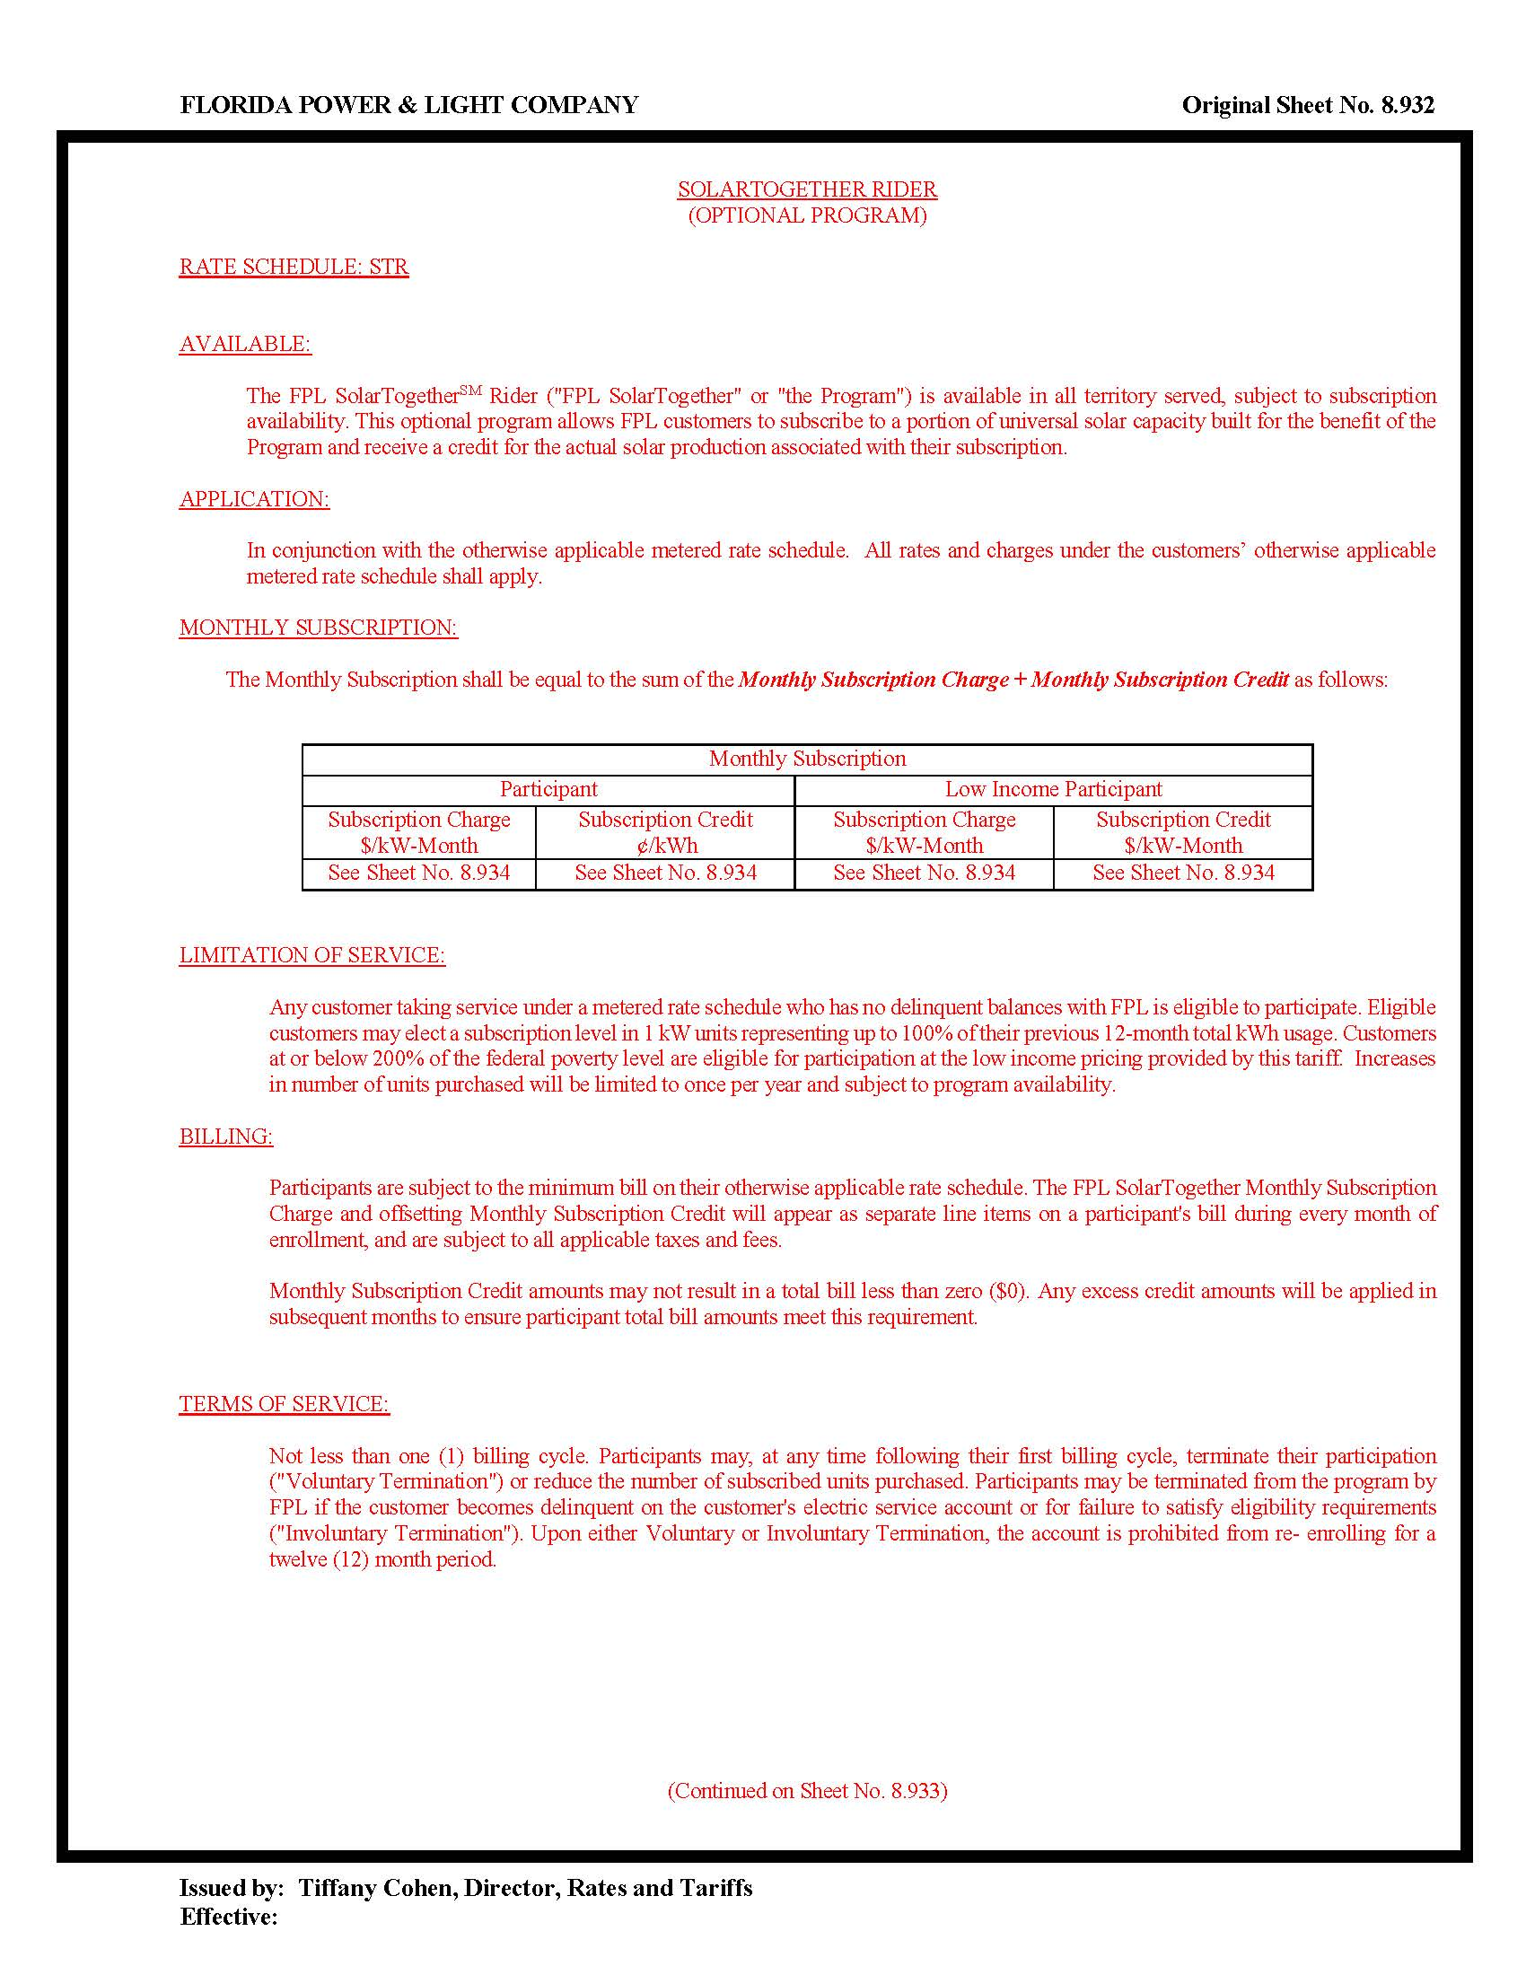
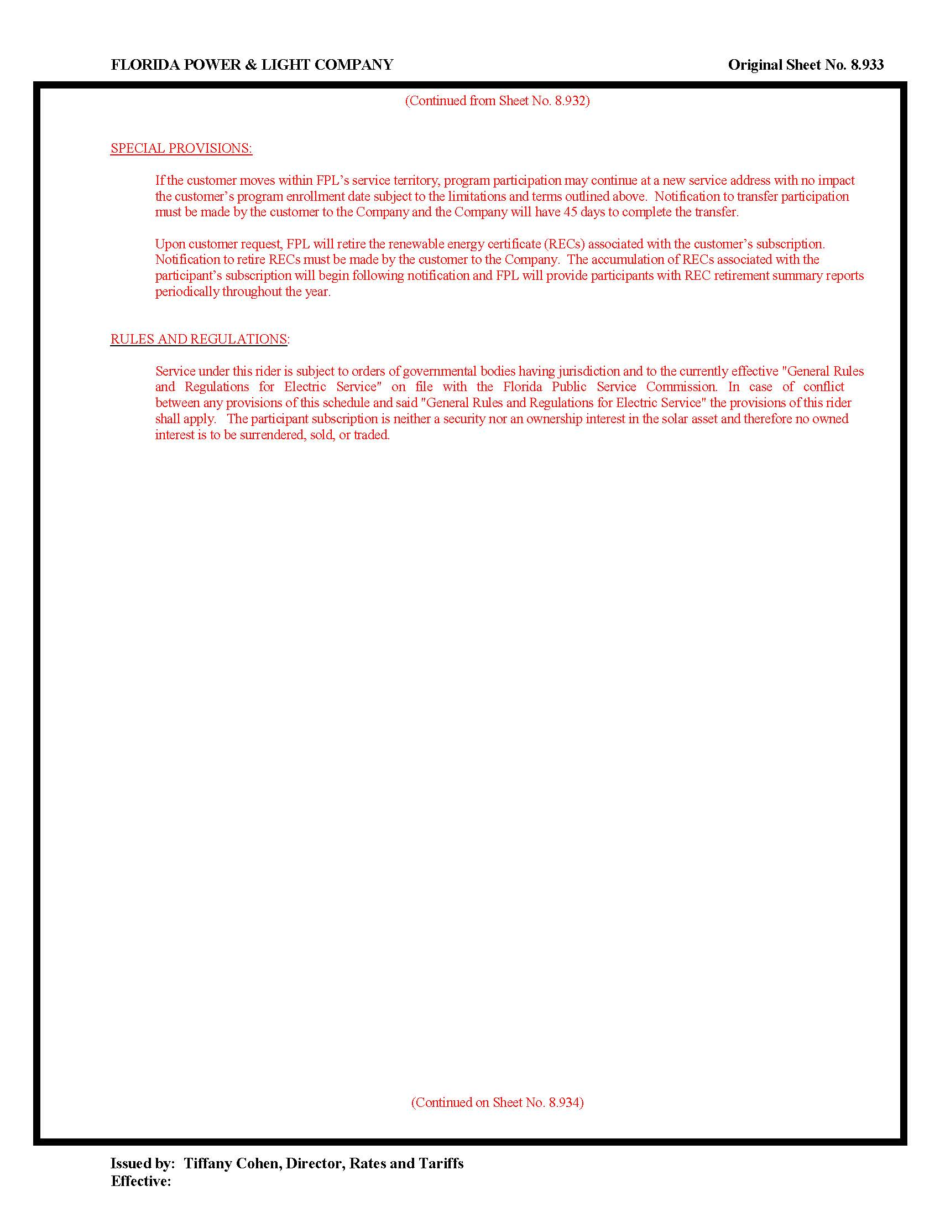

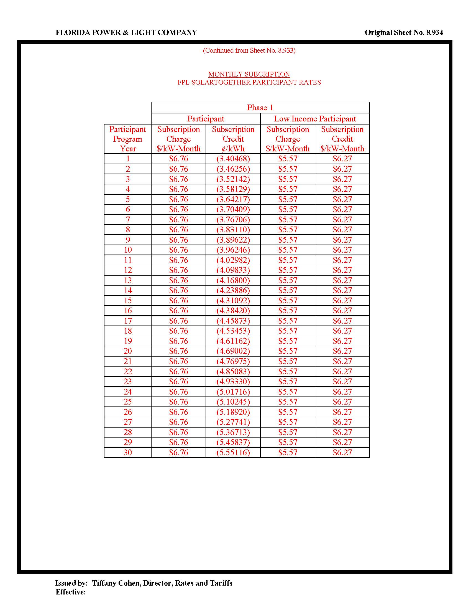

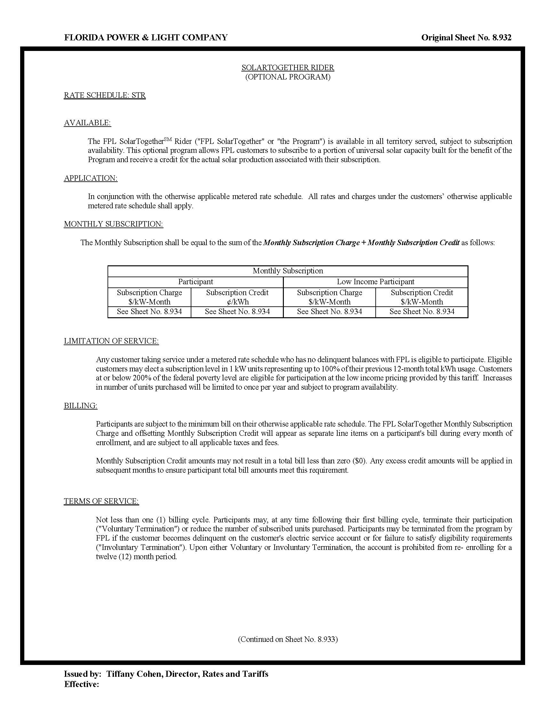

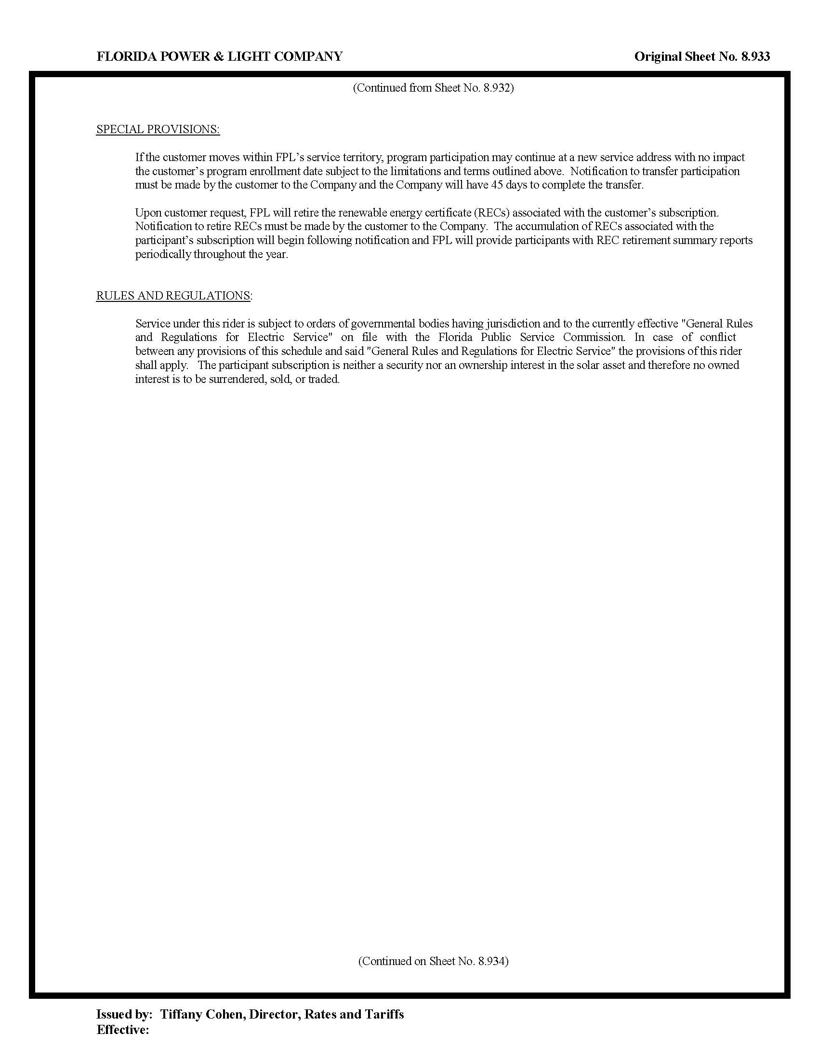

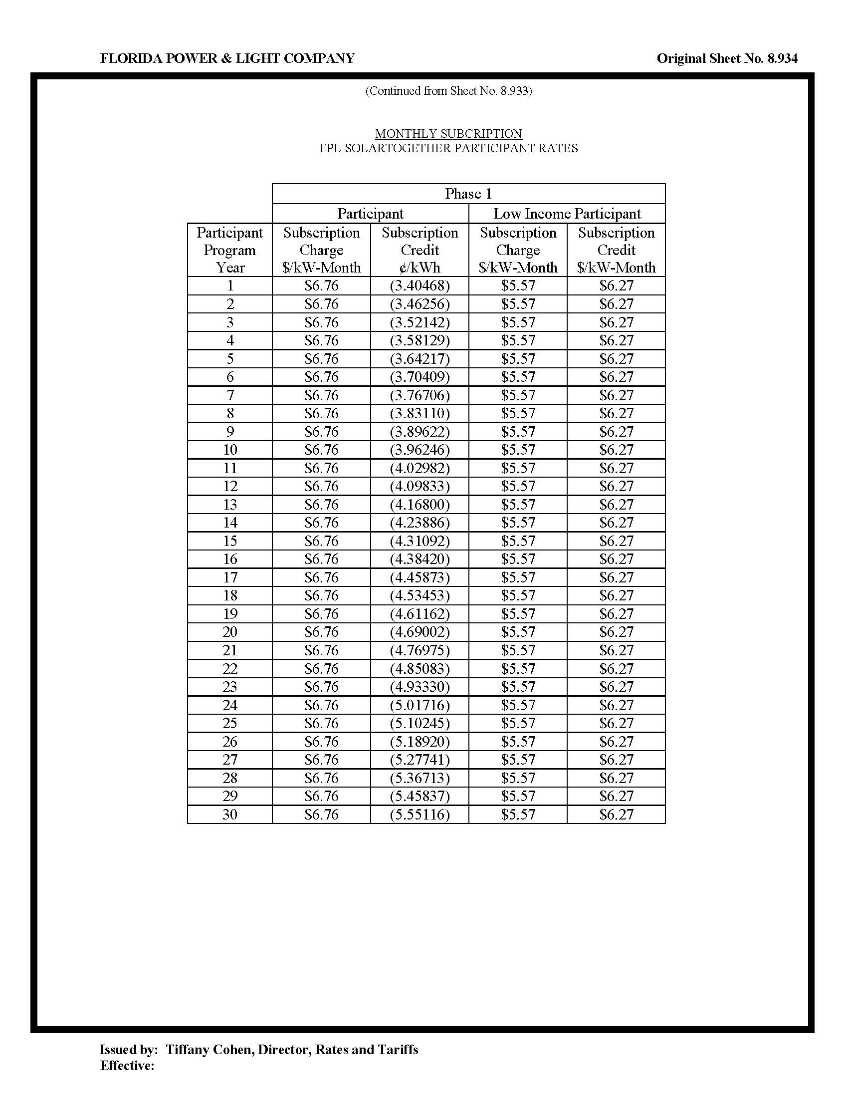

Sierra Club v. Brown, 243 So. 3d 903, 910-913 (Fla. 2018); Order No. PSC-13-0023-S-EI, issued on January 14, 2013, in Docket No. 120015-EI, In re: Petition for increase in rates by Florida Power & Light Company; Order No. PSC-11-0089-S-EI, issued February 1, 2011, in Docket Nos. 080677-EI and 090130-EI, In re: Petition for increase in rates by Florida Power & Light Company and In re: 2009 depreciation and dismantlement study by Florida Power & Light Company; Order No. PSC-10-0398-S-EI, issued June 18, 2010, in Docket Nos. 090079-EI, 090144-EI, 090145-EI, and 100136-EI, In re: Petition for increase in rates by Progress Energy Florida, Inc., In re: Petition for limited proceeding to include Bartow repowering project in base rates, by Progress Energy Florida, Inc., In re: Petition for expedited approval of the deferral of pension expenses, authorization to charge storm hardening expenses to the storm damage reserve, and variance from or waiver of Rule 25-6.0143(1)(c), (d), and (f), F.A.C., by Progress Energy Florida, Inc., and In re: Petition for approval of an accounting order to record a depreciation expense credit, by Progress Energy Florida, Inc.; Order No. PSC-05-0945-S-EI, issued September 28, 2005, in Docket No. 050078-EI, In re: Petition for rate increase by Progress Energy Florida, Inc.
Order No. PSC-13-0023-S-EI, at p. 7.

