BEFORE THE FLORIDA PUBLIC SERVICE COMMISSION

In re: Petition for approval of a permanent optional LED streetlight tariff, by Florida Power & Light Company. | DOCKET NO. 20190223-EI  ORDER NO. PSC-2020-0085-TRF-EI  ISSUED: March 23, 2020

The following Commissioners participated in the disposition of this matter:

GARY F. CLARK, Chairman
ART GRAHAM
JULIE I. BROWN
DONALD J. POLMANN
ANDREW GILES FAY

ORDER APPROVING FLORIDA POWER & LIGHT COMPANY’S LIGHT EMITTING
DIODE (LED) STREETLIGHT TARIFF AND LED STREETLIGHT AGREEMENT

BY THE COMMISSION:
BACKGROUND

On December 30, 2019, Florida Power & Light Company (FPL) filed a petition seeking approval of a permanent Light Emitting Diode (LED) Streetlight Tariff (LT-1) and accompanying LED Streetlight Agreement (LT-1 Agreement) (jointly, LED tariff). The optional LED tariff is available for lighting private or public streets, roadways, parking lots, homeowners associations’ common areas, and parks.

In March 2017, we approved the LED tariff as a three-year pilot program and directed FPL to file a petition by end of December 2019 to modify, terminate, or make permanent the pilot LED tariff and accompanying LT-1 Agreement. Accordingly, FPL submitted the instant petition requesting the pilot program, with certain revisions, be made permanent. The proposed revisions to the LED tariff provide additional LED fixture options, and revised maintenance and conversion recovery charges based on updated costs. All other aspects of the pilot program remain unchanged. On February 11, 2020, FPL filed revised tariff sheets to correct minor errors. The revised LED tariff sheets are included in Attachment A to this order. This petition, as was the pilot program, is consistent with FPL’s 2016 rate case settlement which permits the filing of optional tariffs.

In 2013, FPL began offering FPL-owned LED lighting under its Premium Lighting (PL-1) tariff. The PL-1 tariff was first approved in 1998 and is available to any customer wishing to have lighting installations in streets, parking lots, or homeowners association common areas. Pursuant to the PL-1 tariff, customers are required to pay a lump sum in advance for the construction of LED lighting facilities. By 2016, FPL had 653,165 High Pressure Sodium vapor (HPSV) street light fixtures in service. Due to the upfront payment requirement and conversion costs from HPSV to LED lighting, only 1,691 LED fixtures were installed as of June 2016.

The current pilot LED tariff was designed to offer customers additional lighting options and allow customers to convert from HPSV to LED lighting by paying for those costs through a monthly charge instead of paying an upfront cost. The LED pilot tariffs became effective on March 7, 2017 and the 3-year pilot terminates on March 6, 2020. Customers taking service under the LED tariff are required to sign the LT-1 Agreement for an initial term of 10 years. During the review of this petition, a data request to FPL was issued to which responses were received on January 29, 2020. We have jurisdiction over this matter pursuant to Sections 366.03, 366.04, 366.05, and 366.06, Florida Statutes (F.S.).

DECISION

In the instant petition, FPL proposes four revisions to the current LED tariffs: 1) remove the word pilot, 2) provide additional LED fixture options, 3) revise the maintenance charges, and 4) revise the LED conversion recovery charge. The only proposed changes to the LT-1 Agreement tariff sheets are a change to the tariff manager’s name.
FPL explained that the number of installed LED fixtures increased from 1,691 as of June 2016 to 195,000 as of October 2019. FPL further stated that there is customer demand for additional and more expensive styles of fixtures and that it has approximately 735 customers such as homeowner associations, commercial entities, and city and county governments who have expressed interest in new LED fixtures or conversions to LED lighting.
Monthly LED Tariff Charges
As with the current pilot LED tariff, the proposed LED tariff charges are comprised of three components: a fixture charge, an energy charge, and a maintenance charge, consistent with other lighting tariffs electric utilities offer. In addition, the LED tariff includes an LED conversion charge for customers who choose to convert existing non-LED fixtures to LED fixtures. The revised charges are discussed below. All other Commission-approved street lighting cost recovery factors such as fuel or storm recovery charges will also apply.
Additional Fixture Options
The available LED fixtures are shown in a catalog on FPL’s website as it allows FPL to update the catalog as needed to offer customers the latest LED fixtures. Each fixture shown in the catalog is assigned the appropriate fixture and energy tier. A sample page of the catalog is shown in Exhibit E to the petition.
The matrix (titled Monthly Rates for LED Fixtures), included in Tariff Sheet No. 8.736 (see Attachment A, page 3 of 10), shows the fixture and energy charges applicable to each fixture. Fixtures vary by style, watts, lumens, and other factors. FPL explained that customers have been requesting more expensive fixtures and/or higher wattage fixtures than currently available. FPL, therefore, proposed to include additional fixture and energy tiers in the matrix to accommodate the demand for additional fixture options.
With the additional fixture options, the expanded matrix will show a total of 15 fixture tiers and 31 energy tiers. The 15 fixture tiers are shown on the X axis and each tier represents the monthly fixture charge for LED fixtures whose installed costs fall within the range covered by that tier. Each tier increases by $3. The individual fixture cost is based on the estimated cost to install plus the carrying costs associated with the initial capital investment (cost of capital, depreciation, property tax, and insurance cost). This all-in cost is annualized using the asset life, and then divided by 12 to arrive at the monthly fixture cost. The monthly cost is then assigned to the appropriate fixture tier on the LED matrix. FPL provided the calculation of a monthly fixture cost in response to Staff’s First Data Request No. 9. We find that the monthly fixture cost calculation methodology used by FPL is reasonable.
The 31 energy tiers are shown on the Y axis and each tier represents the monthly energy charge for fixtures whose energy usage falls within specified wattage ranges. Each energy tier increases by $0.20. FPL provided the calculation of a monthly energy charge in response to Staff’s First Data Request No. 11. We find that the monthly energy charge calculation methodology used by FPL is reasonable.
Maintenance Charges
FPL reduced the maintenance charge from $1.82 to $1.29 per fixture for fixtures on FPL-owned poles and from $1.27 to $1.03 per fixture for fixtures on customer-owned poles. The proposed maintenance charges are based on FPL system-wide maintenance costs for LED fixtures. FPL explained that the calculation of the current maintenance charge was based on mostly HPSV fixtures, as in 2016 the majority of FPL’s lighting infrastructure was comprised of HPSV fixtures. However, with the increase in LED fixtures in recent years, FPL stated that it now has more maintenance data specific to LED fixtures. The data show that the maintenance costs for LED fixtures are lower than for HPSV fixtures, resulting in the proposed lower maintenance charges.
The maintenance charge for fixtures on customer-owned poles ($1.03) is set at 80 percent of the maintenance charge for fixtures on FPL-owned poles ($1.29). FPL explained that approximately 20 percent of the maintenance expense is related to pole or conductor repair. We find that the monthly maintenance charge calculation methodology used by FPL is reasonable.
The maintenance charge is designed to recover the costs associated with maintaining the LED street light system and includes costs such as repairing poles, conductors, cable, replacing photocells, or replacing connectors. FPL proposes to continue to utilize a method of allocating maintenance charges which relies upon a flat fee per fixture rather than varying the fee based on the cost of the fixtures.
Conversion Recovery Fee
Customers requesting to convert from HPSV under the SL-1 tariff to LED lights under the LED tariff pay a monthly conversion recovery fee. The conversion recovery fee allows FPL to recover the remaining net book value and removal costs of the HPSV fixtures over a 25-year term. FPL proposes to revise the monthly conversion recovery fee from $1.03 to $1.87 per fixture based on updated cost assumptions and a correction to the calculation.
FPL explained that the quantity of HPSV lights installed has increased since 2016, resulting in a higher net book value per light. The removal cost per light, on the other hand, has reduced as the estimated time to remove a light has decreased. Finally, the cost of capital rate has been updated based on FPL’s current pre-tax cost of capital of 10.36 percent. FPL calculated a levelized payment stream of the net book value plus removal cost multiplied by the cost of capital rate, over the 25-year term of recovery. FPL further explained that its current cost recovery fee calculation included a formula error, resulting in an understated conversion recovery fee. We find that the monthly conversion recovery fee calculation methodology used by FPL is reasonable and that the proposed increase in the conversion recovery fee will be partially offset by the reduction in the proposed maintenance charges.
As a result of the pilot program’s popularity, FPL is proposing to make the LED tariff and accompanying LT-1 Agreement permanent. This optional LED tariff will provide more LED lighting options to customers. Based on our review of FPL’s petition and responses to data requests, we hereby approve as a permanent tariff FPL’s LED tariff as shown in Attachment A to this order. The LED tariff and associated agreement shall become effective as of our vote on March 3, 2020.
Based on the foregoing, it is
ORDERED by the Florida Public Service Commission that Florida Power & Light Company’s Light Emitting Diode Streetlight Tariff and accompanying Light Emitting Diode Streetlight Agreement, as stated on Attachment A, are hereby approved as a permanent tariff. It is further
ORDERED that the effective date of Florida Power & Light Company’s Light Emitting Diode Streetlight Tariff and Streetlight Agreement shall be March 3, 2020. It is further
ORDERED that if no timely protest is filed, within 21 days of the issuance of this order, the tariffs shall remain in effect pending resolution of the protest. If no timely protest is filed, this docket shall be closed upon the issuance of a consummating order.

By ORDER of the Florida Public Service Commission this 23rd day of March, 2020.

/s/ Adam J. Teitzman
ADAM J. TEITZMAN
Commission Clerk
Florida Public Service Commission
2540 Shumard Oak Boulevard
Tallahassee, Florida 32399
(850) 413-6770
www.floridapsc.com

Copies furnished: A copy of this document is provided to the parties of record at the time of issuance and, if applicable, interested persons.
SBr

NOTICE OF FURTHER PROCEEDINGS

The Florida Public Service Commission is required by Section 120.569(1), Florida Statutes, to notify parties of any administrative hearing or judicial review of Commission orders that is available under Sections 120.57 or 120.68, Florida Statutes, as well as the procedures and time limits that apply. This notice should not be construed to mean all requests for an administrative hearing or judicial review will be granted or result in the relief sought.

Mediation may be available on a case-by-case basis. If mediation is conducted, it does not affect a substantially interested person's right to a hearing.

The Commission's decision on this tariff is interim in nature and will become final, unless a person whose substantial interests are affected by the proposed action files a petition for a formal proceeding, in the form provided by Rule 28-106.201, Florida Administrative Code. This petition must be received by the Office of Commission Clerk, 2540 Shumard Oak Boulevard, Tallahassee, Florida 32399-0850, by the close of business on April 13, 2020.

In the absence of such a petition, this Order shall become final and effective upon the issuance of a Consummating Order.

Any objection or protest filed in this docket before the issuance date of this order is considered abandoned unless it satisfies the foregoing conditions and is renewed within the specified protest period.

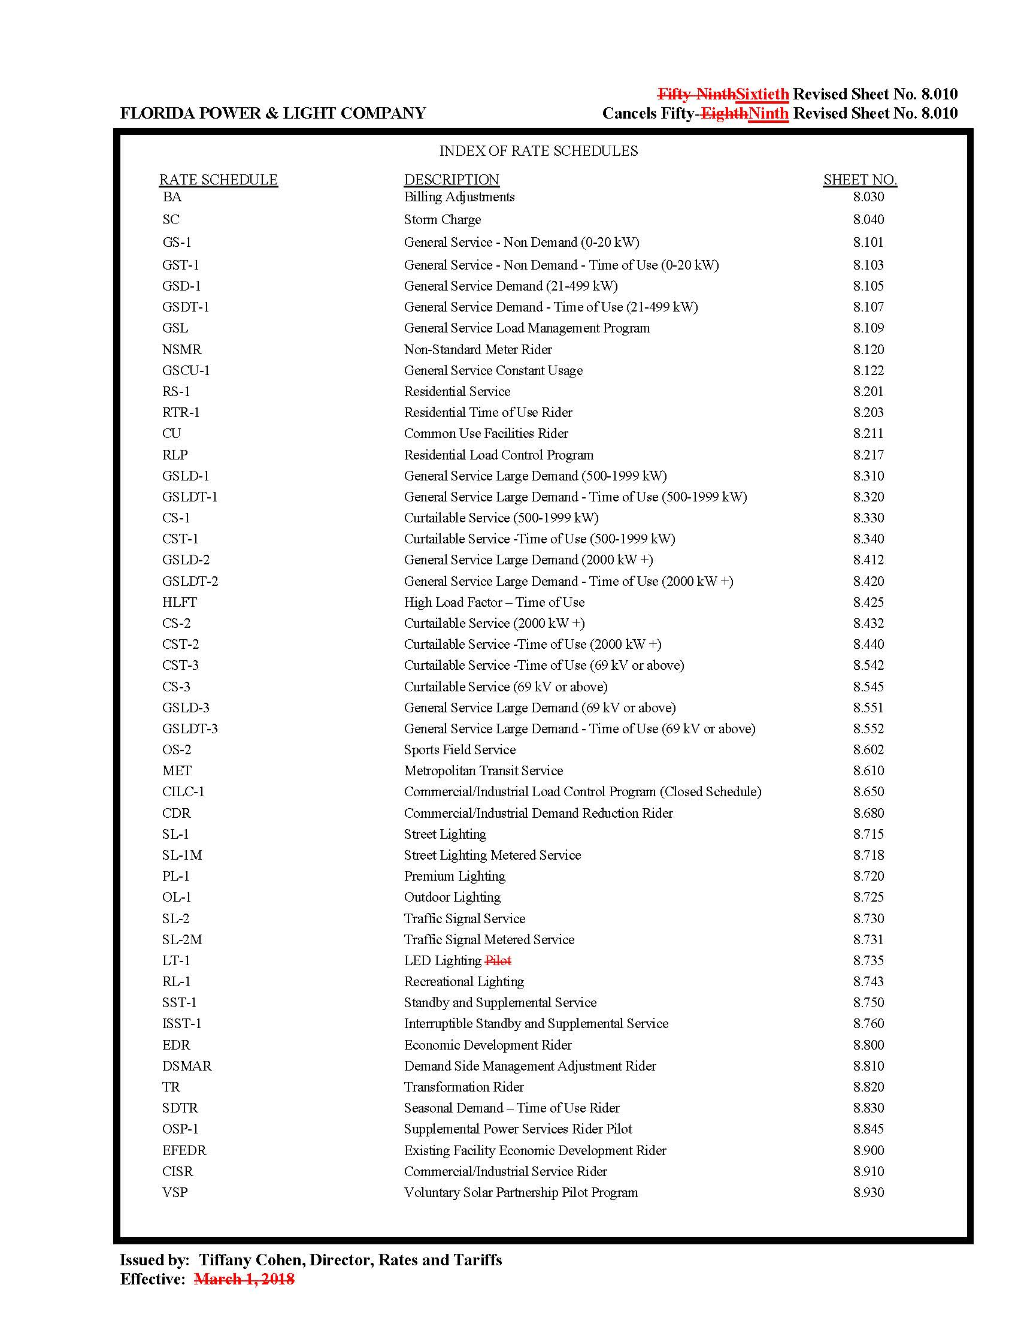

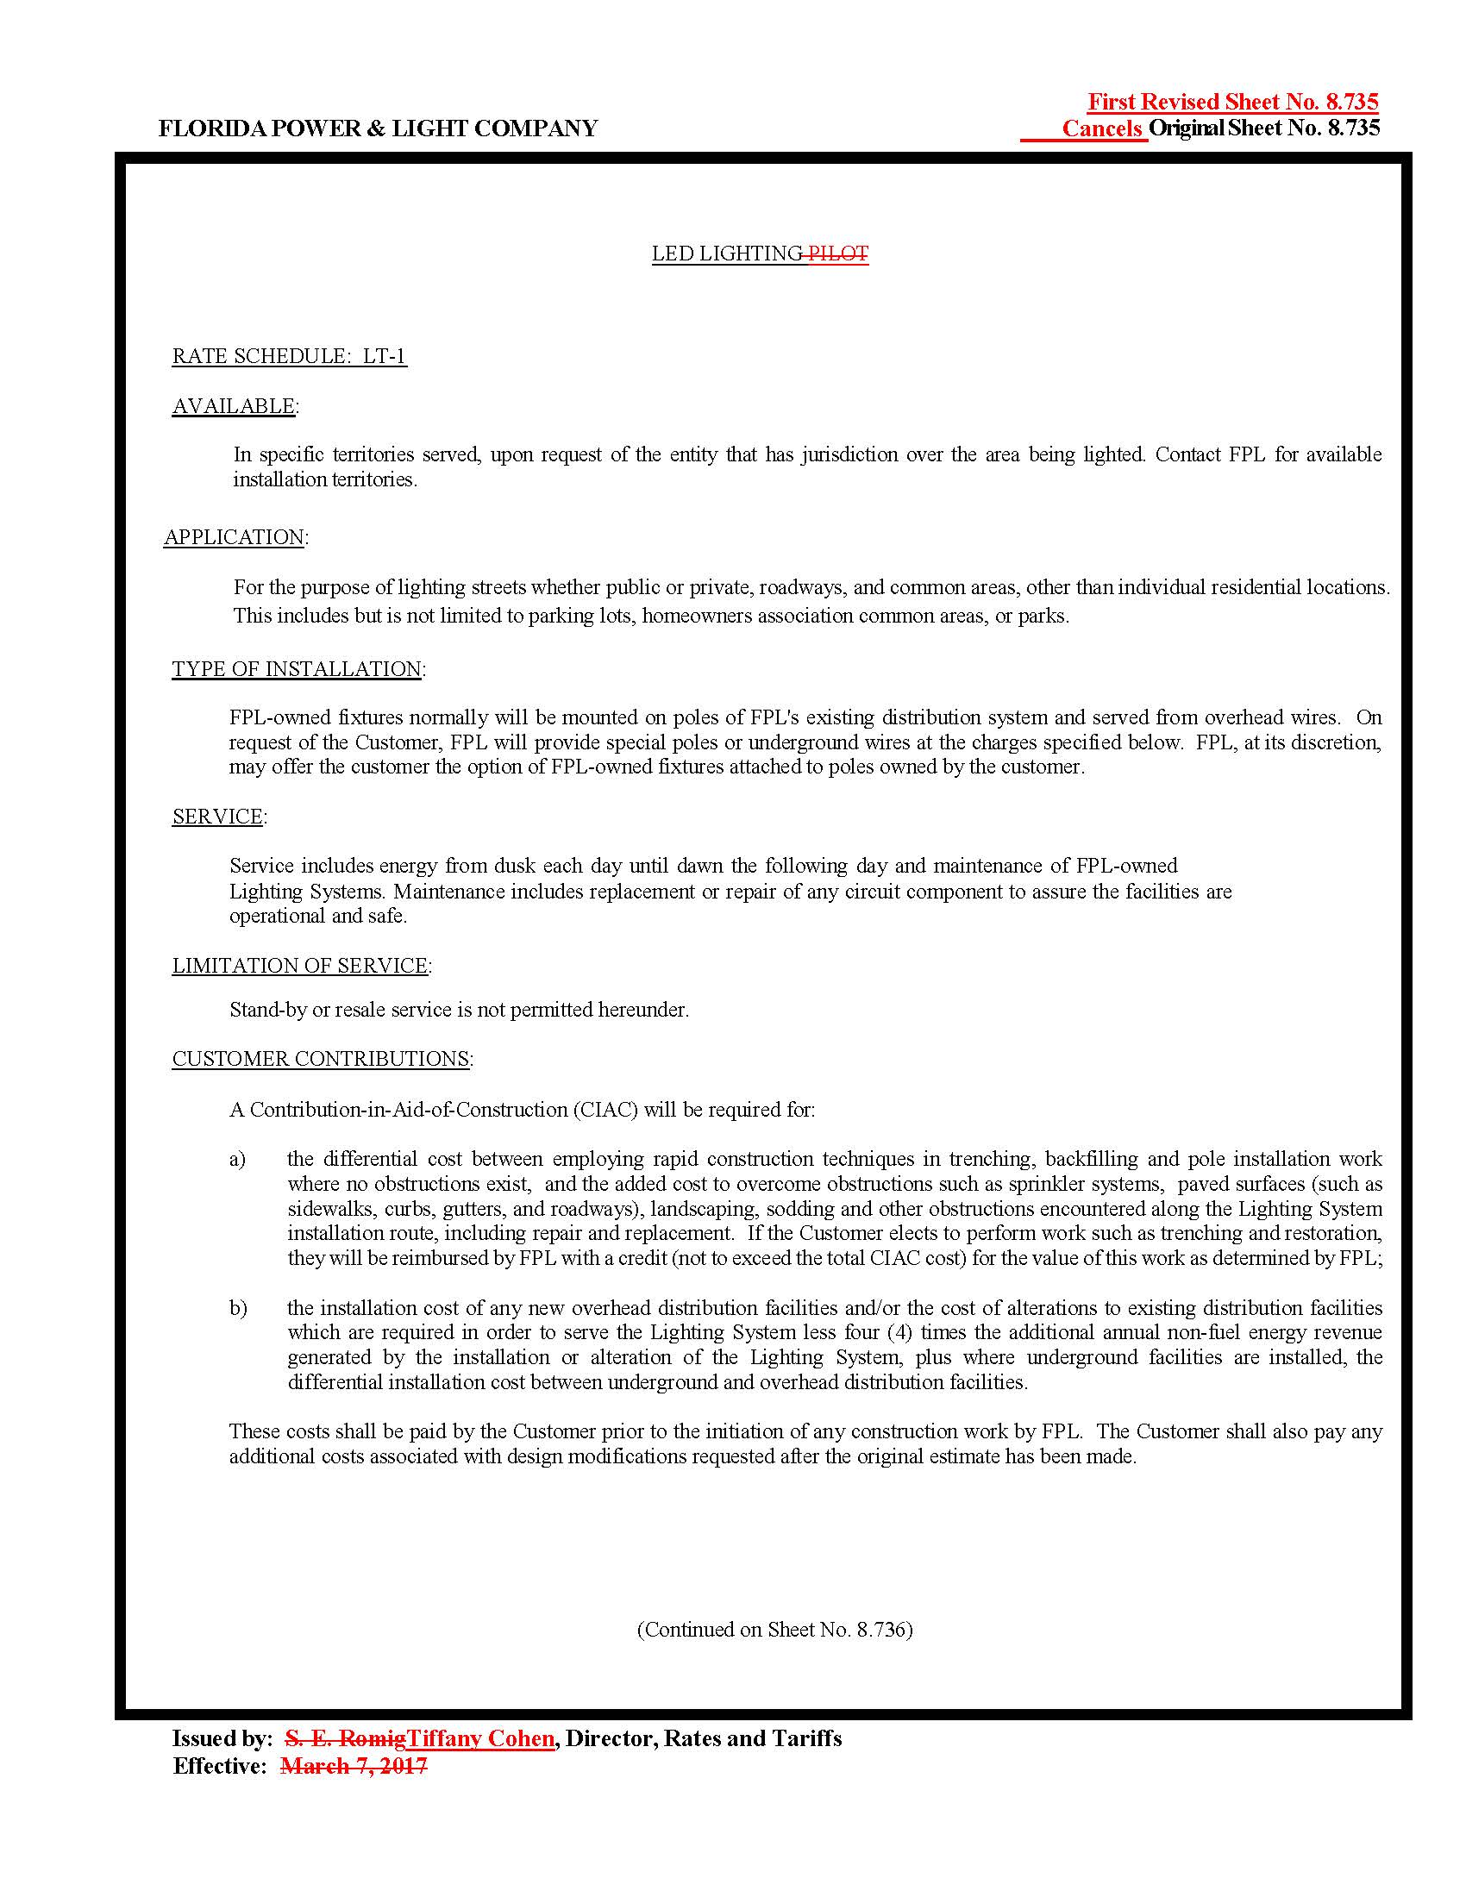

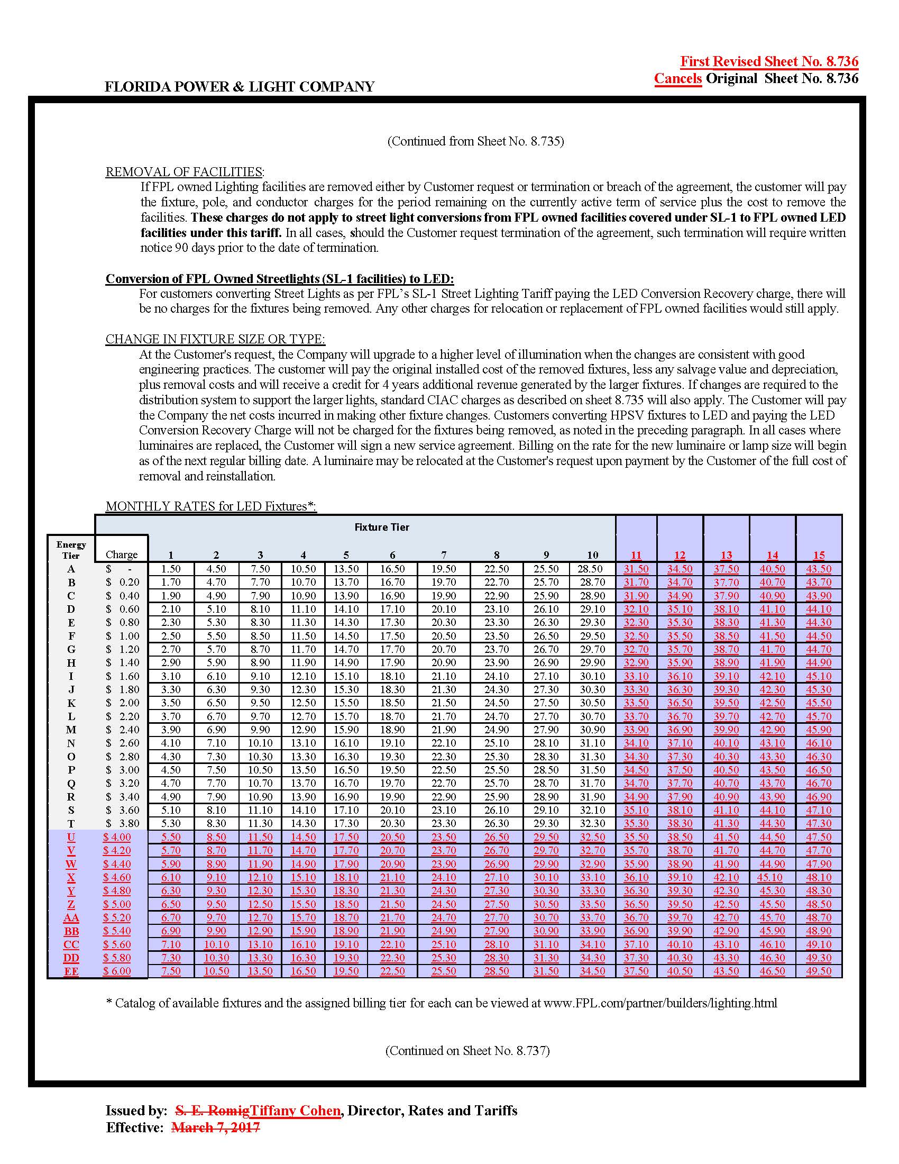

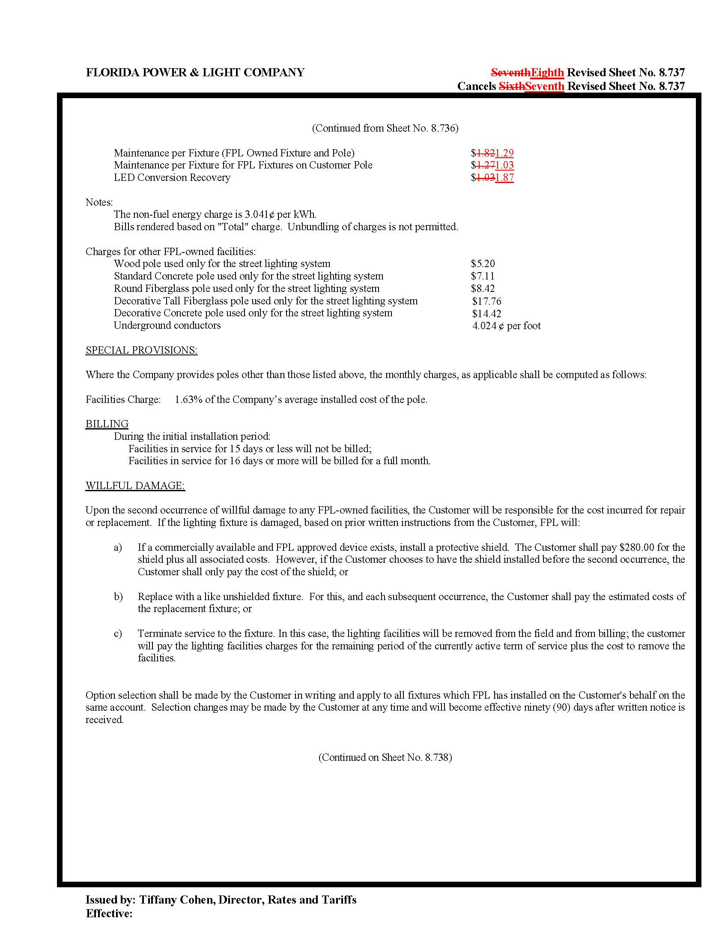

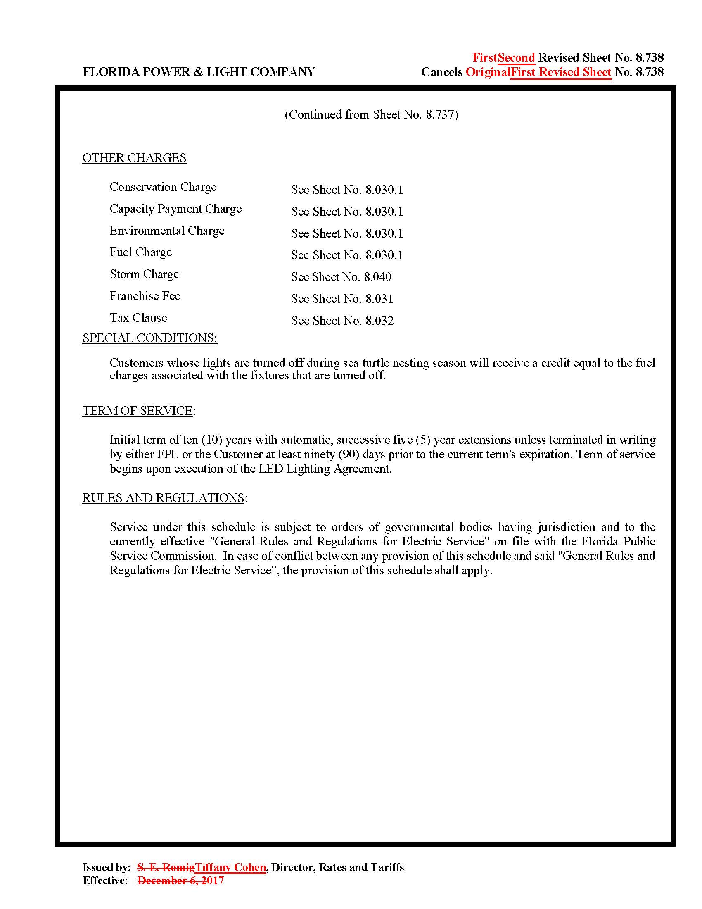

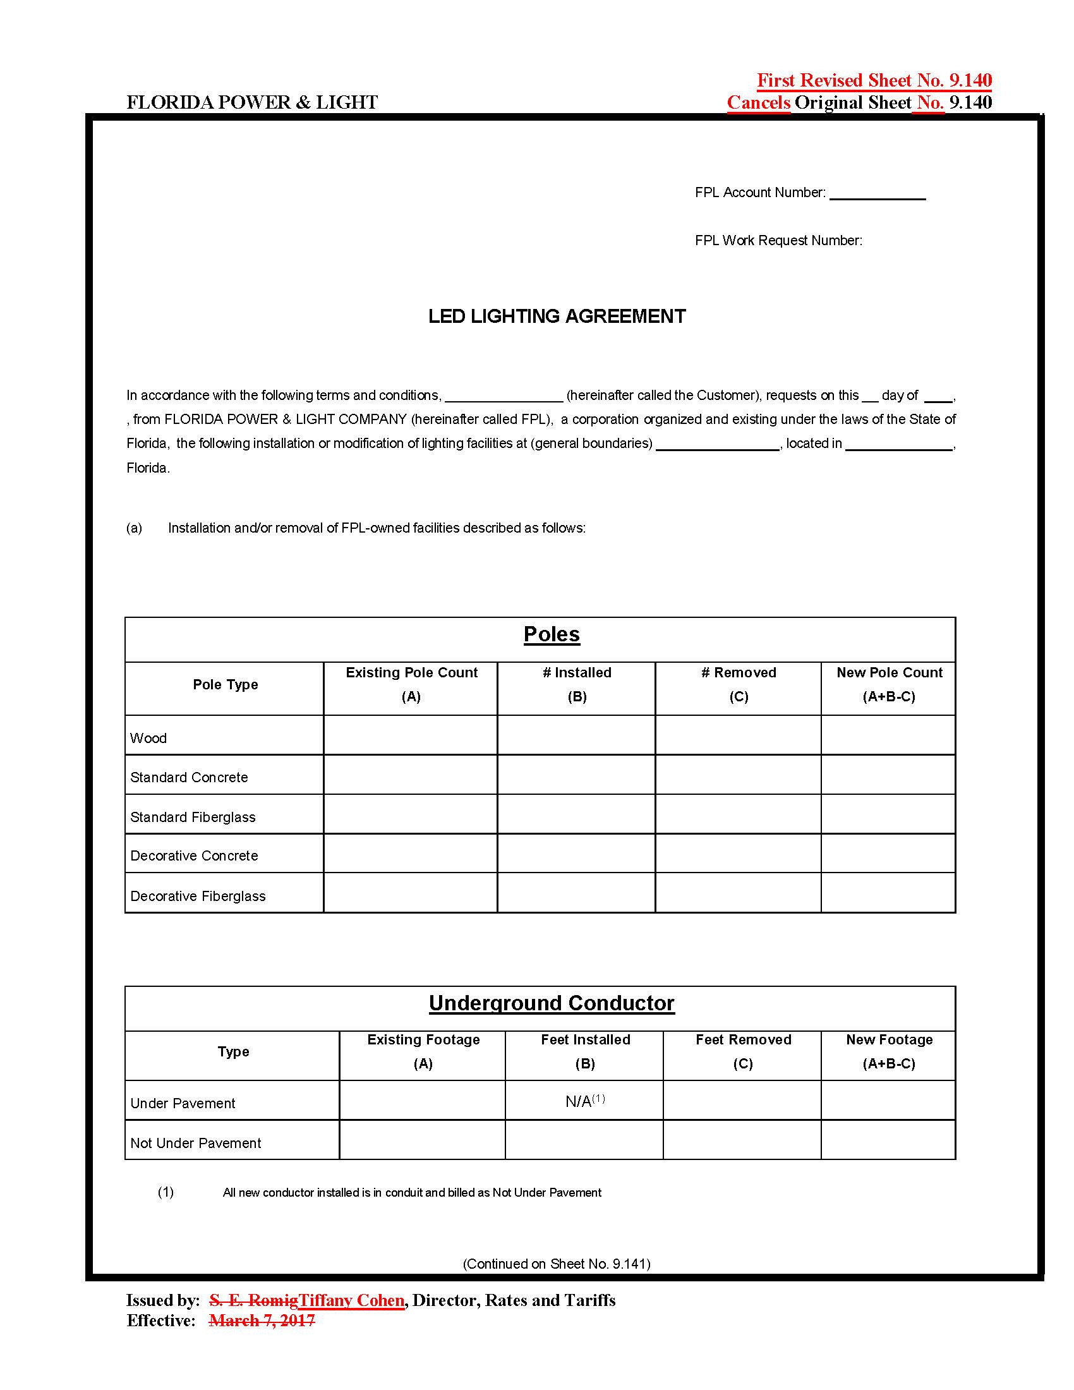

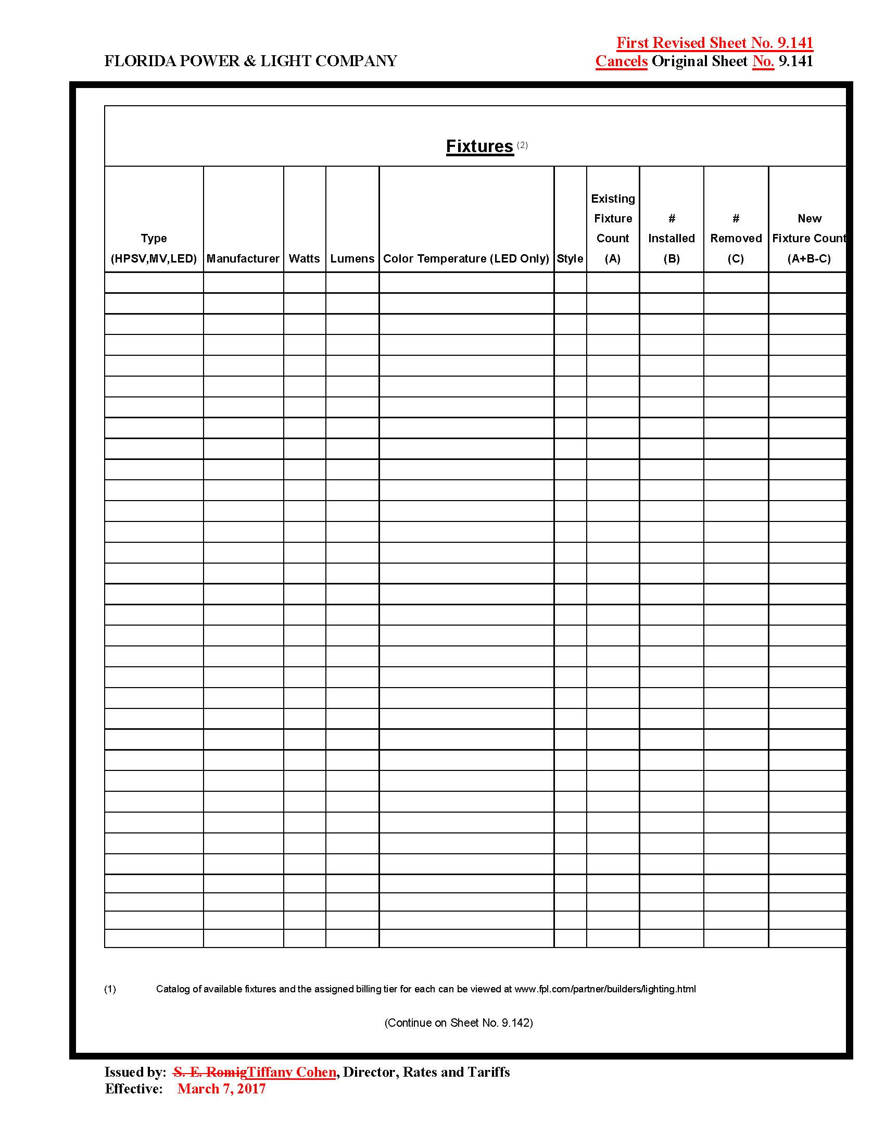

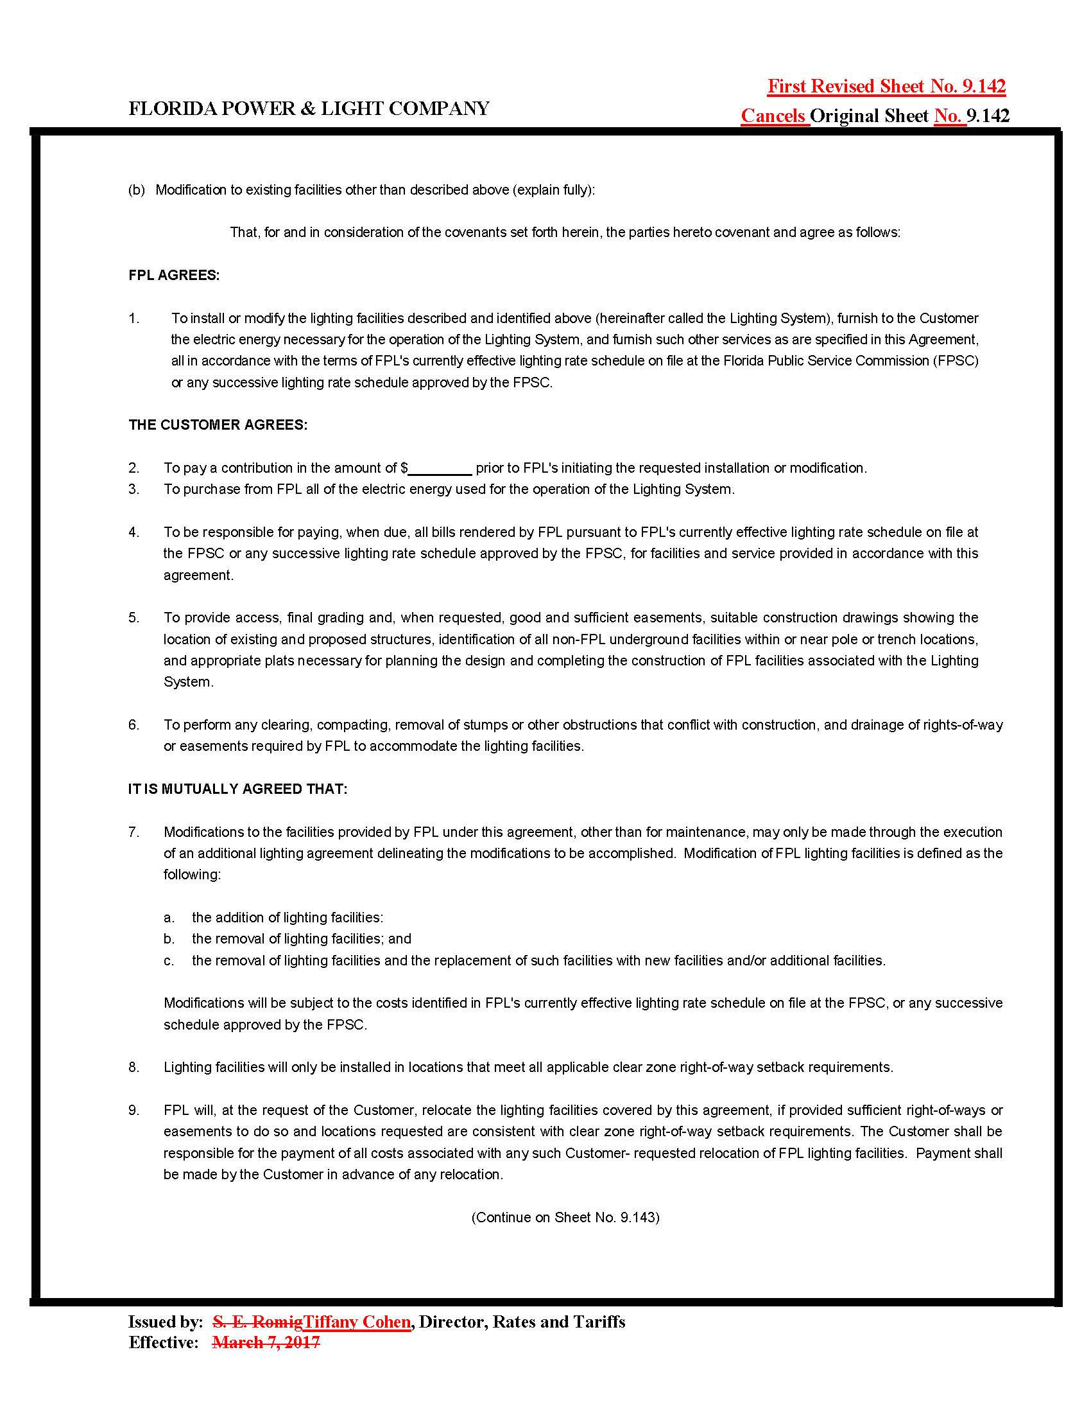

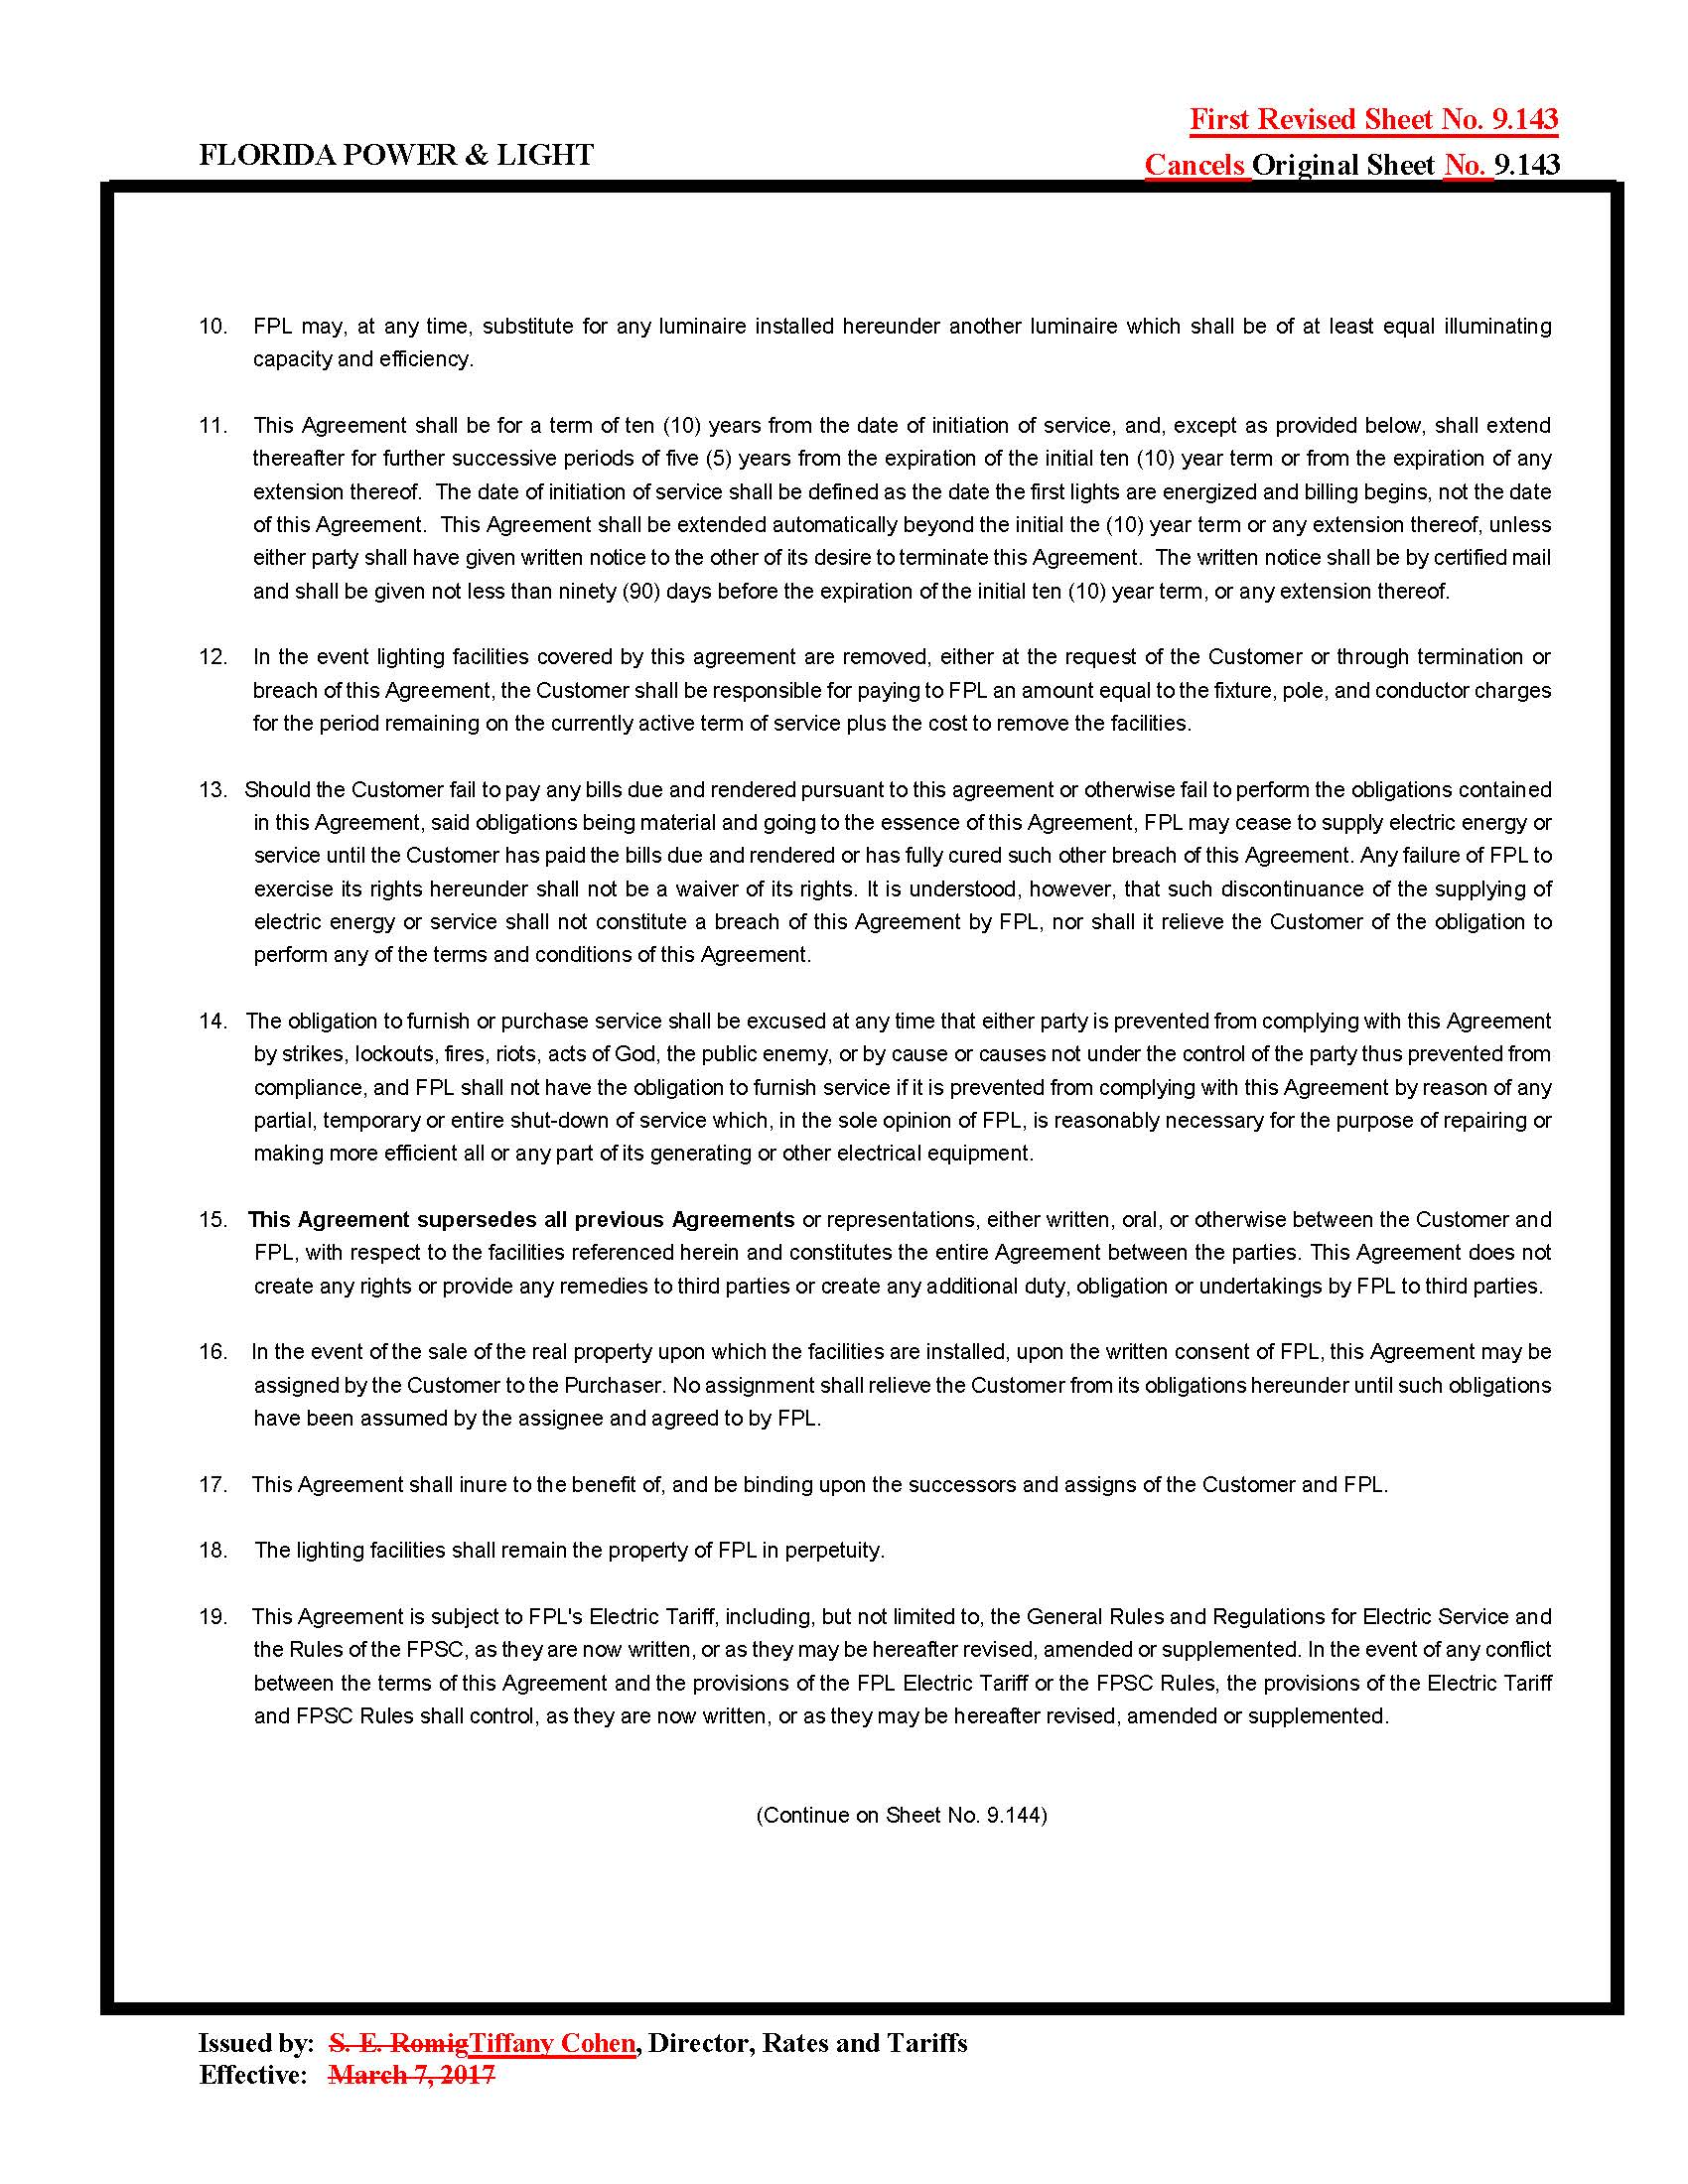

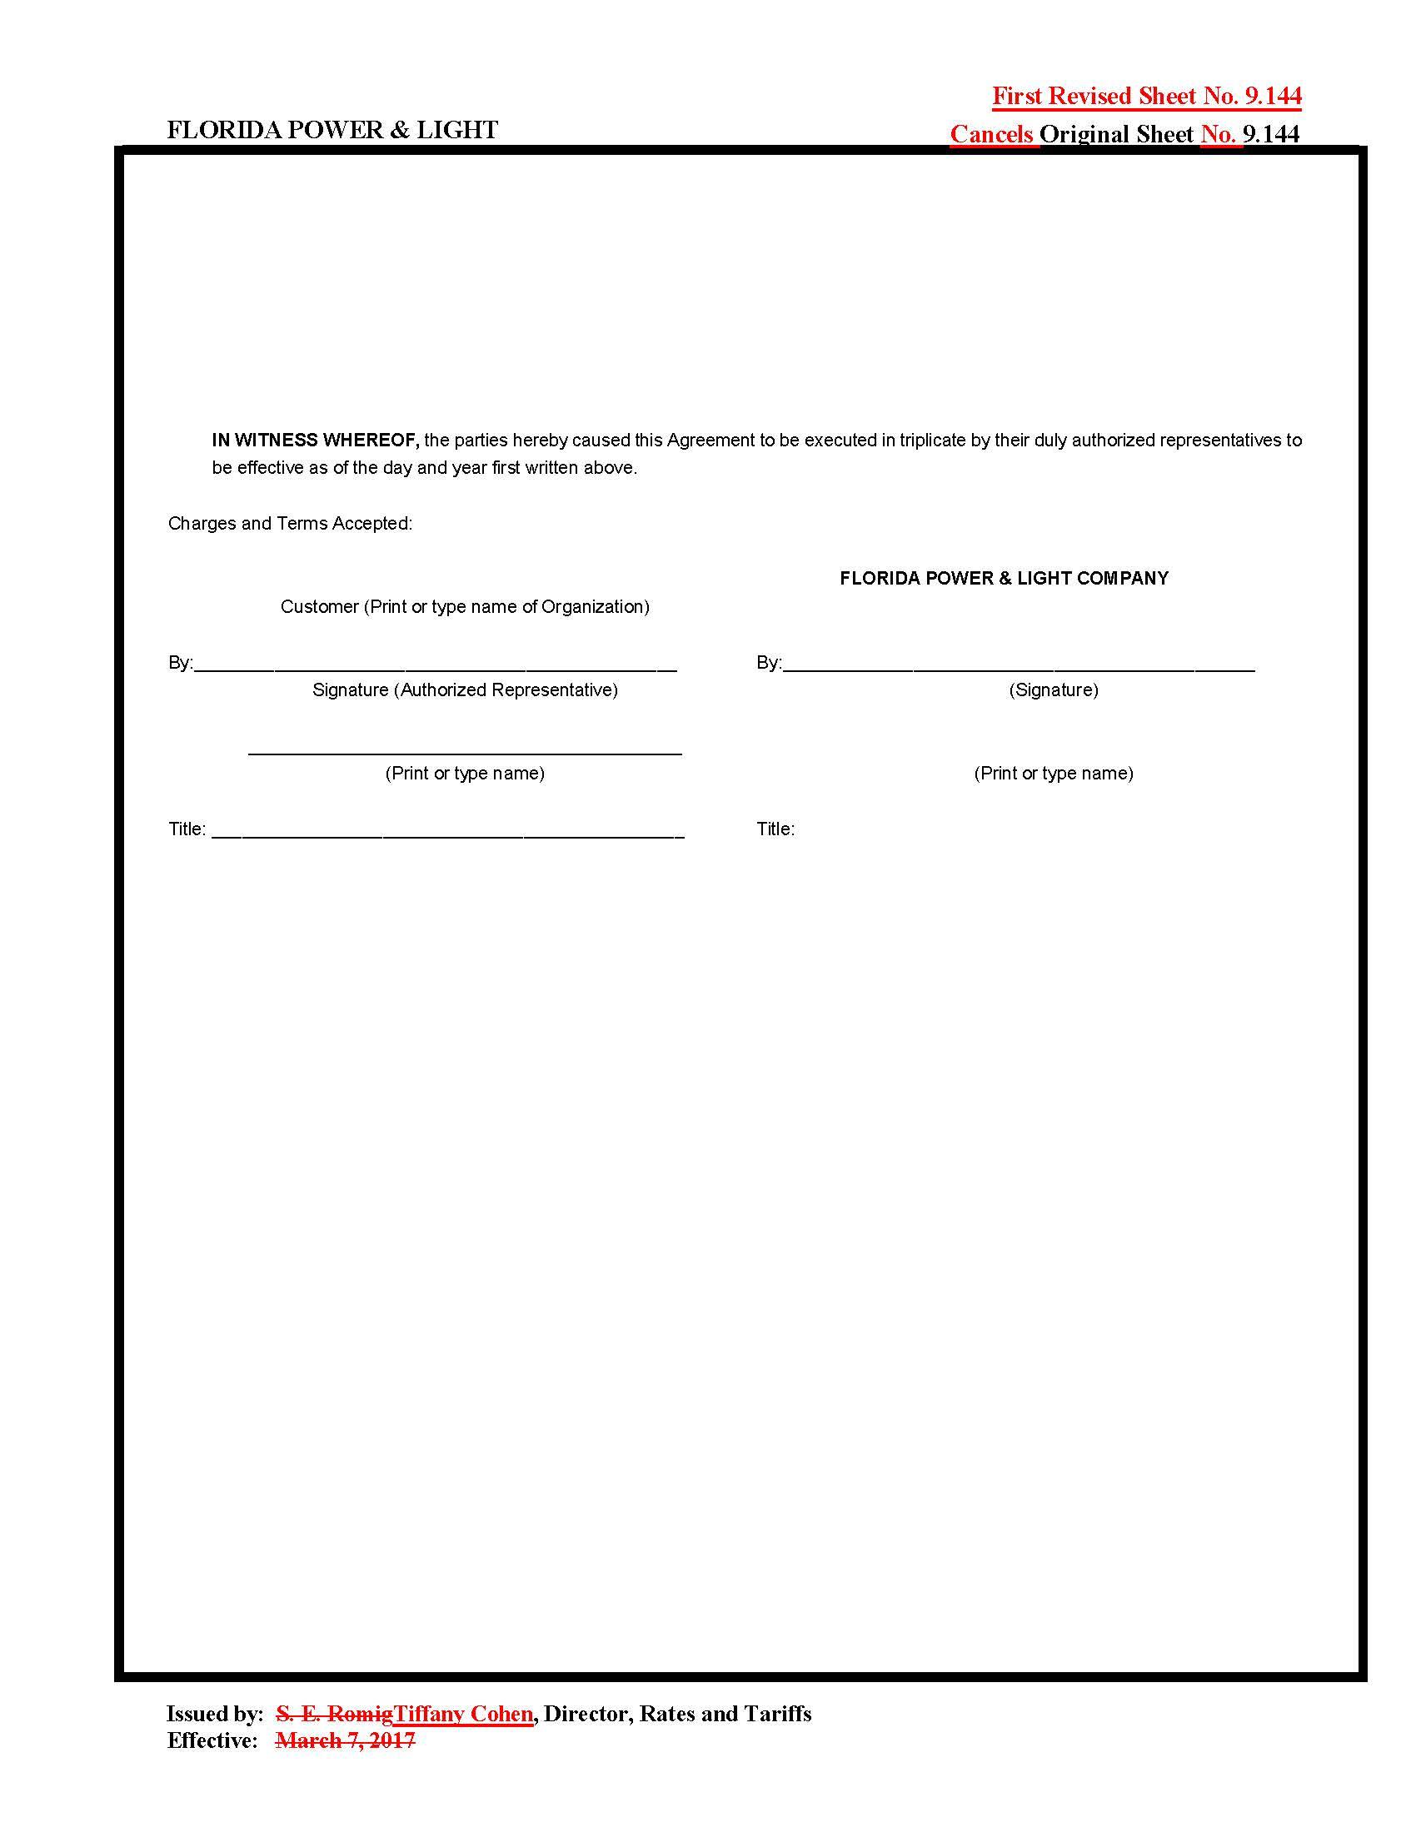

Order No. PSC-17-0115-TRF-EI, issued on March 28, 2017, in Docket No. 20160245-EI, In re: Petition for approval of a new optional pilot LED streetlight tariff, by Florida Power & Light Company.
Order No. PSC-16-0560-AS-EI, issued on December 15, 2016, in Docket No. 20160021-EI, In re: Petition for rate increase by Florida Power & Light Company.
Order No. PSC-98-0260-FOF-EI, issued on February 9, 1998, in Docket No. 971256-EI, In re: Petition for approval of premium lighting and recreational lighting service rates schedules and agreements by Florida Power & Light Company.
www.fpl.com/LED

