BEFORE THE FLORIDA PUBLIC SERVICE COMMISSION

In re: Petition for approval of emergency modification to Duke Energy's rate schedule SC-1, tariff sheet 6.110 by Duke Energy Florida, LLC. | DOCKET NO. 20200095-EI  ORDER NO. PSC-2020-0096-TRF-EI  ISSUED: April 6, 2020

The following Commissioners participated in the disposition of this matter:

GARY F. CLARK, Chairman
ART GRAHAM
JULIE I. BROWN
DONALD J. POLMANN
ANDREW GILES FAY

ORDER APPROVING DUKE ENERGY FLORIDA, LLC’S
MODIFICATIONS TO RATE SCHEDULE SC-1 AND TARIFF SHEET 6.110

BY THE COMMISSION:
BACKGROUND

On March 19, 2020, Duke Energy Florida, LLC (DEF or utility) petitioned for approval of an emergency modification to its Service Charge Rate Schedule (Tariff Sheet No. 6.110). This modification is in response to the public health emergency in Florida related to the outbreak of COVID-19 and the related Executive Orders issued by Governor Ron DeSantis. DEF states it has already temporarily suspended disconnecting customers for non-payment and will offer more robust payment arrangements for customers in need. Further, the utility states it will make the necessary adjustments to its plans to continue to serve customers, and that this may require additional requests to this Commission.

The current tariff allows the utility to waive the Establishment of Service charges in situations of natural disasters or other similar conditions for which an emergency has been declared by an authorized governmental body. The March 19, 2020 tariff modification seeks to give DEF the additional discretion to waive late payment charges, returned check charges, and charges for investigating unauthorized use of electricity. Additionally, the tariff modification expands the waiver language to include any period of declared emergencies by an authorized governmental body, not just those involving natural disasters. On March 23, 2020, the utility modified its tariff to exclude the waiver of charges related to the investigation of unauthorized use of electricity.
DEF’s revised tariff sheet is Attachment 1 to this order. We have jurisdiction over this matter pursuant to Sections 366.04, 366.05, 366.06, Florida Statutes.
DECISION

Currently, Tariff Sheet No. 6.110 allows DEF the discretion to waive applicable charges related to establishment of service and reconnection for customers impacted by natural disasters or similar situations where an emergency has been declared by a governing body. This modification would expand the waiver language to encompass late payment charges and returned check charges. Furthermore, the modification expands the waiver language to apply to any emergency declaration by an authorized governmental body. Florida Power & Light Company has a similar provision in its approved tariff regarding miscellaneous service charges.
We find that the modifications will allow DEF further flexibility to mitigate customer impact during the current public health emergency and the related Executive Orders issued by Governor DeSantis, while still reliably serving customers as a whole. Therefore, we approve the proposed modifications to Tariff Sheet No. 6.110, effective March 31, 2020.

Based on the foregoing, it is

ORDERED by the Florida Public Service Commission that Duke Energy Florida, LLC’s Petition for Approval of Emergency Modification to DEF’s Rate Schedule SC-1 and Tariff Sheet 6.110 is hereby granted. It is further

ORDERED that Rate Schedule SC-1 and Tariff Sheet 6.110, contained in Attachment 1 to this order (as modified on March 23, 2020), are hereby approved and shall be effective as of March 31, 2020. It is further

ORDERED that if a timely protest is filed within 21 days of the issuance of this order, the rate schedule and tariff shall remain in effect, with any revenues held subject to refund, pending resolution of the protest. If no timely protest is filed, this docket shall be closed upon the issuance of a consummating order.

By ORDER of the Florida Public Service Commission this 6th day of April, 2020.

/s/ Adam J. Teitzman
ADAM J. TEITZMAN
Commission Clerk
Florida Public Service Commission
2540 Shumard Oak Boulevard
Tallahassee, Florida 32399
(850) 413-6770
www.floridapsc.com

Copies furnished: A copy of this document is provided to the parties of record at the time of issuance and, if applicable, interested persons.

SBr

NOTICE OF FURTHER PROCEEDINGS

The Florida Public Service Commission is required by Section 120.569(1), Florida Statutes, to notify parties of any administrative hearing or judicial review of Commission orders that is available under Sections 120.57 or 120.68, Florida Statutes, as well as the procedures and time limits that apply. This notice should not be construed to mean all requests for an administrative hearing or judicial review will be granted or result in the relief sought.

Mediation may be available on a case-by-case basis. If mediation is conducted, it does not affect a substantially interested person's right to a hearing.

The Commission's decision on this tariff is interim in nature and will become final, unless a person whose substantial interests are affected by the proposed action files a petition for a formal proceeding, in the form provided by Rule 28-106.201, Florida Administrative Code. This petition must be received by the Office of Commission Clerk, 2540 Shumard Oak Boulevard, Tallahassee, Florida 32399-0850, by the close of business on April 27, 2020.

In the absence of such a petition, this Order shall become final and effective upon the issuance of a Consummating Order.

Any objection or protest filed in this docket before the issuance date of this order is considered abandoned unless it satisfies the foregoing conditions and is renewed within the specified protest period.

ATTACHMENT 1
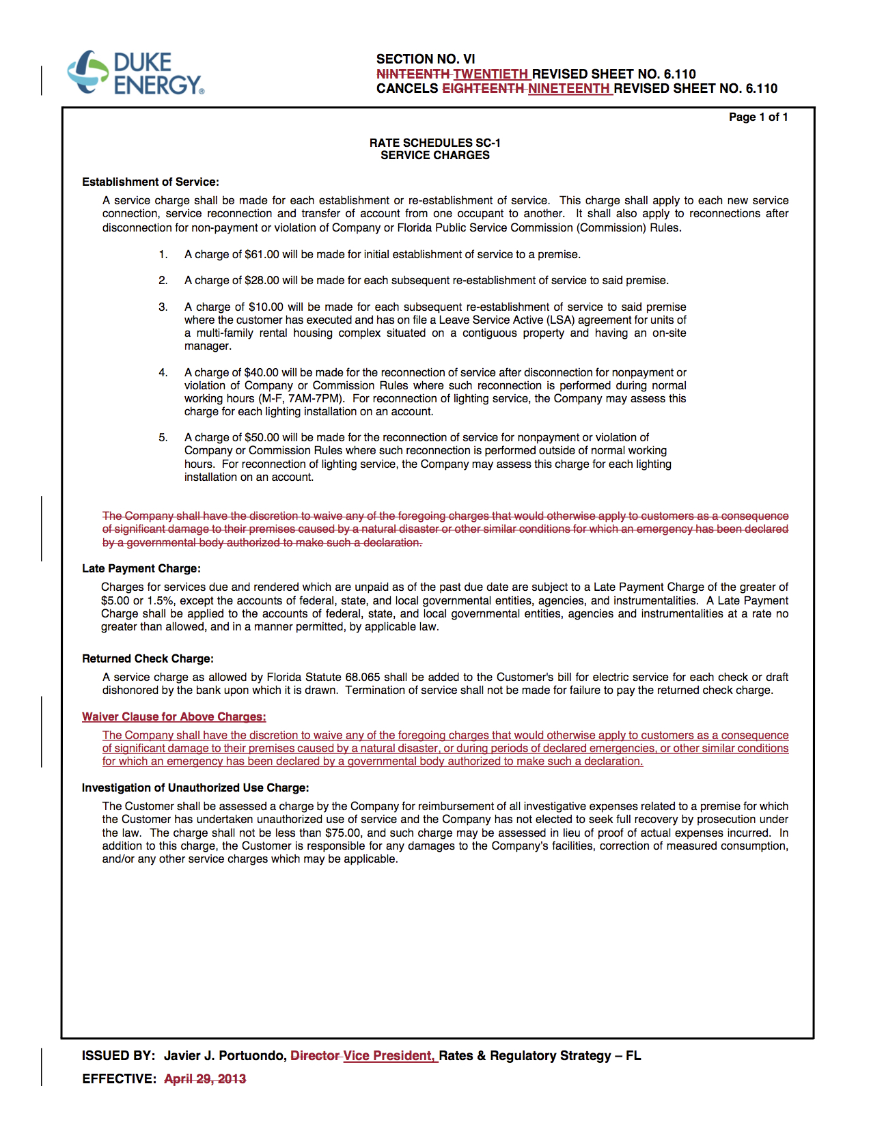

Rule 25-6.105(5), Florida Administrative Code, states “As applicable, each utility may refuse or discontinue service under the following conditions. . .(g) For non-payment of bills or non-compliance with the utility’s rules and regulations. . .”
Florida Power & Light Company Fourteenth Revised Sheet No. 4.020 approved by Order No. PSC-92-0912A-FOF-EI, issued September 16, 1992, in Docket No. 920800-EI, In re: Petition by Florida Power & Light Company to Waive Certain Service Charges For Good-Paying Customers.

