State of Florida |  | Public Service Commission  Capital Circle Office Center ● 2540 Shumard Oak Boulevard  Tallahassee, Florida 32399-0850  -M-E-M-O-R-A-N-D-U-M-
DATE: | April 23, 2020
TO: | Office of Commission Clerk (Teitzman)
FROM: | Division of Economics (Coston)  Office of the General Counsel (Crawford)
RE: | Docket No. 20200120-GU – Petition for approval of emergency modification to tariff, by Sebring Gas System, Inc.
AGENDA: | 05/05/20 – Regular Agenda – Tariff Filing – Interested Persons May Participate
COMMISSIONERS ASSIGNED: |  |  | All Commissioners
PREHEARING OFFICER: |  |  | Administrative
CRITICAL DATES: |  |  | 06/08/20 (60-Day Suspension Date)
SPECIAL INSTRUCTIONS: |  |  | None

Case Background
On April 9, 2020, Sebring Gas Systems, Inc. (Sebring or utility) petitioned for approval of an emergency modification to its tariff sheet No. 48 which addresses delinquent bills and late payment charges. On March 1, 2020, Governor Ron DeSantis declared a public health emergency in Florida as a result of the outbreak of the COVID-19 coronavirus and on March 9, 2020, the Governor declared a state of emergency and implemented the state’s Emergency Management Plan. In addition, the Governor has issued additional Executive Orders to address the current emergency to include a statewide “Safer at Home” requirement. As a result of this emergency, the utility recognizes the economic impact to some residential and commercial customers. Many businesses are struggling financially and have instituted lay-offs or limited their employees’ hours.
Sebring states that during this public emergency, it does not plan to disconnect service to customers for non-payment, as allowed under its current tariff. However, Sebring’s current tariff does not provide the utility the ability to suspend late payment charges during this, or similar, emergency declarations. The proposed tariff modification would allow the utility flexibility to waive late payment charges during emergency situations, such as natural disasters and the current public health emergency.
Sebring’s revised tariff sheet is Attachment 1 to this recommendation. The Commission has jurisdiction over this matter pursuant to Sections 366.04, 366.05, 366.06, Florida Statutes.

Discussion of Issues
Issue 1: Should the Commission approve Sebring’s proposed modifications to Tariff Sheet No. 48?
Recommendation: Yes, the Commission should approve the modifications to Tariff Sheet No. 48, effective May 5, 2020. (Coston)
Staff Analysis: Currently, Sebring’s tariff does not provide the utility the ability to waive late payment charges for any reason. This proposed modification would provide the utility with the flexibility to waive late fees during natural disasters and declared public emergencies issued by an authorized governmental body, including the current public health emergency. The language in this modification is similar to tariff language approved by the Commission for Florida Power & Light Company and Duke Energy Florida, LLC.
Staff believes the modifications will allow Sebring the flexibility to mitigate customer impact during the current public health emergency and the related Executive Orders issued by Governor DeSantis while still reliably serving its customers. Therefore, staff recommends the Commission should approve the modifications to Tariff Sheet No. 48, effective May 5, 2020.

Issue 2:
Should this docket be closed?

Recommendation:
If Issue 1 is approved and a protest is filed within 21 days of the issuance of the order, the tariff should remain in effect, with any revenues held subject to refund, pending resolution of the protest. If no timely protest is filed, this docket should be closed upon the issuance of a consummating order. (Crawford)

Staff Analysis:
If Issue 1 is approved and a protest is filed within 21 days of the issuance of the order, the tariff should remain in effect, with any revenues held subject to refund, pending resolution of the protest. If no timely protest is filed, this docket should be closed upon the issuance of a consummating order.

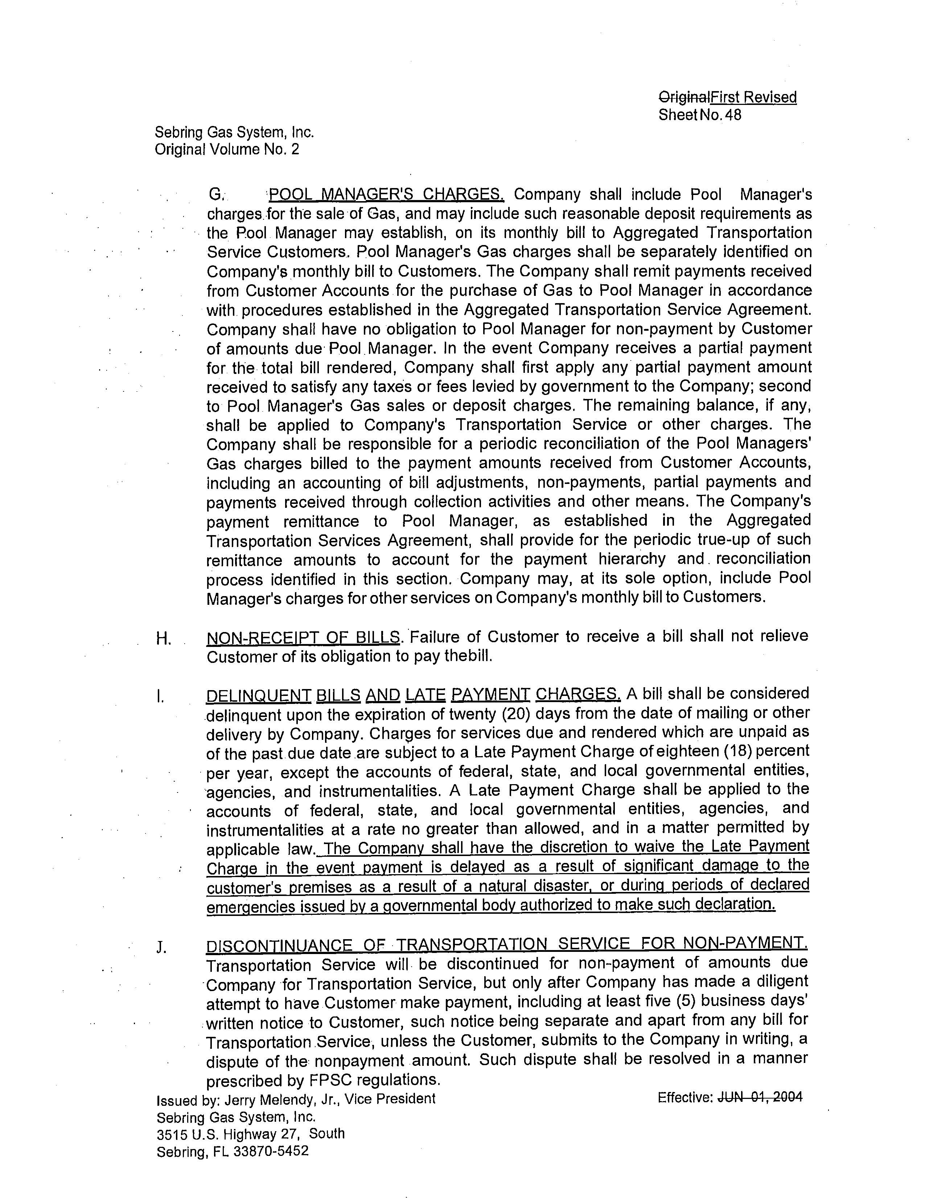

Order No. PSC-92-0912A-FOF-EI, issued September 16, 1992, in Docket No. 920800-EI, In re: Petition by Florida Power & Light Company to Waive Certain Service Charges For Good-Paying Customers. See Tariff Sheet No. 4.020.
Order No. PSC-2020-0096-TRF-EI, issued April 6, 2020, in Docket No. 2020095-EI, In re: Petition of approval of emergency modification to Duke Energy’s rate schedule SC-1, tariff sheet 6.110 by Duke Energy Florida, LLC..

