State of Florida |  | Public Service Commission  Capital Circle Office Center ● 2540 Shumard Oak Boulevard  Tallahassee, Florida 32399-0850  -M-E-M-O-R-A-N-D-U-M-
DATE: | May 28, 2020
TO: | Office of Commission Clerk (Teitzman)
FROM: | Division of Engineering (Kistner, Ellis)  Office of the General Counsel (Murphy)
RE: | Docket No. 20200111-EQ – Petition for approval of amended standard offer contract (Schedule COG-2), by Duke Energy Florida, Inc.
AGENDA: | 06/09/20 – Regular Agenda – Proposed Agency Action - Interested Persons May Participate
COMMISSIONERS ASSIGNED: |  |  | All Commissioners
PREHEARING OFFICER: |  |  | Administrative
CRITICAL DATES: |  |  | None
SPECIAL INSTRUCTIONS: |  |  | None

Case Background
Section 366.91(3), Florida Statutes (F.S.), requires each investor-owned utility (IOU) to continuously offer to purchase capacity and energy from renewable generating facilities and small qualifying facilities. Florida Public Service Commission (Commission) Rules 25-17.200 through 25-17.310, Florida Administrative Code (F.A.C.), implement the statute and require each IOU to file with the Commission, by April 1 of each year, a revised standard offer contract based on the next avoidable fossil fueled generating unit of each technology type identified in the utility’s current Ten-Year Site Plan. On April l, 2020, Duke Energy Florida, LLC (DEF) filed a petition for approval of its amended standard offer contract and rate schedule COG-2, based on its 2020 Ten-Year Site Plan. The Commission has jurisdiction over this standard offer contract pursuant to Sections 366.04 through 366.055, and 366.91, F.S.

Discussion of Issues

Issue 1:
Should the Commission approve the amended standard offer contract and rate schedule COG-2 filed by Duke Energy Florida, LLC?

Recommendation:
Yes. The provisions of DEF’s amended standard offer contract and associated rate schedule COG-2 conform to all requirements of Rules 25-17.200 through 25-17.310, F.A.C. The amended standard offer contract provides flexibility in the arrangements for payments so that a developer of renewable generation may select the payment stream best suited to its financial needs. (Kistner)

Staff Analysis:
Section 366.91(3), F.S., and Rule 25-17.250, F.A.C., require that DEF, an IOU, continuously make available a standard offer contract for the purchase of firm capacity and energy from renewable generating facilities (RF) and small qualifying facilities (QF) with design capacities of 100 kilowatts (kW) or less. Pursuant to Rules 25-17.250(1) and (3), F.A.C., the standard offer contract must provide a term of at least 10 years, and the payment terms must be based on the utility’s next avoidable fossil-fueled generating unit identified in its most recent Ten-Year Site Plan, or if no avoided unit is identified, its next avoidable planned purchase. DEF has identified a 226 megawatt (MW) natural gas-fueled combustion turbine (CT) as the next planned generating unit in its 2020 Ten-Year Site Plan. The projected in-service date of the unit is June 1, 2027.
Under DEF’s standard offer contract, the RF/QF operator commits to certain minimum performance requirements based on the identified avoided unit, such as being operational and delivering an agreed upon amount of capacity by the in-service date of the avoided unit, and thereby becomes eligible for capacity payments in addition to payments received for energy. The standard offer contract may also serve as a starting point for negotiation of contract terms by providing payment information to an RF/QF operator, in a situation where one or both parties desire particular contract terms other than those established in the standard offer.
In order to promote renewable generation, the Commission requires the IOU to offer multiple options for capacity payments, including the options to receive early or levelized payments. If the RF/QF operator elects to receive capacity payments under the normal or levelized contract options, it will receive as-available energy payments only until the in-service date of the avoided unit (in this case June 1, 2027), and thereafter, begin receiving capacity payments in addition to the energy payments. If either the early or early levelized option is selected, then the operator will begin receiving capacity payments earlier than the in-service date of the avoided unit. However, payments made under the early capacity payment options tend to be lower in the later years of the contract term because the net present value (NPV) of the total payments must remain equal for all contract payment options.
Table 1 contains DEF’s estimates of the annual payments for each payment option available under the revised standard offer contract to an operator with a 50 MW facility, operating at a capacity factor of 95 percent, which is the minimum capacity factor required under the contract to qualify for full capacity payments. Normal and levelized capacity payments begin with the projected in-service date of the avoided unit (June 1, 2027).
Table 1 - Estimated Annual Payments to a 50 MW Renewable Facility
(95% Capacity Factor)
Year | Energy Payment | Capacity Payment (By Type)
 |  | Normal | Levelized | Early | Early Levelized
 | $(000) | $(000) | $(000) | $(000) | $(000)
2021 | 8,128 | - | - | 1,378 | 1,521
2022 | 7,385 | - | - | 1,397 | 1,522
2023 | 7,242 | - | - | 1,417 | 1,523
2024 | 7,601 | - | - | 1,437 | 1,524
2025 | 8,419 | - | - | 1,457 | 1,526
2026 | 9,352 | - | - | 1,478 | 1,527
2027 | 10,771 | 1,575 | 1,699 | 1,499 | 1,528
2028 | 12,633 | 2,738 | 2,915 | 1,520 | 1,530
2029 | 13,544 | 2,777 | 2,918 | 1,541 | 1,531
2030 | 14,492 | 2,816 | 2,920 | 1,563 | 1,533
2031 | 15,257 | 2,856 | 2,923 | 1,585 | 1,534
2032 | 16,232 | 2,896 | 2,925 | 1,608 | 1,536
2033 | 16,164 | 2,937 | 2,928 | 1,631 | 1,537
2034 | 16,414 | 2,979 | 2,931 | 1,654 | 1,539
2035 | 16,905 | 3,021 | 2,934 | 1,677 | 1,541
2036 | 17,209 | 3,064 | 2,937 | 1,701 | 1,542
2037 | 18,791 | 3,107 | 2,940 | 1,725 | 1,544
2038 | 19,563 | 3,151 | 2,943 | 1,750 | 1,546
2039 | 20,224 | 3,196 | 2,946 | 1,774 | 1,548
2040 | 20,926 | 3,242 | 2,950 | 1,800 | 1,550
Total | 277,254 | 40,357 | 39,809 | 31,592 | 30,683
Total (NPV) | 132,483 | 16,702 | 16,702 | 16,702 | 16,702

Source: DEF’s Amended Response to Staff’s First Data Request
DEF’s standard offer contract, in type-and-strike format, is included as Attachment A to this recommendation. The DEF’s amended tariff sheets are consistent with the updated avoided unit. In addition to changes associated with the avoided unit, DEF made other revisions to its tariff sheets. These include clarifying potentially ambiguous terminology, modifying force majeure language, and dispute resolution terms.

In order to clarify potentially ambiguous terms, DEF made various language changes. These include a change from “Prudent Utility Practices” to “Prudent Regulated Utility Practices”, found on Sheet Nos. 9.411, 9.419, and 9.424, which DEF states was done to ensure that RF/QF’s are held to the same standards as DEF and other IOUs in Florida. Another addition is “and maintain” to the Conditions Precedent on Sheet No. 9.416, which DEF states was made to avoid any doubt that the RF/QF must maintain the various conditions past the Drop Dead Date, unless stated in writing by DEF on or before the Drop Dead Date. This clarification was due to feedback DEF had received from an RF/QF which did not believe it had to maintain the conditions after the Drop Dead Date.

DEF made revisions to the Force Majeure and Dispute Resolution sections to provide uniform language to coincide with other IOU’s in Florida. The changes to the Force Majeure section found on Sheet Nos. 9.431 and 9.432 include a more focused definition of epidemic, which must be recognized by a health agency authority and have a mandated quarantine that directly impacts the RF/QF, and additional circumstances which are not considered Force Majeure such as performance failure of another entity and interruption of fuel supply. Last, the Dispute Resolution section found on Sheet No. 9.438 was rewritten to use adjudication by the United States District Court located in Hillsborough County rather than arbitration. Overall, these modifications seem reasonable as they align with the IOU’s requirements and do not place a disproportionate burden on the RF/QF.

Conclusion
Staff recommends that the amended standard offer contract and rate schedule COG-2 be approved as filed. The provisions of DEF’s amended standard offer contract and associated rate schedule conform to all requirements of Rules 25-17.200 through 25-17.310, F.A.C. The amended standard offer contract provides flexibility in the arrangements for payments so that a developer of renewable generation may select the payment stream best suited to its financial needs.

Issue 2:
Should this docket be closed?

Recommendation:
Yes. This docket should be closed upon issuance of a consummating order, unless a person whose substantial interests are affected by the Commission’s decision files a protest within 21 days of the issuance of the Commission’s Proposed Agency Action Order. Potential signatories should be aware that, if a timely protest is filed, DEF’s standard offer contract may subsequently be revised. (Murphy)

Staff Analysis:
This docket should be closed upon the issuance of a consummating order, unless a person whose substantial interests are affected by the Commission’s decision files a protest within 21 days of the issuance of the Commission’s Proposed Agency Action Order. Potential signatories should be aware that, if a timely protest is filed, DEF’s standard offer contract may subsequently be revised.

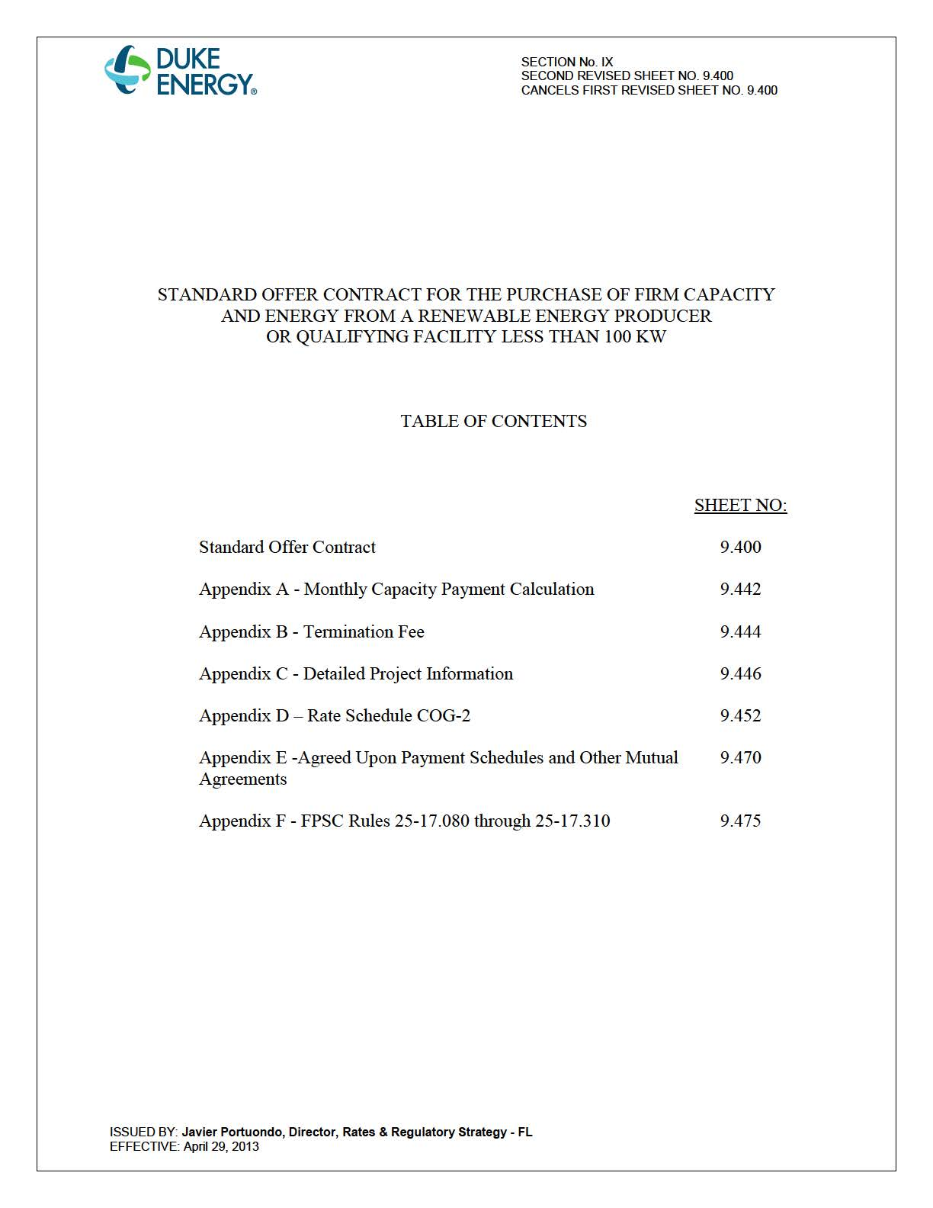

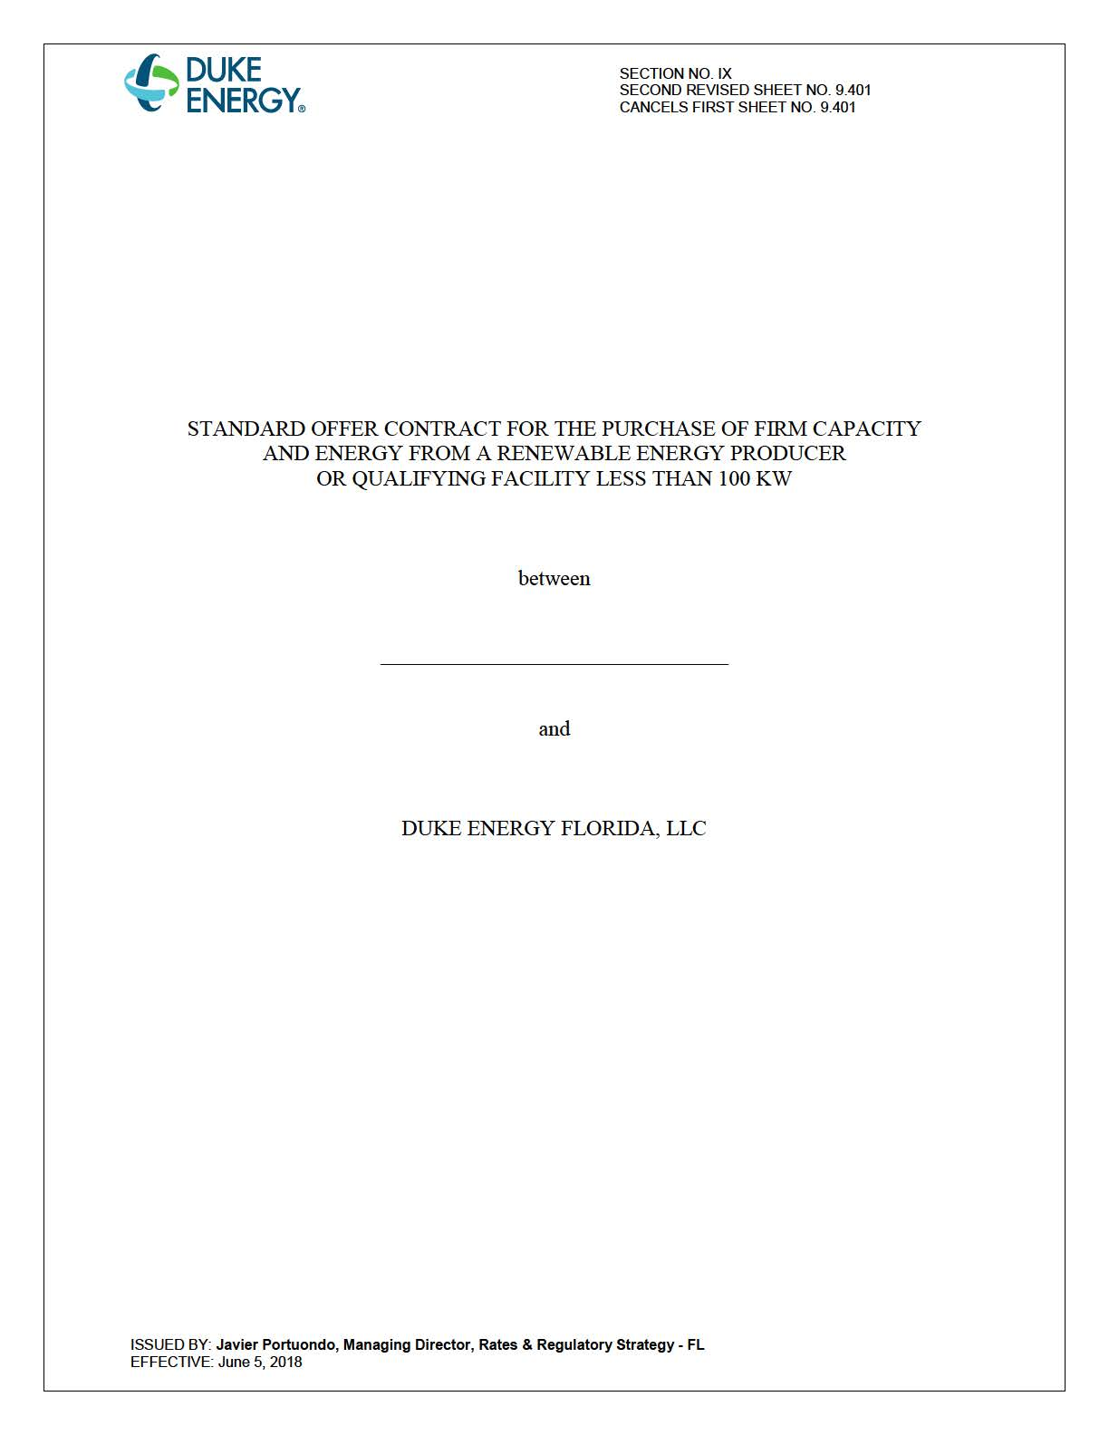

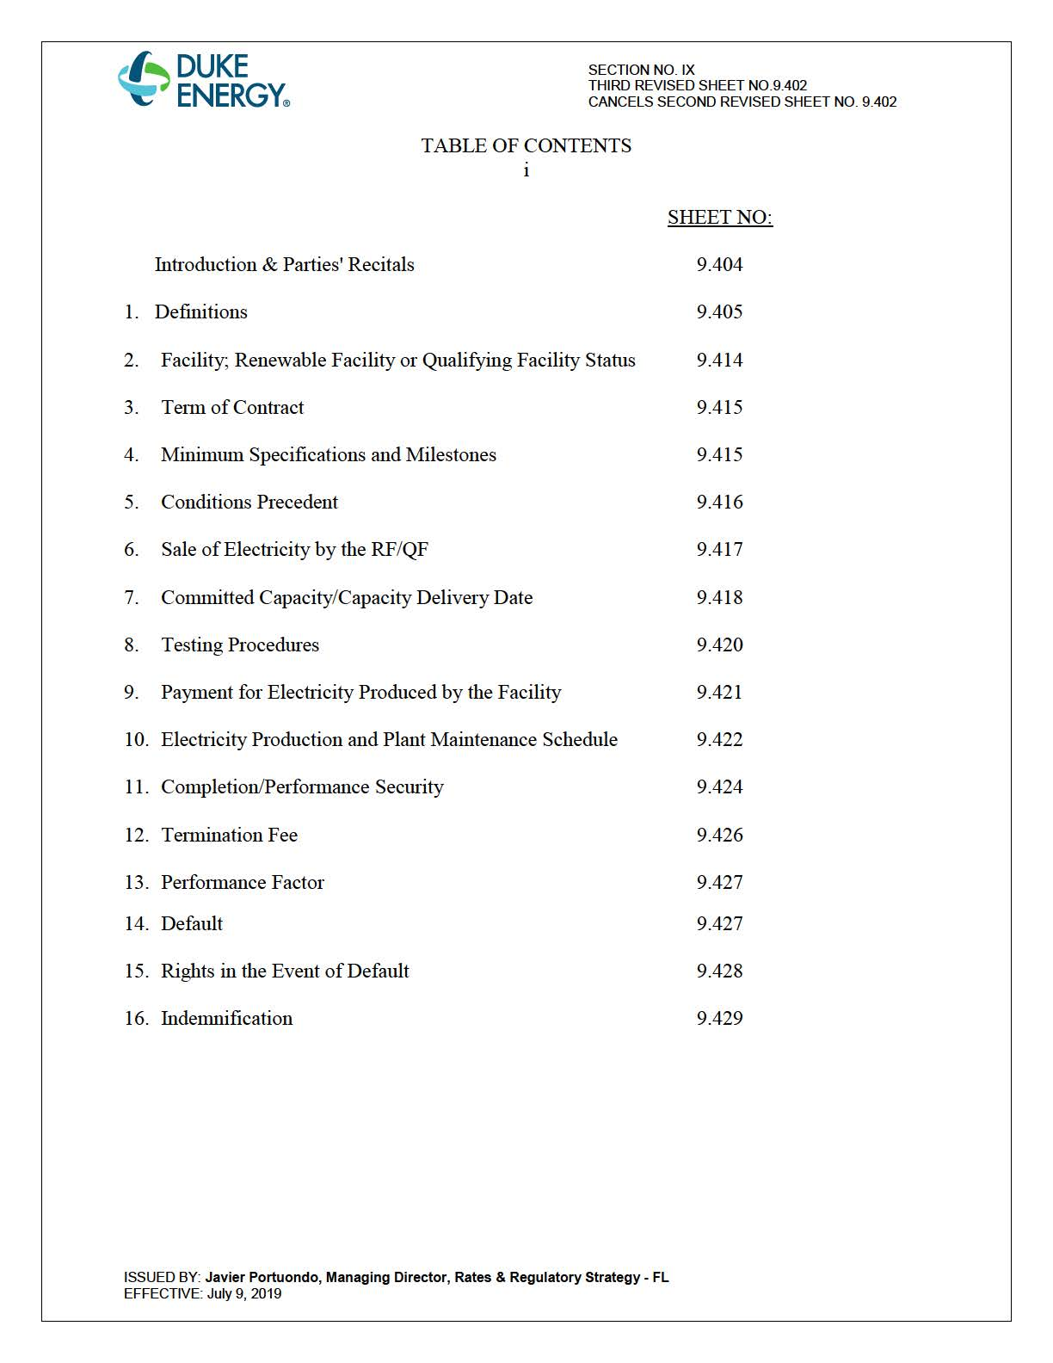

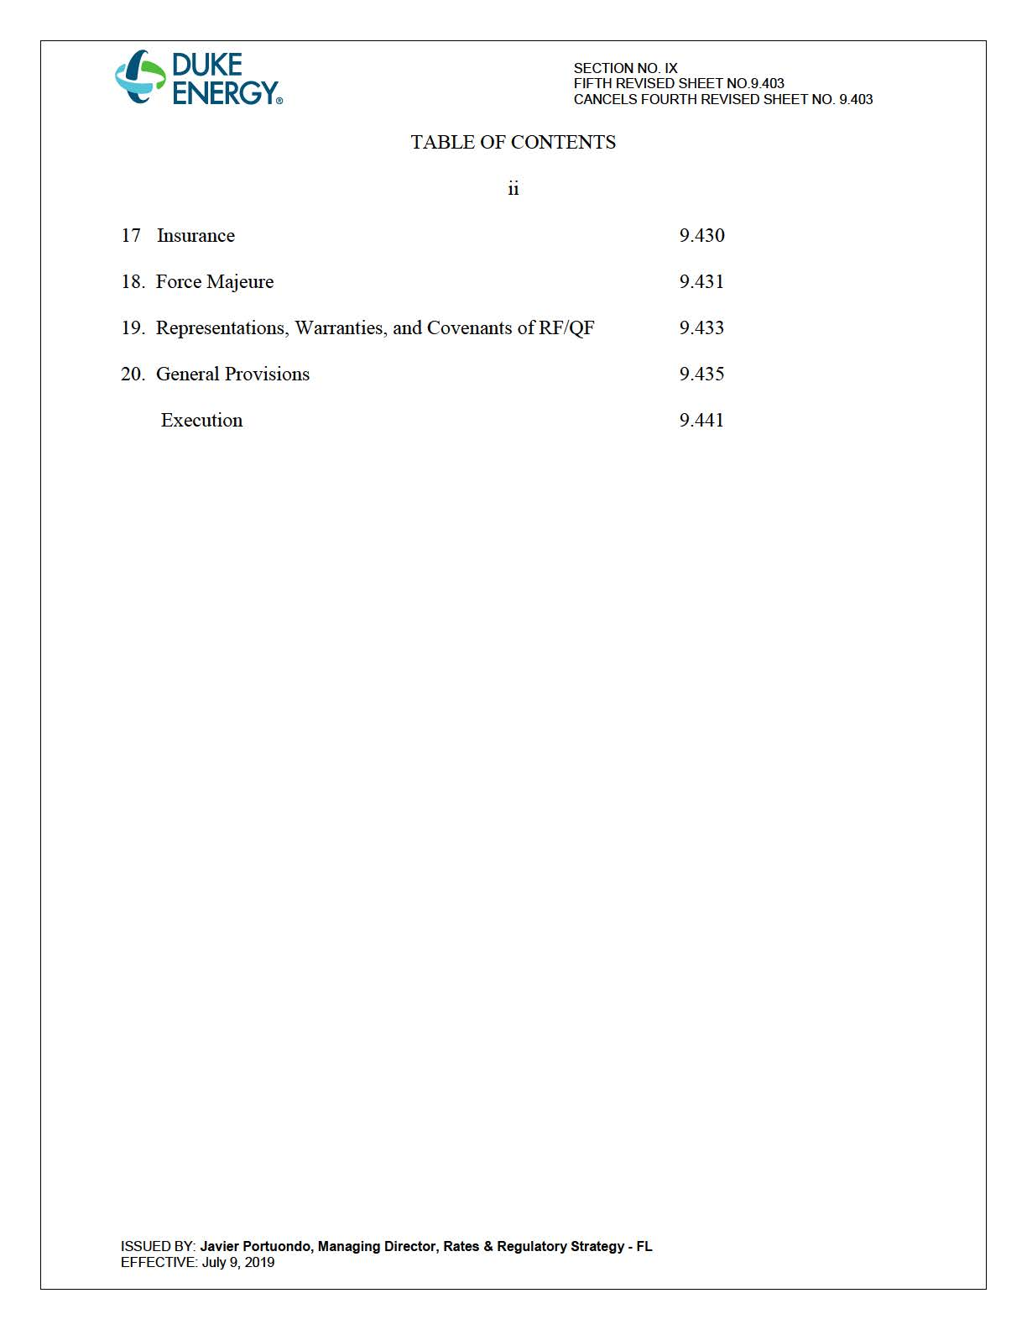

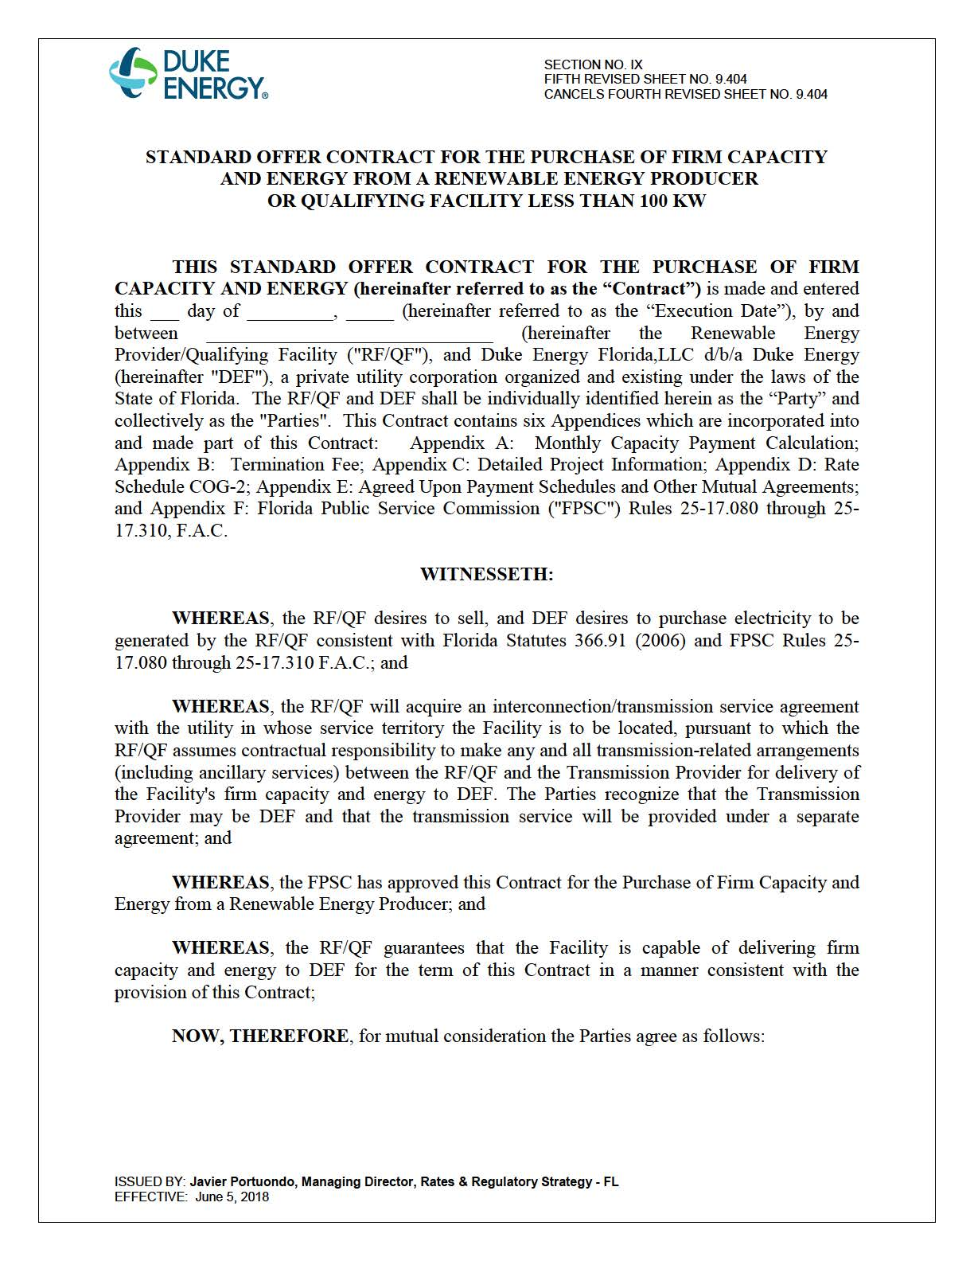

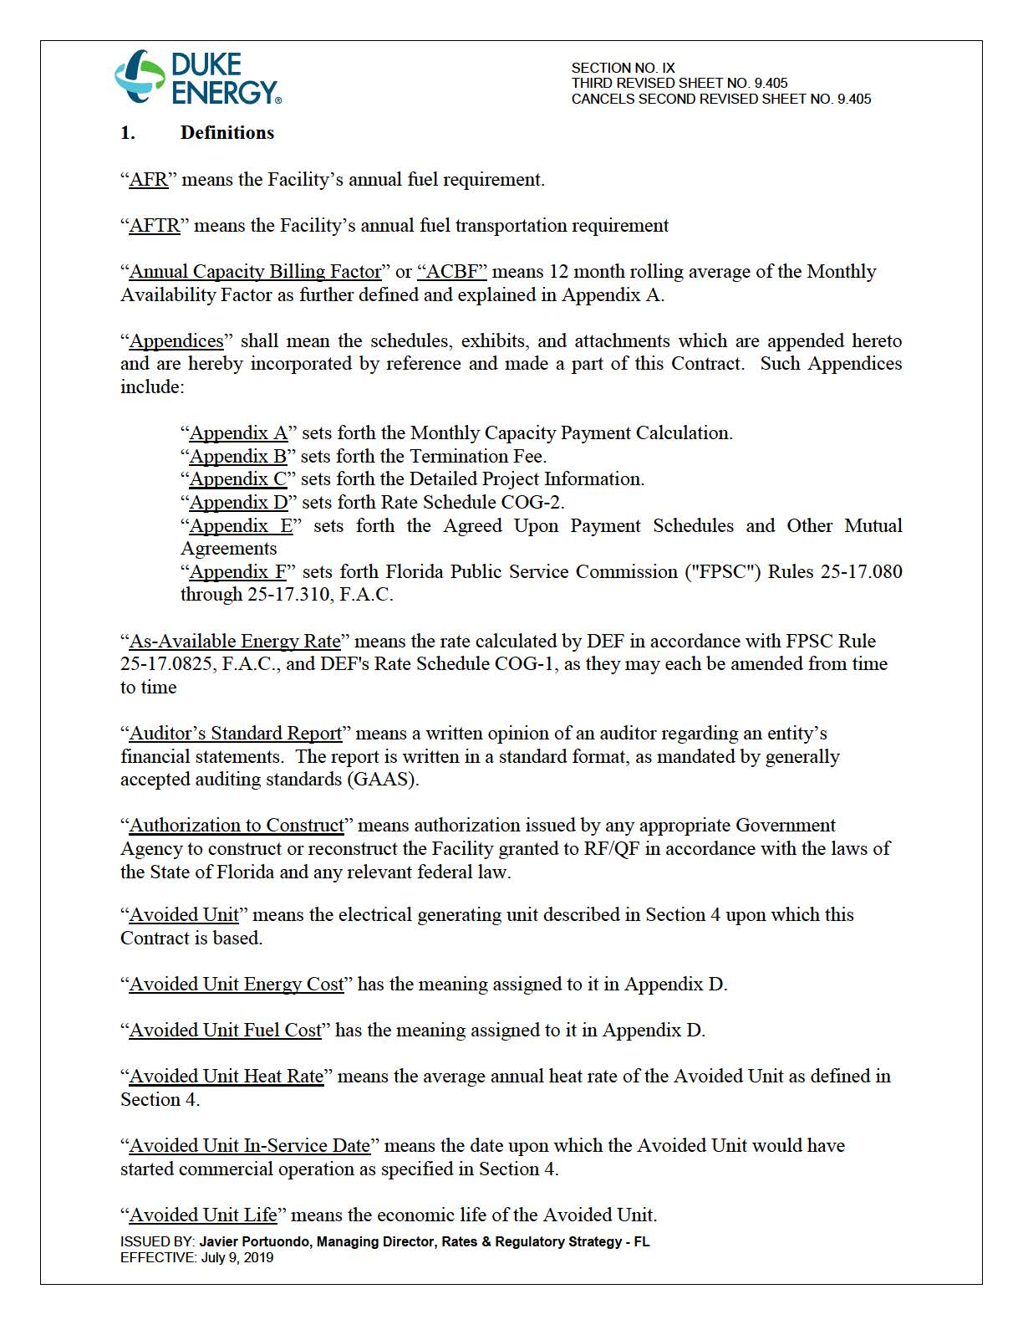

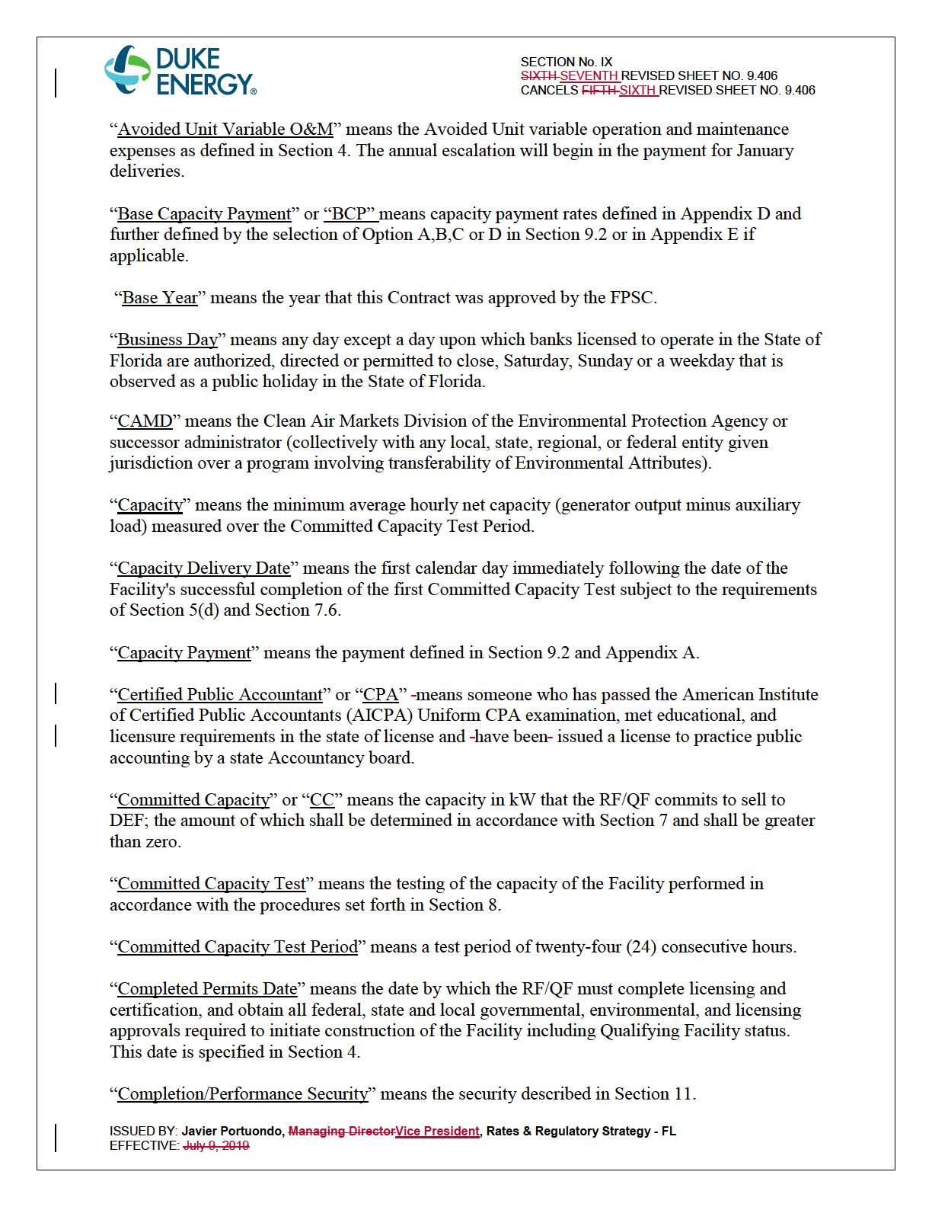

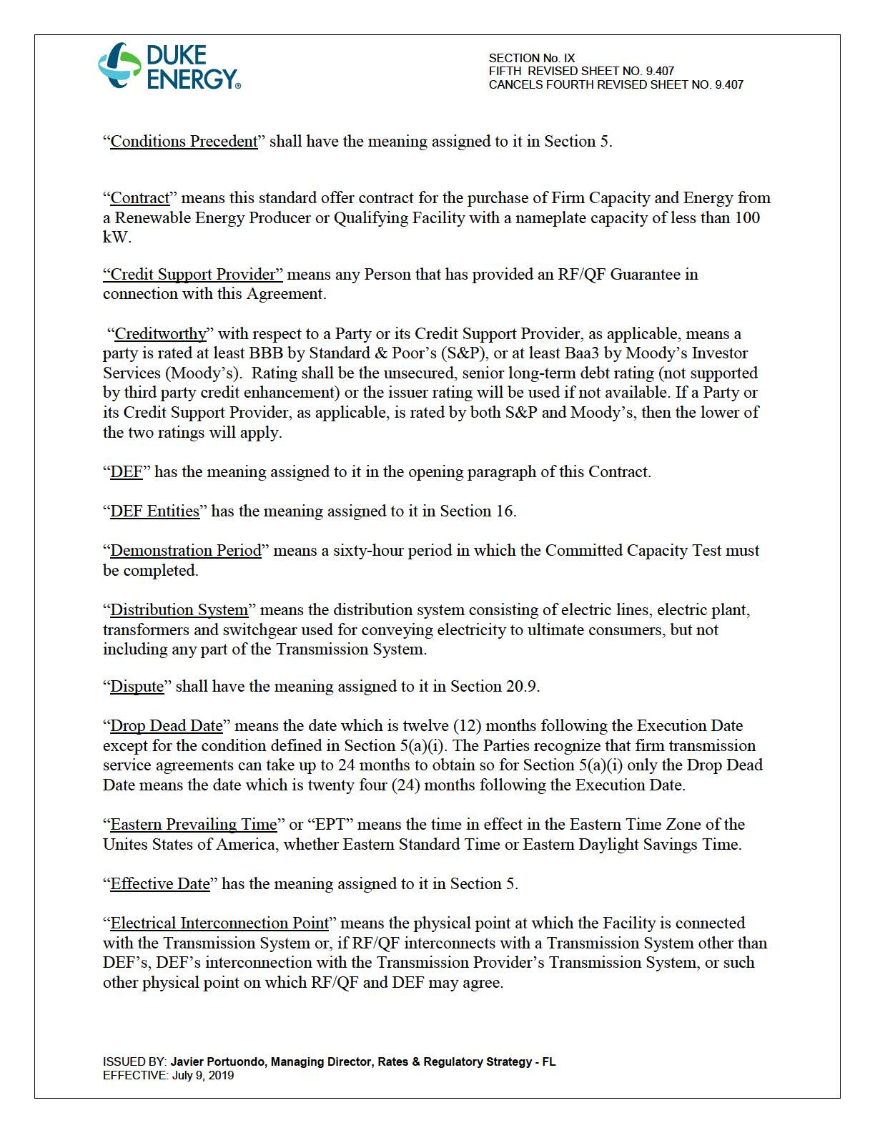

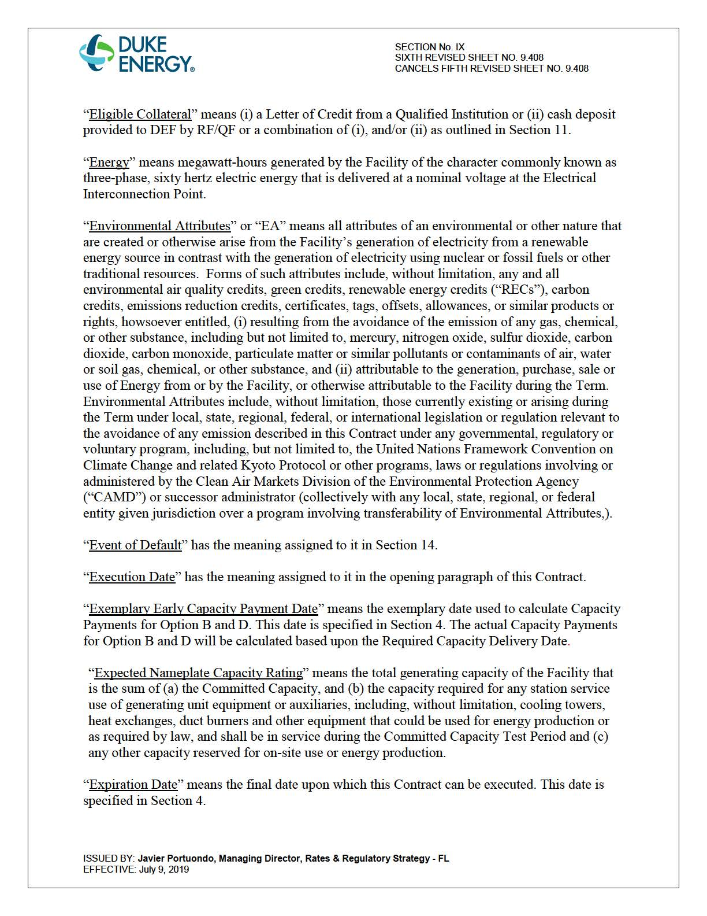

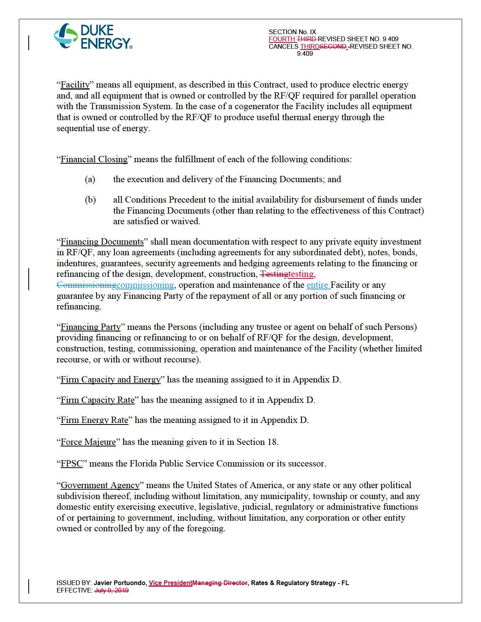

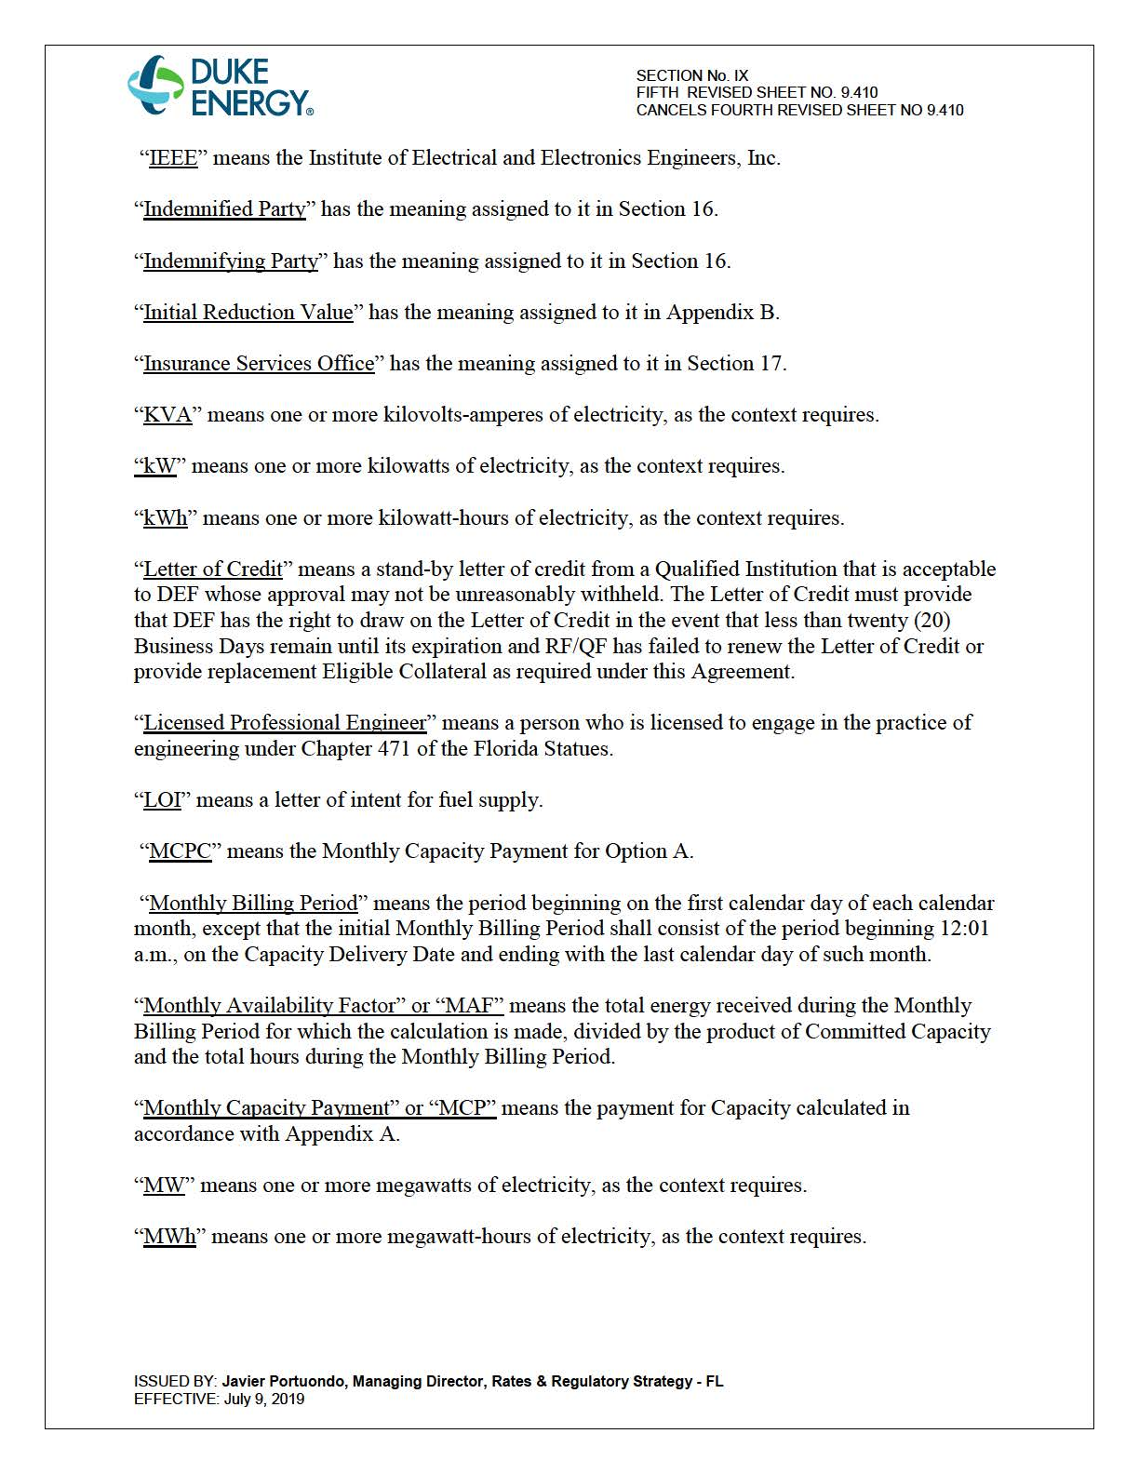

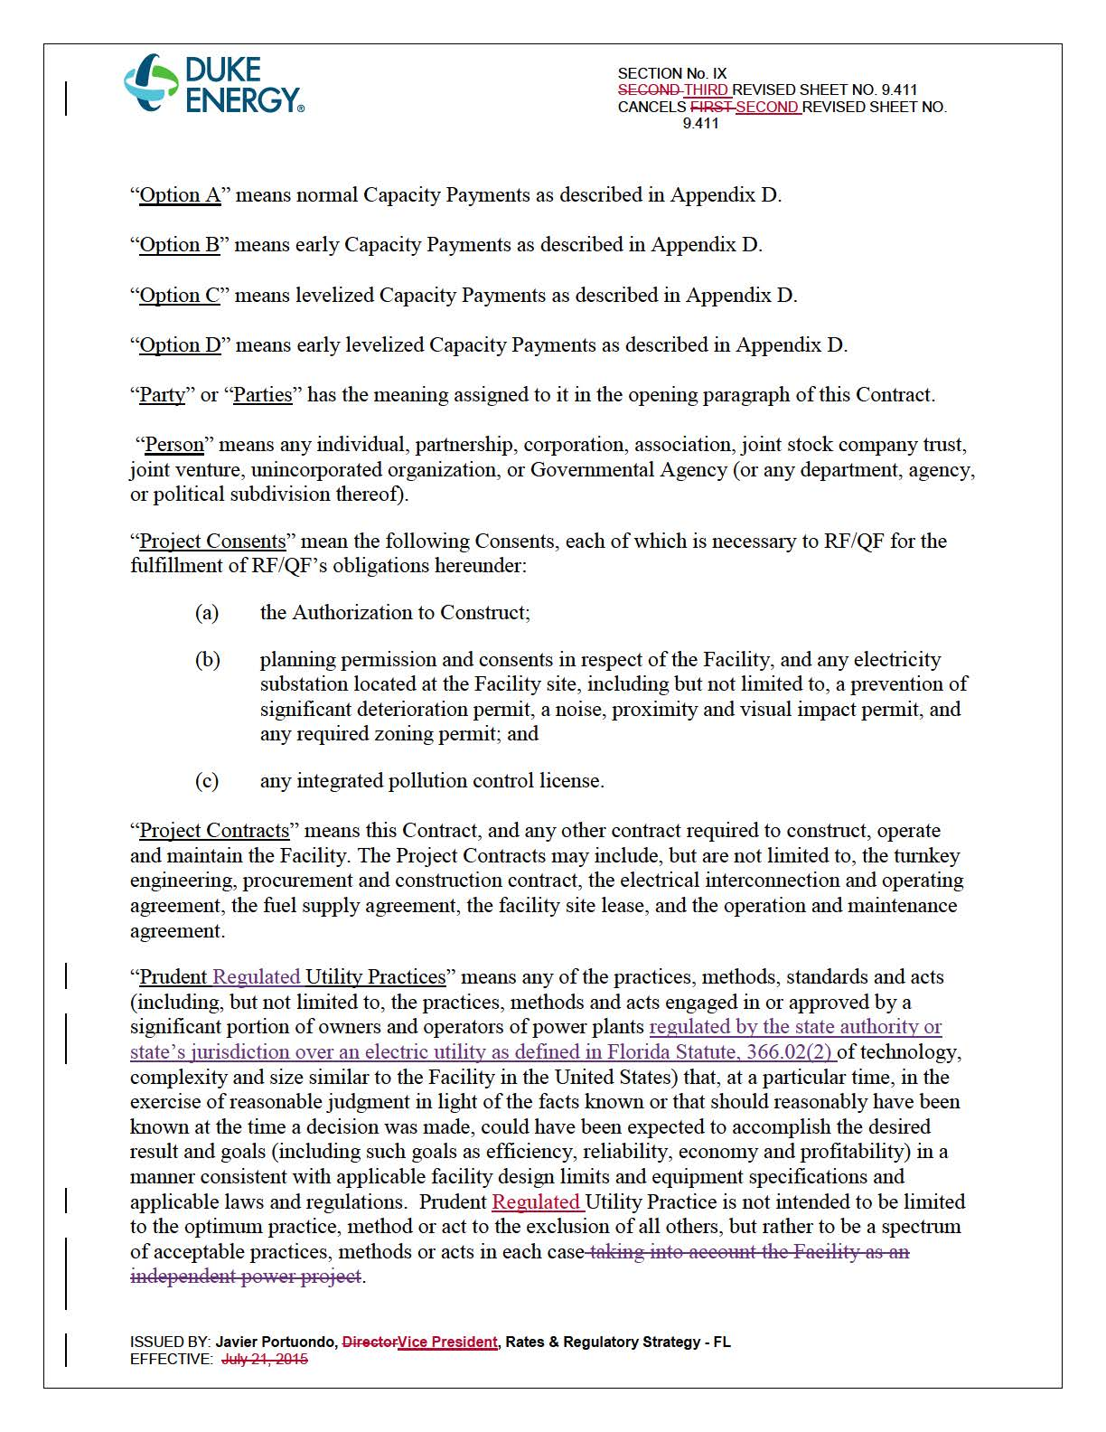

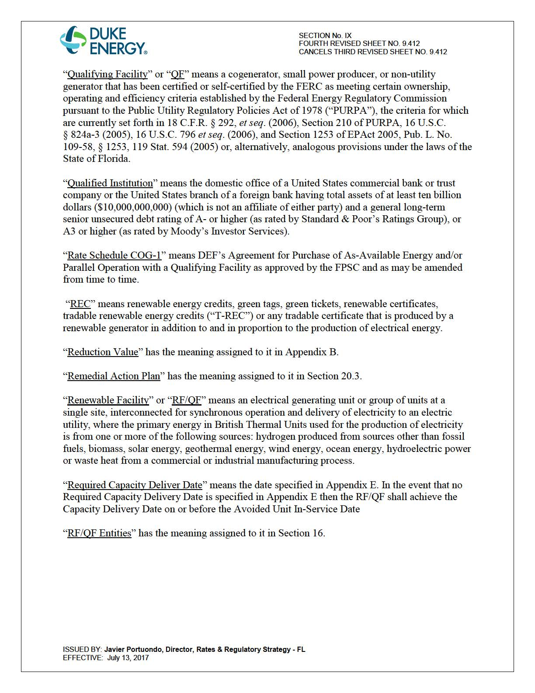

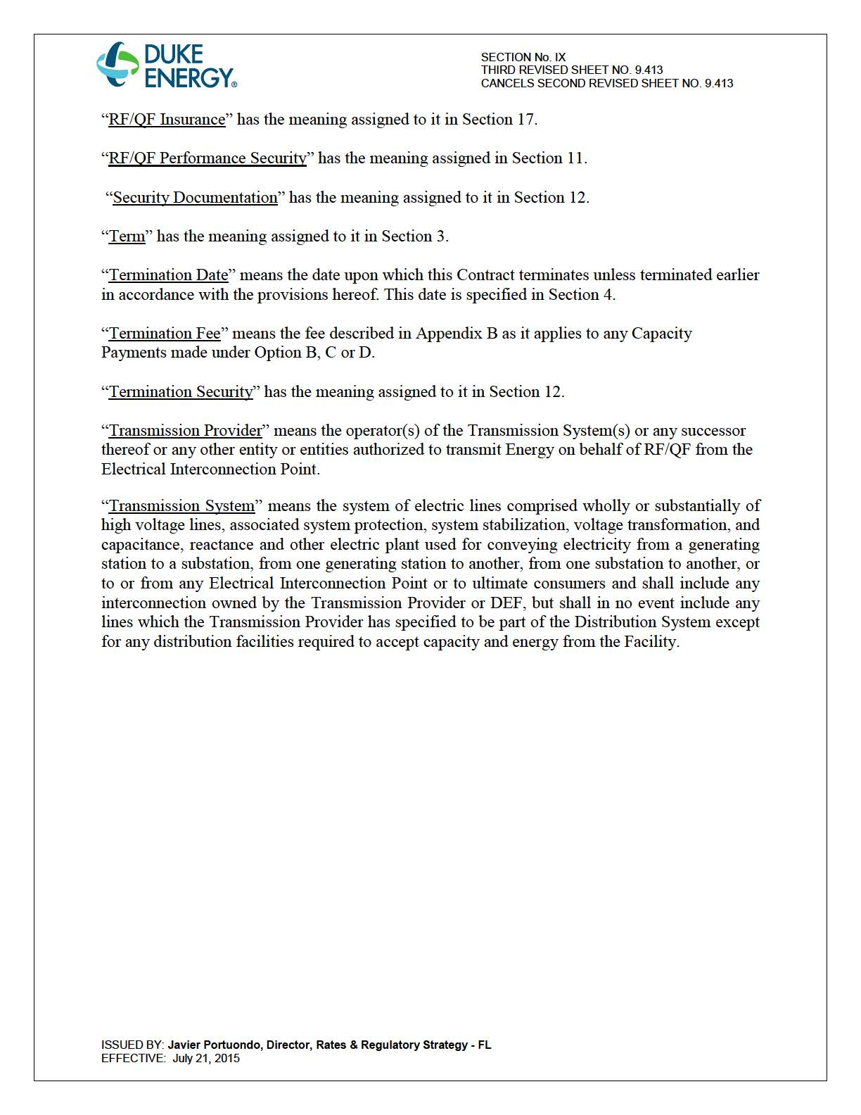

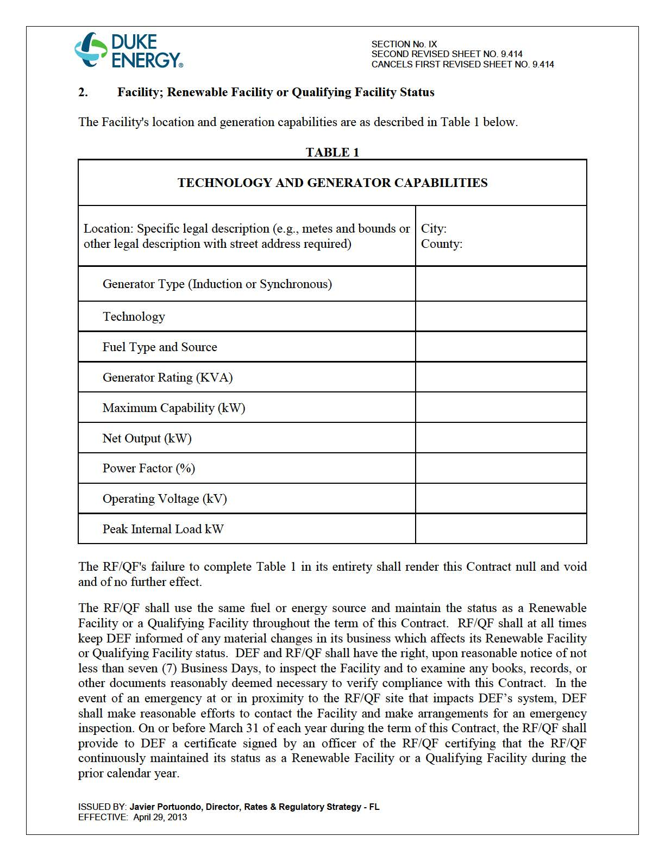

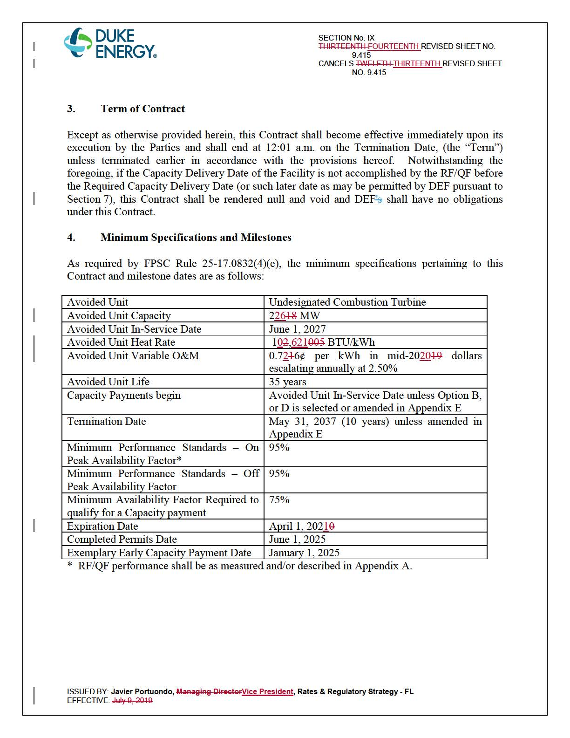

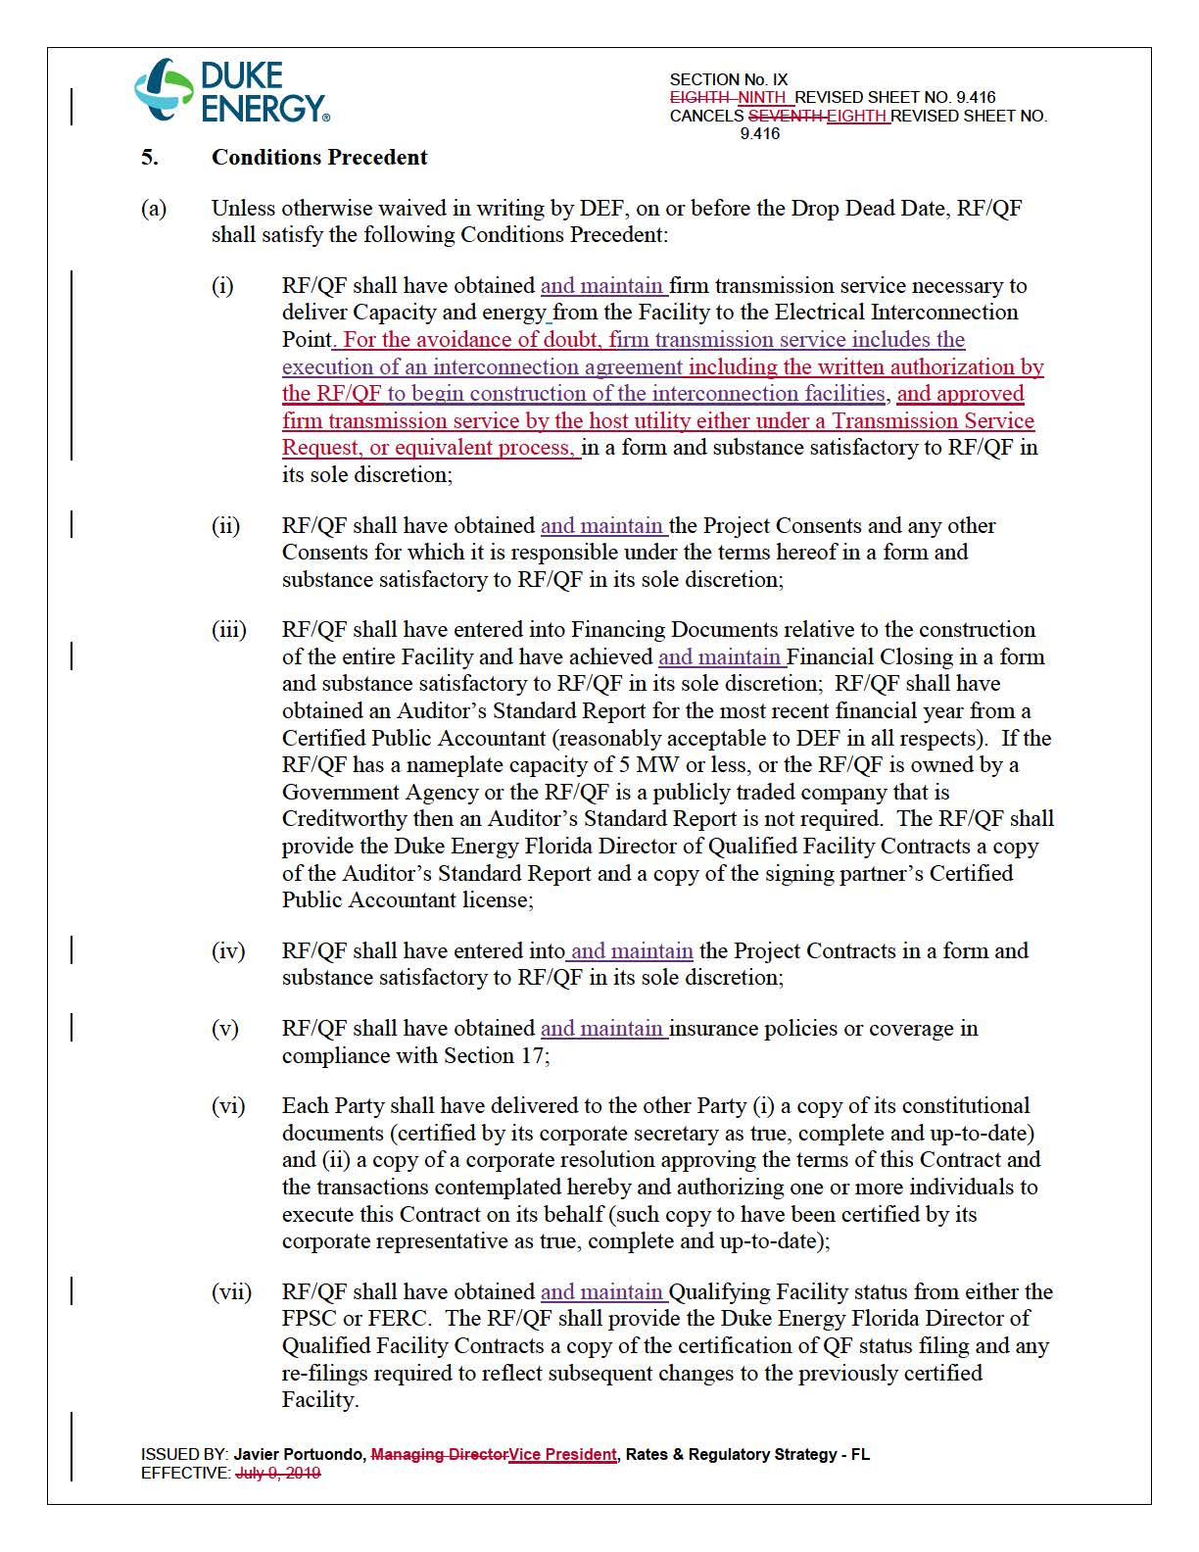

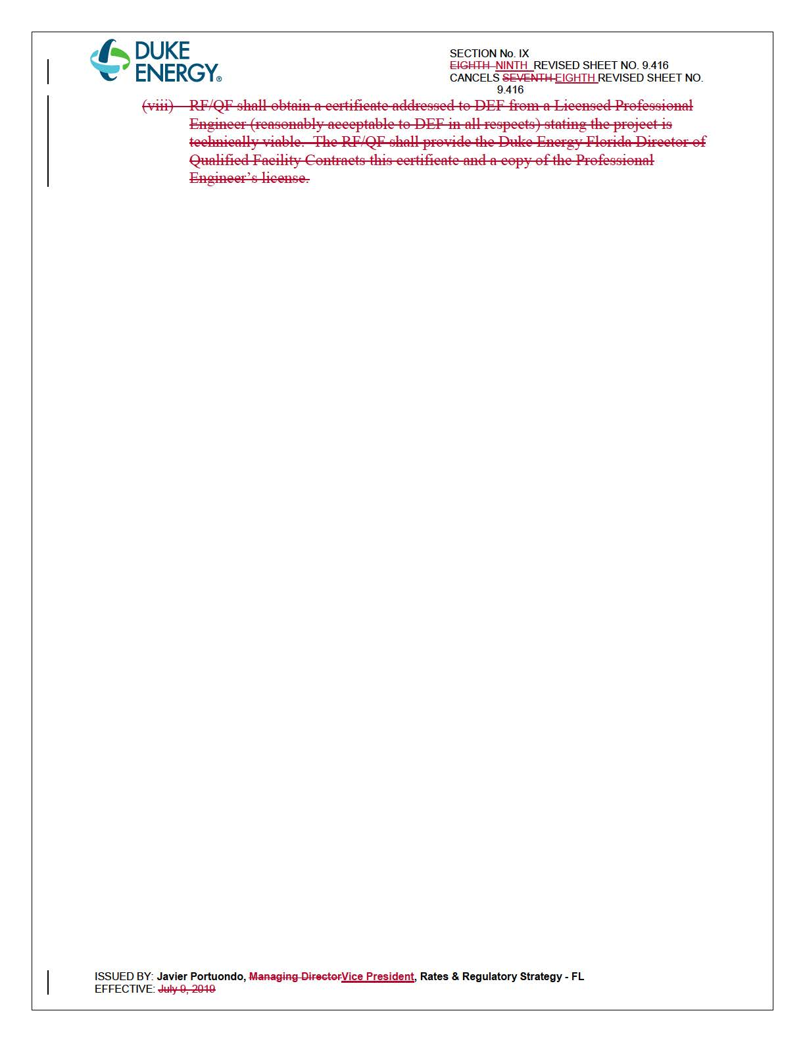

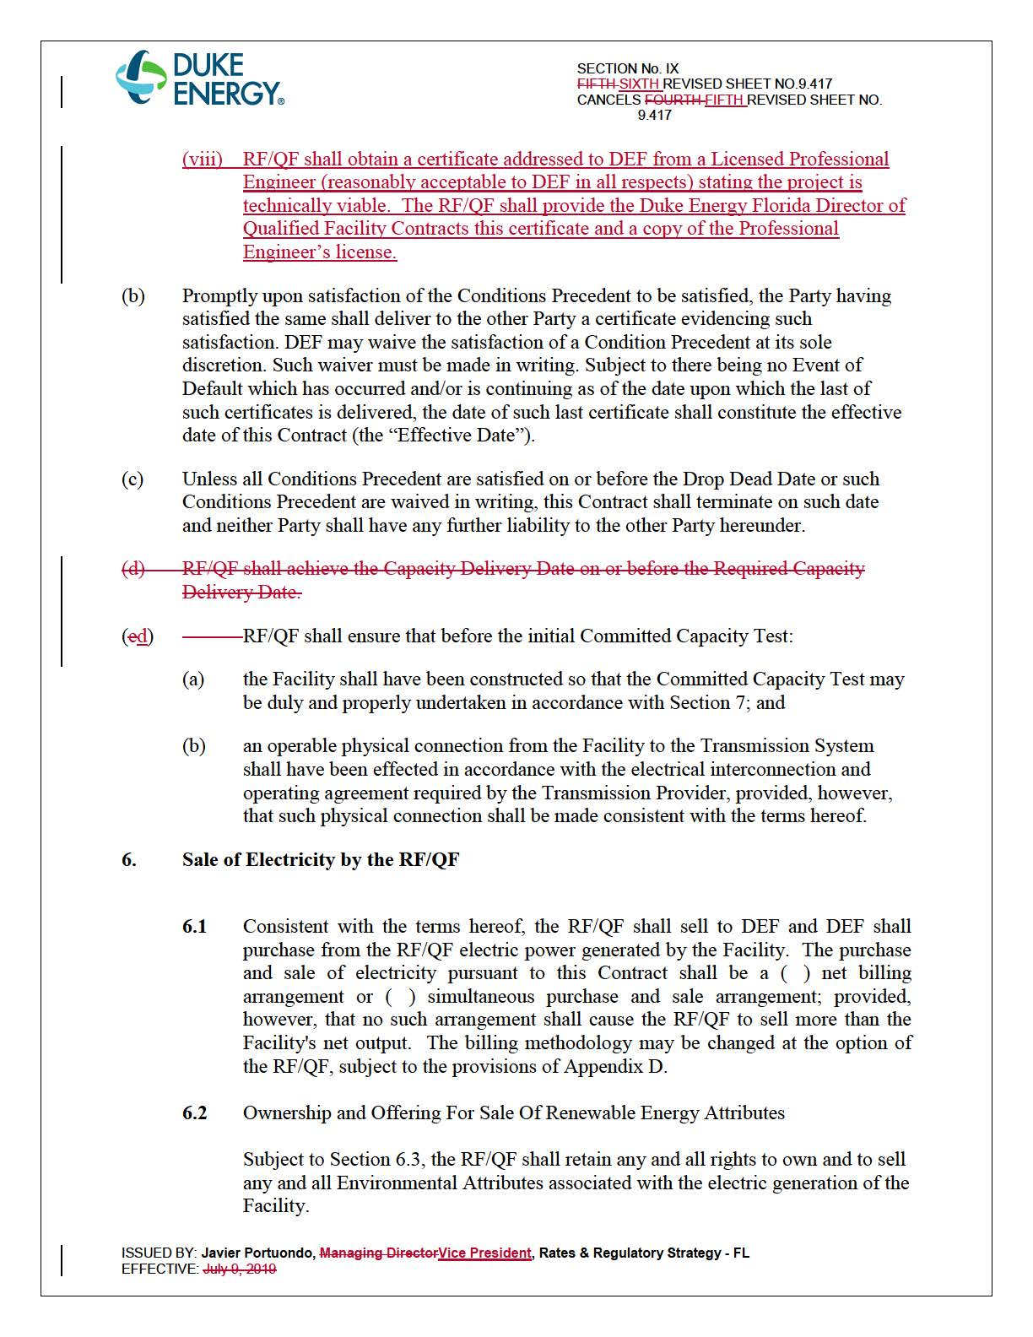

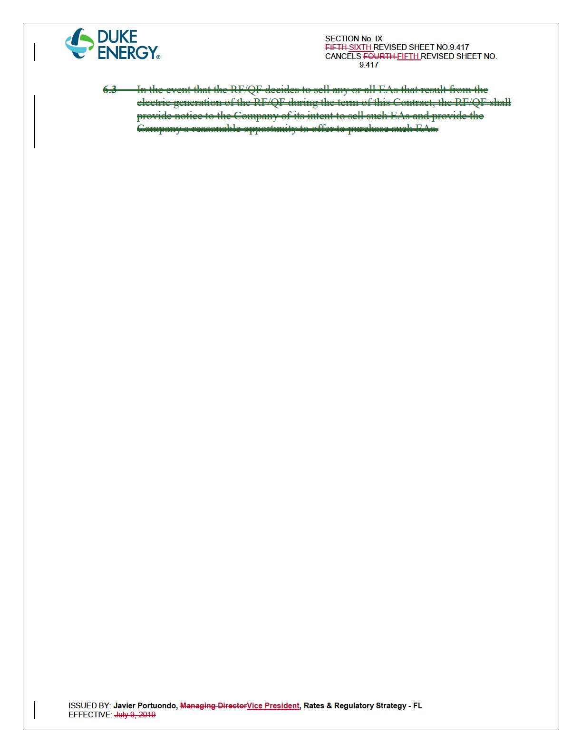

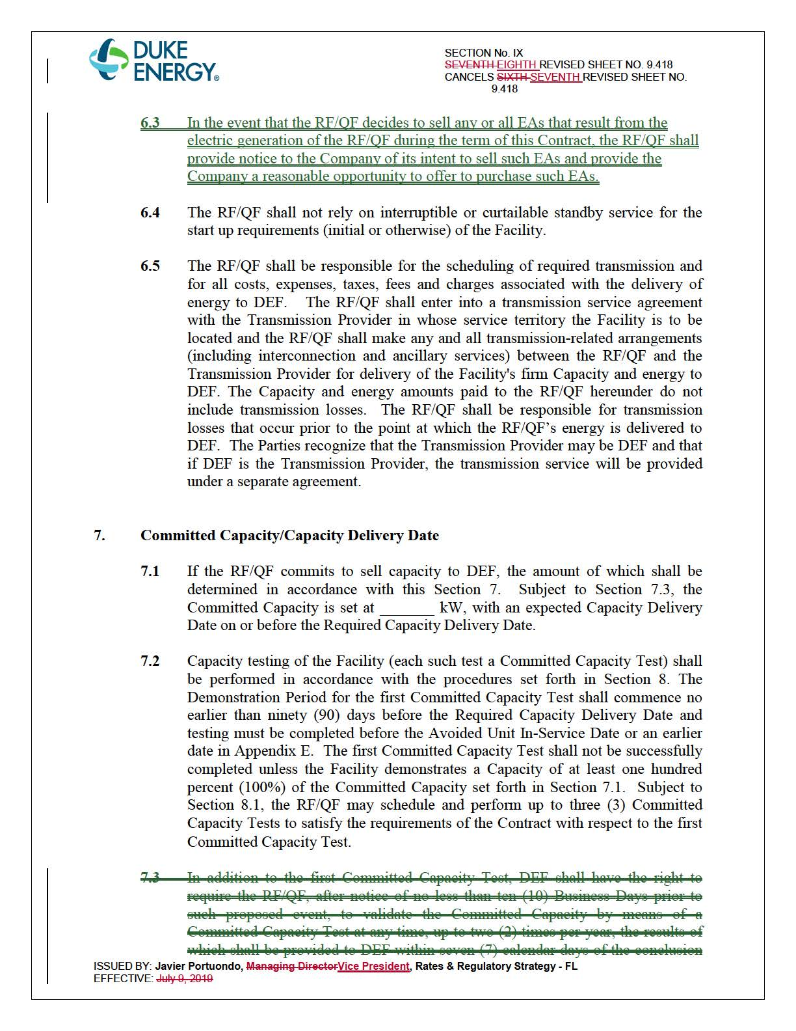

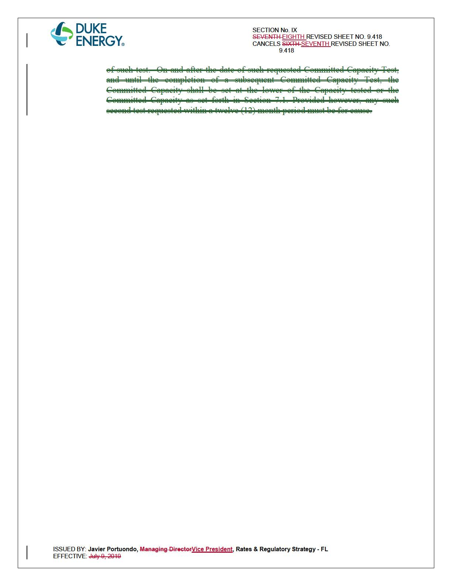

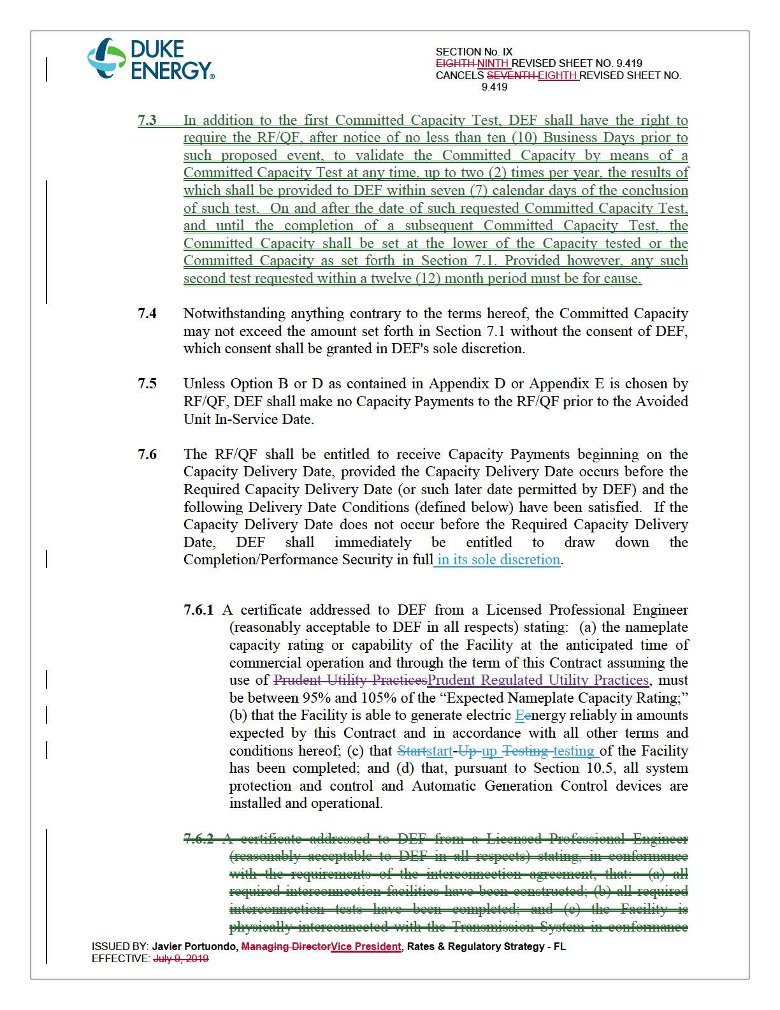

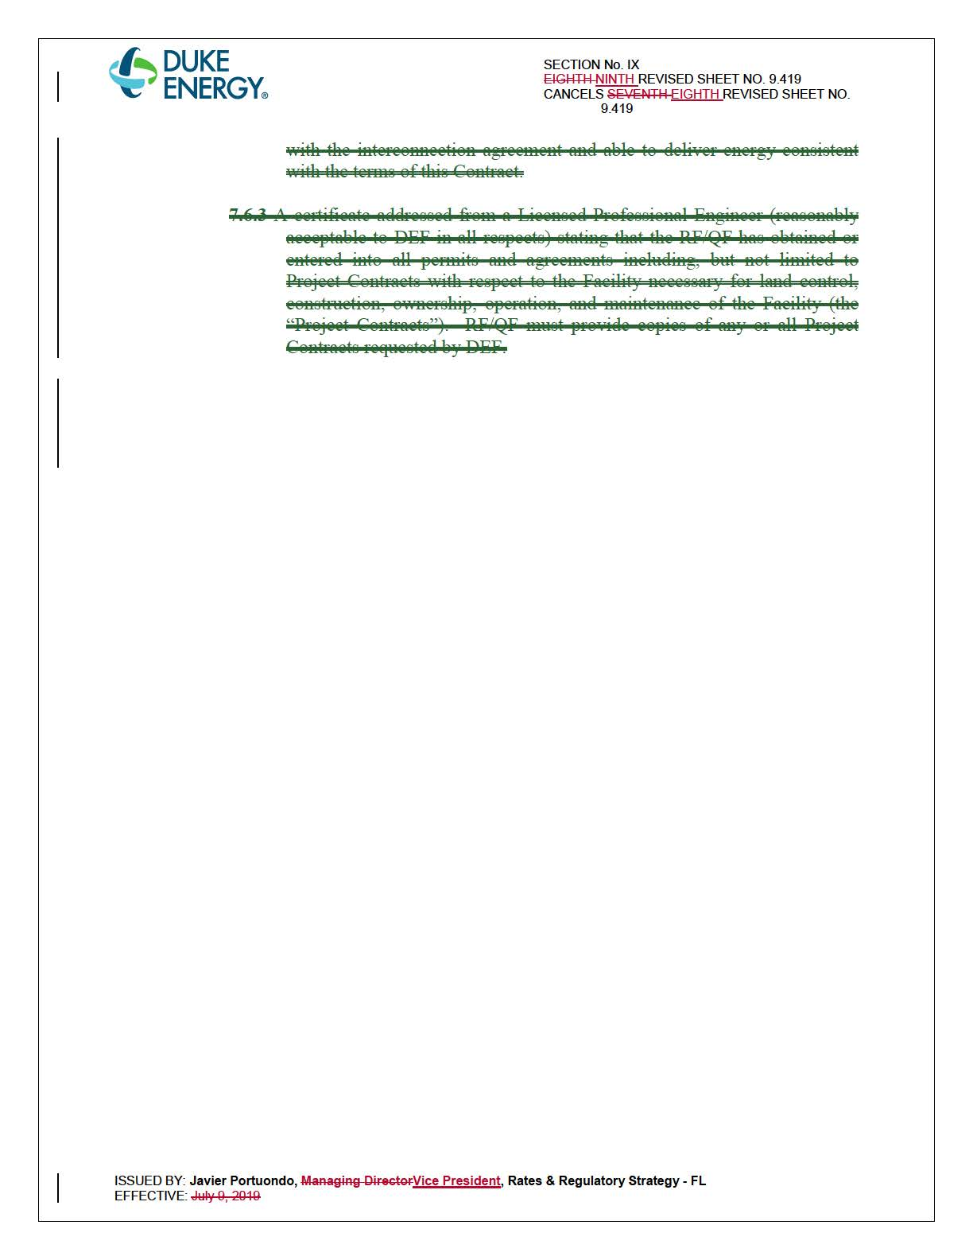

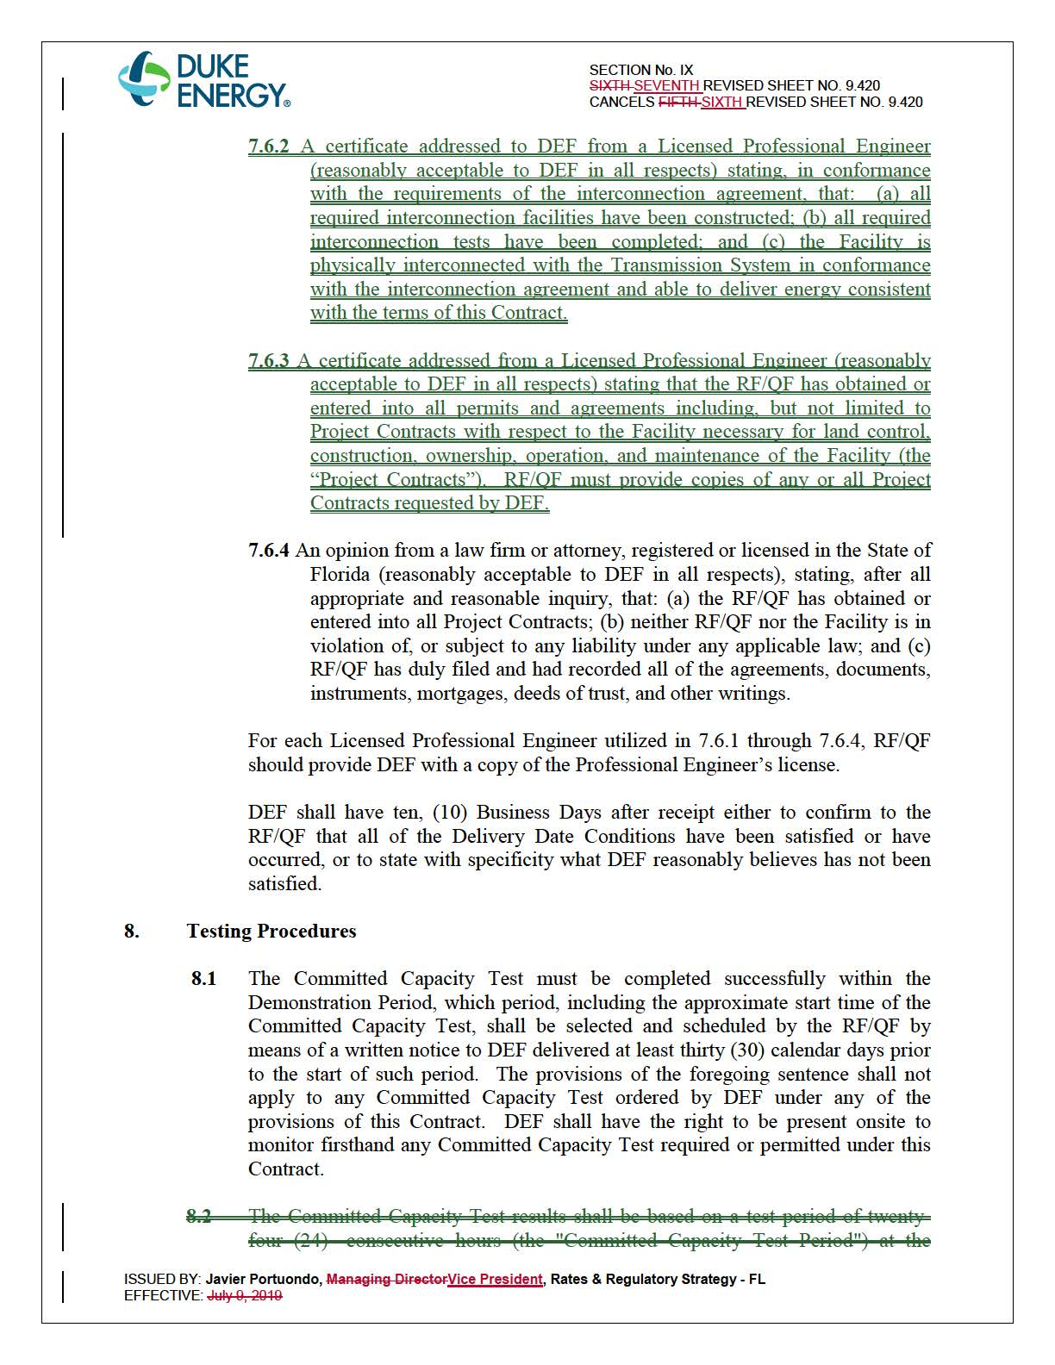

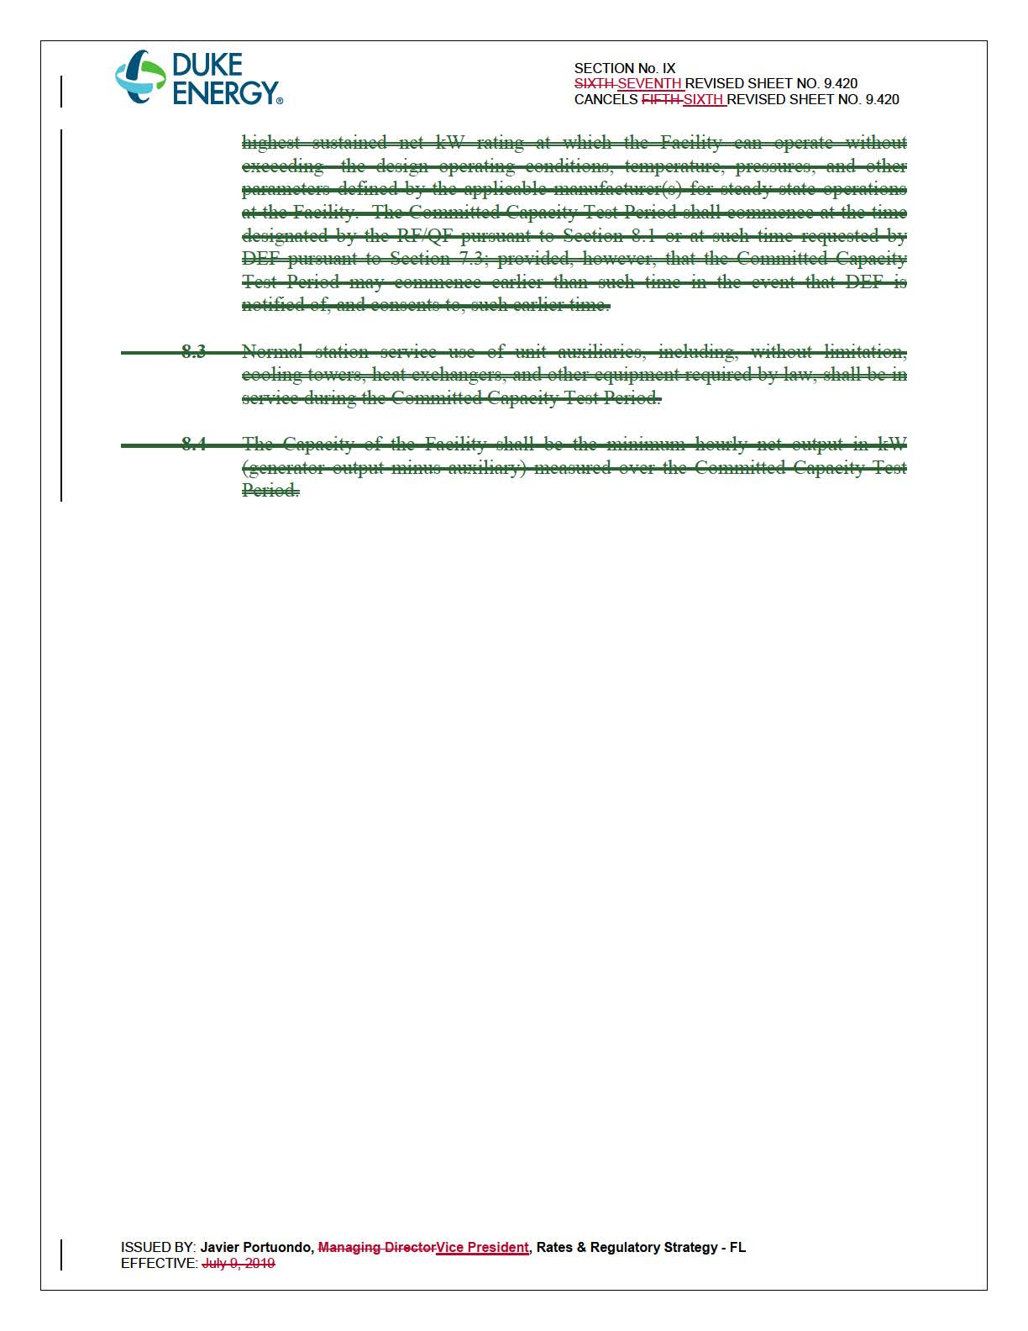

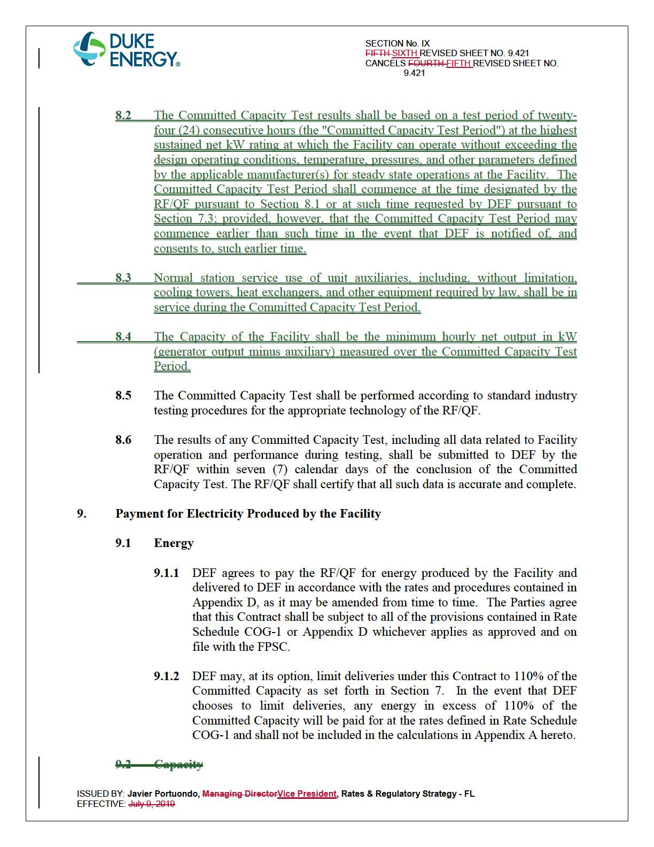

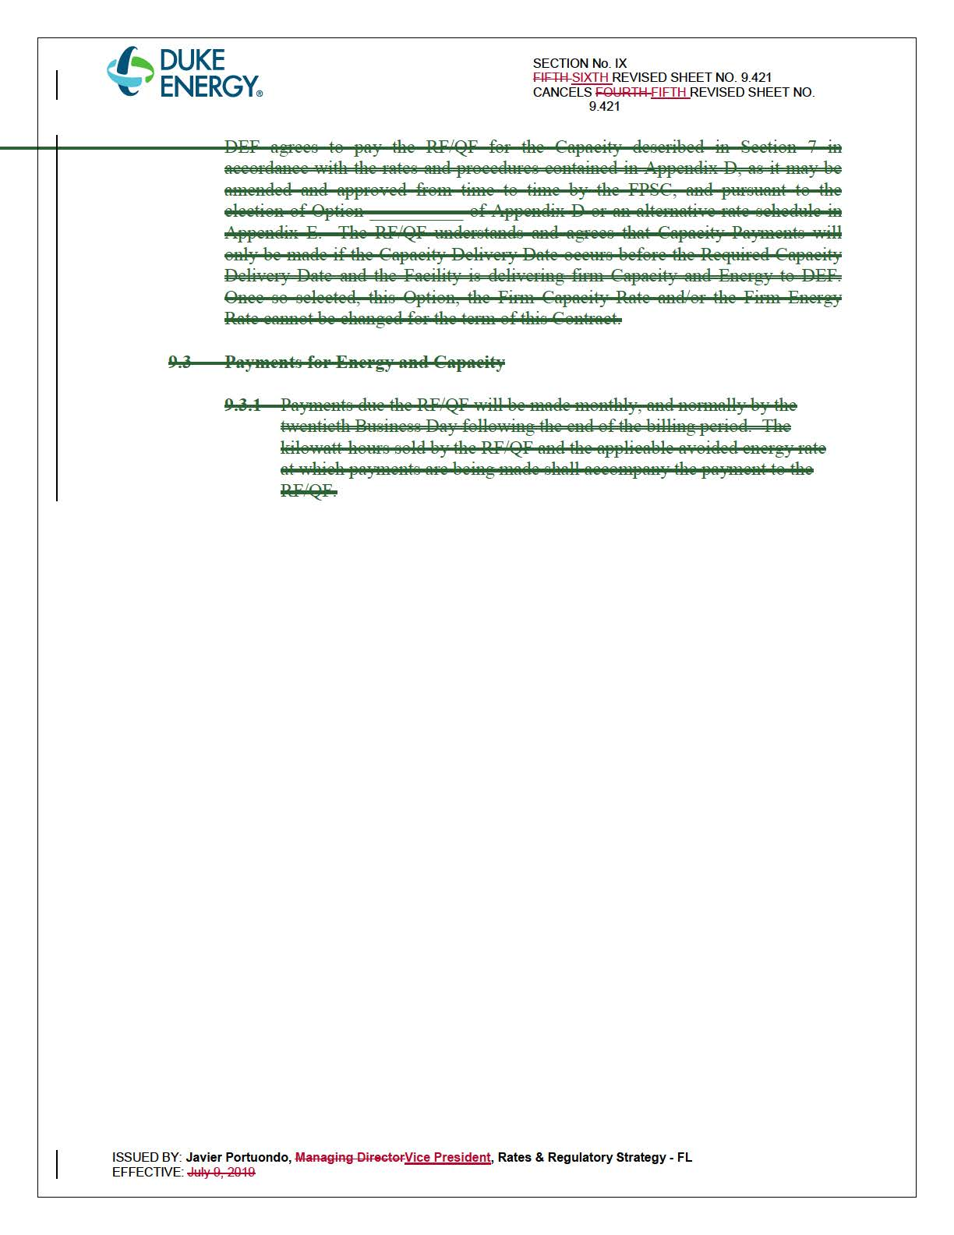

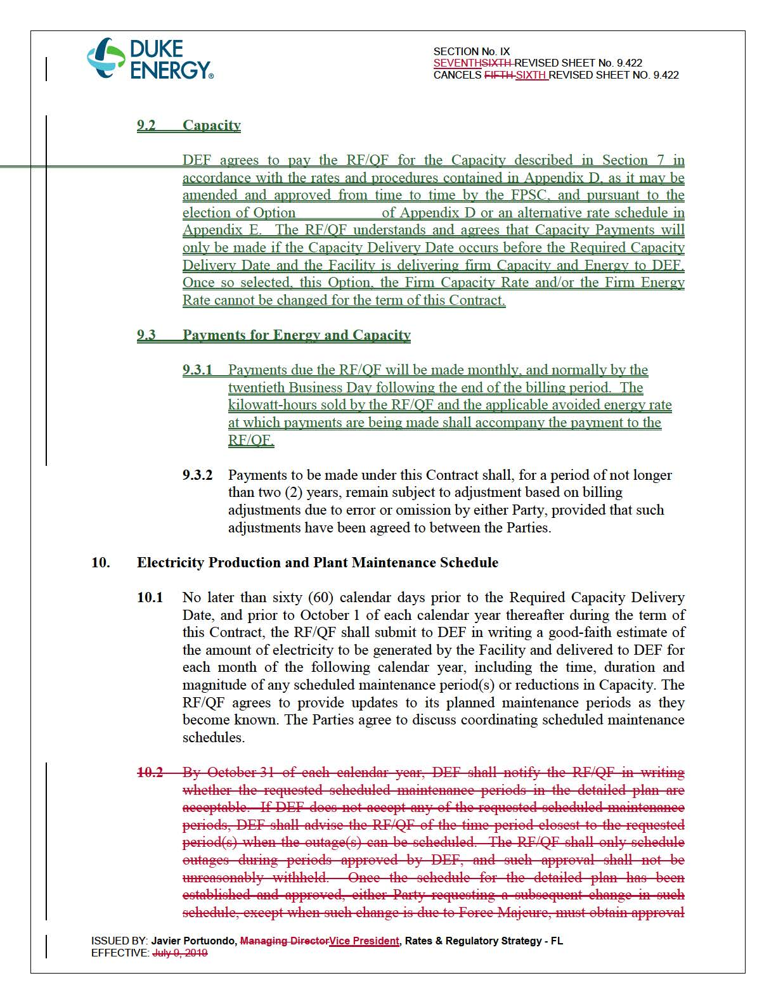

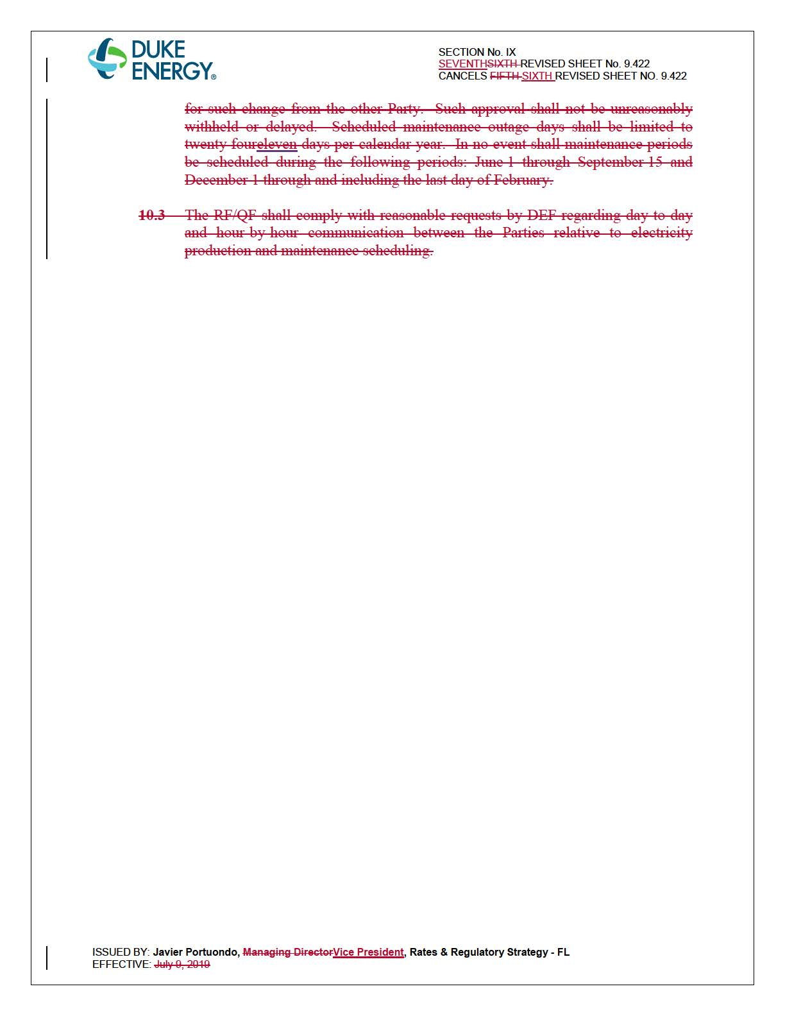

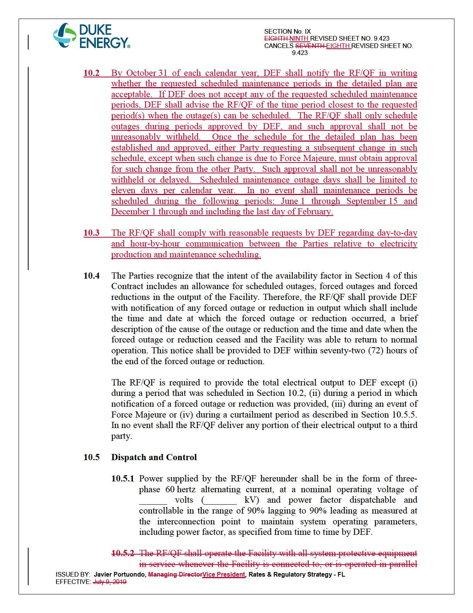

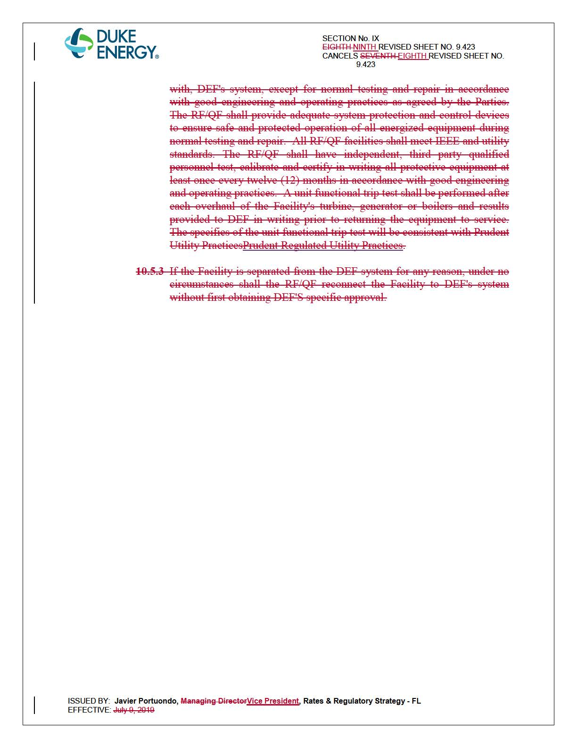

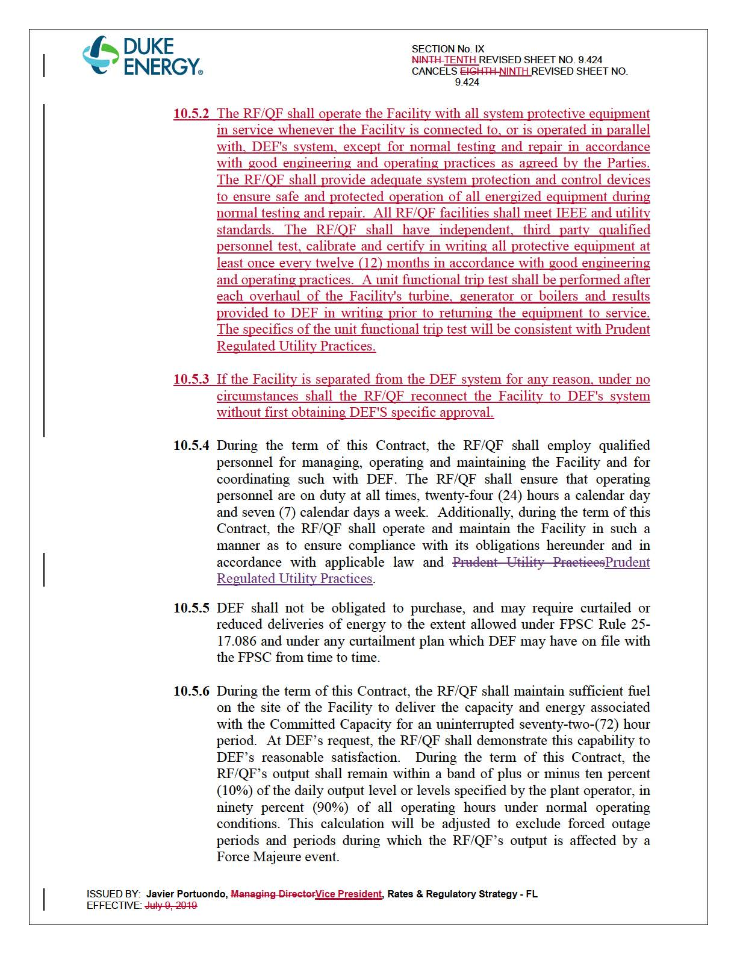

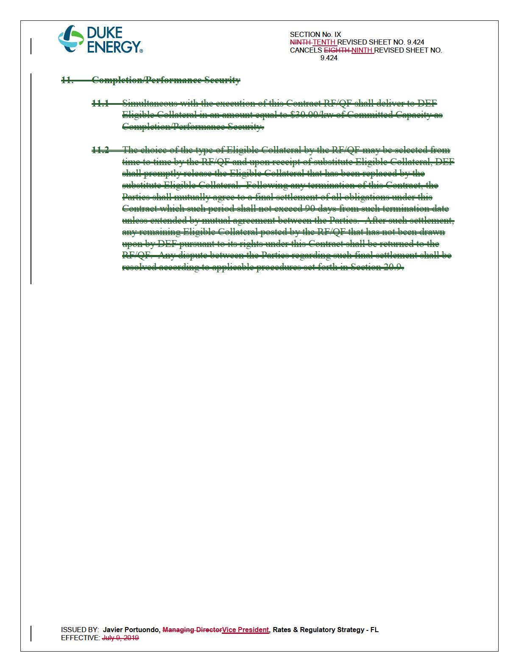

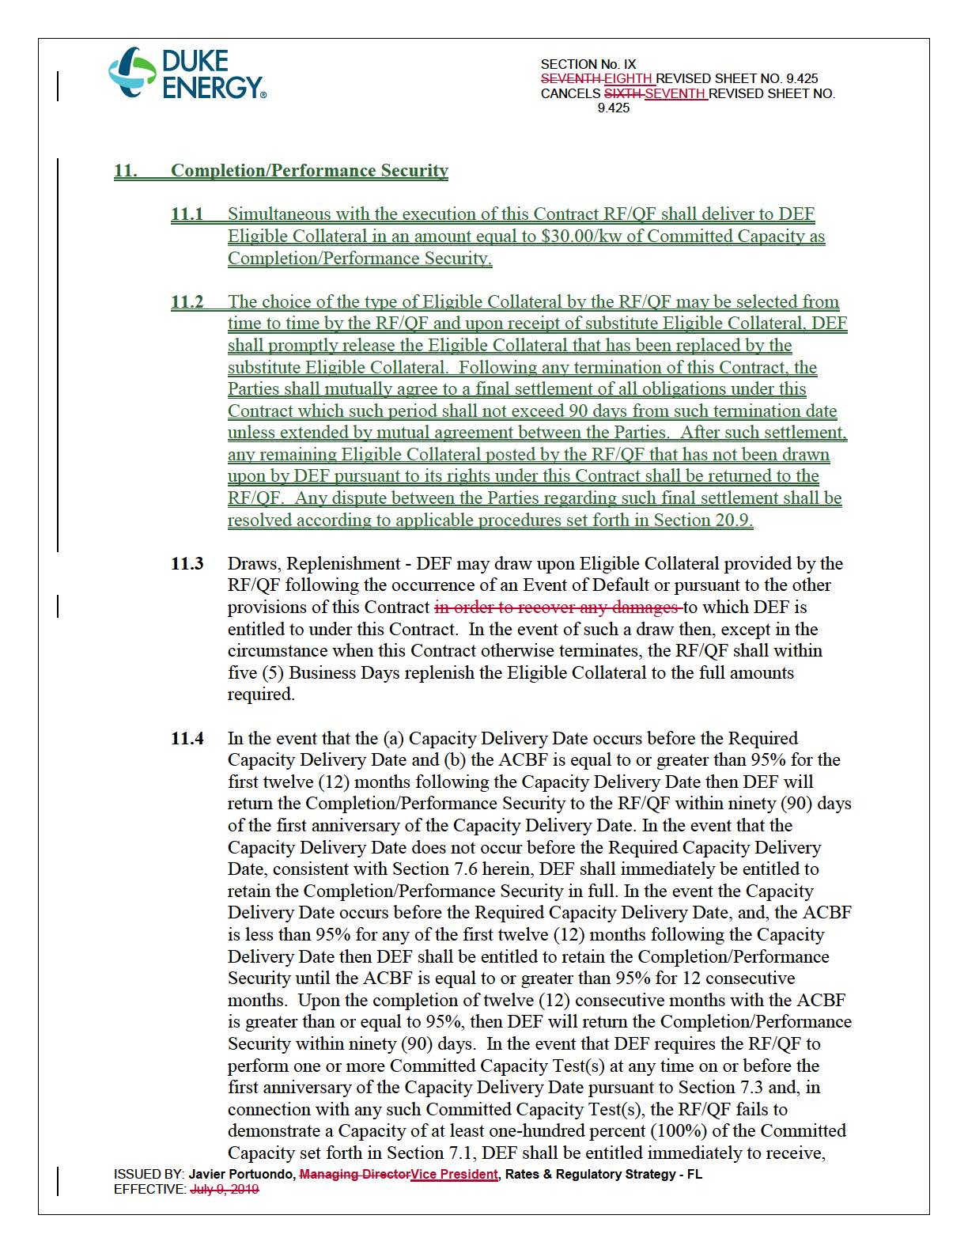

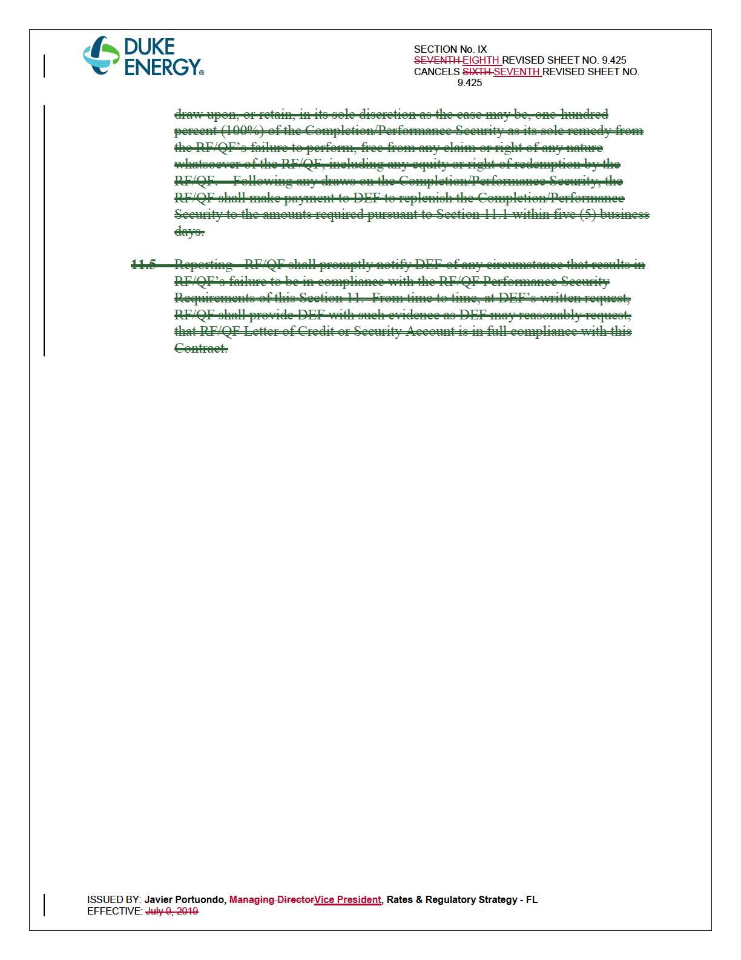

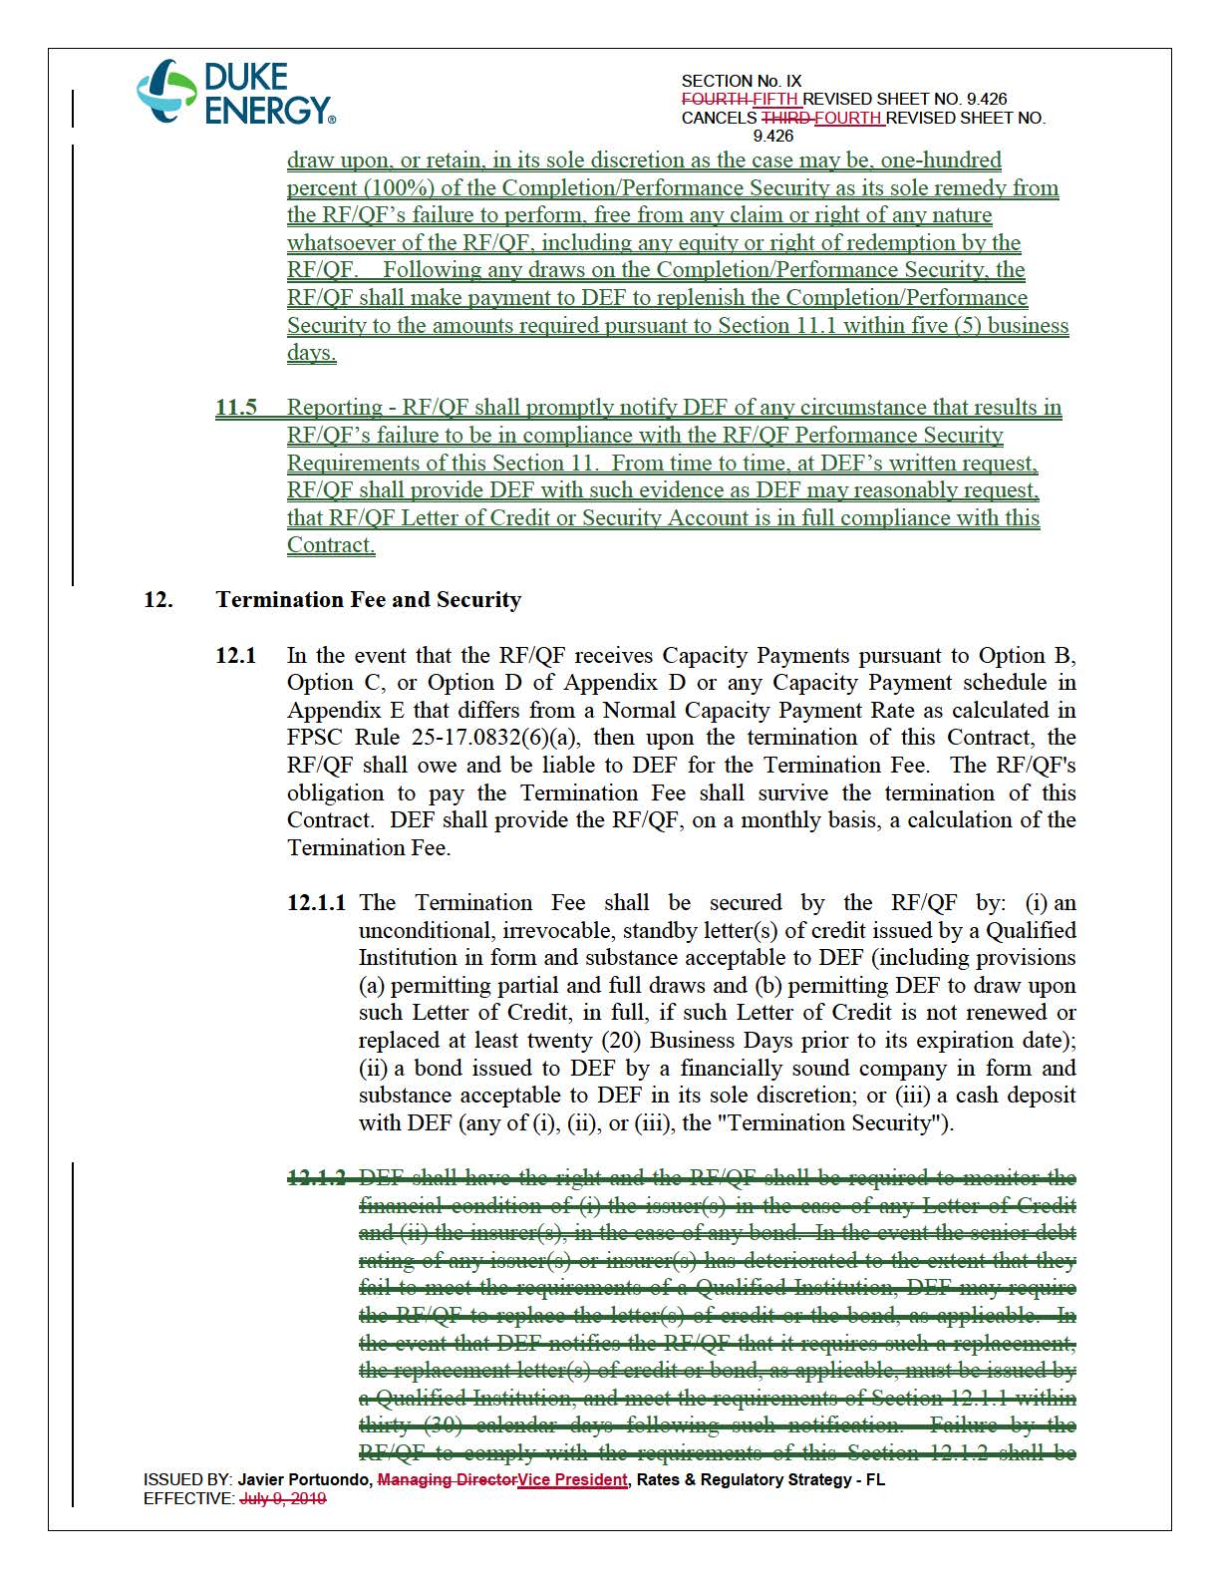

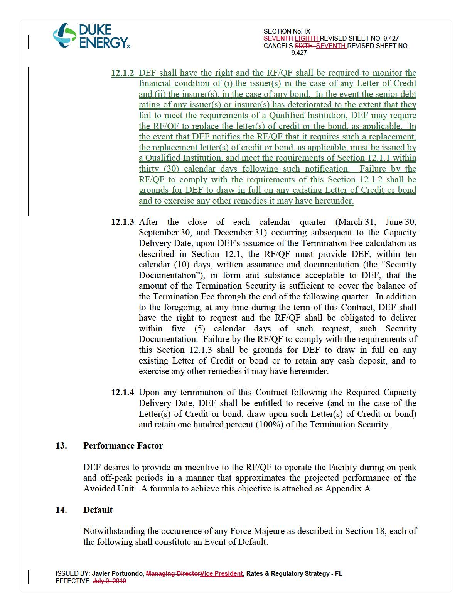

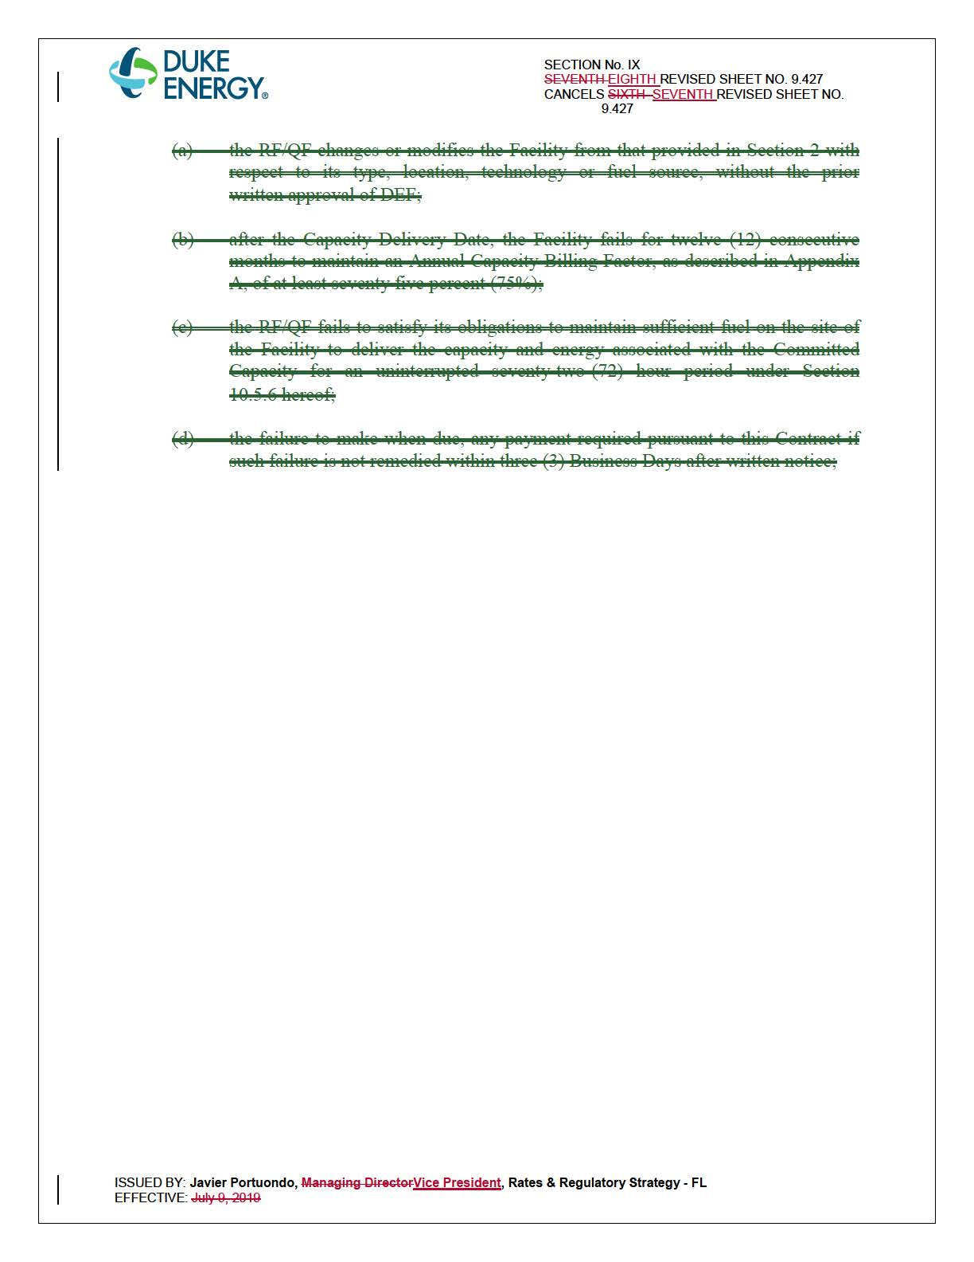

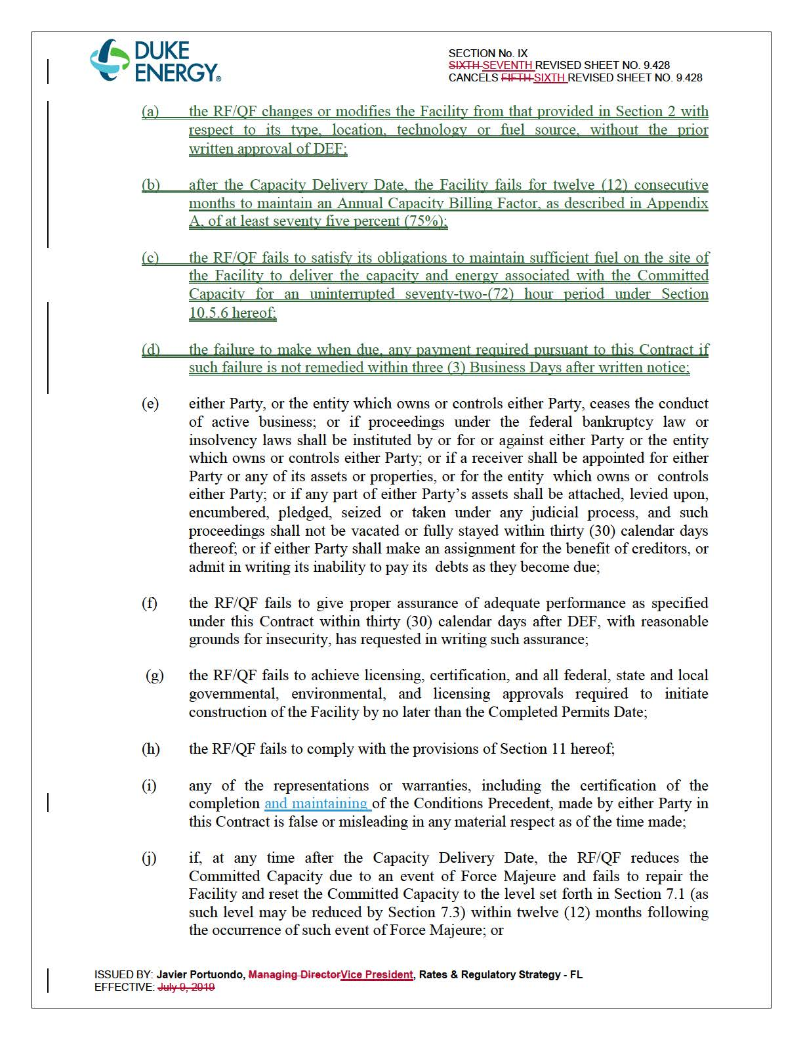

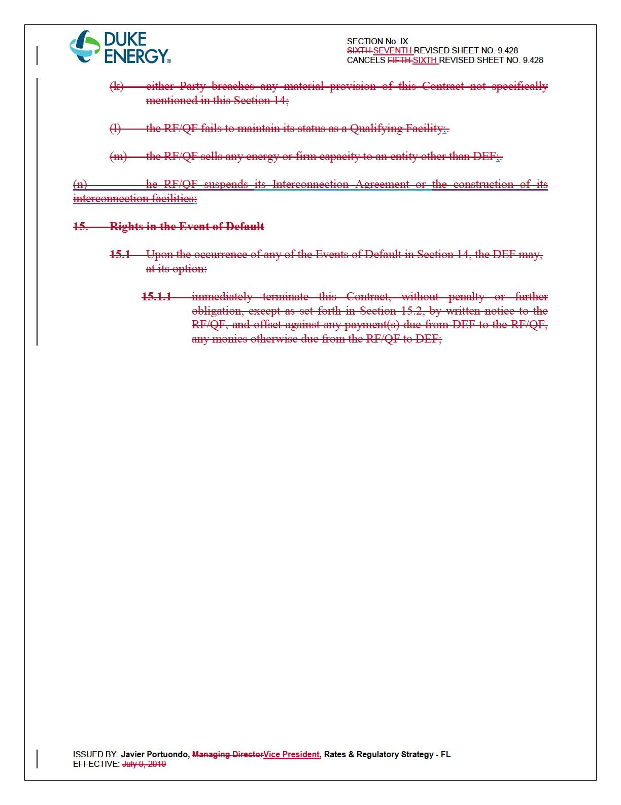

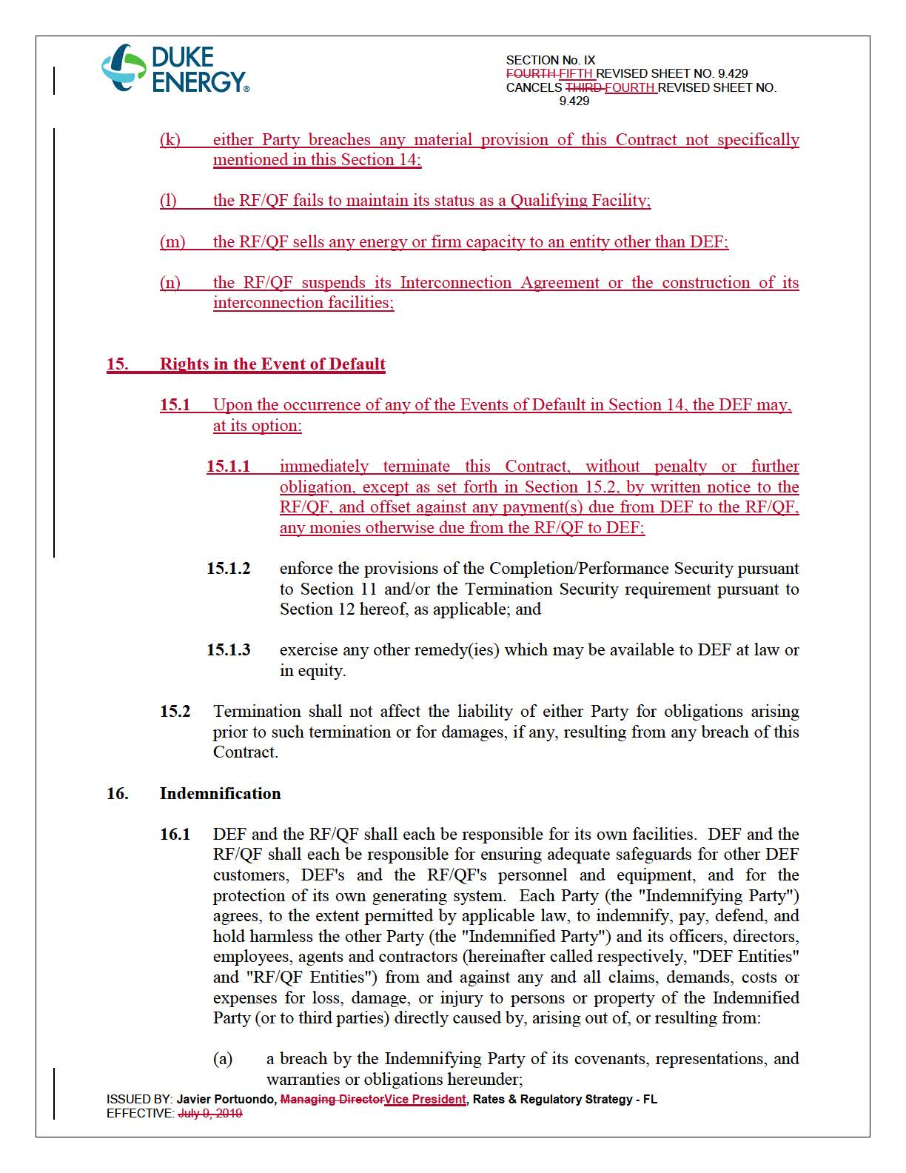

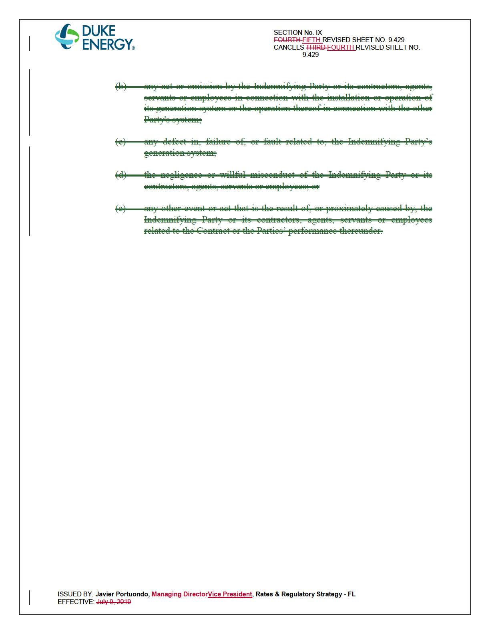

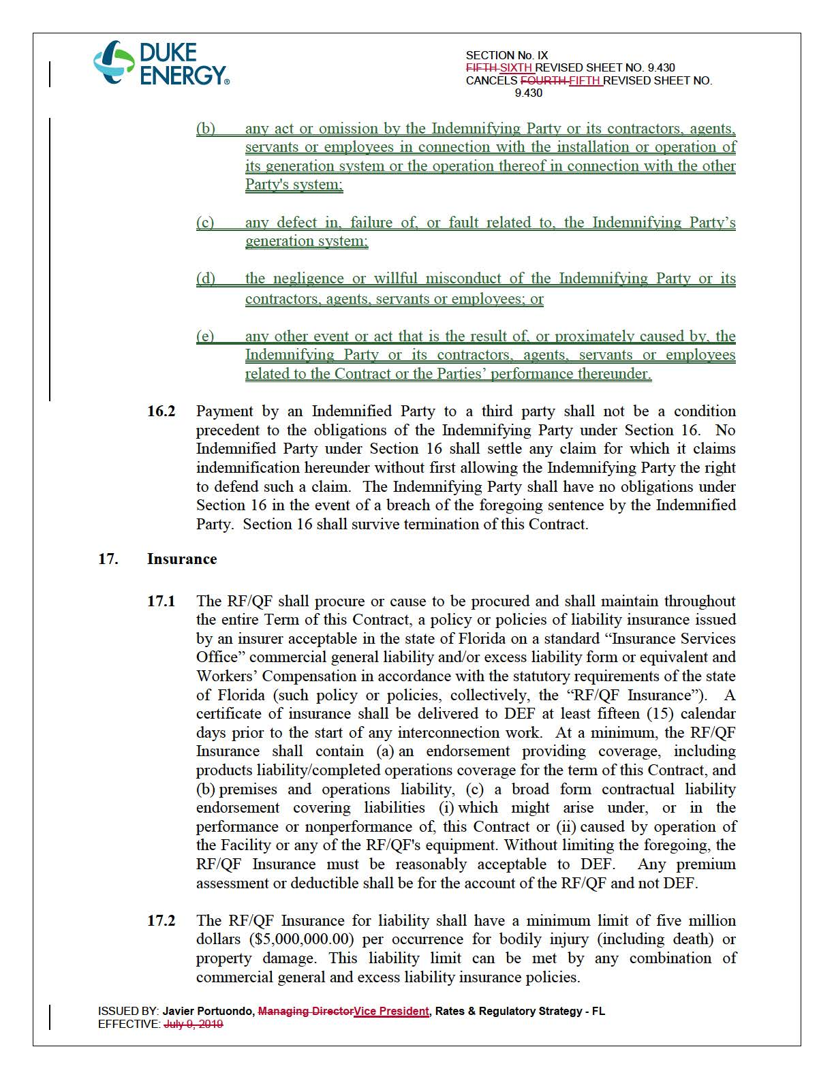

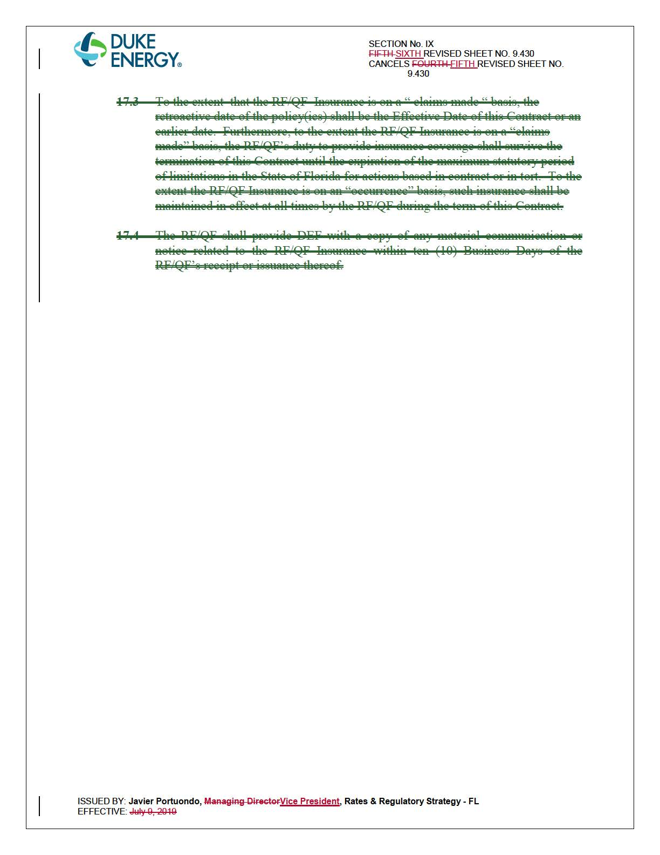

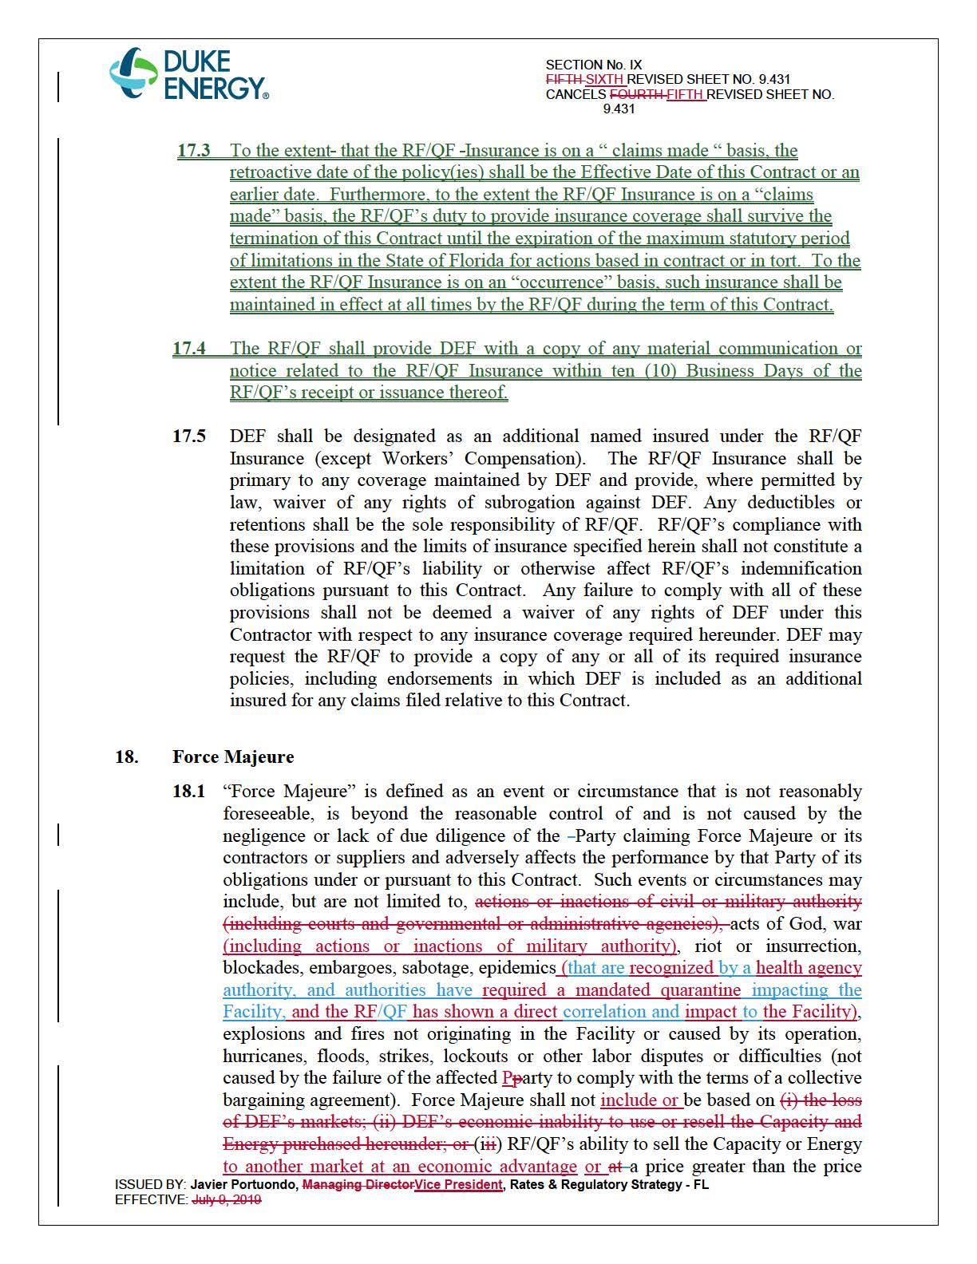

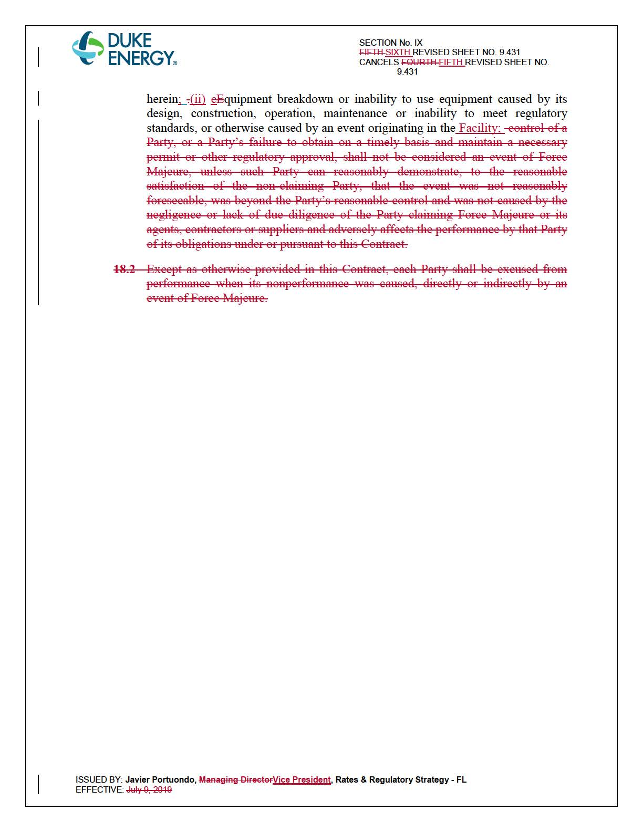

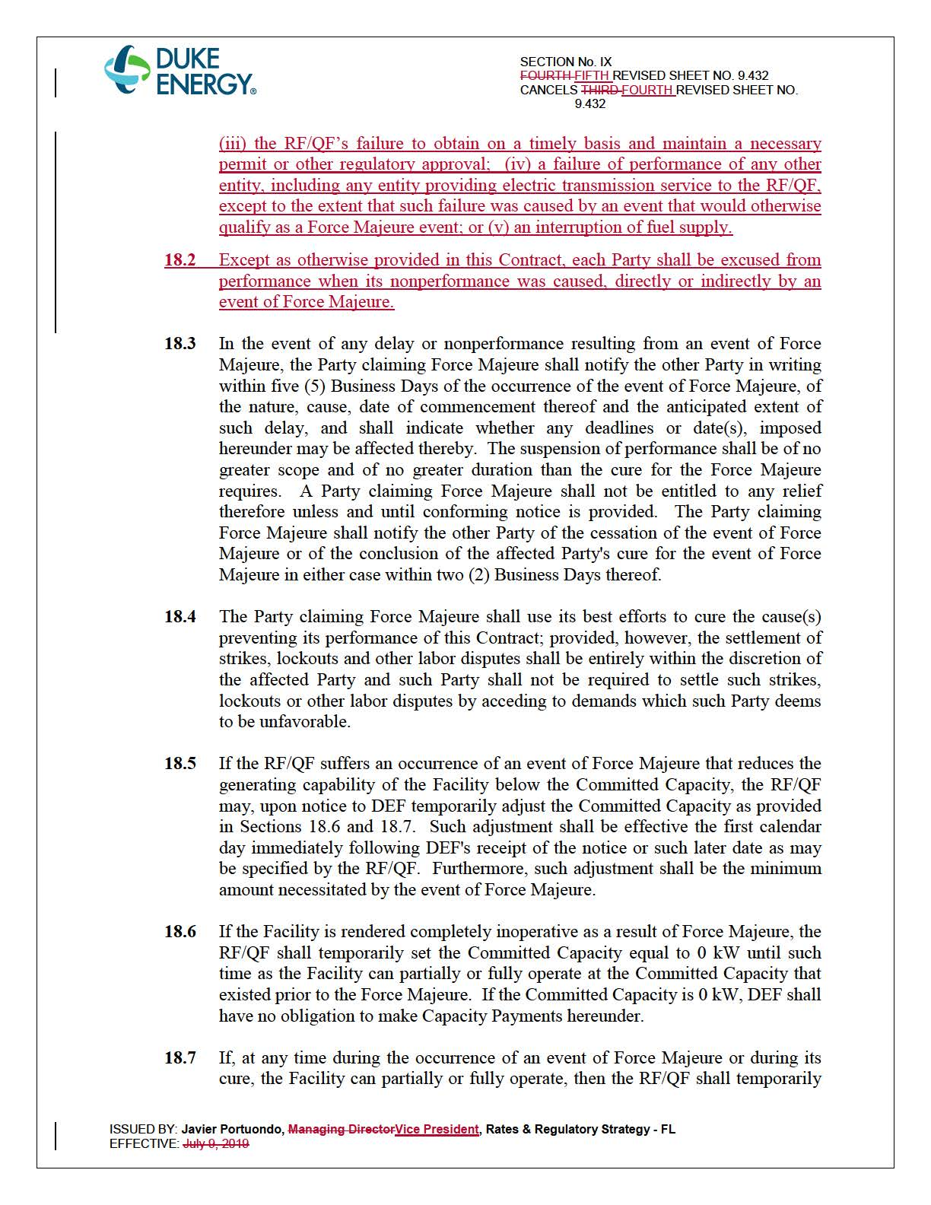

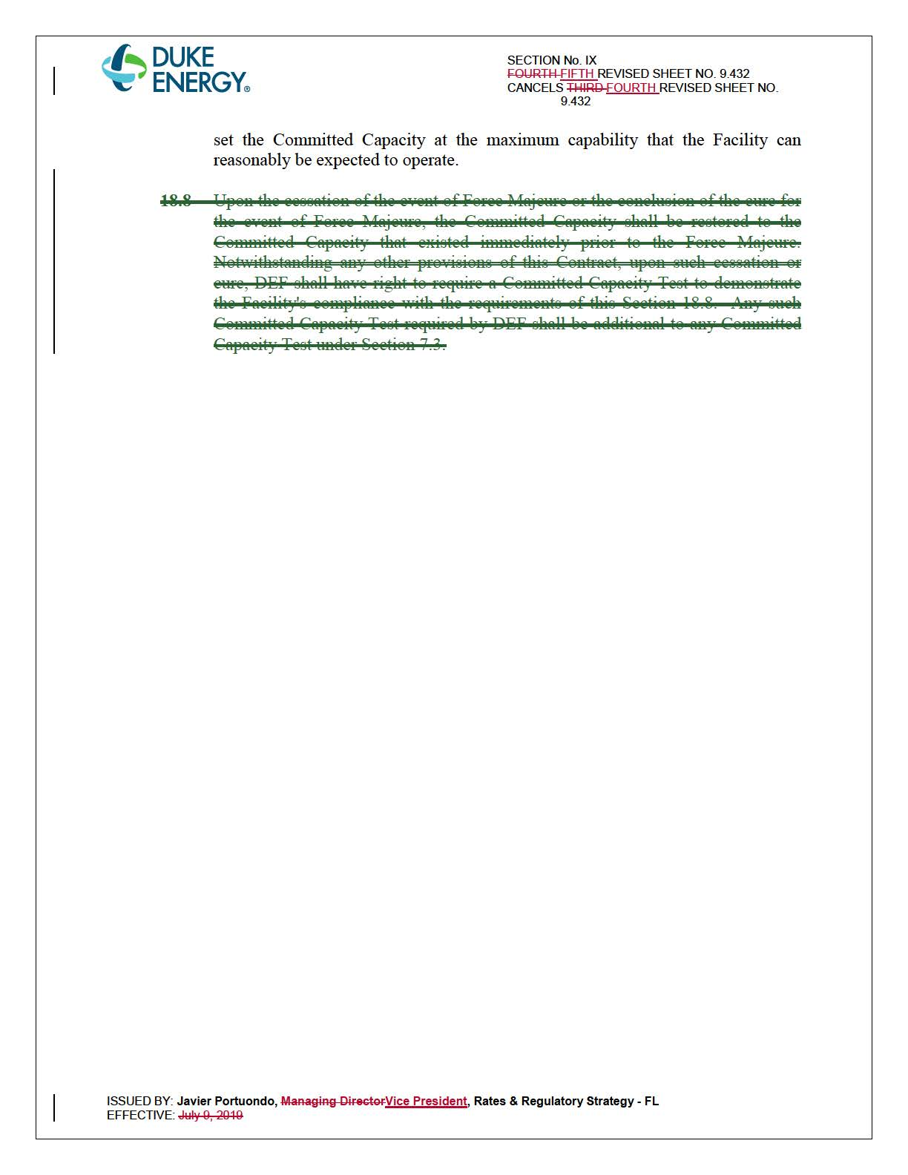

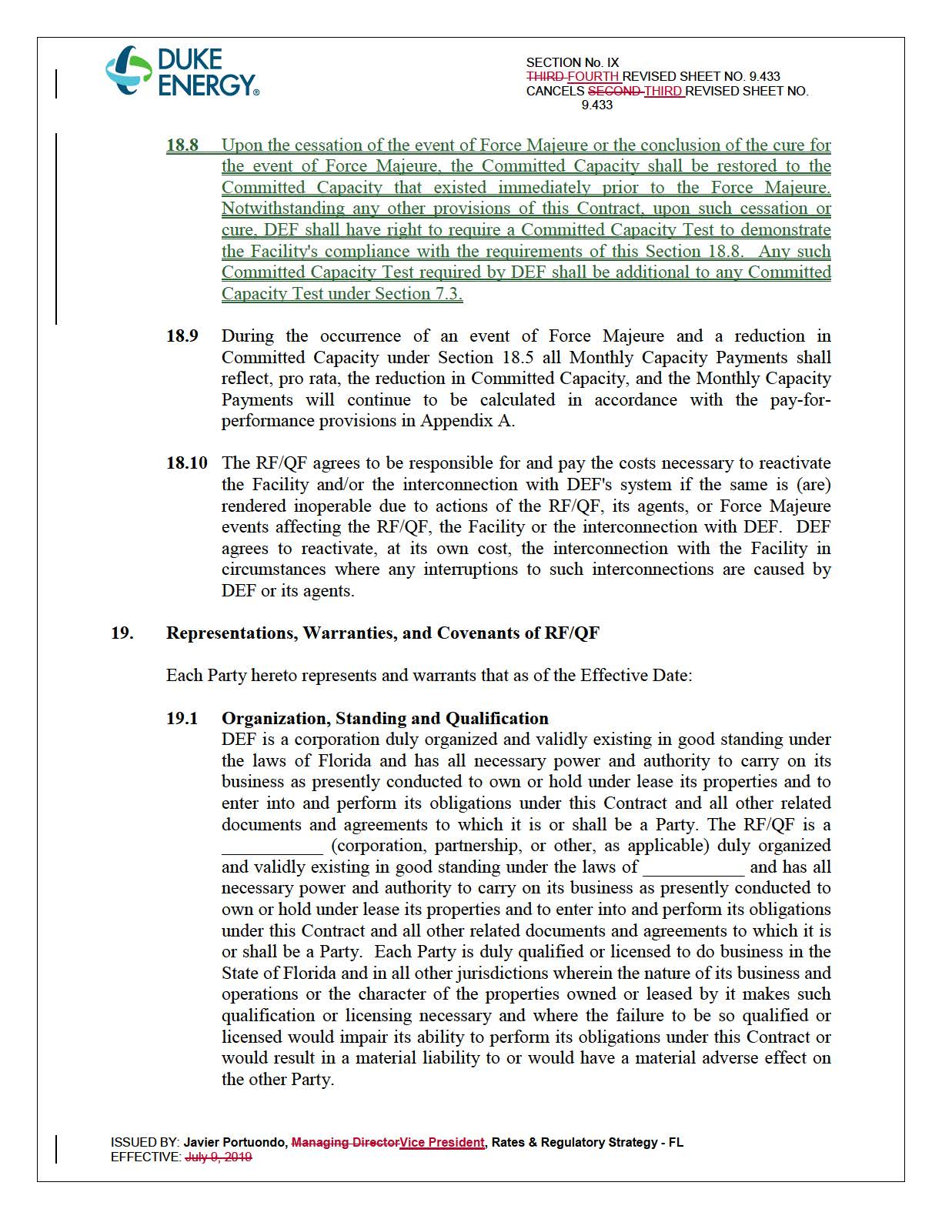

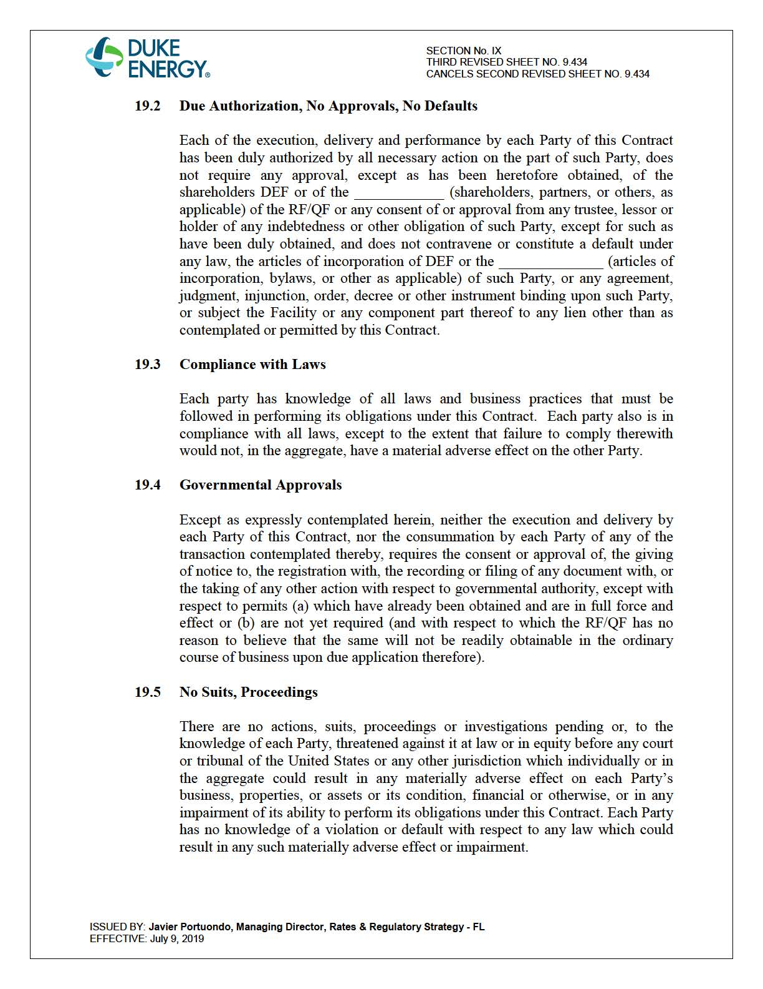

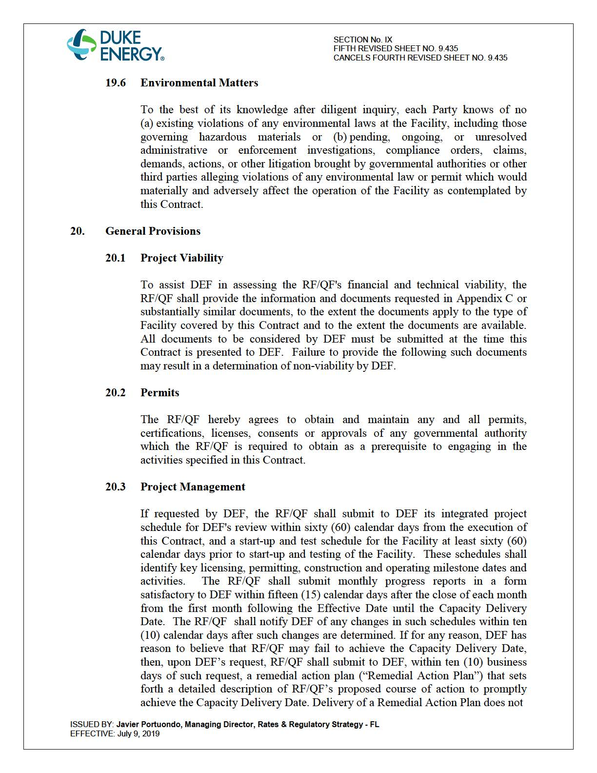

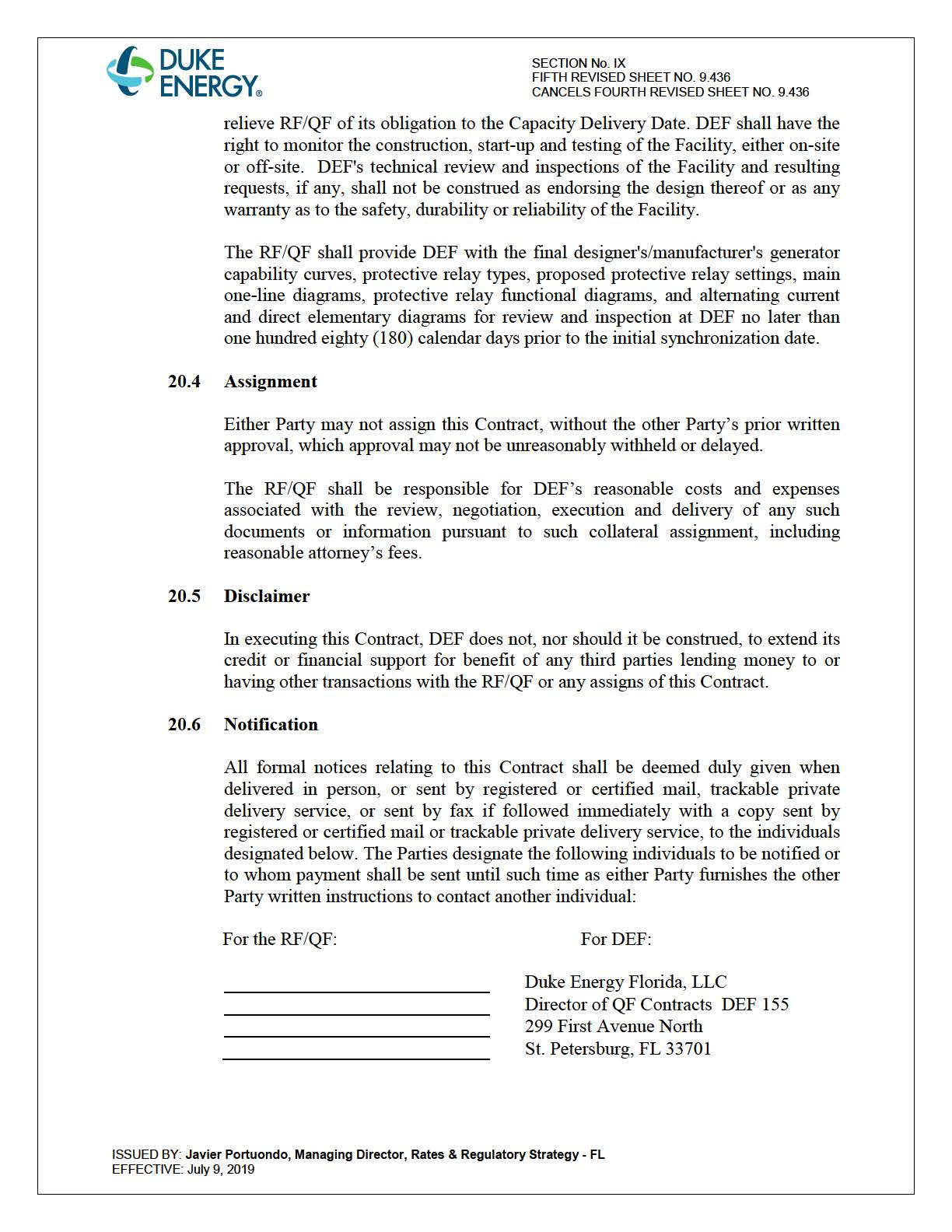

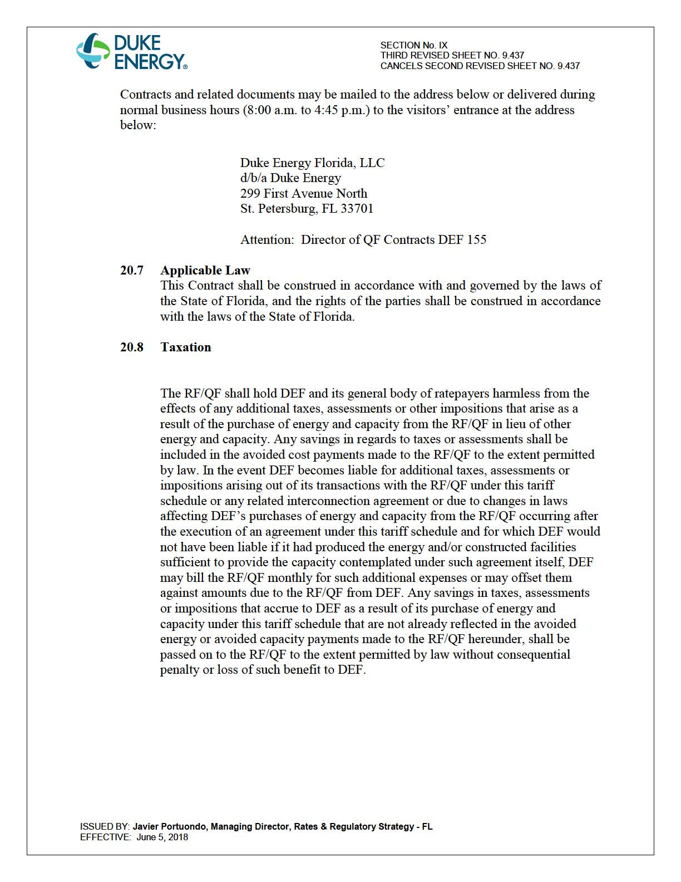

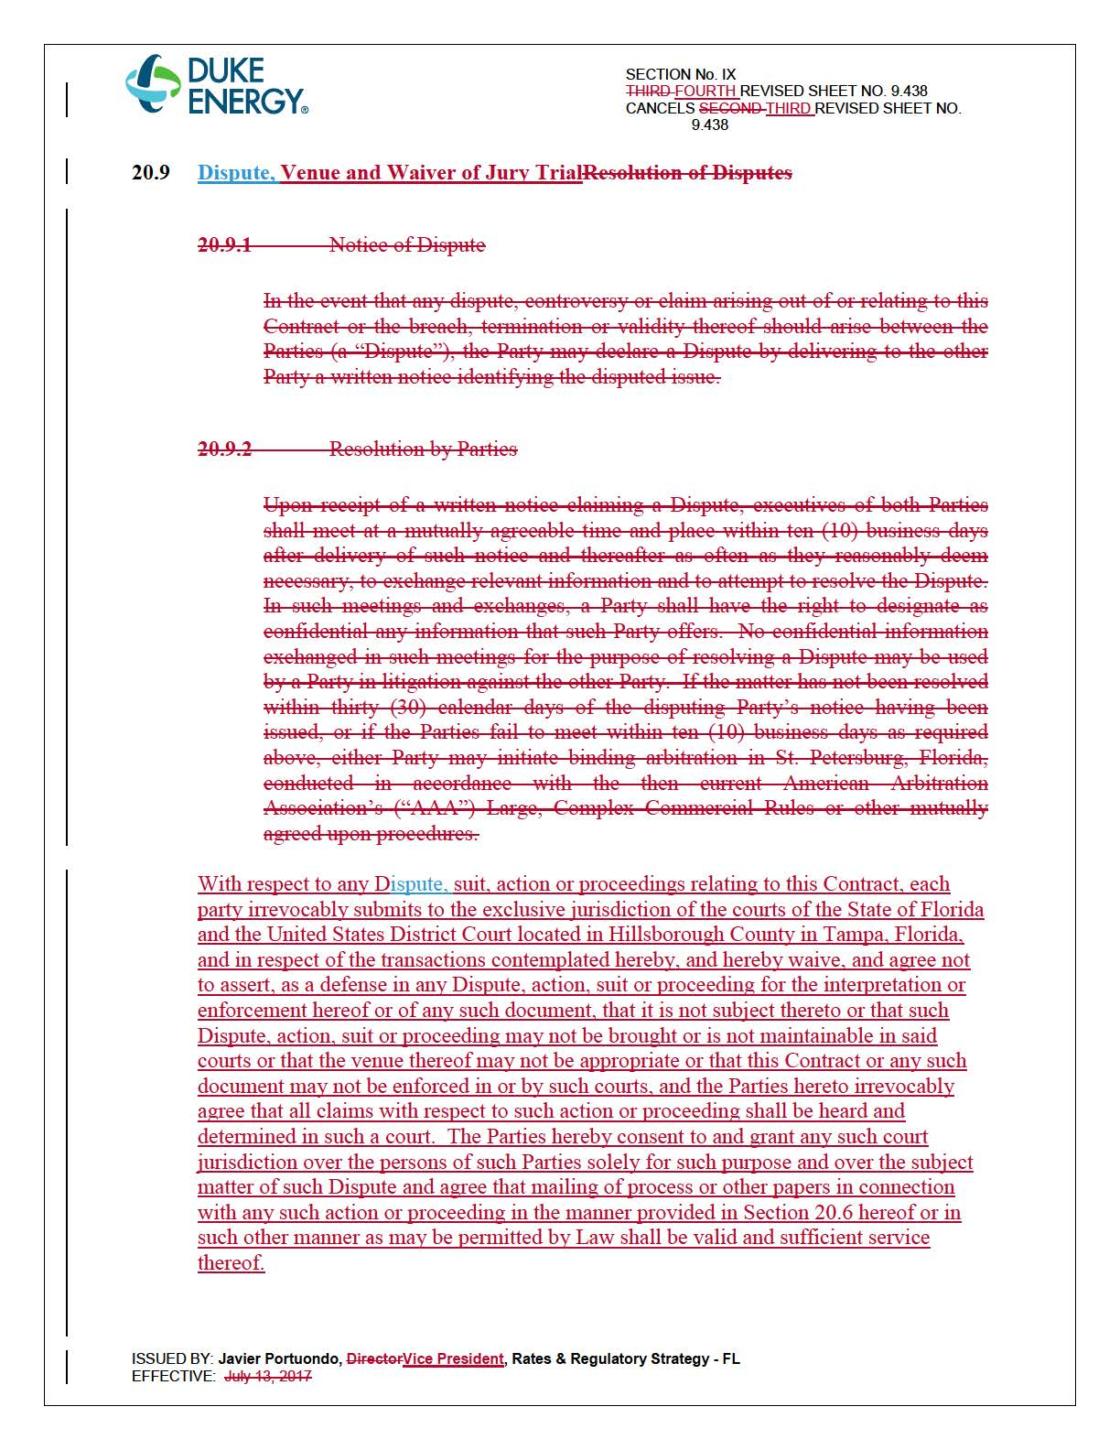

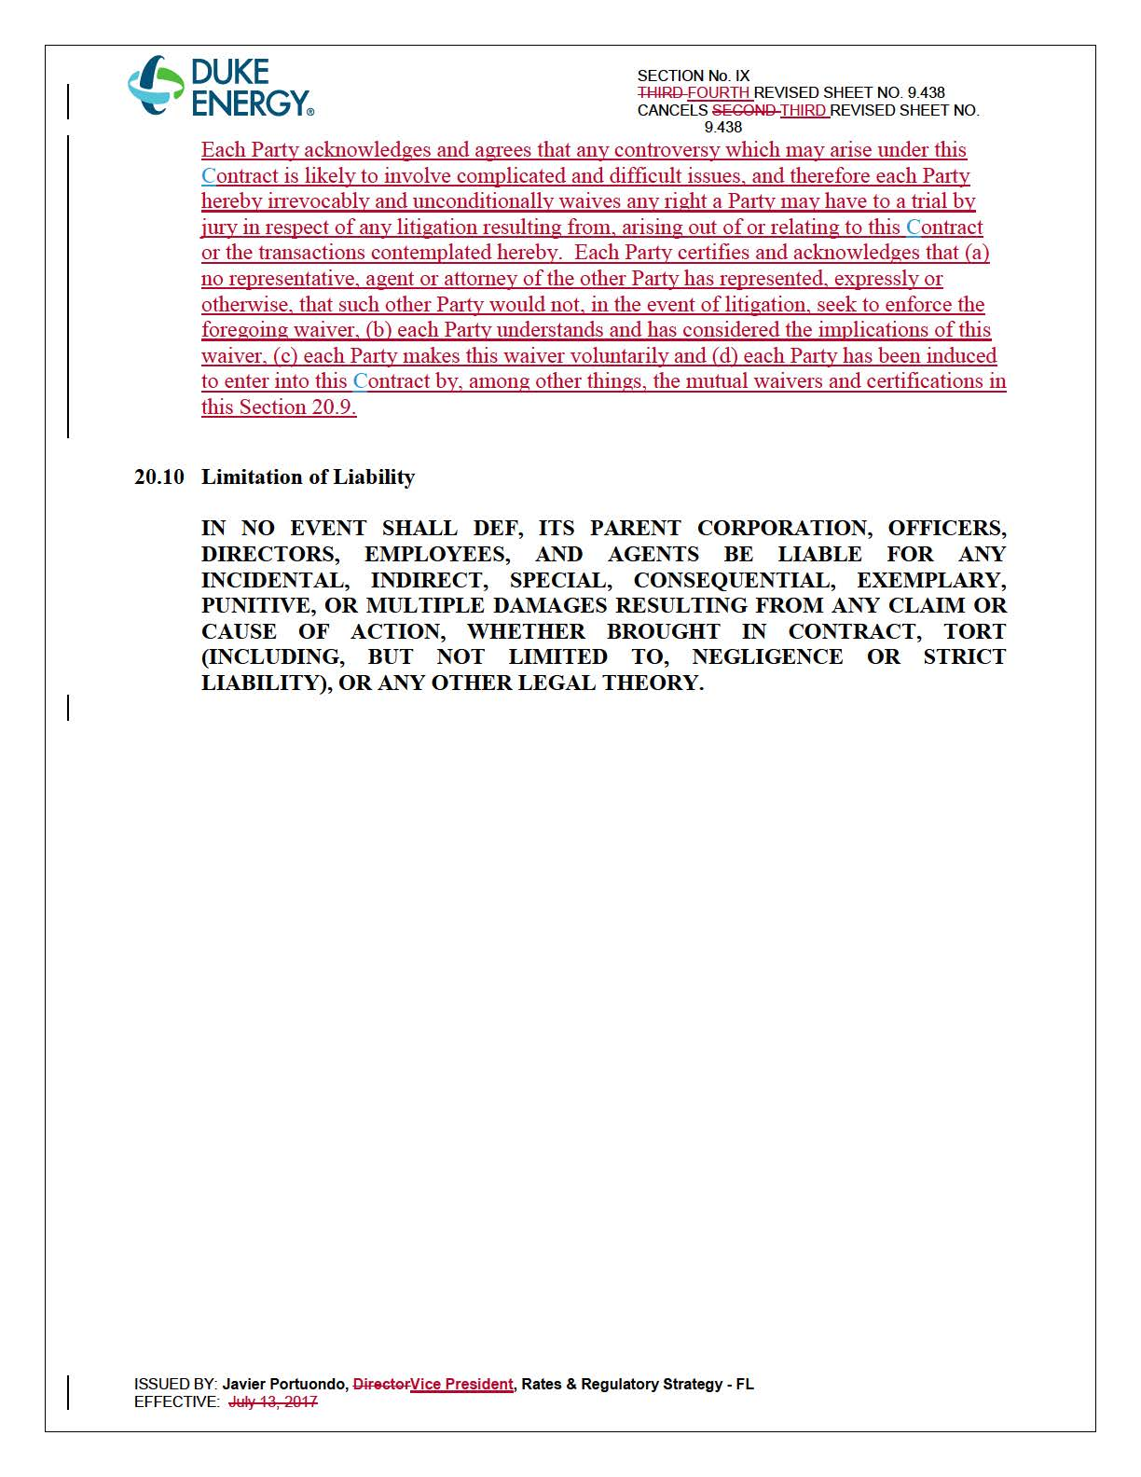

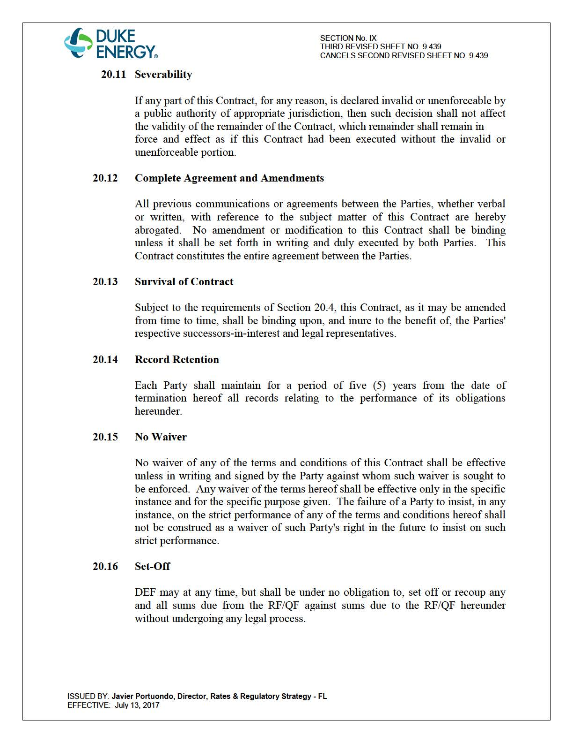

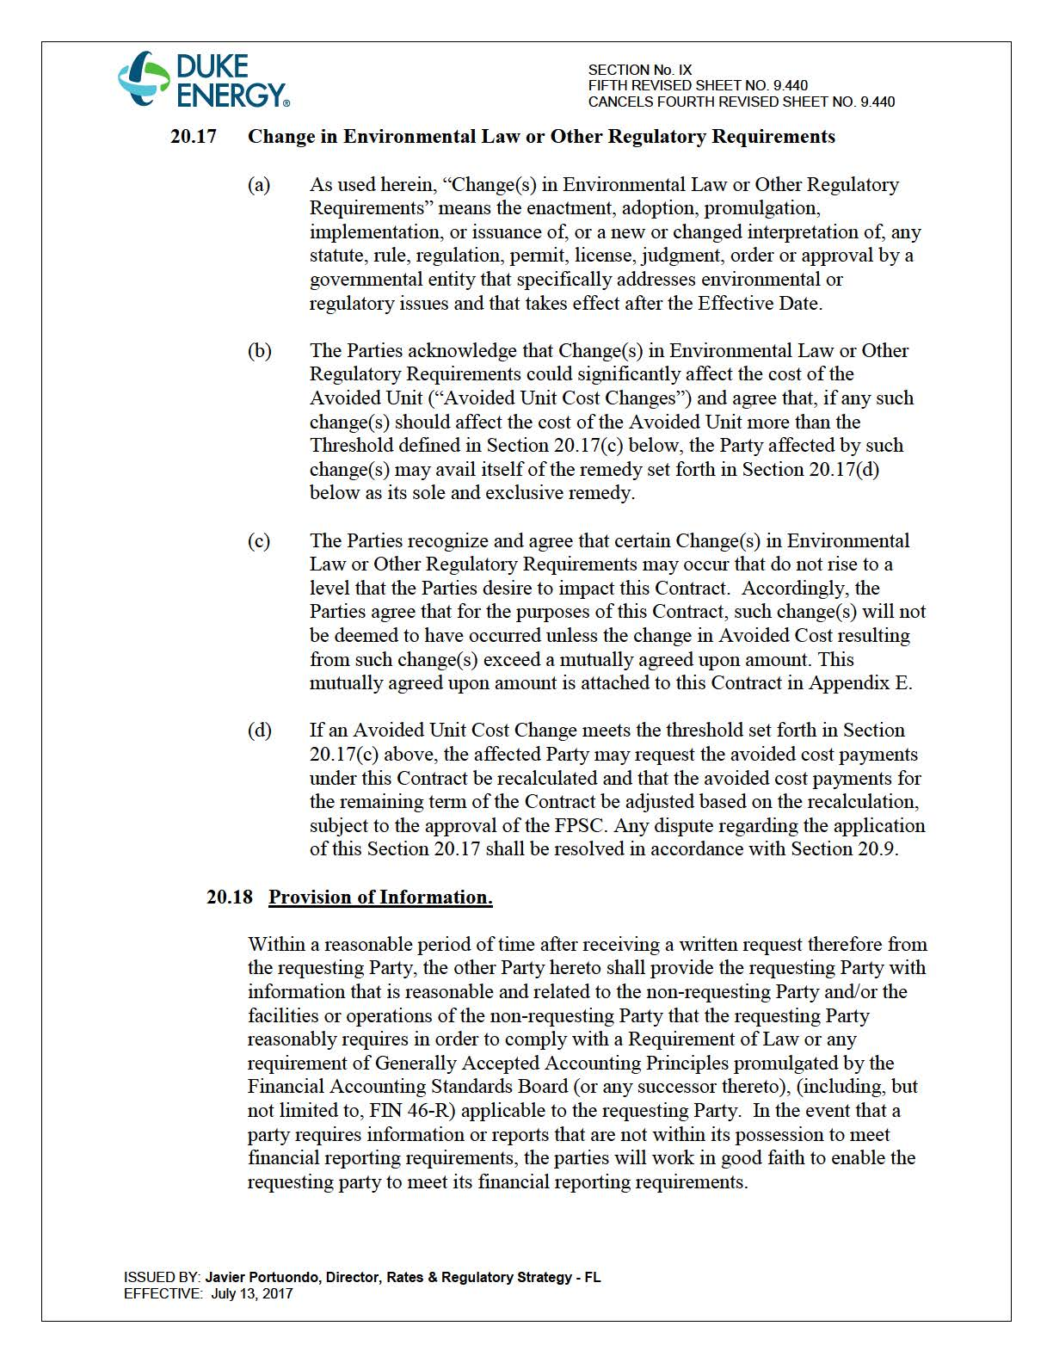

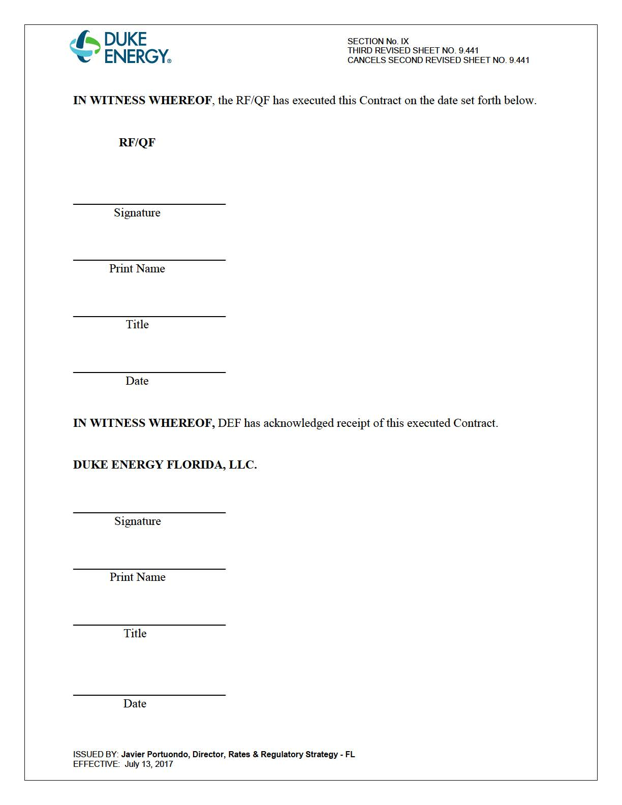

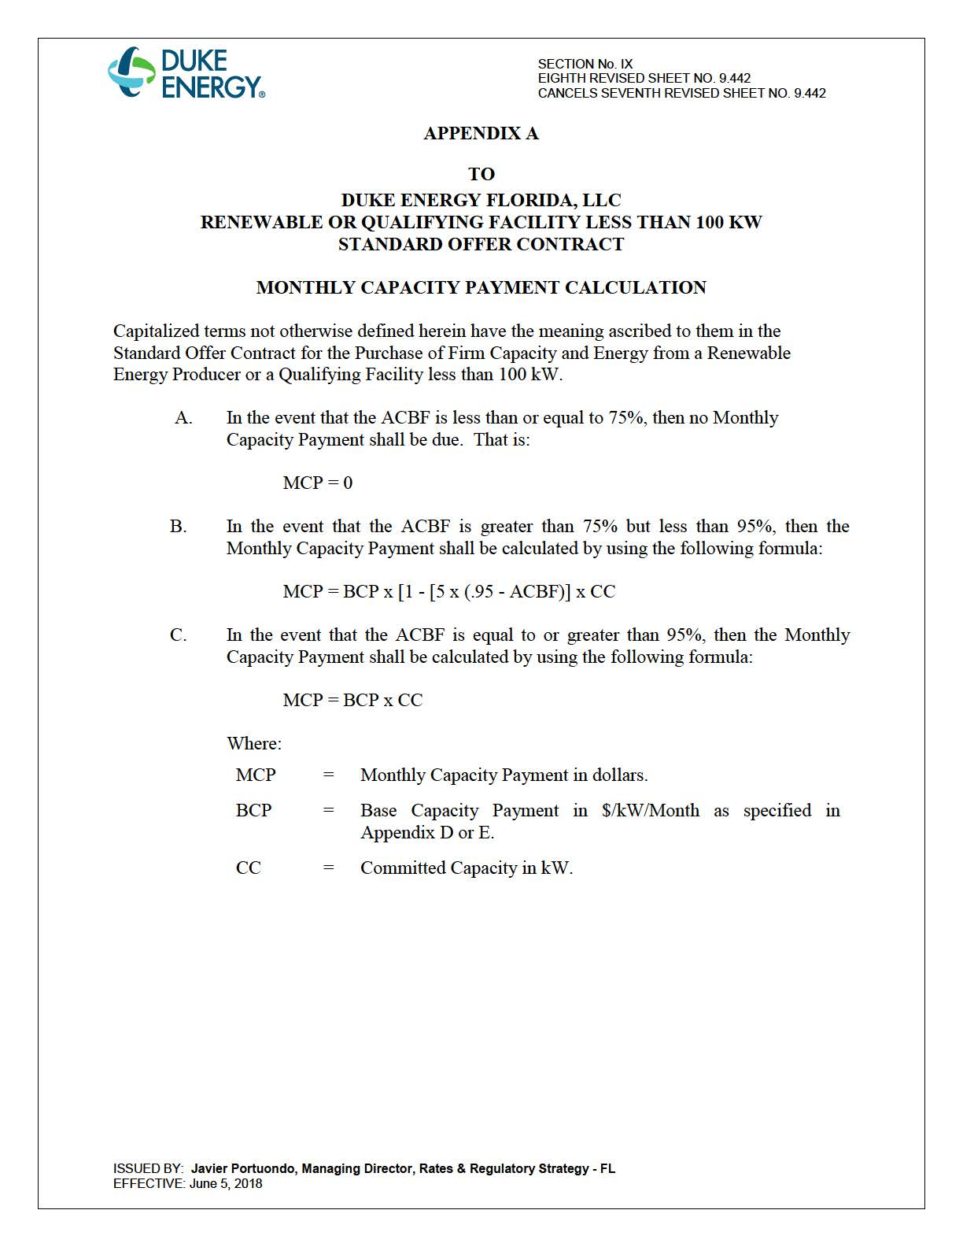

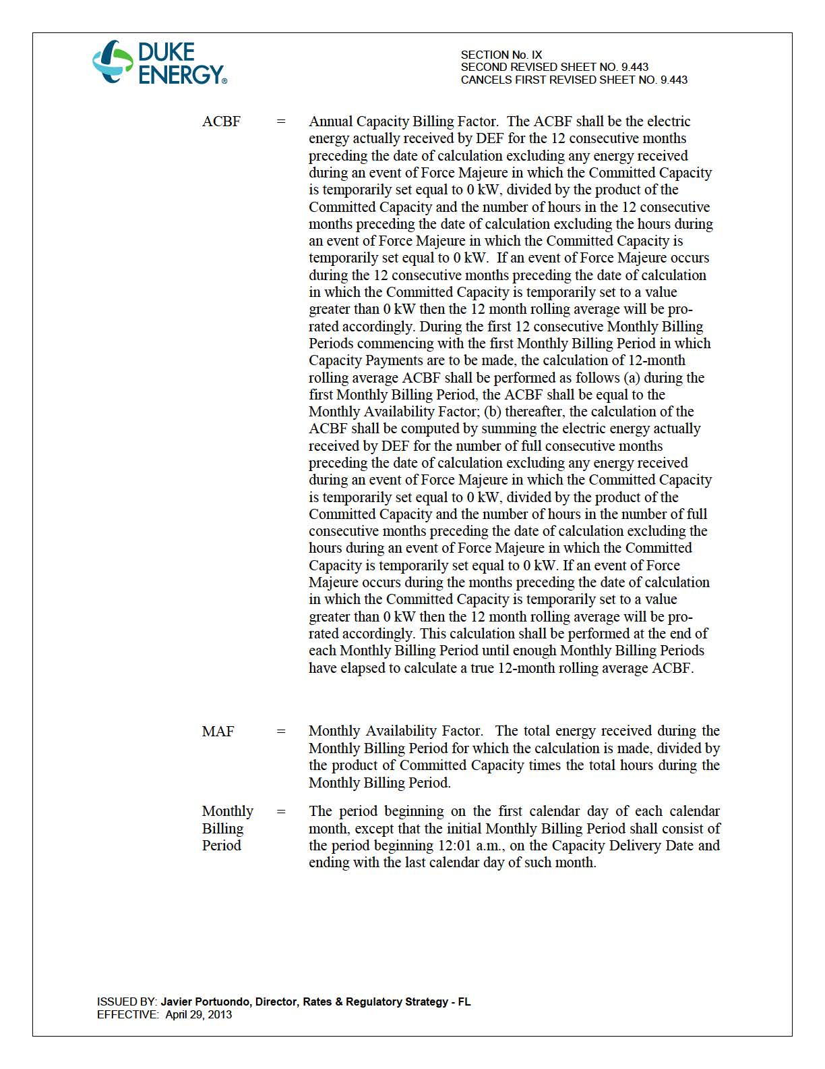

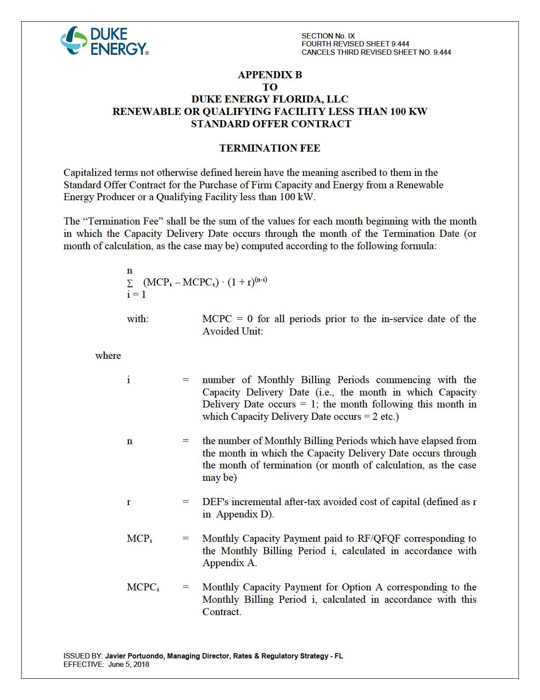

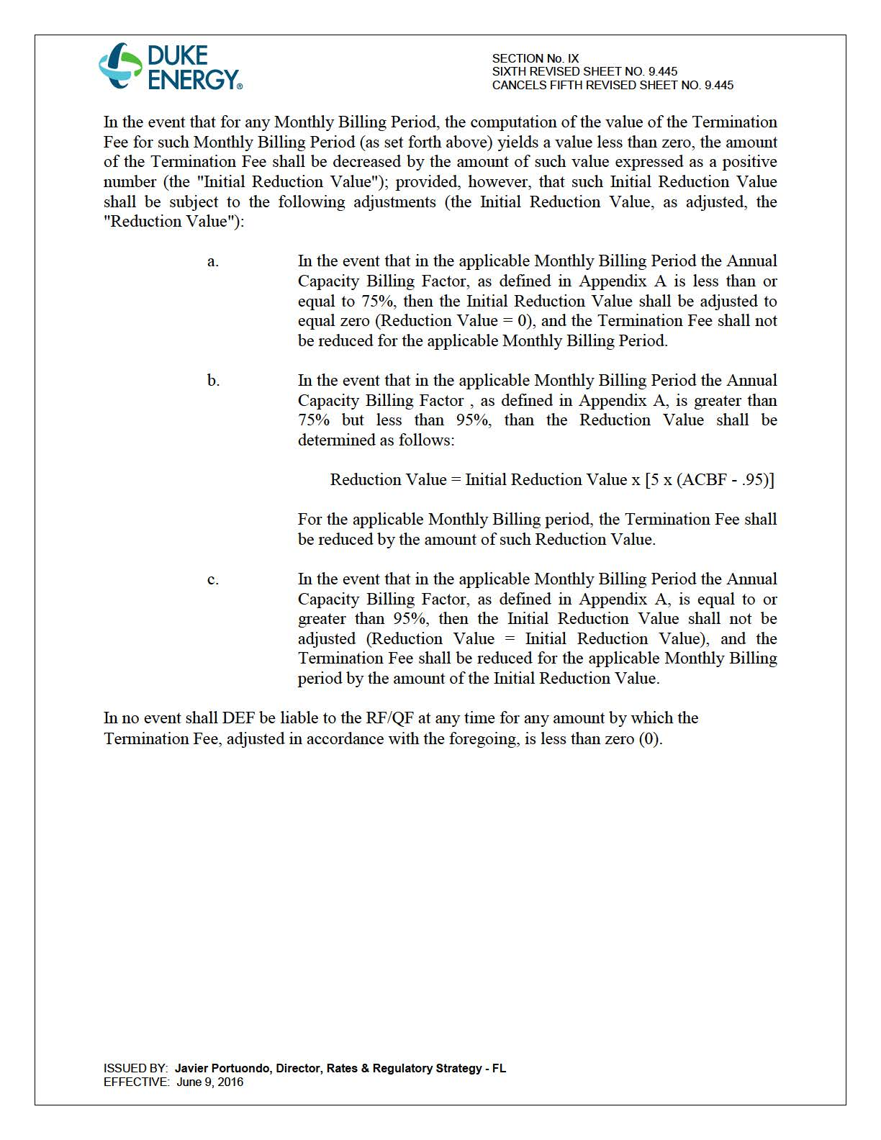

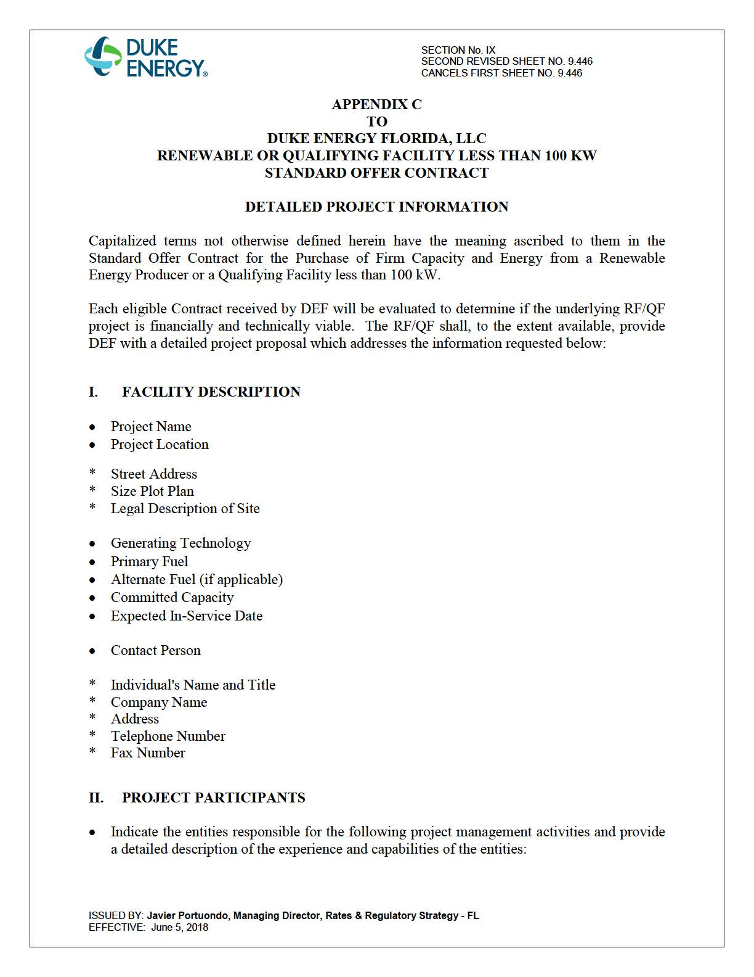

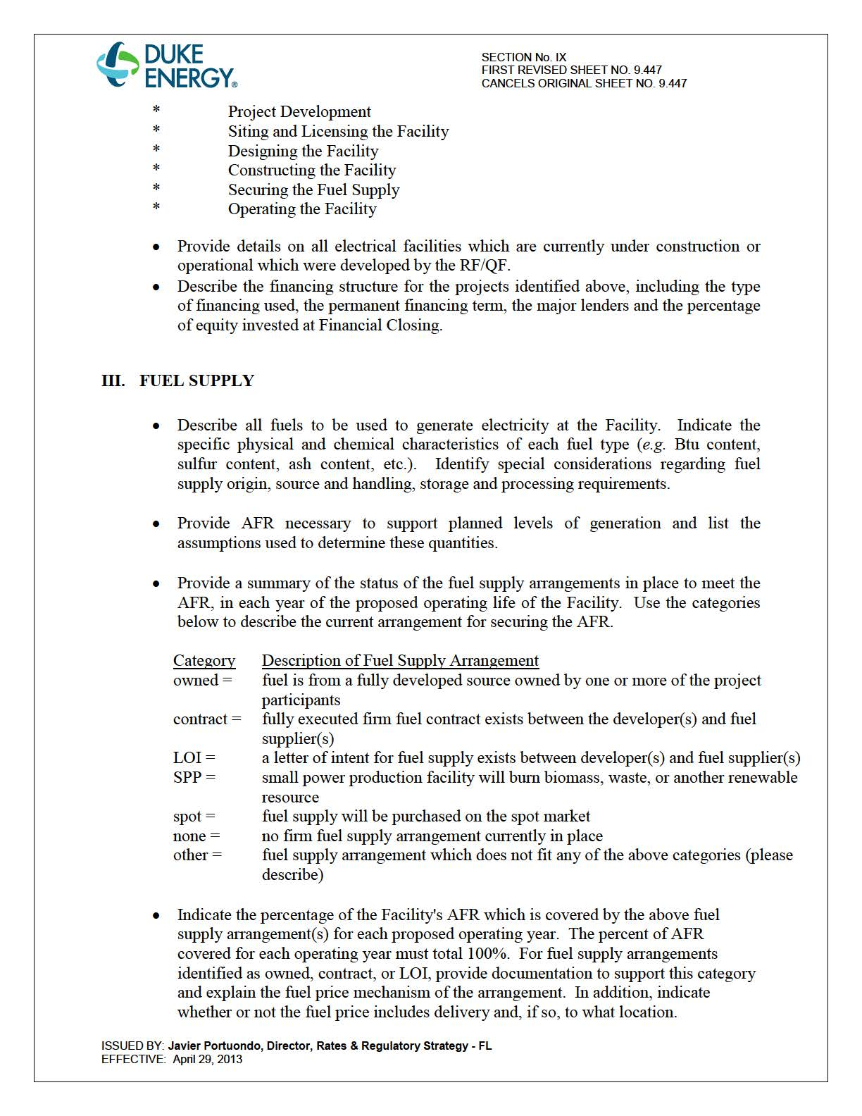

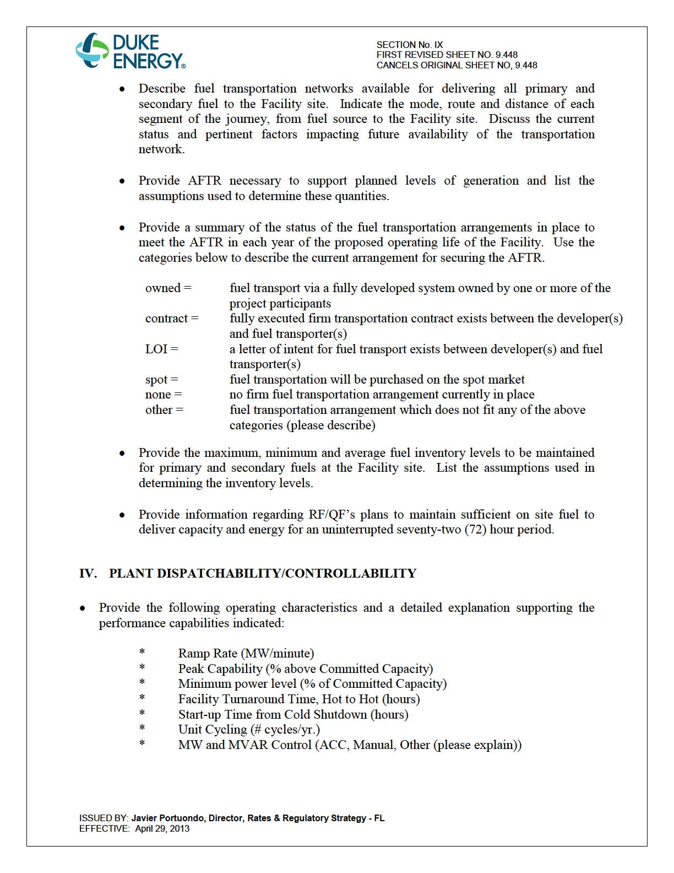

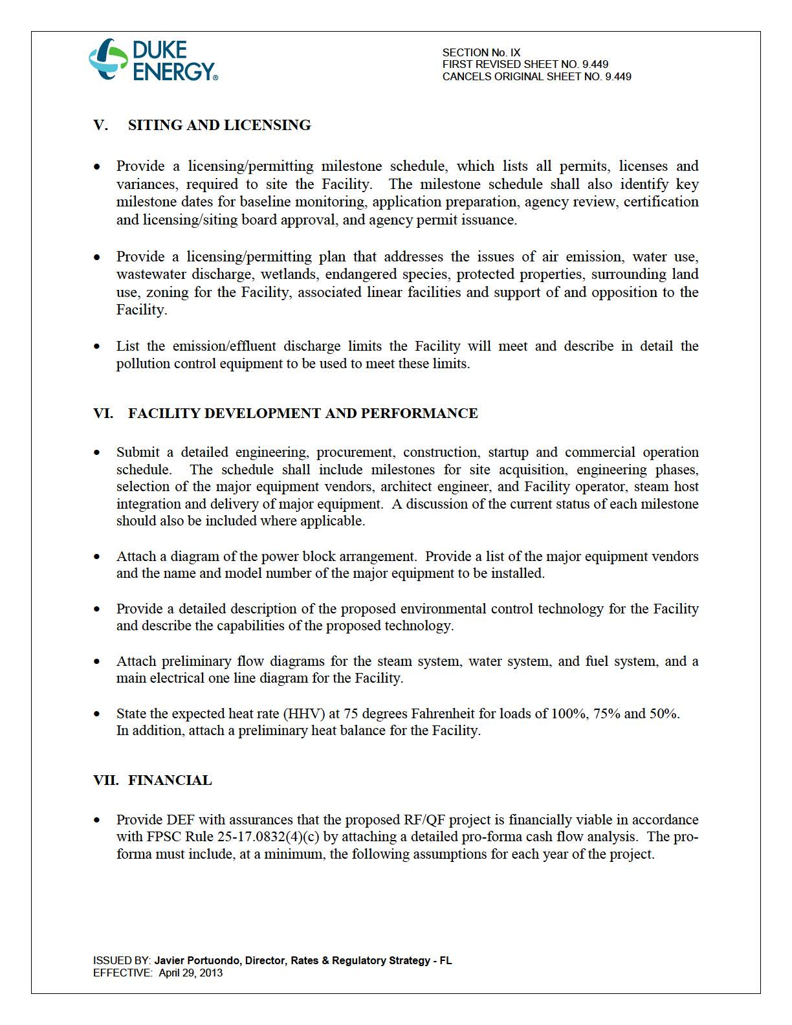

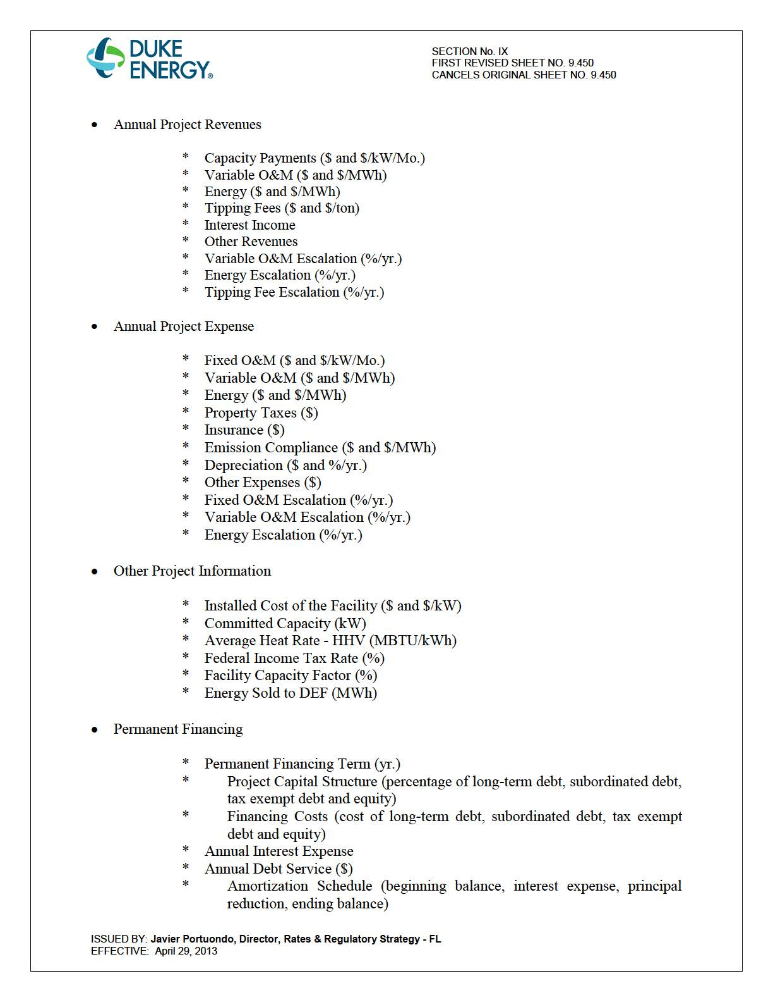

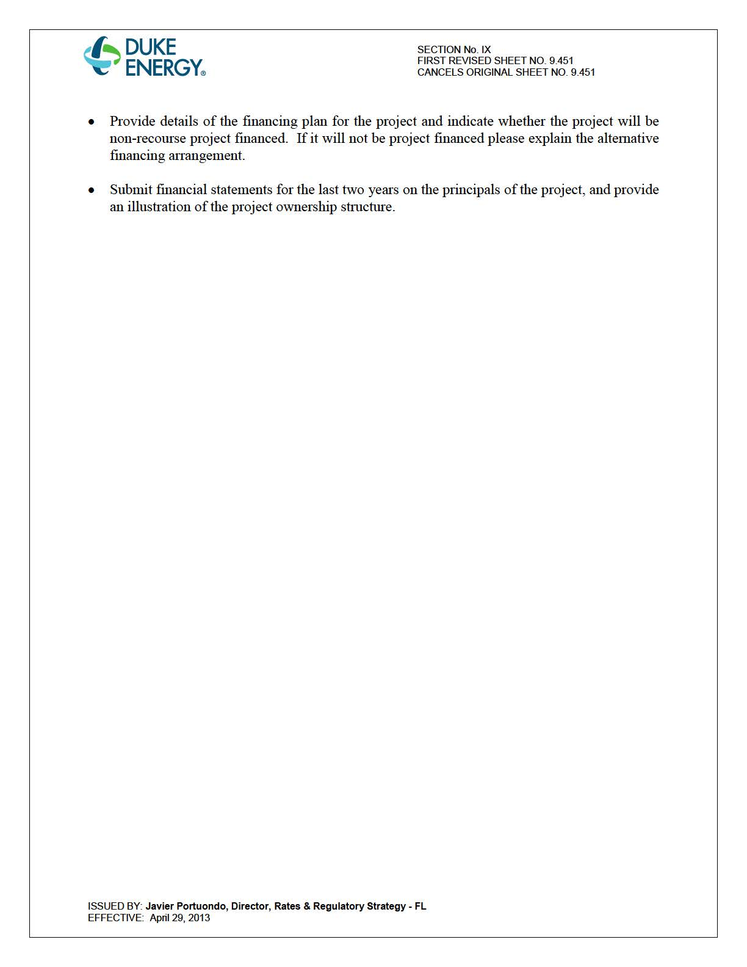

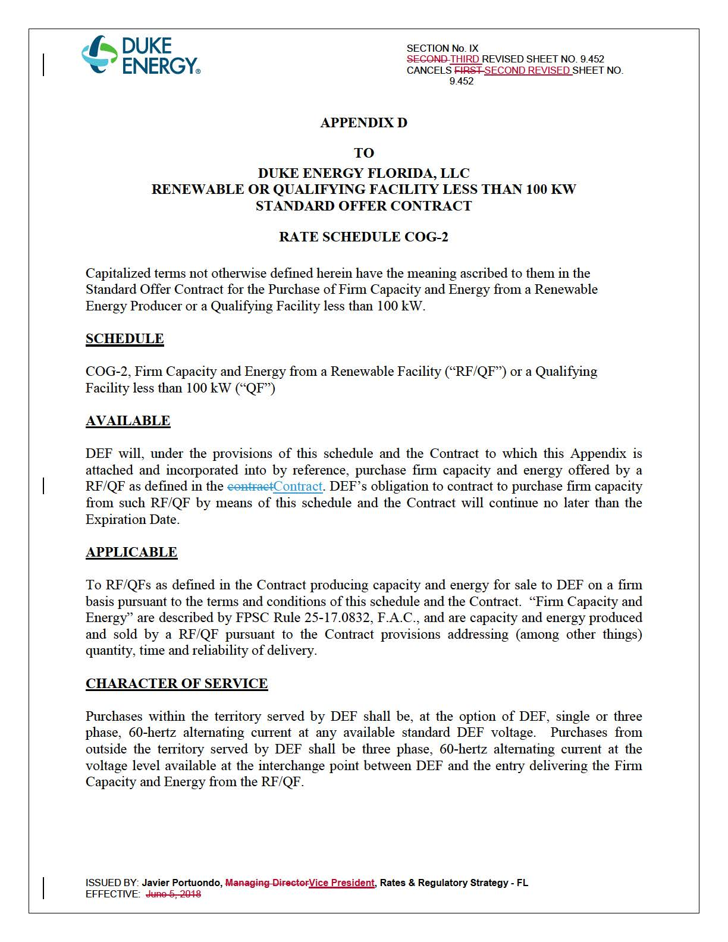

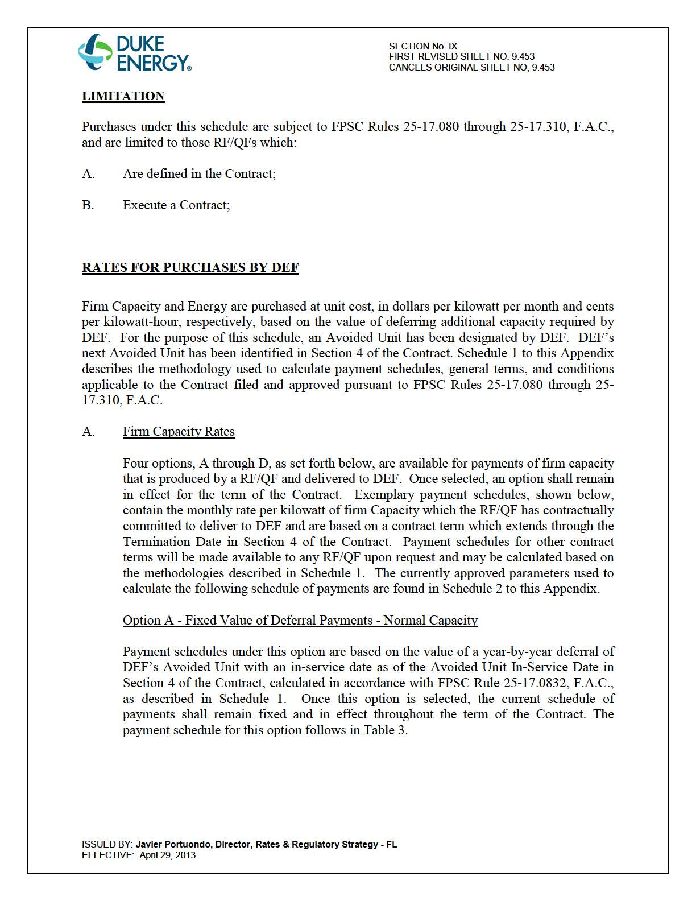

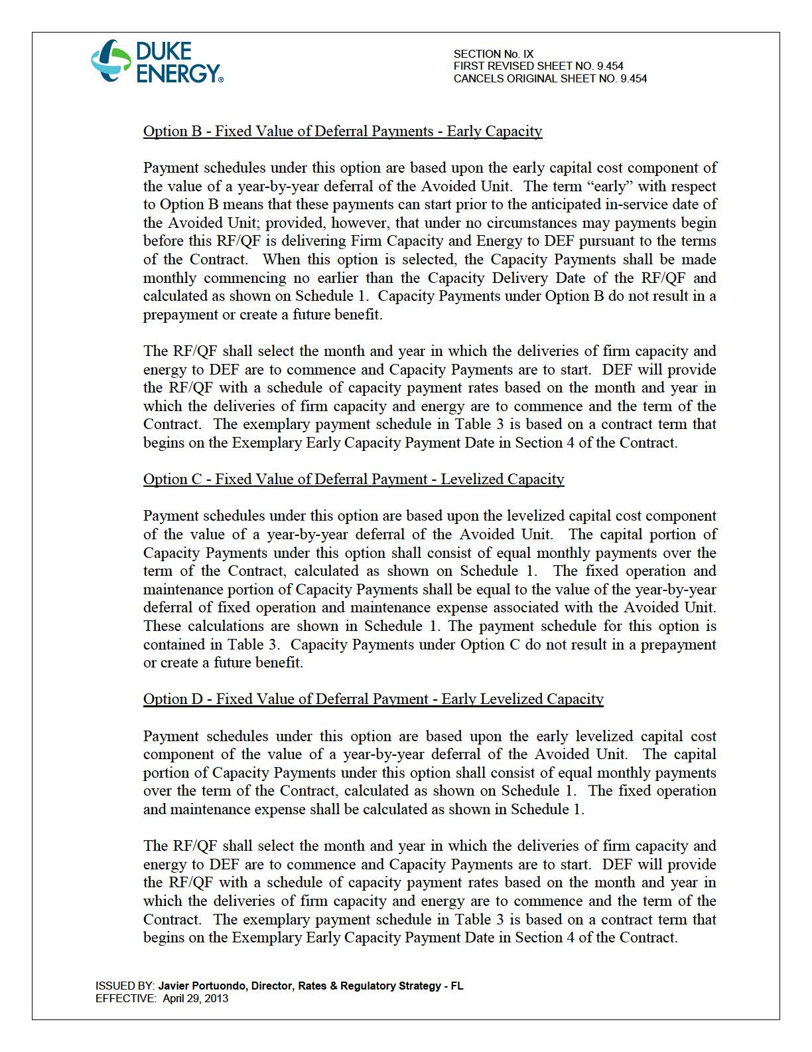

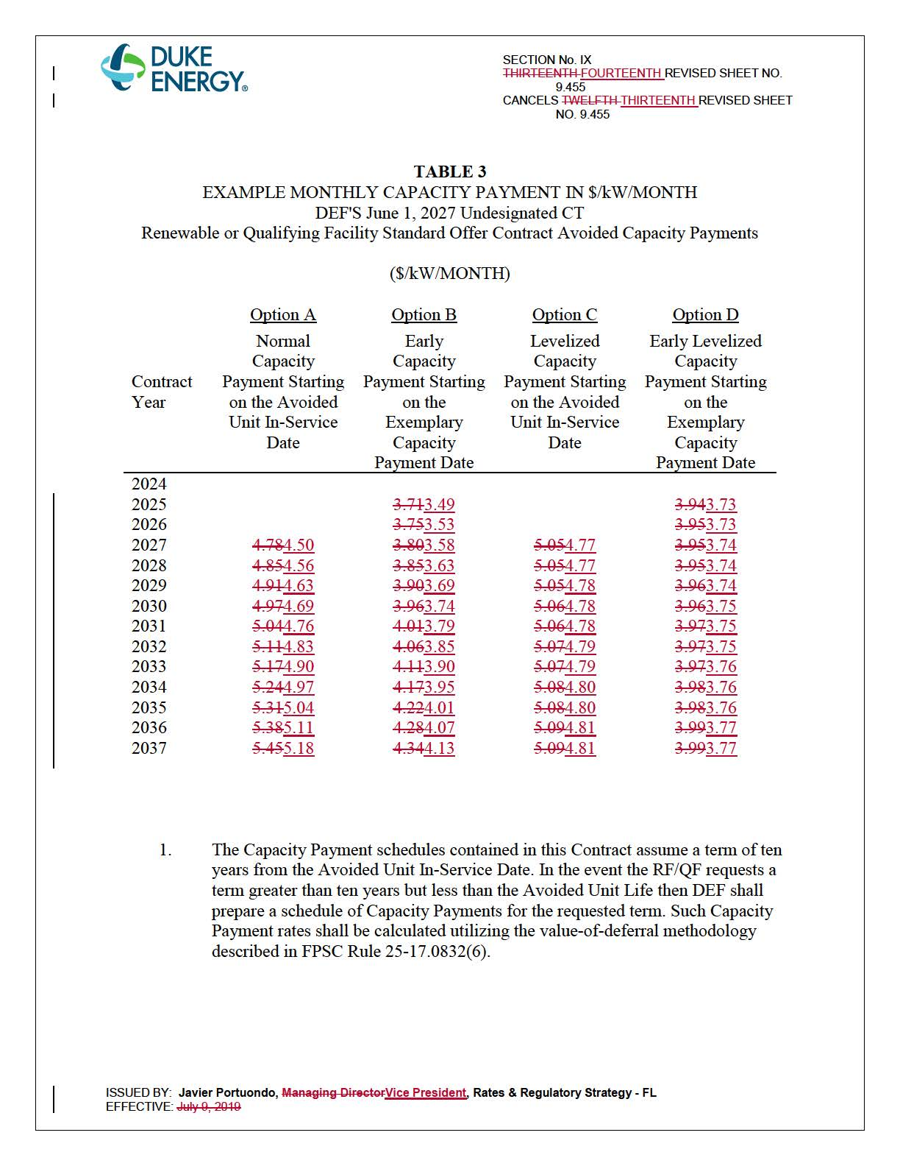

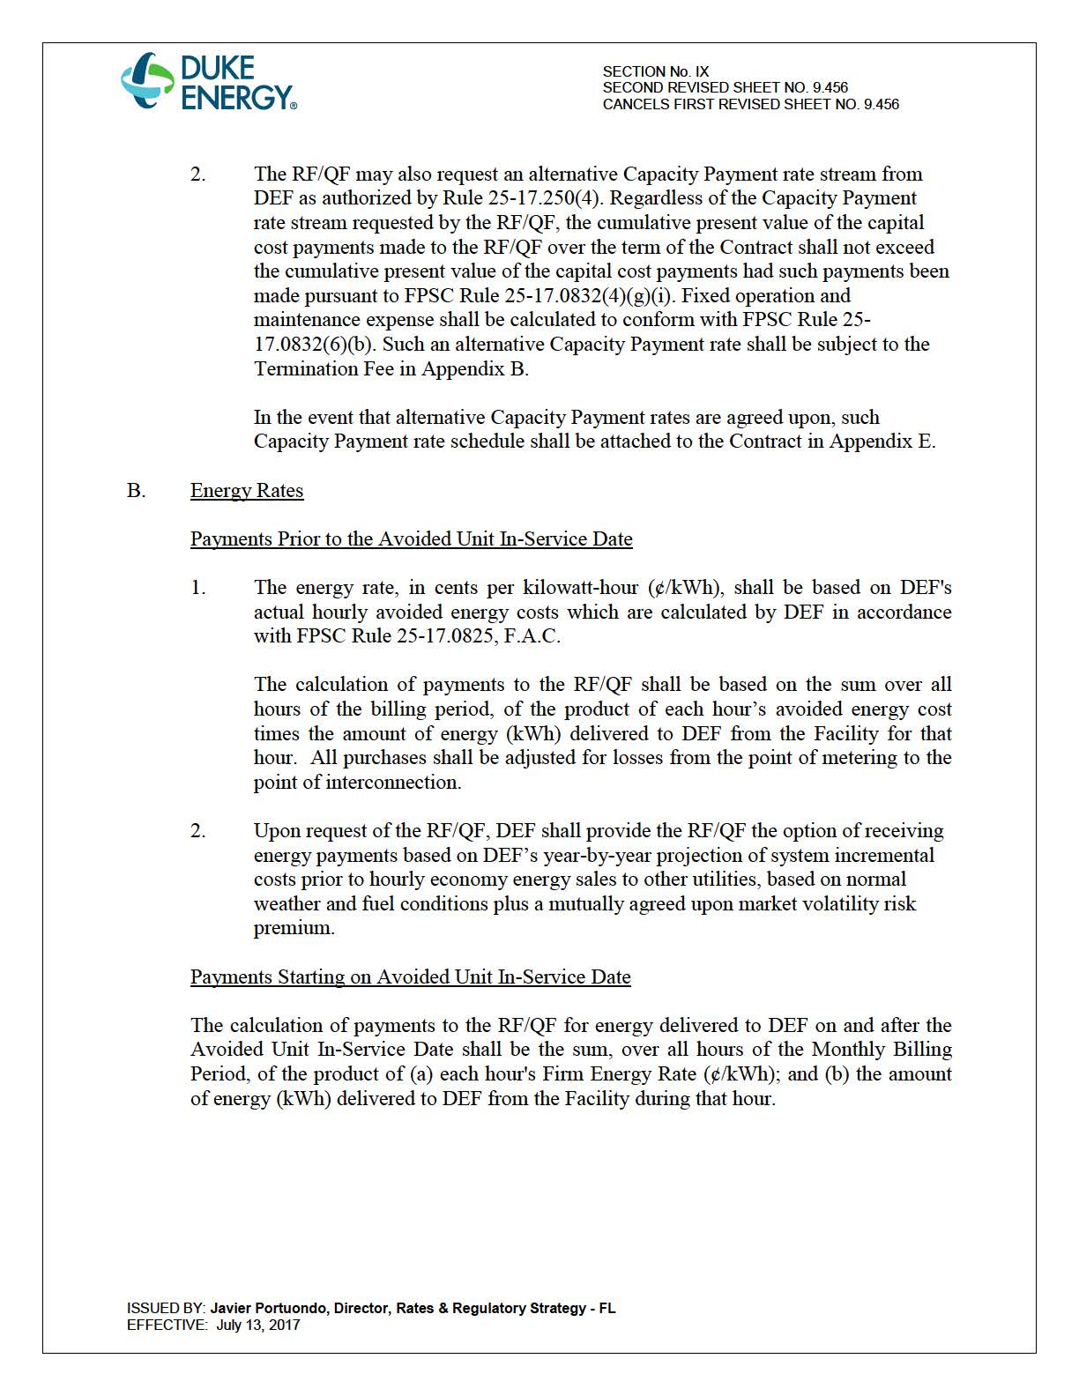

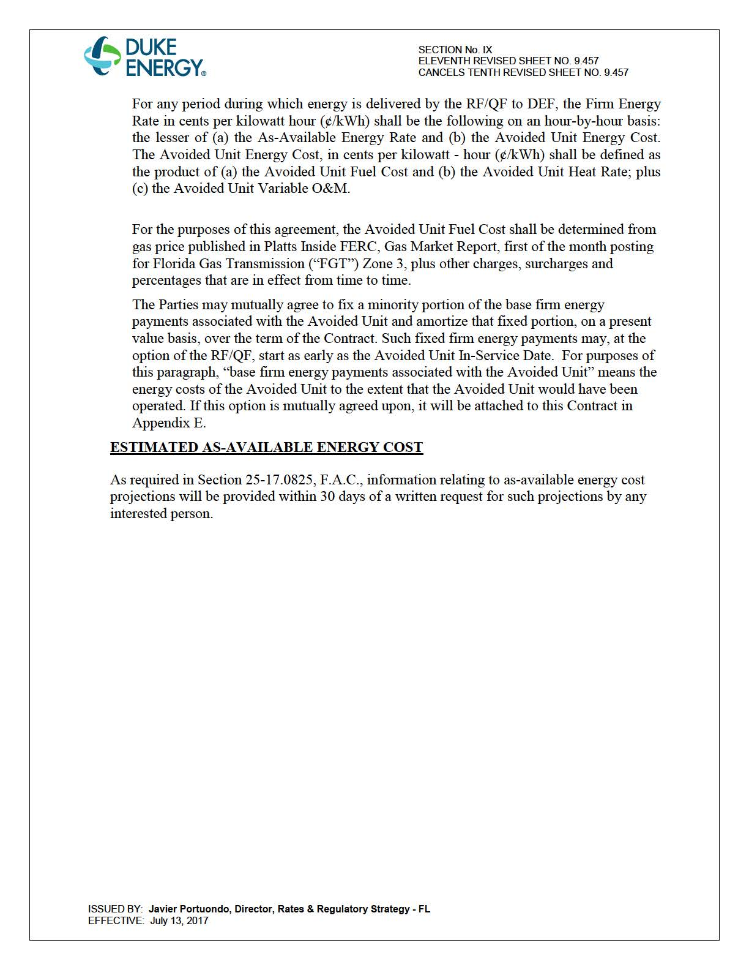

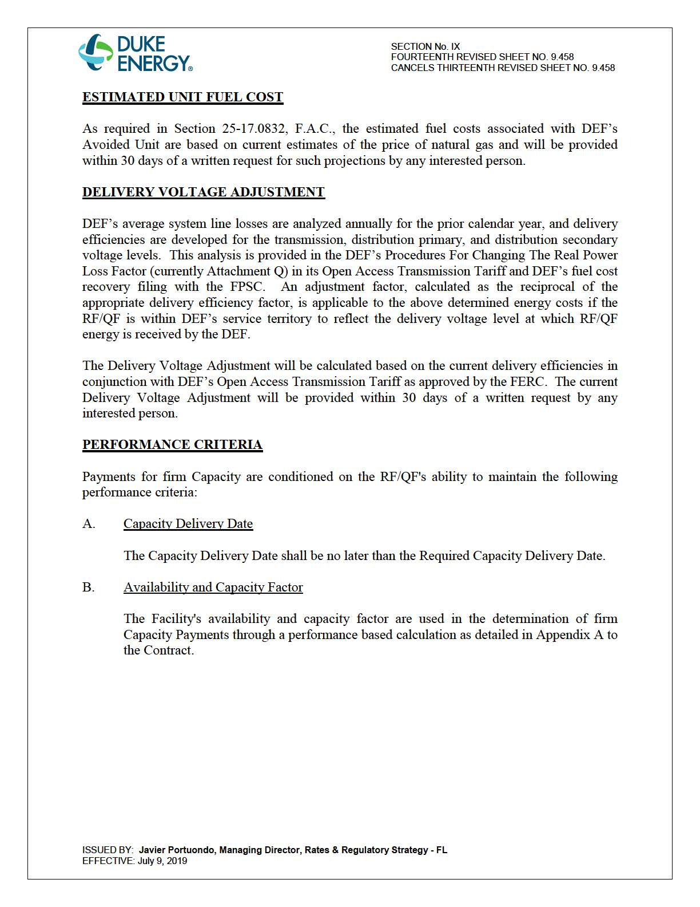

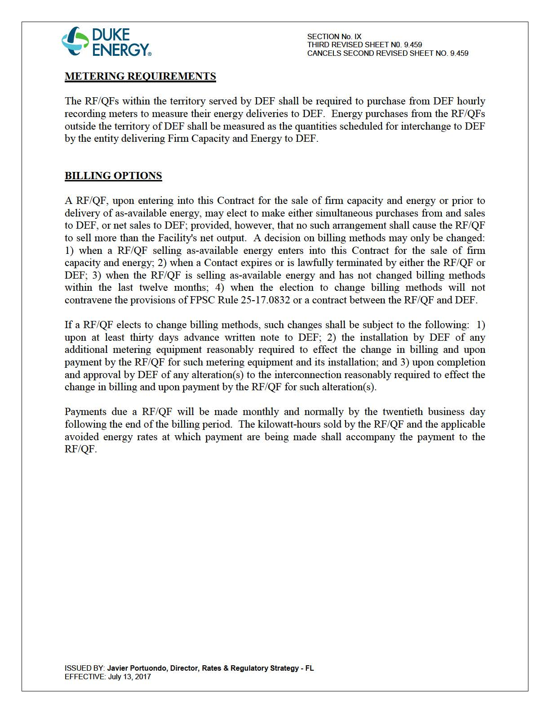

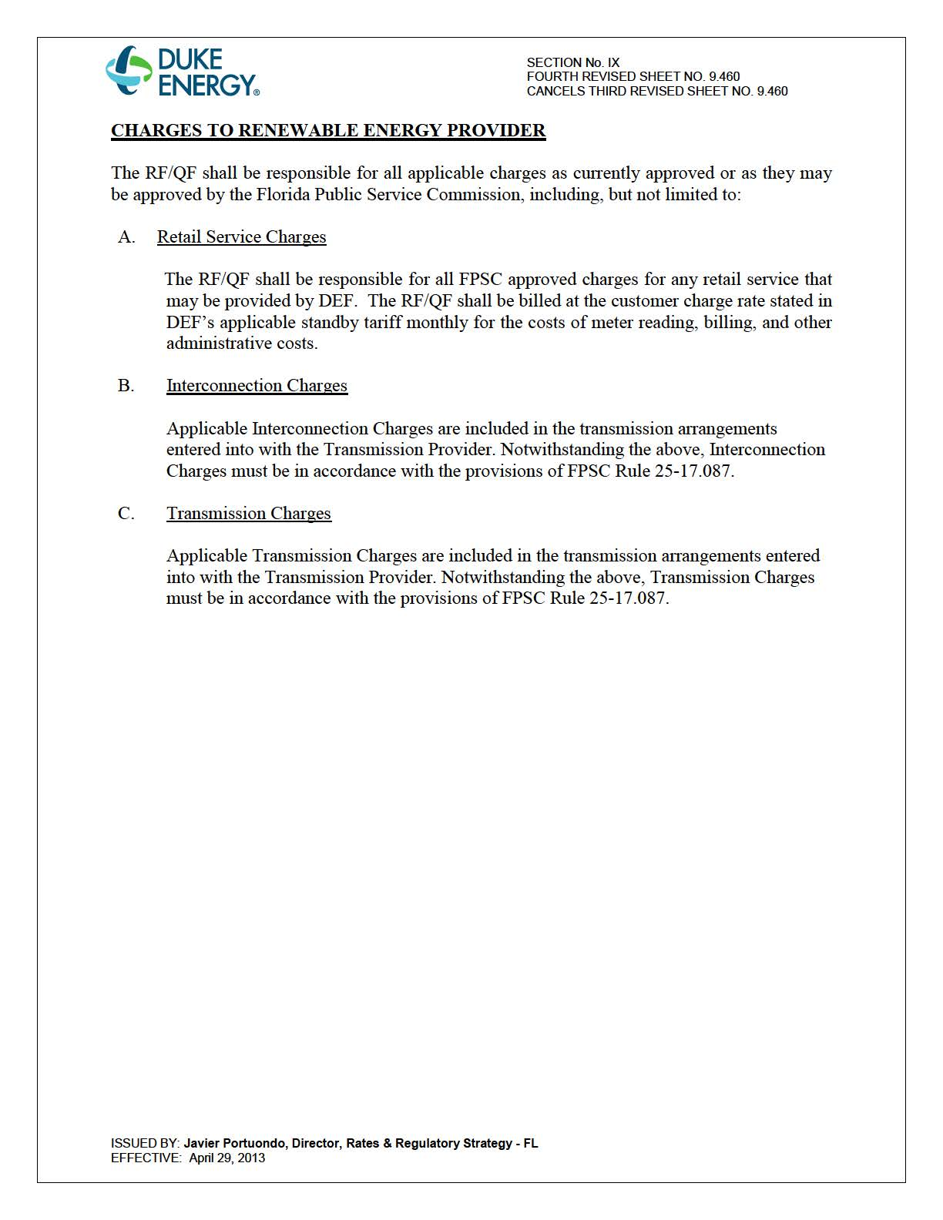

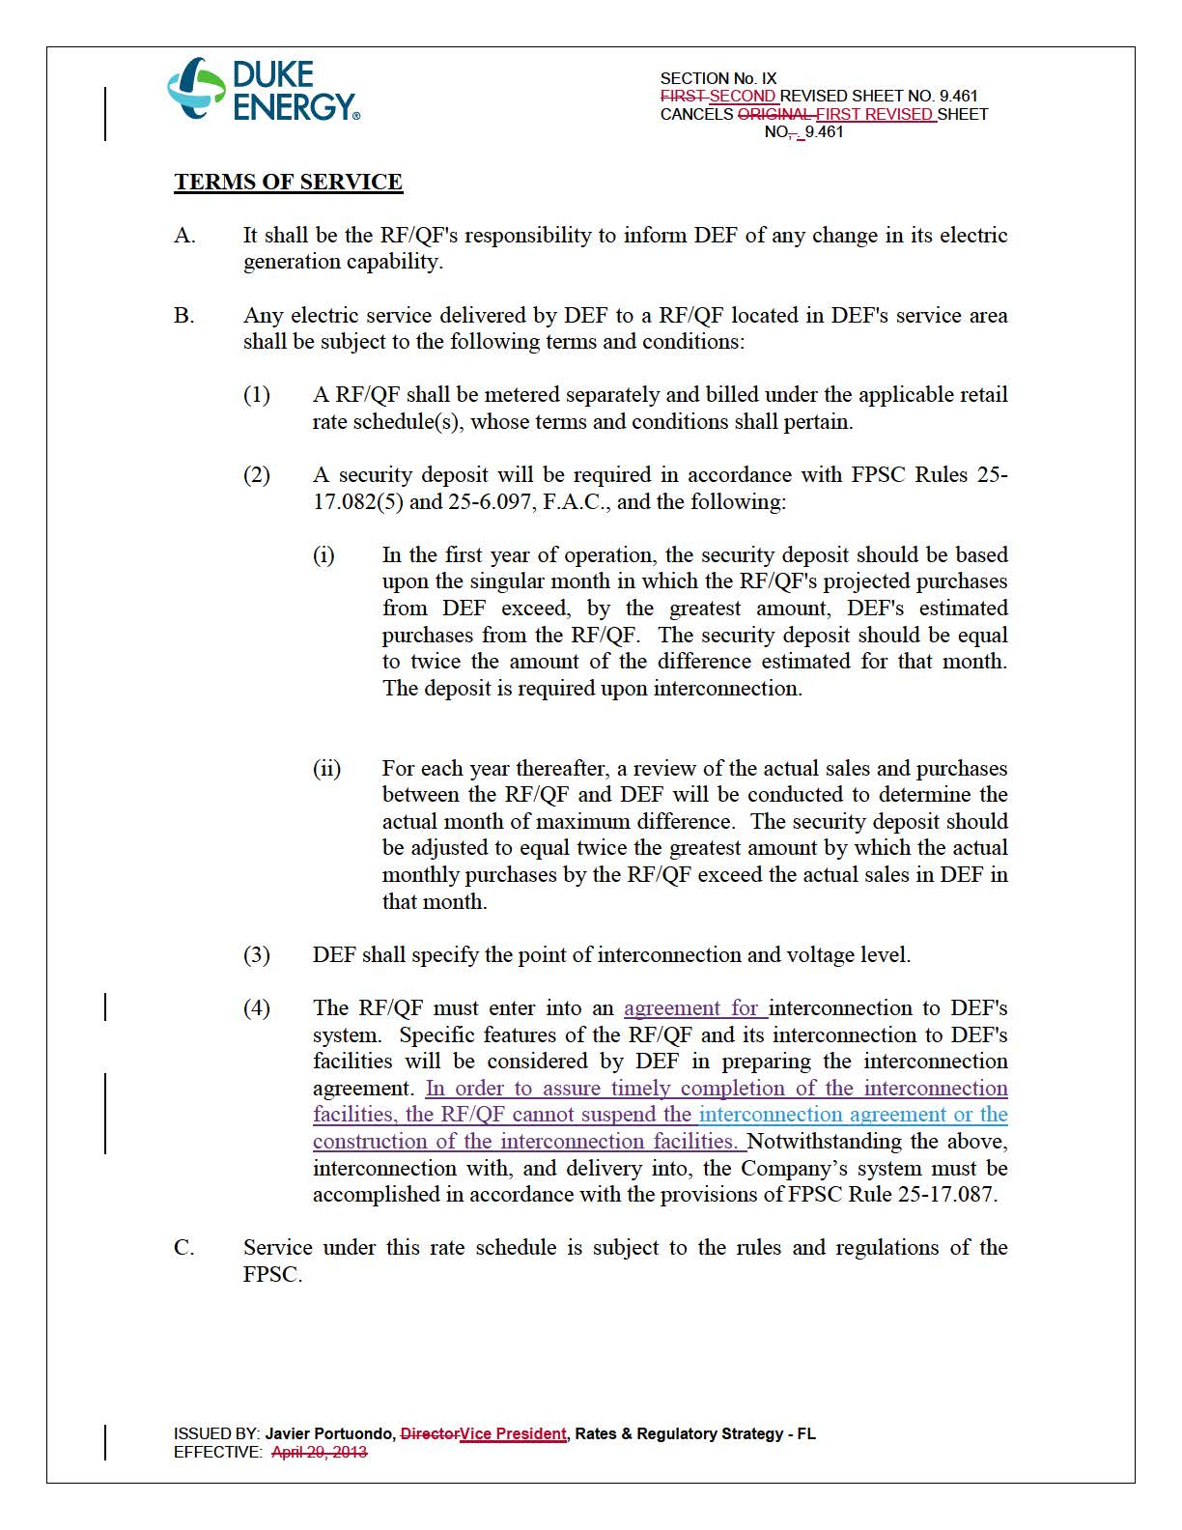

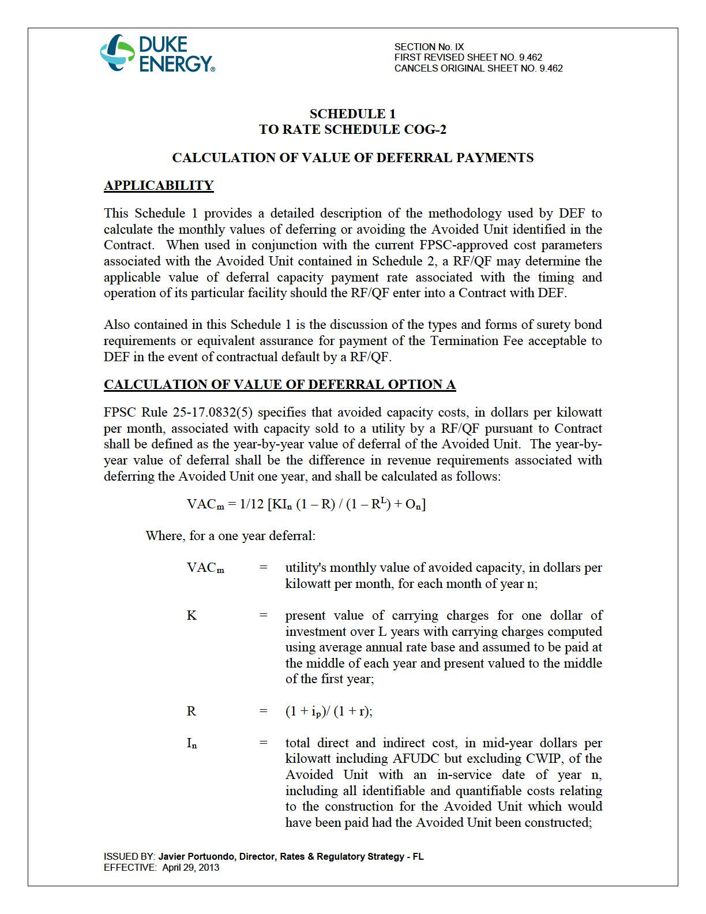

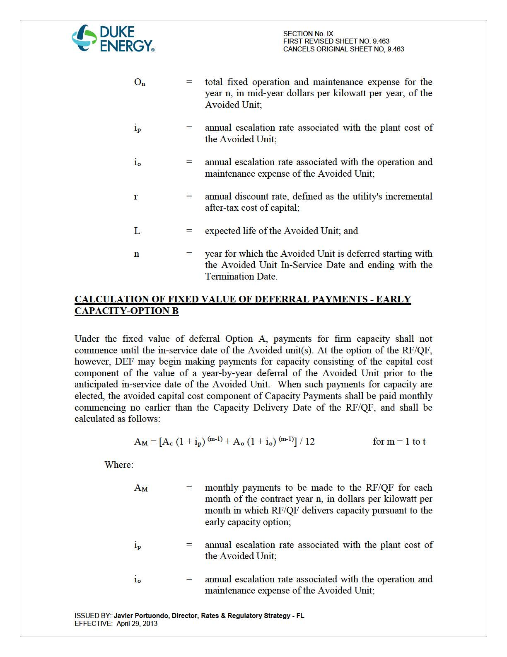

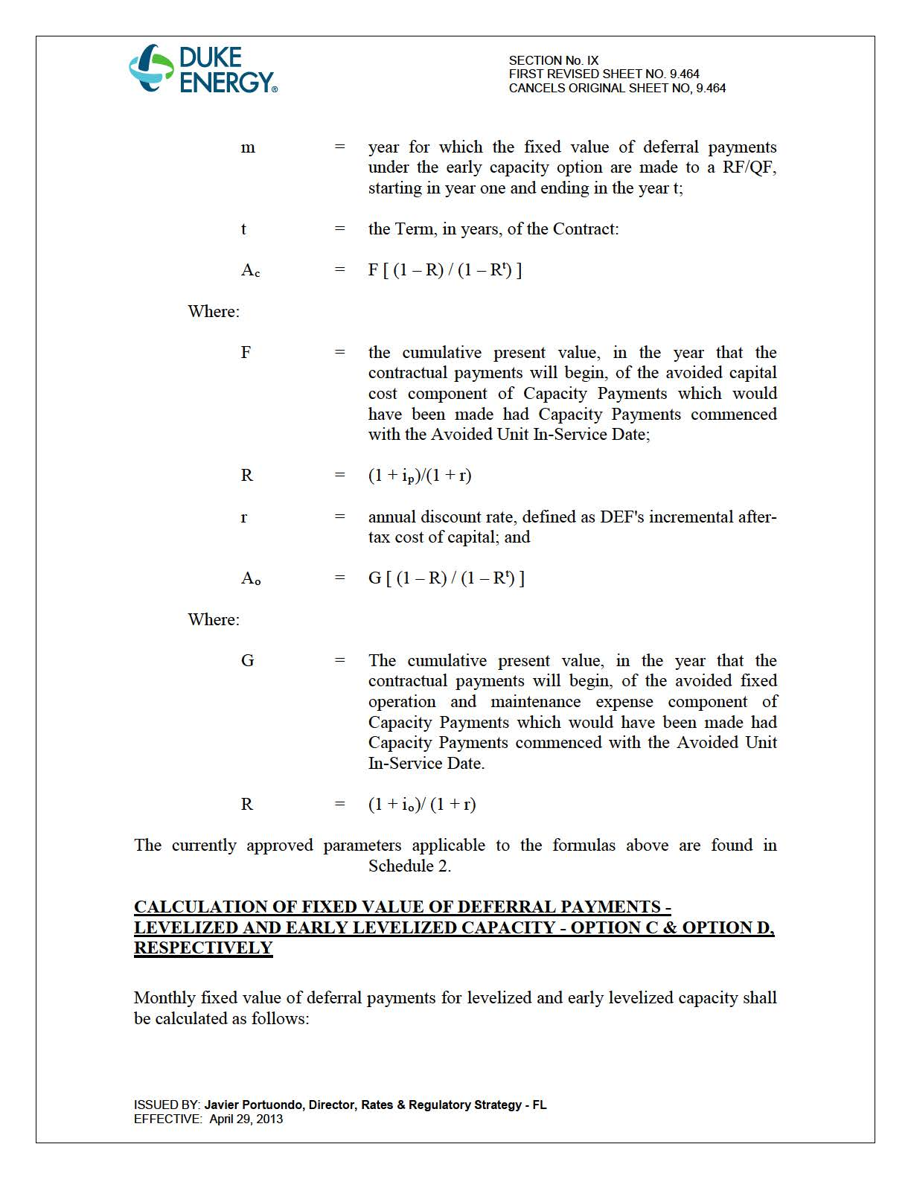

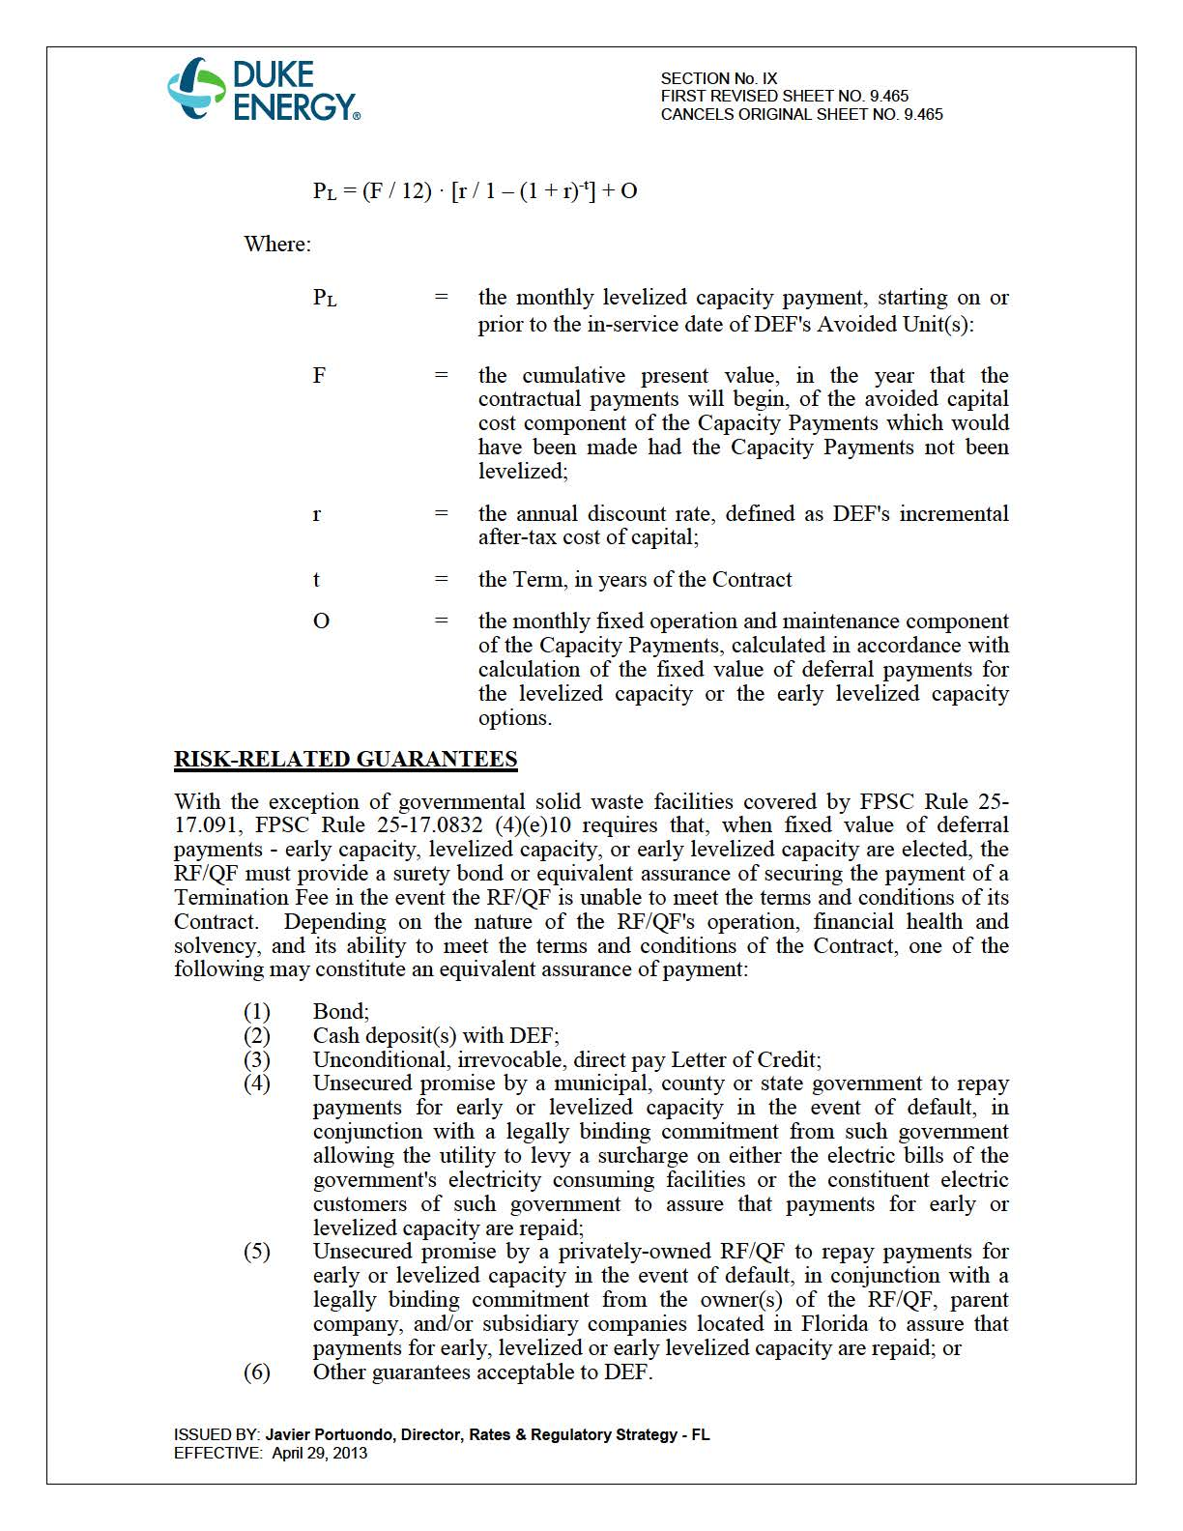

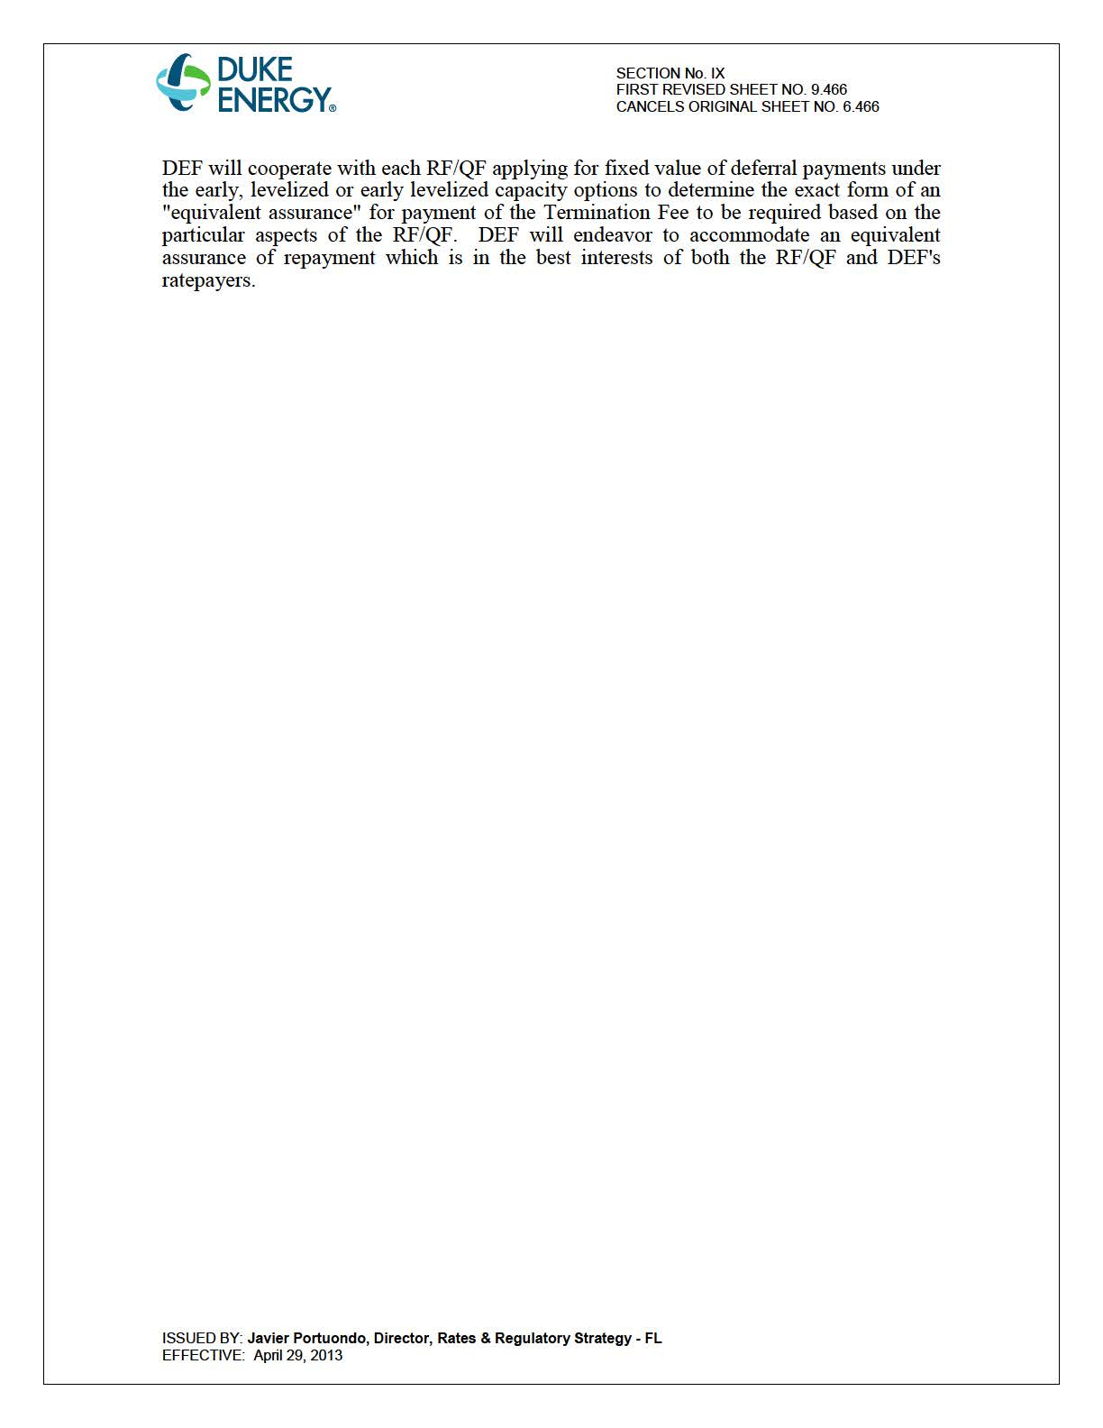

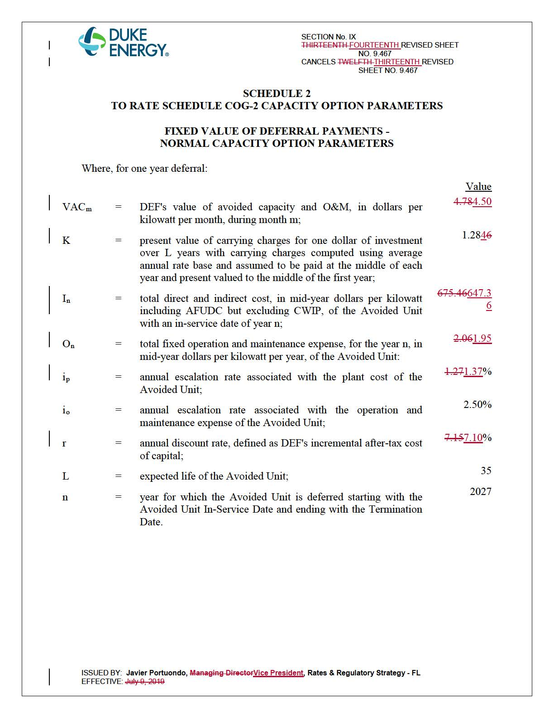

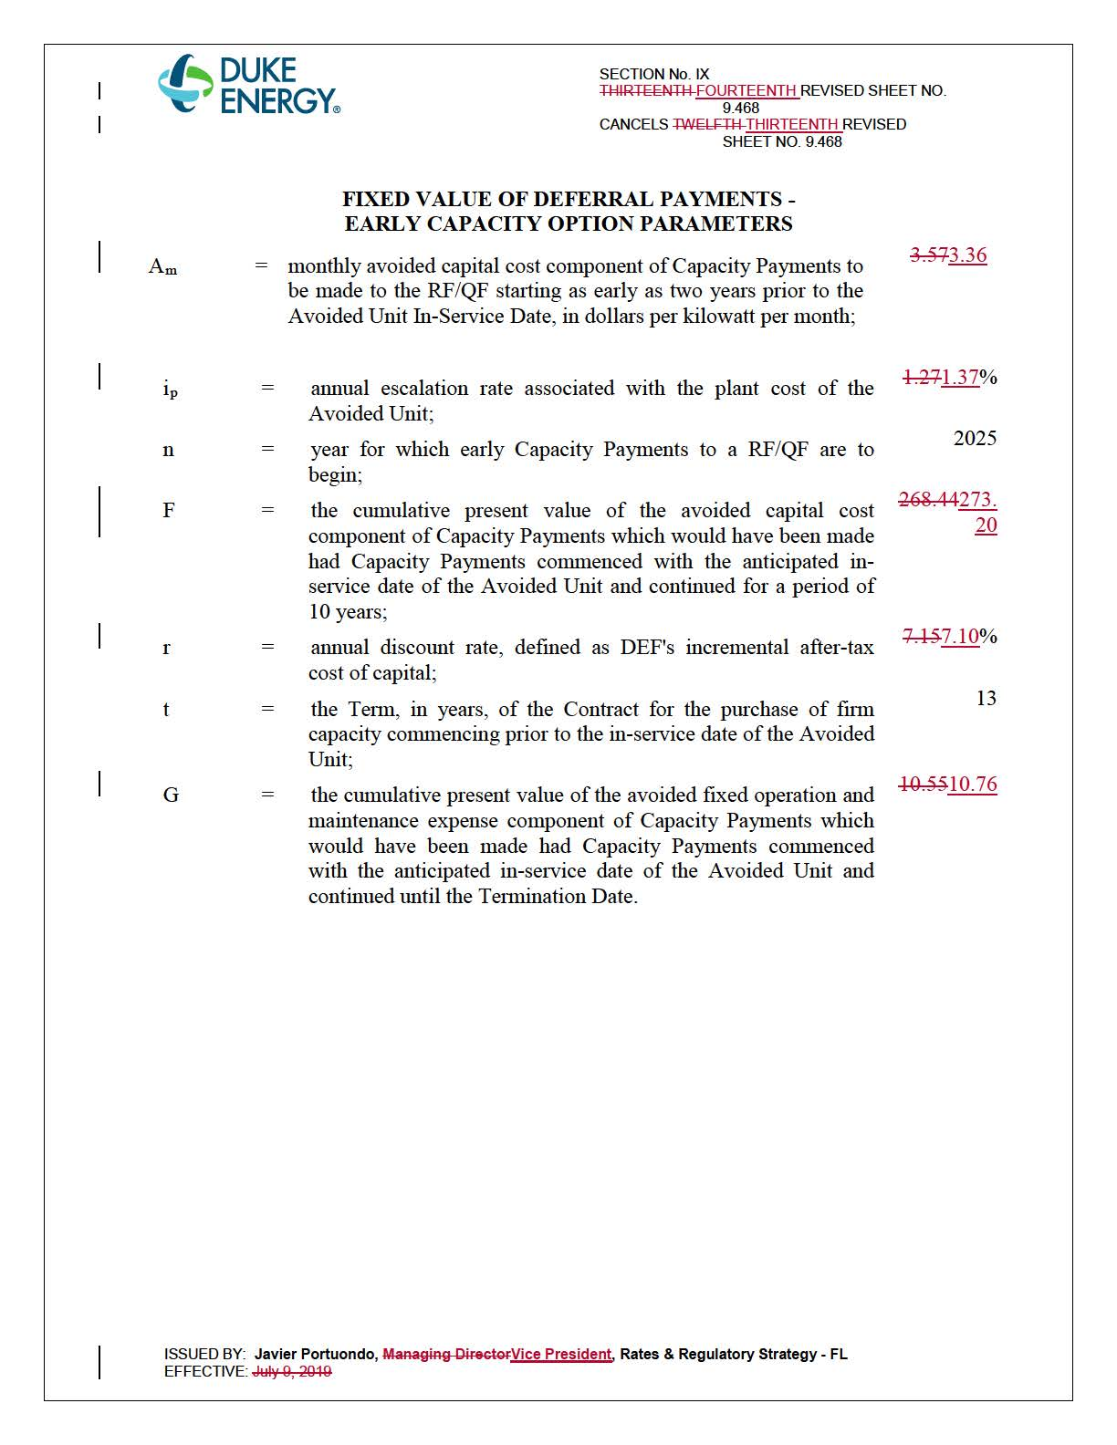

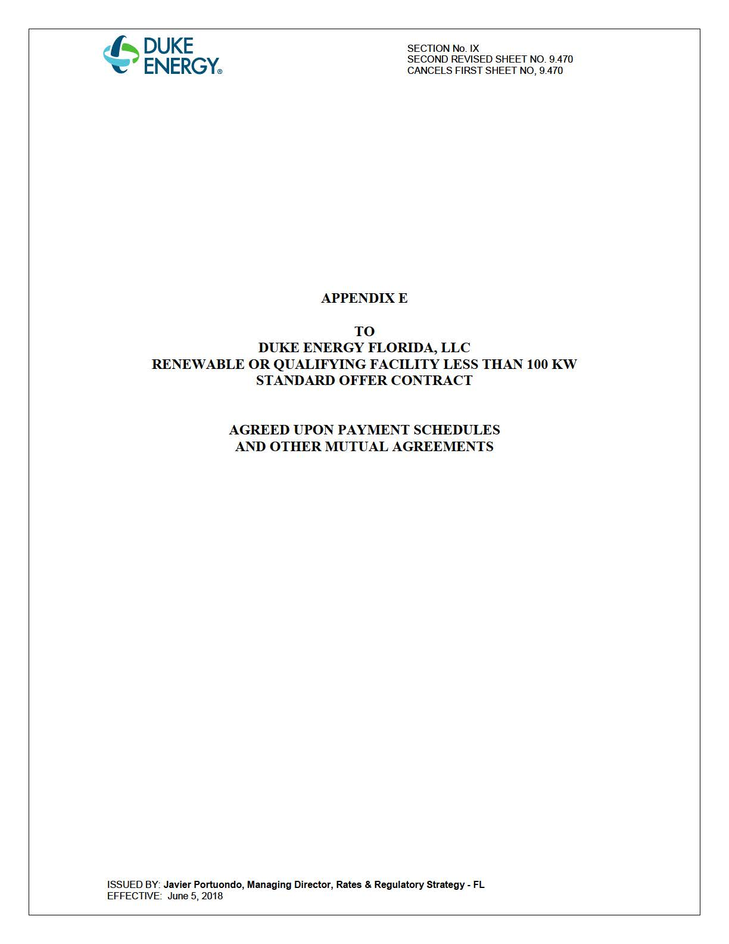

Document No. 02335-2020, filed May 1, 2020, in Docket No. 20200111-EQ.

