State of Florida |  | Public Service Commission  Capital Circle Office Center ● 2540 Shumard Oak Boulevard  Tallahassee, Florida 32399-0850  -M-E-M-O-R-A-N-D-U-M-
DATE: | May 28, 2020
TO: | Office of Commission Clerk (Teitzman)
FROM: | Division of Economics (Guffey)  Office of the General Counsel (Stiller)
RE: | Docket No. 20200121-EI – Petition for approval of revised customer specified lighting tariff, by Tampa Electric Company.
AGENDA: | 06/09/20 – Regular Agenda – Tariff Filing –Interested Persons May Participate
COMMISSIONERS ASSIGNED: |  |  | All Commissioners
PREHEARING OFFICER: |  |  | Administrative
CRITICAL DATES: |  |  | 6/12/2020 (60-Day Suspension Date)
SPECIAL INSTRUCTIONS: |  |  | None

Case Background
On April 13, 2020, Tampa Electric Company (TECO or utility) filed a petition seeking approval of its revised Customer Specified Lighting Tariff (LS-2 tariff). TECO proposes to revise Tariff Sheet No. 6.830 to enable the utility to offer metered service to its LS-2 customers. Currently, the LS-2 tariff is only available as non-metered lighting service. The Commission approved the LS-2 tariff in Order No. PSC-2019-0063-TRF.
During the review of this petition, staff issued a data request to TECO for which responses were received on May 5, 2020. TECO filed a revision to Tariff Sheet No. 6.830 which corrected a scrivener’s error on May 8, 2020. The proposed revised Tariff Sheet No. 6.830 in legislative format is shown in Attachment A to this recommendation. The Commission has jurisdiction over this matter pursuant to Sections 366.03, 366.04, 366.05, and 366.06, Florida Statutes (F.S.).

Discussion of Issues

Issue 1:
Should the Commission approve TECO's revised Customer Specified Lighting Tariff (LS-2) Sheet No. 6.830, as shown in Attachment A?

Recommendation:
Yes. The Commission should approve TECO’s revised LS-2 Sheet No. 6.830, as shown in Attachment A, effective June 9, 2020. The proposed LS-2 tariff revision allows TECO to offer LS-2 customers the option to receive metered lighting service. (Guffey)

Staff Analysis:
TECO offers two outdoor lighting service tariffs: the Lighting Service (LS-1) tariff and the LS-2 tariff. Under the LS-1 tariff, customers have the option of unmetered lighting service for TECO-owned fixtures or of metered lighting service for customer-owned fixtures. The LS-1 tariff lists the TECO-owned fixtures available for the unmetered option and the energy is billed based on the estimated usage of the fixture. Under the customer-owned option, TECO provides the energy only and the customer is responsible for maintaining the fixtures. The customer may own fixtures that are not offered by TECO. TECO explained that the majority of LS-1 customers take service under the unmetered utility-owned fixtures option; however, approximately 200 customers own the lighting facilities and use the energy-only rate offering under the LS-1 tariff.
The LS-2 tariff allows TECO to offer service for utility-owned specific fixtures or poles that are not available under the LS-1 tariff. If a customer requests a special or unique fixture, TECO purchases and installs the lighting facilities and bills the customer for the fixture and maintenance cost based on the in-place value of the facilities. Under the current LS-2 tariff, service is unmetered and the energy is billed based on the estimated usage of the fixture.
TECO explained that while the LS-1 tariff provides a metered service option, the current LS-2 tariff does not offer a metered service option. The proposed revision in the LS-2 tariff adds a section titled Special Conditions which outlines pricing for metered service. The proposed charges for metered service are the same as the currently approved LS-1 metered energy charge of 2.510 cents per kilowatt-hour (kWh) and basic service charge of $10.52 per month. Other charges such as energy conservation, capacity, and environmental charges will also be applicable.
TECO explained that the petition was filed in response to LS-1 customers who own metered lighting systems and expressed an interest to transfer ownership and maintenance of the fixtures to TECO. If the fixtures the customer owns are not offered by the utility under the LS-1 tariff, service would have to be transferred to the LS-2 tariff to allow TECO to take ownership of the lighting facilities. In response to staff’s data request, TECO stated that an advantage to a customer transferring from LS-1 to LS-2 would be the maintenance, repair, and replacement of their lighting system would be the responsibility of TECO.
Customers taking service under the LS-2 tariff are required to sign a Bright Choices Outdoor Lighting Agreement (agreement) with a minimum 20 year initial term and successive one year terms continuing thereafter until either party provides the other party a 90 day written notice of termination. In response to staff’s data request, TECO stated that if an LS-1 customer transferred to LS-2 and later desires to transfer back to LS-1, an early termination penalty would be applicable, per the agreement.
TECO stated that it currently does not have any customers taking service under the LS-2 tariff, but approximately six LS-1 customers have expressed some interest in transferring to the LS-2 tariff to allow TECO to take ownership of the facilities. TECO explained that any compensation to the customer for the transferred lighting facilities would be negotiated between the customer and TECO and the negotiated amount would be specified in the agreement. The utility states the types of customers who would be interested in transferring are municipal lighting systems, parking lot lighting systems, and lighting in car lots/business spaces. TECO explained that if a customer requests their metered lighting system to be taken over by TECO, the utility would evaluate the existing condition and type of lighting equipment and upgrades needed to the equipment.

Conclusion
Staff has reviewed TECO’s petition and response to staff’s data request, and believes the proposed revision to the LS-2 tariff to allow for metered service, as currently is available under the LS-1 tariff, is reasonable and appropriate. Staff recommends that the Commission should approve TECO’s revised LS-2 Sheet No. 6.830, as shown in Attachment A, effective June 9, 2020.

Issue 2:
Should this docket be closed?

Recommendation:
If Issue 1 is approved and a protest is filed within 21 days of the issuance of the order, the tariff should remain in effect, with any revenues held subject to refund, pending resolution of the protest. If no timely protest is filed, this docket should be closed upon the issuance of a consummating order. (Stiller)

Staff Analysis:
If Issue 1 is approved and a protest is filed within 21 days of the issuance of the order, the tariff should remain in effect, with any revenues held subject to refund, pending resolution of the protest. If no timely protest is filed, this docket should be closed upon the issuance of a consummating order.

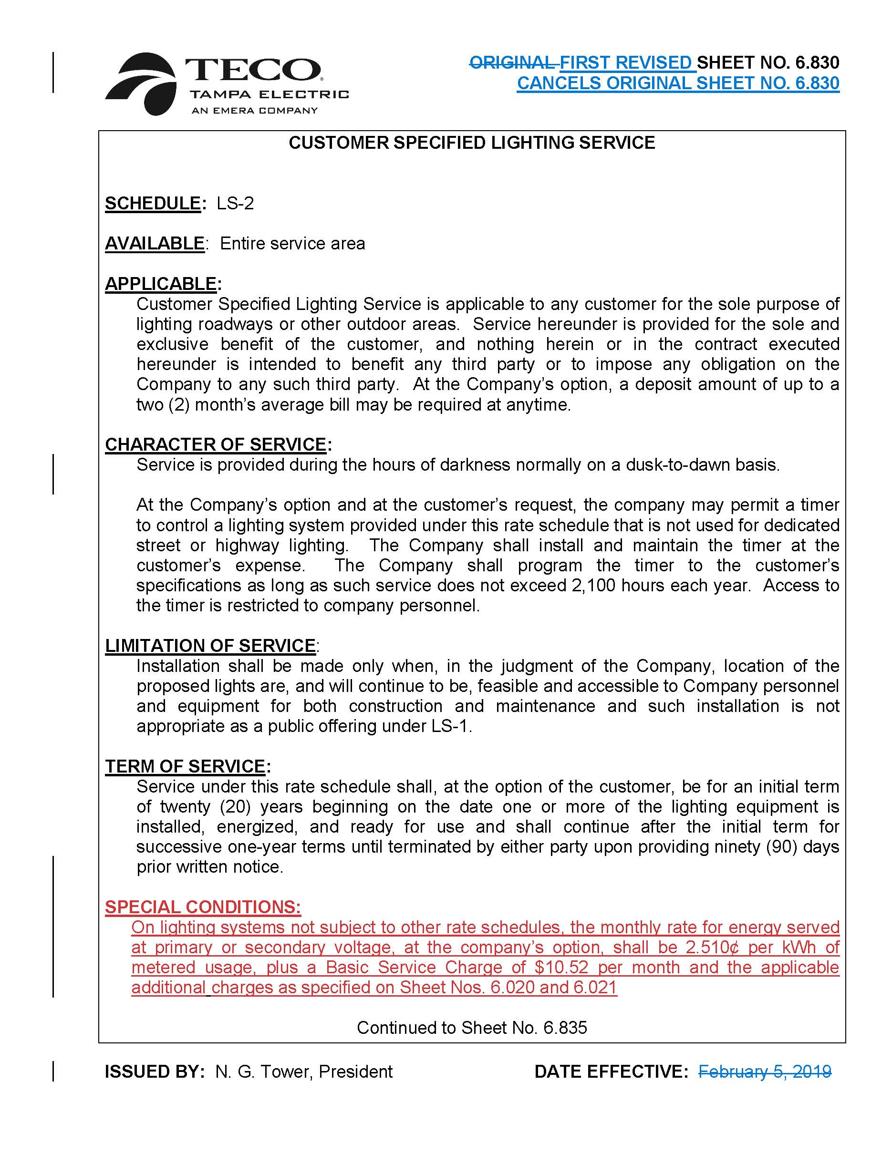

Order No. PSC-2019-0063-TRF-EI, issued February 18, 2019, in Docket No. 20180222-EI, In re: Petition for approval of customer specified lighting tariff by Tampa Electric Company.

