State of Florida |  | Public Service Commission  Capital Circle Office Center ● 2540 Shumard Oak Boulevard  Tallahassee, Florida 32399-0850  -M-E-M-O-R-A-N-D-U-M-
DATE: | May 28, 2020
TO: | Office of Commission Clerk (Teitzman)
FROM: | Office of the General Counsel (Cowdery)  Division of Economics (Guffey)
RE: | Docket No. 20200094-EU – Proposed amendments to Rules 25-6.0440, F.A.C., Territorial Agreements for Electric Utilities, and 25-6.0441, F.A.C., Territorial Disputes for Electric Utilities.
AGENDA: | 06/09/20 – Regular Agenda – Rule Proposal – Interested Persons May Participate
COMMISSIONERS ASSIGNED: |  |  | All Commissioners
PREHEARING OFFICER: |  |  | Polmann
RULE STATUS: |  |  | Proposal May Be Deferred
SPECIAL INSTRUCTIONS: |  |  | None

Case Background

The Rules
On August 17, 2018, the Joint Administrative Procedures Committee (JAPC) sent the Commission a letter providing comments resulting from JAPC’s review of Chapter 25-6, Florida Administrative Code (F.A.C). The letter included comments on Rule 25-6.0440, Territorial Agreements for Electric Utilities, and Rule 25-6.0441, Territorial Disputes for Electric Utilities, F.A.C.
Rule 25-6.0440, F.A.C., requires all territorial agreements between electric utilities to be submitted to the Commission for approval. The rule lists the information that must be provided and sets forth the factors that the Commission may consider in approving territorial agreements. Rule 25-6.0441, F.A.C., states that a territorial dispute proceeding may be initiated by a petition from an electric utility requesting the Commission to resolve the dispute. The rule lists the information required in the petition and identifies the factors the Commission may consider in resolving territorial disputes. Both rules state that the Commission’s consideration is not limited to the factors that are listed.

The territorial agreement and territorial dispute rules implement Section 366.04(2), F.S., which gives the Commission the power to approve territorial agreements and to resolve territorial disputes involving rural electric cooperatives, municipal electric utilities, and other electric utilities under its jurisdiction. For territorial disputes, Section 366.04(2)(e), F.S., states that:

the Commission may consider, but not be limited to consideration of, the ability of the utilities to expand services within their own capabilities and the nature of the area involved, including population, the degree of urbanization of the area, its proximity to other urban areas, and the present and reasonably foreseeable future requirements of the area for other utility services.

The factors listed in Section 366.04(2)(e), F.S., are included in the list of factors in Rule 25-6.0441, F.A.C., although the language is not identical. JAPC’s interpretation of Section 366.04(2)(e), F.S., is that the Legislature gave the Commission authority to consider factors other than those listed in the statute in resolving territorial disputes, but those additional factors need to be identified in the rule.

JAPC’s Comments
JAPC’s letter noted that Rules 25-6.0440 and 25-6.0441, F.A.C., both state that the Commission “may consider, but not be limited to” certain enumerated factors in making its determination. JAPC commented that the use of the quoted phrase in the rules implies that there are additional expectations or standards that could be enforced that are not enumerated. JAPC asked the Commission to review Section 120.52(8)(d), F.S., which provides that it is an invalid exercise of delegated legislative authority if a rule is vague, fails to establish adequate standards for agency decisions, or vests unbridled discretion in the agency.

Procedural Matters
This rulemaking was initiated to address JAPC’s comments on Rules 25-6.0440 and 25-6.0441, F.A.C. The Notice of Development of Rulemaking appeared in the November 18, 2019 edition of the Florida Administrative Register (F.A.R.). Tampa Electric Company (TECO) and the Florida Electric Cooperatives Association (FECA) filed comments on December 3, 2019, and Florida Power & Light Company, Duke Energy Florida, and the Florida Municipal Electric Association joined FECA’s comments. TECO requested a workshop in its December 3, 2019 comments, and FECA requested a workshop on December 4, 2019. However, TECO and FECA withdrew their requests for a workshop on February 3, 2020, after staff revised its draft rule based on comments contained in the requests for workshop. The Office of Public Counsel was provided the opportunity to comment on the draft rule amendments.

This recommendation addresses whether the Commission should amend Rules 25-6.0440 and 25-6.0441, F.A.C. The Commission has jurisdiction under Sections 350.127(2), 366.04(2), (4), (5), and 366.05(7), F.S.

Discussion of Issues

Issue 1:
Should the Commission propose the amendment of Rule 25-6.0440, Territorial Agreements for Electric Utilities, and Rule 25-6.0441, Territorial Disputes for Electric Utilities, F.A.C.?

Recommendation:
Yes, the Commission should propose the amendment of Rules 25-6.0440 and 25-6.0441, F.A.C., as set forth in Attachment A. The Commission should also certify Rules 25-6.0440 and 25-6.0441, F.A.C., as minor violation rules. (Cowdery, Guffey)

Staff Analysis:
The Commission adopted Rules 25-6.0440 and 25-6.0441, F.A.C., to implement its authority under Section 366.04(2), F.S., to approve territorial agreements and resolve territorial disputes. Both rules list factors the Commission may consider in making its determinations. The language in both rules states that the Commission’s consideration is “not limited to” the listed factors. In its rule review letter, JAPC conveyed its concern that the phrase “may consider, but not be limited to the consideration of,” implied that there are additional expectations or standards that could be enforced, which could be considered an invalid exercise of delegated legislative authority under Section 120.52(8)(c), F.S.

In order to address JAPC’s concern, staff is recommending that the phrase “but not be limited to consideration of” be deleted from both rules. In lieu of this phrase, staff is recommending that a criterion be added to each rule that allows the Commission to consider “[a]ny other factor the Commission finds relevant in reaching a determination” that the territorial agreement or resolution of the territorial dispute “is in the public interest.” In addition, staff recommends that the territorial dispute rule be amended for clarity to state that the Commission’s consideration of the listed factors is in addition to the factors listed in Section 366.04(2)(e), F.S.

Florida courts have held that both the resolution of territorial disputes and the approval of territorial agreements should ultimately be guided by the public interest standard. Gulf Coast Elec. Co-op., Inc. v. Johnson, 727 So. 2d 259, 264 (Fla. 1999). As a part of this public interest test, the Commission should ensure its decision prevents the uneconomic duplication of generation, transmission, and distribution assets. Id.; see Section 366.05, F.S. Staff believes that the recommended amendments of these rules will adhere to the public interest standard.

This draft language ensures that the Commission has wide latitude to consider factors that may be unique to each dispute or agreement. At the same time, the draft language limits the Commission’s discretion, using the judicially approved public interest test, and satisfies JAPC’s concerns.

In addition, staff is also recommending some non-substantive amendments to both rules. These recommended amendments are to update and clarify the rules.

Minor Violation Rules Certification
Pursuant to Section 120.695, F.S., the agency head must certify for each rule filed for adoption whether any part of the rule is designated as a rule the violation of which would be a minor violation. Rules 25-6.0440 and 25-6.0441, F.A.C., are currently listed on the Commission’s website as rules for which a violation would be minor because violation of the rules would not result in economic or physical harm to a person or have an adverse effect on the public health, safety, or welfare or create a significant threat of such harm. The amendments to the rules would not change their status as minor violation rules. Thus, staff recommends that the Commission certify Rules 25-6.0440 and 25-6.0441, F.A.C., as minor violation rules.

Statement of Estimated Regulatory Costs
Pursuant to Section 120.54(3)(b), F.S., agencies are encouraged to prepare a statement of estimated regulatory costs (SERC) before the adoption, amendment, or repeal of any rule. The SERC is appended as Attachment B to this recommendation.
The SERC concludes that the rules will not likely directly or indirectly increase regulatory costs in excess of $200,000 in the aggregate in Florida within one year after implementation. Further, the SERC economic analysis concludes that the rules will not likely have an adverse impact on economic growth, private sector job creation or employment, private sector investment, business competitiveness, productivity, or innovation in excess of $1 million in the aggregate within five years of implementation. Thus, the rules do not require legislative ratification pursuant to Section 120.541(3), F.S. In addition, the SERC states that the rules will not have an adverse impact on small business and will have no impact on small cities or counties. No regulatory alternatives were submitted pursuant to paragraph 120.541(1)(a), F.S. None of the impact/cost criteria established in paragraph 120.541(2)(a), F.S., will be exceeded as a result of the recommended amendments to Rules 25-6.0440 and 25-6.0441, F.A.C.

Conclusion

Staff recommends that the Commission should propose the amendment of Rules 25-6.0440 and 25-6.0441, F.A.C., as set forth in Attachment A. The Commission should also certify Rules 25-6.0440 and 25-6.0441, F.A.C., as minor violation rules.
Issue 2:
Should this docket be closed?

Recommendation:
Yes. If no requests for hearing, information regarding the SERC, proposals for a lower cost regulatory alternative, or JAPC comments are filed, the rule should be filed with the Department of State, and the docket should be closed. (Cowdery)

Staff Analysis:
If no requests for hearing, information regarding the SERC, proposals for a lower cost regulatory alternative, or JAPC comments are filed, the rule may be filed with the Department of State and the docket should be closed.

25-6.0440 Territorial Agreements for Electric Utilities.
(1) All territorial agreements between electric utilities must shall be submitted to the Commission for approval. Each territorial agreement must shall clearly identify the geographical area to be served by each utility. The submission must shall include:
(a) A map and a written description of the area,
(b) The terms and conditions pertaining to implementation of the agreement, and any other terms and conditions pertaining to the agreement,
(c) The number and class of customers to be transferred,
(d) Assurance that the affected customers have been contacted and the difference in rates explained,
(e) Information with respect to the degree of acceptance by affected customers, i.e., the number in favor of and those opposed to the transfer, and
(f) An official Florida Department of Transportation (DOT) General Highway County map for each affected county depicting boundary lines established by the territorial agreement. Upon approval of the agreement, any modification, changes, or corrections to this agreement must be approved by this Commission.
(2) Standards for Approval. In approving territorial agreements, the Commission may consider, but not be limited to consideration of:
(a) The reasonableness of the purchase price of any facilities being transferred;
(b) The reasonable likelihood that the agreement, in and of itself, will not cause a decrease in the reliability of electrical service to the existing or future ratepayers of any utility party to the agreement; and
(c) The reasonable likelihood that the agreement will eliminate existing or potential uneconomic duplication of facilities; and.
(d) Any other factor the Commission finds relevant in reaching a determination that the territorial agreement is in the public interest.
(3) The Commission may require additional relevant information from the parties of the agreement, if so warranted.
Rulemaking Authority 350.127(2), 366.05(1) FS. Law Implemented 366.04(2), (4), (5), 366.05(7) FS. History–New 3-4-90, Amended 2-13-96, ____________.

25-6.0441 Territorial Disputes for Electric Utilities.
(1) A territorial dispute proceeding may be initiated by a petition from an electric utility requesting the Commission to resolve the dispute. Additionally the Commission may, on its own motion, identify the existence of a dispute and order the affected parties to participate in a proceeding to resolve it. Each utility that which is a party to a territorial dispute must shall provide a map and a written description of the disputed area along with the conditions that caused the dispute. Each utility party must shall also provide a description of the existing and planned load to be served in the area of dispute and a description of the type, additional cost, and reliability of electrical facilities and other utility services to be provided within the disputed area.
(2) In resolving territorial disputes, the Commission may consider, in addition to the factors listed in s. 366.04(2)(e): but not be limited to consideration of:
(a) The capability of each utility to provide reliable electric service within the disputed area with its existing facilities and the extent to which additional facilities are needed;
(b) The nature of the disputed area, including population and the type of utilities seeking to serve it, the and degree of urbanization of the area and its proximity to other urban areas, and the present and reasonably foreseeable future requirements of the area for other utility services;
(c) The cost of each utility to provide distribution and subtransmission facilities to the disputed area presently and in the future; and
(d) Any other factor the Commission finds relevant in reaching a determination that the resolution of the territorial dispute is in the public interest; and
(e) (d) If all other factors are substantially equal, customer Customer preference if all other factors are substantially equal.
(3) The Commission may require additional relevant information from the parties of the dispute, if so warranted.
(4) Upon resolution of each territorial dispute, the parties to the dispute must shall submit to the Commission an official Florida Department of Transportation (DOT) General Highway County map for each affected county depicting boundary lines established by the resolution of the territorial dispute.
Rulemaking Authority 350.127(2), 366.05(1) FS. Law Implemented 366.04(2), (4), (5), 366.05(7) FS. History–New 3-4-90, Amended 2-13-96,_________.

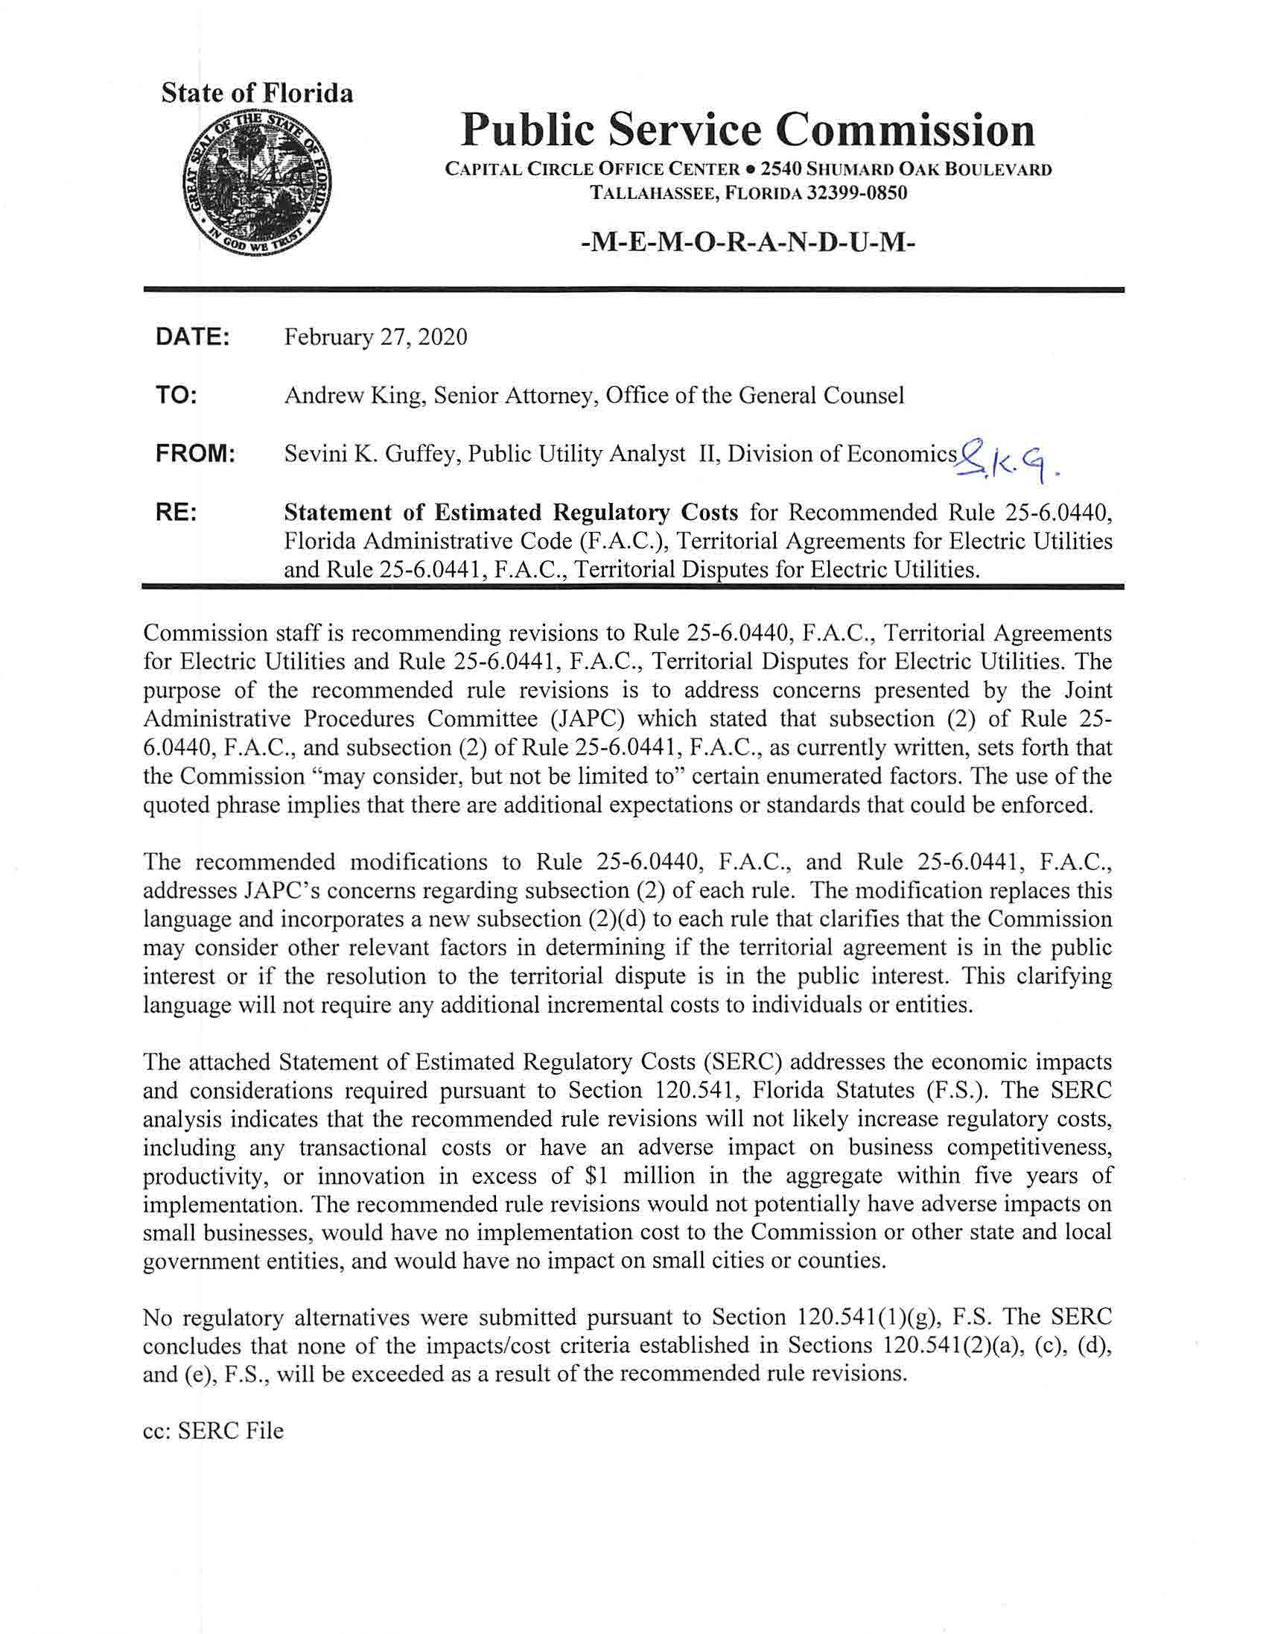

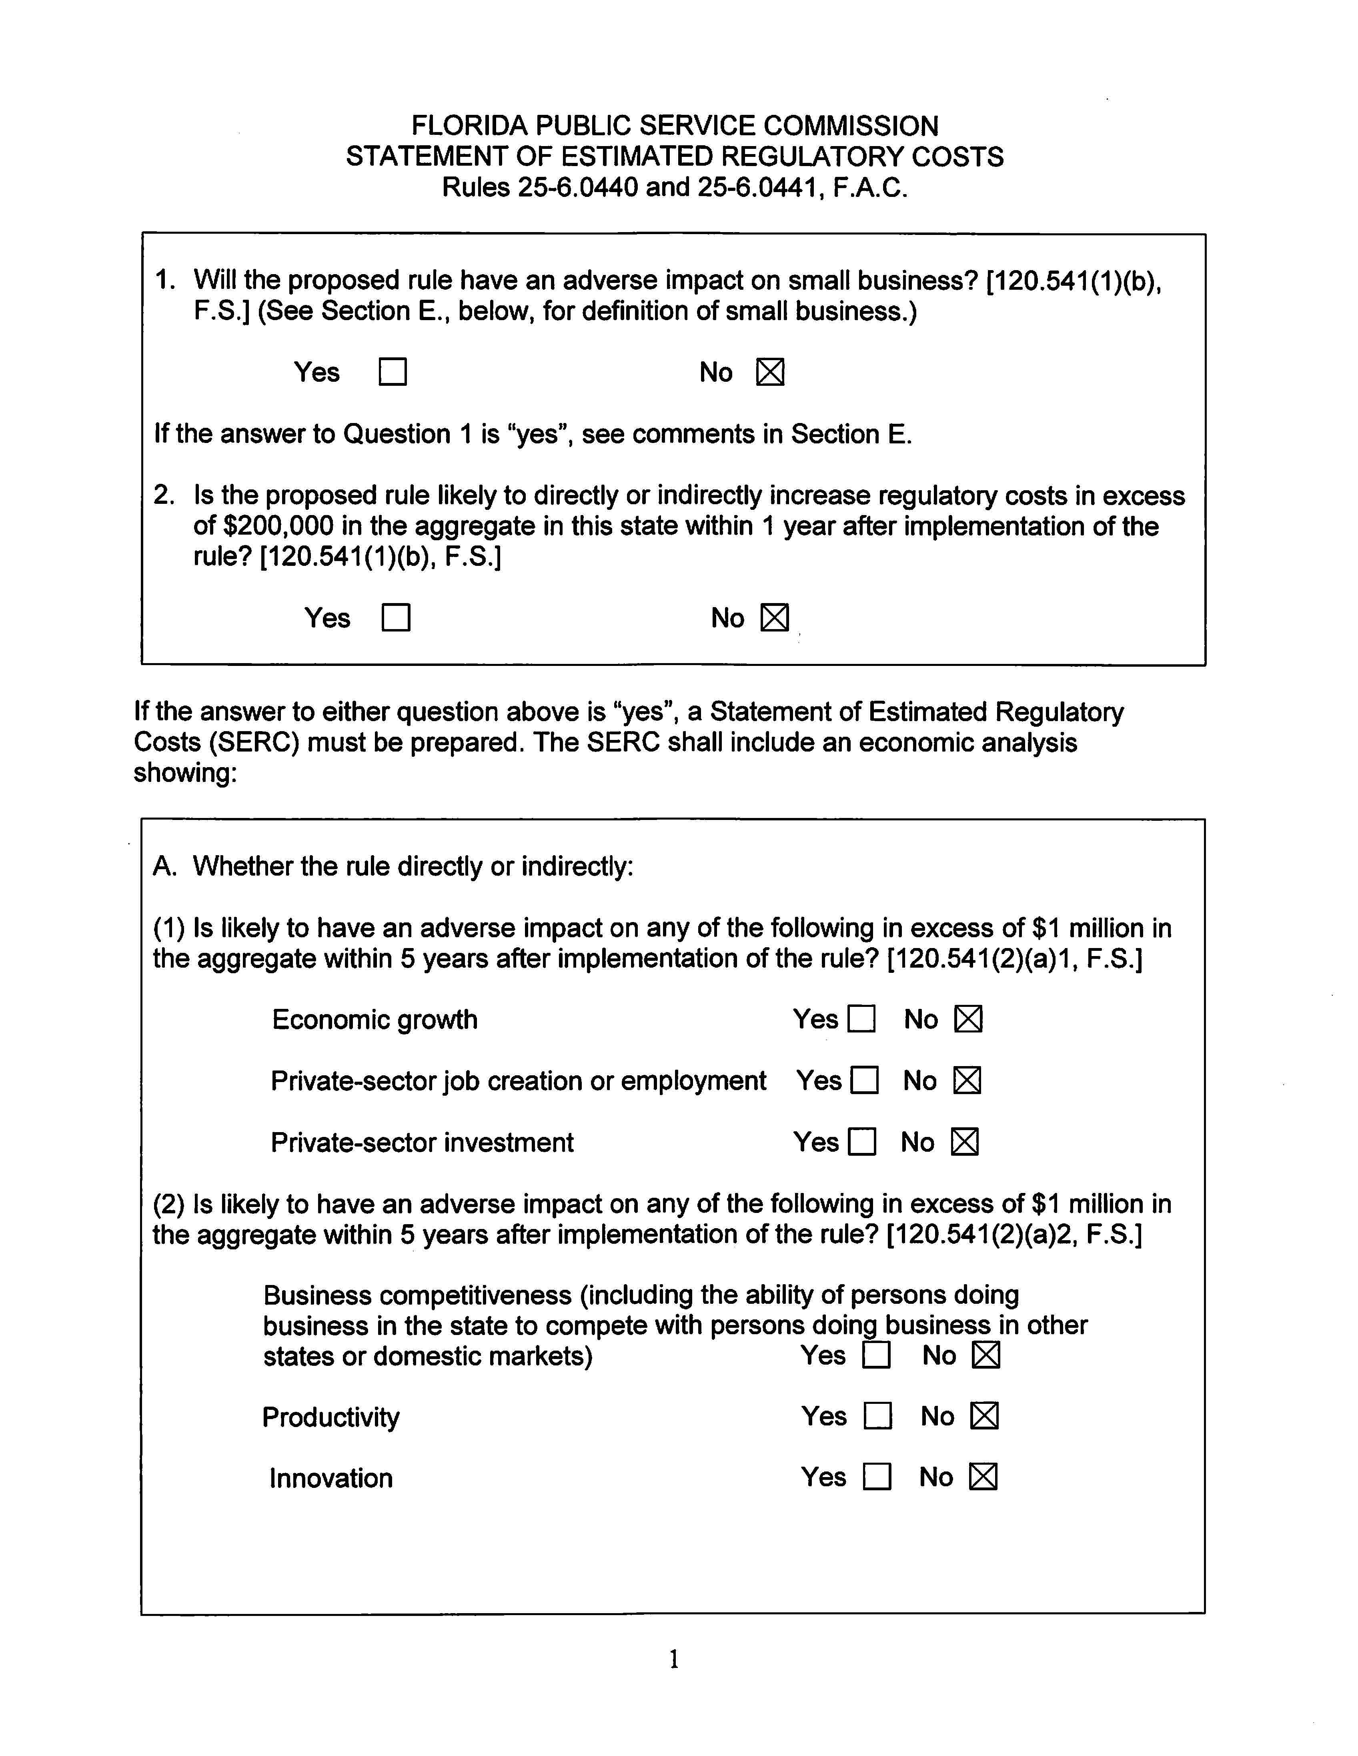

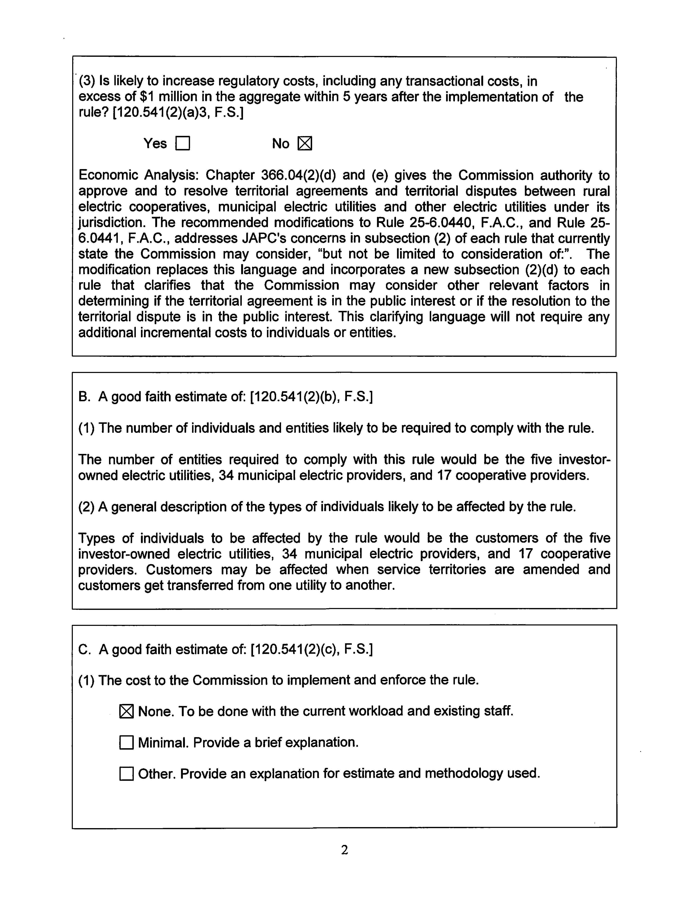

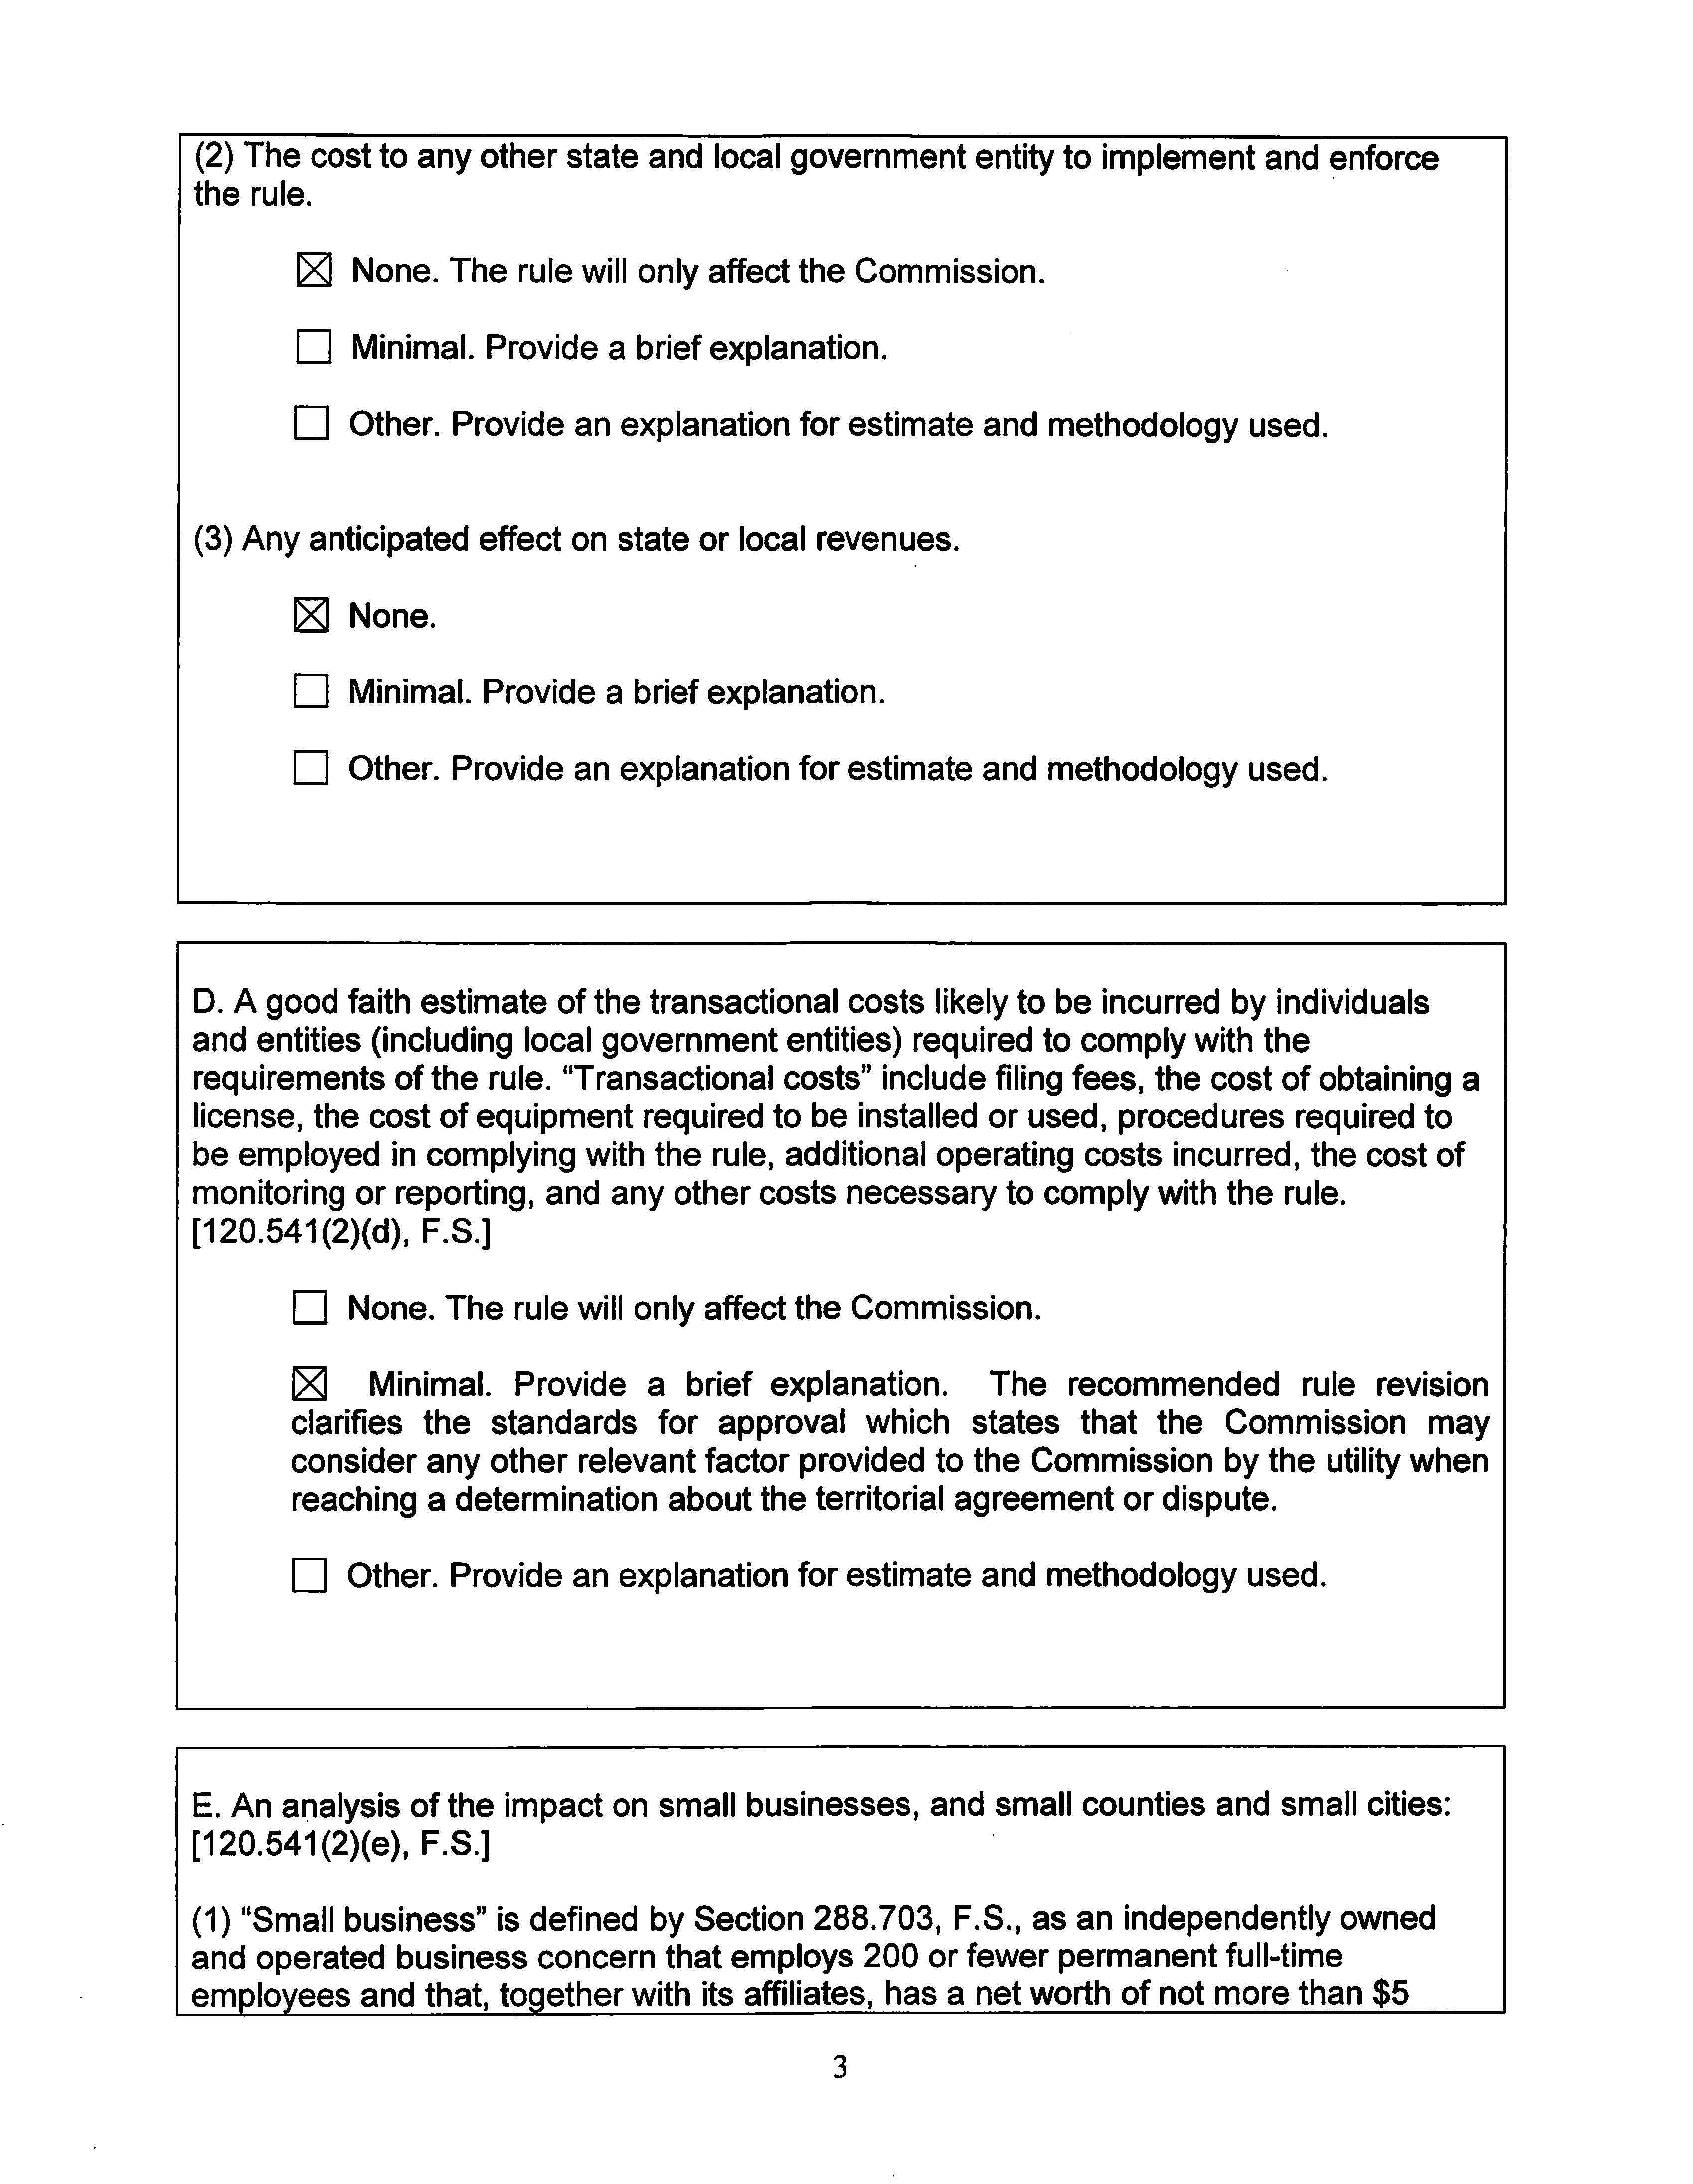

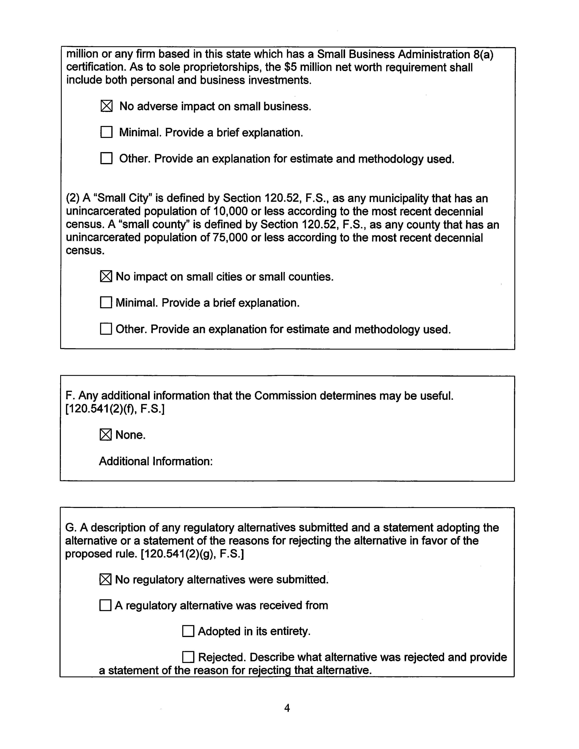

JAPC is required to maintain a continuous review of administrative rules and advise the agencies concerned of its findings under Section 120.545, F.S., and Joint Rule 4.6 of the Florida Legislature.
The Commission previously addressed JAPC’s comments from this letter regarding several other rules. See Order No. PSC-2019-0518-FOF-EI, issued on December 11, 2019, in Docket No. 20190164, In re: Proposed amendment of Rule 25-6.0141, F.A.C., Allowance for Funds Used During Construction; Rule 25-6.033, F.A.C., Tariffs; Rule 25-6.036, F.A.C., Inspection of Plant; and Rule 25-6.037, F.A.C., Extent of System Which Utility Shall Operate and Maintain.

