BEFORE THE FLORIDA PUBLIC SERVICE COMMISSION

In re: Petition for approval of emergency modification to tariff, by Sebring Gas System, Inc. | DOCKET NO. 20200120-GU  ORDER NO. PSC-2020-0172-TRF-GU  ISSUED: June 1, 2020

The following Commissioners participated in the disposition of this matter:

GARY F. CLARK, Chairman
ART GRAHAM
JULIE I. BROWN
DONALD J. POLMANN
ANDREW GILES FAY

ORDER APPROVING MODIFICATION TO TARIFF
BY SEBRING GAS SYSTEM, INC.

BY THE COMMISSION:

Background
On April 9, 2020, Sebring Gas System, Inc. (Sebring or utility) petitioned for approval of an emergency modification to its tariff sheet No. 48, which addresses delinquent bills and late payment charges. On March 1, 2020, Governor Ron DeSantis declared a public health emergency in Florida as a result of the outbreak of the COVID-19 coronavirus and on March 9, 2020, the Governor declared a state of emergency and implemented the state’s Emergency Management Plan. In addition, the Governor has issued additional Executive Orders to address the current emergency to include a statewide “Safer at Home” requirement. As a result of this emergency, the utility recognizes the economic impact to some residential and commercial customers. Many businesses are struggling financially and have instituted lay-offs or limited their employees’ hours.
Sebring states that during this public emergency, it does not plan to disconnect service to customers for non-payment, as allowed under its current tariff. However, Sebring’s current tariff does not provide the utility the ability to suspend late payment charges during this, or similar, emergency declarations. The proposed tariff modification would allow the utility flexibility to waive late payment charges during emergency situations, such as natural disasters and the current public health emergency.
Sebring’s revised tariff sheet is Attachment 1 to this order. We have jurisdiction over this matter pursuant to Sections 366.04, 366.05, 366.06, Florida Statutes.

Decision
Currently, Sebring’s tariff does not provide the utility the ability to waive late payment charges for any reason. This proposed modification would provide the utility with the flexibility to waive late fees during natural disasters and declared public emergencies issued by an authorized governmental body, including the current public health emergency. The language in this modification is similar to tariff language we approved for Florida Power & Light Company and Duke Energy Florida, LLC.
We find the modifications will allow Sebring the flexibility to mitigate customer impact during the current public health emergency and the related Executive Orders issued by Governor DeSantis while still reliably serving its customers. We therefore approve the modifications to Tariff Sheet No. 48, effective May 5, 2020.

Based on the foregoing, it is

ORDERED by the Florida Public Service Commission that the modifications to Sebring Gas System’s Tariff Sheet No. 48, attached hereto, are approved effective May 5, 2020. It is further

ORDERED that if a protest is filed within 21 days of the issuance of the order, the tariff shall remain in effect, with any revenues held subject to refund, pending resolution of the protest. If no timely protest is filed, this docket shall closed upon the issuance of a consummating order.
By ORDER of the Florida Public Service Commission this 1st day of June, 2020.

/s/ Adam J. Teitzman
ADAM J. TEITZMAN
Commission Clerk
Florida Public Service Commission
2540 Shumard Oak Boulevard
Tallahassee, Florida 32399
(850) 413-6770
www.floridapsc.com

Copies furnished: A copy of this document is provided to the parties of record at the time of issuance and, if applicable, interested persons.

JSC

NOTICE OF FURTHER PROCEEDINGS

The Florida Public Service Commission is required by Section 120.569(1), Florida Statutes, to notify parties of any administrative hearing or judicial review of Commission orders that is available under Sections 120.57 or 120.68, Florida Statutes, as well as the procedures and time limits that apply. This notice should not be construed to mean all requests for an administrative hearing or judicial review will be granted or result in the relief sought.

Mediation may be available on a case-by-case basis. If mediation is conducted, it does not affect a substantially interested person's right to a hearing.

The Commission's decision on this tariff is interim in nature and will become final, unless a person whose substantial interests are affected by the proposed action files a petition for a formal proceeding, in the form provided by Rule 28-106.201, Florida Administrative Code. This petition must be received by the Office of Commission Clerk, 2540 Shumard Oak Boulevard, Tallahassee, Florida 32399-0850, by the close of business on June 22, 2020.

In the absence of such a petition, this Order shall become final and effective upon the issuance of a Consummating Order.

Any objection or protest filed in this docket before the issuance date of this order is considered abandoned unless it satisfies the foregoing conditions and is renewed within the specified protest period.

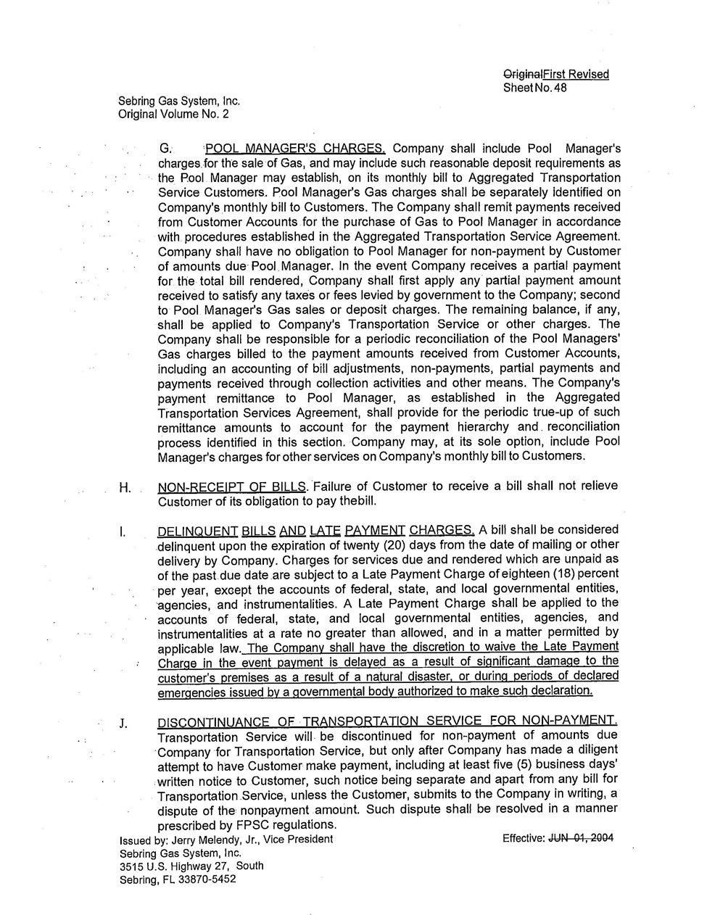

Order No. PSC-92-0912A-FOF-EI, issued September 16, 1992, in Docket No. 920800-EI, In re: Petition by Florida Power & Light Company to Waive Certain Service Charges For Good-Paying Customers. See Tariff Sheet No. 4.020.
Order No. PSC-2020-0096-TRF-EI, issued April 6, 2020, in Docket No. 2020095-EI, In re: Petition of approval of emergency modification to Duke Energy’s rate schedule SC-1, tariff sheet 6.110 by Duke Energy Florida, LLC..

