State of Florida |  | Public Service Commission  Capital Circle Office Center ● 2540 Shumard Oak Boulevard  Tallahassee, Florida 32399-0850  -M-E-M-O-R-A-N-D-U-M-
DATE: | August 20, 2020
TO: | Office of Commission Clerk (Teitzman)
FROM: | Division of Economics (Guffey, Hampson)  Office of the General Counsel (Trierweiler)
RE: | Docket No. 20200162-EU – Joint petition for approval of amendment to territorial agreement in St. Johns County, by Florida Power & Light Company and JEA.
AGENDA: | 09/01/20 – Regular Agenda – Proposed Agency Action – Interested Persons May Participate
COMMISSIONERS ASSIGNED: |  |  | All Commissioners
PREHEARING OFFICER: |  |  | Brown
CRITICAL DATES: |  |  | None
SPECIAL INSTRUCTIONS: |  |  | None

Case Background
On June 3, 2020, Florida Power & Light Company (FPL) and JEA, collectively the joint petitioners or parties, filed a petition seeking Commission approval of a Third Amendment to their existing territorial agreement in St. Johns County. The existing service boundary line bifurcates a planned subdivision located in St. Johns County. The proposed Third Amendment allows FPL and JEA to swap certain parcels within their respective service territories in St. Johns County, which will allow JEA to serve the entire planned subdivision. The proposed Third Amendment, legal descriptions, and maps depicting the swapped land parcels and revised service boundaries are provided in Attachment A to this recommendation.
The Commission approved the parties’ first territorial agreement in St. Johns County in 1965. Thereafter, the territorial boundary was re-affirmed by the Commission in 1980. In 1996, as the result of a territorial dispute, FPL and JEA entered into a new territorial agreement which replaced the prior agreement. After the discovery of an inconsistency between the 1996 Agreement and a territorial agreement between JEA and Clay Electric Cooperative, a new territorial agreement between FPL and JEA was approved by the Commission in 1998. In 2012, the Commission approved an amendment that altered a segment of the territorial boundaries between the parties so that a single utility could serve the electric needs of a new private development planned for an undeveloped area. In 2014, the parties entered into the second amendment to the existing territorial agreement to alter the boundary to align it with planned roadways and accommodate new expanding development.

This recommendation addresses the proposed Third Amendment to the existing territorial agreement. During the review of this joint petition, staff issued a data request to the joint petitioners on June 30, 2020, for which responses were received on July 14, 2020. The Commission has jurisdiction over this matter pursuant to Section 366.04, Florida Statutes (F.S.).

Discussion of Issues

Issue 1:
Should the Commission approve the proposed Third Amendment to the existing territorial agreement between FPL and JEA in St. Johns County?

Recommendation:
Yes, the Commission should approve the proposed Third Amendment, dated June 3, 2020, to the existing territorial agreement between FPL and JEA in St. Johns County. The proposed Third Amendment to the territorial agreement will allow JEA to serve an entire planned residential development and it will enable FPL and JEA to serve their other customers in the county in an efficient manner. (Guffey, Hampson)

Staff Analysis:
Pursuant to Section 366.04(2)(d), F.S., and Rule 25-6.0440, Florida Administrative Code (F.A.C.), the Commission has the jurisdiction to approve territorial agreements between and among rural electric cooperatives, municipal electric utilities, and other electric utilities. Unless the Commission determines that the agreement will cause a detriment to the public interest, the agreement should be approved.

Proposed Third Amendment to Territorial Agreement
On June 3, 2020, FPL and JEA entered into the Third Amendment to their 1998 territorial agreement, which shall continue and remain in effect until the Commission, by order, modifies or withdraws its approval of this Agreement after proper notice and hearing. Other than the proposed parcel swaps, all other parts of the territorial agreement remain in effect. The proposed Third Amendment finalizes the territorial boundary adjustments between FPL and JEA that are necessary to accommodate development and facilitate the provision of electricity to the expanding development by one utility, and is also intended to avoid duplication of services in the areas subject to the parcel swaps. Pursuant to the agreed upon amendment, three parcels (5, 6, and 7) located within JEA’s territory will be transferred to FPL and one parcel (parcel 4) located within FPL’s territory will be transferred to JEA. Total acreage of the swapped parcels is 22.30 acres located in St. Johns County.

Currently, the subject parcels are undeveloped; and therefore, there are no customers or electric facilities in parcels 4, 5, 6, and 7 pursuant to paragraph 2 of the proposed 2020 Amendment. With the parcel swap, JEA will provide electricity to 342 residential customers in the planned development for parcel 4 (13.43 acres), and FPL will provide electricity to parcels 5, 6, and 7 (total of 8.87 acres) if developed in the future. With the parcel swap, the parties will be better positioned to provide electric service in the future to other development within this area.

Customer Notification
Paragraph 18 of the petition states that since the areas subject to the parcel swap in this 2020 Amendment are currently undeveloped, there are no infrastructure or customer accounts to be transferred; therefore, no customers were notified pursuant to Rule 25-6.0440(1), F.A.C.
In paragraph 20 of the petition, the parties state that approval of the proposed 2020 Amendment will not cause a decrease in reliability of electric service to the existing or future customers.

Conclusion
After review of the petition and the petitioners’ joint responses to staff’s data request, staff believes the proposed Third Amendment will enable FPL and JEA to exchange four land parcels within their respective retail service territories, achieve necessary changes to accommodate development, and serve their current and future customers efficiently. It appears that the proposed Third Amendment to the existing agreement eliminates any potential uneconomic duplication of facilities and will not cause a decrease in reliability of electric service. As such, staff believes that the proposed Third Amendment dated June 3, 2020, to the exiting territorial agreement between FPL and JEA in St. Johns County should be approved by the Commission. The proposed Third Amendment to the territorial agreement should become effective on the date the Commission Order approving it becomes final.

Issue 2:
Should this docket be closed?

Recommendation:
If no protest is filed by a person whose substantial interests are affected within 21 days of the issuance of the Order, this docket should be closed upon the issuance of a Consummating Order. (Trierwiler)

Staff Analysis:
If no protest is filed by a person whose substantial interests are affected within 21 days of the issuance of the Order, this docket should be closed upon the issuance of a Consummating Order.

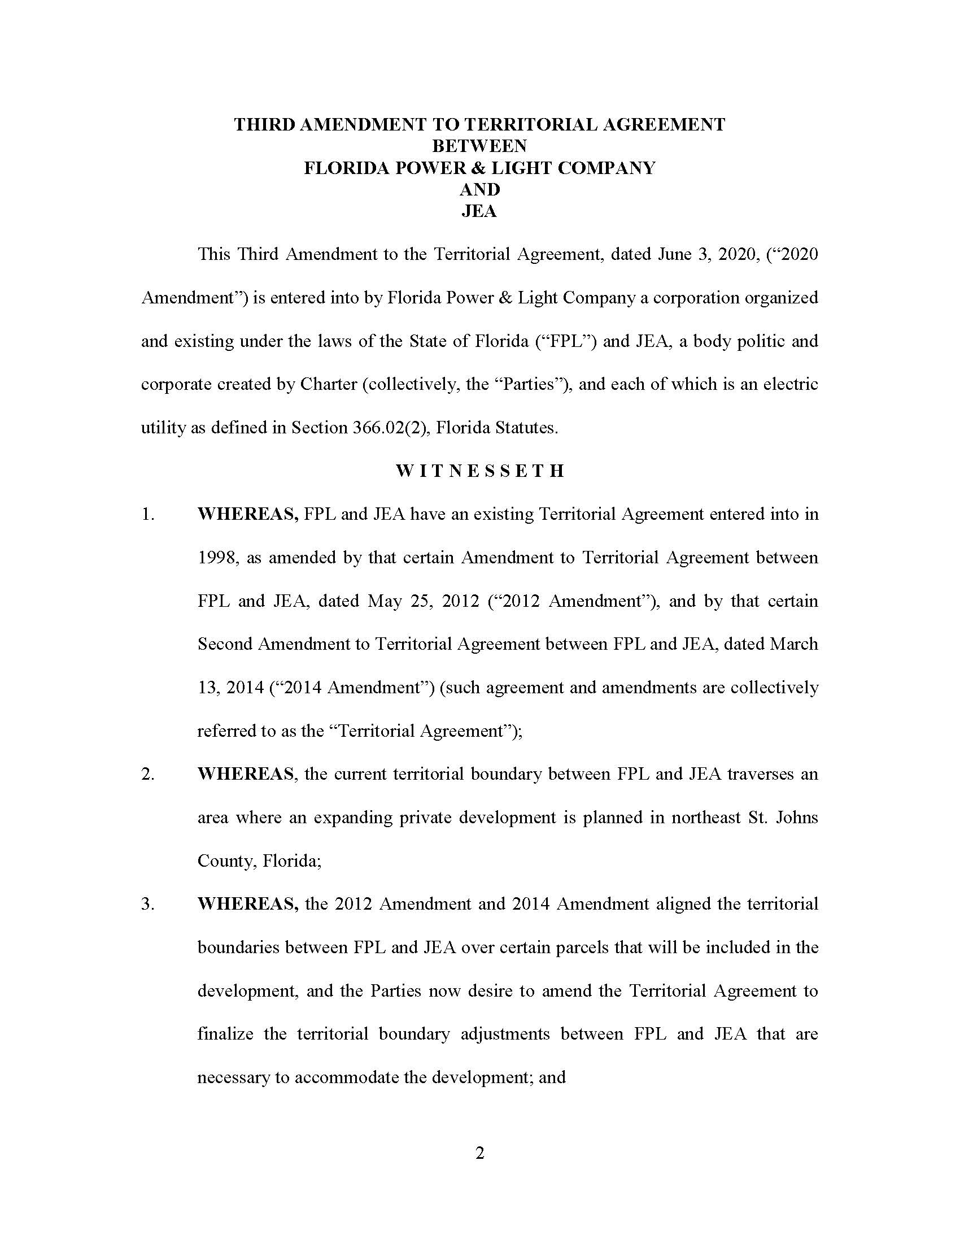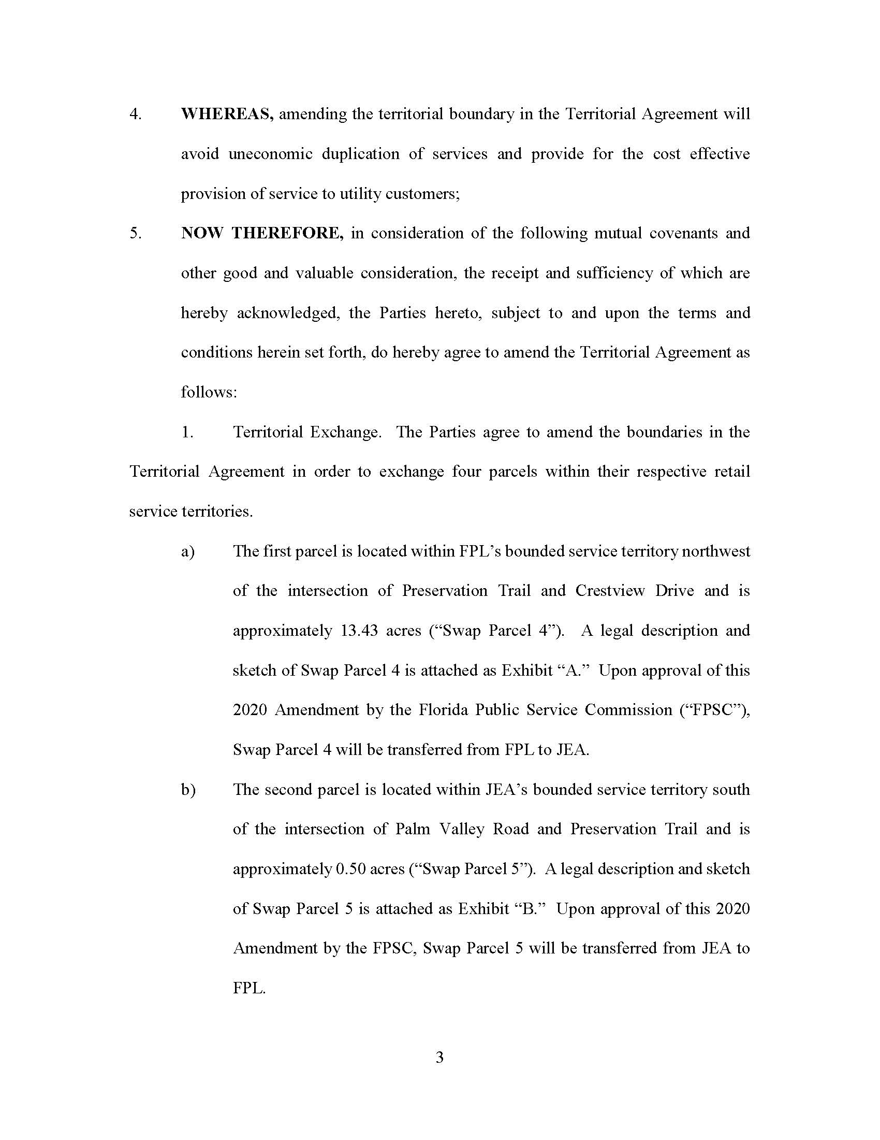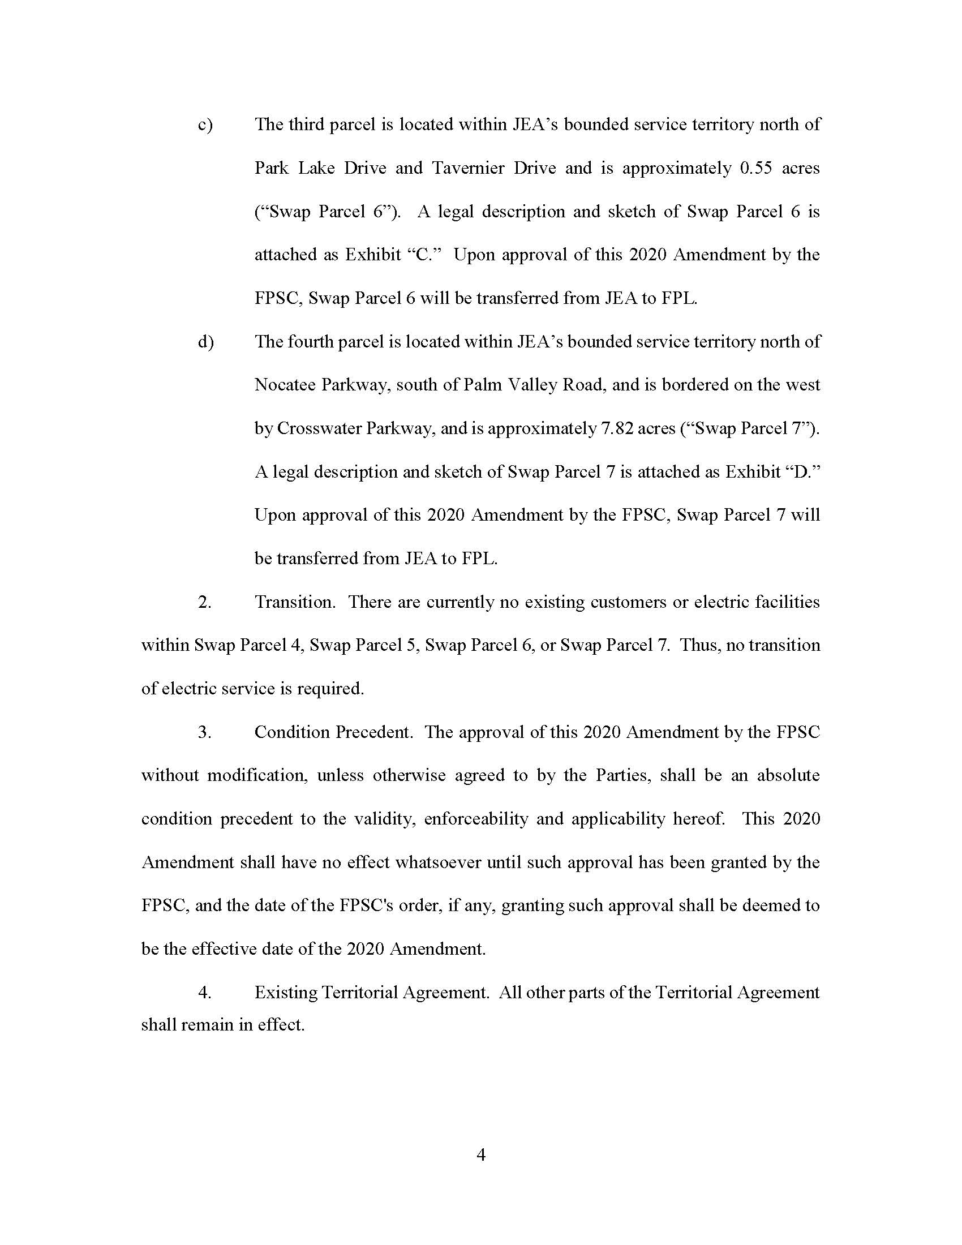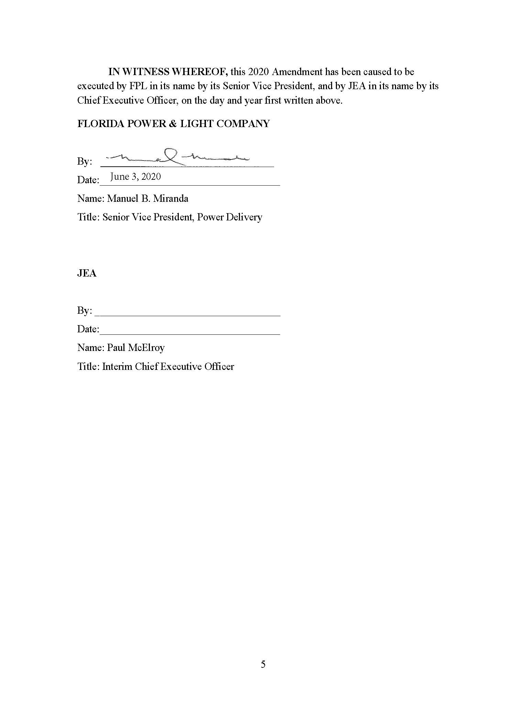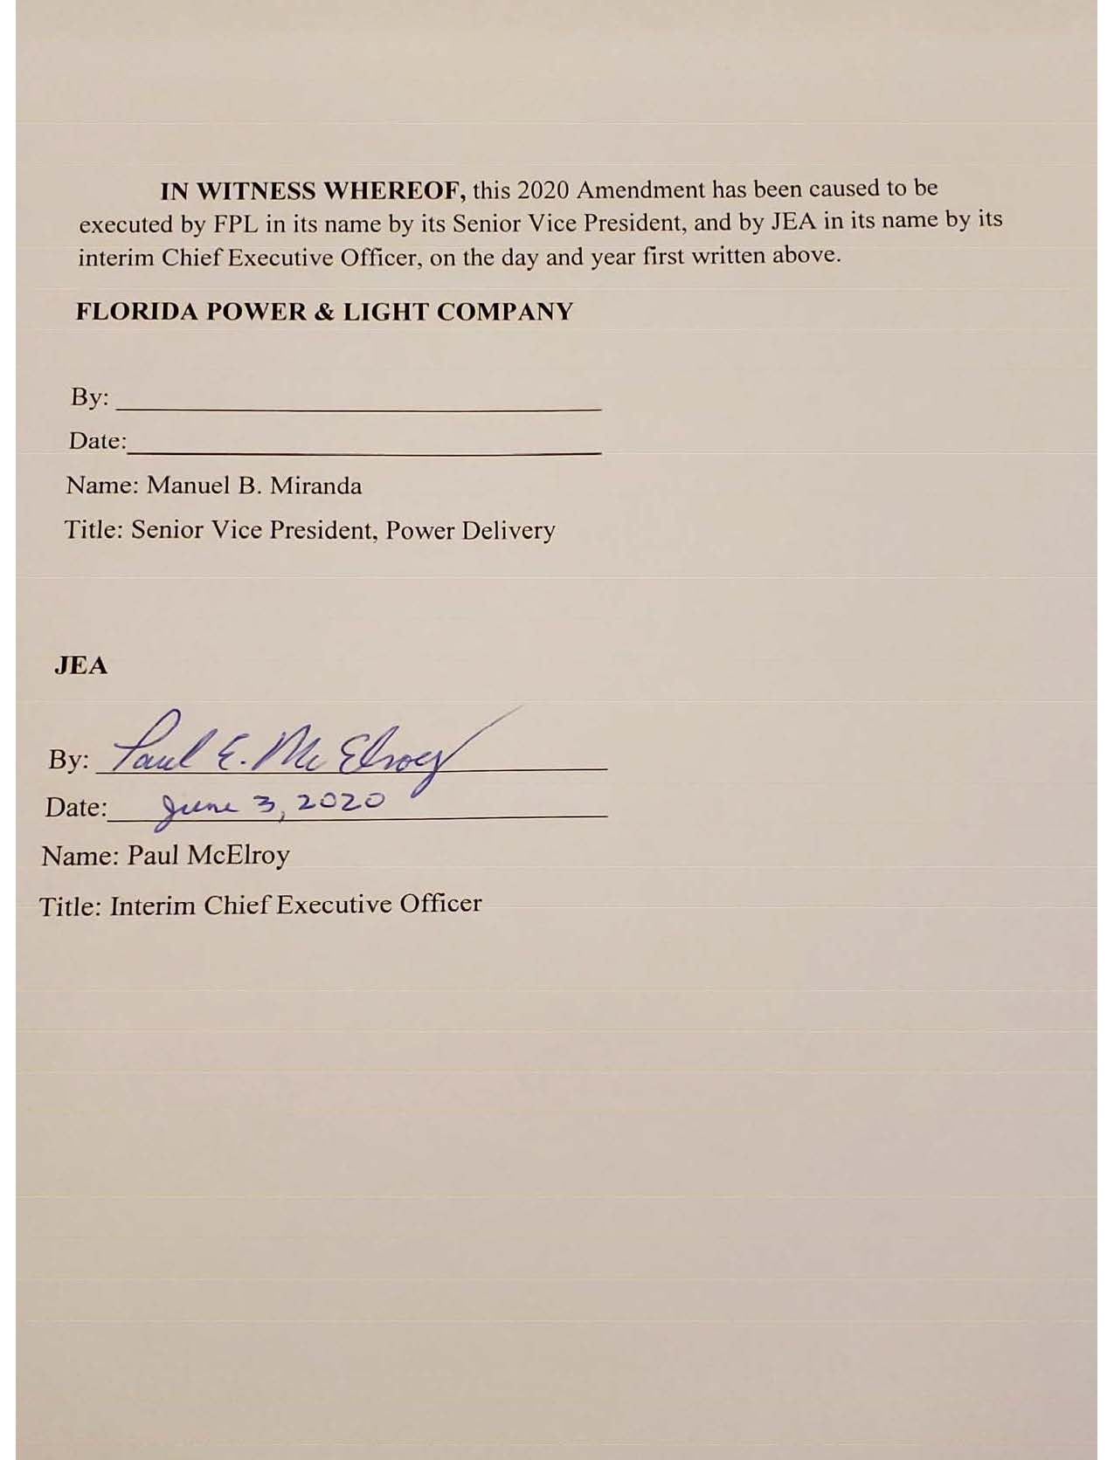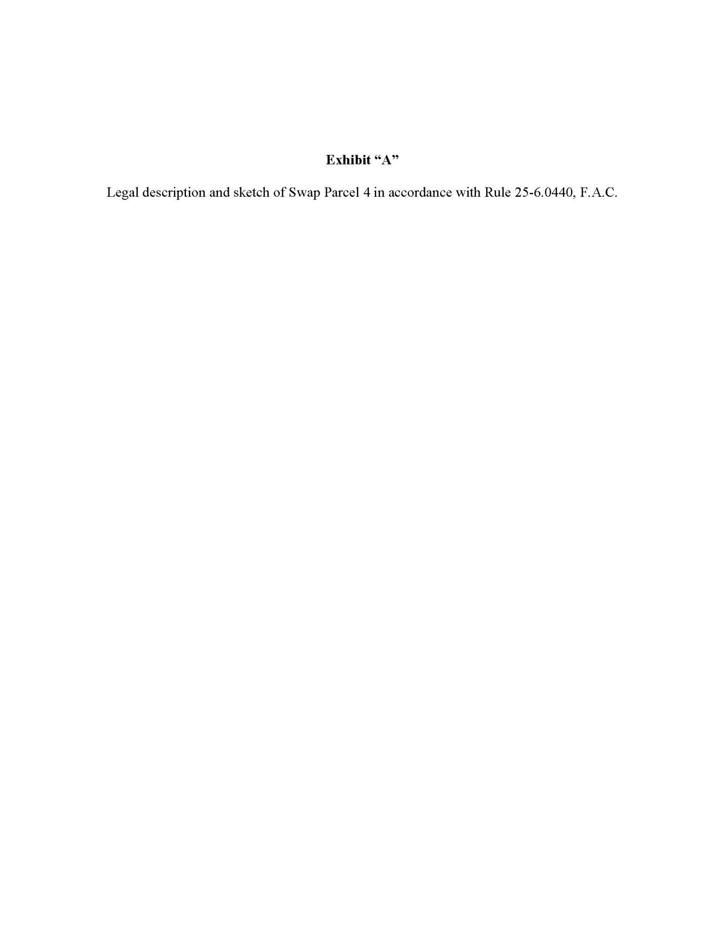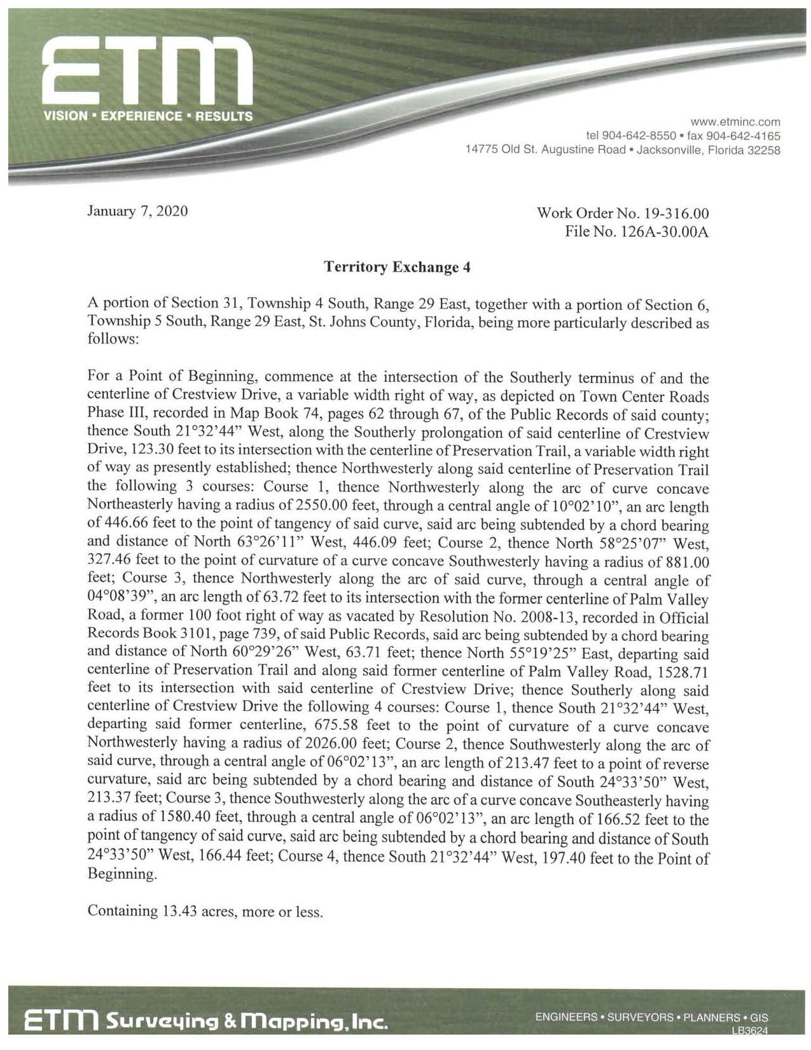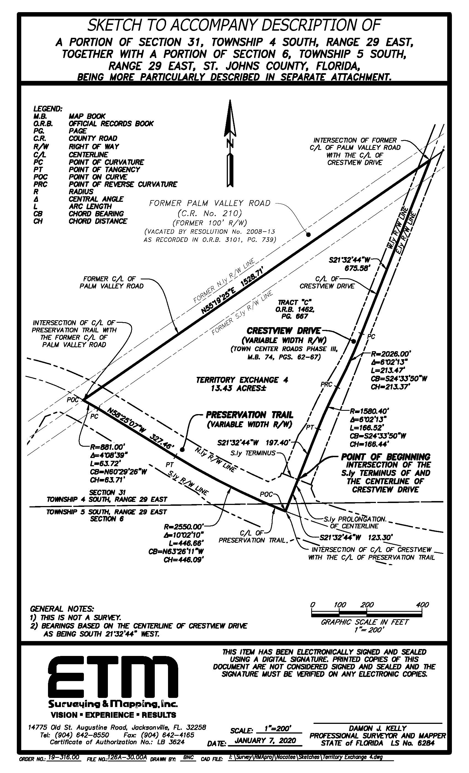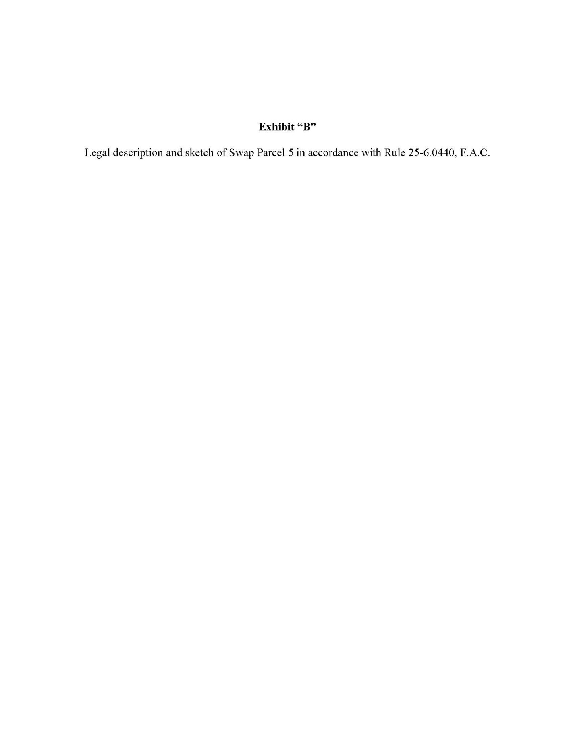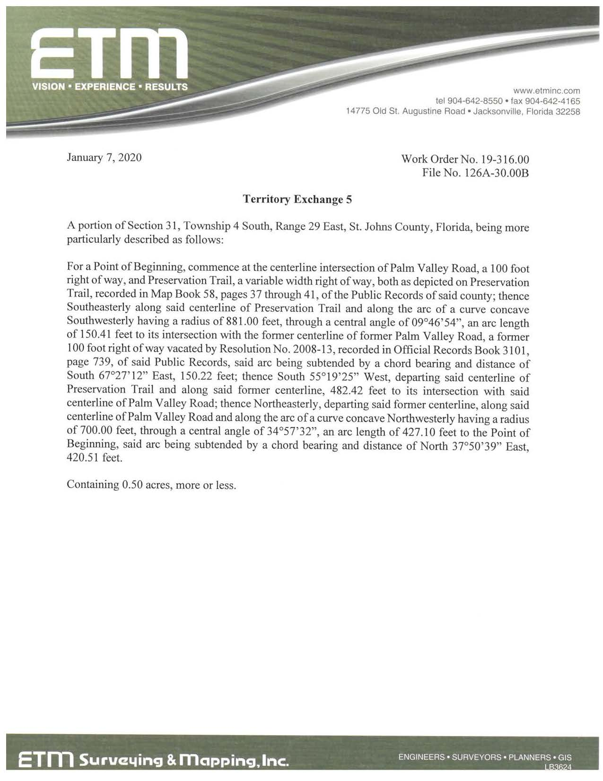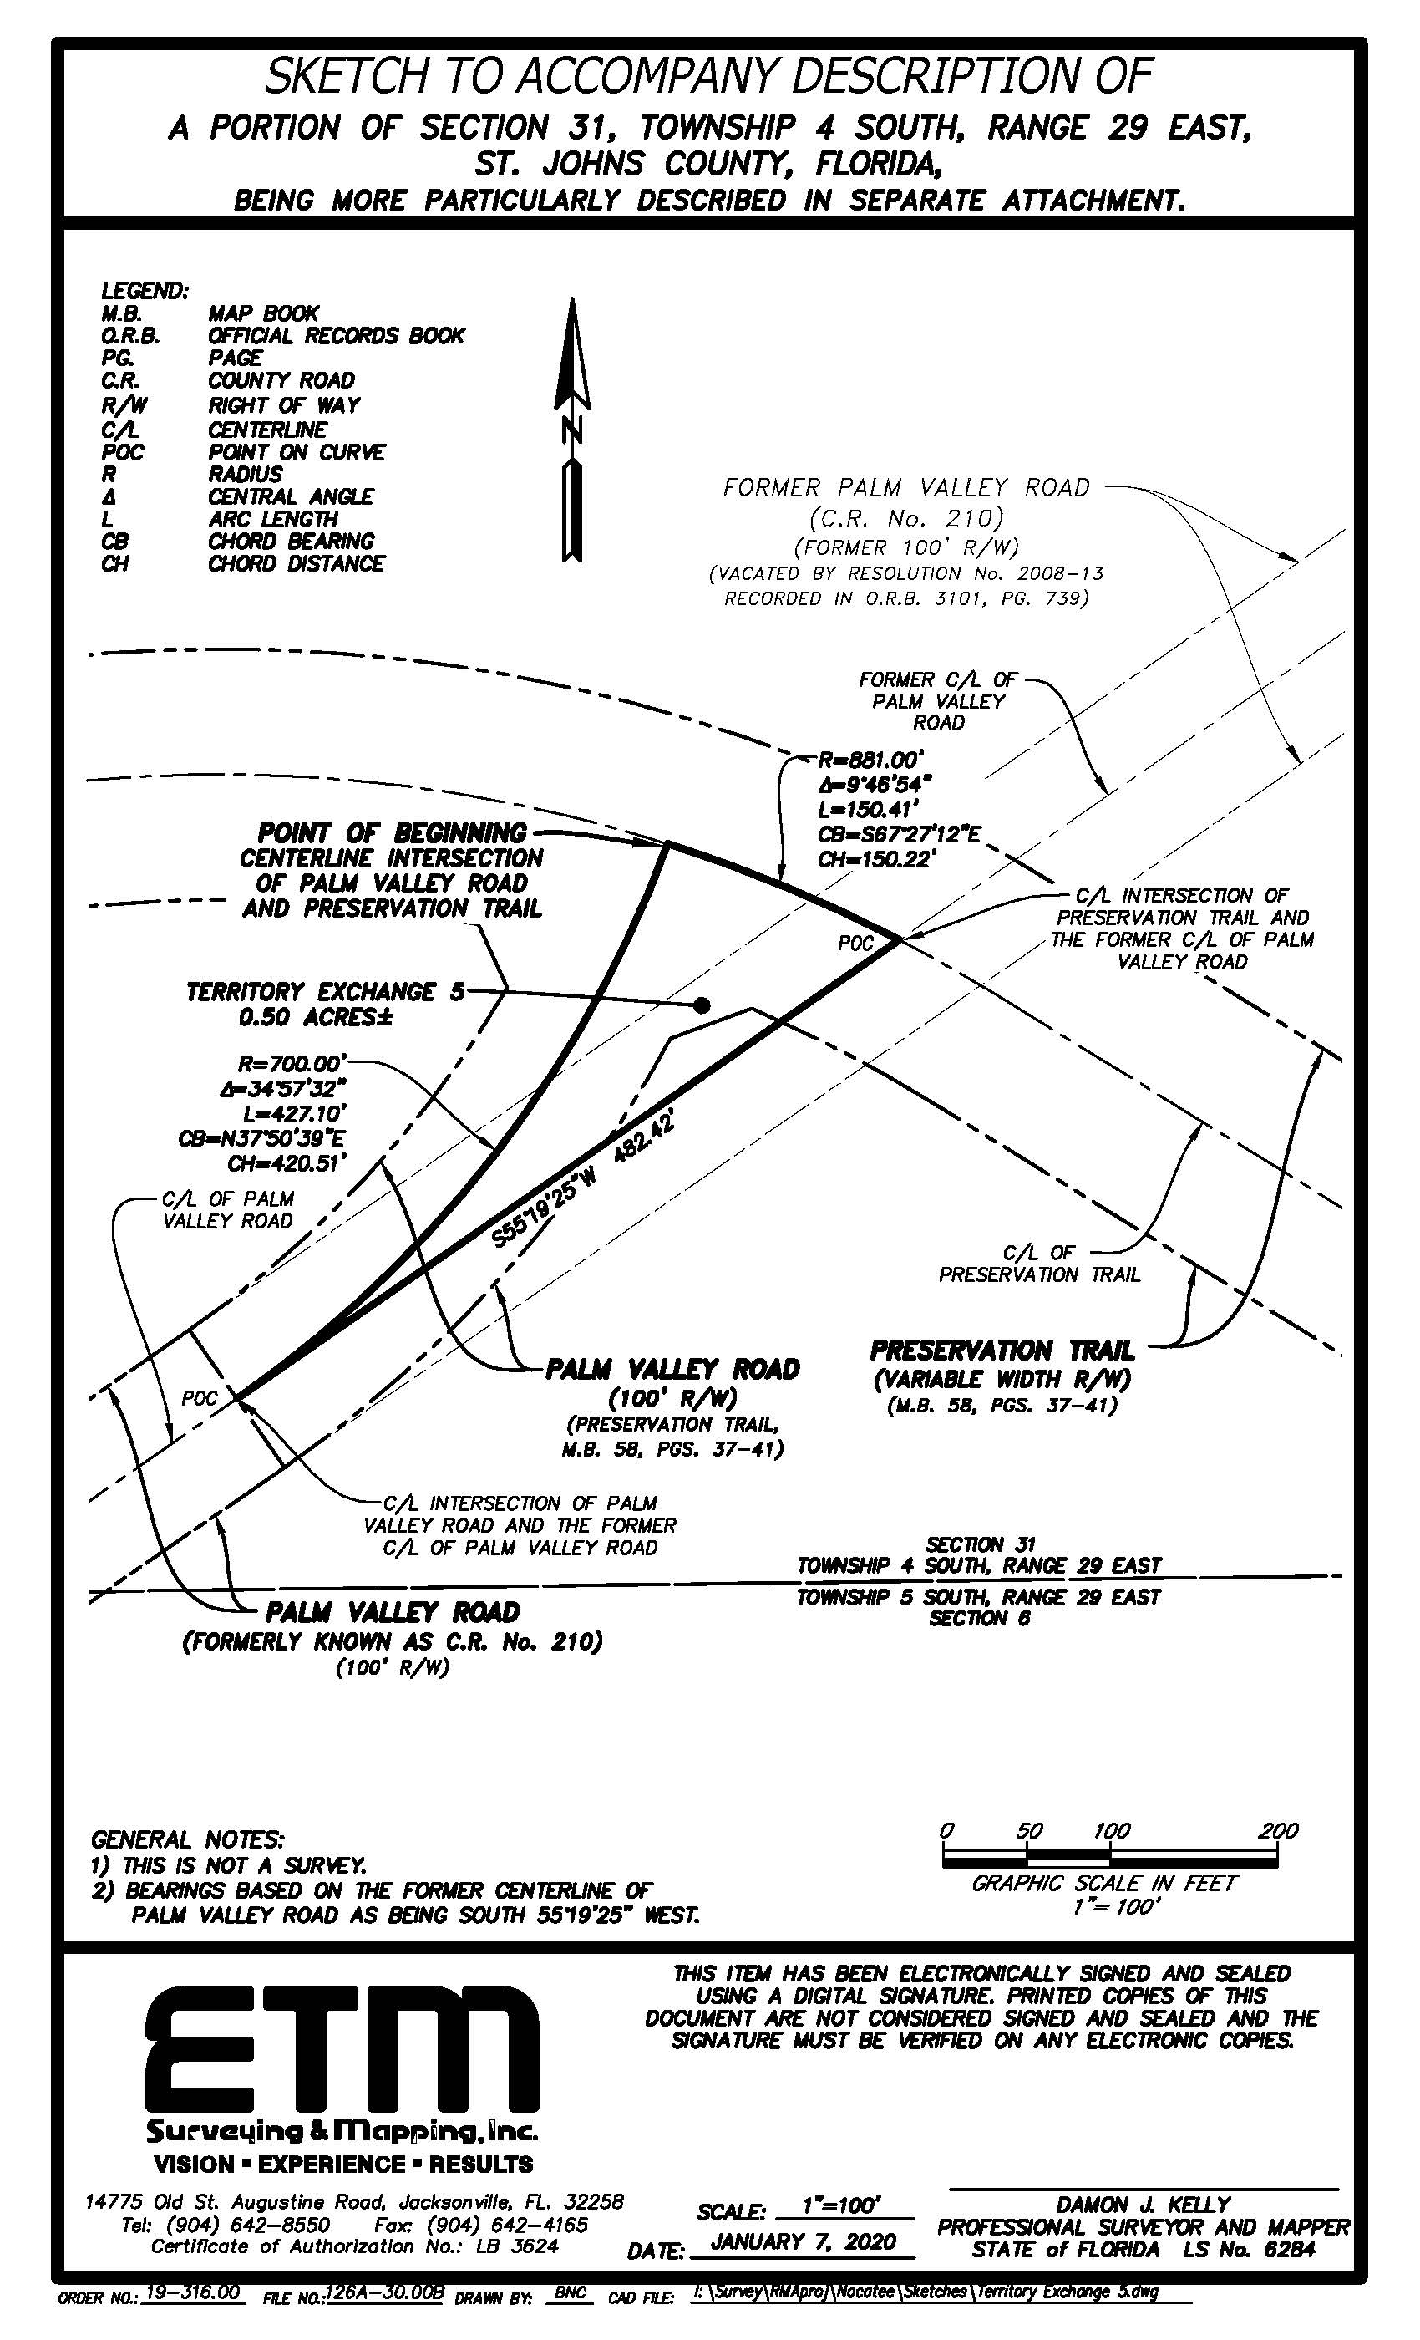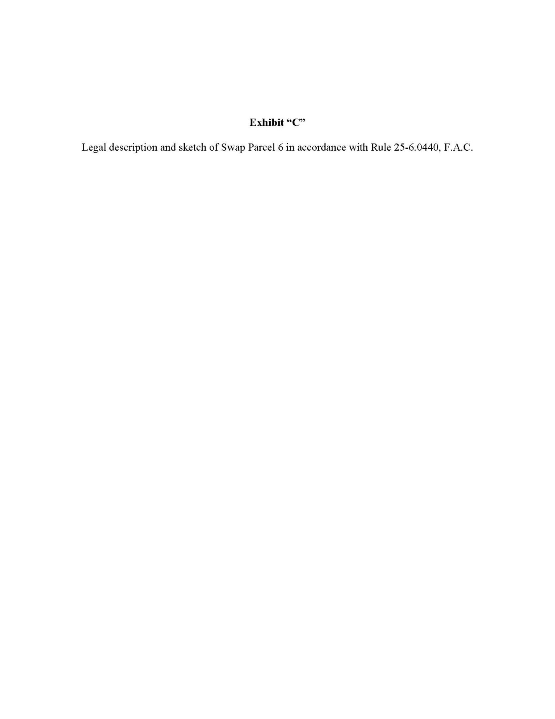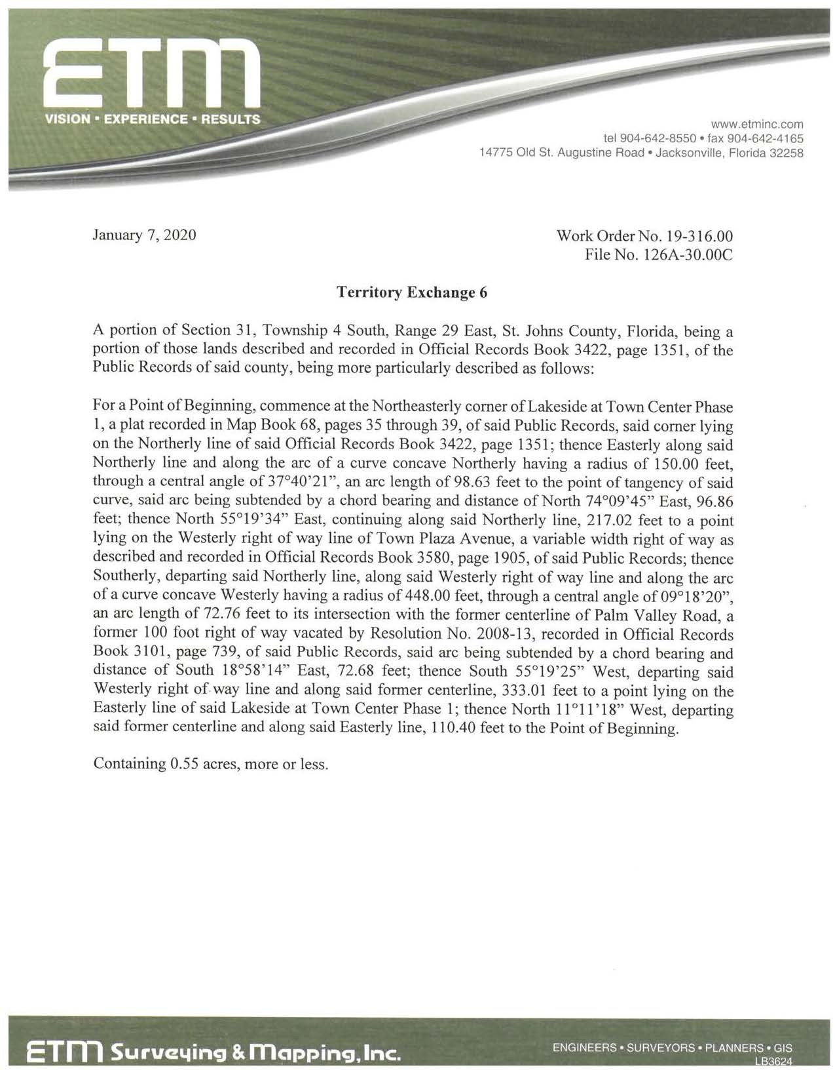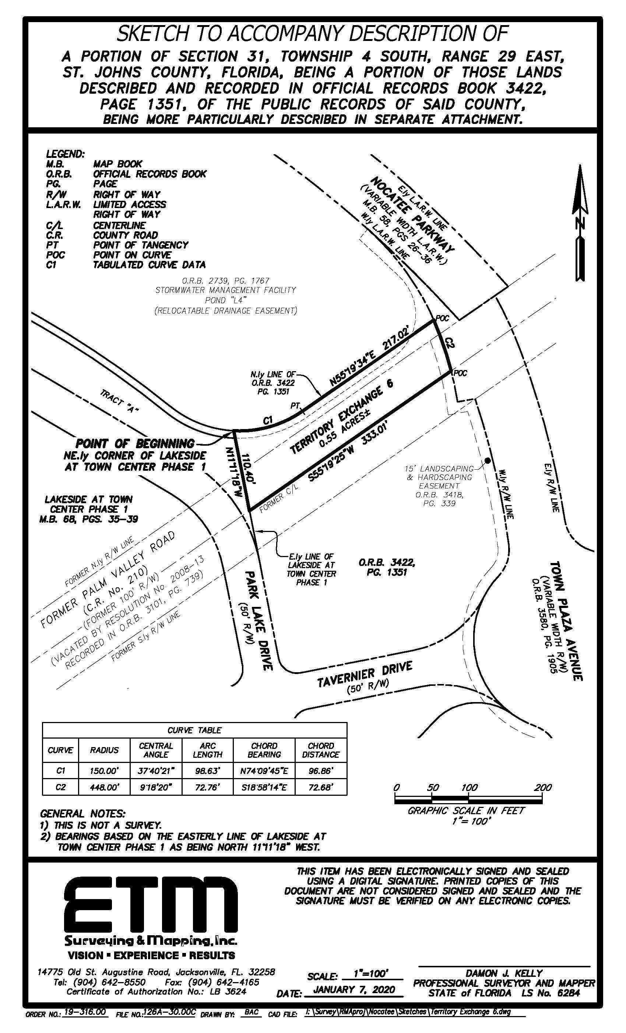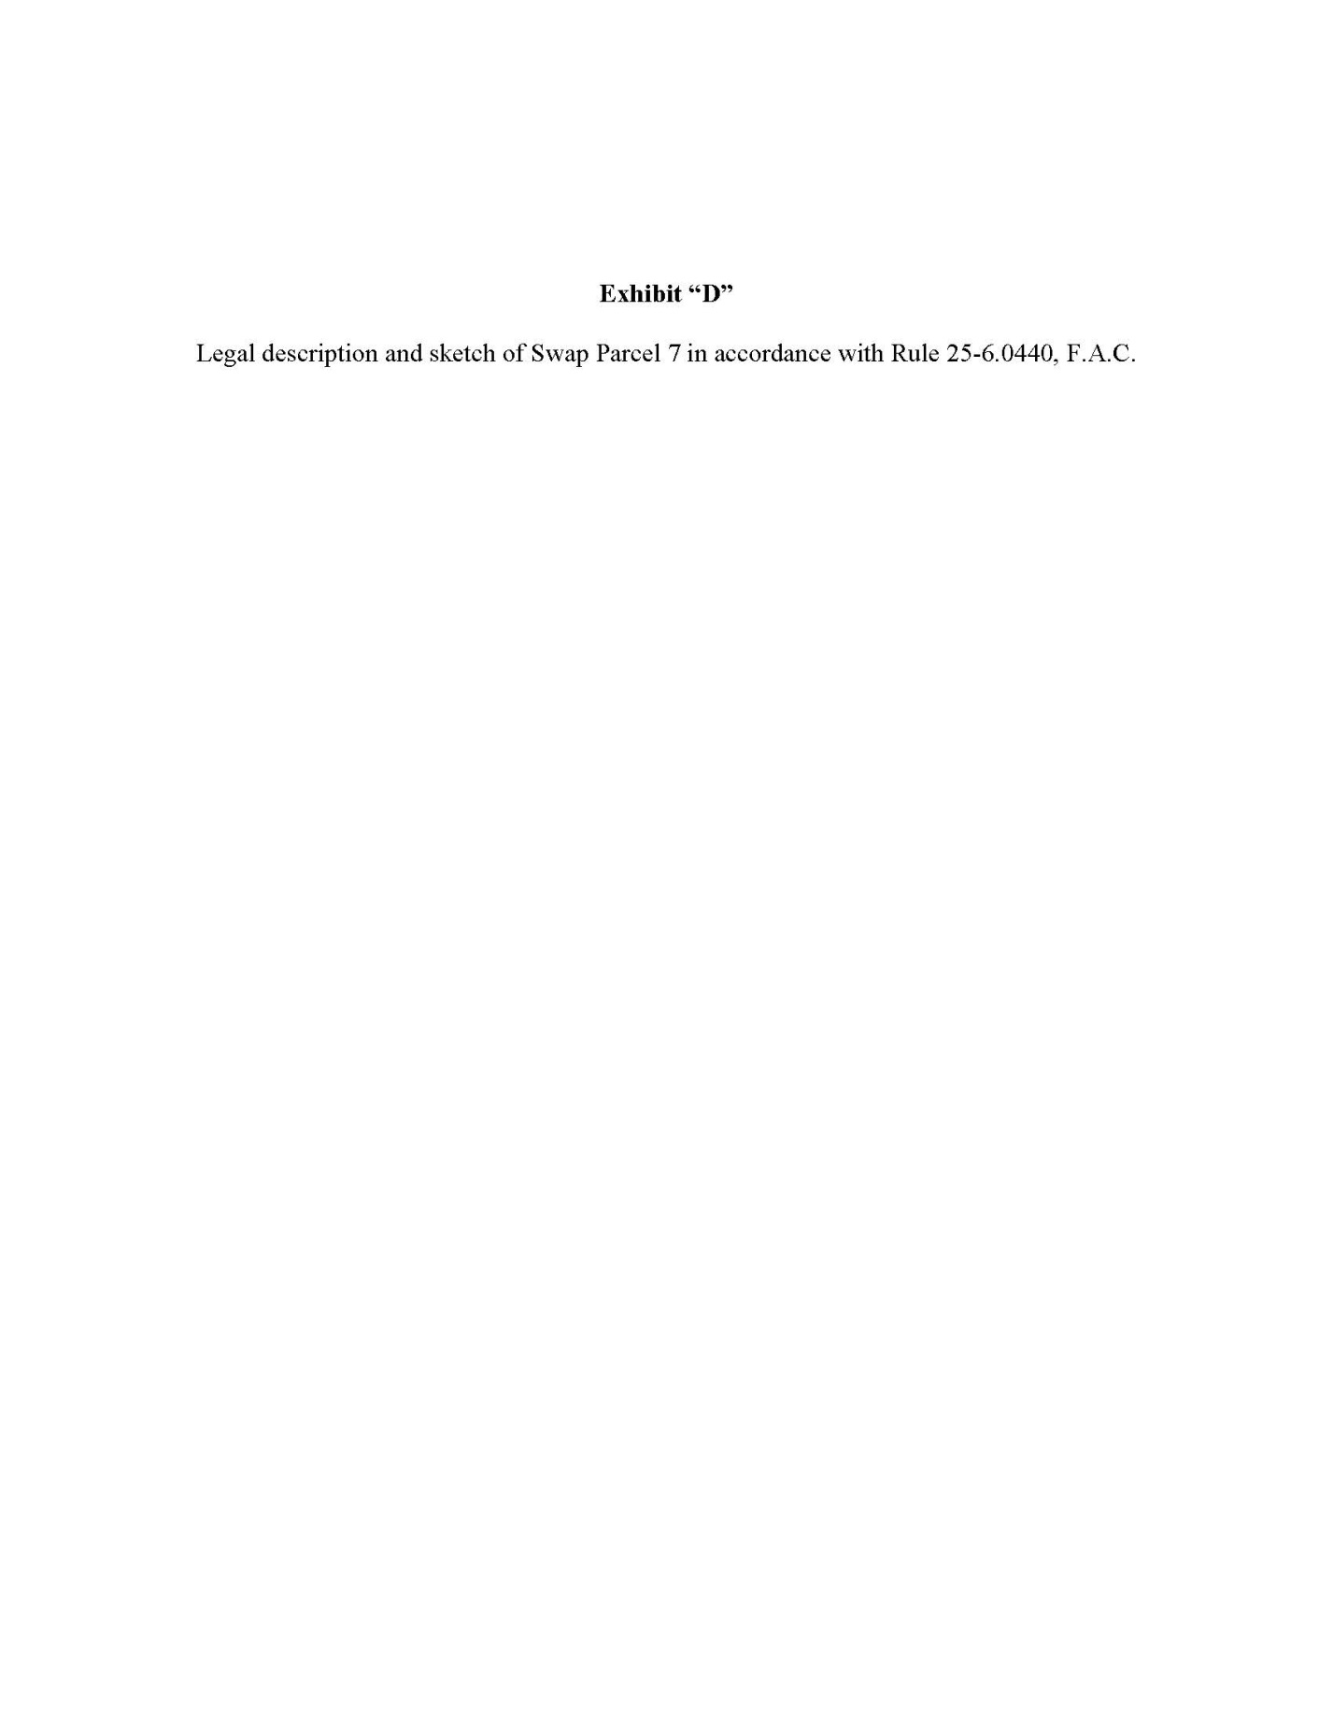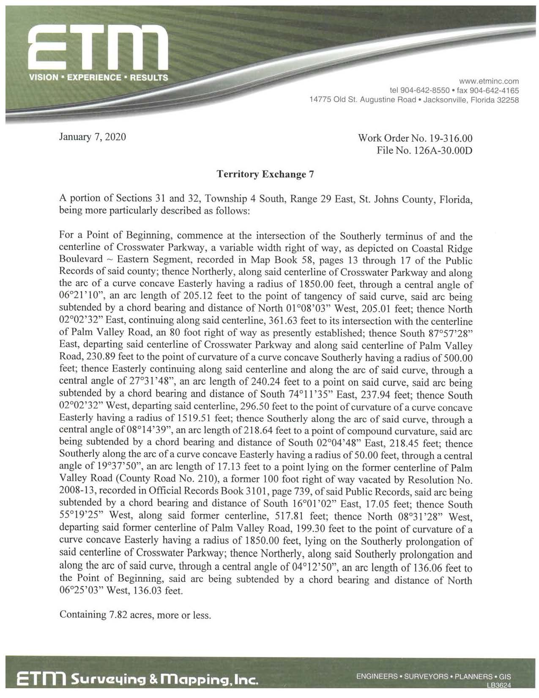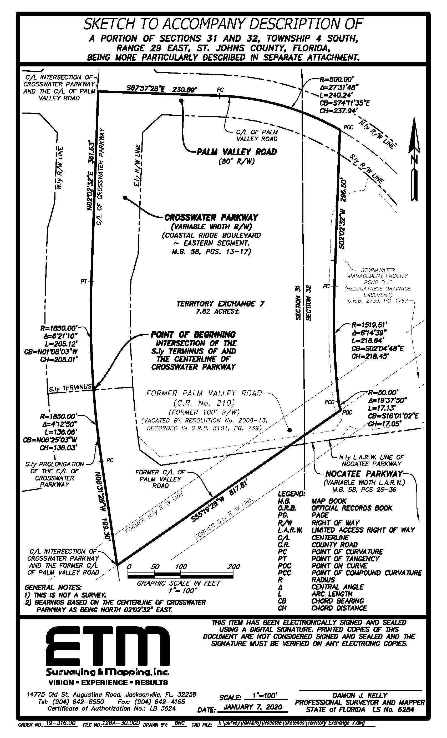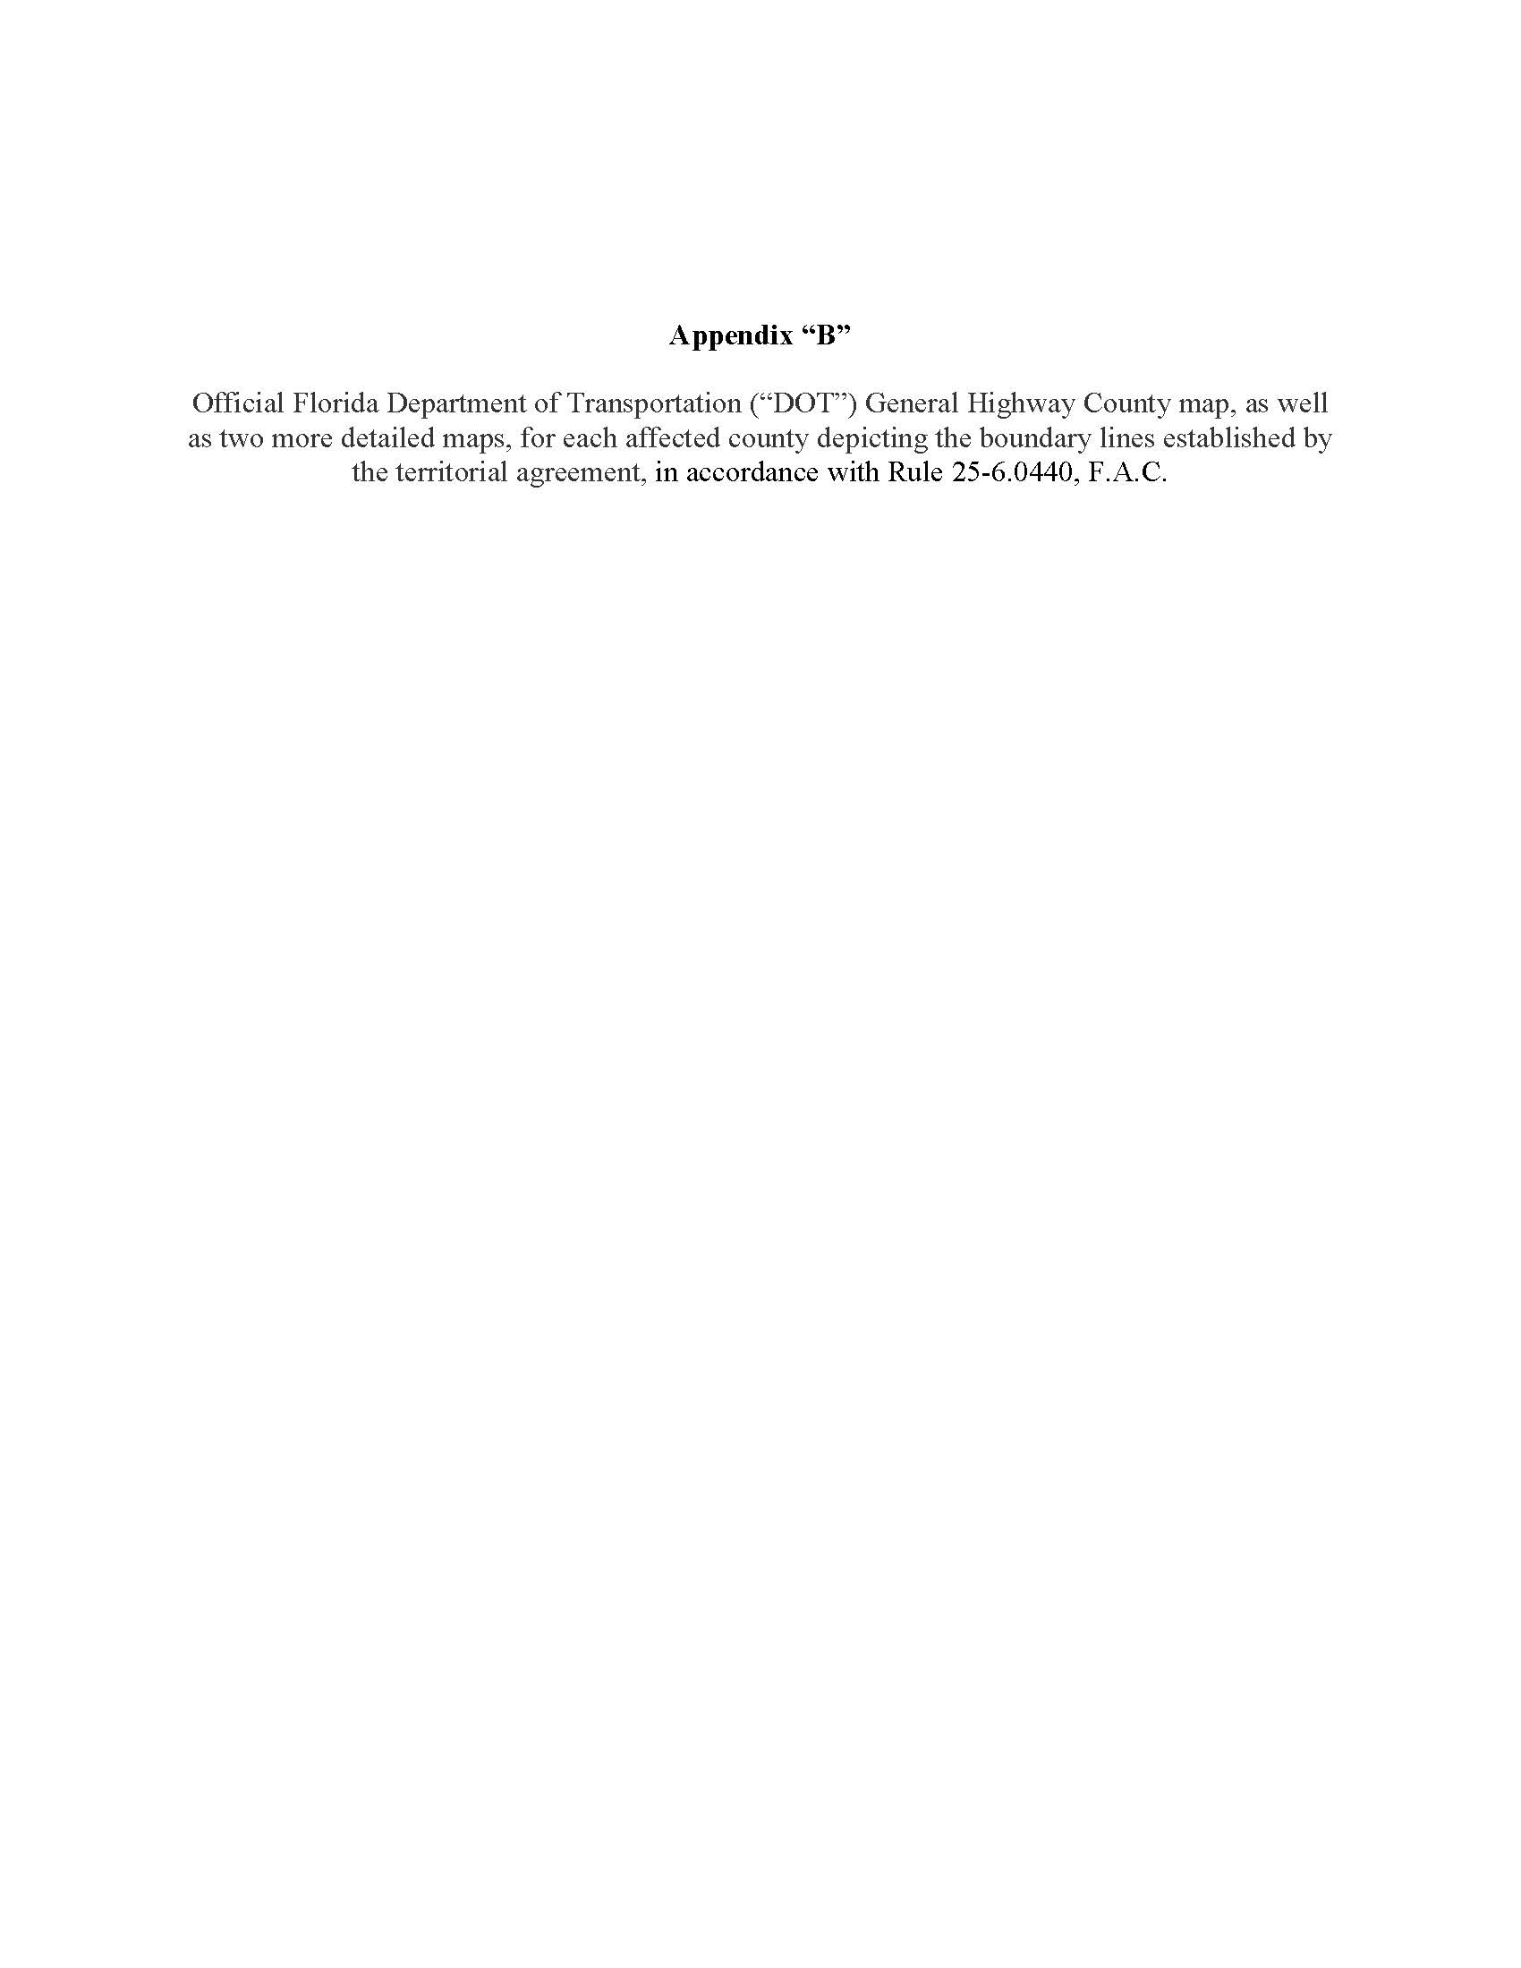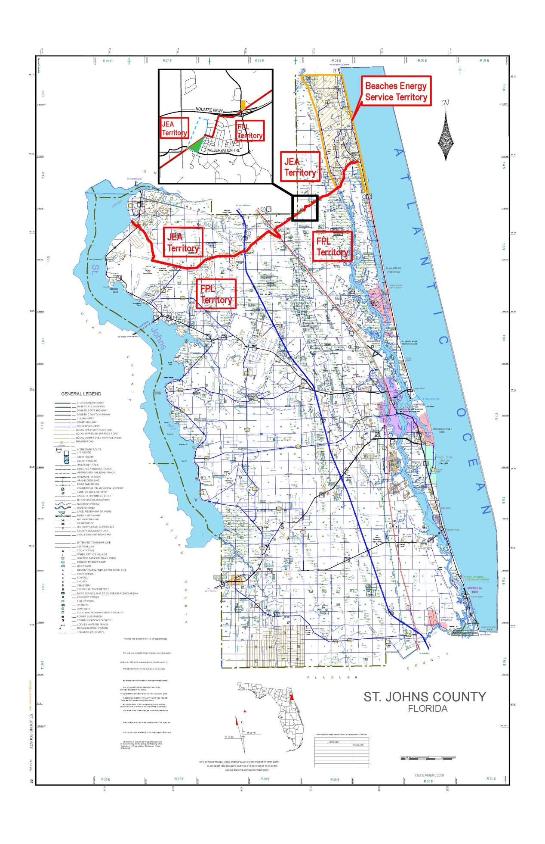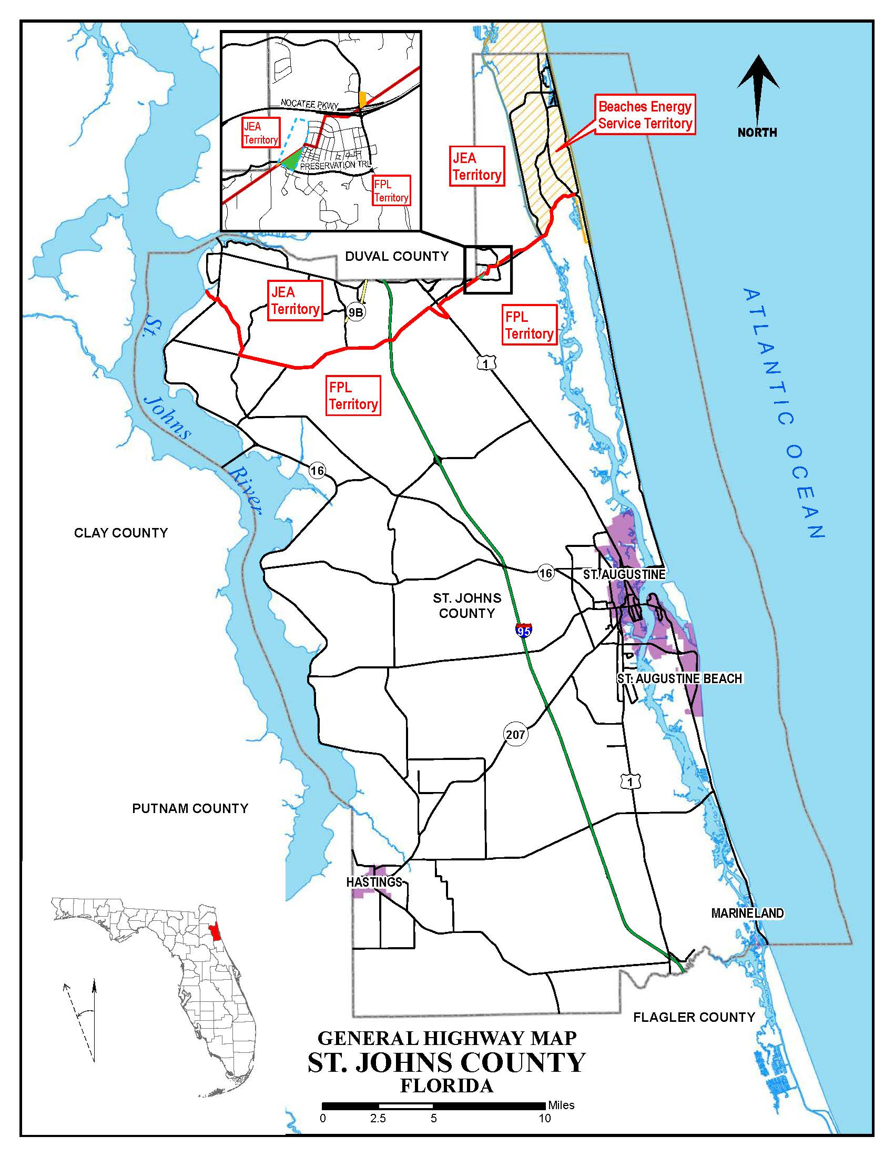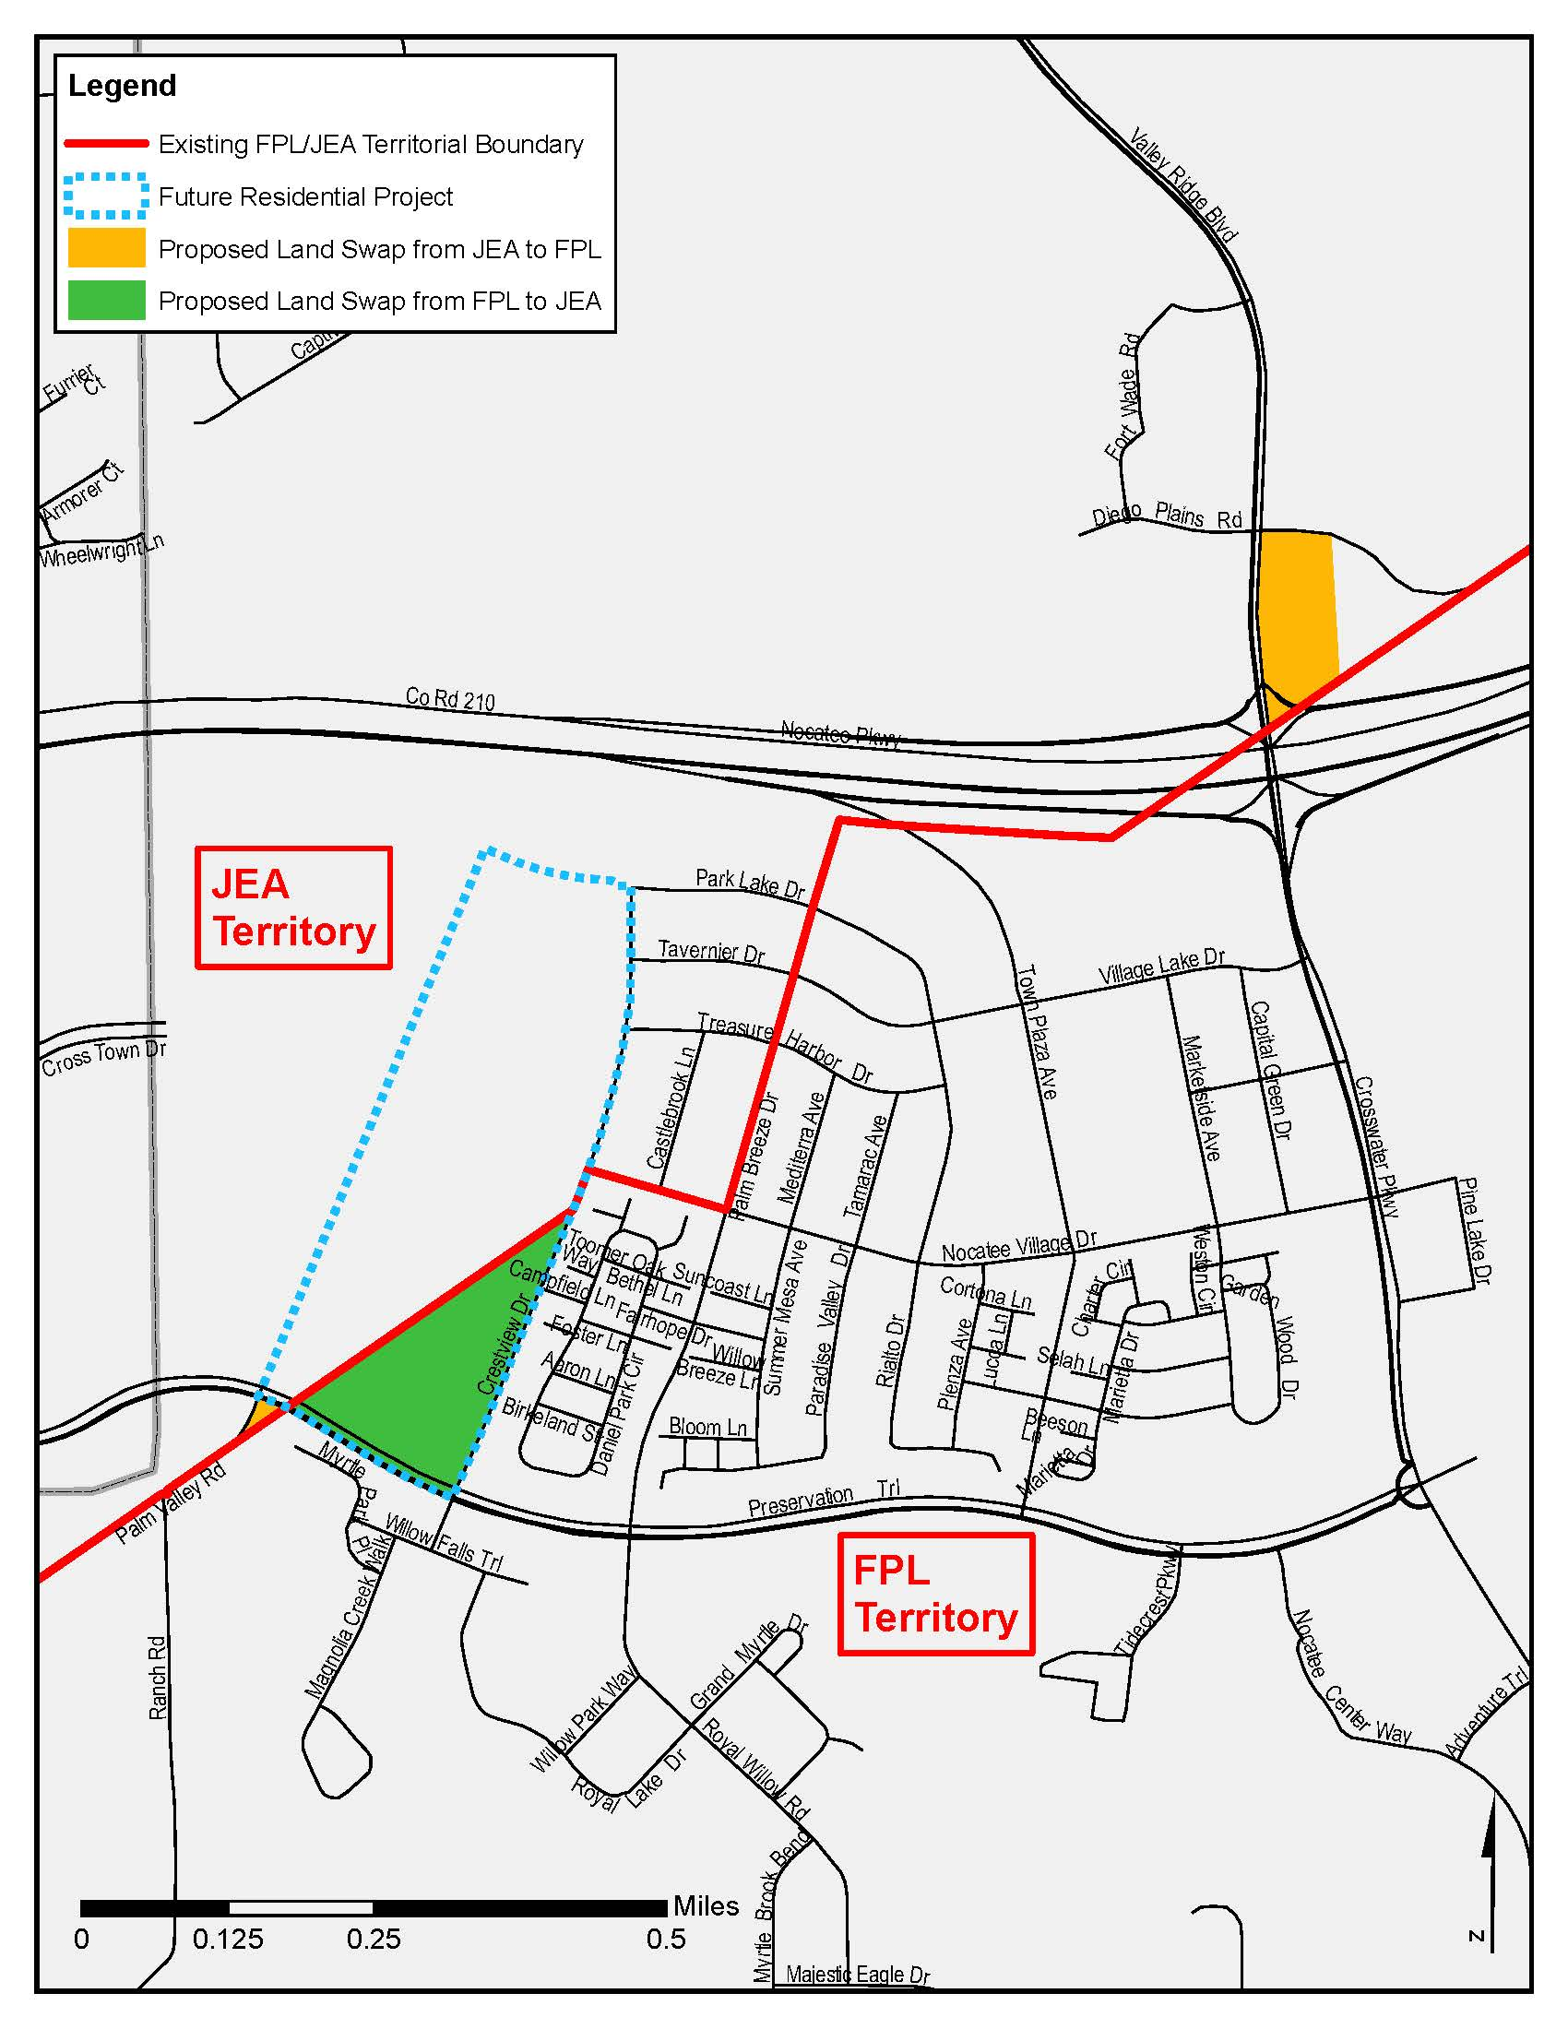

Order No. 3799, issued April 28, 1965, in Docket No. 7421-EU.
Order No. 9363, issued May 9, 1980, in Docket No. 790886-EU, In re: Petition of Jacksonville Electric Authority for approval of a territorial agreement between JEA and Florida Power and Light Company.
Order No. PSC-96-0212-FOF-EU, issued February 14, 1996, and finalized by Order No. PSC-96-0755-FOF-EU, issued June 10, 1996, in Docket No. 950307-EU, In re: Petition of Jacksonville Electric Authority to Resolve a Territorial Dispute With Florida Power & Light Company in St. Johns County.
Order No. PSC-98-1687-FOF-EU, issued December 14, 1998, in Docket No. 980755-EU, In re: Joint petition for approval of new territorial agreement between Florida Power & Light Company and Jacksonville Electric Authority.
Order No. PSC-12-0561-PAA-EU, issued October 22, 2012, in Docket No. 120171-EU, In re: Joint petition for approval of amendment to territorial agreement in St. Johns County between Florida Power & Light Company, a Florida corporation, and JEA, a Florida municipal corporation.
Order No. PSC-14-0469-PAA-EU, issued August 29, 2014, in Docket No. 20140130-EU, In re: Joint petition for approval of amendment to territorial agreement between Florida Power & Light Company and JEA.
Utilities Commission of the City of New Smyrna Beach v. Florida Public Service Commission, 469 So. 2d 731 (Fla. 1985).

