BEFORE THE FLORIDA PUBLIC SERVICE COMMISSION

In re: Joint petition for approval of amendment to territorial agreement in Lee County, by Florida Power & Light Company and Lee County Electric Cooperative. | DOCKET NO. 20200164-EU  ORDER NO. PSC-2020-0318-PAA-EU  ISSUED: September 21, 2020

The following Commissioners participated in the disposition of this matter:

GARY F. CLARK, Chairman
ART GRAHAM
JULIE I. BROWN
DONALD J. POLMANN
ANDREW GILES FAY

NOTICE OF PROPOSED AGENCY ACTION
ORDER APPROVING AMENDMENT TO TERRITORIAL AGREEMENT

BY THE COMMISSION:

NOTICE is hereby given by the Florida Public Service Commission that the action discussed herein is preliminary in nature and will become final unless a person whose interests are substantially affected files a petition for a formal proceeding, pursuant to Rule 25-22.029, Florida Administrative Code (F.A.C.).

Background
On June 4, 2020, Florida Power & Light Company (FPL) and Lee County Electric Cooperative (LCEC), collectively the joint petitioners, filed a petition seeking Commission approval to amend their existing territorial agreement in Lee County. The proposed amendment (2020 Amendment) seeks to modify the territorial boundaries of their existing territorial agreement to allow both utilities to more efficiently serve a planned private development and to avoid the uneconomic duplication of facilities. On June 10, 2020, the joint petitioners filed an amendment to the petition to correct a typographical error in the 2020 Amendment.

In 1965, we approved the joint petitioners’ original territorial agreement by Order No. 3799. In 1993, we approved a new territorial agreement relating to the service areas in Charlotte, Collier, Hendry, and Lee Counties. In 1997, we approved a minor modification to the boundary line between FPL and LCEC in Lee County to reflect development in the area. In 2015, we approved an amendment to reflect service by FPL and LCEC to the Babcock Ranch Community Independent Special District.

The 2020 Amendment, legal descriptions and sketches of the parcels to be exchanged are provided in Attachment A of this Order. The Florida Department of Transportation General Highway County map and two more detailed maps depicting the proposed boundary lines are provided in Attachment B of this Order. We have jurisdiction over this matter pursuant to Section 366.04, Florida Statutes (F.S.).

Decision
Pursuant to Section 366.04(2)(d), F.S., and Rule 25-6.0440, F.A.C., we have jurisdiction to approve territorial agreements between and among rural electric cooperatives, municipal electric utilities, and other electric utilities. Unless we determine that the agreement will cause a detriment to the public interest, the agreement should be approved.

The joint petitioners have proposed an exchange of two parcels, known as Exchange Parcel A and Exchange Parcel B, in order to achieve additional operational efficiencies and to avoid the uneconomic duplication of facilities. The joint petitioners have proposed this exchange as a result of a planned private development in Lee County. Both Exchange Parcels are currently undeveloped, with no existing customers or electric facilities. As such, there are no customers to notify regarding changes in service. Additionally, in Paragraph 14 of the petition, the joint petitioners state that approval of the 2020 Amendment will not cause a decrease in electric service reliability to existing or future customers of either utility.

Exchange Parcel A is approximately 160 acres large and shall be transferred from LCEC to FPL. Exchange Parcel A includes an area planned for 132 residential lots, which will be located in the aforementioned planned development. Exchange Parcel B is approximately 30 acres large and shall be transferred from FPL to LCEC. Within Exchange Parcel B is approximately 26 acres of commercial land that is to be utilized for the planned development’s amenity center. Legal descriptions and sketches of the Exchange Parcels are included in Attachment A of this Order.

Conclusion

After review of the joint petition and amendment filed on June 10, 2020, we find that the 2020 Amendment to the territorial agreement will enable FPL and LCEC to avoid an unnecessary duplication of facilities and to serve their current and future customers in an efficient manner. We hereby approve the proposed 2020 Amendment to the territorial agreement between FPL and LCEC, dated June 3, 2020. The effective date of the 2020 Amendment shall be the date our order granting approval of the amendment in its entirety is no longer subject to judicial review.

Based on the foregoing, it is

ORDERED by the Florida Public Service Commission that the proposed 2020 Amendment to the territorial agreement between Florida Power & Light Company and the Lee County Electric Cooperative, dated June 3, 2020, is approved. The 2020 Amendment is in the public interest and will avoid uneconomic duplication of facilities. It is further

ORDERED that the provisions of this Order, issued as proposed agency action, shall become final and effective upon the issuance of a Consummating Order unless an appropriate petition, in the form provided by Rule 28-106.201, Florida Administrative Code, is received by the Commission Clerk, 2540 Shumard Oak Boulevard, Tallahassee, Florida 32399-0850, by the close of business on the date set forth in the “Notice of Further Proceedings” attached hereto. It is further

ORDERED that in the event this Order becomes final, this docket shall be closed.

By ORDER of the Florida Public Service Commission this 21st day of September, 2020.

/s/ Adam J. Teitzman
ADAM J. TEITZMAN
Commission Clerk
Florida Public Service Commission
2540 Shumard Oak Boulevard
Tallahassee, Florida 32399
(850) 413-6770
www.floridapsc.com

Copies furnished: A copy of this document is provided to the parties of record at the time of issuance and, if applicable, interested persons.
WLT

NOTICE OF FURTHER PROCEEDINGS OR JUDICIAL REVIEW

The Florida Public Service Commission is required by Section 120.569(1), Florida Statutes, to notify parties of any administrative hearing that is available under Section 120.57, Florida Statutes, as well as the procedures and time limits that apply. This notice should not be construed to mean all requests for an administrative hearing will be granted or result in the relief sought.

Mediation may be available on a case-by-case basis. If mediation is conducted, it does not affect a substantially interested person's right to a hearing.

The action proposed herein is preliminary in nature. Any person whose substantial interests are affected by the action proposed by this order may file a petition for a formal proceeding, in the form provided by Rule 28-106.201, Florida Administrative Code. This petition must be received by the Office of Commission Clerk, 2540 Shumard Oak Boulevard, Tallahassee, Florida 32399-0850, by the close of business on October 12, 2020.

In the absence of such a petition, this order shall become final and effective upon the issuance of a Consummating Order.

Any objection or protest filed in this/these docket(s) before the issuance date of this order is considered abandoned unless it satisfies the foregoing conditions and is renewed within the specified protest period.

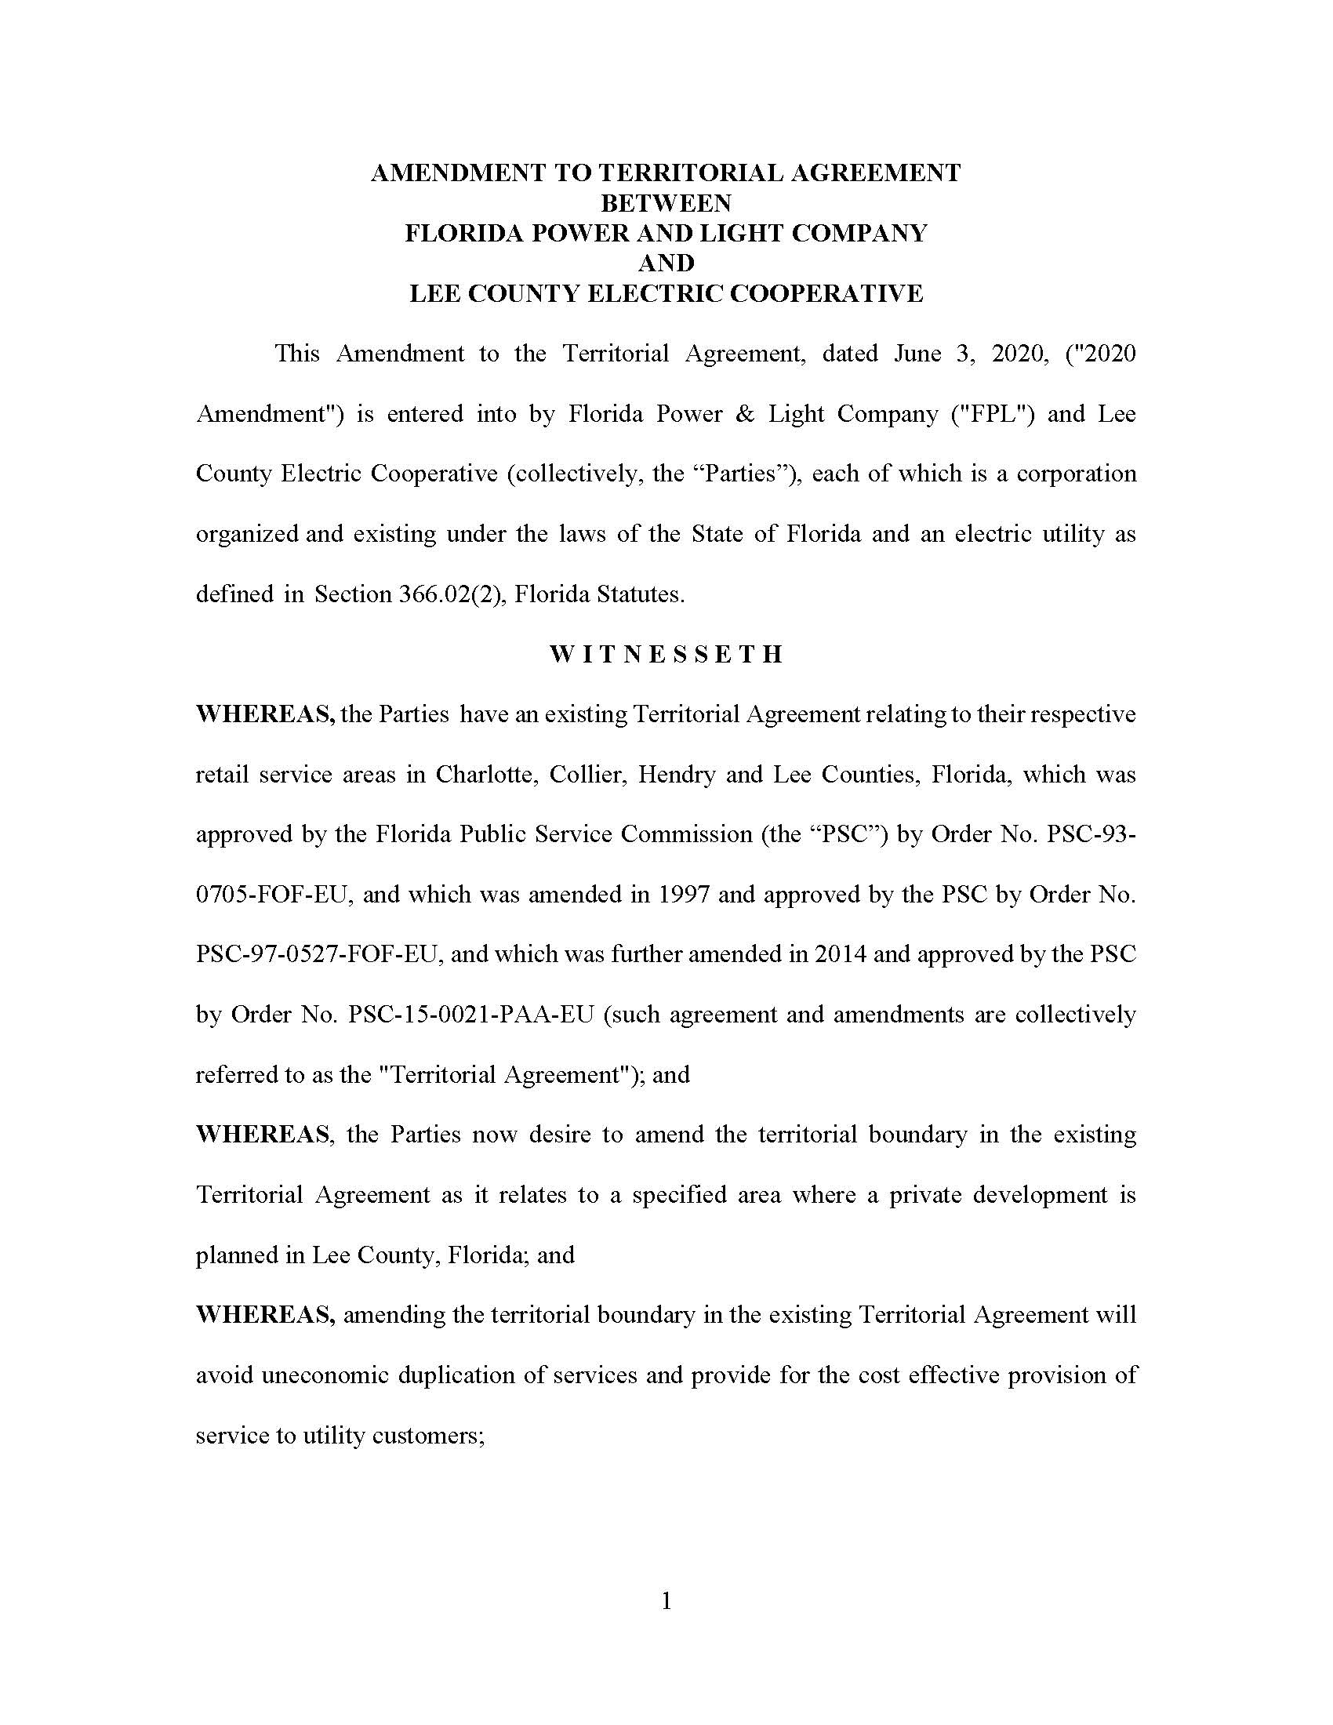

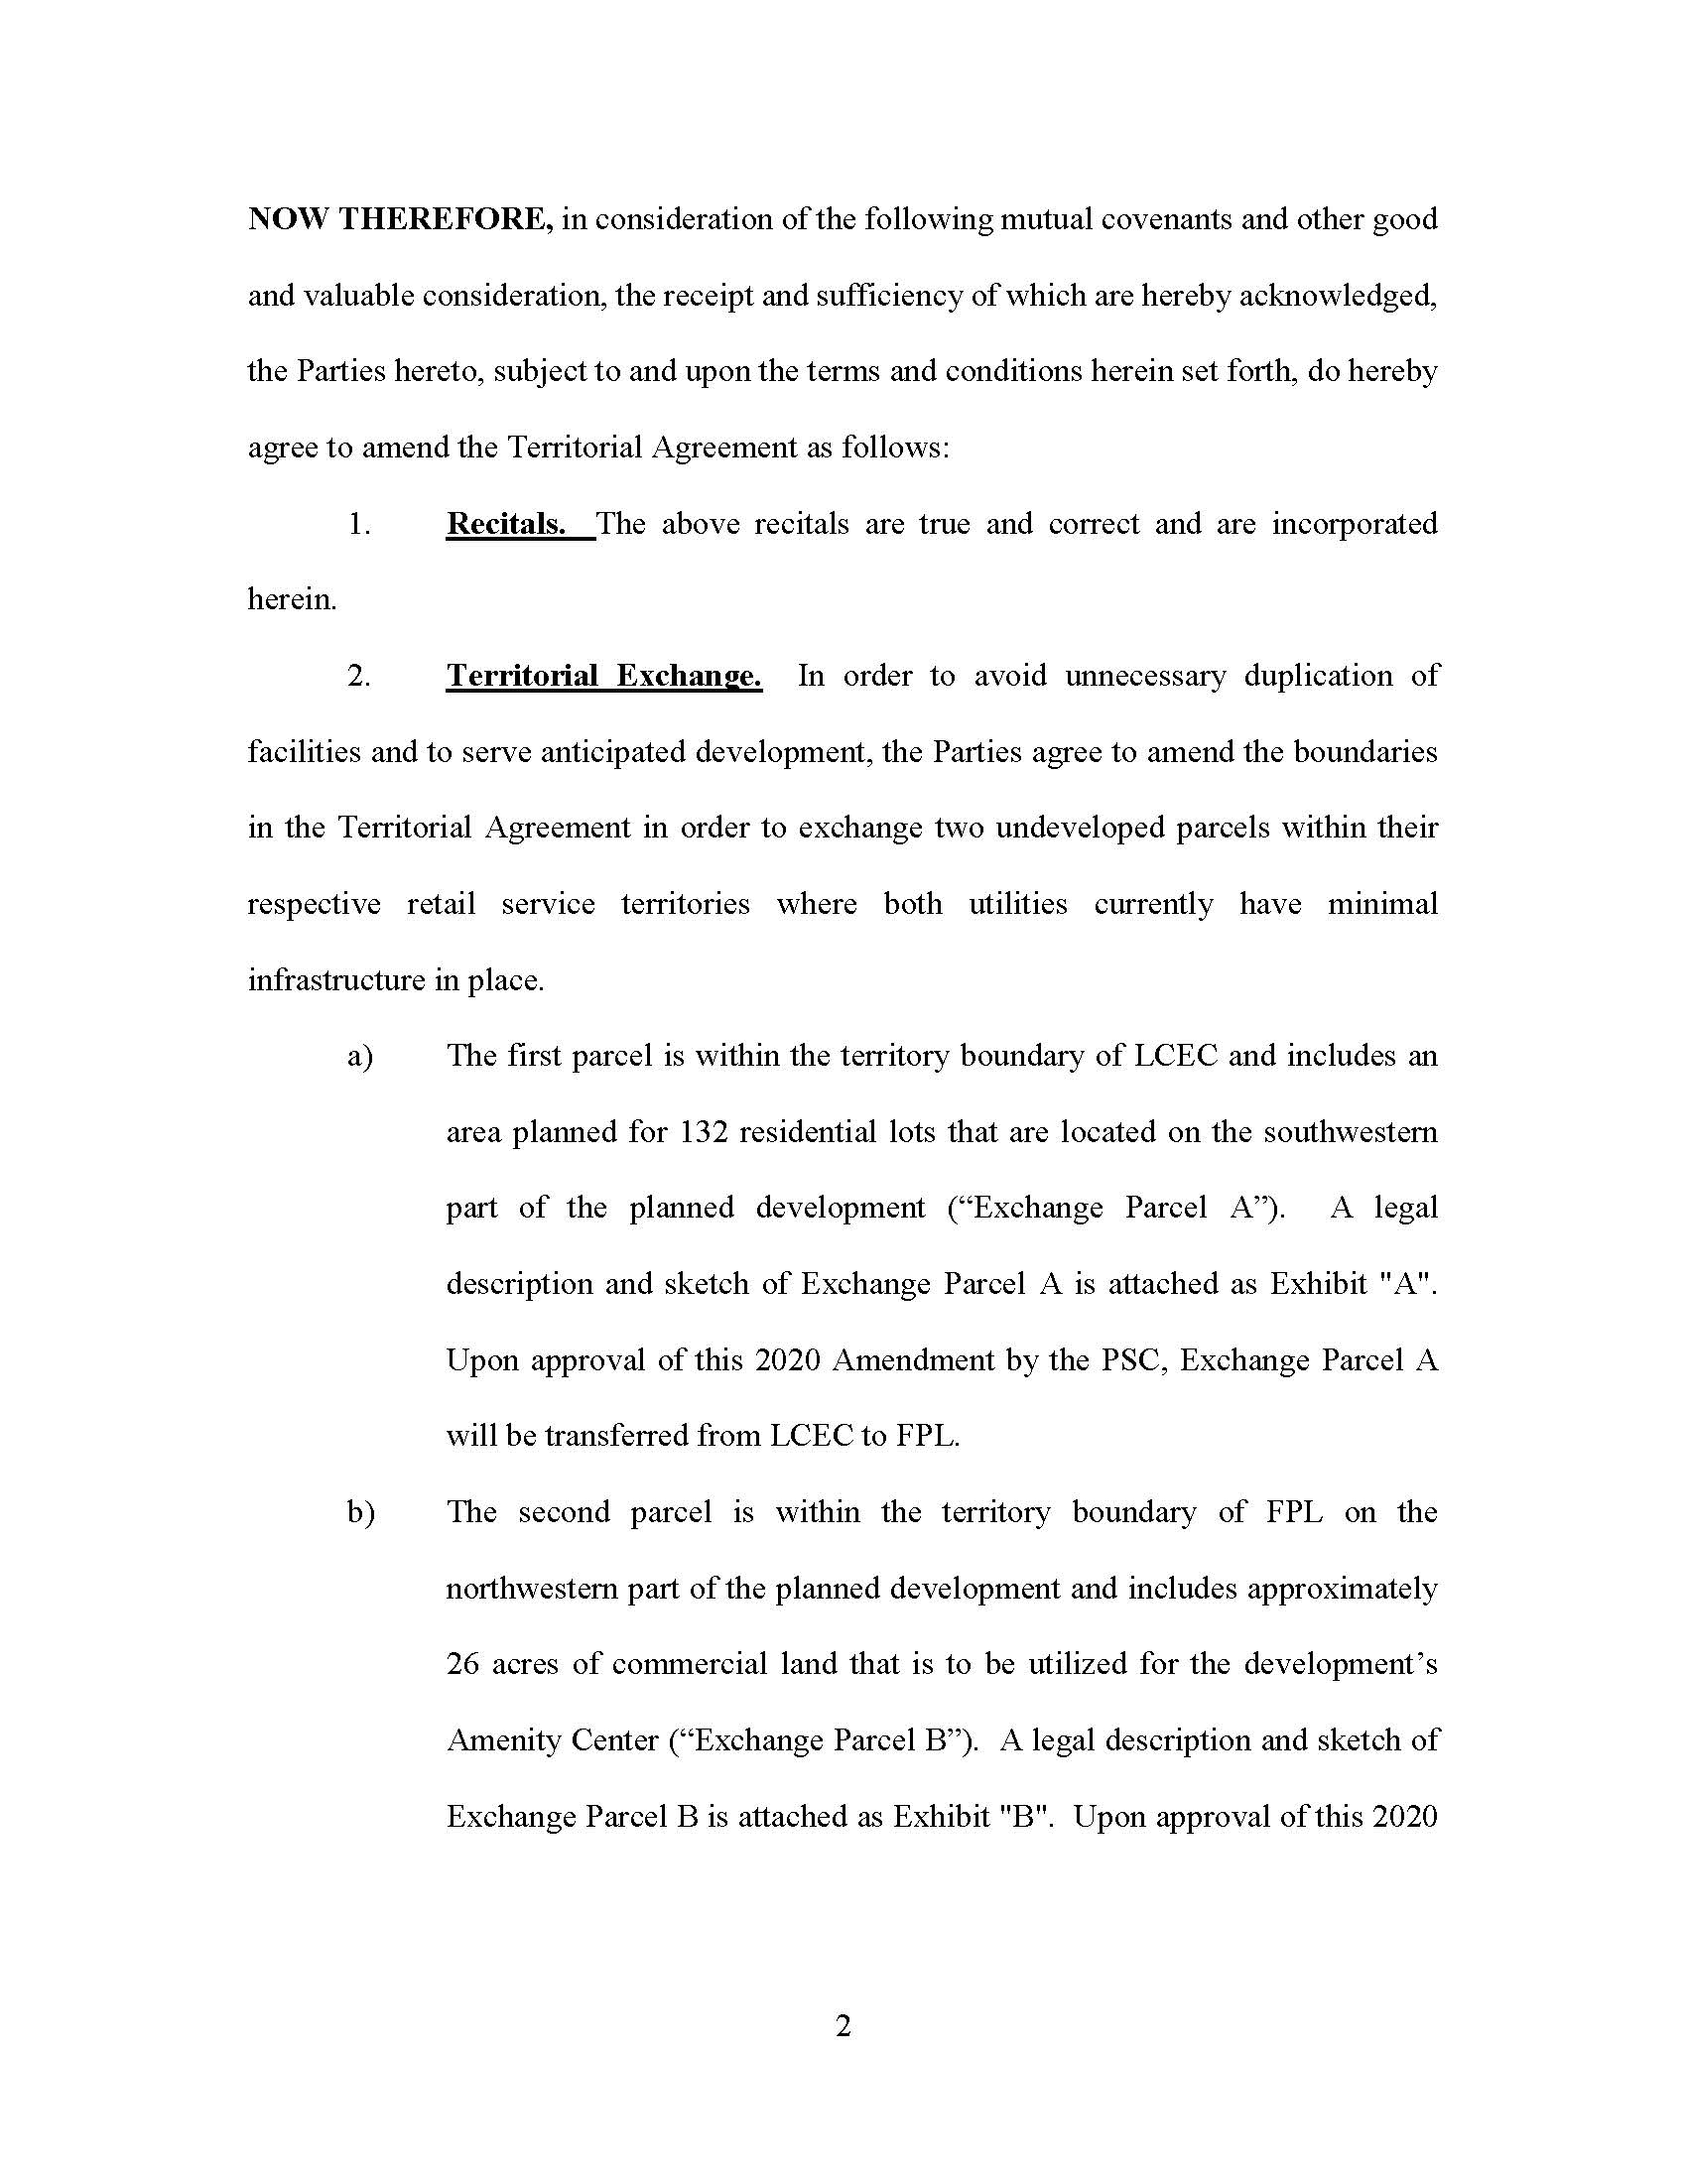

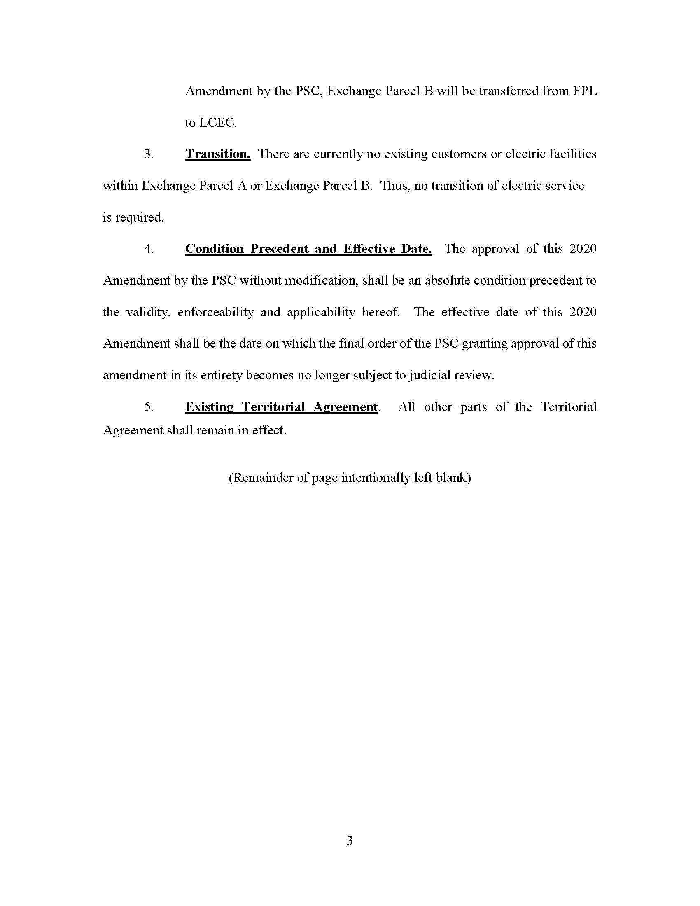

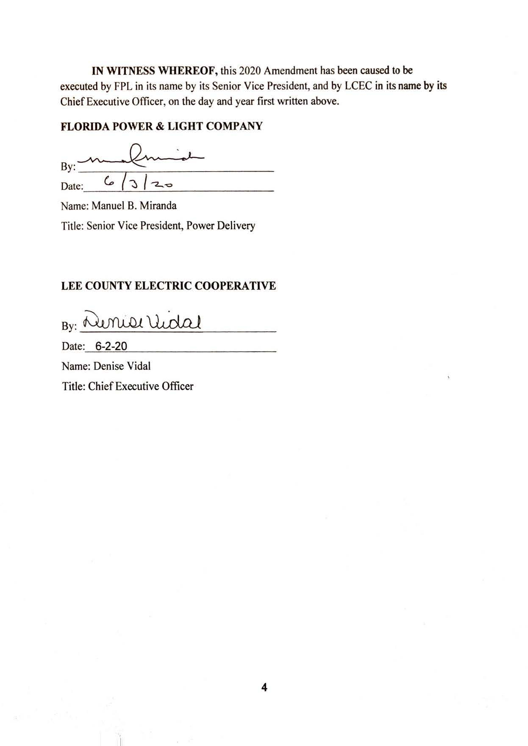
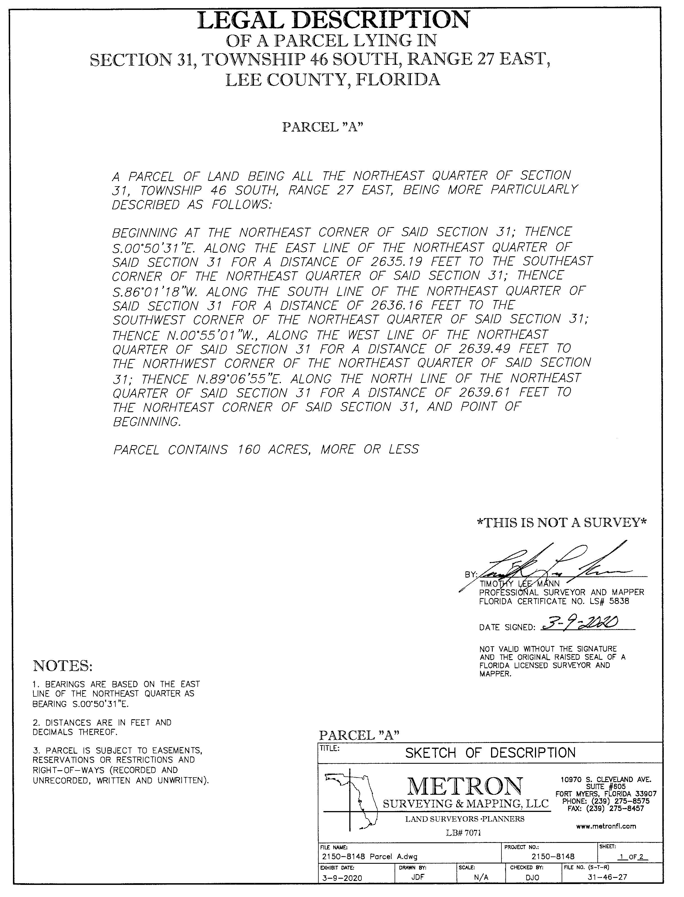

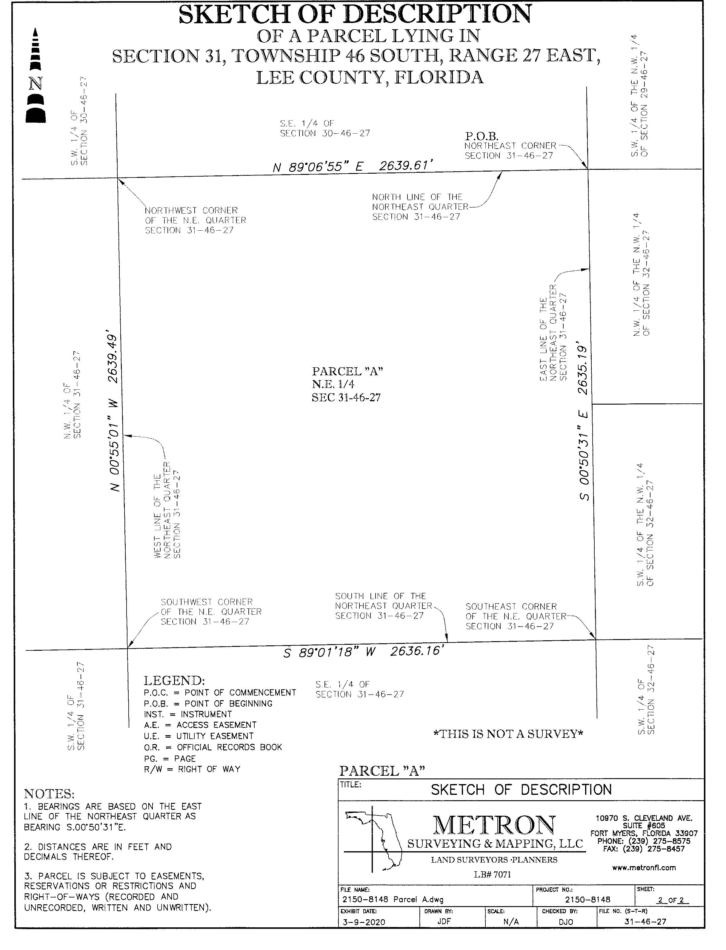

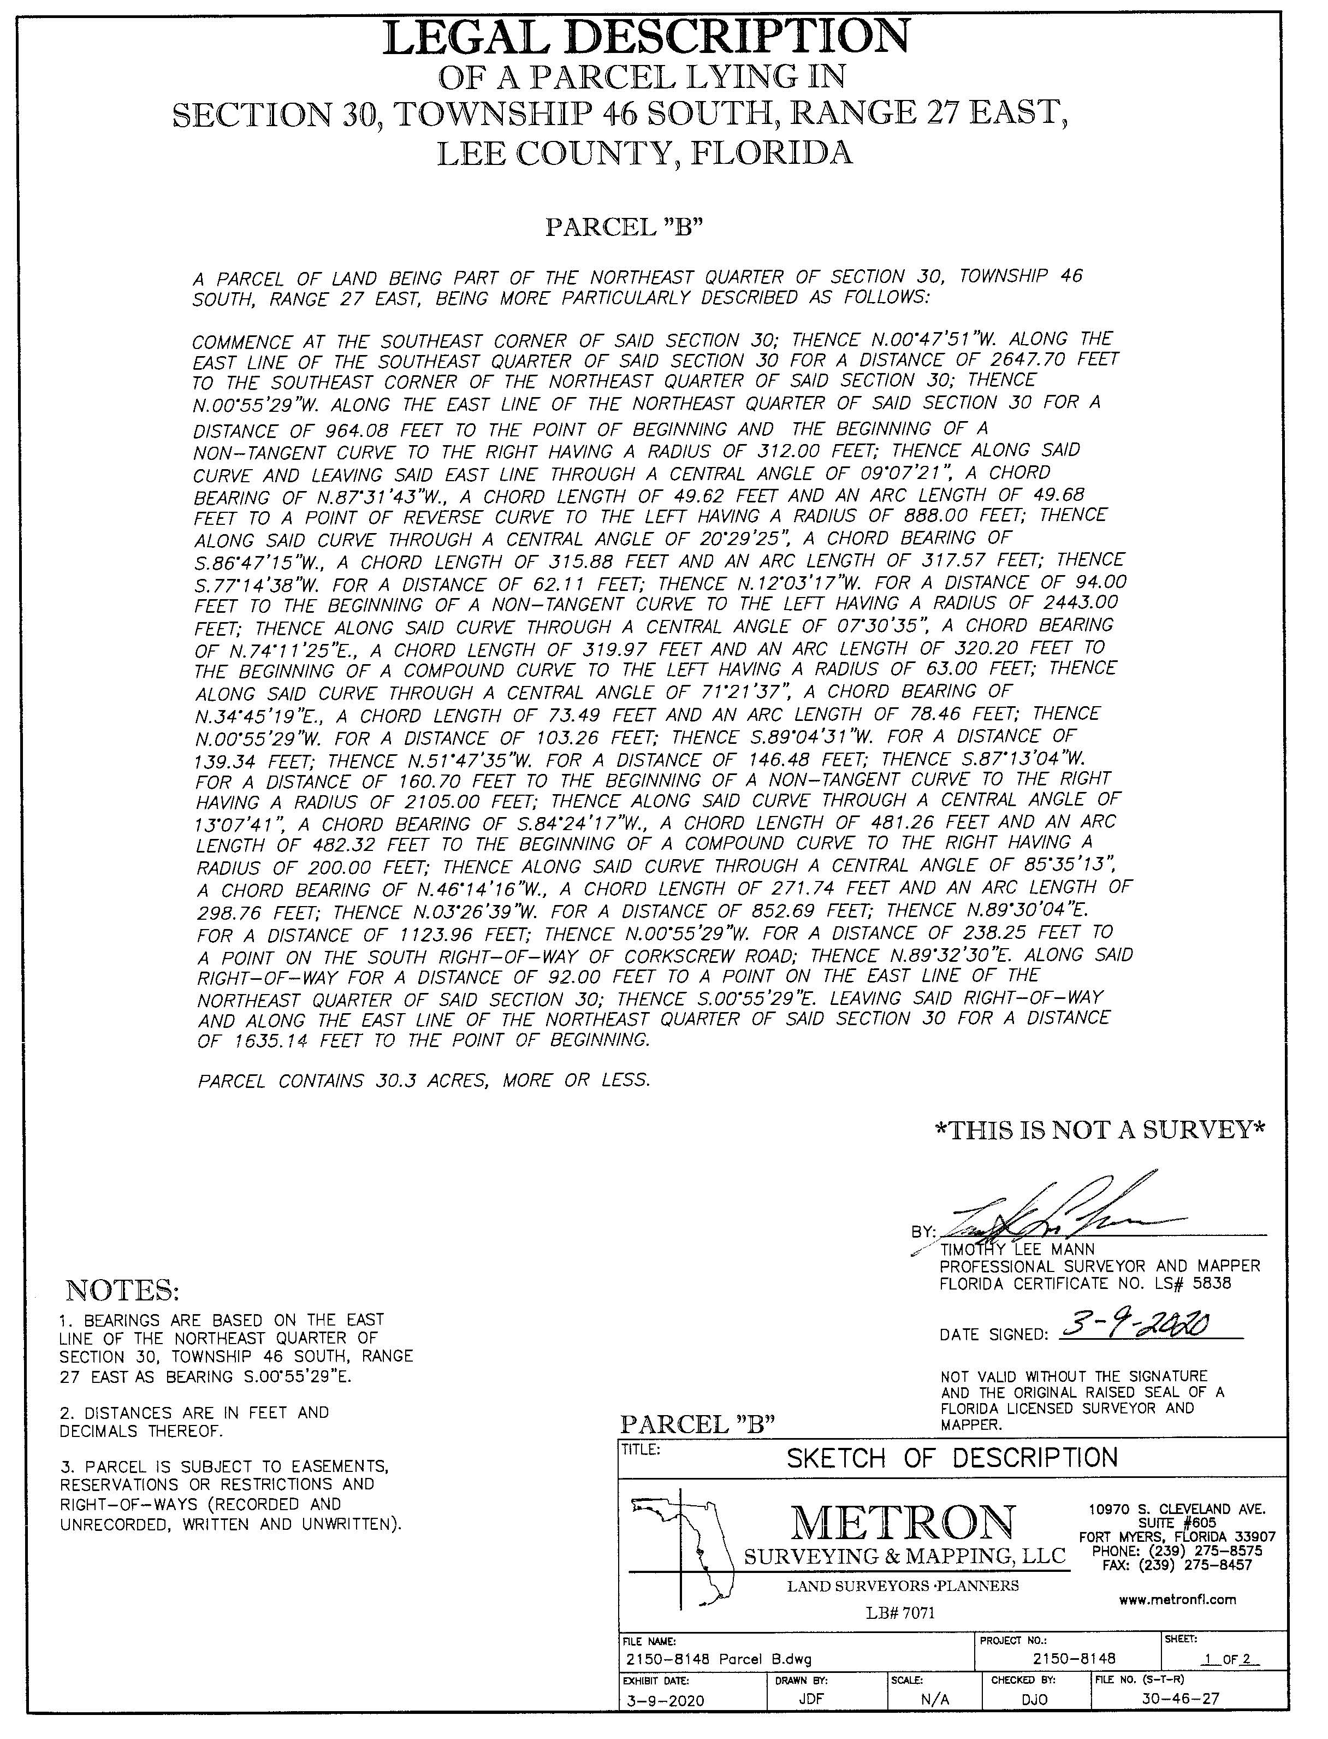
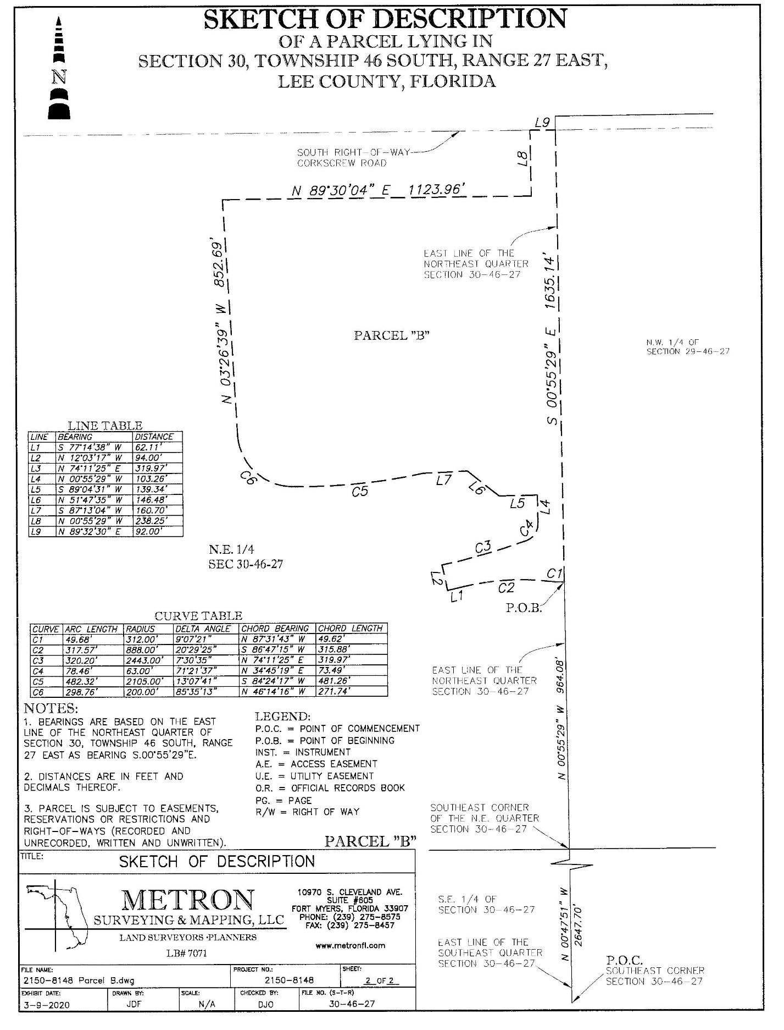
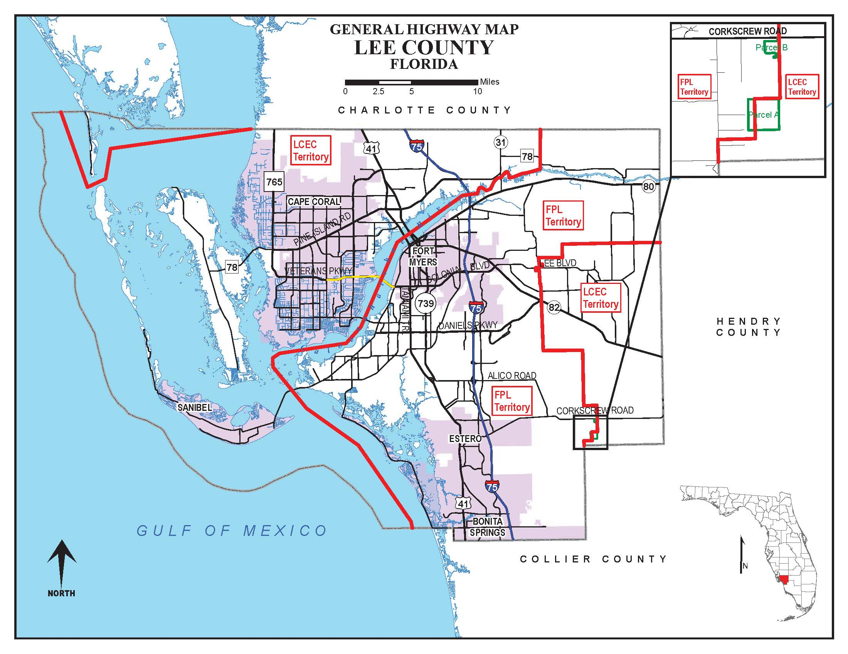

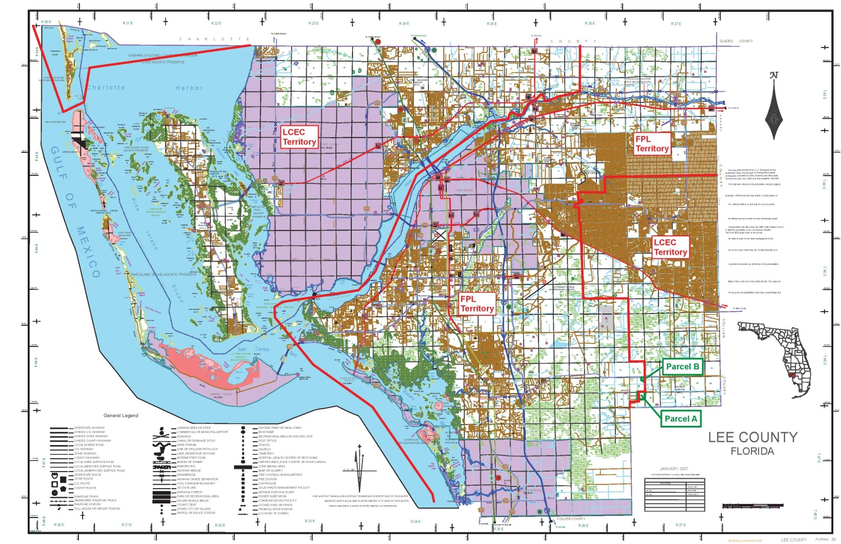

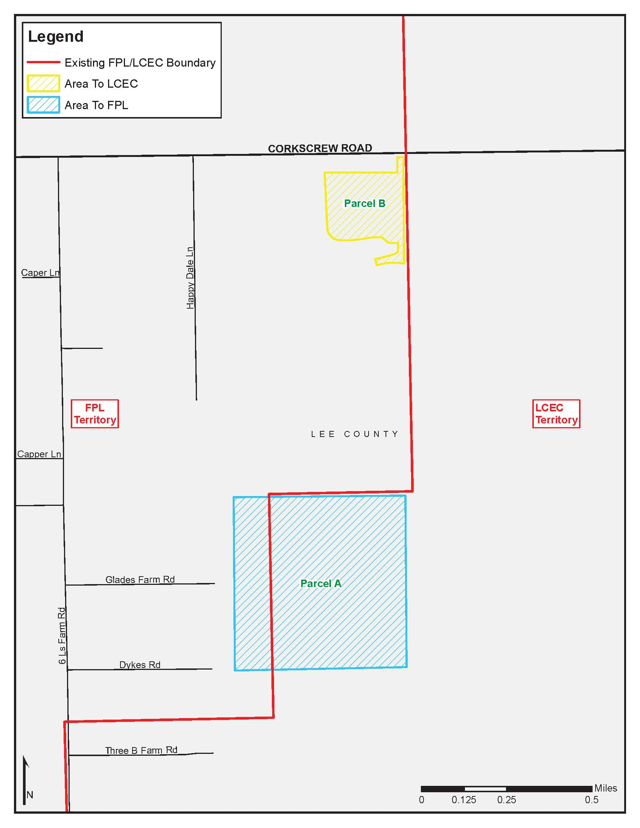

Document No. 03022-2020
Order No. 3799, issued April 28, 1965, in Docket No. 7421-EU.
Order No. PSC-93-0705-FOF-EU, issued May 10, 1993, in Docket No. 930092-EU, In re: Joint application for approval of territorial agreement between Florida Power & Light Company and Lee County Electric Cooperative, Inc.
Order No. PSC-97-0527-FOF-EU, issued May 7, 1997, in Docket No. 970105-EU, In re: Petition for approval of change in territorial boundary under territorial agreement with Lee County Electric Cooperative, Inc., by Florida Power & Light Company.
Order No. PSC-15-0021-PAA-EU, issued January 5, 2015, in Docket No. 20140210-EU, In re: Joint petition for approval of amendment to territorial agreement in Charlotte, Lee, and Collier counties, by Florida Power & Light Company and Lee County Electric Cooperative.
Utilities Commission of the City of New Smyrna Beach v. Florida Public Service Commission, 469 So. 2d 731 (Fla. 1985).

