BEFORE THE FLORIDA PUBLIC SERVICE COMMISSION

In re: Petition for limited proceeding for recovery of incremental storm restoration costs related to Hurricane Michael, by Gulf Power Company. | DOCKET NO. 20190038-EI  ORDER NO. PSC-2020-0349-S-EI  ISSUED: October 8, 2020

The following Commissioners participated in the disposition of this matter:

GARY F. CLARK, Chairman
ART GRAHAM
JULIE I. BROWN
DONALD J. POLMANN
ANDREW GILES FAY

FINAL ORDER APPROVING STIPULATION AND SETTLEMENT AGREEMENT

BY THE COMMISSION:

BACKGROUND

On February 6, 2019, pursuant to Section 366.076(1), Florida Statutes (F.S.), and the provisions of the Stipulation and Settlement Agreement approved by Order No. PSC-2017-0178-S-EI, Gulf Power Company (Gulf) filed its Petition for Limited Proceeding for Recovery of Incremental Storm Restoration Costs Related to Hurricane Michael. By Order No. PSC-2019-0221-PCO-EI, issued on June 3, 2019, we approved the requested 2019 Interim Storm Restoration Recovery Charge for a period of 60 months and required Gulf to submit documentation of the actual storm costs for review and true up of any excess or shortfall. Gulf submitted its actual storm costs on November 15, 2019. The Office of Public Counsel (OPC) was acknowledged as a party to this docket by Order No. PSC-2019-0087-PCO-EI, issued on March 6, 2019. The Federal Executive Agencies (FEA) was granted intervention by Order No. PSC-2019-0512-PCO-EI, issued on December 6, 2019. Gulf, OPC, and FEA (collectively, Signatories) filed a Joint Motion for Expedited Approval of a Stipulation and Settlement Agreement (Settlement Agreement) on August 25, 2020. The Settlement Agreement resolved all of the outstanding issues in this docket and proposed procedures for processing invoices from third-party storm restoration contractors in the future.

A final hearing was held on September 15, 2020, in which we considered whether approval of the Settlement Agreement was in the public interest. At the hearing, the direct testimony and exhibits of witnesses for Gulf, OPC, FEA, and Commission staff were entered into the record, along with a number of stipulated discovery responses. At the hearing, the Signatories discussed the highlights of the Settlement Agreement and how approval of the Settlement Agreement was in the public interest. At the conclusion of the hearing, the Signatories waived the filing of post-hearing briefs, and we voted to approve the Settlement Agreement.

We have jurisdiction pursuant to Sections 366.04, 366.05, and 366.06, Florida Statutes (F.S.).

Settlement Agreement

The Settlement Agreement has three parts: (1) Financial Terms contained in Sections 1-3; (2) Process Provisions contained in Section 4; and (3) Other Provisions contained in Sections 5-9. The Other Provisions are conditions associated with our approval of the Settlement Agreement itself, restrictions on the Signatories’ ability to contest the Settlement Agreement, and each Signatories’ right to pursue its position on any issue raised in this docket in future proceedings.

- The effective date of the Settlement Agreement is the date of the Final Order issued in this docket. [Section 1]

- An aggregate negotiated adjustment in the amount of $5 million shall be made to reduce the amount recoverable by Gulf through the storm cost recovery mechanism. The adjustment includes $2.25 million of costs recoverable in base rates, and $2.75 million of costs reclassified as capital. This adjustment resolves all issues related to contractors’ costs, employee payroll, and materials and supplies cost. [Section 2]

- Beginning with the 2021 storm season, Gulf will implement Paragraphs 5 through 20 of the Process Provisions contained in the Commission-approved settlement in Docket No. 20180049-EI, In re: Evaluation of storm restoration costs for Florida Power and Light Company related to Hurricane Irma. The threshold for the Initial Audit referenced in Paragraph 18 is $150 million for Gulf. Gulf agrees to implement these Process Provisions before the 2021 storm season to help minimize the hourly contractor costs and equipment rental rates. [Section 4]

- The Other Provisions of Gulf’s Settlement Agreement are: (1) that the Settlement Agreement will have no precedential value; (2) that the Settlement Agreement is contingent upon approval by the Commission in its entirety without modification; (3) that Signatories to the Settlement Agreement will support it before the Commission; and (4) that the Settlement Agreement resolves all outstanding issues, is in the public interest, and no signatory will file an appeal of any order issued in this docket. [Sections 5-9]

DECISION

The standard for approval of a settlement agreement is whether it is in the public interest. A determination of public interest requires a case-specific analysis based on consideration of the proposed settlement taken as a whole.

The Settlement Agreement resolves all issues in this docket, and provides for significant improvements in both the real time management of restoration tasks as well as cost verification. Crew tracking, contractor invoicing, and utility billing review procedures will be improved through the smart phone Phase I and Phase II applications that are designed to better monitor and verify contractor charges during storm restoration events. The Settlement Agreement also provides for an outside audit of Gulf’s requested storm restoration costs for the first named tropical storm whose damages exceed $150 million prior to submittal for our approval. These procedures are the result of negotiations between OPC, FEA, and Gulf, and they are a reasonable attempt to address both the cost as well as discovery issues that are part of every storm restoration docket. The Financial Terms contained in the Settlement Agreement will result in Gulf’s total storm restoration costs being reduced by $5 million.

The Signatories represent a broad segment of Gulf’s customer base, including both residential and commercial classes. Having carefully reviewed the Settlement Agreement, the exhibits entered into the record, and the testimony provided by Gulf, OPC, FEA, and Commission staff witnesses, we find that, taken as a whole, it provides a reasonable resolution of all issues raised in this docket. We find, therefore, that the Settlement Agreement, Attachment A hereto, is in the public interest, and we hereby approve it.

Based on the foregoing, it is

ORDERED by the Florida Public Service Commission that the Joint Motion of Gulf Power Company, the Office of Public Counsel, and Federal Executive Agencies to approve the Stipulation and Settlement Agreement is hereby granted. It is further

ORDERED that the Stipulation and Settlement filed on August 25, 2020, referred to herein as the Settlement Agreement, attached hereto as Attachment A, and incorporated by reference, is hereby approved. It is further

ORDERED that in the event no timely appeal is filed, Docket No 20190038-EI shall be closed.

By ORDER of the Florida Public Service Commission this 8th day of October, 2020.

/s/ Adam J. Teitzman
ADAM J. TEITZMAN
Commission Clerk
Florida Public Service Commission
2540 Shumard Oak Boulevard
Tallahassee, Florida 32399
(850) 413-6770
www.floridapsc.com

Copies furnished: A copy of this document is provided to the parties of record at the time of issuance and, if applicable, interested persons.

WLT

NOTICE OF FURTHER PROCEEDINGS OR JUDICIAL REVIEW

The Florida Public Service Commission is required by Section 120.569(1), Florida Statutes, to notify parties of any administrative hearing or judicial review of Commission orders that is available under Sections 120.57 or 120.68, Florida Statutes, as well as the procedures and time limits that apply. This notice should not be construed to mean all requests for an administrative hearing or judicial review will be granted or result in the relief sought.

Any party adversely affected by the Commission's final action in this matter may request: 1) reconsideration of the decision by filing a motion for reconsideration with the Office of Commission Clerk, 2540 Shumard Oak Boulevard, Tallahassee, Florida 32399-0850, within fifteen (15) days of the issuance of this order in the form prescribed by Rule 25-22.060, Florida Administrative Code; or 2) judicial review by the Florida Supreme Court in the case of an electric, gas or telephone utility or the First District Court of Appeal in the case of a water and/or wastewater utility by filing a notice of appeal with the Office of Commission Clerk, and filing a copy of the notice of appeal and the filing fee with the appropriate court. This filing must be completed within thirty (30) days after the issuance of this order, pursuant to Rule 9.110, Florida Rules of Appellate Procedure. The notice of appeal must be in the form specified in Rule 9.900(a), Florida Rules of Appellate Procedure.

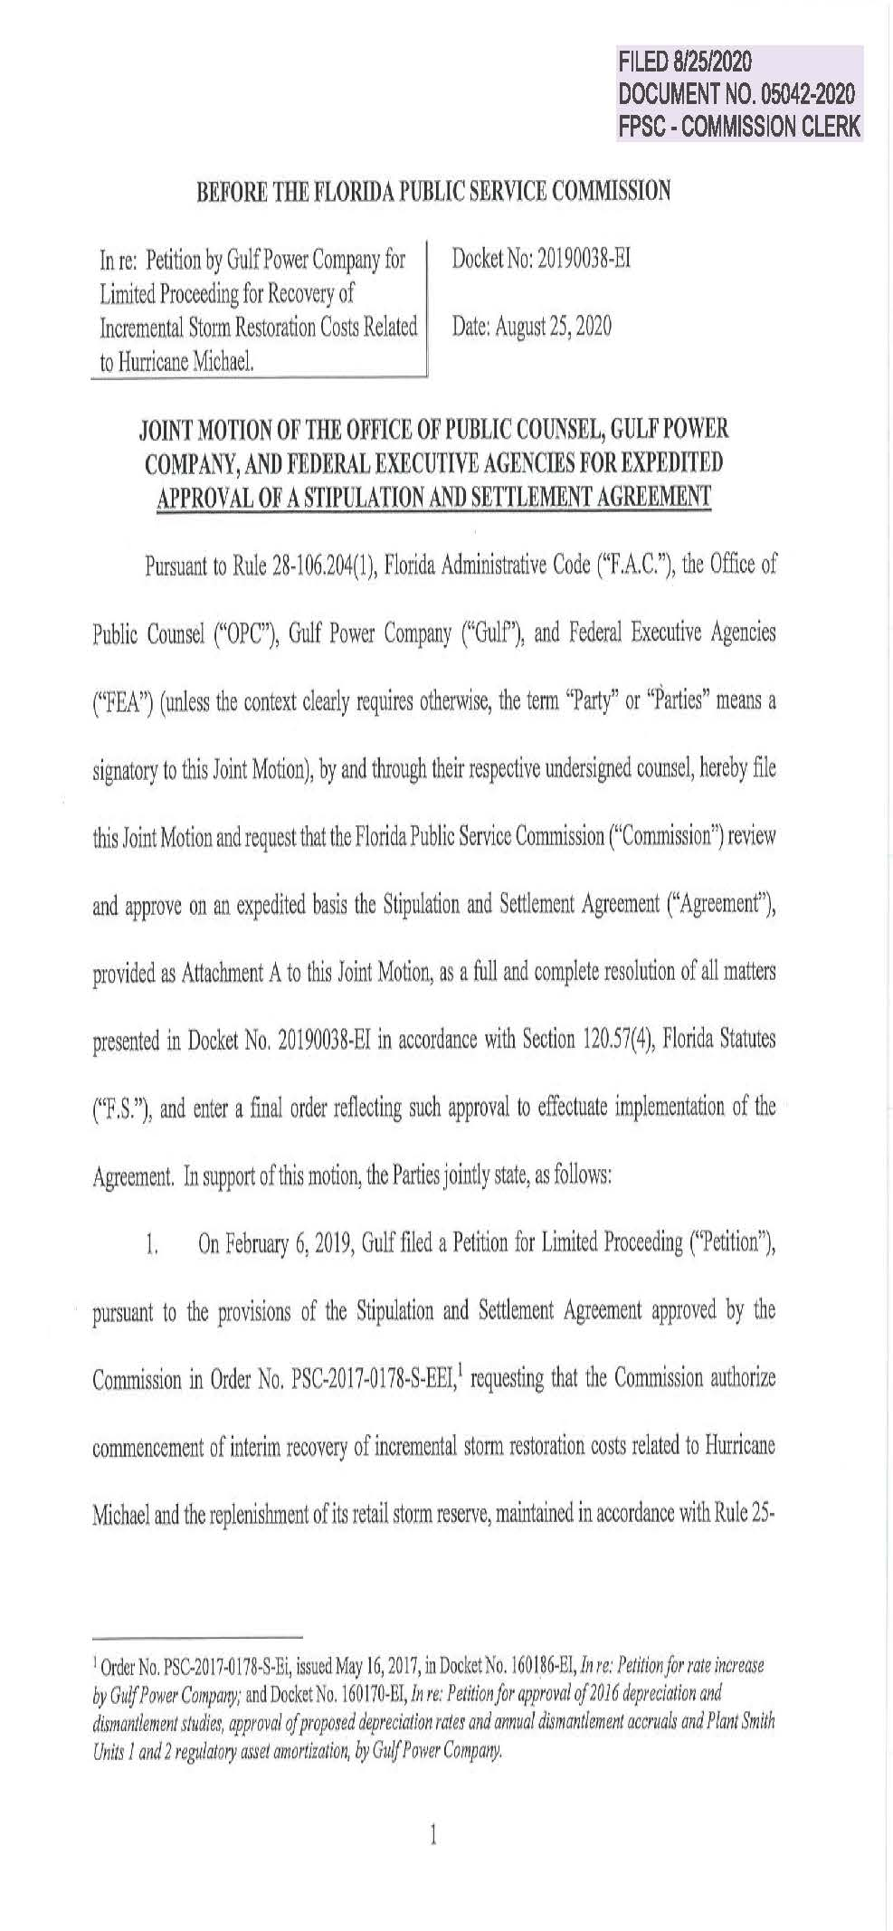

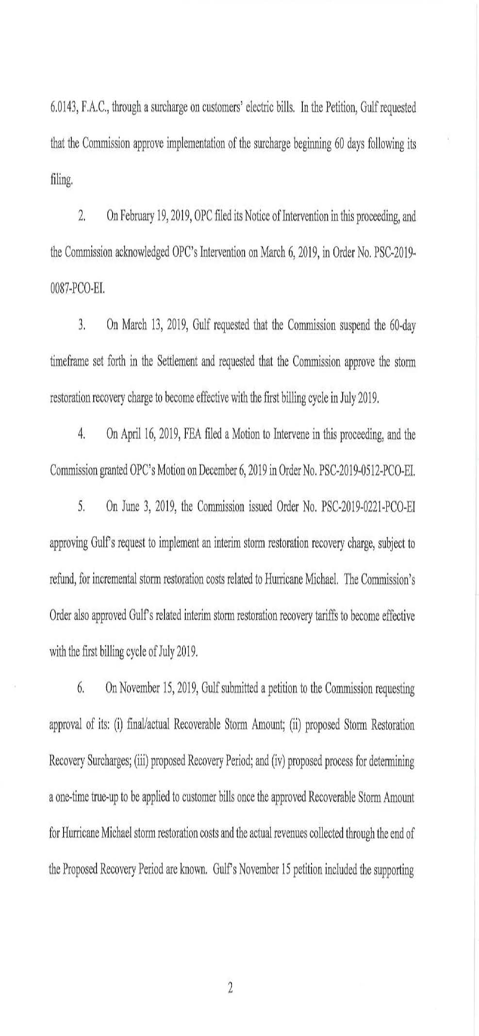

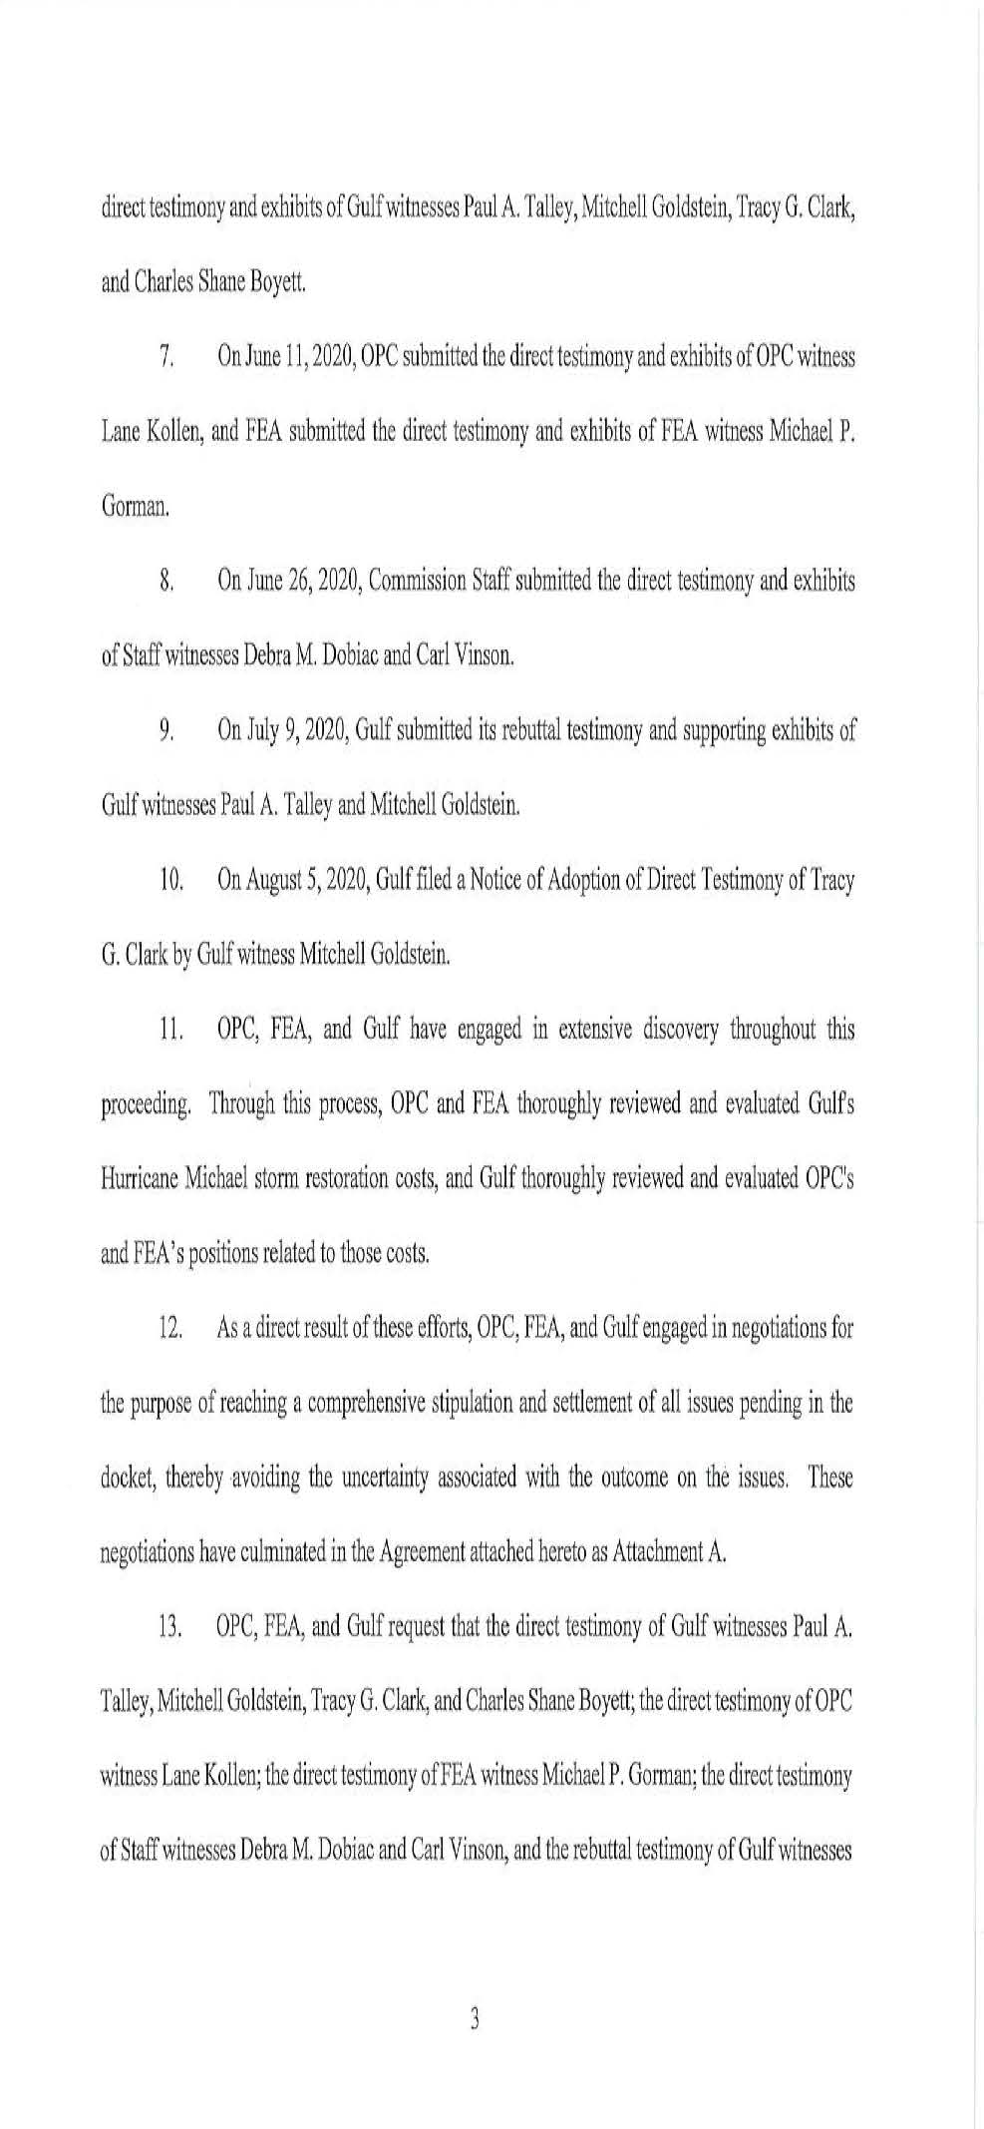

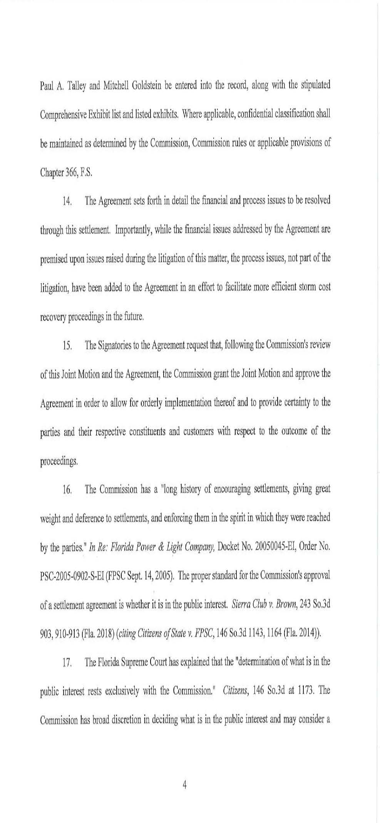

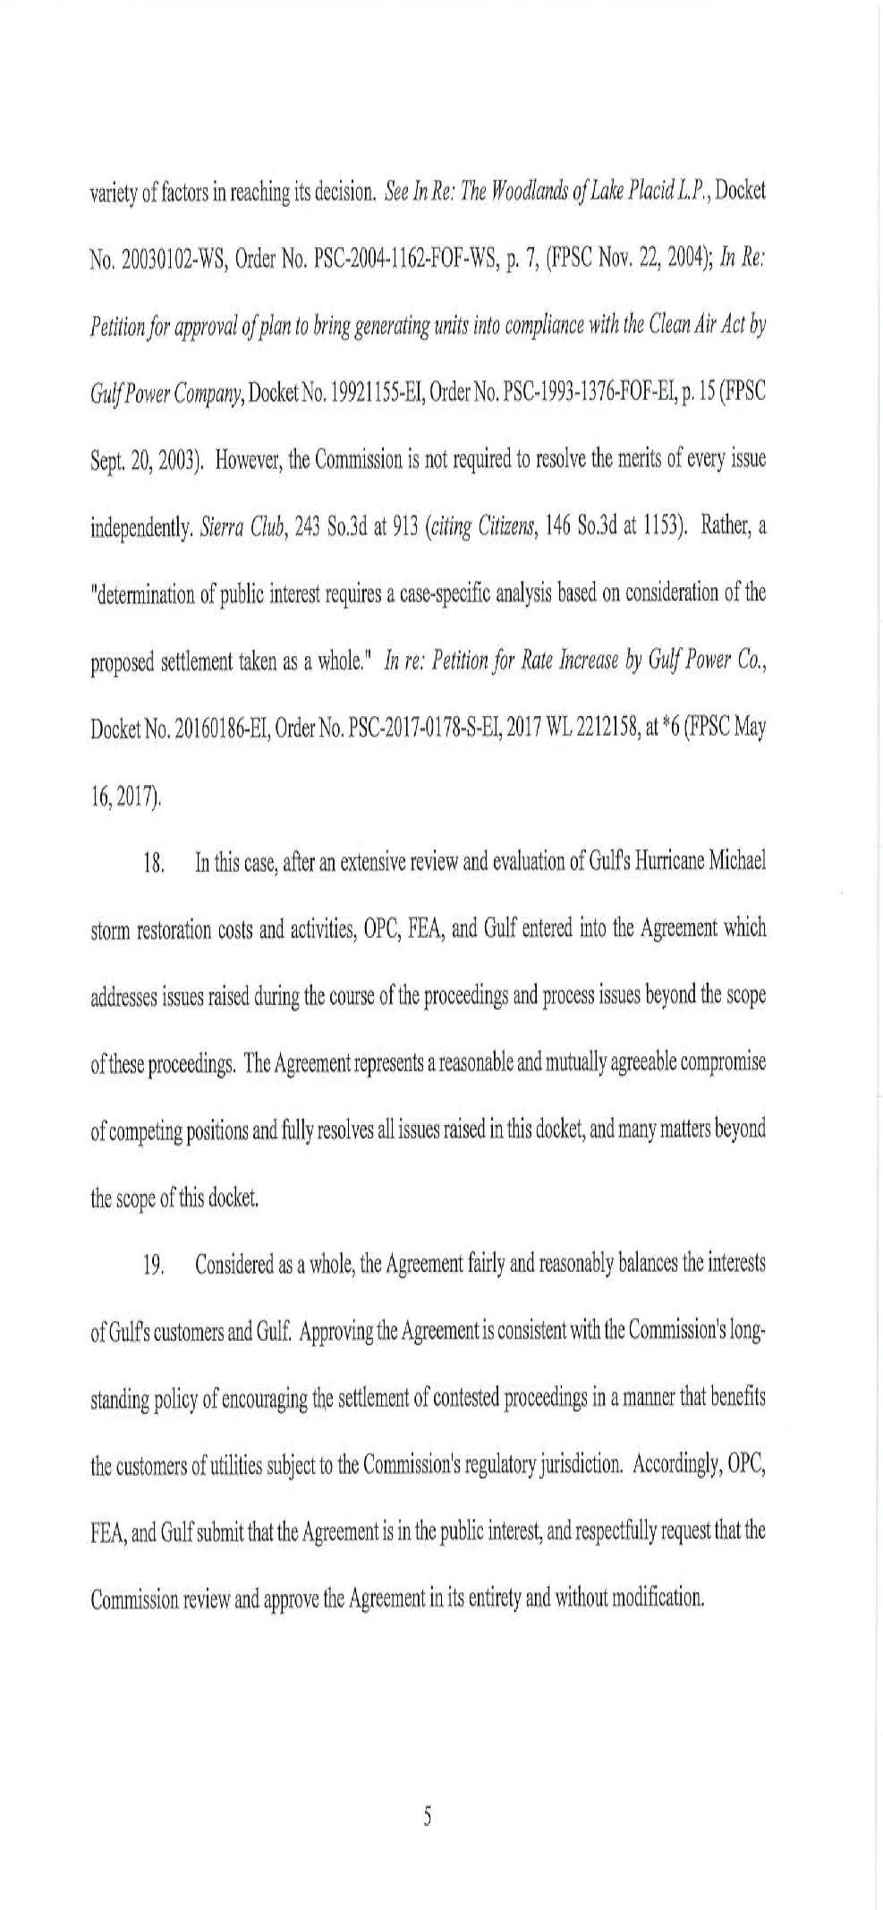

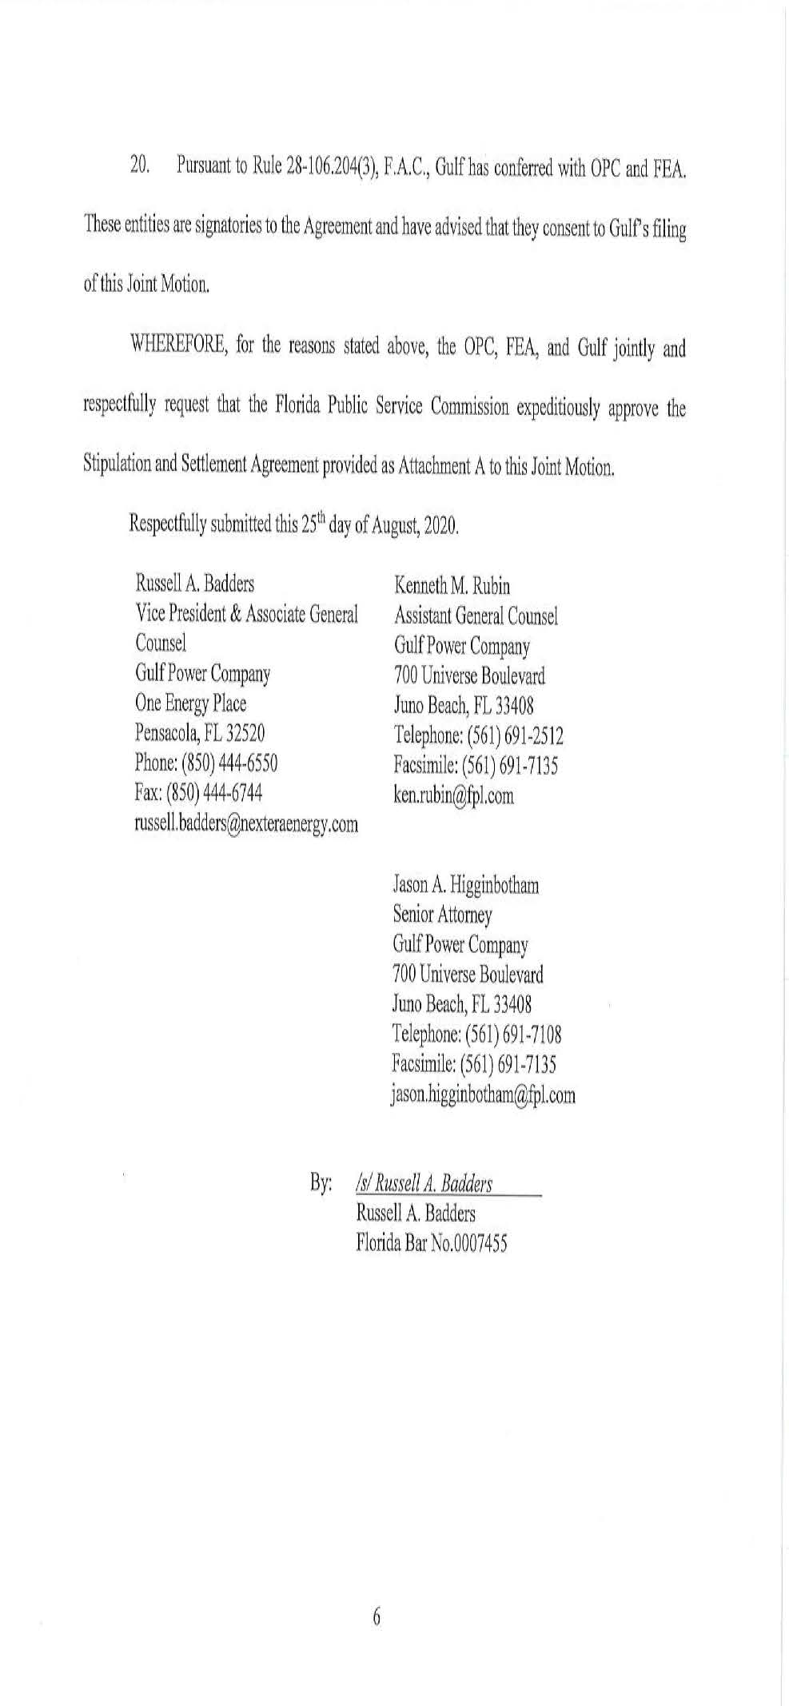

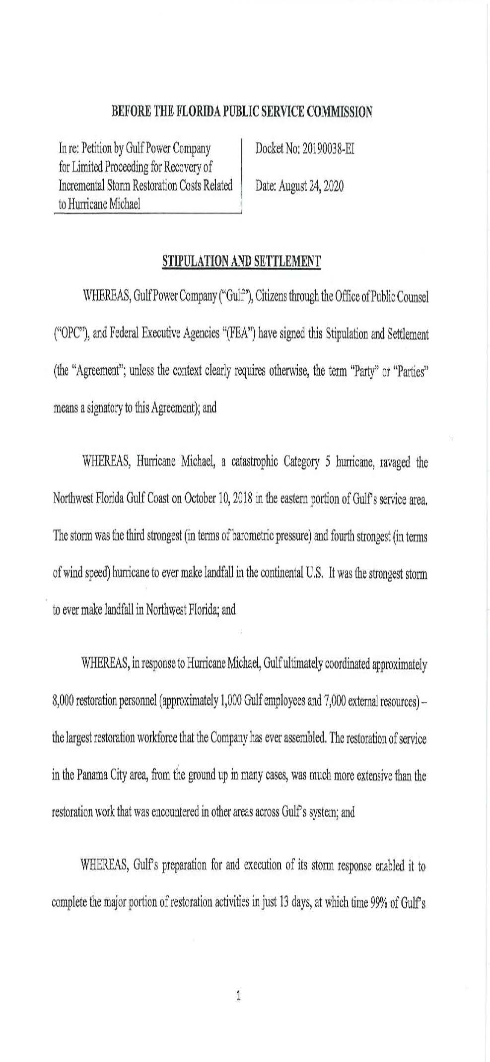

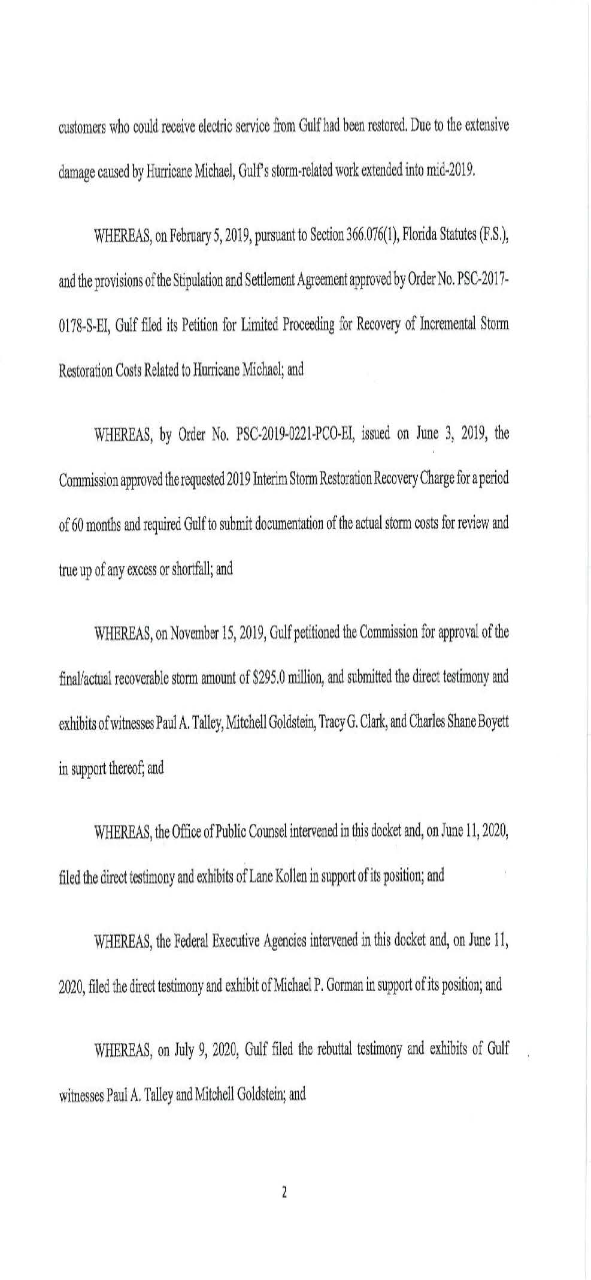

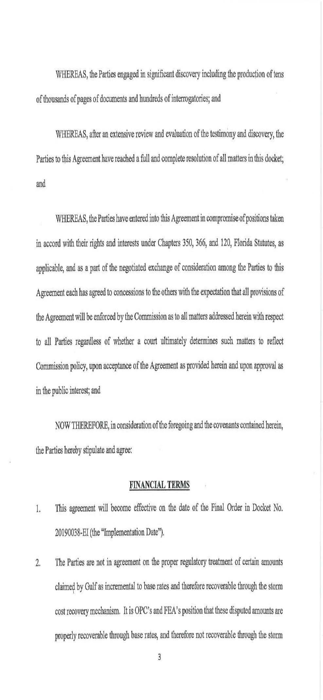

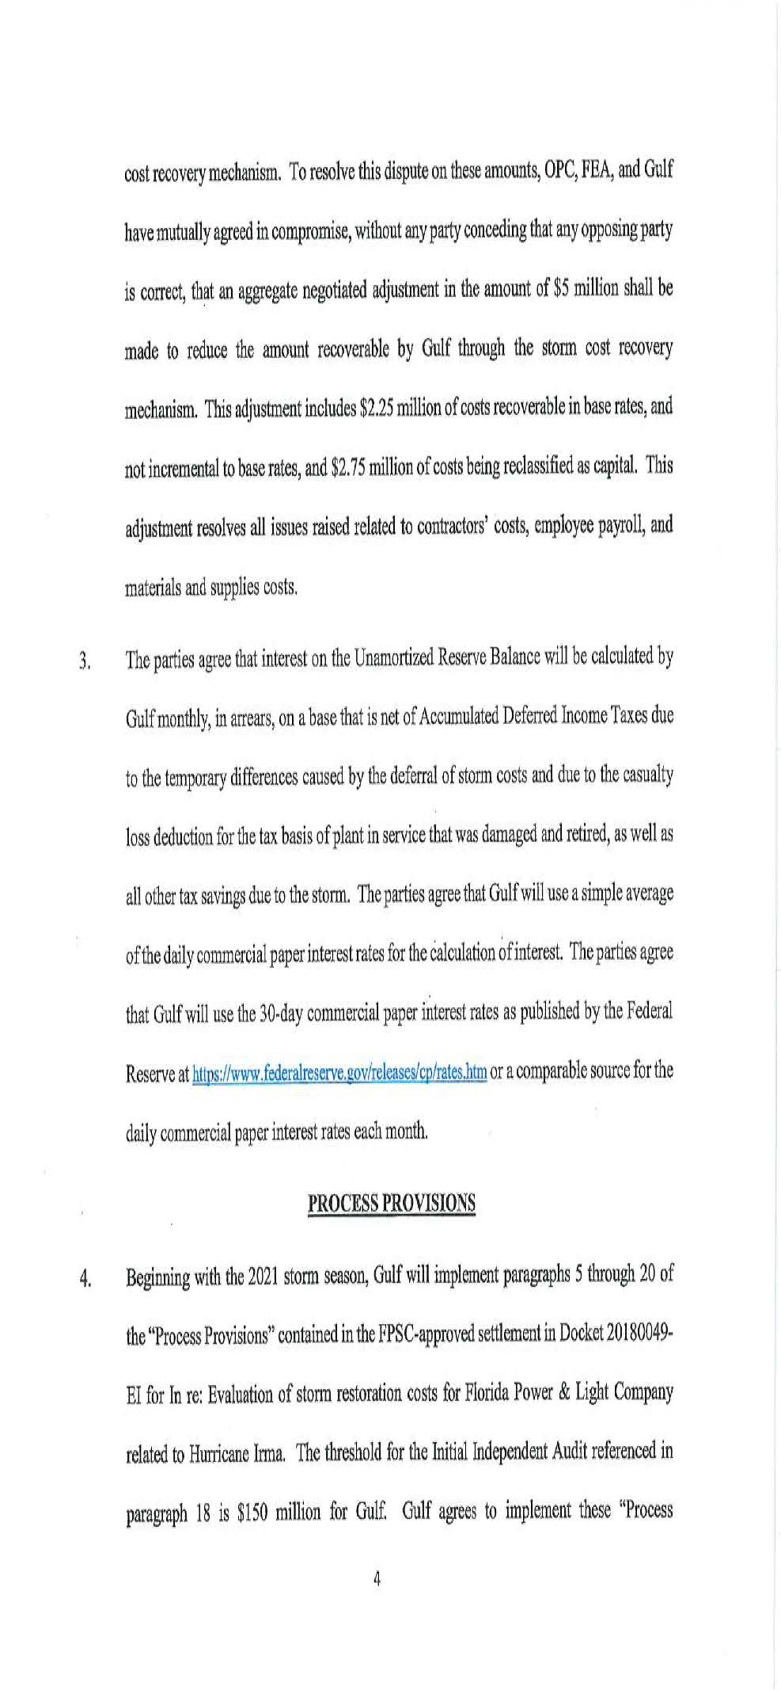

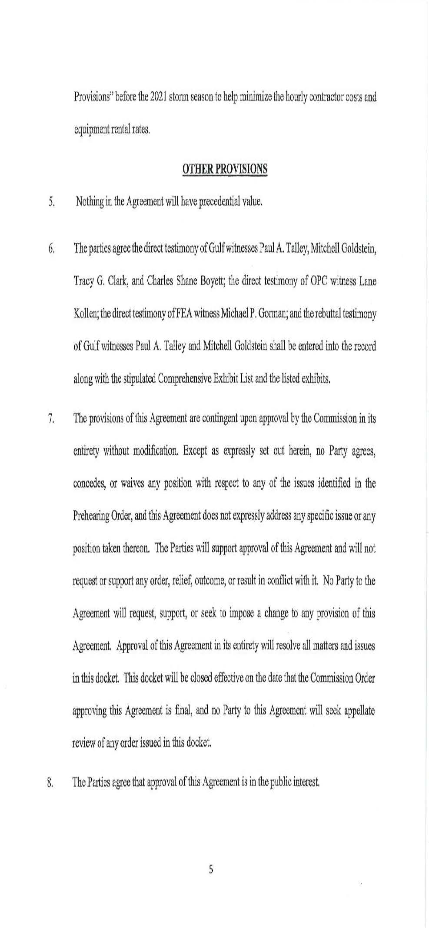

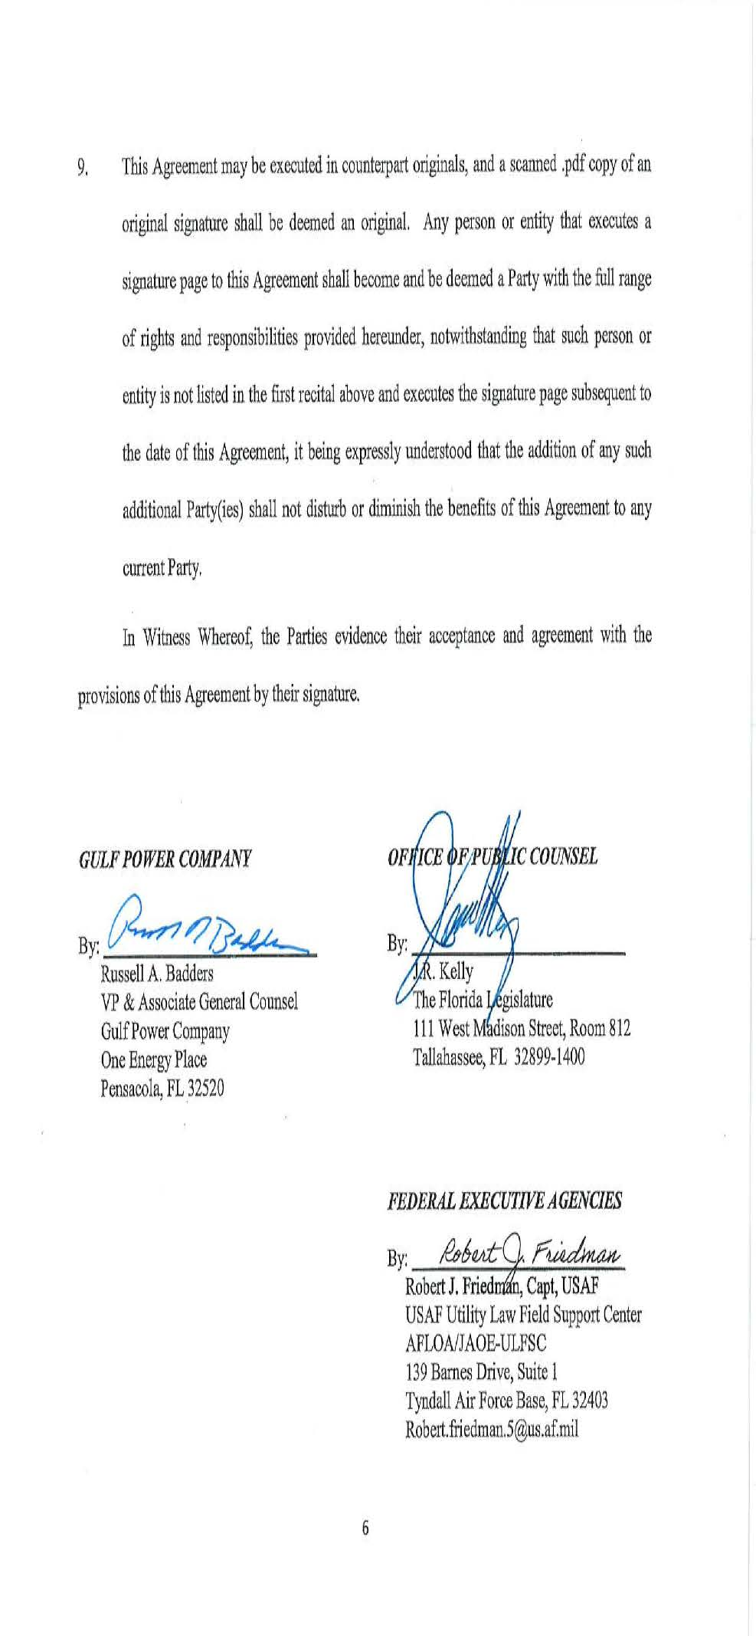

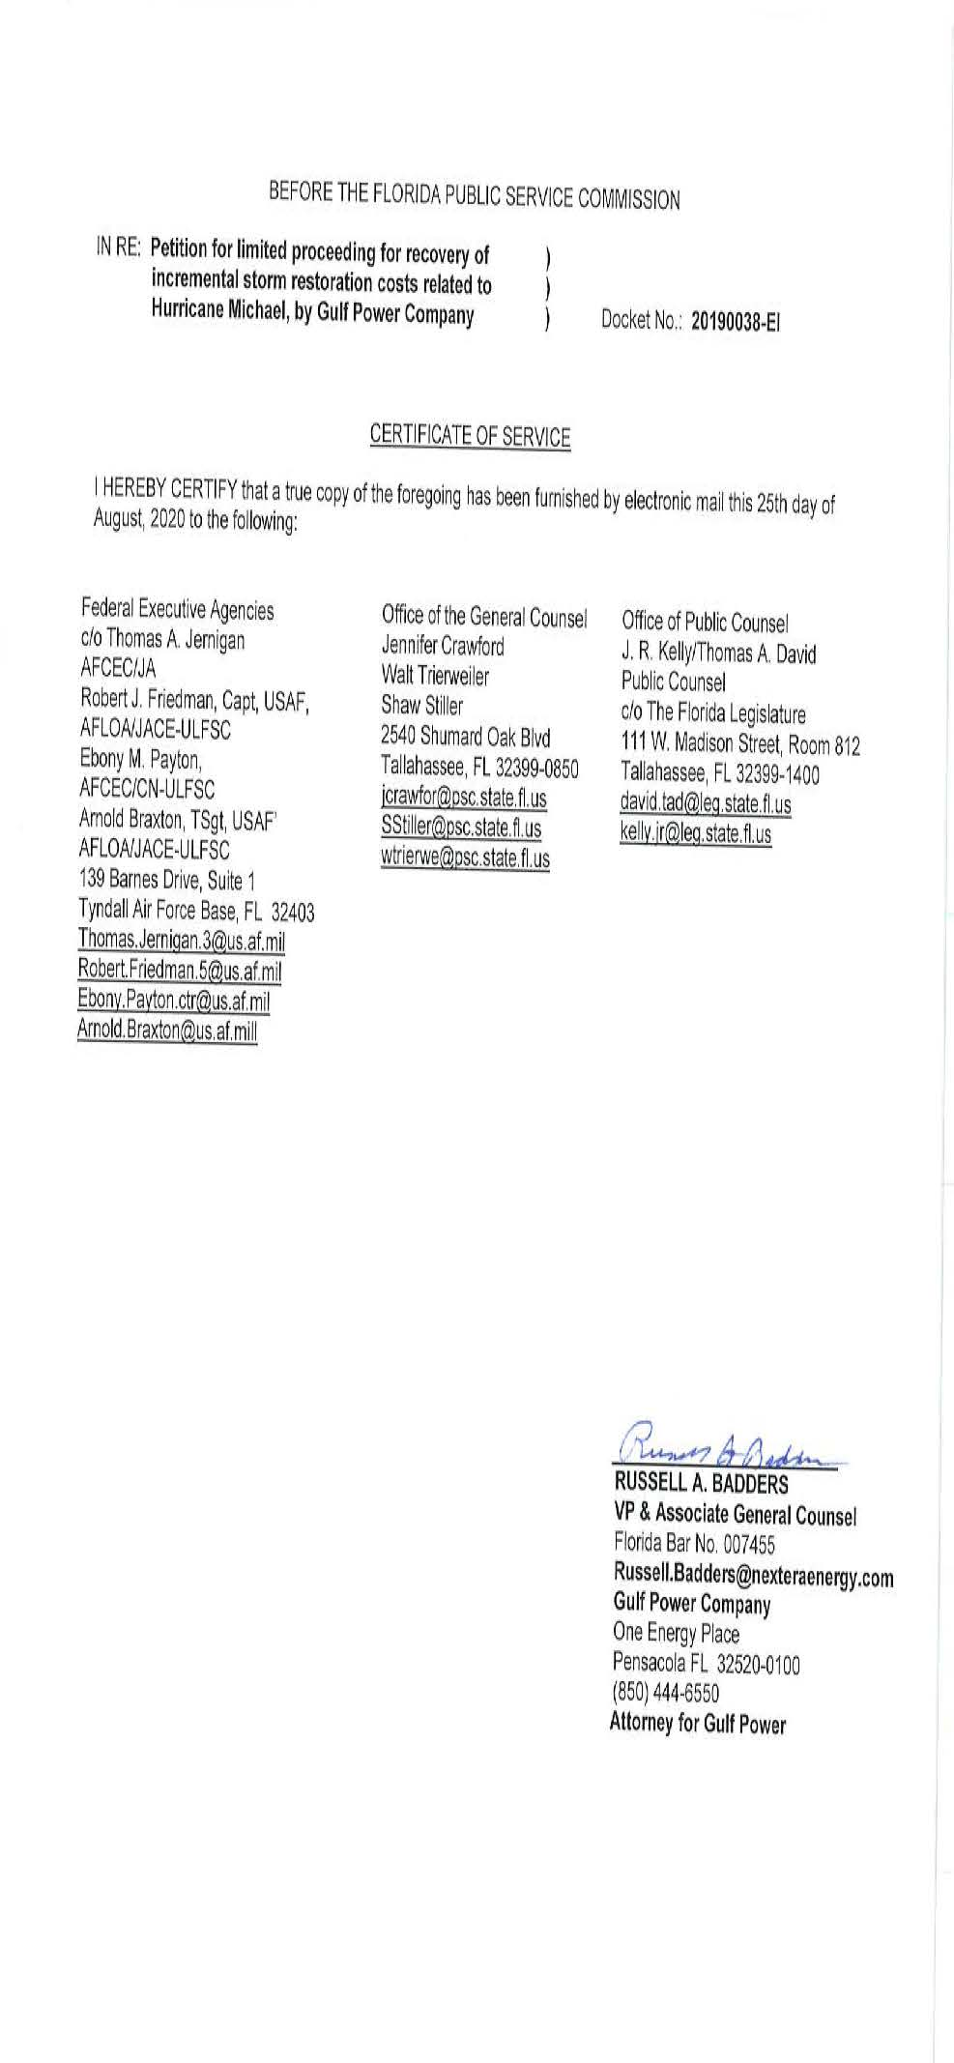

Order No. PSC-2017-0178-S-EI, issued May 16, 2017, in Docket No. 20160186-EI, In re: Petition for rate increase by Gulf Power Company and Docket No. 20160170-EI, In re: Petition for approval of 2016 depreciation and dismantlement studies, approval of proposed depreciation rates and annual dismantlement accruals and Plant Smith Units 1 and 2 regulatory asset amortization, by Gulf Power Company.
Sierra Club v. Brown, 243 So. 3d 903, 910-913 (Fla. 2018); Order No. PSC-13-0023-S-EI, issued on January 14, 2013, in Docket No. 120015-EI, In re: Petition for increase in rates by Florida Power & Light Company; Order No. PSC-11-0089-S-EI, issued February 1, 2011, in Docket Nos. 080677 and 090130, In re: Petition for increase in rates by Florida Power & Light Company and In re: 2009 depreciation and dismantlement study by Florida Power & Light Company; Order No. PSC-10-0398-S-EI, issued June 18, 2010, in Docket Nos. 090079-EI, 090144-EI, 090145-EI, 100136-EI, In re: Petition for increase in rates by Progress Energy Florida, Inc., In re: Petition for limited proceeding to include Bartow repowering project in base rates, by Progress Energy Florida, Inc., In re: Petition for expedited approval of the deferral of pension expenses, authorization to charge storm hardening expenses to the storm damage reserve, and variance from or waiver of Rule 25-6.0143(1)(c), (d), and (f), F.A.C., by Progress Energy Florida, Inc., and In re: Petition for approval of an accounting order to record a depreciation expense credit, by Progress Energy Florida, Inc.; Order No. PSC-05-0945-S-EI, issued September 28, 2005, in Docket No. 050078-EI, In re: Petition for rate increase by Progress Energy Florida, Inc.
Order No. PSC-13-0023-S-EI, at p. 7.

