State of Florida |  | Public Service Commission  Capital Circle Office Center ● 2540 Shumard Oak Boulevard  Tallahassee, Florida 32399-0850  -M-E-M-O-R-A-N-D-U-M-
DATE: | October 22, 2020
TO: | Office of Commission Clerk (Teitzman)
FROM: | Division of Economics (Forrest, Coston)  Office of the General Counsel (Osborn, Crawford)
RE: | Docket No. 20200204-GU – Petition for approval of the safety, access, and facility enhancement program true-up and 2021 cost recovery factors, by Florida City Gas.
AGENDA: | 11/03/20 – Regular Agenda – Tariff Filing - Interested Persons May Participate
COMMISSIONERS ASSIGNED: |  |  | All Commissioners
PREHEARING OFFICER: |  |  | Administrative
CRITICAL DATES: |  |  | 60-day suspension date waived by the utility
SPECIAL INSTRUCTIONS: |  |  | None

Case Background
On September 1, 2020, Florida City Gas (FCG or utility) filed a petition for approval of the Safety, Access and Facility Enhancement Program (SAFE program) true-up and 2021 cost recovery factors. The SAFE program was approved in 2015 in Order No. PSC-15-0390-TRF-GU (2015 order). The 2015 order allows the utility to recover the cost of relocating certain existing gas mains and associated facilities from rear lot easements to the street front. The 2015 order stated that allowing for the relocation of mains and services to the street front provides more direct access to the facilities and will enhance the level of service provided to all customers through improved safety and reliability. The SAFE cost recovery factor is a surcharge on customers’ bills. The Commission ordered the utility to file an annual petition beginning in 2016, for review and resetting of the SAFE factors to true-up any prior over- or under-recovery and to set the factor for the coming year. The SAFE program is a 10-year effective program starting in 2015 to be completed in 2025. The current 2020 SAFE factors were approved by Order No. PSC-2019-0550-TRF-GU (2019 Order). The proposed 2021 SAFE factors are shown in Attachment A to the recommendation on Tariff Sheet No. 79. Proposed revised Tariff Sheet No. 78 includes a revision to the description of the return on the SAFE investments calculation.
During the review process of the petition, staff issued one data request and responses were received on October 8, 2020. In its filing, the utility waived the 60-day suspension deadline pursuant to Section 366.06(3), Florida Statutes (F.S.). On October 14, 2020, FCG filed a corrected petition; the corrections did not impact the proposed SAFE factors. The Commission has jurisdiction over this matter pursuant to Sections 366.03, 366.04, 366.05, 366.06, and Chapter 368, F.S.

Discussion of Issues

Issue 1:
Should the Commission approve Florida City Gas’s proposed SAFE tariffs for the period January through December 2021?

Recommendation:
Yes. The Commission should approve Florida City Gas’s proposed SAFE tariffs for the period January through December 2021. (Forrest)

Staff Analysis:
Under the SAFE program, FCG will relocate or replace 254.3 miles of mains and 11,443 associated service lines from rear property easements to the street over a 10-year period ending in 2025. The utility began its mains and services replacements at the end of 2015, as provided for in the 2015 order; the surcharges have been in effect since January 2016. As of 2020, the utility has replaced 165.3 miles of mains and 6,916 services as shown in Attachment A to the petition.

True-ups by Year
As required by the 2015 order, the utility’s calculations for the 2021 revenue requirement and SAFE factors include a final true-up for 2019, an estimated/actual true-up for 2020, and projected costs for 2021.

Final True-up for 2019
FCG stated that the revenues collected for 2019 were $286,521 compared to a revenue requirement of $419,791 resulting in an under-recovery of $133,270. Adding the 2018 final over-recovery of $338,722 and the $133,270 under-recovery of 2019, including interest, results in a final 2019 over-recovery of $211,530.

Actual/Estimated 2020 True-up
FCG provided actual revenues for January through June and forecast revenues for July through December of 2020, totaling $1,434,656, compared to an actual/estimated revenue requirement of $1,511,621, resulting in an under-recovery of $76,965. Adding the 2019 over-recovery of $211,530 to the 2020 under-recovery of $76,965, the resulting total 2020 true-up including interest is an over-recovery of $137,895.

Projected 2021 Costs
FCG in Attachment B of its petition provided an overview and description of the SAFE pipeline replacement projects undertaken during 2020 and the SAFE projects scheduled for 2021. For 2021, the utility states that it plans to replace approximately 24 miles of mains in six projects in Miami-Dade and Port Saint Lucie counties. The number of projected services to be installed in 2021 is 1,386.
The utility’s projected investment for 2021 is $28,072,875 for its six projects in Miami Dade and Port Saint Lucie counties. The revenue requirement, which includes a return on investment, depreciation, and taxes, is $2,699,930. The return on investment calculation includes federal income taxes, regulatory assessment fees, and bad debt. After subtracting the 2020 over- recovery of $137,895, the total revenue requirement is $2,562,035. Table 1-1 displays the projected 2021 revenue requirement calculation.
Table 1-1
2021 Revenue Requirement Calculation
2021 Projected Investment | $28,072,875
Return on Investment | $1,666,995
Depreciation Expense | 612,326
Property Tax Expense | 420,609
2021 Revenue Requirement | $2,699,930
Less 2020 Over-recovery | $137,895
Total 2021 Revenue Requirement | $2,562,035
Source: Attachment C of the Corrected Petition

Proposed 2021 SAFE factors
The SAFE factors are fixed monthly charges. FCG’s cost allocation method was approved in the 2015 order and was used in the instant filing. The approved methodology allocates the current cost of a 2-inch pipe to all customers on a per customer basis and allocates the incremental cost of replacing a pipe larger than 2 inches to customers who use over 6,000 therms per year. For customers who require 4-inch pipes, the cost allocation takes into account that the minimum pipe is insufficient to serve their demand and, therefore, allocates an incremental per foot cost in addition to the all-customer cost. The resulting allocation factors are applied to the 2021 total revenue requirement to develop the monthly SAFE factors.
The proposed fixed monthly SAFE factor is $1.84 for customers using less than 6,000 therms per year (current factor is $1.05). The proposed fixed monthly SAFE factor for customers using more than 6,000 therms per year is $3.43 (current factor is $1.96).

Conclusion
Staff has reviewed FCG’s filings and supporting documentation and believes that the calculations of the 2021 SAFE factors are consistent with the methodology approved in the 2015 order and are reasonable and accurate. The utility’s proposed change on Tariff Sheet No. 78 addresses the return on investment calculation. FCG explained that the other components of capital structure shown on Tariff Sheet No. 78 pointed to the most recent earnings surveillance report, while equity did not. Therefore, FCG updated the tariff to be consistent. FCG will continue to use the return on equity and equity ratio cap from the most recent rate case. Staff recommends approval of the utility’s proposed SAFE tariffs for the period January through December 2021.

Issue 2:
Should this docket be closed?

Recommendation:
Yes. If Issue 1 is approved and a protest is filed within 21 days of the issuance of the order, the tariffs should remain in effect, with any revenues held subject to refund, pending resolution of the protest. If no timely protest is filed, this docket should be closed upon the issuance of a consummating order. (Osborn, Crawford)

Staff Analysis:
If Issue 1 is approved and a protest is filed within 21 days of the issuance of the order, the tariffs should remain in effect, with any revenues held subject to refund, pending resolution of the protest. If no timely protest is filed, this docket should be closed upon the issuance of a consummating order.
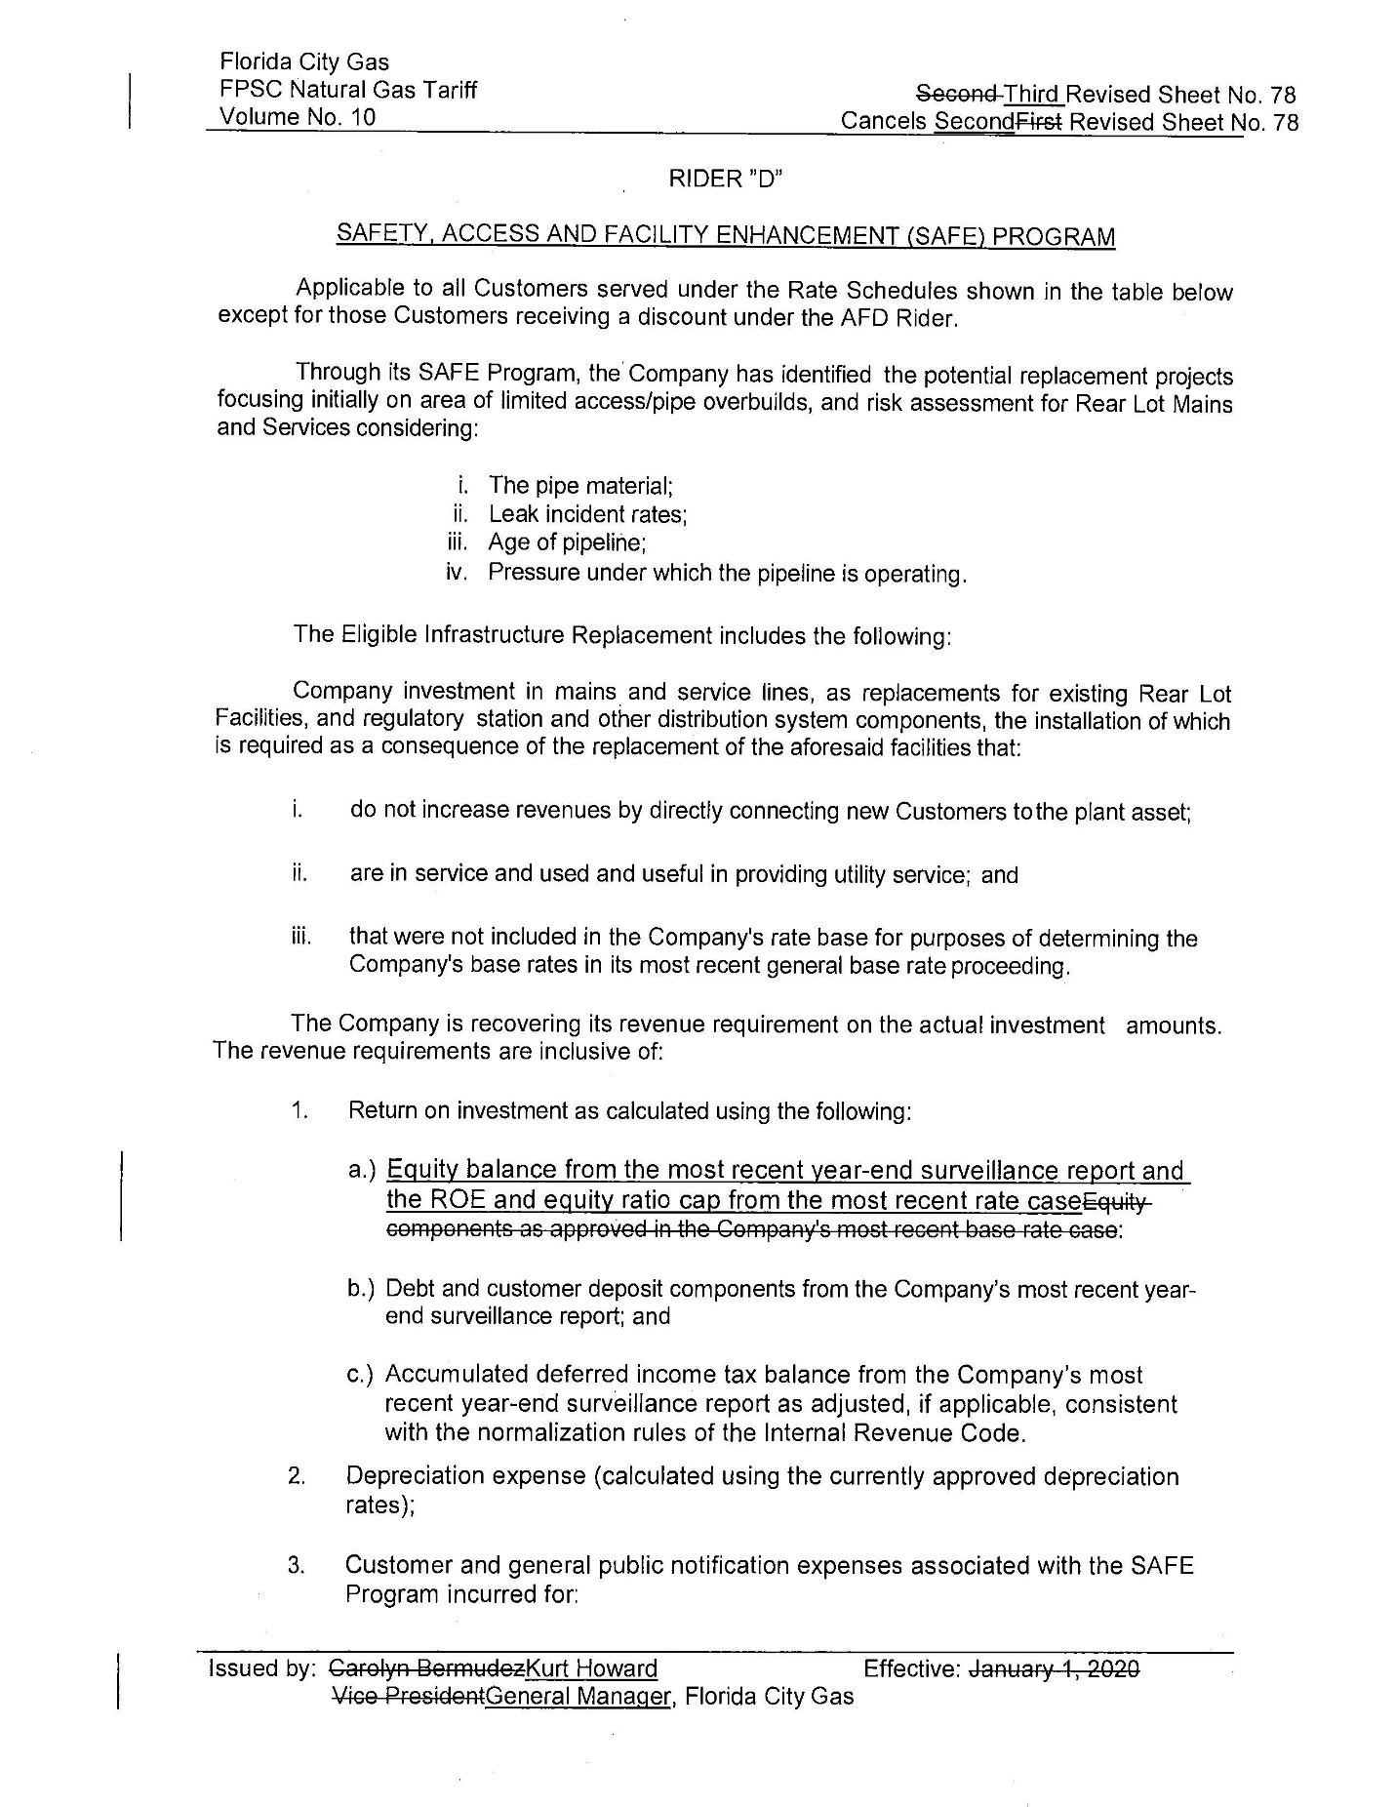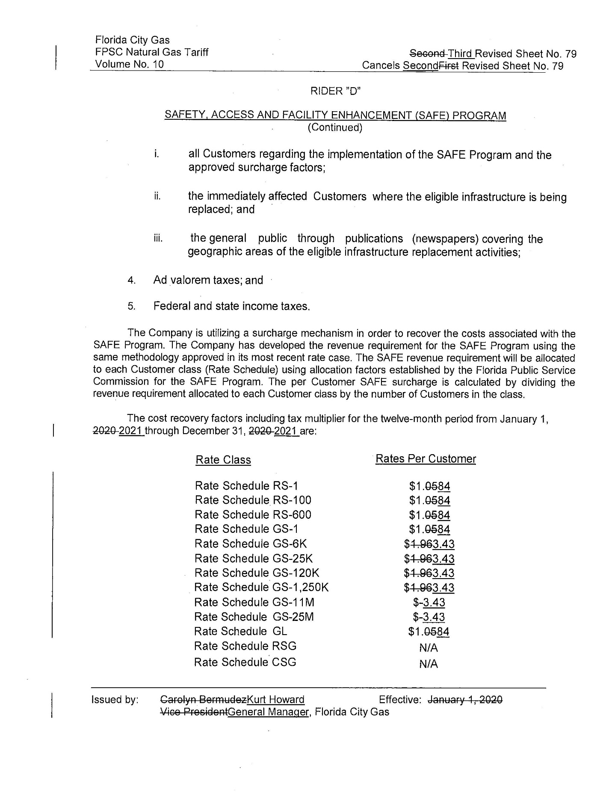

Order No. PSC-15-0390-TRF-GU, issued September 15, 2015, in Docket No. 150116-GU, In re: Petition for approval of safety, access, and facility enhancement program and associated cost recovery methodology, by Florida City Gas.
Order No. PSC-2019-0550-TRF-GU, issued December 30, 2019, in Docket No. 20190172, In re: Petition for approval of safety, access, and facility enhancement program true-up and 2020 cost recovery factors, by Florida City Gas.

