|  |  |  |  |
| --- | --- | --- | --- |
| State of Florida  pscSEAL | | Public Service Commission  Capital Circle Office Center ● 2540 Shumard Oak Boulevard Tallahassee, Florida 32399-0850  -M-E-M-O-R-A-N-D-U-M- | |
| DATE: | April 22, 2021 | | |
| TO: | Office of Commission Clerk (Teitzman) | | |
| FROM: | Office of the General Counsel (Harper) SMC  Division of Accounting and Finance (Fletcher, Mouring) ALM  Division of Economics (Coston, Guffey) JGH | | |
| RE: | Docket No. 20210062-OT – Proposed amendment of Rule 25-6.0143, F.A.C., Use of Accumulated Provision Accounts 228.1, 228.2, and 228.4 and proposed new Rule 25-7.0143, F.A.C., Use of Accumulated Provision Accounts 228.1, 228.2, and 228.4. | | |
| AGENDA: | 05/04/21 – Regular Agenda – Rule Proposal – Interested Persons May Participate | | |
| COMMISSIONERS ASSIGNED: | | | All Commissioners |
| PREHEARING OFFICER: | | | Fay |
| RULE STATUS: | | | Proposal May Be Deferred |
| SPECIAL INSTRUCTIONS: | | | None |

Case Background

Rule 25-6.0143, Florida Administrative Code (F.A.C.), Use of Accumulated Provision Accounts 228.1, 228.2, and 228.4., provides the standards for the application of Accumulated Provision Accounts 228.1, 228.2, and 228.4 for investor-owned electric utilities. The Commission does not currently have a corresponding rule on this subject for investor-owned natural gas utilities. Adoption of new Rule 25-7.0143, F.A.C., Use of Accumulated Provision Accounts 228.1, 228.2, and 228.4, would create a new rule for the standards for the application of Accumulated Provision Accounts 228.1, 228.2, and 228.4 for natural gas utilities.

The focus of this rulemaking is to amend Rule 25-6.0143, F.A.C., for clarity and specificity. Rule 25-7.0143, F.A.C., is being created to provide an industry-specific standard for the application of Accumulated Provision Accounts 228.1, 228.2, and 228.4 for the natural gas utilities***.*** In general, the amendment of Rule 25-6.0143, F.A.C., and the adoption of new Rule 25-7.0143, F.A.C., is intended to provide requirements for the application of Accumulated Provision Accounts 228.1, 228.2, and 228.4,specifically as they apply to storm-related damages.

The Notice of Development of Rulemaking for Rule 25-6.0143, F.A.C., was published in the June 7, 2019 edition of the Florida Administrative Register, Volume 45, No. 111, in conjunction with the Commission’s rulemaking on Rules 25-6.030 and 25-6.031, F.A.C., the storm protection plan and storm protection plan cost recovery clause rulemaking. During the development of those rules, staff determined that Rule 25-6.0143, F.A.C., needed to be updated.

In the course of considering potential amendments to Rule 25-6.0143, F.A.C., staff determined that the gas industry needed a rule similar to Rule 25-6.0143, F.A.C. Accordingly, a Notice of Development of Rulemaking for new Rule 25-7.0143, F.A.C., was published in the June 10, 2020 edition of the Florida Administrative Register, Volume 46, No. 113.

A rule development workshop on both rules was held on June 29, 2020. Representatives from Florida Power & Light Company (FPL), Tampa Electric Company (TECO), Duke Energy Florida, LLC (DEF), Gulf Power Company (Gulf), Florida Public Utilities Company (FPUC), Florida City Gas (FCG), Peoples Gas System (PGS), and the Office of Public Counsel (OPC) participated at the workshop and submitted post-workshop comments.

This recommendation addresses whether the Commission should propose the amendment of Rule 25-6.0143, F.A.C., and propose the adoption of new Rule 25-7.0143, F.A.C. The Commission has jurisdiction pursuant toSection 366.05(1),Florida Statutes (F.S.).

Discussion of Issues

Issue :

 Should the Commission propose the amendment of Rule25-6.0143, F.A.C., Use of Accumulated Provision Accounts 228.1, 228.2, and 228.4., and propose the adoption of Rule 25-7.0143, F.A.C., Use of Accumulated Provision Accounts 228.1, 228.2, and 228.4?

Recommendation:

 Yes. The Commission should propose the amendment of Rule25-6.0143, F.A.C., and propose the adoption of Rule 25-7.0143,F.A.C., as set forth in Attachment A. The Commission should also certify Rules 25-6.0143 and 25-7.0143*,*F.A.C., as minor violation rules. (Mouring, Harper, Guffey)

Staff Analysis:

 Staff recommends that the Commission amend Rule 25-6.0143, F.A.C., and adopt new Rule 25-7.0143, F.A.C., as set forth in Attachment A. Staff’s recommended language for Rule 25-7.0143, F.A.C., generally mirrors the Commission’s current use of accumulated provision accounts rule for investor-owned electric utilities. Both rules address the categories of storm-related costs eligible for certain accounting. As such, the recommended amendments discussed below for Rule 25-6.0143, F.A.C., are also reflected in staff’s recommended language for Rule 25-7.0143, F.A.C.

**Rule 25-7.0143, F.A.C.**

Draft Rule 25-7.0143, F.A.C., is virtually identical to the electric rule, Rule 25-6.0143, F.A.C., in that both rules address the storm related costs that will be allowed to be charged to the reserve under the Incremental Cost and Capitalization Approach (ICCA) methodology. Also, draft Rule 25-7.0143, F.A.C., provides an accounting mechanism for probable liability that is not covered by insurance and a “catch-all” account for operating provisions that are not covered elsewhere in the rule. This account must be maintained in such a manner as to show the amount of each separate provision established by the utility and the nature and amounts of the debits and credits.

In addition, draft Rule 25-7.0143, F.A.C., requires the utility to show the level and annual accrual rate for each account listed in the rule so it can be evaluated at the time of a rate proceeding and adjusted as necessary. Pursuant to the draft rule, a utility may petition the Commission for a change in the provision level and accrual of a certain account outside a rate proceeding under certain, specified circumstances, but a utility may not fund any account listed in the rule unless the Commission approves such funding.

The only substantive difference between the electric and gas rules is that the gas rule does not have the subsection (1)(m) requirement that the utility must submit additional reports on insurance. Staff believes that this type of insurance may not be available to the gas utilities, and thus, to require a gas utility to provide this kind of storm insurance would be extremely uneconomical. Accordingly, staff believes an insurance provision would not be feasible for gas utilities and the proposed rule should not require it.

**Subsection (1) of Both Rules**

Subsection (1) of draft Rules 25-6.0143 and 25.7.0143, F.A.C., contain provisions for an account to provide for losses through accident, fire, flood, storms, nuclear accidents and similar type hazards to the utility’s own property or property leased from others, which is not covered by insurance. Staff recommends updating this subsection of the rules to require a utility to notify the Commission Clerk in writing for each incident expected to exceed 1.5 percent of jurisdictional revenues for the most recent calendar year.

Staff also recommends updating subsection (1) in Rule 25-6.0143, F.A.C., and including a provision in new Rule 25-7.0143, F.AC., for the storm-related costs that will be allowed to be charged to the reserve under the ICCA methodology. For each of the identified accounts, a calculation is made to compare the actual average costs for a specific calendar month to the actual average costs of that same month for each of the previous three years. The actual costs for a specific calendar month that are in excess of actual average costs of that same month for each of the previous three years, would be identified as incremental costs.[1] For example, staff recommends that rule language be included to address contract labor and payroll expenses incurred in storm restoration activities and that such costs must be incurred in any month in which storm damage restoration activities are conducted. Staff recommends similar clarifications and rule language be added to address the fuel costs for both company and contractor vehicles used in storm restoration activities, as well as the vegetation management costs that are specifically related to storm restoration activities for the utilities. For all of these cost categories, staff’s recommended rule language requires that the costs must be greater than the actual monthly average of contract labor or payroll costs charged to operation and maintenance expense for the same month in the three previous calendar years, and each adjustment must be accompanied by a detailed explanation of the nature of the adjustment. Finally, staff is also recommending an added “catch-all” provision to the rules, which provides that for any other costs or expenses not specifically identified in the rules but that are directly and solely attributable to a storm restoration event, such costs must be explained.

With regard to the payroll costs, DEF commented that staff’s draft language in Subsection (1) of Rule 25-6.0143, F.A.C., is unclear as to which payroll expenses were eligible. It is staff’s intention that the rule language allow for *all* payroll and payroll-related costs, including overtime payroll, to be eligible. Staff believes the rule as reflected in Attachment A is sufficient to address this point. The other stakeholders agreed that staff’s recommended language was sufficient and clear in this regard.

Minor Violation Rules Certification

Pursuant to Section 120.695, F.S., as of July 1, 2017, the agency head shall certify whether any part of each rule filed for adoption is designated as a minor violation rule. A minor violation rule is a rule that would not result in economic or physical harm to a person or an adverse effect on the public health, safety, or welfare or create a significant threat of such harm when violated. Staff recommends that the Commission certify Rule 25-6.0143, F.A.C., and Rule 25-7.0143, F.A.C., as minor violation rules.

Statement of Estimated Regulatory Costs

Pursuant to Section 120.54(3)(b)1., F.S., agencies are encouraged to prepare a statement of estimated regulatory costs (SERC) before the adoption, amendment, or repeal of any rule. A SERC was prepared for this rulemaking and is appended as Attachment B. As required by Section 120.541(2)(a)1., F.S., the SERC analysis includes whether the rule amendments and rule adoption are likely to have an adverse impact on economic growth, private sector job creation or employment, or private sector investment in excess of $1 million in the aggregate within five years after implementation. Staff notes that none of the impact/cost criteria will be exceeded as a result of the recommended amendments to Rule 25-6.0143 or the adoption new Rule 25-7.0143.

Based on the utilities’ responses to data requests and discussions with technical staff that oversee the accumulated provision rules, the recommended proposed rule amendments and proposed new rule will not likely increase regulatory costs, as contemplated by Section 120.541, F.S., including any transactional costs or have an adverse impact on business competitiveness, productivity, or innovation in excess of $1 million in the aggregate within five years of implementation. The proposed new rule and rule amendments would not potentially have adverse impacts on small businesses, would have no implementation cost to the Commission or other state and local government entities, and would have no negative impact on small cities or counties.

No regulatory alternatives were submitted pursuant to Section 120.541(1)(g), F.S. The SERC concludes that none of the impacts/cost criteria established in Sections 120.541(2)(a), (c), (d), and (e), F.S., will be exceeded as a result of the proposed rule amendments or the adoption of the new rule.

Conclusion

The Commission should propose the amendment of Rule 25-6.0143, F.A.C., and the adoption of Rule 25-7.0143, F.A.C., as set forth in Attachment A. The Commission should certify Rule 25-6.0143, F.A.C., and Rule 25-7.0143, F.A.C., as minor violation rules.

Issue :

 Should this docket be closed?

Recommendation:

  Yes. If no requests for hearing, information regarding the SERC, proposals for a lower cost regulatory alternative, or JAPC comments are filed, the rules should be filed with the Department of State, and the docket should be closed. (Harper)

Staff Analysis:

 If no requests for hearing, information regarding the SERC, proposals for a lower cost regulatory alternative, or JAPC comments are filed, the rules should be filed with the Department of State, and the docket should be closed.

**25-6.0143 Use of Accumulated Provision Accounts 228.1, 228.2, and 228.4.**

(1) Account No. 228.1 Accumulated Provision for Property Insurance.

(a) This account may be established to provide for losses through accident, fire, flood, storms, nuclear accidents and similar type hazards to the utility’s own property or property leased from others, which is not covered by insurance. This account would also include provisions for the deductible amounts contained in property loss insurance policies held by the utility as well as retrospective premium assessments stemming from nuclear accidents under various insurance programs covering nuclear generating plants. A schedule of risks covered must ~~shall~~ be maintained, giving a description of the property involved, the character of risks covered and the accrual rates used.

(b) Except as provided in paragraphs (1)(f), (1)(g) and (1)(h) charges to this account must ~~shall~~ be made for all occurrences in accordance with the schedule of risks to be covered which are not covered by insurance. Recoveries, insurance proceeds or reimbursements for losses charged to this account must ~~shall~~ be credited to the account.

(c) A separate subaccount must ~~shall~~ be established for that portion of Account No. 228.1 which is designated to cover storm-related damages to the utility’s own property or property leased from others that is not covered by insurance. The records supporting the entries to this account must ~~shall~~ be so kept that the utility can furnish full information as to each storm event included in this account.

(d) In determining the costs to be charged to cover storm-related damages, the utility must ~~shall~~ use an Incremental Cost and Capitalization Approach methodology (ICCA). Under the ICCA methodology, the costs charged to cover storm-related damages must ~~shall~~ exclude those costs that normally would be charged to non-cost recovery clause operating expenses in the absence of a storm. Under the ICCA methodology for determining the allowable costs to be charged to cover storm-related damages, the utility will be allowed to charge to Account No. 228.1 costs that are incremental to costs normally charged to non-cost recovery clause operating expenses in the absence of a storm. All costs charged to Account 228.1 are subject to review for prudence and reasonableness by the Commission. In addition, capital expenditures for the removal, retirement and replacement of damaged facilities charged to cover storm-related damages must ~~shall~~ exclude the normal cost for the removal, retirement and replacement of those facilities in the absence of a storm. The utility must ~~shall~~ notify ~~the Director of~~ the Commission Clerk in writing for each incident expected to exceed 1.5 percent of jurisdictional revenues for the most recent calendar year ~~$10 million~~.

(e) The types of storm related costs allowed to be charged to the reserve under the ICCA methodology include~~, but are not limited to,~~ the following:

1. Additional contract labor hired for storm restoration activities incurred in any month in which storm damage restoration activities are conducted, that are greater than the actual monthly average of contract labor costs charged to operation and maintenance expense for the same month in the three previous calendar years. The utility may adjust historical monthly contract labor costs charged to operation and maintenance expense from calculated monthly average. Each adjustment shall be accompanied by a detailed explanation of the nature and derivation of the adjustment;

2. Logistics costs of providing meals, lodging, and linens for tents and other staging areas;

3. Transportation of crews and other personnel for storm restoration;

4. Vehicle costs for vehicles specifically rented for storm restoration activities;

5. Waste management costs specifically related to storm restoration activities;

6. Rental equipment specifically related to storm restoration activities;

7. Materials and supplies used to repair and restore service and facilities to pre-storm condition, such as poles, transformers, meters, light fixtures, wire, and other electrical equipment, excluding those costs that normally would be charged to non-cost recovery clause operating expenses in the absence of a storm;

8. Payroll ~~Overtime payroll~~ and payroll-related costs for utility personnel included in storm restoration activities incurred in any month in which storm damage restoration activities are conducted, that are greater than the actual monthly average of payroll and payroll-related costs charged to operation and maintenance expense for the same month in the previous three calendar years. The utility may adjust historical monthly payroll and payroll-related costs charged to operation and maintenance expense from calculated monthly average. Each adjustment shall be accompanied by a detailed explanation of the nature and derivation of the adjustment;

9. Fuel cost for company and contractor vehicles used in storm restoration activities incurred in any month in which storm damage restoration activities are conducted, that are greater than the actual monthly average of fuel costs charged to operation and maintenance expense for the same month in the previous three calendar years. The utility may adjust historical monthly fuel costs charged to operation and maintenance expense from calculated monthly average. Each adjustment shall be accompanied by a detailed explanation of the nature and derivation of the adjustment; ~~and~~

10. Cost of public service announcements regarding key storm-related issues, such as safety and service restoration estimates;~~.~~

11. Vegetation management costs specifically related to storm restoration activities incurred in any month in which storm damage restoration activities are conducted, that are greater than the actual monthly average of vegetation management costs charged to operation and maintenance expense for the same month in the previous three calendar years. The utility may adjust historical monthly vegetation management costs charged to operation and maintenance expense from calculated monthly average. Each adjustment shall be accompanied by a detailed explanation of the nature and derivation of the adjustment; and

12. Other costs or expenses not specifically identified in paragraph (1)(e)1. through (1)(e)11. that are directly and solely attributable to a storm restoration event.

(f) The types of storm related costs prohibited from being charged to the reserve under the ICCA methodology include~~, but are not limited to,~~ the following:

~~1. Base rate recoverable regular payroll and regular-payroll related costs for utility managerial and non-managerial personnel;~~

1.~~2.~~ Bonuses or any other special compensation for utility personnel not eligible for overtime pay;

2.~~3. Base rate recoverable~~ D~~d~~epreciation expenses, insurance costs and lease expenses for utility-owned or utility-leased vehicles and aircraft;

3. ~~4.~~ Utility employee assistance costs;

4.~~5.~~ Utility employee training costs incurred prior to 72 hours before the storm event;

5.~~6.~~Utility advertising, media relations or public relations costs, except for public service announcements regarding key storm-related issues as listed above in subparagraph (1)(e)10.;

6.~~7.~~ Utility call center and customer service costs, except for non-budgeted overtime or other non-budgeted incremental costs associated with the storm event;

~~8. Tree trimming expenses, incurred in any month in which storm damage restoration activities are conducted, that are less than the actual monthly average of tree trimming costs charged to operation and maintenance expense for the same month in the three previous calendar years;~~

7.~~9.~~ Utility lost revenues from services not provided; and

8.~~10.~~ Replenishment of the utility’s materials and supplies inventories.

(g) Under the ICCA methodology for determining the allowable costs to be charged to cover storm-related damages, certain costs may be charged to Account 228.1 only after review and approval by the Commission. Prior to the Commission’s determination of the appropriateness of including such costs in Account No. 228.1, the costs may be deferred in Account No. 186, Miscellaneous Deferred Debits. The deferred costs must be incurred prior to June 1 of the year following the storm event. By September 30 a utility must ~~shall~~ file a petition for the disposition of any costs deferred prior to June 1 of the year following the storm event giving rise to the deferred costs. These costs include~~, but are not limited to,~~ the following:

1. Costs of normal non-storm related activities which must be performed by employees or contractors not assigned to storm damage restoration activities (“back-fill work”) or normal non-storm related activities which must be performed following the restoration of service after a storm by an employee or contractor assigned to storm damage restoration activities in addition to the employee’s or contractor’s regular activities (“catch-up work”); and

2. Uncollectible accounts expenses.

(h) A utility may, at its own option, charge storm-related costs as operating expenses rather than charging them to Account No. 228.1. The utility must ~~shall~~ notify ~~the Director of~~ the Commission Clerk in writing and provide a schedule of the amounts charged to operating expenses for each incident exceeding 0.5 percent of jurisdictional revenues for the most recent calendar year ~~$5 million~~. The schedule must ~~shall~~ be filed annually by February 15 of each year for information pertaining to the previous calendar year.

(i) If the charges to Account No. 228.1 exceed the account balance, the excess must ~~shall~~ be carried as a debit balance in Account No. 182.3 ~~228.1~~ and no request for a deferral of the excess or for the establishment of a regulatory asset is necessary.

(j) A utility may petition the Commission for the recovery of a debit balance in Account No. 182.3 discussed in paragraph (1)(i) ~~228.1~~ plus an amount to replenish the storm reserve through a surcharge, securitization or other cost recovery mechanism.

(k) A utility must ~~shall~~ not establish or change an annual accrual amount or a target accumulated balance amount for Account No. 228.1 without prior Commission approval.

(l) Each utility must ~~shall~~ file a Storm Damage Self-Insurance Reserve Study (Study) with the Commission Clerk by January 15, 2011 and at least once every 5 years thereafter from the submission date of the previously filed study. A Study must ~~shall~~ be filed whenever the utility is seeking a change to either the target accumulated balance or the annual accrual amount for Account No. 228.1. At a minimum, the Study must ~~shall~~ include data for determining a target balance for, and the annual accrual amount to, Account No. 228.1.

(m) Each utility must ~~shall~~ file a report with ~~the Director of~~ the Commission Clerk providing information concerning its efforts to obtain commercial insurance for its transmission and distribution facilities and any other programs or proposals that were considered. The report must ~~shall~~ also include a summary of the amounts recorded in Account 228.1. The report must ~~shall~~ be filed annually by February 15 of each year for information pertaining to the previous calendar year.

(2) Account No. 228.2 Accumulated Provision for Injuries and Damages.

(a) This account may be established to meet the probable liability, not covered by insurance, for deaths or injuries to employees or others and for damages to property neither owned nor held under lease by the utility. When liability for any injury or damage is admitted or settled by the utility either voluntarily or because of the decision of a Court or other lawful authority, such as a workman’s compensation board, the admitted liability or the amount of the settlement must ~~shall~~ be charged to this account.

(b) Charges to this account must ~~shall~~ be made for all losses covered. Detailed supporting records of charges made to this account must ~~shall~~ be maintained in such a way that the year the event occurred which gave rise to the loss can be associated with the settlement. Recoveries or reimbursements for losses charged to the account must ~~shall~~ be credited to the account.

(3) Account No. 228.4 Accumulated Miscellaneous Operating Provisions.

(a) This account may be established for operating provisions which are not covered elsewhere. This account must ~~shall~~ be maintained in such a manner as to show the amount of each separate provision established by the utility and the nature and amounts of the debits and credits thereto. Each separate provision must ~~shall~~ be identified as to purpose and the specific events to be charged to the account to ensure that all such events and only those events are charged to the provision accounts.

(b) Charges to this account must ~~shall~~ be made for all costs or losses covered. Recoveries or reimbursements for amounts charged to this account must ~~shall~~ be credited hereto.

(4)(a) The provision level and annual accrual rate for each account listed in subsections (1) through (3) must ~~shall~~ be evaluated at the time of a rate proceeding and adjusted as necessary. However, a utility may petition the Commission for a change in the provision level and accrual outside a rate proceeding.

(b) If a utility elects to use any of the above listed accumulated provision accounts, each and every loss or cost which is covered by the account must ~~shall~~ be charged to that account and must ~~shall~~ not be charged directly to expenses except as provided for in paragraphs (1)(f), (1)(g) and (1)(h). Charges must ~~shall~~ be made to accumulated provision accounts regardless of the balance in those accounts.

(c) No utility must ~~shall~~ fund any account listed in subsections (1) through (3) unless the Commission approves such funding. Existing funded provisions which have not been approved by the Commission must ~~shall~~ be credited by the amount of the funded balance with a corresponding debit to the appropriate current asset account, resulting in an unfunded provision.

*Rulemaking Authority 366.05(1) FS. Law Implemented 350.115, 366.04(2)(a) FS. History–New 3-17-88, Amended 6-11-07,___________.*

**25-7.0143 Use of Accumulated Provision Accounts 228.1, 228.2, and 228.4.**

(1) Account No. 228.1 Accumulated Provision for Property Insurance.

(a) This account may be established to provide for losses through accident, fire, flood, storms and similar type hazards to the utility’s own property or property leased from others, which is not covered by insurance. A schedule of risks covered must be maintained, giving a description of the property involved, the character of risks covered and the accrual rates used.

(b) Except as provided in paragraphs (1)(f), (1)(g) and (1)(h) charges to this account must be made for all occurrences in accordance with the schedule of risks to be covered which are not covered by insurance. Recoveries, insurance proceeds or reimbursements for losses charged to this account must be credited to the account.

(c) A separate subaccount must be established for that portion of Account No. 228.1 which is designated to cover storm-related damages to the utility’s own property or property leased from others that is not covered by insurance. The records supporting the entries to this account must be so kept that the utility can furnish full information as to each storm event included in this account.

(d) In determining the costs to be charged to cover storm-related damages, the utility must use an Incremental Cost and Capitalization Approach methodology (ICCA). Under the ICCA methodology, the costs charged to cover storm-related damages must exclude those costs that normally would be charged to non-cost recovery clause operating expenses in the absence of a storm. Under the ICCA methodology for determining the allowable costs to be charged to cover storm-related damages, the utility will be allowed to charge to Account No. 228.1 costs that are incremental to costs normally charged to non-cost recovery clause operating expenses in the absence of a storm. All costs charged to Account 228.1 are subject to review for prudence and reasonableness by the Commission. In addition, capital expenditures for the removal, retirement and replacement of damaged facilities charged to cover storm-related damages must exclude the normal cost for the removal, retirement and replacement of those facilities in the absence of a storm. The utility must notify the Commission Clerk in writing for each incident expected to exceed 1.5 percent of jurisdictional revenues for the most recent calendar year.

(e) The types of storm related costs allowed to be charged to the reserve under the ICCA methodology include the following:

1. Additional contract labor hired for storm restoration activities incurred in any month in which storm damage restoration activities are conducted, that are greater than the actual monthly average of contract labor costs charged to operation and maintenance expense for the same month in the three previous calendar years. The utility may adjust historical monthly contract labor costs charged to operation and maintenance expense from calculated monthly average. Each adjustment must be accompanied by a detailed explanation of the nature and derivation of the adjustment;

2. Logistics costs of providing meals, lodging, and linens for tents and other staging areas;

3. Transportation of crews and other personnel for storm restoration;

4. Vehicle costs for vehicles specifically rented for storm restoration activities;

5. Waste management costs specifically related to storm restoration activities;

6. Rental equipment specifically related to storm restoration activities;

7. Materials and supplies used to repair and restore service and facilities to pre-storm condition, excluding those costs that normally would be charged to non-cost recovery clause operating expenses in the absence of a storm;

8. Payroll and payroll-related costs for utility personnel included in storm restoration activities incurred in any month in which storm damage restoration activities are conducted, that are greater than the actual monthly average of payroll and payroll-related costs charged to operation and maintenance expense for the same month in the three previous calendar years. The utility may adjust historical monthly payroll and payroll-related costs charged to operation and maintenance expense from calculated monthly average. Each adjustment must be accompanied by a detailed explanation of the nature and derivation of the adjustment;

9. Fuel cost for company and contractor vehicles used in storm restoration activities incurred in any month in which storm damage restoration activities are conducted, that are greater than the actual monthly average of fuel costs charged to operation and maintenance expense for the same month in the three previous calendar years. The utility may adjust historical monthly fuel costs charged to operation and maintenance expense from calculated monthly average. Each adjustment must be accompanied by a detailed explanation of the nature and derivation of the adjustment;

10. Cost of public service announcements regarding key storm-related issues, such as safety and service restoration estimates;

11. Vegetation management expenses specifically related to storm restoration activities incurred in any month in which storm damage restoration activities are conducted, that are greater than the actual monthly average of vegetation management costs charged to operation and maintenance expense for the same month in the previous three calendar years. The utility may adjust historical monthly vegetation management costs charged to operation and maintenance expense from calculated monthly average. Each adjustment must be accompanied by a detailed explanation of the nature and derivation of the adjustment; and

12. Other costs or expenses not specifically identified in paragraph (1)(e)1. through (1)(e)11. that are directly and solely attributable to a storm restoration event.

(f) The types of storm related costs prohibited from being charged to the reserve under the ICCA methodology include the following:

1. Bonuses or any other special compensation for utility personnel not eligible for overtime pay;

2. Depreciation expenses, insurance costs and lease expenses for utility-owned or utility-leased vehicles and aircraft;

3. Utility employee assistance costs;

4. Utility employee training costs incurred prior to 72 hours before the storm event;

5. Utility advertising, media relations or public relations costs, except for public service announcements regarding key storm-related issues as listed above in subparagraph (1)(e)10.;

6. Utility call center and customer service costs, except for non-budgeted overtime or other non-budgeted incremental costs associated with the storm event;

7. Utility lost revenues from services not provided; and

8. Replenishment of the utility’s materials and supplies inventories.

(g) Under the ICCA methodology for determining the allowable costs to be charged to cover storm-related damages, certain costs may be charged to Account 228.1 only after review and approval by the Commission. Prior to the Commission’s determination of the appropriateness of including such costs in Account No. 228.1, the costs may be deferred in Account No. 186, Miscellaneous Deferred Debits. The deferred costs must be incurred prior to June 1 of the year following the storm event. By September 30 a utility must file a petition for the disposition of any costs deferred prior to June 1 of the year following the storm event giving rise to the deferred costs. These costs include the following:

1. Costs of normal non-storm related activities which must be performed by employees or contractors not assigned to storm damage restoration activities (“back-fill work”) or normal non-storm related activities which must be performed following the restoration of service after a storm by an employee or contractor assigned to storm damage restoration activities in addition to the employee’s or contractor’s regular activities (“catch-up work”); and

2. Uncollectible accounts expenses.

(h) A utility may, at its own option, charge storm-related costs as operating expenses rather than charging them to Account No. 228.1. The utility must notify the Commission Clerk in writing and provide a schedule of the amounts charged to operating expenses for each incident exceeding 0.5 percent of jurisdictional revenues for the most recent calendar year. The schedule must be filed annually by February 15 of each year for information pertaining to the previous calendar year.

(i) If the charges to Account No. 228.1 exceed the account balance, the excess must be carried as a debit balance in Account No. 182.3 and no request for a deferral of the excess or for the establishment of a regulatory asset is necessary.

(j) A utility may petition the Commission for the recovery of a debit balance in Account No. 182.3 discussed in paragraph (1)(i) plus an amount to replenish the storm reserve through a surcharge, securitization or other cost recovery mechanism.

(k) A utility must not establish or change an annual accrual amount or a target accumulated balance amount for Account No. 228.1 without prior Commission approval.

(l) Each utility must file a Storm Damage Self-Insurance Reserve Study (Study) with the Commission Clerk by January 15, 2022 and at least once every 5 years thereafter from the submission date of the previously filed study. A Study must be filed whenever the utility is seeking a change to either the target accumulated balance or the annual accrual amount for Account No. 228.1. At a minimum, the Study must include data for determining a target balance for, and the annual accrual amount to, Account No. 228.1.

(2) Account No. 228.2 Accumulated Provision for Injuries and Damages.

(a) This account may be established to meet the probable liability, not covered by insurance, for deaths or injuries to employees or others and for damages to property neither owned nor held under lease by the utility. When liability for any injury or damage is admitted or settled by the utility either voluntarily or because of the decision of a Court or other lawful authority, such as a workman’s compensation board, the admitted liability or the amount of the settlement must be charged to this account.

(b) Charges to this account must be made for all losses covered. Detailed supporting records of charges made to this account must be maintained in such a way that the year the event occurred which gave rise to the loss can be associated with the settlement. Recoveries or reimbursements for losses charged to the account must be credited to the account.

(3) Account No. 228.4 Accumulated Miscellaneous Operating Provisions.

(a) This account may be established for operating provisions which are not covered elsewhere. This account must be maintained in such a manner as to show the amount of each separate provision established by the utility and the nature and amounts of the debits and credits thereto. Each separate provision must be identified as to purpose and the specific events to be charged to the account to ensure that all such events and only those events are charged to the provision accounts.

(b) Charges to this account must be made for all costs or losses covered. Recoveries or reimbursements for amounts charged to this account must be credited hereto.

(4)(a) The provision level and annual accrual rate for each account listed in subsections (1) through (3) must be evaluated at the time of a rate proceeding and adjusted as necessary. However, a utility may petition the Commission for a change in the provision level and accrual outside a rate proceeding.

(b) If a utility elects to use any of the above listed accumulated provision accounts, each and every loss or cost which is covered by the account must be charged to that account and must not be charged directly to expenses except as provided for in paragraphs (1)(f), (1)(g) and (1)(h). Charges must be made to accumulated provision accounts regardless of the balance in those accounts.

(c) No utility must fund any account listed in subsections (1) through (3) unless the Commission approves such funding. Existing funded provisions which have not been approved by the Commission must be credited by the amount of the funded balance with a corresponding debit to the appropriate current asset account, resulting in an unfunded provision.

*Rulemaking Authority 366.05(1) FS. Law Implemented 350.115, 366.04(2)(a) FS. History - New______.*

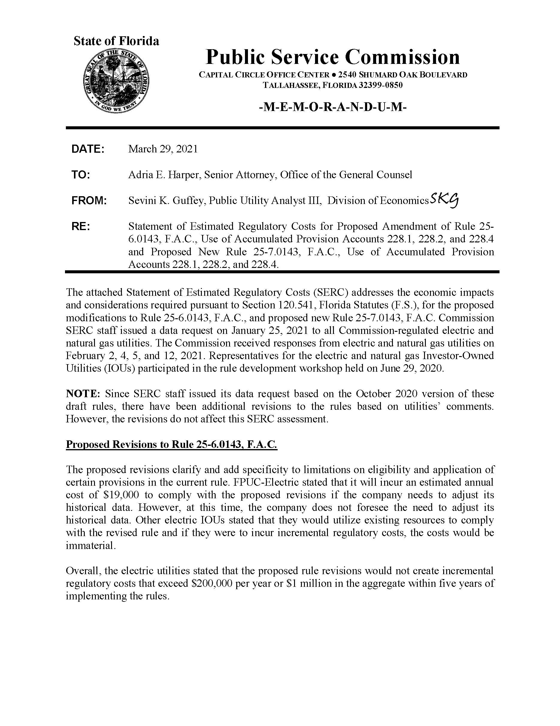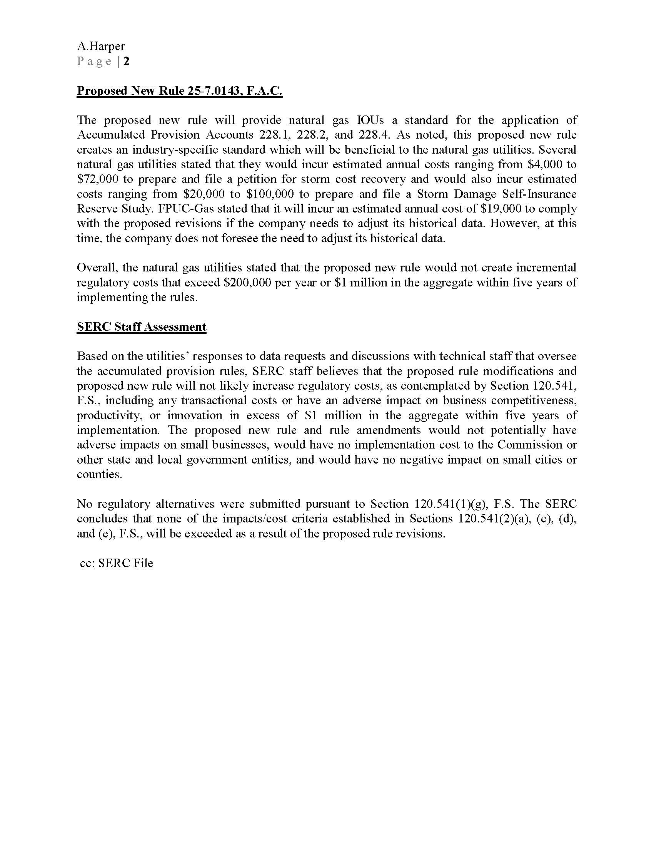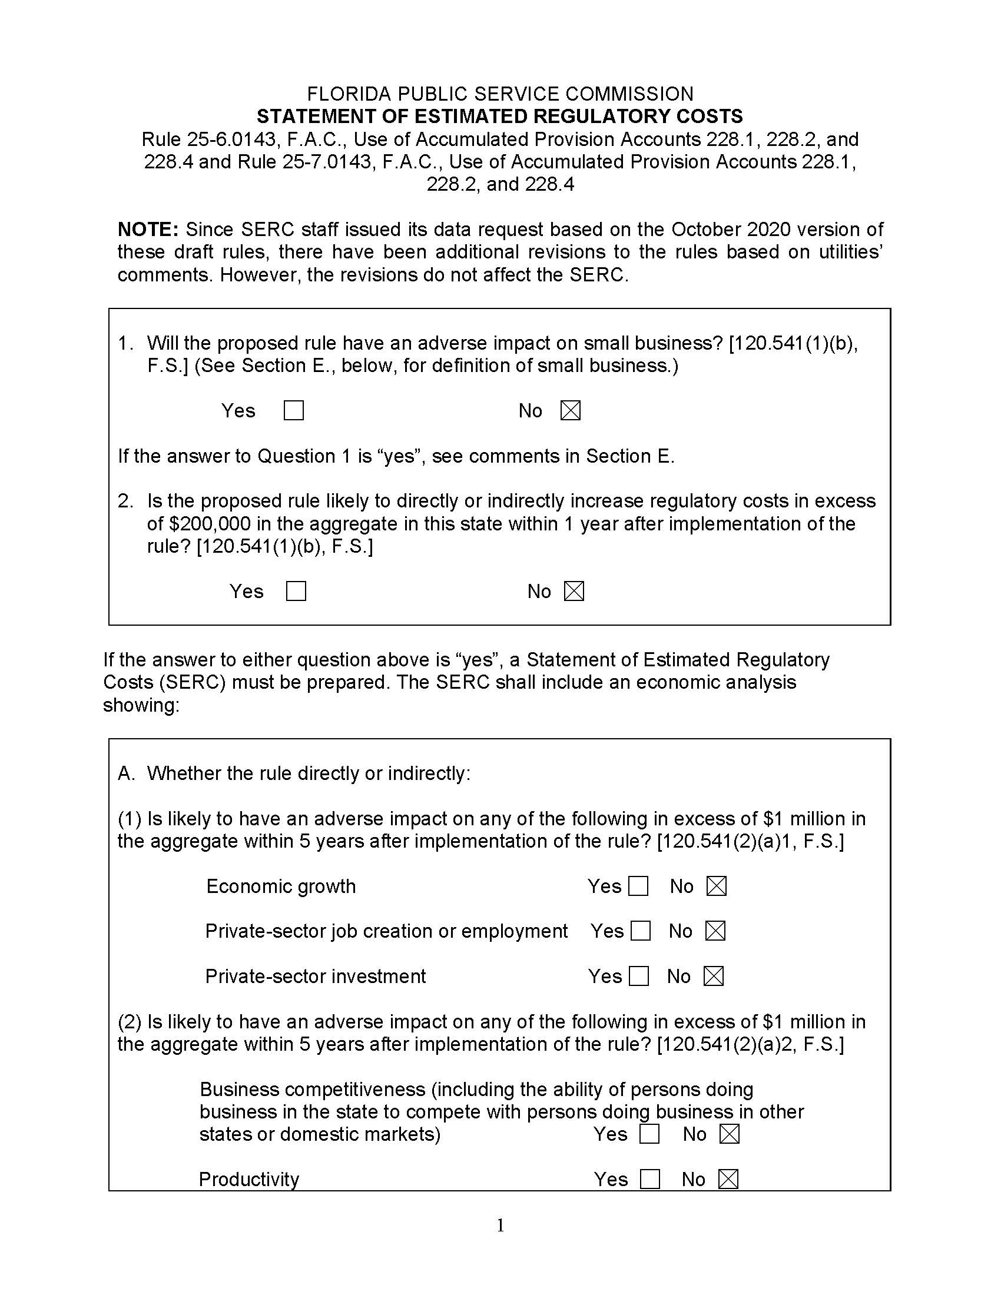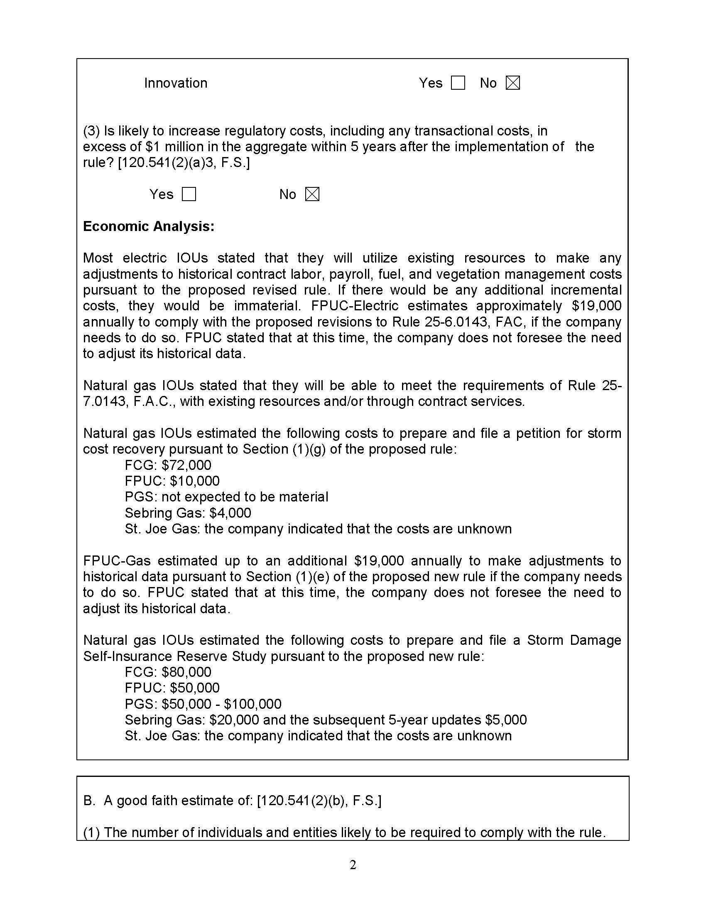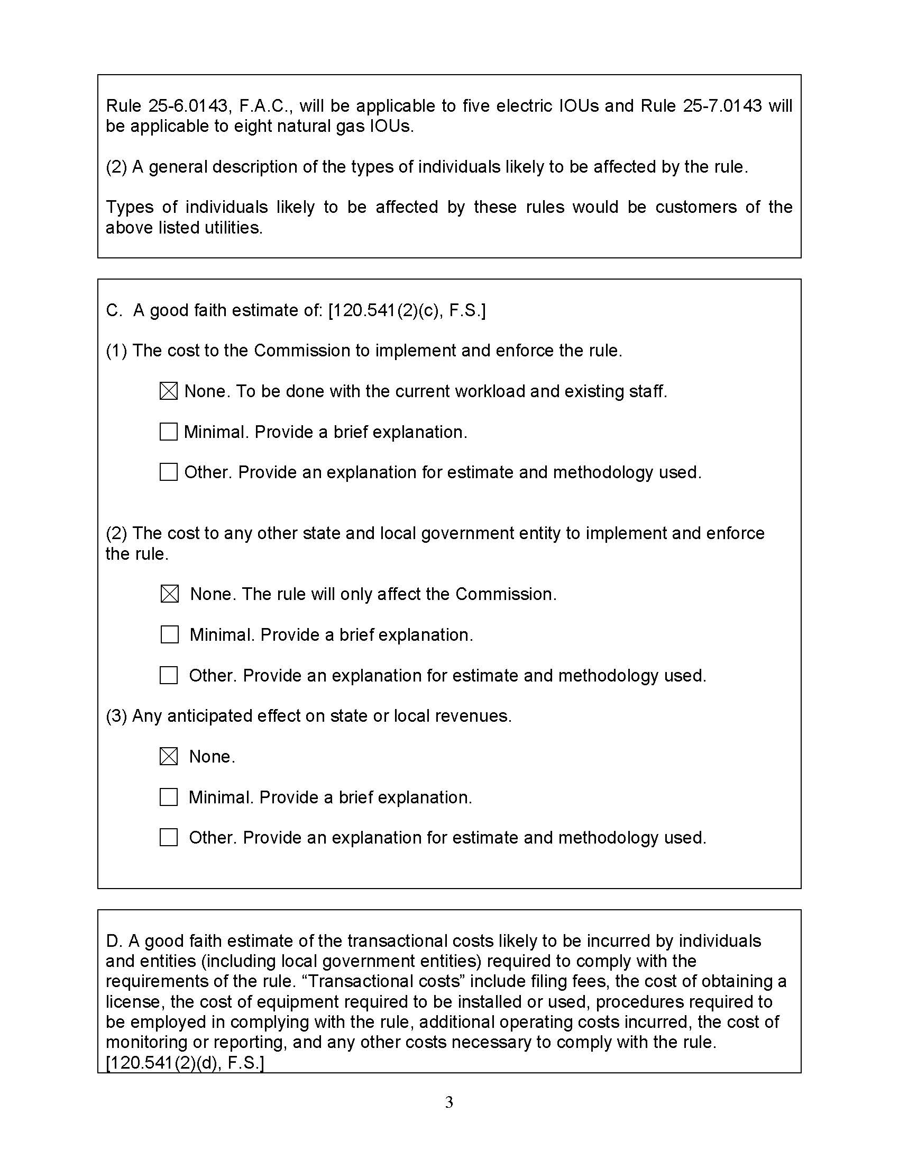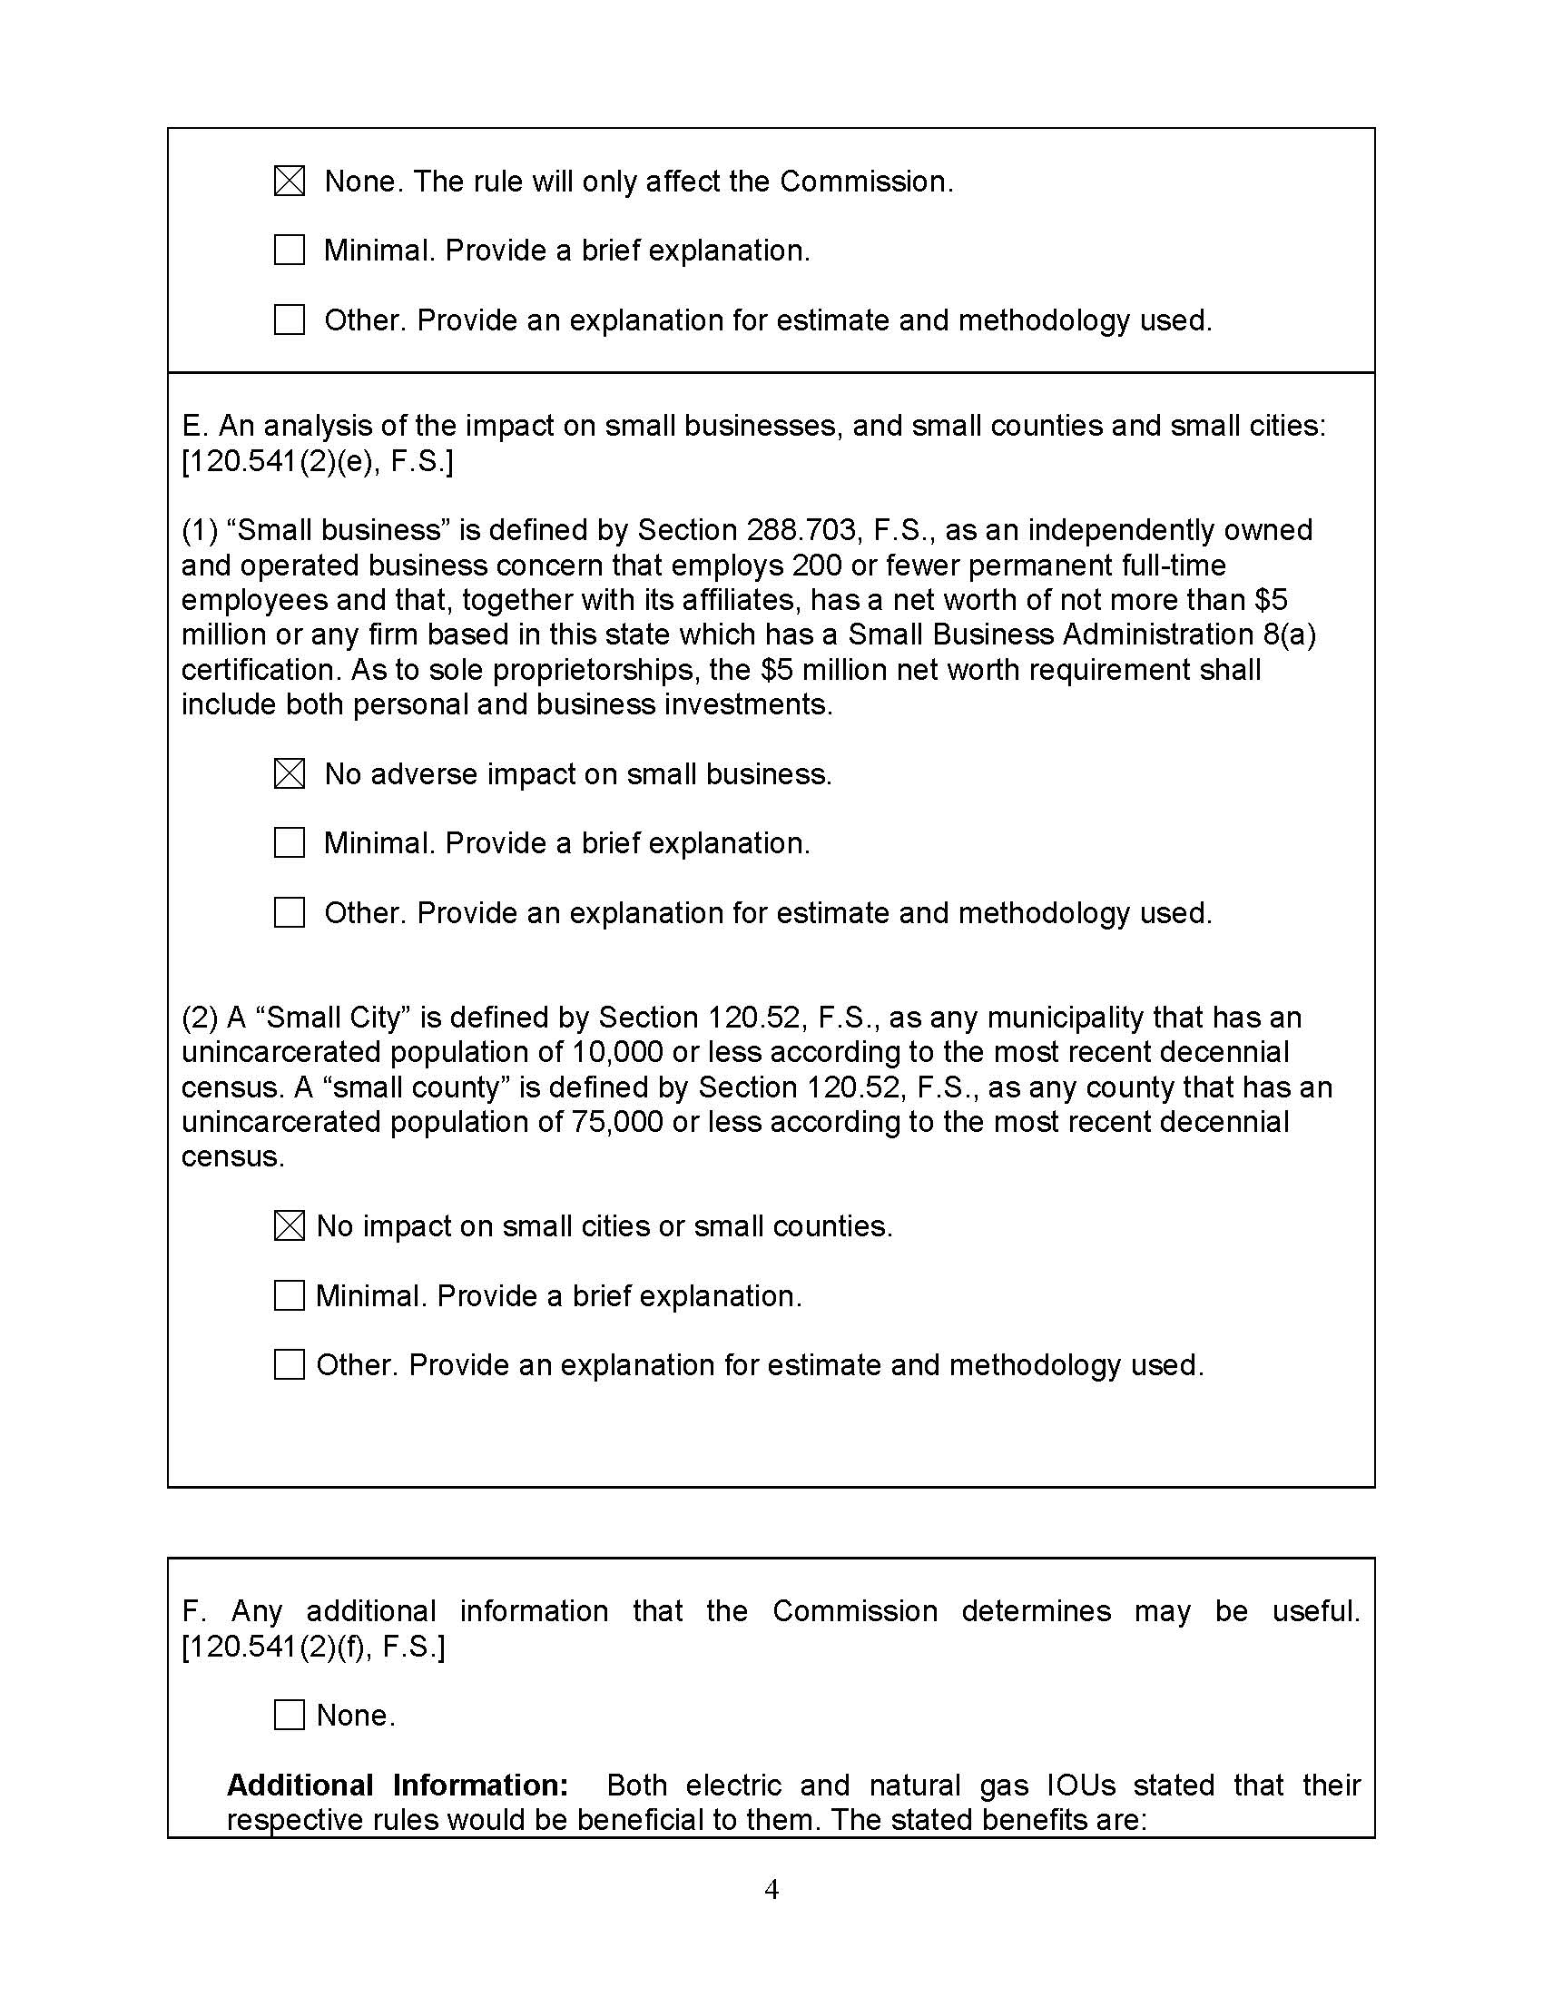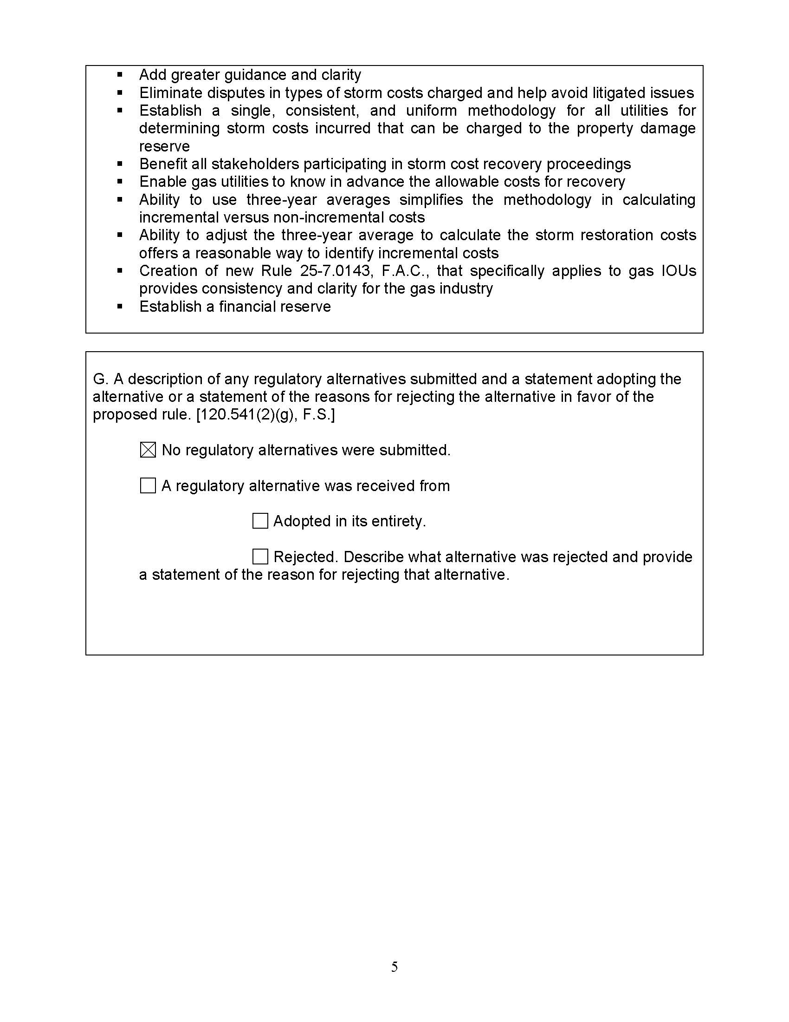

1. In its post-workshop comments, FPUC, indicated that developing a three-year average may be challenging, and it did not believe that “incremental” should be determined by the previous three years spending. FPUC recommends a yearly average instead. Staff preferred three years because it is consistent with the current rule on tree trimming, and staff believes this is reasonable. Also, staff's rule language allows for the utilities to make adjustments to the baseline three-year average when accompanied by a detailed explanation of the nature and derivation of the adjustment.