BEFORE THE FLORIDA PUBLIC SERVICE COMMISSION

In re: Joint petition for approval of territorial agreement in Calhoun, Jackson, and Washington Counties between Gulf Coast Electric Cooperative, Inc. and West Florida Electric Cooperative Association, Inc. | DOCKET NO. 20210131-EU  ORDER NO. PSC-2021-0415-PAA-EU  ISSUED: November 8, 2021

The following Commissioners participated in the disposition of this matter:

GARY F. CLARK, Chairman
ART GRAHAM
ANDREW GILES FAY
MIKE LA ROSA
GABRIELLA PASSIDOMO

NOTICE OF PROPOSED AGENCY ACTION
ORDER APPROVING TERRIROTIAL AGREEMENT

BY THE COMMISSION:

NOTICE is hereby given by the Florida Public Service Commission that the action discussed herein is preliminary in nature and will become final unless a person whose interests are substantially affected files a petition for a formal proceeding, pursuant to Rule 25-22.029, Florida Administrative Code (F.A.C.).

Background
On August 5, 2021, Gulf Coast Electric Cooperative, Inc. (Gulf Coast) and West Florida Electric Cooperative Association, Inc. (West Florida), collectively the joint petitioners, filed a petition seeking our approval of a Territorial Agreement (Agreement) delineating their respective retail service boundaries in Calhoun, Jackson, and Washington counties. The proposed Agreement is the joint petitioners’ first Agreement applicable to the petitioners’ service boundaries specific to Calhoun, Jackson, and Washington counties. The Agreement is Attachment A and composite maps depicting the proposed boundaries is Attachment B to this Order.
The joint petitioners assert that Gulf Coast and West Florida each have electric facilities adjacent to each other in Calhoun, Jackson, and Washington counties. The joint petitioners negotiated the proposed Agreement to establish defined retail area service boundaries in order to avoid duplication of facilities and expenditures, avoid hazardous conditions, and serve their current and future customers in a safe manner.
During its review process, our staff issued two data requests to the joint petitioners to which responses were received on September 10, 2021 and September 21, 2021.

Decision

Pursuant to Section 366.04(2)(d), F.S., and Rule 25-6.0440(2), F.A.C., we have jurisdiction to approve territorial agreements between and among rural electric cooperatives, municipal electric utilities, and other electric utilities. Unless we determine that the Agreement will cause a detriment to the public interest, the Agreement should be approved.

In response to our staff’s first data request, the joint petitioners stated Gulf Coast does not currently serve in any municipalities within the service territory subject to this Agreement, but over the term of the Agreement, Gulf Coast estimates that it will serve approximately 5,383 customers.

Currently, West Florida provides service in the Town of Grand Ridge (in Jackson County), and in the Town of Wausau (in Washington County) and over the term of the Agreement, West Florida estimates it will serve approximately 18,370 customers (including existing customers in Grand Ridge and Wausau) within its service territory in Calhoun, Jackson, and Washington counties.

In responses to our staff’s second data request, the joint petitioners confirmed that both Gulf Coast and West Florida have the capacity and ability to serve their expected future customers without negatively impacting their existing customer base. The joint petitioners also affirmed that the proposed Agreement would enhance the service reliability by avoiding any potential uneconomic duplication of facilities and hazardous conditions.

Pursuant to Paragraph 5 of the joint petition, there are no customer transfers contemplated in this Agreement. Therefore, no notice to customers is required pursuant to Rule 25-6.0440, F.A.C. Pursuant to Section 3.1 of the Agreement, there will be no electric facilities transferred between the two cooperatives. Section 1.10 of the Agreement states that, as of the date of this Agreement, there are no extra-territorial customers. If the parties discover extra-territorial customers, they will be transferred to the appropriate cooperative within 12 months of discovering the inadvertent service error pursuant to Section 2.4 of the Agreement.

The duration of this proposed Agreement is 30 years pursuant to Section 5.1. Thereafter, the Agreement may automatically be extended for succeeding 5-year terms. The Agreement may be terminated by either party after the expiration of the initial 30-year term or succeeding 5-year terms by providing one year prior notification to the other party to terminate the Agreement.

Conclusion

After review of the joint petition, the proposed Agreement, and the joint petitioners’ responses to staff’s data requests, we find that the proposed Agreement is in the public interest and will enable Gulf Coast and West Florida to serve their customers in an efficient manner. The approval of this Agreement will not be a detriment to the public interest, as it will enable Gulf Coast and West Florida to avoid duplication of facilities, and expenditures, avoid hazardous conditions, and serve their current and future customers in a safe manner.

Furthermore, the Agreement between Gulf Coast and West Florida shall become effective on the date this order becomes final and is no longer subject to judicial review.

Based on the foregoing, it is

ORDERED by the Florida Public Service Commission that the proposed Territorial Agreement in Calhoun, Jackson, and Washington counties between Gulf Coast Electric Cooperative, Inc. and West Florida Electric Cooperative Association, Inc. is hereby approved, effective upon the date this order becomes final and is no longer subject to judicial review. It is further

ORDERED that the provisions of this Order, issued as proposed agency action, shall become final and effective upon the issuance of a Consummating Order unless an appropriate petition, in the form provided by Rule 28-106.201, Florida Administrative Code, is received by the Commission Clerk, 2540 Shumard Oak Boulevard, Tallahassee, Florida 32399-0850, by the close of business on the date set forth in the “Notice of Further Proceedings” attached hereto. It is further

ORDERED that in the event this Order becomes final, this docket shall be closed.

By ORDER of the Florida Public Service Commission this 8th day of November, 2021.

/s/ Adam J. Teitzman
ADAM J. TEITZMAN
Commission Clerk
Florida Public Service Commission
2540 Shumard Oak Boulevard
Tallahassee, Florida 32399
(850) 413-6770
www.floridapsc.com

Copies furnished: A copy of this document is provided to the parties of record at the time of issuance and, if applicable, interested persons.

RPS

NOTICE OF FURTHER PROCEEDINGS OR JUDICIAL REVIEW

The Florida Public Service Commission is required by Section 120.569(1), Florida Statutes, to notify parties of any administrative hearing that is available under Section 120.57, Florida Statutes, as well as the procedures and time limits that apply. This notice should not be construed to mean all requests for an administrative hearing will be granted or result in the relief sought.

Mediation may be available on a case-by-case basis. If mediation is conducted, it does not affect a substantially interested person's right to a hearing.

The action proposed herein is preliminary in nature. Any person whose substantial interests are affected by the action proposed by this order may file a petition for a formal proceeding, in the form provided by Rule 28-106.201, Florida Administrative Code. This petition must be received by the Office of Commission Clerk, 2540 Shumard Oak Boulevard, Tallahassee, Florida 32399-0850, by the close of business on November 29, 2021.

In the absence of such a petition, this order shall become final and effective upon the issuance of a Consummating Order.

Any objection or protest filed in this/these docket(s) before the issuance date of this order is considered abandoned unless it satisfies the foregoing conditions and is renewed within the specified protest period.

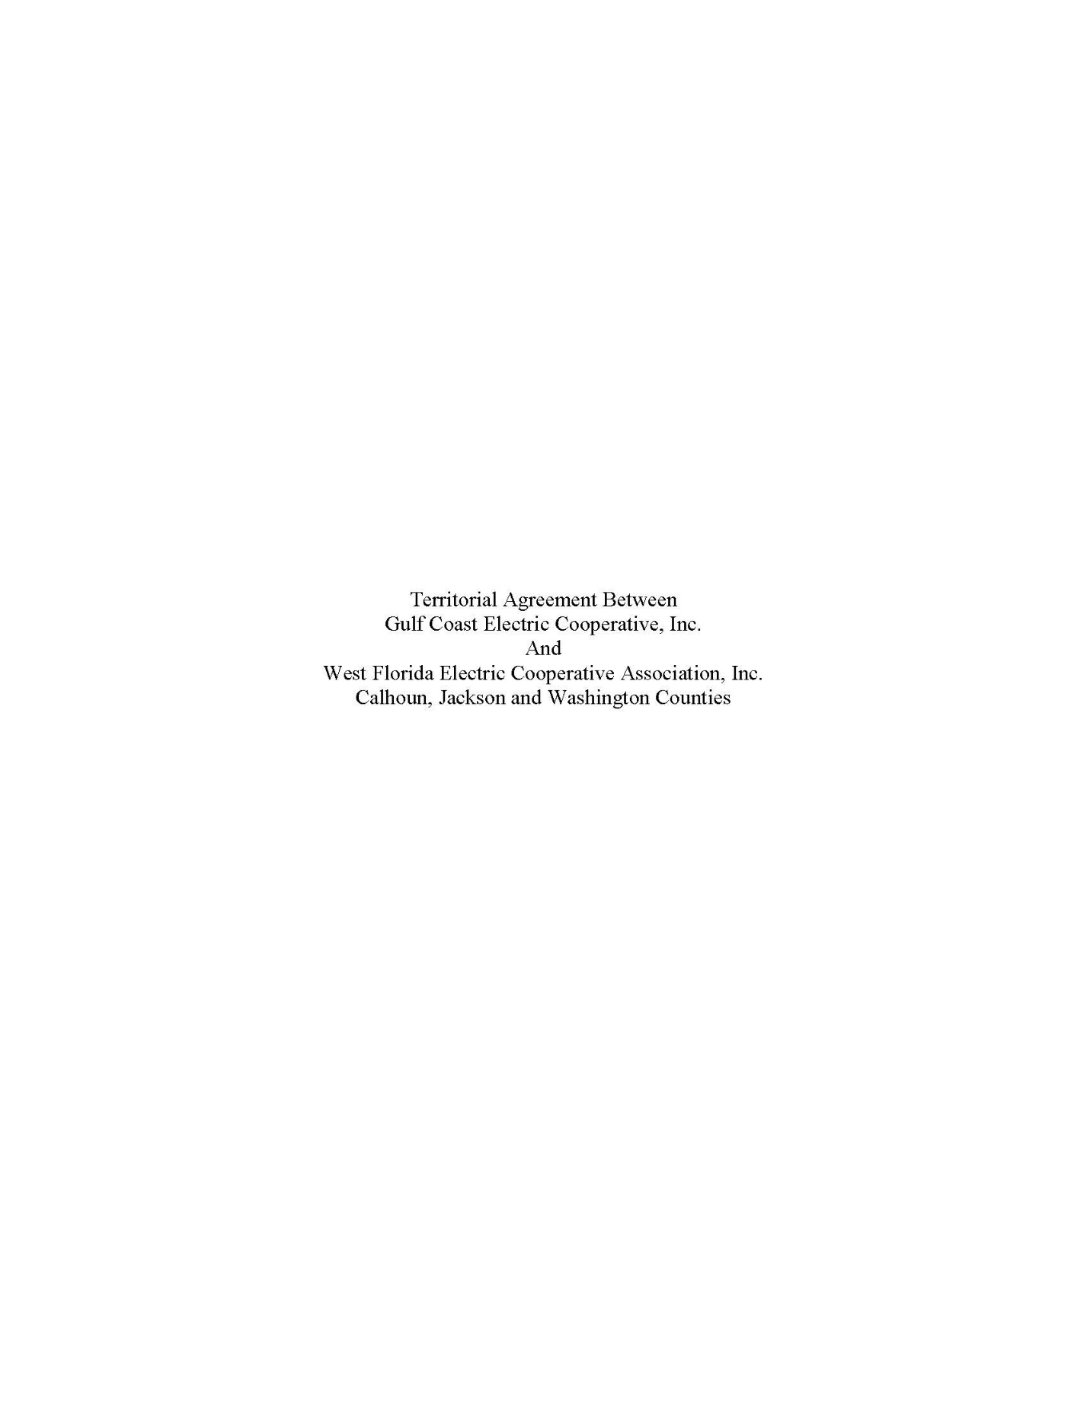
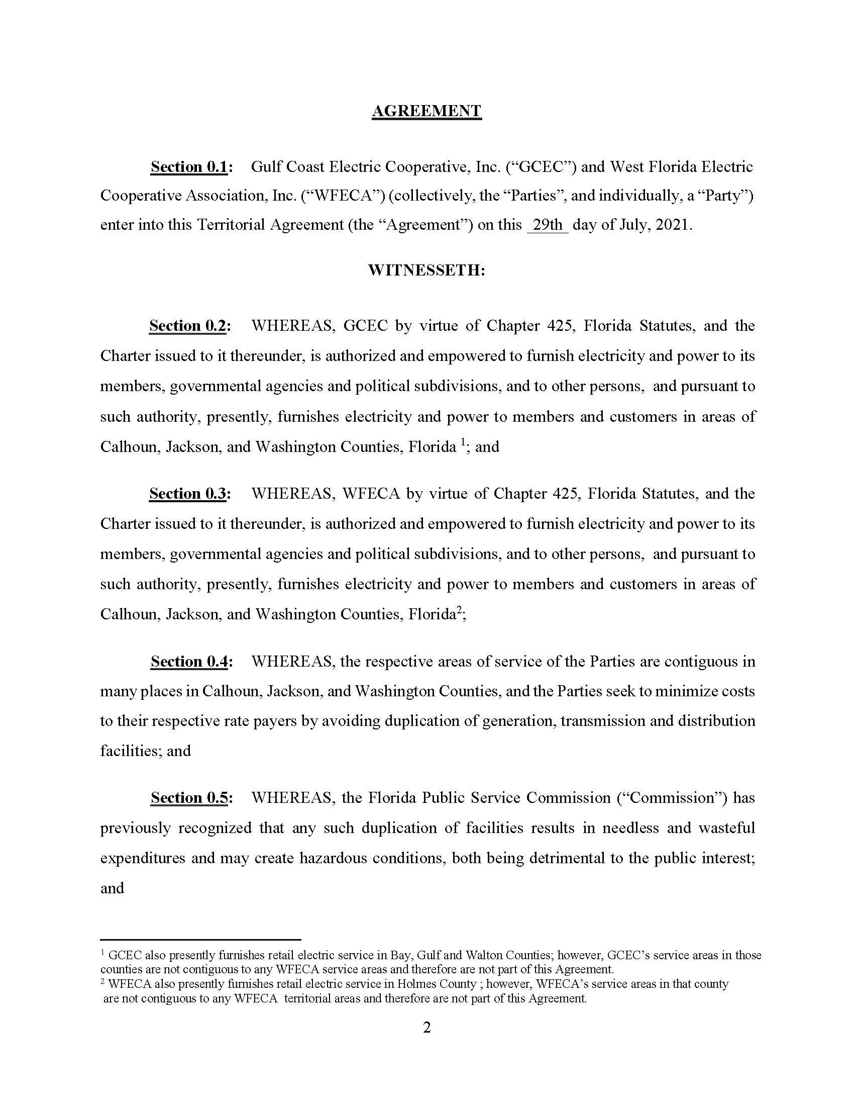
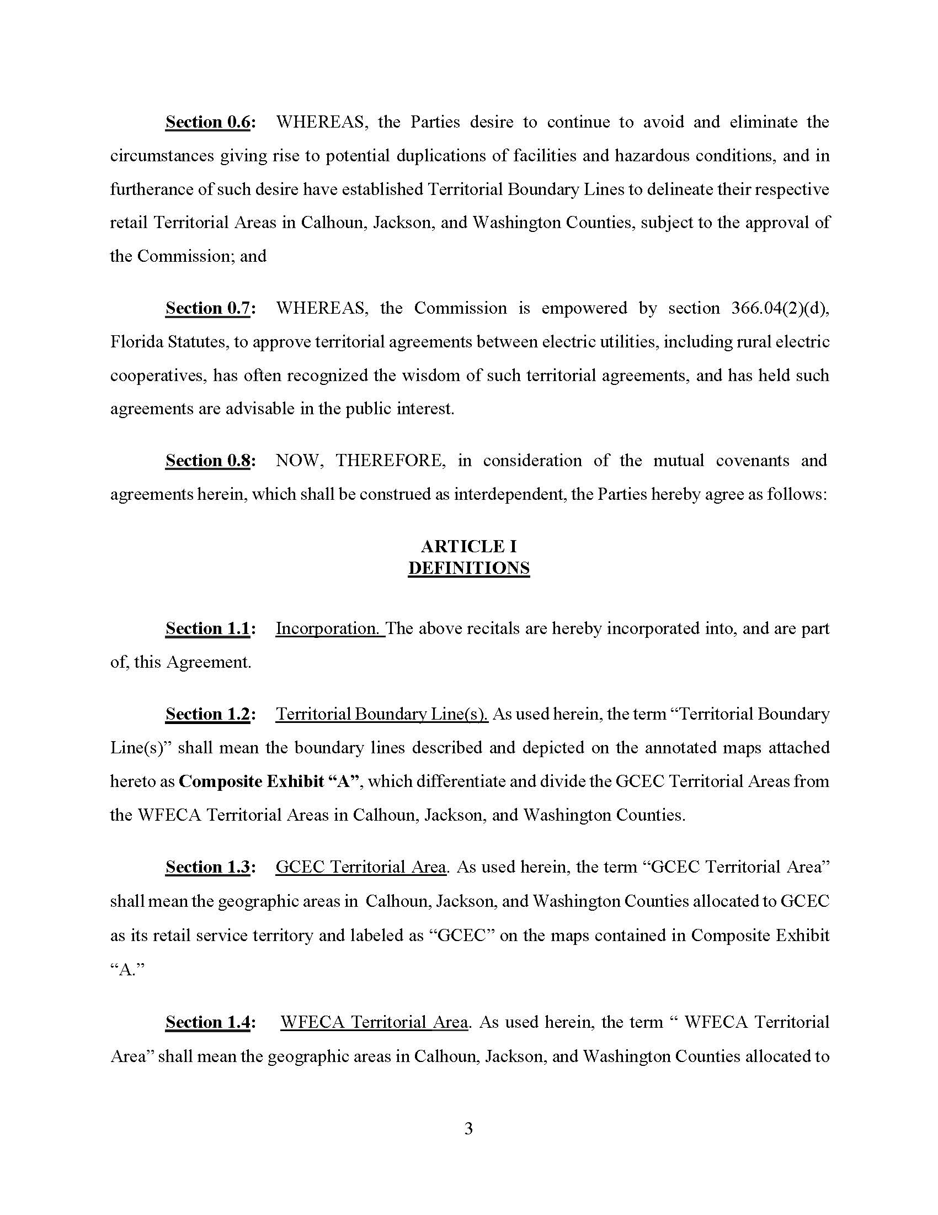
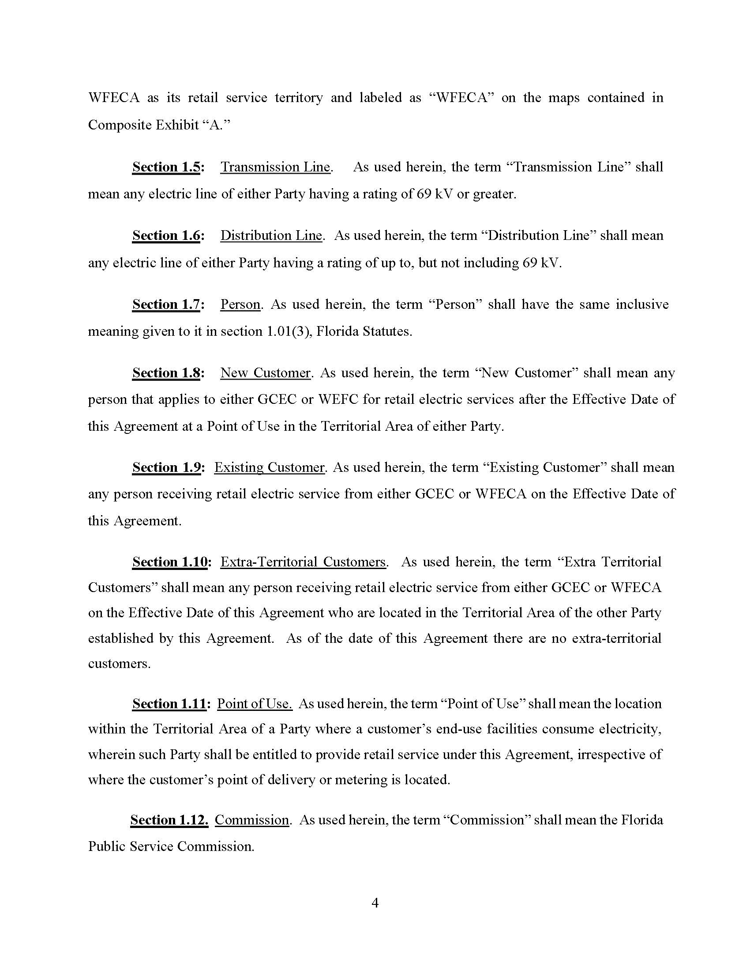
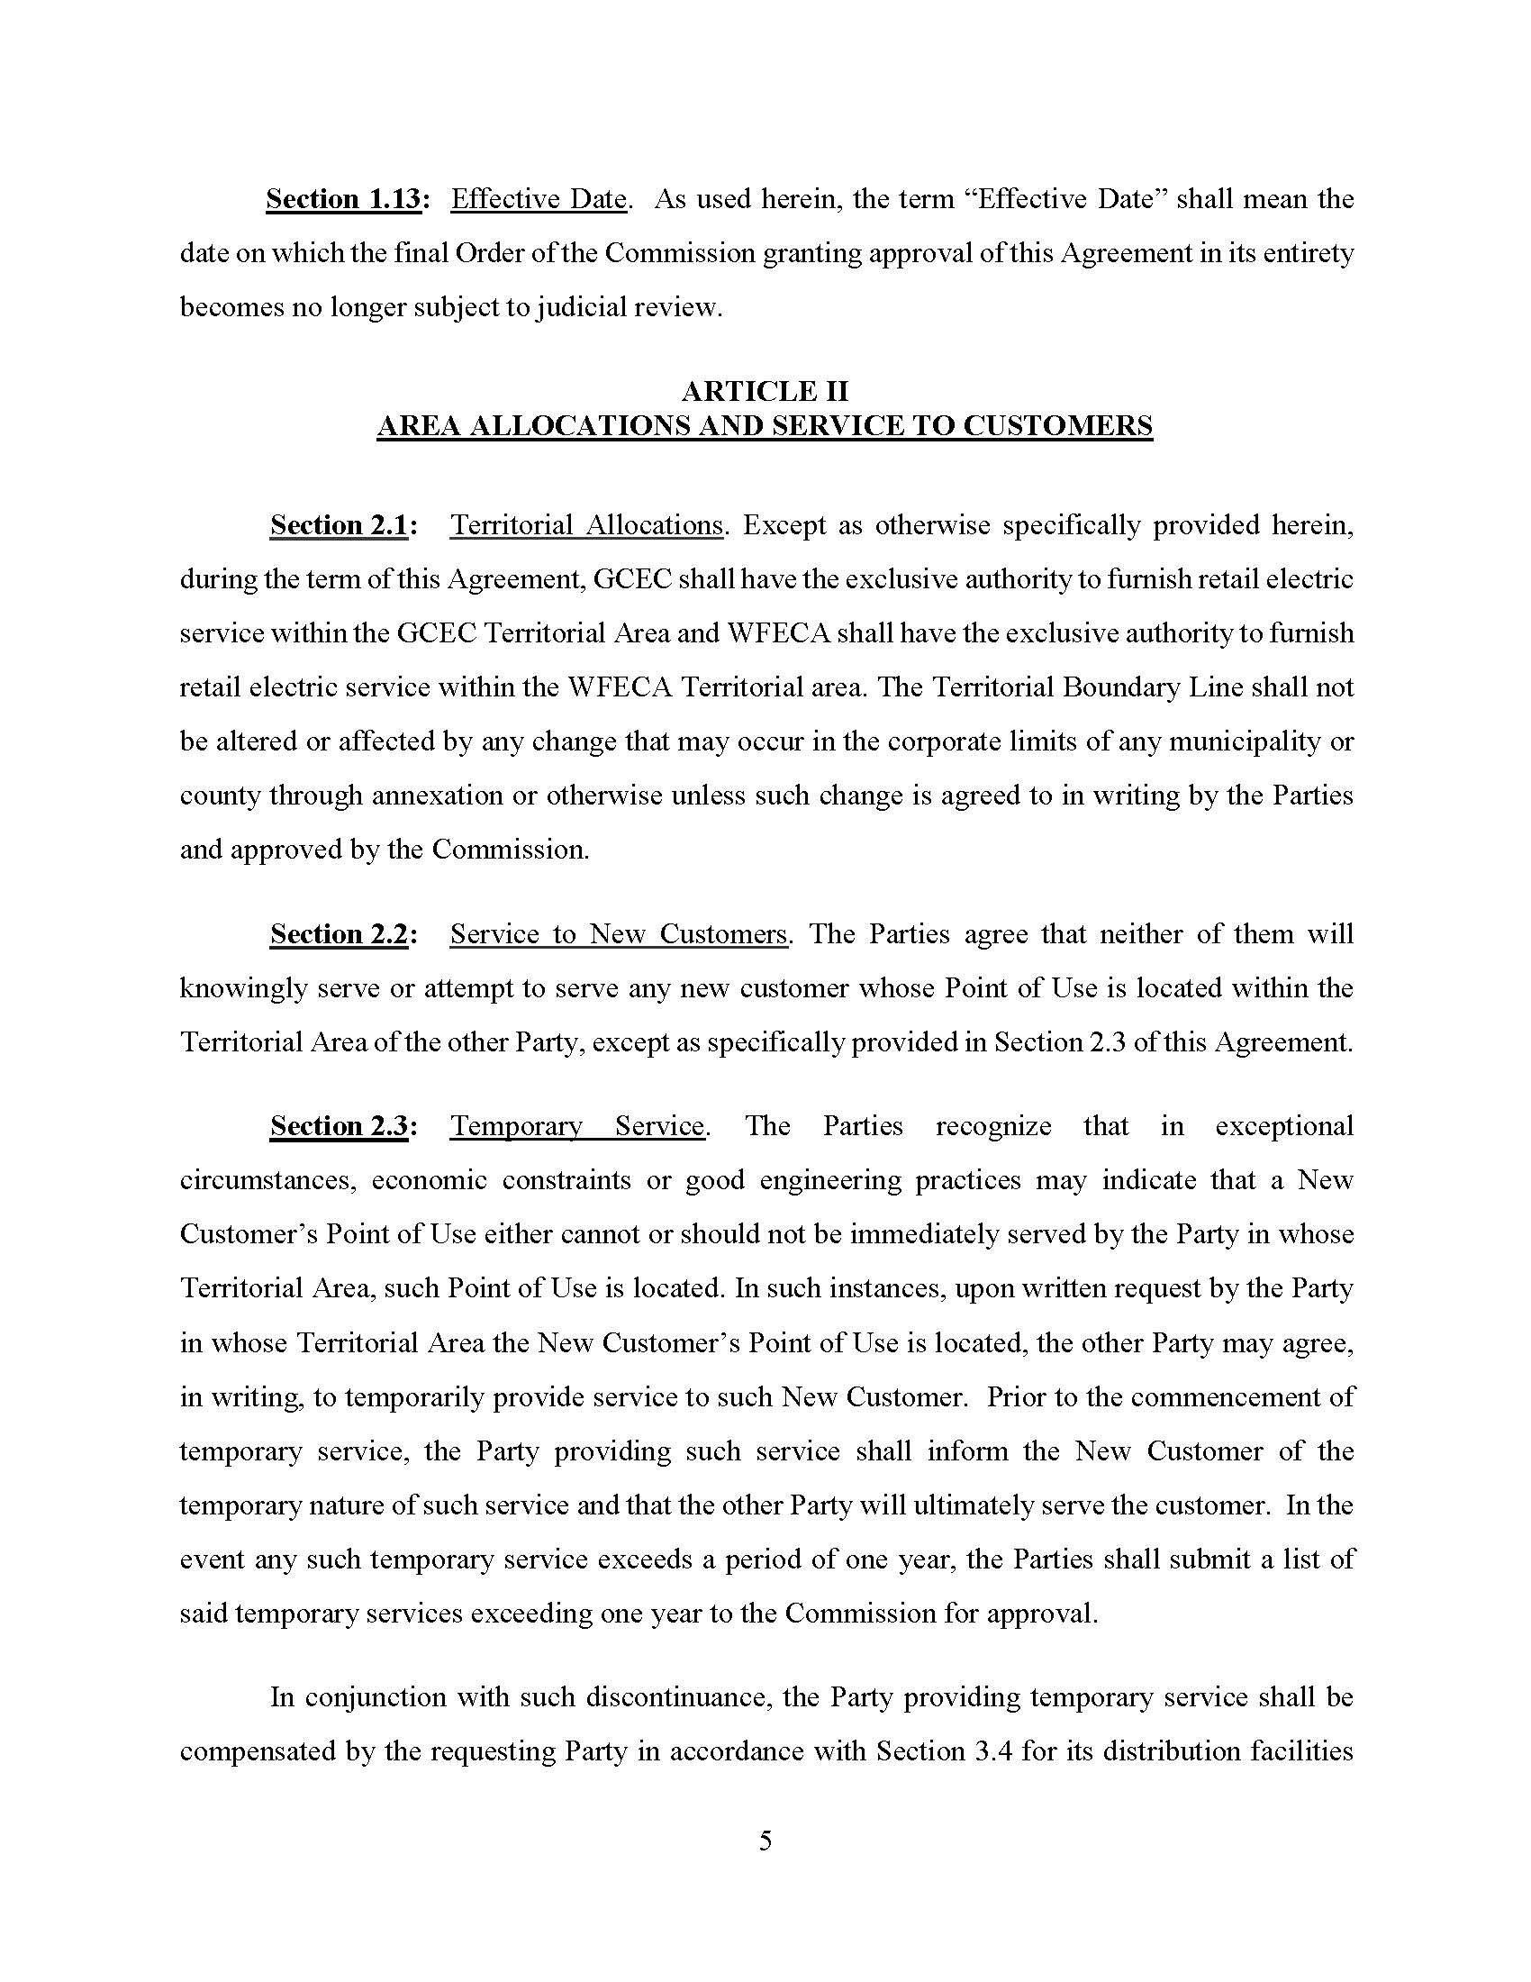
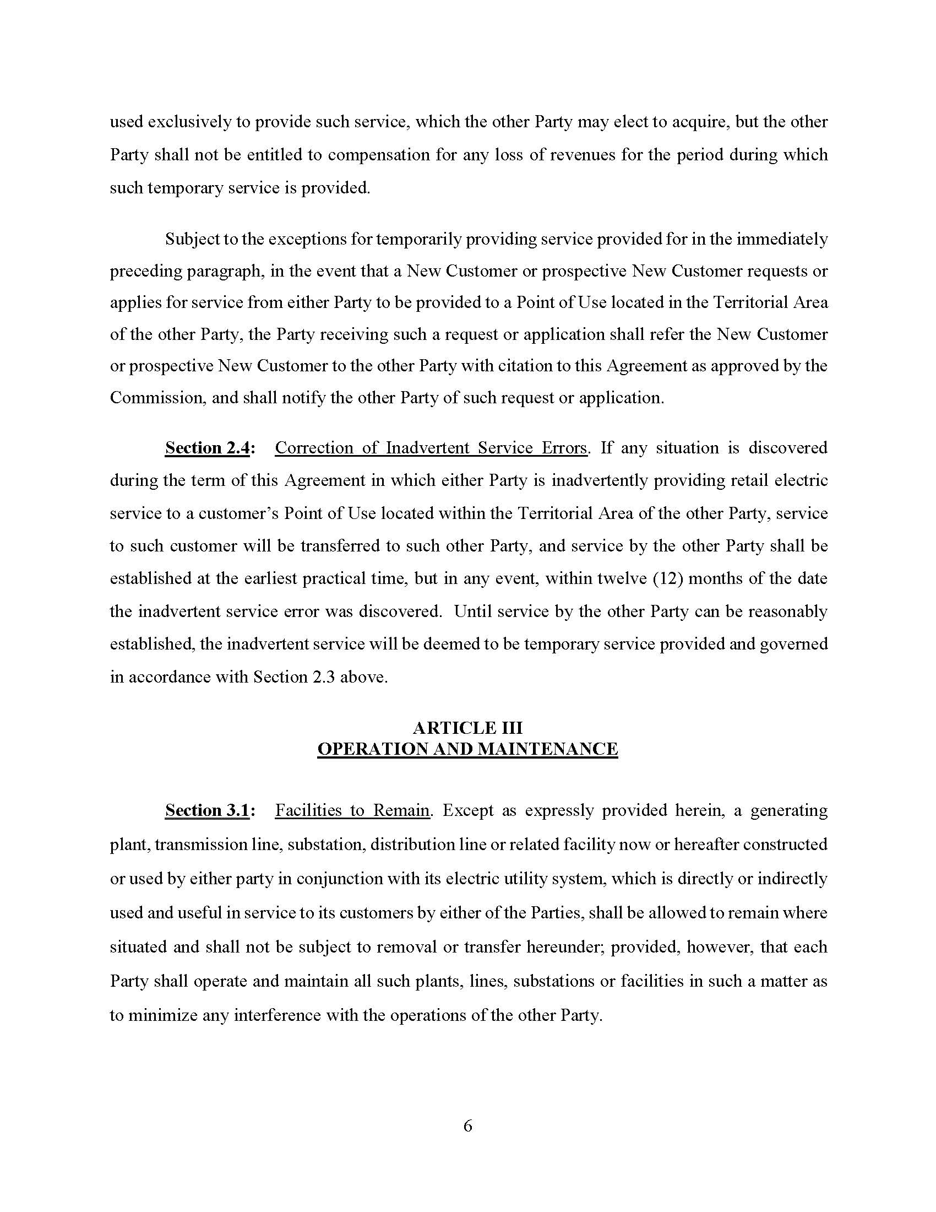
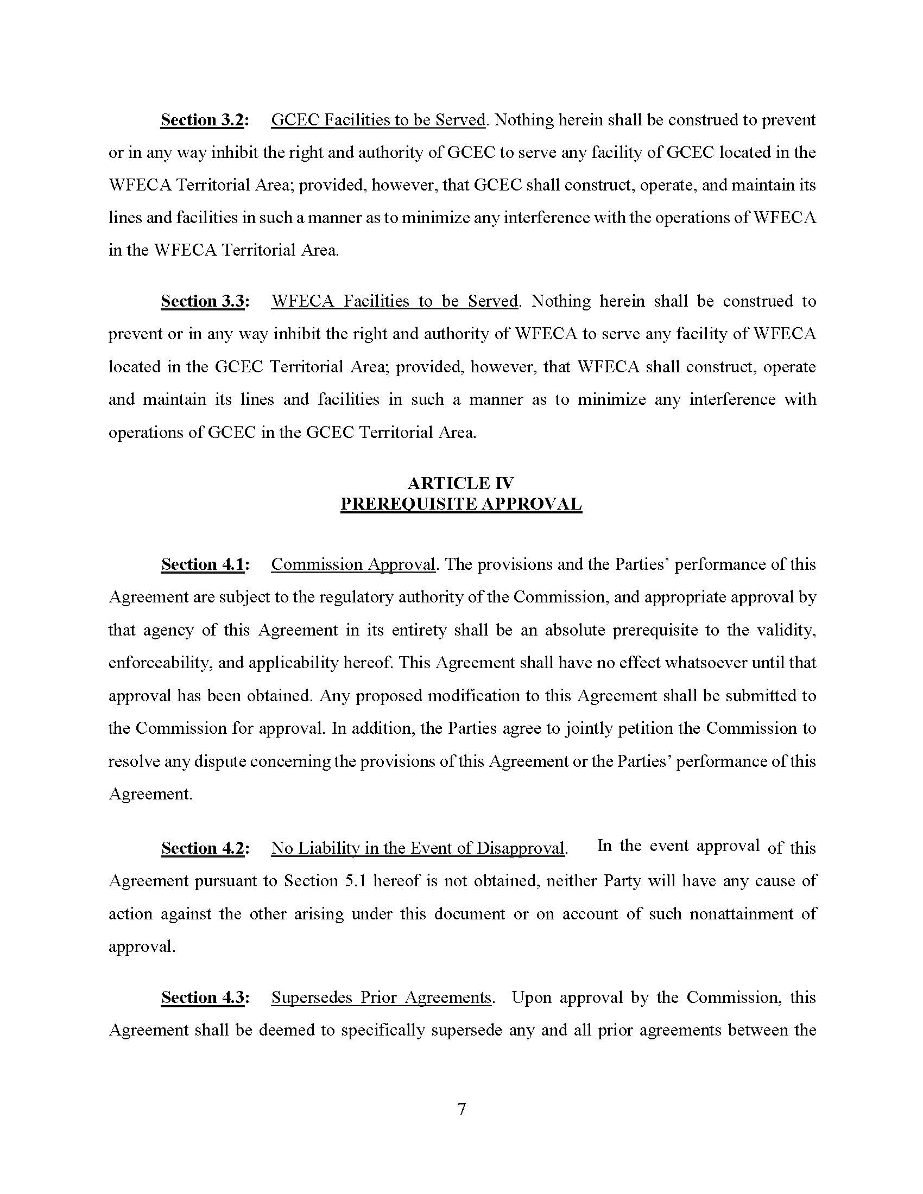
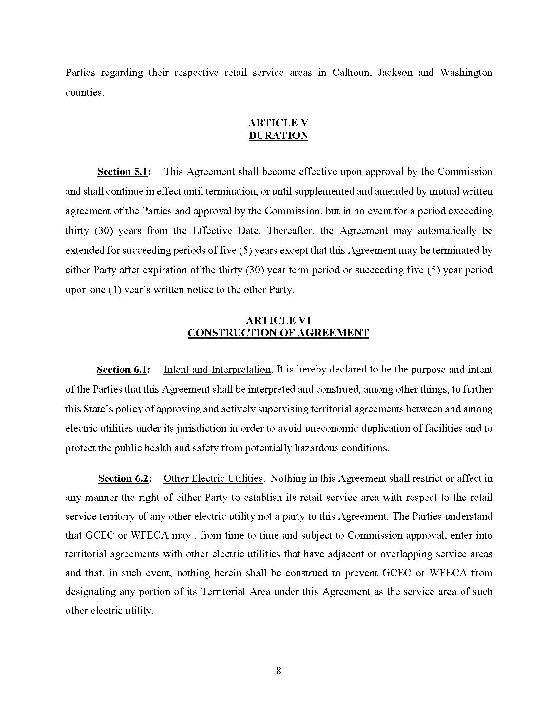
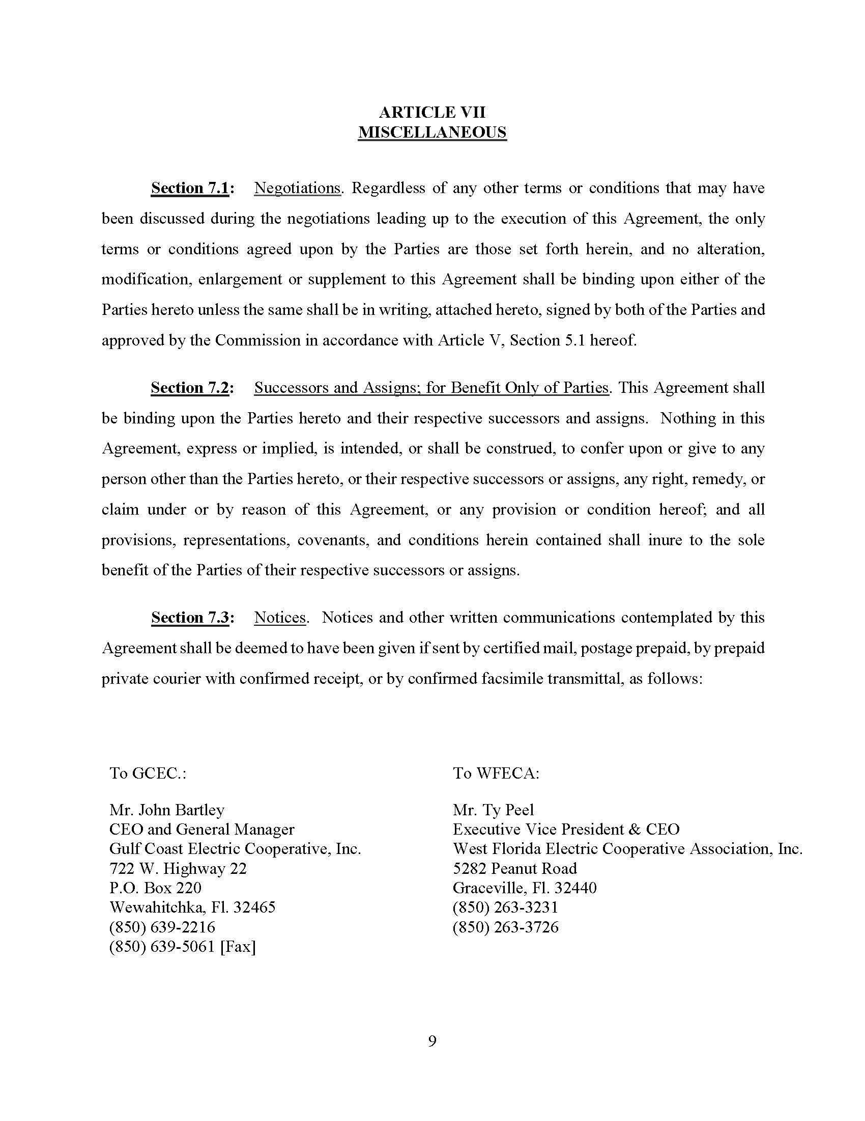
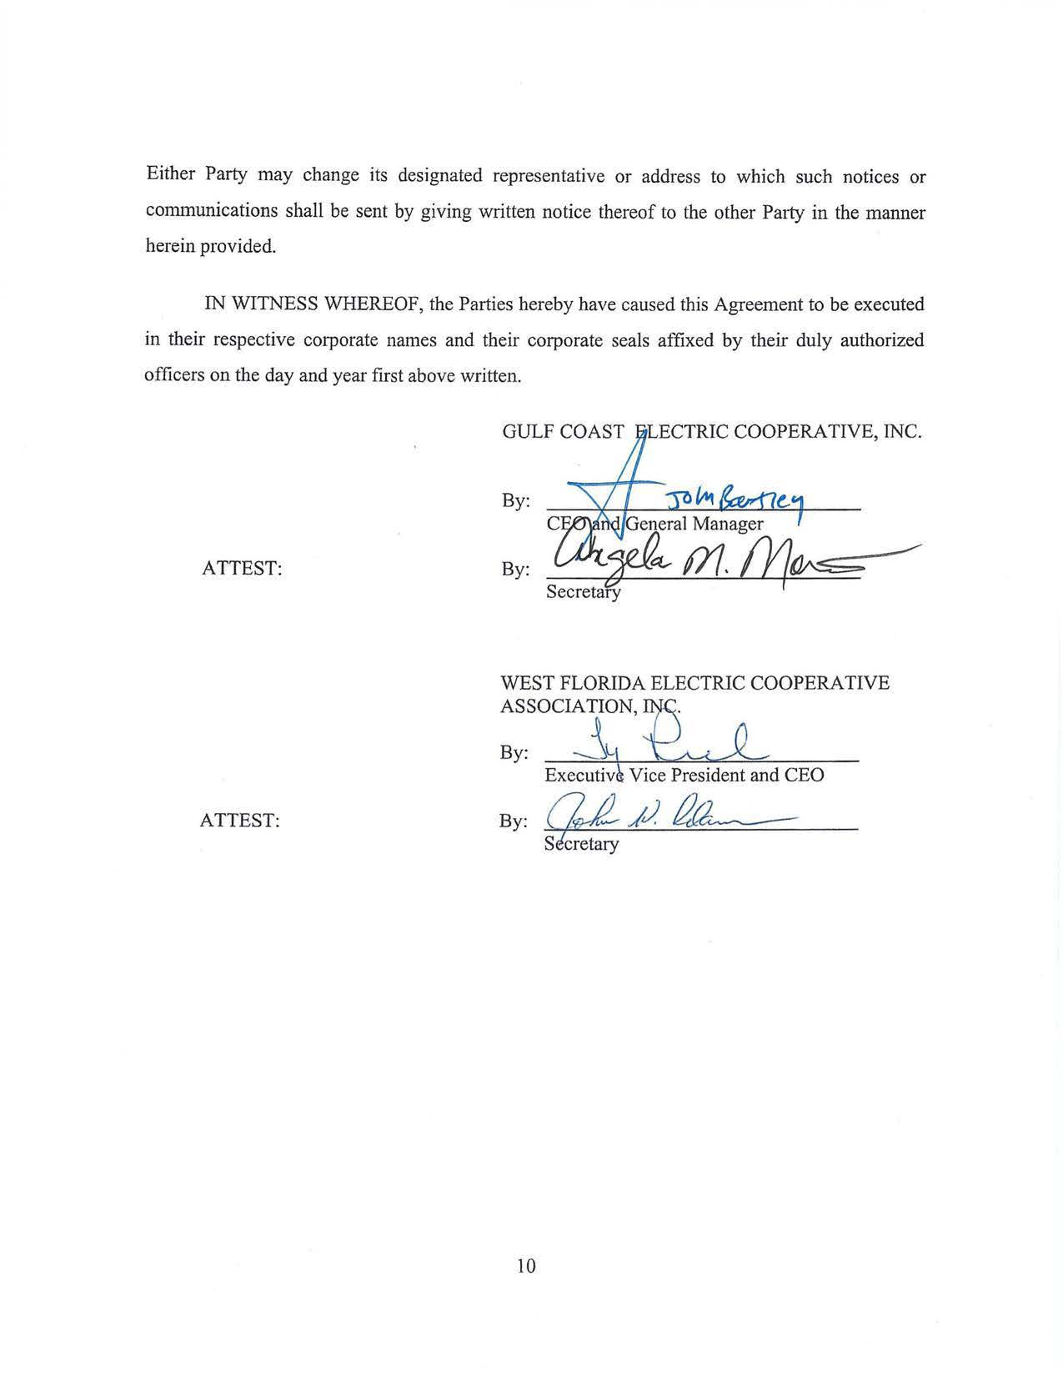
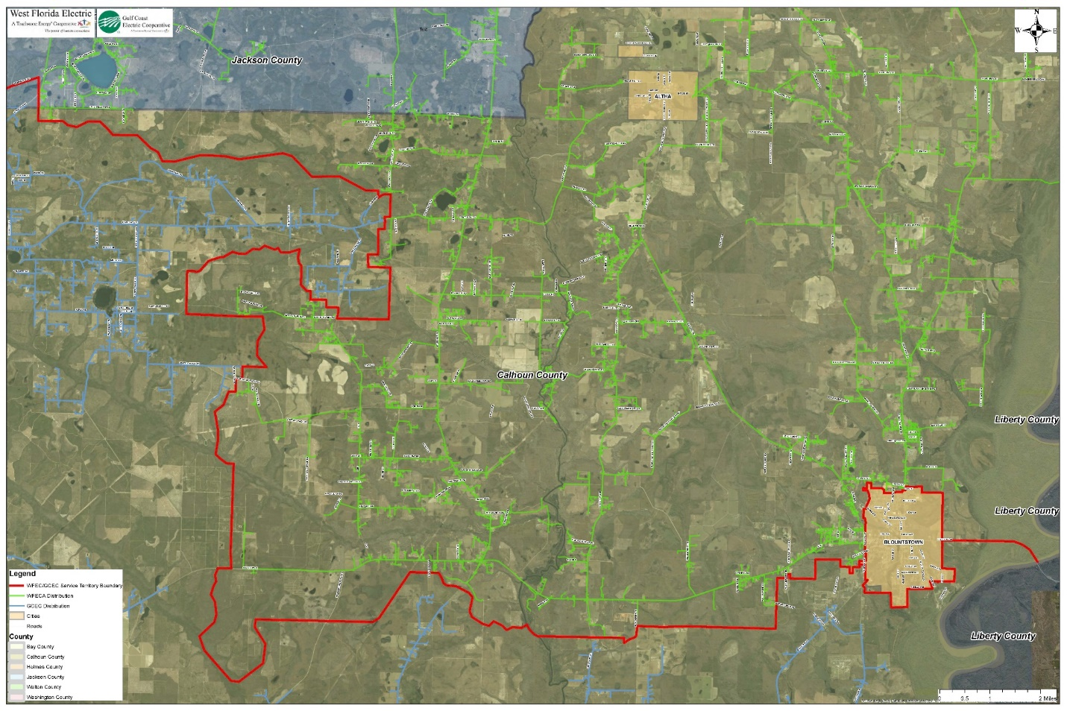
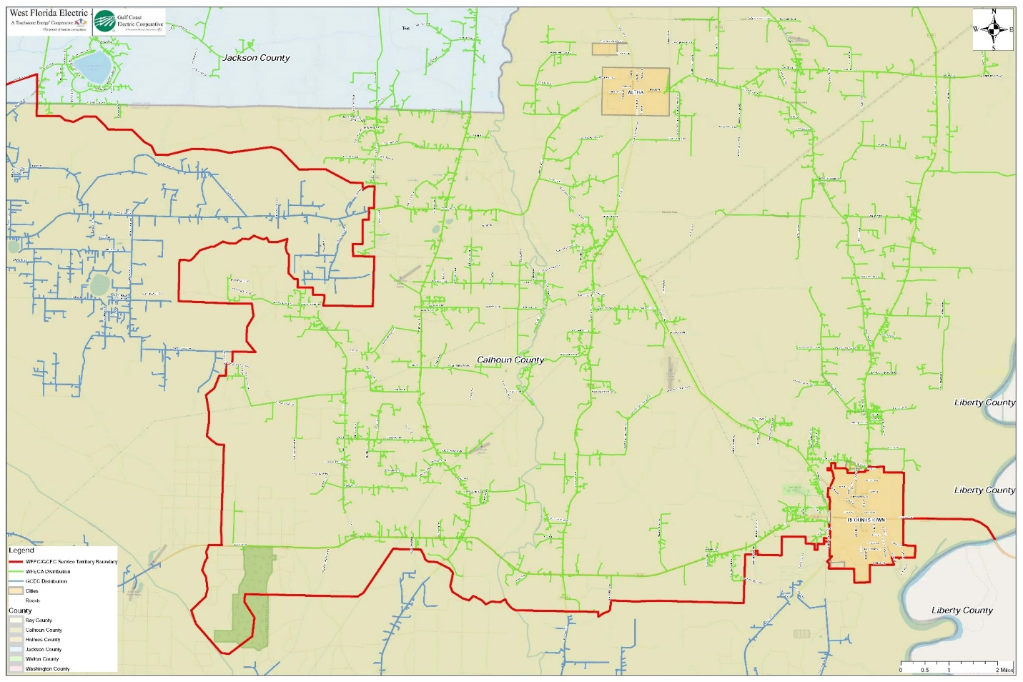
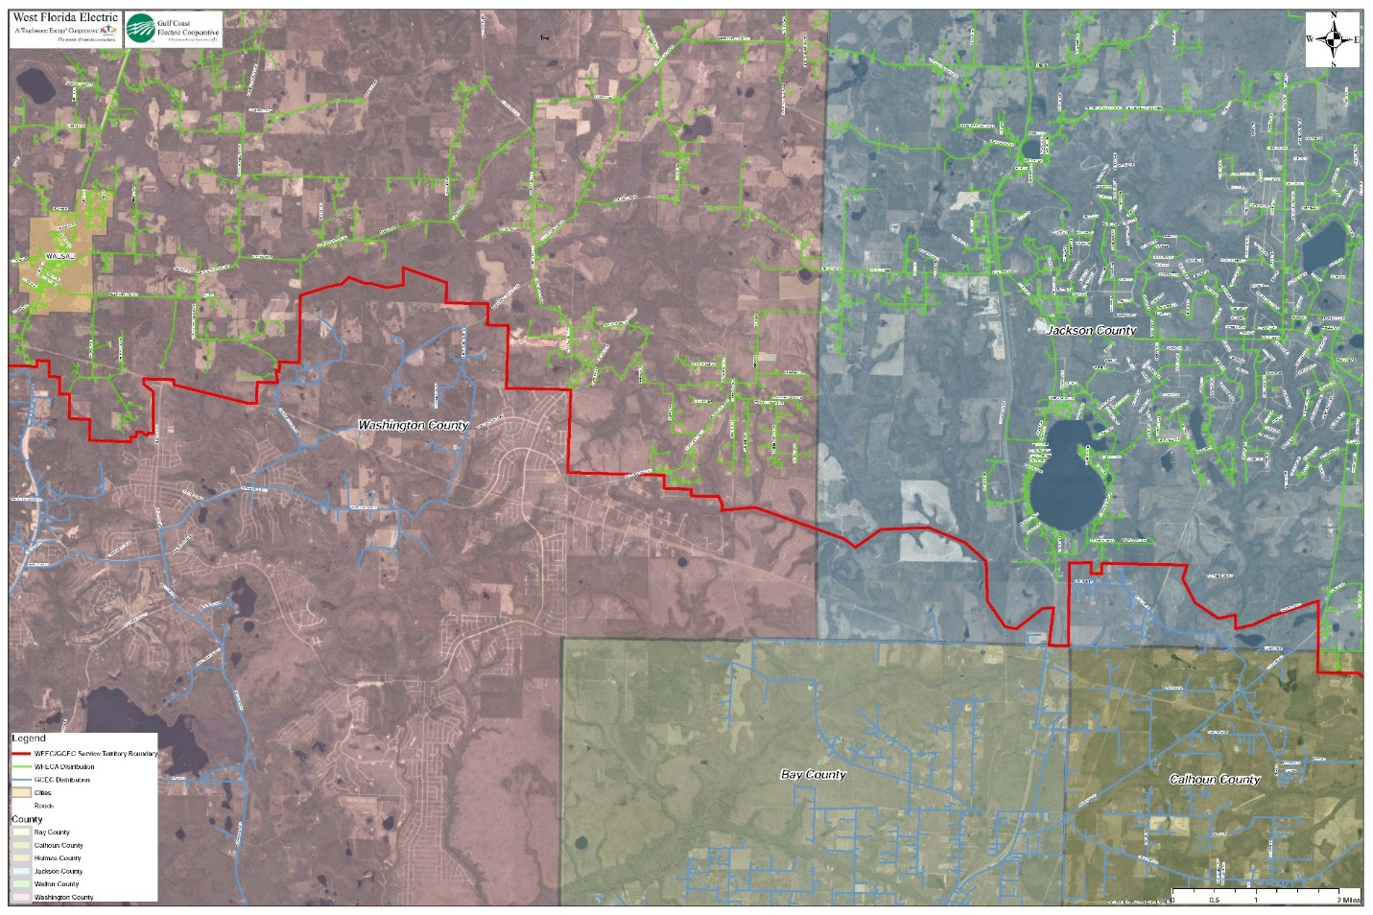
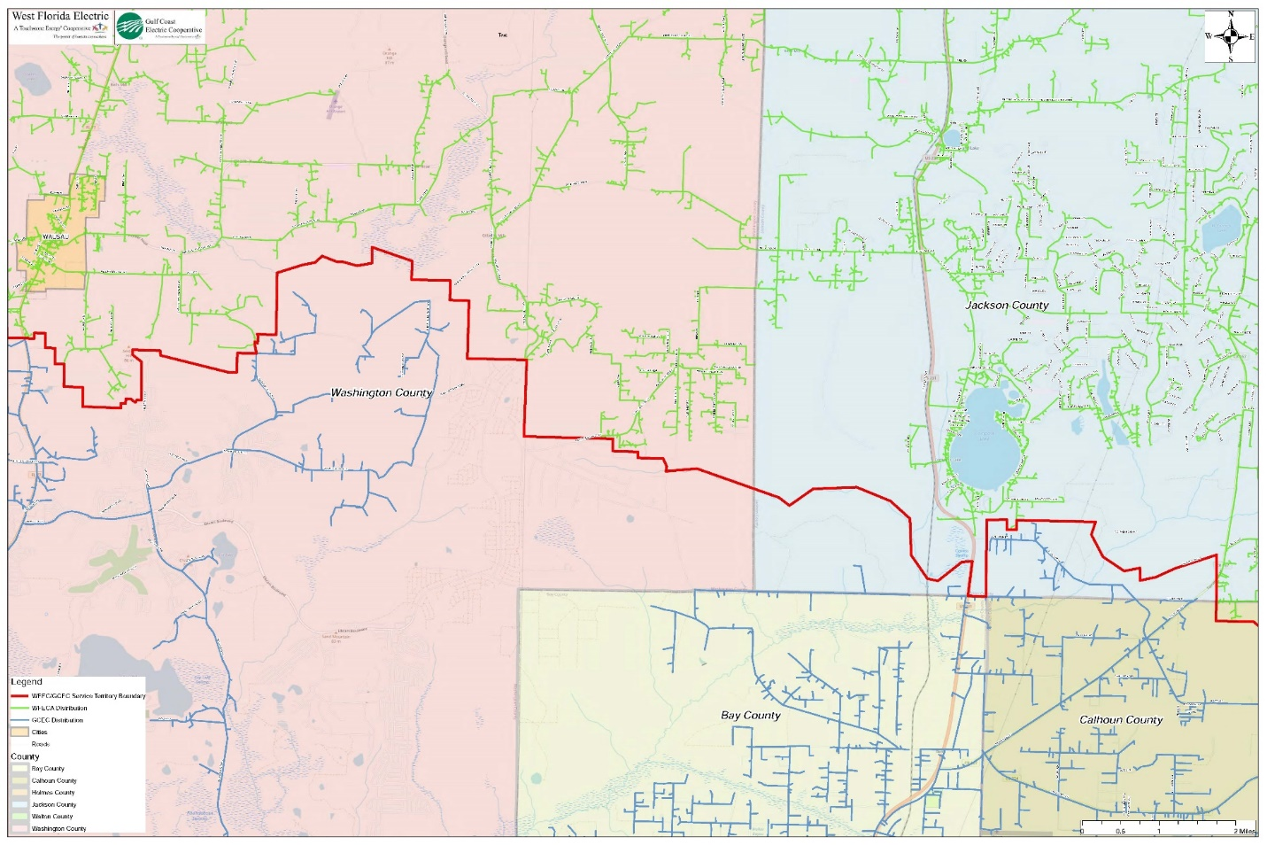
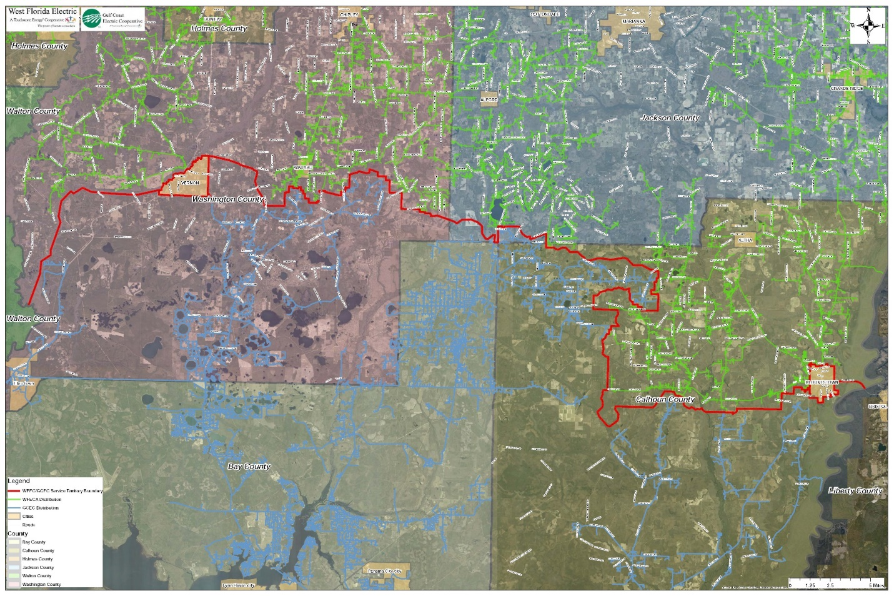
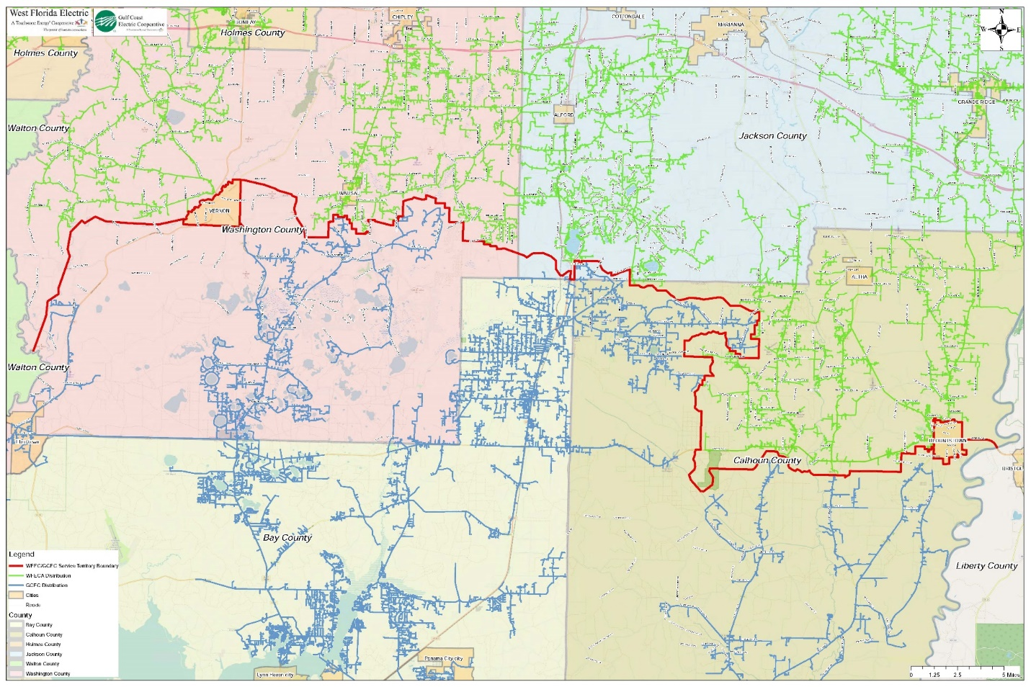
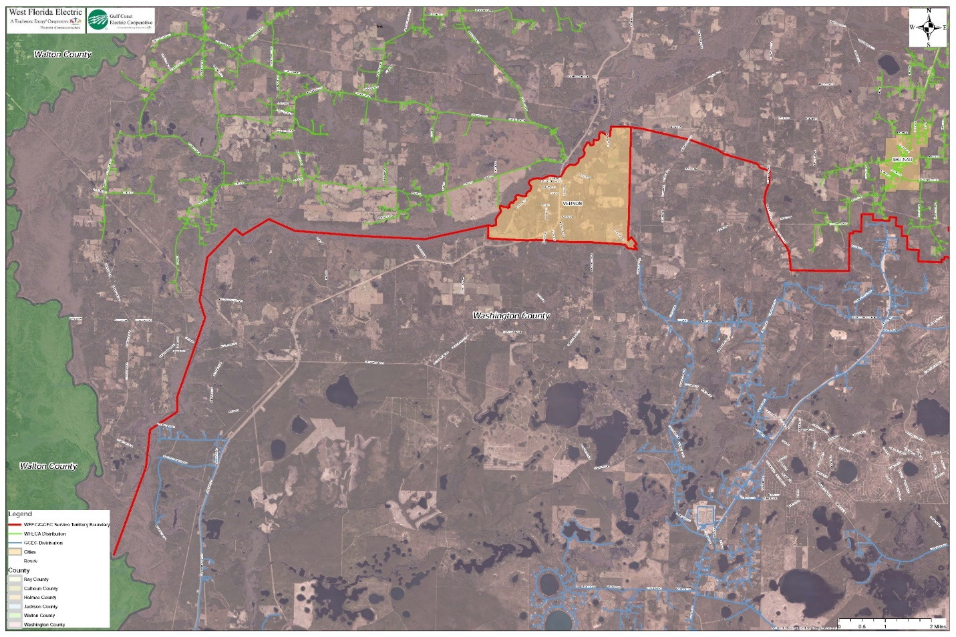
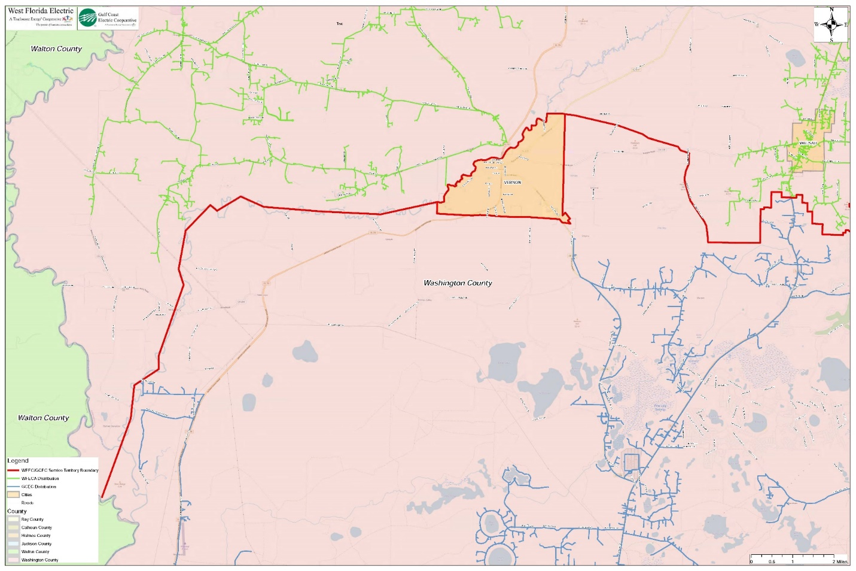

Responses 1 and 2 in Staff’s First Data Request, Document No. 11046-2021.
Utilities Commission of the City of New Smyrna Beach v. Florida Public Service Commission, 469 So. 2d 731 (Fla. 1985).
Responses 3 and 5 to Staff’s First Data Request, Document No. 11046-2021.
Responses 4 and 6 to Staff’s First Data Request, Document No. 11046-2021.
Responses 2 and 4 to Staff’s Second Data Request, Document No. 11323-2021.
Responses 1 and 3 to Staff’s Second Data Request, Document No. 11323-2021.
Pursuant to Section 1.10 Extra-Territorial Customers shall mean any person receiving retail electric service from either Gulf Coast or West Florida on the effective date of this agreement who are located in the territorial area of the other party established by this agreement.

