BEFORE THE FLORIDA PUBLIC SERVICE COMMISSION

In re: Petition for approval of safety, access, and facility enhancement program true-up and 2022 cost recovery factors, by Florida City Gas. | DOCKET NO. 20210149-GU  ORDER NO. PSC-2021-0430-TRF-GU  ISSUED: November 19, 2021

The following Commissioners participated in the disposition of this matter:

GARY F. CLARK, Chairman
ART GRAHAM
ANDREW GILES FAY
MIKE LA ROSA
GABRIELLA PASSIDOMO

ORDER APPROVING TARIFF

BY THE COMMISSION:

Background
On September 1, 2021 Florida City Gas (FCG or utility) filed a petition for approval of its safety, access, and facility enhancement program (SAFE) true-up and 2022 cost recovery factors. The SAFE program was originally approved by us in Order No. PSC-15-0390-TRF-GU (2015 order) to recover the cost of relocating on an expedited basis certain existing gas mains and associated facilities from rear lot easements to the street front. In the 2015 order, we found that the relocation of mains and services to the street front provides for more direct access to the facilities and will enhance the level of service provided to all customers through improved safety and reliability. The SAFE factor is a surcharge on customers’ bills.
We ordered the utility to file an annual petition, beginning in 2016, for review and resetting of the SAFE factors to true-up any prior over- or under-recovery and to set the surcharge for the coming year. The SAFE program is a 10-year program that was effective in 2015 and should finish in 2025. The utility’s annual progress in the SAFE program is shown in Attachment A to this order. The current 2021 SAFE factors were approved by Order No. PSC-2020-0456-TRF-GU (2020 order). The proposed 2022 SAFE factors are shown in Attachment B to this order on Tariff Sheet No. 79.
During the review process of the petition, Commission staff issued one data request and responses were received on October 6, 2021. In its filing, the utility waived the 60-day suspension deadline pursuant to Section 366.06(3), Florida Statutes (F.S.). We have jurisdiction over the matter pursuant to Sections 366.03, 366.04, 366.05, 366.06, and Chapter 368, F.S.

Decision

Under the SAFE program, FCG will relocate or replace 254.3 miles of mains and 11,443 associated service lines from rear property easements to the street over a 10-year period, ending in 2025. The utility began its mains and services replacements at the end of 2015. The surcharges have been in effect since January 2016. During 2021, the utility has replaced 26 miles of mains and 1,105 services as shown in Attachment A to the petition.

True-ups by Year
As required by the 2015 order, the utility’s calculations for the 2022 revenue requirement and SAFE factors include a final true-up for 2020, an estimated/actual true-up for 2021, and projected costs for 2022.

Final True-up for 2020
FCG stated that the revenues collected for 2020 were $1,449,091, compared to a revenue requirement of $1,589,766, resulting in an under-recovery of $140,674. Adding the 2019 final over-recovery of $211,530 and the $140,674 under-recovery of 2020, including interest, results in a final 2020 over-recovery of $82,915.

Actual/Estimated 2021 True-up
FCG provided actual revenues for January through June and forecast revenues for July through December 2021, totaling $2,588,062, as compared to a projected revenue requirement of $3,182,760, resulting in an under-recovery of $594,699. Adding the 2020 over-recovery of $82,915 to the 2021 under-recovery of $594,699, the resulting total 2021 true-up, including interest, is an under-recovery of $520,582.

Projected 2022 Costs
The utility’s projected investment for 2022 is $39,273,733 for its seven projects in Miami-Dade and Brevard counties. This is an approximate increase of $10 million from 2021 in the annual SAFE investment as contemplated in the 2015 order. The revenue requirement, which includes a return on investment, depreciation, and taxes is $4,148,112. The return on investment calculation includes federal income taxes, regulatory assessment fees, and bad debt. After adding the 2021 under-recovery of $520,582, the total revenue requirement is $4,668,694. Table 1 below displays the projected 2022 revenue requirement calculation.

Table 1
2022 Revenue Requirements Calculation
2022 Projected Investment | $39,273,733
Return on Investment | $2,580,536
Depreciation Expense | 940,762
Property Tax Expense | 626,814
2022 Revenue Requirement | $4,148,112
Plus 2021 Under-recovery | $520,582
Total 2022 Revenue Requirement | $4,668,694
Source: Attachment C of the petition

Proposed 2022 SAFE Factors
The SAFE factors are fixed monthly charges. FCG’s cost allocation methodology was approved in the 2015 order and was used in the instant filing. The approved methodology allocates the current cost of a 2-inch pipe to all customers on a per customer basis and allocates the incremental cost of replacing a 4-inch pipe to customers who use over 6,000 therms per year. For customers who require 4-inch pipes, the cost allocation takes into account that the minimum pipe is insufficient to serve their demand and, thus, allocates an incremental per foot cost in addition to the all-customer cost. The resulting allocation factors are applied to the 2022 total revenue requirement to develop the monthly SAFE factors.

The proposed fixed monthly SAFE factor is $3.17 for customers using less than 6,000 therms per year (current factor is $1.84). The proposed monthly SAFE factor for customers using more than 6,000 therms per year is $6.39 (current factor is $3.43).

Conclusion
We reviewed FCG’s filing and supporting documentation and find that the calculations of the 2022 SAFE factors are consistent with the methodology approved in the 2015 order and are reasonable and accurate. We hereby approve the utility’s proposed SAFE tariff for the period January through December 2022.

Based on the foregoing, it is

ORDERED by the Florida Public Service Commission that Florida City Gas’s proposed SAFE tariff for the period January through December 2022 is hereby approved.

ORDERED that if a protest is filed within 21 days of issuance of the Order, the tariff shall remain in effect with any charges held subject to refund pending resolution of the protest. It is further

ORDERED that if no timely protest is filed, this docket shall be closed upon the issuance of a Consummating Order.

By ORDER of the Florida Public Service Commission this 19th day of November, 2021.

/s/ Adam J. Teitzman
ADAM J. TEITZMAN
Commission Clerk
Florida Public Service Commission
2540 Shumard Oak Boulevard
Tallahassee, Florida 32399
(850) 413-6770
www.floridapsc.com

Copies furnished: A copy of this document is provided to the parties of record at the time of issuance and, if applicable, interested persons.

SFO

NOTICE OF FURTHER PROCEEDINGS

The Florida Public Service Commission is required by Section 120.569(1), Florida Statutes, to notify parties of any administrative hearing or judicial review of Commission orders that is available under Sections 120.57 or 120.68, Florida Statutes, as well as the procedures and time limits that apply. This notice should not be construed to mean all requests for an administrative hearing or judicial review will be granted or result in the relief sought.

Mediation may be available on a case-by-case basis. If mediation is conducted, it does not affect a substantially interested person's right to a hearing.

The Commission's decision on this tariff is interim in nature and will become final, unless a person whose substantial interests are affected by the proposed action files a petition for a formal proceeding, in the form provided by Rule 28-106.201, Florida Administrative Code. This petition must be received by the Office of Commission Clerk, 2540 Shumard Oak Boulevard, Tallahassee, Florida 32399-0850, by the close of business on December 10, 2021.

In the absence of such a petition, this Order shall become final and effective upon the issuance of a Consummating Order.

Any objection or protest filed in this docket before the issuance date of this order is considered abandoned unless it satisfies the foregoing conditions and is renewed within the specified protest period.

Table 1
Florida City Gas’s SAFE Program Progress

 | Main Replacements |  | Service Replacements
Year* | Replaced Main (miles) | Total Miles Remaining | Replaced Services (number) | Total Remaining Services
2014 | 0.0 | 254.3 | 0 | 11,443
2015 | 0.0 | 254.3 | 49 | 11,394
2016 | 17.1 | 237.2 | 1,433 | 9,961
2017 | 37.5 | 199.7 | 1,551 | 8,410
2018 | 27.6 | 172.1 | 1,634 | 6,776
2019 | 37.8 | 134.3 | 1,183 | 5,593
2020 | 25.5 | 108.8 | 1,186 | 4,407
2021 | 26.0 | 82.8 | 1,105 | 3,302
2022 | 29.4 | 53.4 | 1,355 | 1,947
2023 | 17.8 | 35.6 | 649 | 1,298
2024 | 17.8 | 17.8 | 649 | 649
2025 | 17.8 | 0.0 | 0 | 0
Source: Attachment A of the petition for Docket No. 20210149-GU. *Actuals 2014-July 2021. Projections August 2021-2025.

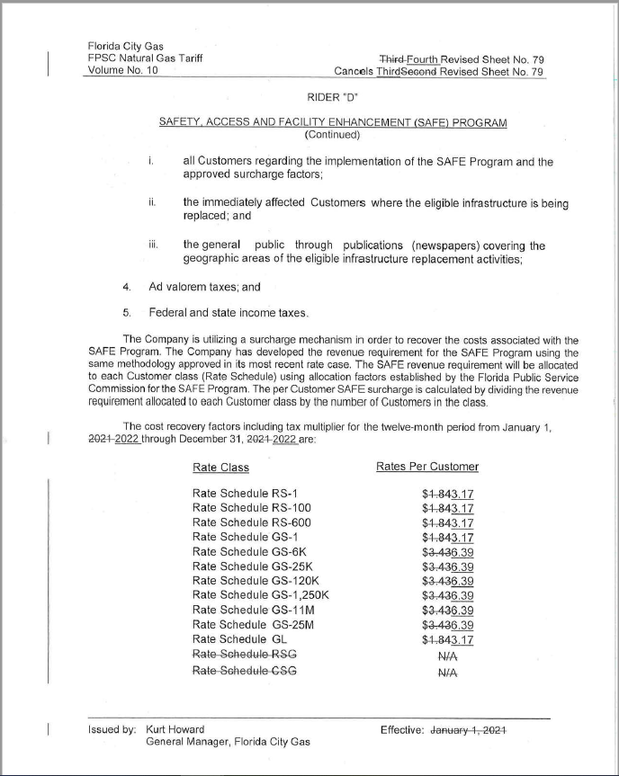

Order No. PSC-15-0390-TRF-GU, issued September 15, 2015, in Docket No. 150116-GU, In re: Petition for approval of safety, access, and facility enhancement program and associated cost recovery methodology, by Florida City Gas.
Order No. PSC-2020-0456-TRF-GU, issued November 23, 2020, in Docket No. 20200204-GU, In re: Petition for approval of the safety, access, and facility enhancement program true-up and 2021 cost recovery factors, by Florida City Gas.
The calculation also includes a December 2019 true-up credit of $1,857 booked in January 2020 minus a December 2020 true-up of $8,758 booked in January 2021.

