BEFORE THE FLORIDA PUBLIC SERVICE COMMISSION

In re: Petition for approval of revised underground residential distribution tariffs, by Tampa Electric Company. | DOCKET NO. 20210064-EI  ORDER NO. PSC-2021-0462-TRF-EI  ISSUED: December 16, 2021

The following Commissioners participated in the disposition of this matter:

GARY F. CLARK, Chairman
ART GRAHAM
ANDREW GILES FAY
MIKE LA ROSA
GABRIELLA PASSIDOMO

ORDER APPROVING REVISED UNDERGROUND
RESIDENTIAL DISTRIBUTION TARIFFS FOR
TAMPA ELECTRIC COMPANY

BY THE COMMISSION:

Background
On April 1, 2021, Tampa Electric Company (TECO or utility) filed a petition (original petition) for approval of tariff modifications of its underground residential distribution (URD) tariff. TECO’s current URD tariffs were approved in Order No. PSC-2018-0319-TRF-EI.
In TECO’s original petition, the utility provided updated cost calculations and supporting documentation for its low-density and high-density service lateral differential cost, per Rule 25-6.078, Florida Administrative Code (F.A.C.). These calculations take into account current labor and material costs and an updated net present value (NPV) analysis, which includes the average historical storm restoration costs, as allowed in subsection 4 of the rule. The utility’s calculation determined that the per lot undergrounding differential for high-density subdivisions is $0.00 and the per lot undergrounding differential for low-density subdivisions is $370.29. In its original petition, TECO proposed to waive the $370.29 per lot low-density subdivision charge, pursuant to Rule 25-6.078(10), F.A.C., and continue to set the charge at $0.00.
Commission staff issued three data requests on the original petition, for which responses were provided on May 19, July 14, and August 2, 2021. In addition, on August 4, 2021, TECO filed a revised response to question 3a in the third data request. Commission staff held a conference call with the utility on August 31, 2021. As a result of that call, on September 15, 2021, the utility provided a supplement to its response to the first data request, question one. On September 30, 2021, TECO filed a response to Commission staff’s first supplemental data request.
On November 10, 2021, staff held a conference call with the utility. On November 12, 2021, the utility filed an amended petition, removed the requested waiver of the $370.29 per lot charge, pursuant to Rule 25-6-078(10), F.A.C., and proposed a low-density per lot differential of $370.29, as supported by the calculations. The filed tariffs and charges associated with the amended petition are shown in legislative format in Attachment A to this Order.
We suspended the proposed tariffs on May 4, 2021, pursuant to Section 366.06(3), Florida Statutes (F.S.). On September 28, 2021, TECO waived the eight-month requirement of Section 366.06(3), F.S.
We have jurisdiction over this matter pursuant to Sections 366.03, 366.04, 366.05, and 366.06, F.S.

Decision
Rule 25-6.078, F.A.C., (URD rule) defines the responsibilities of electric investor-owned utilities (IOU) to file updated URD tariffs. All electric IOUs are required to file supporting data and analyses for URD tariffs at least once every three years. The URD tariffs provide standard charges for underground service in new residential subdivisions and represent the additional costs, if any, the utility incurs to provide underground service in place of overhead service. The cost of standard overhead construction is recovered through base rates from all ratepayers. In lieu of overhead construction, customers have the option of requesting underground facilities. Typically, the URD customer is the developer of the subdivision.
In its amended petition, the utility resubmitted its cost calculations and supporting documentation for its low-density and high-density per lot service lateral cost differentials as filed in the original petition. The utility’s calculation determined that the per lot undergrounding differential for high-density subdivisions is $0.00 and the per lot undergrounding differential for low-density subdivisions is $370.29. The currently approved high- and low-density cost differentials are $0.00. While labor and material costs have fluctuated since the 2018 filing, the main reason for the increase in the calculated low-density differential is the decrease in the NPV operational cost analysis credit. A lower URD differential charge is typically the result of the avoided storm restoration costs, offsetting any higher labor and material costs associated with underground construction.
Table 1 presents a comparison between the currently approved and proposed URD differentials for the low-density and high-density subdivision models. The differentials are shown as a per lot charge.

Table 0
Comparison of URD Differential per Lot
 | Current Differential | Proposed Differential
Low-density | $0.00 | $370.29
High-density | $0.00 | $0.00

As shown in Table 1 above, the differential has increased for low-density subdivisions and has remained $0.00 for the high-density subdivisions. Two primary factors impacted the calculation of TECO’s proposed URD charges and are discussed in greater detail below: (1) updated labor and material costs and (2) calculation of operational costs.

Updated Labor and Material Costs

The installation costs of both underground and overhead facilities include the labor and material costs to provide primary, secondary, and service distribution lines as well as transformers. The costs of poles are specific to overhead service while the costs of trenching and backfilling are specific to underground service. Table 2 compares the currently approved per lot 2018 costs and the 2021 costs for underground and overhead labor and material for the two subdivision models.
Table 2
Labor and Material Costs per Lot
 | 2018 Costs | 2021 Costs | Difference
Low-density
Underground labor/material costs | $2,082 | $2,441 | $359
Overhead labor/material costs | $1,289 | $1,429 | $140
Per lot differential | $793 | $1,013 | $220
High-density
Underground labor/material costs | $1,597 | $1,881 | $284
Overhead labor/material costs. | $1,001 | $1,122 | $121
Per lot differential | $595 | $760 | $165

As indicated in Table 2 above, the total labor and material cost differentials increased for both model subdivisions. The utility states that the reason for the increase is due to the Covid-19 pandemic’s effect on the supply chain which caused reduced manufacturing capacity.

Calculation of Operational Costs

Rule 25-6.078(4), F.A.C., provides that the differences in NPV of operational costs between overhead and underground systems, including average historical storm restoration costs over the life of the facilities, be included in the URD charge. Operational costs include operations and maintenance (O&M) costs and capital costs. The inclusion of the operational costs is intended to capture longer term costs and benefits of undergrounding.
In calculating the per lot cost differential between overhead and underground, Rule 25-6.078(4), F.A.C., allows the utility to calculate the NPV of operational costs to include the average historical storm restoration costs over the life of underground and overhead systems, and take into consideration any cost differential in its calculations. In recent URD filings, TECO has used a three-year rolling historical average to calculate its NPV storm restoration costs. In response to Commission staff’s data request number two, the utility explained that it used an updated computer-generated methodology to calculate storm restoration costs. This methodology relies on long-term potential costs based on hurricane simulations and is based on the testimony of TECO witness Steven P. Harris in TECO’s recent rate case proceeding. We approved the use of this methodology in calculating the utility’s storm reserve surplus in Docket No. 20210034-EI. TECO explained that the study looks at likely outcomes over a long time period based on historical storm data. The utility states that this methodology helps to reduce the volatility in estimated, avoided storm restoration costs.
Table 3
NPV of Operational Costs Differential per Lot
 | 2018 Calculation | 2021 Calculation | Difference
Low-density
Underground NPV- Operational Costs | $1,247 | $1,254 | $7
Overhead NPV- Operational Costs | $2,531 | $1,897 | $(634)
Per lot Differential | $(1,284) | $(642) | $642
High-density
Underground NPV- Operational Costs | $590 | $584 | $(6)
Overhead NPV- Operational Costs | $1,871 | $1,408 | $(463)
Per lot Differential | $(1,281) | $(825) | $456

Table 3 shows that the NPV of operational costs for overhead service decreased in both low-density and high-density subdivision models.

Other Proposed Tariff Changes

TECO’s proposed URD tariffs also include standard charges for the installation and trenching to install underground service laterals from overhead distribution, underground service laterals converted from existing overhead service drops, and non-refundable deposits for cost estimates for the conversion of existing overhead distribution facilities to underground facilities. If a customer requests an underground service lateral, the tariff includes a credit to the customer for avoiding a pole. The charges have been updated to reflect current material and labor costs.

Following a full review of TECO’s proposed changes to its URD tariffs and associated charges, the accompanying work papers, and responses to staff’s data requests, we find and conclude TECO’s proposed URD tariffs and associated charges as filed in the amended petition are reasonable and approve the tariffs shown in Attachment A. These tariffs shall become effective thirty days after our vote.

Based on the foregoing, it is

ORDERED by the Florida Public Service Commission that Tampa Electric Company’s revised underground residential differential tarrifs as shown in Attachment A are approved effective January 6, 2022. It is further

ORDERED that if a protest is filed within 21 days of issuance of the Order, the tariffs shall remain in effect with any charges held subject to refund pending resolution of the protest. It is further

ORDERED that if no timely protest is filed, this docket shall be closed upon the issuance of a Consummating Order.

By ORDER of the Florida Public Service Commission this 16th day of December, 2021.

/s/ Adam J. Teitzman
ADAM J. TEITZMAN
Commission Clerk
Florida Public Service Commission
2540 Shumard Oak Boulevard
Tallahassee, Florida 32399
(850) 413-6770
www.floridapsc.com

Copies furnished: A copy of this document is provided to the parties of record at the time of issuance and, if applicable, interested persons.

SPS

NOTICE OF FURTHER PROCEEDINGS

The Florida Public Service Commission is required by Section 120.569(1), Florida Statutes, to notify parties of any administrative hearing or judicial review of Commission orders that is available under Sections 120.57 or 120.68, Florida Statutes, as well as the procedures and time limits that apply. This notice should not be construed to mean all requests for an administrative hearing or judicial review will be granted or result in the relief sought.

Mediation may be available on a case-by-case basis. If mediation is conducted, it does not affect a substantially interested person's right to a hearing.

The Commission's decision on this tariff is interim in nature and will become final, unless a person whose substantial interests are affected by the proposed action files a petition for a formal proceeding, in the form provided by Rule 28-106.201, Florida Administrative Code. This petition must be received by the Office of Commission Clerk, 2540 Shumard Oak Boulevard, Tallahassee, Florida 32399-0850, by the close of business on January 6, 2022.

In the absence of such a petition, this Order shall become final and effective upon the issuance of a Consummating Order.

Any objection or protest filed in this docket before the issuance date of this order is considered abandoned unless it satisfies the foregoing conditions and is renewed within the specified protest period.

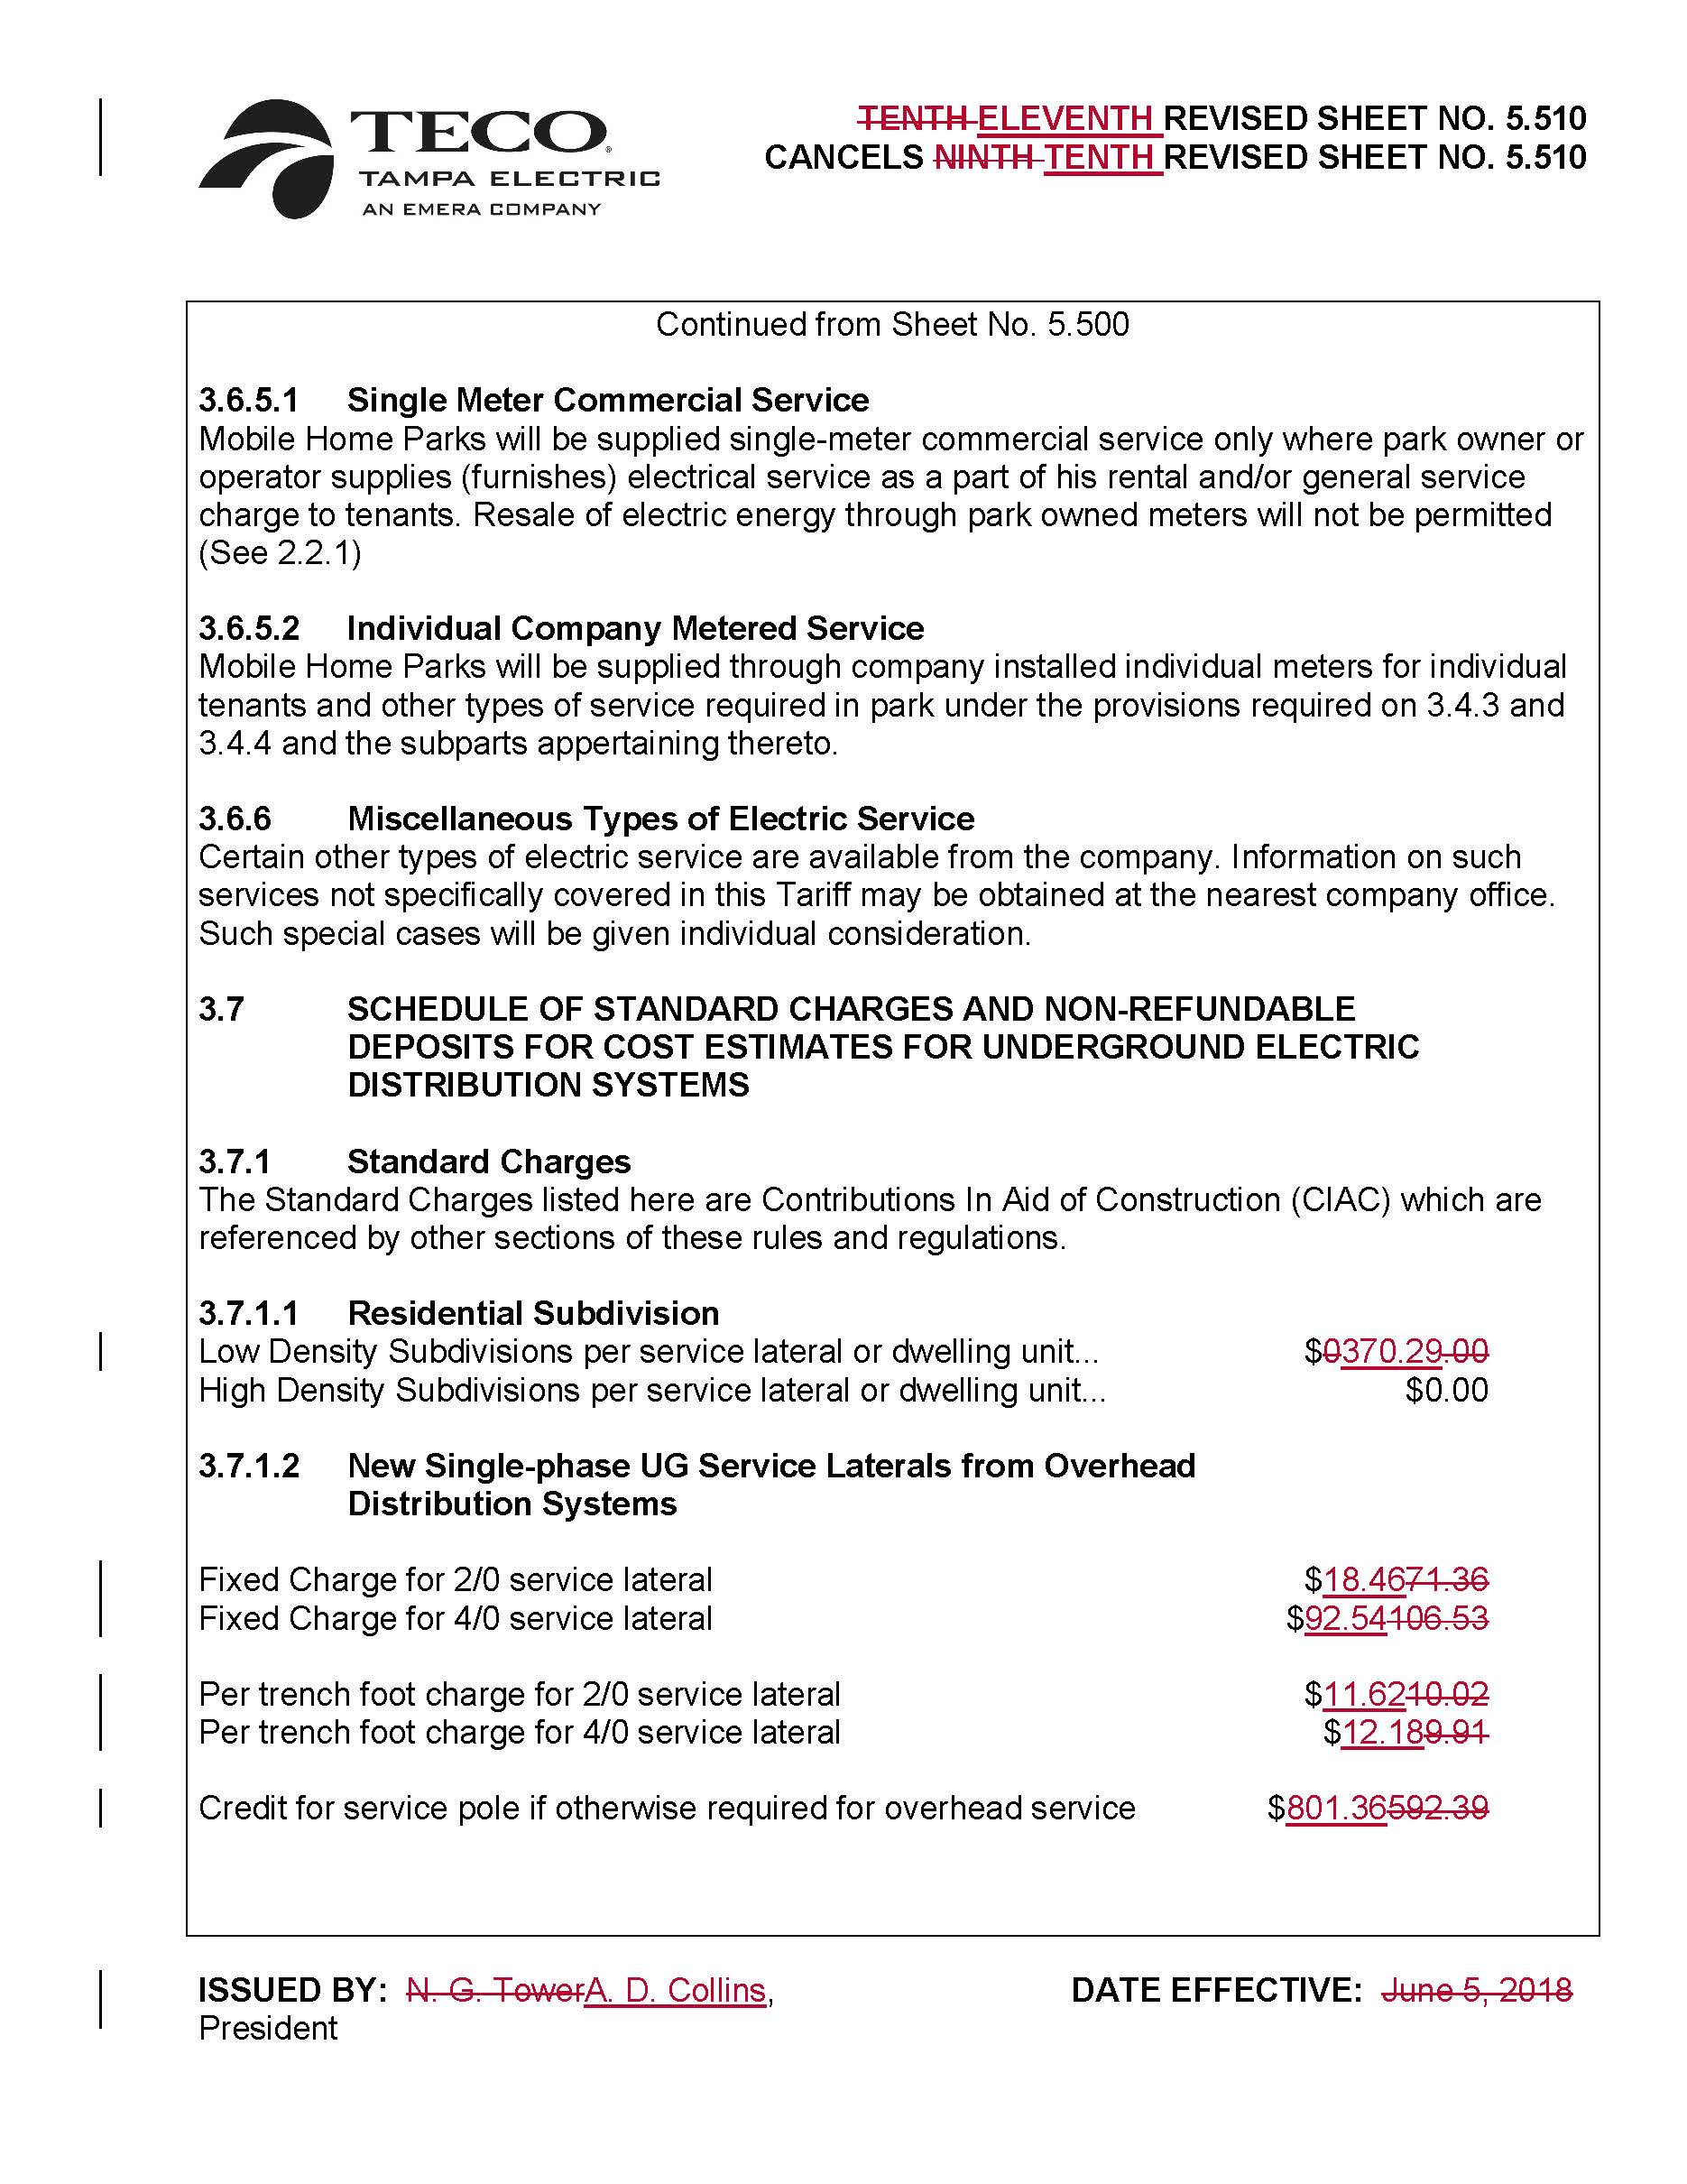

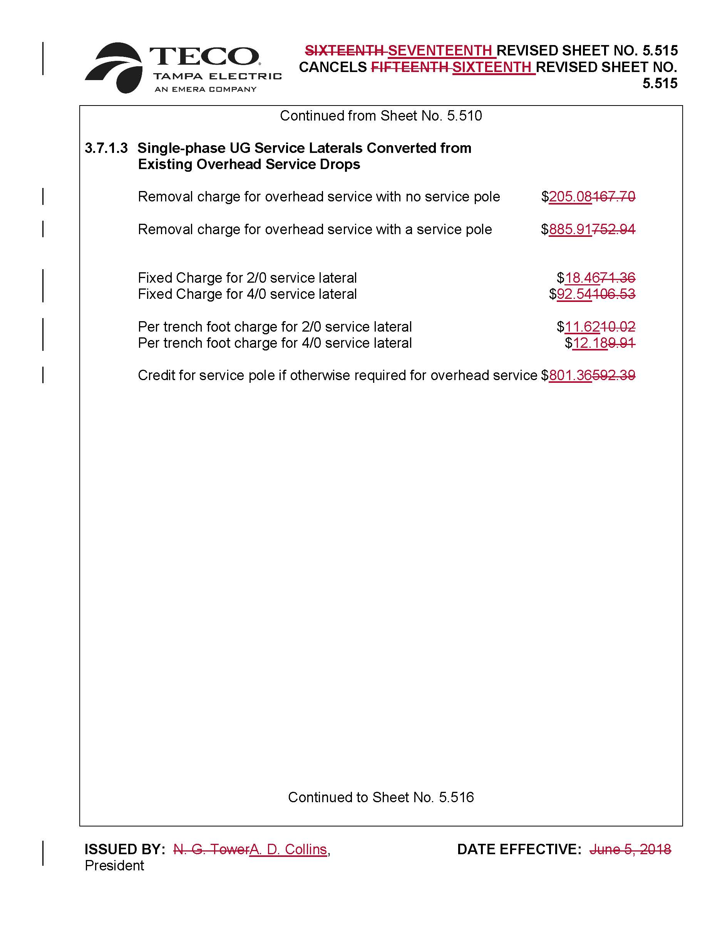

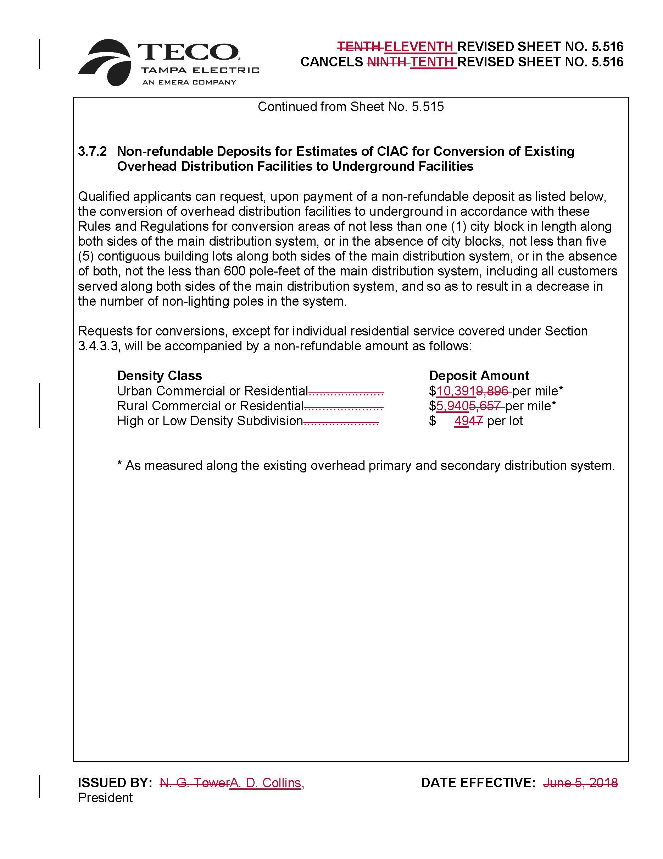

Order No. PSC-2018-0319-TRF-EI, issued June 25, 2018, in Docket No. 20180086-EI, In re: Petition for approval of revised underground residential distribution tariffs, by Tampa Electric Company.
Order No. PSC-2021-0423-S-EI, issued November 10, 2021, in Docket No. 20210034-EI, In re: Petition for rate increase by Tampa Electric Company.

