State of Florida   |  | Public Service Commission  Capital Circle Office Center ● 2540 Shumard Oak Boulevard  Tallahassee, Florida 32399-0850  -M-E-M-O-R-A-N-D-U-M-
DATE: | January 20, 2022
TO: | Office of Commission Clerk (Teitzman)
FROM: | Division of Economics (Guffey)  Office of the General Counsel (Lherisson)
RE: | Docket No. 20210170-EU – Joint petition for approval of amendment to territorial agreement in Sumter County, by Sumter Electric Cooperative, Inc. and City of Bushnell.
AGENDA: | 02/01/22 – Regular Agenda – Proposed Agency Action - Interested Persons May Participate
COMMISSIONERS ASSIGNED: |  |  | All Commissioners
PREHEARING OFFICER: |  |  | Passidomo
CRITICAL DATES: |  |  | None
SPECIAL INSTRUCTIONS: |  |  | None

Case Background
On October 29, 2021, Sumter Electric Cooperative, Inc. (SECO) and the City of Bushnell (City or Bushnell) filed a joint petition for approval of an amendment (First Amendment) to their currently effective territorial agreement (2020 Territorial Agreement) in Sumter County. In Order No. PSC-2020-0258-PAA-EU, the Florida Public Service Commission (Commission) approved the joint petitioners’ currently effective agreement. The proposed First Amendment is to accommodate three customer-driven requests. The proposed First Amendment and associated maps are included in Attachment A to this recommendation.
During the review process, staff issued a data request to the joint petitioners, to which the response was received on December 22, 2021. The Commission has jurisdiction over this matter pursuant to Section 366.04, Florida Statutes (F.S.).

Discussion of Issues

Issue 1:
Should the Commission approve the proposed First Amendment to the 2020 Territorial Agreement in Sumter County between SECO and Bushnell?

Recommendation:
Yes, the Commission should approve the proposed First Amendment to the 2020 Territorial Agreement in Sumter County between SECO and Bushnell. The approval of this First Amendment will enable SECO and Bushnell to redefine their existing service boundary to better serve their existing and future customers in Sumter County, and will not be a detriment to the public interest. (Guffey, Lherisson)

Staff Analysis:
Pursuant to Section 366.04(2)(d), F.S., and Rule 25-6.0440(2), Florida Administrative Code (F.A.C.), the Commission has the jurisdiction to approve territorial agreements between and among rural electric cooperatives, municipal electric utilities, and other electric utilities. Unless the Commission determines that the First Amendment to the 2020 Territorial Agreement will cause a detriment to the public interest, the First Amendment should be approved.

The Proposed First Amendment to the Territorial Agreement
Through this proposed First Amendment, the joint petitioners seek to modify the existing territorial boundary in Sumter County to address service needs of three customers. The proposed amendment will result in lower capital expenditure to serve each of the three customers. The first request is from a new customer seeking to construct and operate a large industrial facility in the City’s service area. However, the City is unable to serve the large industrial customer without significant capital investment and construction of new facilities. After review of the customer’s needs, the parties agreed that SECO is able to serve the customer with less new investment and facilities.
The second customer request is for security lighting service within the City’s service territory where electric service is not currently available and the City is unable to provide the required service without significant costs and facility extensions. SECO is able to provide the security lighting service with less new investment and less costly extension of existing facilities. The City has agreed to allow SECO to provide the security lighting service to the customer.
The third customer request is from an existing recreational vehicle (RV) park owner, served by the City, who is planning to expand the RV park to an area within SECO’s service territory. Although the RV park is expanding within SECO’s service territory, the specific area currently does not have electric service. SECO would require extensive capital investment and construction of new facilities to provide electricity to the proposed RV expansion area. The RV park customer desires that the City provide electric service for the expanded area and the City is able to provide the needed electric service with less expenses and facility enhancements than SECO.
In order to provide electricity to the three customers discussed above in an efficient manner, the parties have agreed to exchange certain territorial area parcels and modify the boundary of the currently effective territorial agreement. Paragraph 7 of the First Amendment states that the proposed boundary modifications will meet the customers’ needs and will eliminate uneconomic duplication of facilities, and will not cause a decrease in reliability of electric service to existing or future customers of either party.
The proposed First Amendment also asserts that the territorial areas subject to this amendment currently do not have electric service, and therefore there are no customers to be notified or customer accounts to be transferred between the two parties. Pursuant to Paragraph 4 of the petition, the proposed First Amendment to the 2020 Territorial Agreement will become effective upon the issuance of an Order by the Commission approving the First Amendment in its entirety.

Conclusion
After review of the joint petition, staff believes the First Amendment to the Territorial Agreement will not cause a detriment to the public interest, will eliminate any potential uneconomic duplication of facilities, and will not cause a decrease in reliability of electric service to the present or future customers of SECO or Bushnell. Therefore, staff recommends that the Commission should approve the proposed First Amendment to the 2020 Territorial Agreement between SECO and Bushnell in Sumter County.

Issue 2:
Should this docket be closed?

Recommendation:
Yes. If no protest is filed by a person whose substantial interests are affected within 21 days of the issuance of the Order, this docket should be closed upon the issuance of the Consummating Order. (Lherisson)

Staff Analysis:
If no protest is filed by a person whose substantial interests are affected within 21 days of the issuance of the Order, this docket should be closed upon the issuance of the Consummating Order.

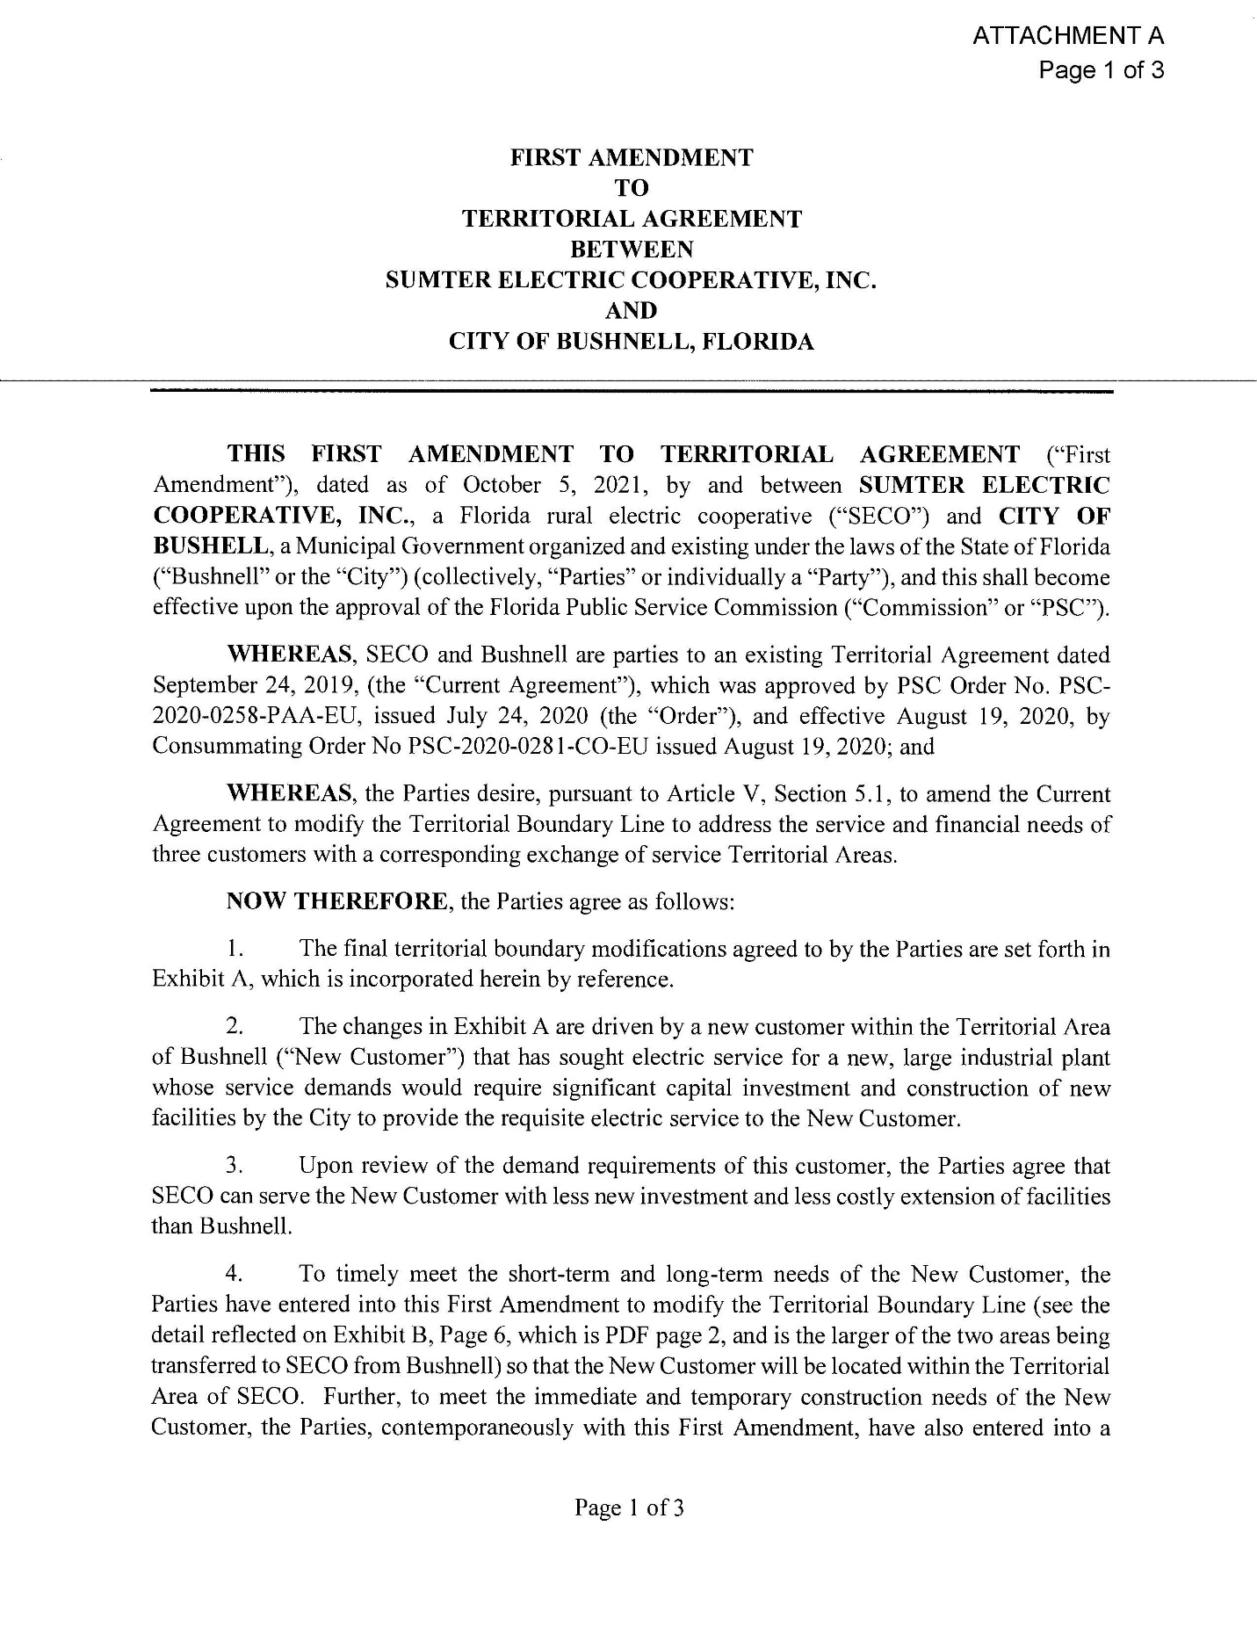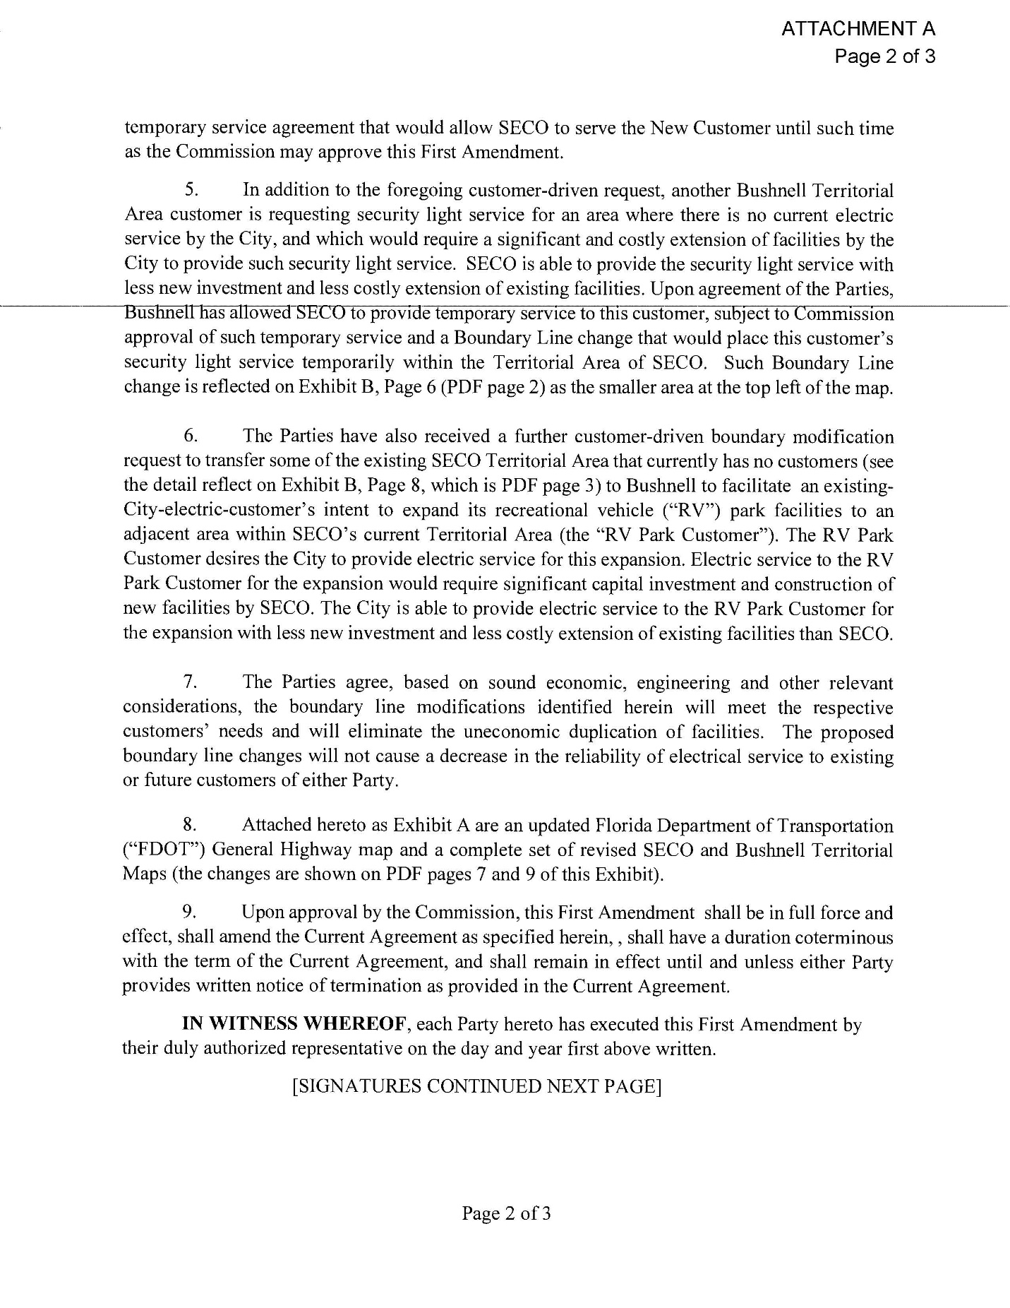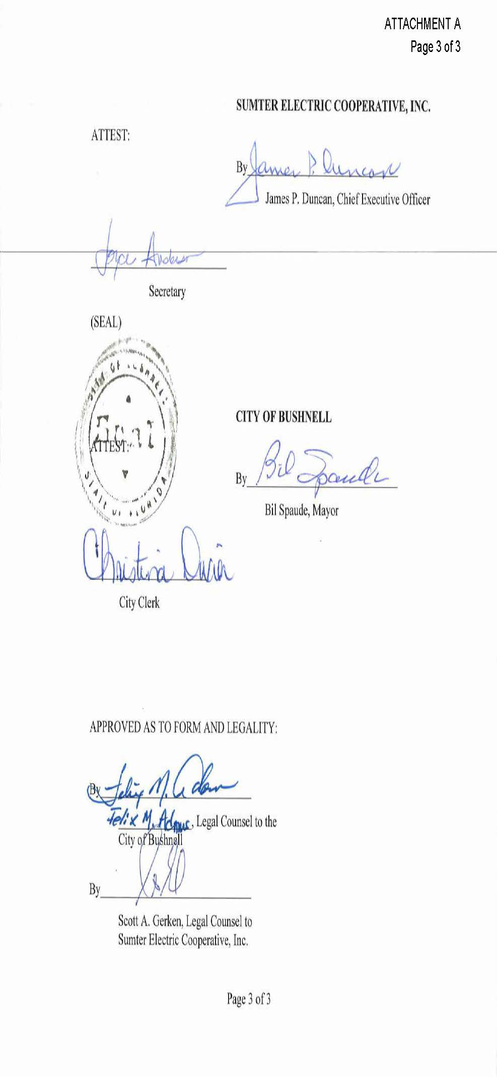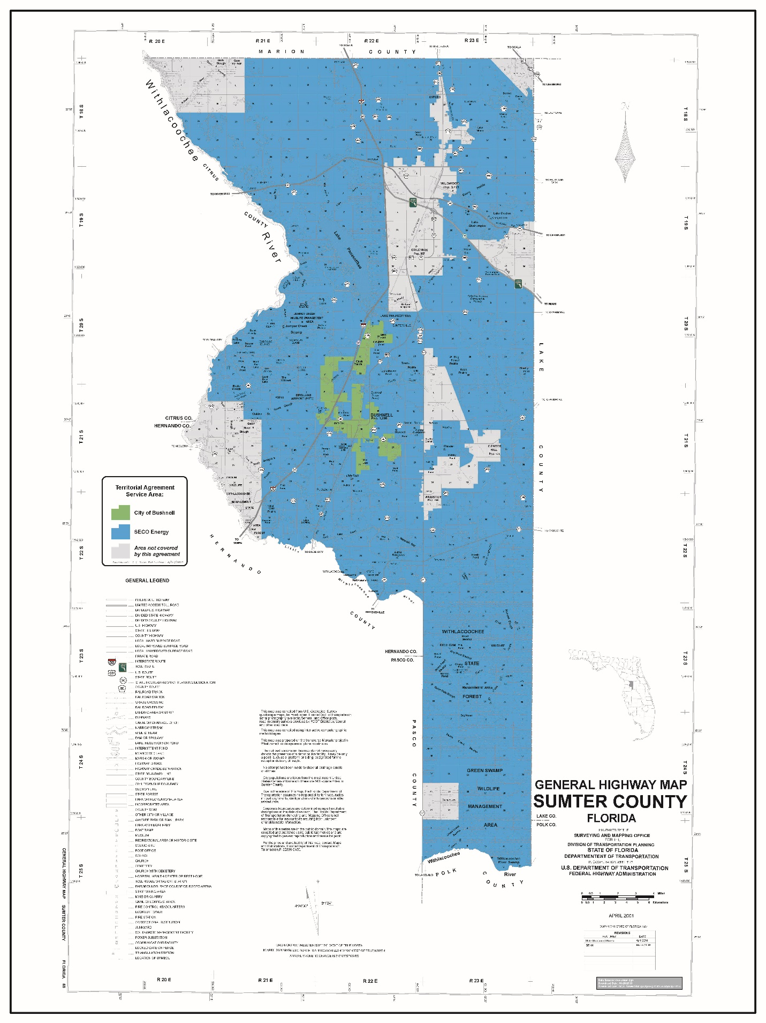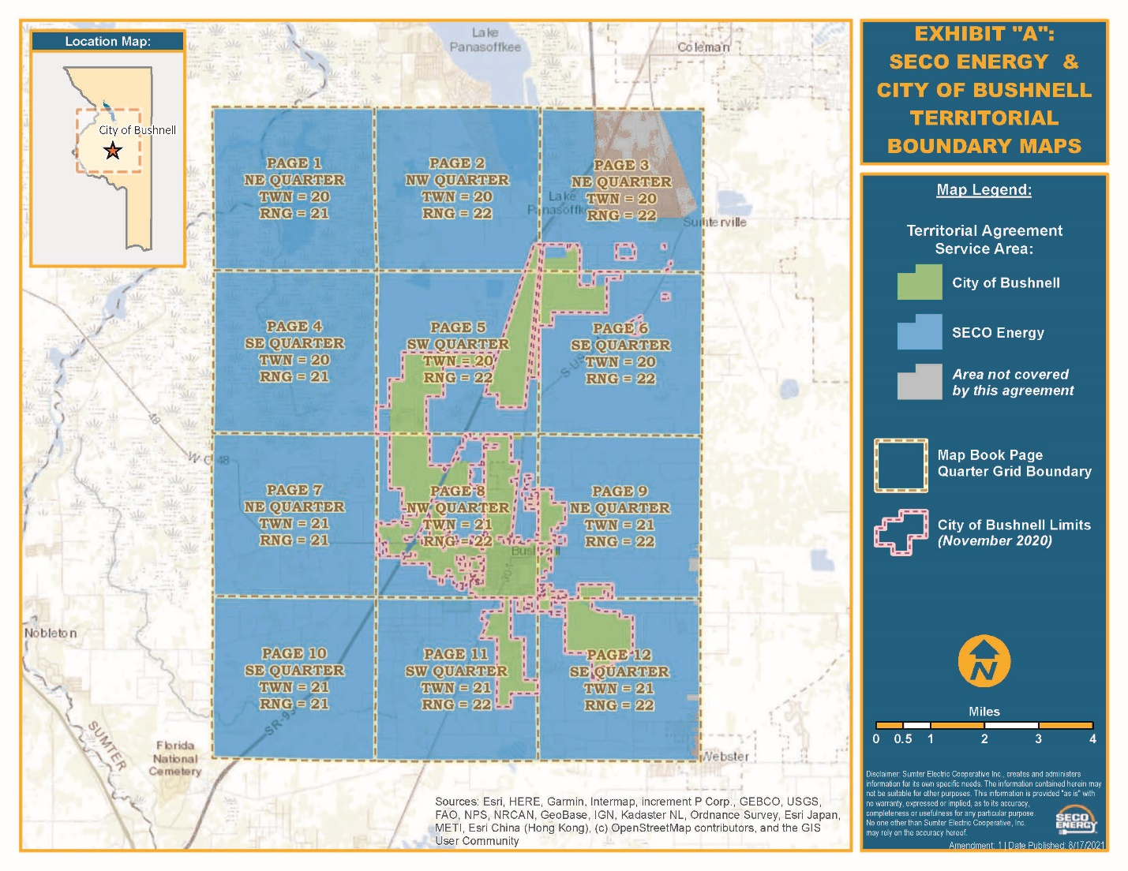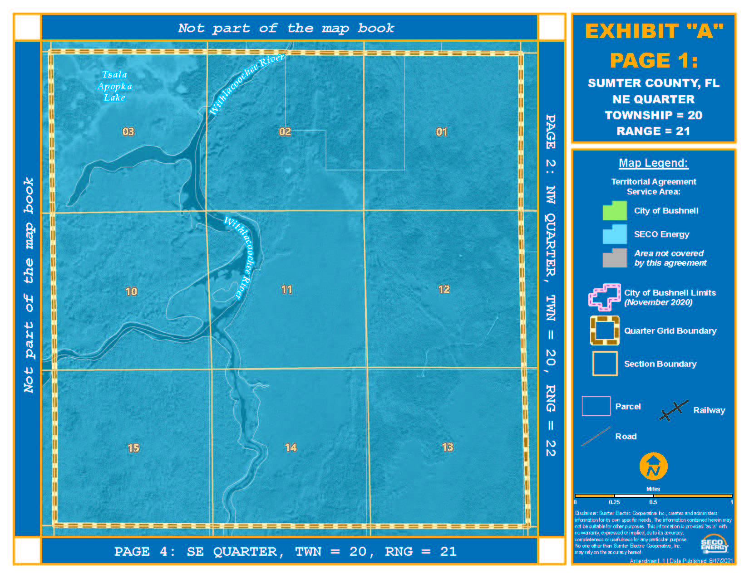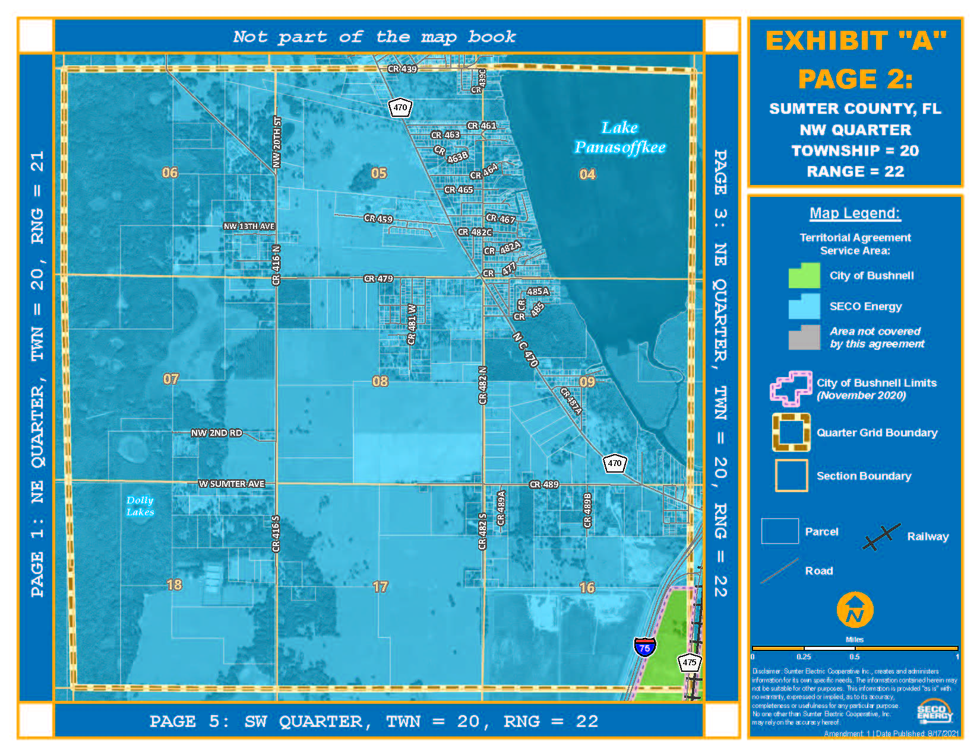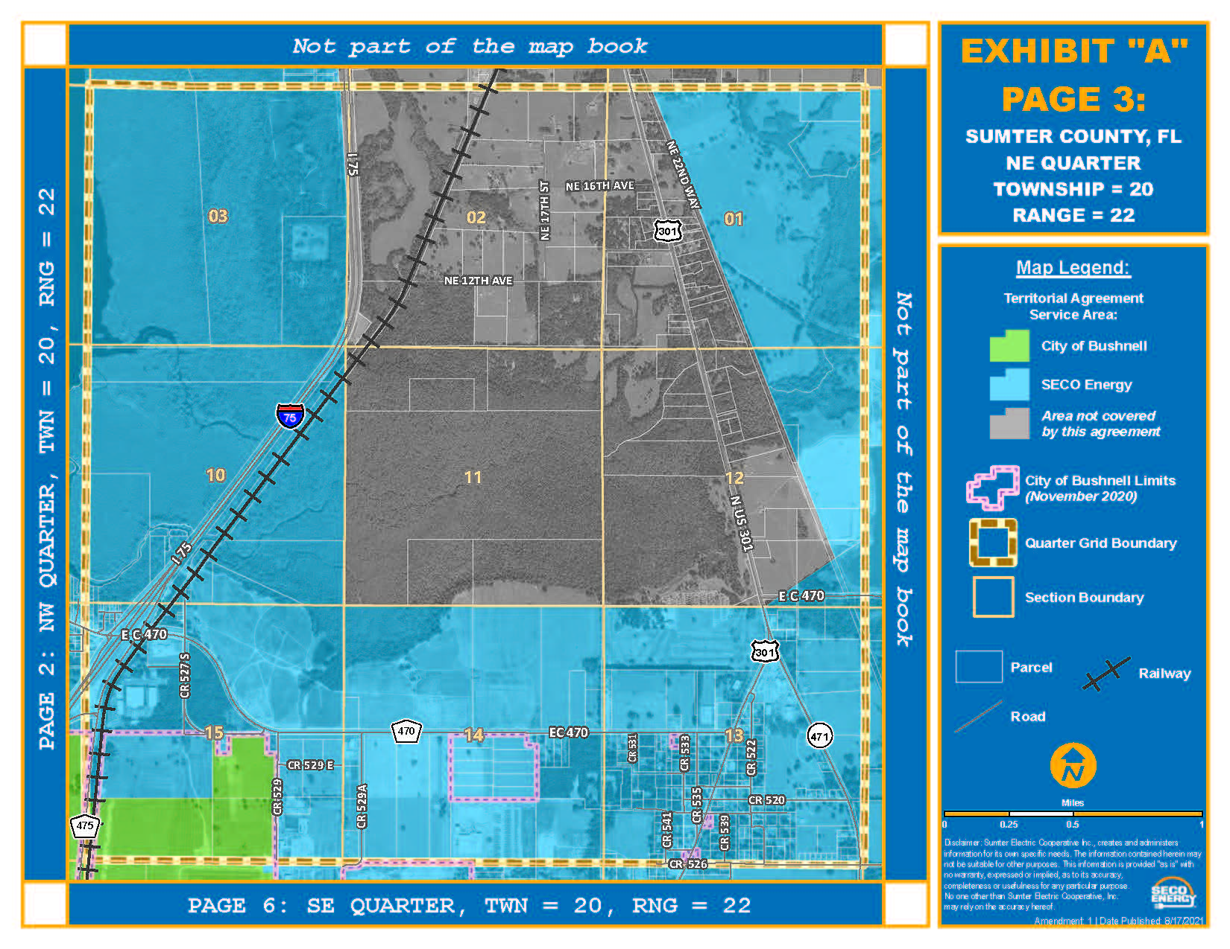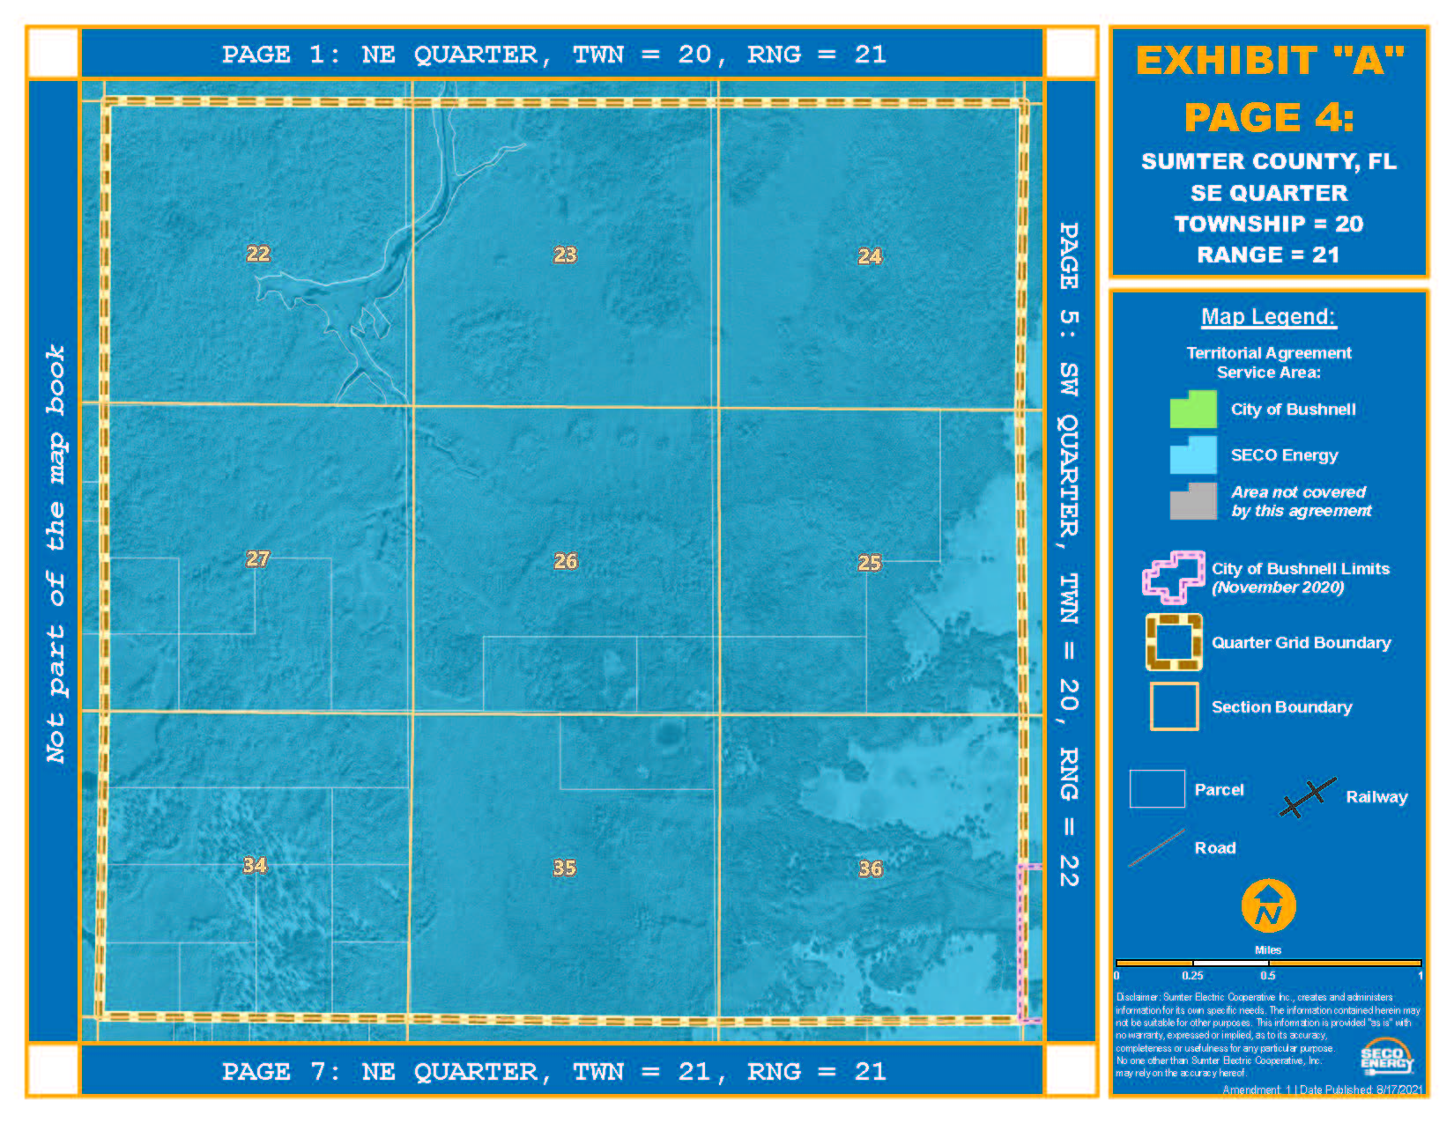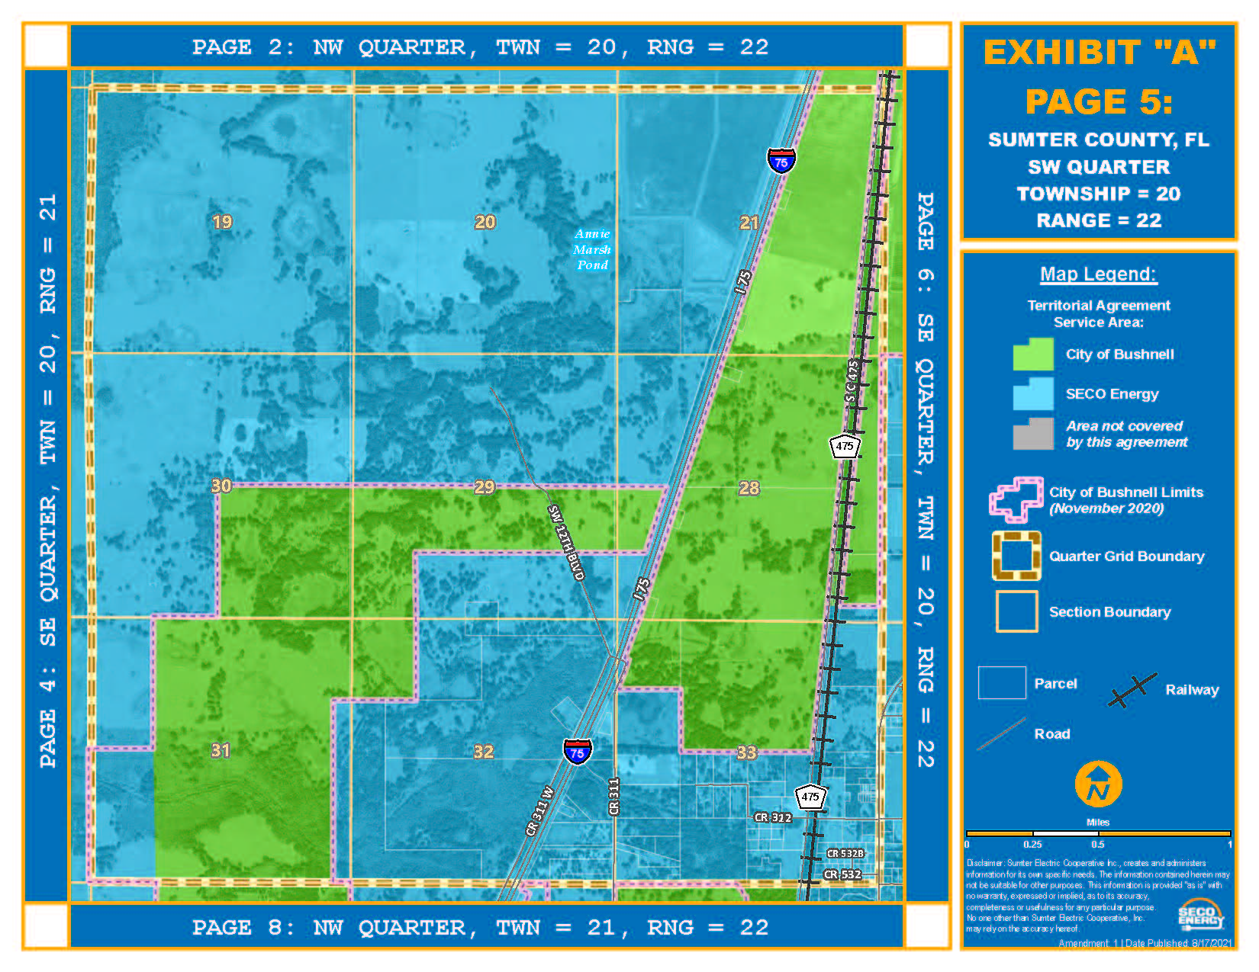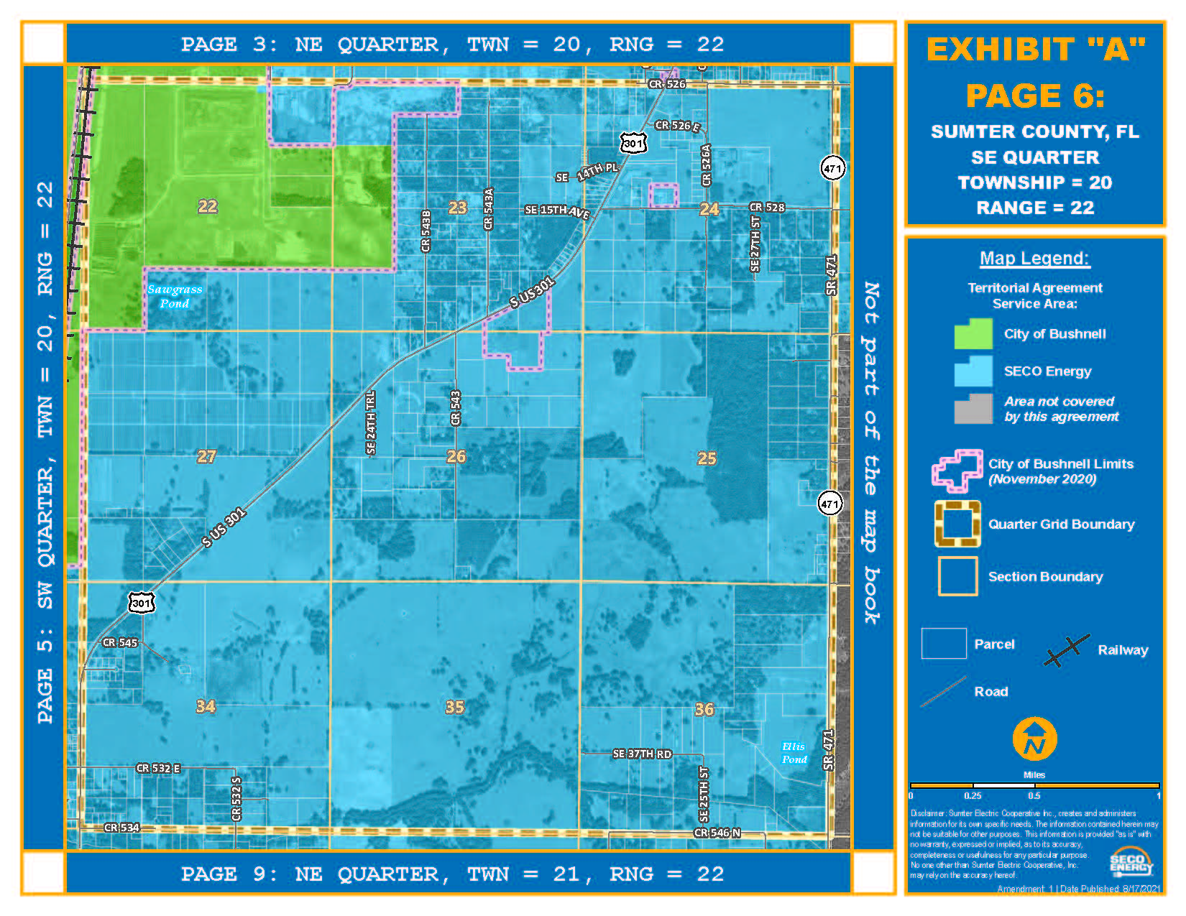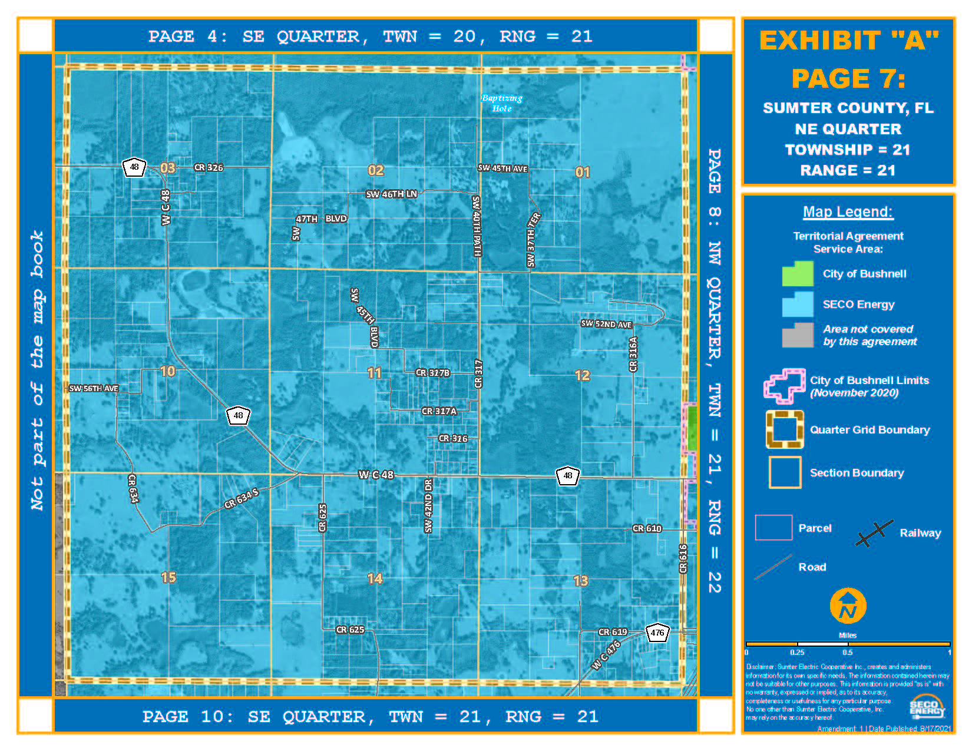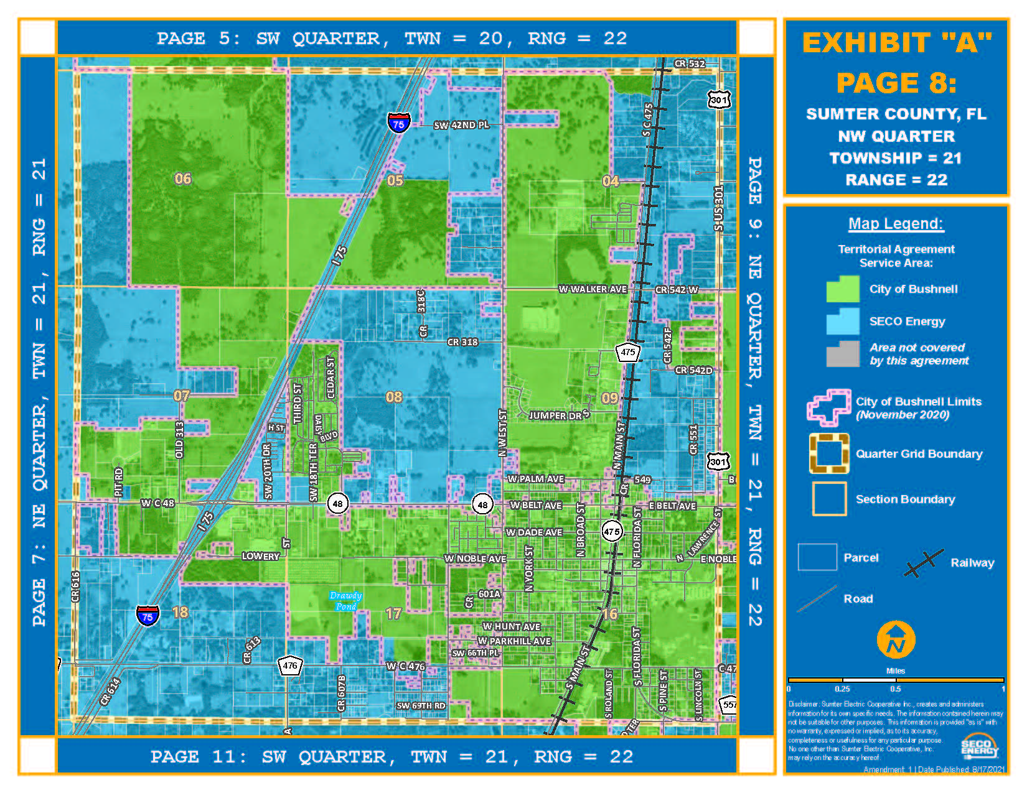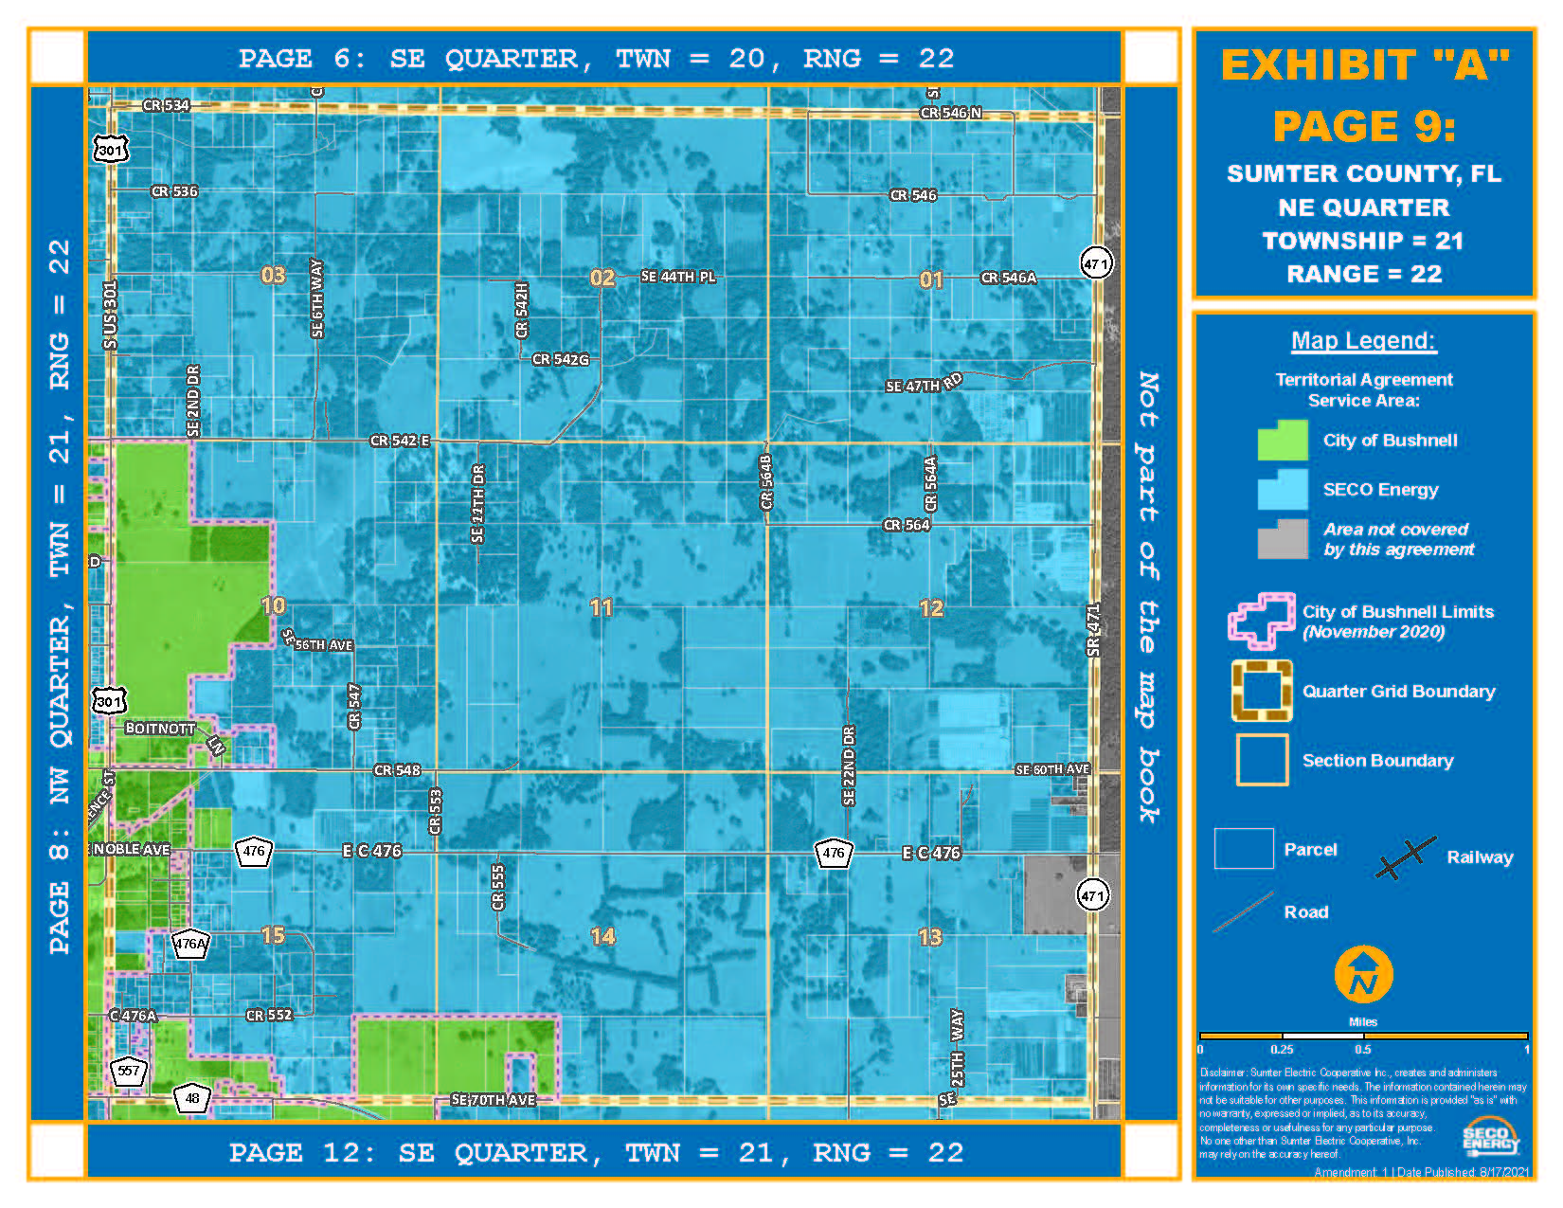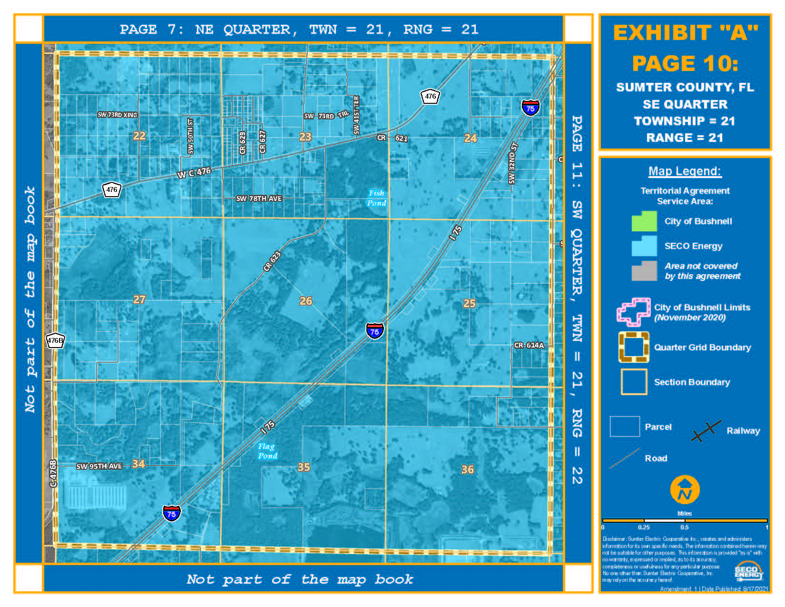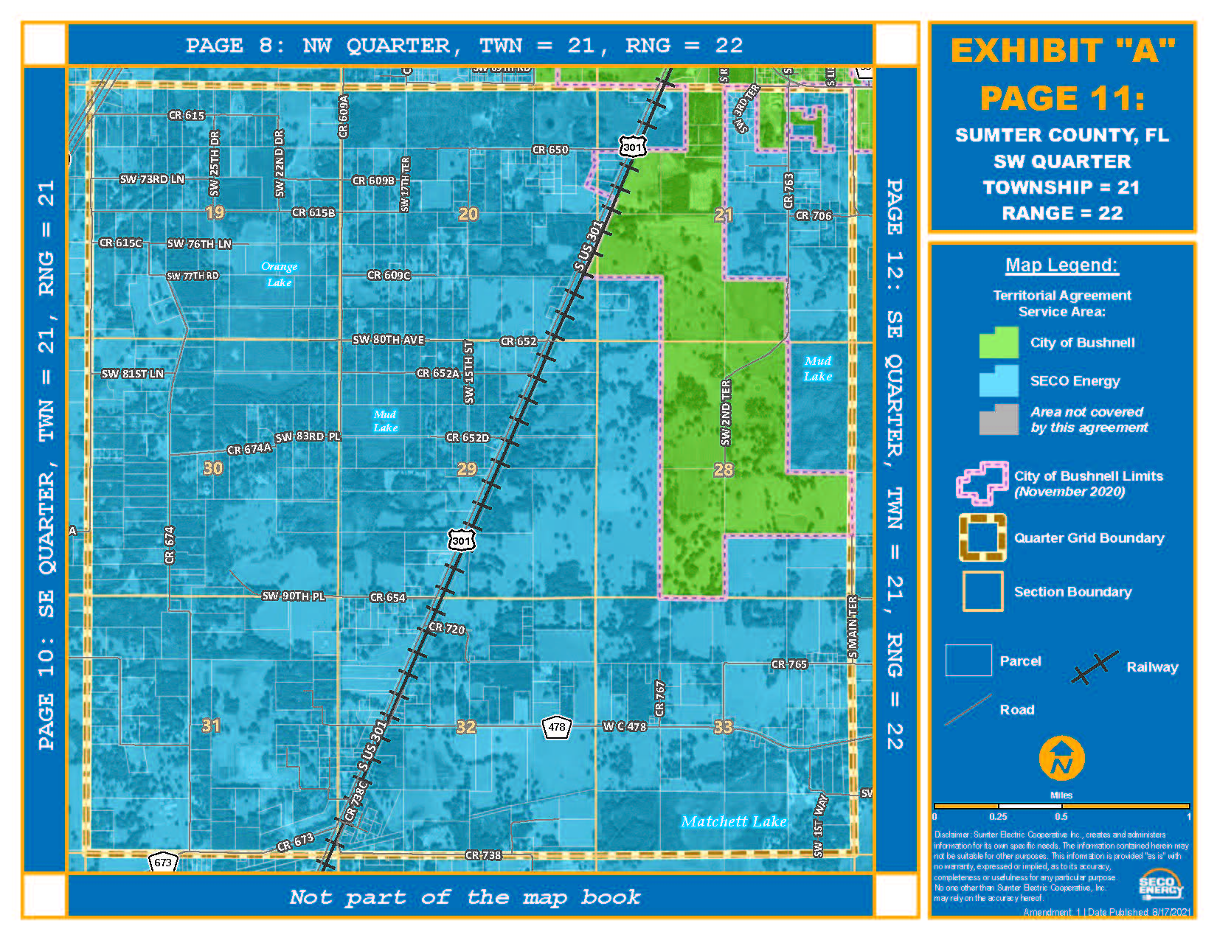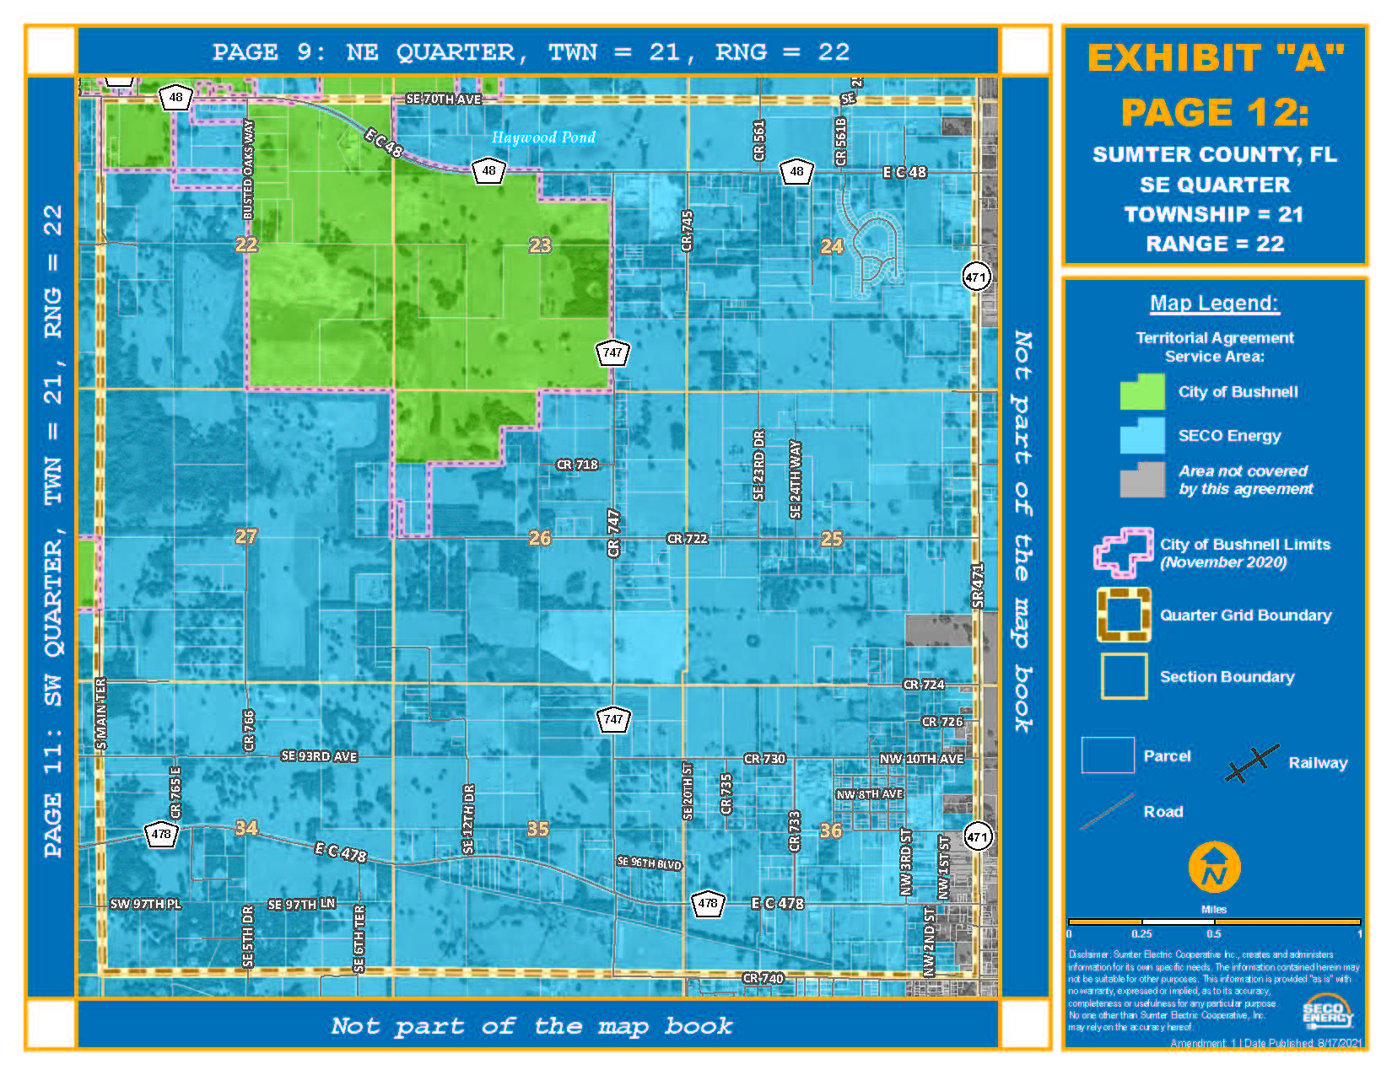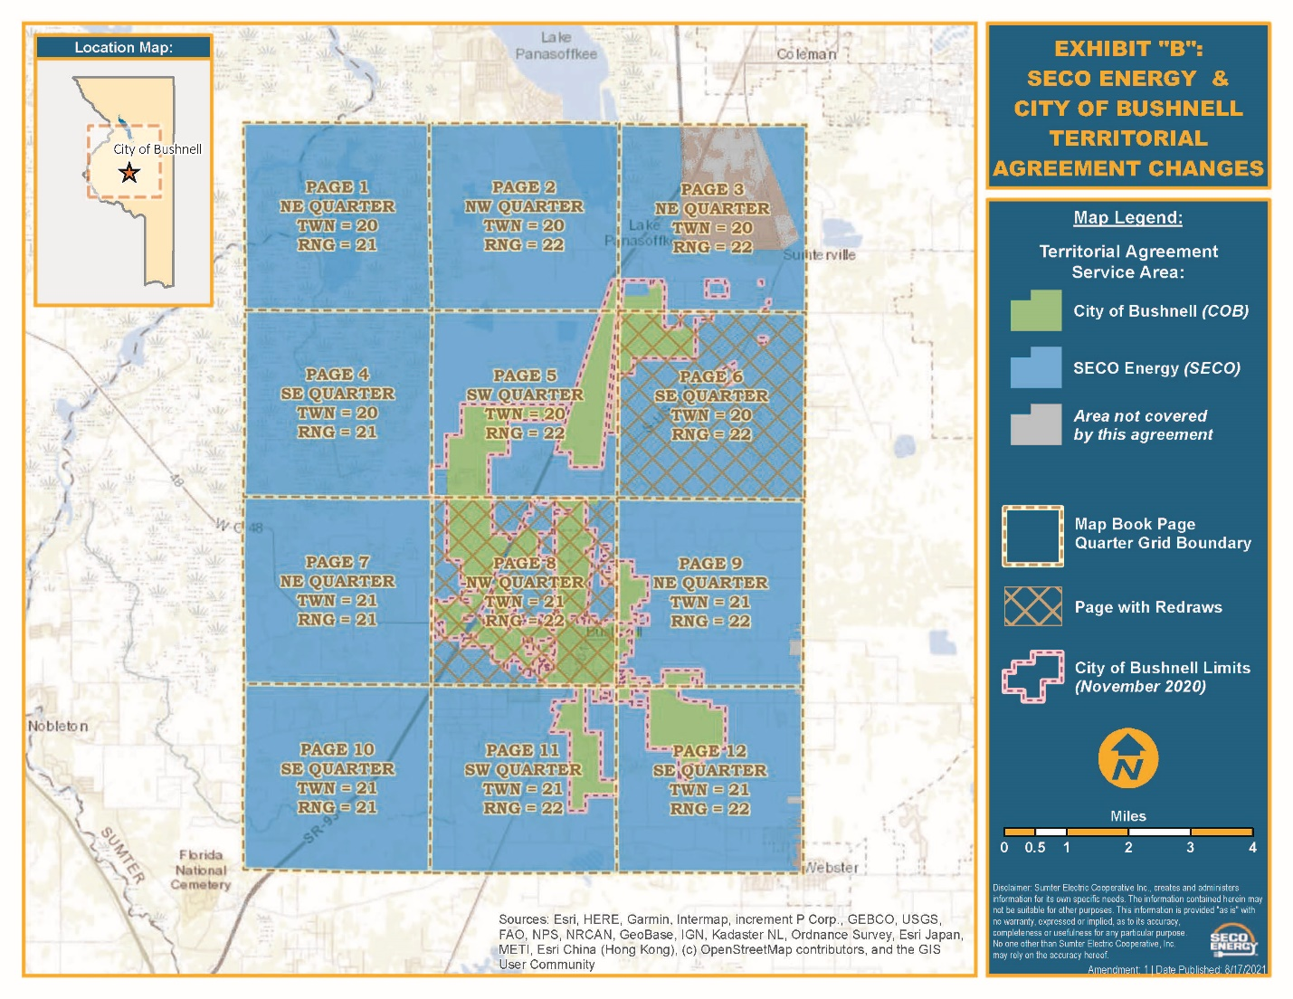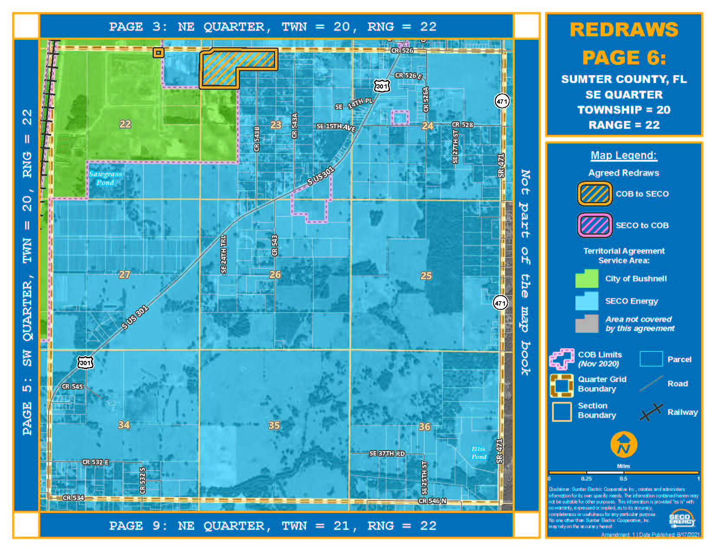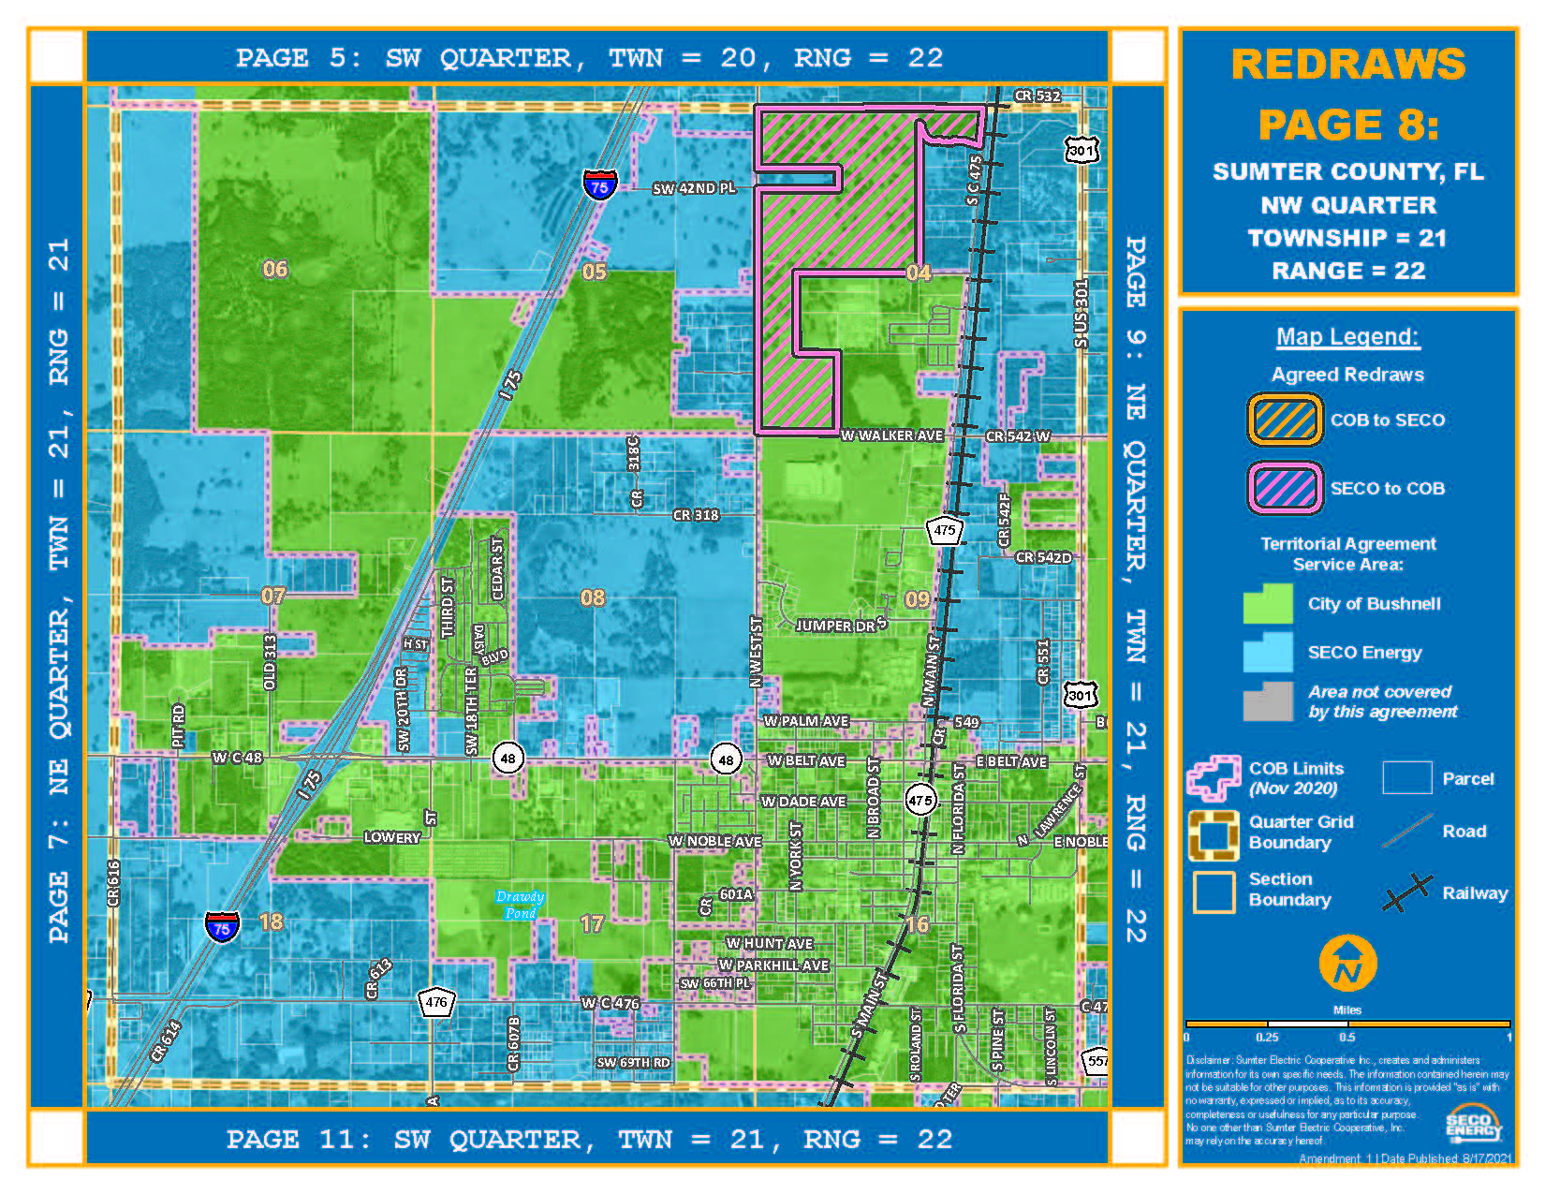

Order No. PSC-2020-0258-PAA-EU, issued July 24, 2020, in Docket No. 20200138-EU, In re: Joint petition for approval of territorial agreement in Sumter County, by Sumter Electric Cooperative, Inc. and City of Bushnell.
Utilities Commission of the City of New Smyrna Beach v. Florida Public Service Commission, 469 So. 2d 731 (Fla. 1985).

