State of Florida |  | Public Service Commission  Capital Circle Office Center ● 2540 Shumard Oak Boulevard  Tallahassee, Florida 32399-0850  -M-E-M-O-R-A-N-D-U-M-
DATE: | February 17, 2022
TO: | Office of Commission Clerk (Teitzman)
FROM: | Division of Economics (Ward)  Office of the General Counsel (Sandy)
RE: | Docket No. 20210197-EU – Joint petition for approval of amendment to territorial agreement, by Tampa Electric Company and Withlacoochee River Electric Cooperative, Inc.
AGENDA: | 03/01/22 – Regular Agenda – Proposed Agency Action – Interested Persons May Participate
COMMISSIONERS ASSIGNED: |  |  | All Commissioners
PREHEARING OFFICER: |  |  | Graham
CRITICAL DATES: |  |  | None
SPECIAL INSTRUCTIONS: |  |  | None

Case Background
On December 28, 2021, Tampa Electric Company (TECO) and Withlacoochee River Electric Cooperative, Inc. (WREC) (collectively, joint petitioners) filed a joint petition for approval of an amendment to their current territorial agreement in Pasco County (the proposed amendment). TECO serves retail customers in Hillsborough County and in portions of Polk, Pinellas, and Pasco Counties. WREC serves retail customers in portions of Hernando, Citrus, Sumter, Pasco, and Polk Counties.
The original electric service boundary between TECO and WREC was approved by the Commission in 1974 in Order No. 6281. The boundary was amended in 1990 in Order No. 23905 and further amended in 2006 in Order No. PSC-06-0128-PAA-EU (2006 Order). The boundary was amended for a third time in 2017 in Order No. PSC-17-0241-PAA-EU (2017 Order). The instant petition seeks to amend the territorial boundaries to accommodate proposed modifications to the service area within the Two Rivers Ranch subdivision (Two Rivers Ranch or subdivision) located adjacent to the Hillsboro-Pasco County line, as shown in Attachment B. All other aspects of the current agreement, shown as Attachment A, would remain in place.
Staff issued a data request on January 25, 2022, to which the responses were received on February 9, 2022. The Commission has jurisdiction over this matter pursuant to Section 366.04, Florida Statutes, (F.S.).

Discussion of Issues

Issue 1:
Should the Commission approve the joint petition by TECO and WREC to amend their territorial agreement related to the boundaries of Two Rivers Ranch in Pasco County?

Recommendation:
Yes, the Commission should approve the joint petition by TECO and WREC to amend their territorial agreement related to the boundaries of Two Rivers Ranch in Pasco County. The approval of this amendment would enable TECO and WREC to redefine their existing service boundary to better serve their existing and future customers in Pasco County, and will not be a detriment to the public interest. (Ward)

Staff Analysis:
Pursuant to Section 366.04(2)(d), F.S., and Rule 25-6.0440(2), Florida Administrative Code (F.A.C.), the Commission has the jurisdiction to approve territorial agreements between and among rural electric cooperatives, municipal electric utilities, and other electric utilities. Unless the Commission determines that the amendment to the 1990 territorial agreement will cause a detriment to the public interest, the amendment should be approved.

The Proposed Amendment to the 1990 Territorial Agreement
A new residential subdivision, known as Two Rivers Ranch, is currently under development adjacent to the Hillsborough-Pasco County line. A section of the existing service boundary runs through the planned subdivision. The joint petitioners state that the current service boundary runs through proposed home lots, across planned streets, and without regard to future utility easement areas in the subdivision.
In 2021, TECO and WREC had discussions for the provision of electric service to the new Two Rivers Ranch subdivision. These discussions led to a mutual agreement between TECO and WREC regarding the most efficient, reliable provision of electricity to the new subdivision. Under this agreement, the revised boundary lines would follow along parcel lines within the subdivision and only cross one road. The joint petitioners assert that this proposal would allow both utilities to have sufficient access to the areas to be served and it would facilitate the orderly provision of electricity by the two utilities. If approved, the joint petitioners state that the revised agreement would ensure that each parcel tract and homeowners’ association within the larger development would be served by a single utility. Furthermore, the petitioners assert that the proposed territorial amendment would not cause a decrease in the reliability of electric service to the existing and future ratepayers of either utility and would prevent the uneconomic duplication of facilities.
Under the proposed amendment, TECO could gain 475 new residential customers from the transfer of proposed lots in WREC’s current territory, while WREC could gain 561 new residential customers from the transfer of proposed lots in TECO’s current territory. In response to staff’s data request, the joint petitioners stated that all of the aforementioned customers would be within the Two Rivers Ranch subdivision. The joint petitioners state that the boundaries are designed to reallocate lots, as evenly as possible, between the utilities, while avoiding uneconomic duplication and providing safe and reliable service. As this subdivision has not been developed, there are no current customers to be transferred as a result of the proposed territorial amendment. Similarly, there are no affected customers to be notified. Pursuant to Rule 25-6.0440(1)(f), F.A.C., the joint petitioners provided a map depicting the proposed boundary line of the subdivision. The map is shown in Attachment B to this recommendation.

Conclusion
After review of the petition, the proposed territorial amendment, and the joint petitioners' responses to staff’s data request, staff believes that the proposed territorial amendment is in the public interest and will enable TECO and WREC to better serve the future customers in the Two Rivers Ranch subdivision in Pasco County. It appears that the proposed territorial amendment eliminates any potential uneconomic duplication of facilities and will not cause a decrease in the reliability of electric service. Therefore, staff recommends that the Commission should approve the proposed amendment to the territorial agreement between TECO and WREC in Pasco County.

Issue 2:
Should this docket be closed?

Recommendation:
Yes. If no protest is filed by a person whose substantial interests are affected within 21 days of the issuance of the Order, this docket should be closed upon the issuance of a Consummating Order. (Sandy)

Staff Analysis:
If no protest is filed by a person whose substantial interests are affected within 21 days of the issuance of the Order, this docket should be closed upon the issuance of a Consummating Order.

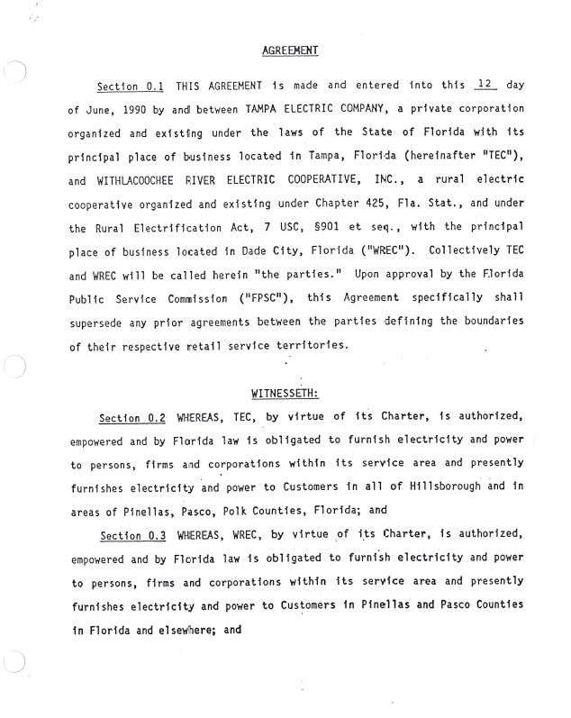

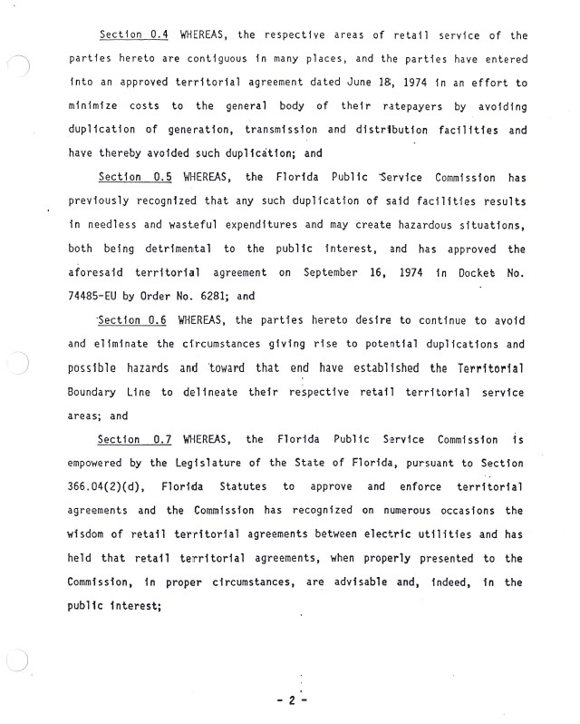

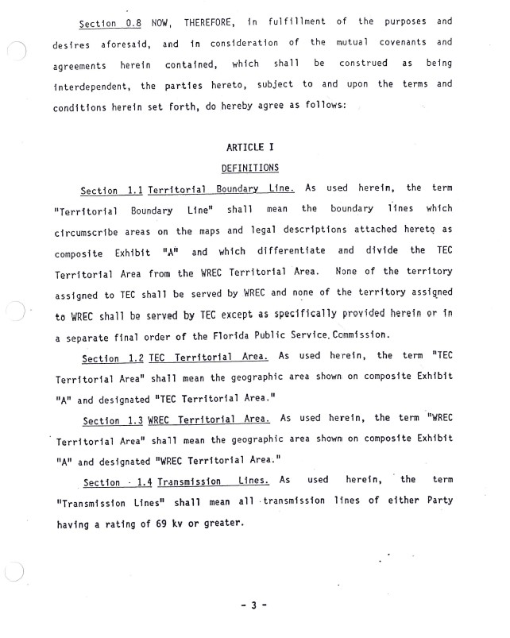

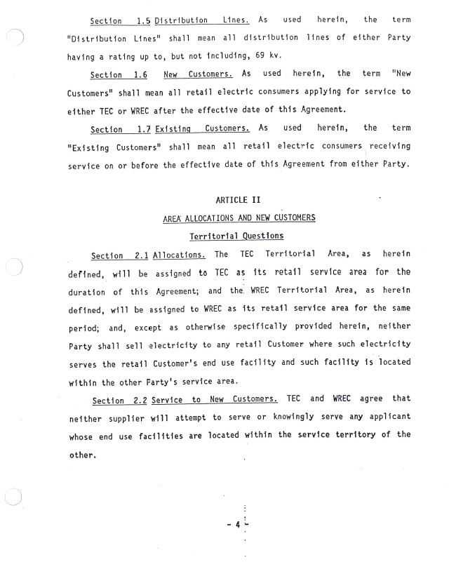

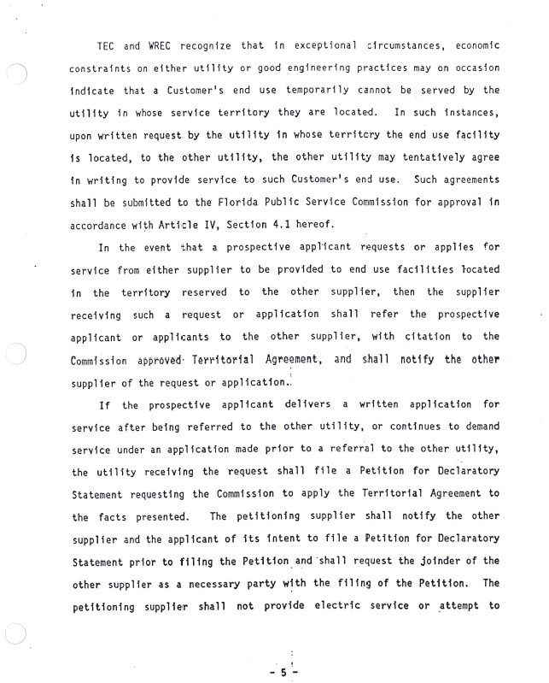

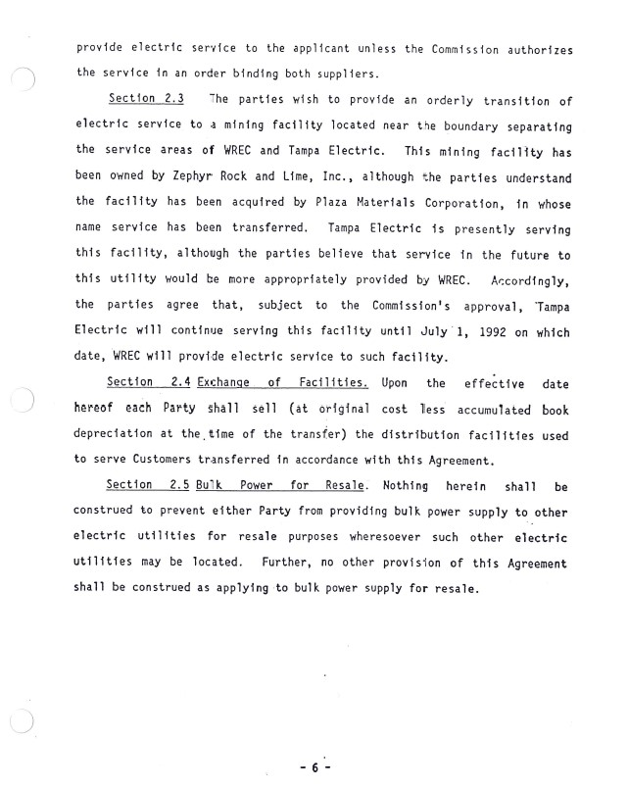

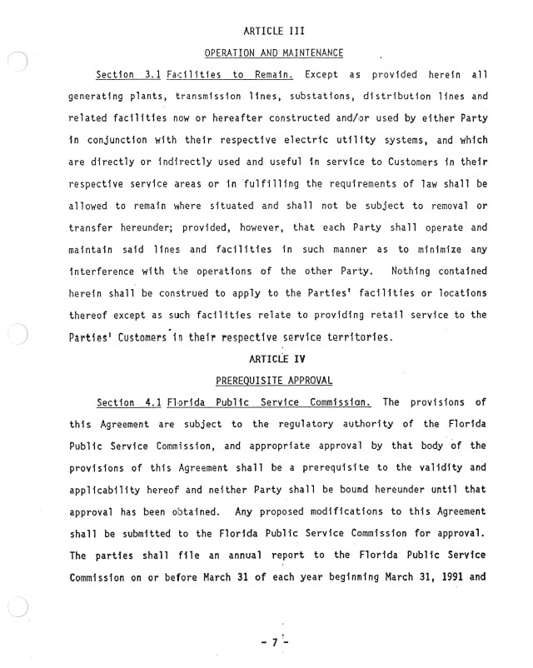

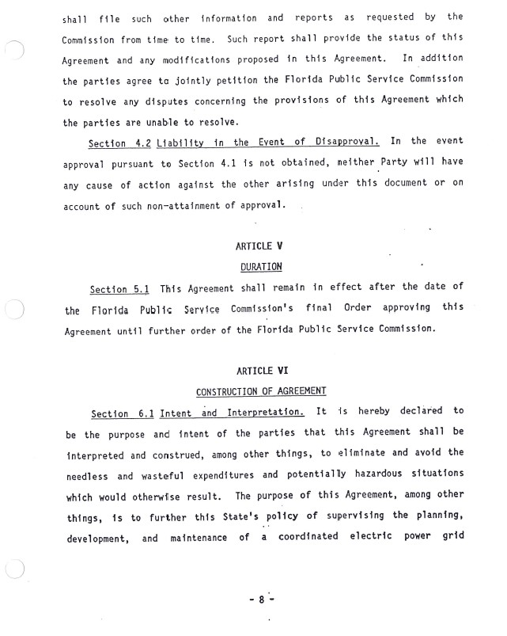

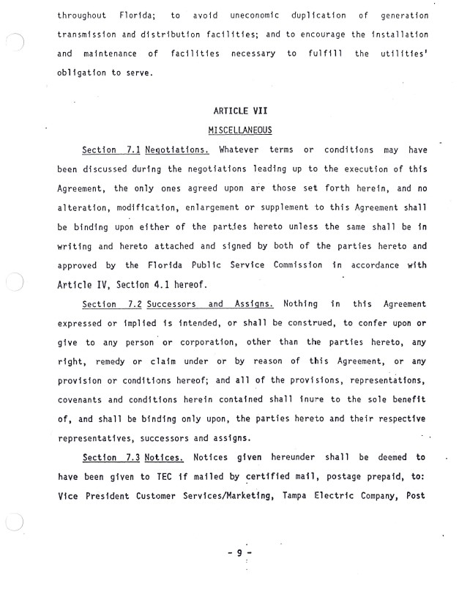

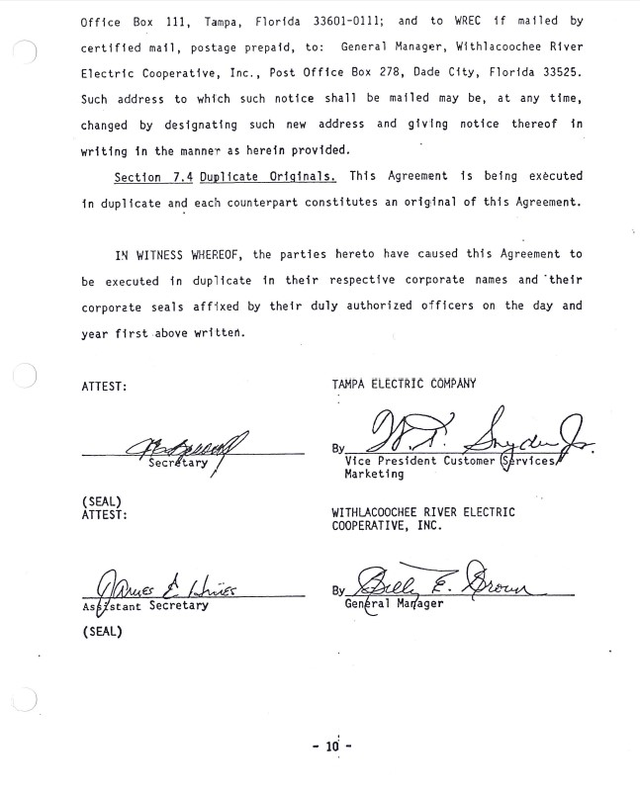

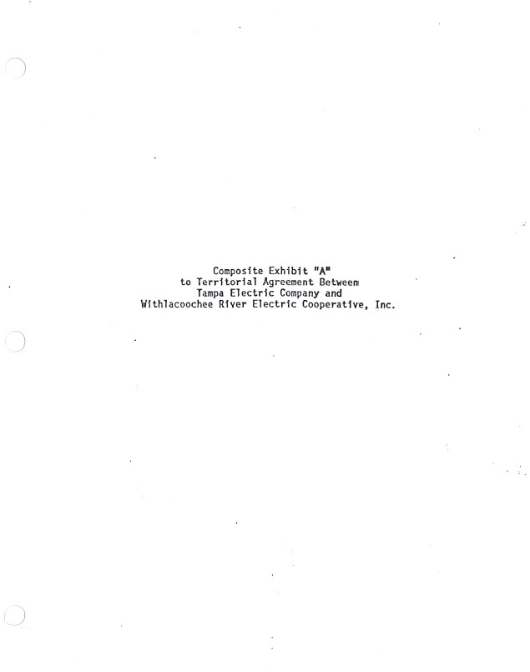

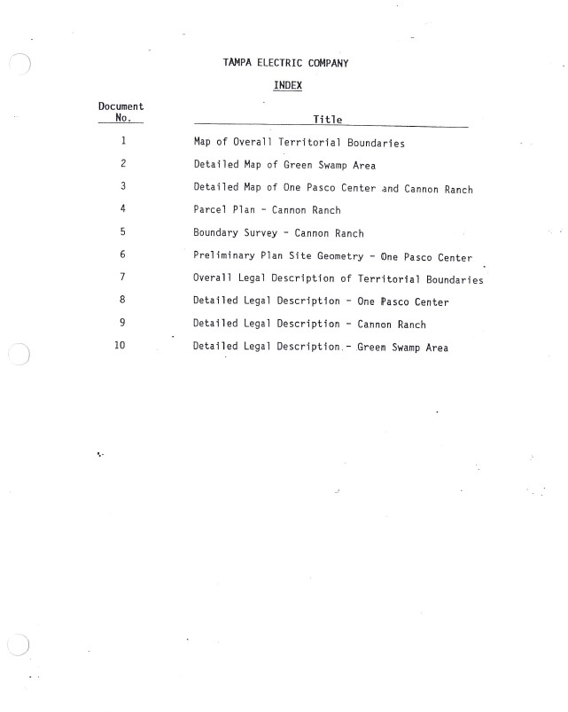
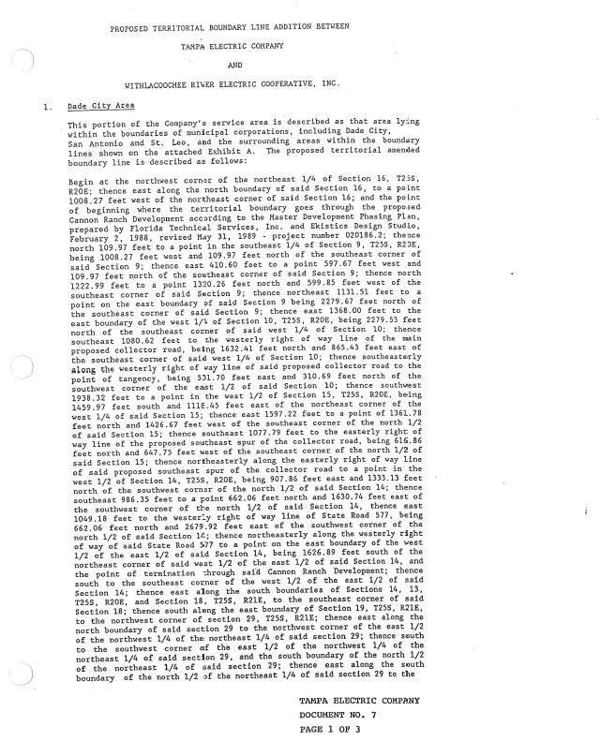

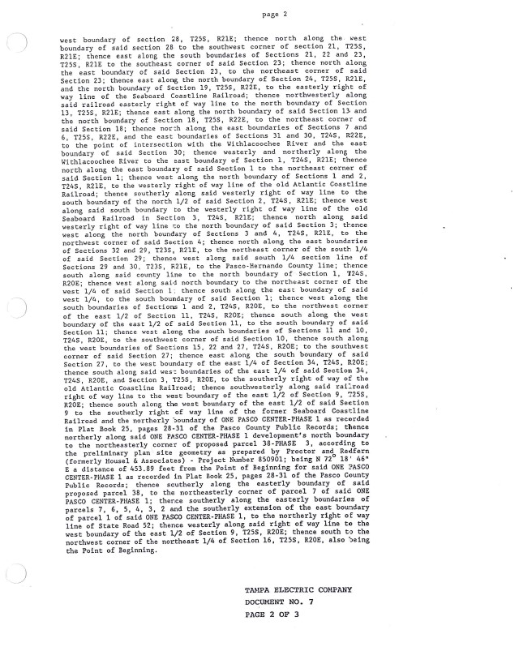

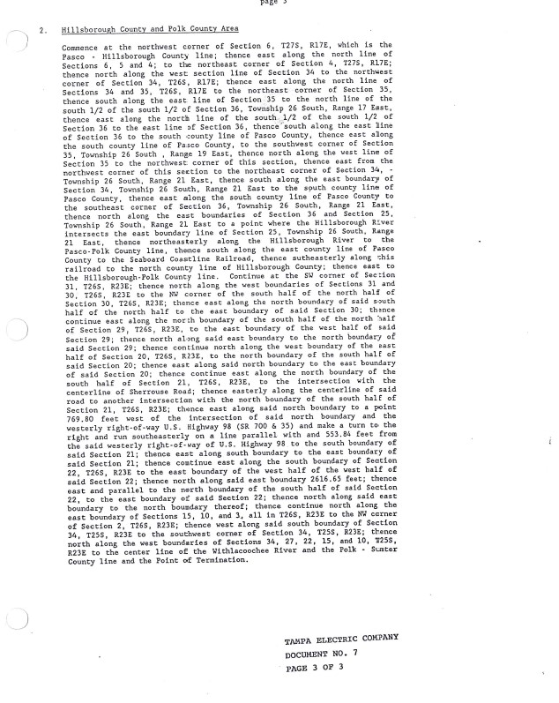

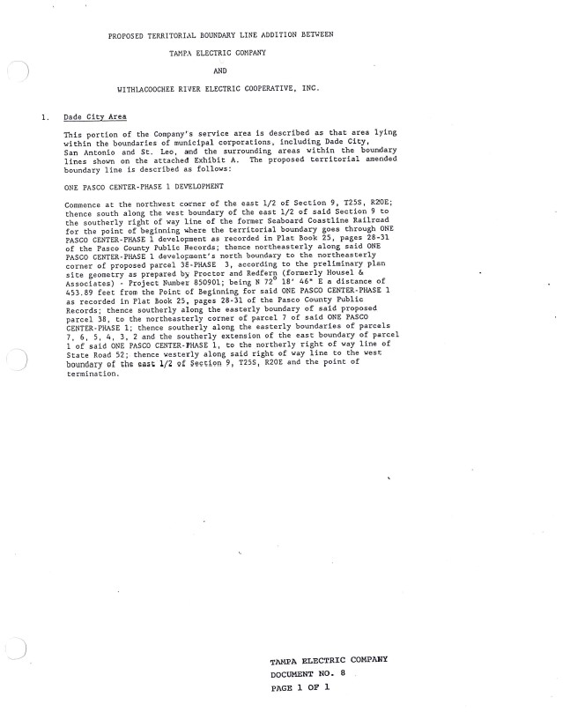

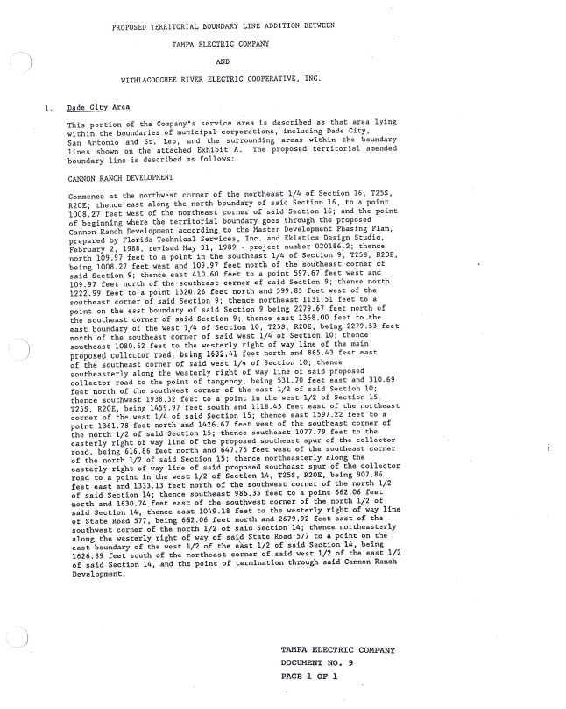

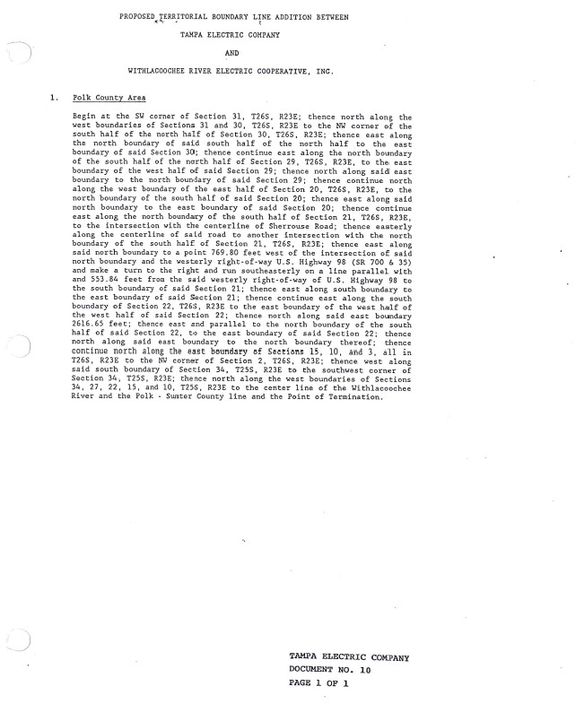

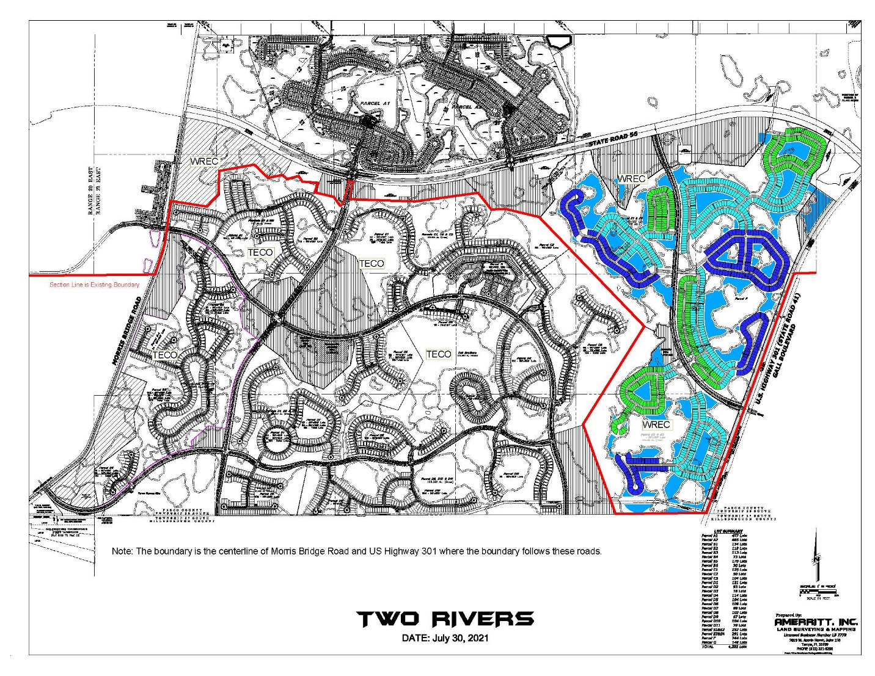

Order No. 6281, issued September 16, 1974, in Docket No. 1974485-EU, In re: Application of Tampa Electric Company for approval of territorial agreement with Withlacoochee River Electric Cooperative, Inc., relative to respective retail electric systems and service areas.
Order No. 23905, issued December 20, 1990, in Docket No 19900752-EU, In re: Joint Petition for Approval of 1990 Amendment to Territorial Agreement by Tampa Electric Company and Withlacoochee River Electric Cooperative, Inc.
Order No. PSC-06-0128-PAA-EU, issued February 16, 2006, in Docket No. 20041408-EU, In re: Joint petition of Tampa Electric Company and Withlacoochee River Electric Cooperative, Inc. for expedited interim approval of customer transfers pending consideration of joint application for permanent relocation of territorial boundaries.
Order No. PSC-17-0241-PAA-EU, issued June 21, 2017, in Docket No. 20170068-EU, In re: Joint petition for approval of amendment to territorial agreement, by Tampa Electric Company and Withlacoochee River Electric Cooperative, Inc.
Utilities Commission of the City of New Smyrna Beach v. Florida Public Service Commission, 469 So. 2d 731 (Fla. 1985).

