|  |  |  |  |
| --- | --- | --- | --- |
| State of Florida  pscSEAL | | Public Service Commission  Capital Circle Office Center ● 2540 Shumard Oak Boulevard Tallahassee, Florida 32399-0850  -M-E-M-O-R-A-N-D-U-M- | |
| DATE: | March 24, 2022 | | |
| TO: | Office of Commission Clerk (Teitzman) | | |
| FROM: | Division of Engineering (Wooten, Ellis)  Division of Accounting and Finance (Cicchetti)  Office of the General Counsel (Trierweiler, Weisenfeld) | | |
| RE: | Docket No. 20210016-EI – Petition for limited proceeding to approve 2021 settlement agreement, including general base rate increases, by Duke Energy Florida, LLC. | | |
| AGENDA: | 04/05/22 – Regular Agenda – Proposed Agency Action - Interested Persons May Participate | | |
| COMMISSIONERS ASSIGNED: | | | All Commissioners |
| PREHEARING OFFICER: | | | La Rosa |
| CRITICAL DATES: | | | None |
| SPECIAL INSTRUCTIONS: | | | None |

Case Background

On September 14, 2021, the Florida Department of Revenue issued a Tax Information Publication (TIP) that stated the “Florida corporate income/franchise tax rate is reduced from 4.458% to 3.535% for taxable years beginning on or after January 1, 2021, but before January 1, 2022. The tax rate returns to 5.5% for taxable years beginning on or after January 1, 2022.”

Paragraph 18 of Duke Energy Florida’s (DEF) 2021 Settlement Agreement describes the methodology for calculating tax impacts and flow back associated with tax reform, including changes such as those provided for in the TIP.[1] On December 9, 2021, DEF filed a motion requesting that the Commission approve its calculation of tax impacts resulting from the change in the Florida corporate income tax rate.[2]

The Commission has jurisdiction over this matter pursuant to Sections 366.04 and 366.06, Florida Statutes.

Discussion of Issues

Issue 1:

 Should the Commission approve DEF’s calculation of the tax reform impacts and acknowledge that DEF has agreed to forego collection of the associated deficiency?

Recommendation:

 Yes. Staff recommends the Commission approve DEF’s calculation of the tax reform impacts and acknowledge that DEF has agreed to forego collection of the associated deficiency of $98,969. (Cicchetti)

Staff Analysis:

 DEF’s 2021 Settlement Agreement contained provisions for addressing tax changes including changes to tax rates, changes to deductibility of certain costs, and changes to the timing of the deductibility of certain costs. The Florida Department of Revenue issued a Tax Information Publication (TIP) on September 14, 2021, that stated the “Florida corporate income/franchise tax rate is reduced from 4.458% to 3.535% for taxable years beginning on or after January 1, 2021, but before January 1, 2022. The tax rate returns to 5.5% for taxable years beginning on or after January 1, 2022.”

DEF used the 2021 Forecasted Earnings Surveillance Report to calculate the impact of the Florida corporate income tax rate changing from 4.458 percent to 3.535 percent for 2021. The change in the Florida corporate income tax rate resulted in a revenue requirement increase of $98,969. Although the lowered Florida corporate income tax rate results in tax savings on a system-wide basis, the benefit is more than offset by the tax impact associated with Florida Public Service Commission (Commission) adjustments at the retail level. Commission adjustments that reduce revenues also reduce taxes. When the tax rate is lowered the tax benefit associated with reduced revenues is also lowered. In the instant case, as shown on Attachment 1, DEF’s retail tax savings of $356,484 were offset by the tax impacts of $431,905 associated with Commission adjustments at the base rates retail level resulting in a revenue requirement increase of $75,421 which increases to $98,969 after grossing-up for taxes. DEF has agreed to forego collection of the $98,969 deficiency.

Staff reviewed DEF’s calculation of the tax reform impacts and found no errors. As indicated in its motion, DEF has conferred with the signatories to the 2021 Settlement and Nucor Steel Florida, Inc., PCS Phosphate d/b/a White Springs and the Office of Public Counsel concur with DEF’s calculation. DEF represents that the Florida Industrial Power Users Group takes no position.

For the reasons discussed above, staff recommends the Commission approve DEF’s calculation of the tax reform impacts and acknowledge that DEF has agreed to forego collection of the associated deficiency of $98,969.

Issue 2:

 Should this docket be closed?

Recommendation: Yes.

 If no person whose substantial interests are affected by the proposed agency action files a protest within 21 days of the issuance of the order, this docket should be closed upon the issuance of a consummating order. (Trierweiler, Weisenfeld)

Staff Analysis:

 At the conclusion of the protest period, if no protest is filed this docket should be closed upon the issuance of a consummating order.

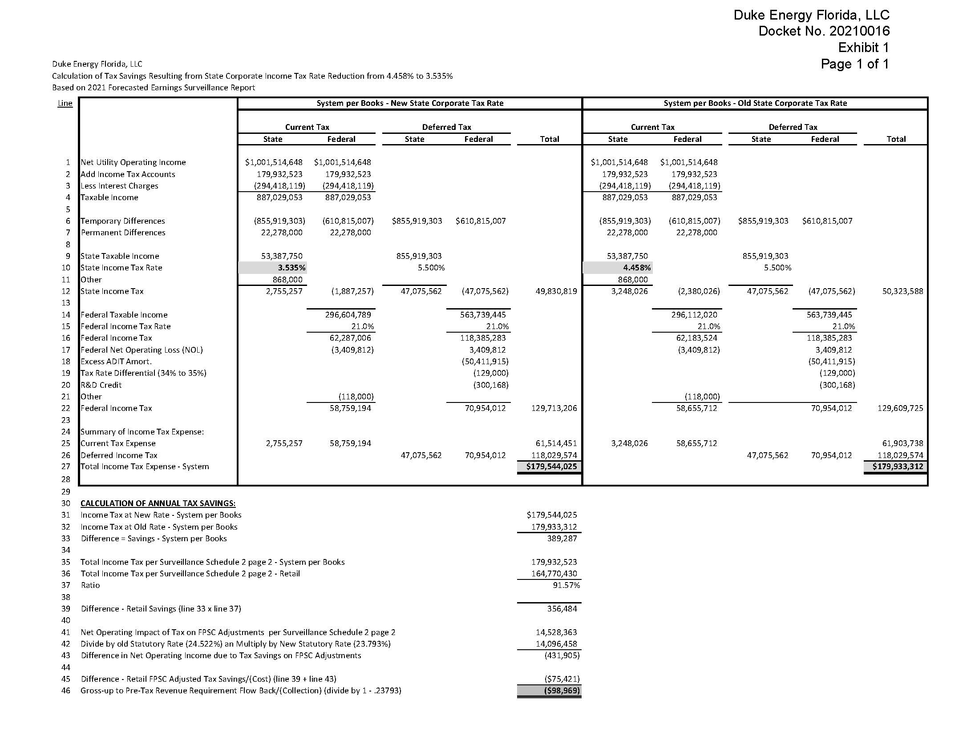

1. Order No. PSC-2021-0202-AS-EI, issued June 4, 2021, in Docket No. 20210016-EI, *In re: Petition for limited proceeding to approve 2021 settlement agreement, including general base rate increases, by Duke Energy Florida, LLC*, as amended by Order No. PSC-20210020A-AS-EI, issued June 28, 2021.
2. Document No. 13005-2021.