BEFORE THE FLORIDA PUBLIC SERVICE COMMISSION

In re: Petition of North American Numbering Plan Administrator on behalf of the Florida telecommunications industry, in the matter of the implementation for relief of the 904 numbering plan area. | DOCKET NO. 20220036-TP  ORDER NO. PSC-2022-0178-PAA-TP  ISSUED: May 10, 2022

The following Commissioners participated in the disposition of this matter:

ANDREW GILES FAY, Chairman
ART GRAHAM
GARY F. CLARK
MIKE LA ROSA
GABRIELLA PASSIDOMO

NOTICE OF PROPOSED AGENCY ACTION
ORDER APPROVING AN ALL-SERVICES DISTRIBUTED OVERLAY
AS THE AREA CODE RELIEF PLAN FOR THE 904 AREA CODE

BY THE COMMISSION:

NOTICE is hereby given by the Florida Public Service Commission that the action discussed herein is preliminary in nature and will become final unless a person whose interests are substantially affected files a petition for a formal proceeding, pursuant to Rule 25-22.029, Florida Administrative Code (F.A.C.).

Case Background
On February 17, 2022, the North American Numbering Plan Administrator (NANPA), on behalf of Florida’s telecommunications industry (Industry), filed a petition with the Florida Public Service Commission (Commission) for approval of its area code relief plan for the 904 Numbering Plan Area (NPA). The Industry reached a consensus decision to recommend an all-services distributed overlay as the form of relief for the 904 NPA. NANPA projects that the supply of central office codes in the 904 NPA will exhaust during the third quarter of 2024. Consequently, NANPA is also requesting that the Commission approve the recommended 13-month implementation schedule.
NANPA is the neutral third-party administrator of the North American Numbering Plan, which is the area code system shared by the United States, Canada, Bermuda, and 17 Caribbean countries. The area served by NANPA is divided into NPAs, which are each identified by a three-digit NPA code, commonly called an area code. NANPA’s responsibilities include assigning area codes and prefixes, and tracking numbering usage to ensure effective and efficient utilization. NANPA is also responsible for forecasting the exhaust of geographic area codes and area code relief planning. NANPA publishes its forecasted exhaust of all area codes on a semi-annual basis. This forecast is used to determine when to start the area code relief process.
The 904 area code was introduced in 1965 when the 305 area code needed relief due to substantial growth. It was the third area code assigned in Florida. Originally, the 904 area code covered the entire northern part of Florida. The first geographic split of the 904 NPA occurred in 1995, resulting in the creation of the 352 NPA. In 1997, as a result of additional growth the 904 NPA was split again creating the 850 NPA. The last geographic split of the 904 NPA was implemented in 2001, which created the 386 NPA. The 386 area code serves the only non-contiguous NPA in Florida, with one part at the western boundary of the 904 NPA and the other at the southeastern boundary. Currently, the 904 area code includes all or most of Nassau, Duval, Baker, Bradford, Clay, St Johns and Union Counties.
In January 2022, NANPA forecasted that the 904 area code would exhaust during the third quarter of 2024. NANPA convened an industry meeting on January 13, 2022, to review and approve the area code relief filing. On February 17, 2022, NANPA filed a petition with the Commission on behalf of the Industry requesting approval of an all services distributed overlay for the 904 area code (see map Attachment A). We have jurisdiction to address this issue pursuant to Sections 364.16(7) and 120.80(13)(d), Florida Statutes, and 47 Code of Federal Regulations (C.F.R.) § 52.19.

Analysis and Decision
Area code relief responsibilities have been delegated to the states by the Federal Communication Commission (FCC) pursuant to 47 C.F.R. § 52.19. In Florida, the Commission is responsible for determining the appropriate form of area code relief when telephone numbers exhaust within an area code. There are a number of methods available to address area code exhaust issues; however, the two most commonly used methods are a geographic split or an overlay.

Geographic Split

The geographic split method divides the exhausting NPA into two, leaving the existing area code to serve one NPA and assigning a new area code to serve the other NPA. This method generally acknowledges jurisdictional or natural boundaries, but for technical reasons and number optimization considerations, the actual boundaries must conform to existing rate center boundaries. Under this method, customers on both sides of the split would retain seven digit dialing; however, it would require customers in the new NPA to change their area code. The last split implemented in Florida was 20 years ago. Industry guidelines specify that in the case of a geographic split, the difference in area code life expectancies between the split areas should be 10 years or less.

Overlay

The overlay method adds a new area code to the same geographic area served by the area code requiring relief. This results in the assignment of more than one area code to the same NPA. Current customers keep their existing area code and number, while new customers or customers adding additional lines would receive the new area code. Once an overlay is implemented, the FCC requires 10-digit dialing for all local calls within the NPA. There are four potential implementation strategies for an overlay, which are as follows:

a) All-Services Distributed Overlay - The distributed overlay strategy may be considered in situations when growth in telephone numbers is expected to be more or less
evenly distributed throughout the existing NPA. The new area code is added to the same geographic area as the area code requiring relief and shares exactly the same geographic boundaries.
b) Concentrated Growth Overlay - A concentrated growth overlay may be considered in situations when the majority of need for the new telephone numbers is expected to be concentrated in one section of the existing NPA. For example, a fast growing metropolitan area and a sparsely populated rural area could exist within the same NPA. The overlay area code would be assigned initially to the section of the NPA experiencing the fastest growth, and new phone numbers in that section would be assigned from the new area code. As more relief is required, the geographic area served by multiple area codes could expand to the rest of the NPA.
c) Boundary Elimination Overlay - With a boundary elimination overlay, the NPA requiring relief is adjacent to an NPA with available numbering resources. The boundary between these NPAs is eliminated, and spare telephone numbers from the adjacent area code are assigned within the NPA boundary where relief is required.

During the February 17, 2022, Industry meeting hosted by NANPA, the following six relief plans were considered.

Alternative No. 1 - All-Services Distributed Overlay (see map in Attachment A)

A new area code would be assigned to the same geographic area occupied by the existing 904 area code. Customers would retain their current telephone numbers; however, 10-digit dialing would be required by all customers within the NPA. At the exhaust of the 904 area code, all future assignments will be made from the new area code. The projected life of this method would be approximately 29 years.

Alternative No. 2 - Boundary Elimination Overlay (see map in Attachment B)

The boundary between the existing 904 and 386 area codes would be eliminated and both area codes would be assigned to the combined geographic area. This alternative would allow customers assigned the 904 and 386 area codes to retain their telephone numbers and would eliminate the need for a new area code. However, it would require 10-digit dialing for all customers within the combined NPA. The projected life of this method would be approximately 9 years.

Alternative No. 3 - Overlay of a New Area Code with Boundary Elimination (see map in Attachment C)

The boundary between the 904 and 386 area codes would be eliminated and a new area code would be assigned to the combined geographic area. This alternative would allow customers assigned the 904 and 386 area codes to retain their telephone numbers. However, it would require 10-digit dialing for all customers within the NPA. At the exhaust of the 904 and 386 area codes all future assignments would be made from the new area code. The projected life of this method would be approximately 26 years.

Alternative No. 4 - Overlay of a New Area Code with Boundary Elimination (see map in Attachment D)

The boundary between the existing 904, 386, and 352 area codes would be eliminated and a new area code would be assigned to the combined geographic area. This alternative would allow customers assigned the 904, 386, and 352 area codes to retain their telephone numbers. However, it would require 10-digit dialing for all customers within the combined NPA. At the exhaust of the 904, 386, and 352 area codes all future assignments would be made from the new area code. The projected life of this method would be approximately 17 years.

Alternative No. 5 - Overlay of a New Area Code with Boundary Elimination (see map in Attachment E)

The boundary between the 904 and 352 area codes would be eliminated and a new area code would be assigned to the combined geographic area. This alternative would allow customers assigned the 904 and 352 area codes to retain their telephone numbers. However, it would require 10-digit dialing for all customers within the combined NPA. At the exhaust of the 904 and 352 area codes all future assignments would be made from the new area code. The projected life of this method would be approximately 17 years.

Alternative No. 6 – A Geographic Split (see map in Attachment F and G)

The 904 area code would be split into two geographic areas. The split boundary would separate the Jacksonville rate center which consist of the city of Jacksonville (Area A) and the remaining 18 rate centers which includes Jacksonville Beach (Area B). The 904 area code would serve one area and the new area code would serve the other. The Commission would have to determine which geographic area would retain the 904 area code. Customers on both sides of the split would retain seven digit dialing. The projected life of this method would be approximately 26 years for Area A and 33 years for Area B.

Industry Consensus

After review of the six alternatives, the Industry reached a consensus recommending alternative No. 1, an all-services distributed overlay, as the form of relief for the 904 NPA. The Industry decided against the other alternatives due to the fact that they have shorter projected exhaust dates. Also, the complicated technical and customer education issues would potentially prolong implementation.

Industry Proposed Dialing Plan

If an all-services distributed overlay is approved by the Commission, the Industry recommends the dialing plan be set forth as follows:

Local Calls 10-digit dialing (as required by the FCC)
Toll Calls 1 + 10-digit dialing
Operator Calls 0 + 10-digit dialing

The Industry has also recommended a 13-month implementation schedule. This schedule includes six-months for network preparation, followed by a six-month permissive 10-digit dialing and customer education period. During the permissive dialing period, calls within the 904 area code can be completed using either 7-digits or 10-digits. The purpose of the permissive dialing period is to facilitate transition from 7-digit to 10-digit dialing by educating customers on the impending changes without impacting the calls. Following the six-month permissive dialing, mandatory 10-digit dialing will be required. If the required 10-digits are not dialed, the caller will receive a recorded message advising them that the area code is required to complete the call.

Staff Workshop

In an effort to educate and receive customer input, Commission staff held a virtual customer workshop on March 23, 2022. During this workshop Commission staff and a representative from NANPA explained the area code relief process, the relief options being considered, and customer impact. Four customer comments were filed with the Commission. Two customers offered suggestions concerning what the new area code should be and the others expressed that they didn’t want their area code to change.

Conclusion

We reviewed the petition and analyzed all alternatives. We considered which alternative would provide the longest length of time before needing relief and the impact on customers and the Industry. We note that except for alternative No. 6, all the alternatives would require customers to dial 10-digits for all local calls. Alternatives No. 2, 3 and 4 would impose 10-digit local dialing for customers in the 386 area code who otherwise potentially would not be affected for another 17 years. Alternative No. 6 is the geographic split option which would allow customers to continue 7-digit local dialing but would require some customers to change their area code. As a result, those customers and businesses receiving the new area code would be forced to incur costs to implement the area code change on advertisements, billboards, etc. Additionally, this Commission would have to determine which customers would receive the new area code. We note that the Industry has indicated alternative’s No. 2-6 would require additional time to implement.

We conclude that alternative No. 1 provides the longest projected exhaust date, it minimizes the number of customers impacted by 10-digit local dialing, and it would take the least amount of time to implement. Therefore, we agree with the Industry and approve the all-services distributed overlay as the form of relief for the 904 area code. Additionally, we approve the proposed 13-month implementation schedule. Finally, we approve that central office codes in the new area code be available only when all assignable prefixes in the 904 area code have been assigned.

Based on the foregoing, it is

ORDERED by the Florida Public Service Commission that the Industry’s consensus recommendation of an all-services distrusted overlay as the area code relief plan for the 904 area code is approved. It is further

ORDERED that the proposed 13-month implementation schedule is approved. It is further

ORDERED that central office codes in the new area code be available only when all assignable prefixes in the 904 area code have been assigned. It is further

ORDERED that the provisions of this Order, issued as proposed agency action, shall become final and effective upon the issuance of a Consummating Order unless an appropriate petition, in the form provided by Rule 28-106.201, Florida Administrative Code, is received by the Commission Clerk, 2540 Shumard Oak Boulevard, Tallahassee, Florida 32399-0850, by the close of business on the date set forth in the “Notice of Further Proceedings” attached hereto. It is further

ORDERED that this docket shall remain open pending the full implementation of the all-services distributed overlay of the 904 area code. Once this action is complete, the docket shall be closed administratively.

By ORDER of the Florida Public Service Commission this 10th day of May, 2022.

/s/ Adam J. Teitzman
ADAM J. TEITZMAN
Commission Clerk
Florida Public Service Commission
2540 Shumard Oak Boulevard
Tallahassee, Florida 32399
(850) 413-6770
www.floridapsc.com

Copies furnished: A copy of this document is provided to the parties of record at the time of issuance and, if applicable, interested persons.
AJW/JDI

NOTICE OF FURTHER PROCEEDINGS OR JUDICIAL REVIEW

The Florida Public Service Commission is required by Section 120.569(1), Florida Statutes, to notify parties of any administrative hearing that is available under Section 120.57, Florida Statutes, as well as the procedures and time limits that apply. This notice should not be construed to mean all requests for an administrative hearing will be granted or result in the relief sought.

Mediation may be available on a case-by-case basis. If mediation is conducted, it does not affect a substantially interested person's right to a hearing.

The action proposed herein is preliminary in nature. Any person whose substantial interests are affected by the action proposed by this order may file a petition for a formal proceeding, in the form provided by Rule 28-106.201, Florida Administrative Code. This petition must be received by the Office of Commission Clerk, 2540 Shumard Oak Boulevard, Tallahassee, Florida 32399-0850, by the close of business on May 31, 2022.

In the absence of such a petition, this order shall become final and effective upon the issuance of a Consummating Order.

Any objection or protest filed in this/these docket(s) before the issuance date of this order is considered abandoned unless it satisfies the foregoing conditions and is renewed within the specified protest period.

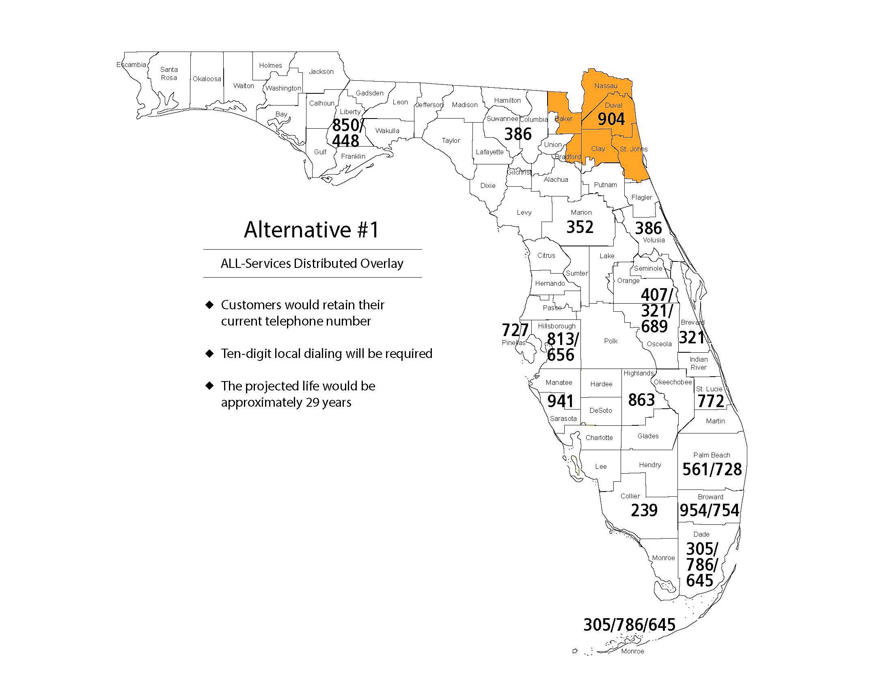

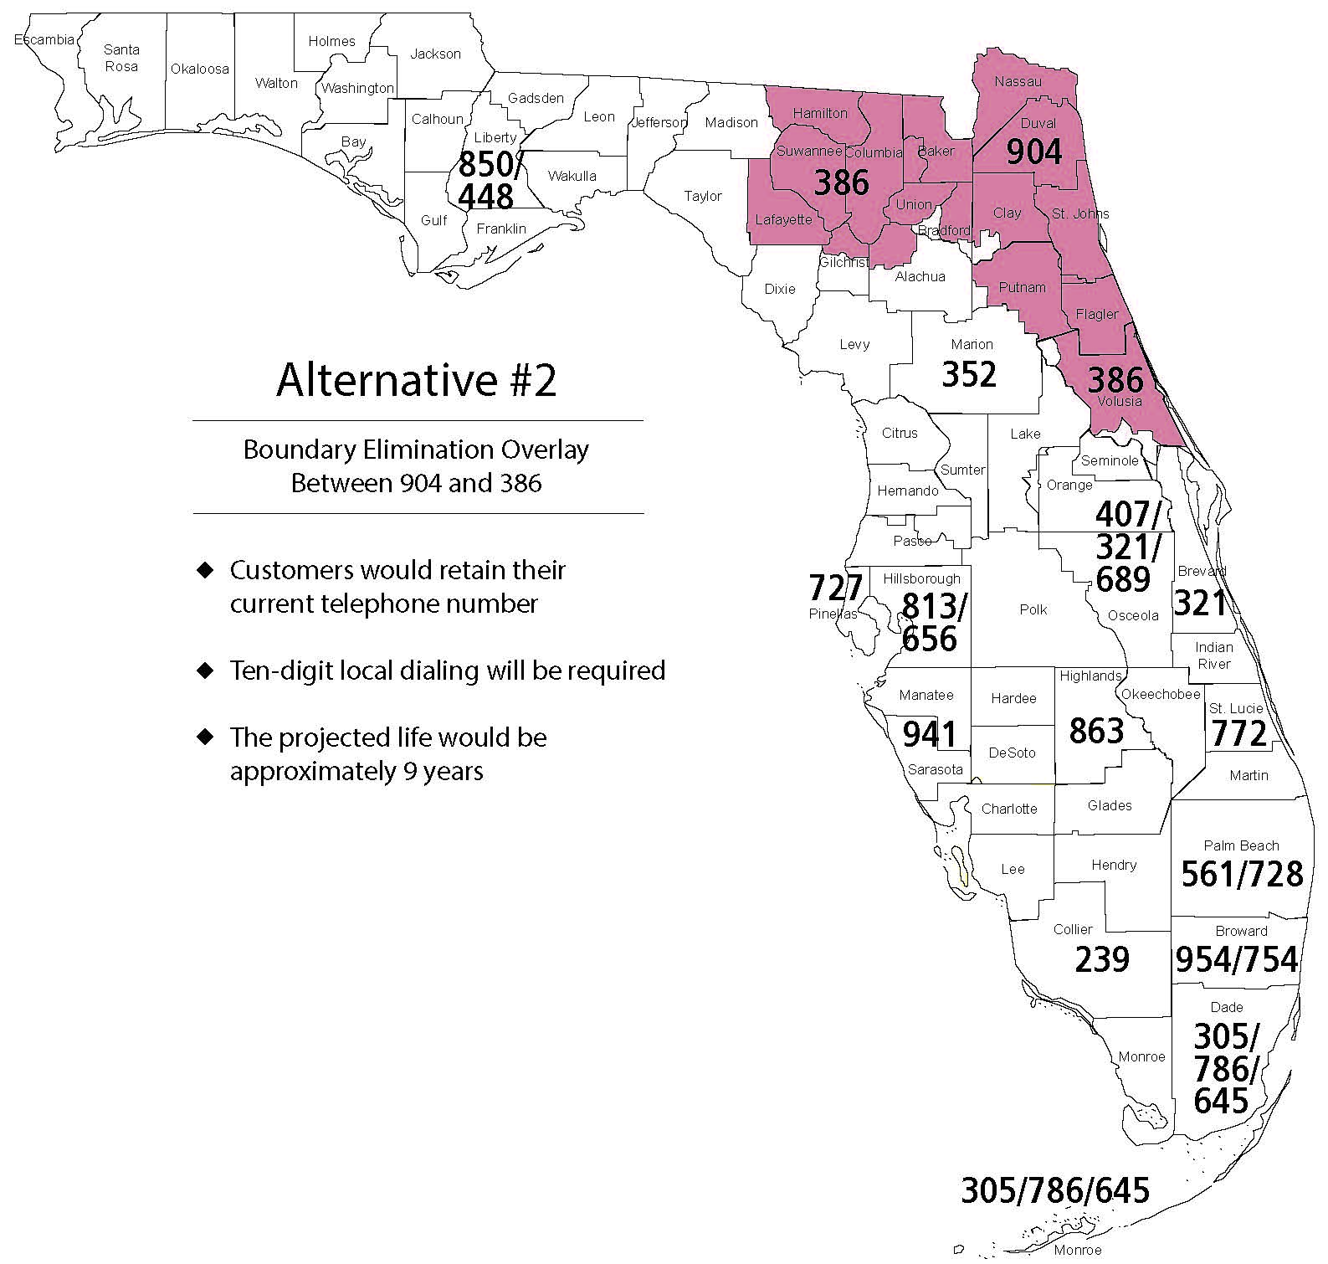

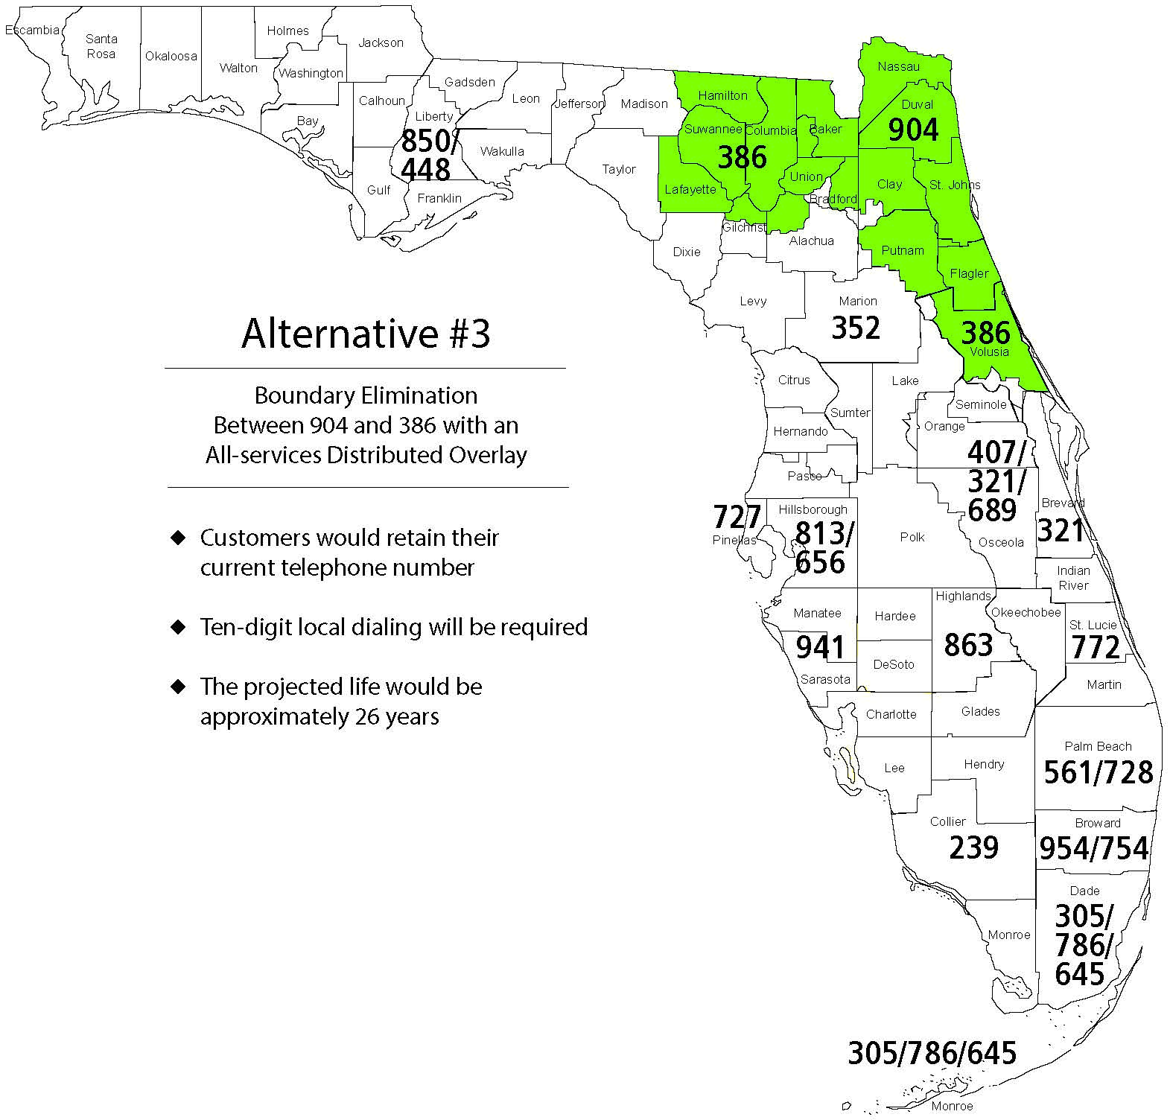

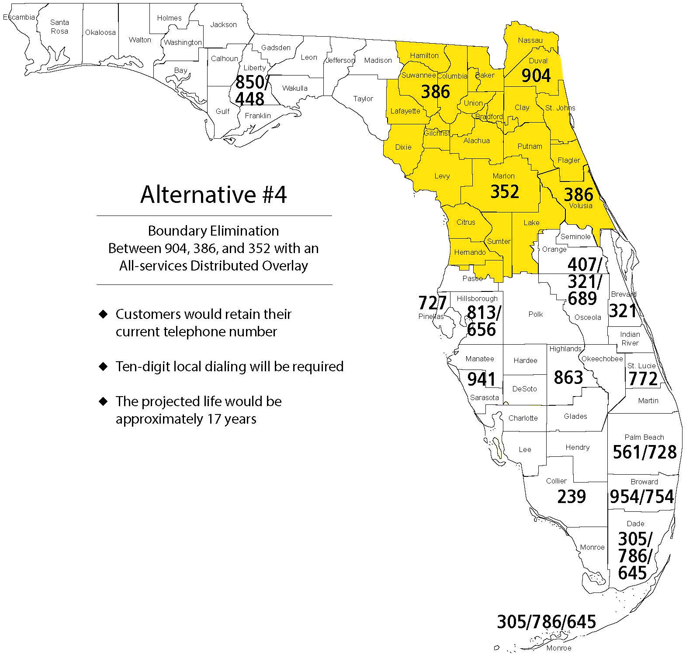

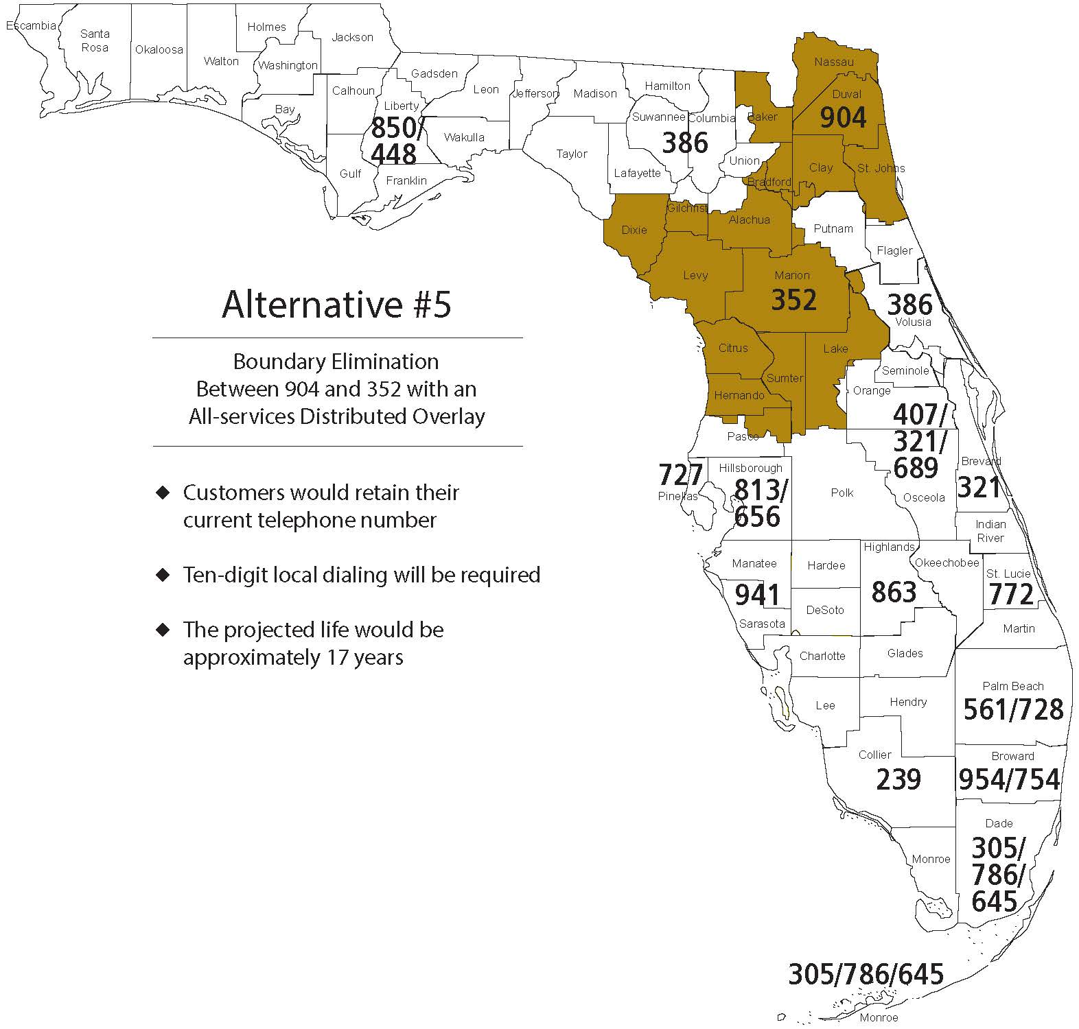

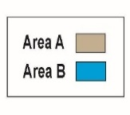
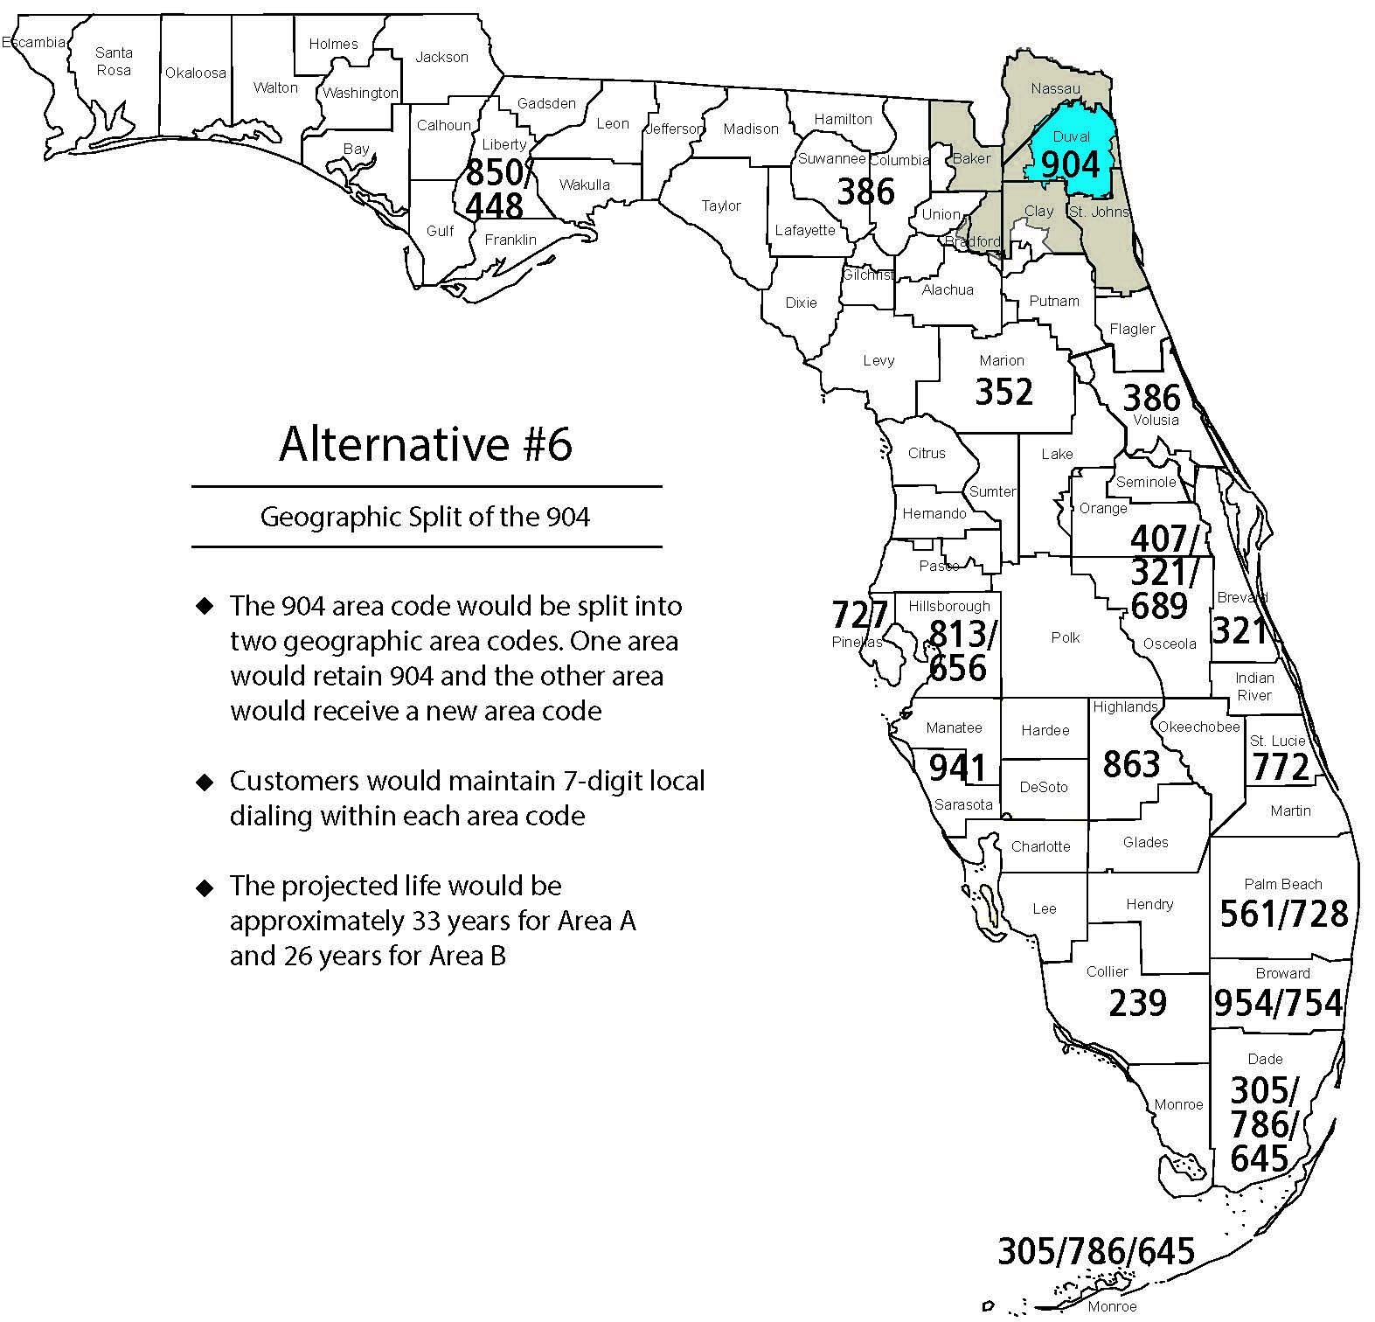

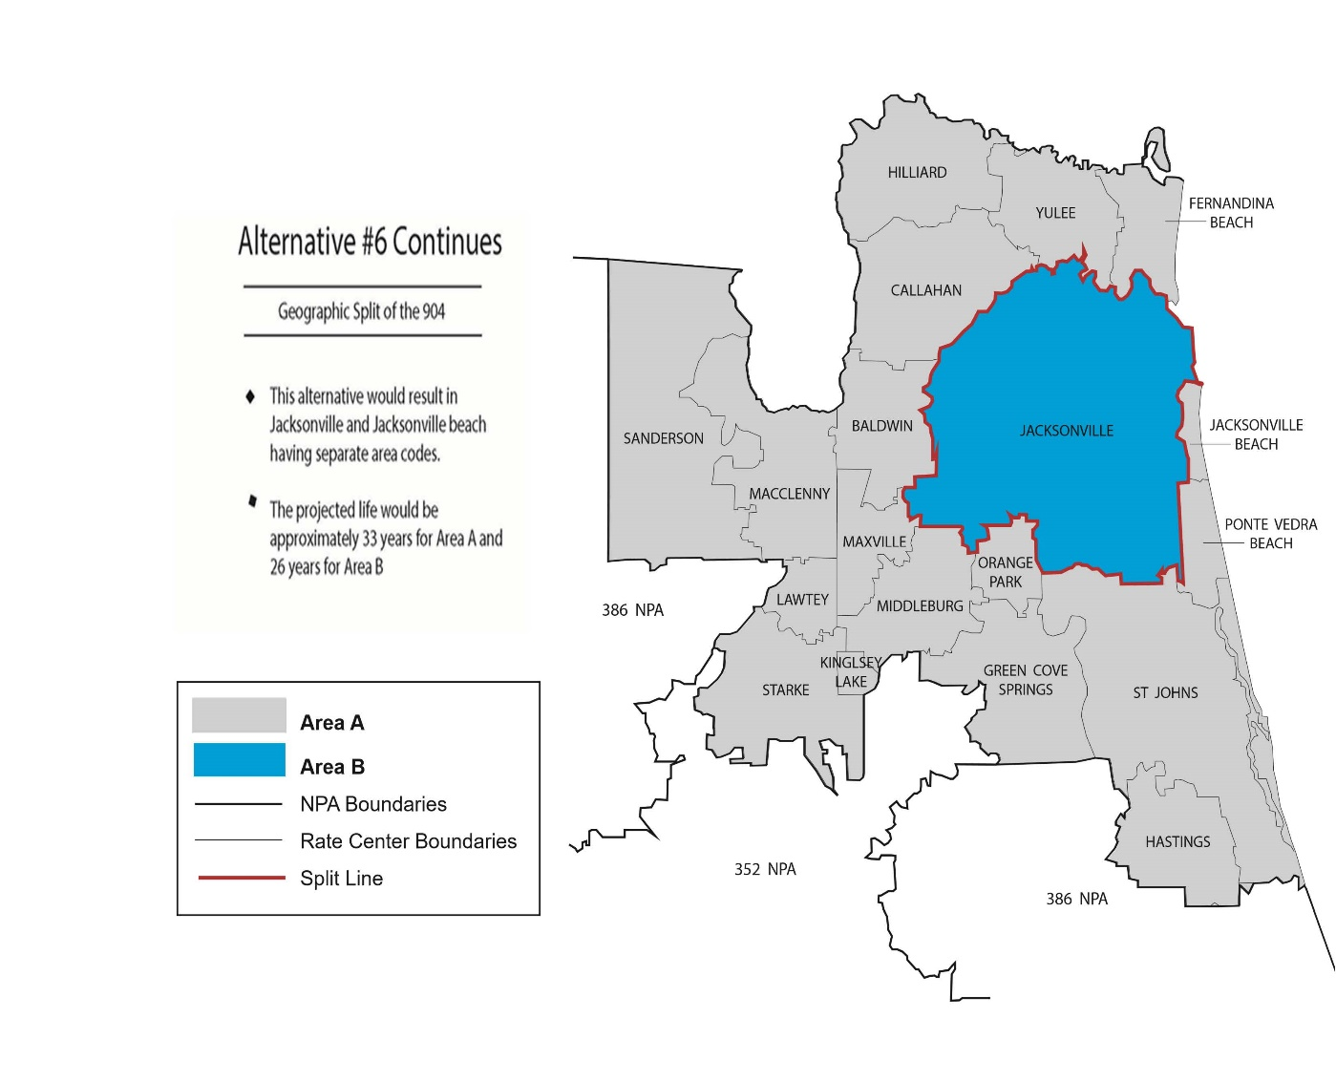
Alternative #6 Continues
Geographic Split of the 904
- This alternative would result in Jacksonville and Jacksonville Beach having separate area codes

- The projected life would be approximately 33 years for Area A and 26 years for Area B

Alternative #6 Continues
Geographic Split of the 904
- This alternative would result in Jacksonville and Jacksonville Beach having separate area codes

- The projected life would be approximately 33 years for Area A and 26 years for Area B

NPA Code Relief Planning & Notification Guidelines ATIS-0300061 - Section 5.0 (g).

