BEFORE THE FLORIDA PUBLIC SERVICE COMMISSION

In re: Petition for approval of revised standard offer contract and a revised accompanying rate schedule QS-2, by Florida Power & Light Company. | DOCKET NO. 20220072-EQ  ORDER NO. PSC-2022-0203-PAA-EQ  ISSUED: June 9, 2022

The following Commissioners participated in the disposition of this matter:

ANDREW GILES FAY, Chairman
ART GRAHAM
GARY F. CLARK
MIKE LA ROSA
GABRIELLA PASSIDOMO

NOTICE OF PROPOSED AGENCY ACTION
ORDER APPROVING FLORIDA POWER & LIGHT COMPANY’S
AMENDED STANDARD OFFER CONTRACT AND RATE SCHEDULE

BY THE COMMISSION:

NOTICE is hereby given by the Florida Public Service Commission that the action discussed herein is preliminary in nature and will become final unless a person whose interests are substantially affected files a petition for a formal proceeding, pursuant to Rule 25-22.029, Florida Administrative Code (F.A.C.).

Background
Section 366.91(3), Florida Statutes (F.S.), requires each investor-owned utility (IOU) to continuously offer to purchase capacity and energy from renewable generating facilities and small qualifying facilities. Florida Public Service Commission (Commission) Rules 25-17.200 through 25-17.310, F.A.C., implement the statute and require each IOU to file with the Commission, by April 1 of each year, a revised standard offer contract based on the next avoidable fossil-fueled generating unit of each technology type identified in the utility’s current Ten-Year Site Plan (TYSP). On April l, 2022, Florida Power & Light Company (FPL) filed a petition for approval of its amended standard offer contract based on its 2022 TYSP. We have jurisdiction over this amended standard offer contract pursuant to Sections 366.04 through 366.055, and 366.91, F.S.

Review and Decision

Section 366.91(3), F.S., and Rule 25-17.250, F.A.C., require that FPL, an IOU continuously make available a standard offer contract for the purchase of firm capacity and energy from renewable generating facilities (RF) and small qualifying facilities (QF) with design capacities of 100 kilowatts (kW) or less. Pursuant to Rules 25-17.250(1) and (3), F.A.C., the standard offer contract must provide a term of at least 10 years, and the payment terms must be based on the utility’s next avoidable fossil-fueled generating unit identified in its most recent TYSP, or if no avoided unit is identified, its next avoidable planned purchase. While FPL’s 2022 TYSP does not feature an avoidable fossil-fueled generating unit or planned purchases that could be deferred during the planning period, FPL has identified a 1,991 megawatt (MW) combined cycle with a projected in-service date of June 1, 2032 as the next avoidable planned generating unit. FPL submitted two planning scenarios for its 2022 TYSP; and, the avoided unit is identical in both scenarios. We have previously approved using a unit outside of the TYSP planning period as the avoided unit for standard offer contract purposes.
Under FPL’s standard offer contract, the RF/QF operator commits to certain minimum performance requirements based on the identified avoided unit, such as being operational and delivering an agreed upon amount of capacity by the in-service date of the avoided unit, and thereby becomes eligible for capacity payments in addition to payments received for energy. The standard offer contract may also serve as a starting point for negotiation of contract terms by providing payment information to an RF/QF operator, in a situation where one or both parties desire particular contract terms other than those established in the standard offer.
In order to promote renewable generation, we require the IOU to offer multiple options for capacity payments, including the options to receive early or levelized payments. If the RF/QF operator elects to receive capacity payments under the normal or levelized contract options, it will receive as-available energy payments only until the in-service date of the avoided unit (in this case June 1, 2032), and thereafter, begin receiving capacity payments in addition to firm energy payments. If either the early or early levelized option is selected, then the operator will begin receiving capacity payments earlier than the in-service date of the avoided unit. However, payments made under the early capacity payment options tend to be lower in the later years of the contract term because the net present value (NPV) of the total payments must remain equal for all contract payment options.
Table 1 contains FPL’s estimates of the annual payments for each payment option available under the revised standard offer contract to an operator with a 50 MW facility operating at a capacity factor of 94 percent, which is the minimum capacity factor required under the contract to qualify for full capacity payments. Normal and levelized capacity payments begin with the projected in-service date of the avoided unit (June 1, 2032) and continue for 10 years, while early and early levelized capacity payments begin four years prior to the in-service date, or 2028 for this example.
Table 1 Estimated Annual Payments to a 50 MW Renewable Facility
(94% Capacity Factor)
Year | Energy Payment | Capacity Payment
 |  | Normal | Levelized | Early | Early Levelized
 | $(000) | $(000) | $(000) | $(000) | $(000)
2023 | 10,849 | - | - | - | -
2024 | 8,776 | - | - | - | -
2025 | 8,929 | - | - | - | -
2026 | 9,196 | - | - | - | -
2027 | 8,917 | - | - | - | -
2028 | 9,389 | - | - | 1,211 | 1,358
2029 | 10,160 | - | - | 2,102 | 2,328
2030 | 10,595 | - | - | 2,146 | 2,328
2031 | 10,861 | - | - | 2,191 | 2,328
2032 | 10,409 | 2,064 | 2,243 | 2,237 | 2,328
2033 | 9,958 | 3,582 | 3,845 | 2,284 | 2,328
2034 | 10,230 | 3,657 | 3,845 | 2,332 | 2,328
2035 | 10,527 | 3,734 | 3,845 | 2,381 | 2,328
2036 | 10,854 | 3,812 | 3,845 | 2,431 | 2,328
2037 | 11,023 | 3,893 | 3,845 | 2,483 | 2,328
2038 | 11,271 | 3,975 | 3,845 | 2,535 | 2,328
2039 | 11,445 | 4,058 | 3,845 | 2,588 | 2,328
2040 | 11,675 | 4,144 | 3,845 | 2,643 | 2,328
2041 | 11,743 | 4,231 | 3,845 | 2,698 | 2,328
2042 | 11,842 | 1,778 | 1,602 | 1,134 | 970
Total | 208,651 | 38,927 | 38,450 | 33,396 | 32,599
Total (NPV) | 103,307 | 13,382 | 13,382 | 13,382 | 13,382
Source: Response to Staff’s First Data Request
FPL’s standard offer contract, in type-and-strike format, is included as Attachment A to this recommendation. The changes made to FPL’s tariff sheets are consistent with the updated avoided unit. Revisions include updates to calendar dates and payment information which reflect the current economic and financial assumptions for the avoided unit. In addition, the language in Section 15, Sheet No. 9.042, which addresses insurance, has been updated. The current language requires insurance with a minimum limit of one million dollars per occurrence. The new language requires that, in addition to the one million, the QF insurance shall have a two million dollar combined aggregate limit for bodily injury or property damage. In response to our staff’s data request, FPL states that the proposed change aligns with current market conditions and is similar to other utilities. For customer-owned net metering interconnections, Rule 25-6.065(5)(e), F.A.C., allows for up to $2 million in liability insurance for Tier 3 (100 kW to 2 MW) installations. We find that the change to the language in Section 15 is reasonable and consistent with other approved utility standard offer contracts and net metering standards.
The provisions of FPL’s renewable energy tariff and amended standard offer contract conform to the requirements of Rules 25-17.200 through 25-17.310, F.A.C. The amended standard offer contract offers multiple payment options so that a developer of renewable generation may select the payment stream best suited to its financial needs.

Based on the foregoing, it is

ORDERED by the Florida Public Service Commission that the amended standard offer contract and associated rate schedule QS-2 filed by Florida Power & Light Company are hereby approved. It is further

ORDERED that the provisions of this Order, issued as proposed agency action, shall become final and effective upon the issuance of a Consummating Order unless an appropriate petition, in the form provided by Rule 28-106.201, Florida Administrative Code, is received by the Commission Clerk, 2540 Shumard Oak Boulevard, Tallahassee, Florida 32399-0850, by the close of business on the date set forth in the “Notice of Further Proceedings” attached hereto.
Potential signatories should be aware that, if a timely protest is filed, FPL’s standard offer contract may subsequently be revised. It is further

ORDERED that in the event this Order becomes final, this docket shall be closed.

By ORDER of the Florida Public Service Commission this 9th day of June, 2022.

/s/ Adam J. Teitzman
ADAM J. TEITZMAN
Commission Clerk
Florida Public Service Commission
2540 Shumard Oak Boulevard
Tallahassee, Florida 32399
(850) 413-6770
www.floridapsc.com

Copies furnished: A copy of this document is provided to the parties of record at the time of issuance and, if applicable, interested persons.

JDI

NOTICE OF FURTHER PROCEEDINGS OR JUDICIAL REVIEW

The Florida Public Service Commission is required by Section 120.569(1), Florida Statutes, to notify parties of any administrative hearing or judicial review of Commission orders that is available under Sections 120.57 or 120.68, Florida Statutes, as well as the procedures and time limits that apply. This notice should not be construed to mean all requests for an administrative hearing or judicial review will be granted or result in the relief sought.

As identified in the body of this order, our action is preliminary in nature. Any person whose substantial interests are affected by the action proposed by this order may file a petition for a formal proceeding, in the form provided by Rule 28-106.201, Florida Administrative Code. This petition must be received by the Office of Commission Clerk, at 2540 Shumard Oak Boulevard, Tallahassee, Florida 32399-0850, by the close of business on June 30, 2022. If such a petition is filed, mediation may be available on a case-by-case basis. If mediation is conducted, it does not affect a substantially interested person's right to a hearing. In the absence of such a petition, this order shall become effective and final upon the issuance of a Consummating Order.

Any objection or protest filed in this docket before the issuance date of this order is considered abandoned unless it satisfies the foregoing conditions and is renewed within the specified protest period.

Any party adversely affected by the Commission's final action in this matter may request: (1) reconsideration of the decision by filing a motion for reconsideration with the Office of Commission Clerk, within fifteen (15) days of the issuance of this order in the form prescribed by Rule 25-22.060, Florida Administrative Code; or (2) judicial review by the Florida Supreme Court in the case of an electric, gas or telephone utility or the First District Court of Appeal in the case of a water or wastewater utility by filing a notice of appeal with the Office of Commission Clerk and filing a copy of the notice of appeal and the filing fee with the appropriate court. This filing must be completed within thirty (30) days after the issuance of this order, pursuant to Rule 9.110, Florida Rules of Appellate Procedure. The notice of appeal must be in the form specified in Rule 9.900(a), Florida Rules of Appellate Procedure.

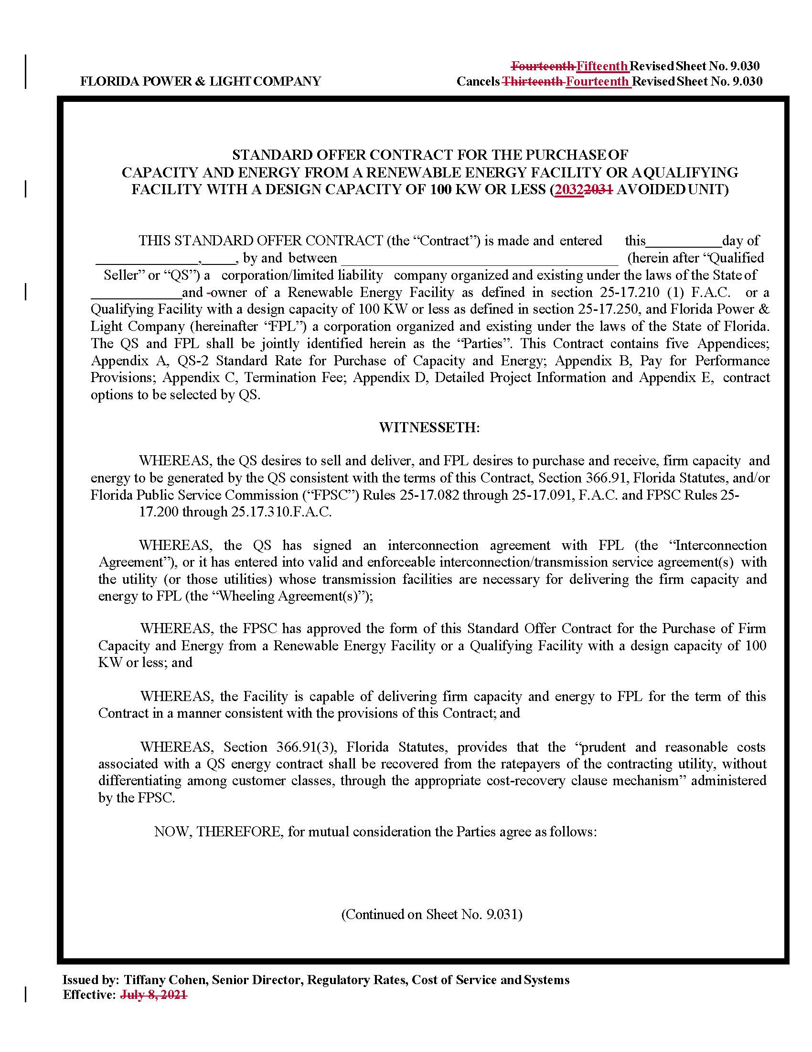

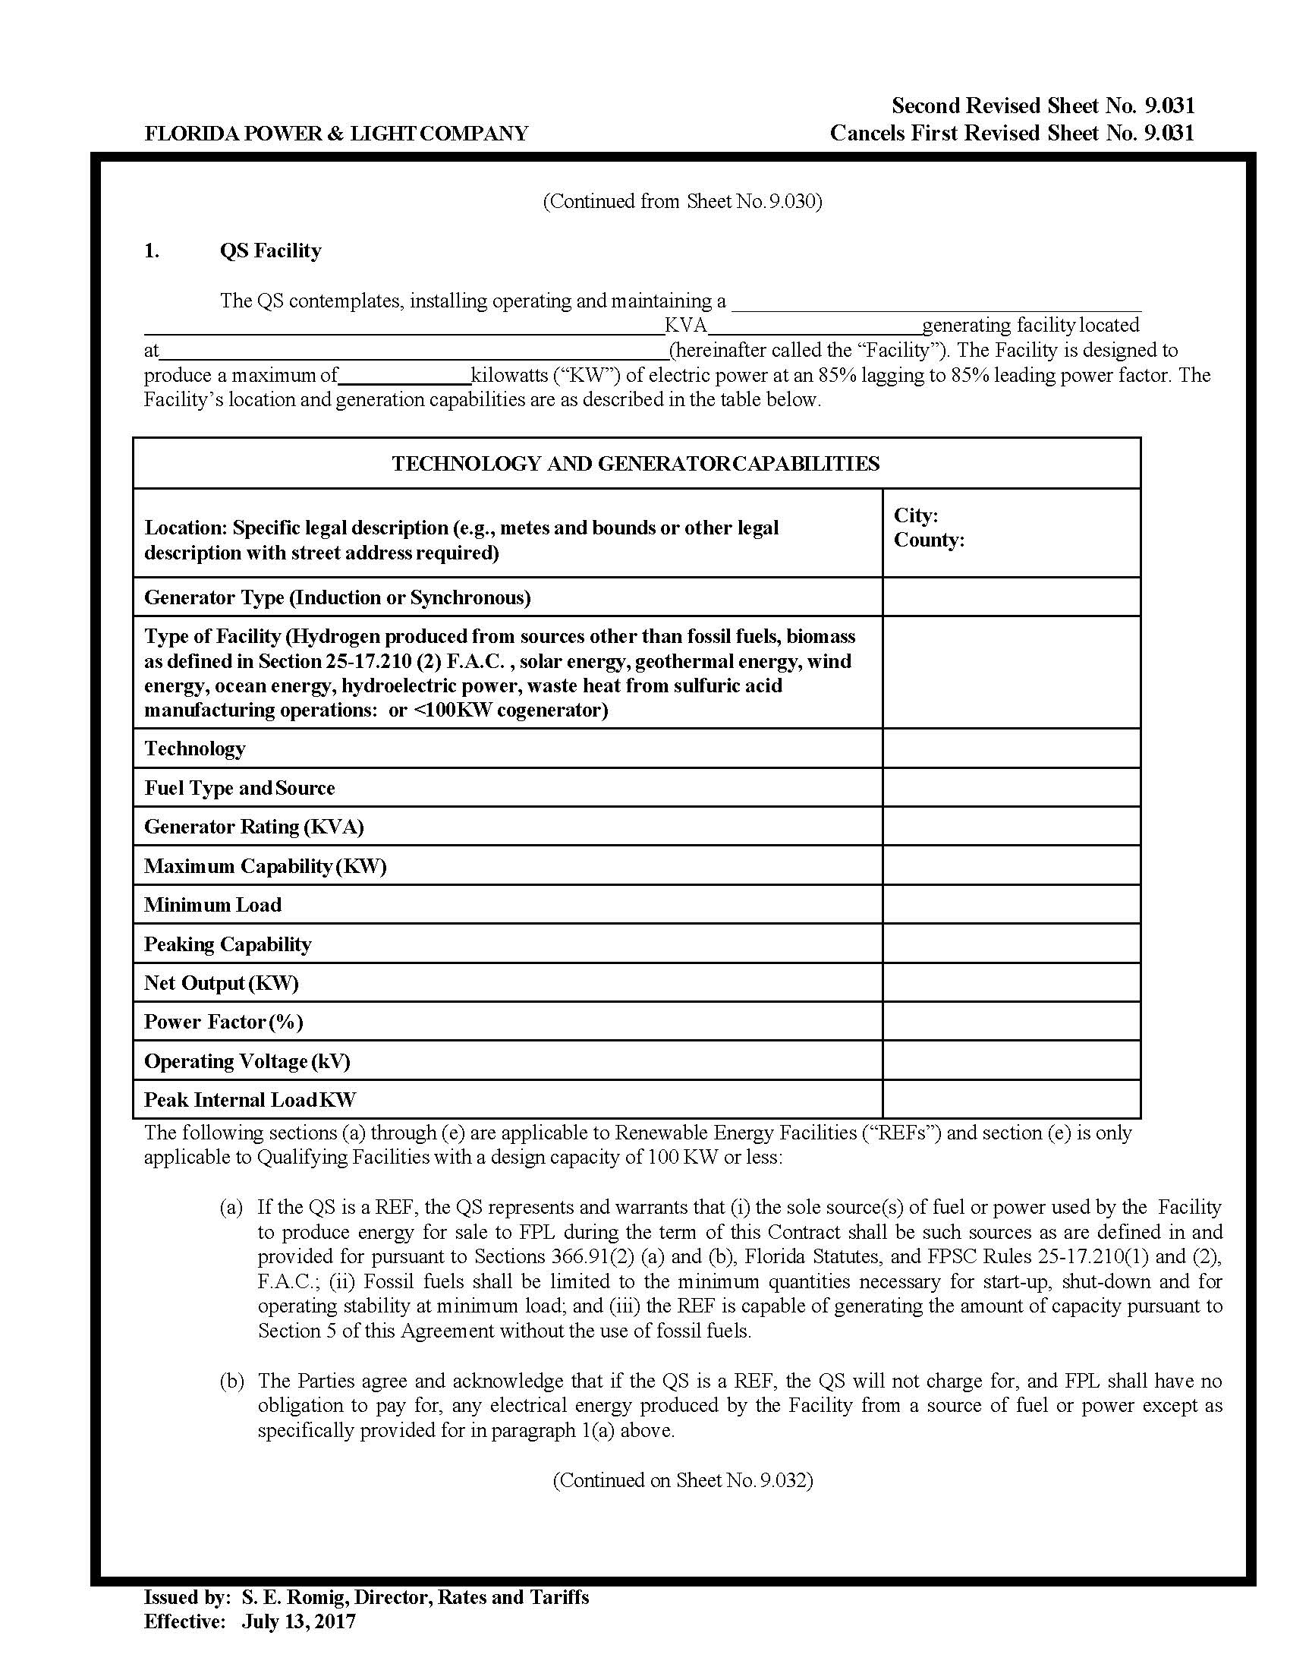

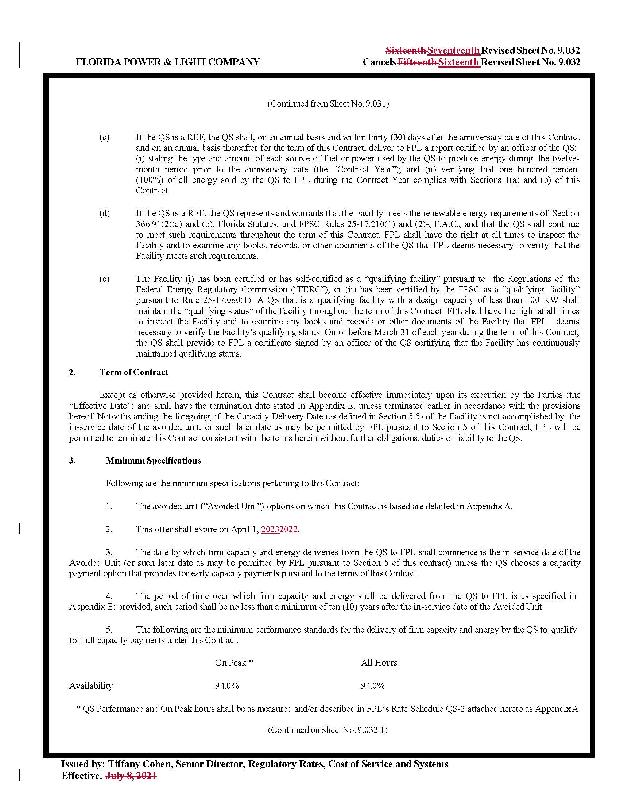

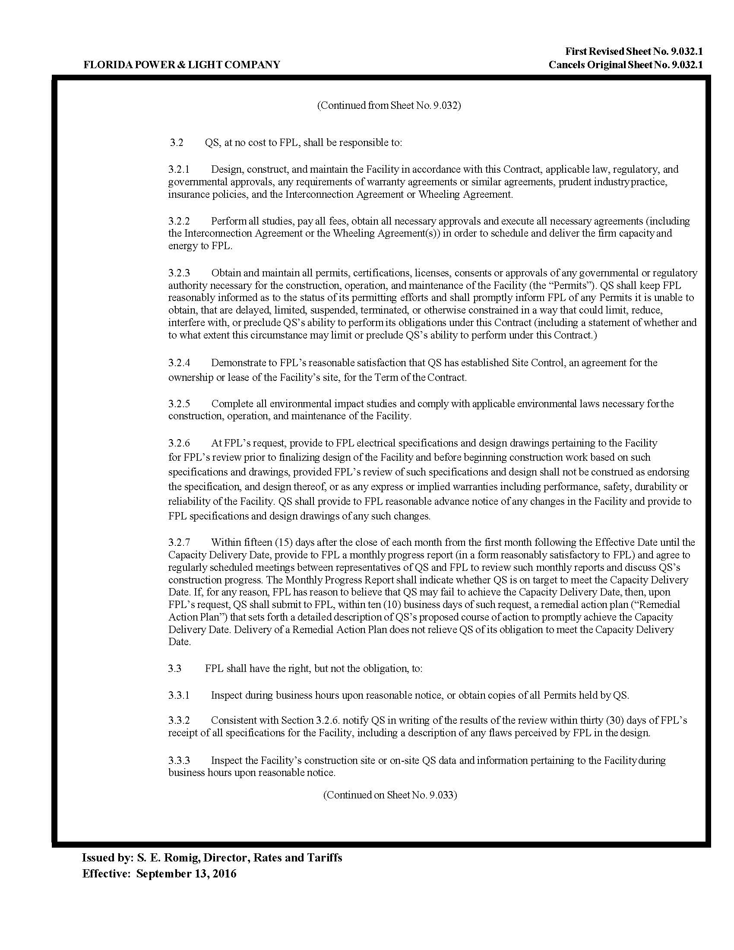

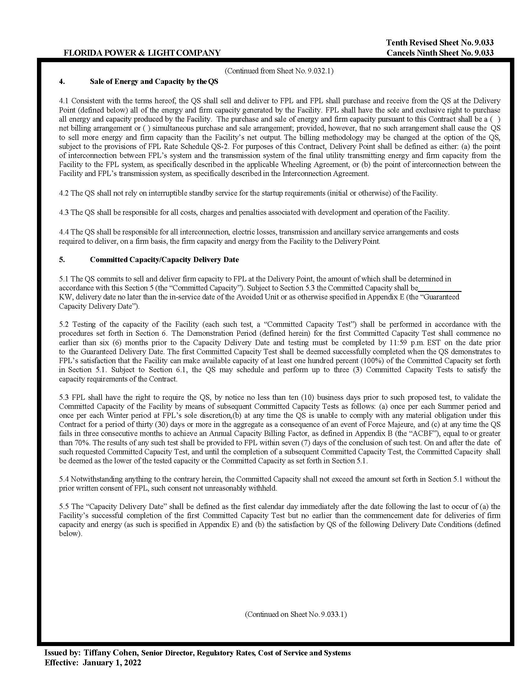

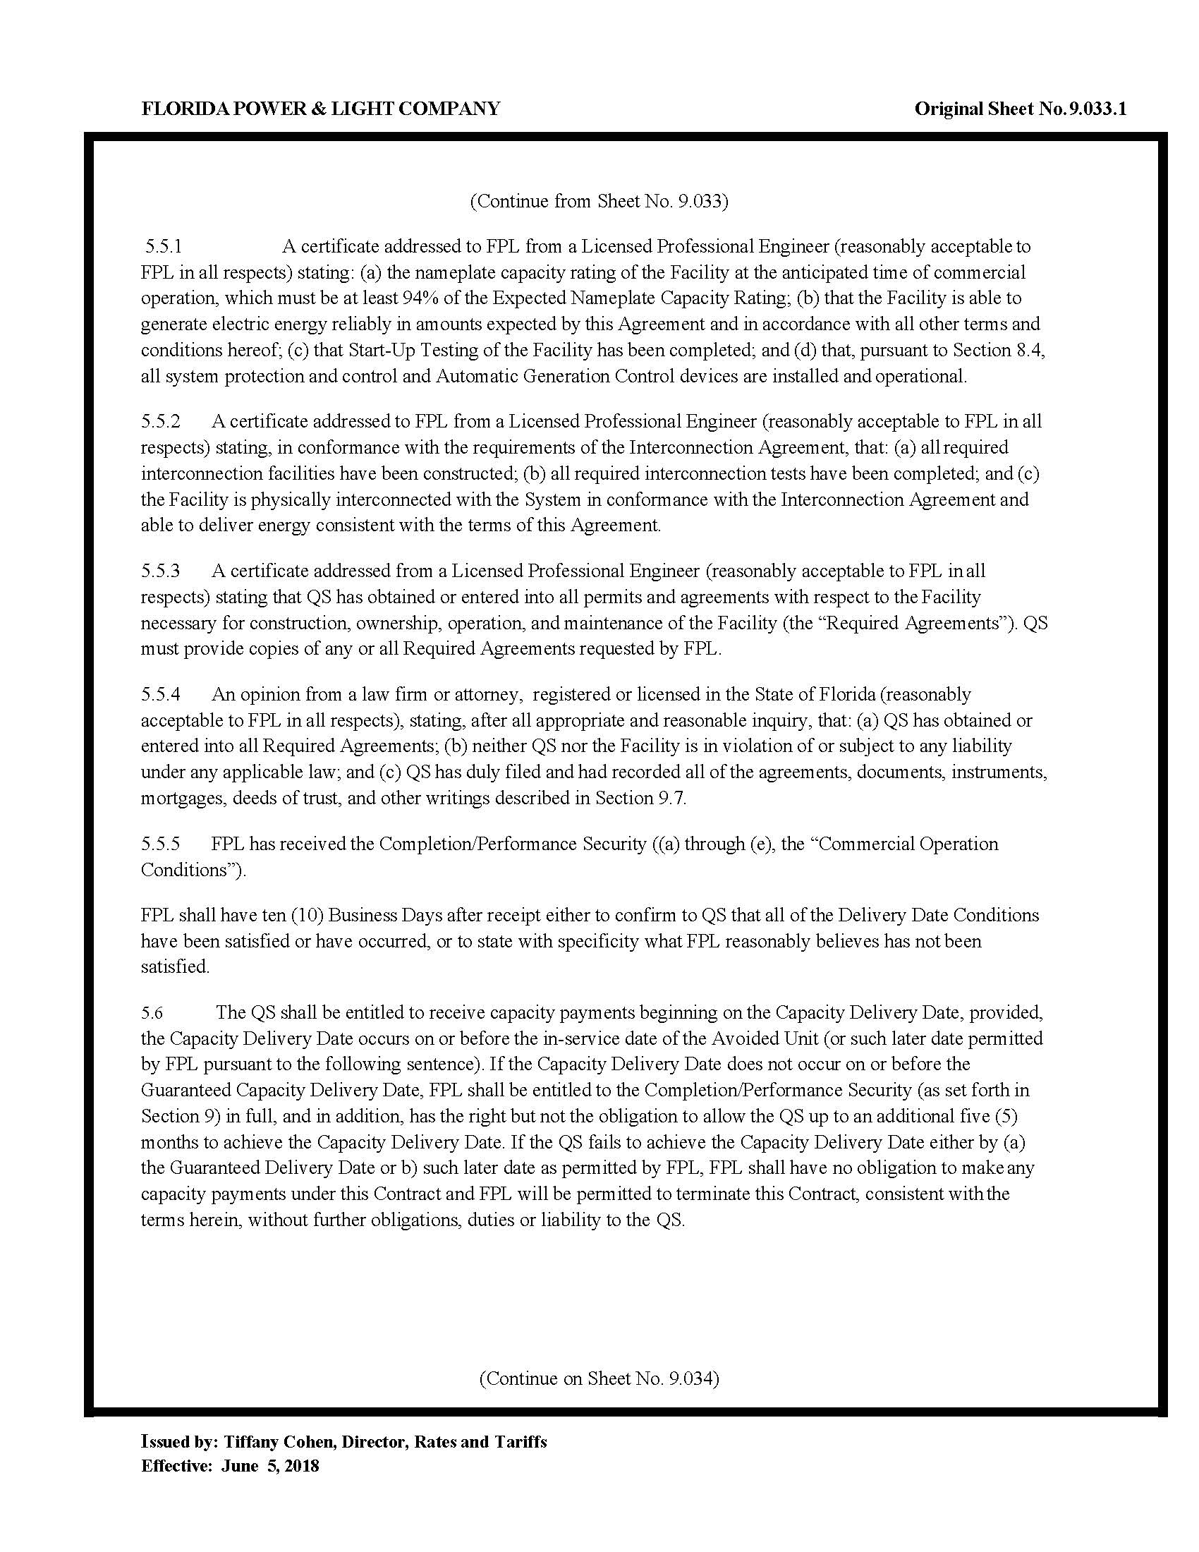

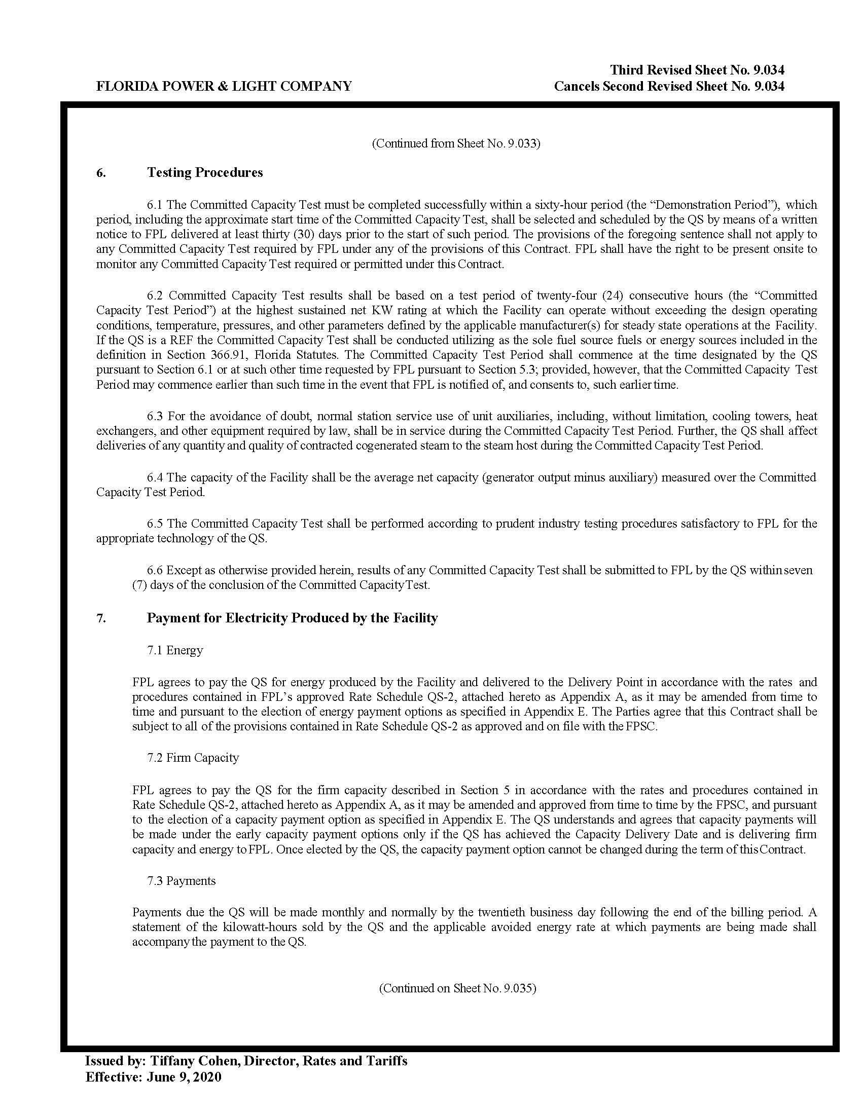

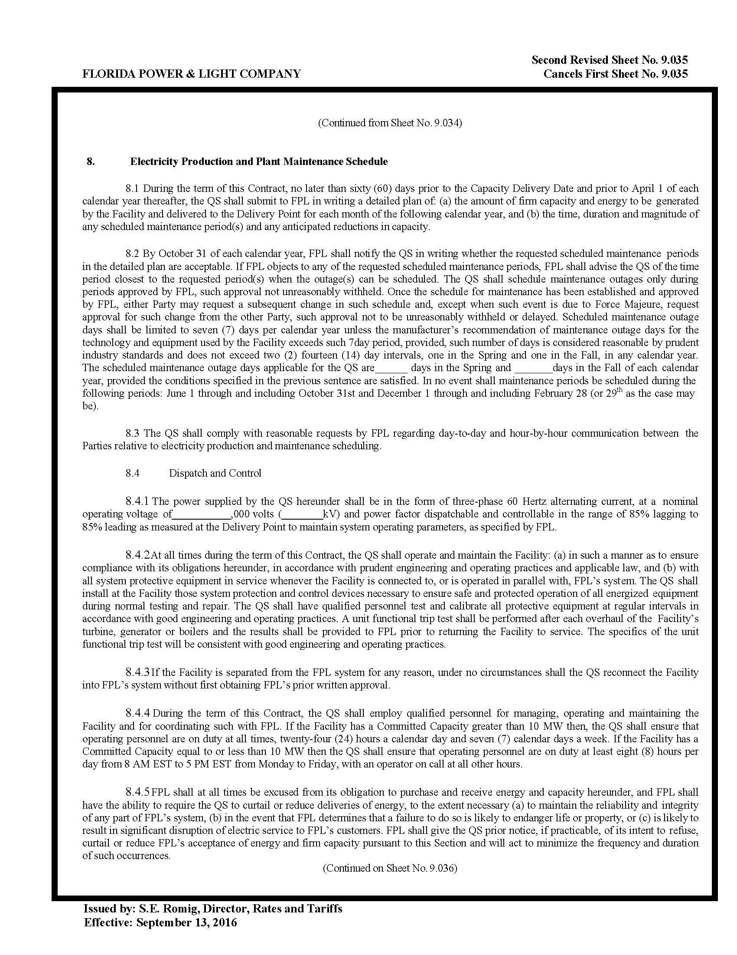

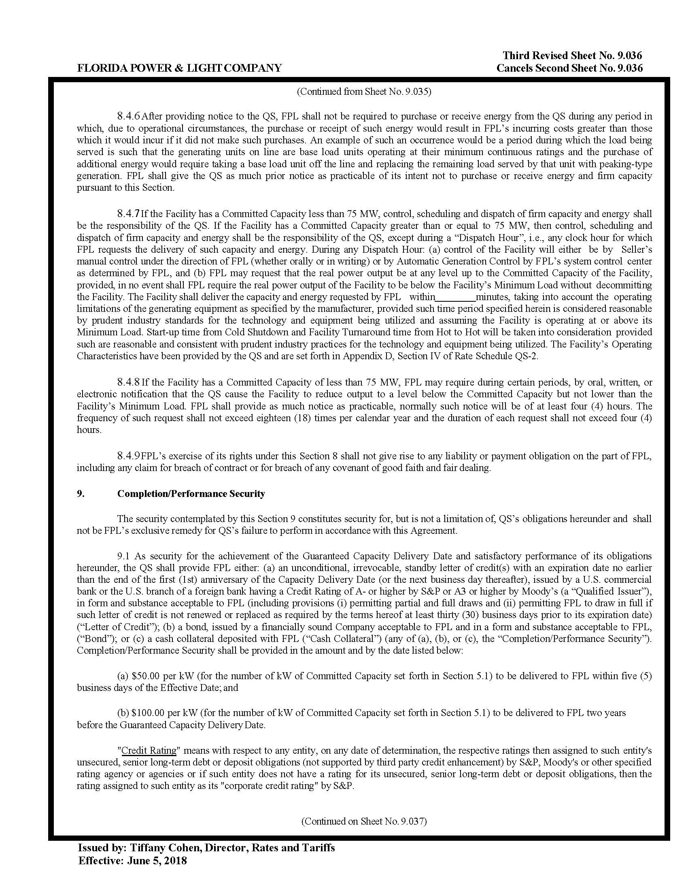

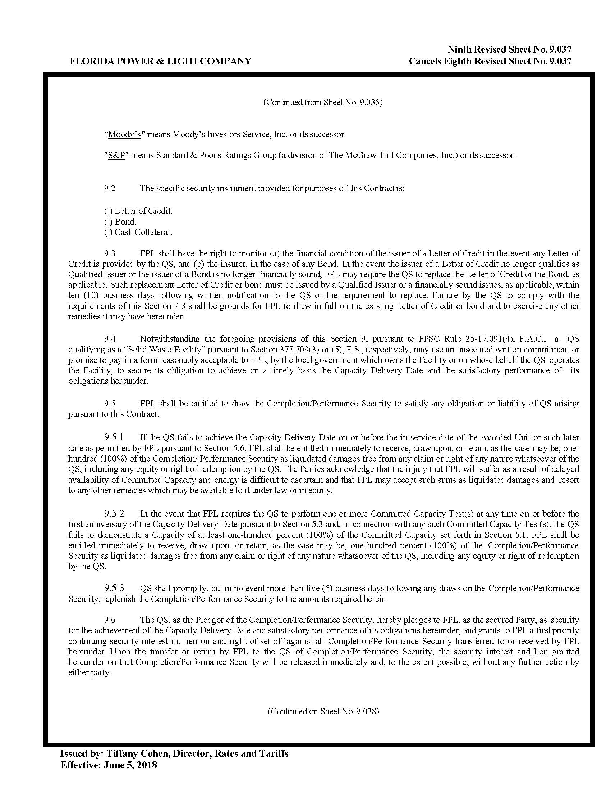

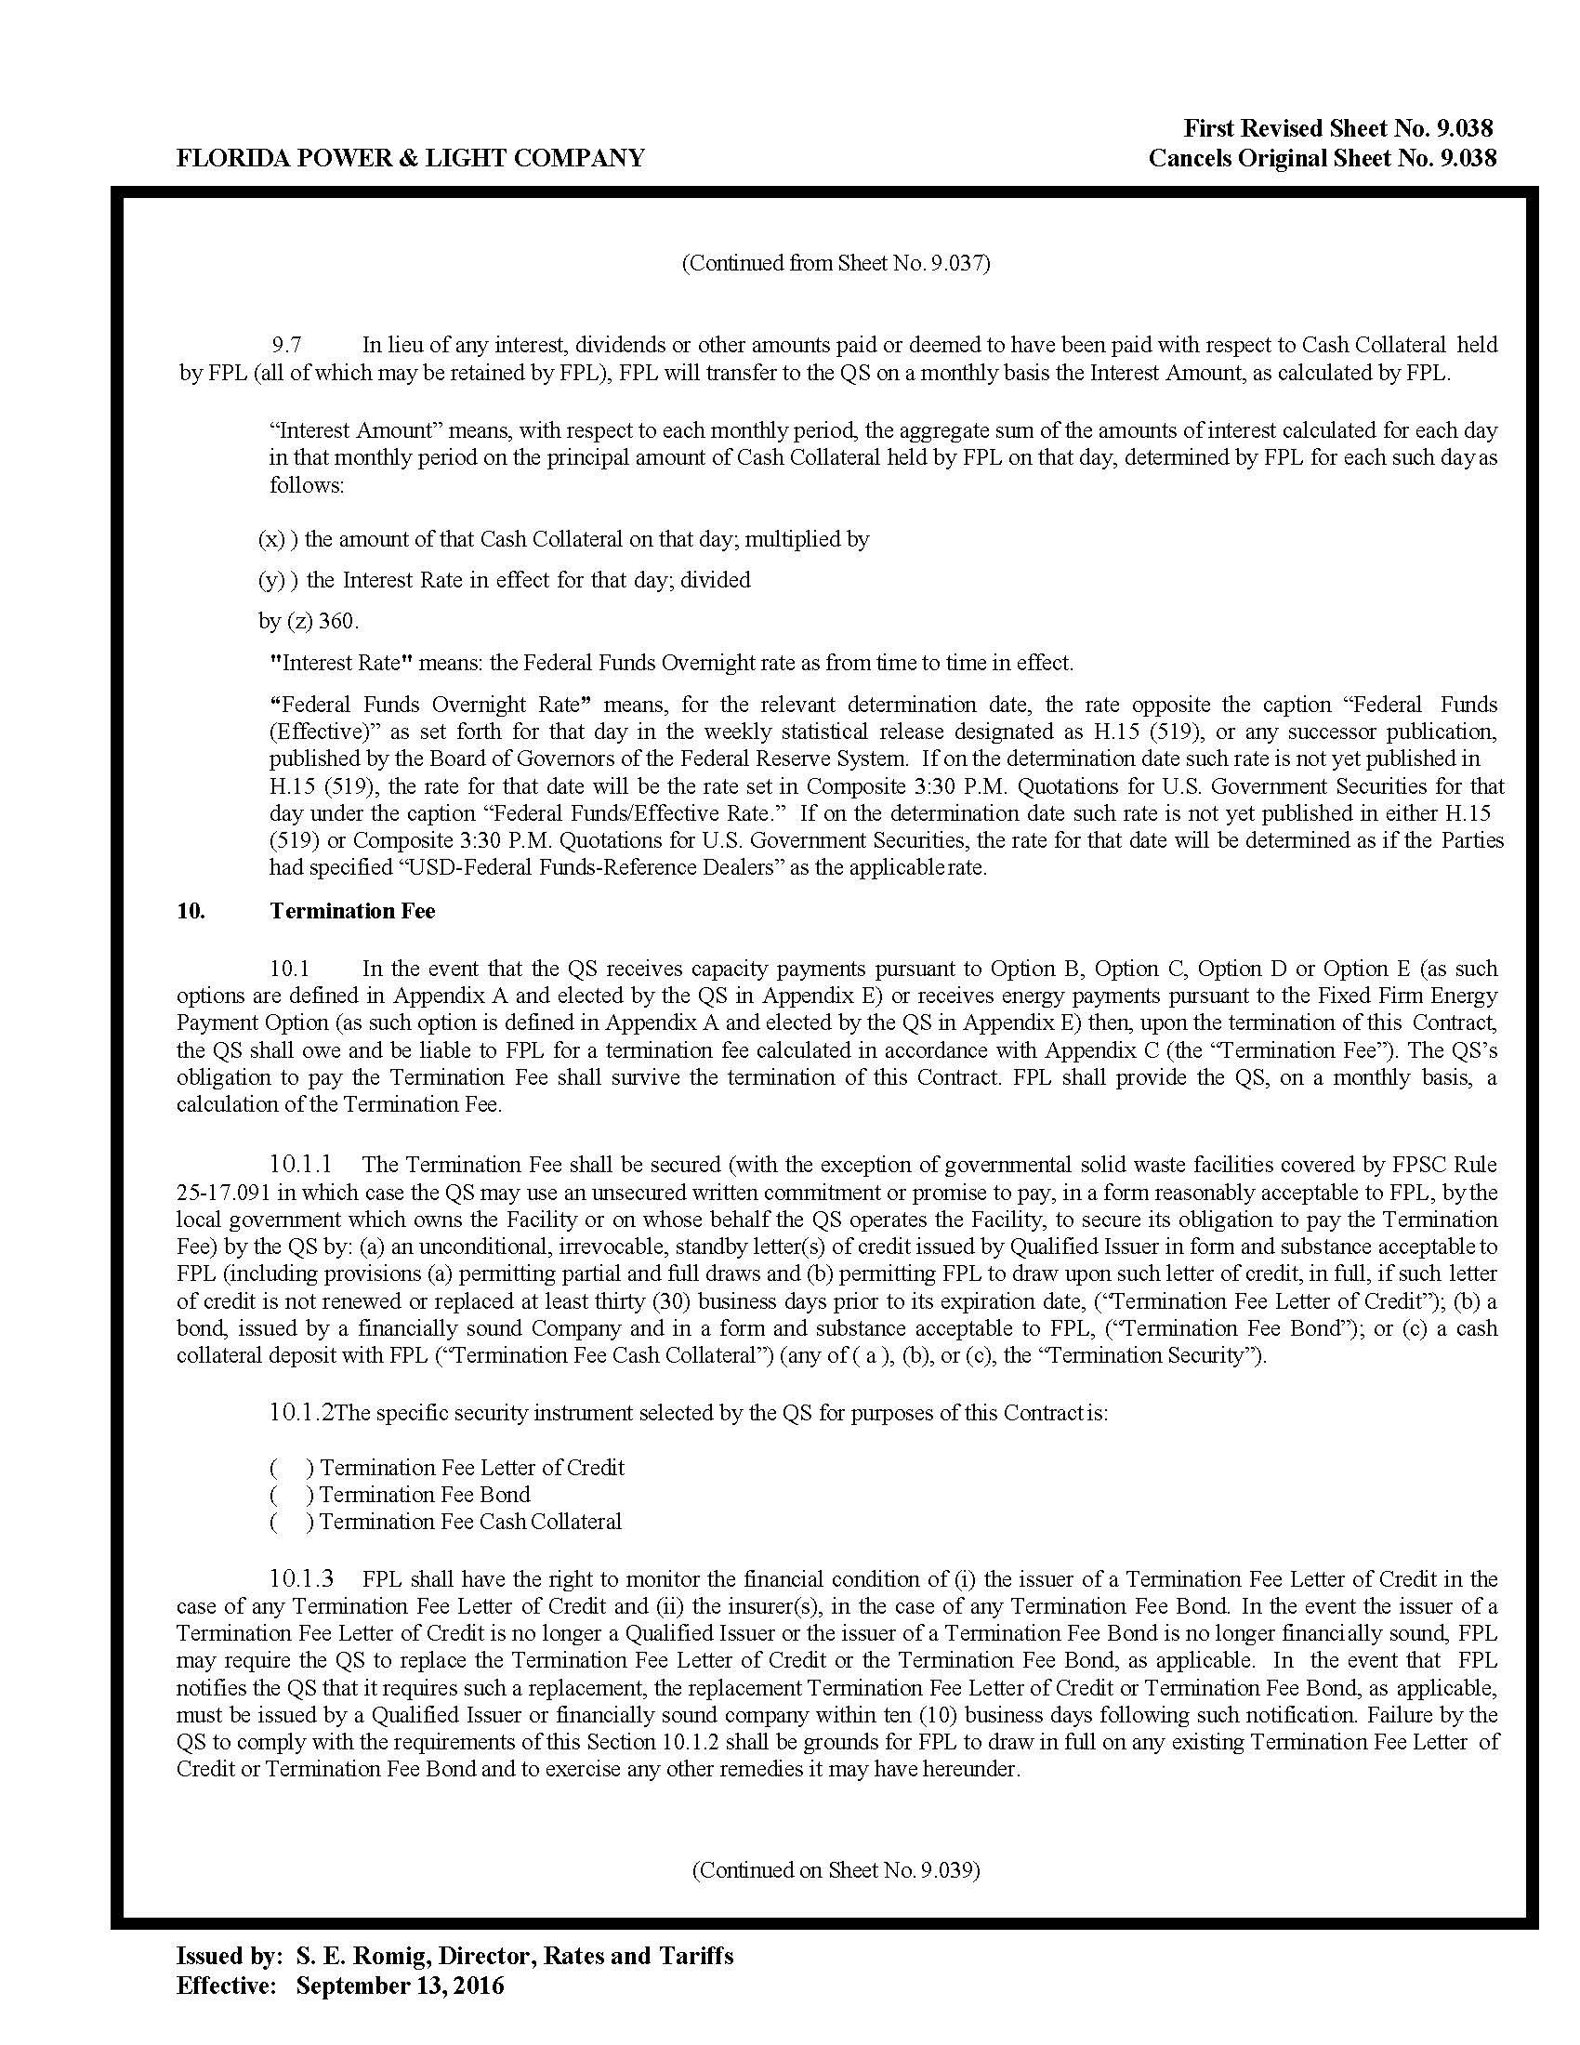

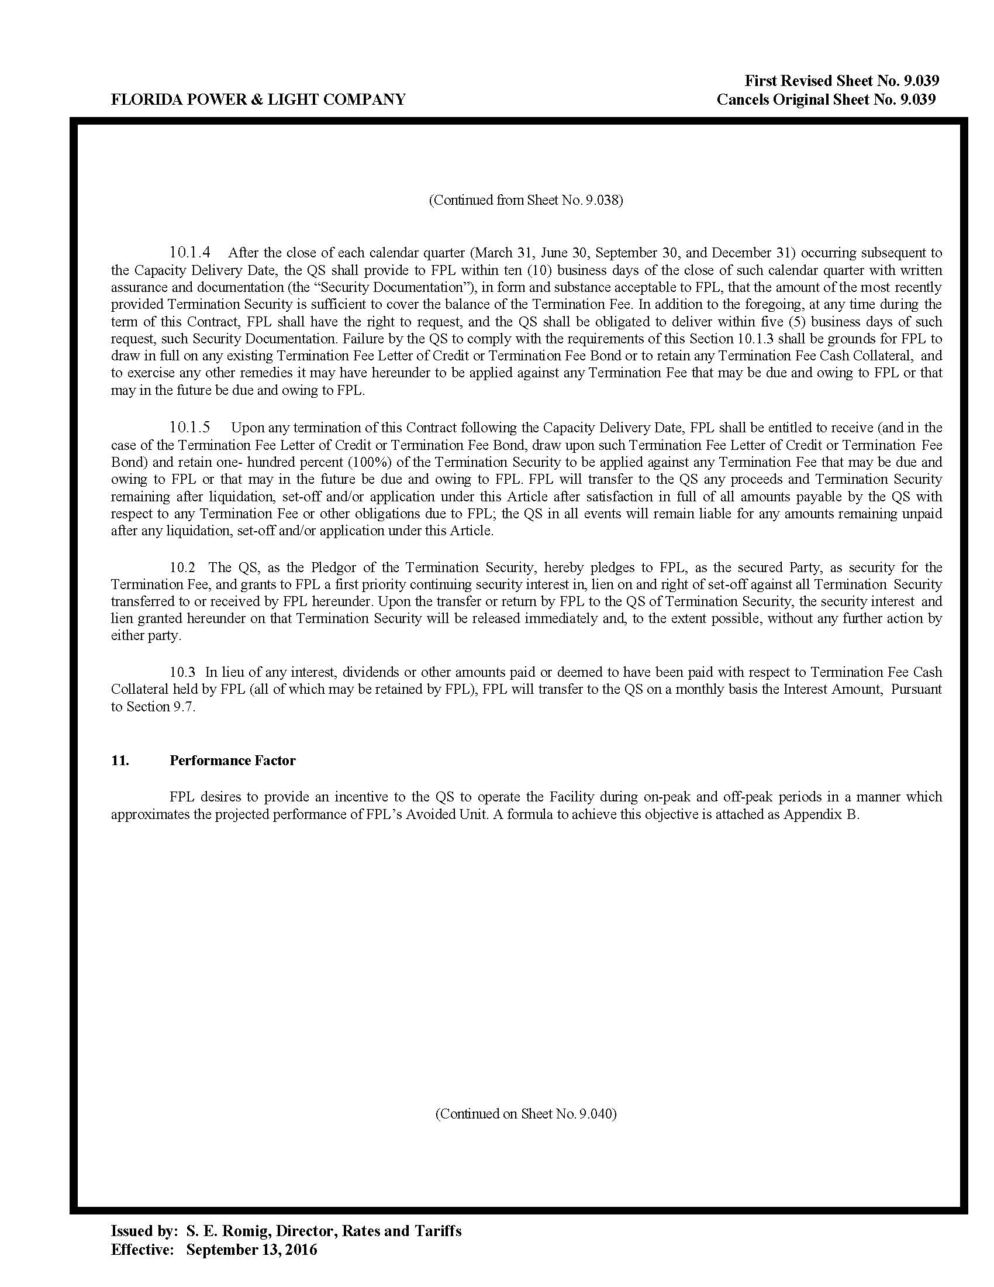

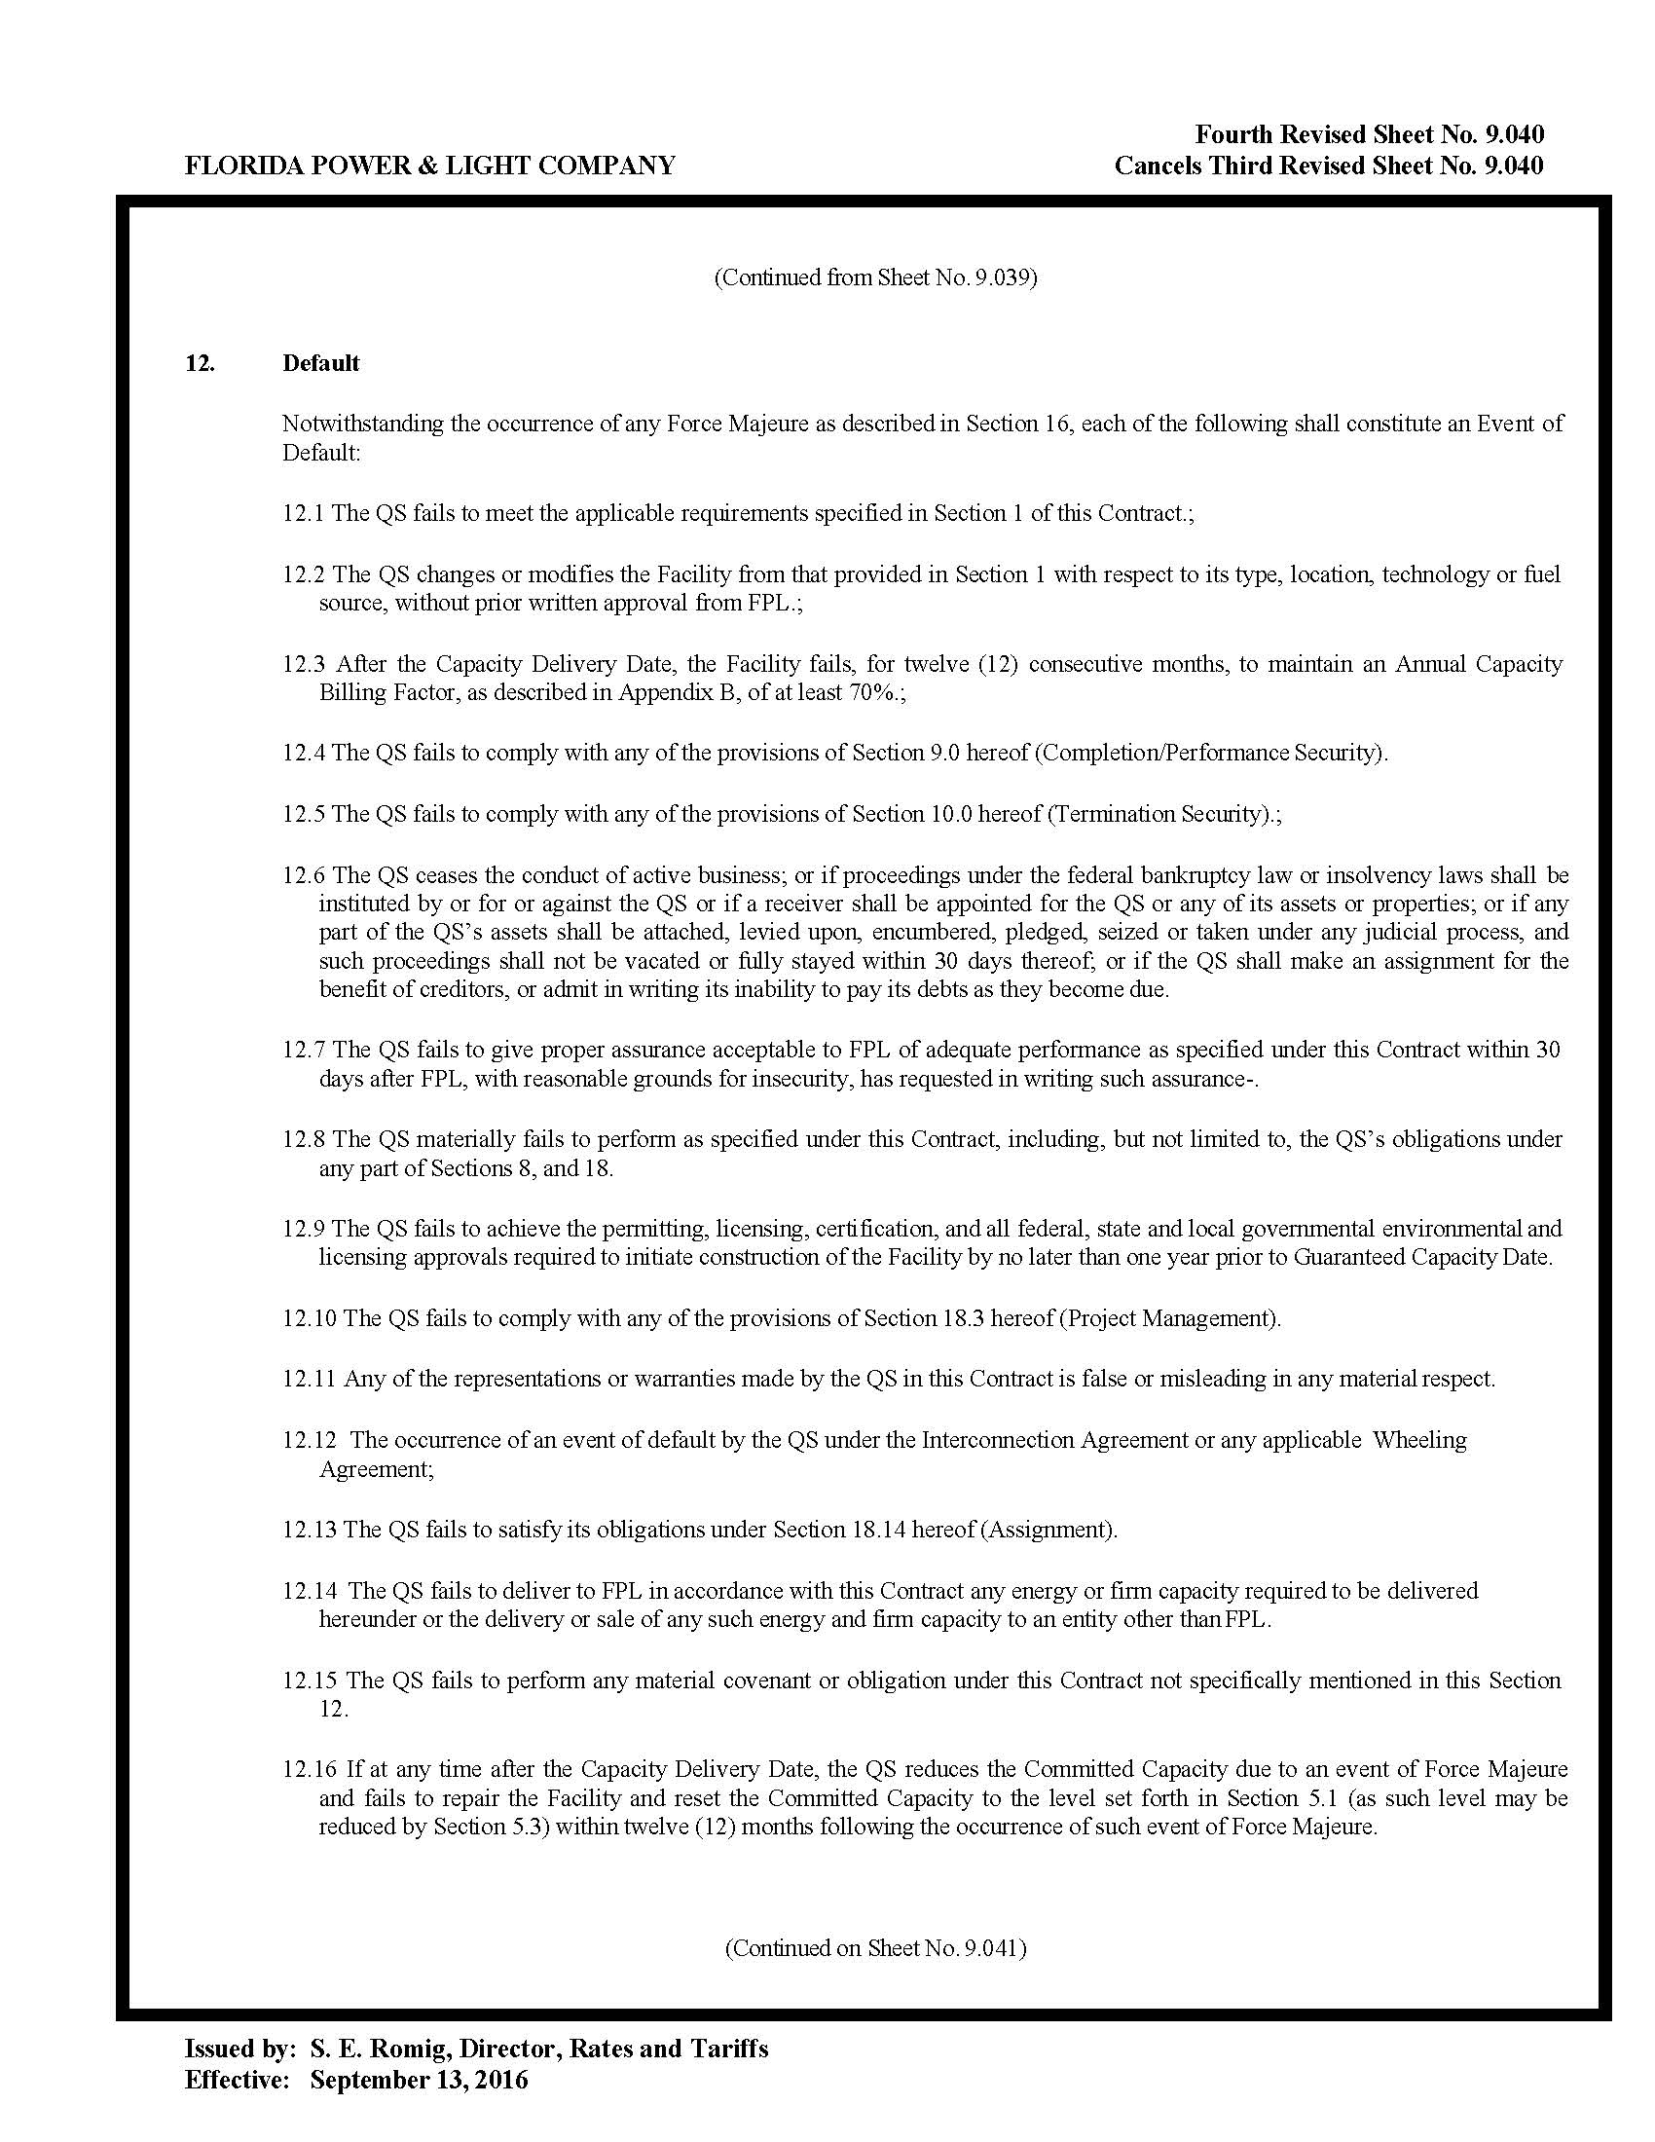

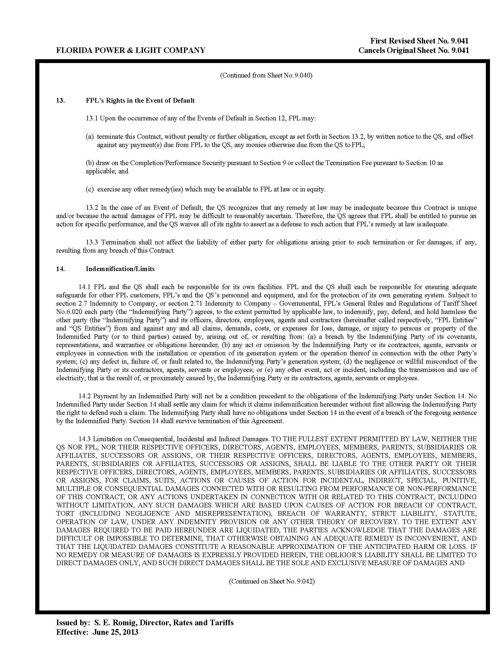

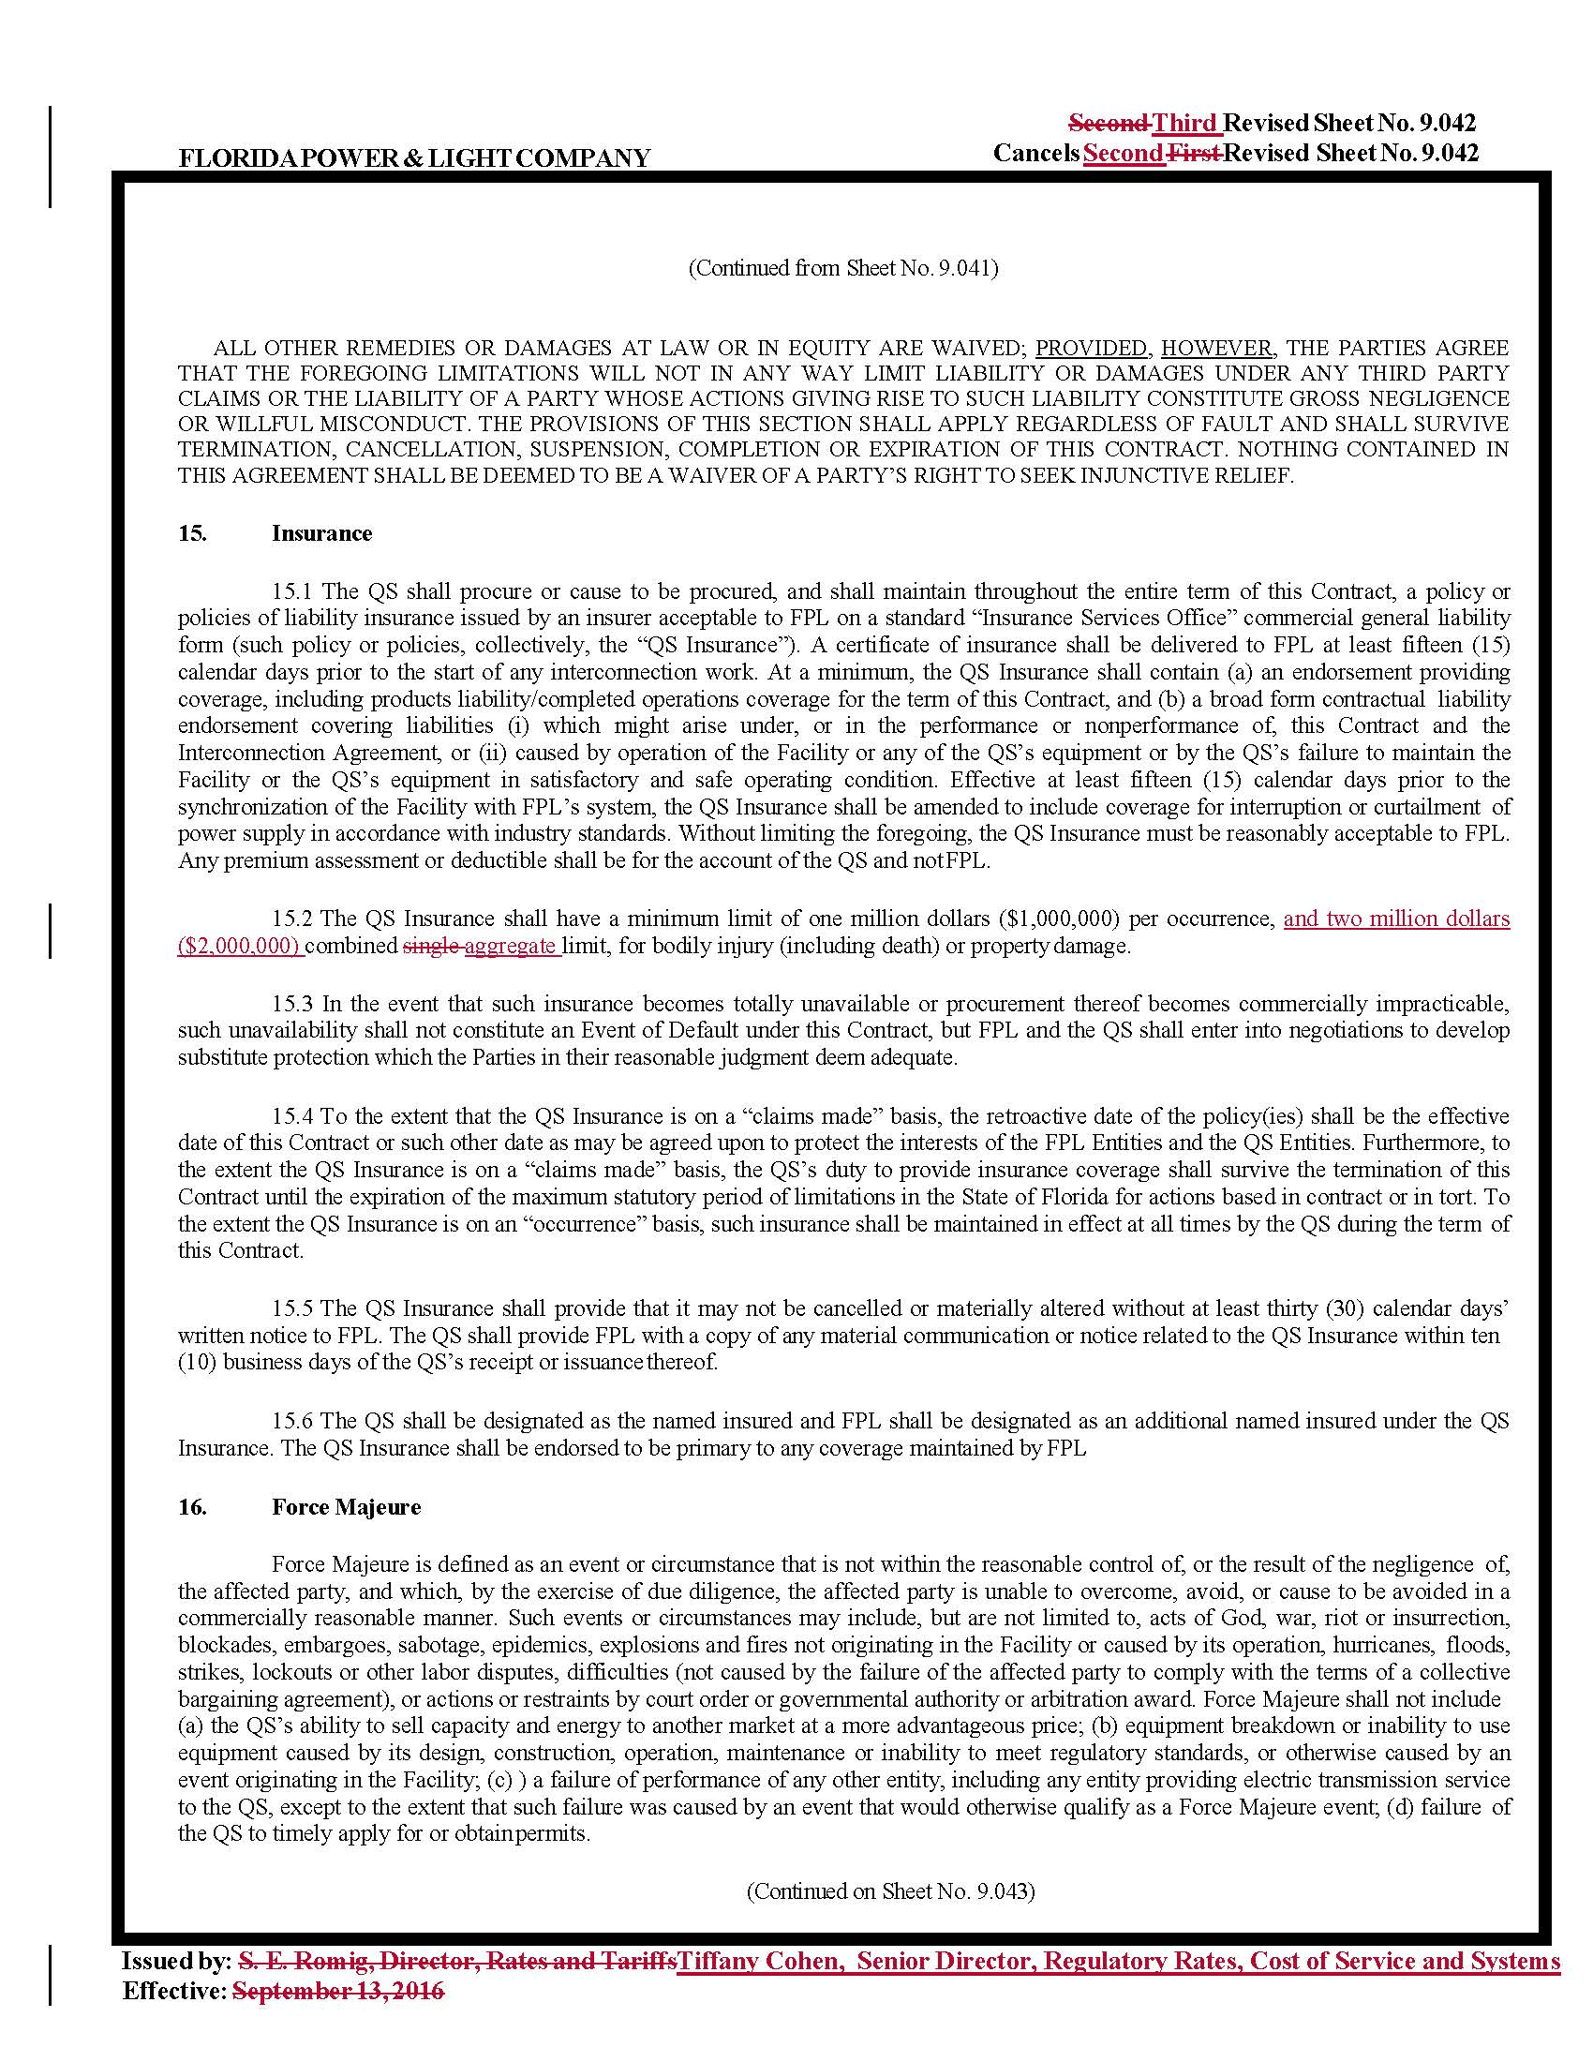

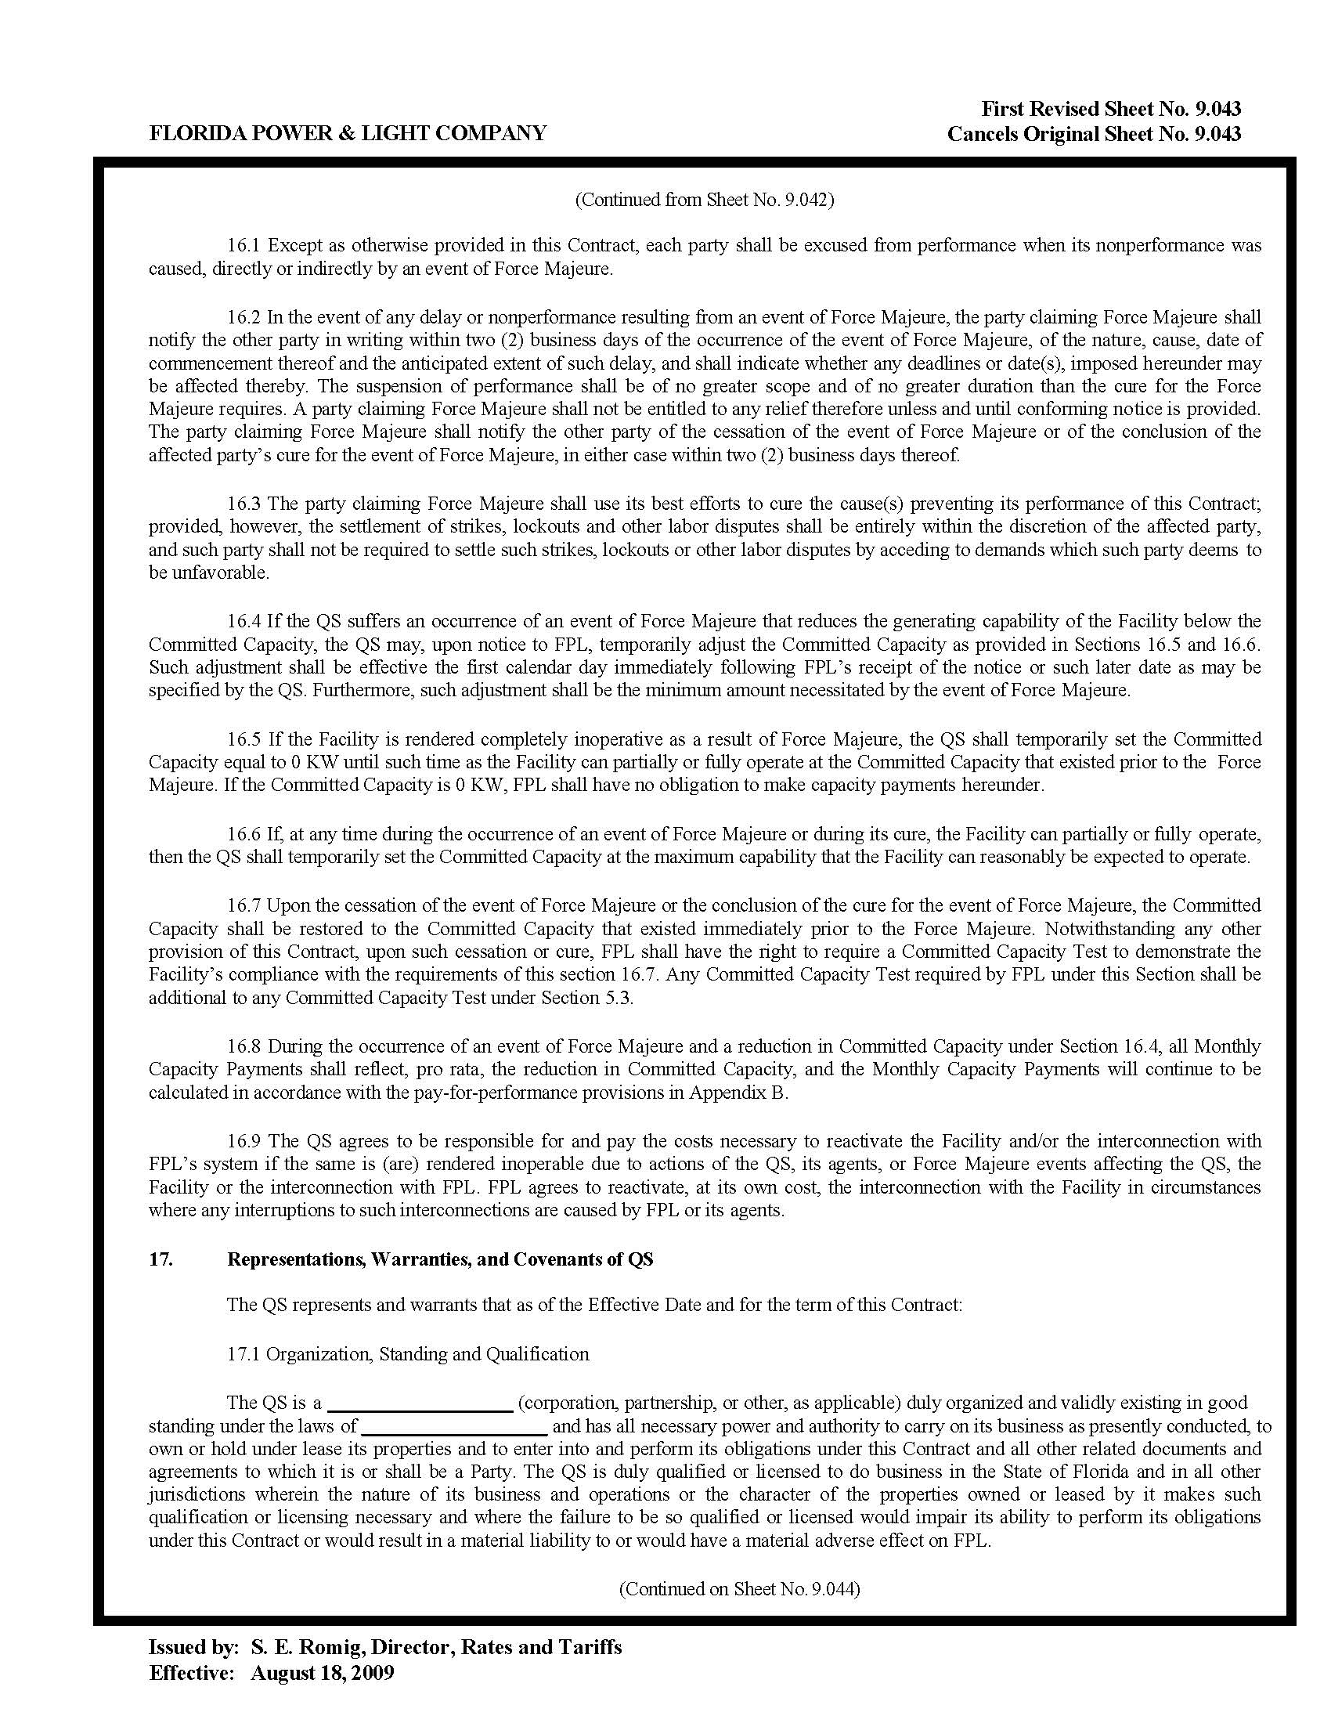

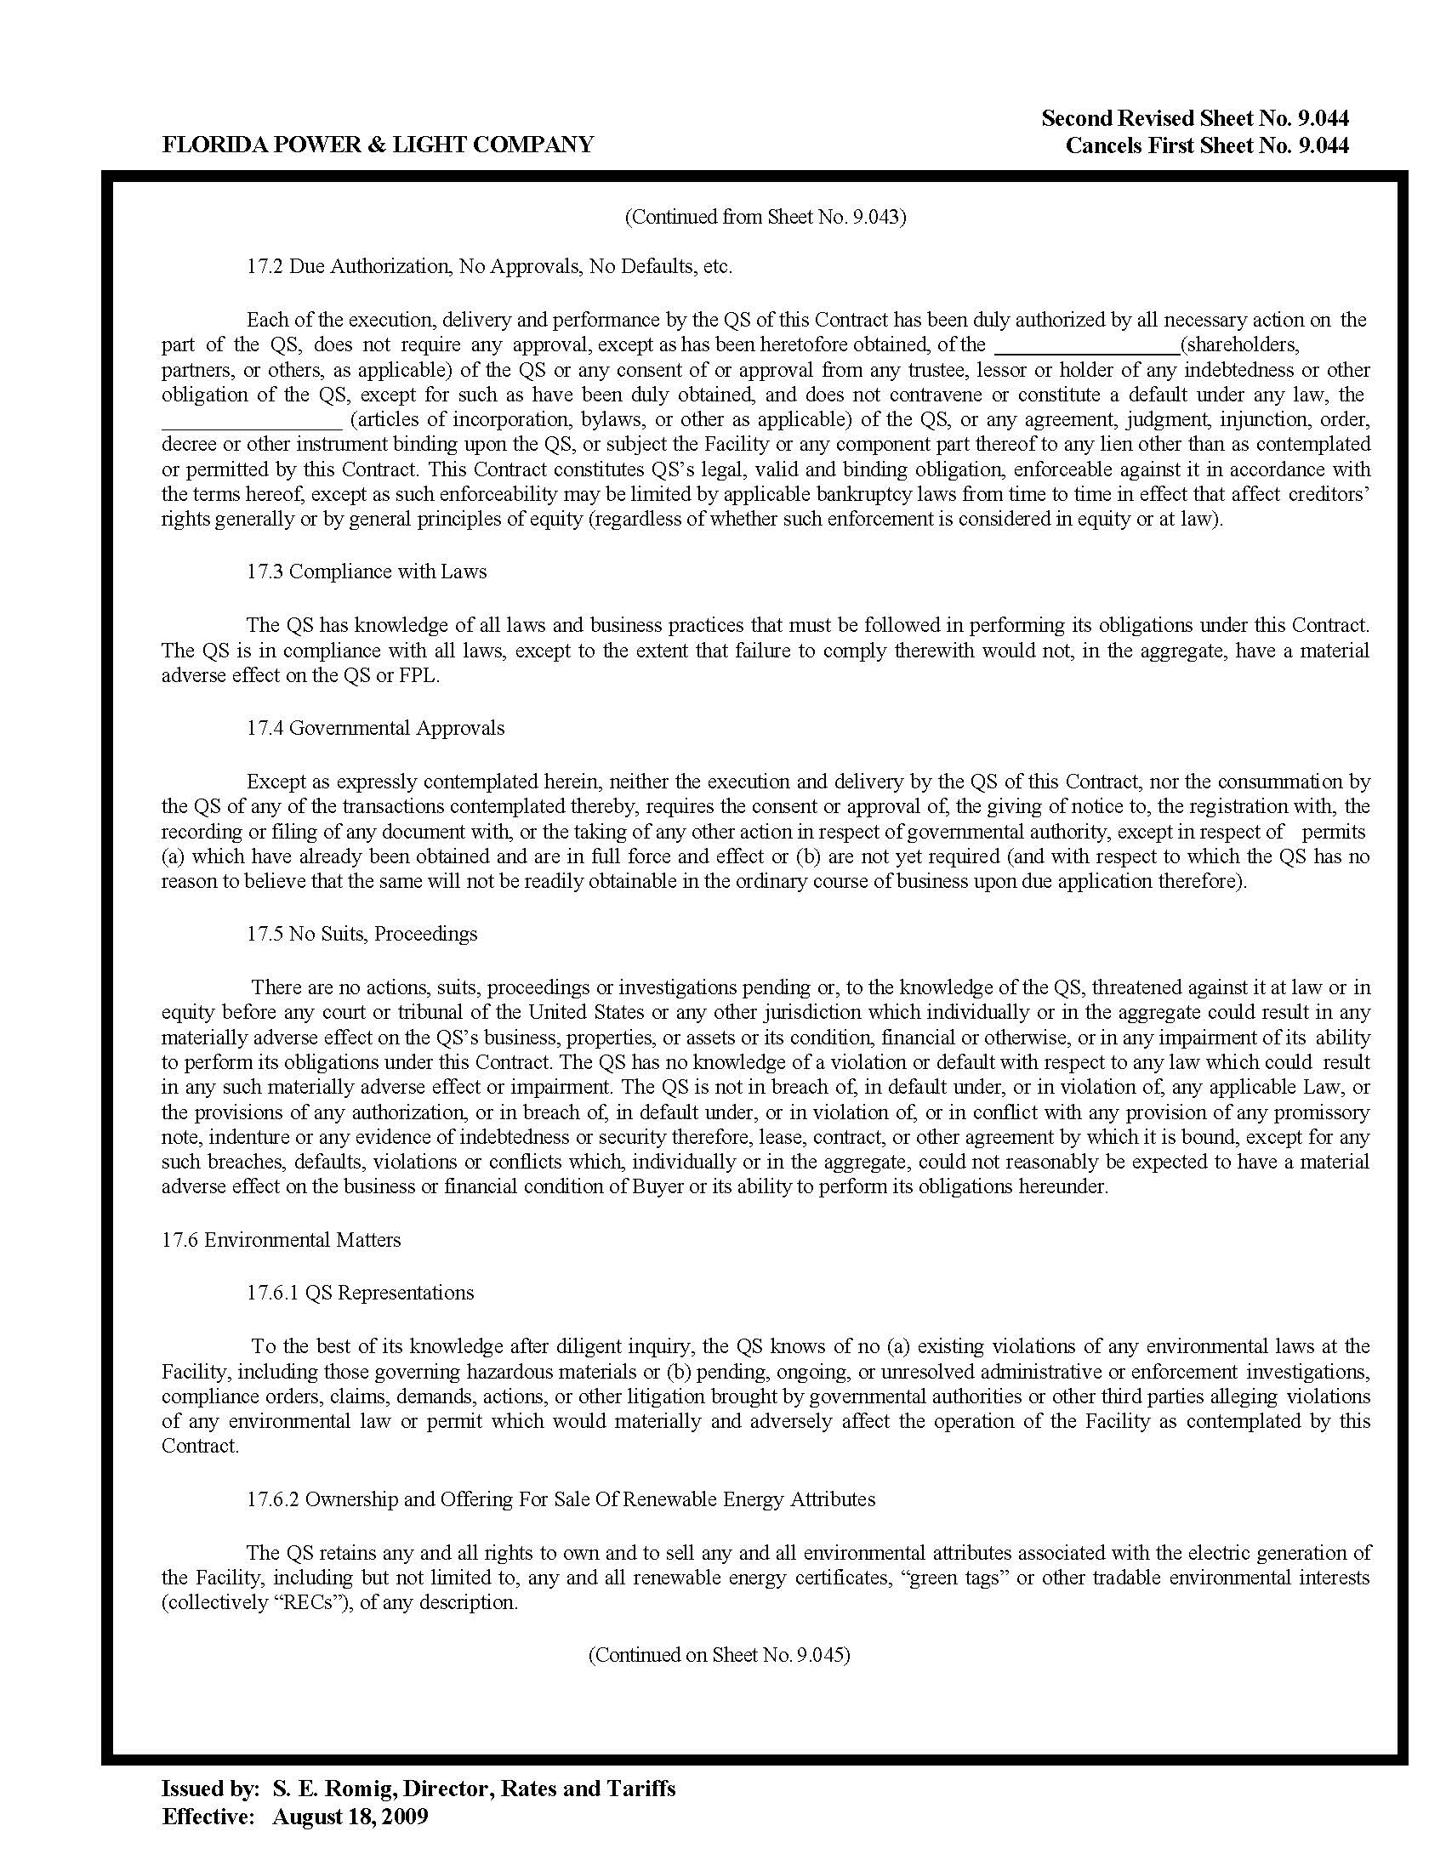

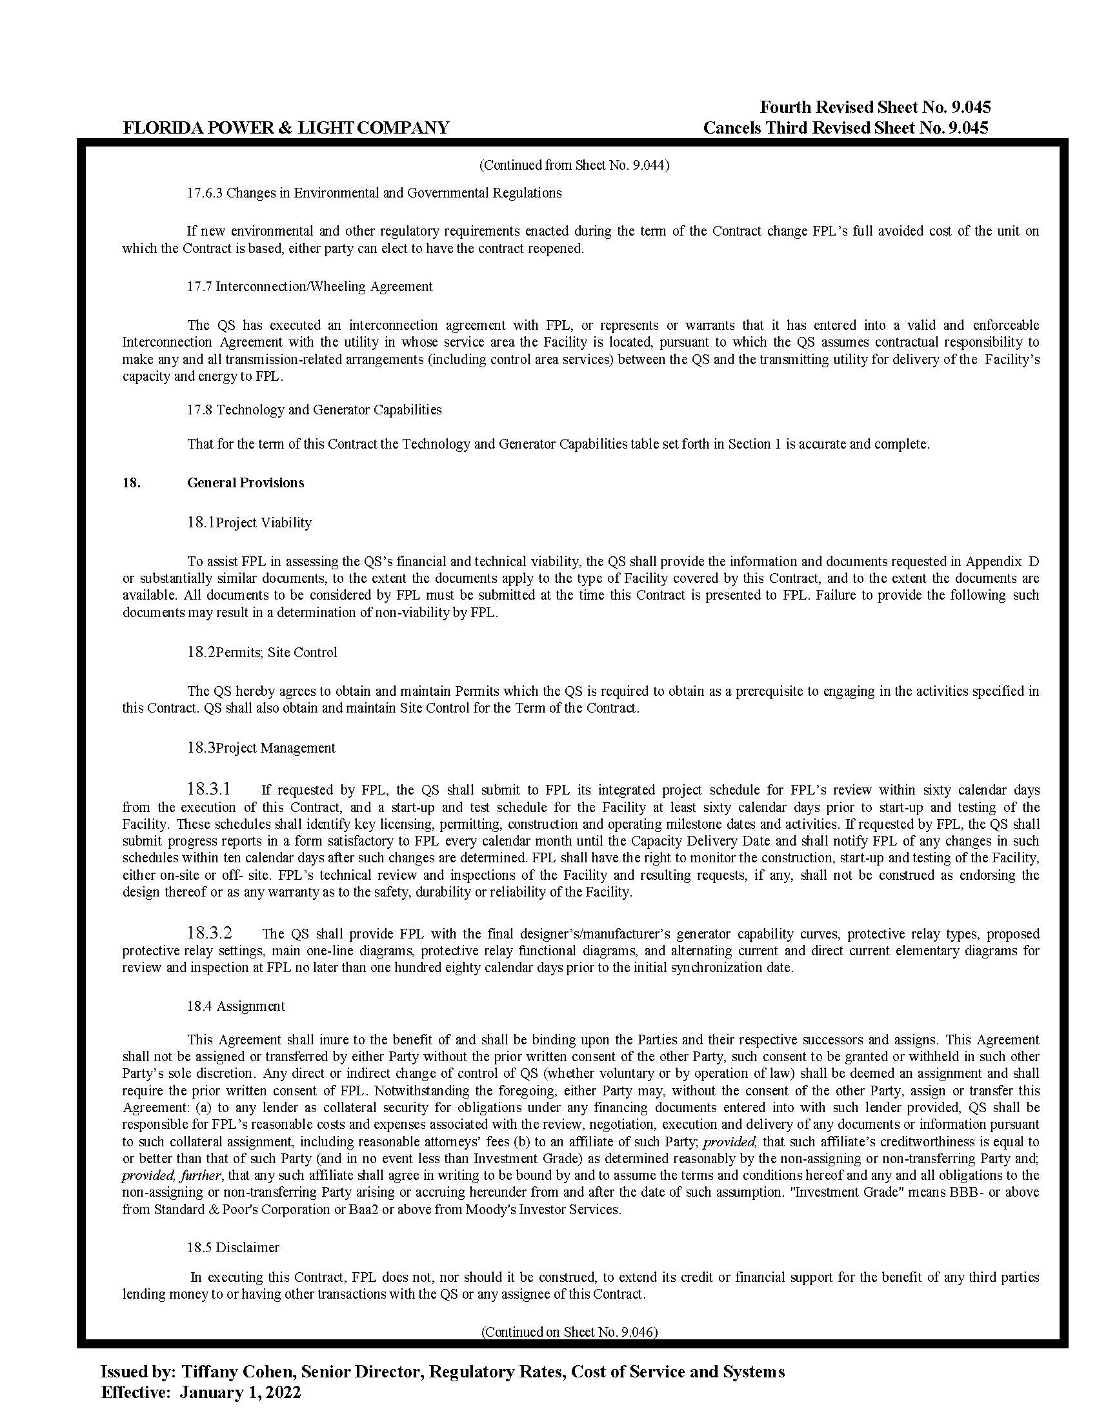

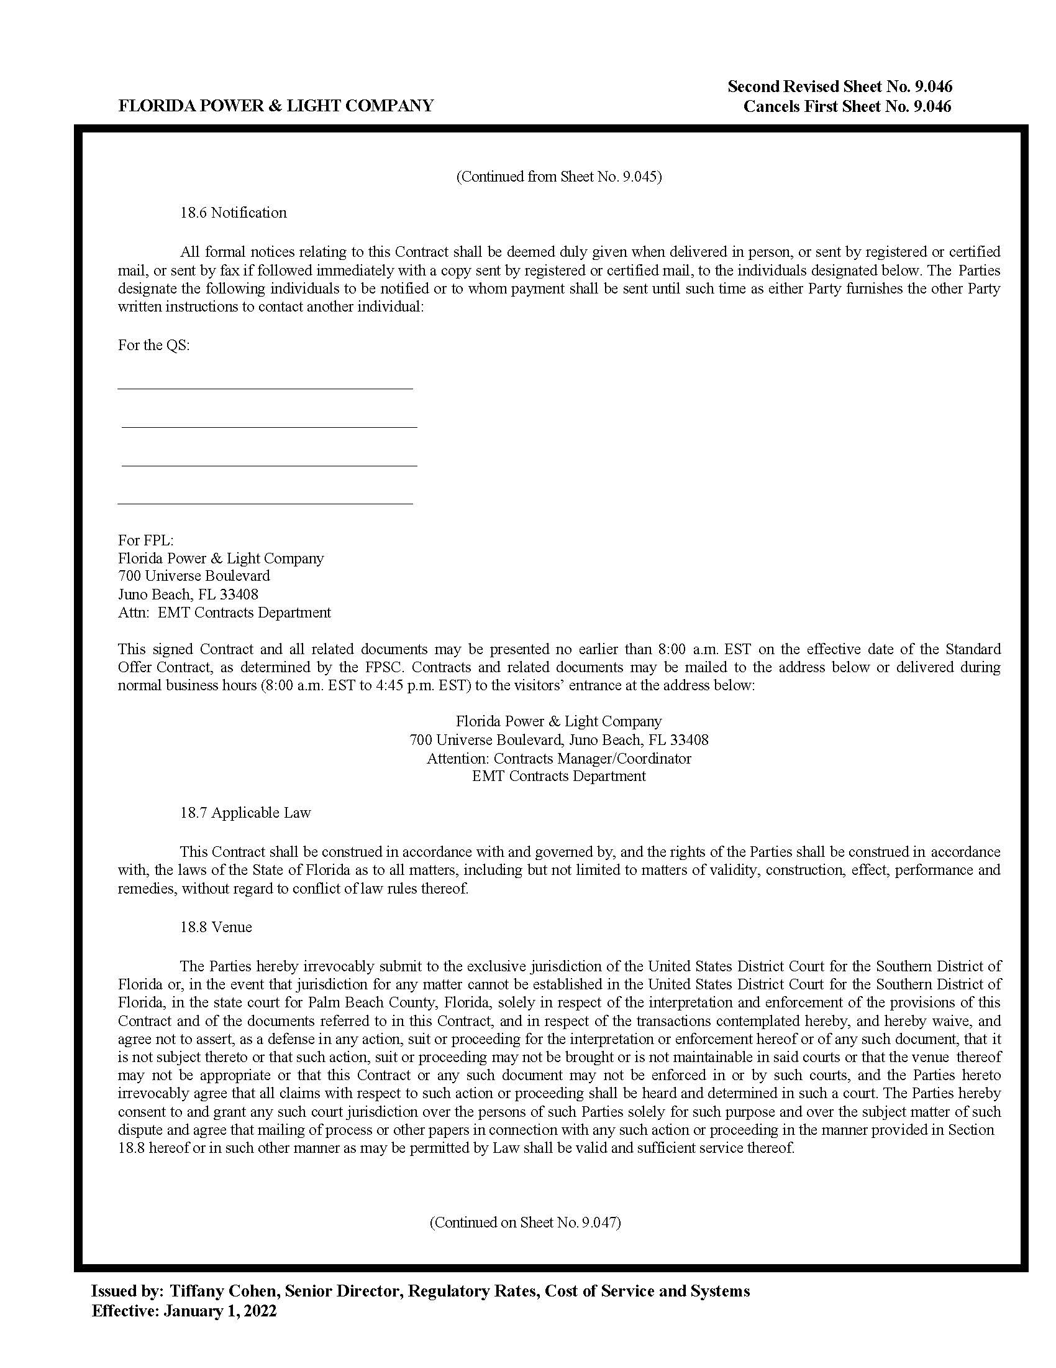

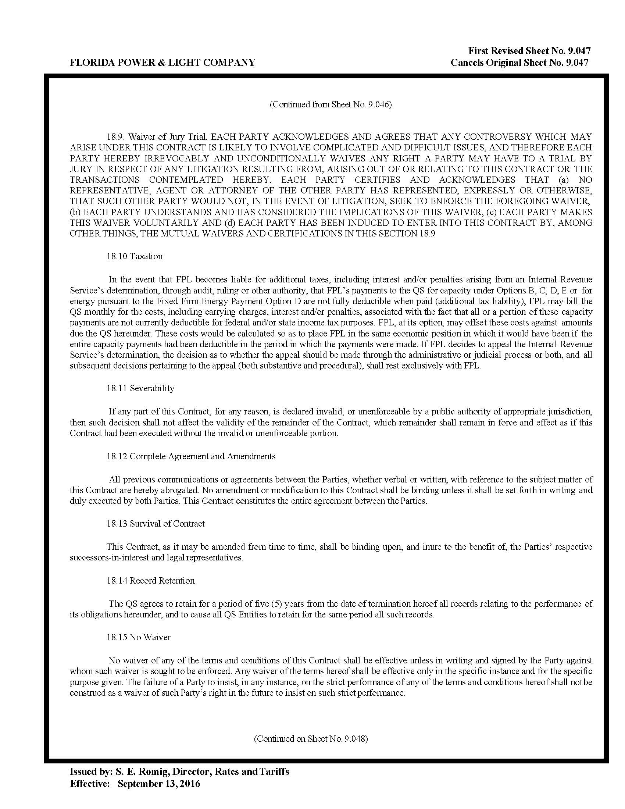

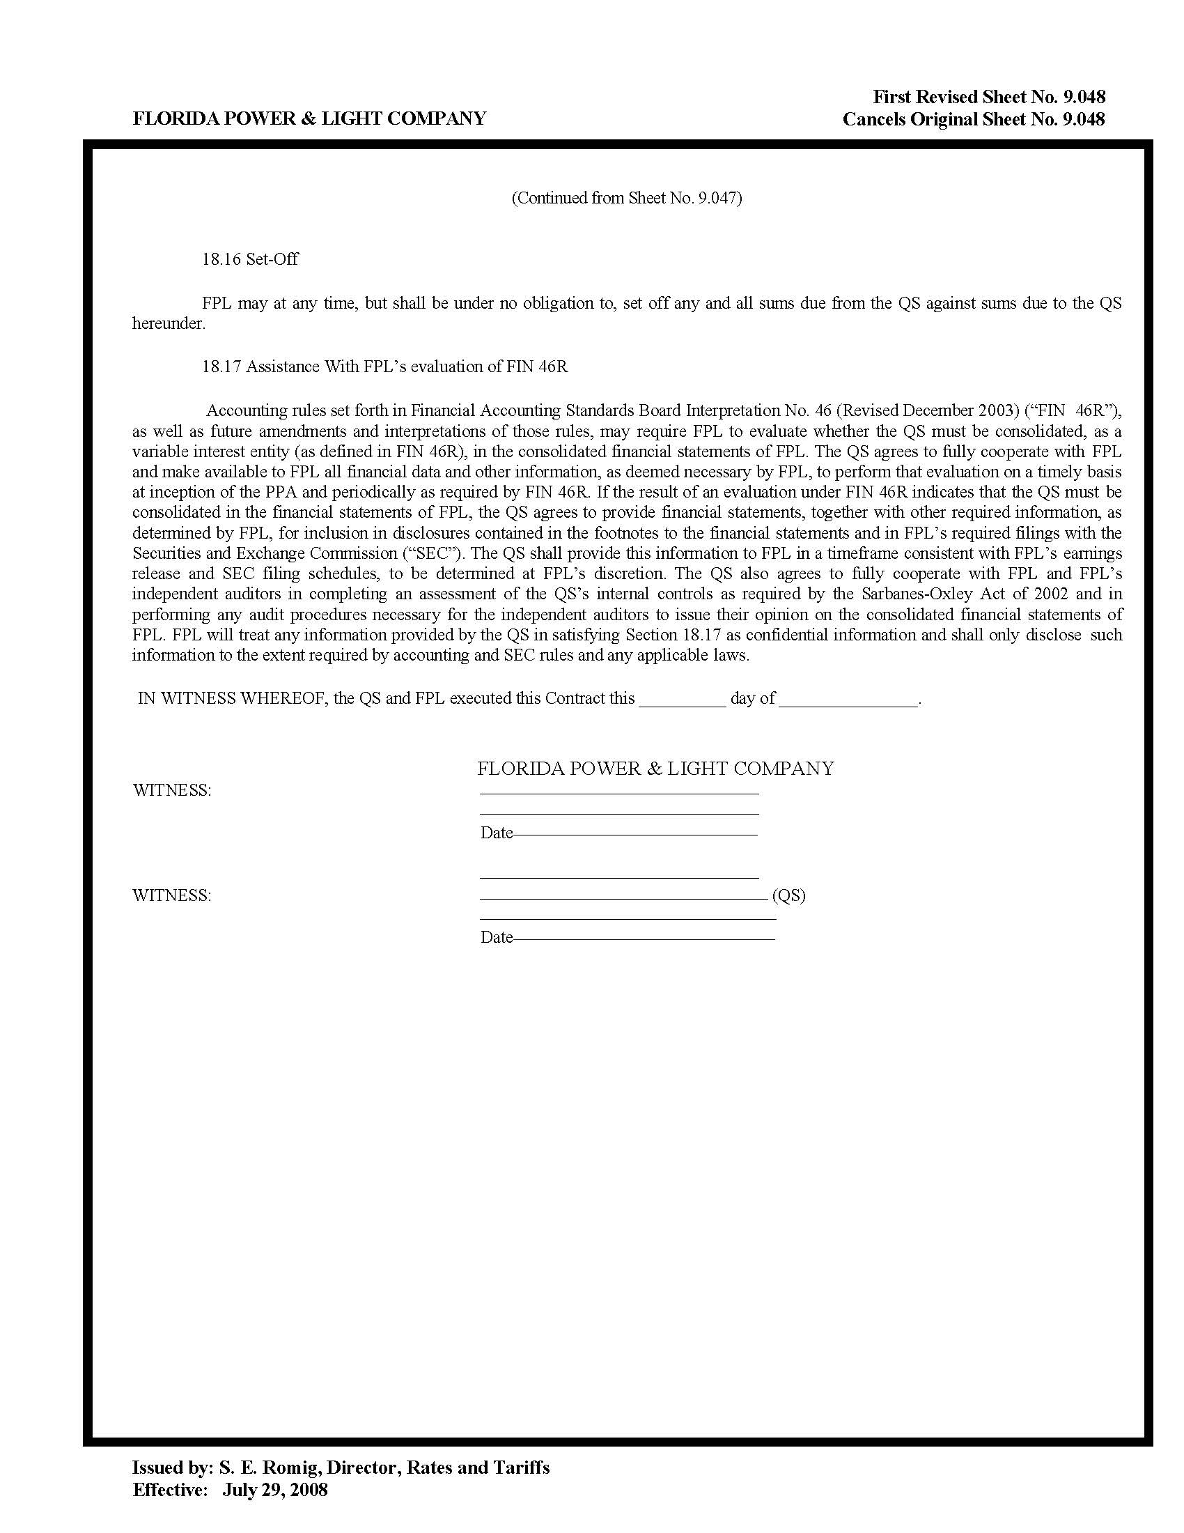

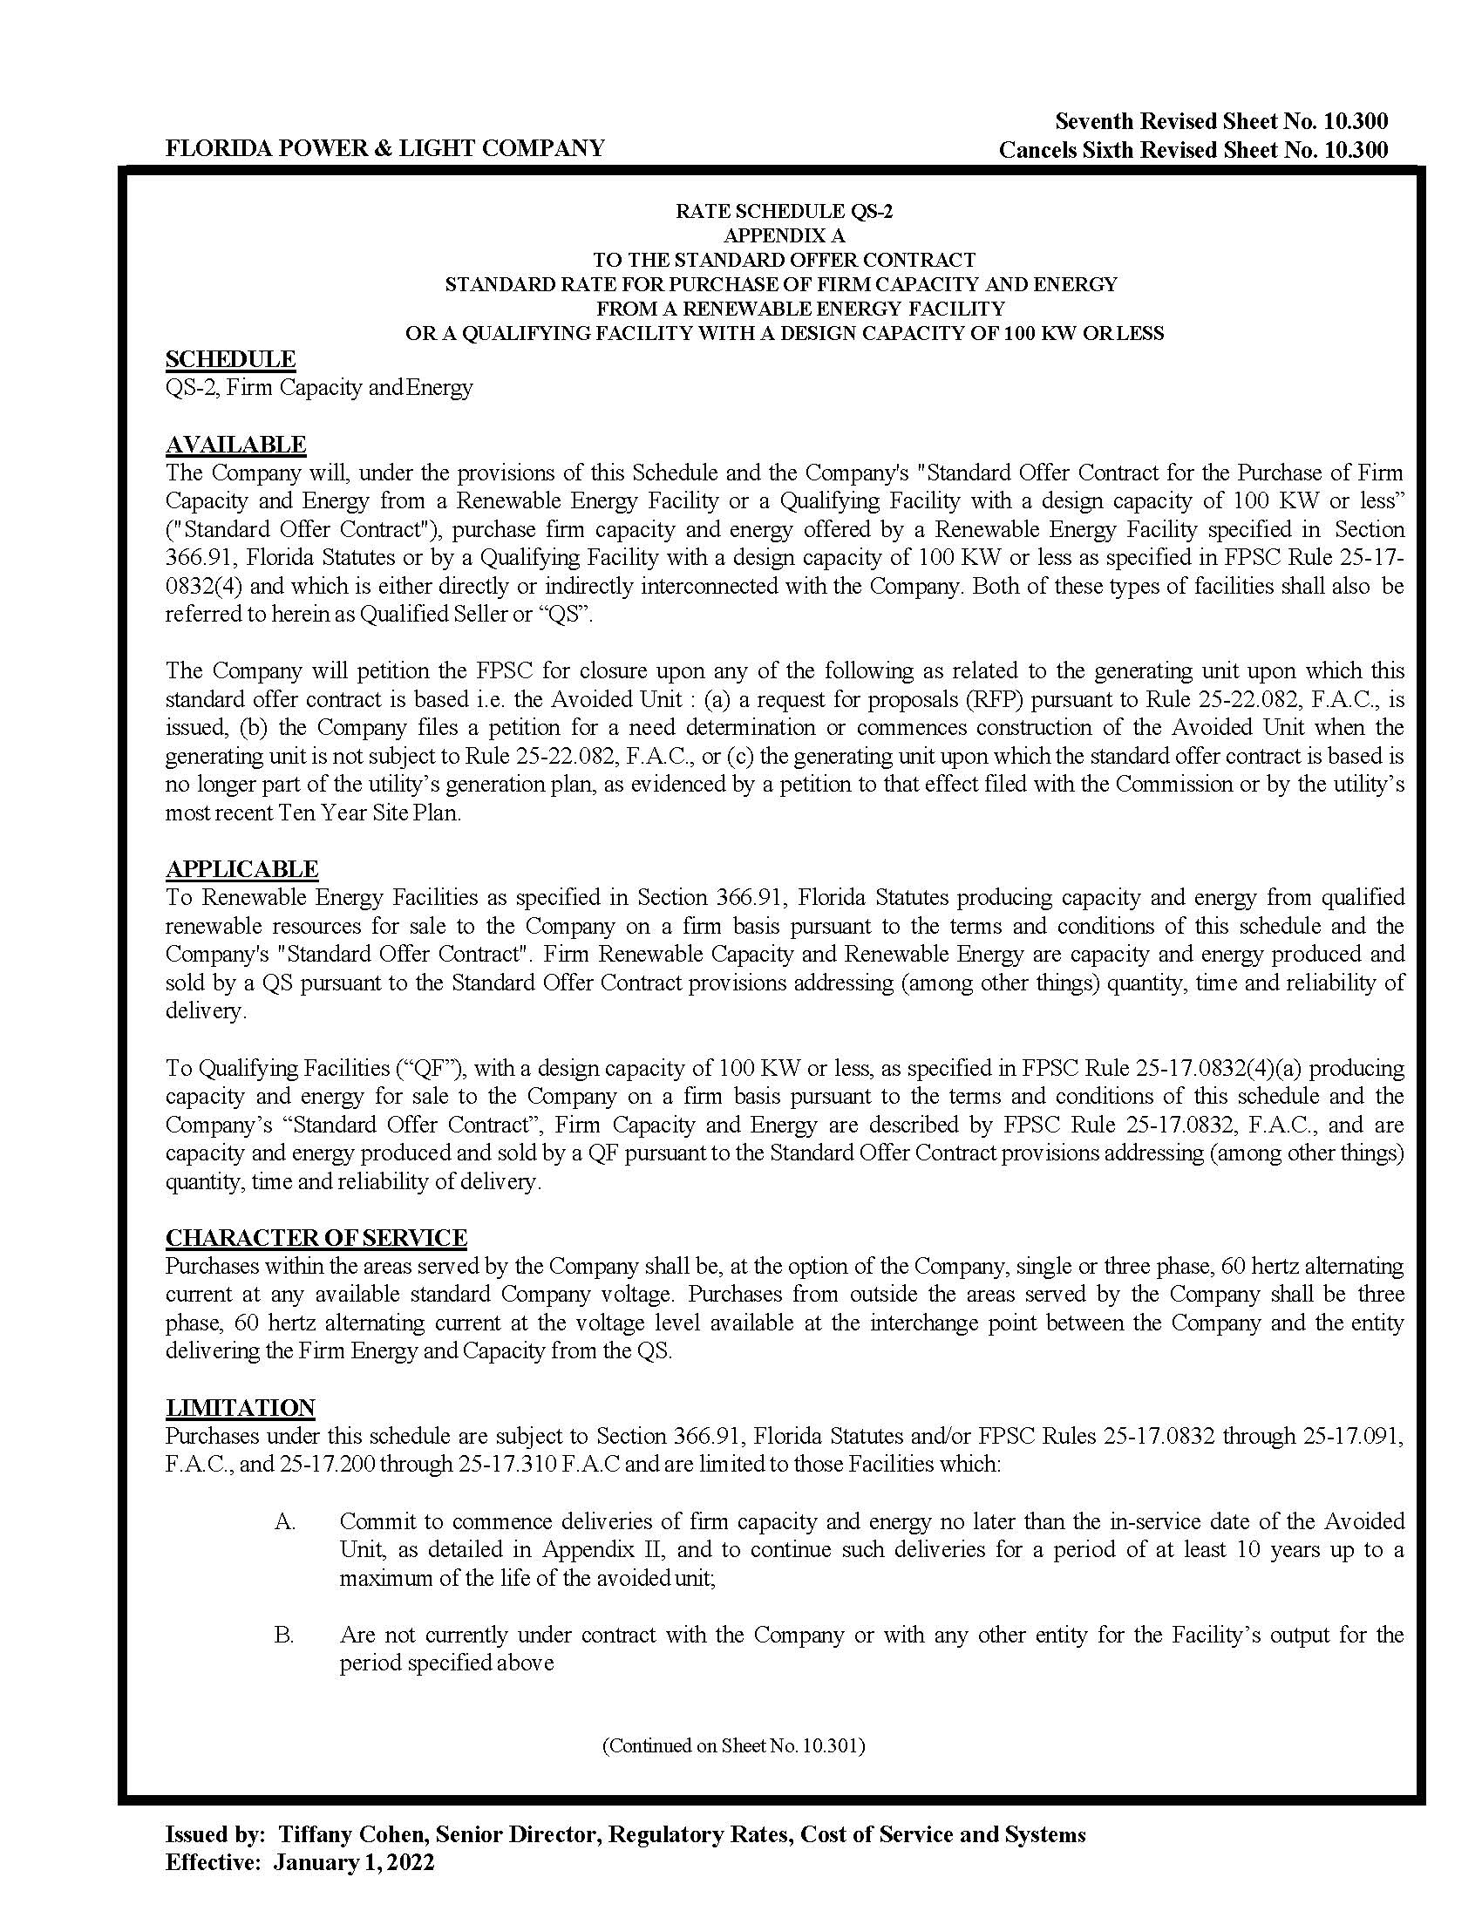

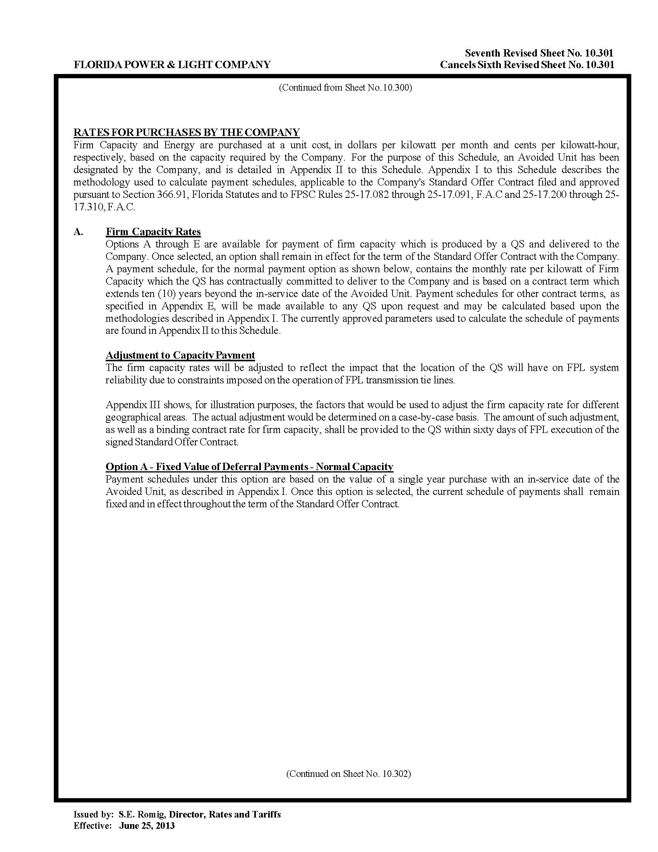

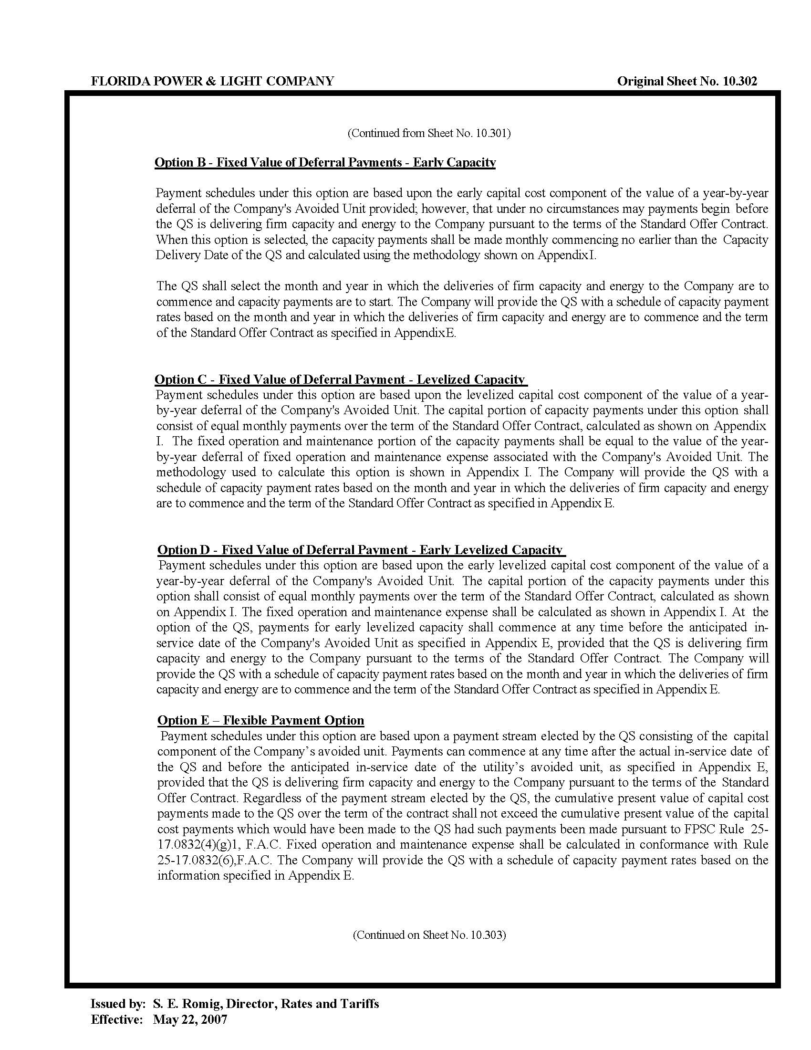

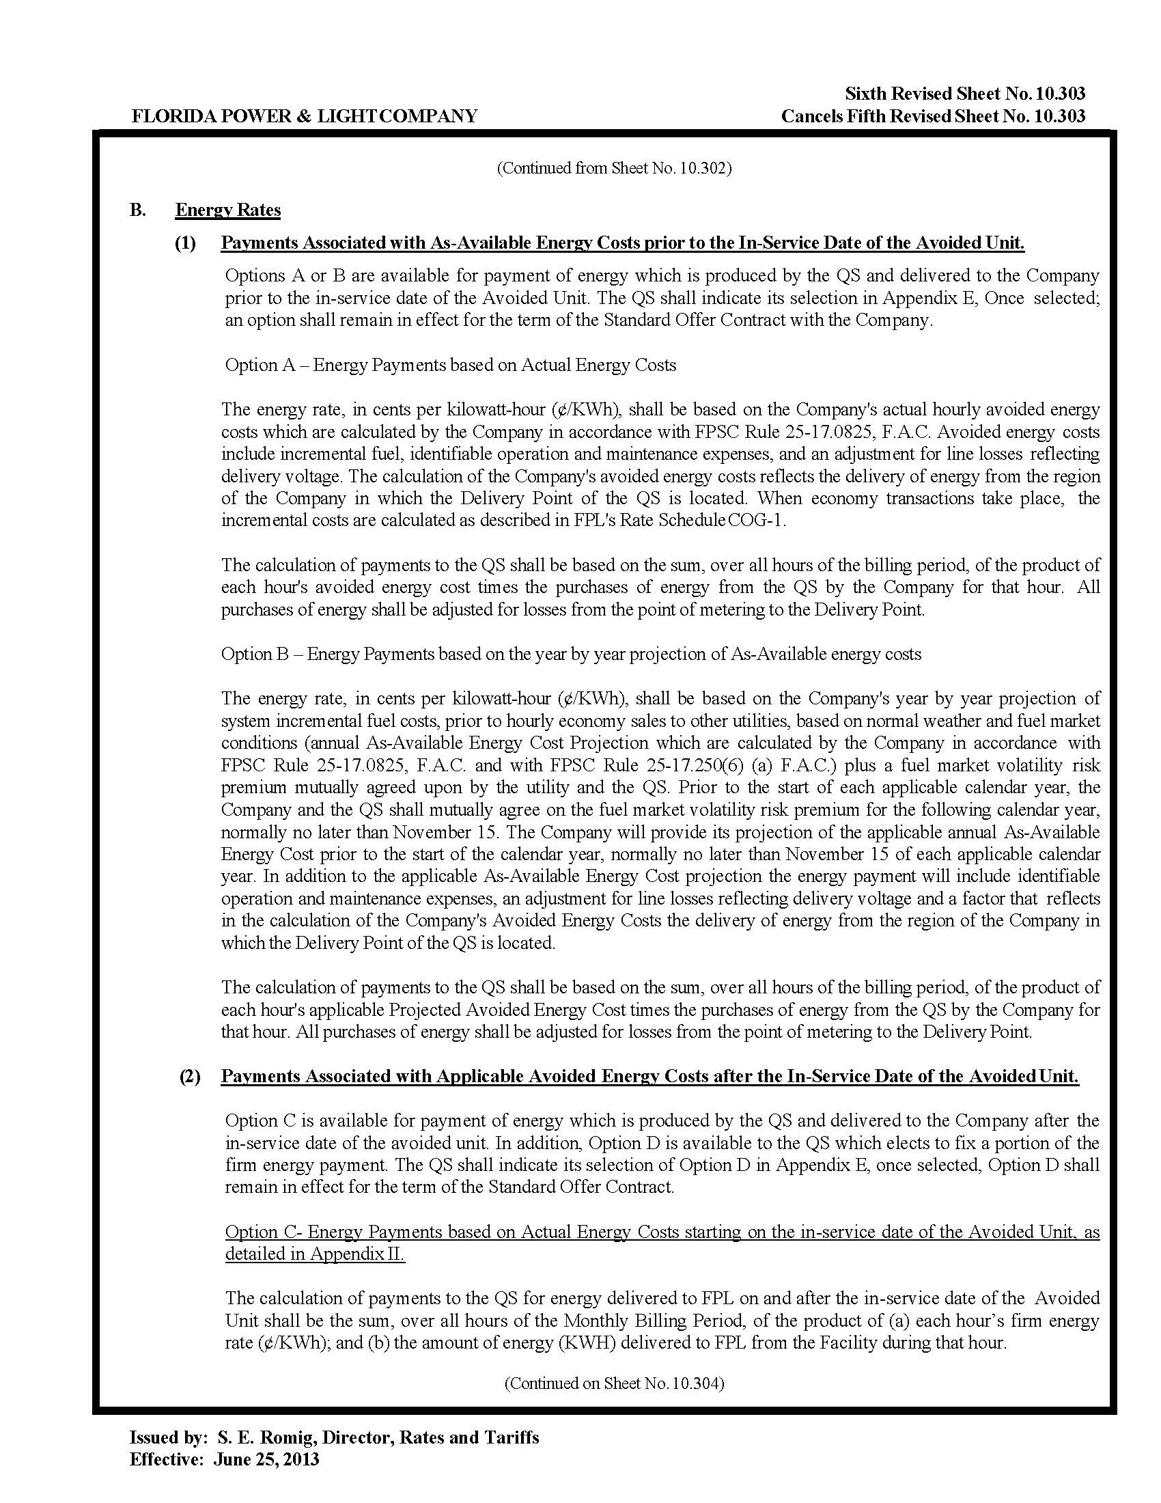

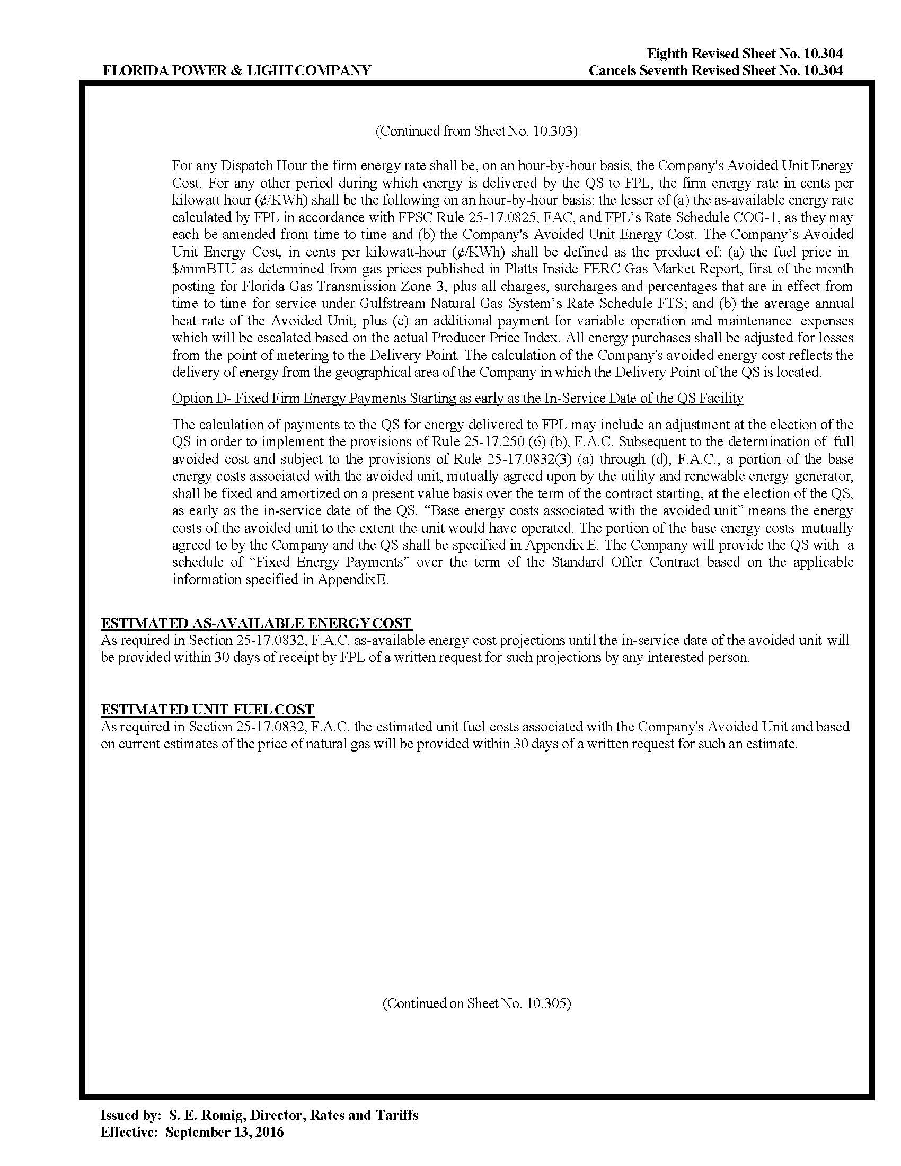

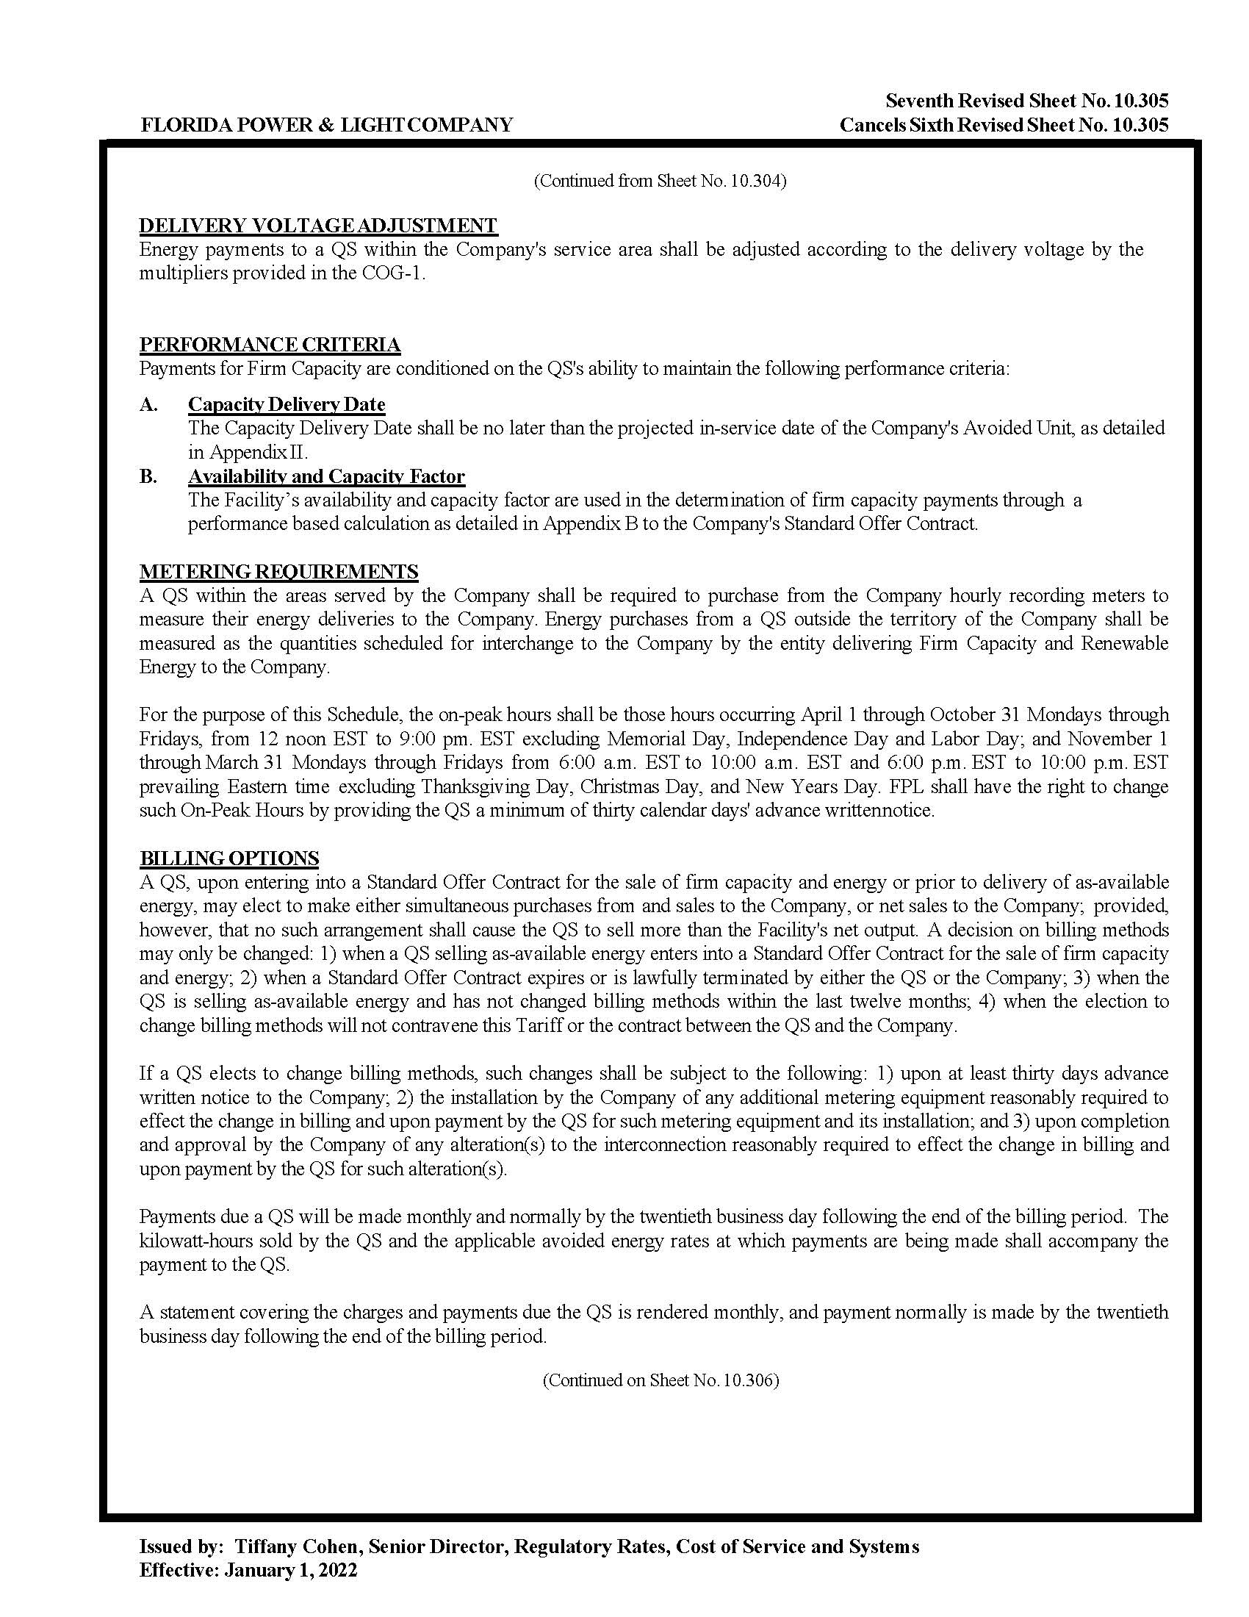

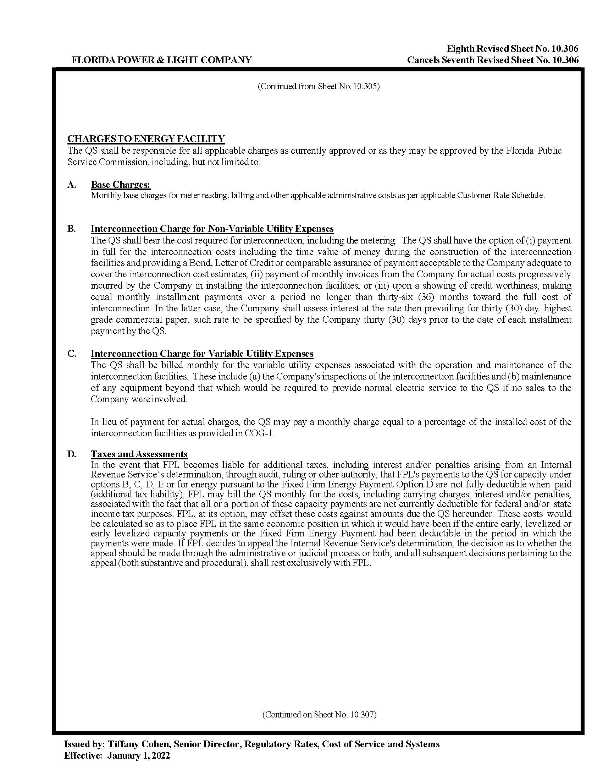

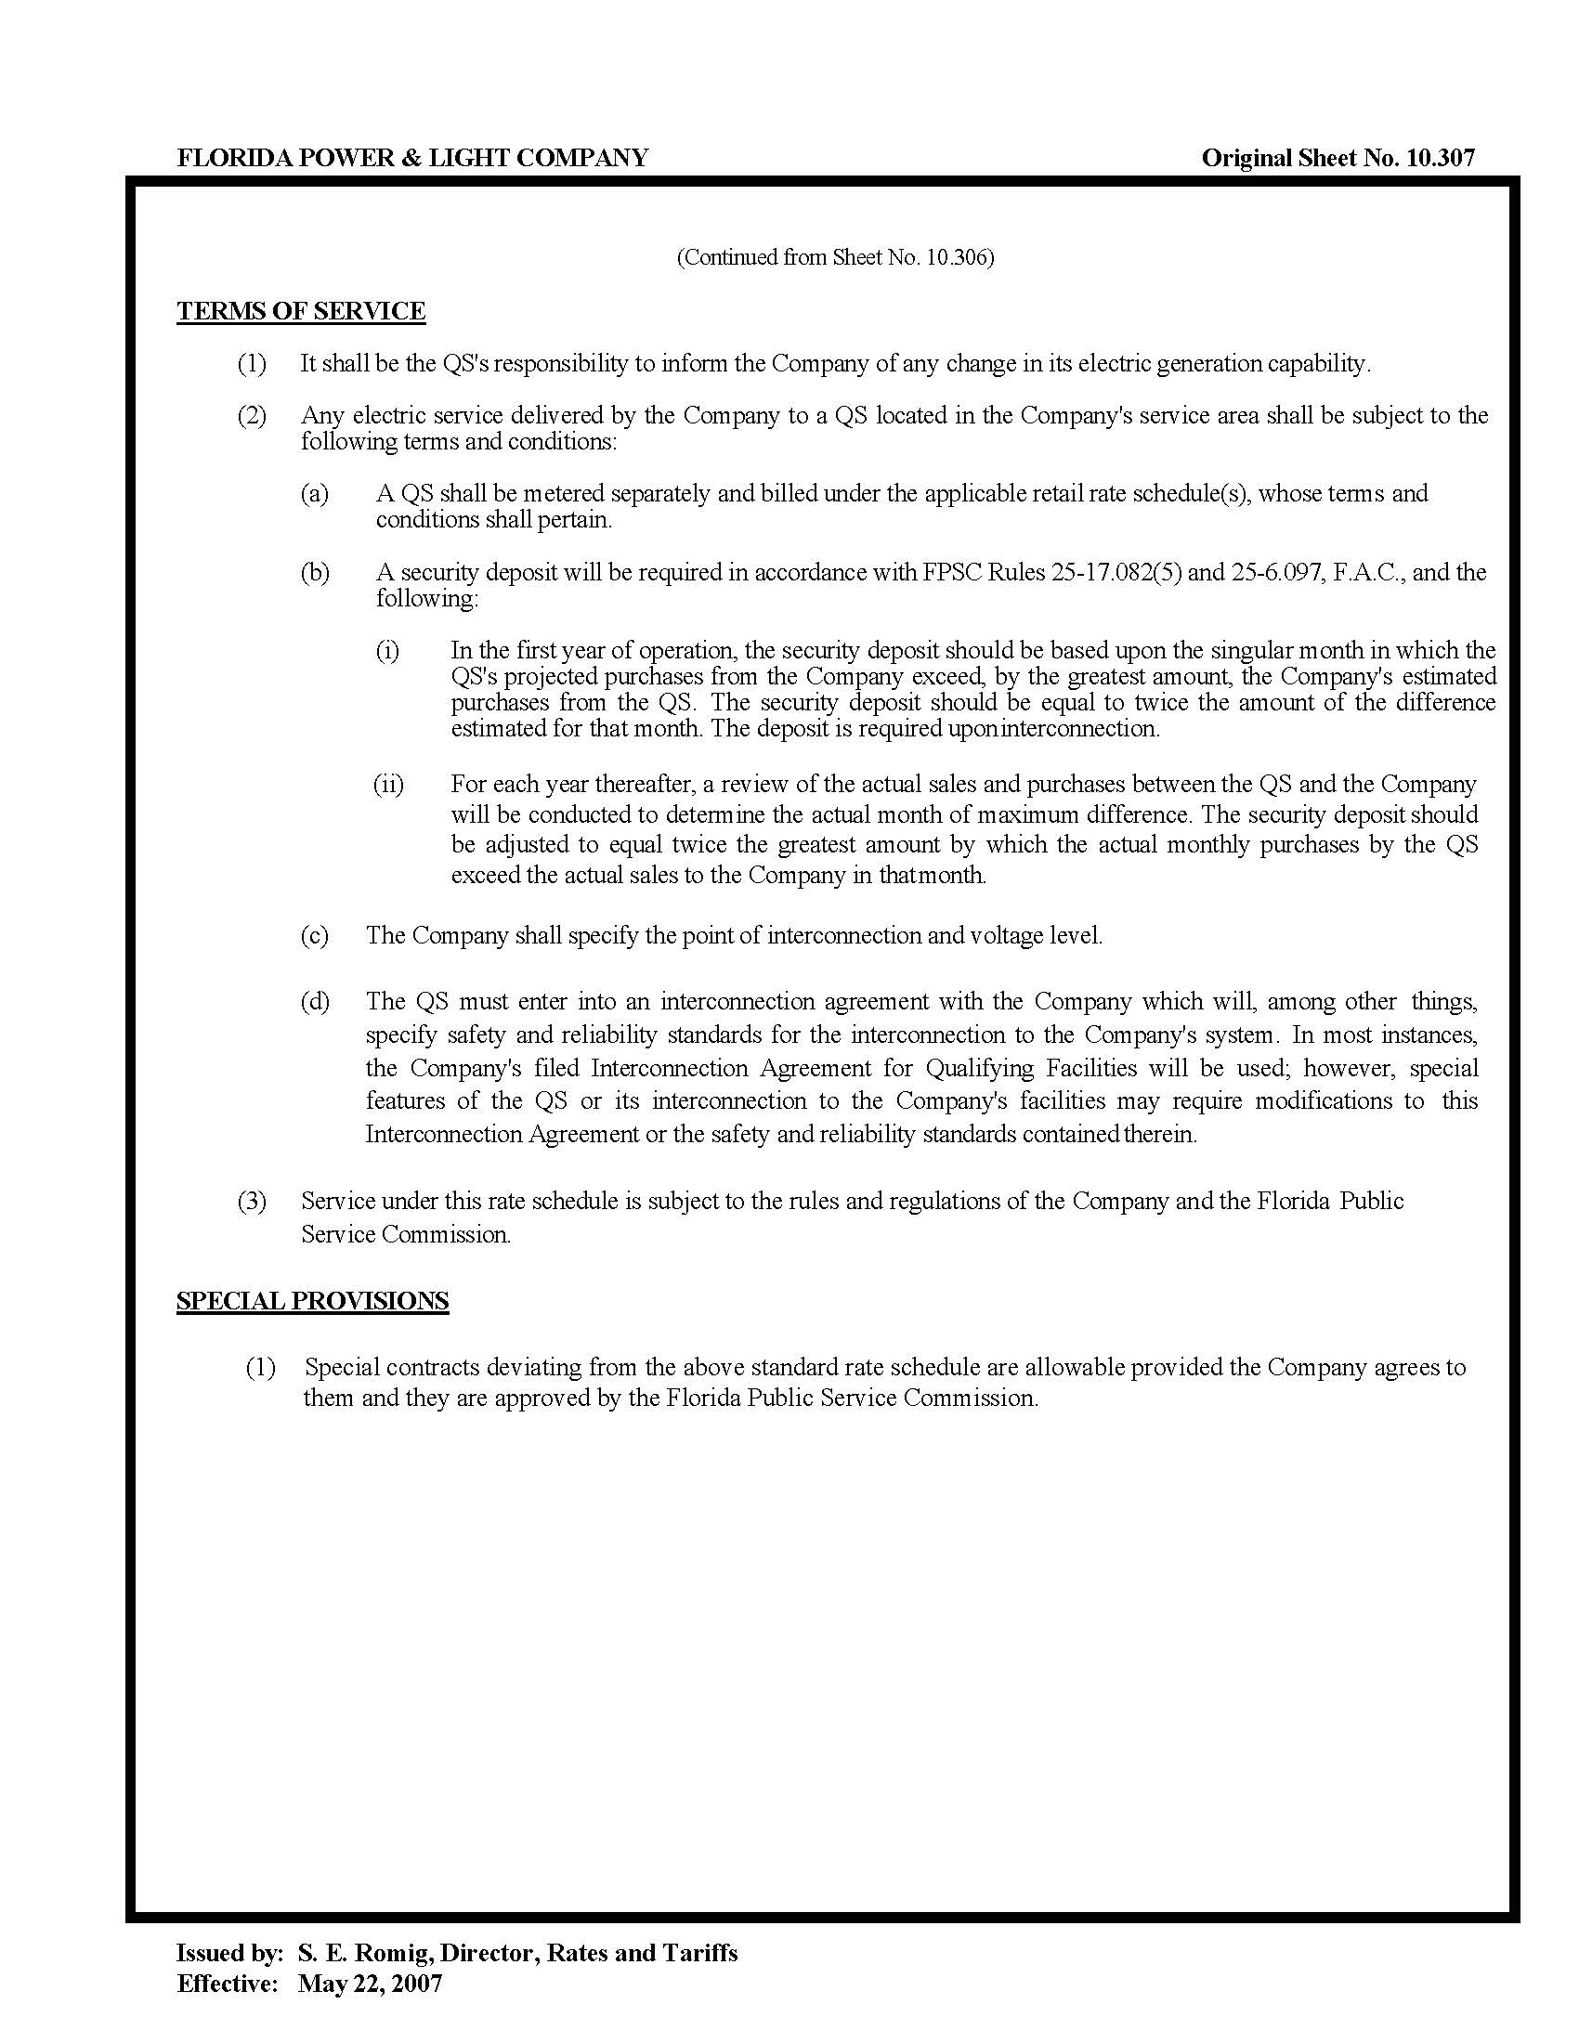

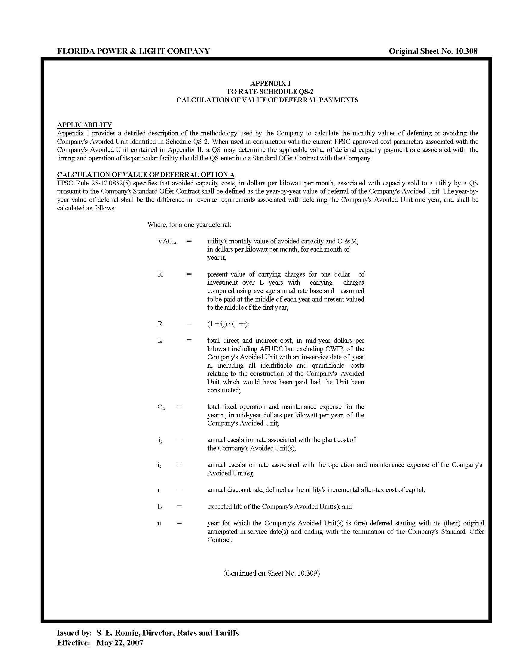

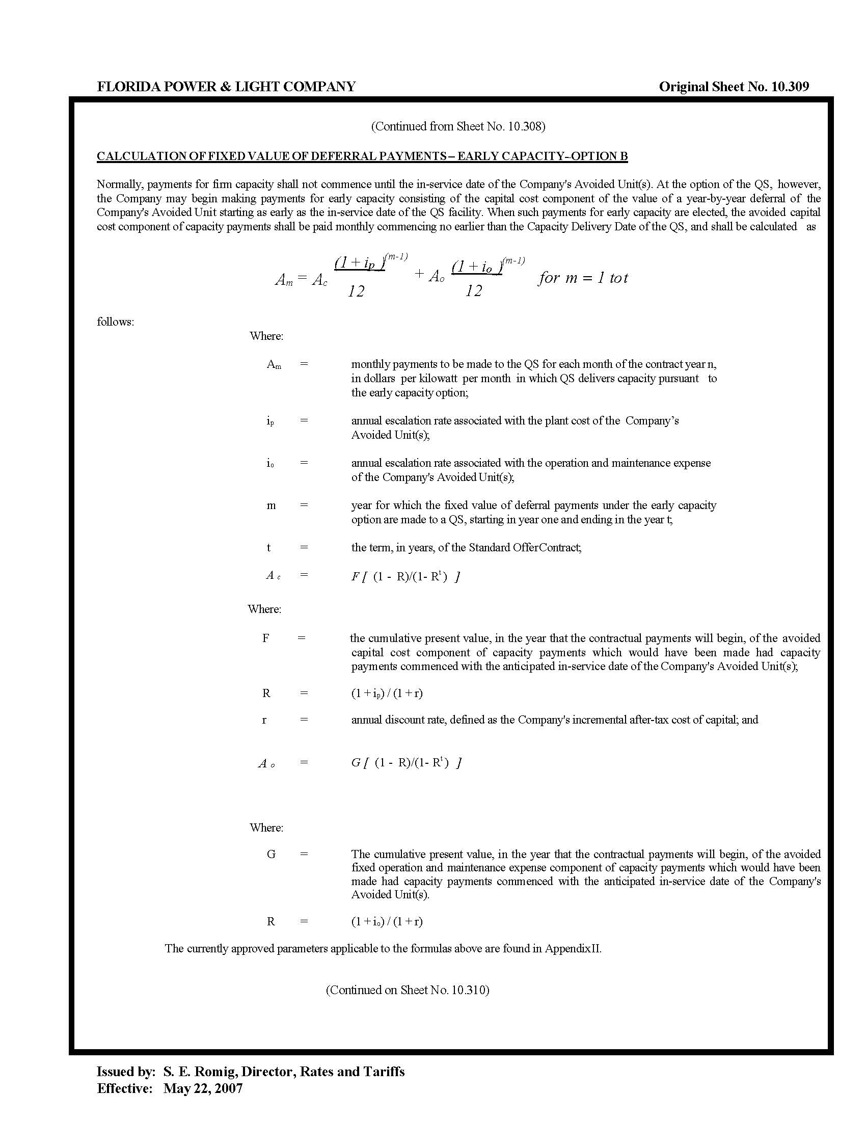

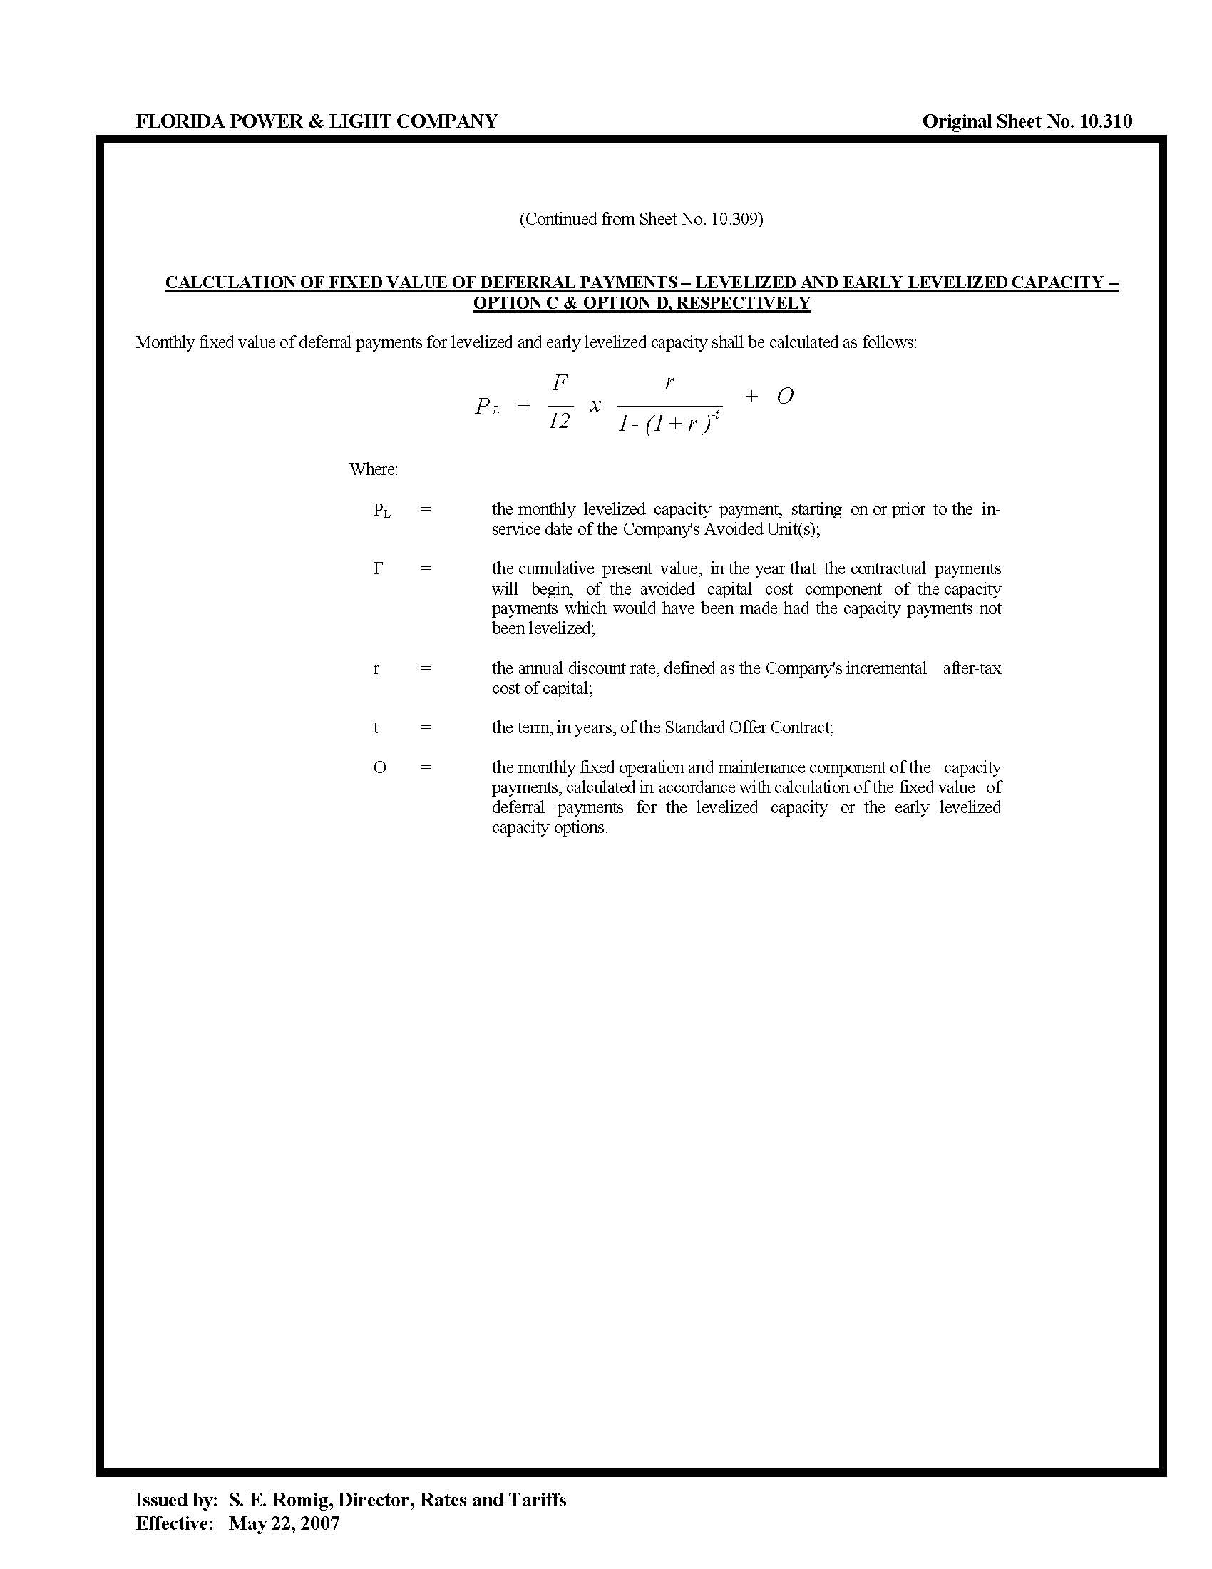

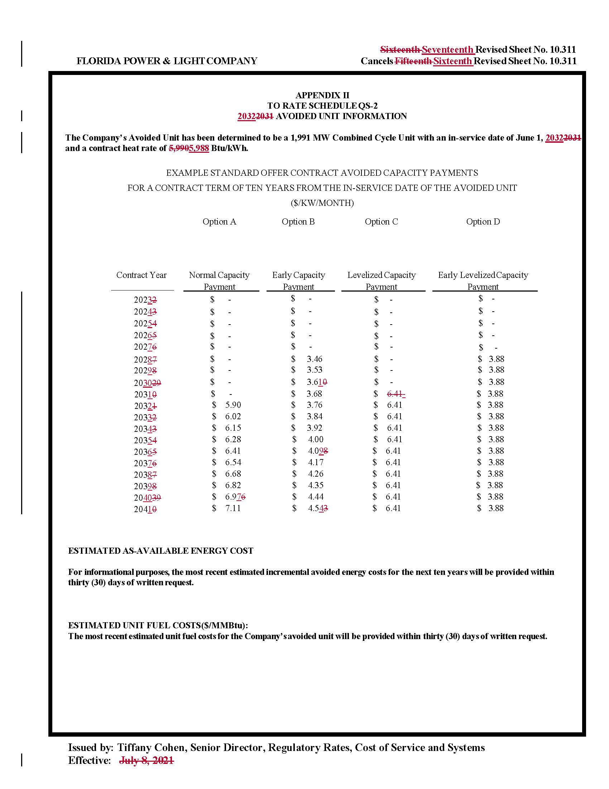

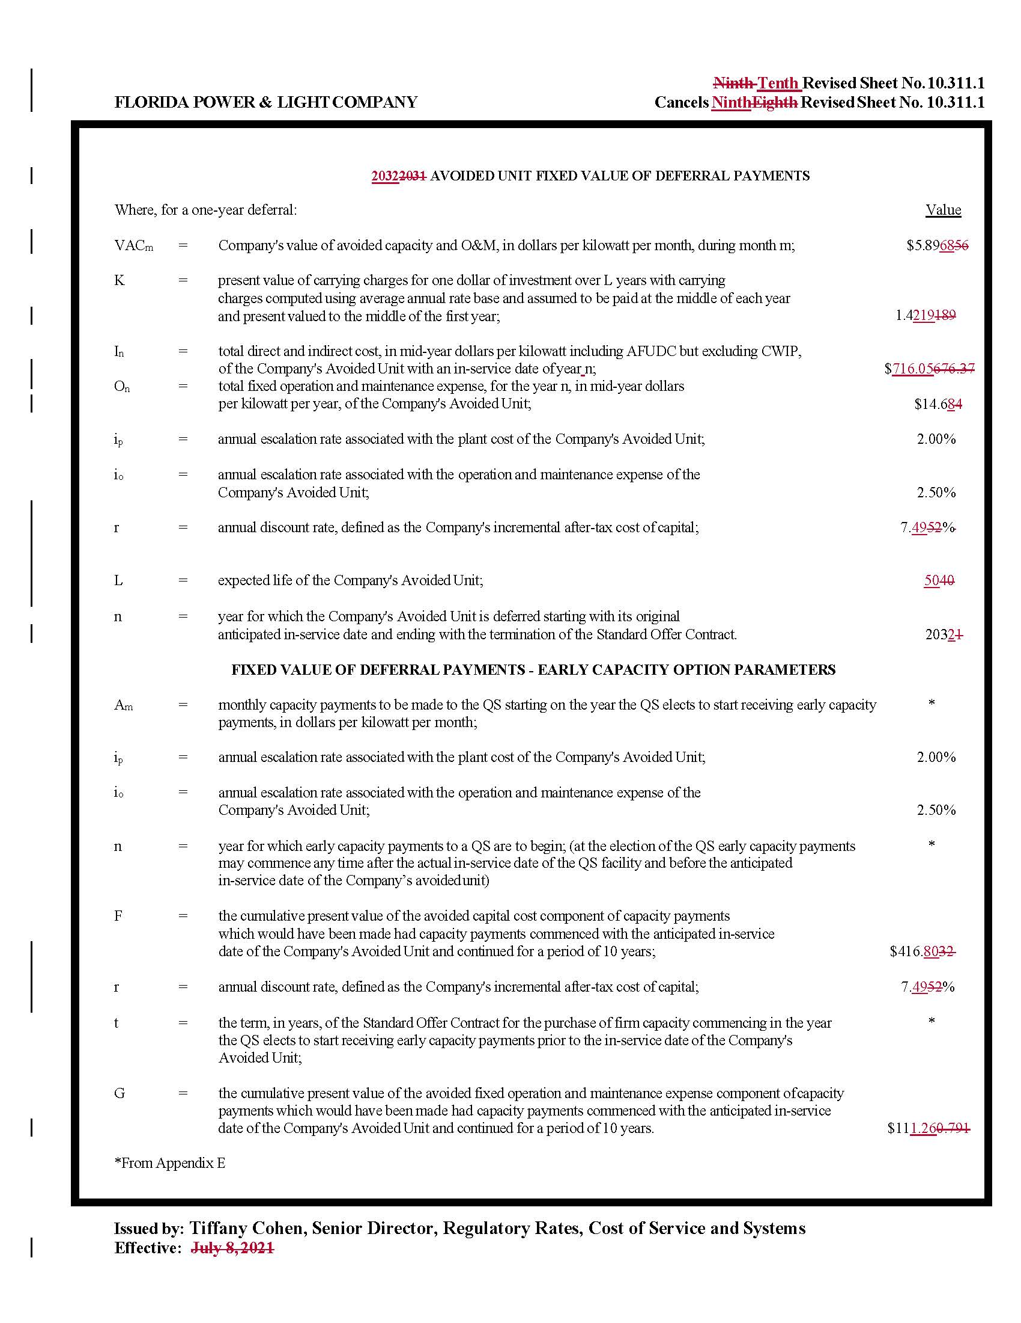

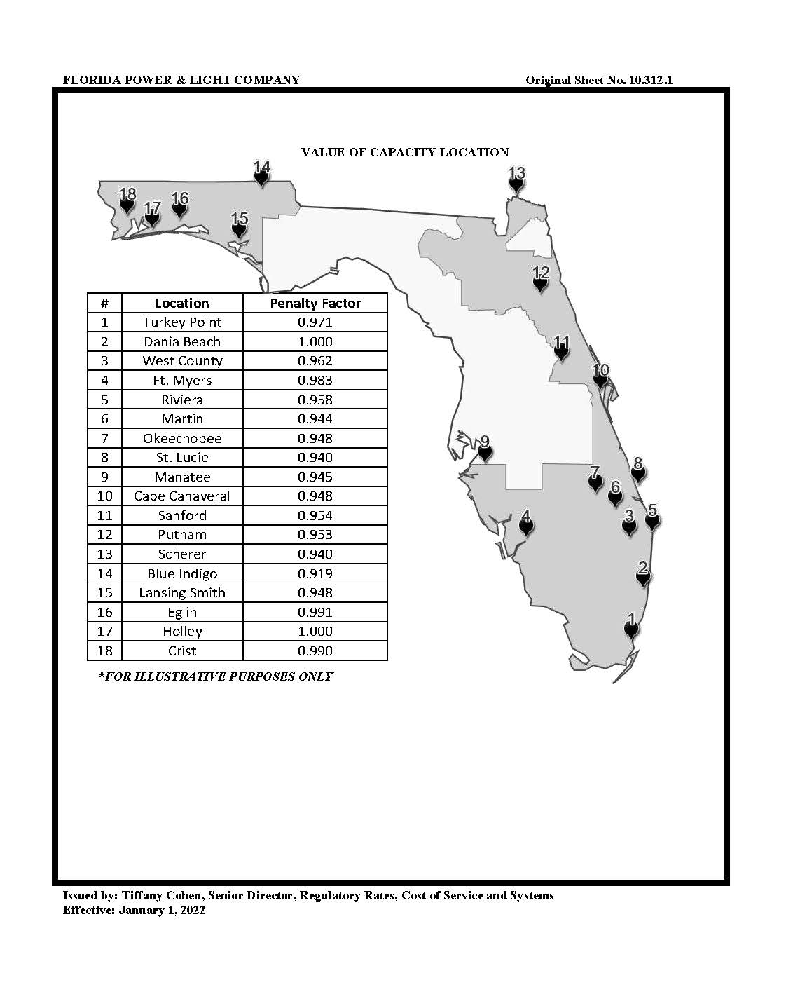

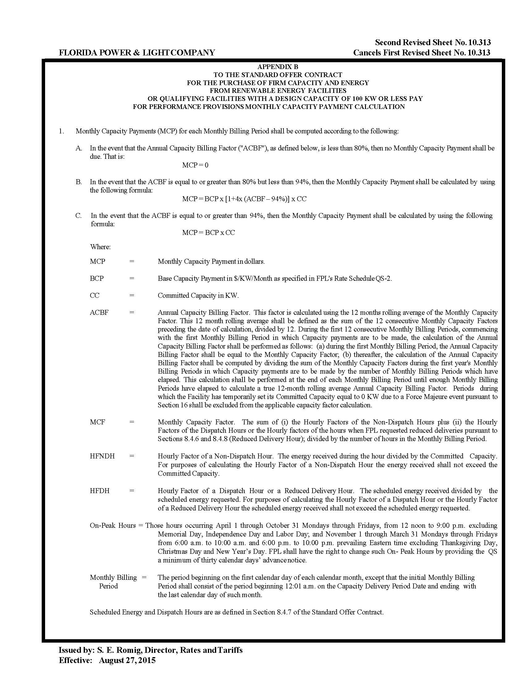

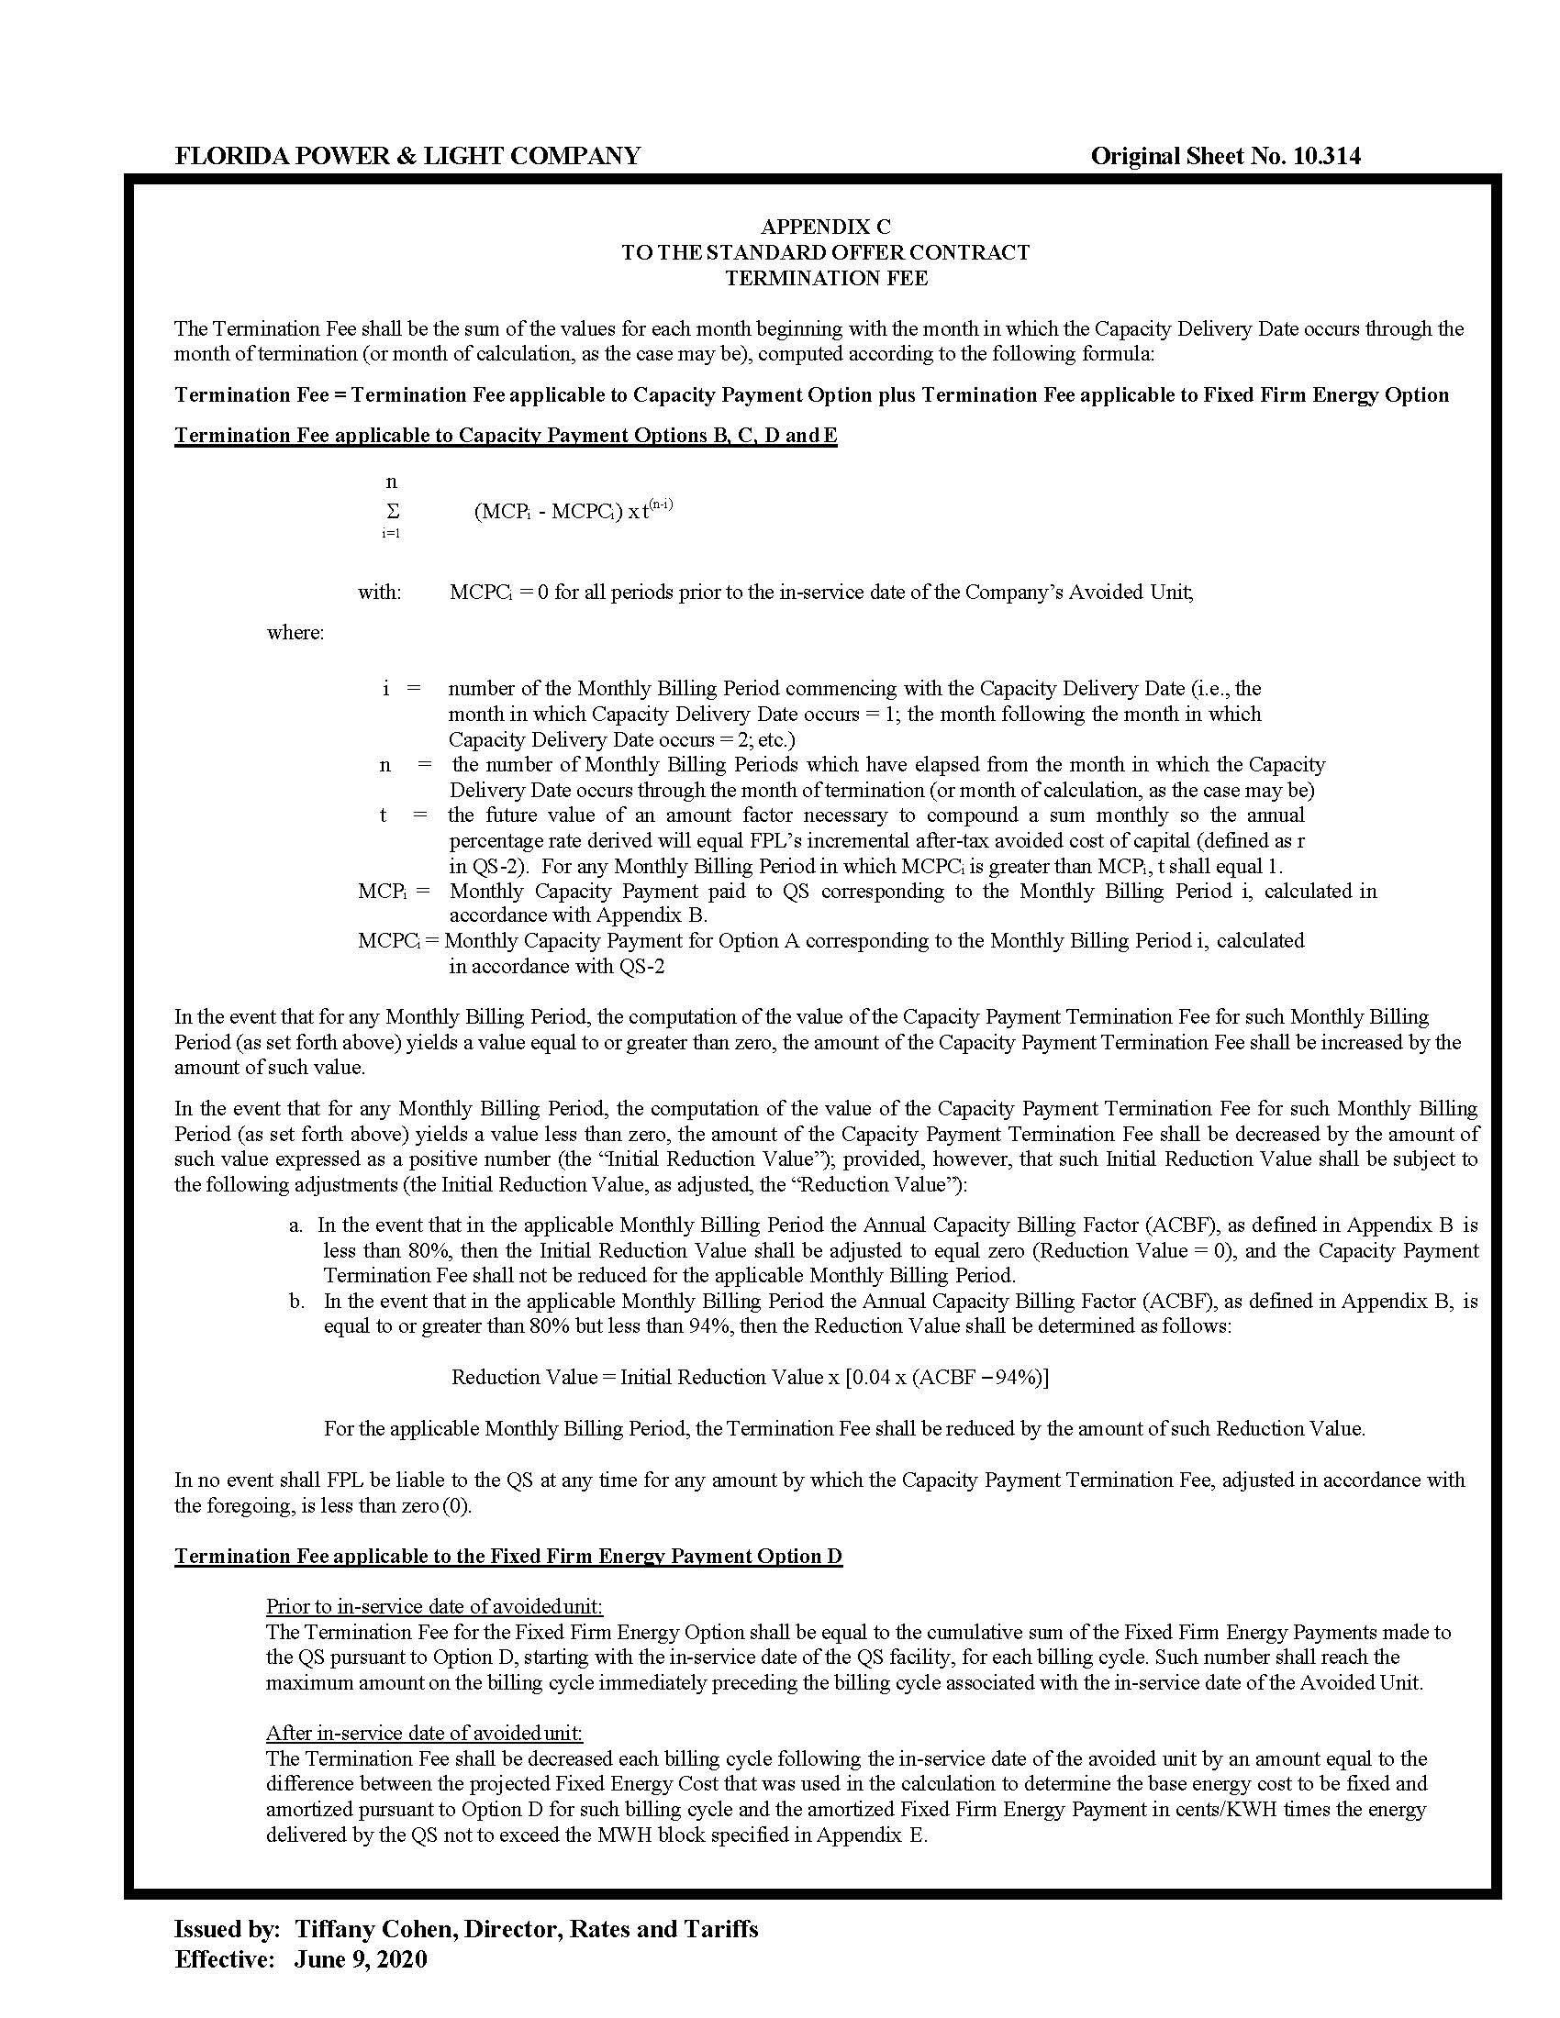

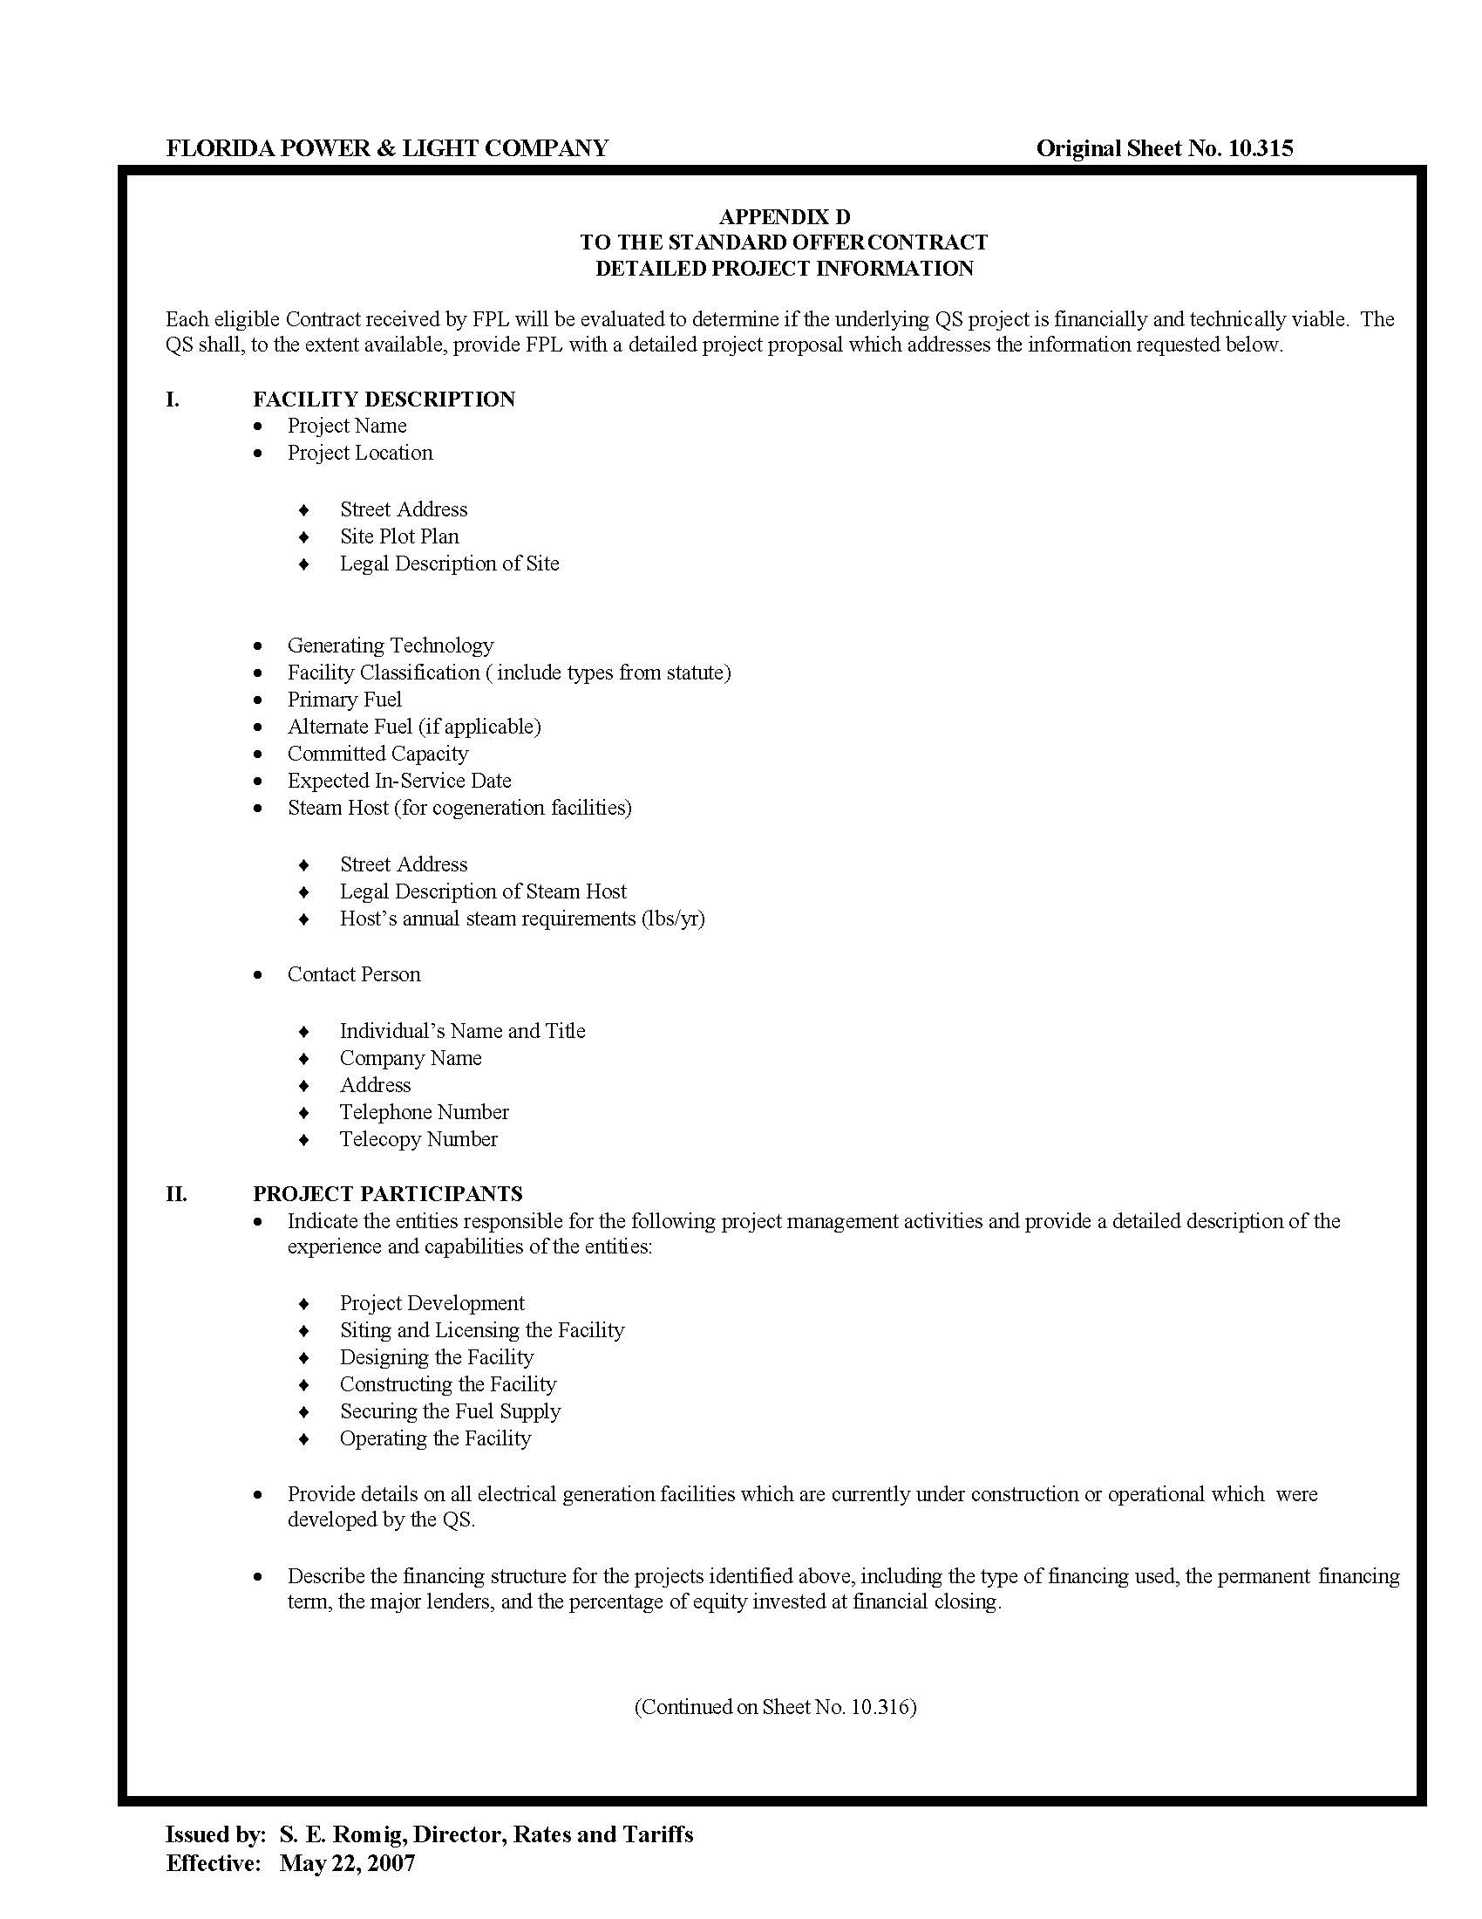

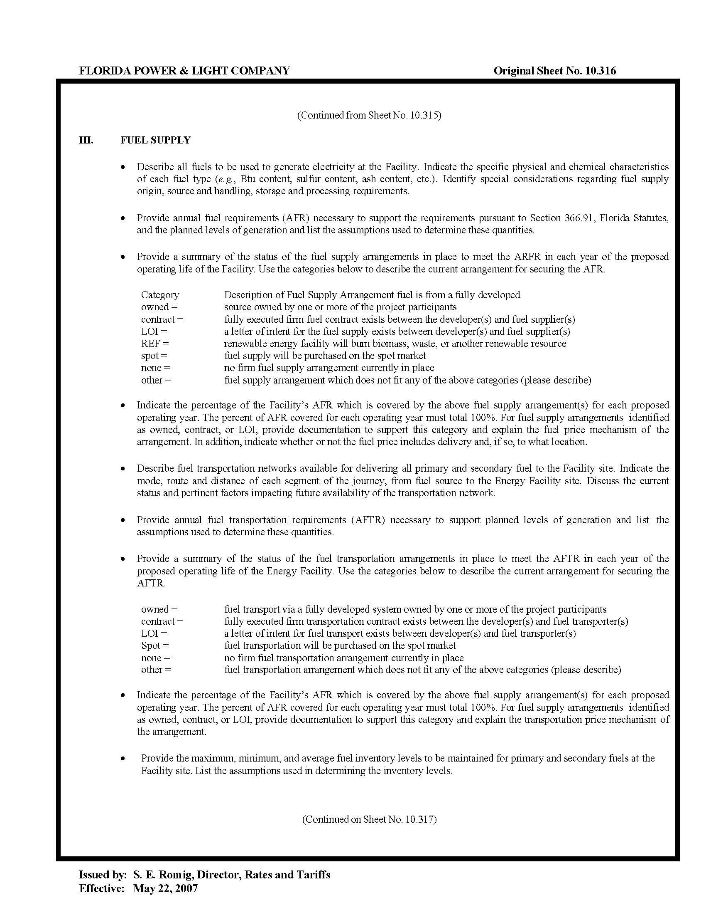

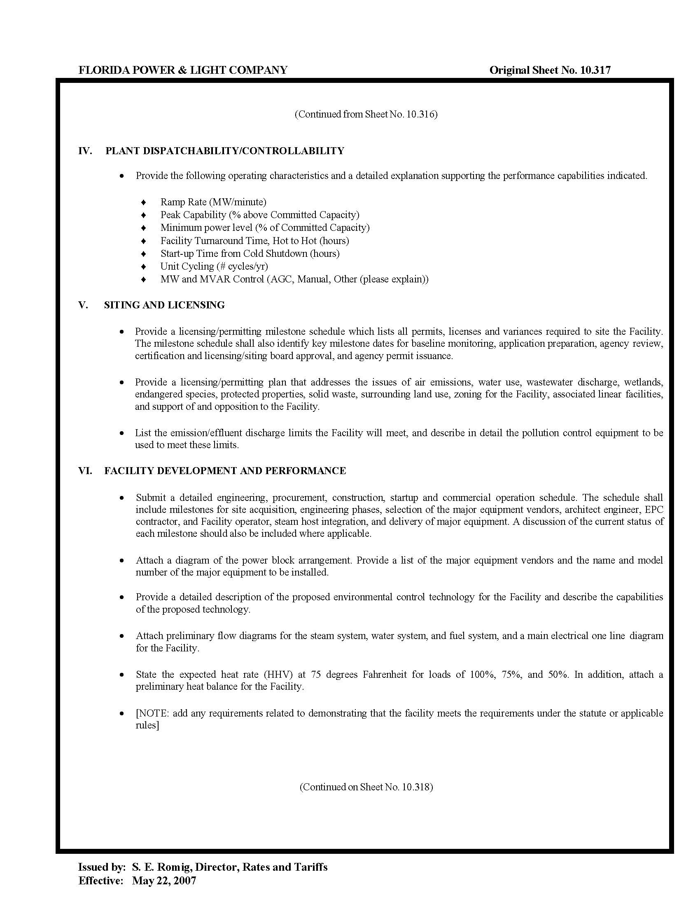

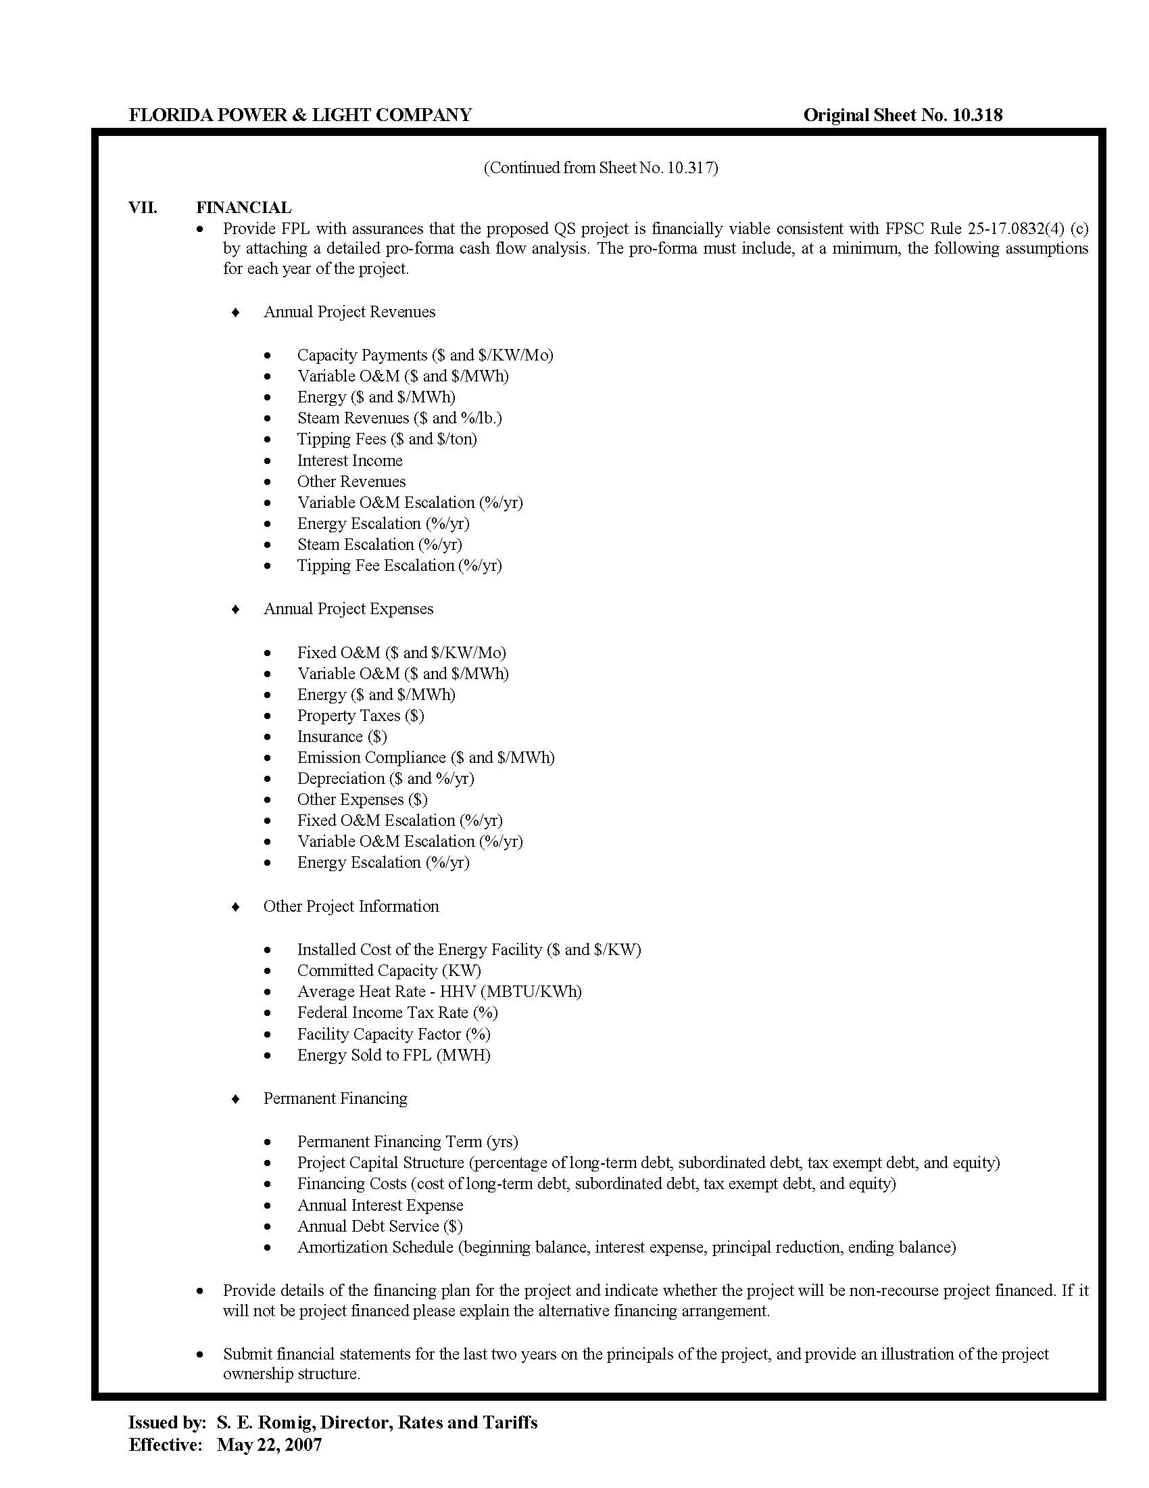

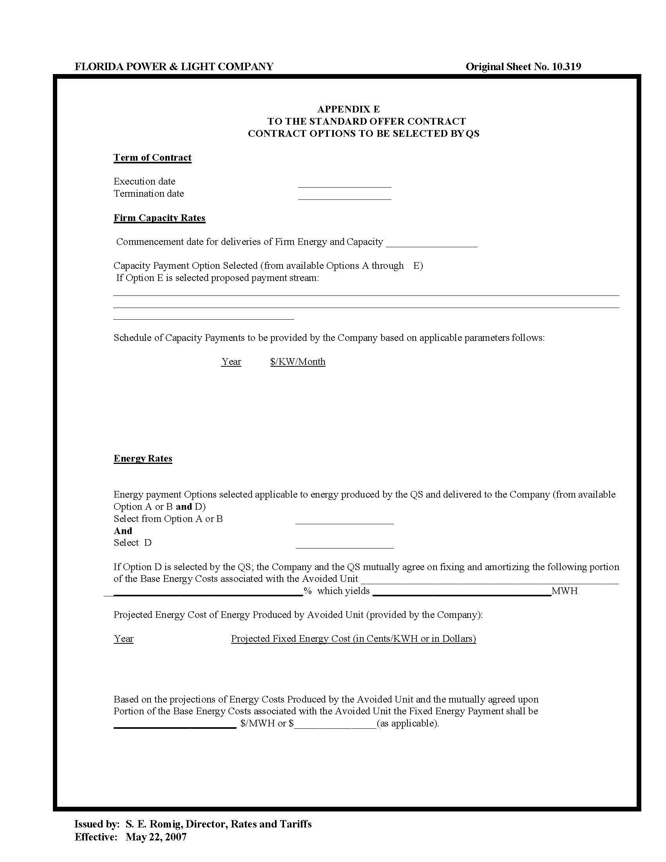

FPL’s 2022 TYSP contains two scenarios, the Recommended scenario and the Business as Usual (BAU) scenario. The Recommended scenario uses a novel methodology for forecasting winter peak demand based on potential extreme winter weather events. The BAU scenario uses the same methodology as FPL’s prior TYSPs for forecasting winter peak demand. FPL also submitted alternative versions of each of these scenarios assuming the passage of new federal tax credits for batteries and solar for informational purposes only.
See Order No. PSC-2018-0316-PAA-EQ, issued June 20, 2018, in Docket No. 20180083-EQ, In re: Petition for approval of renewable energy tariff and standard offer contract, by Florida Power & Light Company; Order No. PSC-2020-0212-PAA-EQ, issued June 26, 2020, in Docket No. 20200114-EQ, In re: Florida Power & Light Company’s Petition for Approval of a Renewable Energy Tariff and Standard Offer Contract; and Order No. PSC-2020-0213-PAA-EQ, issued June 26, 2020, in Docket No. 20200115-EQ, In re: Petition for approval of new standard offer for purchase of firm capacity and energy from renewable energy facilities or small qualifying facilities and rate schedule QS-2, by Gulf Power Company.
Document No. 02718-2022, filed April 29, 2022, in Docket No. 20220072-EQ.
Duke Energy Florida, LLC’s standard offer contract increased liability insurance requirements to $5 million as of 2014. See Order PSC-2014-0391-PAA-EI, issued July 28, 2014, in Docket 20140065-EI, in re: Petition for approval of amended standard offer contract COG-2 by Duke Energy Florida, Inc.

