State of Florida  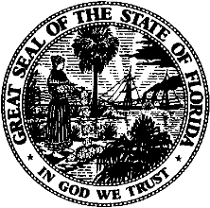 |  | Public Service Commission  Capital Circle Office Center ● 2540 Shumard Oak Boulevard  Tallahassee, Florida 32399-0850  -M-E-M-O-R-A-N-D-U-M-
DATE: | June 24, 2022
TO: | Office of Commission Clerk (Teitzman)
FROM: | Division of Economics (Guffey)  Office of the General Counsel (Brownless)
RE: | Docket No. 20220075-EU – Joint petition for approval of modification to territorial agreement in Polk County, by City of Lakeland and City of Bartow.
AGENDA: | 07/07/22 – Regular Agenda – Proposed Agency Action – Interested Persons May Participate
COMMISSIONERS ASSIGNED: |  |  | All Commissioners
PREHEARING OFFICER: |  |  | Clark
CRITICAL DATES: |  |  | None
SPECIAL INSTRUCTIONS: |  |  | None

Case Background
On April 13, 2022, the City of Lakeland, on behalf of Lakeland Electric (Lakeland) and the City of Bartow (Bartow), filed a joint petition for approval of a modification (New Territorial Agreement) to their territorial agreement first approved by the Commission in 1984 (Legacy Agreement) in Polk County. In 2006, Lakeland and Bartow entered into an informal agreement to swap a portion of each other’s service territory. While the intent of both parties was to formalize their agreement and submit it to their respective city councils and the Commission, those actions were never completed by the parties. No customers were impacted by this informal agreement, as the affected territories at the time were vacant land. While the Legacy Agreement expired in 2009, the utilities have continued to operate under the general parameters of that agreement.
The proposed New Territorial Agreement reflects the 2006 service territory swap and new subdivision developments that have occurred since 2006. The proposed New Territorial Agreement is included in Attachment A to this recommendation. The relevant maps including a map depicting the swapped territory and timeline of subdivision development are shown in Attachment B to this recommendation.
During the review process, staff issued its first data request to the joint petitioners on April 15, 2022. After review of this request, the joint petitioners requested an informal meeting with staff to discuss the unique circumstances involving the proposed New Territorial Agreement. An informal conference call was held on April 21, 2022, during which the joint petitioners provided additional information not contained in the petition and explained the circumstances leading up to the proposed New Territorial Agreement.

As a result of the discussions and additional information received at the informal conference call, staff withdrew its first data request on April 26, 2022 to allow the joint petitioners to file a supplemental response, which included additional information and maps. The supplemental response was filed on April 29, 2022, and included the information requested in staff’s first data request. After review of the supplemental information, staff issued its second data request on May 10, 2022, for which responses were filed on May 20, 2022. The Commission has jurisdiction over this matter pursuant to Section 366.04, Florida Statutes (F.S.).

Discussion of Issues

Issue 1:
Should the Commission approve the proposed New Territorial Agreement in Polk County between Lakeland and Bartow?

Recommendation:
Yes, the Commission should approve the proposed New Territorial Agreement in Polk County between Lakeland and Bartow. The approval of this New Territorial Agreement will enable Lakeland and Bartow to accurately reflect their current service areas, better serve existing and future customers in Polk County, and will not be a detriment to the public interest. (Guffey)

Staff Analysis:
Pursuant to Section 366.04(2)(d), F.S., and Rule 25-6.0440(2), Florida Administrative Code (F.A.C.), the Commission has the jurisdiction to approve territorial agreements between and among rural electric cooperatives, municipal electric utilities, and other electric utilities. Unless the Commission determines that the modification to the Legacy Agreement will cause a detriment to the public interest, the proposed New Territorial Agreement should be approved.

The Proposed New Territorial Agreement
In 1983, Lakeland and Bartow entered into a territorial agreement which was approved by the Commission in 1984. The Legacy Agreement had a term of 25 years (1984-2009). In 2006, Lakeland and Bartow informally agreed to swap a portion of their respective electric service areas because it allowed for better infrastructure access to serve future development. While the utilities entered into a written agreement dated May 19, 2006, to swap this territory, they did not seek nor receive Commission approval as required by Rule 25-6.0440(1), F.A.C. The May 19, 2006 agreement indicates that the joint petitioners had intended to file a petition with the Commission to amend their service territories; however, the joint petitioners explained that as a result of utility staffing changes and due to an administrative oversight a timely petition was not filed.

In the 2006 territory swap, Bartow acquired from Lakeland the Wind Meadows subdivision which is comprised of 39.65 acres. During the time of the territory swap, the Wind Meadows was a platted subdivision (no customers) and it is located within Bartow’s city limits. Between August 2006 and April 2022, the Wind Meadows subdivision was developed and now consists of 134 homes. The joint petitioners explained that in 2006, Bartow had the capacity and readily accessible facilities available to serve the future Wind Meadows subdivision.

In return, in 2006 Lakeland acquired 58.19 acres of vacant pastureland from Bartow’s service territory. In May 2022, construction started and the pastureland is being developed as the Wind Meadows South subdivision, with 145 potential new residential customers. During the recent platting and development of the Wind Meadows South subdivision on this pastureland, the developer and Lakeland realized that the 2006 service territory swap and boundary adjustment had not been submitted to the Commission for approval. Thereafter, the parties also became aware that the Legacy Agreement had expired in 2009, at the end of its 25-year term. From 2009 to date, the parties have continued to abide by the terms of the Legacy Agreement as modified by the informal agreement and have worked cooperatively to serve their customers. There are currently no outstanding service issues or territorial disputes between the subject utilities.

To remedy the unapproved territory swap and the expired territorial agreement, on April 4, 2022, the joint petitioners entered into the New Territorial Agreement (see Attachment A). Through the New Territorial Agreement, Lakeland and Bartow desire to define specific areas of their respective electric service areas corresponding to the Wind Meadows and Wind Meadows South subdivisions in Polk County. The swapped territory and the above discussed subdivisions, along with their development timelines, are depicted on a map in Attachment B to this recommendation.

The proposed New Territorial Agreement does not contemplate any customer or facility transfers and therefore no customer notification is required pursuant to Rule 25-6.0440(1)(d), F.A.C. If there is a need to transfer customers and facilities in the future during the term of the agreement, pursuant to Article 2, the transfers will be based on sound economic and engineering practices.

The proposed New Territorial Agreement is for an initial term of 15 years and after that, the agreement would automatically renew for successive 5-year terms. If either of the parties desire not to renew for successive 5-year terms, the party should provide to the other party written notification of their desire to not renew, no less than 12 months prior to automatic extension date. Any modifications to this proposed agreement will be submitted to the Commission for its review and approval.

Conclusion
Both Lakeland and Bartow should be cautioned if they enter into other territorial agreements or amendments in the future, such documents should be timely submitted for Commission approval pursuant to Rule 25-6.0440, F.A.C. After review of the joint petition, the supplemental information, responses to staff’s second data request, and the informal meeting with the joint petitioners, staff believes the proposed New Territorial Agreement will not cause a detriment to the public interest, will eliminate any potential uneconomic duplication of facilities, and will not cause a decrease in reliability of electric service to the present or future customers of Lakeland or Bartow. Therefore, staff recommends that the Commission approve the proposed new Territorial Agreement between Lakeland and Bartow in Polk County.

Issue 2:
Should this docket be closed?

Recommendation:
Yes. If no protest is filed by a person whose substantial interests are affected within 21 days of the issuance of the Order, this docket should be closed upon the issuance of the Consummating Order. (Brownless)

Staff Analysis:
If no protest is filed by a person whose substantial interests are affected within 21 days of the issuance of the Order, this docket should be closed upon the issuance of a Consummating Order.
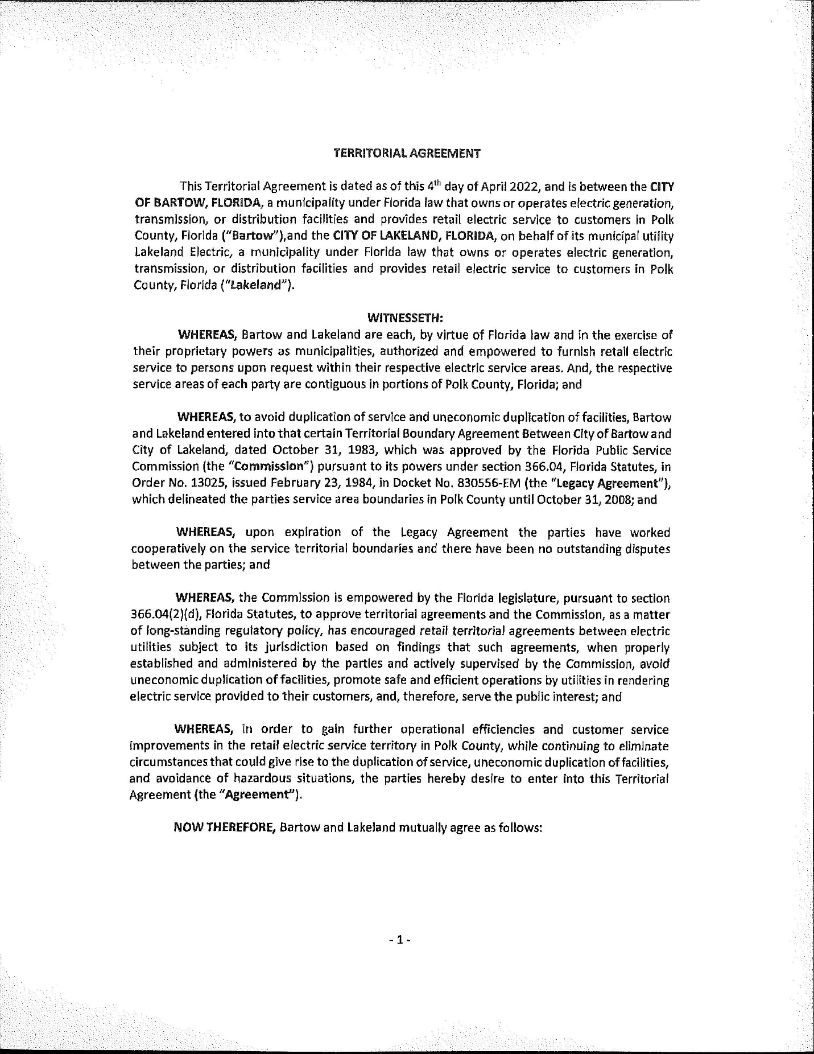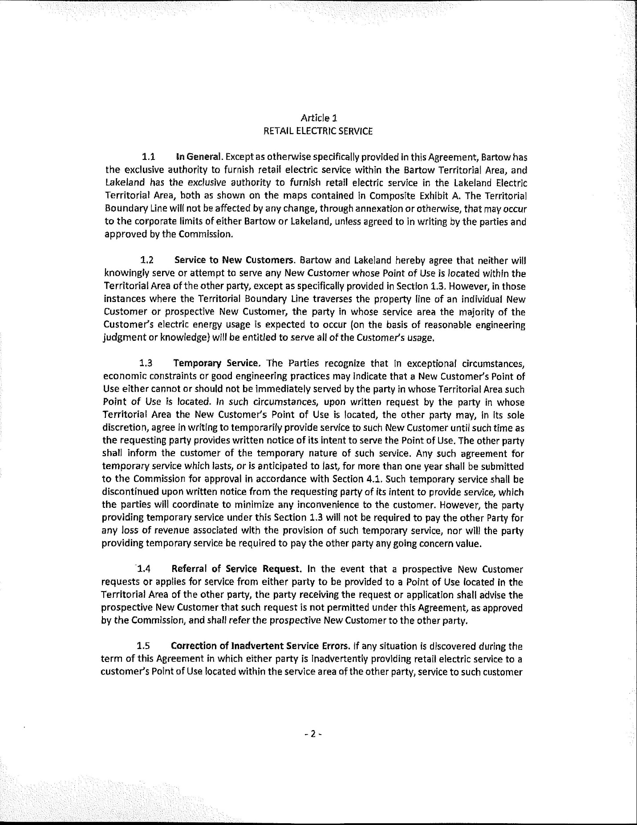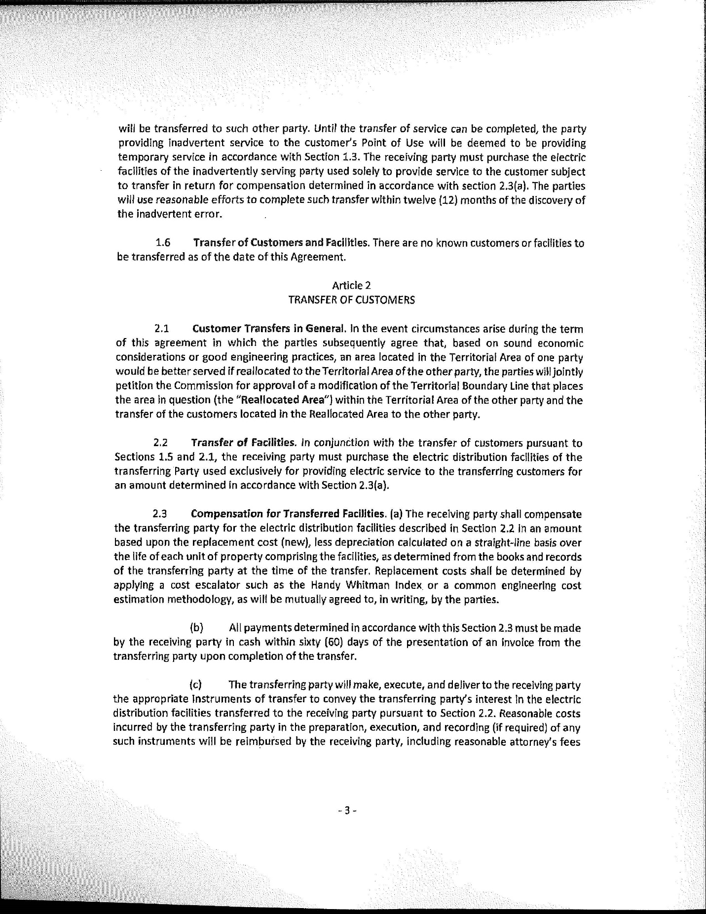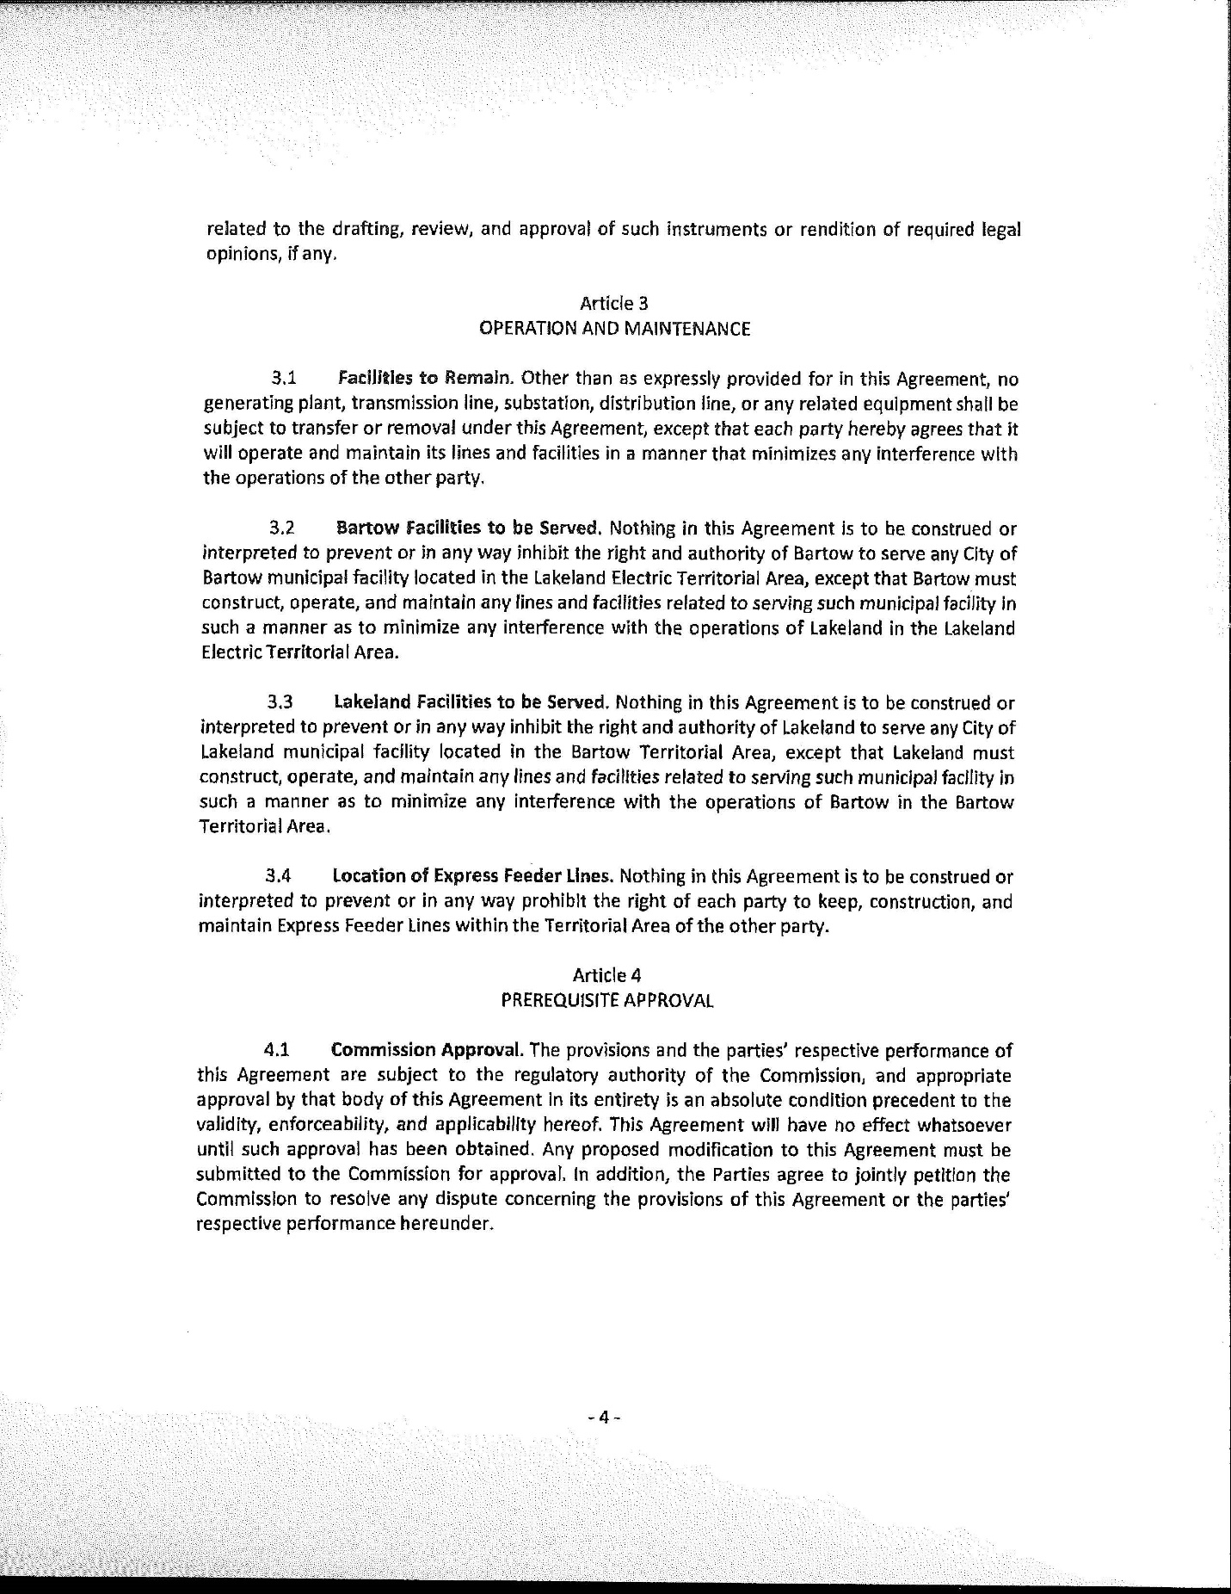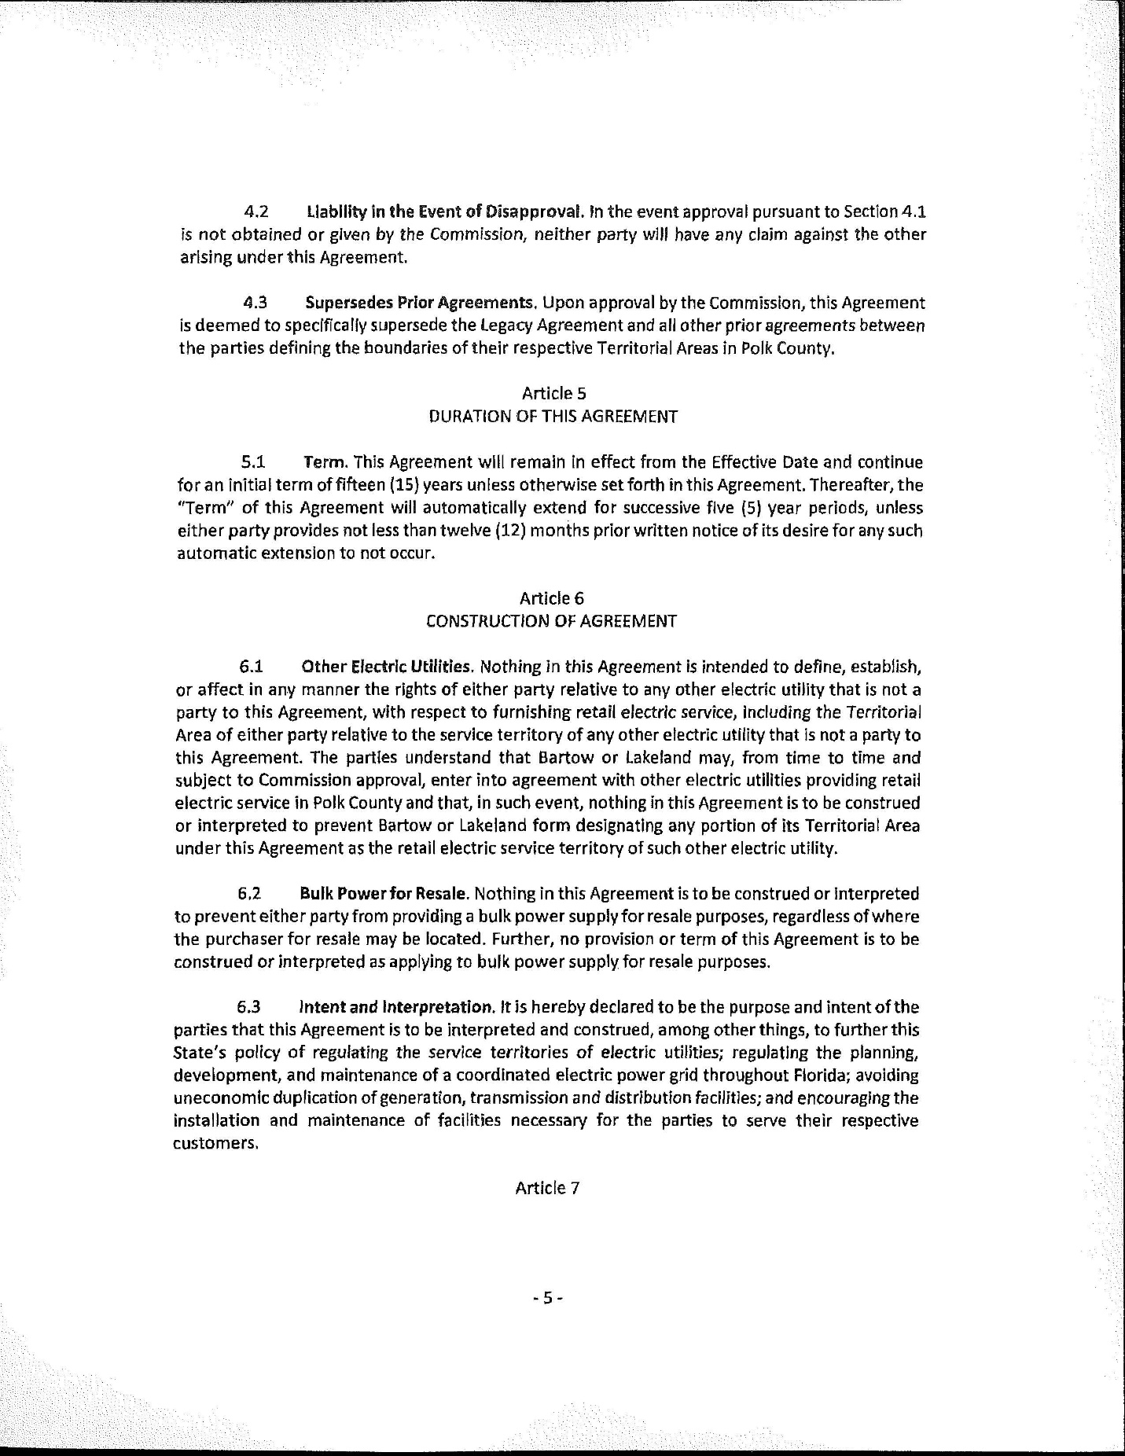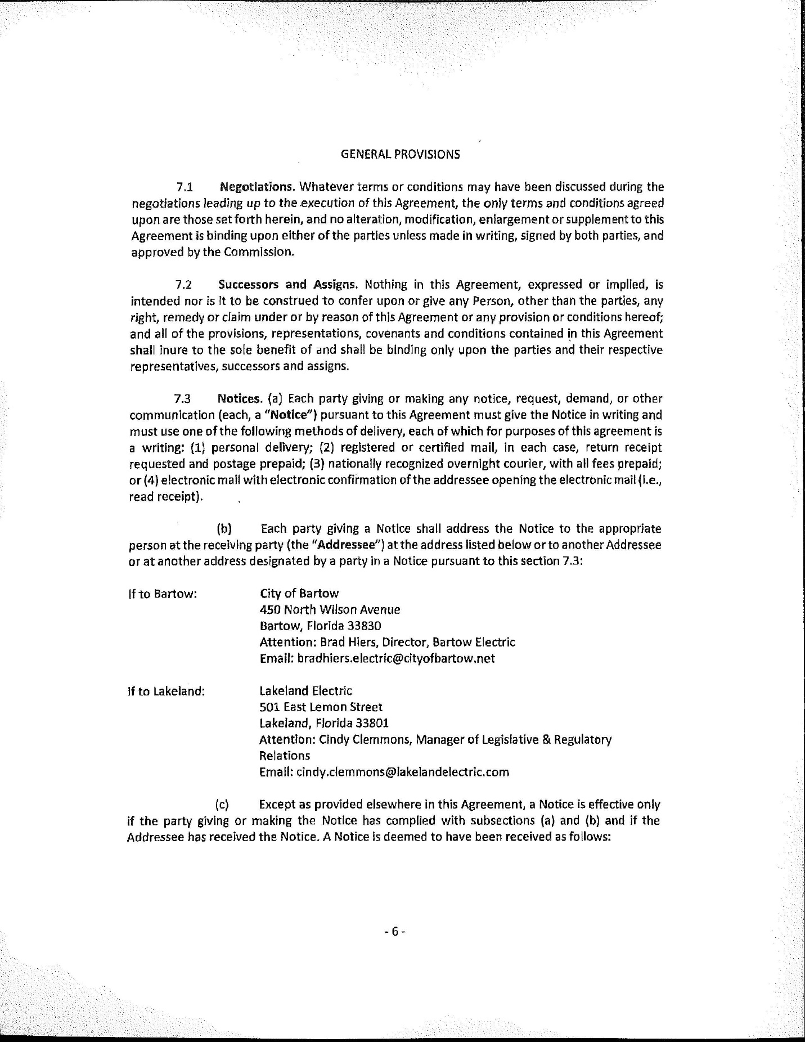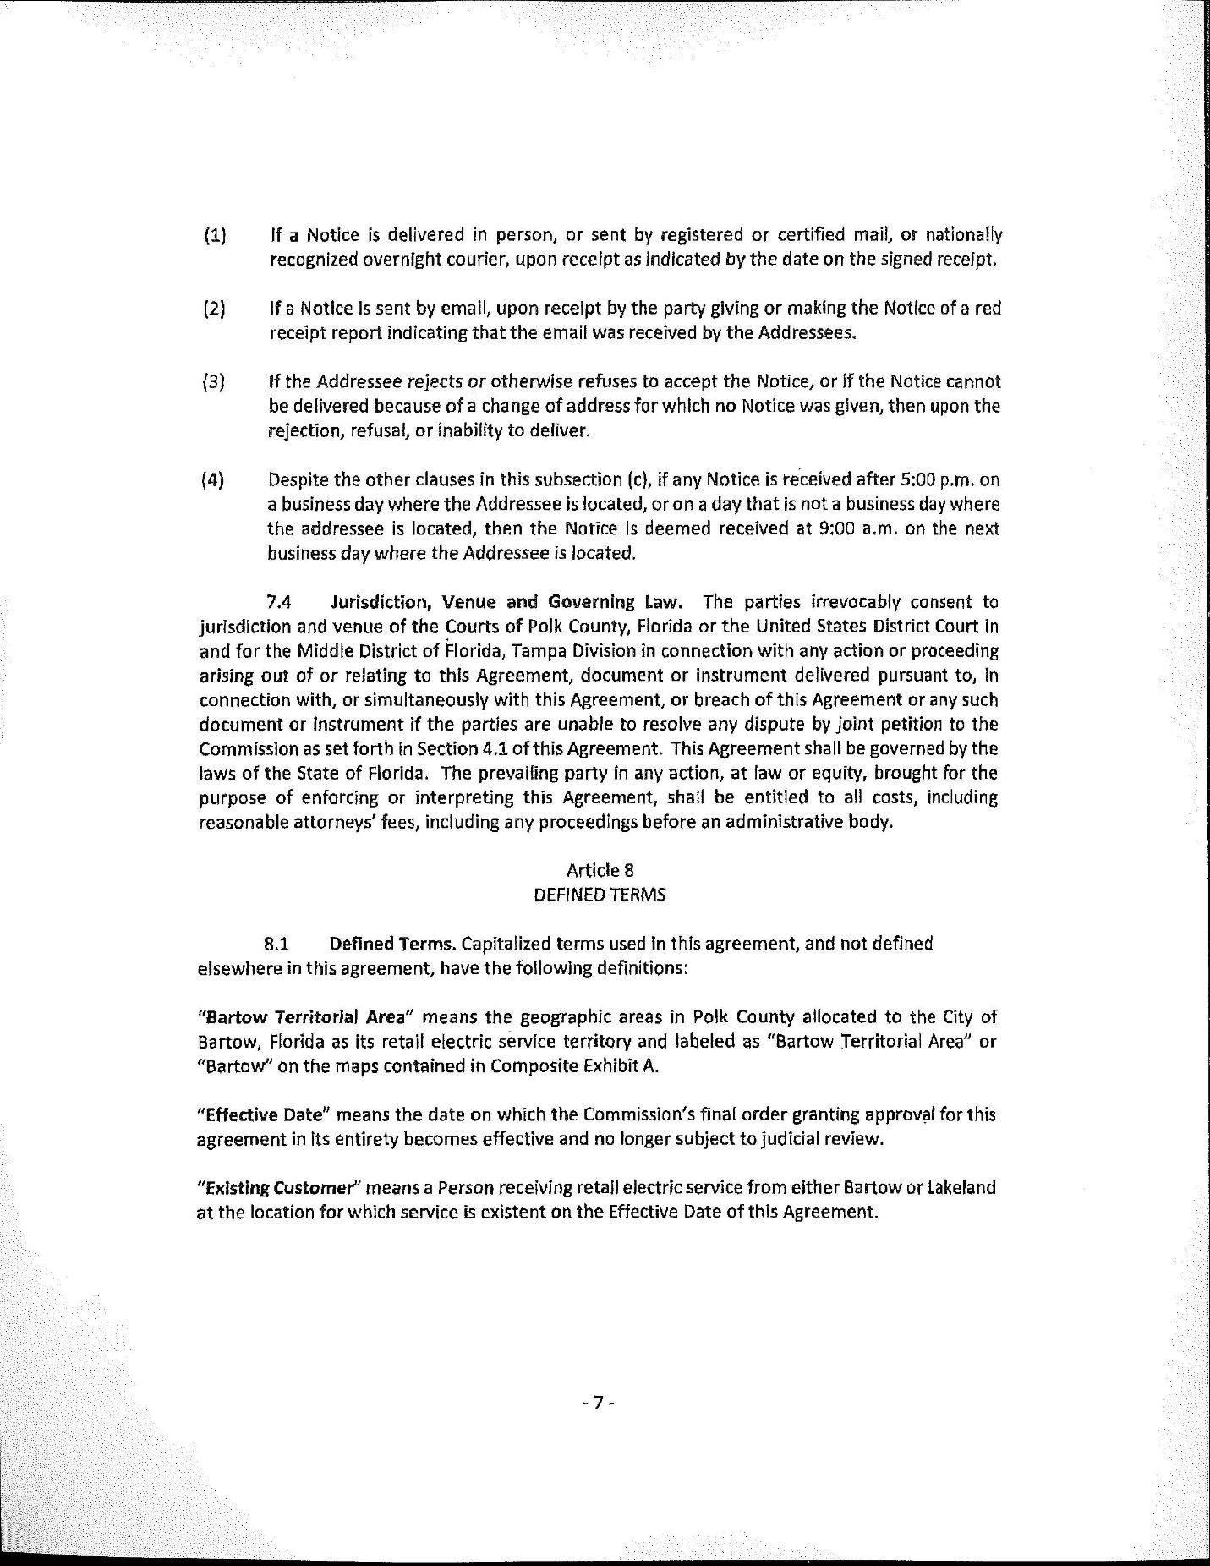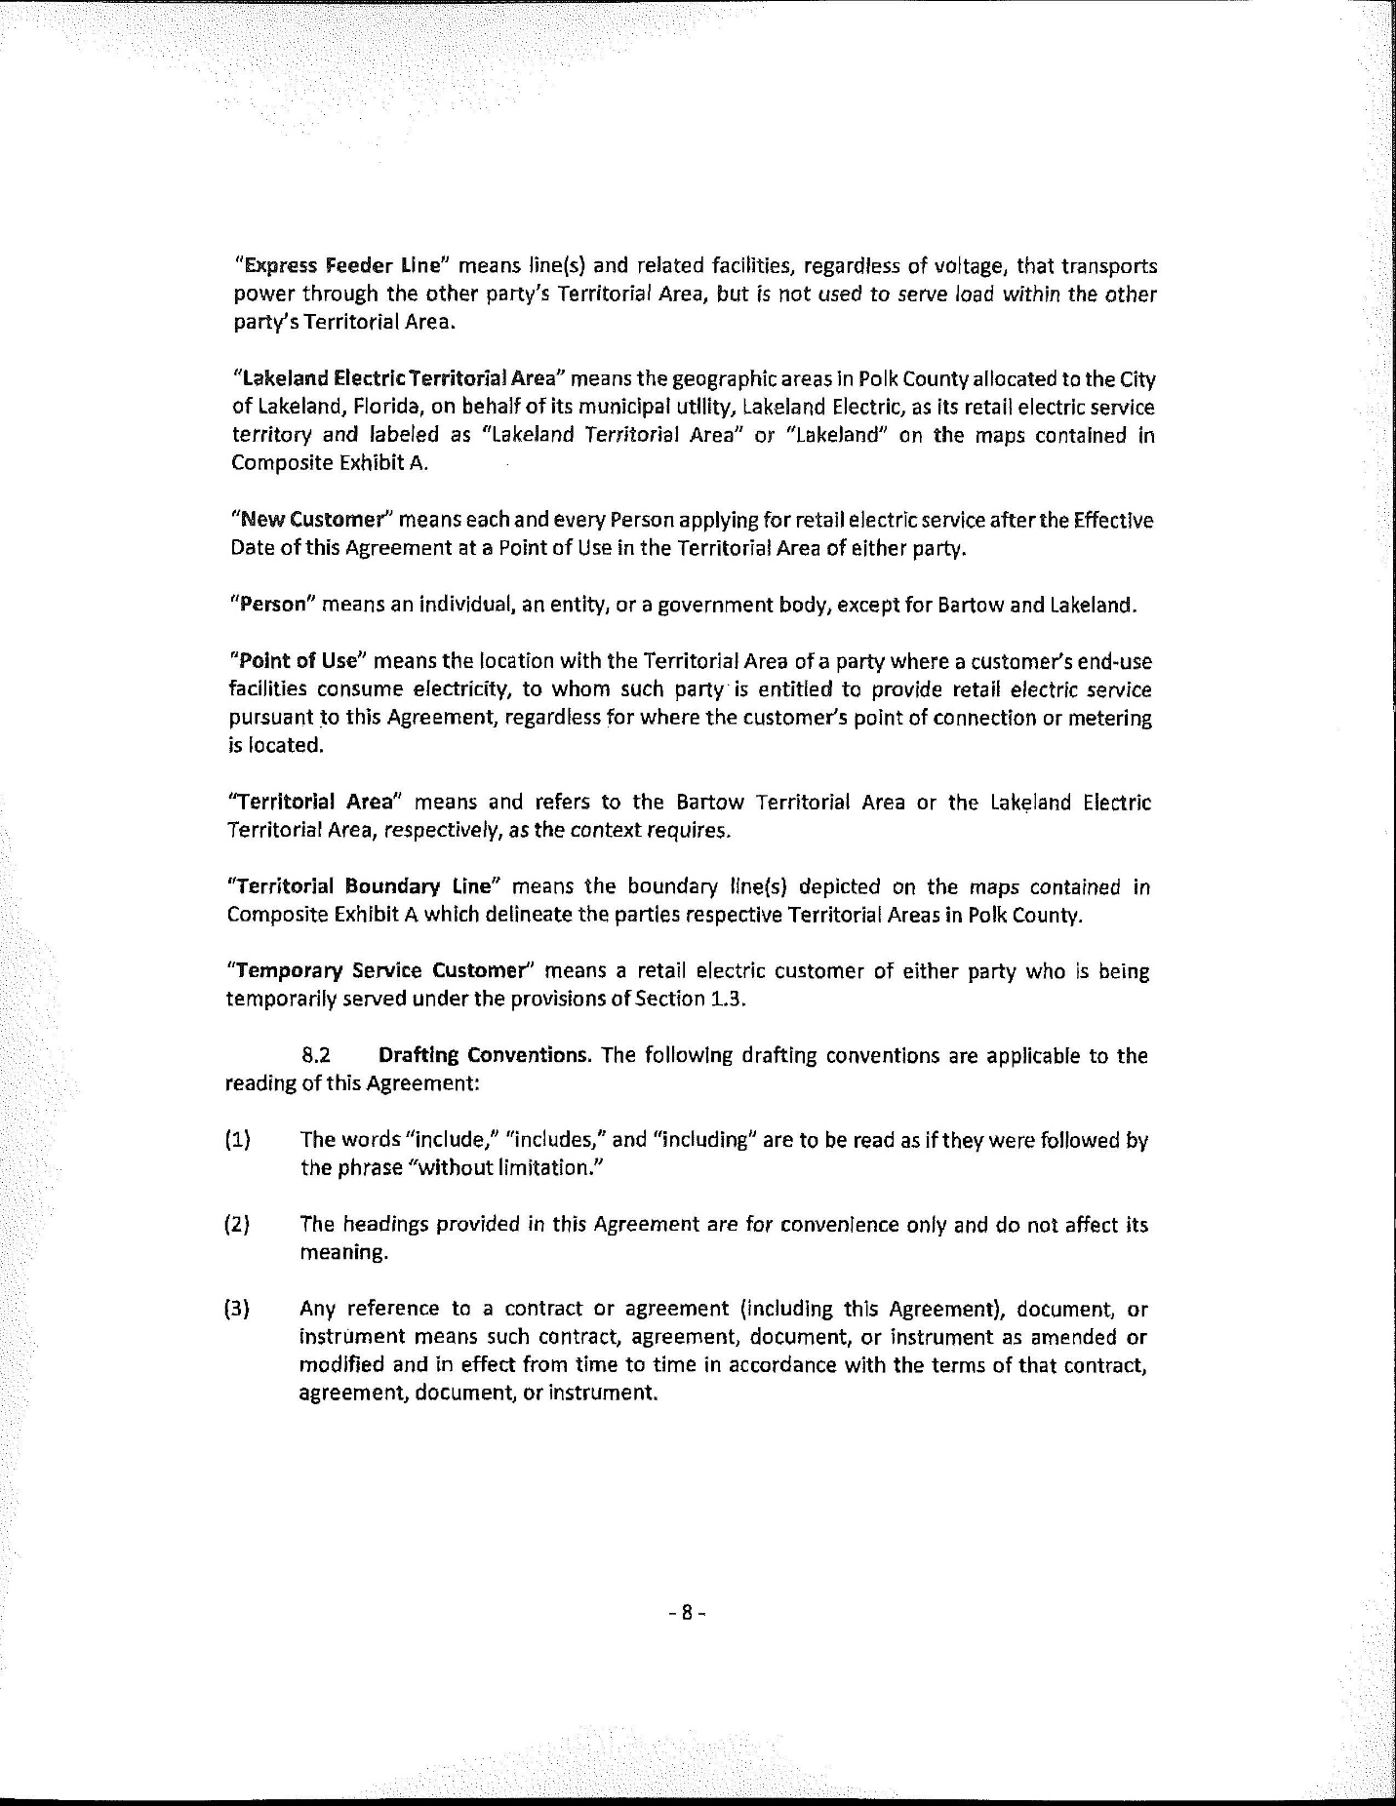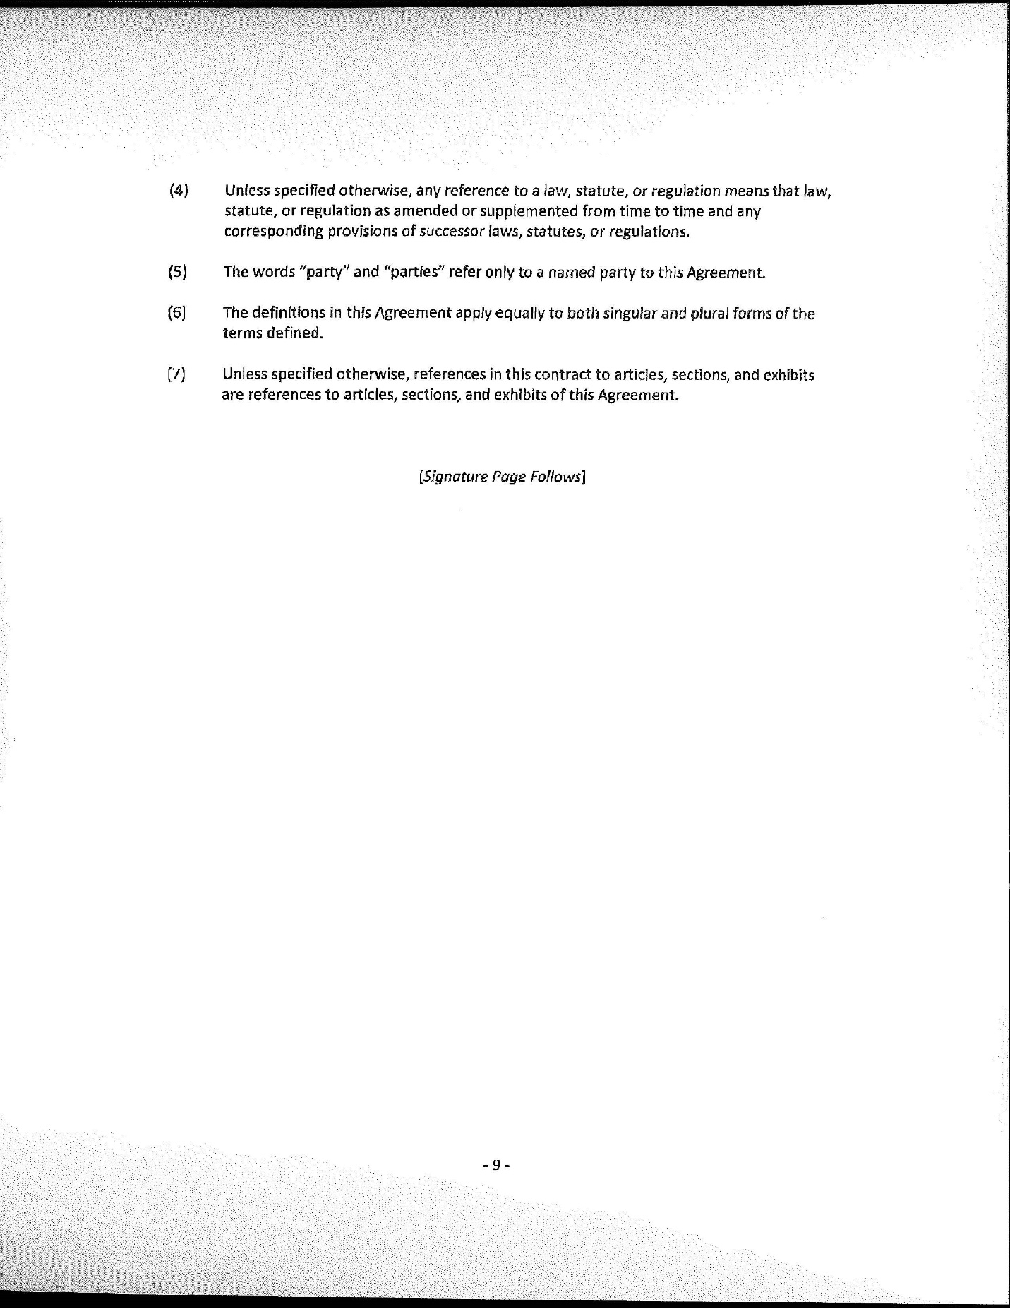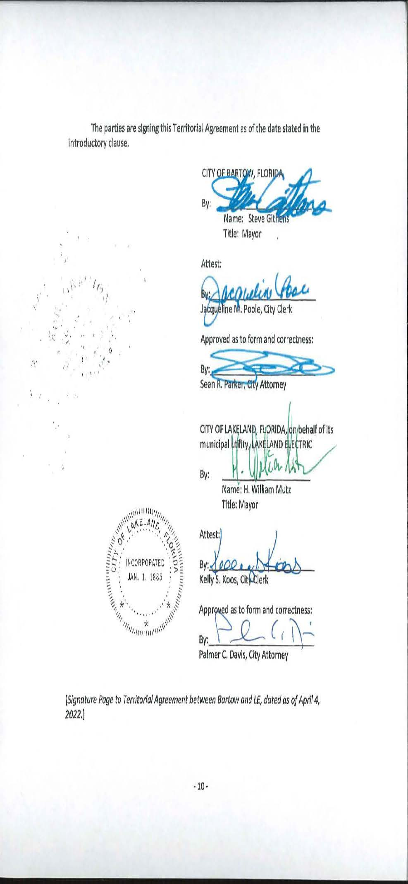
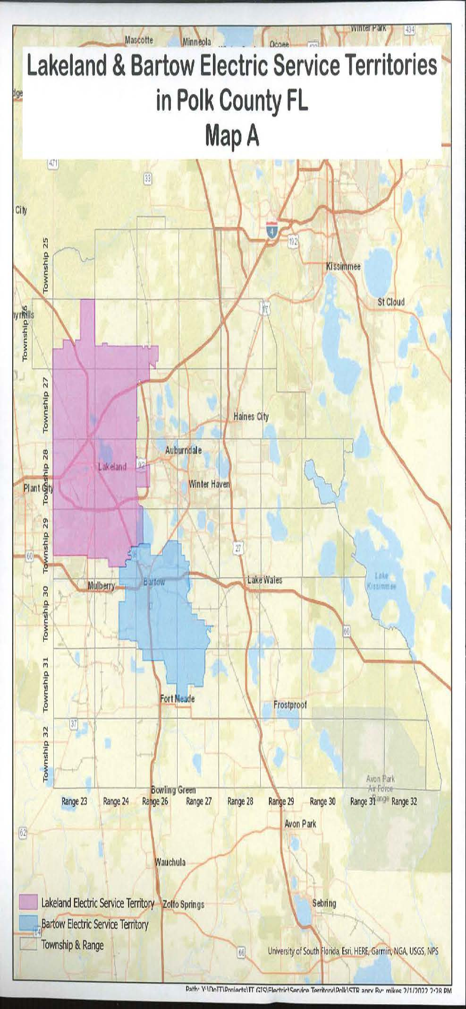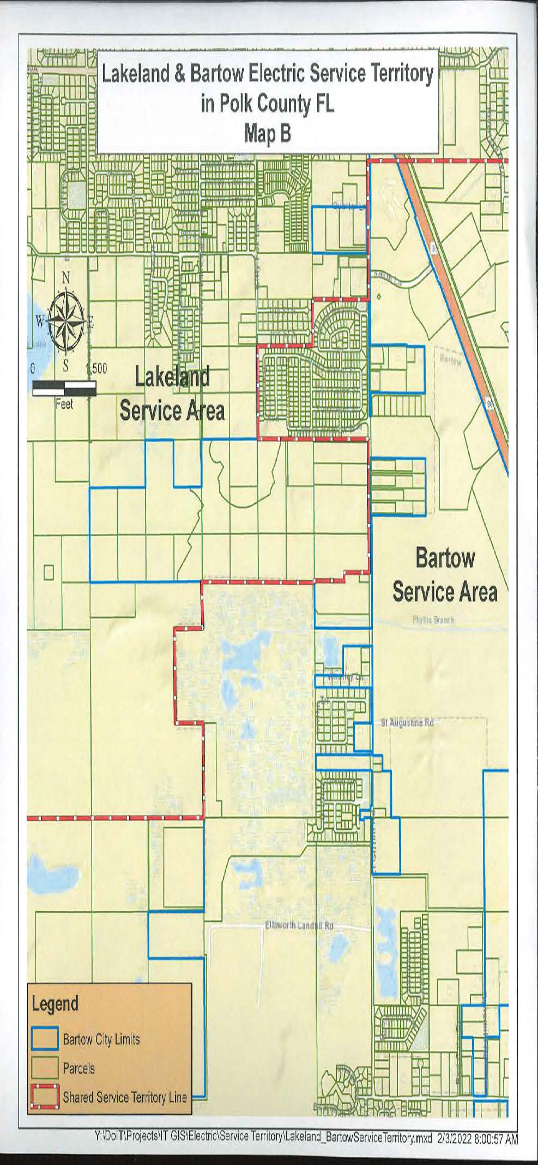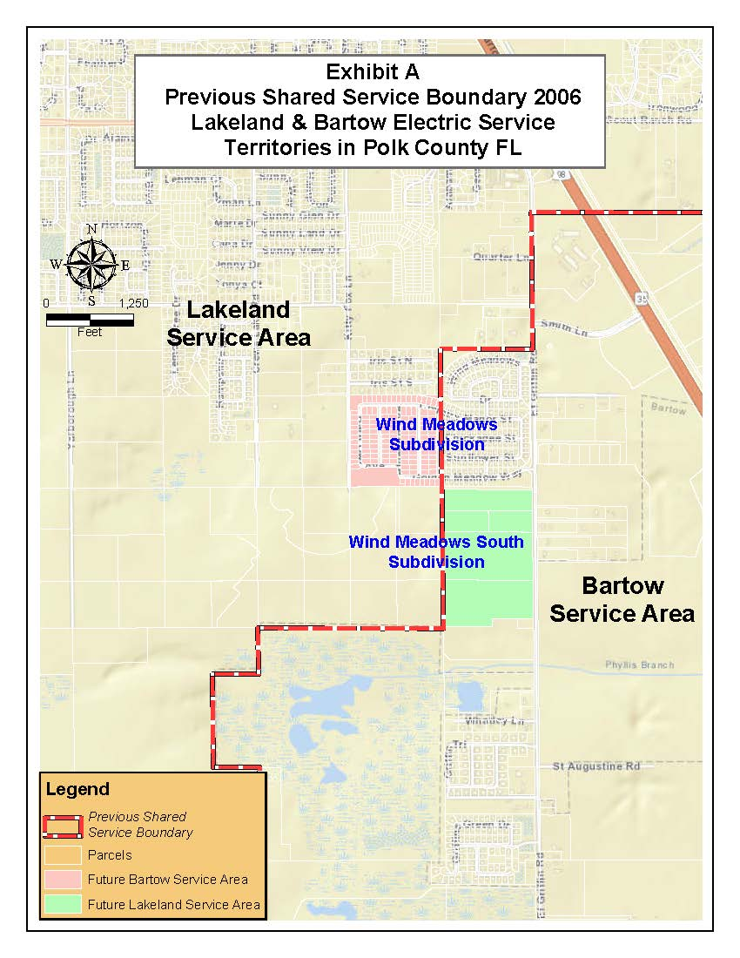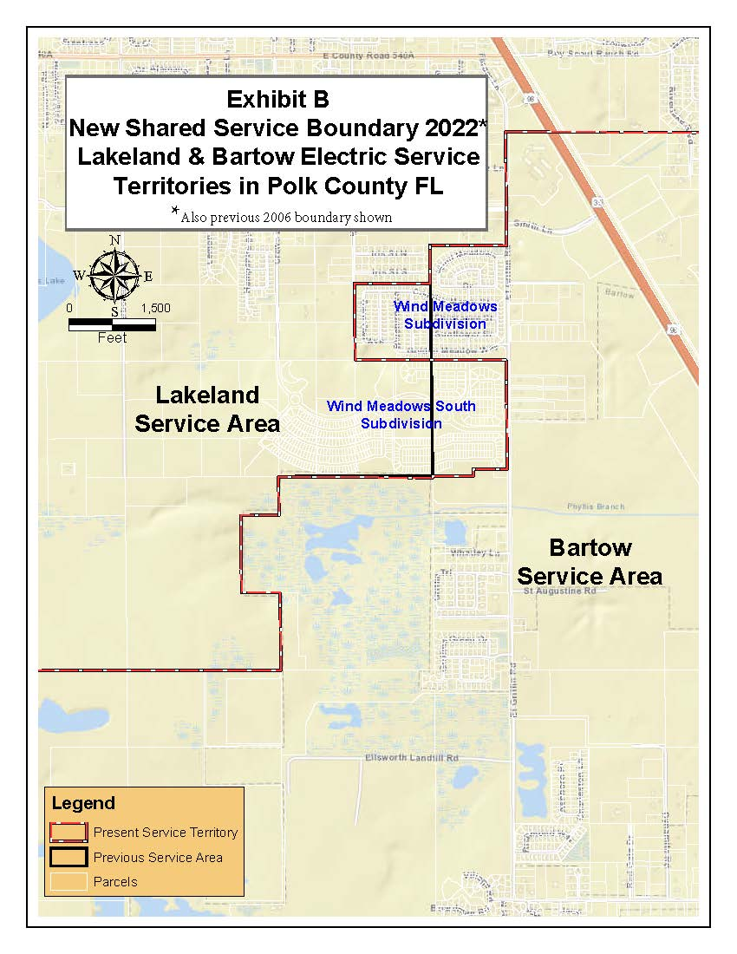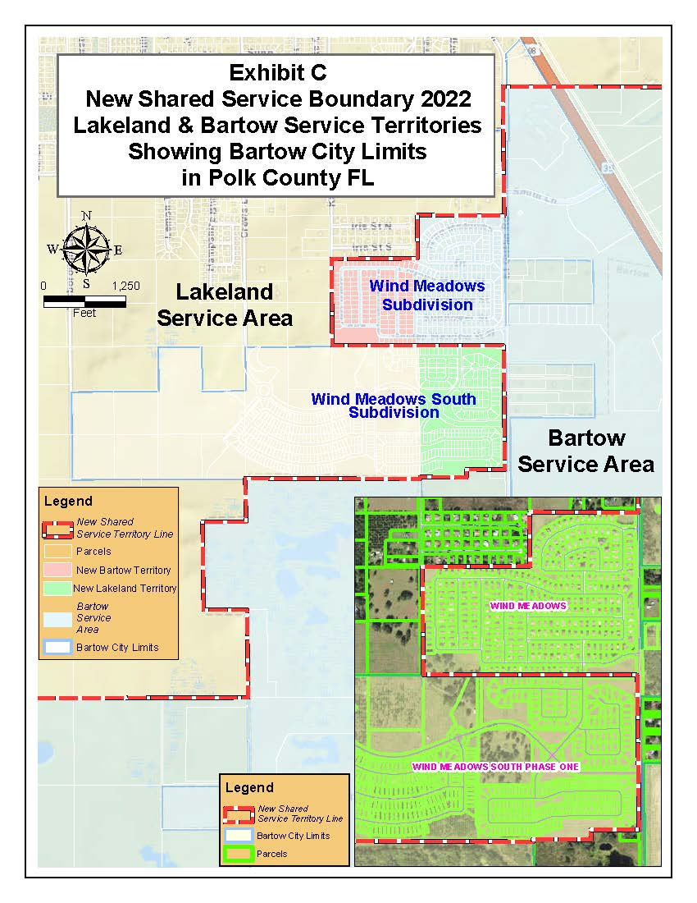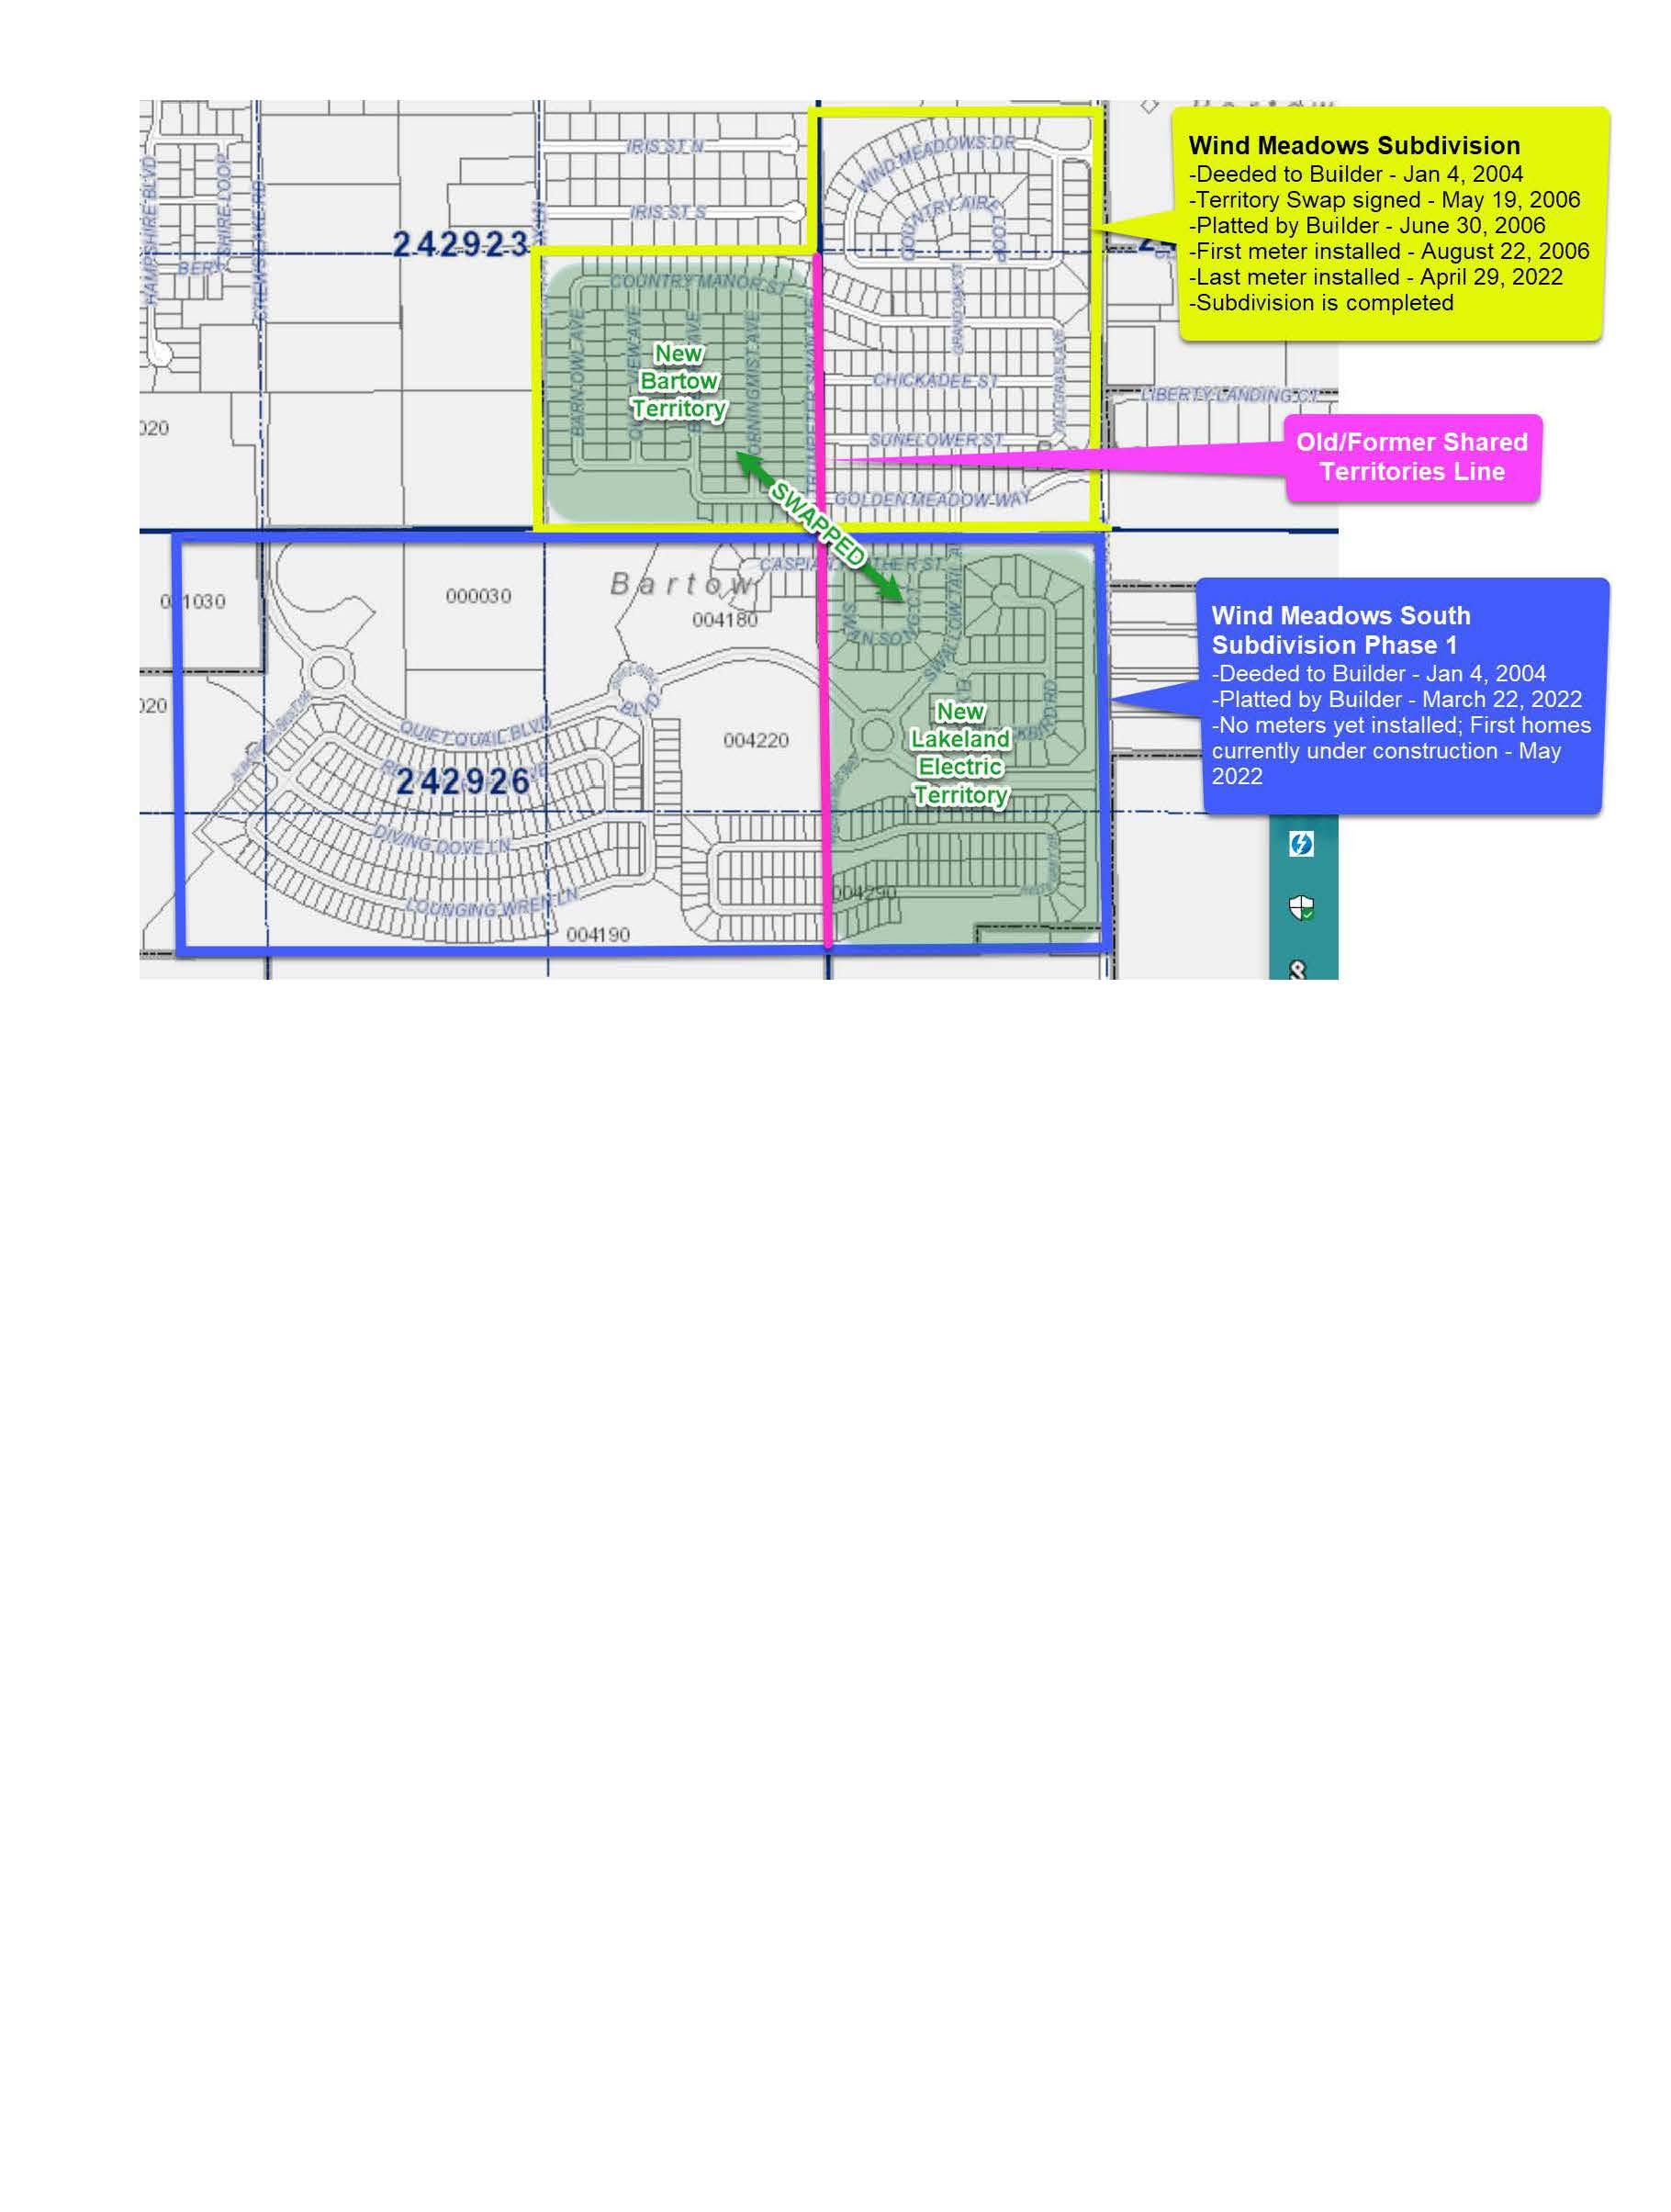

Order No. 13025, issued February 23, 1984, in Docket No. 19830566-EM, In re: Joint Stipulation and Petition for Approval of Territorial Agreement between City of Lakeland and City of Bartow.
Utilities Commission of the City of New Smyrna Beach v. Florida Public Service Commission, 469 So. 2d 731 (Fla. 1985).
Paragraph 4 of the Supplemental Information (Document No. 02715-2022) and as explained during the April 21, 2022 informal meeting.
Response 2 in Staff’s Second Data Request (Document No. 03048-2022).

