|  |  |  |  |
| --- | --- | --- | --- |
| State of Florida  pscSEAL | | Public Service Commission  Capital Circle Office Center ● 2540 Shumard Oak Boulevard Tallahassee, Florida 32399-0850  -M-E-M-O-R-A-N-D-U-M- | |
| DATE: | July 21, 2022 | | |
| TO: | Office of Commission Clerk (Teitzman) | | |
| FROM: | Division of Economics (Hampson, Coston, Draper, Guffey)  Division of Accounting and Finance (Norris, Andrews, D. Buys, Osorio)  Office of the General Counsel (Sandy, Crawford) | | |
| RE: | Docket No. 20220067-GU – Petition for rate increase by Florida Public Utilities Company, Florida Division of Chesapeake Utilities Corporation, Florida Public Utilities Company - Fort Meade, and Florida Public Utilities Company - Indiantown Division. | | |
| AGENDA: | 08/02/22 – Regular Agenda – Decision on Interim Rates – Participation is at the Discretion of the Commission | | |
| COMMISSIONERS ASSIGNED: | | | Clark, Fay, Passidomo |
| PREHEARING OFFICER: | | | Passidomo |
| CRITICAL DATES: | | | 08/02/22 (60-day provision of Section 366.071(2), F.S., waived by Company until 08/02/22) |
| SPECIAL INSTRUCTIONS: | | | None |

Case Background

On May 24, 2022, Florida Public Utilities Company (FPUC), Florida Division of Chesapeake Utilities Corporation (Chesapeake), Florida Public Utilities Company-Fort Meade (Ft. Meade), and Florida Public Utilities Company-Indiantown Division (Indiantown) (collectively the Company) filed a petition seeking Commission approval to increase rates and charges and to consolidate the four natural gas utilities into one utility operating under the name Florida Public Utilities Company. The four natural gas utilities provide sales and transportation of natural gas and are public utilities subject to the Commission’s regulatory jurisdiction under Chapter 366, Florida Statutes (F.S.).

In 2009, Chesapeake Utilities Corporation (CUC), a Delaware corporation, which owned and operated the Florida Division of Chesapeake Utilities Corporation, acquired Florida Public Utilities Company’s electric and gas divisions. In 2010, Florida Public Utilities Company acquired Indiantown Gas Company and in 2013 the natural gas assets of Fort Meade, a municipal utility. Since the acquisitions, Indiantown Gas Company operates as Florida Public Utilities Company-Indiantown Division and Fort Meade as Florida Public Utilities Company-Fort Meade.

The Company currently serves approximately 92,000 residential, commercial, and industrial customers in 26 counties throughout the state of Florida. In its petition, the Company requested an increase of $43.8 million in additional annual revenues. Of that amount, $19.8 million is associated with moving the Company’s current investment in the Commission-approved Gas Reliability Infrastructure Program (GRIP), which is being recovered through a separate surcharge on customers’ bills, into base rates. The remaining $24 million, according to FPUC, is necessary for the Company to earn a fair return on its investment and a requested return on equity of 11.25 percent. The Company based its request on a 13-month average rate base of $454.9 million for the projected test year January through December 2023. The requested overall rate of return is 6.43 percent.

FPUC’s last approved rate case was in 2008,[1] Chesapeake’s last rate case was in 2009,[2] and Indiantown’s last rate case was in 2003, prior to its acquisition in 2013.[3] Ft. Meade was a municipal utility prior to its acquisition in 2013 and has not had a rate case prior to this pending docket. More recently, in Commission Order No. PSC-2021-0148-TRF-GU,[4] the four individual utilities’ tariffs were consolidated without modifications to customer rates. Prior to the consolidation of the tariffs, the utilities provided natural gas service under four separate Commission-approved tariffs.

The Company stated that the key drivers for the proposed rate increase are: capital investments to expand service, technology and safety investments, increased insurance premiums, and an increase in cost of materials and labor as a result of high inflation. As part of the petition, the Company filed a new 2023 depreciation study, a cost recovery environmental surcharge, revisions to its Area Expansion Program (AEP), and consolidated rate structures.

Pursuant to Sections 366.06(2) and (4), F.S., FPUC requested that this rate case be processed using the Commission’s hearing process. Accordingly, an administrative hearing has been scheduled for this matter from October 25 through 28, 2022. At the July 7, 2022 Agenda Conference, the Commission suspended the proposed permanent increase in rates and charges.

In its petition, the Company requested an interim rate increase of $7.13 million. Section 366.071, F.S., addresses interim rates and procedures and requires the Commission to authorize within 60 days of a filing for an interim rate increase the collection of interim rates. On June 7, 2022, the Company waived the 60-day provision of Section 366.071(2), F.S., and agreed to defer implementation of the proposed interim rates until the issue is addressed at the scheduled August 2, 2022 Agenda Conference.[5]

This recommendation addresses the requested interim revenue increase and rates. The interim revenue increases are calculated separately for each of the four utilities and are addressed in Issues 1 through 7. As discussed in Issue 5, staff recommends approval of Indiantown and Ft. Meade’s requested interim revenue increase. However, staff recommends adjustments to the interim revenue requests for FPUC and Chesapeake. The Commission has jurisdiction over this request under Sections 366.06 and 366.071, F.S.

Discussion of Issues

Issue :

 Are FPUC’s, Chesapeake’s, Indiantown’s, and Ft. Meade’s proposed interim rate bases appropriate?

Recommendation:

 Yes. The appropriate interim rate base for FPUC, Chesapeake, Indiantown, and Ft. Meade should be $319,224,069, $111,929,536, $1,998,095, and $1,294,682, respectively. (Andrews)

Staff Analysis:

 In its filing, the Company proposed interim year-end rate bases of $319,224,069, $111,929,536, $1,998,095, and $1,294,682 for FPUC, Chesapeake, Indiantown, and Ft. Meade, respectively, for the period ended December 31, 2021. Pursuant to Section 366.071(5)(a), F.S., the Company is permitted to elect either an average or year-end rate base to calculate its interim revenue request. Staff reviewed the rate base adjustments made in the current interim filing for consistency with the Commission-approved adjustments in each utility’s last rate case proceeding, where appropriate, as well as other applicable dockets.[6] Based on staff’s review, it appears that the Company made applicable and appropriate adjustments that are consistent with the prior Commission Orders. Staff’s recommendation of whether FPUC is entitled to the proposed interim increase is discussed in Issue 5. If it is determined that interim relief should be granted to the Company in this case, staff agrees that $319,224,069, $111,929,536, $1,998,095, and $1,294,682 for FPUC, Chesapeake, Indiantown, and Ft. Meade, respectively, are the appropriate amounts of rate base for each utility for the historical interim test year ended December 31, 2021. The calculations are shown on Attachment A.

Issue :

 Are FPUC’s, Chesapeake’s, Indiantown’s, and Ft. Meade’s proposed interim returns on equity and overall rates of return appropriate?

Recommendation:

 Yes, in part, and no, in part. The appropriate return on equity for FPUC, Chesapeake, Indiantown, and Ft. Meade should be 9.85 percent, 9.80 percent, 10.50 percent, and 9.85 percent, respectively, and the overall cost of capital should be 5.50 percent, 5.33 percent, 6.86 percent, and 4.28 percent, respectively, for purposes of determining interim rates. (Andrews)

Staff Analysis:

 For purposes of its interim rate request, FPUC, Chesapeake, Indiantown, and Ft. Meade used an overall cost of capital of 5.41 percent, 5.30 percent, 5.35 percent, and 4.73 percent, respectively, based on a return on equity (ROE) of 9.85 percent, 9.80 percent, 10.50 percent, and 10.00 percent, respectively. Each utility reflected a capital structure for the 13-month average historical interim test year ended December 31, 2021. Staff believes several adjustments are necessary.

Pursuant to Section 366.071(2)(a), F.S., the appropriate ROE for purposes of determining an interim rate increase is the minimum of the Company’s currently authorized ROE range. Staff believes that the ROE is consistent with each utility’s last rate case proceeding as well as other applicable dockets for FPUC, Chesapeake, and Indiantown. However, the minimum of Ft. Meade’s authorized ROE range is 9.85 percent. Ft. Meade was acquired by FPUC in 2013 and has not had a rate case before the Commission to determine ROE.[7] Therefore, Ft. Meade’s authorized ROE range is set equal to FPUC’s until another determination can be made. Therefore, staff recommends an ROE of 9.85 percent for the purpose of determining interim rates for Ft. Meade.

MFR Schedule F-8 for Indiantown and Ft. Meade reflected negative per book balances for long-term debt, short-term debt, and common equity. However, there is no such thing as negative long-term debt or negative short-term debt. Consequently, the Company used the ratio of the parent company capital structure components to make pro rata adjustments in order to reconcile the capital structure to rate base. In order to be consistent, staff made an adjustment to use the ratio of the parent company capital structure components to make pro rata adjustments for all four systems.

Staff also recommends that the capital structure for each utility be reconciled to the year-end rate bases, as each utility’s requested revenue increase is calculated based on year-end rate base. Pursuant to Section 366.071(5)(a), F.S., the Company is permitted to elect either average or year-end rate base to calculate its interim revenue request. The Company’s election to use year-end rate base should be applied consistently. However, the MFR Schedule F-8 for each individual utility reflected a capital structure reconciled to average rate base. Staff made an adjustment to reconcile each utility’s capital structure to year-end rate base and made an additional correction to the pro rata adjustment of Indiantown. Staff made Indiantown’s pro rata adjustment across all sources of capital to stay consistent with its last rate case.[8]

Staff recommends that the capital structure of FPUC, Chesapeake, Indiantown, and Ft. Meade for the historical interim test year ended December 31, 2021, reflect an ROE of 9.85 percent, 9.80 percent, 10.50 percent, and 9.85 percent, respectively, resulting in an overall cost of capital of 5.50 percent, 5.33 percent, 6.86 percent, and 4.28 percent, respectively, based on staff’s recommended adjustments. Attachment B details the calculations of the each utility’s overall cost of capital for each utility.

Issue :

 Are FPUC’s, Chesapeake’s, Indiantown’s, and Ft. Meade's proposed interim test year net operating incomes appropriate?

Recommendation:

 No. The appropriate historical base year ended December 31, 2021 net operating income for FPUC, Chesapeake, Indiantown, and Ft. Meade should be $17,555,780, $5,961,365, $137,069, and $55,412, respectively. (Andrews)

Staff Analysis:

 The proposed historical interim test year net operating income for FPUC, Chesapeake, Indiantown, and Ft. Meade of $17,267,622, $5,927,716, $106,898, $61,238 are the twelve-month amounts for the historical interim test year ended December 31, 2021. Staff reviewed the net operating income adjustments made in the current interim filing for consistency with the Commission-approved adjustments in the last rate case proceeding for each individual utility, as well as other applicable dockets.[9] Based on staff’s review, it appears that each utility made the applicable and appropriate adjustments that are consistent with the prior Commission Orders. However, staff is recommending adjustments to each system’s cost of capital in Issue 2 and bad debt expense rate in Issue 4. These adjustments have fallout effects which have altered the proposed net operating income for FPUC, Chesapeake, Indiantown, and Ft. Meade.

Staff’s recommendation of whether the Company is entitled to the proposed interim increases is discussed in Issue 5. If it is determined that interim relief should be granted to FPUC, Chesapeake, Indiantown, and Ft. Meade in this case, staff recommends that $17,555,780, $5,961,365, $137,069, and $55,412, respectively, are the appropriate amounts of net operating income for the historical interim test year ended December 31, 2021. The calculations are shown on Attachment A.

Issue :

 Are FPUC’s, Chesapeake’s, Indiantown’s, and Ft. Meade's proposed interim net operating income multipliers appropriate?

Recommendation:

 No. FPUC, Chesapeake, Indiantown, and Ft. Meade should be granted interim net operating income (NOI) multipliers of 1.3599, 1.3506, 1.3652, and 1.3807, respectively. (Andrews)

Staff Analysis:

 On MFR Schedule F-6, FPUC, Chesapeake, Indiantown, and Ft. Meade calculated an interim revenue expansion factor of 74.1443 using a 21 percent federal income tax rate, a 5.5 percent state income tax rate, and a 0.5030 percent factor for regulatory assessment fees. Additionally, the Company reflected the same factor of 0.1811 percent for bad debt expense in each utility’s calculation. Upon review, staff determined that the bad debt expense rate was a consolidated calculation reflecting all of the utilities. Staff recommends that the appropriate bad debt expense rate for each utility’s interim revenue expansion factor be calculated on a stand-alone basis, as the Commission has not yet approved the request to consolidate rate structure for the four utilities. Therefore, staff recommends that FPUC, Chesapeake, Indiantown, and Ft. Meade use a bad debt expense factor of 0.9977 percent, 0.3199 percent, 1.3779 percent, and 2.4786 percent, respectively. Therefore, staff recommends that 1.3599, 1.3506, 1.3652, and 1.3807 are the appropriate interim NOI multipliers for FPUC, Chesapeake, Indiantown, and Ft. Meade, respectively. The calculations are shown below.

Table 4-1

FPUC – Interim NOI Multiplier

|  |  |
| --- | --- |
| **Description** |  |
| Revenue Requirement | 100.0000% |
| Regulatory Assessment Fee | -0.5030% |
| Bad Debt Rate | -0.9977% |
| Net Before Income Tax | 98.4993% |
| State Income Tax @ 5.5% | -5.4175% |
| Federal Income Tax @ 21% | -19.5472% |
| Revenue Expansion Factor | 73.5347% |
| NOI Multiplier (100/73.5347) | 1.3599 |

Table 4-2

Chesapeake – Interim NOI Multiplier

|  |  |
| --- | --- |
| **Description** |  |
| Revenue Requirement | 100.0000% |
| Regulatory Assessment Fee | -0.5030% |
| Bad Debt Rate | -0.3199% |
| Net Before Income Tax | 99.1771% |
| State Income Tax @ 5.5% | -5.4547% |
| Federal Income Tax @ 21% | -19.6817% |
| Revenue Expansion Factor | 74.0407% |
| NOI Multiplier (100/74.0407) | 1.3506 |

Table 4-3

Indiantown – Interim NOI Multiplier

|  |  |
| --- | --- |
| **Description** |  |
| Revenue Requirement | 100.0000% |
| Regulatory Assessment Fee | -0.5030% |
| Bad Debt Rate | -1.3779% |
| Net Before Income Tax | 98.1191% |
| State Income Tax @ 5.5% | -5.3966% |
| Federal Income Tax @ 21% | -19.4717% |
| Revenue Expansion Factor | 73.2509% |
| NOI Multiplier (100/73.2509) | 1.3652 |

Table 4-4

Ft. Meade – Interim NOI Multiplier

|  |  |
| --- | --- |
| **Description** |  |
| Revenue Requirement | 100.0000% |
| Regulatory Assessment Fee | -0.5030% |
| Bad Debt Rate | -2.4786% |
| Net Before Income Tax | 97.0184% |
| State Income Tax @ 5.5% | -5.3360% |
| Federal Income Tax @ 21% | -19.2533% |
| Revenue Expansion Factor | 72.4291% |
| NOI Multiplier (100/72.4291) | 1.3807 |

Issue :

 Should FPUC, Chesapeake, Indiantown, and Ft. Meade's requested interim revenue increases be granted?

Recommendation:

 Yes, in part, and no, in part. Indiantown and Ft. Meade’s requested interim revenue increases of $31,095 and $35,138, respectively, should be granted. However, the appropriate interim revenue increase for FPUC and Chesapeake should be $5,284,334 and $2,329,697, respectively. (Andrews)

Staff Analysis:

 FPUC, Chesapeake, Indiantown, and Ft. Meade requested interim rate relief of $4,852,243, $2,281,056, $31,095, and $35,138, respectively, for the historical interim test year ended December 31, 2021. As discussed in Issues 2 and 4, staff is recommending adjustments to each system’s cost of capital and bad debt expense rate. These adjustments result in fallout adjustments to the total interim revenue increase for FPUC, Chesapeake, Indiantown, and Ft. Meade. However, in the petition, the Companies applied a downward adjustment to the interim rate relief for Indiantown and Ft. Meade in an effort to mitigate the upward rate pressure customers would experience if they were charged the full rate increase necessary to meet their required rates of return.[10] Staff believes these adjustments are reasonable.

Staff’s fallout adjustments discussed above result in interim rate relief that is higher than the adjusted amount requested by the Companies for Indiantown and Ft. Meade. Thus, staff recommends Indiantown’s and Ft. Meade’s requested interim revenue increases of $31,095 and $35,138, respectively, be granted. The fallout adjustments discussed above result in increases to the interim revenue increase for FPUC and Chesapeake of $432,091 and $48,641, respectively. Therefore, staff recommends that the appropriate revenue increases for FPUC, Chesapeake, Indiantown, and Ft. Meade are $5,284,334, $2,329,697, $31,095, and $35,138, respectively, for the historical interim test year ended December 31, 2021. A summary of the rate increases for all four utilities is shown in Table 5-1.

Table 5-1

Interim Revenue Increases

|  |  |  |  |
| --- | --- | --- | --- |
|  | **Requested Increase** | **Staff Adjustment** | **Staff Recom.**  **Increase** |
| FPUC | $4,852,243 | $432,091 | $5,284,334 |
| Chesapeake | $2,281,056 | $48,641 | $2,329,697 |
| Indiantown | $31,095 | $0 | $31,095 |
| Ft. Meade | $35,138 | $0 | $35,138 |

The interim revenue increases would allow FPUC and Chesapeake an opportunity to earn an overall rate of return of 5.50 percent and 5.33 percent, respectively, and the minimum of the range of return on equity of 9.85 percent and 9.80 percent, respectively. As a result of the Company’s election to cap the level of rate increases for Indiantown and Ft. Meade, the interim rate increases requested will provide these systems an opportunity to earn returns below the minimum of their respective range of return on equity.

After a determination of the permanent rate increase has been made, the interim rate increases will be reviewed to determine if any portion should be refunded to customers. The calculations of interim rate relief are shown in Tables 5-2 through 5-5.

Table 5-2

FPUC – Interim Revenue Increase

|  |  |
| --- | --- |
| **Description** |  |
| Jurisdictional Adjusted Rate Base | $319,224,069 |
| Overall Rate of Return | 5.50% |
| Jurisdictional Net Operating Income | $17,555,780 |
| Jurisdictional Adjusted Net Operating Income | $13,669,962 |
| Revenue Deficiency | $3,885,818 |
| Net Operating Income Multiplier | 1.3599 |
| Interim Revenue Increase | $5,284,334 |
| Base Rate Revenues | $42,307,452 |
| Recommended Percentage Increase Factor | 12.49% |

Table 5-3

Chesapeake – Interim Revenue Increase

|  |  |
| --- | --- |
| **Description** |  |
| Jurisdictional Adjusted Rate Base | $111.929.536 |
| Overall Rate of Return | 5.33% |
| Jurisdictional Net Operating Income | $5,961,365 |
| Jurisdictional Adjusted Net Operating Income | $4,236,442 |
| Revenue Deficiency | $1,724,923 |
| Net Operating Income Multiplier | 1.3506 |
| Interim Revenue Increase | $2,329,697 |
| Base Rate Revenues | $14,548,672 |
| Recommended Percentage Increase Factor | 16.01% |

Table 5-4

Indiantown – Interim Revenue Increase

|  |  |
| --- | --- |
| **Description** |  |
| Jurisdictional Adjusted Rate Base | $1,998,095 |
| Overall Rate of Return | 6.86% |
| Jurisdictional Net Operating Income | $137.069 |
| Jurisdictional Adjusted Net Operating Income | ($138,334) |
| Revenue Deficiency | $275.403 |
| Net Operating Income Multiplier | 1.3652 |
| Interim Revenue Increase | $375.973 |
| Less: Adjustment for Decrease in Indiantown | ($344,878) |
| Adjusted Interim Revenue Requested | $31,095 |
| Base Rate Revenues | $129,024 |
| Recommended Percentage Increase Factor | 24.10% |

Table 5-5

Ft. Meade – Interim Revenue Increase

|  |  |
| --- | --- |
| **Description** |  |
| Jurisdictional Adjusted Rate Base | $1,294,682 |
| Overall Rate of Return | 4.28% |
| Jurisdictional Net Operating Income | $55,412 |
| Jurisdictional Adjusted Net Operating Income | $3,172 |
| Revenue Deficiency | $52,240 |
| Net Operating Income Multiplier | 1.3807 |
| Interim Revenue Increase | $72,126 |
| Less: Adjustment for Decrease in Indiantown | ($36,988) |
| Adjusted Interim Revenue Requested | $35,138 |
| Base Rate Revenues | $189,935 |
| Recommended Percentage Increase Factor | 18.50% |

Issue :

 Should FPUC, Chesapeake, Indiantown, and Ft. Meade's proposed interim rates and associated tariffs be approved?

Recommendation:

 Yes, in part, and no, in part. Indiantown and Ft. Meade’s proposed interim rates and associated tariffs should be approved. However, the interim rates for FPUC and Chesapeake should be adjusted to recover the staff-recommended interim revenue increase, as discussed in Issue 5. If the staff-recommended adjustments are approved by the Commission, the Company should file revised interim tariffs for FPUC and Chesapeake for administrative approval by staff. The interim rates should be made effective for all meter readings occurring on or after thirty days from the date of the Commission vote. In addition, pursuant to Rule 25-22.0406(8), F.A.C., the Company should provide notice to customers of the revised rates with the first bill containing the new rates. (Hampson)

Staff Analysis:

 As discussed in Issue 5, staff recommends approval of Indiantown and Ft. Meade’s requested interim revenue increase. However, staff recommends adjustments to the interim revenue requests for FPUC and Chesapeake.

Attachment C to the recommendation shows, for each respective utility, the allocation of the interim increase and the resulting cents-per-therm increases to be applied to the rate classes. Pages 1 – 3 of Attachment C show the allocation of the increase for FPUC and Chesapeake, as adjusted by staff, to recover the staff-recommended interim revenue increase. Pages 4 and 5 of Attachment C show the allocation of the increase for Indiantown and Ft. Meade, as proposed by the Company. These increases were calculated using the methodology contained in Rule 25-7.040, F.A.C., which requires that any increase be applied evenly across the board to all rate classes based on their base rate revenues. Attachment D shows the resulting interim per-therm distribution charges for all rate classes of each utility.

The interim rates should be made effective for all meter readings occurring on or after thirty days from the date of the Commission vote and decision herein. The Company included proposed interim tariffs in its petition. If the staff-recommended adjustments are approved by the Commission, the Company should file revised interim tariffs for FPUC and Chesapeake for administrative approval by staff. Pursuant to Rule 25-22.0406(8), F.A.C., the Company should provide notice to customers of the revised rates with the first bill containing the new rates and a copy of the customer notice should be submitted to Commission staff for approval prior to its use.

Issue :

 What is the appropriate security to guarantee the amount subject to refund?

Recommendation:

 The appropriate security to guarantee the funds collected subject to refund is a corporate undertaking. (Andrews, D. Buys, Osorio)

Staff Analysis:

 The Company has requested a corporate undertaking in the amount of $5,136,247. The criteria for a corporate undertaking include sufficient liquidity, ownership equity, profitability, and interest coverage to guarantee any potential refund. Staff reviewed the financial statements of the parent company, Chesapeake Utilities Corporation (CUC), to determine if it can support a corporate undertaking for the requested amount. CUC’s 2021, 2020 and 2019 financial statements were used to determine the condition of CUC. CUC has experienced an increase in liquidity over the three-year review period. CUC’s average equity ratio over the three-year period has been stable at 47.7 percent which is sufficient in this instance based on CUC’s overall financial condition. In addition, CUC has experienced a strong and improving interest coverage ratio. Finally, net income has been on average fourteen times greater than the requested corporate undertaking amount. CUC’s financial performance has demonstrated adequate levels of profitability, interest coverage, and equity capitalization.

Staff believes CUC has adequate resources to support a corporate undertaking for the Company in the amount requested. Also, CUC has provided a written guarantee in the amount of its requested interim increase, which supports the corporate undertaking. Therefore, staff recommends that a corporate undertaking of $5,136,247 is acceptable.

This brief financial analysis is only appropriate for deciding if the Company, through its parent company, can support a corporate undertaking in the amount proposed and should not be considered a finding regarding staff’s position on other issues in this proceeding.

Issue :

 Should this docket be closed?

Recommendation:

 No. This docket should remain open to process the revenue increase request of the Company. (Sandy)

Staff Analysis:

 This docket should remain open pending the Commission’s final resolution of the Company’s requested rate increase.

**Florida Public Utilities Company**

**FPUC**

**Docket No. 20220067-GU**

**Interim Base Year**

**December 31, 2021**

|  |  |  |  |  |  |
| --- | --- | --- | --- | --- | --- |
|  |  | **Adjusted Base** |  | **Adjusted Base** |  |
|  |  | **Year Per Company** | **Adjustments** | **Year Per Staff** |  |
|  | Rate Base |  |  |  |  |
|  | Plant in Service | $366,153,578 | - | $366,153,578 |  |
|  | Common Plant Allowed | 7,900,957 | - | 7,900,957 |  |
|  | Customer Advances | (695,131) | - | (695,131) |  |
|  | Acquisition Adjustment | 35,456,269 | - -- | 35,456,269 |  |
|  | Accumulated Depreciation | (101,243,731) | - -- | (101,243,731) |  |
|  | Net Plant in Service | $307,571,942 | - -- | $307,571,942 |  |
|  | Construction Work In Progress | 4,690,537 | - -- | 4,690,537 |  |
|  | Net Utility Plant | $312,262,479 | - -- | $312,262,479 |  |
|  | Working Capital Allowance | 6,961,590 | - - | 6,961,590 |  |
|  | Total Rate Base | $319,224,069 | - | $319,224,069 |  |
|  |  |  |  |  |  |
|  |  |  |  |  |  |
|  | Income Statement |  |  |  |  |
|  | Operating Revenues | $57,836,957 | $5,284,334 | $63,121,291 |  |
|  | Operating Expenses: |  |  |  |  |
|  | Operation & Maintenance | $24,620,563 | $52,720 | $24,673,283 |  |
|  | Depreciation | 8,837,925 | - | 8,837,925 |  |
|  | Amortizations | 2,548,711 | - | 2,548,711 |  |
|  | Taxes Other Than Income | 5,134,340 | 26,580 | 5,160,920 |  |
|  | Income Taxes - Federal | 1,188,290 | 1,032,939 | 2,221,229 |  |
|  | Income Taxes - State | (153,377) | 286,277 | 132,900 |  |
|  | Deferred Income Taxes - Federal | 1,100,758 | - | 1,100,758 |  |
|  | Deferred Income Taxes - State | 889,785 | - | 889,785 |  |
|  | Total Operating Expenses | $44,166,995 | $1,398,516 | $45,565,511 |  |
|  | Net Operating Income | $13,669,962 | $3,885,818 | $17,555,780 |  |
|  | Overall Rate of Return | 4.28% |  | 5.50% |  |
|  |  |  |  |  |  |

**Florida Public Utilities Company**

**Chesapeake**

**Docket No. 20220067-GU**

**Interim Base Year**

**December 31, 2021**

|  |  |  |  |  |  |
| --- | --- | --- | --- | --- | --- |
|  |  | **Adjusted Base** |  | **Adjusted Base** |  |
|  |  | **Year Per Company** | **Adjustments** | **Year Per Staff** |  |
|  | Rate Base |  |  |  |  |
|  | Plant in Service | $140,726,977 | - | $140,726,977 |  |
|  | Common Plant Allowed | 3,401,222 | - | 3,401,222 |  |
|  | Customer Advances |  | - | 0 |  |
|  | Acquisition Adjustment |  | - | 0 |  |
|  | Accumulated Depreciation | (34,295,795) | - | (34,295,795) |  |
|  | Net Plant in Service | $109,832,404 | - | $109,832,404 |  |
|  | Construction Work In Progress | 1,259,290 | - | 1,259,290 |  |
|  | Net Utility Plant | $111,091,694 | - | $111,091,694 |  |
|  | Working Capital Allowance | 837,842 | - | 837,842 |  |
|  | Total Rate Base | $111,929,536 | - | $111,929,536 |  |
|  |  |  |  |  |  |
|  |  |  |  |  |  |
|  | Income Statement |  |  |  |  |
|  | Operating Revenues | $20,530,527 | $2,329,697 | $22,860,224 |  |
|  | Operating Expenses: |  |  |  |  |
|  | Operation & Maintenance | $10,242,786 | $7,452 | $10,250,238 |  |
|  | Depreciation | 3,770,056 | - | 3,770,056 |  |
|  | Amortizations | (124,248) | - | (124,248) |  |
|  | Taxes Other Than Income | 1,525,492 | 11,718 | 1,537,210 |  |
|  | Income Taxes - Federal | 275,981 | 458,524 | 734,505 |  |
|  | Income Taxes - State | (66,463) | 127,079 | 60,616 |  |
|  | Deferred Income Taxes - Federal | 427,271 | - | 427,271 |  |
|  | Deferred Income Taxes - State | 243,210 | - | 243,210 |  |
|  | Total Operating Expenses | $16,294,085 | $604,773 | $16,898,858 |  |
|  | Net Operating Income | $4,236,442 | $1,724,923 | $5,961,365 |  |
|  | Overall Rate of Return | 3.78% |  | 5.33% |  |
|  |  |  |  |  |  |

**Florida Public Utilities Company**

**Indiantown**

**Docket No. 20220067-GU**

**Interim Base Year**

**December 31, 2021**

|  |  |  |  |  |  |
| --- | --- | --- | --- | --- | --- |
|  |  | **Adjusted Base** |  | **Adjusted Base** |  |
|  |  | **Year Per Company** | **Adjustments** | **Year Per Staff** |  |
|  | Rate Base |  |  |  |  |
|  | Plant in Service | $2,807,409 | - | $2,807,409 |  |
|  | Common Plant Allowed | (16,983) | - | (16,983) |  |
|  | Customer Advances | 0 | - | 0 |  |
|  | Acquisition Adjustment | 745,800 | - | 745,800 |  |
|  | Accumulated Depreciation | (1,795,804) | - | (1,795,804) |  |
|  | Net Plant in Service | $1,740,422 | - | $1,740,422 |  |
|  | Construction Work In Progress | 9,540 | - | 9,540 |  |
|  | Net Utility Plant | $1,749,962 | - | $1,749,962 |  |
|  | Working Capital Allowance | 248,133 | - | 248,133 |  |
|  | Total Rate Base | $1,998,095 | - | $1,998,095 |  |
|  |  |  |  |  |  |
|  |  |  |  |  |  |
|  | Income Statement |  |  |  |  |
|  | Operating Revenues | $140,075 | $ | $516,048 |  |
|  | Operating Expenses: |  |  |  |  |
|  | Operation & Maintenance | $168,302 | $5,180 | $173,482 |  |
|  | Depreciation | 79,674 | - | 79,674 |  |
|  | Amortizations | 44,904 | - | 44,904 |  |
|  | Taxes Other Than Income | 35,943 | 1,891 | 37,834 |  |
|  | Income Taxes - Federal | (40,911) | 73,208 | 32,297 |  |
|  | Income Taxes - State | (6,049) | 20,290 | 14,241 |  |
|  | Deferred Income Taxes - Federal | (4,073) | - | (4,073) |  |
|  | Deferred Income Taxes - State | 619 | - | 619 |  |
|  | Total Operating Expenses | $278,409 | $100,570 | $378,979 |  |
|  | Net Operating Income | ($138,334) | $275,403 | $137,069 |  |
|  | Overall Rate of Return | -6.92% |  | 6.86% |  |
|  |  |  |  |  |  |

**Florida Public Utilities Company**

**Ft. Meade**

**Docket No. 20220067-GU**

**Interim Base Year**

**December 31, 2021**

|  |  |  |  |  |  |
| --- | --- | --- | --- | --- | --- |
|  |  | **Adjusted Base** |  | **Adjusted Base** |  |
|  |  | **Year Per Company** | **Adjustments** | **Year Per Staff** |  |
|  | Rate Base |  |  |  |  |
|  | Plant in Service | $1,329,032 | - | $1,329,032 |  |
|  | Common Plant Allowed | 33,091 | - | 33,091 |  |
|  | Customer Advances | - | - | - |  |
|  | Acquisition Adjustment | - | - | - |  |
|  | Accumulated Depreciation | (240,611) | - | (240,611) |  |
|  | Net Plant in Service | $1,121,512 | - | $1,121,512 |  |
|  | Construction Work In Progress | 12,857 | - | 12,857 |  |
|  | Net Utility Plant | $1,134,369 | - | $1,134,369 |  |
|  | Working Capital Allowance | 160,313 | - | 160,313 |  |
|  | Total Rate Base | $1,294,682 | - | $1,294,682 |  |
|  |  |  |  |  |  |
|  |  |  |  |  |  |
|  | Income Statement |  |  |  |  |
|  | Operating Revenues | $229,197 | $72,126 | $301,323 |  |
|  | Operating Expenses: |  |  |  |  |
|  | Operation & Maintenance | $174,325 | $1,788 | $176,113 |  |
|  | Depreciation | 37,292 | - | 37,292 |  |
|  | Amortizations | (6,432) | - | (6,432) |  |
|  | Taxes Other Than Income | 23,954 | 363 | 24,317 |  |
|  | Income Taxes - Federal | (16,673) | 13,887 | (2,786) |  |
|  | Income Taxes - State | (2,556) | 3,849 | 1,293 |  |
|  | Deferred Income Taxes - Federal | 10,348 | - | 10,348 |  |
|  | Deferred Income Taxes - State | 5,767 | - | 5,767 |  |
|  | Total Operating Expenses | $226,025 | $19,886 | $245,911 |  |
|  | Net Operating Income | $3,172 | $52,240 | $55,412 |  |
|  | Overall Rate of Return | 0.25% |  | 4.28% |  |
|  |  |  |  |  |  |

**Florida Public Utilities Company**

**FPUC**

**Docket No. 20220067-GU**

**Interim Base Year**

**December 31, 2021**

|  |  |  |  |  |  |  |
| --- | --- | --- | --- | --- | --- | --- |
|  |  | **Jurisdictional** |  |  |  |  |
|  |  | **Capital** |  | **Cost** | **Weighted** |  |
|  | **Capital Component** | **Structure** | **Ratio** | **Rate** | **Cost Rate** |  |
|  | Long-Term Debt | $95,615,922 | 29.95% | 3.60% | 1.08% |  |
|  | Short-Term Debt | 33,865,614 | 10.61% | 1.42% | 0.15% |  |
|  | Customer Deposits | 8,766,028 | 2.75% | 2.41% | 0.07% |  |
|  | Common Equity | 136,231,707 | 42.68% | 9.85% | 4.20% |  |
|  | Deferred Income Taxes | 44,744,797 | 14.02% | 0.00% | 0.00% |  |
|  | Investment Tax Credits | - | 0.00% | 0.00% | 0.00% |  |
|  | Total | $319,224,069 | 100.00% |  | 5.50% |  |
|  |  |  |  |  |  |  |

**Florida Public Utilities Company**

**Chesapeake**

**Docket No. 20220067-GU**

**Interim Base Year**

**December 31, 2021**

|  |  |  |  |  |  |  |
| --- | --- | --- | --- | --- | --- | --- |
|  |  | **Jurisdictional** |  |  |  |  |
|  |  | **Capital** |  | **Cost** | **Weighted** |  |
|  | **Capital Component** | **Structure** | **Ratio** | **Rate** | **Cost Rate** |  |
|  | Long-Term Debt | $32,810,549 | 29.31% | 3.60% | 1.06% |  |
|  | Short-Term Debt | 11,620,966 | 10.38% | 1.42% | 0.15% |  |
|  | Customer Deposits | 1,510,544 | 1.35% | 2.19% | 0.03% |  |
|  | Common Equity | 46,747,833 | 41.77% | 9.80% | 4.09% |  |
|  | Deferred Income Taxes | 19,239,644 | 17.19% | 0.00% | 0.00% |  |
|  | Investment Tax Credits | - | 0.00% | 0.00% | 0.00% |  |
|  | Total | $111,929,536 | 100.00% |  | 5.33% |  |
|  |  |  |  |  |  |  |

**Florida Public Utilities Company**

**Indiantown**

**Docket No. 20220067-GU**

**Interim Base Year**

**December 31, 2021**

|  |  |  |  |  |  |  |
| --- | --- | --- | --- | --- | --- | --- |
|  |  | **Jurisdictional** |  |  |  |  |
|  |  | **Capital** |  | **Cost** | **Weighted** |  |
|  | **Capital Component** | **Structure** | **Ratio** | **Rate** | **Cost Rate** |  |
|  | Long-Term Debt | $718,783 | 35.97% | 3.60% | 1.30% |  |
|  | Short-Term Debt | 254,581 | 12.74% | 1.42% | 0.18% |  |
|  | Customer Deposits | 10 | 0.00% | 2.19% | 0.00% |  |
|  | Common Equity | 1,024,108 | 51.25% | 10.50% | 5.38% |  |
|  | Deferred Income Taxes | 612 | 0.03% | 0.00% | 0.00% |  |
|  | Investment Tax Credits | - | 0.00% | 0.00% | 0.00% |  |
|  | Total | $1,998,095 | 100.00% |  | 6.86% |  |
|  |  |  |  |  |  |  |

**Florida Public Utilities Company**

**Ft. Meade**

**Docket No. 20220067-GU**

**Interim Base Year**

**December 31, 2021**

|  |  |  |  |  |  |  |
| --- | --- | --- | --- | --- | --- | --- |
|  |  | **Jurisdictional** |  |  |  |  |
|  |  | **Capital** |  | **Cost** | **Weighted** |  |
|  | **Capital Component** | **Structure** | **Ratio** | **Rate** | **Cost Rate** |  |
|  | Long-Term Debt | $304,237 | 23.50% | 3.60% | 0.85% |  |
|  | Short-Term Debt | 107,756 | 8.32% | 1.42% | 0.12% |  |
|  | Customer Deposits | 7,344 | 0.57% | 2.19% | 0.01% |  |
|  | Common Equity | 433,472 | 33.48% | 9.85% | 3.30% |  |
|  | Deferred Income Taxes | 441,873 | 34.13% | 0.00% | 0.00% |  |
|  | Investment Tax Credits | - | 0.00% | 0.00% | 0.00% |  |
|  | Total | $1,294,682 | 100.00% |  | 4.28% |  |
|  |  |  |  |  |  |  |

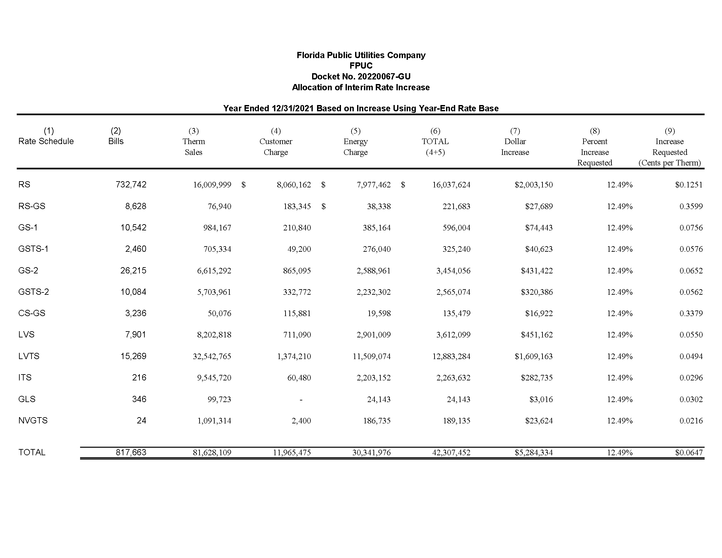

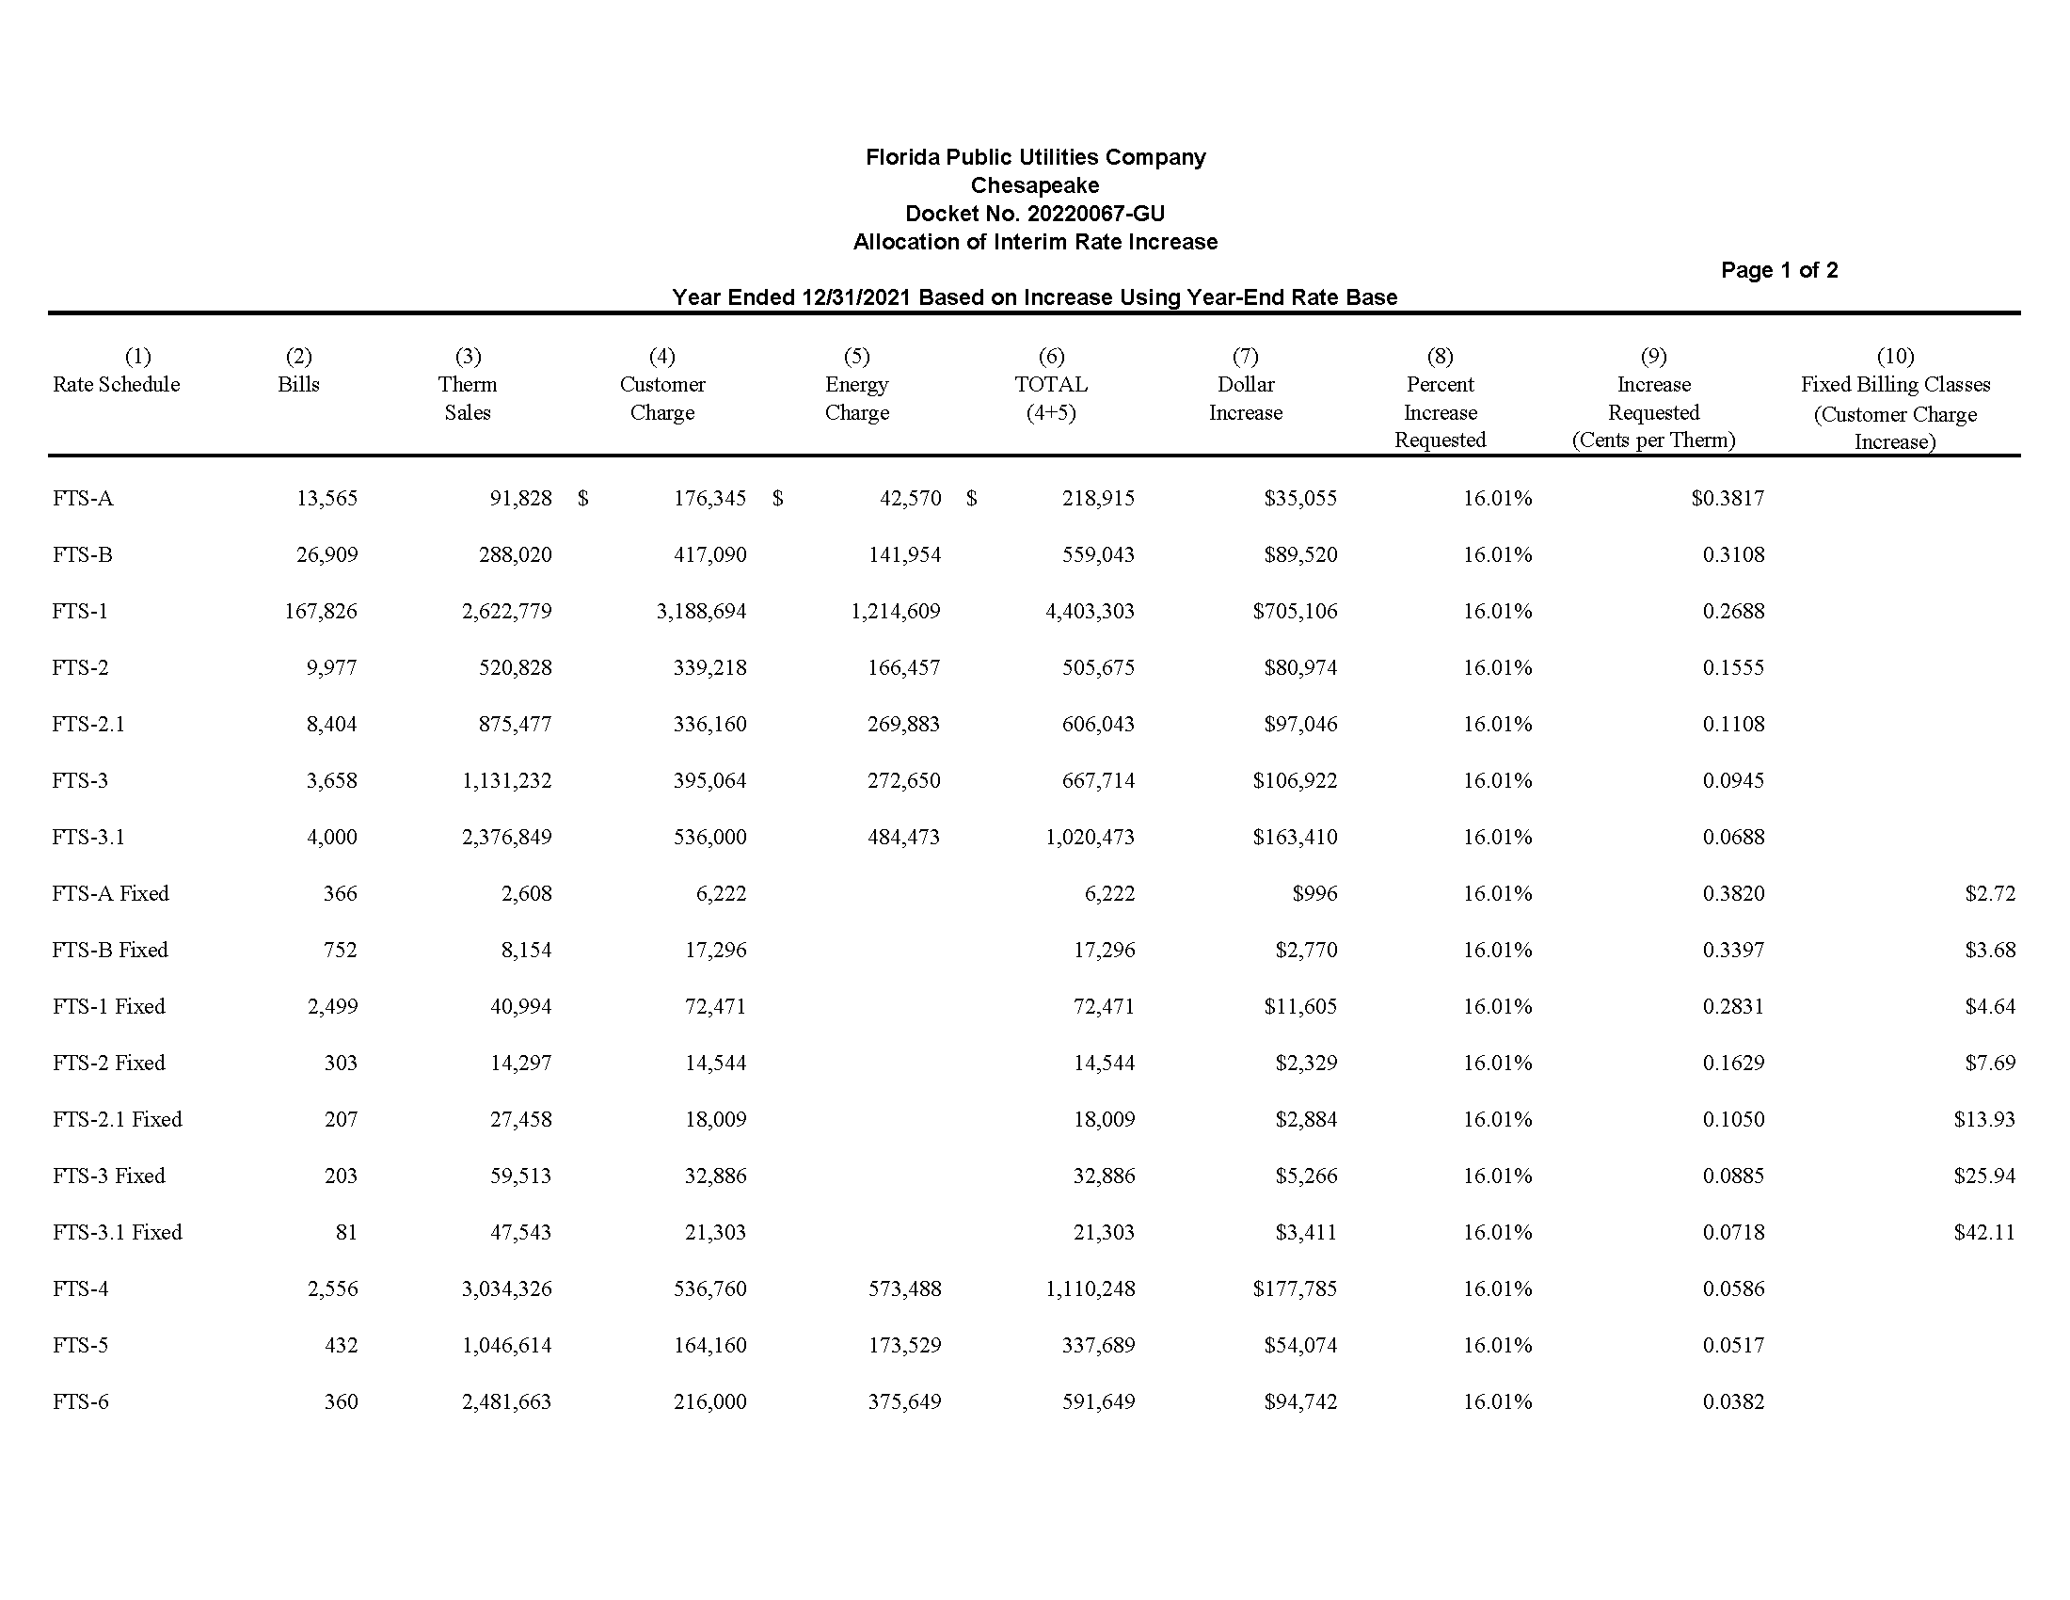

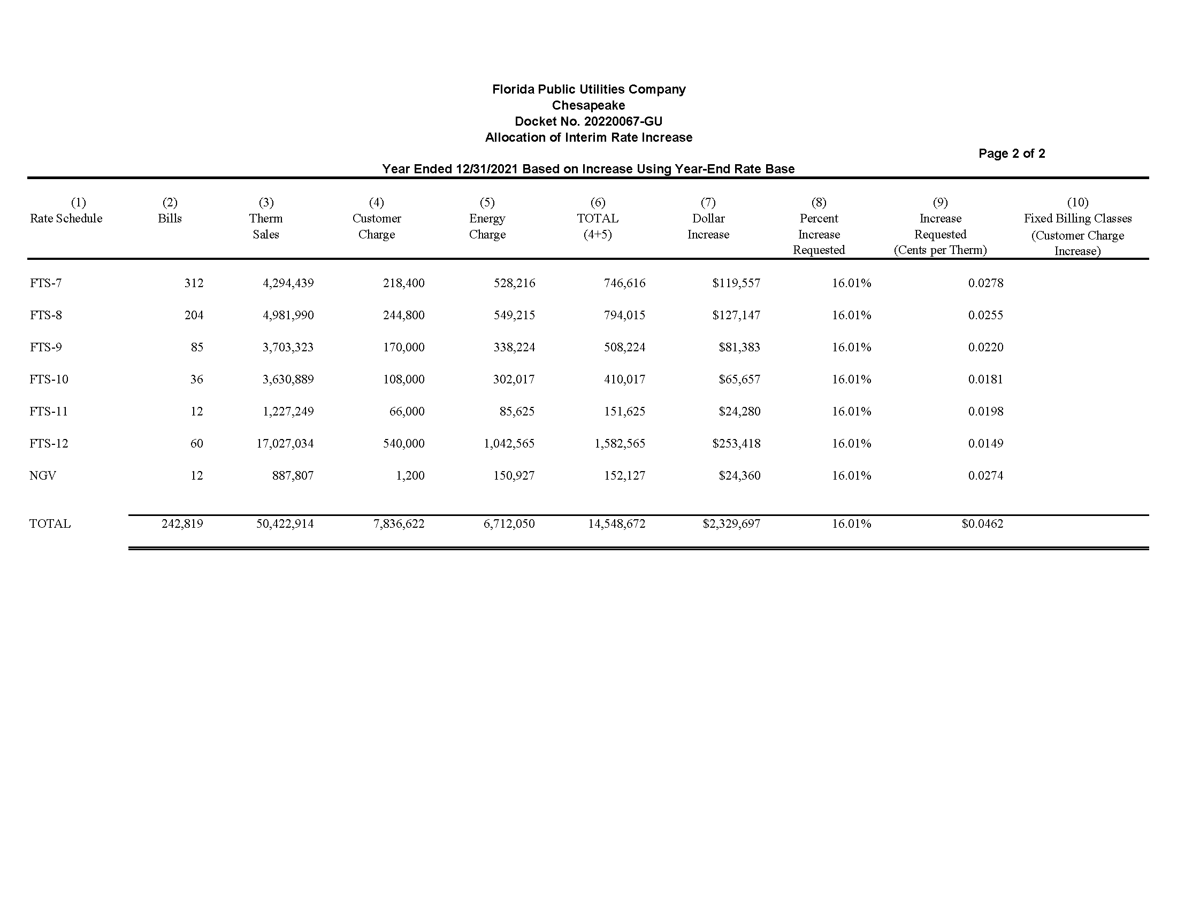

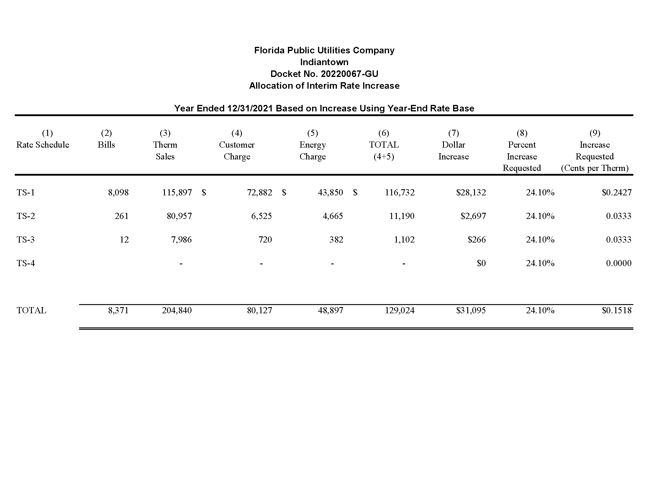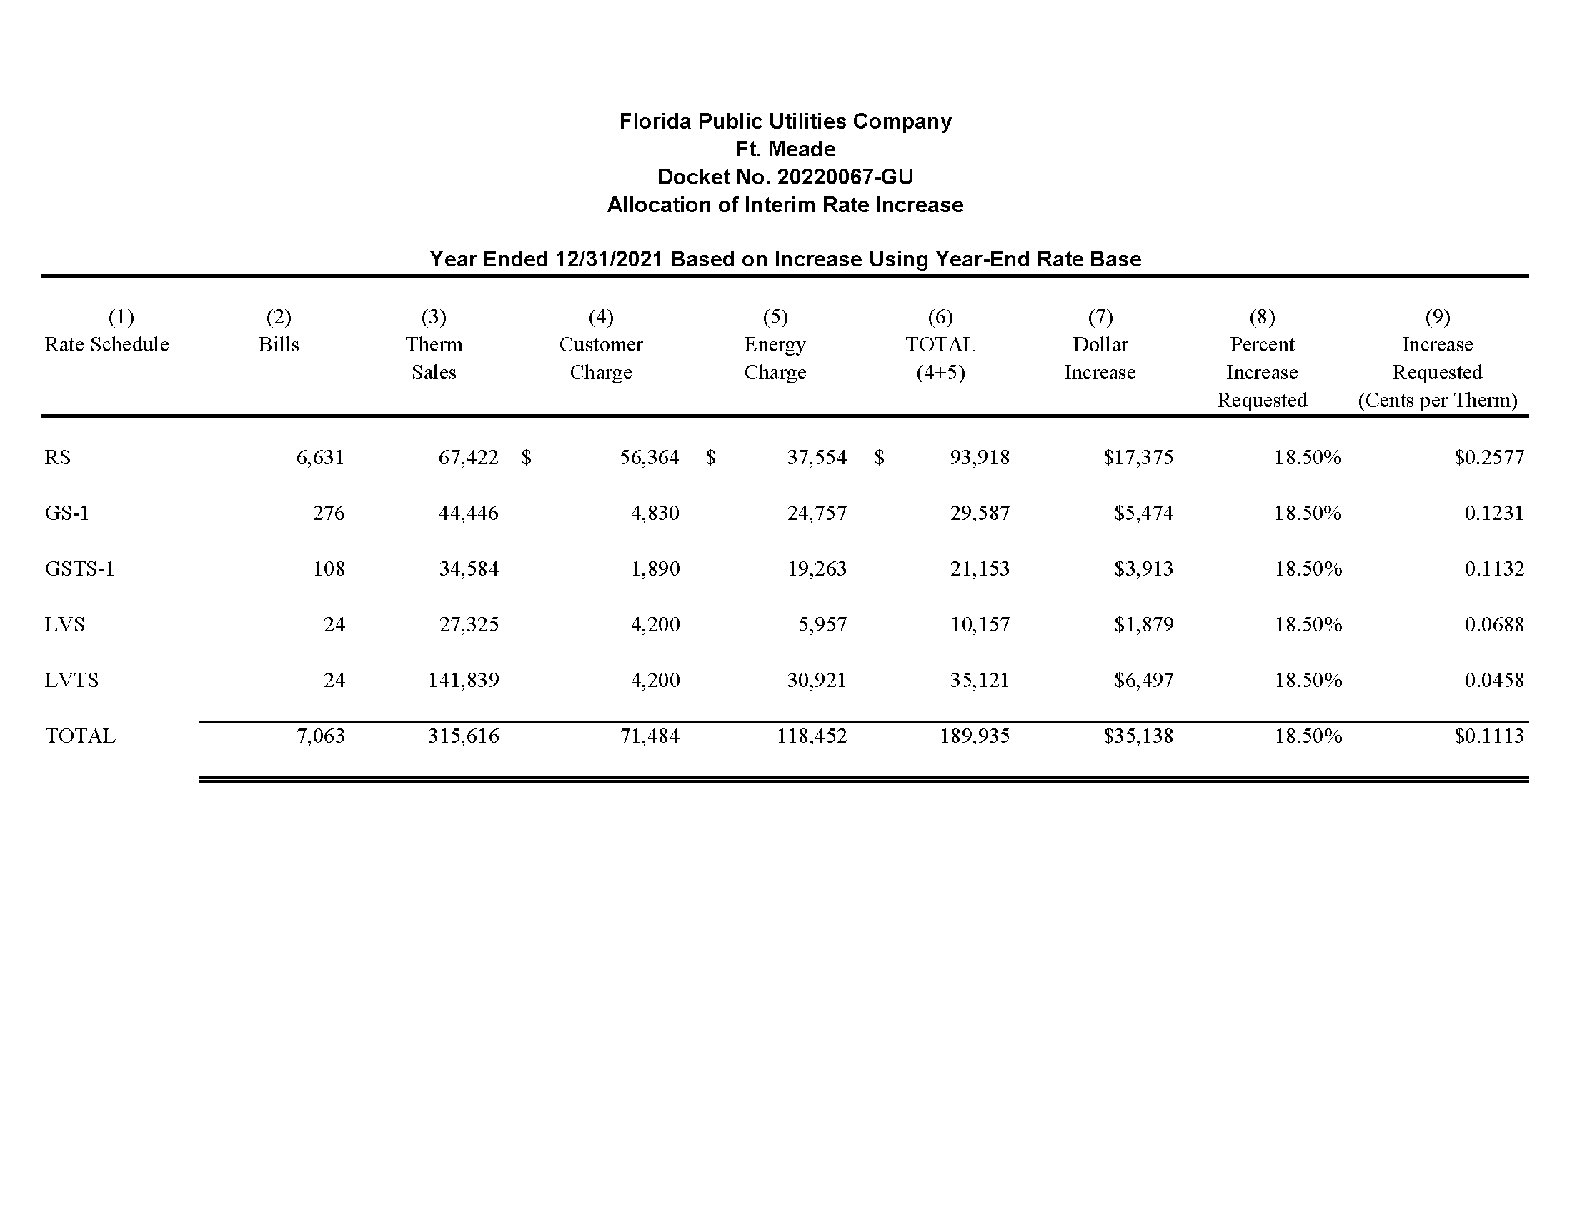

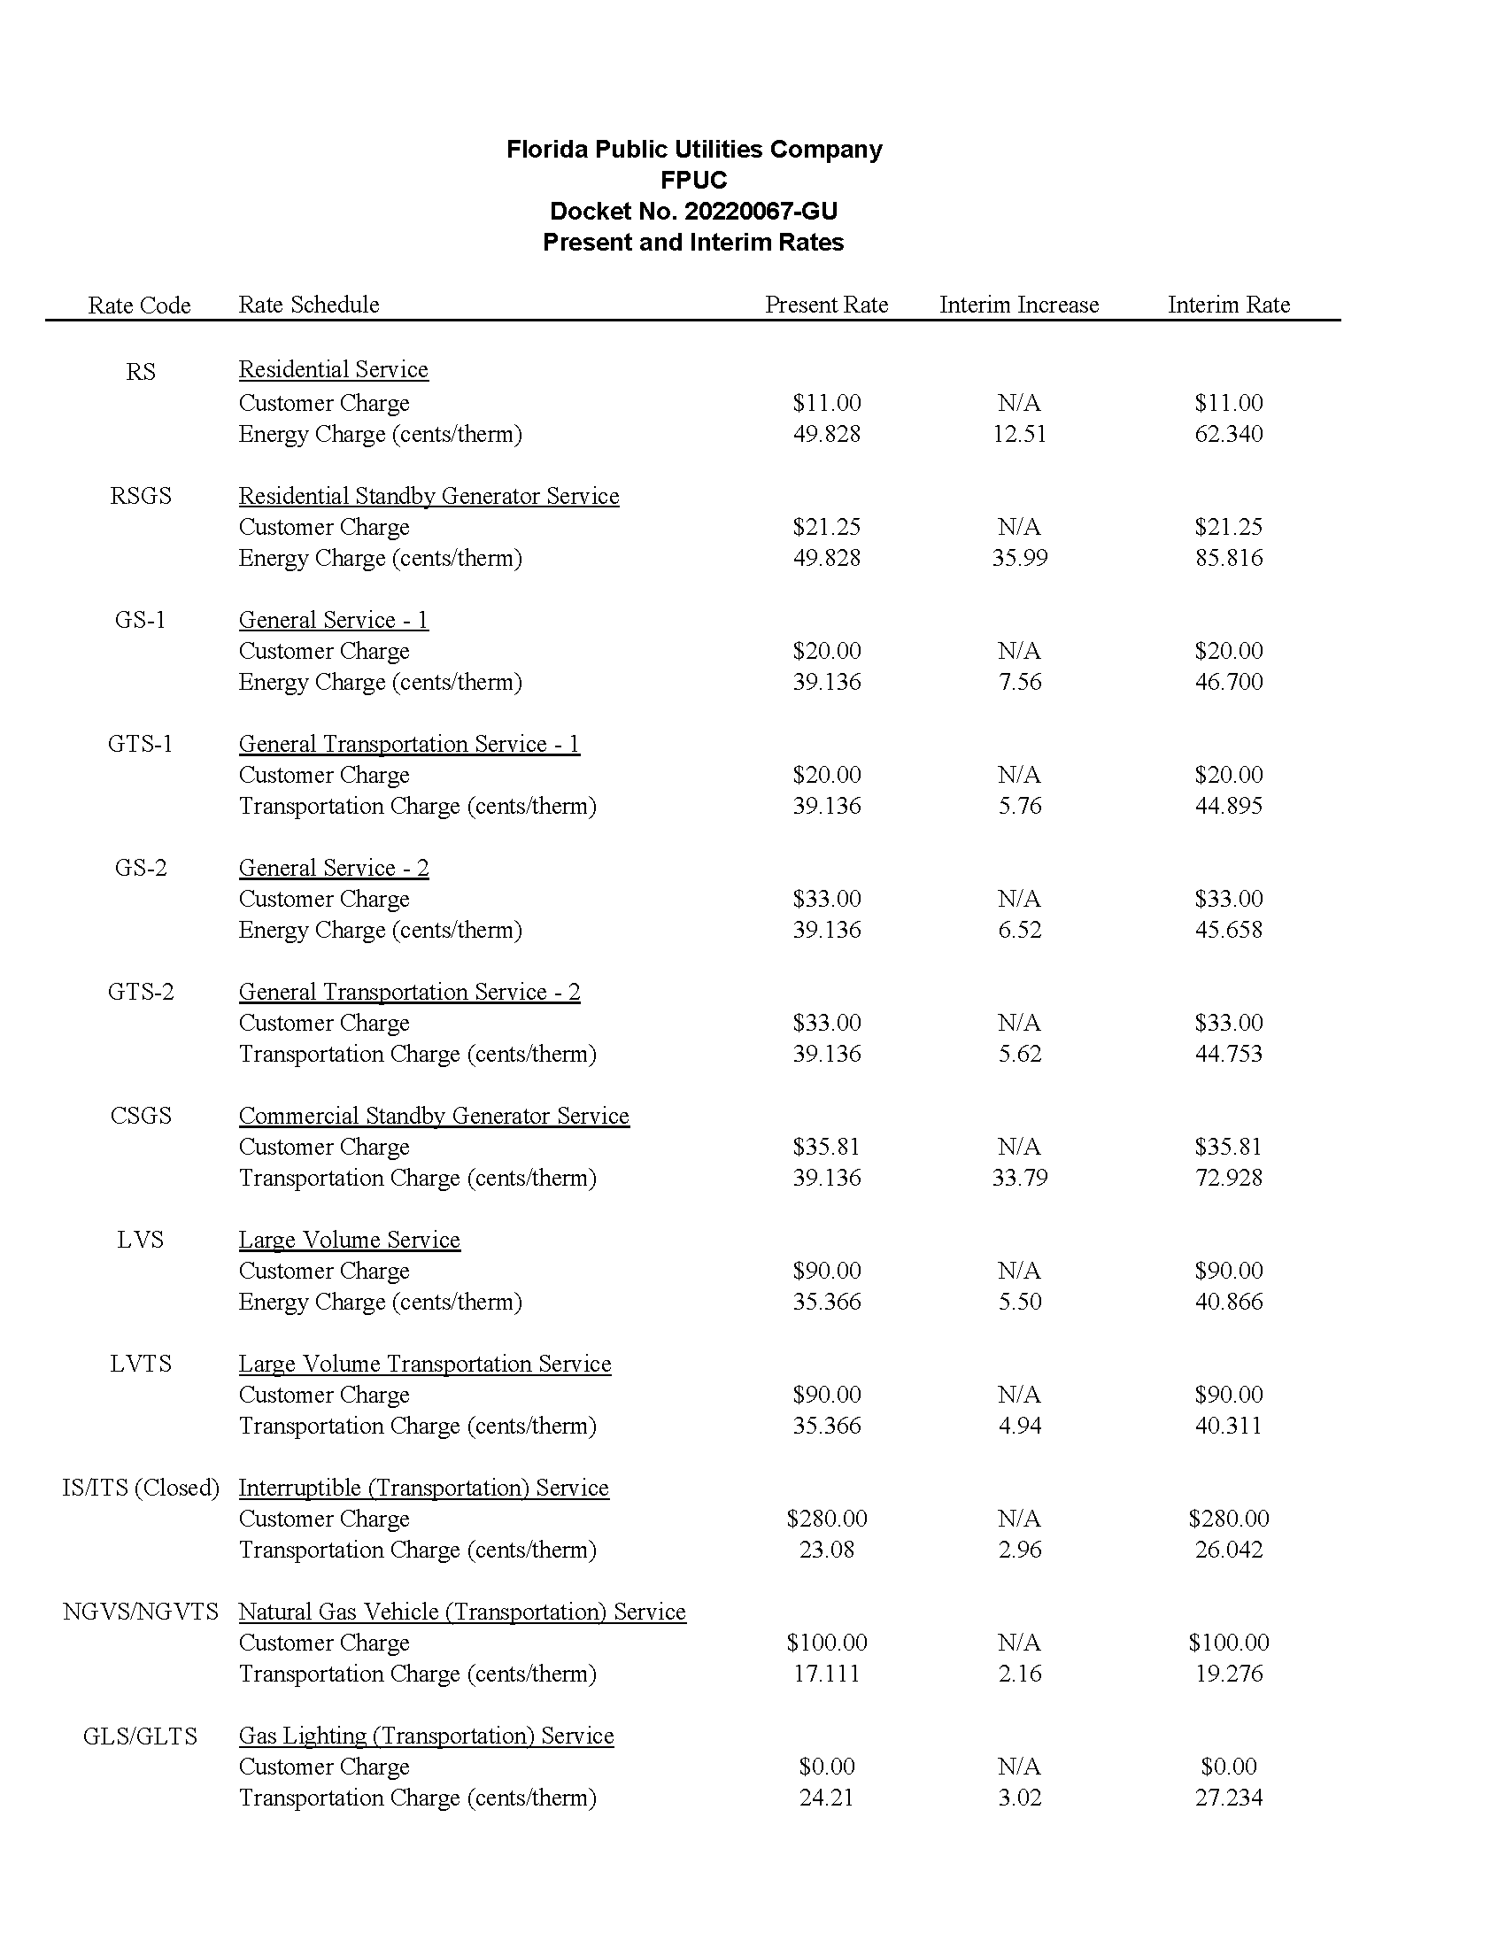

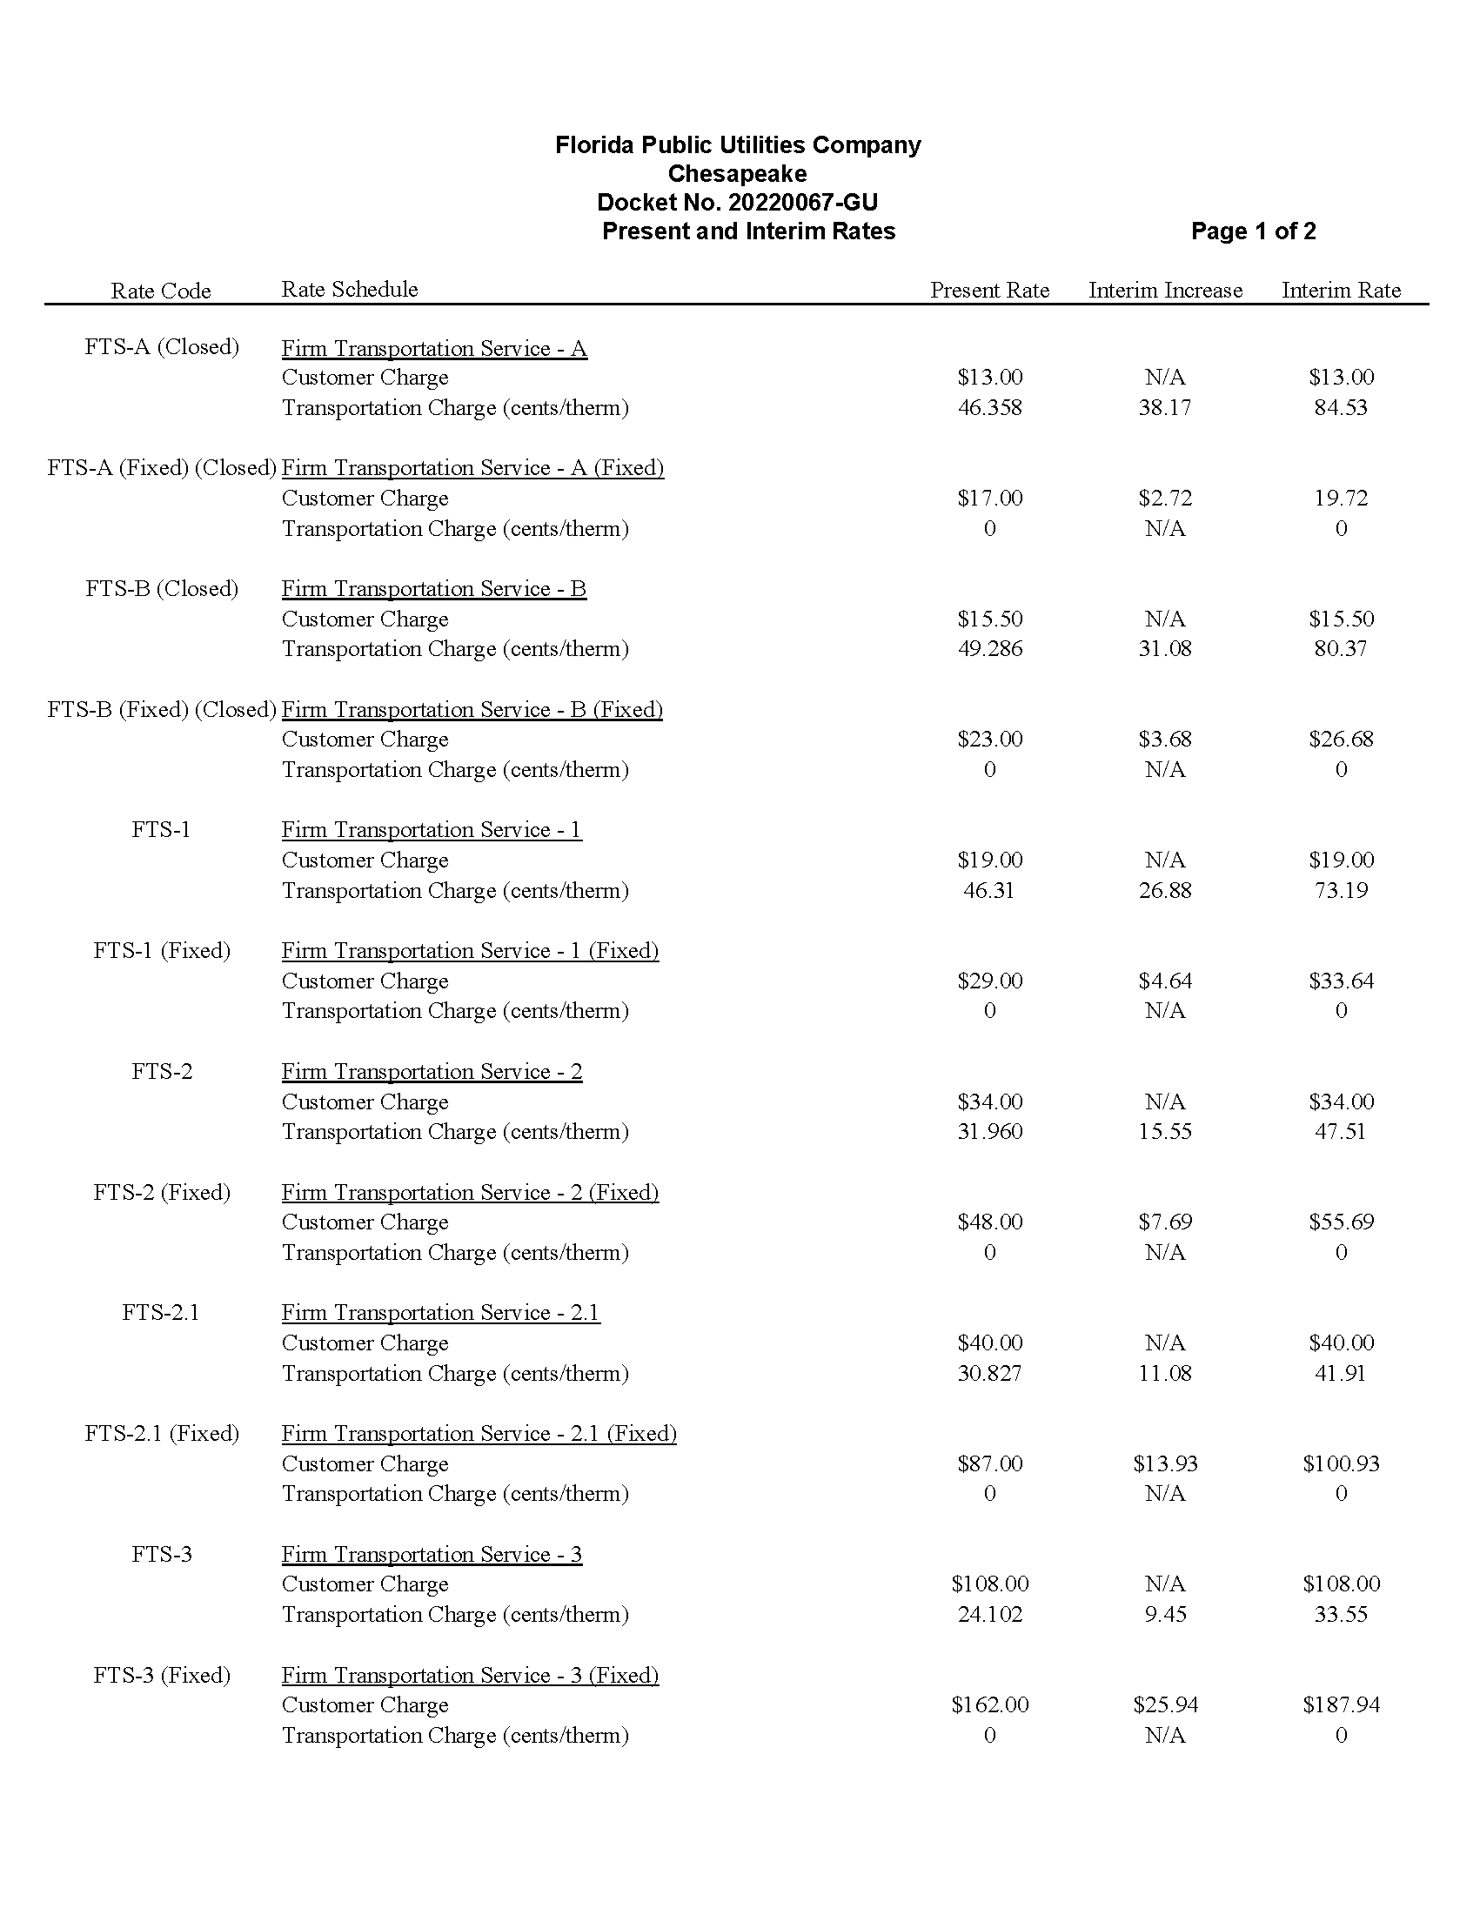

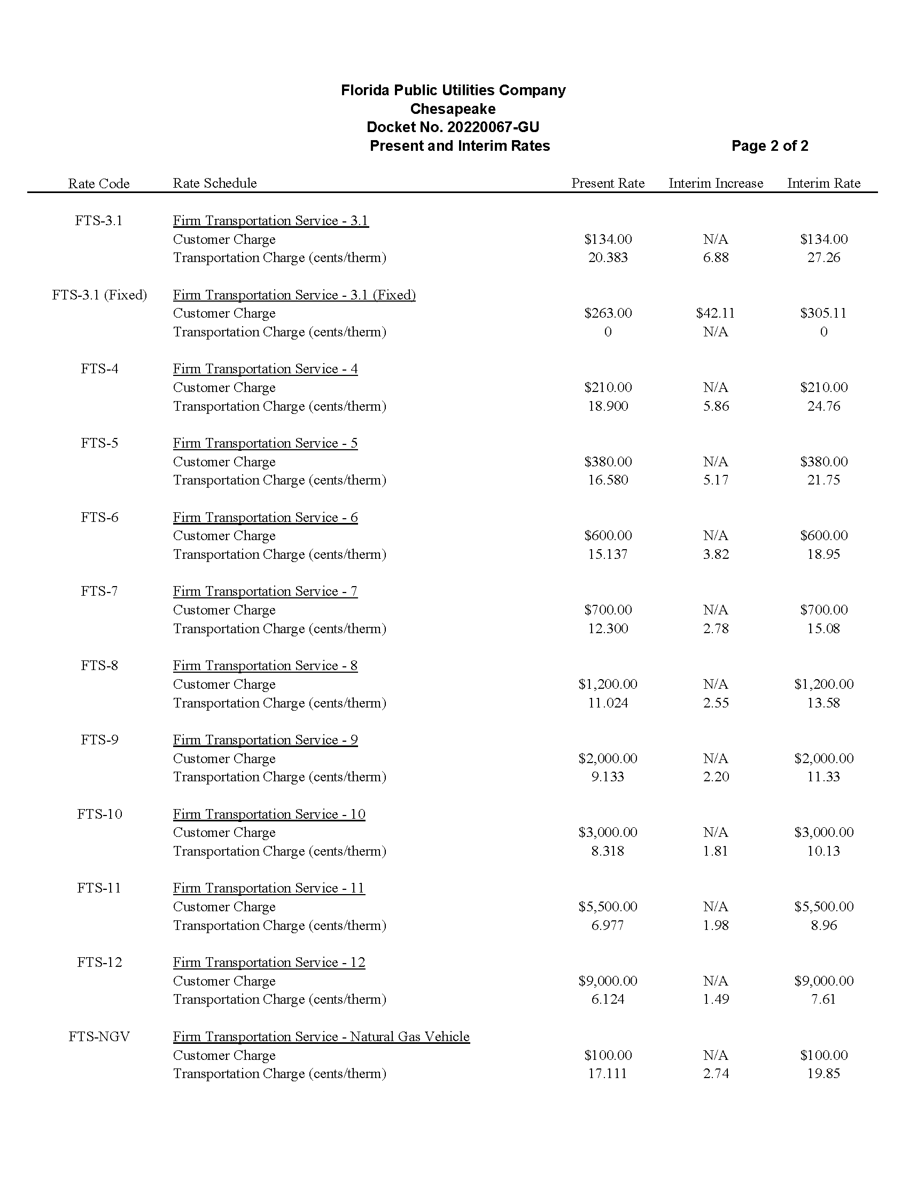

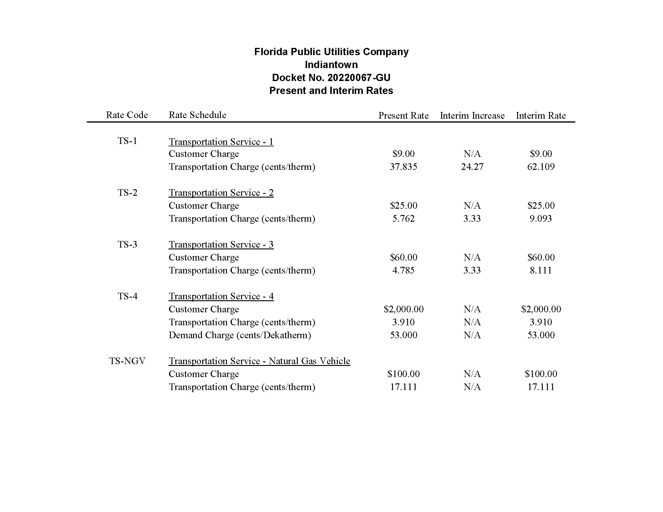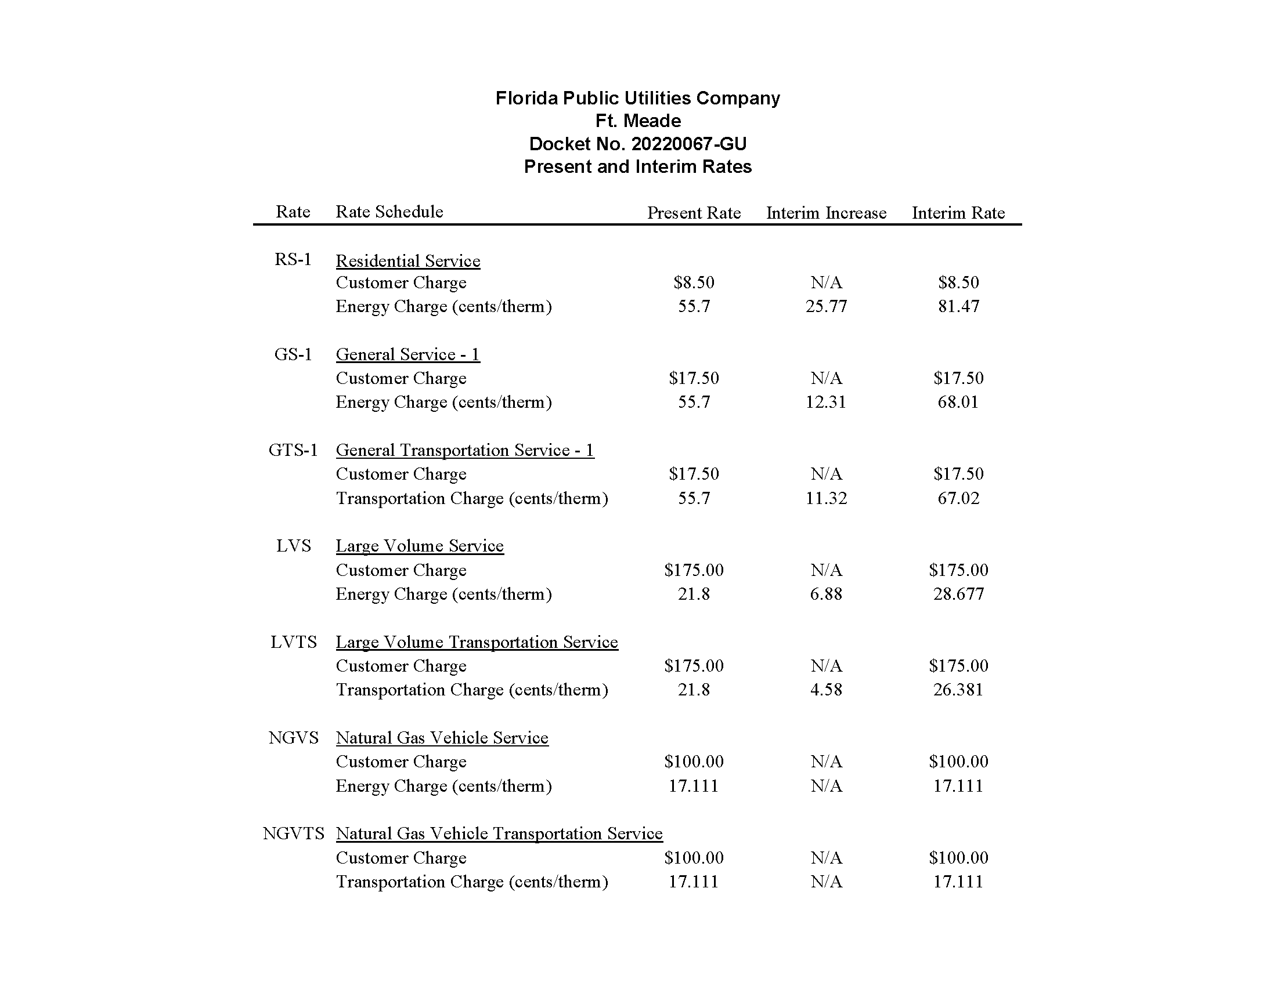

1. Order Nos. PSC-2009-0375-PAA-GU, issued May 27, 2009, and PSC-2009-0848-S-GU, issued December 28, 2009, in Docket No. 20080366-GU, *In re:* *Petition for rate increase by Florida Public Utilities Company.*
2. Order No. PSC-2010-0029-PAA-GU, issued January 14, 2010, in Docket No. 20090125-GU, *In re: Petition for increase in rates by Florida Division of Chesapeake Utilities Corporation.*
3. Order No. PSC-2004-0565-PAA-GU, issued June 2, 2004, in Docket No. 20030954-GU, *In re: Petition for rate increase by Indiantown Gas Company*.
4. Order No. PSC-2021-0148-TRF-GU, issued April 22, 2021, in Docket No. 20200214-GU, *In re: Joint petition of Florida Public Utilities Company, Florida Public Utilities Company-Indiantown Division, Florida Public Utilities Company-Fort Meade, and the Florida Division of Chesapeake Utilities Corporation for approval of consolidation of tariffs, for modifications to retail choice transportation service programs, and to change the MACC for Florida Public Utilities Company.*
5. Document No. 03478-2022, filed June 7, 2022.
6. Order Nos. PSC-2009-0375-PAA-GU, issued May 27, 2009, in Docket No. 20080366-GU, *In re: Petition for rate increase by Florida Public Utilities Company;* PSC-2010-0029-PAA-GU, issued January 14, 2010, in Docket No. 20090125-GU, *In re: Petition for increase in rates by Florida Division of Chesapeake Utilities Corporation;* and PSC-2004-0565-PAA-GU, issued June 2, 2004, in Docket No. 20030954-GU, *In re: Petition for rate increase by Indiantown Gas Company.*
7. Order No. PSC-2013-0676-TRF-GU, issued December 20, 2013, in Docket No. 20130258-GU, *In re: Petition for approval of tariff sheets reflecting gas service to customers in the City of Ft. Meade, by Florida Public Utilities Company.*
8. Order No. PSC-2004-0565-PAA-GU, issued June 2, 2004, in Docket No. 20030954-GU, *In re: Petition for rate increase by Indiantown Gas Company.*
9. Order Nos. PSC-2009-0375-PAA-GU, issued May 27, 2009, in Docket No. 20080366-GU, *In re: Petition for rate increase by Florida Public Utilities Company;* PSC-2010-0029-PAA-GU, issued January 14, 2010, in Docket No. 20090125-GU, *In re: Petition for increase in rates by Florida Division of Chesapeake Utilities Corporation;* and PSC-2004-0565-PAA-GU, issued June 2, 2004, in Docket No. 20030954-GU, *In re: Petition for rate increase by Indiantown Gas Company.*
10. The Companies stated that the calculated interim rate increases for Indiantown and Ft. Meade would be 257.58 percent and 41.23 percent, respectively. For interim purposes, the Companies limited the interim rate increase request for Indiantown and Ft. Meade to the proposed total final rate increases of 24.1 percent and 18.5 percent.