State of Florida |  | Public Service Commission  Capital Circle Office Center ● 2540 Shumard Oak Boulevard  Tallahassee, Florida 32399-0850  -M-E-M-O-R-A-N-D-U-M-
DATE: | August 26, 2022
TO: | Office of Commission Clerk (Teitzman)
FROM: | Division of Economics (Iturralde, Barrett, Guffey)  Office of the General Counsel (Sandy)
RE: | Docket No. 20220003-GU – Purchased gas adjustment (PGA) true-up
AGENDA: | 09/08/22 – Regular Agenda – Interested Persons May Participate
COMMISSIONERS ASSIGNED: |  |  | All Commissioners
PREHEARING OFFICER: |  |  | La Rosa
CRITICAL DATES: |  |  | None
SPECIAL INSTRUCTIONS: |  |  | None

Case Background
On August 8, 2022, St. Joe Natural Gas Company, Inc. (SJNG or Company) filed a Petition for a Mid-Course Correction of its purchased gas adjustment factor cap (PGA cap). After input from staff, the Company replaced the original filing with a Revised Petition on August 11, 2022 (Petition). SJNG asserts that, without a mid-course adjustment to its PGA cap for the last three months of 2022, it expects an under-recovery of costs to total $348,459 by the end of December. In its Petition, SJNG is requesting to increase its PGA cap effective with the first billing cycle in October through the last billing cycle for December 2022. The currently-effective PGA cap was established by Order No. PSC-2021-0437-FOF-GU (2021 PGA Order). At Page 3 in the 2021 PGA Order, the Commission approved a levelized PGA cap for SJNG for the period January through December 2022 of $0.6170 per therm. Although the Commission sets a levelized PGA cap, utilities have the flexibility to charge a lower factor on the monthly bill. The Company seeks a mid-cycle adjustment because recent market price projections for natural gas significantly exceed the price projections that were used to set the current PGA cap. Absent a correction, this projected increase in the price of natural gas is expected to result in a relatively large under-recovery of PGA costs by the end of 2022.
SJNG’s Petition conforms to requirements previously established by the Commission for seeking a mid-course correction to forecasted gas expenses. The Commission recently approved a mid-course correction to a PGA cap for Peoples Gas System on July 7, 2022. Prior to that decision, the Commission has previously approved mid-course corrections to the PGA cap for several utilities when the amount of projected under-recovery was substantial.
Issue 1 in this recommendation addresses the actual and projected PGA cost differences and the proposed related adjustment to the PGA cap. The proposed effective date of the revised PGA cap, as reflected in the proposed tariff sheet revision, is addressed in Issue 2. The revised tariff sheet is included as Attachment A to this recommendation.
The Commission is vested with jurisdiction over the subject matter of this proceeding by the provisions of Chapter 366, Florida Statutes (F.S.), including Sections 366.04, 366.05, and 366.06, F.S.

Discussion of Issues

Issue 1:
Should the Commission approve the Petition for Mid-Course Correction filed by SJNG?

Recommendation:
Yes. Staff recommends the Commission approve the Petition for Mid-Course Correction filed by SJNG. Adjusting the PGA cap to $1.60 per therm as proposed by the Company would allow SJNG the opportunity to timely recover a portion of the recent market-driven escalation in the Company’s actual and forecasted costs for natural gas that are expected to be much higher than originally forecasted. (Barrett, Iturralde)

Staff Analysis:

Summary of Petition
By the 2021 PGA Order, the Commission approved SJNG’s levelized PGA cap factor of $0.6170 per therm, effective with the first billing cycle for January 2022. On an ongoing basis, SJNG monitors its natural gas cost recovery revenue and expenses, and based upon the actual 2021 results and updated estimates for 2022, the Company now projects that an under-recovery greater than 10 percent is likely to occur absent a modification to the current PGA cap.
Based upon a revised projection of revenues and expenses for the remainder of 2022, the Company estimates that the expense for purchasing natural gas will significantly exceed the revenues that are projected to be recovered via the currently-approved levelized PGA cap. Specifically, the revised 2022 expense for purchasing natural gas is estimated to be $779,685, while the projected revenues for the same period would be $541,062. When this difference between expenses and revenues is coupled with the true-up balances, interest charges, and other adjustments, the beginning of the year true up balance of $107,920 is projected to grow to $348,459 by the end of December 2022. The mid-course correction the Company is proposing would recover only a portion ($172,099) of that imbalance.
SJNG asserts that the primary cause of the projected 2022 under-recovery is a significant increase in actual and projected 2022 natural gas prices, yielding higher costs than the projected costs that were used to establish the currently-approved PGA cap. According to SJNG, since the issuance of the 2021 PGA Order, a convergence of inter-related factors has “resulted in an extraordinary environment affecting natural gas pricing.” These factors include geopolitical uncertainty caused by Russia’s military invasion of Ukraine and demand for natural gas exceeding current natural gas production levels. (Petition at 9) SJNG believes resetting the PGA cap for October through December of 2022 would allow it the flexibility to provide its customers with the appropriate price signal, while at the same time allow it to recover a portion of the reprojected costs for purchased natural gas.
SJNG is proposing to reset its PGA cap from $0.6170 per therm to $1.60 per therm, effective with the first billing cycle of October 2022 through the last billing cycle of December 2022. In SJNG’s proposed notice to its customers that will be included in September bills, the Company states:
St Joe Natural Gas has asked [the Public Service Commission to approve] a cap of $1.60 [per therm] for October through December 2022. St Joe Natural Gas is allowed to charge anything up to the cap to cover the costs of natural gas that is bought and sold to its customers. There is no profit on the fuel charge and it is a direct pass through to the customer. Waiting until 2023 would cause the cap to be set even higher to recover the unbilled gas costs associated with 2022’s loss. This does not mean that the fuel charge will be $1.60 [per therm] on your bill. It means that we are able to charge up to $1.60 [per therm] should fuel prices continue to climb. Starting with your October bill, the fuel charge portion will likely increase from $0.617 [per therm] up to no more than $1.60 [per therm] to cover the cost of gas purchased from the pipeline and delivered to your meter. The fuel charge will more likely be set around $1.10 to $1.30 [per therm] in order to cover the current price and recover the unbilled fuel costs associated with 2022 so far.
If approved, applying this revised PGA cap will allow the Company to address much of the under-recovered true-up balance for 2022, although it will not eliminate the full amount of the true-up balance, or even the full amount of the re-projected expenses for 2022. However, Commission approval of this mid-cycle correction would allow the Company to reduce the impact of the true-up balance in 2022, and thereby mitigate having to do so during the year 2023, for customers who are subject to the PGA. If approved, staff’s calculation of the bill impact indicates than an average RS-2 residential customer with monthly consumption of 20 therms would incur an additional gas cost of $19.66 per month, based upon projections that implement the proposed new PGA cap at its full value between October and December 2022. The Company, however, has indicated in its notice to customers that it may set the fuel recovery charge at a lower rate that, if implemented, would result in a lower bill impact.
A revised tariff sheet in “clean” and “legislative” formats is attached to the Revised Petition, with the requested effective date beginning with the first billing cycle in October 2022. SJNG requested consideration of this Petition on or before the September 8, 2022 Commission Agenda Conference in order to allow it to provide notice to customers. The Company’s proposed effective date and revisions to its tariff are addressed in Issue 2.

Analysis
In projecting its costs for natural gas, the Company evaluates New York Mercantile Exchange (NYMEX) natural gas futures settlement prices, recent historical records for therm sales, and the balance within its true up account. With that data, the Company observed NYMEX values in August of 2021 in the range of $4.50 per MMBTU, with NYMEX futures for 2022 forecasted between $5.00 and $6.00 for most of 2022. The Company states that at the time it revised its price projection, the NYMEX forecasted values for September through December 2022 were in the range of $8.00 to $9.00 per MMBTU, with most of 2023 forecasted to be back in the range of $5.00 per MMBTU. In its Petition, the Company also noted that current events in Ukraine have influenced natural gas market prices, and in a Data Request response, SJNG indicated that federal government policies related to production and leases has also influenced natural gas markets.
Staff evaluated historic NYMEX settlement prices and observed that when SJNG prepared its forecast of 2022 (in August of 2021), the NYMEX 12-month average of natural gas was $3.42 per MMBTU. Beginning in the second quarter of 2022, significant changes in the market impacted settlement prices, which ranged from $6.60 to $8.15 per MMBTU (through August 2022). Near-term forecasts of monthly futures for September through December 2022 are over $9.00 per MMBTU for all months. However, forecasted NYMEX futures extending into 2023 indicate that by the middle and later months in 2023, forecasted prices are considerably lower, with estimates ranging from $5.35 to $5.85 per MMBTU.
As noted above, SJNG’s revised PGA cap will not eliminate the full amount of the projected year-end true-up balance. As presented, the SJNG Petition seeks to recover a total of $172,099 in projected true up costs, while deferring recovery of $176,359, as a mitigation to limit the impact its request will have on customer bills. Table 1-1 below presents information to demonstrate the calculations. Based on analyzing NYMEX future prices for 2023, which are lower than current prices, the Company structured its mid-course correction to only recover a portion of its full under-recovered balance, with the hope that lower market prices in 2023 will enable it to address the deferred under-recovery balance naturally.
Table 1-1
True-Up Calculations for SJNG’s Mid-Course Correction
Components | Current (No Mid-Course Recovery) | Mid-Course Correction, as proposed | Difference
Reprojected Actual/Estimated 2022 Costs | $779,685 | $779,685 | $0
Reprojected Actual/Estimated 2022 Revenue | $541,062 | $712,861 | $171,799
Difference Between Reprojected Actual/Estimated 2022 Costs and Revenue | $238,623 | $68,821
Prior Year True Up and Interest Provision | $109,835 | $109,535 | $300
Projected Year End (2022) Total True Up | $348,458 Under | $176,359 Under | $172,099 Under
Source: Schedules E-1/R and E-2, from Appendices A and B, attached to Revised Petition.
Absent the instant pleading, November’s cost recovery hearing would be the forum for SJNG to seek recovery of its actual and estimated costs. However, as the Petition demonstrates, SJNG has experienced and is expecting to continue to incur higher market prices than originally projected for natural gas, resulting in an estimated 2022 year-end under-recovery balance of $348,459.
Staff believes addressing the imbalance in costs at an earlier occasion is preferred over waiting until November’s hearing to do so. Although the Commission sets a levelized PGA cap, utilities have the flexibility to charge a lower factor on monthly bills. Staff notes, however, that the revenue projections the Company provided with its Revised Petition are based on setting the PGA to the cap for October through December 2022. A mid-cycle change to reset the PGA cap is an opportunity for the Commission to be responsive to the market-driven escalation in actual and forecasted costs. While it is possible that market prices between now and November’s hearing could change in a manner that would reduce the projected under-recovery balance, the opposite is possible as well. Absent any action, the higher or lower true-up balance would be addressed at the November evidentiary hearing in this docket, when the Commission sets the Company’s 2023 PGA cap. However, staff believes a PGA cap change implemented for the October through December 2022 billing cycles is more timely. Staff believes this action will reduce the true-up balance through the remaining months of 2022, and would, in turn, moderate the portion of the 2023 PGA cap that is calculated from the end-of-year (2022) true-up balance.
In addition, it is important to note that, while the instant Petition addresses a proposed revision to the PGA cap for SJNG, the determination of prudence of PGA costs incurred is reserved as an issue to be resolved at the time of the hearing or in a subsequent Commission Agenda Conference. Any costs found to be imprudently incurred and recovered would be a matter to be addressed by the Commission at that time.
Bill Impact for typical residential customer
The revised PGA cap the Company is recommending is $1.60 per therm, an increase of approximately $0.98 cents per therm. For comparative purposes, staff assumes typical residential usage of 20 therms per month. Staff’s calculation of the bill impact for a residential customer on the RS-2 rate schedule using 20 therms of natural gas is shown below in Table 1-2. Based on the Company’s proposed PGA cap adjustment, a residential customer taking service under the RS-2 tariff with monthly consumption of 20 therms would incur an additional gas cost of up to $19.66 per month, for the October through December 2022 billing cycles.

Table 1-2
Sample Bill for a Residential Customer on the
RS-2 Rate Schedule Using 20 Therms
Invoice Component | Currently-Approved Charges ($)  (with PGA Cap at $0.617) | Proposed Charges for  Oct-Dec, 2022 ($) (with PGA Cap at $1.60) | Current to Proposed Difference  ($) | Current to Proposed Difference  (%)
Customer Charge | $16.00 | $16.00 | - | -
Distribution Charge | 24.66 | 24.66 | - | -
Purchased Gas Adjustment | 12.34 | 32.00 | $19.66 | 159.3%
Total Bill | $53.00 | $72.66 | $19.66 | 37.1%
Source: Staff’s calculation, noting that utility and gross receipts taxes were not included.
Staff observes, however, that this example demonstrating a bill impact of about 36 percent is based on SJNG setting its PGA factor at the full cap of $1.60 per therm for October through December 2022. However, as expressed in its customer notification, SJNG seeks the flexibility to set its PGA cap at $1.60 per therm, but is hopeful that market conditions for what it pays for gas may allow it to set its PGA recovery amount at a level below the $1.60 per therm upper limit. If the PGA recovery factor was set at an amount less than $1.60 per therm, then the bill impact would be lower than as shown in Table 1-2. In addition, the Company has filed its projection testimony and exhibits for 2023, which forecast a lower PGA cap in 2023 than the $1.60 per therm under consideration in this pleading, if its mid-course correction is approved.
By requesting a mid-course correction for only a portion of it estimated total true up balance, staff believes the Company is balancing the uncertainty of whether market conditions will be more or less favorable for reducing the under-recovery balances at a later time, against the near-term impact the requested correction will have on its customers. Staff believes this is a reasonable approach for two reasons. First, market conditions are at historically high levels, which has created the under-recovery balance that prompted the Company to request relief. By requesting only a portion of its total estimated true up balance, the Company is attempting to moderate the impact of what customers would pay in order to address the under-recovery of its purchased gas costs. Second, NYMEX future prices for 2023 are reflecting that market prices may recede from current levels, which is favorable in 2023 for the imbalance between costs and revenues to improve. Table 1-3 below illustrates what the remaining true-up balances would be with and without the requested mid-course correction. If the mid-course correction is approved, the projected year end (2022) under-recovery balance will be $176,359, rather than $348,458, if no mid-course correction is implemented.
Table 1-3
True-Up Calculations for SJNG
Components of True Up | Current PGA Rates (Without a Mid-Course Correction) | SJNG Mid-Course Correction
Beginning of 2022 Balance | $107,920 | $107,920
Amount authorized in prior order | $45,103 | $45,103
Actual/Estimated Results of 2022 | $193,520 | $21,721
Interest Provision | $1,915 | $1,615
Projected Year End (2022) Balance | $348,458 | $176,359
Source: Schedules E-1/R and E-2, from Appendices A and B, attached to Revised Petition.

Conclusion
Staff recommends the Commission approve the Petition for Mid-Course Correction filed by SJNG. Adjusting the PGA cap to $1.60 per therm as proposed by the Company would allow SJNG the opportunity to timely recover a portion of the recent market-driven escalation in the Company’s actual and forecasted costs for natural gas that are expected to be much higher than originally forecasted.

Issue 2:
If approved by the Commission, what is the appropriate effective date for SJNG’s revised levelized PGA cap?

Recommendation:
The appropriate revised levelized PGA cap shown on Attachment A (Fifteenth Revised Sheet No. 103) should become effective with the first billing cycle of October 2022. (Guffey)

Staff Analysis:
In its Petition, SJNG has requested that the proposed revisions to the PGA cap and associated tariffs become effective beginning with the first billing cycle of October 2022, which starts October 1, 2022. Under this request, the effective date of the increase would be 23 days post-Commission vote. The Company will provide the relevant tariff sheet to correspond with the given decision by the Commission.
The Commission has considered the effective date of rates and charges of the revised PGA cap and for the levelized purchased gas adjustment cost recovery factors on a case-by-case basis. While petitions for purchased gas adjustment cost recovery mid-course corrections are infrequent, the Commission has approved an effective date less than 30 days from the Commission’s vote.
In Order No. PSC-05-1029-PCO-GU, the Commission approved a mid-course correction to Florida Public Utilities Company’s PGA cap on the effective date of the Commission’s vote. In 2001, the Commission approved requests by six natural gas utilities for mid-course corrections to their caps. In each of these cases, the Commission allowed the new cap to take effect the day of the Commission’s vote. In the 2001 cases, the Commission stated that the requests were driven by drastic increases in the price of natural gas. For the recent Peoples Gas mid-course correction, the Commission approved an effective date of 26 days after the vote.
For comparison purposes, over the last 20 years, in the electric Fuel Cost Recovery Clause docket, the Commission has approved fuel cost recovery factor rate decreases effective sooner than the next full billing cycle after the date of the Commission’s vote, with the range between the vote and effective date being from 25 to 2 days. The rationale for that action being that it was in the customers’ best interests to implement the lower rate as soon as possible. With regard to fuel cost recovery factor/rate increases, the Commission has approved an effective date of the revised factors ranging from 14 to 29 days after the vote. In two of these cases, the Commission noted that the utility had given its customers 30 days’ written notice before the date of the vote that a fuel cost recovery factor increase had been requested and provided the proposed effective date of the higher fuel factors. Staff believes the same rationale is applicable to a gas mid-course correction.
As previously noted, there are 23 days between the Commission’s vote on September 8, 2022, and the beginning of SJNG’ billing cycle on October 1, 2022. Staff notes that an effective date in October 2022 will provide the greatest number of months within 2022 over which to spread recovery, resulting in a lower potential monthly bill impact for SJNG’s customers.

Conclusion
Based on the above, staff recommends that the appropriate revised levelized PGA cap shown on Attachment A (Fifteenth Revised Sheet No. 103) should become effective with the first billing cycle of October 2022.

Issue 3:
Should this docket be closed?

Recommendation:
No. Docket No. 20220003-GU is an on-going proceeding and should remain open. (Sandy)

Staff Analysis:
Docket No. 20220003-GU is an on-going proceeding and should remain open.
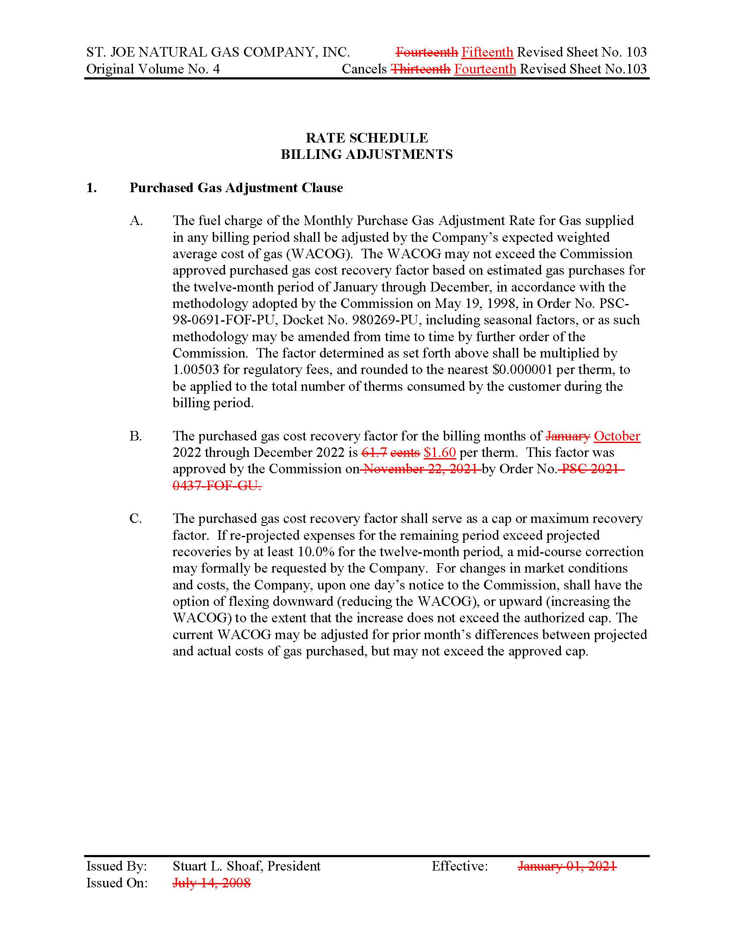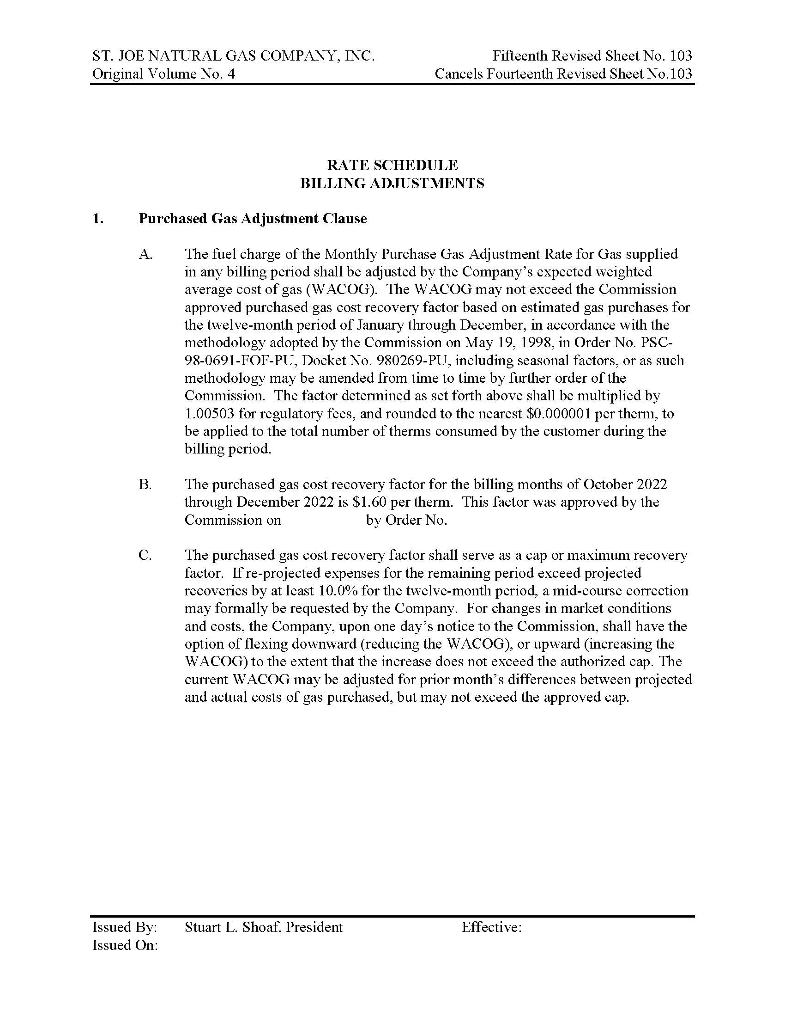

Document No. 05406-2022, the Revised Petition for a Mid-Course Correction, was filed on August 11, 2022. Instructions to the Clerk indicated that the Revised Petition was intended to replace Document No. 05304-2022, the August 8, 2022 filing.
Order No. PSC-2021-0437-FOF-GU, Final Order Approving Purchased Gas Adjustment True-up Amounts and Establishing Purchased Gas Cost Recovery Factors To Be Applied During the Period of January 2022 through December 2022, issued November 22, 2021, in Docket No. 20210003-GU, In re: Purchased Gas Adjustment (PGA) true-up.
An annual docket is established to review the actual and estimated purchased gas costs. Ordinarily, the appropriate levelized purchased gas cost recovery (cap) factors for SJNG and the other investor-owned natural gas utilities are set/reset for a full 12-month period on an annual basis. The next hearing for the Purchased Gas Adjustment docket is scheduled to begin on November 1, 2022.
See Order No. PSC-05-1029-PCO-GU (2005 Mid-course Order, issued October 21, 2005, in Docket No. 20050003-GU, In re: Purchased Gas Adjustment (PGA) true up. (The Commission has adopted a method for recovery of purchased gas costs by regulated natural gas utilities by means of a levelized Purchased Gas Adjustment (PGA) factor to serve as a cap, or maximum recovery factor, for each calendar year commencing January 1 through December 31. The Commission has also adopted a method by which a utility may, at its option, request a mid-course correction if revised projected expenses for the remainder of the period significantly exceed projected revenues as calculated under the Commission-approved cap. The Commission has previously approved mid-course corrections to the PGA cap for several utilities when the amount of projected under-recovery was substantial.)
See Order No. PSC-00-1910-PCO-GU, Chesapeake Utilities Corporation Mid-Course Correction, issued February 19, 2001, in Docket No. 010003-GU, In re: Purchased Gas Adjustment (PGA) True-up; Order No. PSC-00-1422-PCO-GU, City Gas Company of Florida Mid-Course Correction, issued February 19, 2001, in Docket No. 010003-GU, In re: Purchased Gas Adjustment (PGA) True-up; Order No. PSC-00-2137-PCO-GU, Florida Public Utilities Mid-Course Correction, issued February 19, 2001, in Docket No. 010003-GU, In re: Purchased Gas Adjustment (PGA) True-up; Order No. PSC-00-1524-PCO-GU, Peoples Gas System Mid Course Correction, issued February 19, 2001, in Docket No. 010003-GU, In re: Purchased Gas Adjustment (PGA) True-up; Order No. PSC-00-1909- PCO-GU, Indiantown Gas Company Mid Course Correction, issued February 19, 2001, in Docket No. 010003-GU, In re: Purchased Gas Adjustment (PGA) True-up; Order No. PSC-00-2138-PCO-GU, St. Joe Natural Gas Company Mid-Course Correction, issued February 19, 2001, in Docket No. 010003-GU, In re: Purchased Gas Adjustment (PGA) True-up; Order No. PSC-2022-0287-PCO-GU, Peoples Gas System Mid Couse Correction, issued July 22, 2022, in Docket No. 20220003-GU, In re: Purchased Gas Adjustment (PGA) True-up.
Schedules E-1/R and E-2, from Appendix A, attached to Revised Petition.
As reflected in Schedules E-1/R and E-2 from Appendix B, SJNG’s proposed PGA cap implemented for October through December 2022 is projected to produce higher revenue to offset most, but not all of the projected higher costs for 2022. If approved, the revised PGA cap is projected to result in revenues of $712,861.
With its mid-course correction, SJNG is proposing to recover $172,099 of the $348,458 total estimated true up balance. The deferred portion ($176,359) includes the remainder of the actual under-recovery balances from 2021, through six months of 2022, and also includes $21,721 in reprojected expenses for 2022.
Table 1-2 was prepared as an example of a typical residential bill. Staff research indicates that November and December are months when usage is higher than the average of other months, which means the actual bill impacts could be higher in those months than as presented as in Table 1-2.
In its Projection filing, the Company prepared schedules with and without the approval of the instant Petition. If the mid-course correction is granted, the Company projects that its 2023 PGA cap will be $1.495 per therm, and without, the 2023 PGA cap is estimated to be $1.713 per therm.
Order No. PSC-2005-1029-PCO-GU, Final Order Approving Mid-Course Correction, issued October 21, 2005, in Docket No. 20050003-GU, In re: Purchased Gas Adjustment (PGA) true-up.
See Order No. PSC-00-1910-PCO-GU, Chesapeake Utilities Corporation Mid-Course Correction, issued February 19, 2001, in Docket No. 010003-GU, In re: Purchased Gas Adjustment (PGA) True-up; Order No. PSC 00-1422- PCO-GU, City Gas Company of Florida Mid-Course Correction, issued February 19, 2001, in Docket No. 010003-GU, In Re: Purchased Gas Adjustment (PGA) True-up; Order No. PSC-00-2137-PCO-GU, Florida Public Utilities Mid-Course Correction, issued February 19, 2001, in Docket No. 010003-GU, In Re: Purchased Gas Adjustment (PGA) True-up; Order No. PSC-00-1524-PCO-GU, Peoples Gas System Mid Course Correction, issued February 19, 2001, in Docket No. 010003-GU, In Re: Purchased Gas Adjustment (PGA) True-up; Order No. PSC-00-1909- PCO-GU, Indiantown Gas Company Mid Course Correction, issued February 19, 2001, in Docket No. 010003-GU, In Re: Purchased Gas Adjustment (PGA) True-up; Order No. PSC-00-2138-PCO-GU, St. Joe Natural Gas Company Mid-Course Correction, issued February 19, 2001, in Docket No. 010003-GU, In Re: Purchased Gas Adjustment (PGA) True-up.

