|  |  |  |  |
| --- | --- | --- | --- |
| State of Florida  pscSEAL | | Public Service Commission  Capital Circle Office Center ● 2540 Shumard Oak Boulevard Tallahassee, Florida 32399-0850  -M-E-M-O-R-A-N-D-U-M- | |
| DATE: | August 26, 2022 | | |
| TO: | Office of Commission Clerk (Teitzman) | | |
| FROM: | Office of the General Counsel (Stiller, Harper) JSC  Division of Accounting and Finance (Higgins, Mouring, Richards) ALM  Division of Engineering (Ellis, King, Wooten) TB | | |
| RE: | Docket No. 20200176-EI – Petition for a limited proceeding to approve clean energy connection program and tariff and stipulation, by Duke Energy Florida, LLC. | | |
| AGENDA: | 09/08/22 – Regular Agenda – Post-Hearing Decision – Participation is Limited to Commissioners and Staff | | |
| COMMISSIONERS ASSIGNED: | | | All Commissioners |
| PREHEARING OFFICER: | | | La Rosa |
| CRITICAL DATES: | | | None |
| SPECIAL INSTRUCTIONS: | | | None |

Case Background

On January 26, 2021, the Commission entered a Final Order Approving Stipulation in this Docket.[1] The Order approved Duke Energy Florida, LLC’s (Duke) Clean Energy Connection (CEC) Program and associated tariffs as set forth in the stipulation. Duke’s CEC Program is a voluntary community solar program that allows participating customers to pay a subscription fee in exchange for receiving bill credits related to the solar generation produced by the CEC Program solar facilities. The League of United Latin American Citizens of Florida (LULAC) timely appealed that Final Order to the Florida Supreme Court. After full briefing and oral argument, the Court remanded this proceeding to the Commission with the following guidance:

The [final] order under review is inadequate to an extent that prevents us from deciding the central issue that we have identified. To be clear, we express no position now on the merits of LULAC’s challenge. But we believe it is necessary to remand this case and afford the Commission an opportunity to enter a revised final order that adequately explains the agency’s findings and reasoning. *See* § 120.68(6)(a)(1), Fla. Stat. (a reviewing court may “remand the case for further agency proceedings”). Subject to any requirements imposed by law, the form of the proceedings on remand will be up to the Commission, including the decision whether to allow the parties to present additional evidence.[2]

A copy of the Florida Supreme Court’s Order is appended to this Recommendation as Attachment A.

The “central issue” raised by LULAC and for which the Court has requested additional findings and conclusions is whether the funding structure of the CEC program results in a subsidy to the participants in violation of Section 366.03, Florida Statutes (F.S.). The Court identified the following specific aspects of this issue for the Commission to address on remand:

[1] whether the Commission accepts LULAC’s characterization of the program’s bill credit feature as a ‘subsidy,’ and if so, [2] why the Commission nonetheless considers the program to have established rates that are fair, reasonable, and not unduly preferential.

Appended to this recommendation as Attachment B is a draft Revised Final Order setting forth staff’s recommended additional findings, reasoning, and conclusions regarding the CEC program, tariff, and stipulation based on the existing record. Staff recommends that all aspects of the original Final Order remain unchanged.

Discussion of Issues

Issue :

 Should the record be reopened?

Recommendation:

 No. (Stiller)

Staff Analysis:

 On June 8, 2022, staff conducted an informal conference with the parties to obtain input regarding remand procedures. All parties agreed that the record need not be re-opened and no further briefing was desired. Staff concurs with the parties that it is not necessary to open the record to take additional evidence or receive further written submissions from the parties. Staff recommends the existing record is sufficient for the Commission to address the matters identified by the Court.

Issue :

 Should the Commission accept LULAC’s characterization of the CEC program’s bill credit feature as a “subsidy,” and if so, should the Commission nonetheless consider the program to have established rates that are fair, reasonable, and not unduly preferential?

Recommendation:

 Staff recommends that the Commission not accept LULAC’s characterization of the CEC program’s bill credit feature as a “subsidy.” Staff further recommends that Commission find that the program has established rates that that are fair, reasonable, and not unduly preferential. (Stiller)

Staff Analysis:

 Staff’s full analysis for Commission consideration is set forth in the attached draft Revised Final Order.

Issue :

 Should this docket be closed?

Recommendation:

 No. This docket should remain open pending resolution of the appeal by the Florida Supreme Court. Once the Court has disposed of the appeal, the docket should be closed administratively. (Stiller)

Staff Analysis:

 Staff conferred with the Clerk’s Office at the Florida Supreme Court regarding this matter and was informed that the prior Final Order had not been vacated and that Supreme Court Docket Number SC21-303 remains open. Staff was informed that the Revised Final Order is to be filed with the Florida Supreme Court in Docket Number SC21-303. Accordingly, this docket should remain in litigation status pending resolution of the appeal by the Florida Supreme Court. Once the Court has disposed of the appeal, this docket should be closed administratively.

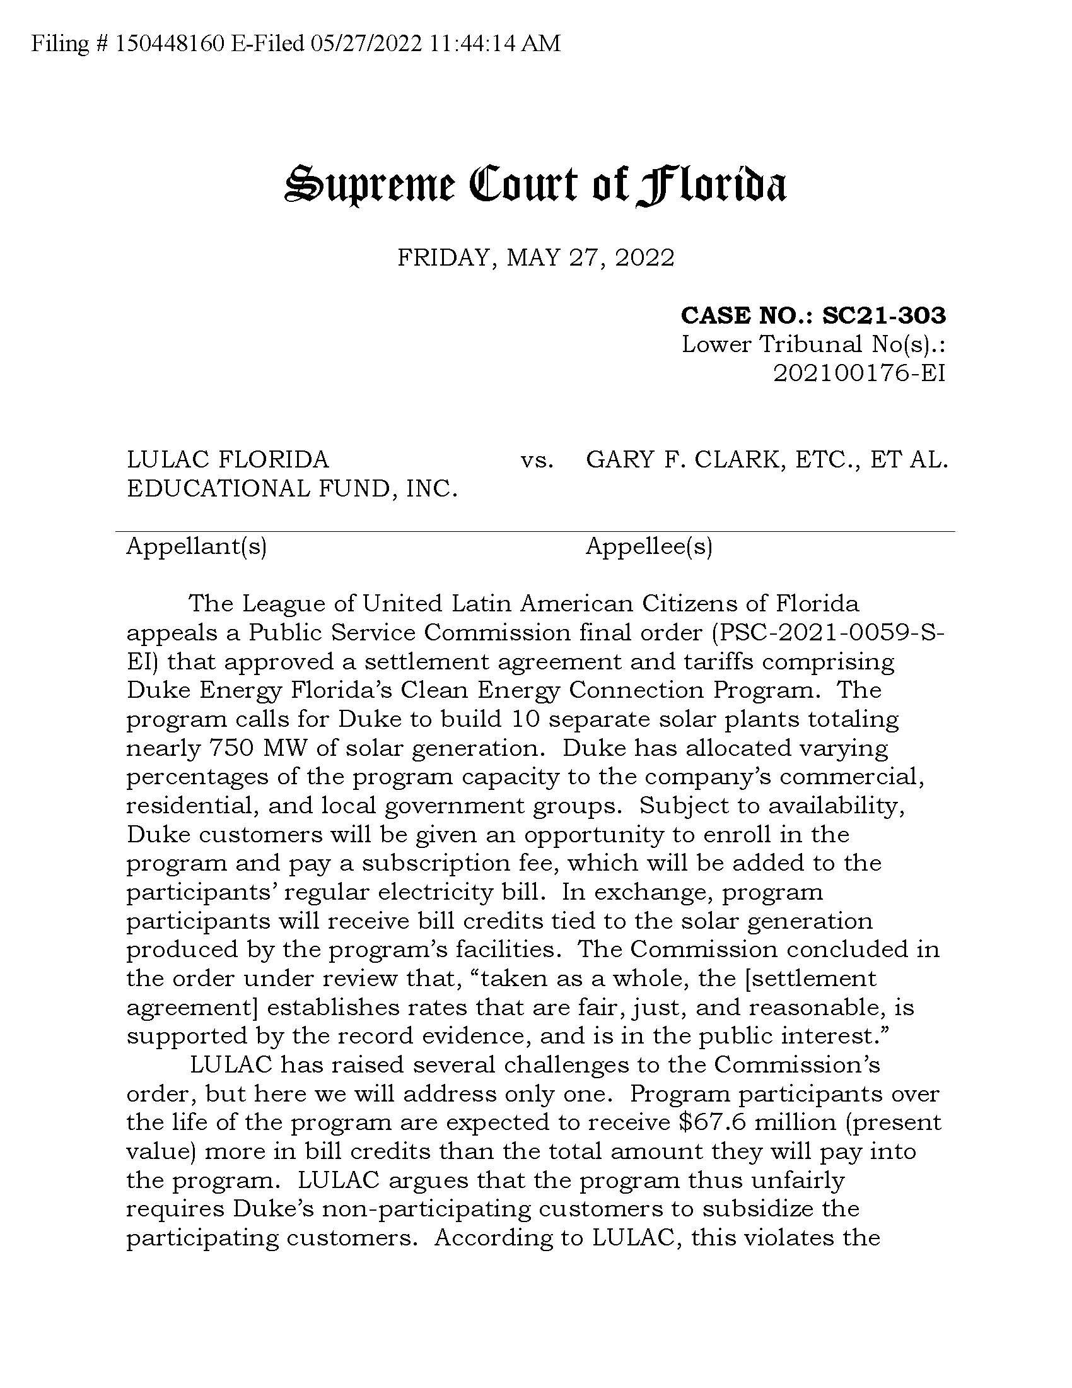

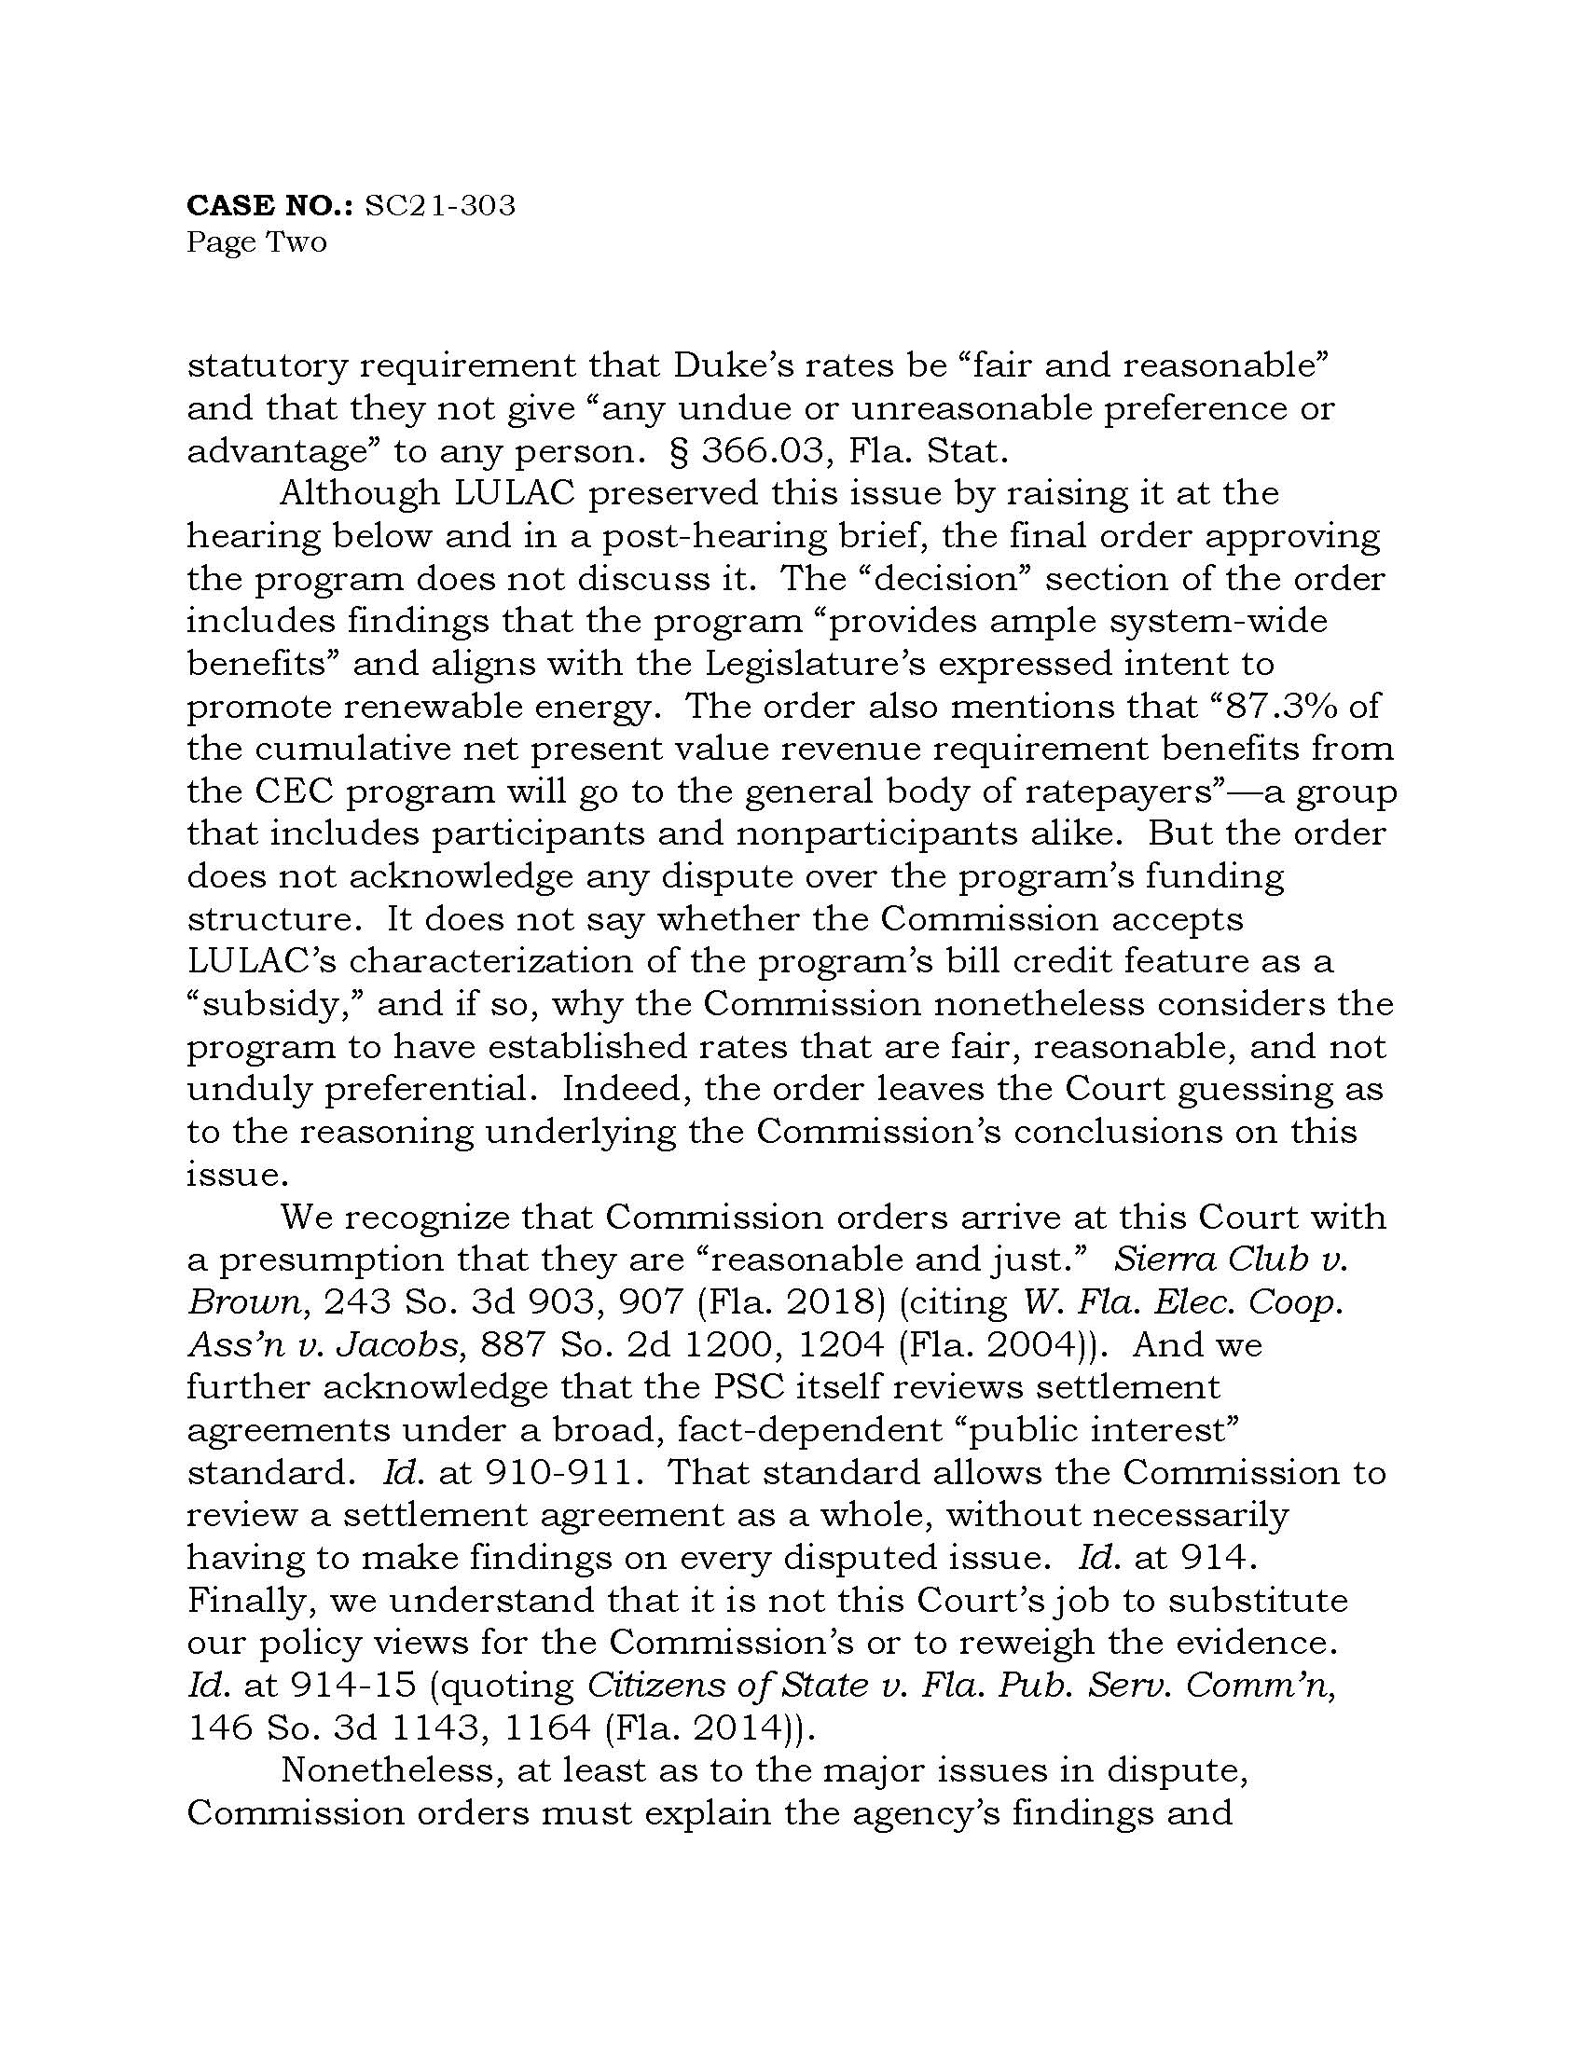

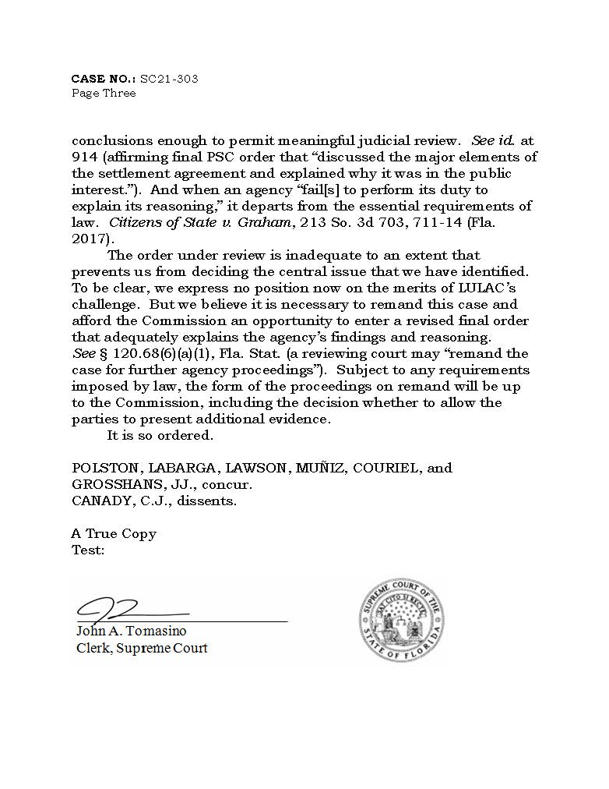

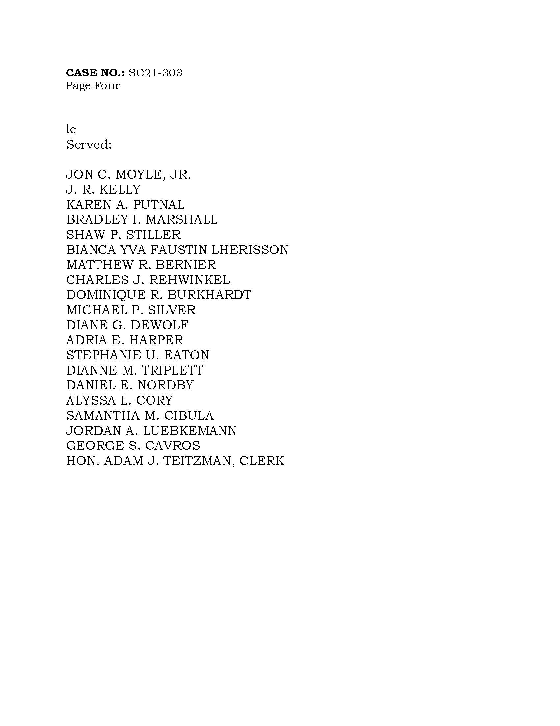

BEFORE THE FLORIDA PUBLIC SERVICE COMMISSION

|  |  |
| --- | --- |
| In re: Petition for a limited proceeding to approve clean energy connection program and tariff and stipulation, by Duke Energy Florida, LLC. | DOCKET NO. 20200176-EI  ORDER NO.  ISSUED: |

The following Commissioners participated in the disposition of this matter:

ANDREW GILES FAY, Chairman

ART GRAHAM

GARY F. CLARK

MIKE LA ROSA

GABRIELLA PASSIDOMO

APPEARANCES:

DIANNE M. TRIPLETT, ESQUIRE, 299 First Avenue North, St. Petersburg, Florida 33701 and MATTHEW R. BERNIER, ESQUIRE, 106 E. College Avenue, Suite 800, Tallahassee, Florida 32301

On behalf of Duke Energy Florida, LLC (Duke or Company).

RICHARD GENTRY and CHARLES REHWINKEL, ESQUIRES, 111 West Madison Street, Room 812, Tallahassee, Florida 32399-1400

On behalf of Office of Public Counsel (OPC).

Bradley Marshall and Jordan Luebkemann, ESQUIRES, 111 S. Martin Luther King Jr. Blvd., Tallahassee, Florida 32301 and Dominique Burkhardt, ESQUIRE, 4500 Biscayne Blvd., Ste. 201, Miami, Florida 33137

On behalf of League of United Latin American Citizens of Florida, a/k/a

LULAC Florida Educational Fund, Inc. (LULAC).

STEPHANIE U. EATON, ESQUIRE, 110 Oakwood Drive, Suite 500, Winston-Salem, North Carolina 27103 and DERRICK PRICE WILLIAMSON and BARRY A. NAUM, ESQUIRES, 1100 Bent Creek Boulevard, Suite 101, Mechanicsburg, Pennsylvania 17050

On behalf of Walmart Inc. (Walmart).

GEORGE CAVROS, ESQUIRE, 120 E. Oakland Park Blvd., Suite 105, Oakland Park, Florida 33334

On behalf of Southern Alliance for Clean Energy (SACE).

Katie Chiles Ottenweller, 838 Barton Woods Road NE, Atlanta, Georgia 30307

On behalf of Vote Solar (Vote Solar).

JON C. MOYLE, JR. and KAREN PUTNAL, ESQUIRES, 118 North Gadsden Street, Tallahassee, Florida 32312

On behalf of Florida Industrial Power Users Group (FIPUG).

SHAW STILLER and JENNIFER CRAWFORD, ESQUIRES, Florida Public Service Commission, 2540 Shumard Oak Boulevard, Tallahassee, Florida 32399-0850

On behalf of the Florida Public Service Commission (Staff).

MARY ANNE HELTON, ESQUIRE, Senior Attorney, Florida Public Service Commission, 2540 Shumard Oak Boulevard, Tallahassee, Florida 32399-0850

Advisor to the Florida Public Service Commission.

KEITH C. HETRICK, ESQUIRE, General Counsel, Florida Public Service Commission, 2540 Shumard Oak Boulevard, Tallahassee, Florida 32399-0850

Florida Public Service Commission General Counsel

REVISED FINAL ORDER

BY THE COMMISSION:

Background

On January 26, 2021, we entered a Final Order Approving Stipulation in this docket.[3] The Order approved Duke Energy Florida, LLC’s (Duke) Clean Energy Connection (CEC) Program and associated tariffs as set forth in the stipulation. Duke’s CEC Program is a voluntary community solar program that allows participating customers to pay a subscription fee in exchange for receiving bill credits related to the solar generation produced by the CEC Program solar facilities. The League of United Latin American Citizens of Florida (LULAC) timely appealed that Final Order to the Florida Supreme Court. After full briefing and oral argument, the Court remanded this proceeding to us with the following guidance:

The [final] order under review is inadequate to an extent that prevents us from deciding the central issue that we have identified. To be clear, we express no position now on the merits of LULAC’s challenge. But we believe it is necessary

to remand this case and afford the Commission an opportunity to enter a revised final order that adequately explains the agency’s findings and reasoning. *See* § 120.68(6)(a)(1), Fla. Stat. (a reviewing court may “remand the case for further agency proceedings”). Subject to any requirements imposed by law, the form of the proceedings on remand will be up to the Commission, including the decision whether to allow the parties to present additional evidence.[4]

On June 8, 2022, Commission staff conducted an informal conference with the parties to obtain input regarding remand procedures. Staff has represented to us that the parties agreed that the record need not be re-opened and no further briefing was desired. After reviewing the existing record in light of the Court’s direction on remand, we agree and conclude that it is not necessary to open the record to take additional evidence or receive further written submissions from the parties. The existing record is sufficient for us to address the matters identified by the Court.

This Order contains additional findings, reasoning, and conclusions regarding the CEC program, tariff, and stipulation based on the existing record. All aspects of the original Final Order remain unchanged.

Supplemental Findings and Conclusions

The “central issue” raised by LULAC and for which the Court has requested additional findings and conclusions is whether the funding structure results in a subsidy to the participants in violation of Section 366.03, Florida Statutes (F.S.). The Court identified the following specific aspects of this issue for us to address on remand:

[1] whether the Commission accepts LULAC’s characterization of the program’s bill credit feature as a ‘subsidy,’ and if so, [2] why the Commission nonetheless considers the program to have established rates that are fair, reasonable, and not unduly preferential.

After a brief discussion of the facets of the CEC program most relevant to this Revised Order, we will specifically address and answer these questions.

The Subscription Fee and Bill Credits

As characterized by LULAC, the “subsidy” at issue on remand is the positive difference between the subscription fees paid by participants and the bill credits they are projected to receive over the life of the program, which amounts to $67.6 million in present value. In other words, it is the bill credits of $67.6 million received by subscription fee paying participants, and paid by the general body of ratepayers, which LULAC characterizes as a subsidy.

The total amount to be paid by program participants in subscription fees was calculated as 104.9% of the fixed revenue requirement associated with constructing and operating the

program’s solar power plants, net of avoided generation and transmission capital, fixed costs, and gas reservation charges. This total paid by participants over the life of the program is projected to be $833.4 million, which exceeds the fixed revenue requirement by $39.2 million. This excess inures to the benefit of the general body of ratepayers, as the electricity generated by the program’s solar power plants will be used to provide service to all customers.

The bill credit was calculated to ensure payback to each participant of the subscription fee at year seven. This timeframe is consistent with SolarTogether, an existing Florida Power & Light Company solar program we approved several years ago.[5] Applying general principles from SolarTogether and other community solar programs, Duke then calculated a flat amount per kWh to be allocated as a bill credit, with that amount increasing 1.5% annually beginning in year four (first year of full production from all ten solar plants), such that participants hit a break-even point of fees and credits at year five and achieve full payback at year seven.

Importantly, a non-low-income participant will receive bill credits that exceed the subscription fee only after five years of continuous enrollment, and will realize full payback only after seven years of continuous enrollment. A customer who exits the program would start again at the year one credit level if they chose to rejoin.

The estimated net benefit value of the program’s solar power plants to Duke’s system is substantial. This value consists of avoided or deferred capacity, and reduced fuel consumption,[6] purchased power, variable operating and maintenance, and conventional pollutant and carbon emission costs. Duke calculated the total net benefit value of the CEC program as $532.7 million cumulative present value revenue requirement (CPVRR).

The net amount of bill credits over subscription fees represents 12.7% of this economic value. The remainder of the total economic value (87.3%) will inure to the benefit of the general body of ratepayers. All of the electricity from the ten solar plants will be on the grid that serves the general body of ratepayers. The CEC program will result in the construction of 749 megawatts (MW) of clean energy that is expected to serve all of Duke’s customers for at least thirty years. We previously found and here affirm that this program is in the public interest.

The CEC program bill credits are not properly characterized as a “subsidy”

The term “subsidy” is not defined in Chapter 366, F.S., or its implementing rules. LULAC did not argue in this proceeding that we apply a specific definition of that term, and referred to the bill credits interchangeably in written submissions as a “subsidy” and a “cross-subsidy.” Those terms are labels affixed by LULAC as part of its argument that the CEC program’s funding structure violates Section 366.03, F.S. As set forth below, use of the terms “subsidy” or “cross-subsidy” or characterizing bill credits as such are not dispositive of whether the rates are lawful.

Turning to LULAC’s specific allegations on this record and this Court’s first question, we do not accept LULAC’s characterization of the program’s bill credit feature as a “subsidy” because the bill credits do not neatly fit the mold of “subsidy.”[7] The recipients of the bill credits are not receiving a credit to construct solar facilities, which is the goal of the CEC program. In fact, the very purpose of the program is to provide a participation opportunity for those who desire to support solar energy development but do not have the capability, physical space, or desire to construct on-site solar. Additionally, those who choose to participate are not the sole users or beneficiaries of the electricity the solar plants will generate. Importantly, for the first five years of their subscription, most participants will pay more cumulatively in subscription fees than they receive in return, which is the antithesis of a subsidy.

However, as we note below, these utility-scale solar plants would not be constructed on the proposed timeline were it not for the CEC program, and the customers would not be incentivized economically to participate in the program but for the bill credits. Over the life of the program, participants who remain continuously subscribed for more than five years will receive a greater benefit as compared to non-participants, and thus the bill credits do result in some degree of different treatment of participants and non-participants by Duke, no matter the label assigned. However, the mere existence of disparate treatment of participants and nonparticipants (whether or not labeled or characterized as a subsidy) is not itself dispositive of the lawfulness of the program. As previously noted, Chapter 366, Florida Statutes, does not mention, define, or even prohibit a “subsidy.”[8] What Section 366.03, F.S. expressly prohibits is “undue preference or advantage.” Thus, whether or not we accept LULAC’s characterization of the bill credit as a subsidy, the only question we ultimately must answer is the second question the Court remanded: Do the bill credits result in rates that are just, reasonable, fair, and not unduly preferential?

The bill credits do not create an undue preference and the resulting rates are fair, reasonable, and just

Section 366.03, F.S., provides, in pertinent part: “No public utility shall make or give any undue or unreasonable preference or advantage to any person or locality, or subject the same to any undue or unreasonable prejudice or disadvantage in any respect.”[9] The CEC program, with the bill credit feature, does not create an undue preference or rates that are unfair, unreasonable, or unjust.

We first note that the CEC program does not provide an undue preference to any existing class of customers. The program is required to have diverse participants across numerous customer classes, including commercial and industrial (65%), and residential, small business, and local government (35%). These groups have differing service, load, and cost characteristics.

Accordingly, any feature of the program (such as bill credits) that impacts participants differently than non-participants impacts a diverse group of ratepayers, not one class.[10] The existence of one current[11] customer – whether Walmart or some other entity – with a substantially larger allocation than the other commercial customers does not dilute this class diversity. Notably, twenty-two of the thirty customers who are currently signed on as participants are local governments, healthcare organizations, and schools.

There is a rational basis to treat participants differently. Early subscribers to the program who have steady, relatively high electricity use are referred to by Duke as “anchor customers.” Due to these initial participants and their substantial subscription fees, a large amount of solar not previously contemplated is not only being constructed, but is on an accelerated schedule. The entire 749 MW – 10 solar plants sized at 74.9 MW each – is projected to be in service by the end of 2024. In the 2024/2025 timeframe when all ten are projected to be operational, the CEC solar plants should produce approximately 4% of Duke’s net energy for load.

Of significant importance in our analysis of the CEC program is that the benefits that are created by the 749 MW of new generation are realized by the entire body of ratepayers. By virtue of Duke constructing 749 MW of solar instead of relying on traditional fossil fuel generation to meet future energy needs, all customers will experience savings from avoided or deferred generation, reduced fuel costs, lower operating and maintenance costs, and projected emissions cost savings from reductions in carbon dioxide. Over the life of the program, operation of the 10 solar facilities is projected to displace more than 51 MWh of fossil fired generation, decreasing annual average use of natural gas by 11 billion cubic feet and coal consumption by 7,000 tons.

The displaced generation is due, in part, to the deferral of several combustion turbines for multiple years over the thirty year planning period and the reduction in the total number of new turbines by one (for years 2026-2034). Duke is also committing to evaluate no later than in its 2023 Ten Year Site Plan the potential to defer or replace an additional planned combustion turbine unit with solar plus storage facilities. In addition to the direct benefits of reduced investment in fossil fired generation, the deferral of additional traditional generation provides necessary space for new and evolving technologies.

There is no record evidence that Duke had existing plans to add 749 MW of solar power before being approached by customers and subsequently proposing the CEC program. There is record evidence that Duke had existing solar at that time, is capable of developing more, and had plans for only limited expansion. The reasonable inference from these facts is that the CEC program accelerated the timing and amount of solar in Duke’s energy portfolio, and thereby brought expanded benefits to the general body of ratepayers on an expedited schedule.

Duke did not simply grant some benefit to the specific commercial customers who approached the utility. Duke broadened program participation by creating separate participant allocations for local governments and low-income residential customers. Duke further included provisions to ensure low-income participants would never pay more in a subscription fee than

they would receive in bill credits, thereby allowing persons who may not otherwise have the financial ability to participate in solar energy the opportunity to do so.

In sum, while we must generally ensure that one customer is not charged a greater or lesser amount than another customer with like services under the same or similar circumstances, we may allow different treatment among otherwise like customers if there is a reasonable basis to differentiate established in the record.[12] Based on the facts summarized above, we find that affording a modest preference to the various participants is appropriate and not undue.

There is no statutory or rule formula to determine whether a particular rate structure is unduly preferential.[13] The final determination of undue preference is a factual determination vested to the discretion of this Commission to make based on the record and the circumstances in any specific docket.[14] “This Court has consistently recognized the broad legislative grant of authority which [chapter 366] confer[s] and the considerable license the Commission enjoys as a result of this delegation.” *Citizens of State v. Pub. Serv. Comm’n*, , 425 So. 2d 534, 540 (Fla. 1982)*.* Our broad discretion in this docket is also being exercised in the context of a stipulation, to which the public interest test applies. Thus, we must ultimately examine the stipulation as a whole and weigh all of its various components – not solely the bill credit – to make that public interest determination.

The total amount of bill credits afforded the participants is a relatively small percentage of the total net benefits flowing from the CEC program.[15] This total is divided among a diverse group of participants. A portion of the bill credit is dedicated to ensuring that low-income residential customers never pay more in subscription fees than they receive in bill credits. Another portion of the total bill credit amount is distributed to participating local governments, healthcare organizations, and schools. The remaining bill credits are distributed to the various commercial customers. All of the remaining benefits flowing from the solar generation are realized by the entire body of ratepayers. Given this structure that allocates the overwhelming majority of benefits to the general body of ratepayers and divides the remainder among a range of participants, the bill credits do not create an undue preference, and the resulting rates are fair, just, and reasonable.[16]

Decision

Duke did not plan to construct 749 MW of new solar generation before being approached by existing customers about a new solar program. Using that request as a catalyst, Duke engaged in further outreach and ultimately created a program for diverse participation in utility-scale solar for the benefit of all customers. These overall benefits include fuel diversification and substantial new renewable energy, both of which further the stated intent of the Legislature.[17] When placed in this appropriate context, the benefit afforded the participants by one feature of Duke’s CEC program does not create an undue preference.

Having again carefully reviewed the entire record, we find that, taken as a whole, the Stipulation establishes rates that are fair, just, and reasonable, is supported by the record evidence, and is in the public interest, and we hereby approve it.

Based on the foregoing, it is

ORDERED by the Florida Public Service Commission that Order No. PSC-2021-0059-S-EI, issued January 26, 2021, in Docket No. 20200176-EI, *In re: Petition for a limited proceeding to approve clean energy connection program and tariff and stipulation, by Duke Energy Florida, LLC*, is affirmed in its entirety, and revised to the extent set forth above. It is further

ORDERED that the Clerk shall file a true and correct copy of this Revised Final Order with the Florida Supreme Court in Case No. SC21-303. It is further

ORDERED that this docket shall remain open pending resolution of the appeal by the Florida Supreme Court. Once the Court has disposed of the appeal, the docket shall be closed administratively.

By ORDER of the Florida Public Service Commission this            day of                               ,                     .

|  |  |
| --- | --- |
|  |  |
|  | ADAM J. TEITZMAN  Commission Clerk |

Florida Public Service Commission

2540 Shumard Oak Boulevard

Tallahassee, Florida 32399

(850) 413‑6770

www.floridapsc.com

Copies furnished: A copy of this document is provided to the parties of record at the time of issuance and, if applicable, interested persons.

SPS

1. Order No. PSC-2021-0059-S-EI, issued January 26, 2021, in Docket No. 20200176-EI, *In re: Petition for a limited proceeding to approve clean energy connection program and tariff and stipulation, by Duke Energy Florida, LLC.*
2. *LULAC Florida Educational Fund, Inc. v. Clark, et al.,* Case No. SC21-303, slip op. at 3 (May 27, 2022) (emphasis added).
3. Order No. PSC-2021-0059-S-EI, issued January 26, 2021, in Docket No. 20200176-EI, *In re: Petition for a limited proceeding to approve clean energy connection program and tariff and stipulation, by Duke Energy Florida, LLC.*
4. *LULAC Florida Educational Fund, Inc. v. Clark, et al.,* Case No. SC21-303, slip op. at 3 (May 27, 2022) (emphasis added).
5. Order PSC-2020-0084-S-EI, issued March 20, 2020, in Docket No. 20190061-EI, *In re: Petition by Florida Power & Light Company for Approval of FPL SolarTogether Program and Tariff*.
6. As Duke Witness Borsch noted in his rebuttal testimony, as fuel (natural gas and coal) prices rise, solar power provides increased savings.
7. Miriam-Webster defines subsidy as “a grant by a government to a private person or company to assist an enterprise deemed advantageous to the public.” https://www.merriam-webster.com/dictionary/subsidy.
8. “Subsidies, and, therefore, rate discrimination, are inherent in any rate design.” Order No. PSC-04-0417-PAA-EI, issued April 22, 2004, in Docket No. 031135-EI, *In re: Petition for approval to implement consolidated fuel adjustment surcharge by Florida Public Utilities Company.*
9. We may approve the stipulation in this docket under the public interest test only if it is consistent with this governing statute. *See* *Sierra Club v. Brown*, 243 So. 3d 903, 909 (Fla. 2018).
10. Under Section 366.03, Florida Statutes, we are to examine rates “for any possible discrimination or preference between the different classes of service.” *Re Tampa Elec. Co.*, 26 P.U.R.3d 158 (Oct. 22, 1958) (emphasis added).
11. Participants may exit the CEC program at any time.
12. *See Fla. Power Corp. v. Mayo*, 203 So. 2d 614, 615 (Fla. 1967) (utility must “sufficiently identif[y] and distinguish[] a class of consumers to preclude an effective attack based on discrimination or arbitrary preference”).
13. *See* Order No. PSC-15-0496-FOF-EI, issued October 23, 2015, in Docket No. 15085-EI, *In re: Complaint by Erika Alvarez, Jerry Buechler, & Richard C. Silvestri Against Fla. Power & Light Co.* (“No statute, Commission rule or Commission Order prescribes a particular format or manner in which FPL, or any other utility, is required to administer its solar rebate reservations. Moreover, our practice has been not to micromanage the business decisions of regulated companies, but to instead focus on the end-product goal.”).
14. *See* *Pennsylvania Co v. United States*, 236 U.S. 351, 361, 35 S. Ct. 370, 373 (1915) (“what is such undue or unreasonable preference or advantage is a question not of law, but of fact”).
15. *Cf.* *Sierra Club v. Brown,* 243 So. 3d 903, 918 (Fla. 2018) (public interest demonstration in rate case could be defeated by one investment only if it “was so large in comparison to the other, uncontested costs for which FPL sought recovery that the reasonableness of the agreed rate increase could not be determined without a prudence finding on [that] . . . issue”) (Lawson, J., concurring).
16. As a general comparison, the percentage of program benefits afforded the general body of ratepayers by Duke in the CEC program greatly exceeds the benefits Florida Power & Light Company assigned to its customers in SolarTogether (87.3% vs. 45%).
17. Section 366.92(1), F.S.