State of Florida |  | Public Service Commission  Capital Circle Office Center ● 2540 Shumard Oak Boulevard  Tallahassee, Florida 32399-0850  -M-E-M-O-R-A-N-D-U-M-
DATE: | September 22, 2022
TO: | Office of Commission Clerk (Teitzman)
FROM: | Division of Economics (Guffey)  Office of the General Counsel (Brownless)
RE: | Docket No. 20220123-GU – Petition for approval of transportation service agreement to reflect expansion of St. Cloud by Florida Public Utilities Company and Peninsula Pipeline Company, Inc.
AGENDA: | 10/04/22 – Regular Agenda – Proposed Agency Action – Interested Persons May Participate
COMMISSIONERS ASSIGNED: |  |  | All Commissioners
PREHEARING OFFICER: |  |  | La Rosa
CRITICAL DATES: |  |  | None
SPECIAL INSTRUCTIONS: |  |  | None

Case Background
On July 6, 2022, Peninsula Pipeline Company, Inc. (Peninsula) filed a petition seeking approval of a firm transportation service agreement (Agreement) between Peninsula and Florida Public Utilities Company (FPUC), collectively the parties. The purpose of the Agreement is to expand and reinforce the St. Cloud gas distribution system in Osceola County. On July 7, 2022, Peninsula filed an amended petition correcting the title of the petition. Peninsula operates as an intrastate natural gas transmission company as defined by Section 368.103(4), Florida Statutes (F.S.). FPUC is a local distribution company (LDC) subject to the regulatory jurisdiction of the Commission pursuant to Chapter 366, F.S.
By Order No. PSC-07-1012-TRF-GP, Peninsula received approval of an intrastate gas pipeline tariff that allows it to construct and operate intrastate pipeline facilities and to actively pursue agreements with natural gas customers. Peninsula provides gas transportation service only; it does not engage in the sale of natural gas. Pursuant to Order No. PSC-07-1012-TRF-GP, Peninsula is allowed to enter into certain gas transmission agreements without prior Commission approval. However, Peninsula is requesting Commission approval of this proposed Agreement as it does not fit any of the criteria enumerated in the tariff for which Commission approval would not be required. The parties are subsidiaries of Chesapeake Utility Corporation (Chesapeake), a Delaware corporation authorized to conduct business in Florida, and agreements between affiliated companies must be approved by the Commission pursuant to Section 368.105, F.S., and Order No. PSC-07-1012-TRF-GP.

Pursuant to the proposed Agreement and project map (Attachments A and B to this recommendation), Peninsula will construct, own, and operate a new natural gas pipeline, a new district regulator, and an additional interconnect with Florida Gas Transmission Company’s (FGT) system. Additionally, pursuant to the proposed Agreement, FPUC will construct a pipeline which will interconnect to Peninsula. The proposed project will enable FPUC to serve the Twin Lakes community and potential future gas customers in Osceola County. During the evaluation of the amended petition, staff issued a data request to the parties for which responses were received on August 5, 2022. The Commission has jurisdiction over this matter pursuant to Sections 366.05(1), 366.06, and 368.105, F.S.

Discussion of Issues

Issue 1:
Should the Commission approve the proposed firm transportation Agreement dated June 20, 2022 between FPUC and Peninsula?

Recommendation:
Yes, the Commission should approve the proposed firm transportation Agreement dated June 20, 2022 between FPUC and Peninsula. The proposed Agreement is reasonable and meets the requirements of Section 368.105, F.S. Furthermore, the proposed Agreement benefits FPUC’s current and potential future customers by having an additional source of gas for the growing areas in Osceola County. (Guffey)

Staff Analysis:

Proposed Transportation Service Agreement
FPUC provides natural gas service to residential, commercial, and industrial customers in Osceola County, and receives deliveries of natural gas to serve these customers over interstate transmission pipelines owned by Florida Gas Transmission (FGT).
The parties have entered into the proposed firm transportation Agreement to enable FPUC to reinforce its St. Cloud distribution system and meet increased natural gas demand in Osceola County. The proposed Agreement has the added benefit of providing FPUC with an additional source of gas (via the Peninsula intrastate pipeline) and enhancing an existing interconnection with the FGT pipeline.
The proposed Agreement specifies an initial term of 20 years and thereafter shall be extended on a year-to-year basis, unless either party gives no less than 90 days of written notification of termination. If either party desires to negotiate modifications to the rates or terms of this Agreement, they may do so no less than 120 days prior to expiration of the current active term. The proposed St. Cloud expansion project is discussed below and the project map is Attachment B to this recommendation.

Proposed St. Cloud Expansion Project
Attachment B shows the proposed St. Cloud gas distribution expansion project. As shown by the blue line, starting at an existing city gate interconnection with FGT on Missouri Avenue in Osceola County, Peninsula will construct 23,232 feet (4.4 miles) of 4-inch steel pipeline traveling south along Missouri Avenue, west along Fertic Road, then south along Canoe Creek Road up to the Nolte Road intersection.
From the Canoe Creek Road and Nolte Road intersection, Peninsula will continue the steel pipeline east along Nolte Road and conclude at the district regulator station at the intersection of Nolte Road and Hickory Tree Road, also shown by the blue line.
Finally, indicated by a red line, from the Nolte Road and Hickory Tree Road intersection, FPUC will construct 1,320 feet of 6-inch medium-density polyethylene plastic pipeline along Hickory Tree Road providing a connection to an existing gas main. The parties assert that the selected route of the St. Cloud expansion project provides the largest benefit to the area, to FPUC, and its customers.

Anticipated System benefits
The parties assert that the proposed project will enable FPUC to serve the Twin Lakes community, a large residential development projected to have 1,400 dwelling units when fully built out. Other commercial customers, along Peninsula’s portion of the project, are expected to be served as well. The petition also states that FPUC will be positioned to serve other developments to be built in and around St. Cloud in Osceola County. The parties assert that construction of the pipeline is necessary because the existing infrastructure is not adequate to serve the Twin Lakes community when it is expected to be fully built out by 2029. Additionally, FPUC is currently negotiating with the developer of Center Lake Ranch, which at built out is expected to have a total of 2,054 dwelling units (in two development phases) and some commercial development. The parties assert that the proposed project will reinforce FPUC’s St. Cloud distribution system with an additional source of interstate gas with the potential to provide natural gas service to future customers in Osceola County.
In response to staff’s data request, the parties stated that FPUC did not obtain formal Request for Proposals (RFP) responses from other entities. FPUC explained that in previous discussions and requests with FGT for other projects, FGT has declined to bid on projects related to construction, owning, and operating laterals such as the proposed expansion project in this petition, which are not a focus of FGT’s expansion activities.

Negotiated Monthly Reservation Payments to Peninsula
The parties assert that the negotiated monthly reservation charge contained in the proposed agreement is consistent with market rates, because the rates are substantially the same as rates set forth in similar agreements as required by Section 368.105(3)(b), F.S. The parties assert that Peninsula will recover the pipeline and district regulator construction costs through the monthly reservation charge to FPUC as shown in Exhibit A to the proposed Agreement. The monthly reservation charge is designed to recover costs such as, but not limited to, engineering, permitting, materials, and installation costs associated with pipeline and related facilities, ongoing maintenance including Pipeline and Hazardous Materials Safety Administration (PHMSA) compliance, safety requirements, property taxes, gas control, and Peninsula’s return on investment.
FPUC is proposing to recover its payments to Peninsula through Purchased Gas Adjustment (PGA) and swing service rider mechanisms. The PGA allows FPUC to periodically adjust the price of natural gas supplied to its customers to reflect the actual cost of gas purchased and delivered on behalf of the customers. The swing service rider allows FPUC to recover intrastate capacity costs from their transportation customers and is a cents per therm charge that is included in the monthly customer gas bill of transportation customers. While FPUC will incur costs associated with this service expansion, new load added to the system will help spread the costs over a larger customer base.

Conclusion
Based on the petition and the parties’ responses to staff’s data request, staff believes that the proposed Agreement is reasonable and meets requirements of Section 368.105, F.S. Furthermore, the proposed Agreement benefits FPUC’s current and potential future customers by having an additional source of gas for the growing areas in Osceola County. Staff therefore recommends approval of the proposed Agreement between Peninsula and FPUC dated June 20, 2022.

Issue 2:
Should this docket be closed?

Recommendation:
Yes. If no protest is filed by a person whose substantial interest are affected within 21 days of the issuance of the Order, this docket should be closed upon the issuance of a Consummating Order. (Brownless)

Staff Analysis:
If no protest is filed by a person whose substantial interest are affected within 21 days of the issuance of the Order, this docket should be closed upon the issuance of a Consummating Order.

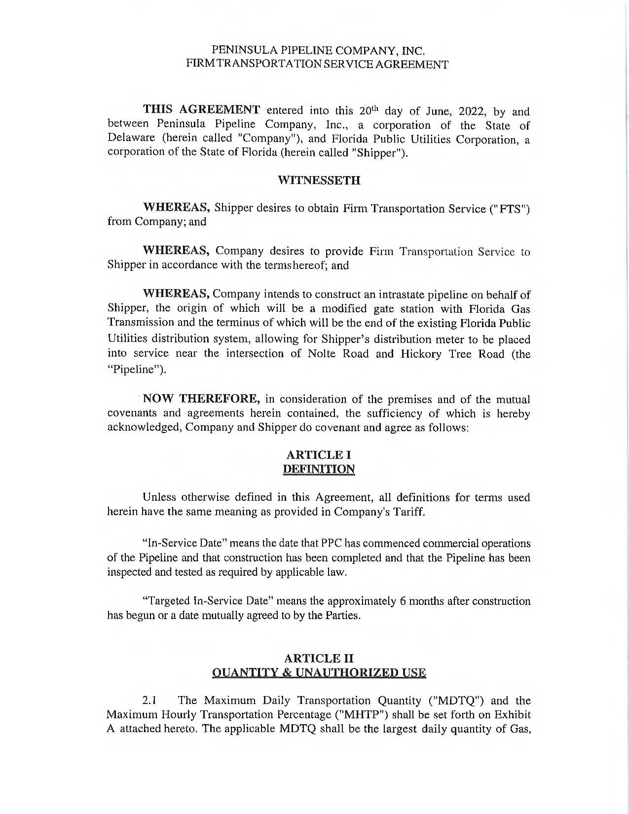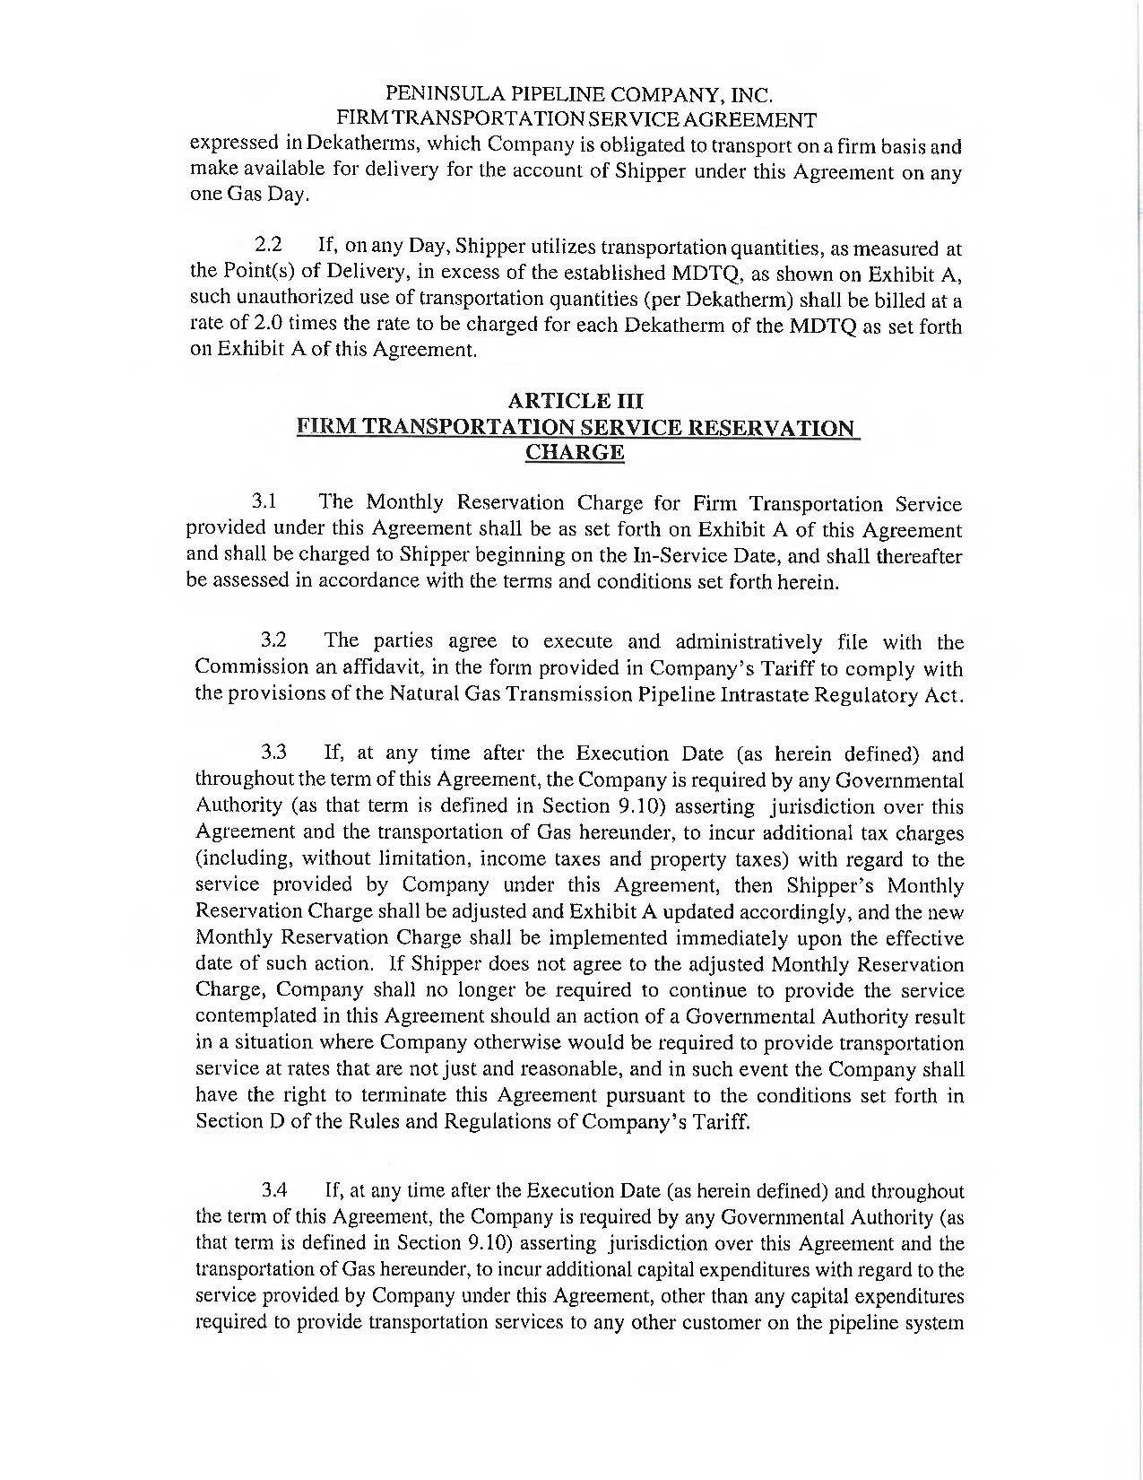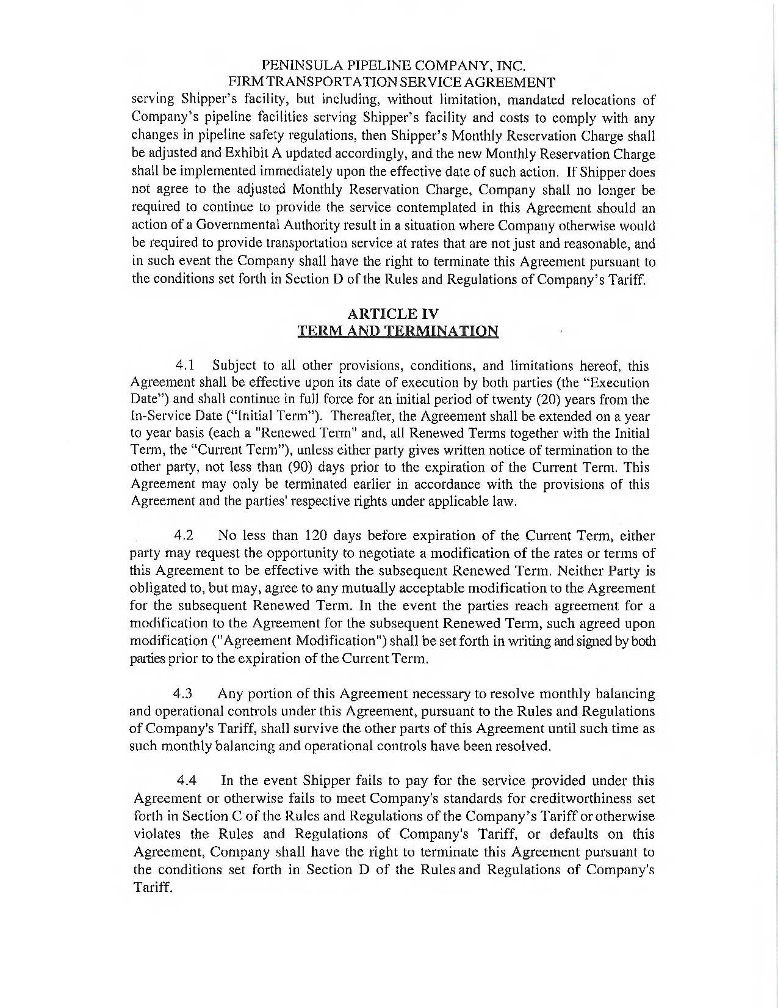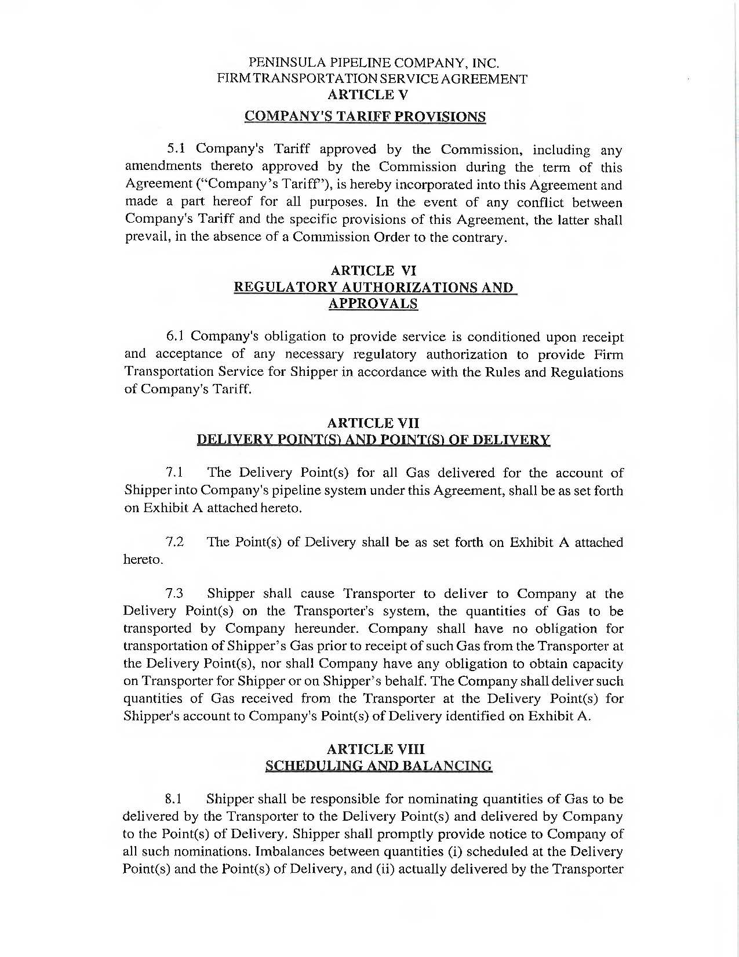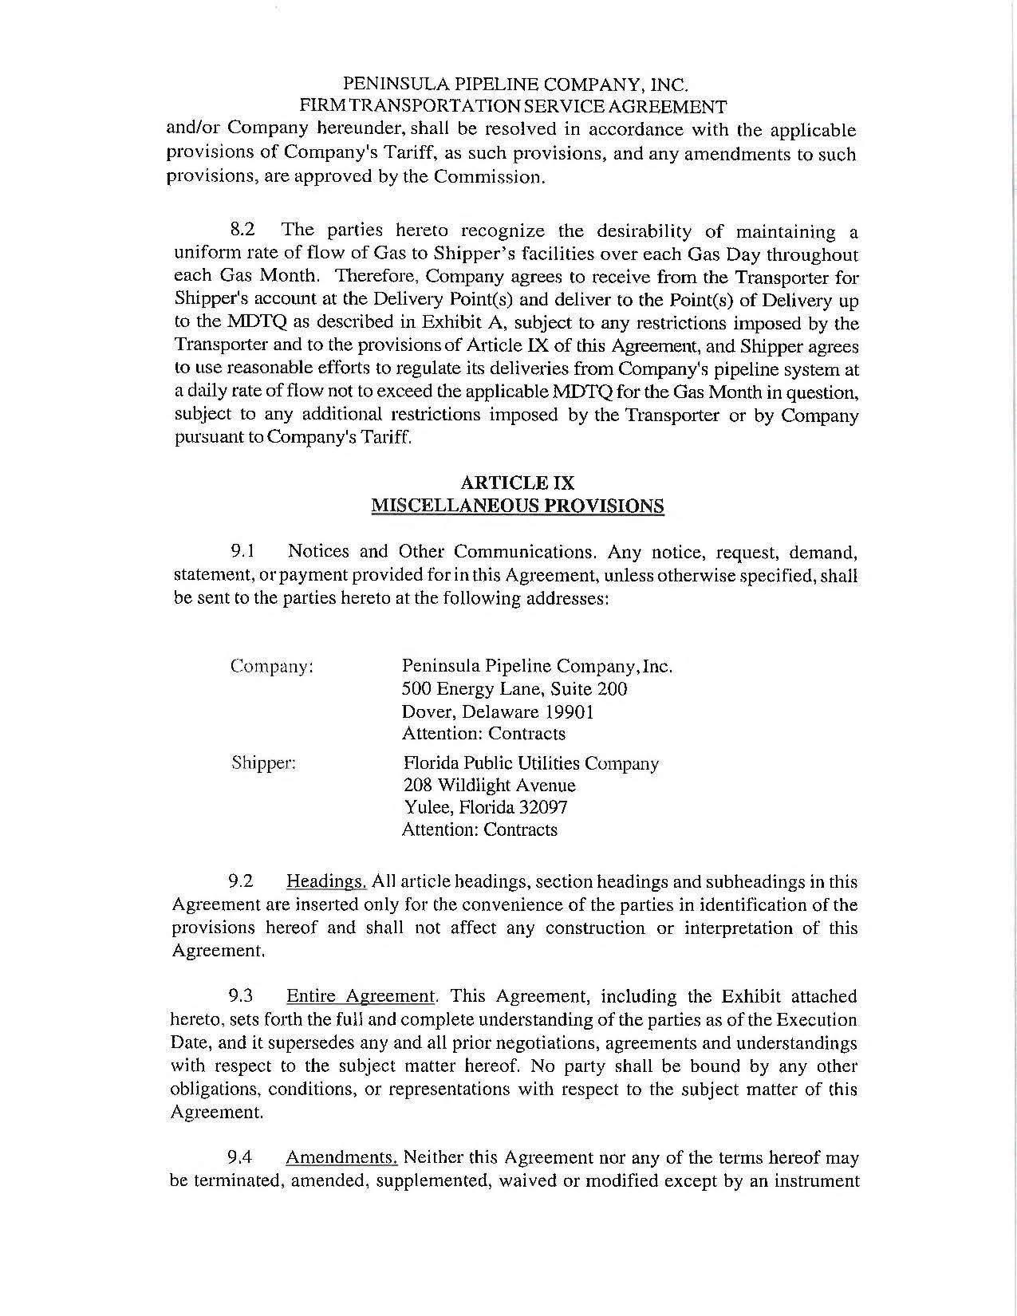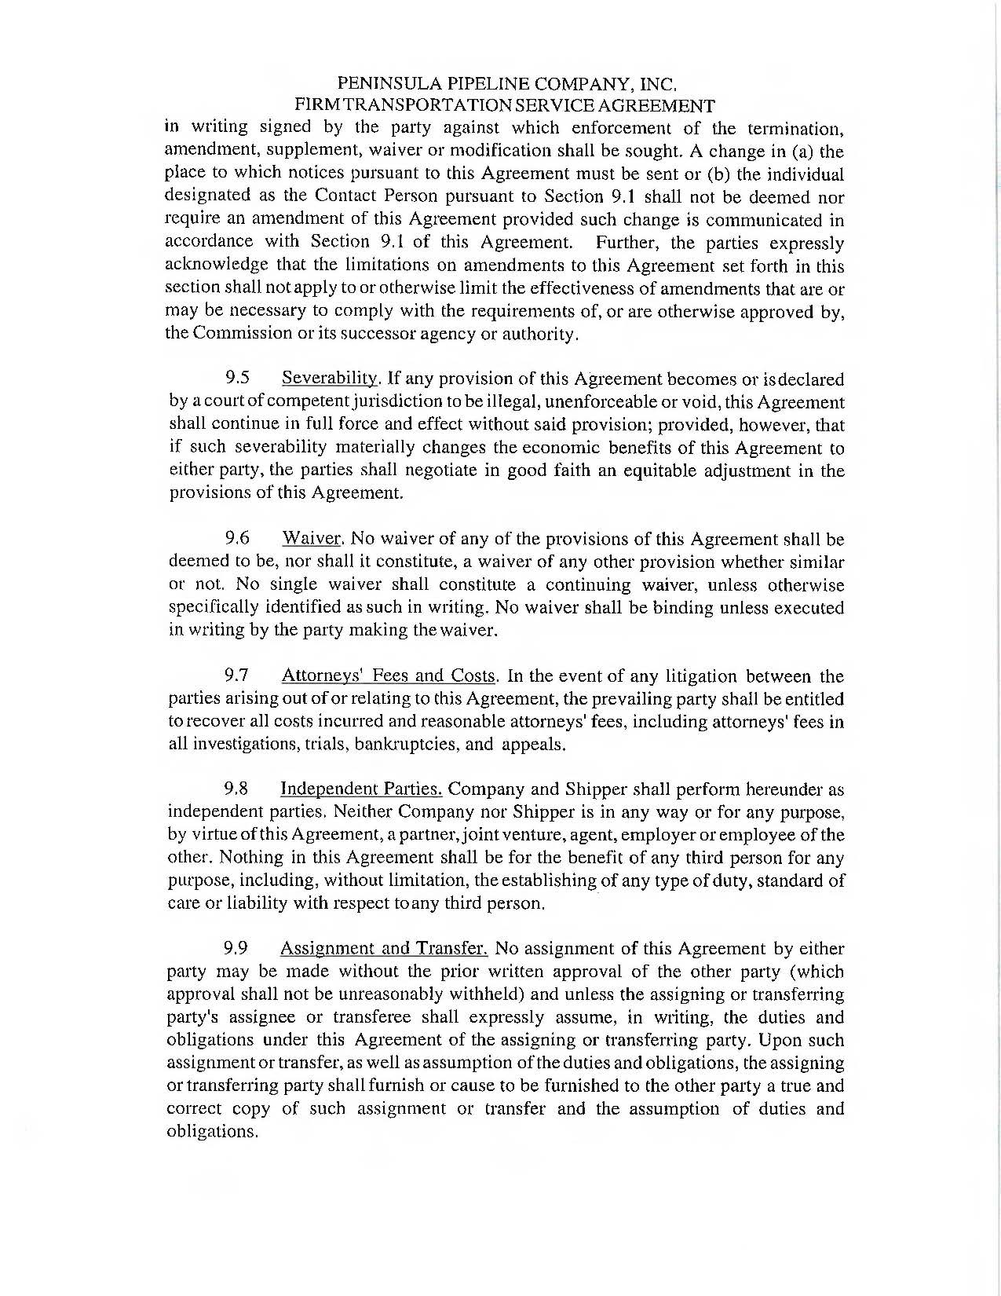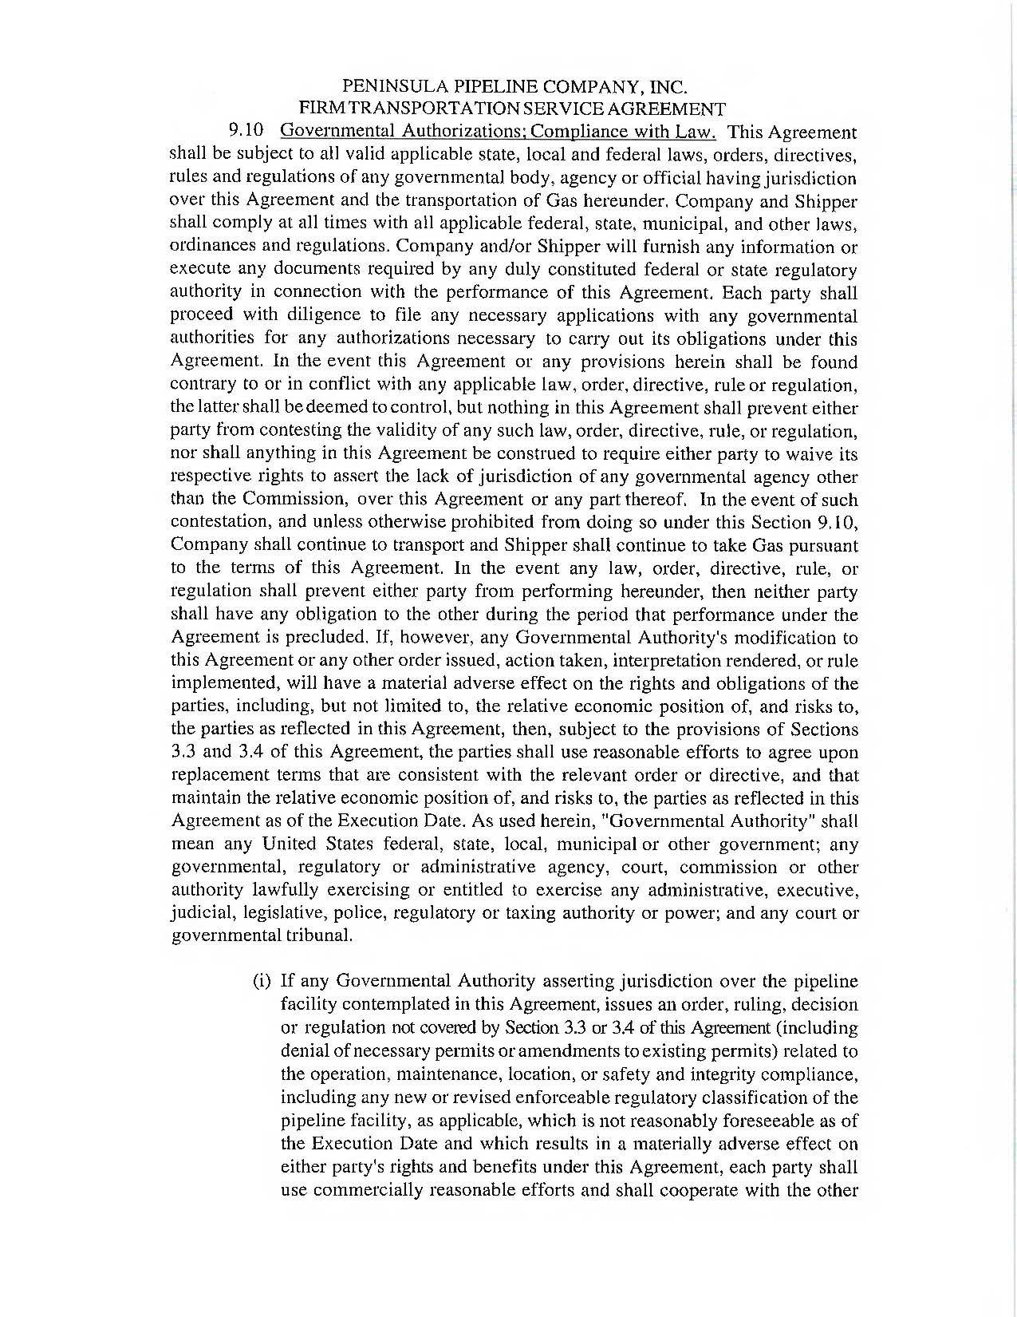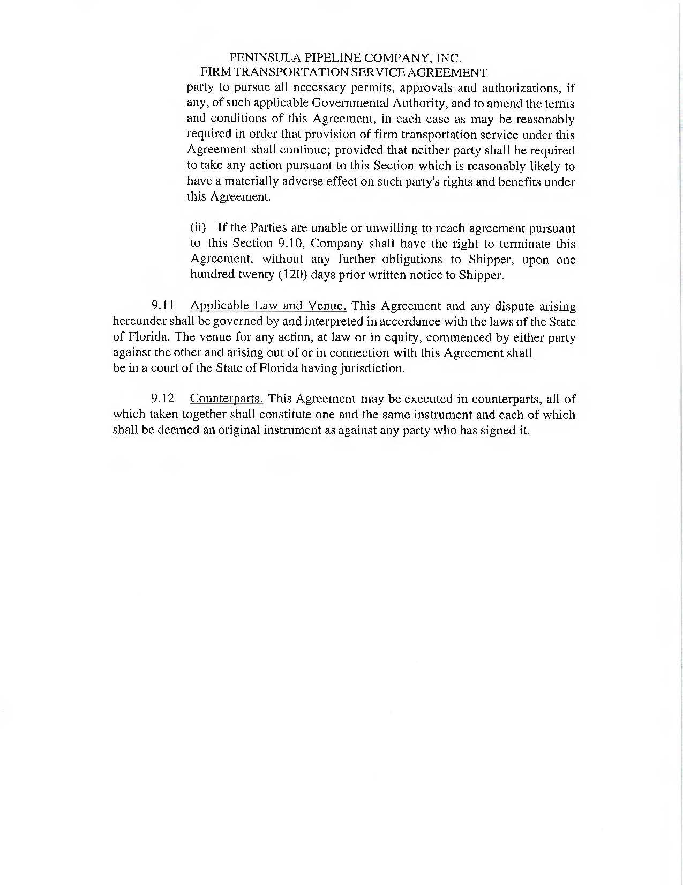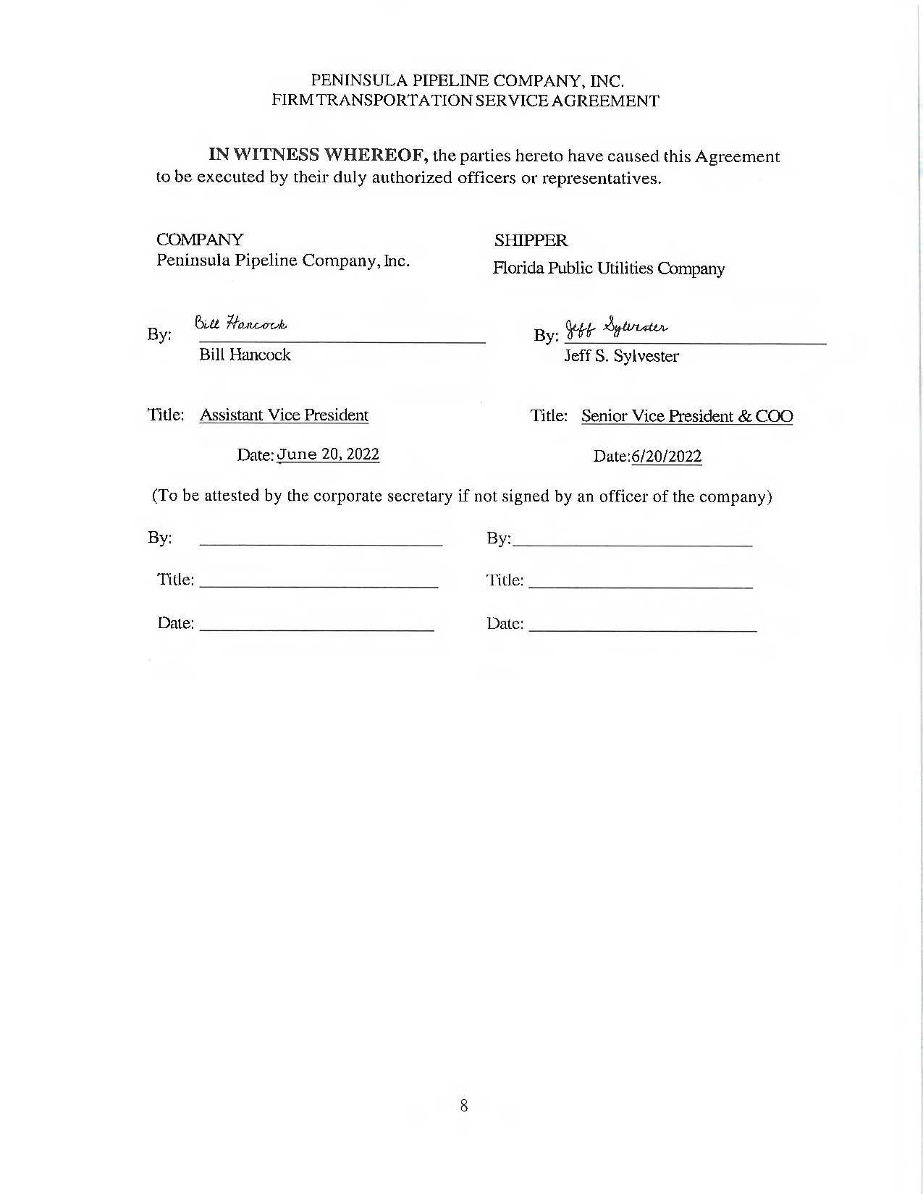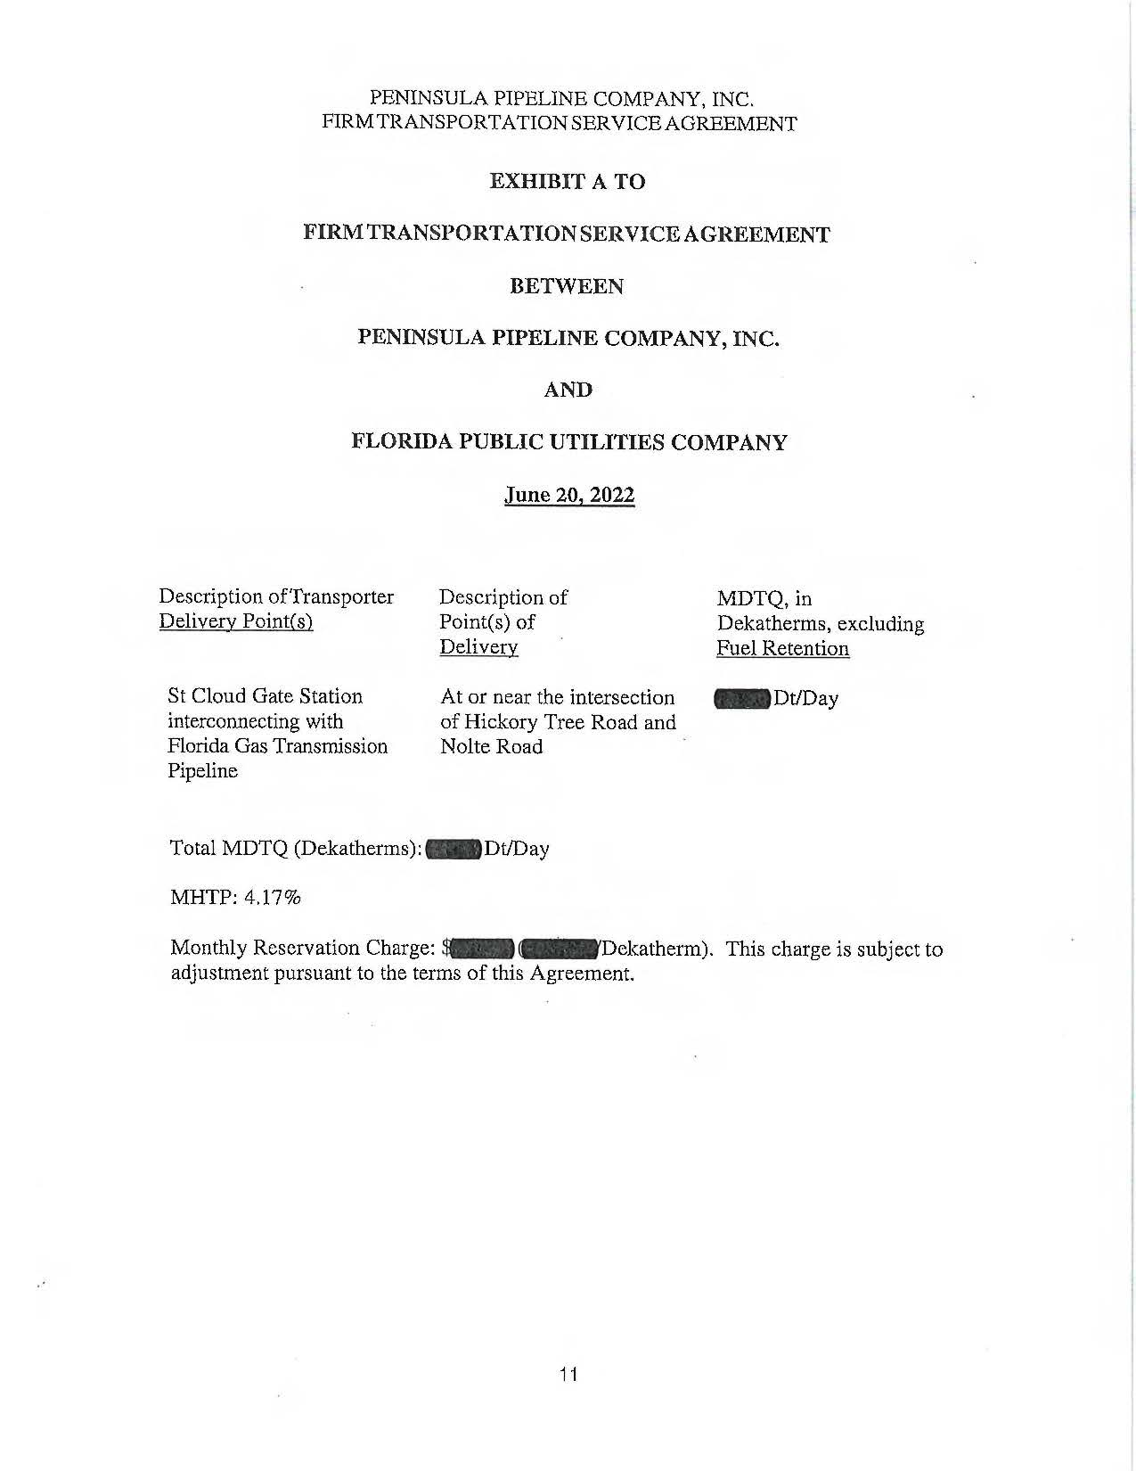
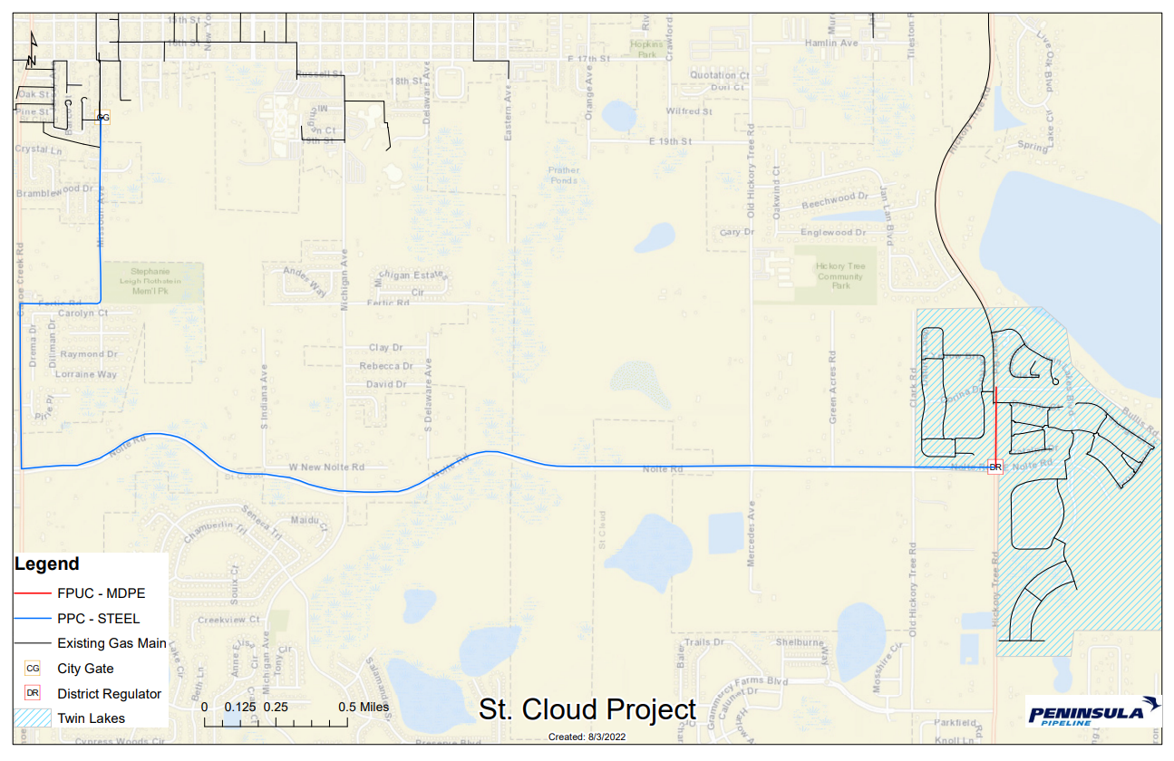

Order No. PSC-06-0023-DS-GP, issued January 9, 2006, in Docket No. 050584-GP, In re: Petition for declaratory statement by Peninsula Pipeline Company, Inc. concerning recognition as a natural gas transmission company under Section 368.101, F.S., et seq.
Order No. PSC-07-1012-TRF-GP, issued December 21, 2007, in Docket No. 070570-GP, In re: Petition for approval of natural gas transmission pipeline tariff by Peninsula Pipeline Company, Inc.
Peninsula Pipeline Company, Inc., Intrastate Pipeline Tariff, Original Vol. 1, Original Sheet No. 11, Section 3.
Peninsula Pipeline Company, Inc., Intrastate Pipeline Tariff, Original Vol. 1, Original Sheet No. 12, Section 4.
Response No. 3 in Staff’s First Data Request, Document No. 05281-2022.
Response No. 11 in Staff’s First Data Request, Document No. 05281-2022

