|  |  |  |  |
| --- | --- | --- | --- |
| State of Florida  pscSEAL | | Public Service Commission  Capital Circle Office Center ● 2540 Shumard Oak Boulevard Tallahassee, Florida 32399-0850  -M-E-M-O-R-A-N-D-U-M- | |
| DATE: | October 20, 2022 | | |
| TO: | Office of Commission Clerk (Teitzman) | | |
| FROM: | Division of Economics (Ward, Draper)  Office of the General Counsel (Watrous, Crawford) | | |
| RE: | Docket No. 20220152-GU – Petition for approval of 2021 true-up, projected 2022 true-up, and 2023 revenue requirements and surcharges associated with cast iron/bare steel pipe replacement rider, by Peoples Gas System. | | |
| AGENDA: | 11/01/22 – Regular Agenda – Tariff Filing – Interested Persons May Participate | | |
| COMMISSIONERS ASSIGNED: | | | All Commissioners |
| PREHEARING OFFICER: | | | Administrative |
| CRITICAL DATES: | | | 5/1/23 (8-Month Effective Date) |
| SPECIAL INSTRUCTIONS: | | | None |

Case Background

On September 1, 2022, Peoples Gas System (Peoples or utility) filed a petition for approval of its final 2021 true-up, projected 2022 true-up, and 2023 revenue requirement and surcharges associated with the cast iron/bare steel replacement rider (CI/BSR Rider or rider). The rider was originally approved in Order No. PSC-12-0476-TRF-GU (2012 order) to recover the cost of accelerating the replacement of cast iron and bare steel pipes through a surcharge on customers' bills.[1] In the 2012 order, the Commission found that "replacement of these types of pipelines is in the public interest to improve the safety of Florida's natural gas infrastructure, and reduce the possibility of loss of life and destruction of property should an incident occur." Peoples' current surcharges were approved in Order No. PSC-2021-0429-TRF-GU (2021 order).[2]

In Order No. PSC-17-0066-AS-GU, the Commission approved a comprehensive settlement agreement between PGS and the Office of Public Counsel (OPC).[3] The settlement agreement, in part, added problematic plastic pipe (PPP) installed in the company's distribution system to eligible replacements under the rider. PPP was manufactured before 1983 and has significant safety concerns. In certain areas, the PPP is interspersed with, or connected to, the cast iron/bare steel pipe that is being replaced under the rider. As provided for in the settlement agreement, PPP replacements are included in the calculation of the 2023 rider surcharges.

In Order No. PSC-2022-0134-PAA-GU, the Commission granted Peoples’ petition to address the impact of changes to Florida state income tax rates.[4] Specifically, the Commission allowed Peoples to increase the 2023 rider surcharges by $253,079 to reflect the impact of the change in Florida income tax rates in 2021 and 2022.

On September 14, 2022, Peoples waived the 60-day file-and-suspend provision of Section 366.06(3), Florida Statutes (F.S.), by email. During the evaluation of the petition, staff issued a data request, for which responses were received on October 17, 2022. Attachment B contains the proposed tariff. The Commission has jurisdiction over this matter pursuant to Sections 366.03, 366.04, 366.05, and 366.06, F.S.

Discussion of Issues

Issue :

 Should the Commission approve Peoples’ proposed CI/BSR Rider surcharges for the period January through December 2023?

Recommendation:

 Yes, the Commission should approve Peoples’ proposed CI/BSR Rider surcharges for the period January through December 2023. (Ward)

Staff Analysis:

 The CI/BSR Rider charges have been in effect since January 2013 and were projected to be in effect for 10 years with replacement projects completed by the end of 2022. In response to staff’s first data request, Peoples stated that they need an additional year to complete the cast iron/bare steel replacements due to complications related to the COVID-19 pandemic. Peoples expects to have 3.4 miles of cast iron/bare steel replacements remaining in 2023.

Rider PPP charges have been in effect since 2017. In 2022, Peoples’ cast iron/bare steel replacement activity focused in the areas of Miami, Tampa, St. Petersburg, Orlando, Eustis, Jacksonville, Lakeland, Daytona, Avon Park, and Ocala. In 2023, Peoples states it will focus on replacement projects in Miami, Tampa, St. Petersburg, Orlando, Eustis, Jacksonville, Lakeland, Daytona, Avon Park, Jupiter, and Ocala. The replacement of PPP is expected to continue until 2028.

Attachment A to this recommendation contains tables which display the replacement progress and forecasts for CI/BSR Rider (Table 2) and for PPP (Table 3). Additionally, Peoples provided Table 1 which consolidates actual and projected CI/BSR and PPP miles replaced investment and revenue requirements for each year of the replacement program.

True-ups by Year

Peoples' calculation for the 2023 revenue requirement and surcharges includes a final true-up for 2021, an actual/estimated true-up for 2022, and projected costs for 2023. Pursuant to the 2012 order, the capital expenditures for 2017 through 2019 exclude the first $1 million of facility replacements each year because that amount is included in rate base. Peoples has included depreciation expense savings as discussed in the 2012 order; however, the utility has not identified any operations and maintenance savings.

Final True-up for 2021

Exhibit A of the petition shows that the revenues collected for 2020 were $5,206,120 compared to a revenue requirement of $1,186,869, resulting in an over-recovery of $4,019,251. The final 2020 under-recovery of $4,581,212, 2021 over-recovery of $4,019,251, and interest associated with any over- and under-recoveries, results in a final 2021 under-recovery of $563,794.

Actual/Estimated 2022 True-up

In Exhibit B of the petition, Peoples provided actual revenues for January through July and forecast revenues for August through December of 2022, totaling $5,190,196, compared to an actual/estimated revenue requirement of $5,092,683, resulting in an over-recovery of $97,513. The final 2021 under-recovery of $563,794, 2022 over-recovery of $97,513, state tax rate change recovery adjustment of $253,079, and interest associated with any over- and under-recoveries, results in a total 2022 under-recovery of $721,168.

Projected 2023 Costs

Exhibit C of the petition shows Peoples projects investment or capital expenditures of $24,817,804 for the replacement of cast iron/bare steel infrastructure and PPP in 2023. As shown in Table 1 of Attachment A of the recommendation, this consists of the CI/BSR infrastructure investment of $4,733,434 and the PPP investment of $20,084,370. The return on investment (which includes federal income taxes, regulatory assessment fees, and bad debt), depreciation expense (less savings), and property tax expense associated with that investment are $8,033,927. After adding the total 2022 under-recovery of $721,168, the total 2023 revenue requirement is $8,755,095. Table 1-1 displays the 2023 revenue requirement calculation.

Table -1

2023 Revenue Requirement

|  |  |
| --- | --- |
| 2023 Projected Expenditures | $24,817,804 |
| Return on Investment | $5,941,404 |
| Depreciation Expense (less savings) | $1,034,085 |
| Property Tax Expense | $1,058,439 |
| 2023 Revenue Requirement | $8,033,927 |
| Plus 2022 Under-recovery | $721,168 |
| Total 2023 Revenue Requirement | $8,755,095 |

Source: Page 1 of 2 in Exhibit C in petition (Docket No. 20220152-GU)

Proposed Surcharges

As established in the 2012 order, the total 2023 revenue requirement is allocated to rate classes using the same methodology that was used for the allocation of mains and services in the cost of service study used in Peoples' most recent rate case. After calculating the percentage of total plant costs attributed to each rate class, the respective percentages were multiplied by the 2023 revenue requirement resulting in the revenue requirement by rate class. Dividing each rate class's revenue requirement by projected therm sales provides the rider surcharge for each rate class.

If the Commission approves this recommendation, the proposed 2023 rider surcharge for residential customers is $0.03111 per therm (compared to the current surcharge of $0.02014). The 2023 monthly bill impact will be $0.62 for a residential customer who uses 20 therms. The proposed tariff page provided in the petition is Attachment B to this recommendation.

Conclusion

Staff reviewed Peoples’ filings and supporting documentation and believes that the calculations are consistent with the methodology approved in the 2012 order and are reasonable and accurate. Therefore, staff recommends approval of Peoples’ proposed 2023 Rider CI/BSR surcharges to be effective for the period January through December 2023.

Issue :

 Should this docket be closed?

Recommendation:

 Yes. If Issue 1 is approved and a protest is filed within 21 days of the issuance of the order, the tariff should remain in effect, with any revenues held subject to refund, pending resolution of the protest. If no timely protest is filed, this docket should be closed upon the issuance of a consummating order. (Watrous)

Staff Analysis:

 Yes. If Issue 1 is approved and a protest is filed within 21 days of the issuance of the order, the tariff should remain in effect, with any revenues held subject to refund, pending resolution of the protest. If no timely protest is filed, this docket should be closed upon the issuance of a consummating order.

Table 1

Peoples’ CI/BSR Replacement Program Progress

|  |  |  |  |  |  |  |
| --- | --- | --- | --- | --- | --- | --- |
| **Year** | **CI/BS Miles Replaced** | **PPP Miles Replaced** | **CI/BS Investment** | **PPP Investment** | **CI/BS Revenue Requirement** | **PPP Revenue Requirement** |
| 2017 | 51 | - | $17,588,366 | $2,915,802 | $6,868,302 | $74,021 |
| 2018 | 62 | 56 | $27,035,678 | $15,890,424 | $8,510,823 | $848,201 |
| 2019 | 52 | 42 | $35,821,371 | $17,425,589 | $11,075,229 | $2,706,161 |
| 2020 | 55 | 43 | $32,317,184 | $11,115,571 | $14,817,804 | $4,358,010 |
| 2021 | 14 | 38 | $23,726,642 | $19,812,603 | $1,347,321 | $(160,452) |
| 2022 | 22.6 | 42 | $12,726,454 | $13,257,487 | $3,198,966 | $1,893,717 |
| 2023 | 3 | 56 | $4,733,434 | $20,084,370 | $4,427,140 | $3,606,787 |
| 2024 | - | 53 | - | $21,113,609 | $4,719,944 | $5,790,505 |
| 2025 | - | 50 | - | $20,422,085 | $4,665,567 | $7,934,661 |
| 2026 | - | 48 | - | $20,065,464 | $4,604,292 | $9,995,517 |
| 2027 | 0.4* | 45 | - | $19,320,794 | $4,542,798 | $11,974,082 |
| 2028 | - | 43 | - | $20,464,387 | $4,481,301 | $13,934,519 |

Source: Response to staff’s first data request.

*The 0.4 CI/BS miles shown in 2027 are a result of a 5-year construction moratorium in effect in the City of Miami preventing completion before 2027.

Table

Peoples’ CI/BSR Replacement Progress

|  |  |  |  |  |  |  |  |
| --- | --- | --- | --- | --- | --- | --- | --- |
| **Year** | **Main Replacements** | | | | | **Service Replacements** | |
| **Replaced Cast Iron (miles)** | **Replaced Bare Steel (miles)** | **Remaining Cast Iron at Year End (miles)** | **Remaining Bare Steel at Year End (miles)** | **Total Miles Remaining of CI/BS Mains** | **Replaced Number of Bare Steel Services** | **Total Number of Remaining Bare Steel Services** |
| 2012 | - | - | 100 | 354 | 454 | - | 14,978 |
| 2013 | 13 | 38 | 87 | 316 | 403 | 907 | 14,071 |
| 2014 | 2 | 15 | 85 | 298 | 383 | 7,964 | 6,107 |
| 2015 | 26 | 60 | 59 | 238 | 297 | 1,019 | 5,088 |
| 2016 | 15 | 35 | 44 | 203 | 247 | 1,050 | 6,963 |
| 2017 | 15 | 36 | 29 | 178 | 207 | 1,135 | 4,279 |
| 2018 | 10 | 52 | 18 | 126 | 144 | 1,970 | 2,309 |
| 2019 | 8 | 44 | 10 | 83 | 93 | 649 | 1,660 |
| 2020 | 4 | 51 | 6 | 35 | 41 | 423 | 1,237 |
| 2021 | 3.5 | 10.5 | 2 | 24 | 26 | 191 | 998 |
| 2022 | 1.8 | 20.8 | 0.2 | 3.2 | 3.4 | 500 | - |

Source: Response to staff’s first data request.

Table 3

Peoples’ PPP Replacement Program Progress

|  |  |  |  |  |
| --- | --- | --- | --- | --- |
| **Miles** | **Replaced PPP (miles)** | **Total Remaining PPP Mains (miles)** | **Replaced Number of PPP Services** | **Total Number of Remaining PPP Services** |
| 2016 | - | 551 | - | 28,237 |
| 2017 | - | 509 | 1,396 | 26,841 |
| 2018 | 56 | 461 | 3,941 | 24,741 |
| 2019 | 42 | 418 | 2,349 | 20,420 |
| 2020 | 43 | 370 | 1,702 | 18,718 |
| 2021 | 38 | 337 | 882 | 17,683 |
| 2022 | 42 | 295 | Not Yet Determined | - |
| 2023 | 56 | 239 | Not Yet Determined | - |
| 2024 | 53 | 186 | Not Yet Determined | - |
| 2025 | 50 | 136 | Not Yet Determined | - |
| 2026 | 48 | 88 | Not Yet Determined | - |
| 2027 | 45 | 43 | Not Yet Determined | - |
| 2028 | 43 | - | Not Yet Determined | - |

Source: Response to staff’s first data request.

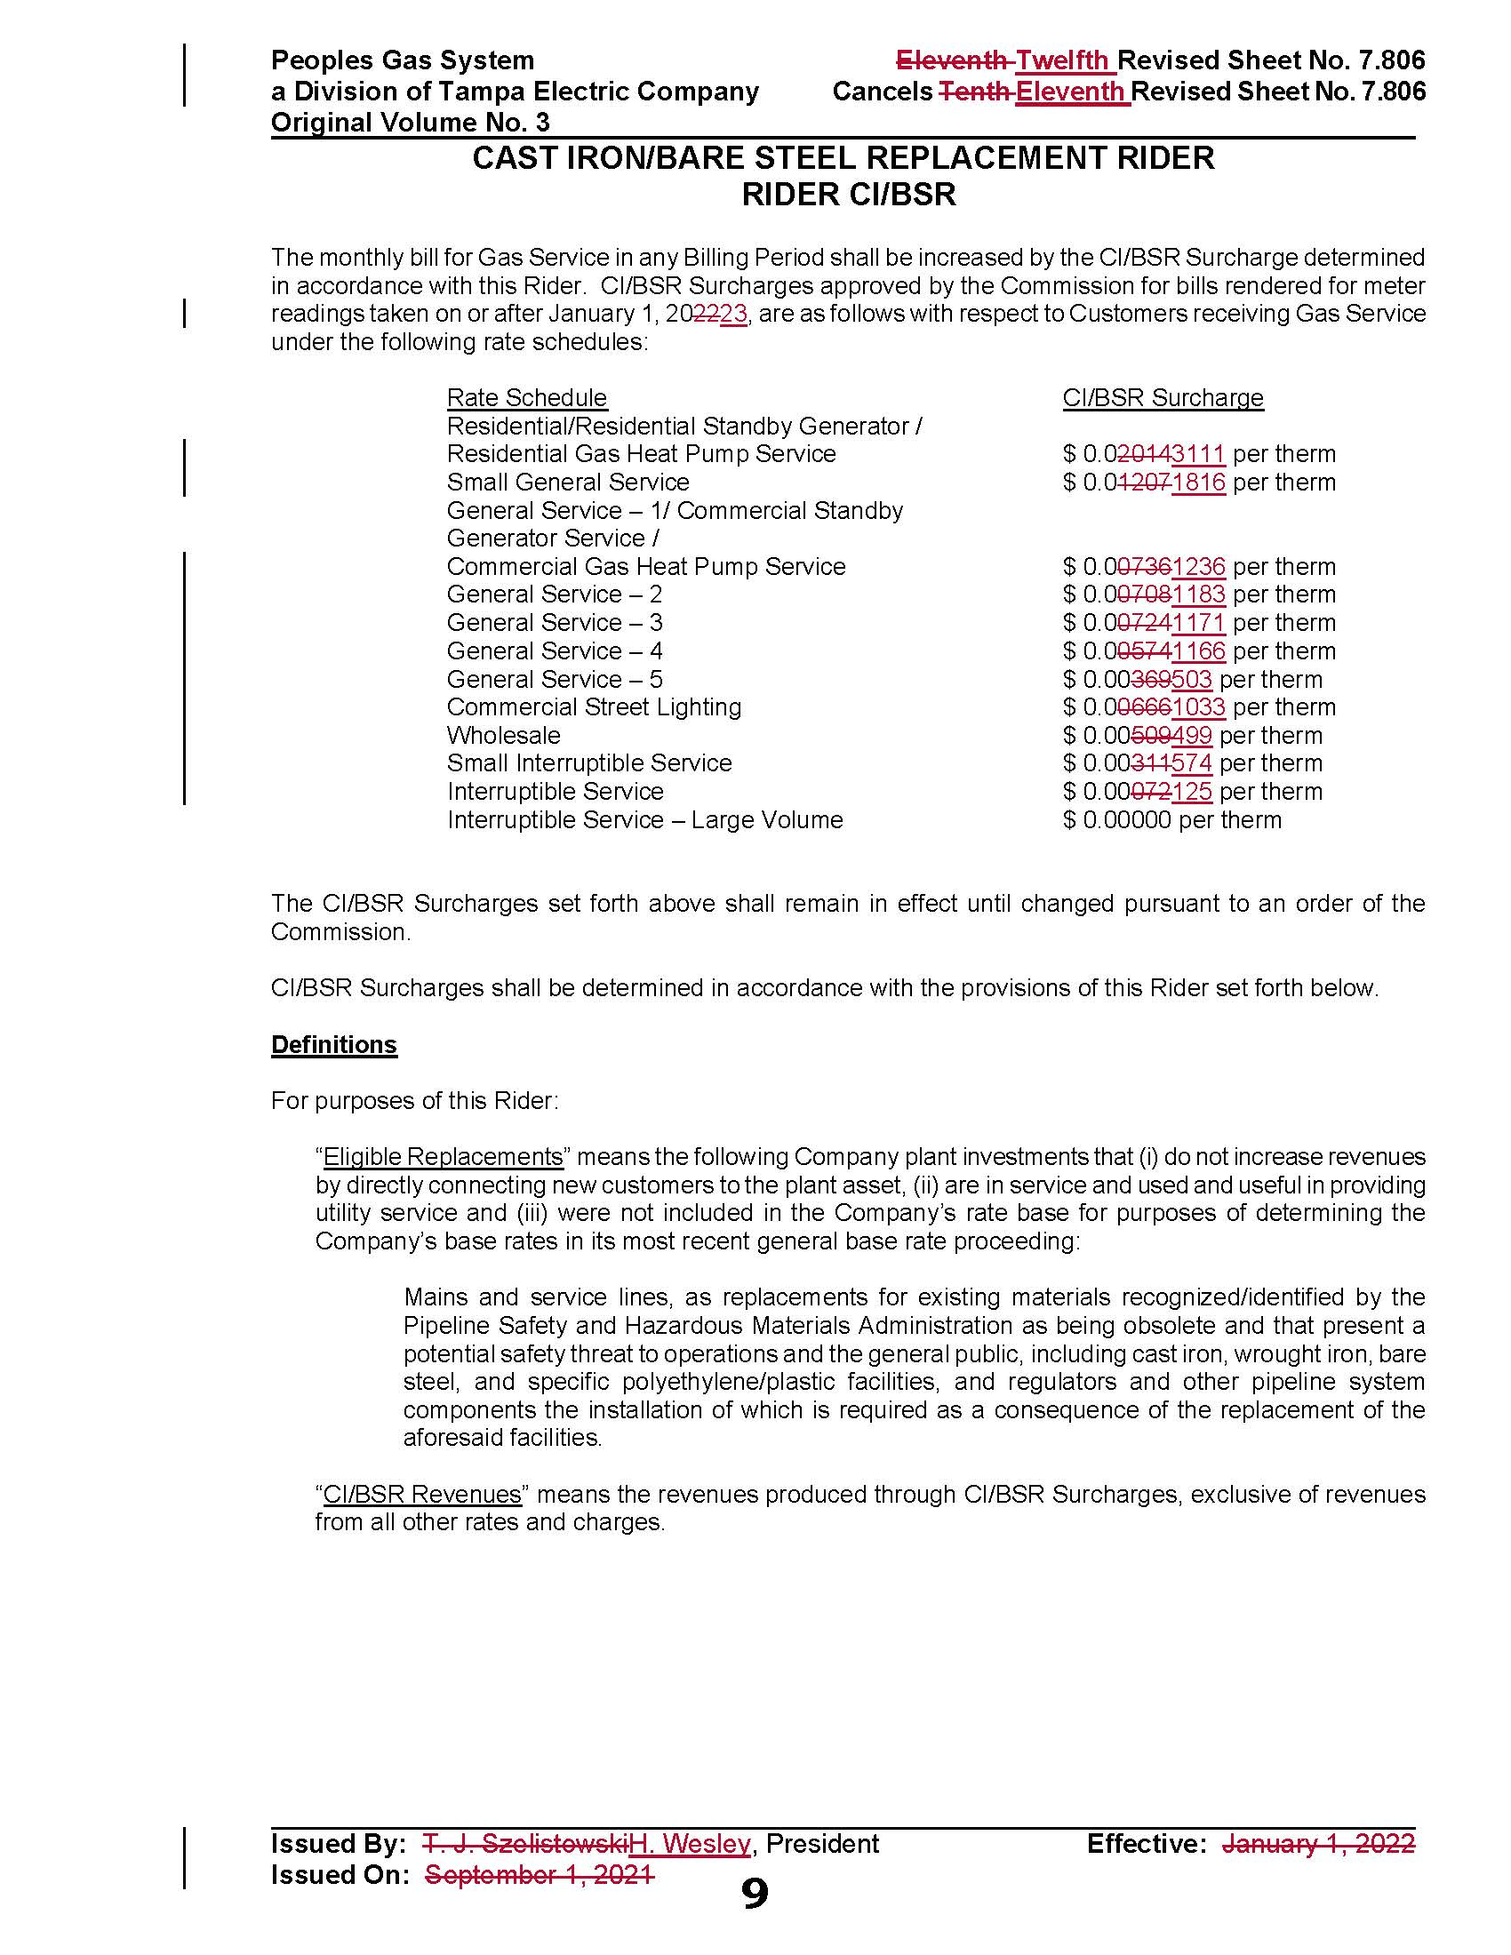

1. Order No. PSC-12-0476-TRF-GU, issued September 18, 2012, in Docket No. 20110320-GU, *In re: Petition for approval of Cast Iron/Bare Steel Pipe Replacement Rider (Rider CI/BSR), by Peoples Gas System.*
2. Order No. PSC-2021-0429-TRF-GU, issued November 19, 2021, in Docket No. 20210148-GU, *In re: Petition for approval of 2020 true-up, projected 2021 true-up, and 2022 revenue requirements and surcharges associated with cast iron/bare steel replacement rider, by Peoples Gas System.*
3. Order No. PSC-17-0066-AS-GU, issued February 28, 2017, in Docket No. 20160159-GU, *In re: Petition for approval of settlement agreement pertaining to Peoples Gas System’s 2016 depreciation study, environmental reserve account, problematic plastic pipe replacement, and authorized ROE.*
4. Order No. PSC-2022-0134-PAA-GU, issued April 11, 2022, in Docket No. 20220018-GU, *In re: Petition for limited proceeding to address the impact of changes to Florida state income tax rates, by Peoples Gas System.*