State of Florida |  | Public Service Commission  Capital Circle Office Center ● 2540 Shumard Oak Boulevard  Tallahassee, Florida 32399-0850  -M-E-M-O-R-A-N-D-U-M-
DATE: | October 20, 2022
TO: | Office of Commission Clerk (Teitzman)
FROM: | Division of Economics (Hampson)  Office of the General Counsel (Dose, Crawford)
RE: | Docket No. 20220155-GU – Joint petition for approval of GRIP cost recovery factors, by Florida Public Utilities Company, Florida Public Utilities Company-Fort Meade, and Florida Division of Chesapeake Utilities Corporation.
AGENDA: | 11/01/22 – Regular Agenda – Tariff Filing – Interested Persons May Participate
COMMISSIONERS ASSIGNED: |  |  | All Commissioners
PREHEARING OFFICER: |  |  | Administrative
CRITICAL DATES: |  |  | 05/1/23 (8-Month Effective Date)
SPECIAL INSTRUCTIONS: |  |  | None

Case Background
On September 1, 2021, Florida Public Utilities Company (FPUC), Florida Public Utilities Company-Fort Meade (Fort Meade), and Florida Division of Chesapeake Utilities Corporation d/b/a Central Florida Gas (Chesapeake), collectively the Companies, filed a joint petition for approval of its gas reliability infrastructure program (GRIP or program) cost recovery factors for the period January through December 2023. The GRIP for FPUC and Chesapeake was first approved in Order No. PSC-12-0490-TRF-GU (2012 Order) to recover the cost of accelerating the replacement of cast iron and bare steel distribution mains and services, including a return on investment, through a surcharge on customers’ bills. Fort Meade’s GRIP was originally approved in Order No. PSC-15-0578-TRF-GU, and allowed Fort Meade to file its annual petition for GRIP factors concurrently with FPUC and Chesapeake. The current GRIP surcharges for January through December 2022 were approved in Order No. PSC-2021-0419-TRF-GU.
In the pending rate case, Docket No. 20220067-GU (2022 rate case), the Companies have proposed to roll GRIP investments into rate base, in compliance with the 2012 Order. Specifically, the 2012 Order stated that the surcharges would be recalculated at the time of a full base rate proceeding, when the GRIP investments would be rolled into base rates. The GRIP tariffs provided in the petition, and shown in Attachment B to the recommendation, have been calculated using the assumption that the Commission would approve the Companies’ request to roll GRIP investments into rate base prior to the effective date of January 2023. Specifically, the Companies stated they would need Commission approval to roll the GRIP investments into base rates by December 1, 2022, in order to implement the proposed GRIP factors by January 1, 2023. If the Commission has not made a decision in the 2022 rate case prior to December 1, 2022, the tariffs provided in Attachment 4 of the joint responses to staff’s first data request should be approved. These tariffs are shown in Attachment C to the recommendation.
The Companies have also proposed, in the 2022 rate case, to consolidate the current 54 rate classes across the four natural gas utilities into 16 rate classes. If the Commission approves the consolidated rate classes in the rate case docket, the Companies would need to allocate the GRIP costs to the appropriate revised rate classes and recalculate the GRIP factors. The proposed tariffs shown in Attachments B and C to the recommendation reflect GRIP factors for the current 54 rate classes.
Consistent with the 2012 Order, the GRIP replacement activities would be scheduled to terminate at the end of 2022. However, the Companies anticipate filing a GRIP Phase II in the near future for Commission approval, under a separate petition. The Companies explained that they have identified additional safety and access related activities that need to be addressed.
On September 15, 2022, the Companies waived their 60-day file and suspend provision of Section 366.06(3), Florida Statutes (F.S.), via an e-mail, which has been placed in the docket file. During the evaluation of the petition, staff issued a data request to the Companies, for which joint responses were received on October 6, 2022. The Companies also provided attachments with its joint responses which were filed in the docket by staff. Attachments 4 and 5 to the joint responses are the tariff sheets and Witness Waruszewski’s exhibit RCW-1, which provides the GRIP factor calculations, assuming the Commission has not made a decision in the 2022 rate case before January 2023. These tariffs and associated GRIP surcharges include the GRIP investment. The Commission has jurisdiction over this matter pursuant to Sections 366.03, 366.04, 366.05, and 366.06, F.S.

Discussion of Issues

Issue 1:
Should the Commission approve FPUC’s, Chesapeake’s, and Fort Meade’s proposed GRIP surcharges for the period January through December 2023?

Recommendation:
If the Commission has not yet made a decision in the 2022 rate case prior to December 1, 2022, then the GRIP surcharges as shown in Attachment C to the recommendation should go into effect for the period January through December 2023, and the surcharges in Attachment B should be denied. If the Commission approves in the 2022 rate case the Companies’ proposals to roll the GRIP investment into rate base prior to December 1, 2022, then the Commission should approve FPUC’s, Chesapeake’s, and Fort Meade’s proposed GRIP surcharges for the period January through December 2023, as shown in Attachment B to the recommendation, and the surcharges shown in Attachment C should be denied.
If the Commission approves to consolidate the rate classes in the 2022 rate case, within 10 business days after the Commission vote in the 2022 rate case docket, the Companies should recalculate the GRIP surcharges for the consolidated rate classes. The revised GRIP surcharges should be submitted for staff’s administrative approval and should be effective concurrent with any revised Commission-approved base rates in the rate case docket. (Hampson)

Staff Analysis:
The GRIP surcharges have been in place since January 2013 for FPUC and Chesapeake, while Fort Meade’s surcharges were first implemented in January 2017. Fort Meade completed its replacement program in 2019 and Chesapeake completed its replacement program in 2021. FPUC completed replacement projects in 2022 in areas including the City of Boynton Beach, the City of West Palm Beach, and the City of Lantana. FPUC has approximately 0.5 miles of pipeline to replace in 2023, due to some permit delays. The Companies stated that they prioritized the replacement projects focusing on areas of high consequence and areas more susceptible to corrosion. Attachment A to the recommendation provides an update of mains and services replaced through 2022 and replacement forecasts for 2023.

FPUC’s True-ups by Year
FPUC’s calculation for the 2023 GRIP revenue requirement and surcharges includes a final true-up for 2021, an actual/estimated true-up for 2022, and projected costs for 2023. In its 2008 rate case, FPUC was authorized to recover $747,727 of annual bare steel replacement expenses in base rates. Therefore, the $747,727 recovered from base rates is excluded from the GRIP true-up calculations for 2021 and 2022.

Final True-up for 2021
FPUC stated that the revenues collected through the GRIP surcharges for 2021 were $10,676,905, compared to a revenue requirement of $12,789,617, resulting in an under-recovery of $2,112,712. Therefore, the 2020 over-recovery of $326,121, the 2021 under-recovery of $2,112,712, and interest of $160 associated with any over- and under-recoveries results in a final 2021 under-recovery of $1,786,751.

Actual/Estimated 2022 True-ups
FPUC provided actual revenues for January through July 2022 and estimated revenues for August through December 2022, totaling $16,474,089, compared to an actual/estimated revenue requirement for 2022 of $15,431,274, resulting in an over-recovery of $1,042,817. Therefore, the 2021 under-recovery of $1,786,751, the 2022 over-recovery of $1,042,817, and interest of $9,859 results in a total 2022 under-recovery of $753,793.

Projected 2023 Costs
FPUC projects zero capital expenditures for the replacement of cast iron/bare steel infrastructure in 2023. FPUC moved $153,684,138 of total qualified investment into rate base in the rate case docket. That amount represents the total investment projected at the time of the rate case filing in May 2022. For the GRIP filing in September 2022, FPUC had additional months of actual investment costs and an updated investment amount of $159,599,228, leaving $5,915,090 ($159,599,228 - $153,684,138) to be recovered through the 2023 GRIP factors as shown in Attachment B to the recommendation.
The return on investment (which includes federal income taxes, regulatory assessment fees, and bad debt), depreciation expense, and property tax associated with the $5,915,090 investment, after subtracting accumulated depreciation, is $366,128. After including the total 2022 under-recovery of $753,793, the 2023 revenue requirement is $1,119,921. Table 1-1 shows FPUC’s 2023 revenue requirement calculation.
Table 1-1
FPUC 2023 Revenue Requirement Calculation
2023 Projected Expenditures |  | $0
Return on Investment | $187,999
Depreciation Expense | 126,275
Property Tax Expense | 51,855
2023 GRIP Revenue Requirement | $366,128
Plus 2022 Under-recovery | +753,793
2023 Total Revenue Requirement | $1,119,921
Source: Witness Waruszewski Testimony Schedules C-2, Page 4, and D-1, Page 5

Chesapeake’s True-ups by Year
Chesapeake’s calculation for the 2023 GRIP revenue requirement and surcharges includes a final true-up for 2021, an actual/estimated true-up for 2022, and projected costs for 2023. Chesapeake does not have a replacement recovery amount embedded in base rates.

Final True-up for 2021
Chesapeake stated that the revenues collected for 2021 were $4,067,038, compared to a revenue requirement of $4,102,754, resulting in an under-recovery of $35,715. The 2020 under-recovery of $278,276, 2021 under-recovery of $35,715 and $124 for interest associated with any over- and under-recoveries results in a final 2021 under-recovery of $314,115.

Actual/Estimated 2022 True-up
Chesapeake provided actual GRIP revenues for January through July 2022 and estimated revenues for August through December 2022, totaling $3,789,938, compared to an actual/estimated revenue requirement of $4,309,484, resulting in an under-recovery of $519,544. The 2021 under-recovery of $314,115, 2022 under-recovery of $519,544, and interest of $8,855 associated with any over- and under-recoveries results in a total 2022 under-recovery of $842,515.

Projected 2023 Costs
Chesapeake projects zero capital expenditures for the replacement of cast iron/bare steel infrastructure in 2023, as the company completed the replacement program in 2021. Chesapeake moved $41,948,432 of total qualified investment into rate base in the rate case docket. That amount represents the total investment projected at the time of the rate case filing in May 2022. For the GRIP filing in September 2022, Chesapeake had additional months of actual investment costs and an updated investment amount of $41,872,674, leaving ($75,758) ($41,948,432 - $41,872,674) as a credit to the 2023 GRIP factors, as shown in Attachment B to the recommendation.
The return on investment (which includes federal income taxes, regulatory assessment fees, and bad debt), depreciation expense, and property tax associated with the ($75,758) investment, after subtracting accumulated depreciation, is ($48,807). The 2023 GRIP factors for Chesapeake are designed to collect the remaining 2022 under-recovery of $842,515 and the revenue requirement of ($48,807) associated with the 2022 investment. Table 1-2 shows Chesapeake’s 2023 revenue requirement calculation.
Table 1-2
Chesapeake 2023 Revenue Requirement Calculation
2023 Projected Expenditures | $0
Return on Investment | ($37,095)
Depreciation Expense | (1,560)
Property Tax Expense | (10,152)
2023 Revenue Requirement | ($48,807)
Plus 2022 Under-recovery | +842,515
2023 Total Revenue Requirement | $793,707
Source: Witness Waruszewski Testimony Schedules C-2, Page 10, and D-1, Page 11

Fort Meade’s True-ups by Year
Fort Meade finished its replacement program in 2019. Unlike FPUC and Chesapeake, only bare steel services (and no mains) required replacement in Fort Meade.

Final True-up for 2021
Fort Meade stated that the revenues collected for 2021 were $26,629, compared to a revenue requirement of $24,363, resulting in an over-recovery of $2,266. Adding the 2020 over-recovery of $8,427, the 2021 over-recovery of $2,266, and $3 for interest associated with any over- and under-recoveries, the final 2021 over-recovery is $10,696.

Actual/Estimated 2022 True-up
Fort Meade provided actual GRIP revenues for January through July 2022 and estimated revenues for August through December 2022 totaling $26,501, compared to an actual/estimated revenue requirement of $24,881, resulting in an over-recovery of $1,619. Adding the 2021 over-recovery of $10,696, the 2022 over-recovery of $1,619, and interest of $212 associated with any over- and under-recoveries, the resulting total 2022 true-up is an over-recovery of $12,527.

Projected 2023 Costs
Fort Meade projects zero capital expenditures for the replacement of cast iron/bare steel infrastructure in 2023, as the company completed the replacement program in 2019. Fort Meade’s total investment of $253,934 has been moved into rate base in the rate case docket, with no rate base balance remaining to be recovered through the 2023 GRIP factors. Therefore, the 2023 GRIP factors, as shown in Attachment B to the recommendation, will be a credit on customers’ bills and are designed to refund the remaining 2022 over-recovery of $12,527.

Proposed Surcharges for FPUC, Chesapeake, and Fort Meade
As established in the 2012 Order approving the GRIP program, the total 2023 revenue requirement is allocated to the rate classes using the same methodology used for the allocation of mains and services in the cost of service study used in the utilities’ most recent rate case. The respective percentages were multiplied by the 2023 revenue requirements and divided by each rate class’ projected therm sales to provide the GRIP surcharge for each rate class.
The proposed 2023 GRIP surcharge for FPUC’s residential customers on the Residential Service (RS) schedule is $0.02166 per therm (compared to the current surcharge of $0.31642 per therm). The monthly bill impact is $0.43 for a residential customer using 20 therms per month. The proposed FPUC GRIP surcharges are shown in Attachment B, Tariff Sheet No. 7.907.
The proposed 2023 GRIP surcharge for Chesapeake’s residential customers on the FTS-1 schedule is $0.01970 per therm (compared to the current surcharge of $0.11405). The monthly bill impact is $0.39 for a residential customer using 20 therms per month. The proposed Chesapeake GRIP surcharges are shown in Attachment B, Tariff Sheet Nos. 7.907 and 7.910.
The proposed 2023 GRIP surcharge for Fort Meade’s residential customers on the RS schedule is ($0.12822) per therm (compared to the current surcharge of $0.15245). The monthly bill impact is a credit of $2.56 for a residential customer using 20 therms per month. The proposed Fort Meade GRIP surcharges are shown on Tariff Sheet No. 7.906 in Attachment B.

Conclusion
If the Commission has not yet made a decision in the 2022 rate case prior to December 1, 2022, then the GRIP surcharges as shown in Attachment C to the recommendation should go into effect for the period January through December 2023, and the surcharges shown in Attachment B should be denied. If the Commission approves in the 2022 rate case the Companies’ proposals to roll the GRIP investment into rate base prior to December 1, 2022, then the Commission should approve FPUC’s, Chesapeake’s, and Fort Meade’s proposed GRIP surcharges for the period January through December 2023, as shown in Attachment B to the recommendation, and the surcharges shown in Attachment C should be denied.
If the Commission approves to consolidate the rate classes in the 2022 rate case, within 10 business days after the Commission vote in the 2022 rate case docket, the Companies should recalculate the GRIP surcharges for the consolidated rate classes. The revised GRIP surcharges should be submitted for staff’s administrative approval and should be effective concurrent with any revised Commission-approved base rates in the rate case docket.

Issue 2:
Should this docket be closed?

Recommendation:
Yes. If Issue 1 is approved and a protest is filed within 21 days of the issuance of the order, the approved tariffs should remain in effect, with any revenues held subject to refund, pending resolution of the protest. If no timely protest is filed, this docket should be closed upon the issuance of a consummating order. (Dose)

Staff Analysis:
If Issue 1 is approved and a protest is filed within 21 days of the issuance of the order, the approved tariffs should remain in effect, with any revenues held subject to refund, pending resolution of the protest. If no timely protest is filed, this docket should be closed upon the issuance of a consummating order.

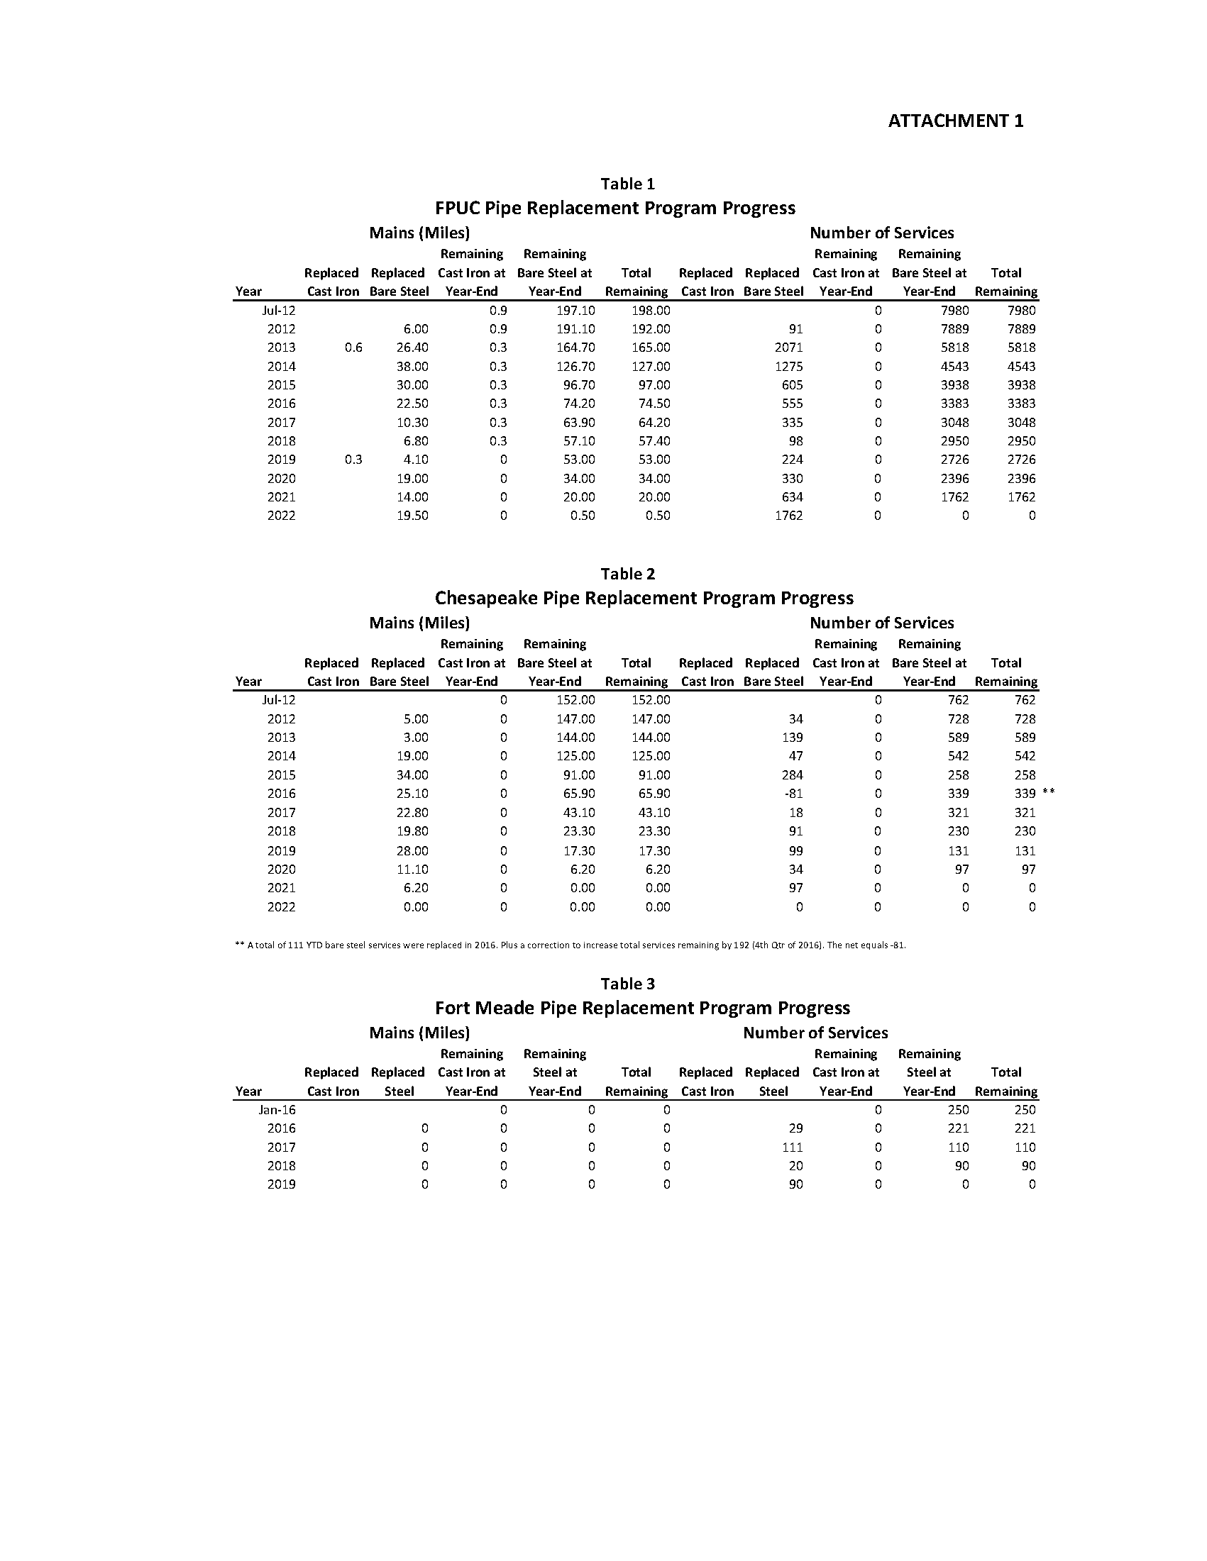
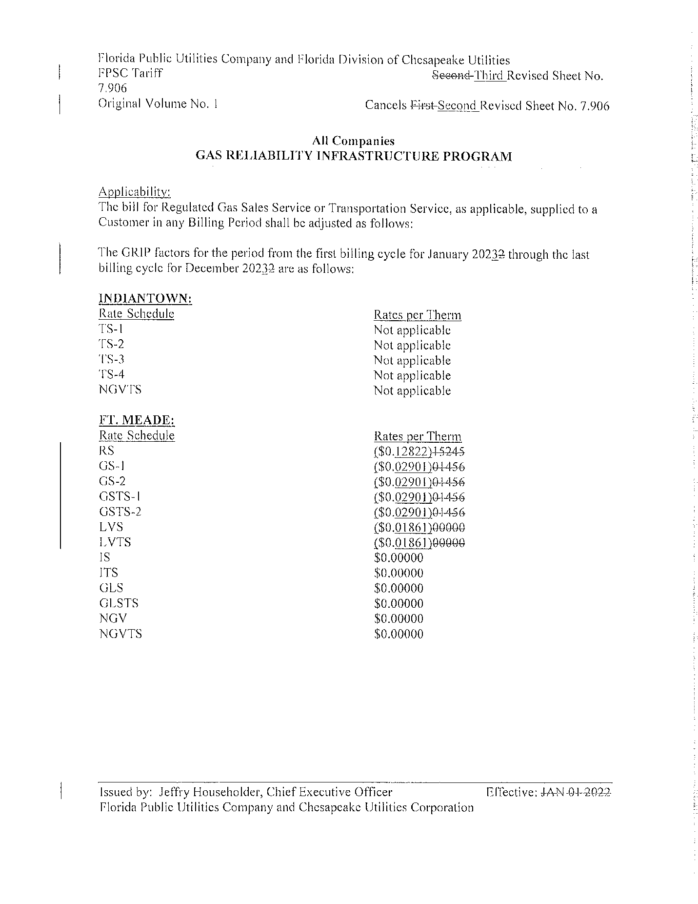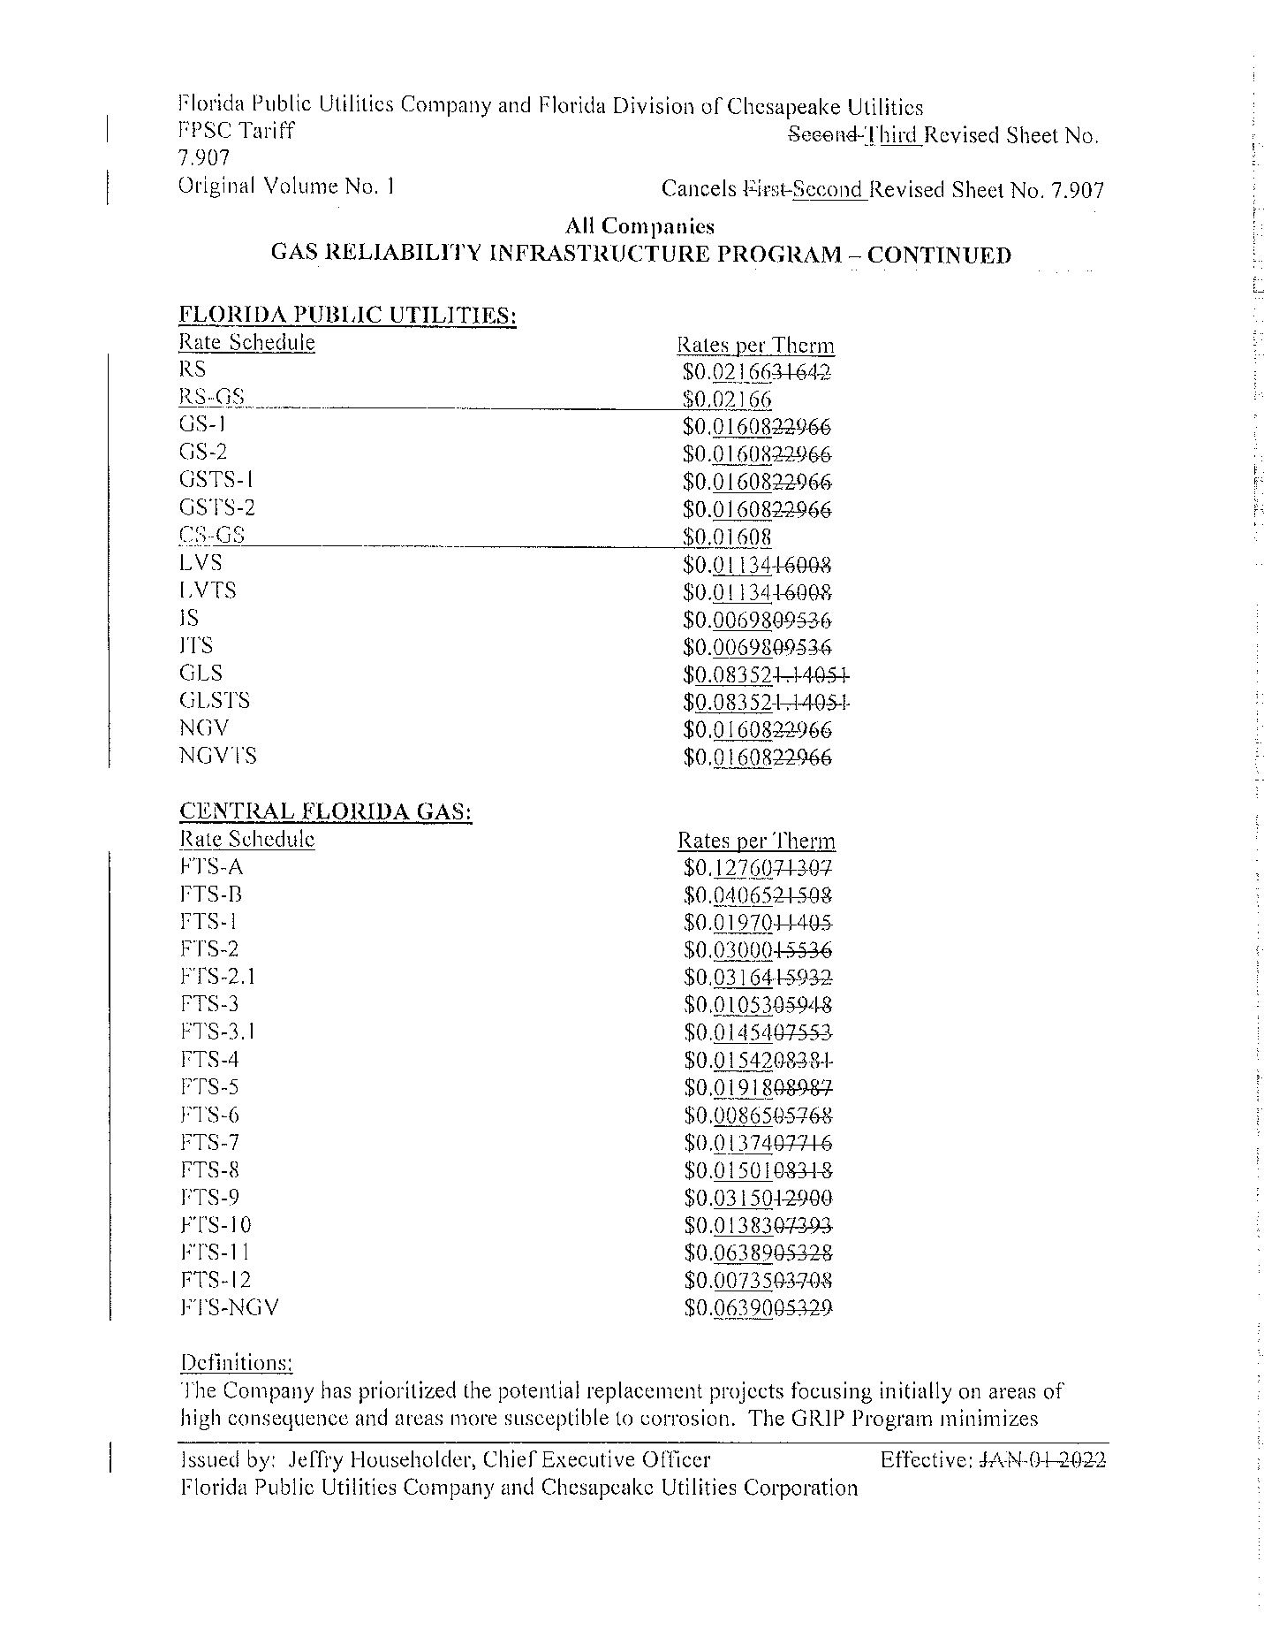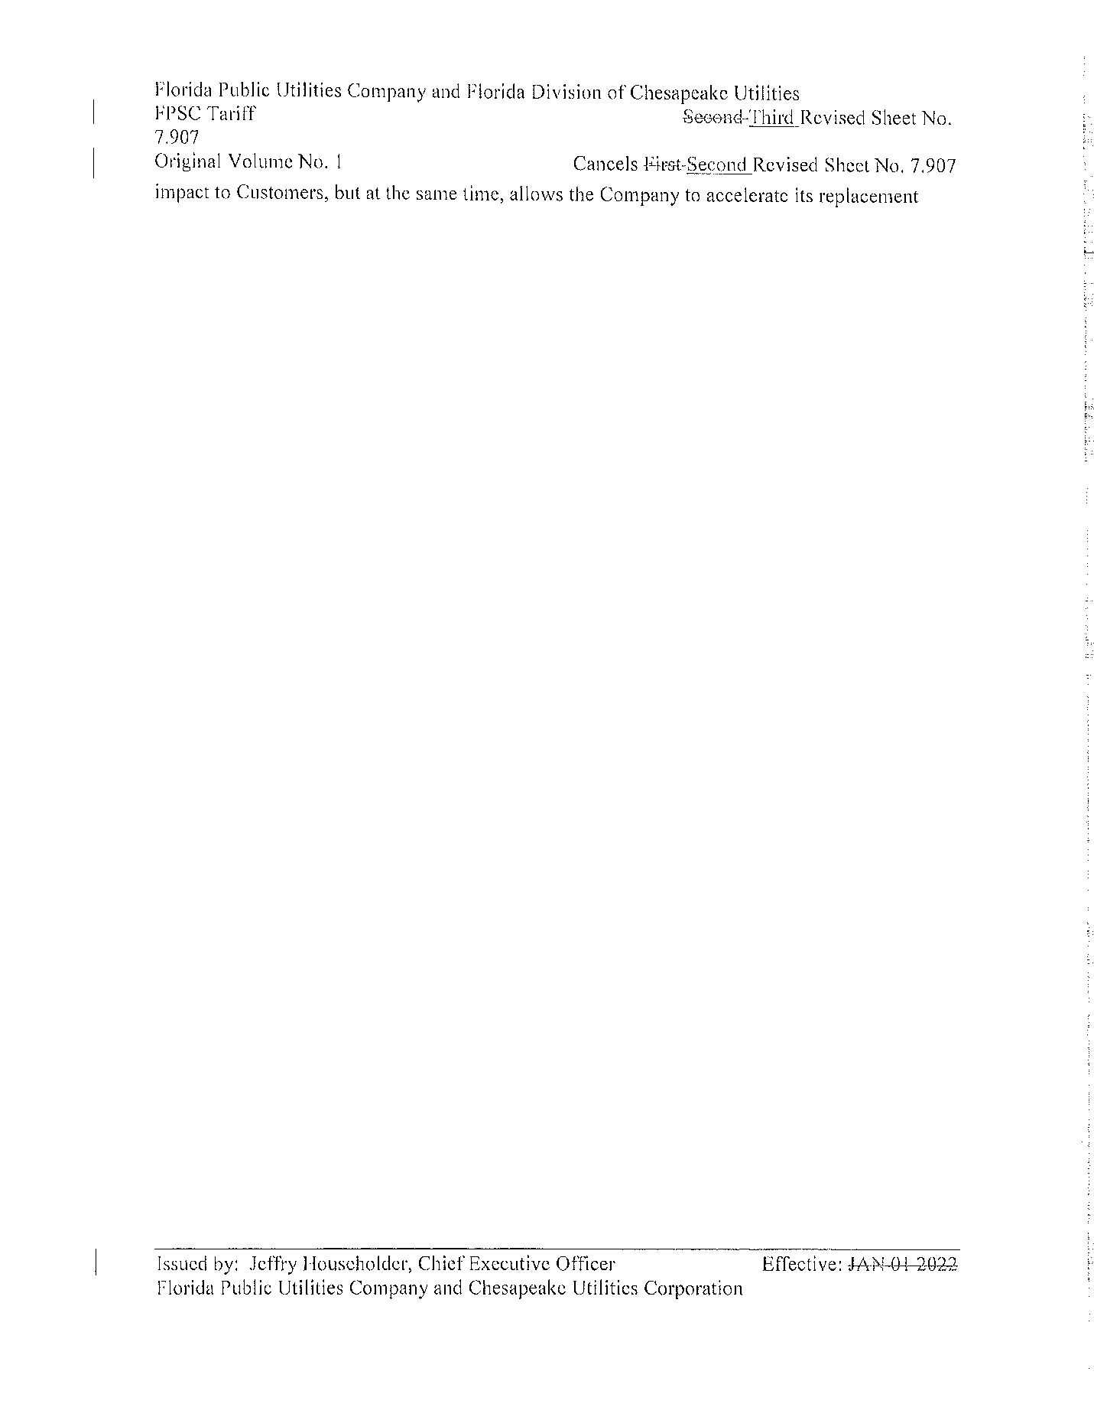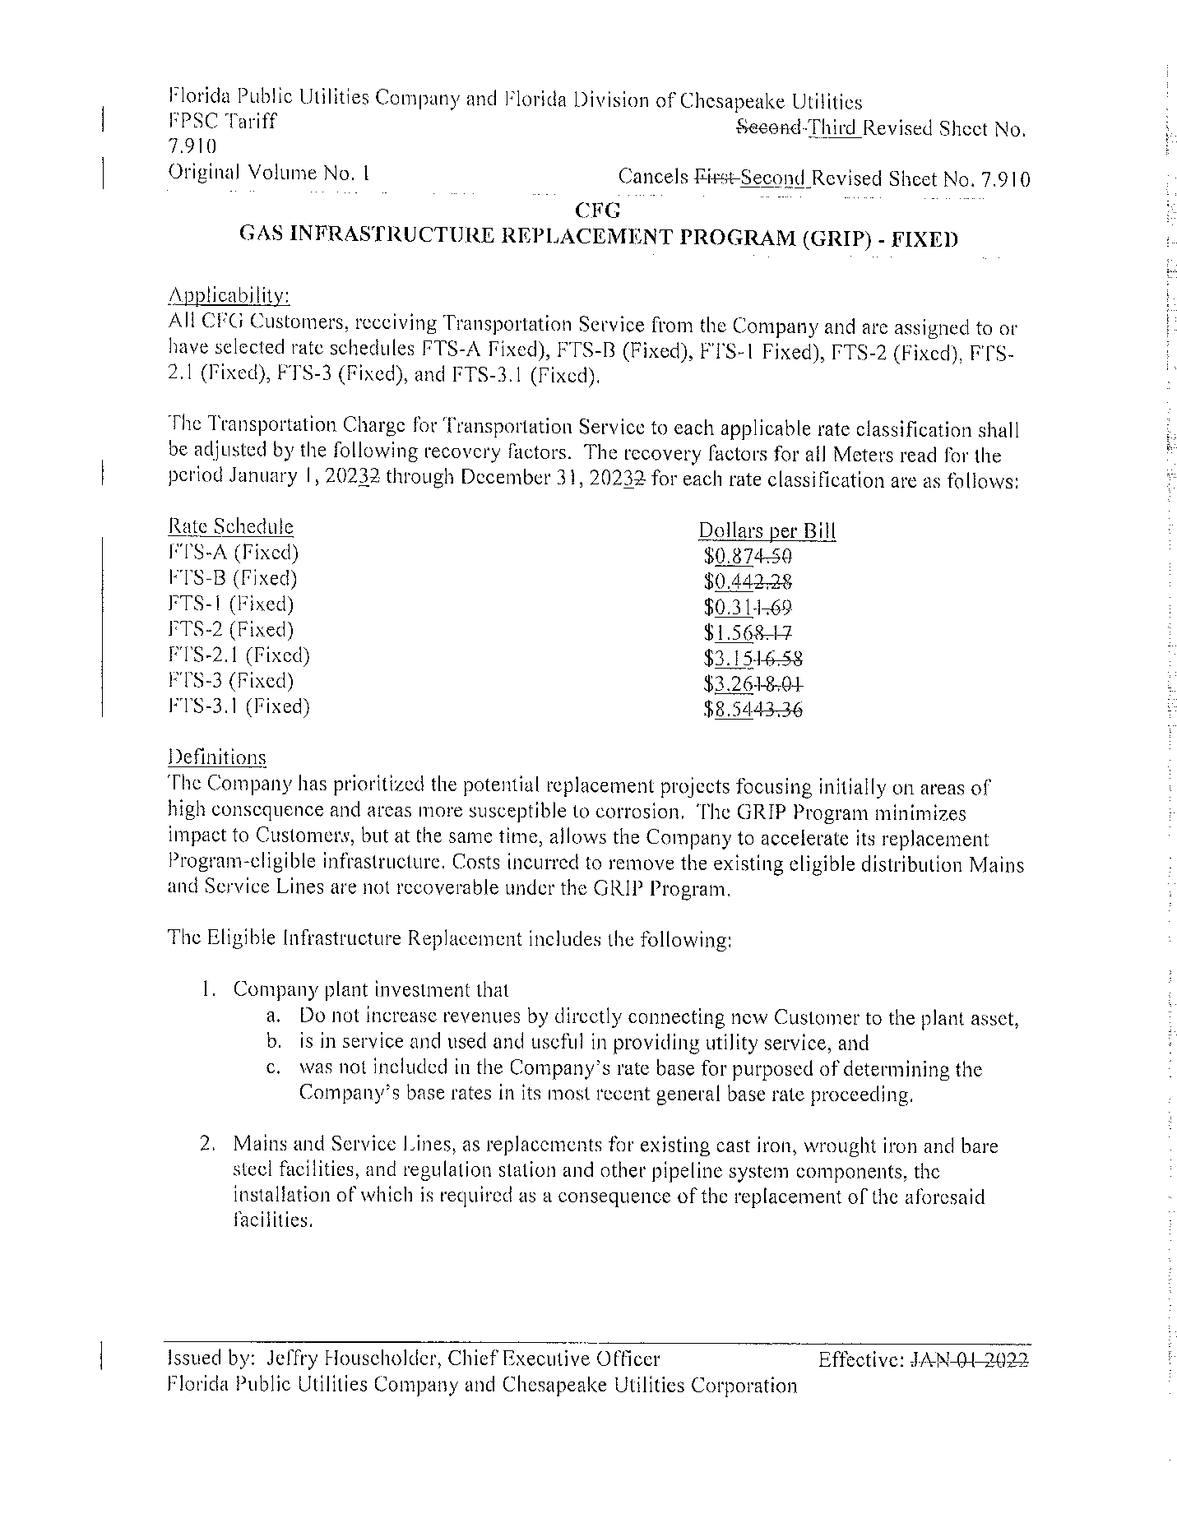
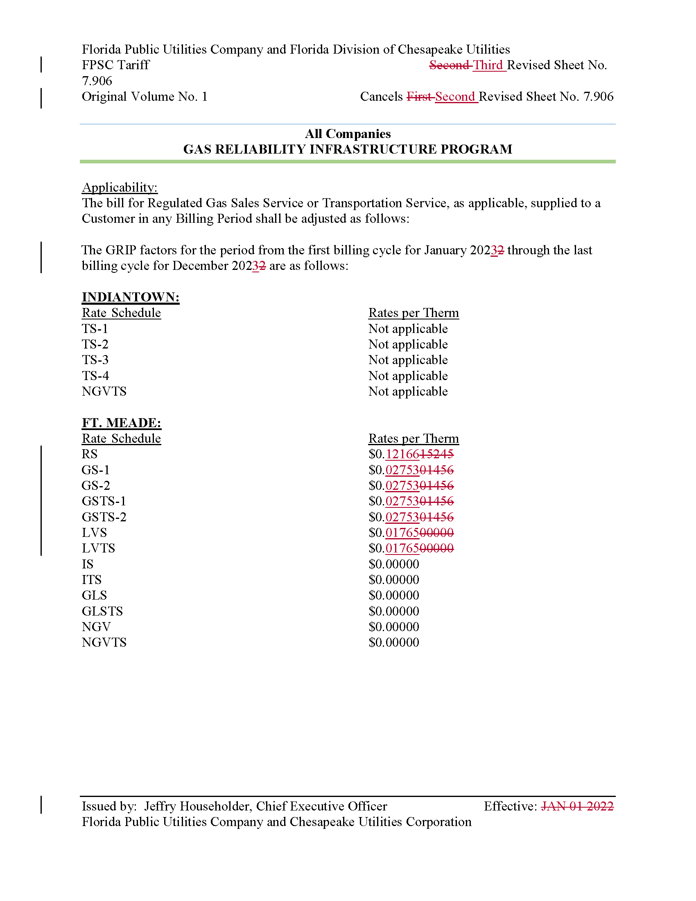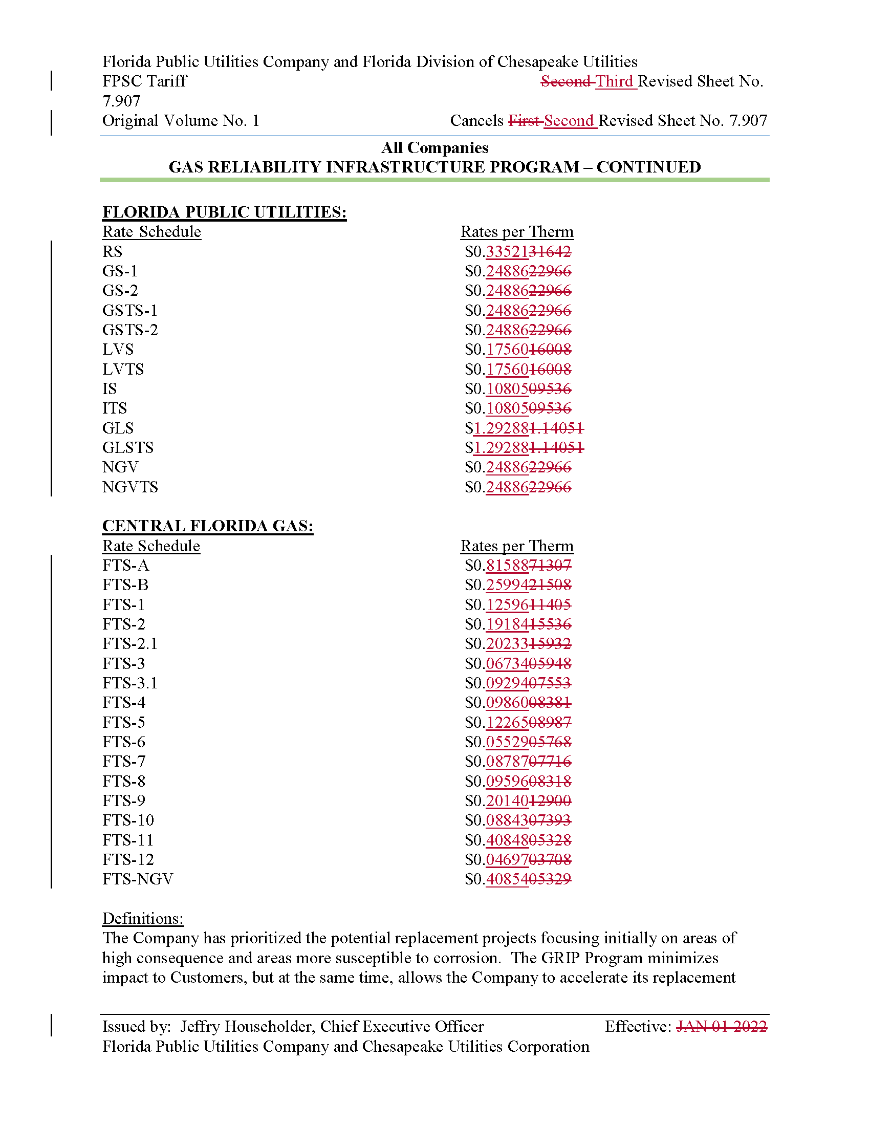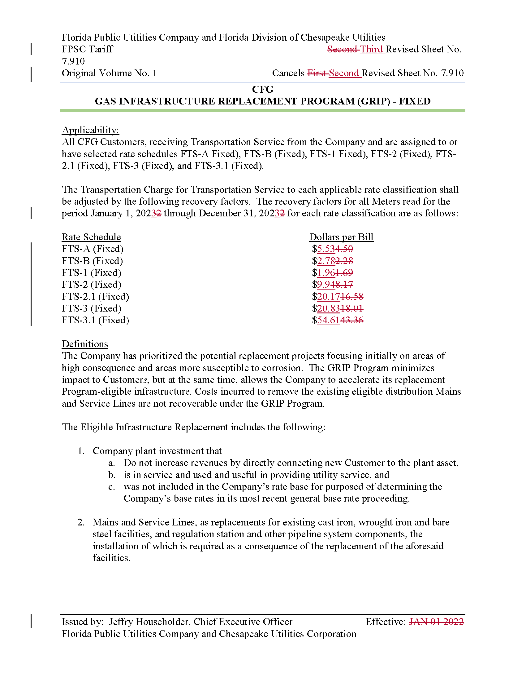

Order No. PSC-12-0490-TRF-GU, issued September 24, 2012, in Docket No. 20120036-GU, In re: Joint petition for approval of Gas Reliability Infrastructure Program (GRIP) by Florida Public Utilities Company and the Florida Division of Chesapeake Utilities Corporation.
Order No. PSC-15-0578-TRF-GU, issued December 21, 2015, in Docket No. 20150191-GU, In re: Joint petition for approval to implement gas reliability infrastructure program (GRIP) for Florida Public Utilities Company-Fort Meade and for approval of GRIP cost recovery factors by Florida Public Utilities Company, Florida Public Utilities Company-Fort Meade and the Florida Division of Chesapeake Utilities Corporation.
Order No. PSC-2021-0419-TRF-GU, issued November 9, 2021, in Docket No. 20210150-GU, In re: Joint petition for approval to implement gas reliability infrastructure program (GRIP) cost recovery factors for January 2022 through December 2022 by Florida Public Utilities Company, Florida Public Utilities Company-Fort Meade and the Florida Division of Chesapeake Utilities Corporation.
See Document No. 09182-2022.
Responses to Staff’s First Data Request, No. 3 (DN 08870-2022)
Responses to Staff’s First Data Request, No. 1 (DN 08870-2022)
Order No. PSC-09-0375-PAA-GU, issued May 27, 2009, in Docket No, 20080366-GU, In re: Petition for rate increase by Florida Public Utilities Company.
Capital expenditures for the remaining 0.5 miles of pipe replacement to be completed in 2023 were included in FPUC’s actual/estimated investments for 2022. Any additional expenses related to the 0.5 miles of pipeline incurred would be trued-up in FPUC’s 2023 GRIP filing.

