BEFORE THE FLORIDA PUBLIC SERVICE COMMISSION

In re: Application for approval of a new classes of service for bulk wastewater service in Pasco County, by Ni Florida, Inc. | DOCKET NO. 20220147-SU  ORDER NO. PSC-2022-0385-TRF-SU  ISSUED: November 10, 2022

The following Commissioners participated in the disposition of this matter:

ANDREW GILES FAY, Chairman
ART GRAHAM
GARY F. CLARK
MIKE LA ROSA
GABRIELLA PASSIDOMO

ORDER APPROVING REQUEST FOR NEW CLASSES OF SERVICE FOR BULKWATER SERVICE BY NI FLORIDA, INC.

BY THE COMMISSION:

Background
Ni Florida, Inc. (Ni Florida or utility) is a Class A utility serving only water customers in Lee County and only wastewater customers in Pasco County. This filing is for its wastewater system. The utility provides wastewater service to approximately 2,820 customers. For its wastewater, Ni Florida is a reseller and purchases wastewater treatment from Pasco County. According to its 2021 Annual Report, the utility reported wastewater operating revenues of $2,401,726 and wastewater operating expenses of $2,155,625.

Pursuant to Section 367.091(5), Florida Statutes (F.S.), on August 24, 2022, Ni Florida filed an application for new classes of service for bulk wastewater service. Along with the application, the utility filed Second Revised Sheet No. 11, Original Sheet No. 12.3, and Original Sheet No. 12.4. Ni Florida has entered into agreements to provide bulk wastewater service to Shadow Wood West and Shadow Wood Village (entities), which are in its certificated service territory. Both entities are exempt from our regulation pursuant to Section 367.022(5), F.S., because they provide service only to tenants on their properties. Ni Florida has indicated that there is a sense of urgency to connect the entities. For Shadow Wood Village, specifically, its wastewater treatment facilities are nearing capacity and will be unable to accommodate additional homes on the system. Although Shadow Wood West is not at capacity, it is being included for administrative efficiency because it is contiguous and a similar development as Shadow Wood Village.

This order addresses Ni Florida’s proposed tariff sheets to provide bulk wastewater service. We have jurisdiction pursuant to Section 367.091(5), F.S.

Decision

Analysis

As discussed in the case background, Ni Florida entered into bulk service agreements to provide bulk wastewater service to Shadow Wood Village and Shadow Wood West. The utility has ample excess capacity to meet the immediate requirements of the entities. The connection of the entities will not cause an interruption of wastewater service to existing customers.

Ni Florida has an existing tariff for bulk wastewater service to manufactured homes. In Order No. PSC-16-0525-PAA-WS, the bulk wastewater service rate was determined by multiplying the number of manufactured homes behind the meter times .8 to determine the number equivalent residential connections (ERCs). For the entities, Ni Florida proposed rates that are consistent with the methodology established in its last rate case for manufactured homes’ bulk wastewater service rates. Shadow Wood Village has 215 manufactured homes behind the meter resulting in 172 ERCs while Shadow Wood West has 45 manufactured homes resulting in 36 ERCs. The bulk wastewater service rate for each entity consists of a base facility charge (BFC) based on the respective ERCs times the utility’s existing BFC of $26.29 for the 5/8” x 3/4” meter size and the existing bulk service gallonage charge ($9.27). As a result, we find that the proposed rates are reasonable.

The proposed bulk service wastewater rates will provide Ni Florida with additional revenues of $147,245. With these additional revenues, the utility is still earning within its authorized range of return. The entities are not fully built out. Thus, although the tariff will define the number of ERCs at the time of the filing of the instant application, at all times the utility should be billing based on the number of ERCs behind the meter as with the methodology prescribed above. At such time Ni Florida comes in for a rate proceeding, the tariff will be updated to reflect the most current ERCs. If new connections are added and additional revenues are collected, our staff’s annual report surveillance will allow monitoring of the utility’s earning levels for potential overearnings.

In addition, Ni Florida indicated that it has additional territory that could be subject to similar residential developments. As a result, the utility in its petition asked us to consider a generic bulk service tariff for administrative efficiency and reduction in regulatory lag. Ni Florida did not file an actual generic bulk service tariff with its petition. If granted, in its filing Ni Florida committed to filing a separate filing if a unique situation arises. With any new similarly planned development, the utility may furnish the new class of service and charge just, reasonable, and compensatory rates and file with us within 10 days after the service is furnished pursuant to Section 367.091(5), F.S., which minimizes any regulatory lag concern by the utility. We find that our authority to review bulk service agreements and evaluate the impact bulk customers have on the utility’s earnings at the onset of service shall be preserved. Therefore, at this time, we do not find a generic bulk service tariff is appropriate, and this request shall be denied.

Conclusion

The utility’s proposed tariffs containing the bulk service wastewater rates shall be approved. As shown in Attachment 1, Ni Florida’s Second Revised Sheet No. 11, Original Sheet No. 12.3, and Original Sheet No. 12.4 shall be approved as filed. The utility shall file a proposed customer notice for the two bulk service customers to reflect our approved rates. The approved rates shall be effective for service rendered on or after the stamped approval date of the tariffs pursuant to Rule 25-30.475(1), F.A.C., provided that the notice of the tariff has been received by the two bulk service customers impacted. The utility shall provide proof of the date notice was given within 10 days of the date of the notice. The utility’s request for a generic bulk service tariff shall be denied.

Based on the foregoing, it is

ORDERED by the Florida Public Service Commission that Ni Florida, Inc.’s proposed tariffs containing the bulk service wastewater rates shall be approved. As shown in Attachment 1, Ni Florida’s Second Revised Sheet No. 11, Original Sheet No. 12.3, and Original Sheet No. 12.4 shall be approved as filed. The utility shall file a proposed customer notice for the two bulk service customers to reflect our approved rates. The approved rates shall be effective for service rendered on or after the stamped approval date of the tariffs pursuant to Rule 25-30.475(1), F.A.C., provided that the notice of the tariff has been received by the two bulk service customers impacted. The utility shall provide proof of the date notice was given within 10 days of the date of the notice. The utility’s request for a generic bulk service tariff shall be denied. It is further

ORDERED that if a protest is filed within 21 days of issuance of the Order, the tariff shall remain in effect with any charges held subject to refund pending resolution of the protest. It is further

ORDERED that if no timely protest is filed, this docket shall be closed upon the issuance of a Consummating Order.

By ORDER of the Florida Public Service Commission this 10th day of November, 2022.

/s/ Adam J. Teitzman
ADAM J. TEITZMAN
Commission Clerk
Florida Public Service Commission
2540 Shumard Oak Boulevard
Tallahassee, Florida 32399
(850) 413-6770
www.floridapsc.com

Copies furnished: A copy of this document is provided to the parties of record at the time of issuance and, if applicable, interested persons.

NRP/JSC

NOTICE OF FURTHER PROCEEDINGS

The Florida Public Service Commission is required by Section 120.569(1), Florida Statutes, to notify parties of any administrative hearing or judicial review of Commission orders that is available under Sections 120.57 or 120.68, Florida Statutes, as well as the procedures and time limits that apply. This notice should not be construed to mean all requests for an administrative hearing or judicial review will be granted or result in the relief sought.

Mediation may be available on a case-by-case basis. If mediation is conducted, it does not affect a substantially interested person's right to a hearing.

The Commission's decision on this tariff is interim in nature and will become final, unless a person whose substantial interests are affected by the proposed action files a petition for a formal proceeding, in the form provided by Rule 28-106.201, Florida Administrative Code. This petition must be received by the Office of Commission Clerk, 2540 Shumard Oak Boulevard, Tallahassee, Florida 32399-0850, by the close of business on December 1, 2022.

In the absence of such a petition, this Order shall become final and effective upon the issuance of a Consummating Order.

Any objection or protest filed in this docket before the issuance date of this order is considered abandoned unless it satisfies the foregoing conditions and is renewed within the specified protest period.

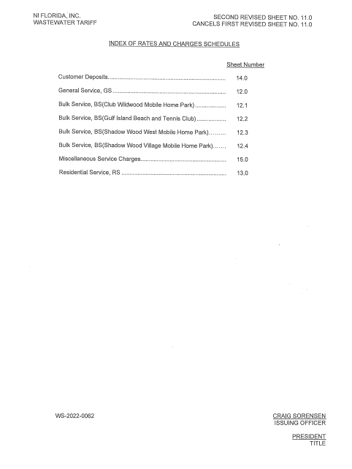
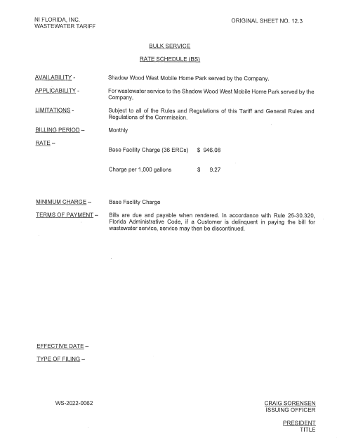
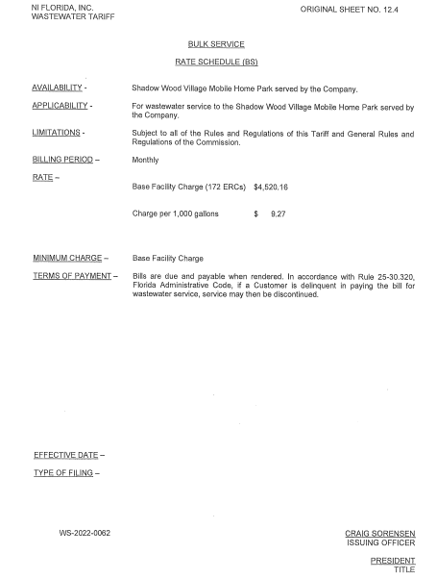

Order No. 2016-0525-PAA-WS, issued November 21, 2016, in Docket No. 20160030-WS, In re: Application for increase in water rates in Lee County and wastewater rates in Pasco County by Ni Florida, LLC.

