BEFORE THE FLORIDA PUBLIC SERVICE COMMISSION

In re: Petition to adjust clean energy transition mechanism to reflect revised authorized return on equity, by Tampa Electric Company. | DOCKET NO. 20220161-EI  ORDER NO. PSC-2022-0400-TRF-EI  ISSUED: November 17, 2022

The following Commissioners participated in the disposition of this matter:

ANDREW GILES FAY, Chairman
ART GRAHAM
GARY F. CLARK
MIKE LA ROSA
GABRIELLA PASSIDOMO

ORDER ADJUSTING CLEAN ENERGY TRANSITION
MECHANISM AMOUNT, RATES, AND TARIFF

BY THE COMMISSION:

Background
On September 16, 2022, Tampa Electric Company (TECO or Company) filed a petition to adjust the Clean Energy Transition Mechanism (CETM) revenue requirement established in Paragraph 5 of the 2021 Stipulation and Settlement Agreement (2021 Agreement). We previously approved the 2021 Agreement in Order No. PSC-2021-0423-S-EI. Paragraph 5 of the 2021 Agreement provides for initial CETM charges, or rates, to recover an annual revenue requirement of $68,550,000, effective January 1, 2022. Per the 2021 Agreement, the CETM is a levelized annual recovery amount that extends through 2036, and is subject to periodic factor updates (every three years) as well as adjustments to account for all rate of return adjustments (i.e. resets to the Company’s mid-point return on equity) and corporate income tax rate changes.
The CETM is made up of two cost categories. The first category includes Big Bend Units One, Two, and Three retirements, as well as the Company’s dismantlement reserve deficiency for the Big Bend Assets. The second category includes costs associated with Automated Meter Reading (AMR) meter retirements. All such costs were identified in testimony and minimum filing requirements (MFRs) in Docket No. 20210034-EI.
In the instant petition, TECO requests that we increase the CETM to $69,168,529, and approve revised customer rates resulting from this change effective January 1, 2023. Such rates are reflected in the proposed revisions to the Company’s tariff page submitted with its Petition, and included as Attachment A to this order. Consistent with Subparagraph 5(f) of the 2021 Agreement, TECO seeks this increase in order to reflect TECO’s Revised Authorized Return on Equity (ROE) mid-point of 10.20 percent effective July 1, 2022, as approved in Order No. PSC-2022-0322-FOF-EI.
We have jurisdiction over this matter pursuant to Sections 366.06 and 366.076, Florida Statutes (F.S.).

Decision
- Updated CETM Amount
Subparagraphs 5(a) and 5(c) of the 2021 Agreement provided that TECO transfer retiring AMR assets and certain retiring Big Bend assets into regulatory asset accounts and recover the costs of those assets from customers using a levelized CETM tariff with a revenue requirement of $68,550,000 effective with the first billing cycle in January 2022. TECO is required to update CETM factors periodically beginning in 2024 and every three years thereafter until the 15-year CETM period expires as stated in subparagraph 5(d). However, in subparagraph 5(f), TECO is required to adjust CETM factors to reflect changes to the Company’s updated overall rate of return, including, but not limited to, operation of the ROE Trigger mechanism.
As memorialized in Order No. PSC-2022-0322-FOF-EI, we approved TECO’s petition to implement the ROE Trigger provisions of subparagraph 2(b) of the 2021 Agreement following an evidentiary hearing on August 16, 2022. As a result, the Company’s authorized ROE mid-point was increased by 25 basis points from 9.95 percent to 10.20 percent, effective as of July 1, 2022, for all regulatory purposes. In its petition to implement the 2023 CETM, TECO provided a calculation adjusting the CETM revenue requirement amount to $69,168,529 to reflect the Company’s 10.20 percent authorized ROE mid-point. We reviewed the Company’s calculations and find that the updated amount be approved.

Revised CETM Rates and Tariff
TECO’s petition included proposed Fourth Revised Tariff Sheet No. 6.025 (Exhibits 5 and 6 to the petition), the allocation of the updated CETM amount of $69.17 million to the rate classes, (Exhibit 3 to the petition), and the updated CETM factor calculations (Exhibit 4 to the petition).
As required by the 2021 Agreement, the allocations of the updated CETM amount to the rate classes are the same used in the initial CETM calculations. Accordingly, each rate class receives an increase in the allocated CETM revenue requirement. However, the residential CETM rate decreases from 0.441 cents per kilowatt-hour (kWh) to 0.430 cents per kWh. Actual revenues collected from the residential rate class exceeded projected revenues when the CETM rate was first calculated, requiring a downward adjustment to the residential CETM rate.
We confirmed that the billing determinants used to calculate the proposed CETM factors are consistent with the billing determinants in TECO’s most recent Energy Conservation Cost Recovery Clause (ECCR) filing, and are in compliance with the 2021 Settlement Agreement. TECO’s most current ECCR filing, in Docket No. 20220002-EI, was filed on August 5, 2022.
We have reviewed TECO’s tariff sheets and supporting documentation. The calculations are accurate. We shall approve TECO’s revised CETM rates and tariff, as shown in Attachment A to this order, effective with the first billing cycle of January 2023.

Based on the foregoing, it is

ORDERED by the Florida Public Service Commission that Tampa Electric Company’s petition to adjust its clean energy transition mechanism to the amount of $69,168,529 is approved. It is further

ORDERED that Tampa Electric Company’s revised clean energy transition mechanism rates and tariff shall be effective with the first billing cycle of January 2023. It is further

ORDERED that if a protest is filed within 21 days of issuance of the Order, the tariff shall remain in effect with any charges held subject to refund pending resolution of the protest. It is further

ORDERED that if no timely protest is filed, this docket shall be closed upon the issuance of a Consummating Order.

By ORDER of the Florida Public Service Commission this 17th day of November, 2022.

/s/ Adam J. Teitzman
ADAM J. TEITZMAN
Commission Clerk
Florida Public Service Commission
2540 Shumard Oak Boulevard
Tallahassee, Florida 32399
(850) 413-6770
www.floridapsc.com

Copies furnished: A copy of this document is provided to the parties of record at the time of issuance and, if applicable, interested persons.

DD

NOTICE OF FURTHER PROCEEDINGS

The Florida Public Service Commission is required by Section 120.569(1), Florida Statutes, to notify parties of any administrative hearing or judicial review of Commission orders that is available under Sections 120.57 or 120.68, Florida Statutes, as well as the procedures and time limits that apply. This notice should not be construed to mean all requests for an administrative hearing or judicial review will be granted or result in the relief sought.

Mediation may be available on a case-by-case basis. If mediation is conducted, it does not affect a substantially interested person's right to a hearing.

The Commission's decision on this tariff is interim in nature and will become final, unless a person whose substantial interests are affected by the proposed action files a petition for a formal proceeding, in the form provided by Rule 28-106.201, Florida Administrative Code. This petition must be received by the Office of Commission Clerk, 2540 Shumard Oak Boulevard, Tallahassee, Florida 32399-0850, by the close of business on December 8, 2022.

In the absence of such a petition, this Order shall become final and effective upon the issuance of a Consummating Order.

Any objection or protest filed in this docket before the issuance date of this order is considered abandoned unless it satisfies the foregoing conditions and is renewed within the specified protest period.

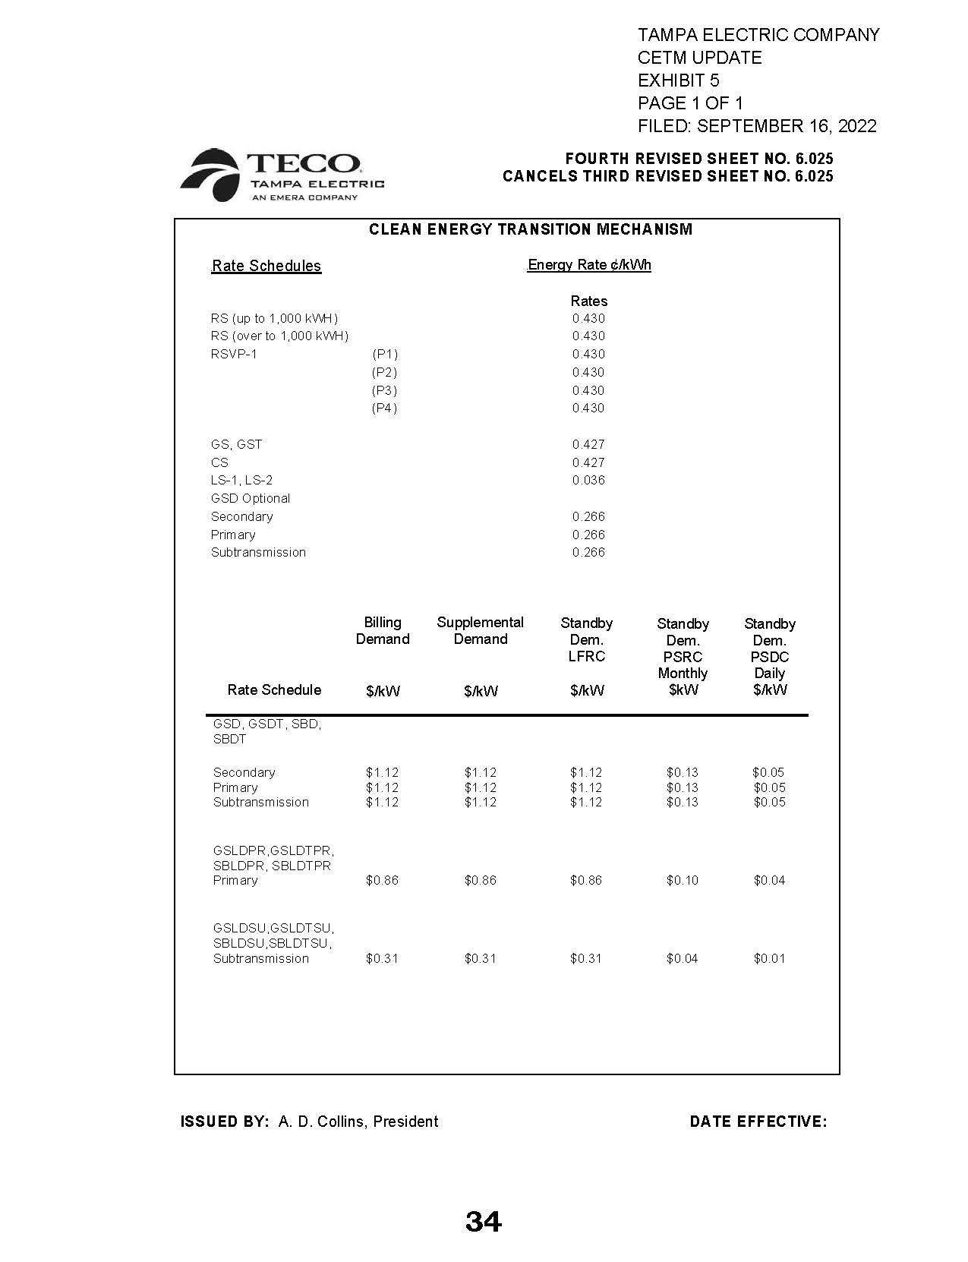

Order No. PSC-2021-0423-S-EI, issued November 10, 2021, in Docket No. 20210034-EI, In re: Petition for rate increase by Tampa Electric Company.
Order No. PSC-2022-0322-FOF-EI, issued September 12, 2022, in Docket No. 20220122-EI, In re: Petition for limited proceeding rate increase to implement return on equity provisions in 2021 agreement, by Tampa Electric Company.
Order No. PSC-2021-0423-S-EI.
Order No. PSC-2022-0322-FOF-EI, issued September 12, 2022, in Docket No. 20220122-EI, In re: Petition for limited proceeding rate increase to implement return on equity provisions in 2021 agreement, by Tampa Electric Company.
Document No. 05237-2022, filed August 5, 2022, in Docket No. 20220002-EI, In re: Energy Conservation Cost Recovery Clause.

