BEFORE THE FLORIDA PUBLIC SERVICE COMMISSION

In re: Petition for approval of safety, access, and facility enhancement program true-up and 2023 cost recovery factors, by Florida City Gas. | DOCKET NO. 20220153-GU  ORDER NO. PSC-2022-0403-TRF-GU  ISSUED: November 21, 2022

The following Commissioners participated in the disposition of this matter:

ANDREW GILES FAY, Chairman
ART GRAHAM
GARY F. CLARK
MIKE LA ROSA
GABRIELLA PASSIDOMO

ORDER APPROVING SAFETY, ACCESS, AND FACILITY ENHANCEMENT PROGRAMS (SAFE) TRUE-UP AND ASSOCIATED COST RECOVERY FACTORS

BY THE COMMISSION:

Background
On September 1, 2022, Florida City Gas (FCG or utility) filed a petition for approval of its safety, access, and facility enhancement program (SAFE) true-up and 2023 cost recovery factors. The SAFE program was originally approved by us in Order No. PSC-15-0390-TRF-GU (2015 order) to recover the cost of relocating on an expedited basis certain existing gas mains and associated facilities from rear lot easements to the street front. In the 2015 order, we found that the relocation of mains and services to the street front provides for more direct access to the facilities and will enhance the level of service provided to all customers through improved safety and reliability. The SAFE factor is a surcharge on customers’ bills.

We ordered the utility to file an annual petition, beginning in 2016, for review and resetting of the SAFE factors to true-up any prior over-or under-recovery and to set the surcharge for the coming year. The SAFE program is a 10-year program that started in 2015 and should finish in 2025. The utility’s annual progress in the SAFE program is shown in Attachment A. The current 2022 SAFE factors were approved by Order No. PSC-2021-0430-TRF-GU (2021 order). The proposed 2023 SAFE factors are shown in Attachment B on Tariff Sheet No. 79, attached to this order.

In the pending rate case, Docket No. 20220069-GU (2022 rate case), FCG has proposed to move the SAFE investment and related expenses as of December 31, 2022, from clause recovery to base rates, in compliance with the 2015 order. Specifically, the 2015 order stated that “…if FCG files a base rate case prior to 2025, the then-current SAFE surcharge program would be folded into any newly approved rate base, and the surcharge would begin anew.” The direct testimony of FCG witness Fuentes filed in the 2022 rate case supports the calculations of the SAFE investments ($42.7 million plant-in-service balance as of December 31, 2022) and $5.7 million transfer of SAFE revenue requirement from SAFE factor recovery to bases rates in the 2023 test year.

Accordingly, the SAFE tariffs provided in the petition, and shown in Attachment B, have been calculated using the assumption that we would approve FCG’s request to roll SAFE investments into rate base. If we have not made a decision in the 2022 rate case prior to the January 1, 2023 effective date of the proposed SAFE factors, then any SAFE revenue requirement not collected in 2023 would be trued-up in the next SAFE filing.

Consistent with the 2015 order, the SAFE program activities would be scheduled to terminate at the end of 2025. However, FCG has proposed in its 2022 rate case to continue the program to replace approximately 150 miles of additional mains and services and to expand the program to replace approximately 160 miles of early vintage polymer pipelines and mains. FCG Witness Howard explains in his direct testimony filed in the rate case that, if approved in the 2022 rate case, FCG will update the SAFE program in its next annual filing in September 2023 for 2024 factors to reflect the continuation and expansion of the SAFE program.

On September 15, 2022, FCG waived the 60-day file and suspend provision of Section 366.06(3), Florida Statutes (F.S.), via an e-mail, which has been placed in the docket file. During the review process of the petition, Commission staff issued one data request and responses were received on October 10, 2022. We have jurisdiction over the matter pursuant to Sections 366.03, 366.04, 366.05, and 366.06 and Chapter 368, F.S.

Decision
Under the SAFE program, FCG was ordered to relocate or replace 254.3 miles of mains and 11,443 associated service lines from rear property easements to the street over a 10-year period, ending in 2025. The utility began its mains and services replacements at the end of 2015. The surcharges have been in effect since January 2016. During 2022, the utility has replaced 36.5 miles of mains and 1,503 services, as shown in Attachment A.

True-ups by Year
As required by the 2015 order, the utility’s calculations for the 2023 revenue requirement and SAFE factors include a final true-up for 2021, and an estimated/actual true-up for 2022, and projected costs for 2023.

Final True-up for 2021
FCG stated that the revenues collected for 2021 were $2,615,885, compared to a revenue requirement of $3,016,838, resulting in an under-recovery of $400,953. Adding the 2020 final over-recovery of $90,225 and the $400,953 under-recovery of 2021, including interest, results in a final 2021 under-recovery of $326,217.

Actual/Estimated 2022 True-up
FCG provided actual revenues for January through June and forecast revenues for July through December 2022, totaling $4,616,422, as compared to a projected revenue requirement of $4,223,438, resulting in over-recovery of $392,984. Adding the 2021 under-recovery of $326,217 to the 2022 over-recovery of $392,984, the resulting total 2022 true-up, including interest, is an over-recovery of $74,528.

Projected 2023 Costs

The utility’s projected investment for 2023 is $11,679,589 for its projects located in Miami-Dade County. The revenue requirement, which includes a return on investment, depreciation, and taxes is $714,310. The return on investment calculation includes federal income taxes, regulatory assessment fees, and bad debt. After adding the 2022 over-recovery of $74,528, the total 2023 revenue requirement is $639,783. Table 1 below displays the projected 2023 revenue requirement calculation.
Table 0
2023 Revenue Requirements Calculation
2023 Projected Investment | $11,679,589
Return on Investment | $466,970
Depreciation Expense | 140,344
Property Tax Expense | 106,996
2023 Revenue Requirement | $714,310
Minus 2022 Over-recovery | $74,528
Total 2023 Revenue Requirement | $639,783
Source: Attachment C of the Petition and Attachment 1 in Response to Commission staff’s First Data Request No. 3

Proposed 2023 SAFE Factors
The SAFE factors are fixed monthly charges. FCG’s cost allocation methodology was approved in the 2015 order and was used in the instant filing. The approved methodology allocates the current cost of a 2-inch pipe to all customers on a per customer basis and allocates the incremental cost of replacing a 4-inch pipe to customers who use over 6,000 therms per year. For customers who require 4-inch pipes, the cost takes into account that the minimum pipe is insufficient to serve their demand, and therefore, allocates an incremental per foot cost in addition to the all-customer cost. The resulting allocation factors are applied to the 2023 total revenue requirement to develop the monthly SAFE factors.

The proposed fixed monthly SAFE factor is $0.44 for customers using less than 6,000 therms per year (current factor is $3.17). The proposed fixed monthly SAFE factor for customers using more than 6,000 therms per year is $0.98 (current factor is $6.39). The proposed 2023 SAFE factors decreased because FCG assumed the SAFE investment as of December 31, 2022 was moved from SAFE factor recovery to base rates and the SAFE factors are beginning anew.

Conclusion
Based on the above, we approve FCG’s proposed SAFE tariff for the period January through December 2023. After reviewing FCG’s filings and supporting documentation, the calculations of the 2023 SAFE factors appear consistent with the methodology approved in the 2015 order and are reasonable and accurate.

Based on the foregoing, it is

ORDERED by the Florida Public Service Commission that Florida City Gas’s proposed SAFE tariff for the period January through December 2023 is hereby approved. It is further

ORDERED that if a protest is filed within 21 days of issuance of the Order, the tariff shall remain in effect with any charges held subject to refund pending resolution of the protest. It is further

ORDERED that if no timely protest is filed, this docket shall be closed upon the issuance of a Consummating Order.

By ORDER of the Florida Public Service Commission this 21st day of November, 2022.

/s/ Adam J. Teitzman
ADAM J. TEITZMAN
Commission Clerk
Florida Public Service Commission
2540 Shumard Oak Boulevard
Tallahassee, Florida 32399
(850) 413-6770
www.floridapsc.com

Copies furnished: A copy of this document is provided to the parties of record at the time of issuance and, if applicable, interested persons.

AAW

NOTICE OF FURTHER PROCEEDINGS

The Florida Public Service Commission is required by Section 120.569(1), Florida Statutes, to notify parties of any administrative hearing or judicial review of Commission orders that is available under Sections 120.57 or 120.68, Florida Statutes, as well as the procedures and time limits that apply. This notice should not be construed to mean all requests for an administrative hearing or judicial review will be granted or result in the relief sought.

Mediation may be available on a case-by-case basis. If mediation is conducted, it does not affect a substantially interested person's right to a hearing.

The Commission's decision on this tariff is interim in nature and will become final, unless a person whose substantial interests are affected by the proposed action files a petition for a formal proceeding, in the form provided by Rule 28-106.201, Florida Administrative Code. This petition must be received by the Office of Commission Clerk, 2540 Shumard Oak Boulevard, Tallahassee, Florida 32399-0850, by the close of business on December 12, 2022.

In the absence of such a petition, this Order shall become final and effective upon the issuance of a Consummating Order.

Any objection or protest filed in this docket before the issuance date of this order is considered abandoned unless it satisfies the foregoing conditions and is renewed within the specified protest period.

Table 1
Florida City Gas’s SAFE Program Progress
 | Main Replacements |  | Service Replacements
Year* | Replaced Main (miles) | Total Miles Remaining | Replaced Services (number) | Total Remaining Services
2014 | 0.0 | 254.3 | 0 | 11,443
2015 | 0.0 | 254.3 | 49 | 11,394
2016 | 17.1 | 237.2 | 1,433 | 9,961
2017 | 37.5 | 199.7 | 1,551 | 8,410
2018 | 27.6 | 172.1 | 1,634 | 6,776
2019 | 37.8 | 134.3 | 1,183 | 5,593
2020 | 25.5 | 108.8 | 1,186 | 4,407
2021 | 26.0 | 82.8 | 1,105 | 3,302
2022 | 36.5 | 46.4 | 1,503 | 1,799
2023 | 12.8 | 33.6 | 671 | 1,128
2024 | 16.8 | 16.8 | 564 | 564
2025 | 16.8 | 0.0 | 564 | 0

Source: Attachment A to the petition.
*Actuals 2014-July 2022. Projections August 2022-2025.

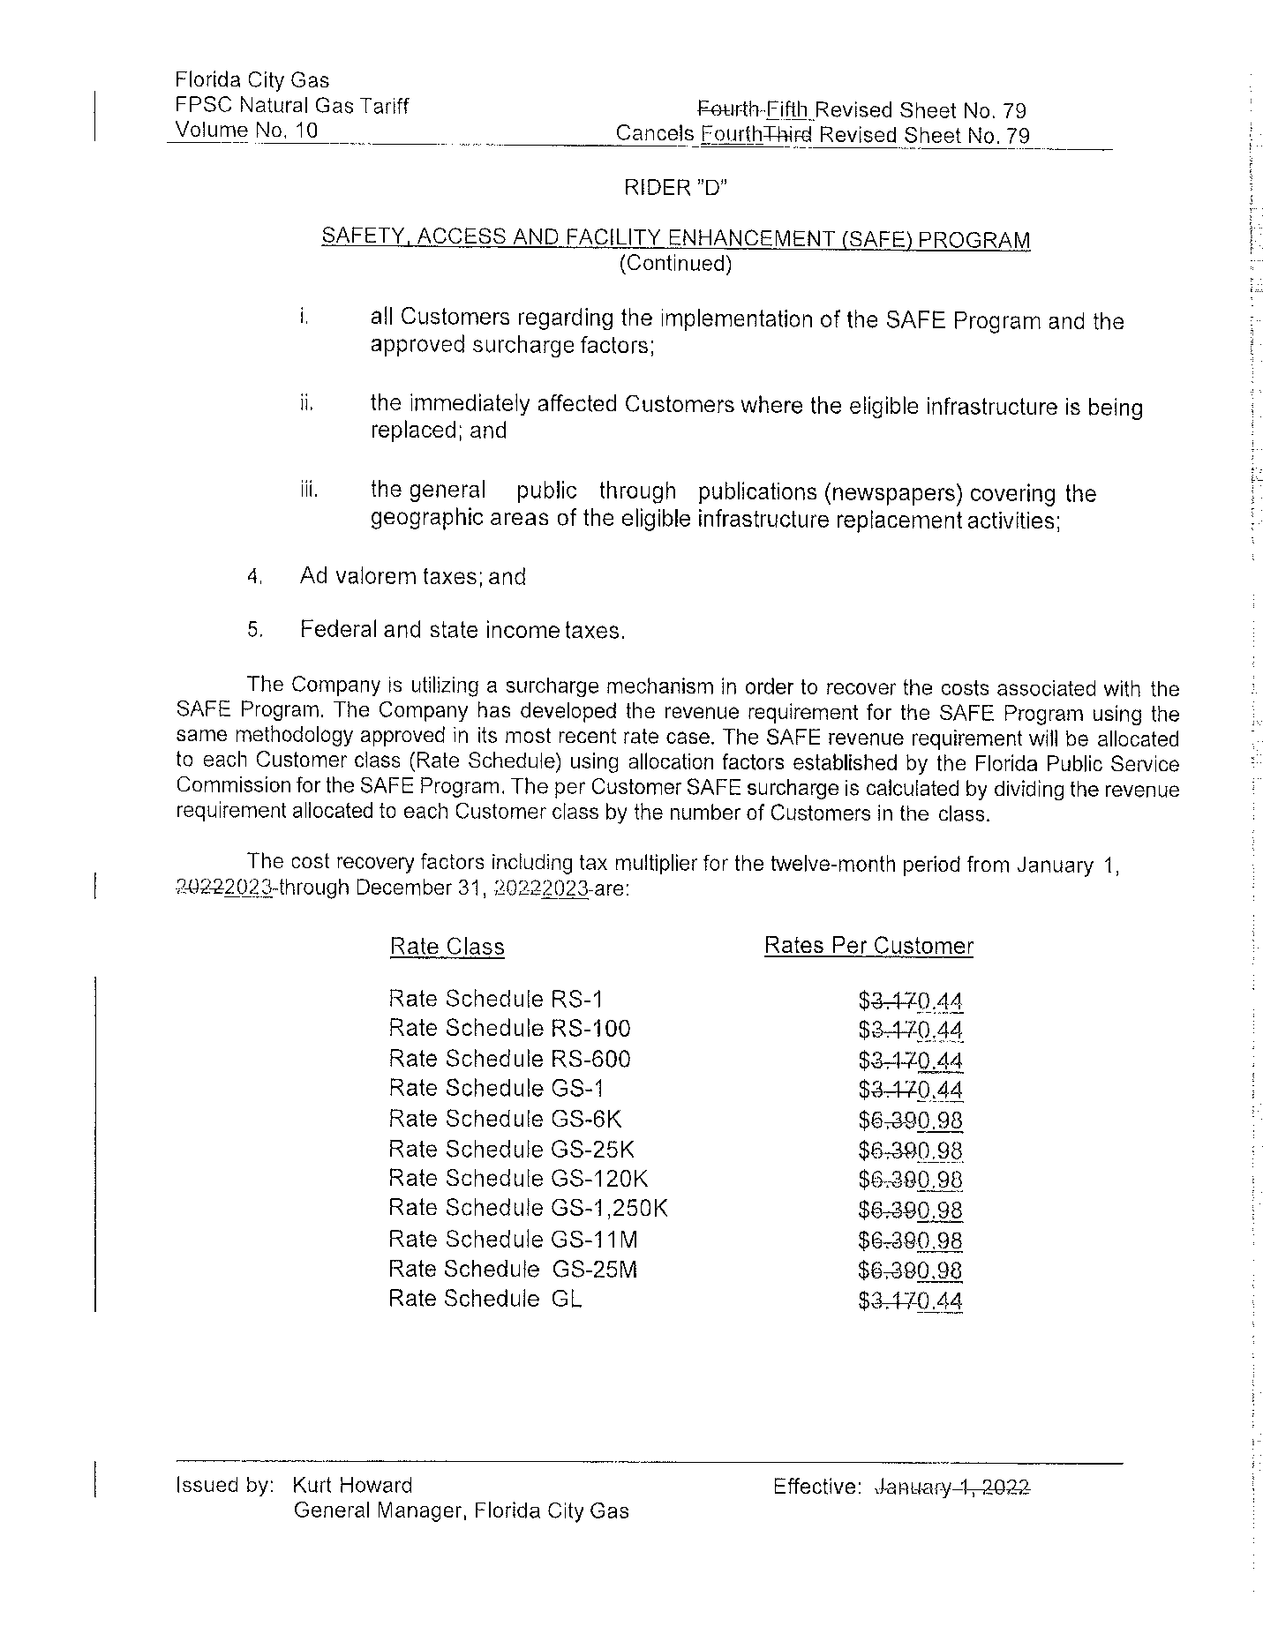

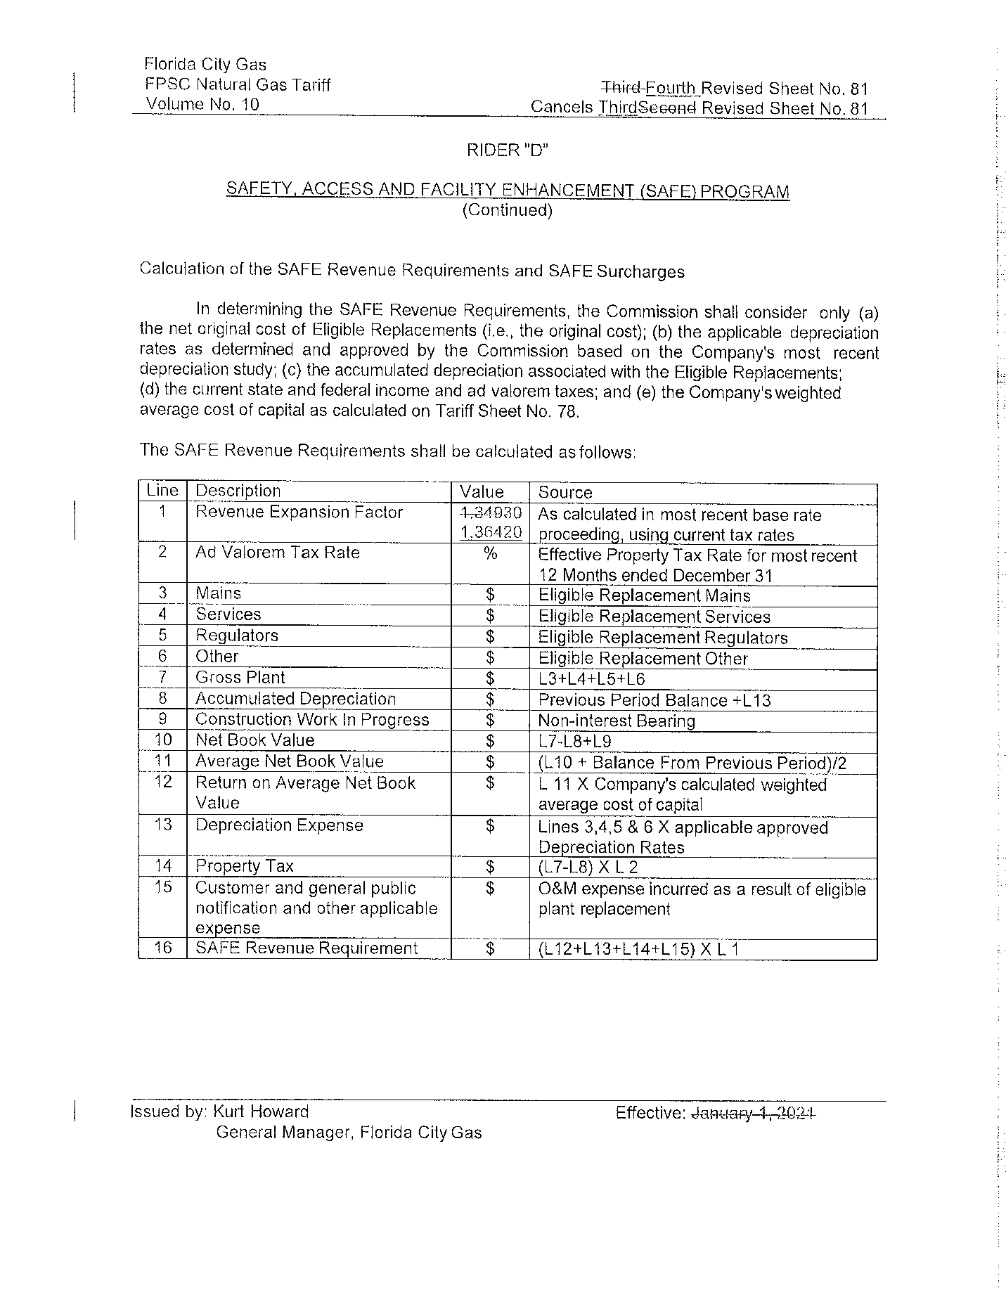

Order No. PSC-15-0390-TRF-GU, issued September 15, 2015, in Docket No. 20150116-GU, In re: Petition for approval of safety, access, and facility enhancement program and associated cost recovery methodology, by Florida City Gas.
Order No. PSC-2021-0430-TRF-GU, issued November 19, 2021, in Docket No. 20210149-GU, In re: Petition for approval of safety, access, and facility enhancement program true-up and 2022 cost recovery factors, by Florida City Gas.
Docket No. 20220069-EI, In re: Petition for approval of rate increase and request for approval of depreciation rates, filed May 31, 2022.
See Page No. 4 of Order No. PSC-15-0390-TRF-GU.
See direct testimony of Kurt S. Howard, Page Nos. 34-37 (DN 03277-2022) filed in Docket No. 20220069-GU.
The calculation also includes a December 2020 true-up of $7,789 booked in January 2021 plus a December 2021 true-up credit of $7,690.

