State of Florida |  | Public Service Commission  Capital Circle Office Center ● 2540 Shumard Oak Boulevard  Tallahassee, Florida 32399-0850  -M-E-M-O-R-A-N-D-U-M-
DATE: | September 22, 2022 November 22, 2022
TO: | Office of Commission Clerk (Teitzman)
FROM: | Division of Economics (Forrest, Draper)  Division of Accounting and Finance (Gatlin, Norris)  Division of Engineering (Ellis, Phillips)  Office of the General Counsel (Stiller, Crawford)
RE: | Docket No. 20220148-EI – Petition to implement 2023 generation base rate adjustment provisions in 2021 agreement, by Tampa Electric Company.
AGENDA: | 10/04/22 12/06/22 – Regular Agenda – Tariff Filing – Interested Persons May Participate
COMMISSIONERS ASSIGNED: |  |  | All Commissioners
PREHEARING OFFICER: |  |  | Administrative
CRITICAL DATES: |  |  | 10/25/22 (60-Day Suspension Date)  04/26/23 (8-Month Effective Date)
SPECIAL INSTRUCTIONS: |  |  | None

Case Background
On August 26, 2022, Tampa Electric Company (TECO or Company) filed a petition to implement the 2023 Generation Base Rate Adjustment (GBRA) provisions in its 2021 rate case Stipulation and Settlement Agreement (settlement agreement). The Commission previously approved the settlement agreement in Order No. PSC-2021-0423-S-EI (settlement order). The GBRA provisions of the settlement agreement provide for an increase in base rates to reflect the 2023 GBRA amount of $89,754,622, effective with the first billing cycle of January 2023. In this petition, TECO proposed to increase the GBRA amount to $91,011,994, to reflect the increased return on equity (ROE) allowed by a trigger provision of the 2021 settlement agreement and approved by the Commission on August 16, 2022, in Docket No. 20220122-EI.
This item was deferred from the October 4, 2022 Agenda Conference to give the Company time to update its request to reflect the impact of the Inflation Reduction Act of 2022 (IRA). The Company now has indicated it is in the process of updating the 2023 GBRA and is in discussions with the Office of Public Counsel about its proposed update. The Company is requesting the Commission consider staff’s recommendation now so the 2023 GBRA can go into effect with the first billing cycle of January 2023. The Company agrees to collect the rate increase reflected in the 2023 GBRA subject to refund. The Company will refund the difference between the 2023 GBRA, as reflected in the Original Petition and staff’s recommendation, and the 2023 GBRA as adjusted for the IRA, once the 2023 GBRA adjusted for the IRA has been approved by the Commission.

On October 10, 2022, TECO filed a letter in the docket file waiving the 60-day file and suspend provision of Section 366.06(3), Florida Statutes (F.S.). The Commission has jurisdiction over this matter pursuant to Section 366.076, Florida Statutes (F.S.). F.S.

Discussion of Issues

Issue 1:
Should the Commission approve the updated GBRA amount of $91,011,994?

Recommendation:
Yes, the updated 2023 GBRA amount of $91,011,994 should be approved. (Gatlin, Norris)

Staff Analysis:
As discussed in the Case Background, subparagraphs 4(a) and (b) of the 2021 settlement agreement provide that TECO’s base rates will increase by $89,754,622 effective with the first billing cycle in January 2023. The calculation of this GBRA amount was based on the authorized return on equity (ROE) mid-point of 9.95 percent as specified in subparagraph 2(a). However, subparagraph 4(d) states that if the Company’s authorized ROE mid-point changes by operation of subparagraph 2(b) prior to the effective date of the rate adjustment specified in subparagraph 4(b), the calculation of the 2023 GBRA amount shall be updated to reflect the new authorized ROE.
As memorialized in Order No. PSC-2022-0322-FOF-EI, the Commission approved TECO’s petition to implement the ROE trigger provisions of subparagraph 2(b) of the 2021 settlement agreement following an evidentiary hearing on August 16, 2022. As a result, the Company’s authorized ROE midpoint was increased by 25 basis points from 9.95 percent to 10.20 percent, effective as of July 1, 2022, for all regulatory purposes. In its petition to implement the 2023 GBRA, TECO provided a calculation updating the GBRA amount to $91,011,994 to reflect the Company’s 10.20 percent authorized ROE mid-point. Staff reviewed the Company’s calculation and recommends the updated amount be approved.

Issue 2:
Should the Commission approve TECO’s revised tariffs to implement the GBRA increase effective January 2023?

Recommendation:
Yes, the Commission should approve TECO’s revised tariffs to implement the GBRA increase effective with the first billing cycle of January 2023 as approved in the settlement order. (Draper)

Staff Analysis:
TECO’s petition includes the proposed tariff sheets, the allocation of the revenue increase to the various rate classes and calculations showing the revenue from the sale of electricity by rate schedule under current and proposed rates. A residential customer who uses 1,000 kilowatt-hours (kWh) per month will see an increase of $6.76 on the base rate portion of their monthly bill as a result of the GBRA increase.
Subparagraph 4(e) of the settlement agreement, which addresses the GBRA increase and was approved by Order No. PSC-2021-0423-S-EI, states:
… the GBRAs shall be reflected on customer bills by allocating each GBRA revenue requirement to rate classes as shown in Exhibit K and demand and energy base rate charges shall be increased on an equal percentage basis (to the extent practicable) within each class to recover the allocated revenue requirement increase for each class, and shall be calculated based upon the billing determinants used in the company’s then-most-current-ECCR filing with the Commission for the twelve months following the effective date of any respective GBRA. For GSD, GSLDPR, and GSLDSU rate classes, the increase will be recovered exclusively based on demand charges.
TECO’s most current Energy Conservation Cost Recovery Clause (ECCR) filing in Docket No. 20220002-EI was filed on August 5, 2022. Staff has confirmed that the billing determinants used in calculating the proposed GBRA base rate charges are consistent with the billing determinants in TECO’s most recent ECCR filing, and in compliance with the language of the settlement agreement.
Staff has also reviewed TECO’s proposed 2023 GBRA tariff sheets and supporting documentation. The calculations are accurate and reflect the language of the approved settlement agreement. The Commission should approve TECO’s tariff rate changes to implement the updated GBRA increase of $91,011,994, due to the ROE trigger provision in the settlement agreement. Pursuant to the settlement order, the rate changes should become effective with the first billing cycle of January 2023. TECO should notify its customers of the approved new rates, by way of bill notification, in the December 2022 billing cycle.

Issue 3:
Should this docket be closed?

Recommendation:
If Issues 1 and 2 are approved and a protest is filed within 21 days of the issuance of the order, the tariffs should remain in effect, with any revenues held subject to refund, pending resolution of the protest. If no timely protest is filed, this docket should be closed upon the issuance of a consummating order. (Stiller)

Staff Analysis:
If Issues 1 and 2 are approved and a protest is filed within 21 days of the issuance of the order, the tariffs should remain in effect, with any revenues held subject to refund, pending resolution of the protest. If no timely protest is filed, this docket should be closed upon the issuance of a consummating order.

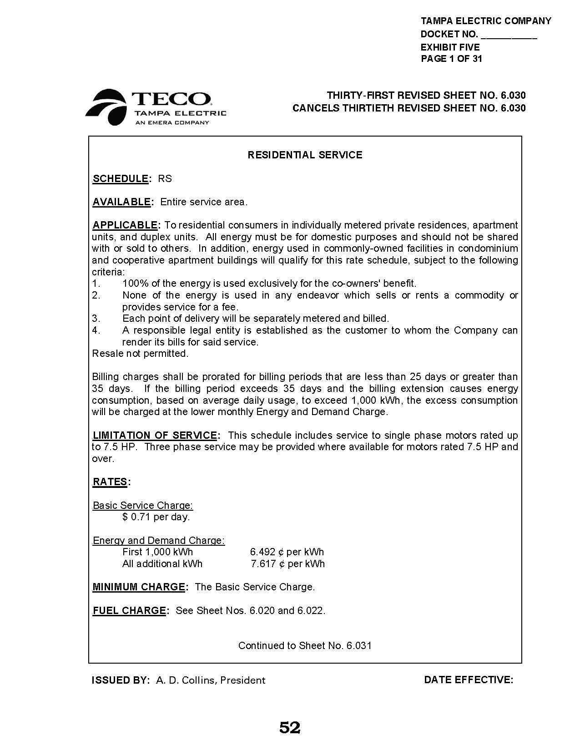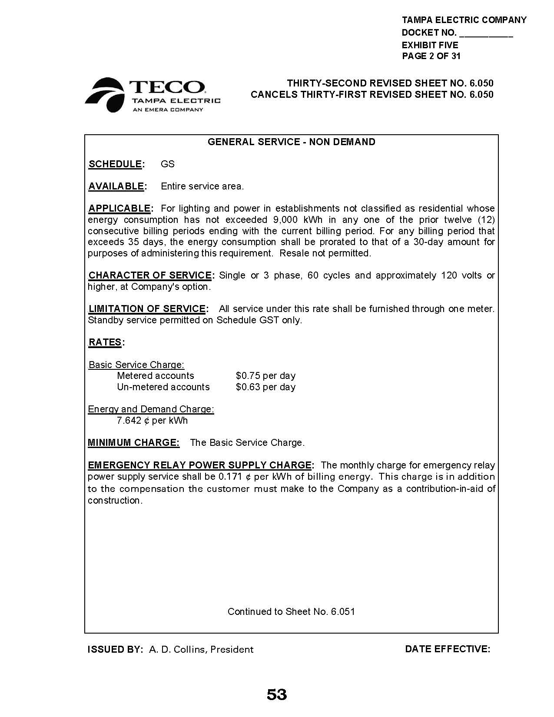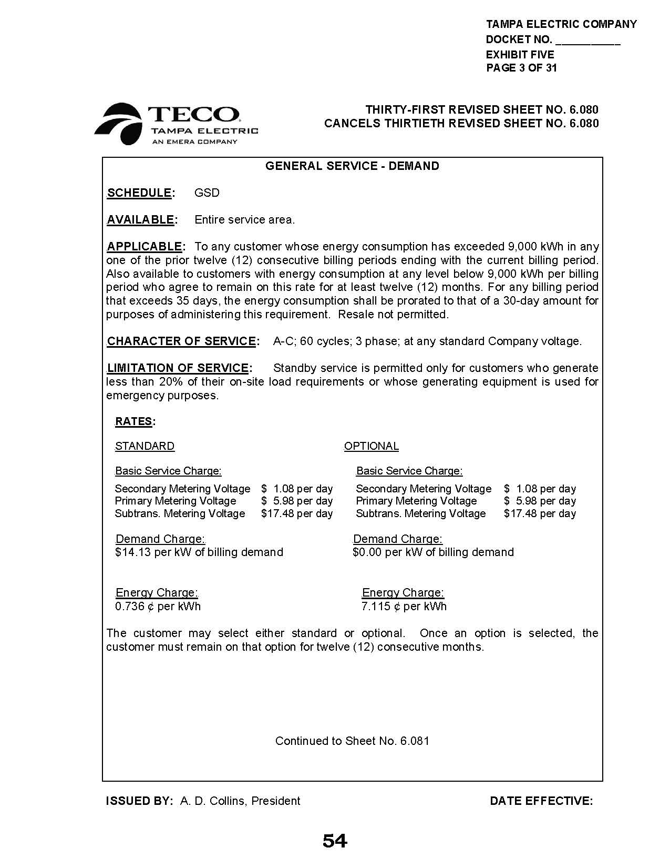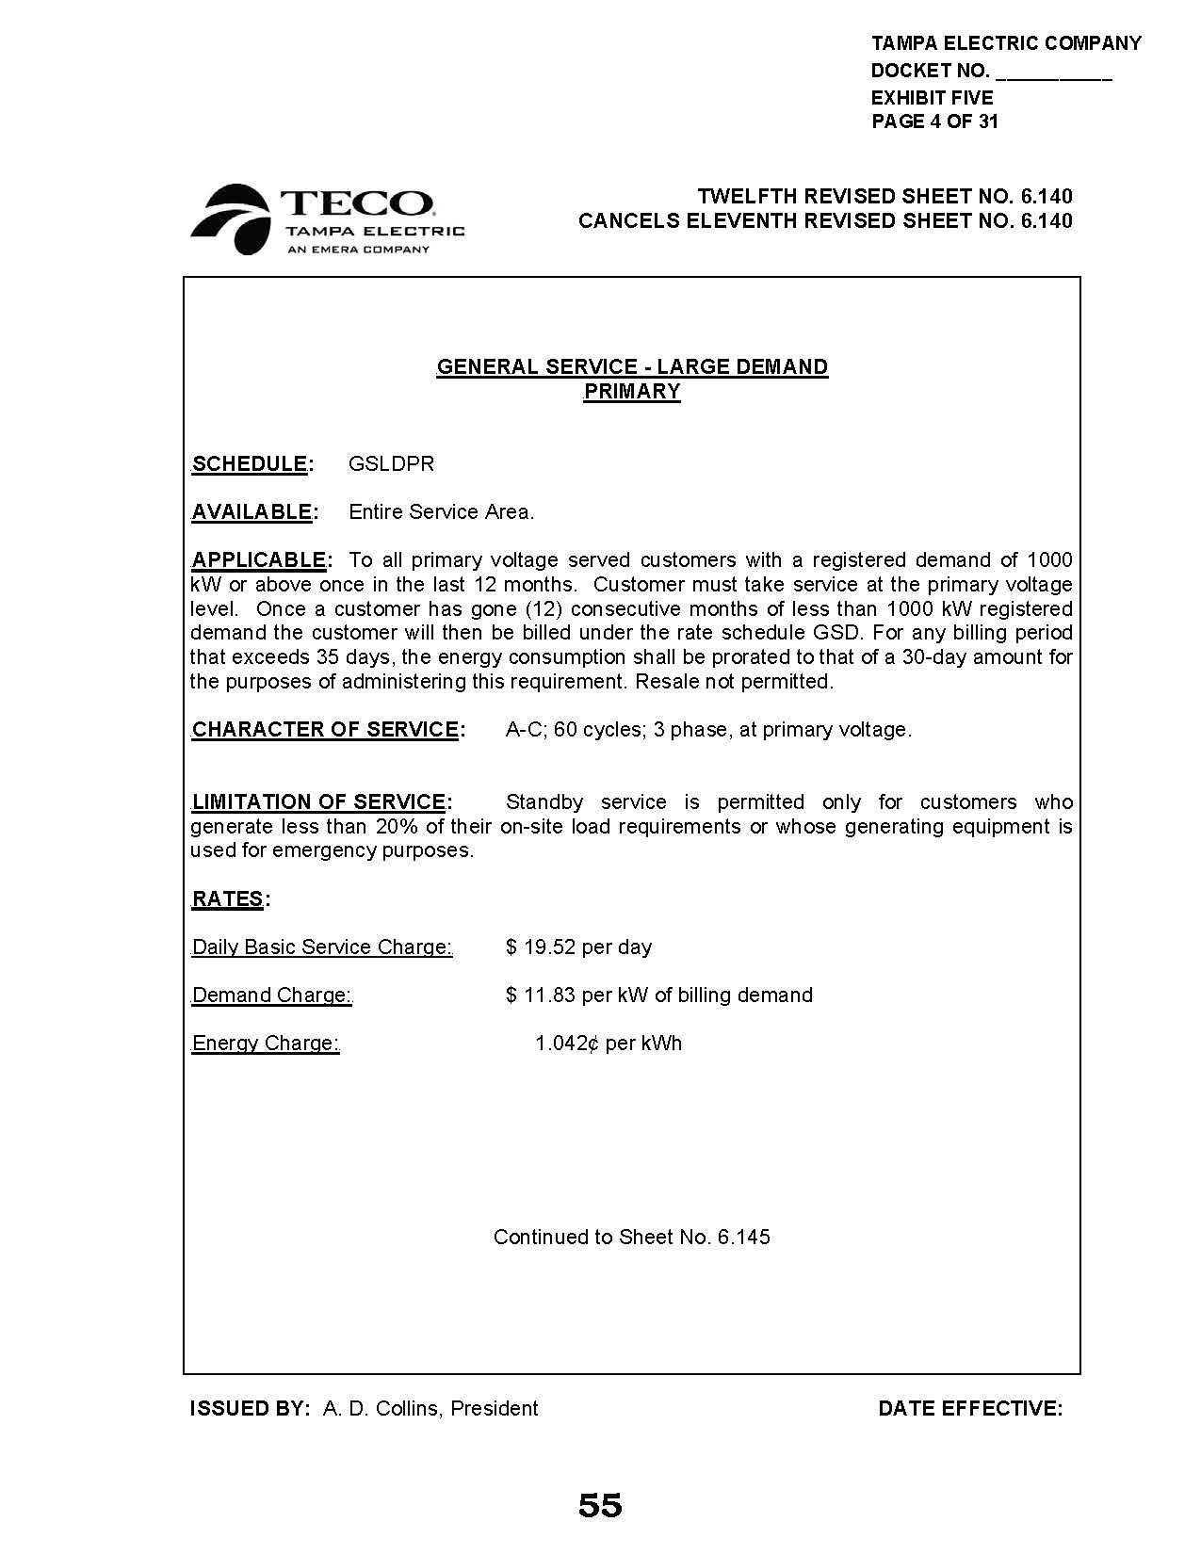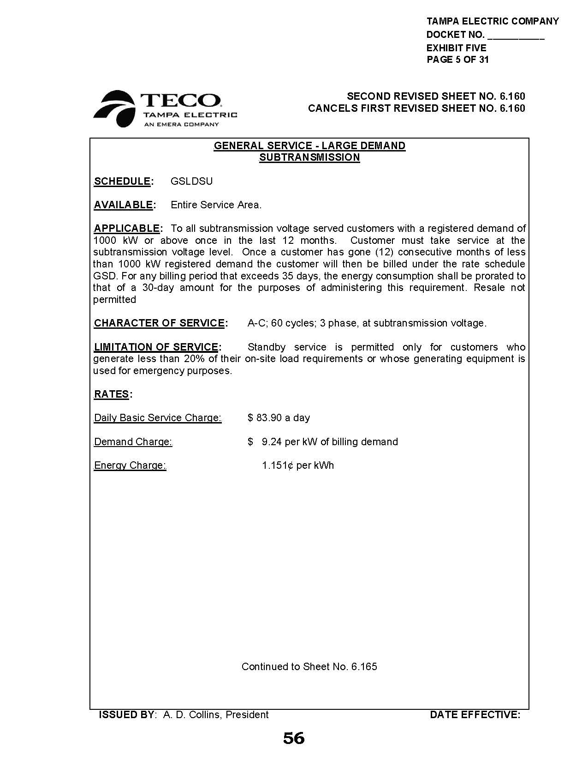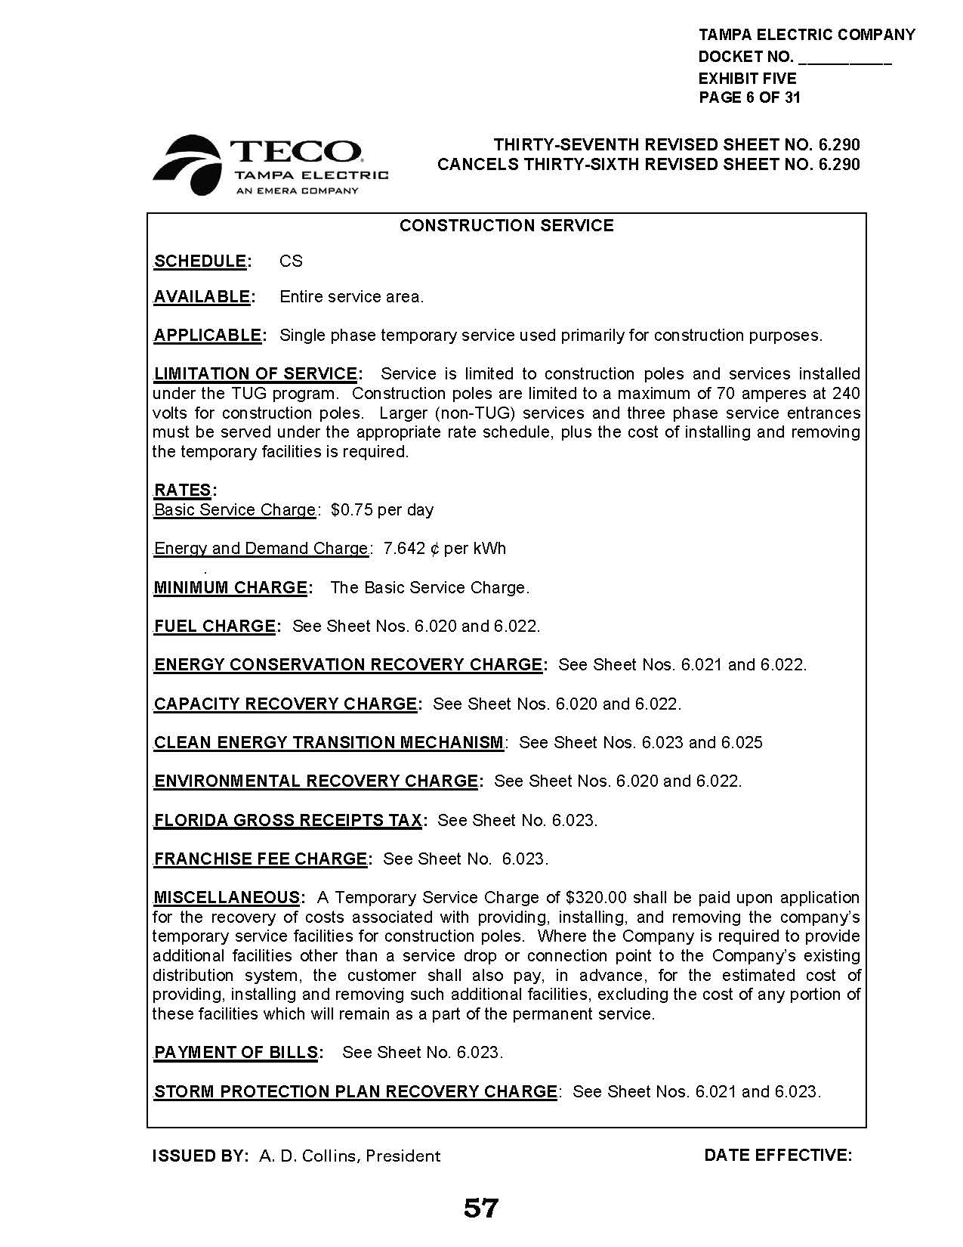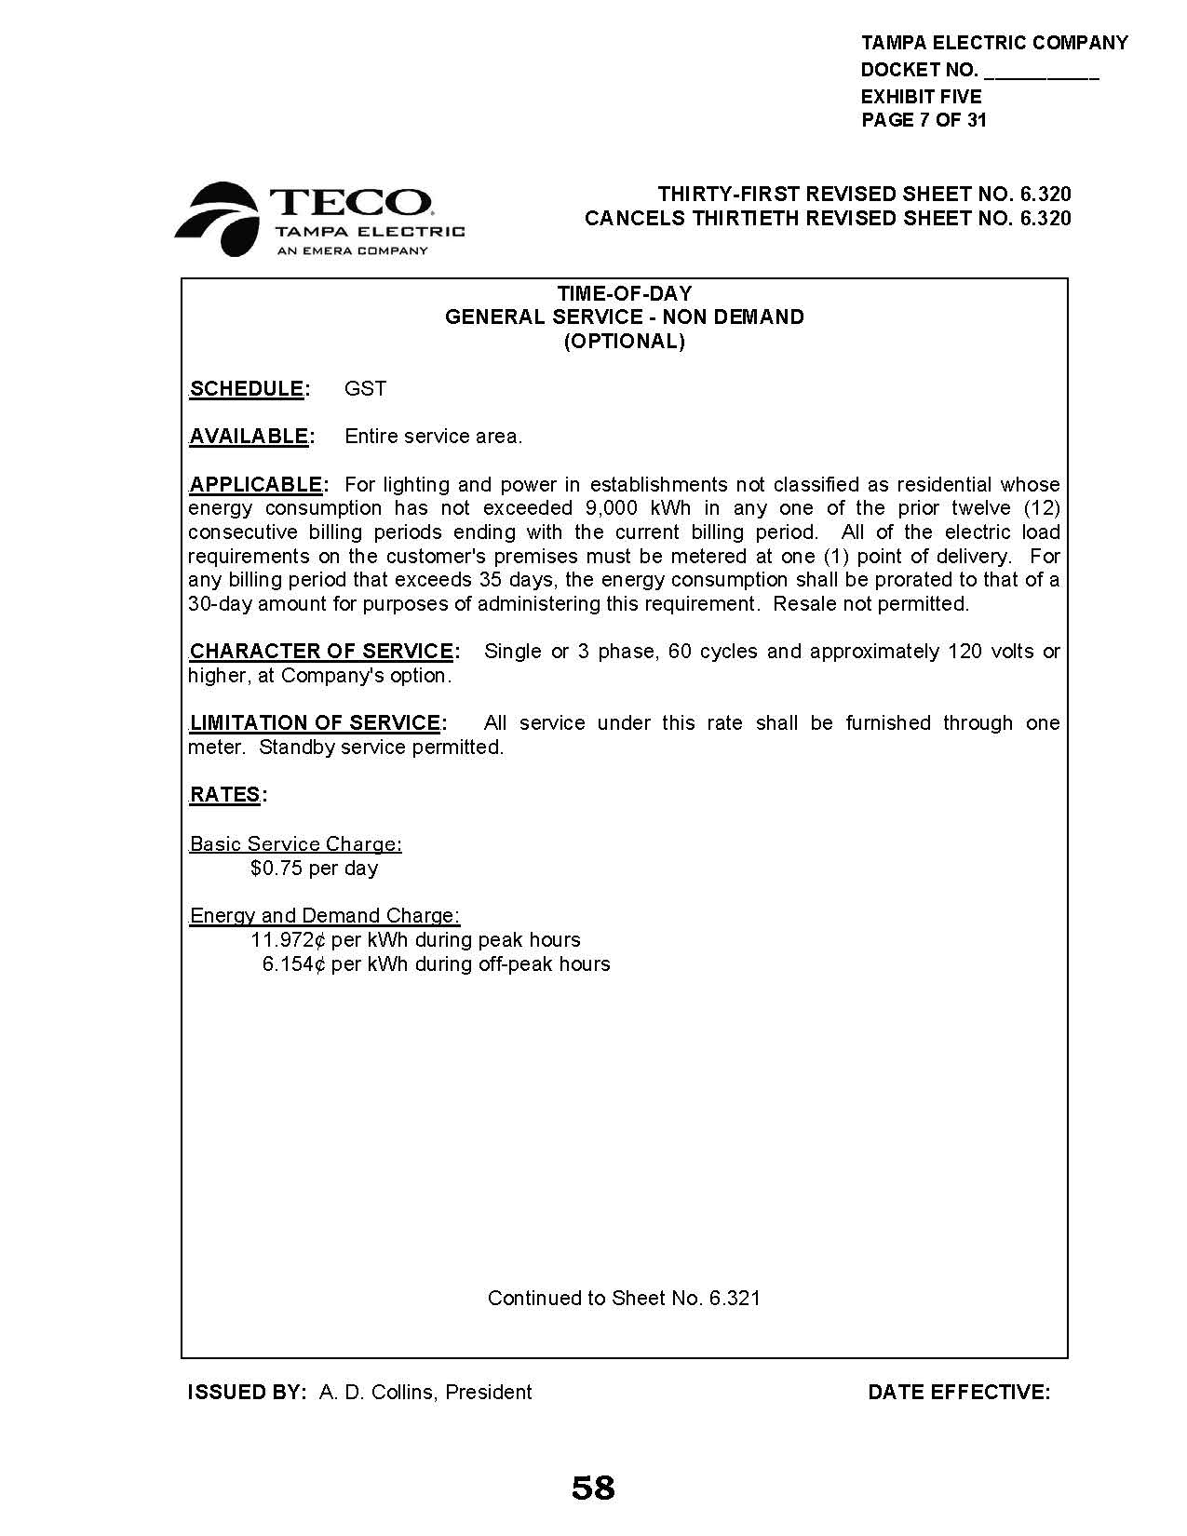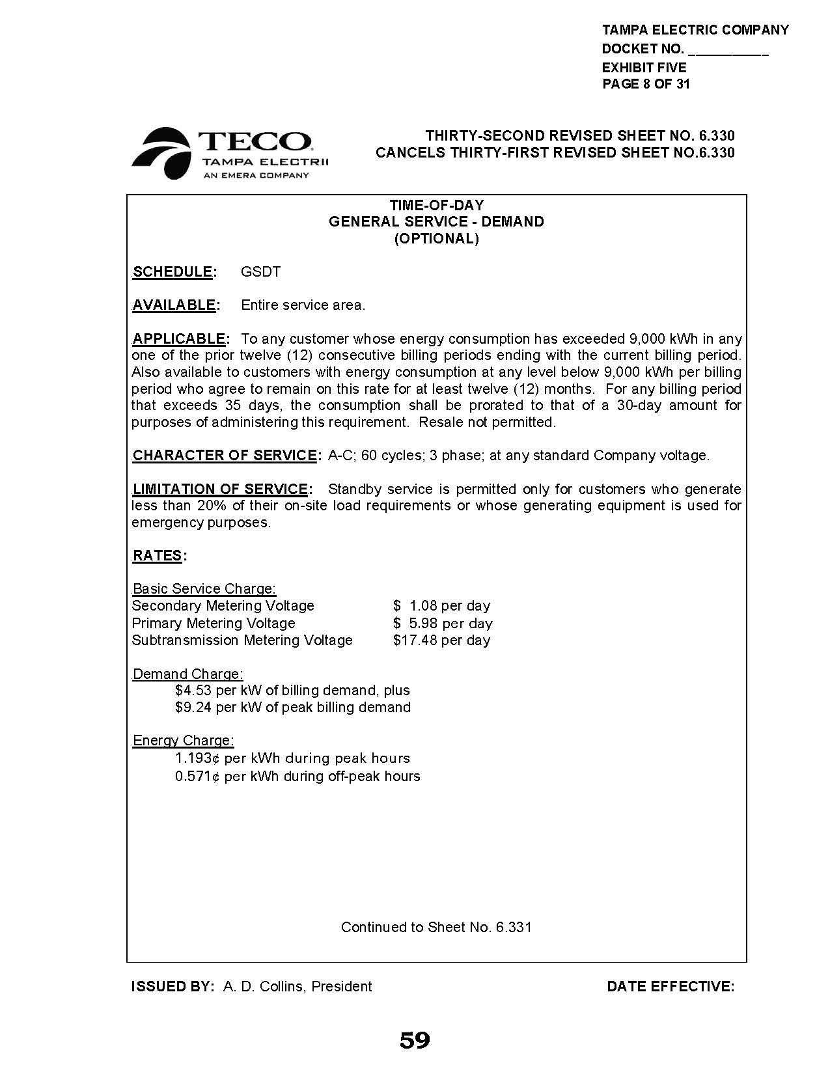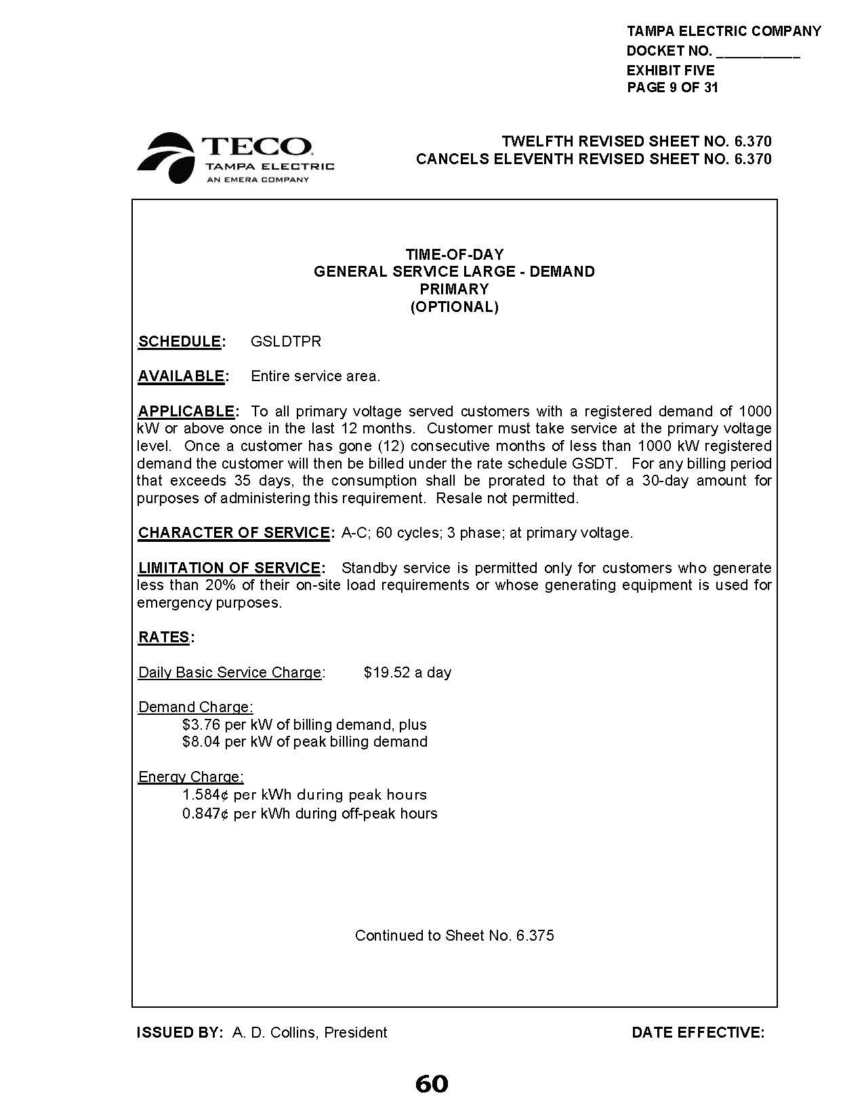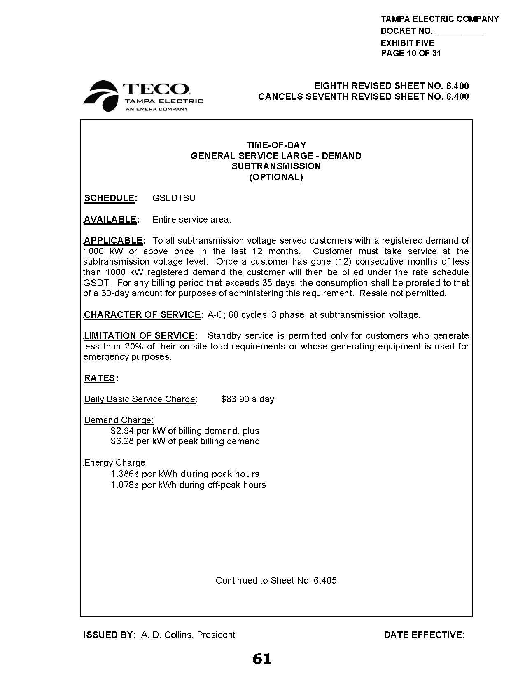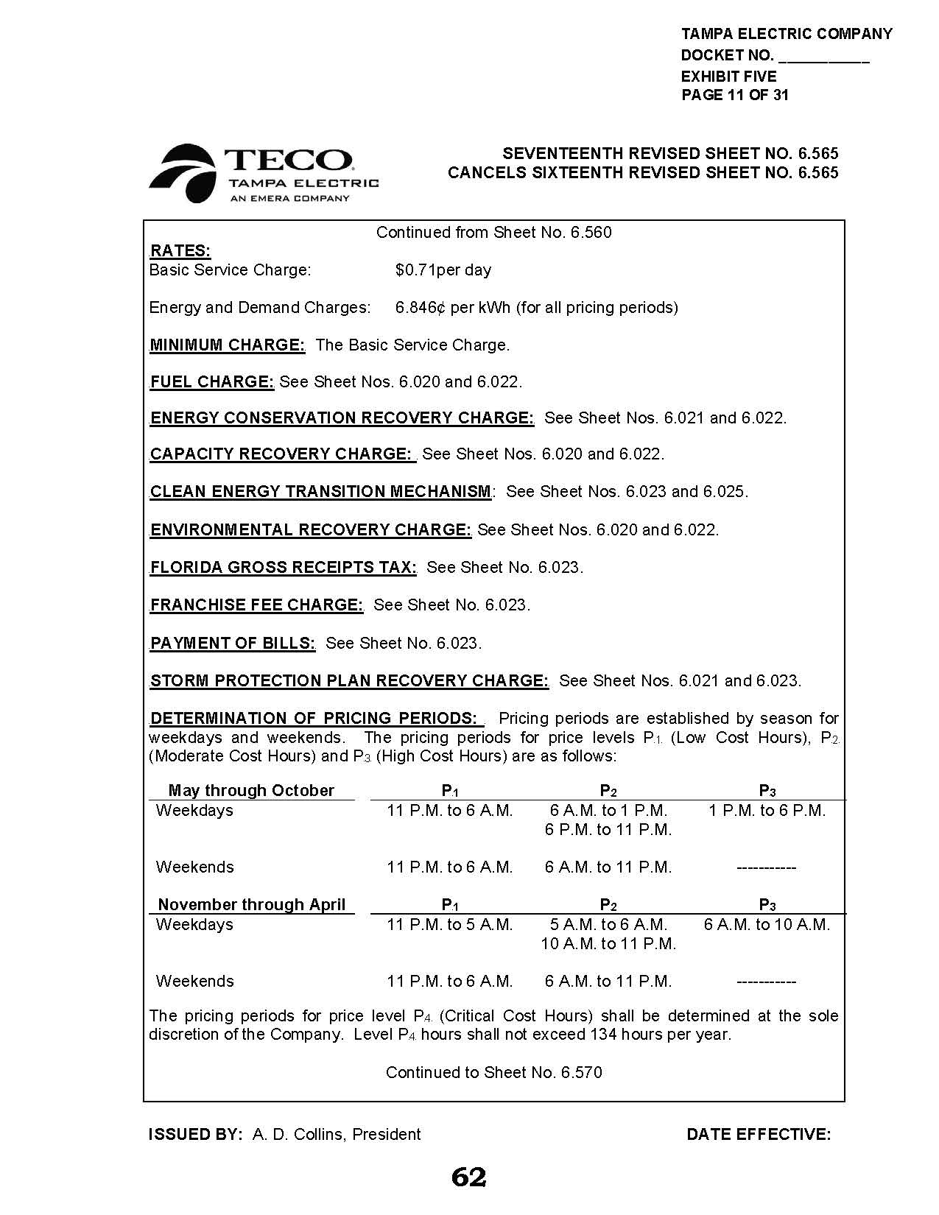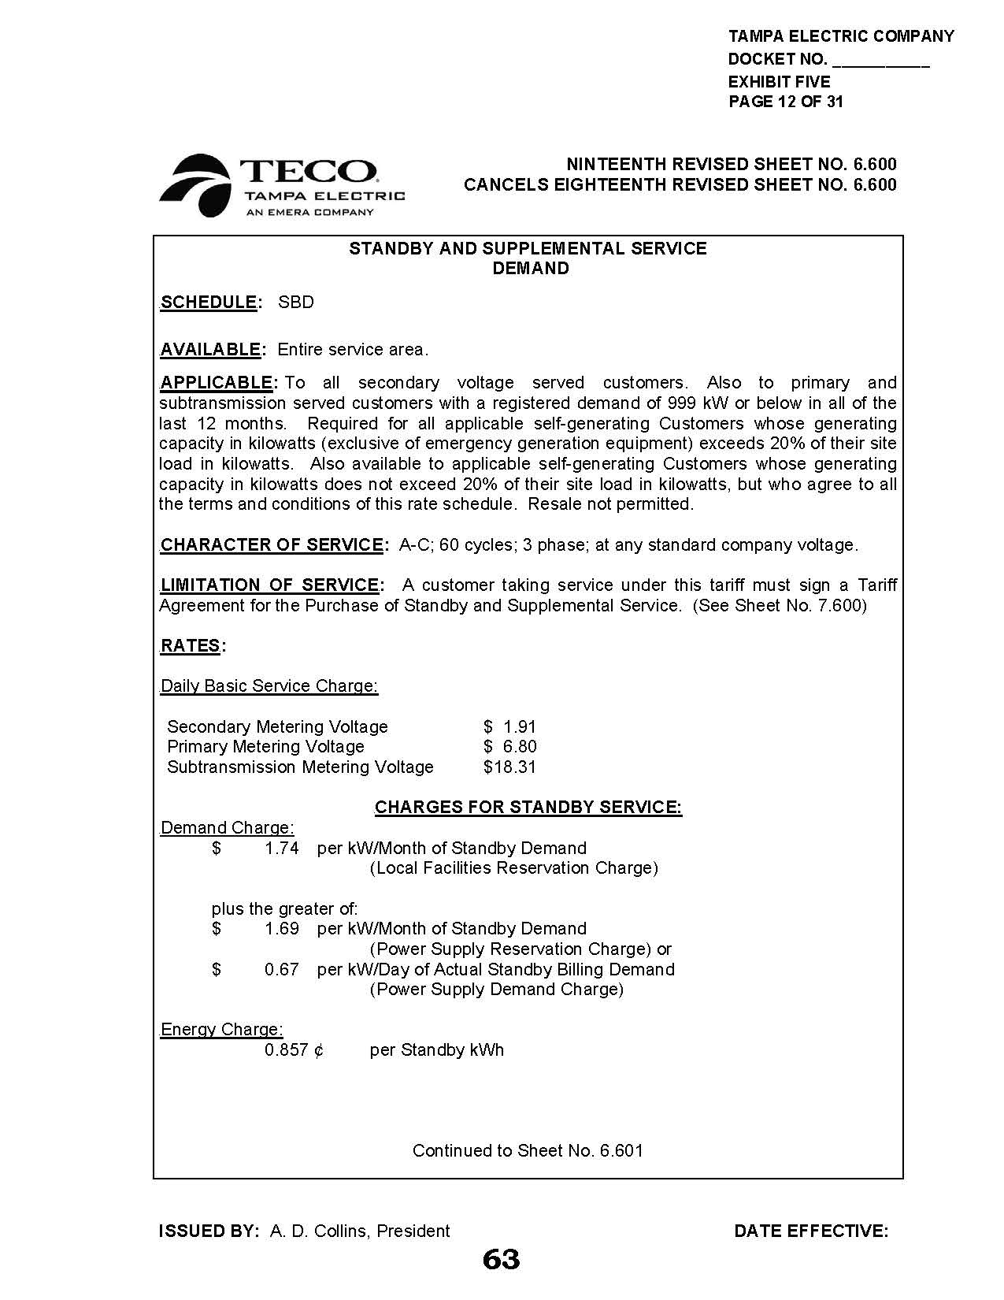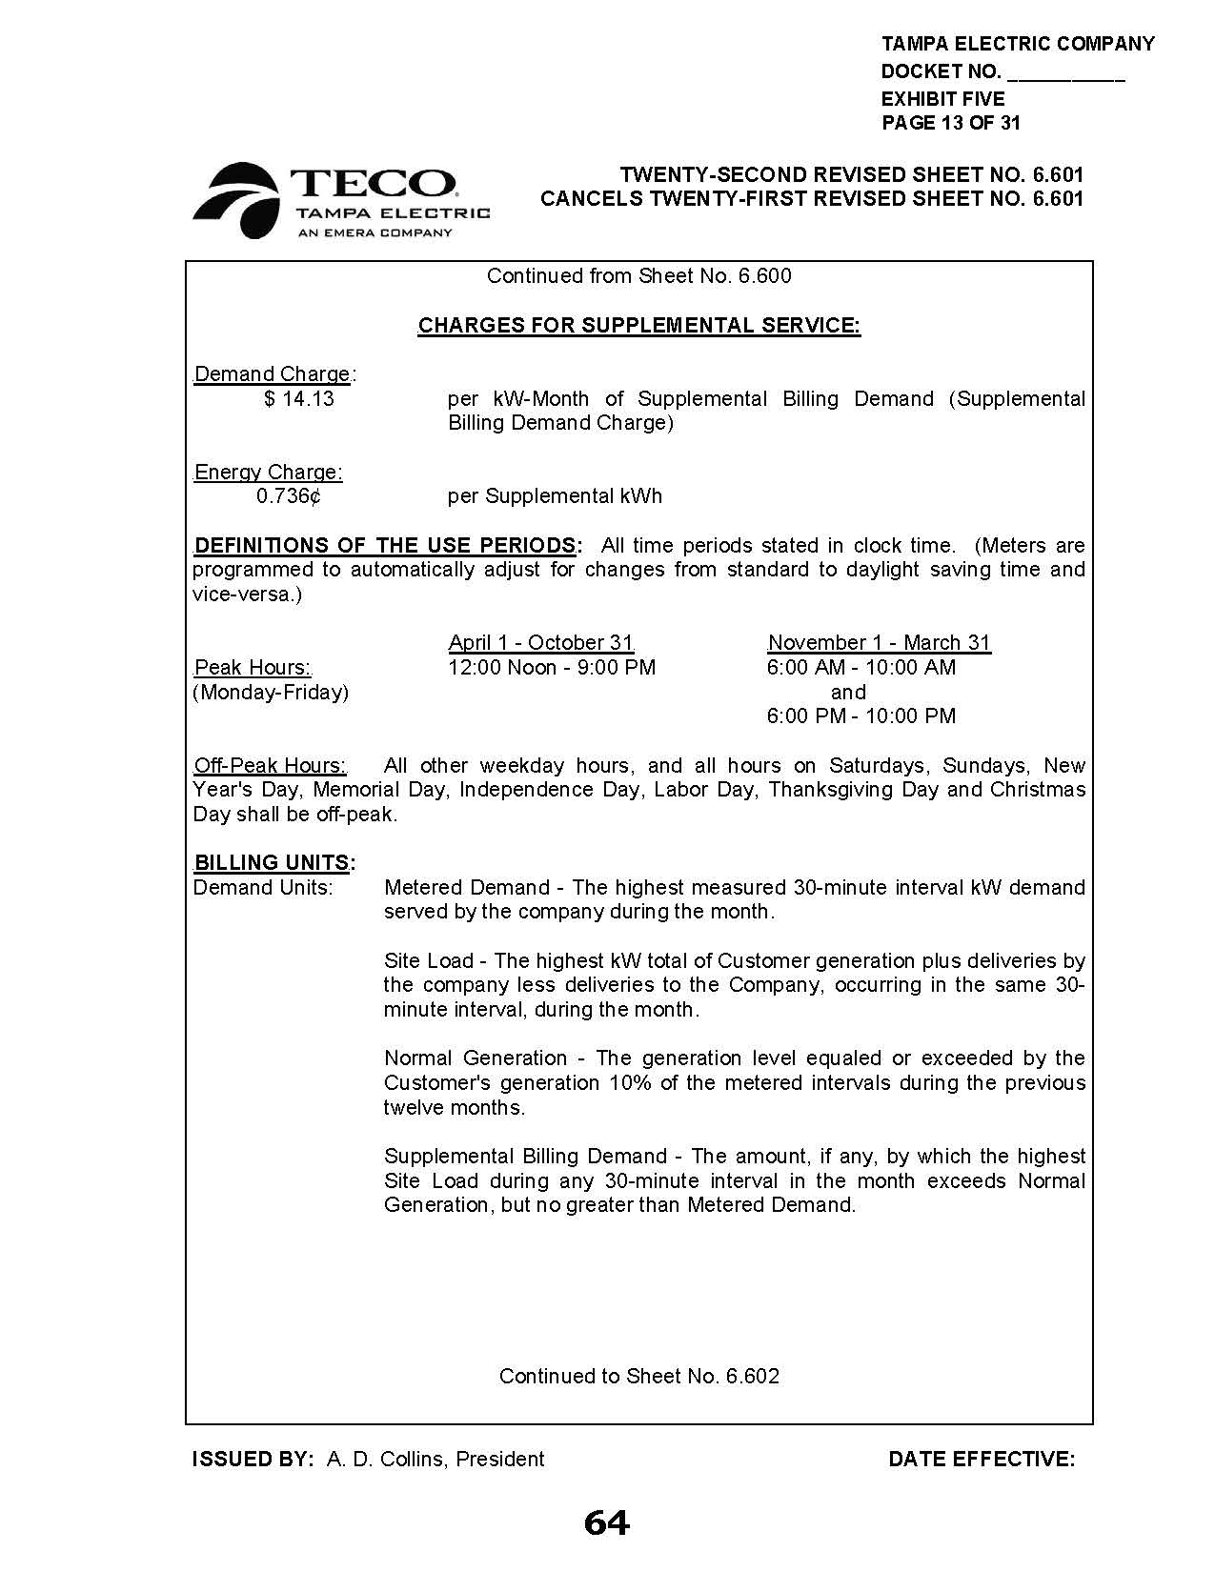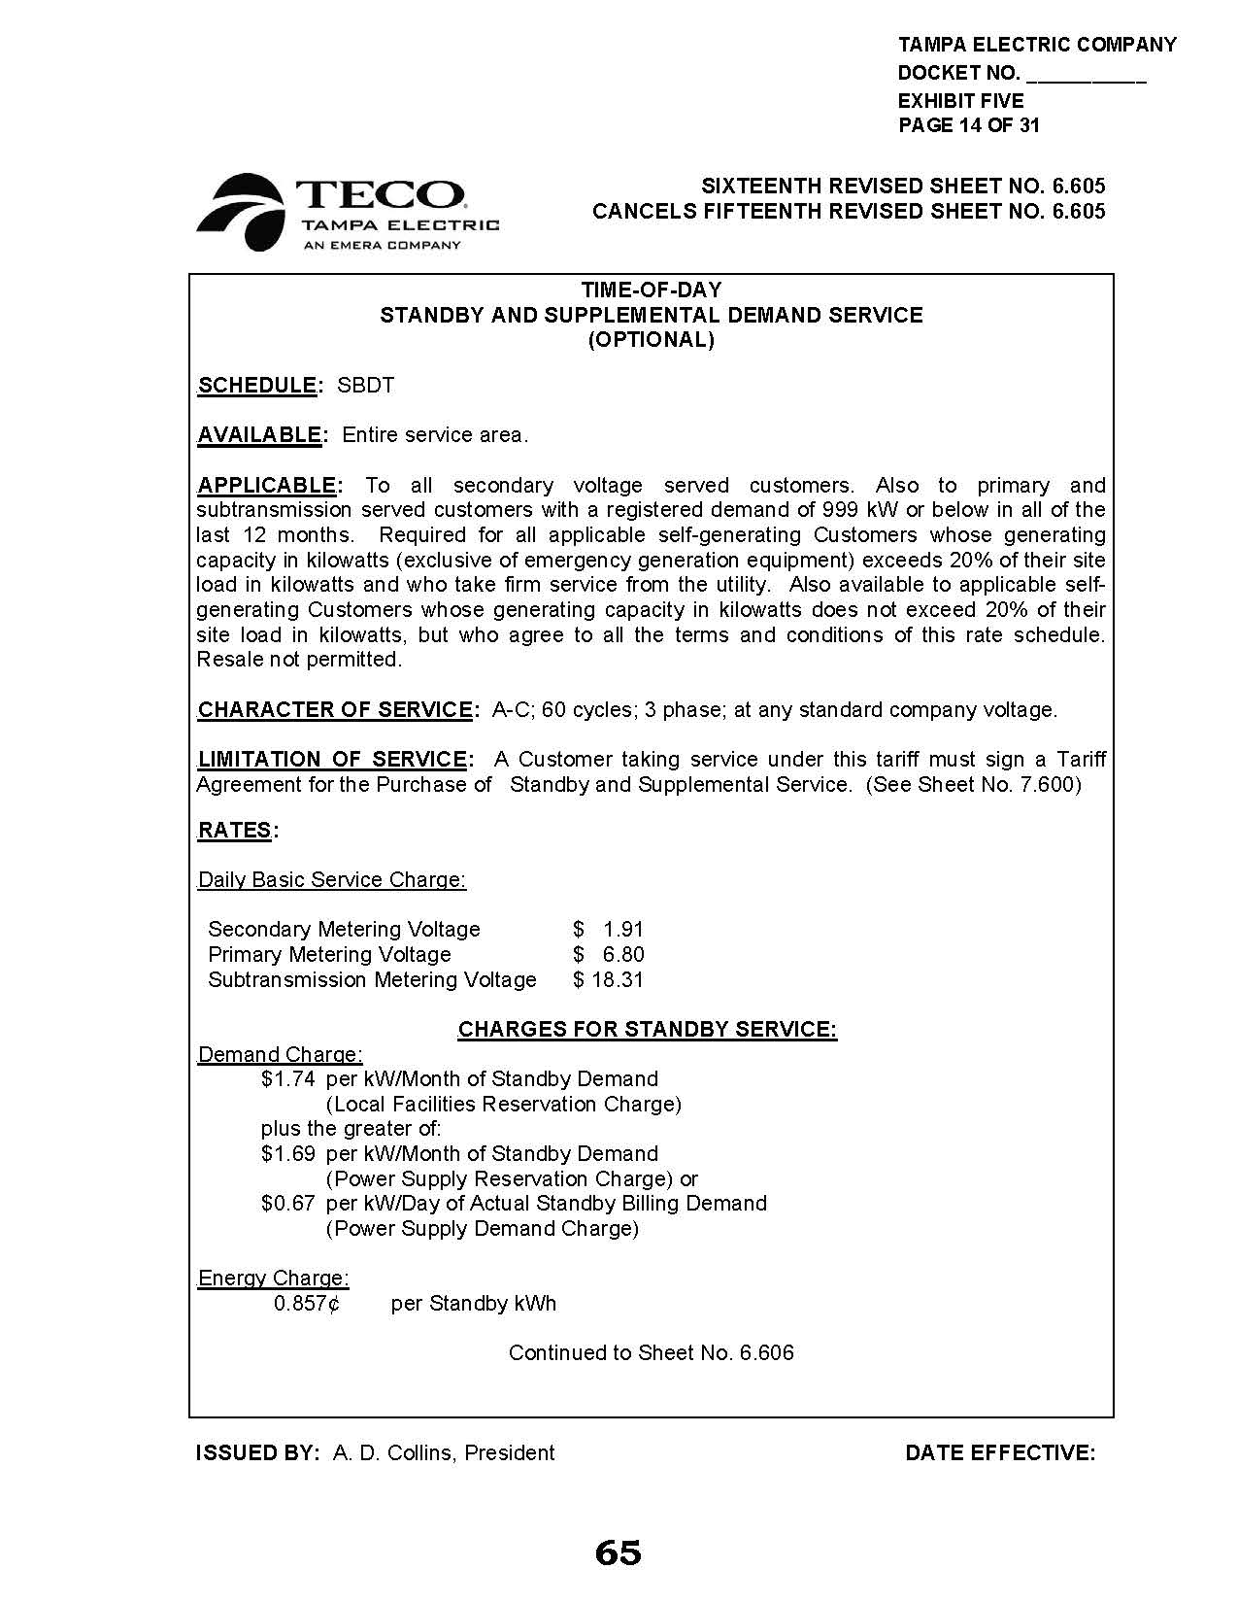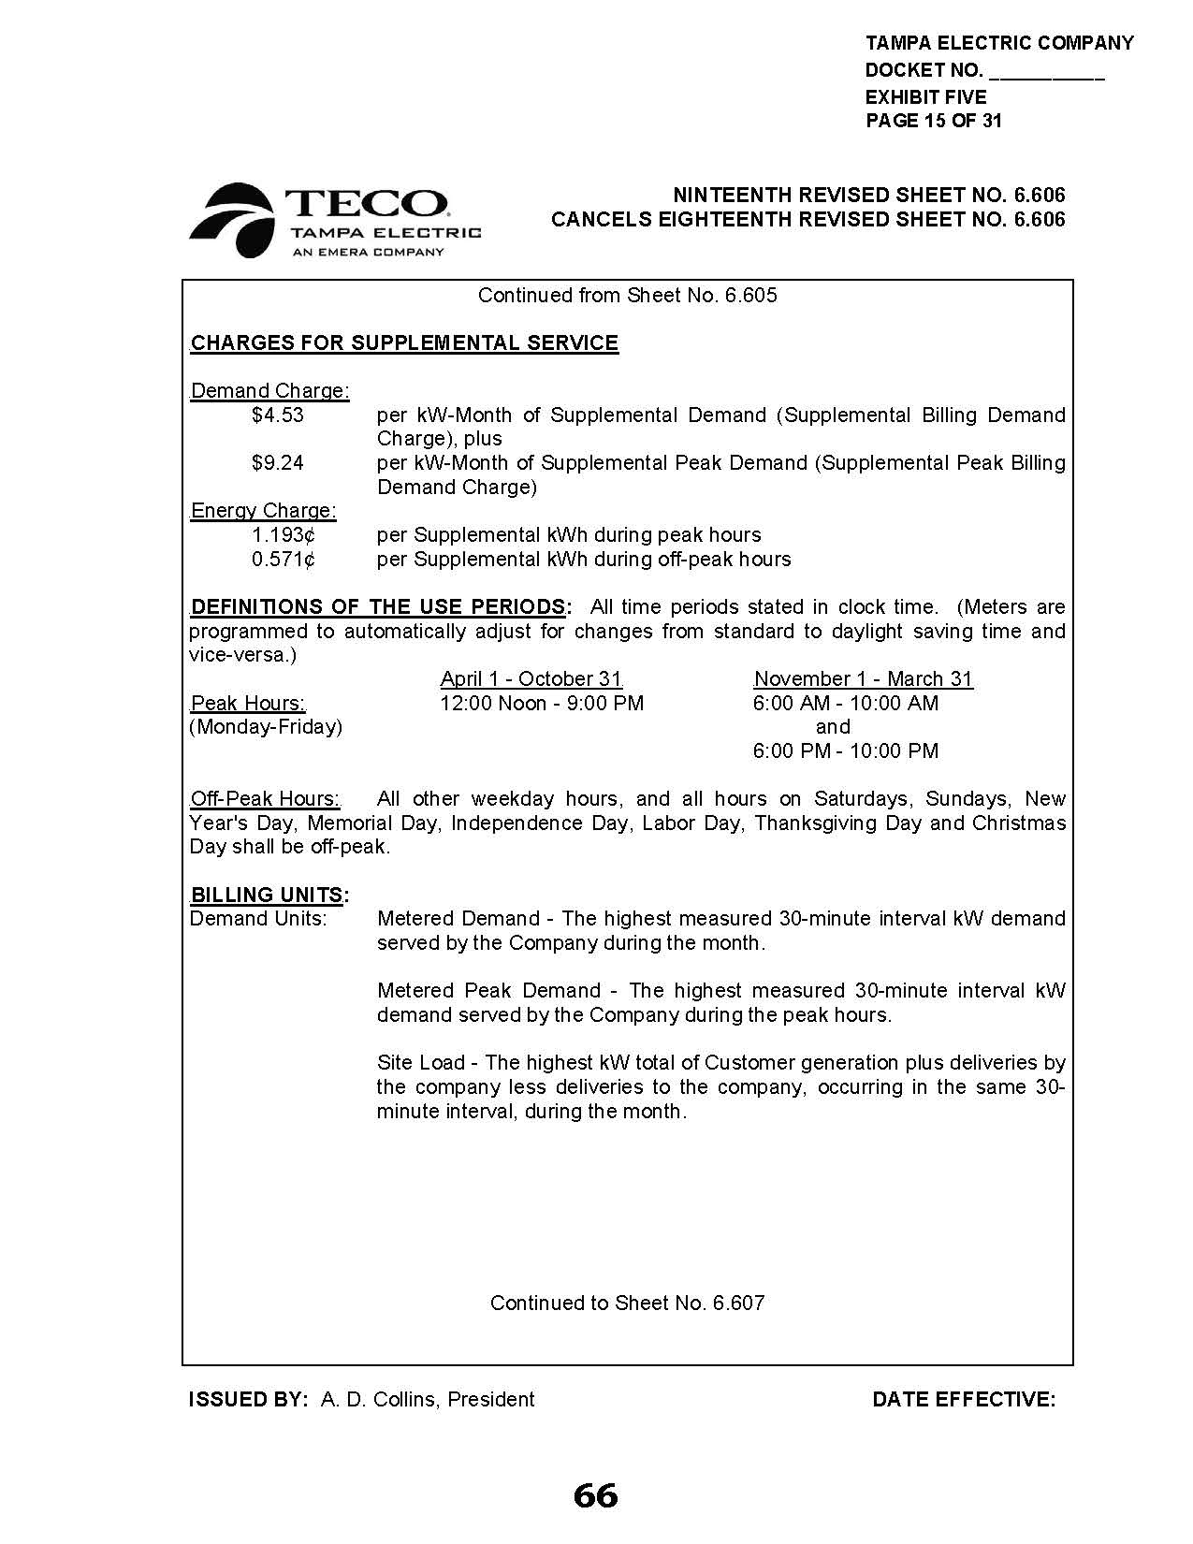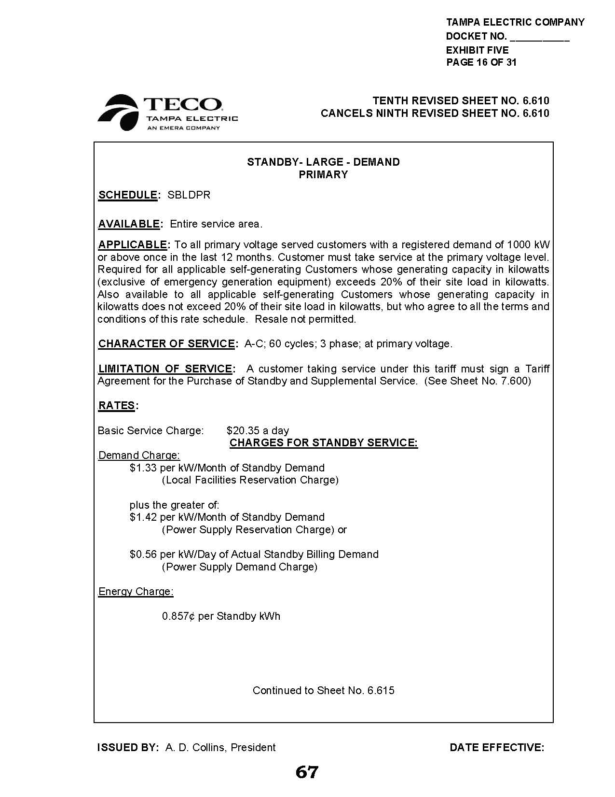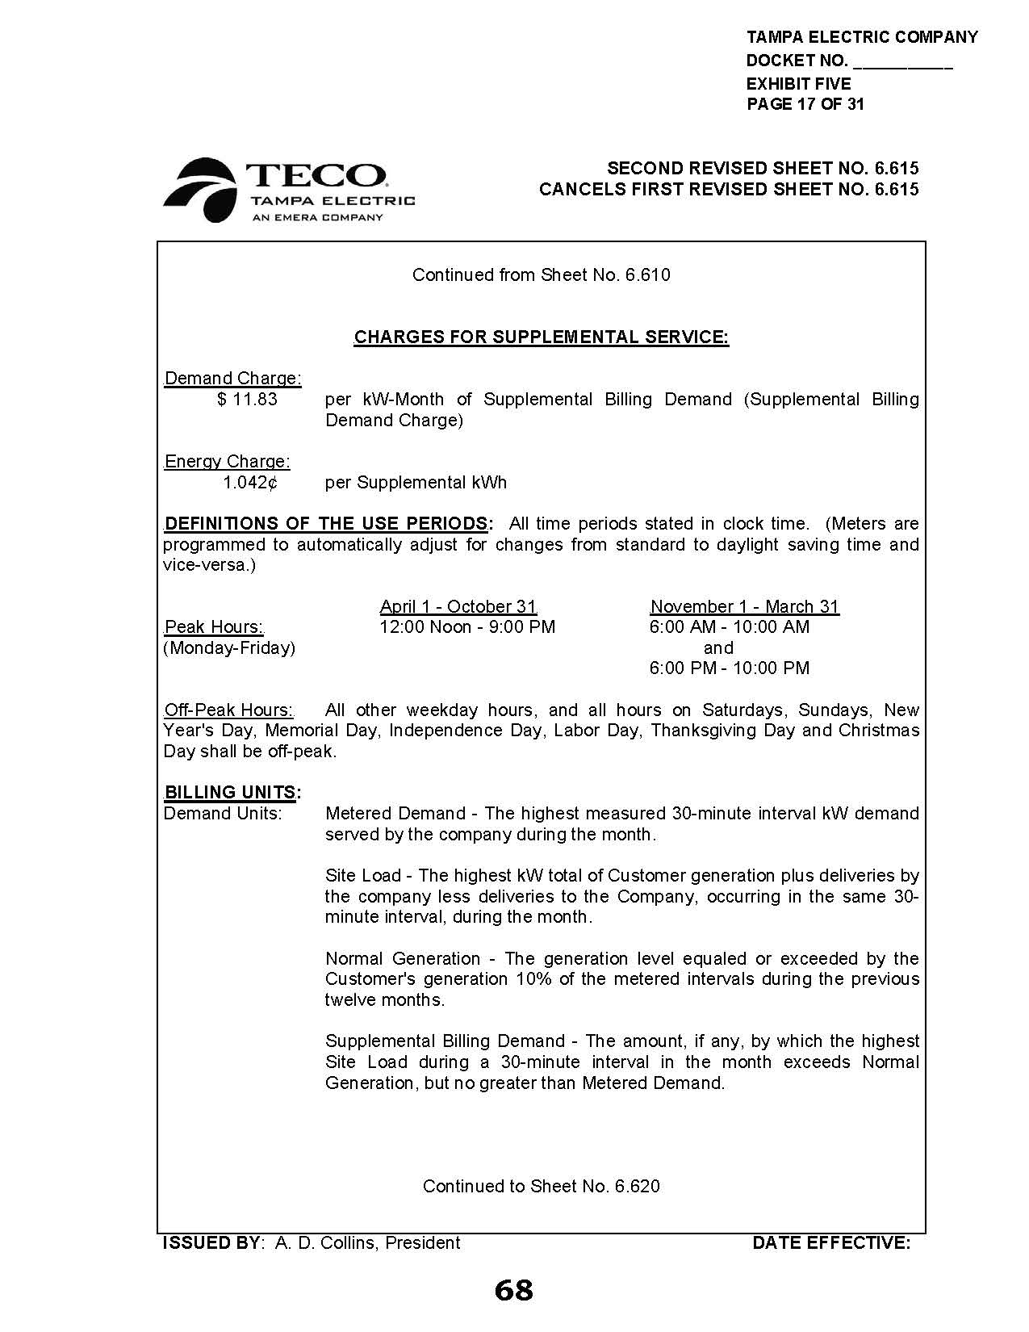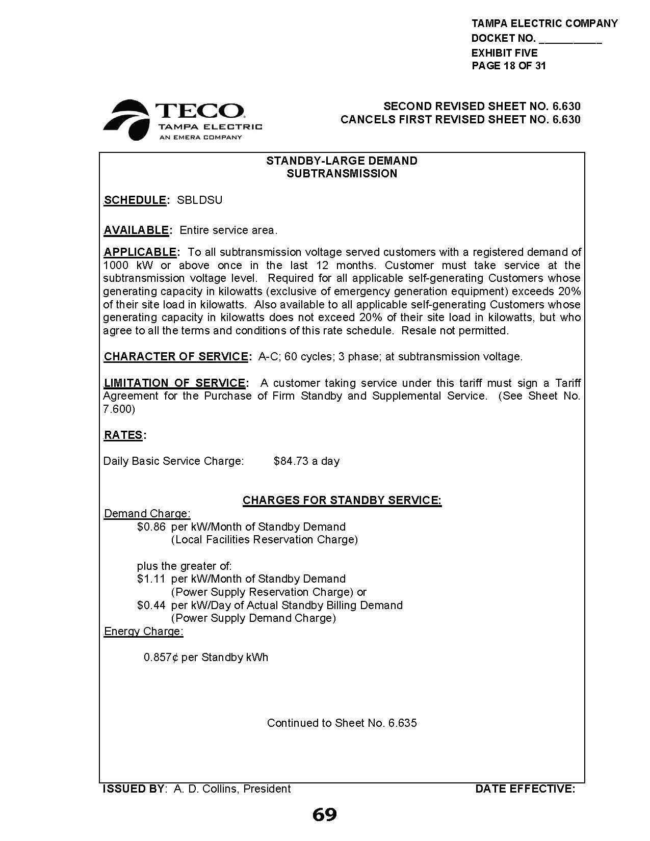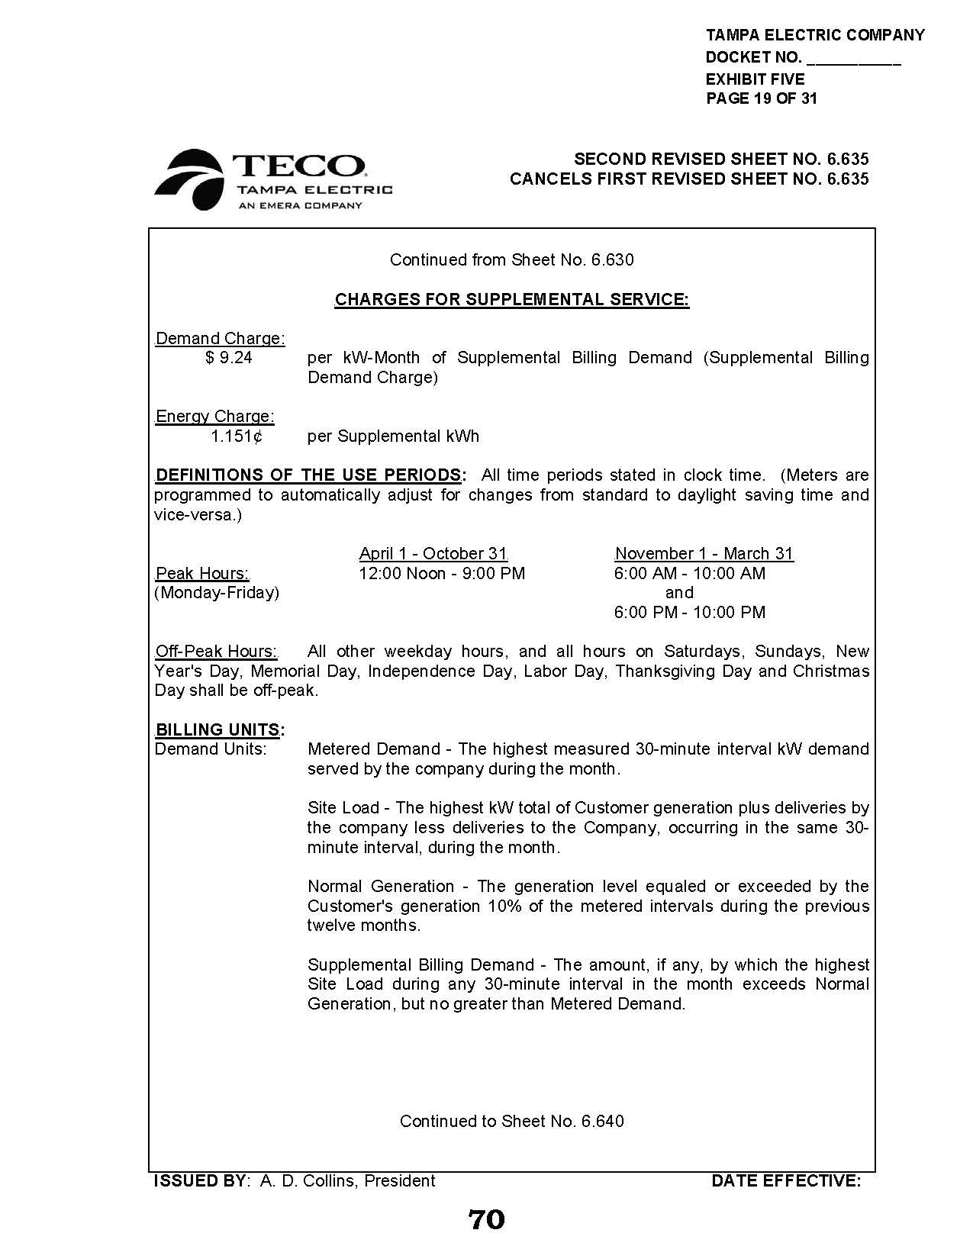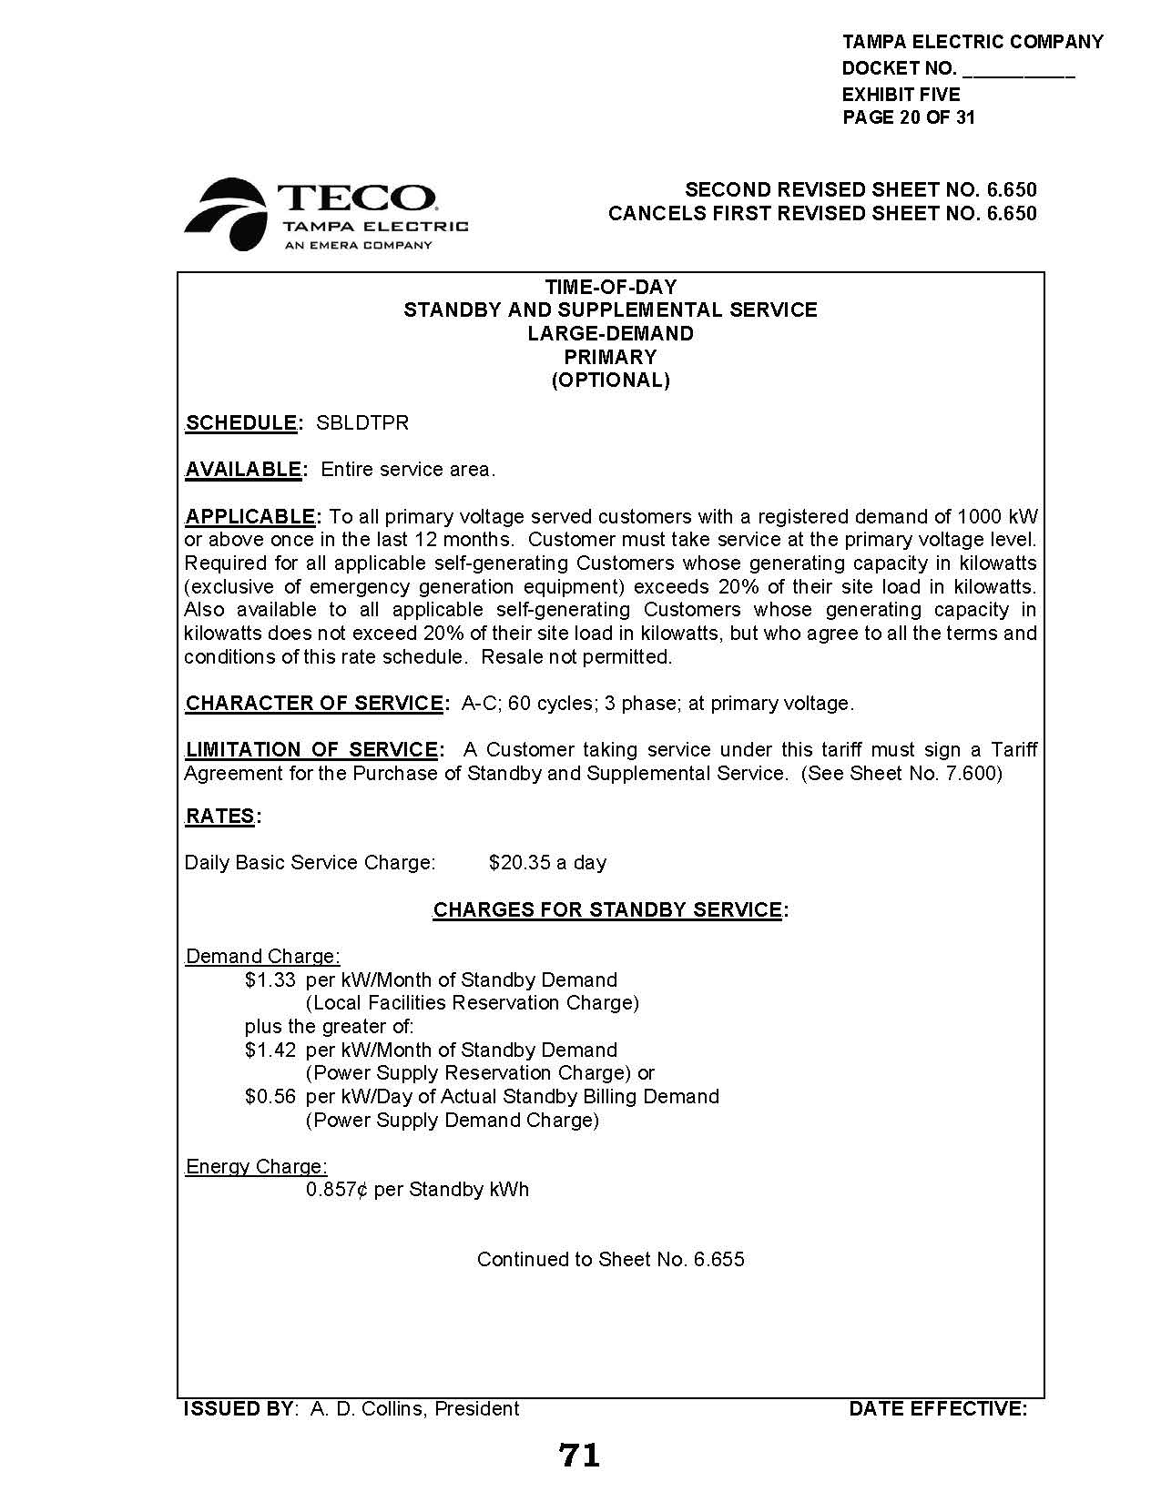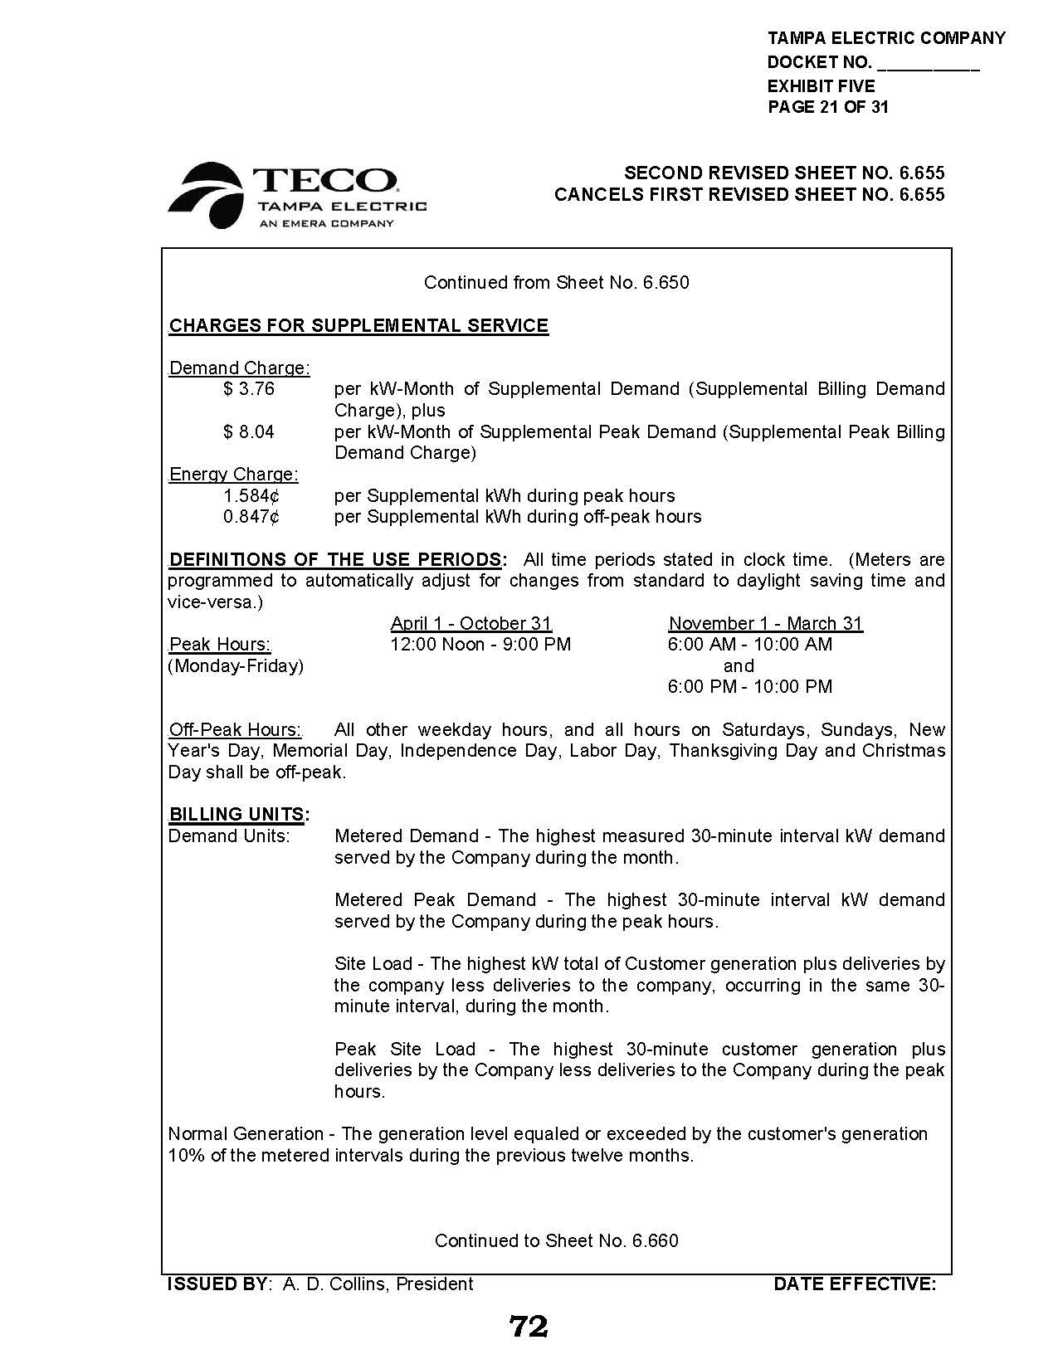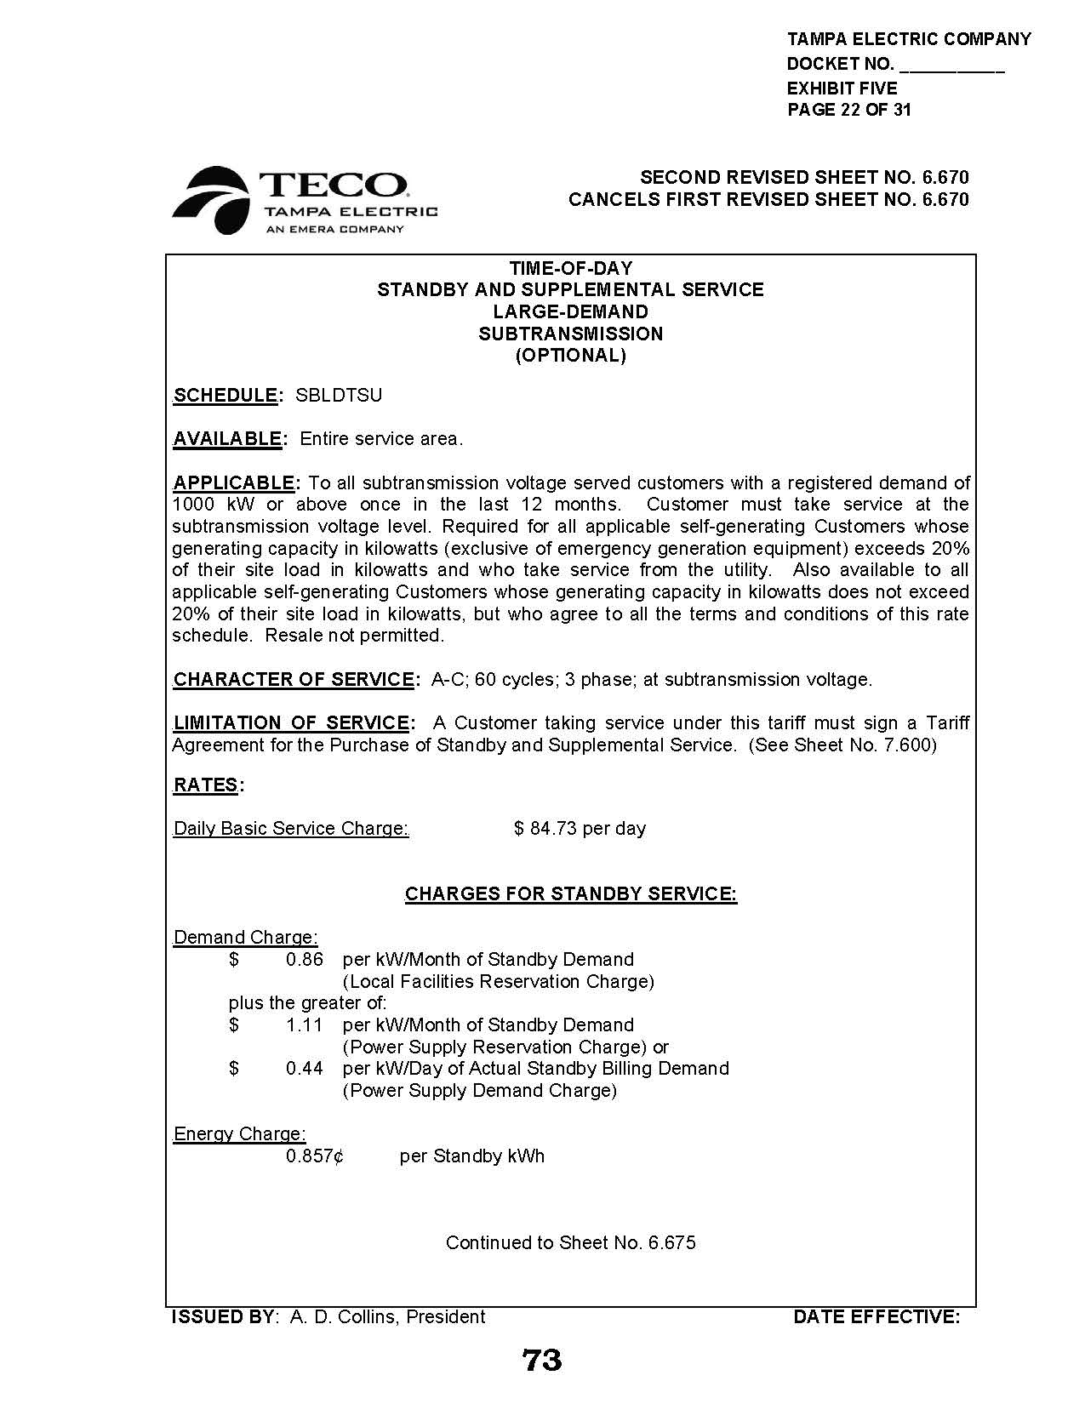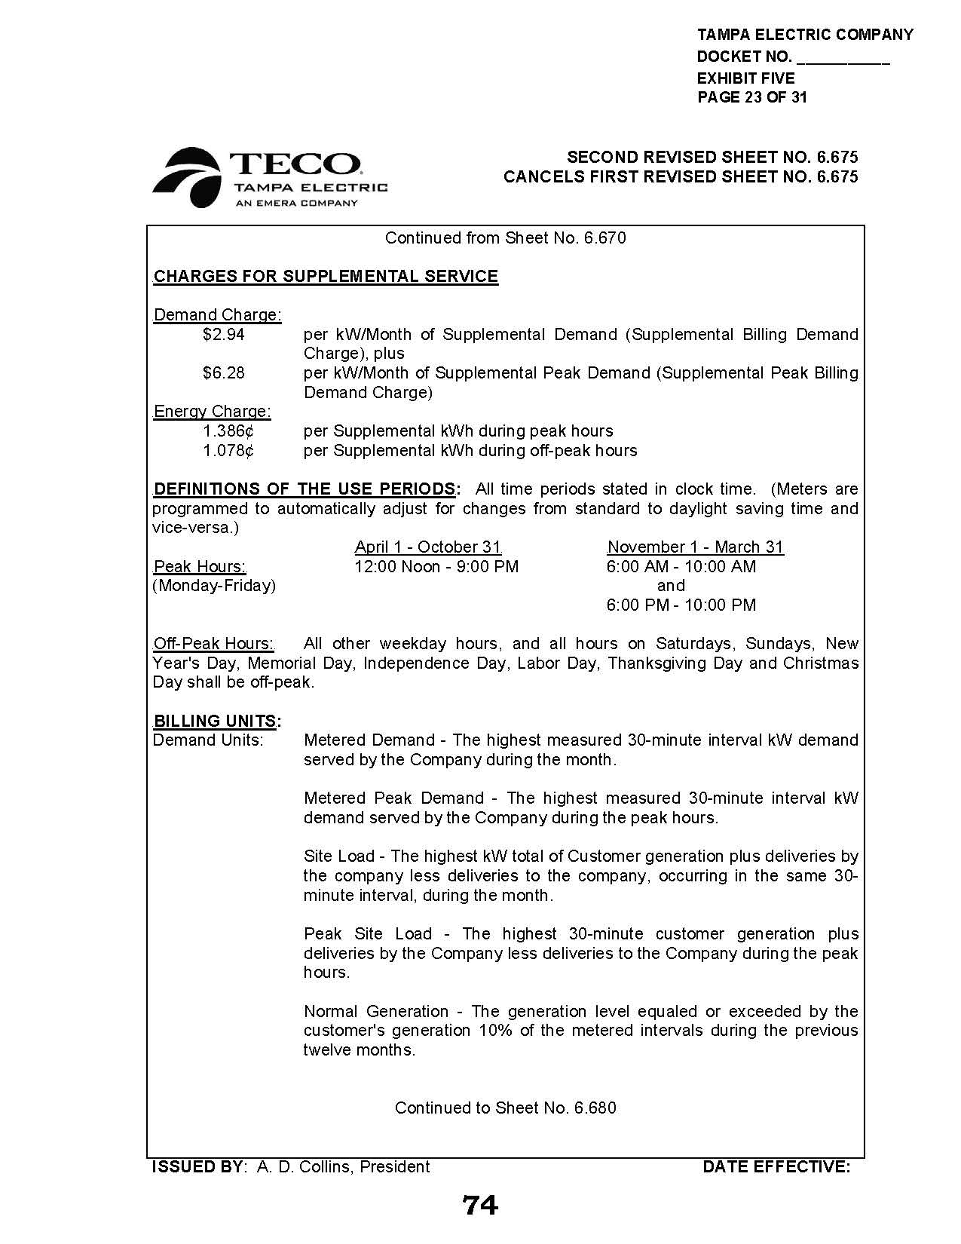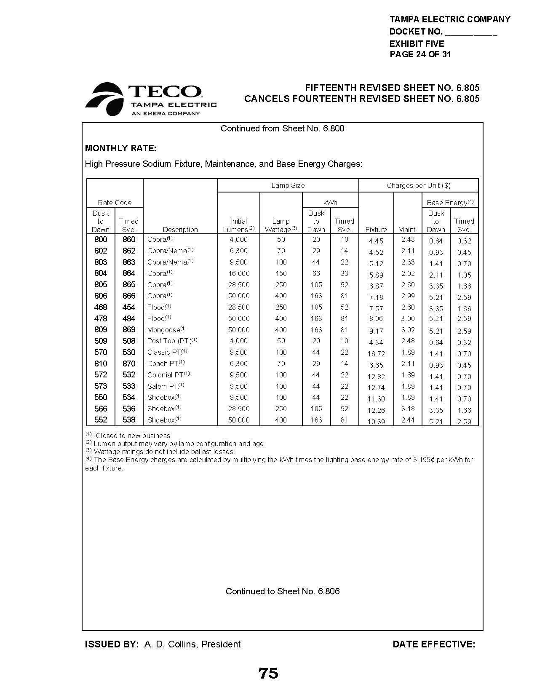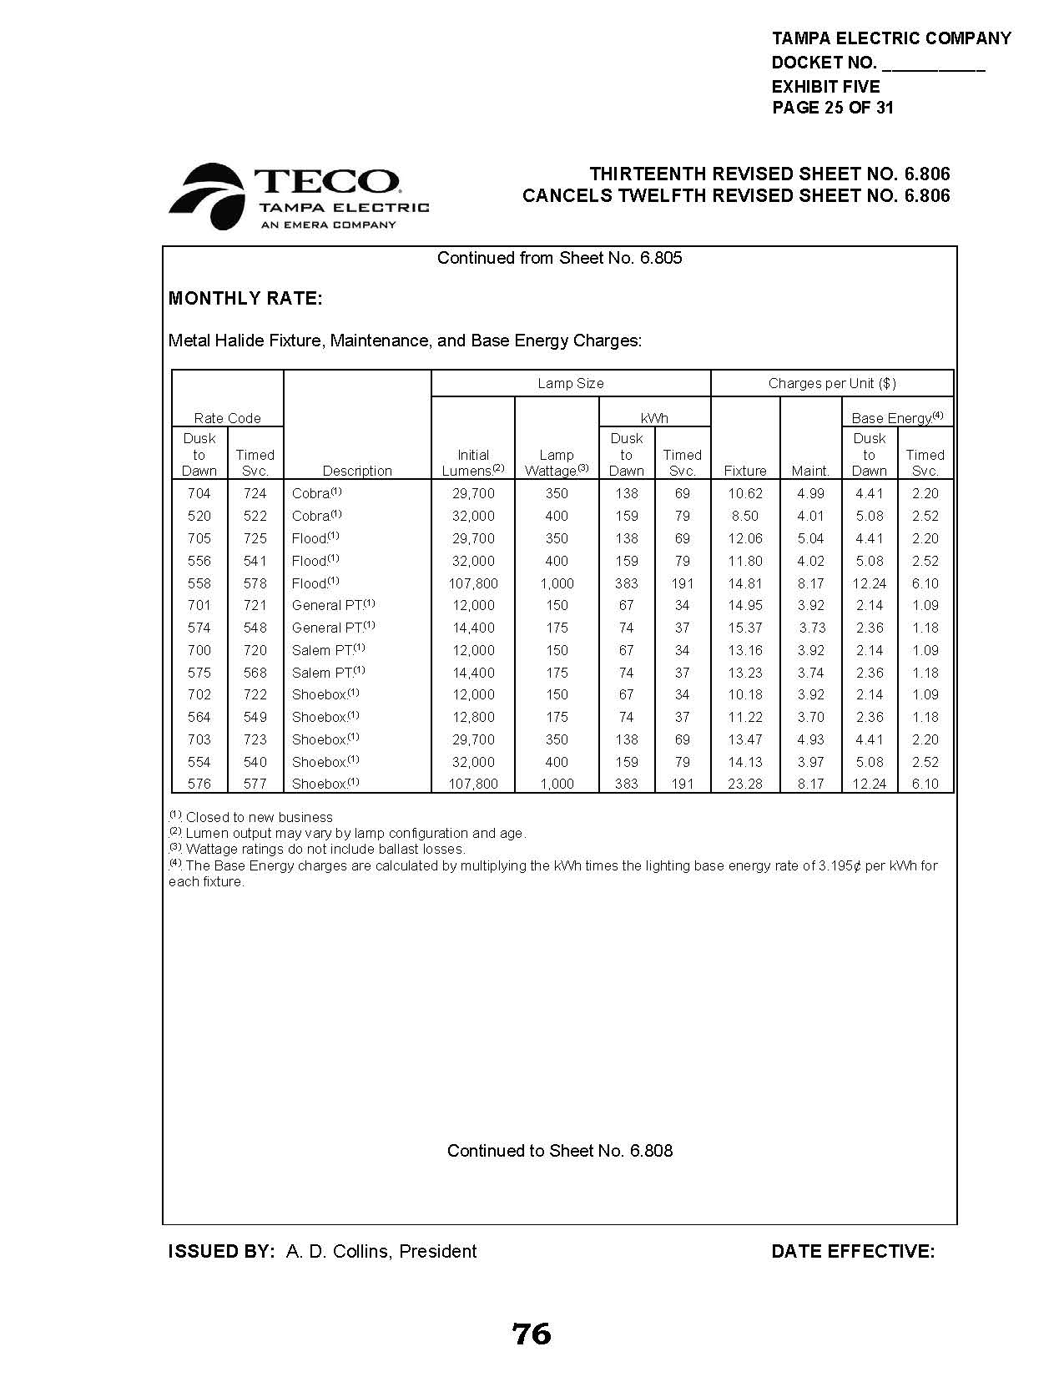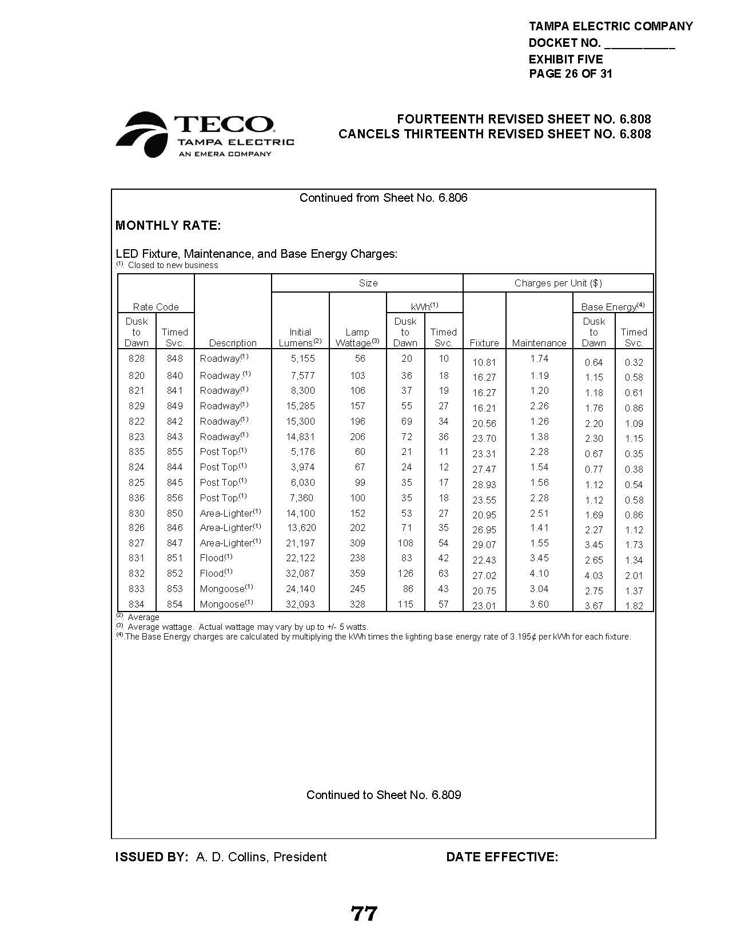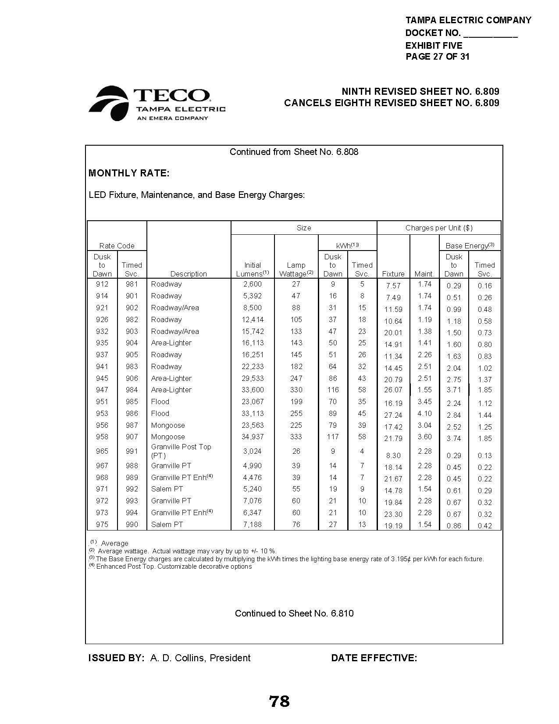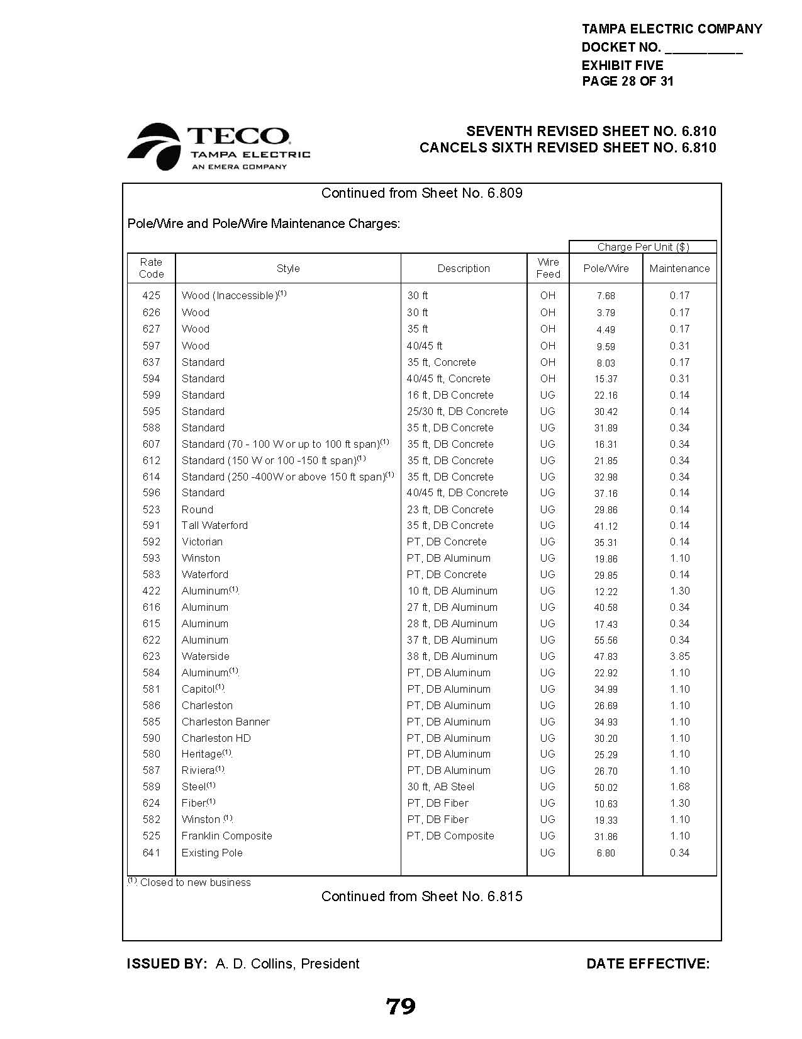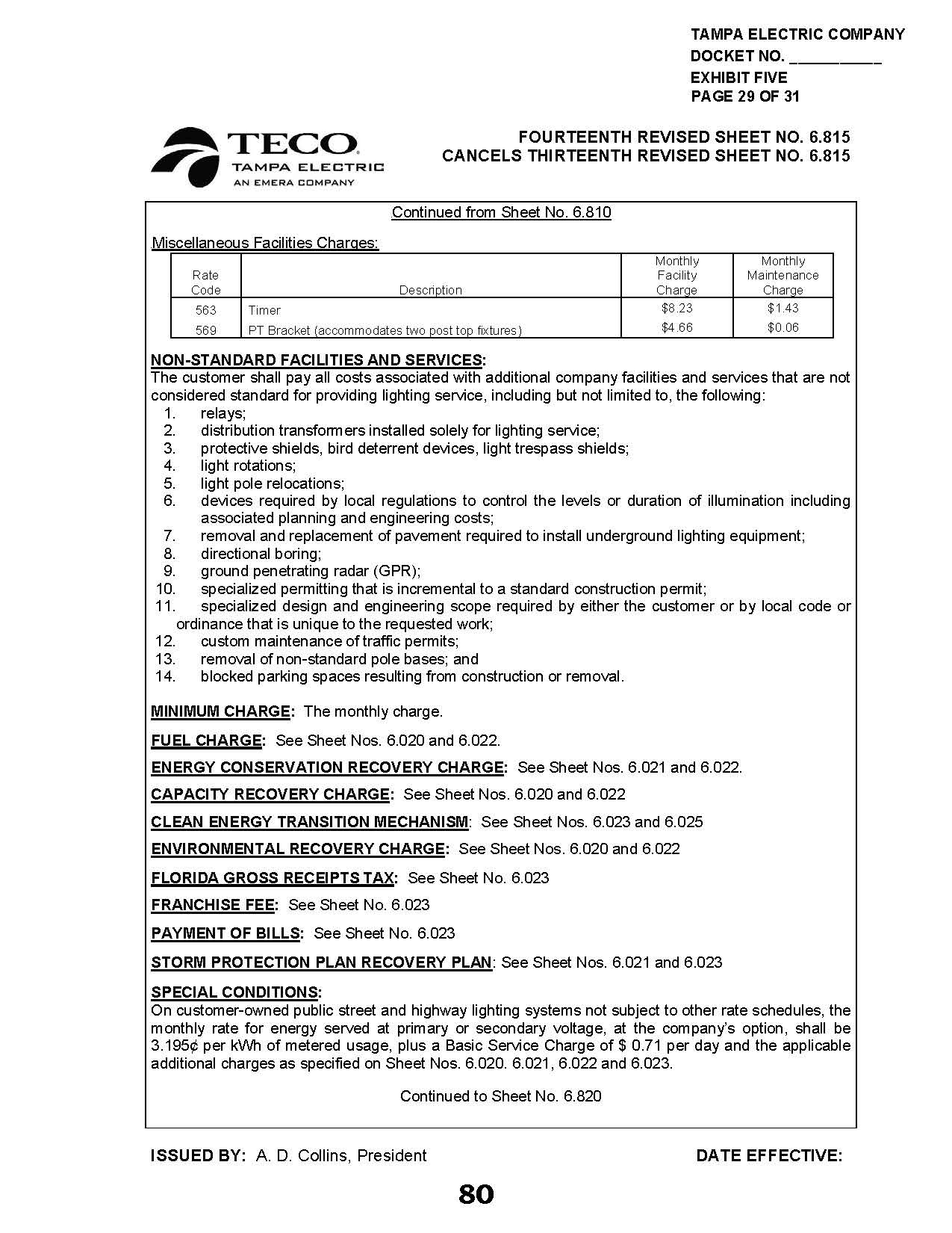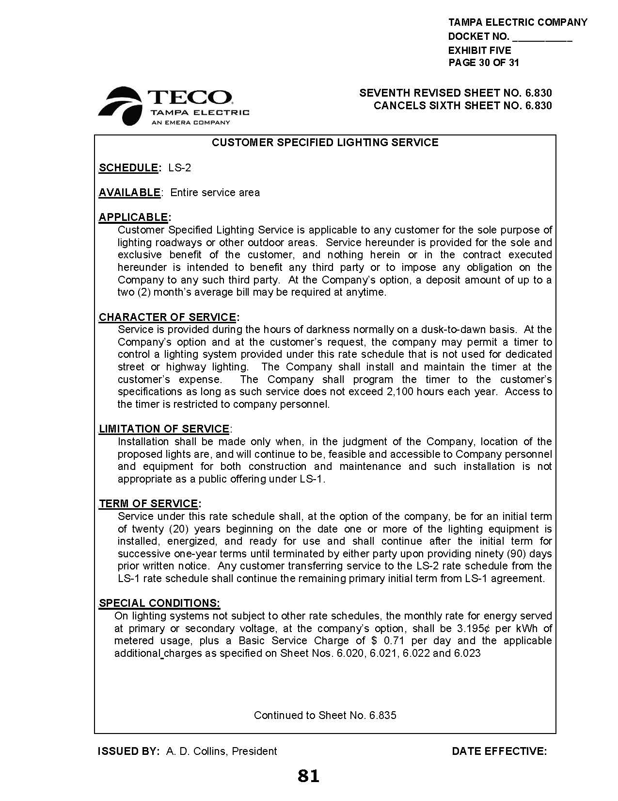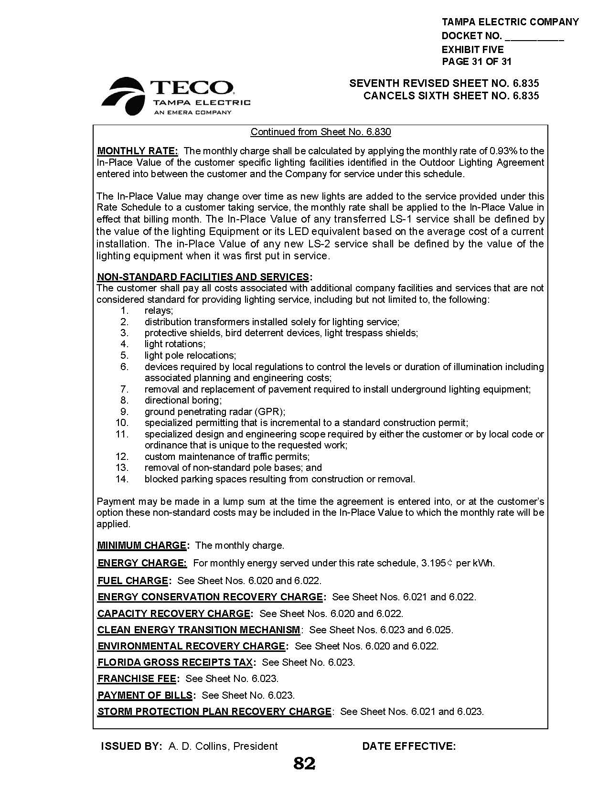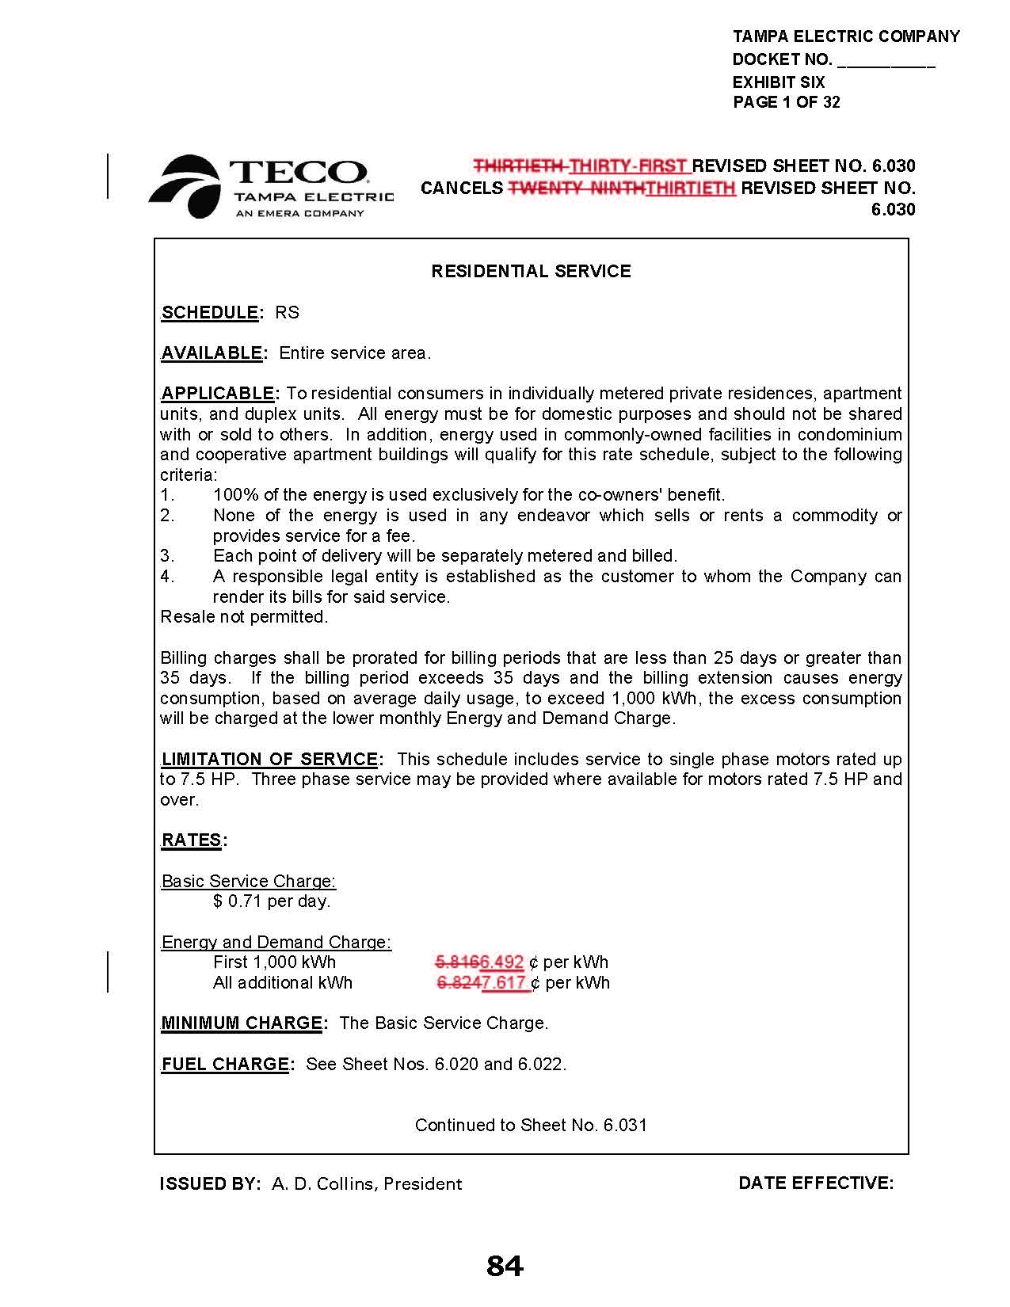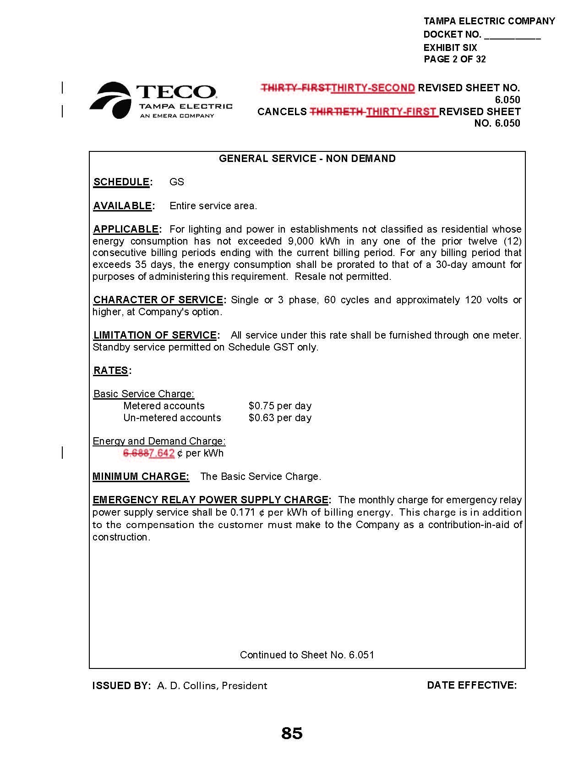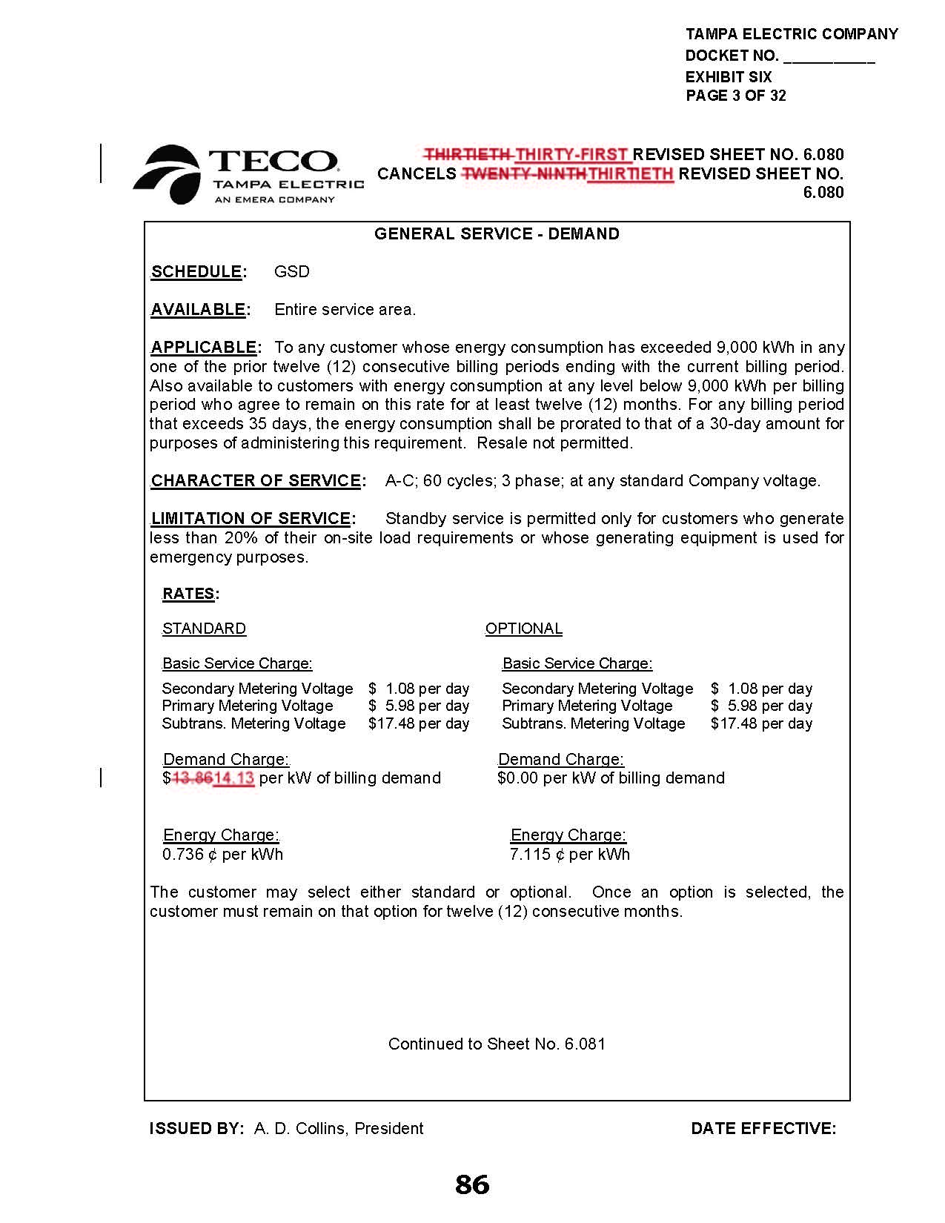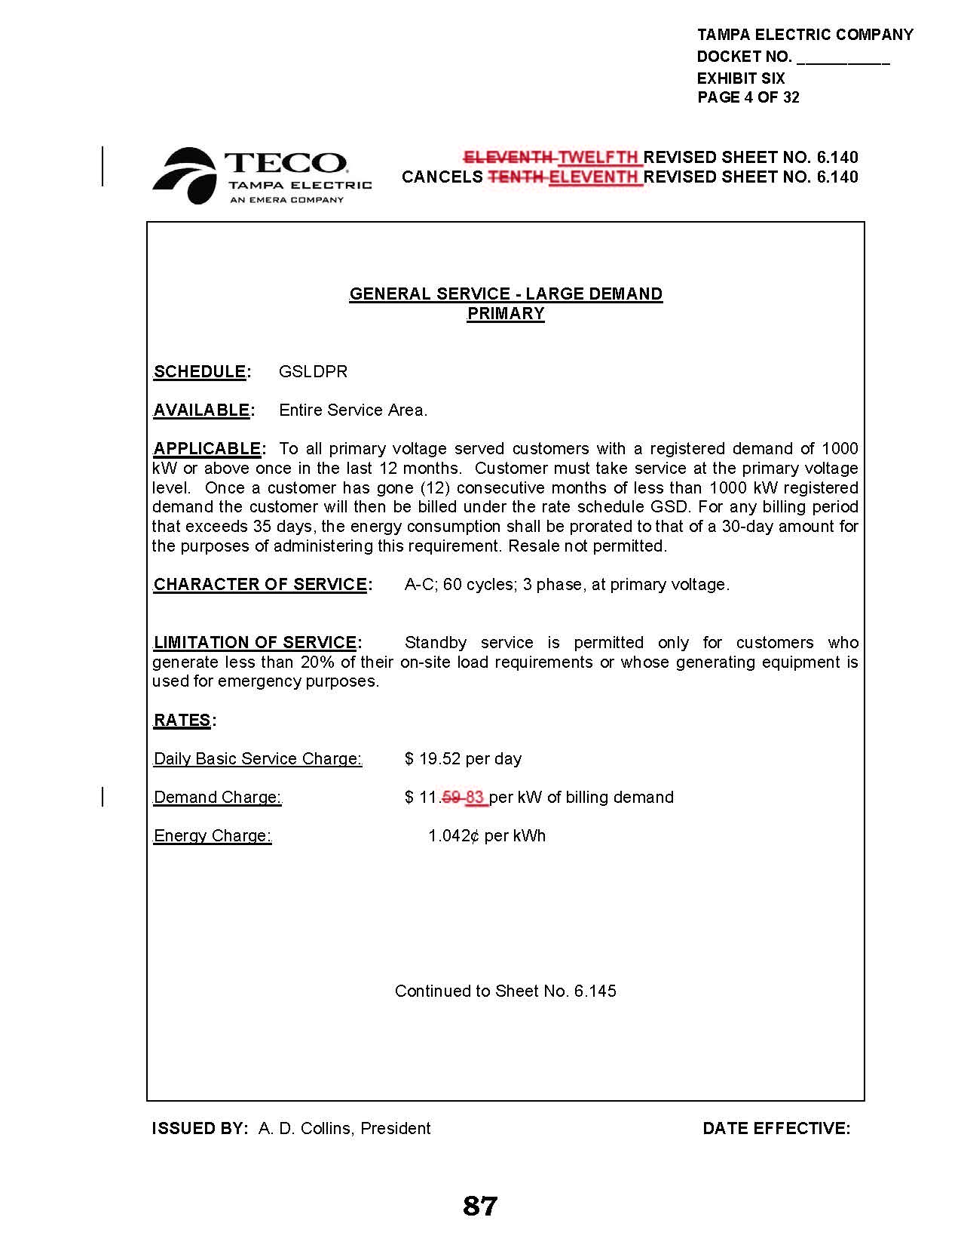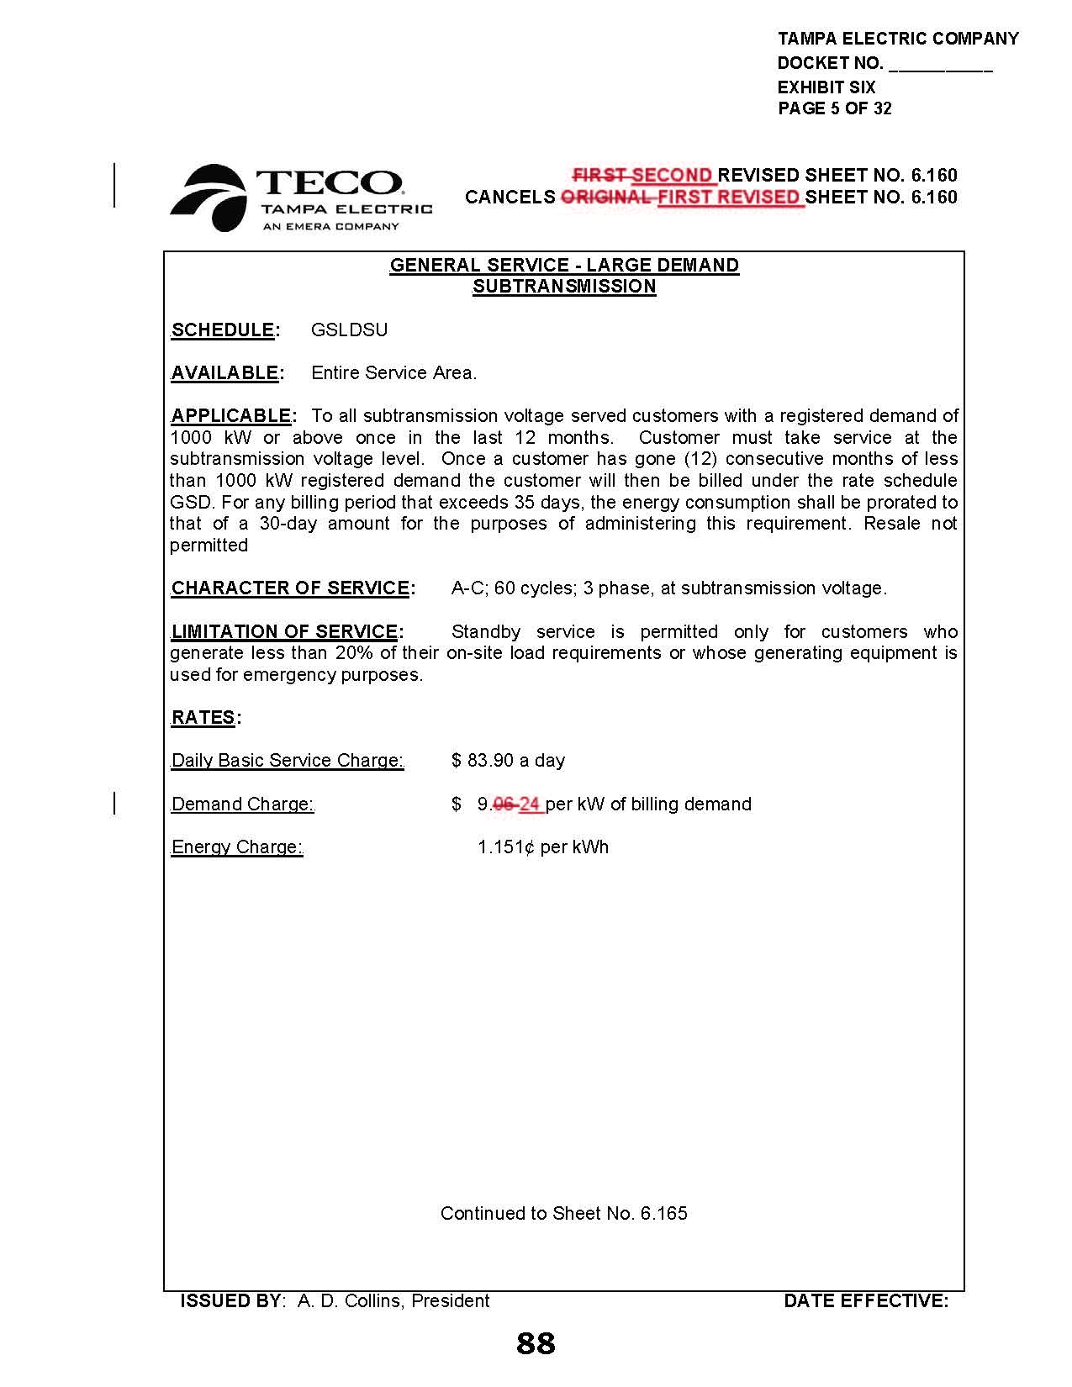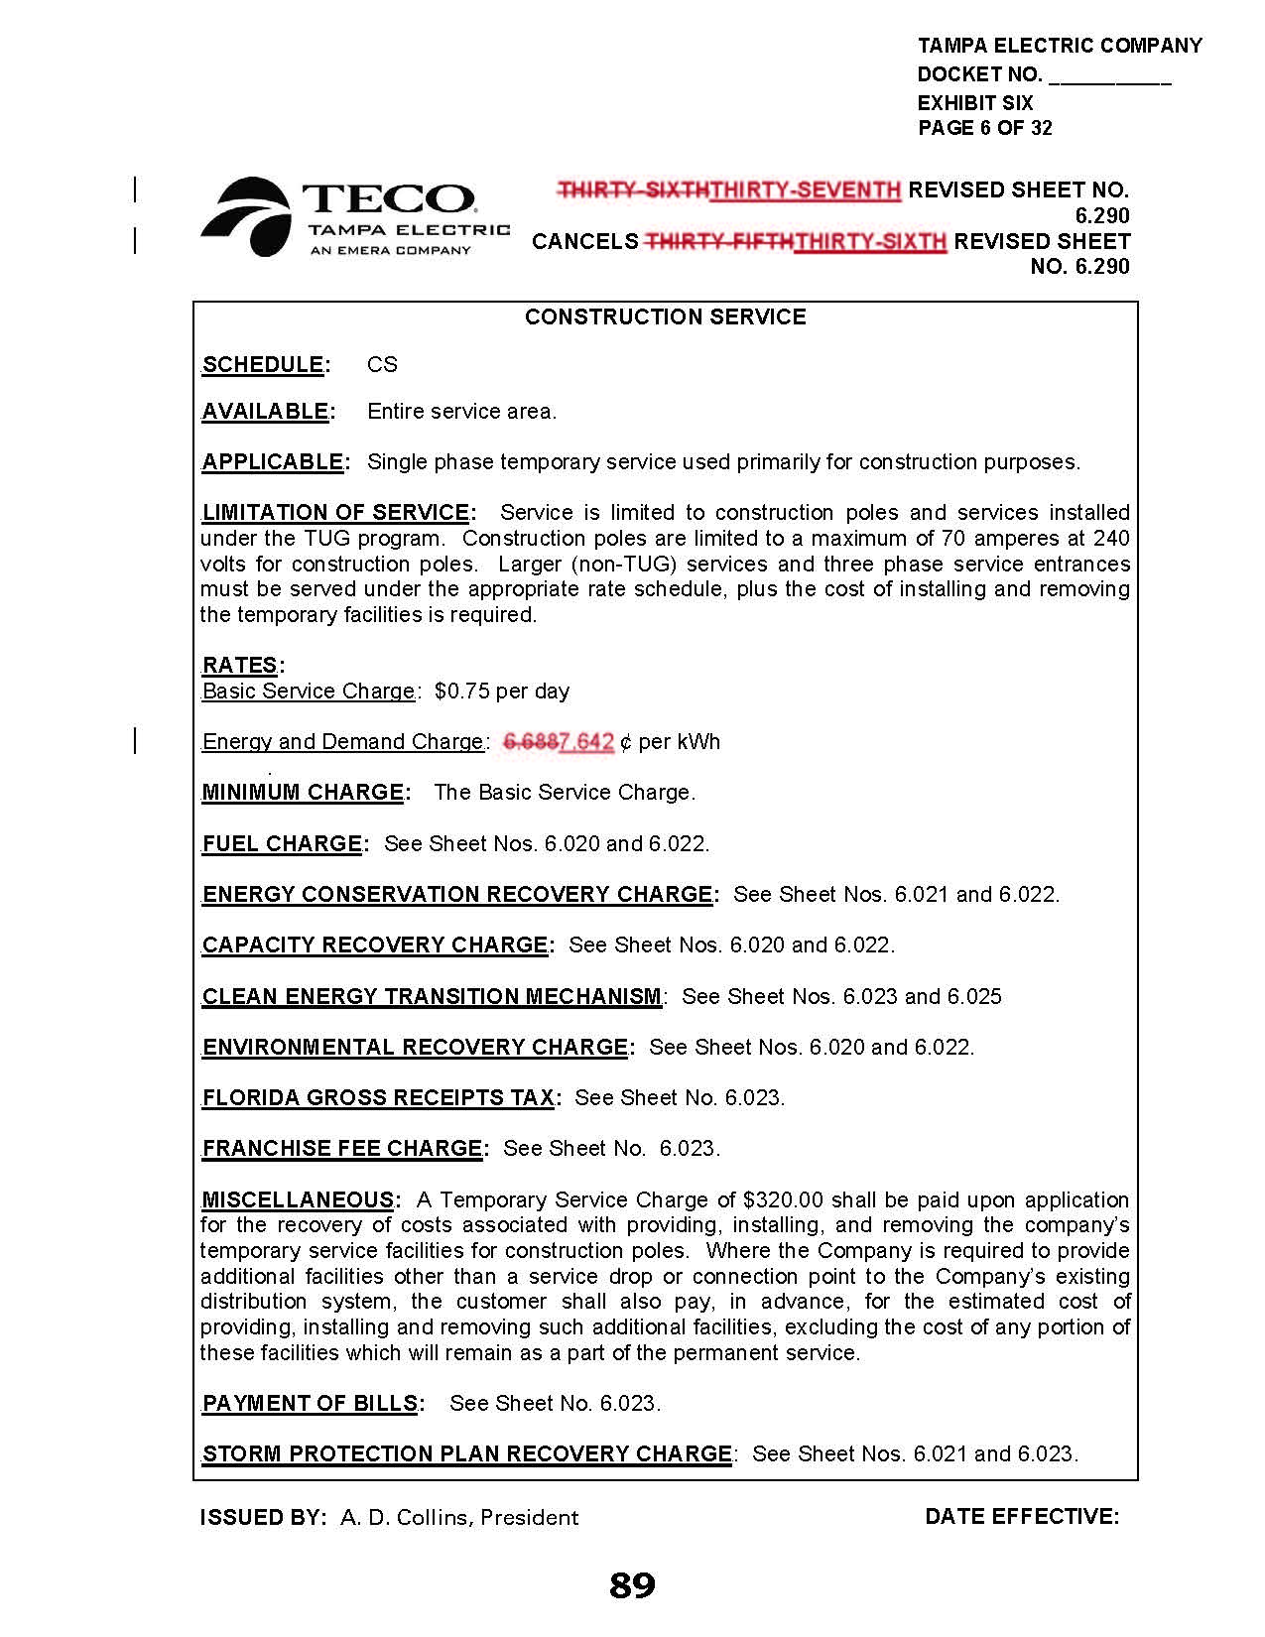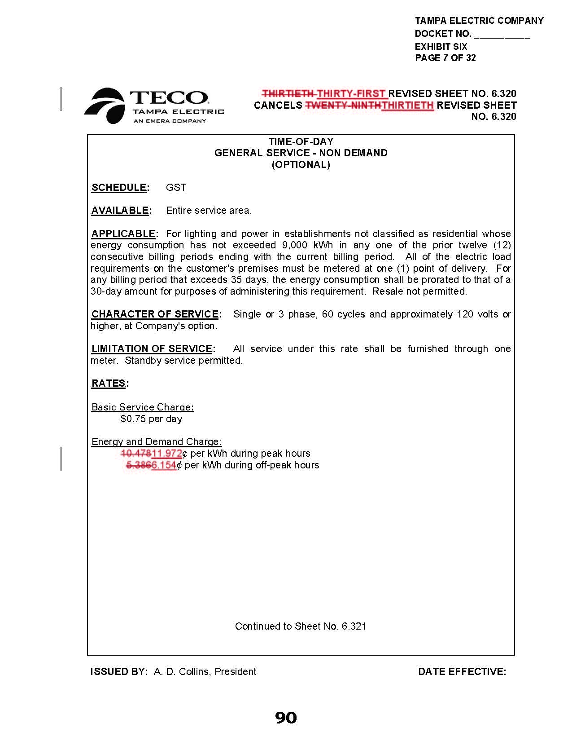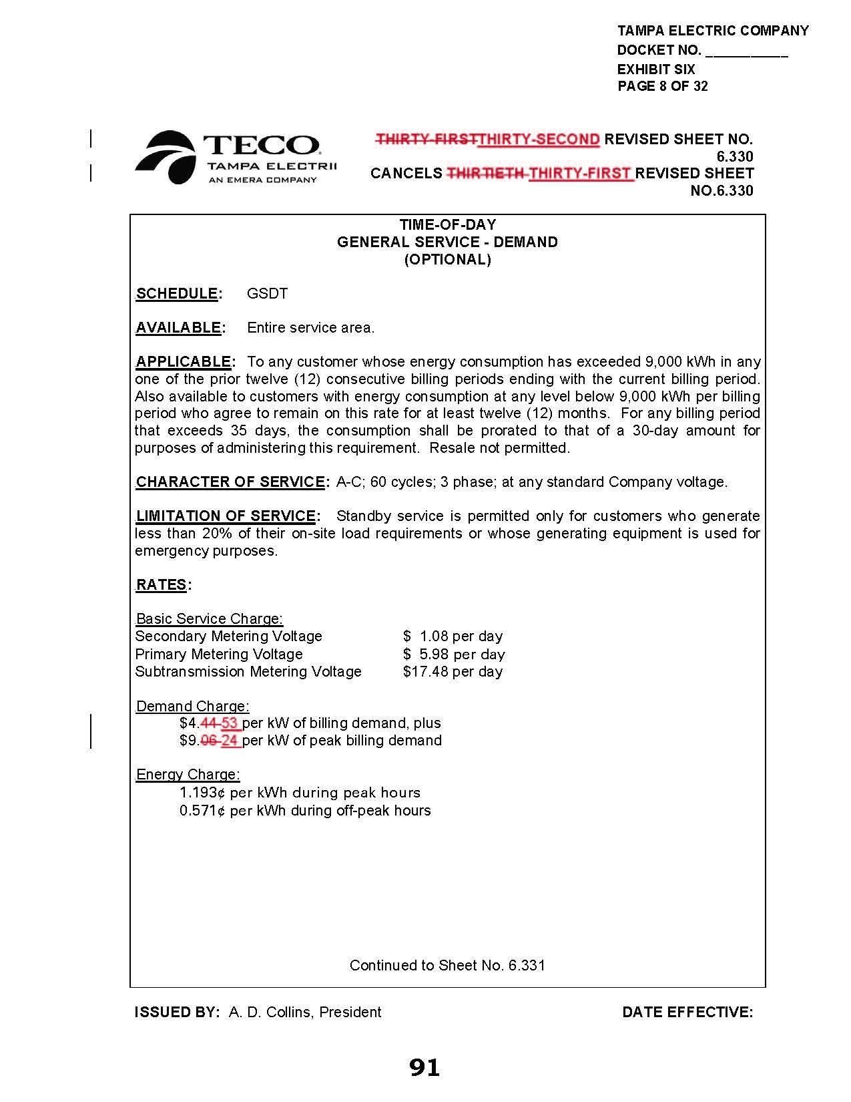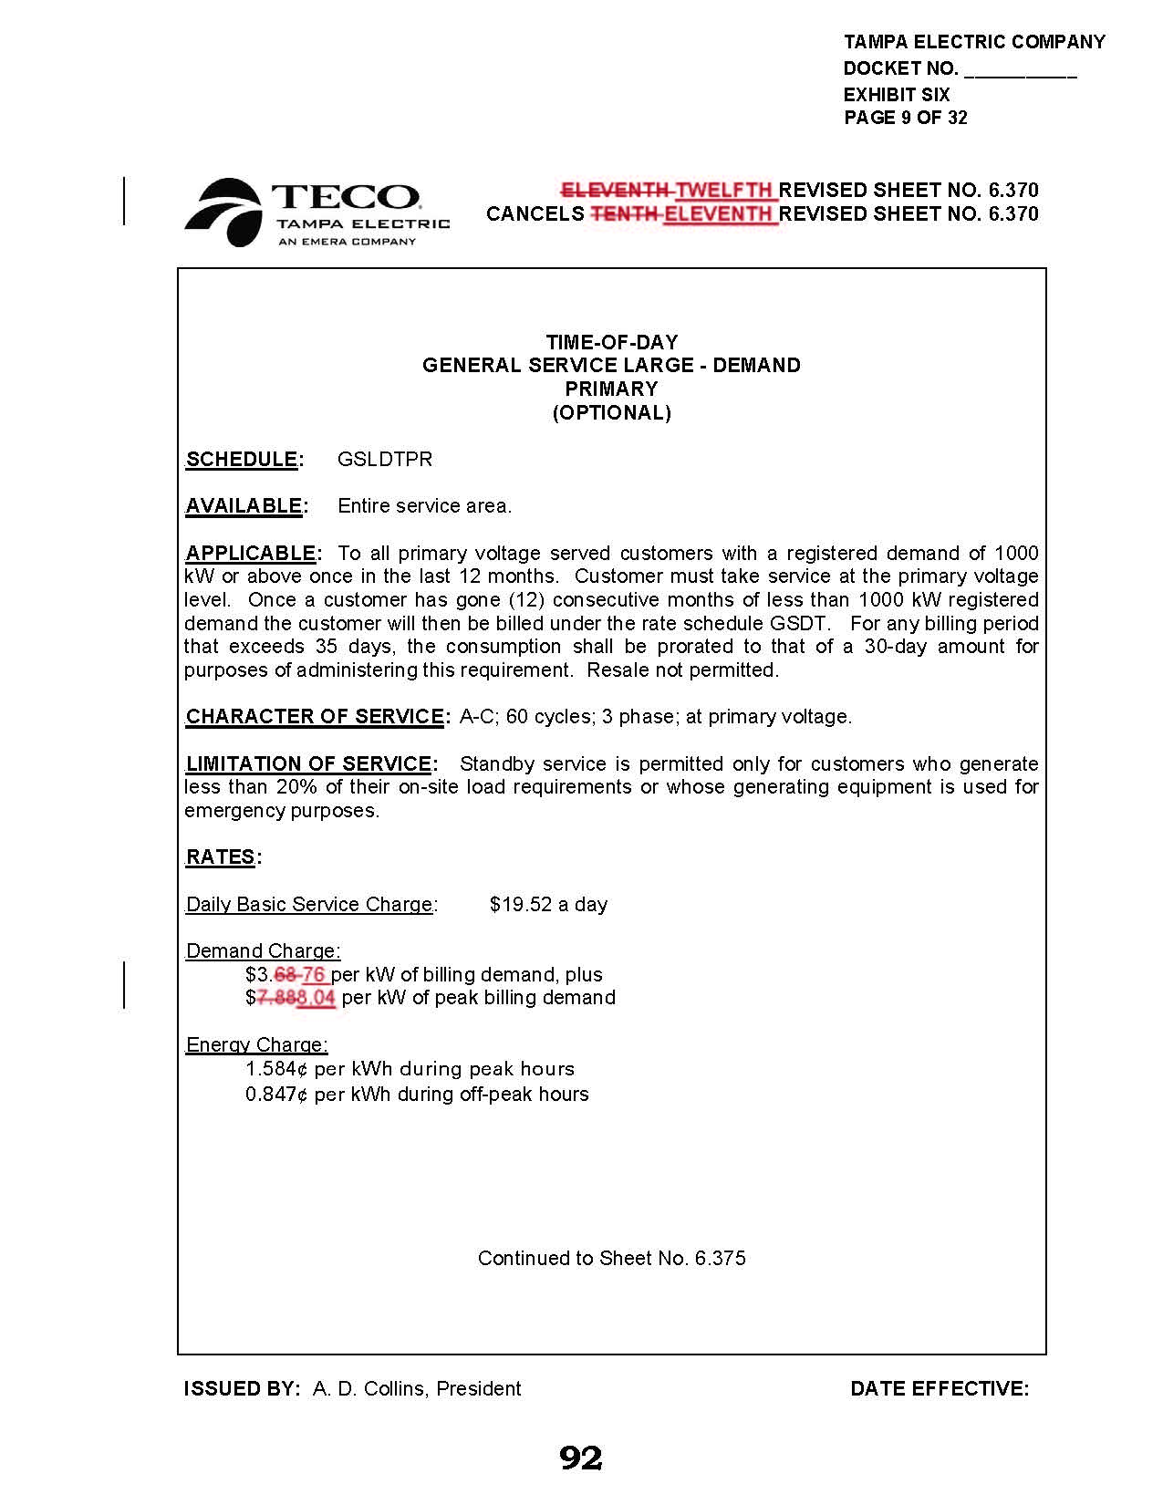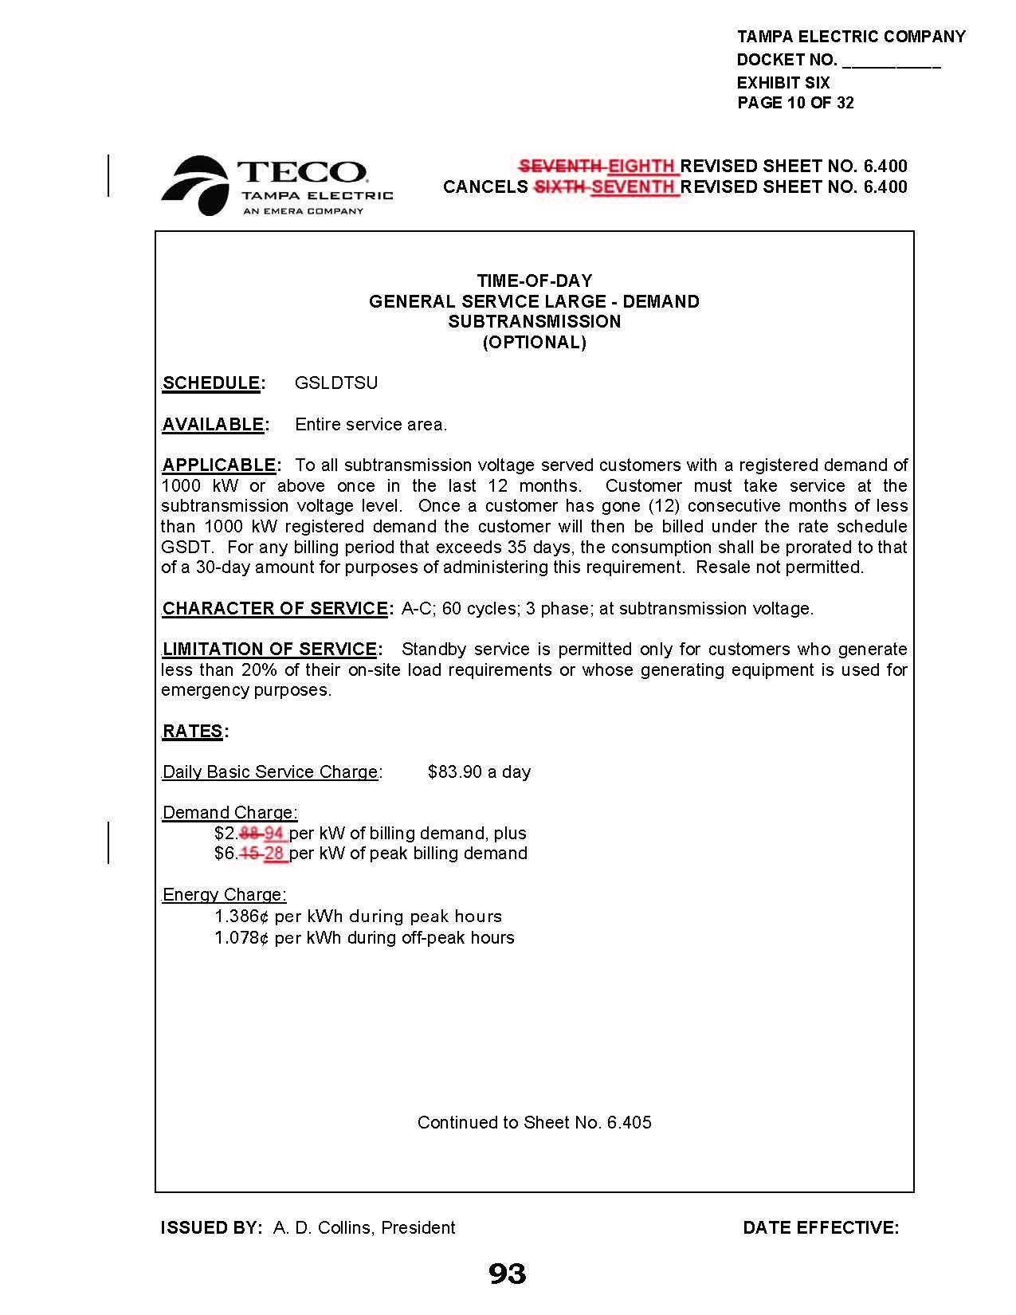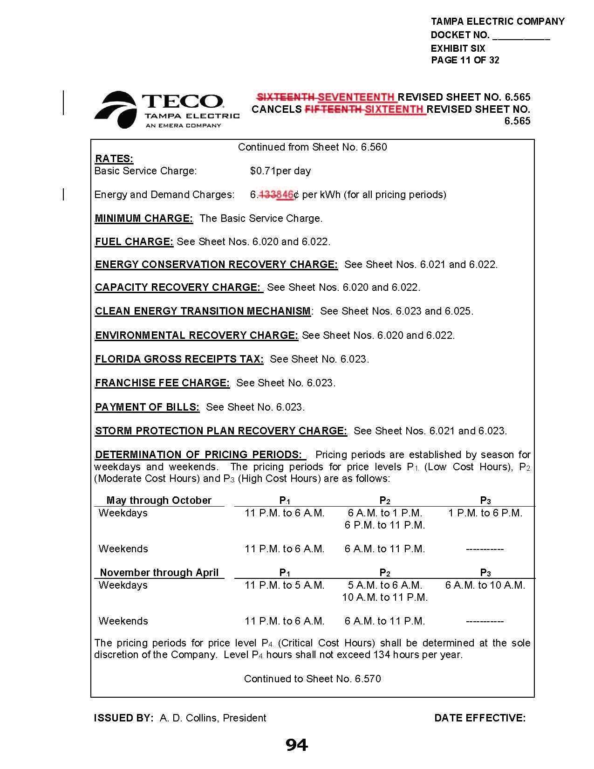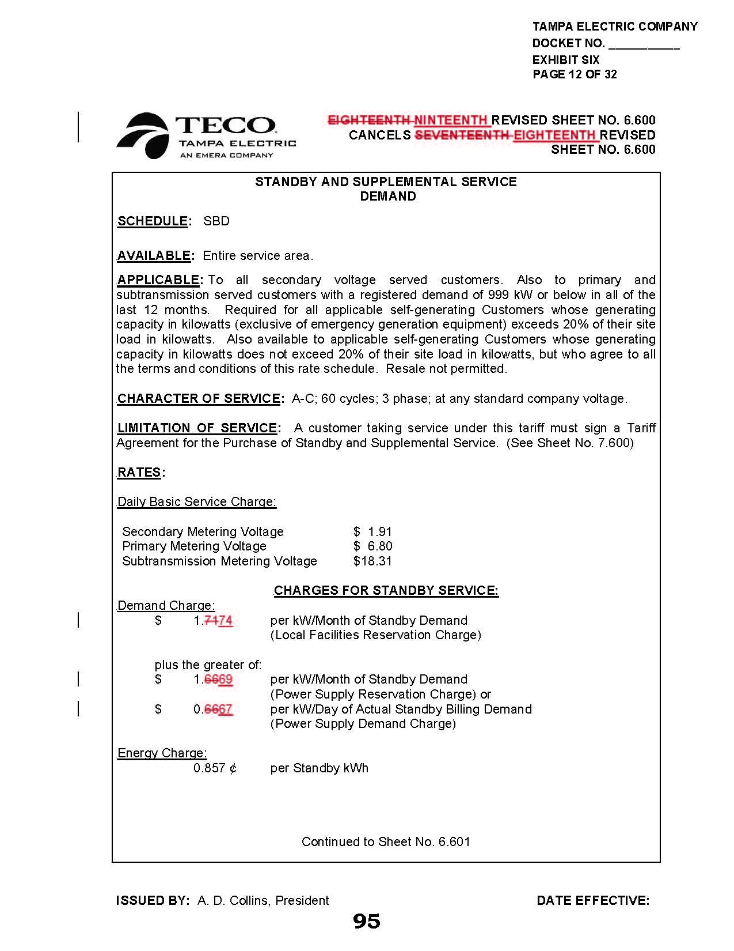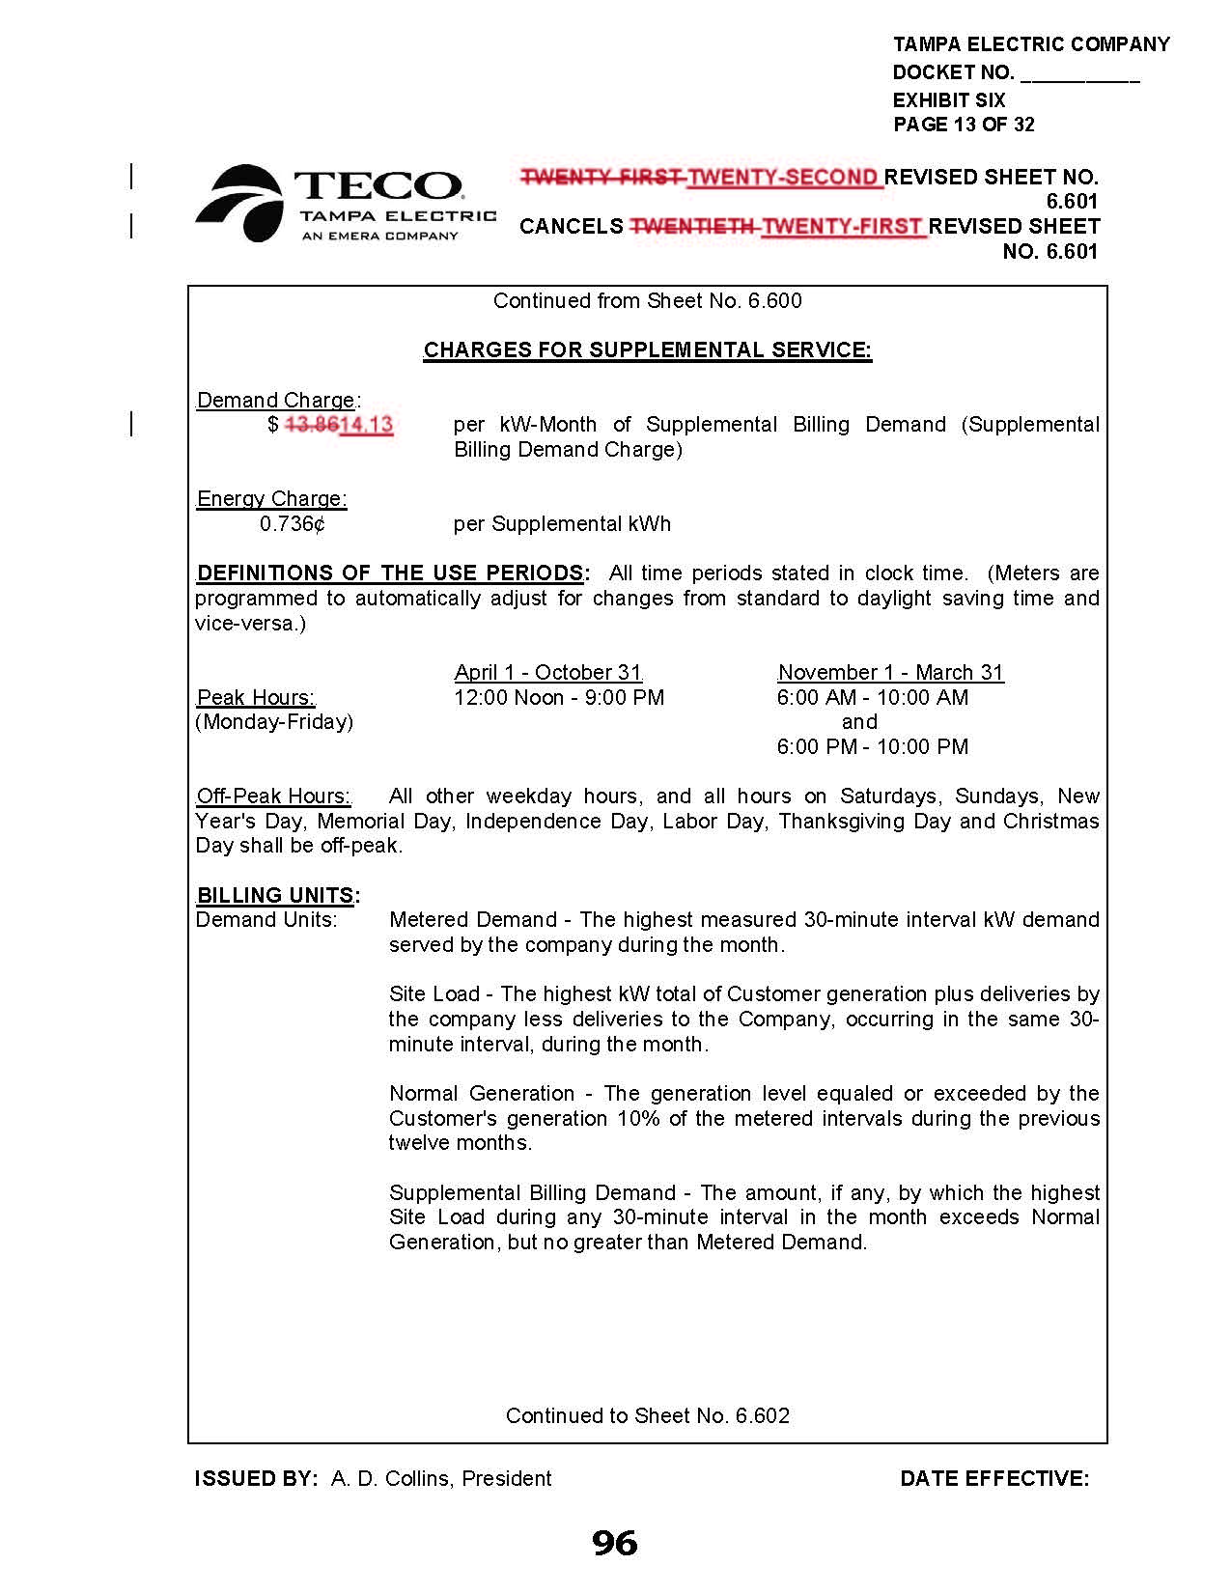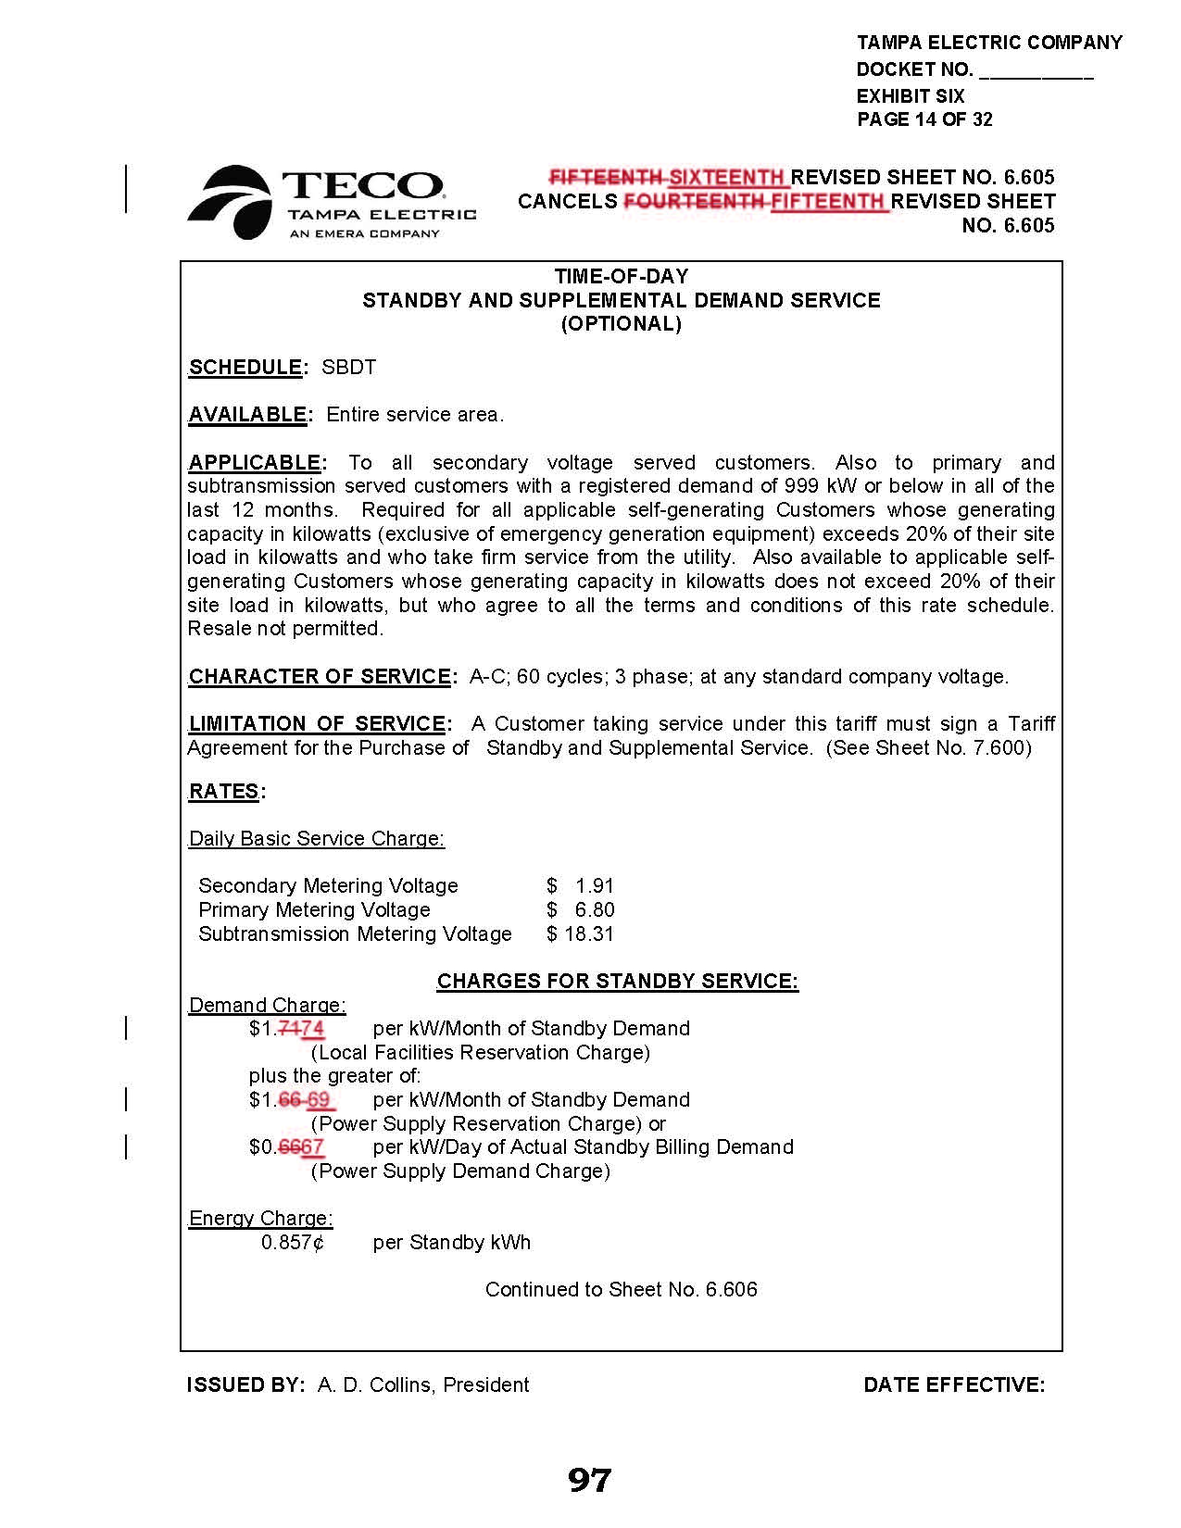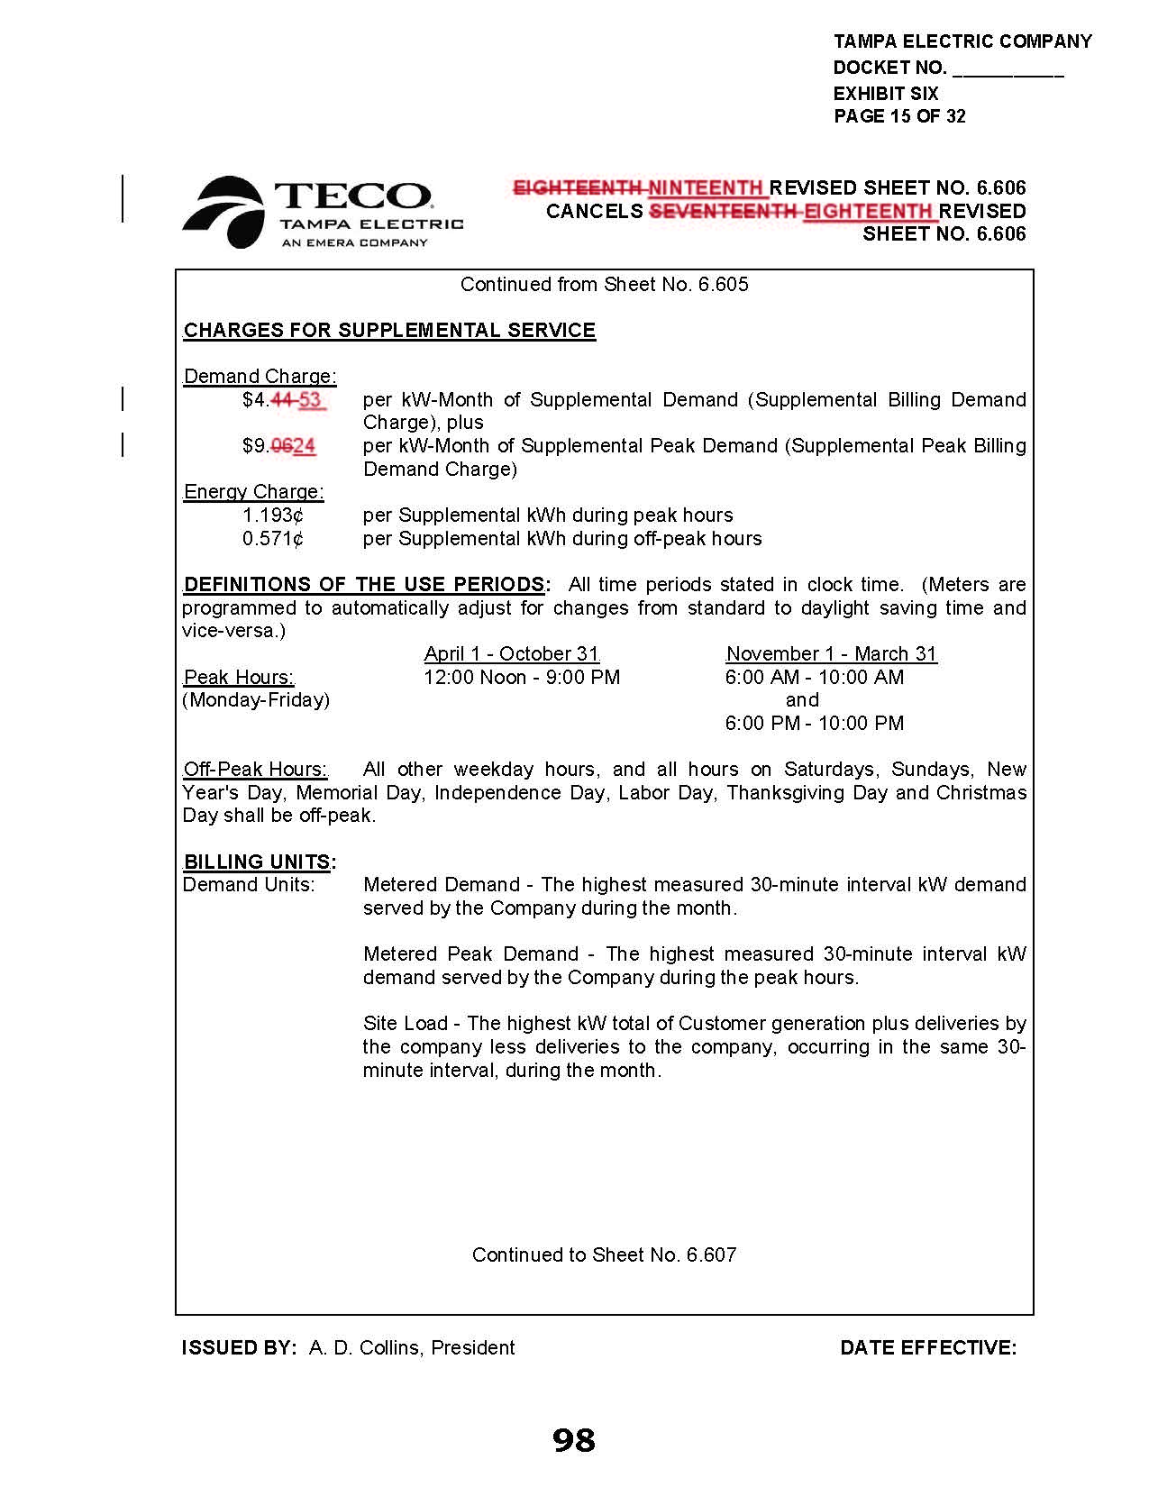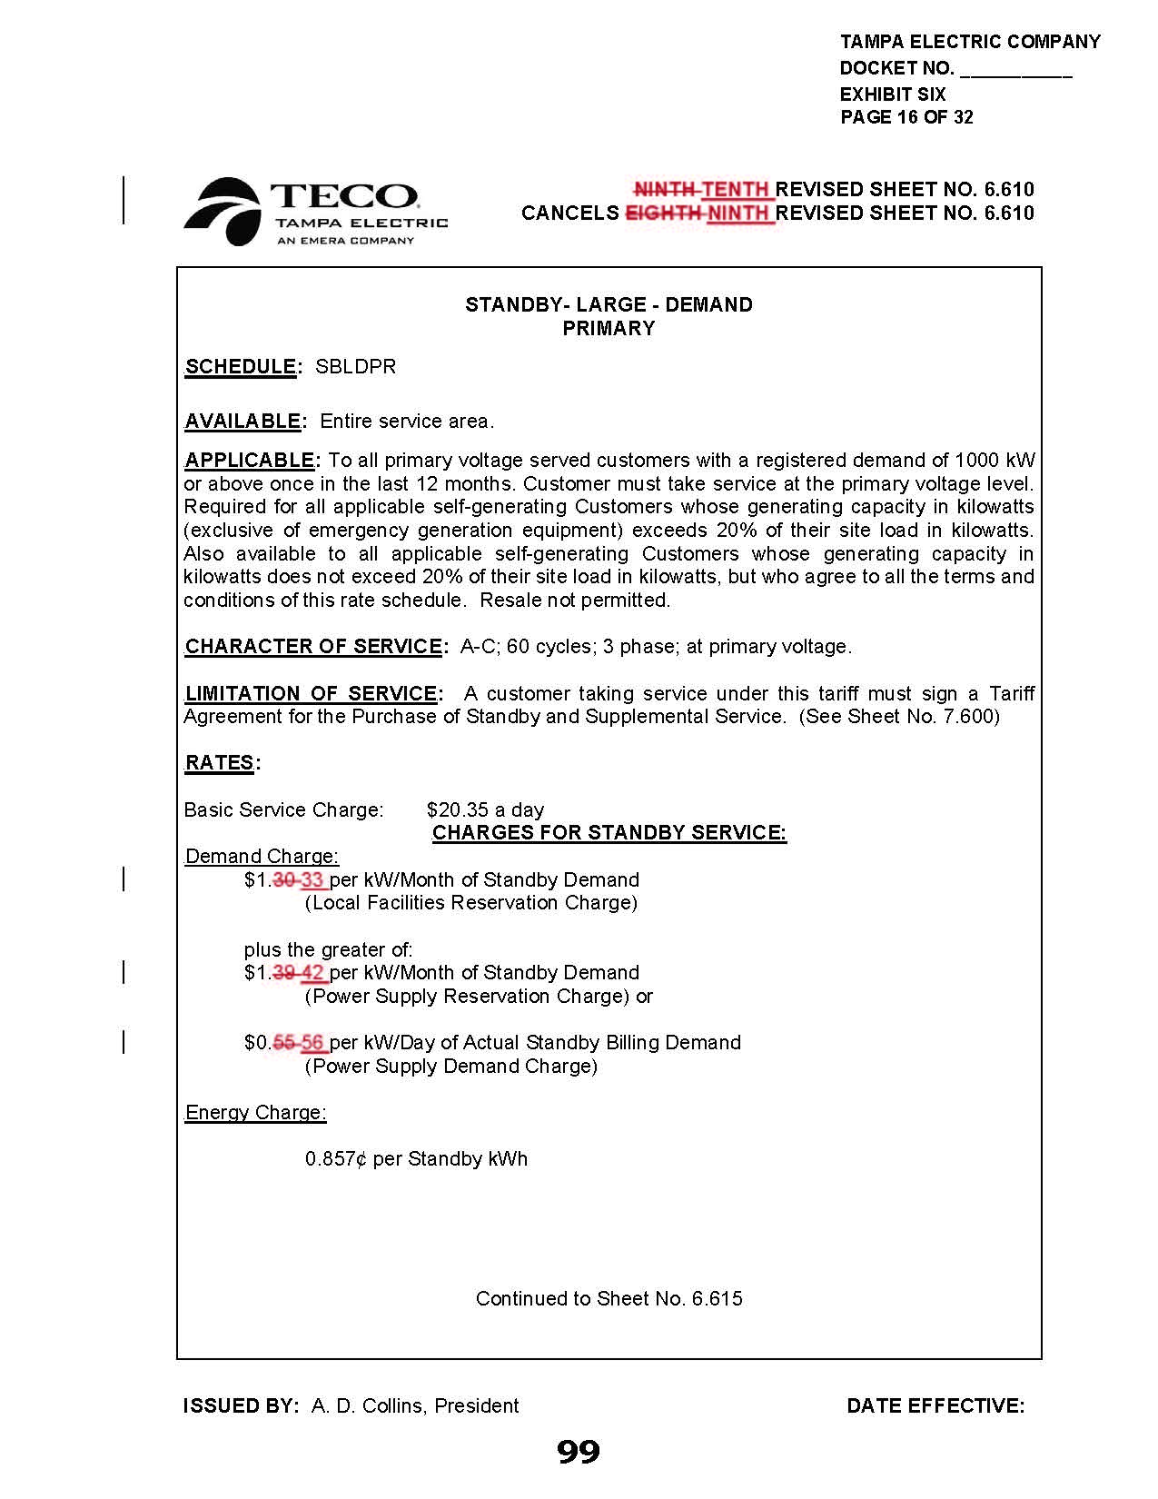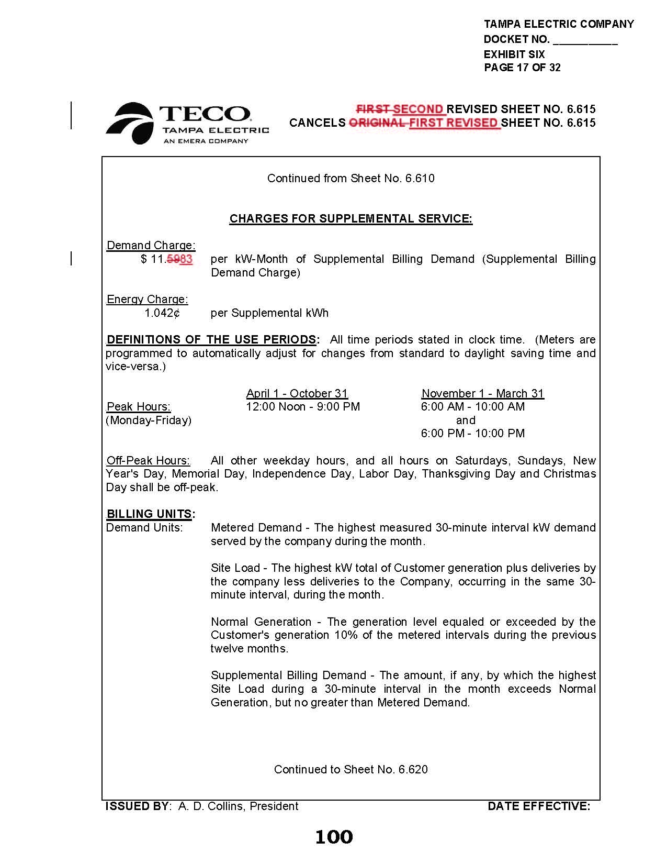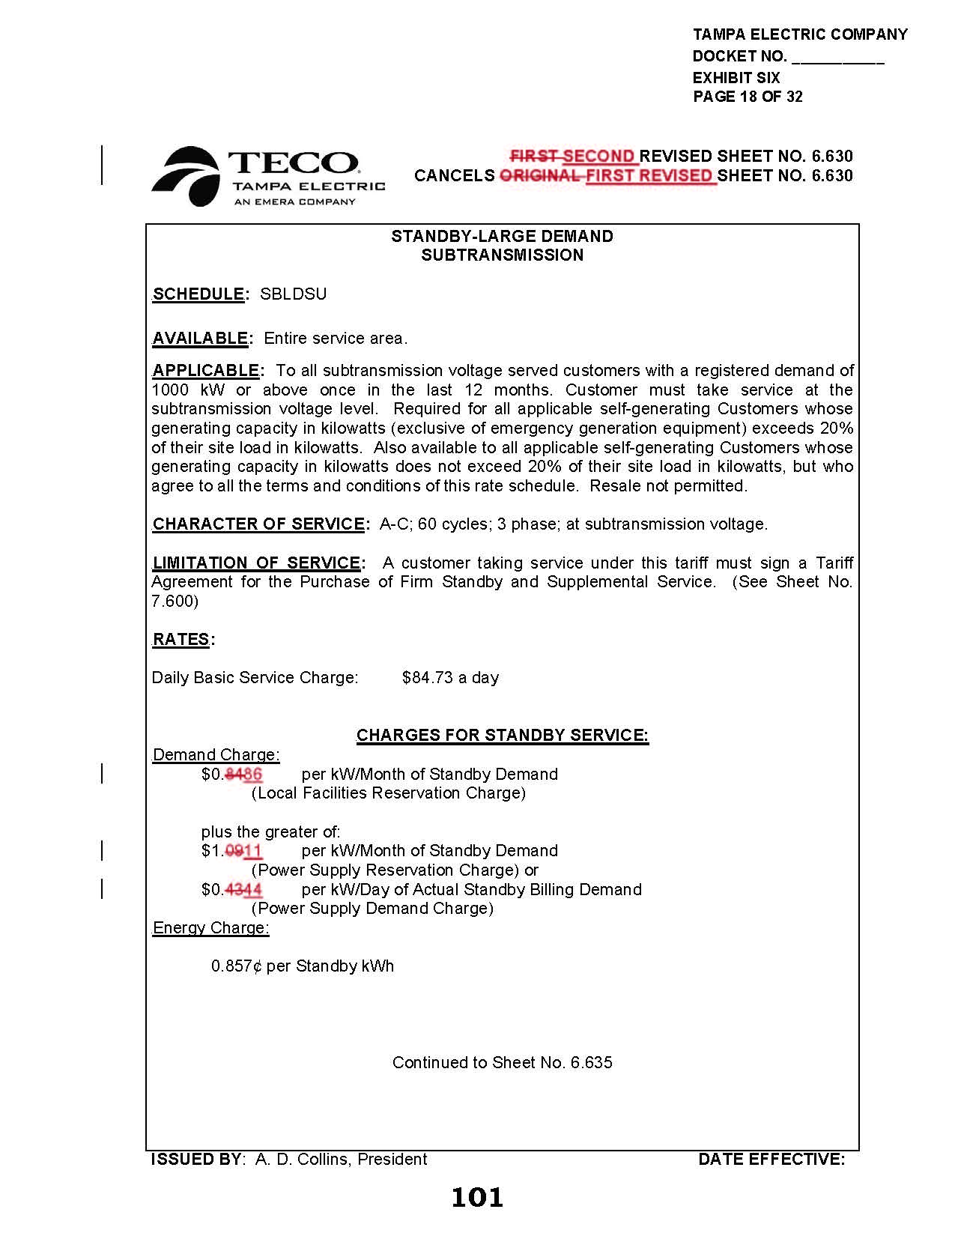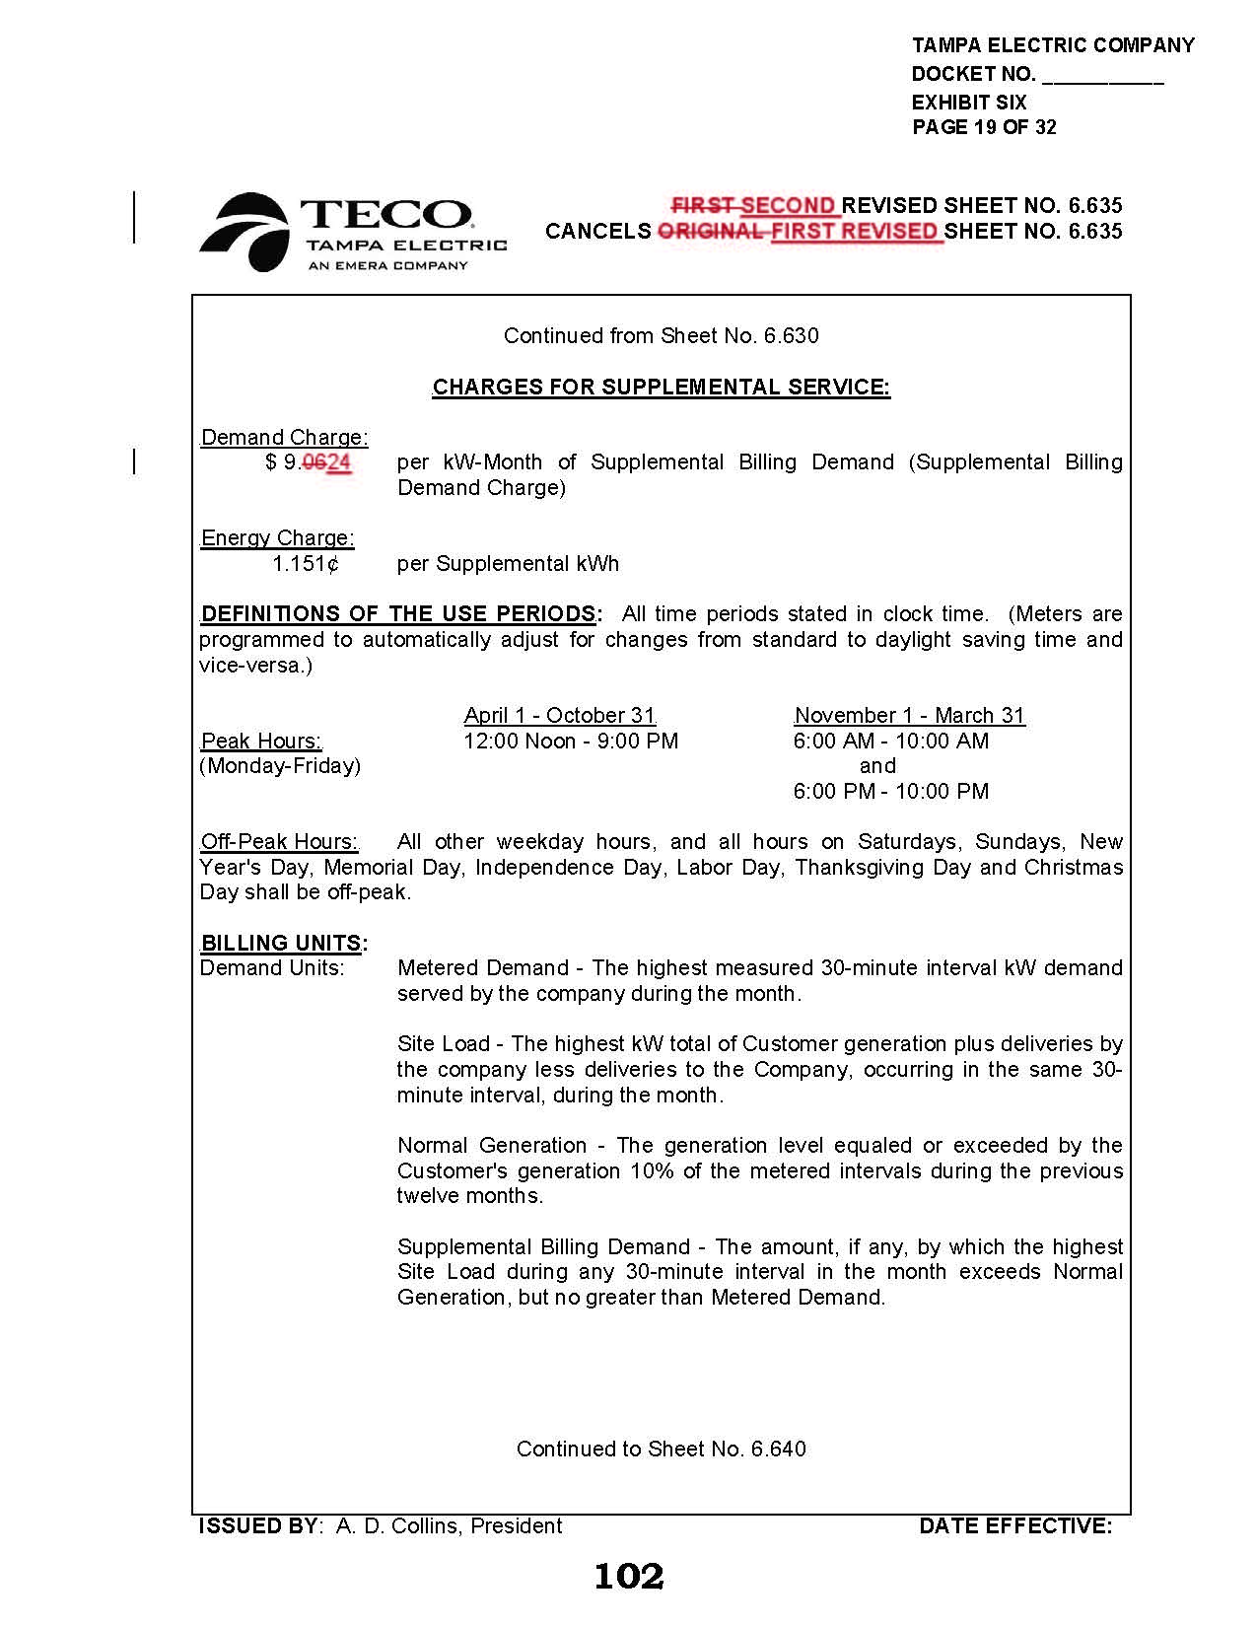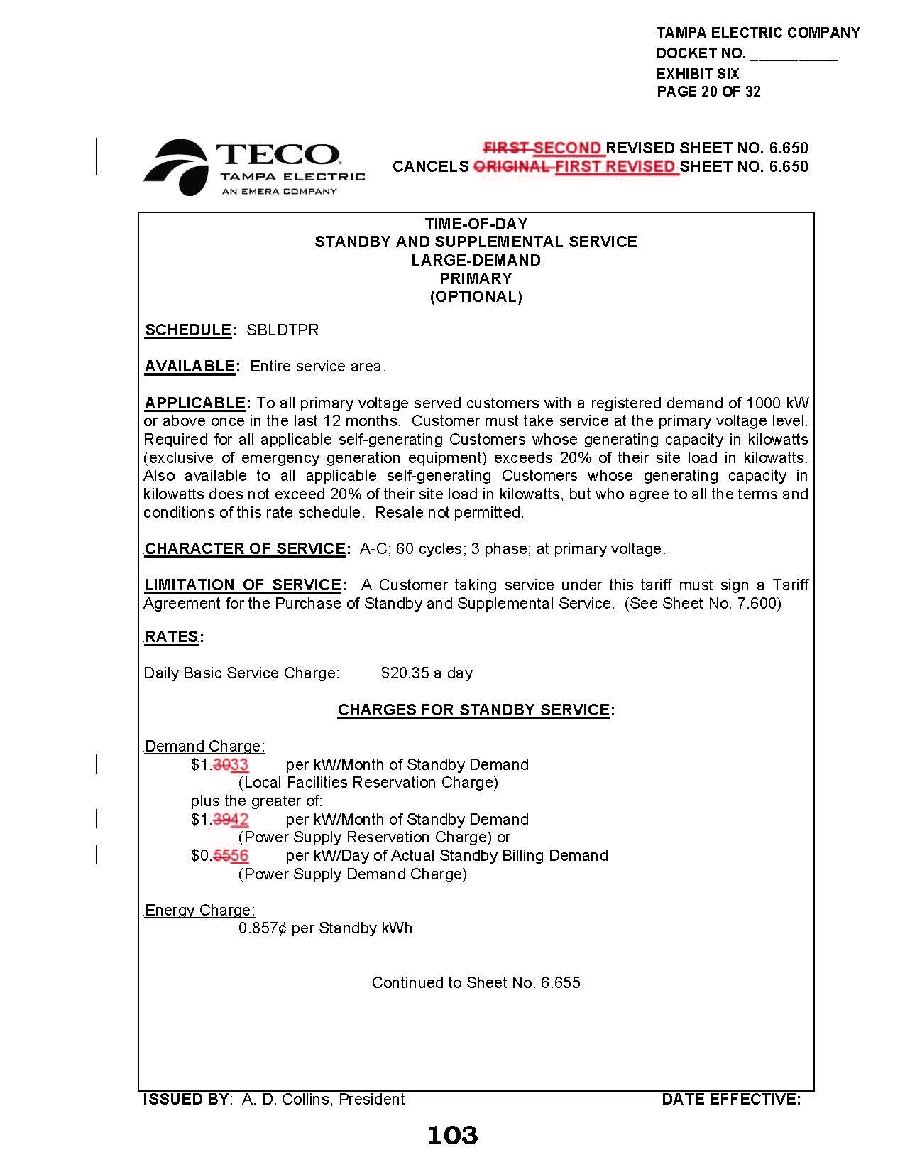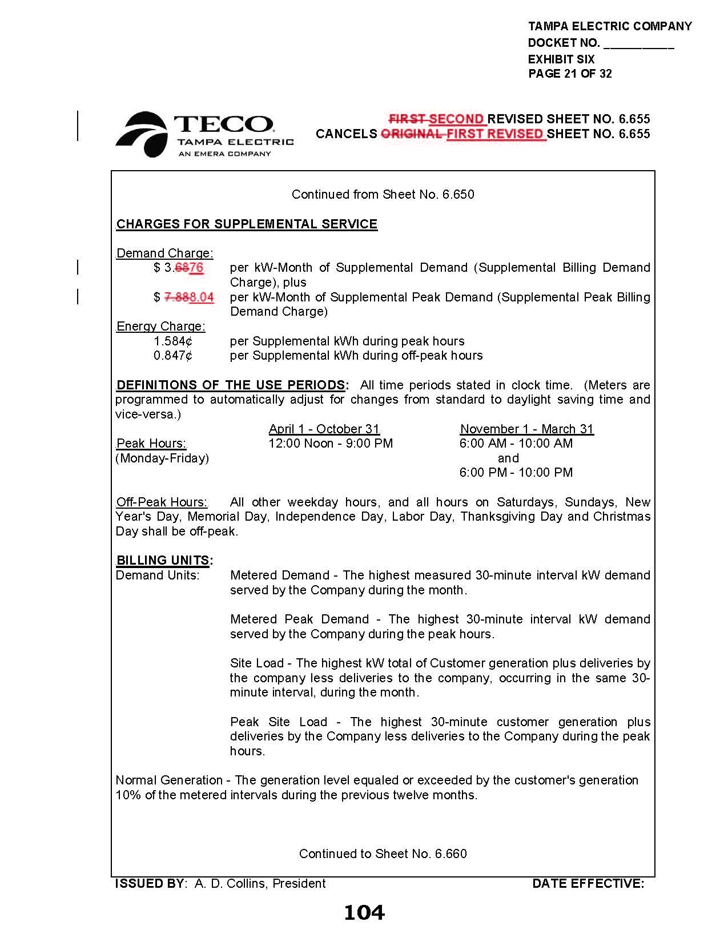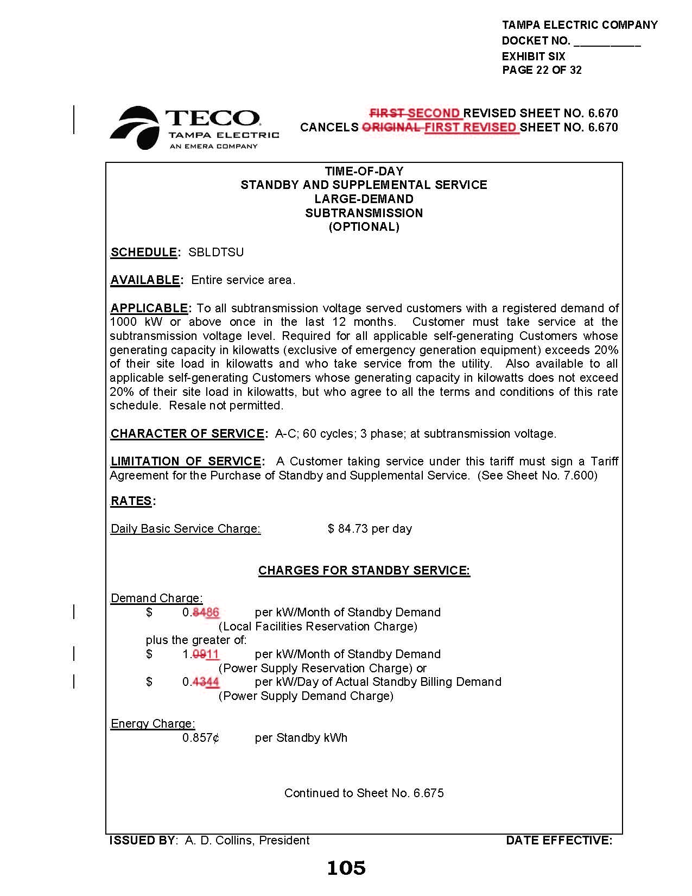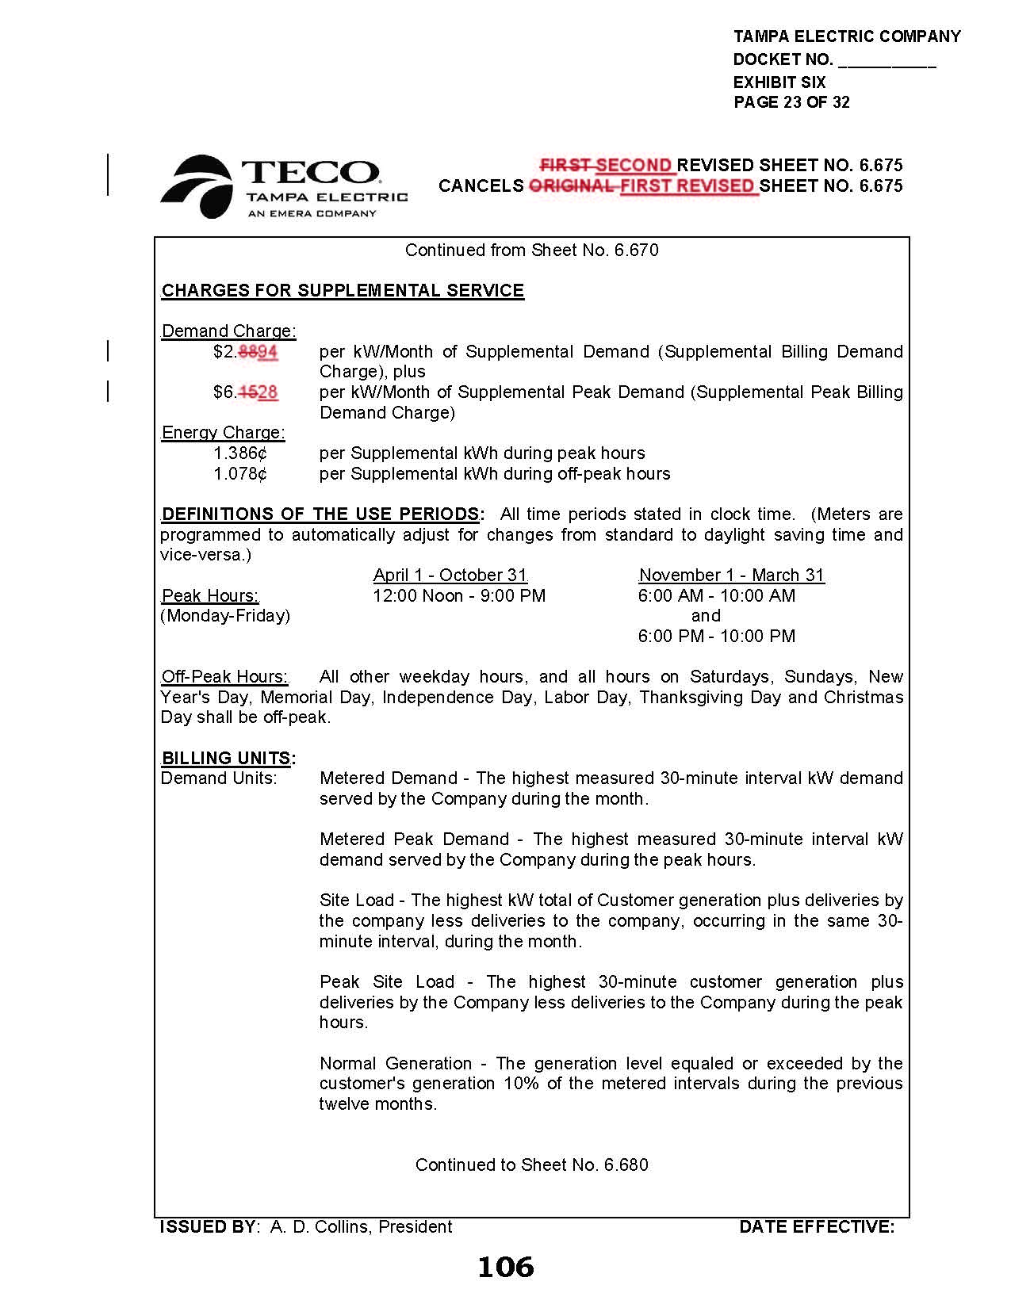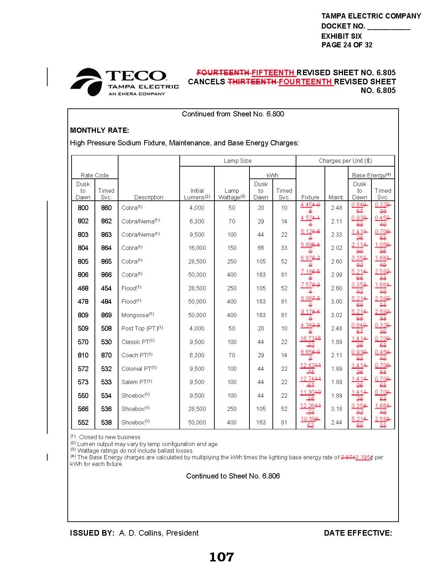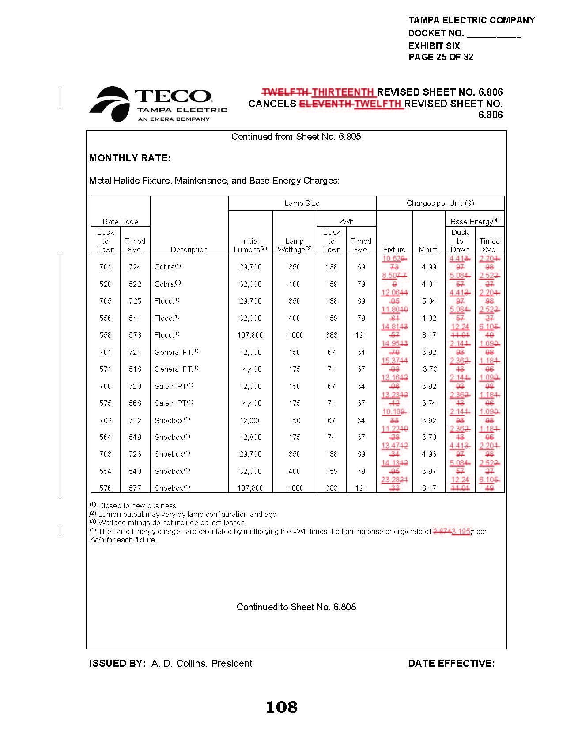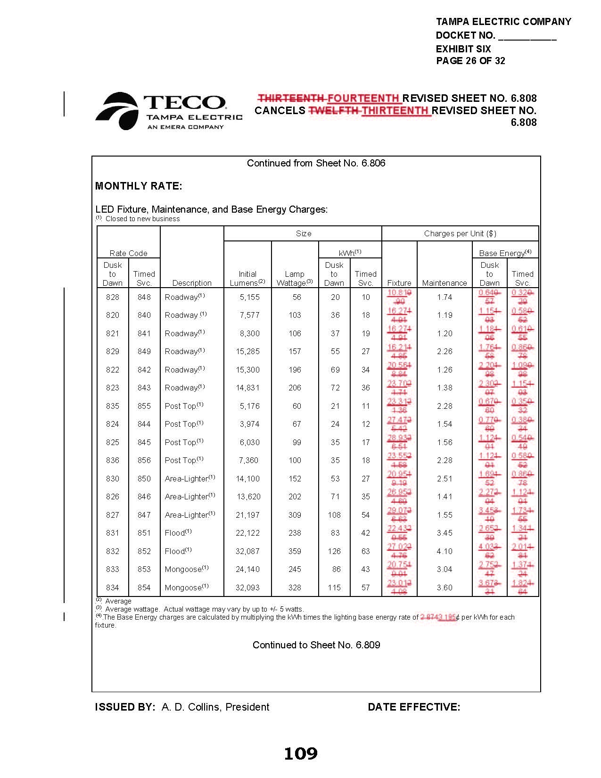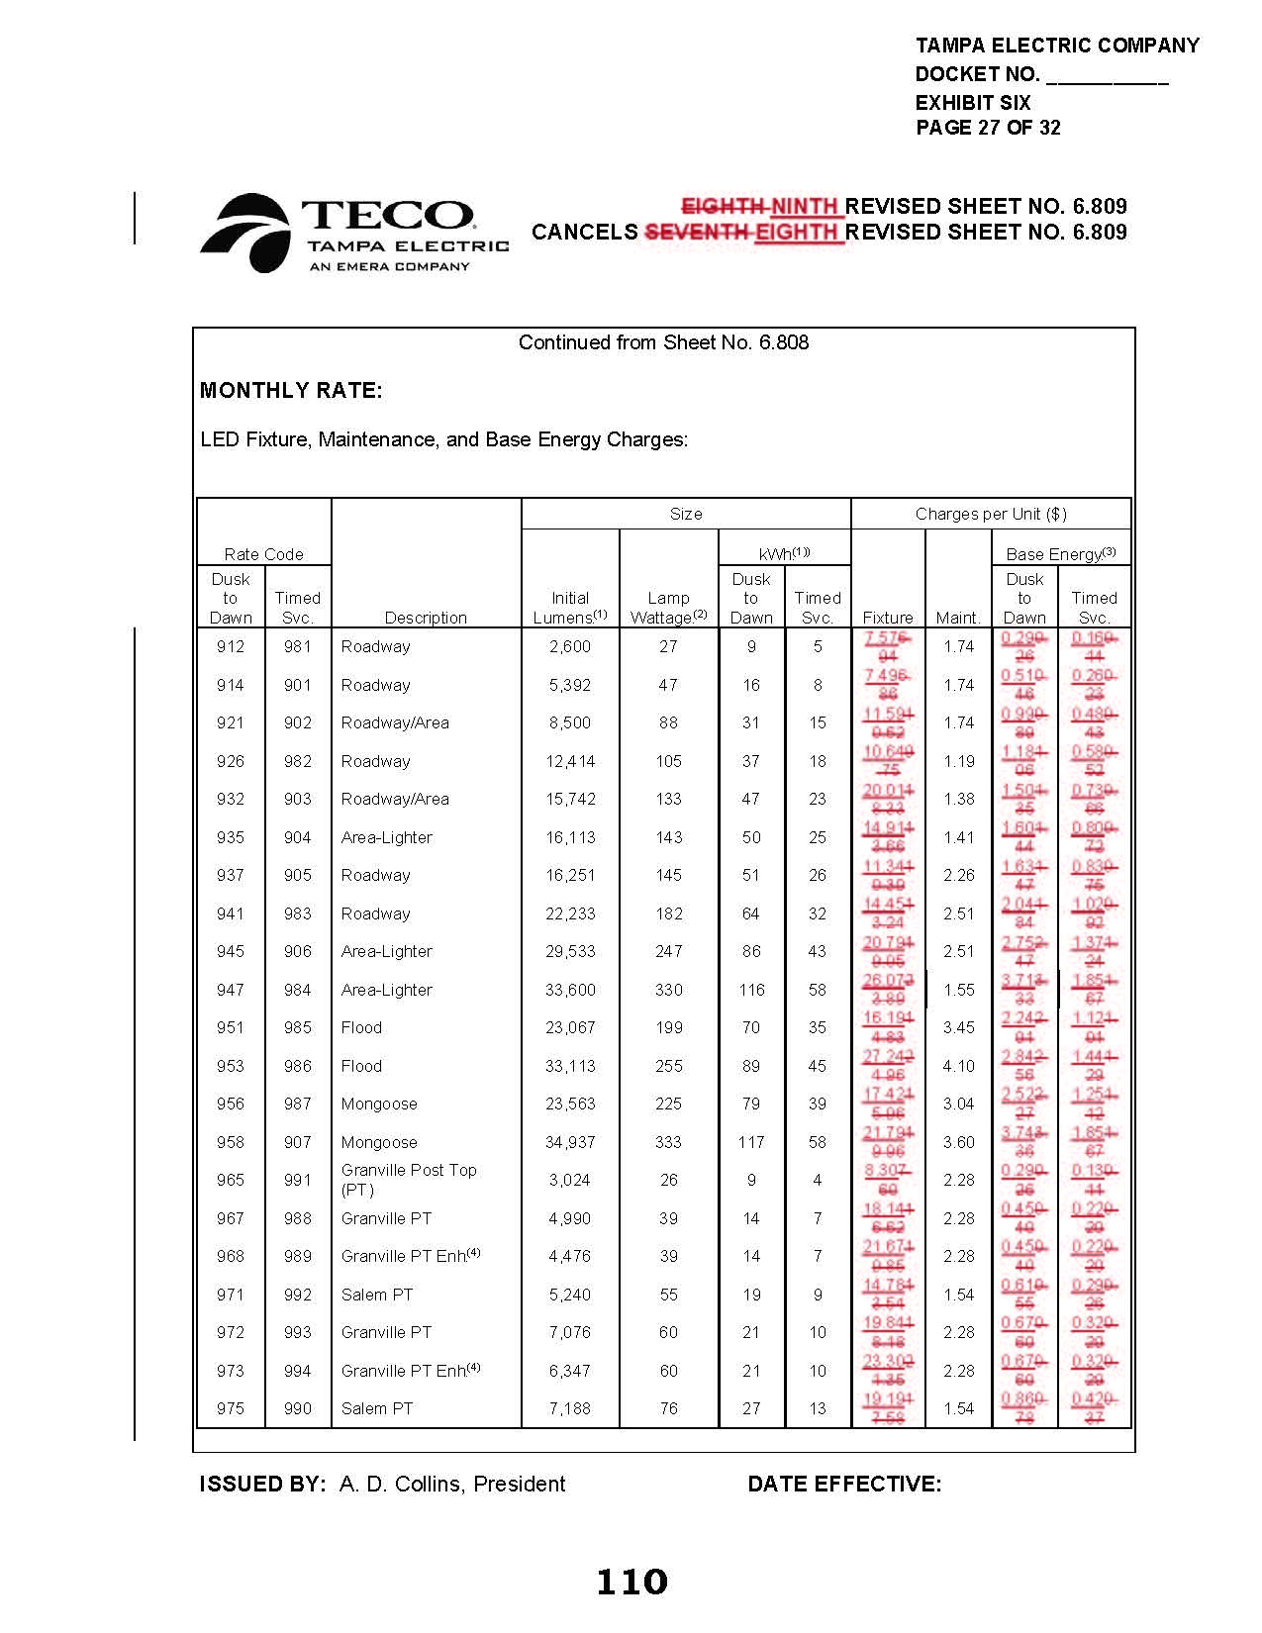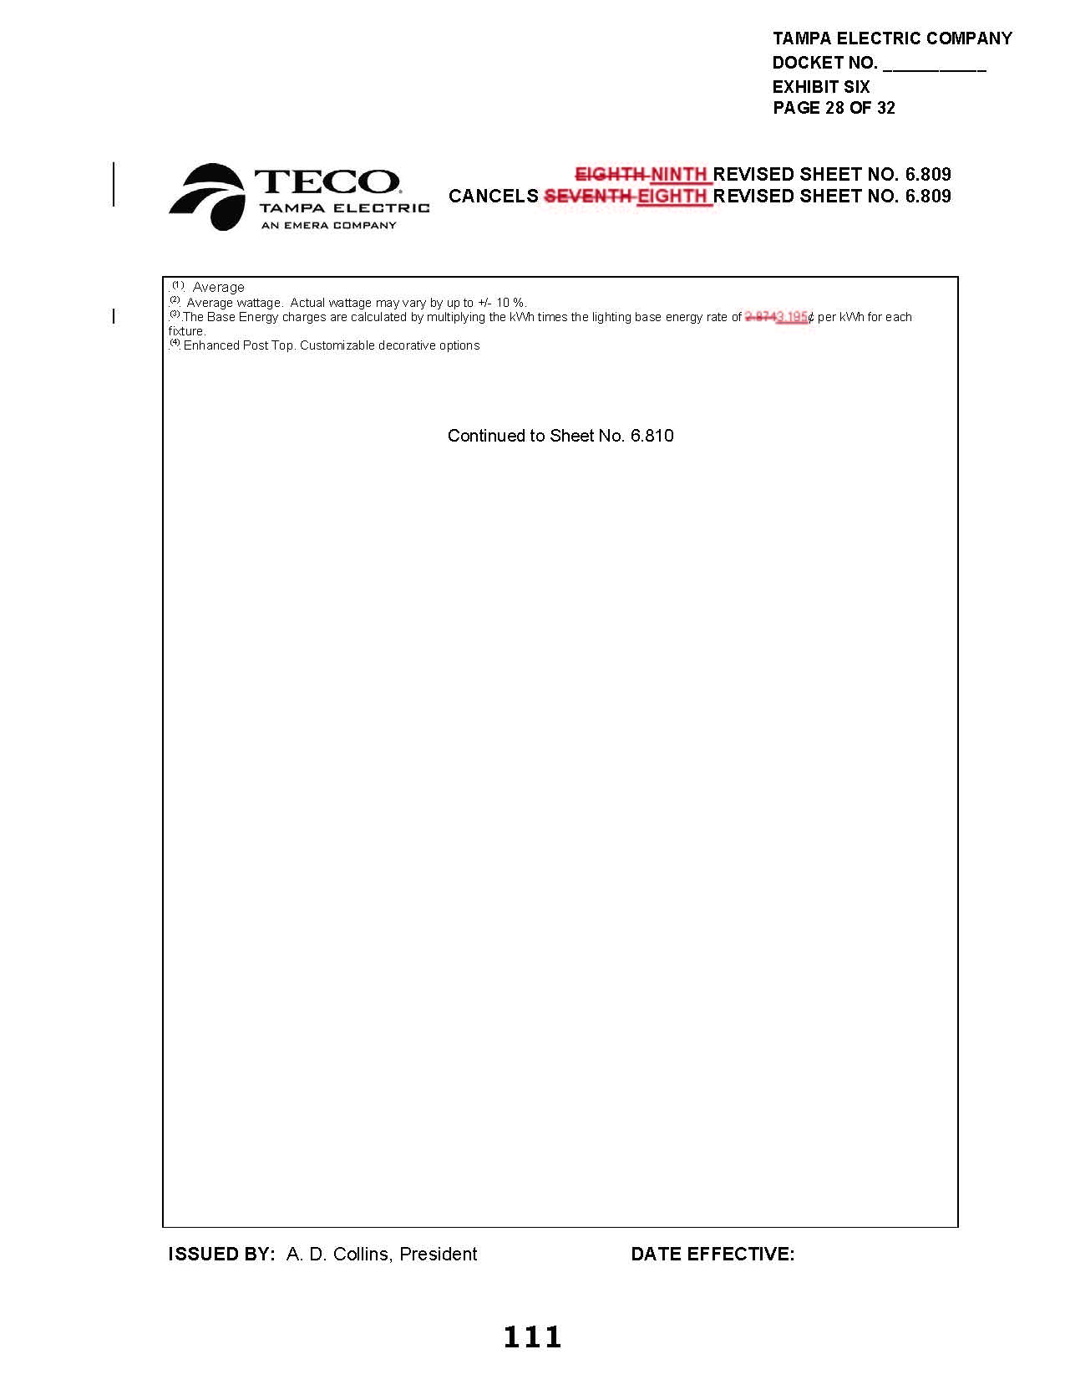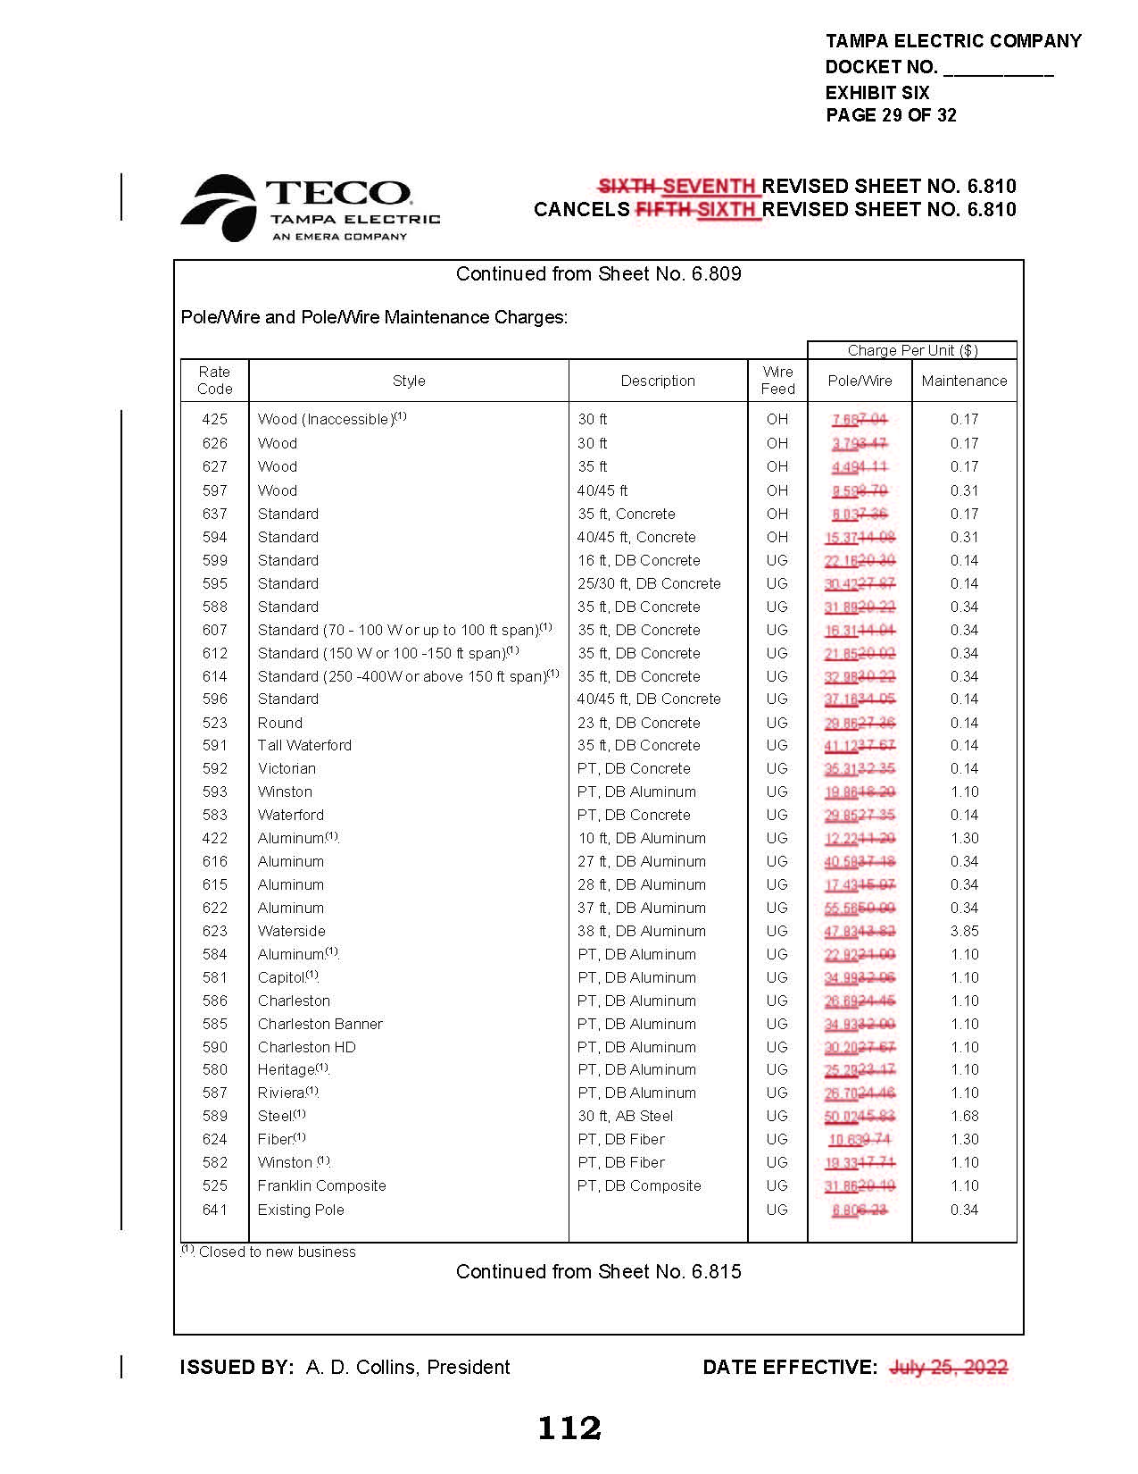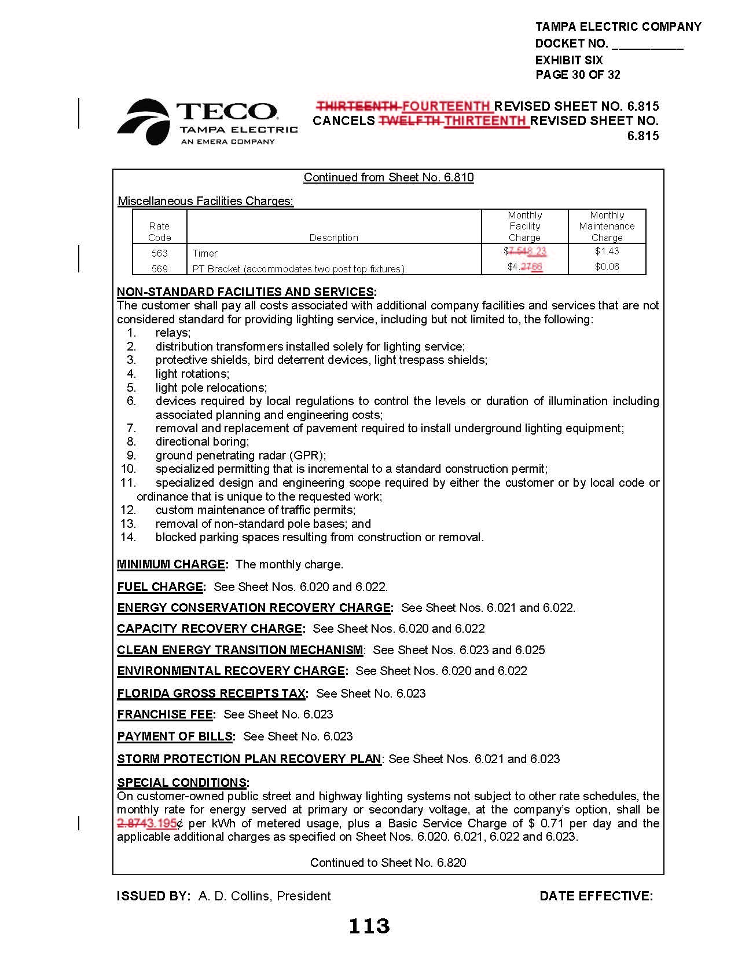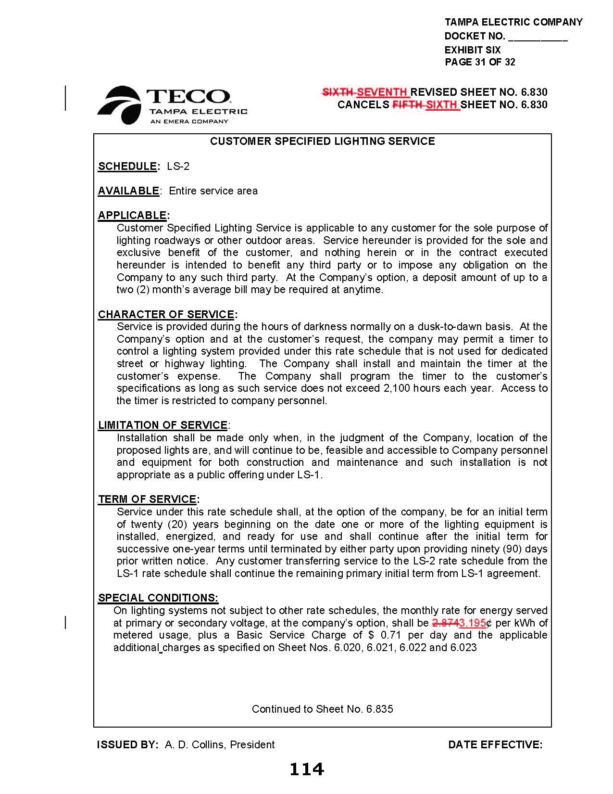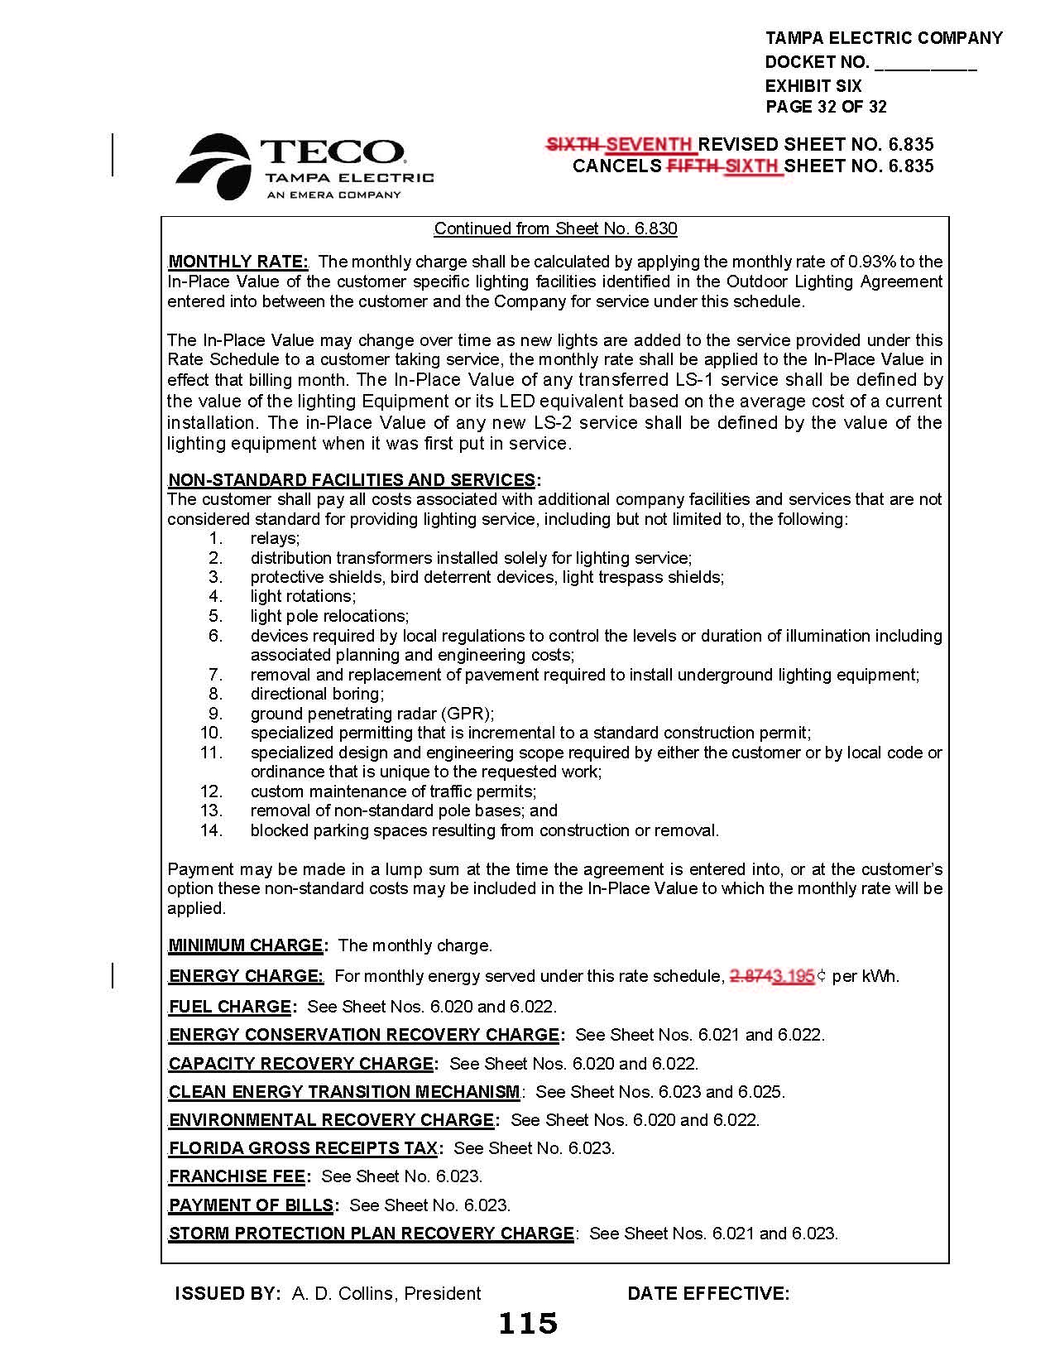

Order No. PSC-2021-0423-S-EI, issued November 10, 2021, in Docket No. 20210034-EI, In re: Petition for rate increase by Tampa Electric Company.
Order No. PSC-2022-0322-FOF-EI, issued September 12, 2022, in Docket No. 20220122-EI, In re: Petition for limited proceeding rate increase to implement return on equity provisions in 2021 agreement, by Tampa Electric Company.
Order No. PSC-2021-0423-S-EI
Order No. PSC-2022-0322-FOF-EI
Document No. 05237-2022, filed August 5, 2022, in Docket No. 20220002-EI, In re: Energy Conservation Cost Recovery Clause.

