State of Florida  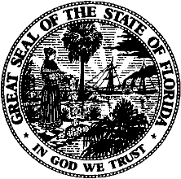 |  | Public Service Commission  Capital Circle Office Center ● 2540 Shumard Oak Boulevard  Tallahassee, Florida 32399-0850  -M-E-M-O-R-A-N-D-U-M-
DATE: | November 22, 2022
TO: | Office of Commission Clerk (Teitzman)
FROM: | Division of Accounting and Finance (Cicchetti)  Division of Economics (Draper, Guffey)  Office of the General Counsel (Stiller)
RE: | Docket No. 20220172-EI – Petition for limited proceeding to approve rate reductions associated with the Inflation Reduction Act of 2022, by Duke Energy Florida, LLC.
AGENDA: | 12/06/22 – Regular Agenda – Tariff Filing – Interested Persons May Participate
COMMISSIONERS ASSIGNED: |  |  | All Commissioners
PREHEARING OFFICER: |  |  | Passidomo
CRITICAL DATES: |  |  | 12/17/22 (60-Day Suspension Date)  12/16/22 (2021 Settlement Agreement Date)
SPECIAL INSTRUCTIONS: |  |  | None

Case Background
Duke Energy Florida, LLC (DEF or Company) is an investor-owned utility providing service to approximately 1.9 million retail customers in Florida. On October 17, 2022, DEF filed a petition requesting Commission approval of a refund and rate reduction resulting from the Inflation Reduction Act (IRA or Tax Reform) that was signed into law on August 16, 2022. The Company’s request is being made pursuant to Paragraph 18 of the 2021 Settlement Agreement (2021 Settlement) that was approved on June 28, 2021, in Docket No. 20210016-EI. Paragraph 18(b) of the 2021 Settlement requires, in part, that the impacts of any tax reform on base revenue requirements be adjusted for retail customers within 120 days of the effective date of the tax reform. The Commission has jurisdiction over this matter pursuant to Sections 366.05 and 366.06, Florida Statutes.

Discussion of Issues

Issue 1:
Should the Commission approve DEF’s calculation of the tax savings associated with the IRA for 2023?

Recommendation:
Yes. The Commission should approve DEF’s calculations of the net tax savings of $56 million for 2023 resulting from the Company’s election to use Production Tax Credits (PTCs) instead of Investment Tax Credits (ITCs) as allowed by the IRA. (Cicchetti)

Staff Analysis:
Effective January 1, 2022, the IRA expanded federal income tax benefits for renewable energy by allowing owners of solar projects which begin construction before 2025 the option to elect to receive PTCs instead of ITCs. DEF has elected to use PTCs instead of ITCs because it provides a greater tax benefit and greater customer savings. The application of PTCs to DEF’s solar facilities results in net tax savings of $56 million. The net tax savings is comprised of $34.7 million from the generation of PTCs, $7.0 million from the net change in DEF’s weighted average cost of capital (WACC) due to replacing ITCs with PTCs, and $14.3 million from applying the revenue expansion factor.
There are two adjustments to DEF’s WACC as a result of replacing the ITCs with PTCs: 1) the removal of the ITCs and 2) the addition of a deferred tax asset (DTA). DEF has proposed to flow back the full value of PTCs generated in 2023 but will not have sufficient income to be able to use these credits to reduce its taxes payable until sometime in the future, currently estimated to be no sooner than 2027. Consequently, DEF has recorded a DTA in the amount of the 13-month average balance of the accumulated PTCs. Staff reviewed DEF’s calculations in the direct testimony of Witness Olivier filed on October 17, 2022, in the instant docket, and believes they are reasonable and appropriate. Based on the aforementioned, staff recommends the Commission approve DEF’s calculations of net tax savings of $56 million for 2023 resulting from the Company’s election to use PTCs instead of ITCs as allowed by the IRA.

Issue 2:
Should the Commission approve DEF’s proposed process for flowing the tax reform impacts to DEF's customers?

Recommendation:
Yes. Staff recommends the Commission approve a base rate reduction of $56 million starting with the first billing cycle of January 2023 and allow DEF to credit customers for the actual 2022 tax savings impact in the next Capacity Cost Recovery (CCR) Clause filing (expected in March 2023). (Cicchetti)

Staff Analysis:
As discussed in Issue 1, DEF’s application of PTCs has reduced its 2023 jurisdictional adjusted revenue requirement by $56 million. Pursuant to Paragraph 18(b) of the 2021 Settlement, DEF is obligated to adjust base rates within 120 days of the latter of the enactment date or effective date of a change in tax law. The IRA was effective August 16, 2022, and December 16, 2022 is 120 days from the effective date. DEF proposes to adjust base rates with the first billing cycle for January 2023 so that the tax savings base rate change will be effective with the first billing cycle of the month and to align the tax savings base rate change with other changes that will be occurring January 2023. The PTC change in the IRA is retroactive to January 1, 2022. Consequently, DEF proposes to credit customers for the actual 2022 tax savings in its next CCR filing (expected in March 2023). This is consistent with Paragraph 18(b) of the 2021 Settlement which states:
Any effects of tax reform on retail revenue requirements from the effective date through the date of the base rate adjustment shall be flowed back or collected from customers through the CCR Clause on the same basis used in any rate adjustment.
Staff has reviewed the Company’s calculation of the net tax savings from the IRA and recommends the Commission approve a base rate reduction of $56 million starting with the first billing cycle of January 2023 and allow DEF to credit customers for the actual 2022 tax savings impact in the next Capacity Cost Recovery (CCR) Clause filing (expected in March 2023).

Issue 3:
Should the Commission give staff approval to administratively approve DEF’s revised tariffs which reflect and implement the multi-year base rate increase, ROE trigger, SoBRA (Duette) true-up, and the IRA base revenue decrease effective January 2023?

Recommendation:
Yes. The Commission should give staff administrative authority to approve DEF’s revised tariffs which reflect and implement the multi-year base rate increase, ROE trigger, SoBRA (Duette) true-up, and the IRA base revenue decrease effective January 2023. (Guffey)

Staff Analysis:
In its petition, DEF requested that the Commission give staff authority to administratively approve tariffs reflecting base rates for all customer classes to be effective January 2023. On October 27, 2022, DEF filed tariffs in this docket that reflect previous Commission-approved base rate changes and implement the proposed IRA base revenue decrease at issue in this docket. Witness Olivier, in her direct testimony, discusses and summarizes in Exhibit MJO-3 the four base rate changes effective January 2023.
The Commission has previously approved the following base rate changes effective January 2023. First, in Order No. PSC-2021-0202A-AS-EI, the Commission approved a 2023 multi-year base rate increase of $48.9 million in DEF’s base rates. Second, consistent with Order No. PSC-2017-0451-AS-EU, DEF calculated adjusted base rates to reflect the Duette Solar Base Rate Adjustment (SoBRA) true-up. The SoBRA true-up results in a $1.1 million decrease in base rates. Finally, in Order No. PSC-2022-0357-FOF-EI, the Commission approved an annual base revenue increase of $24.4 million to reflect the ROE trigger provisions of the 2021 Settlement Agreement.
The calculation of the IRA adjustment factor of (2.095) percent is shown in Exhibit MJO-2 of the petition and the adjustment factor has been applied in a uniform manner to the base rates for all rate classes. The IRA adjustment factor was calculated by dividing the $56 million reduction by the 2023 projected $2,671.1 million retail base revenue sales of electricity.
Staff has reviewed DEF’s tariff sheets and supporting documentation for accuracy. The Commission should give staff administrative authority to approve DEF’s revised tariffs which reflect and implement the multi-year base rate increase, ROE trigger, SoBRA (Duette) true-up, and the IRA base revenue decrease effective January 2023.

Issue 4:
Should this docket be closed?

Recommendation:
Yes. At the conclusion of the protest period, if no protest is filed, this docket should be closed upon the issuance of a consummating order. If a protest is filed within 21 days of the issuance of the order, the tariffs should remain in effect, subject to adjustments pending the resolution of the protest. (Stiller)

Staff Analysis:
At the conclusion of the protest period, if no protest is filed, this docket should be closed upon the issuance of a consummating order. If a protest is filed within 21 days of the issuance of the order, the tariffs should remain in effect, subject to adjustments pending the resolution of the protest.

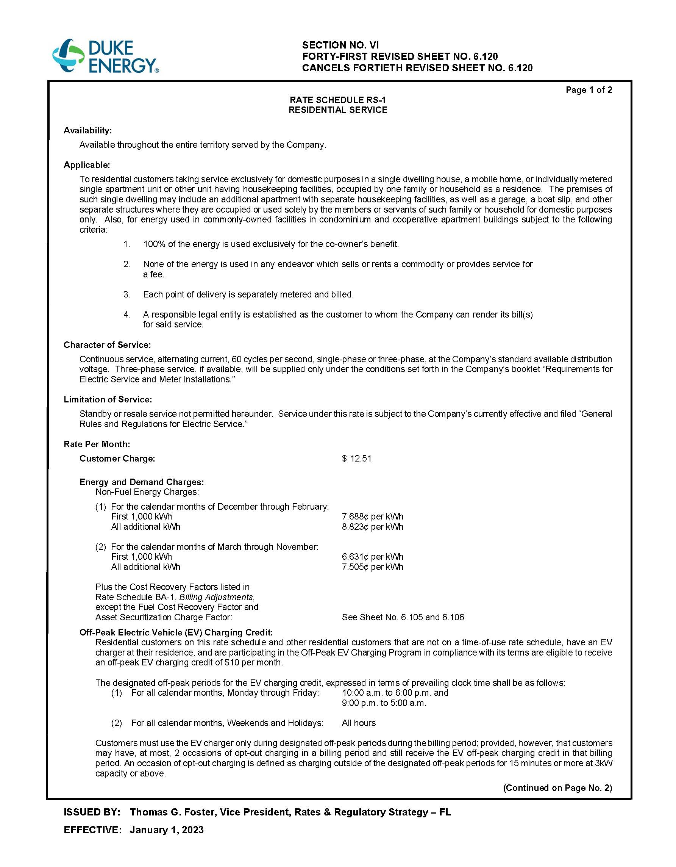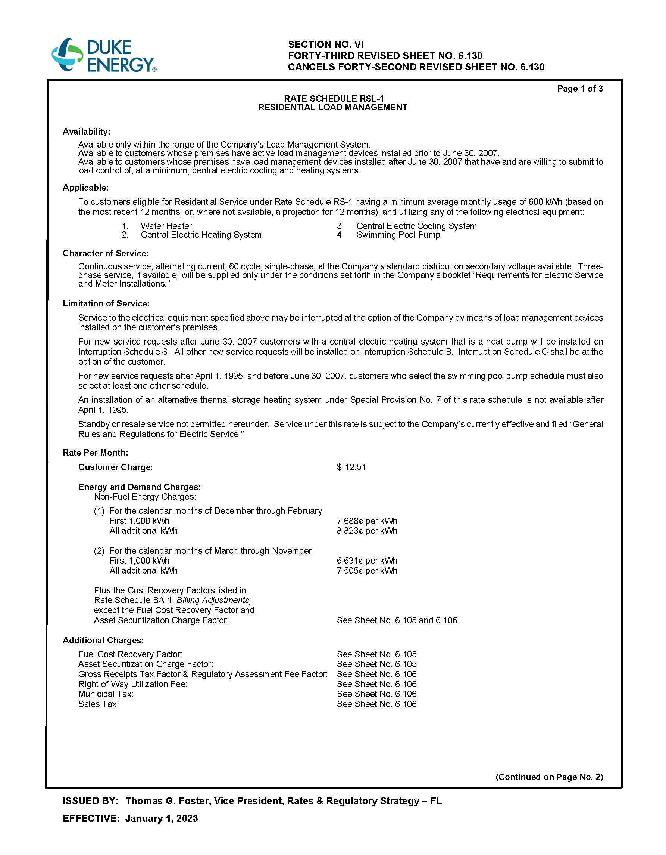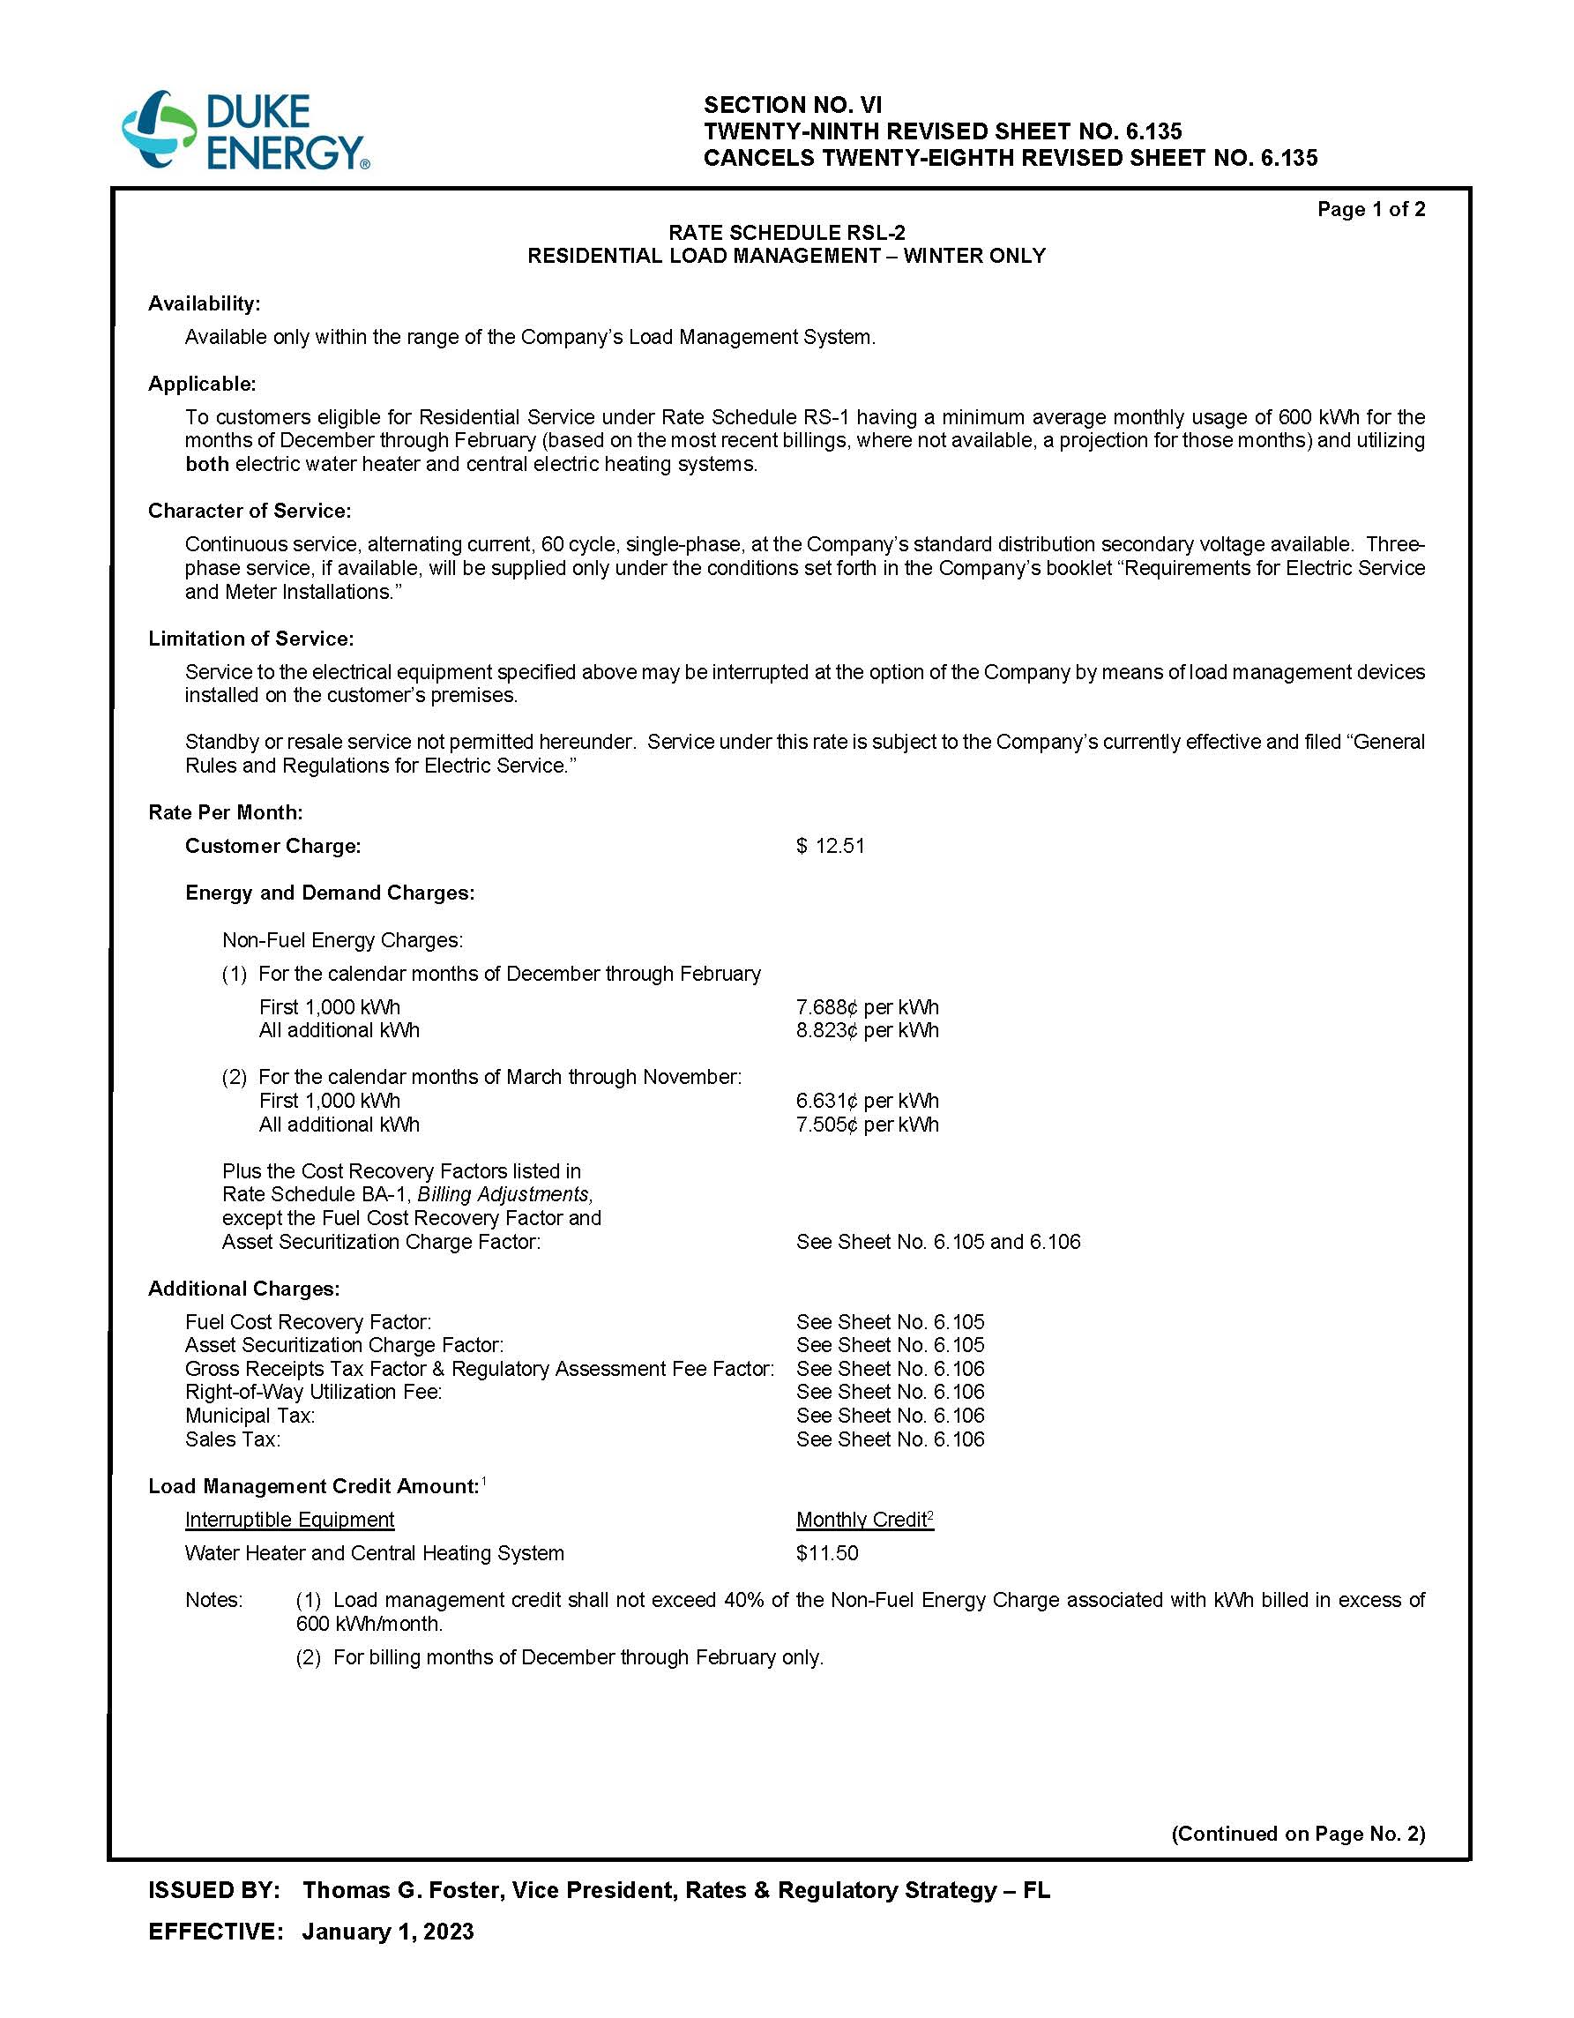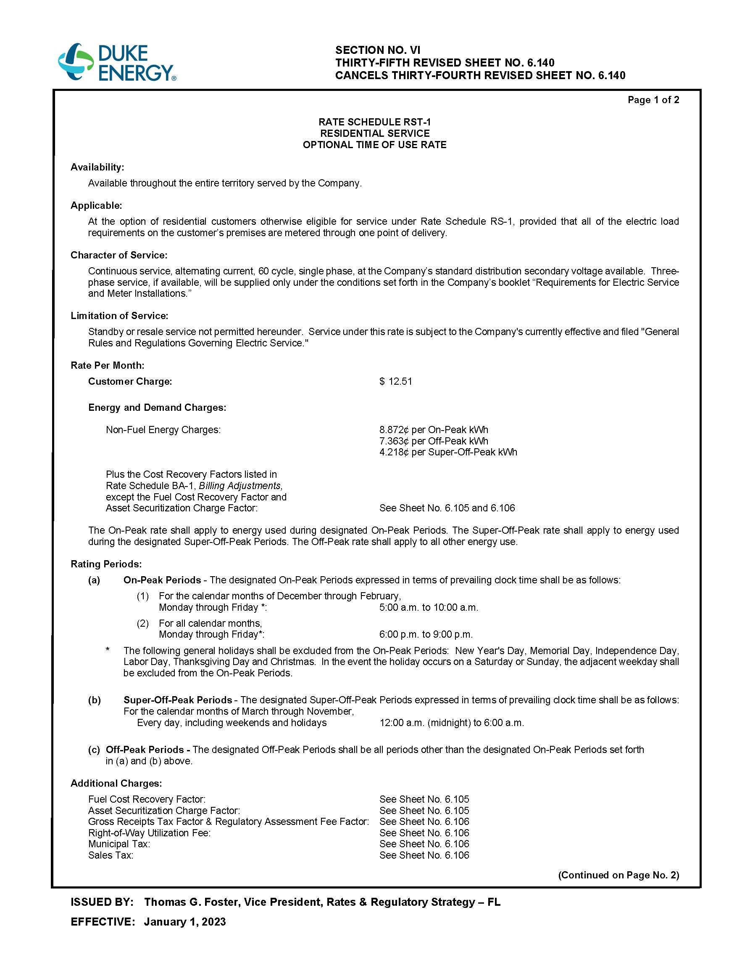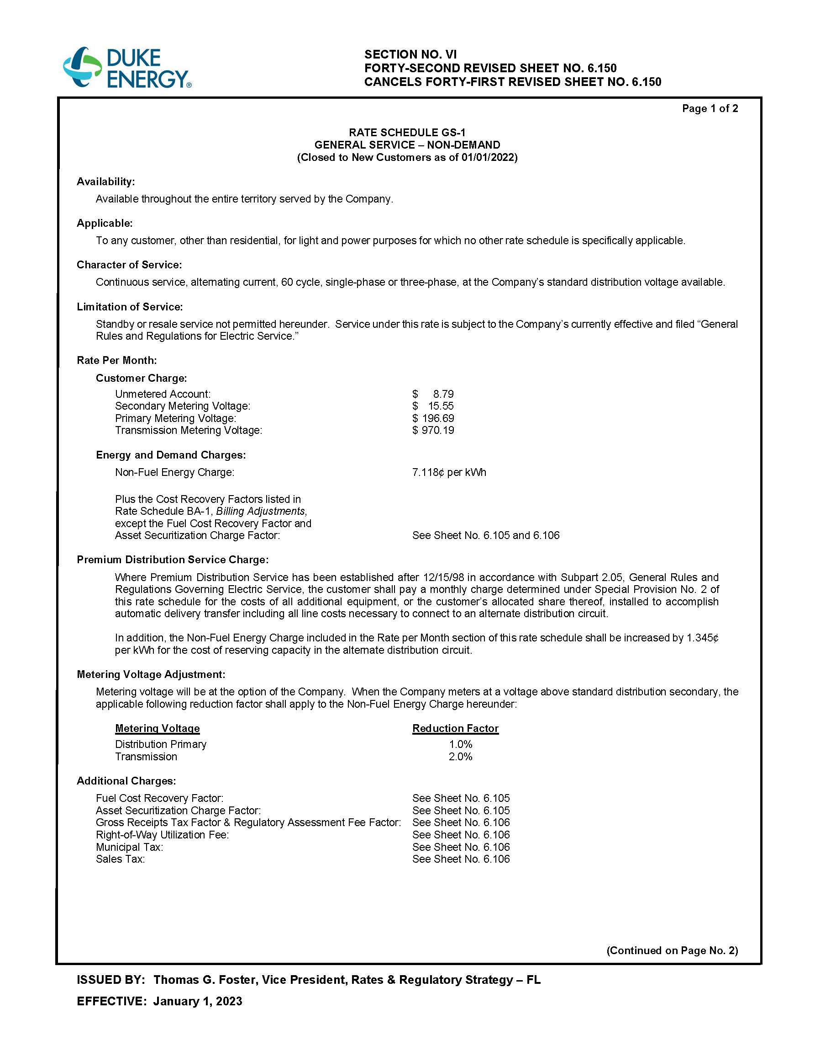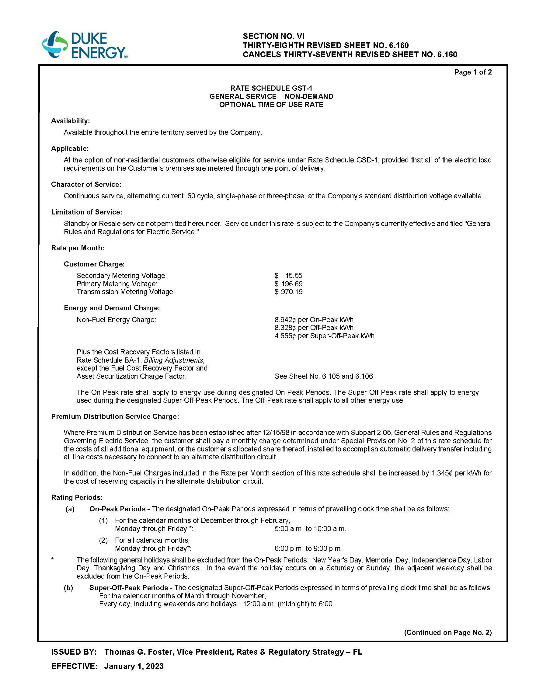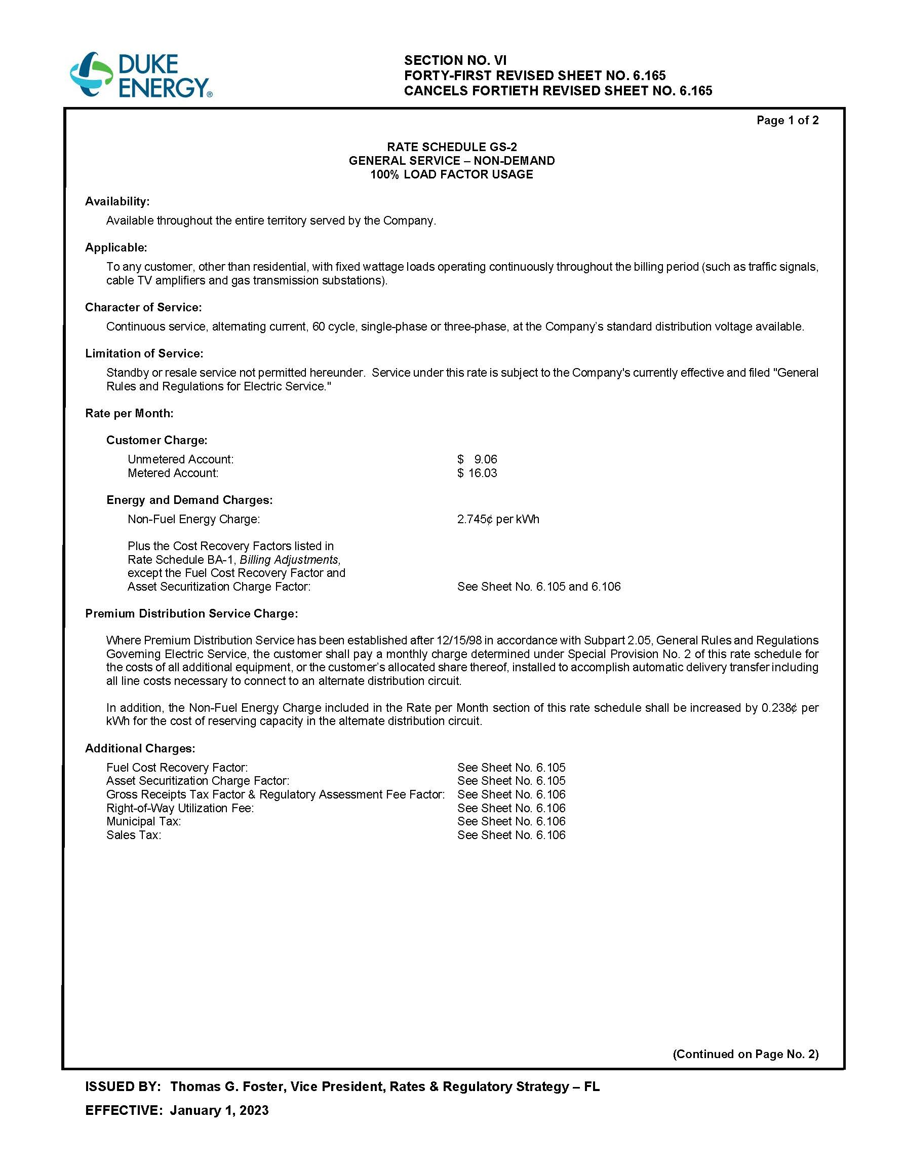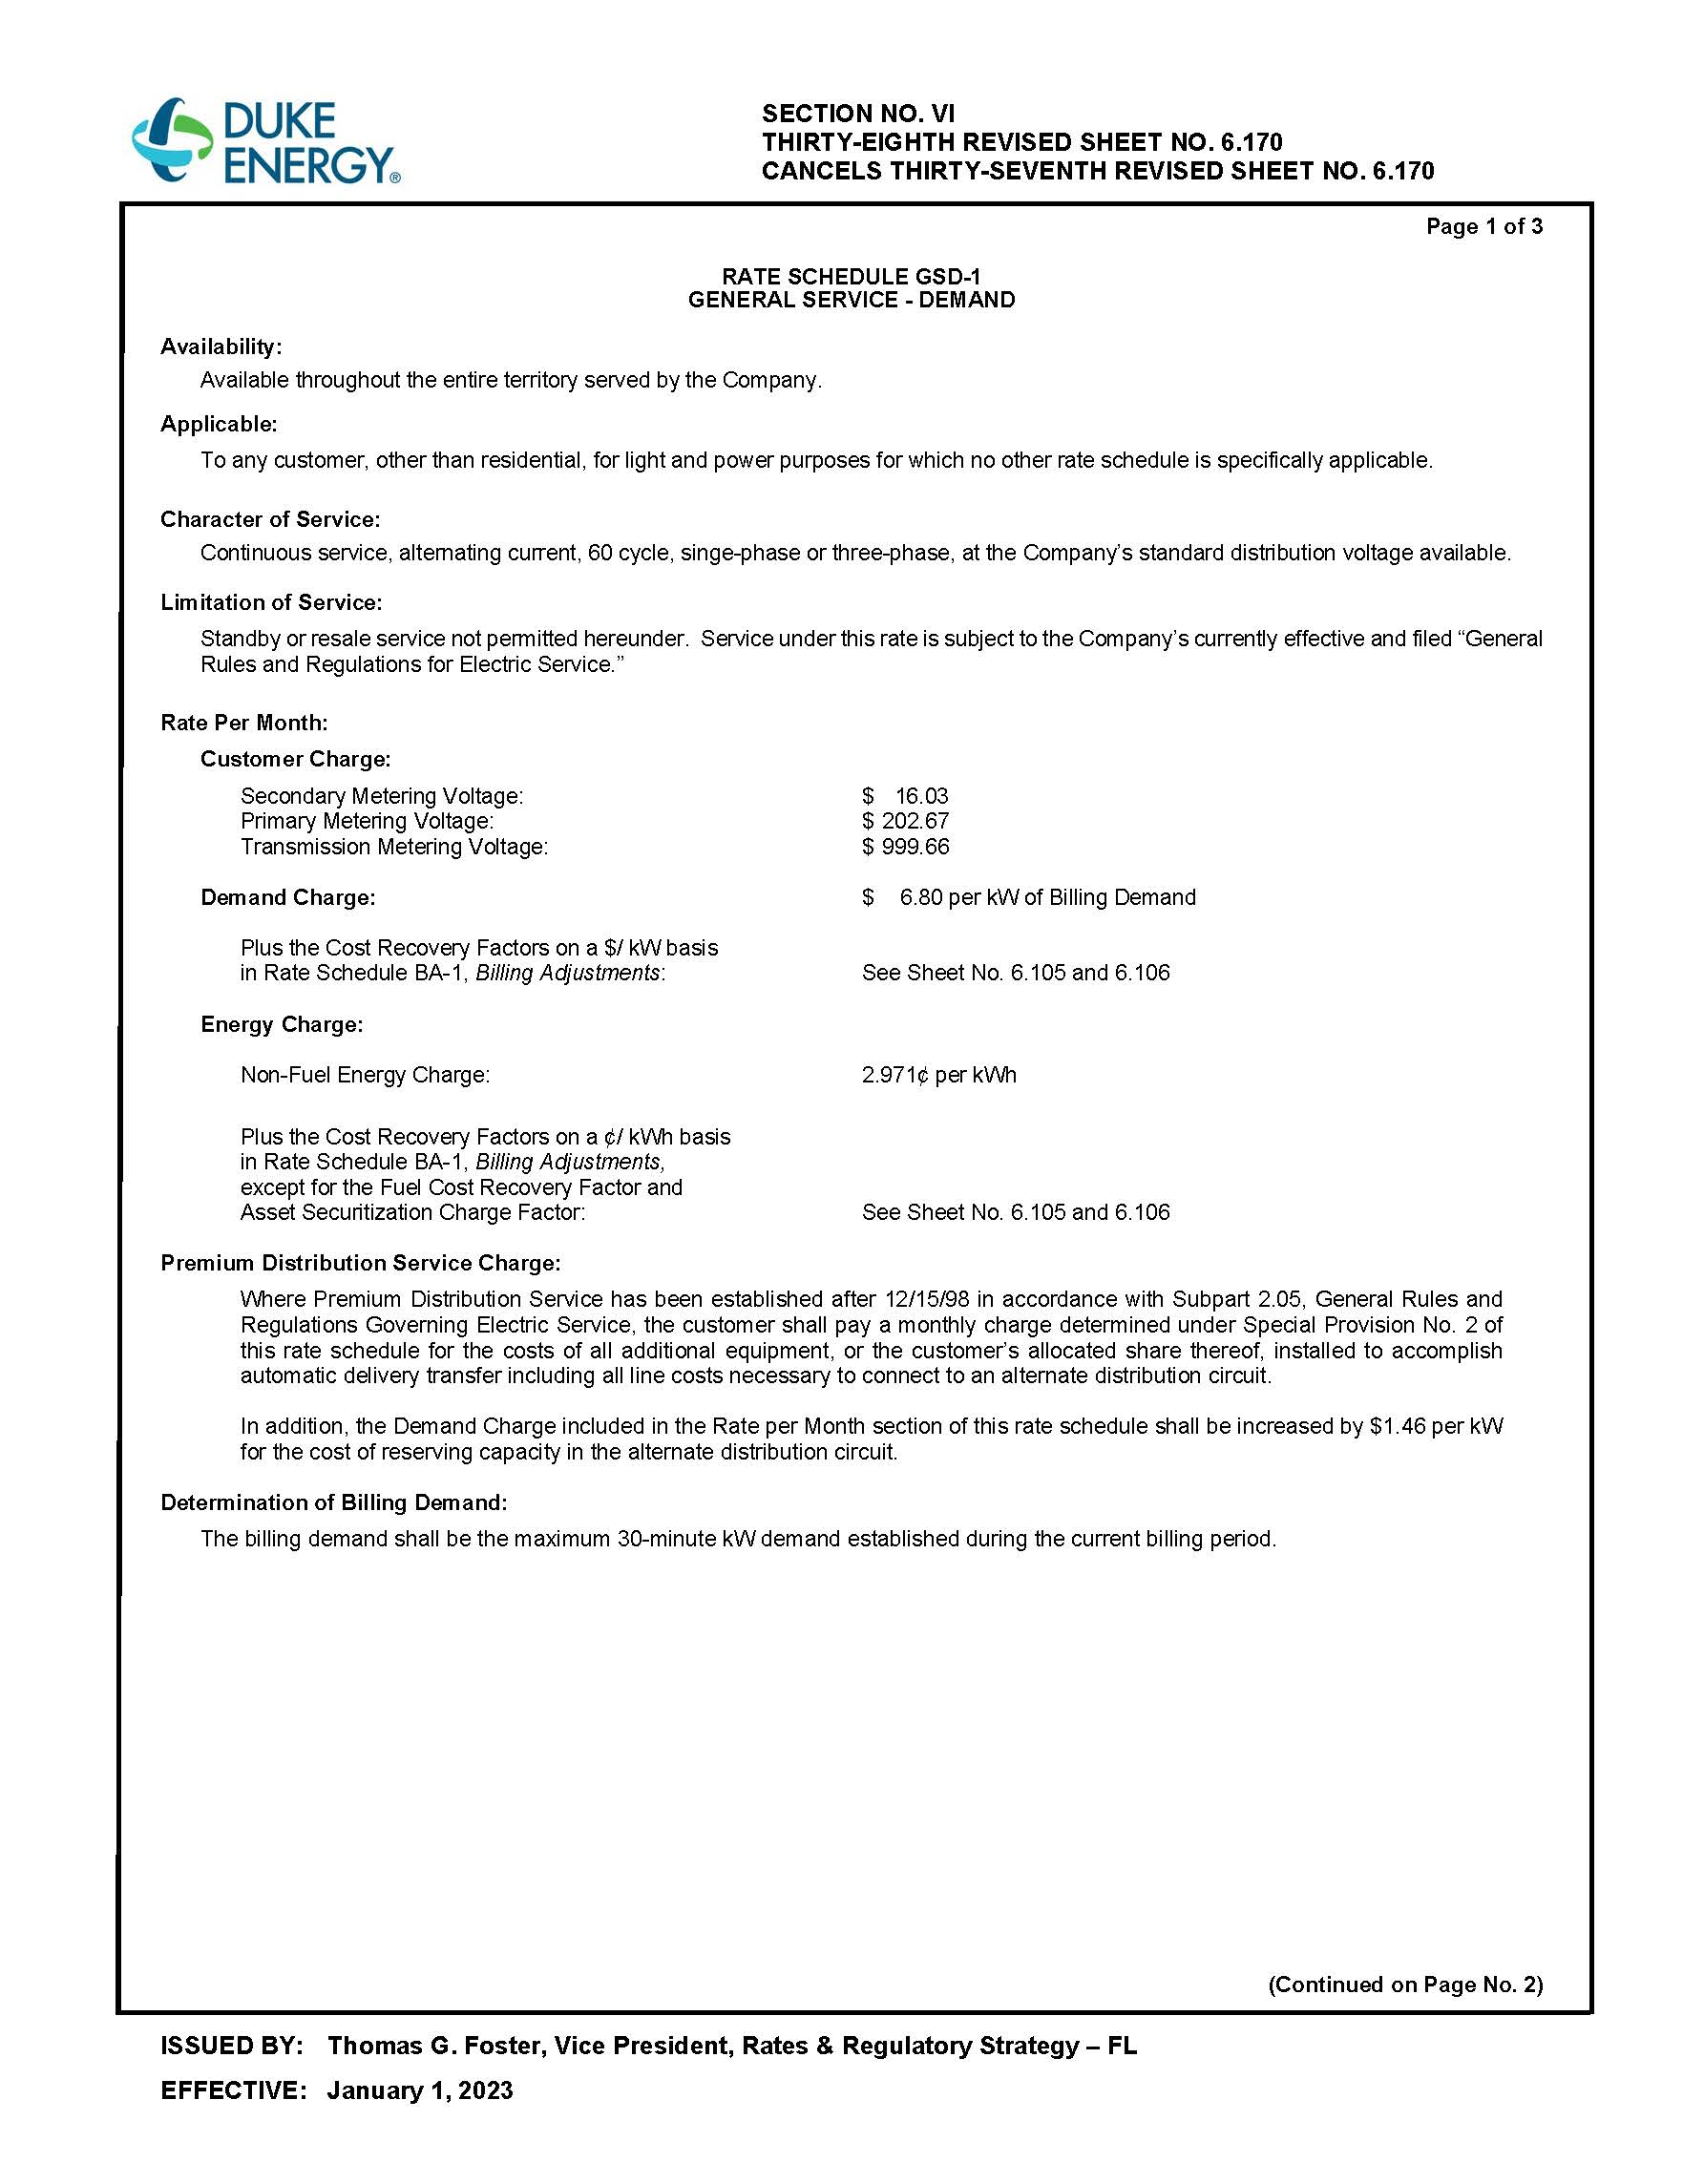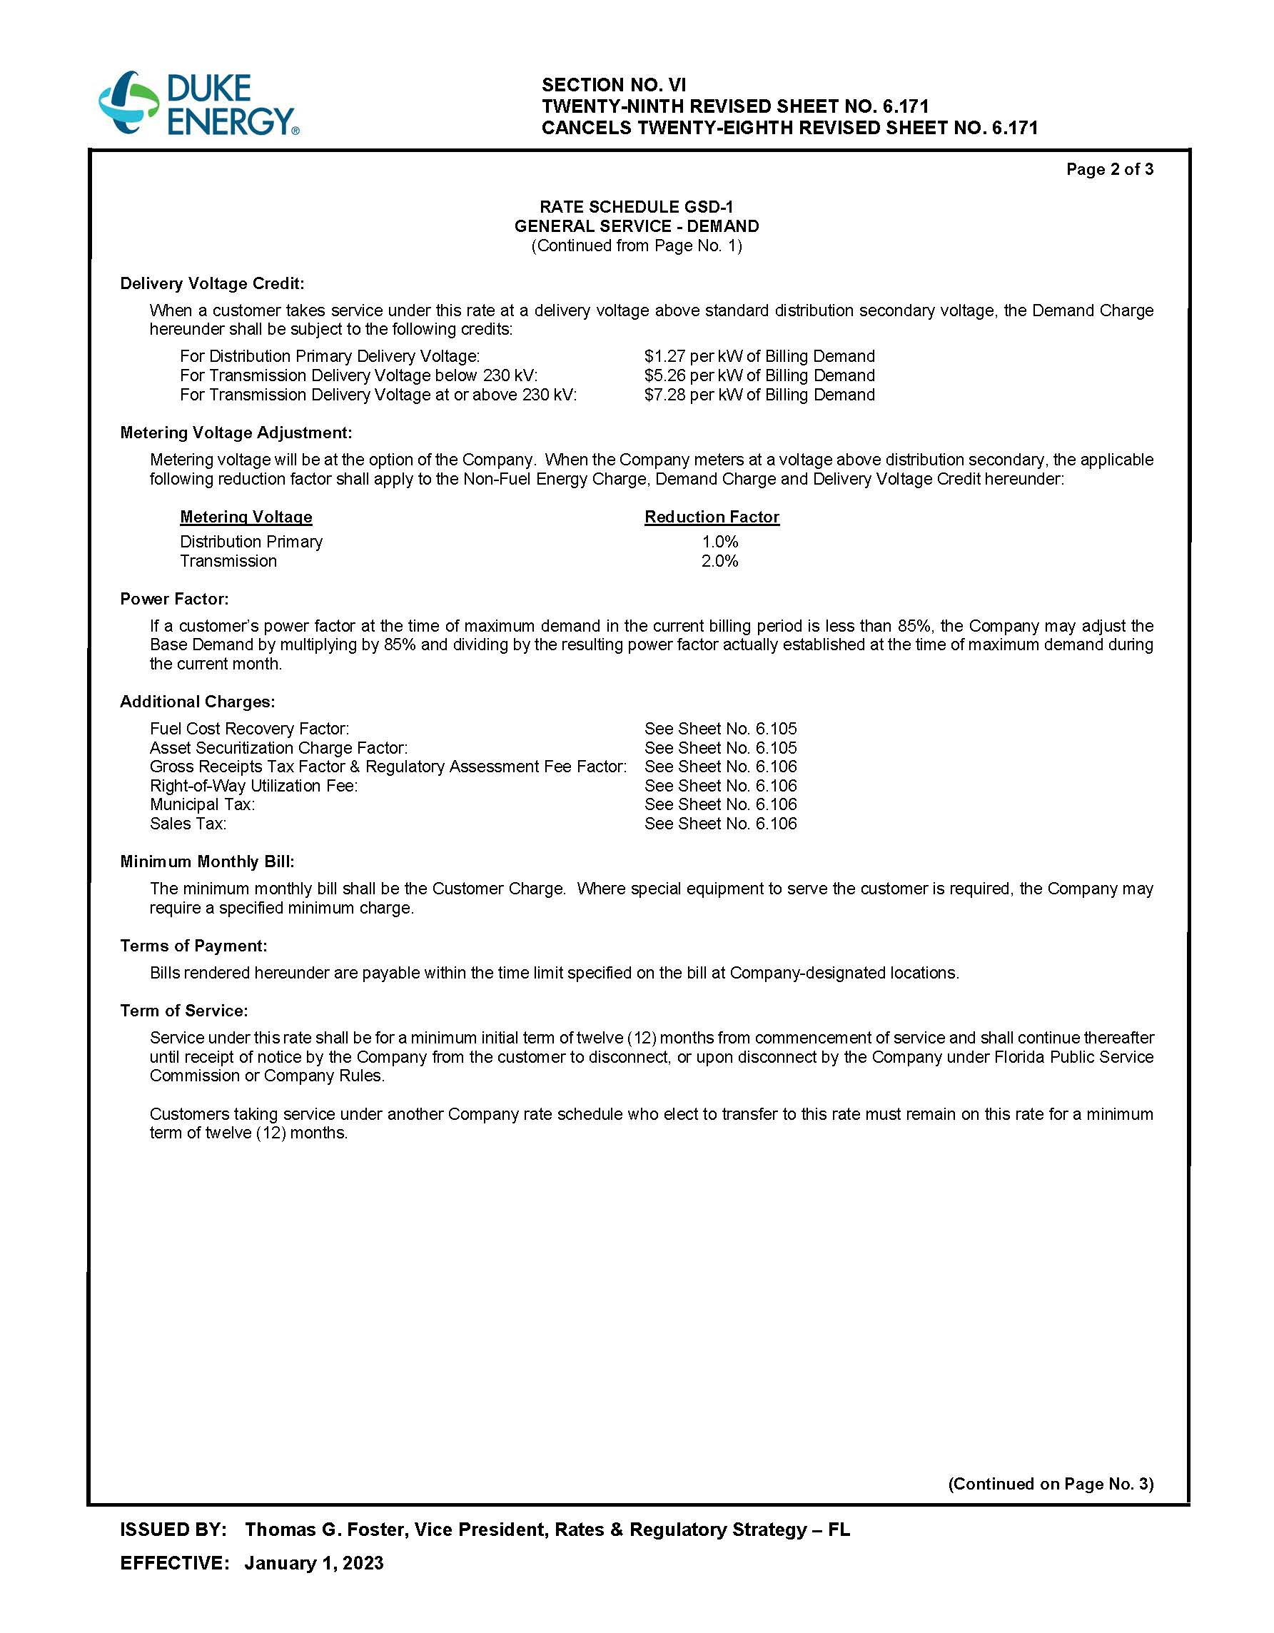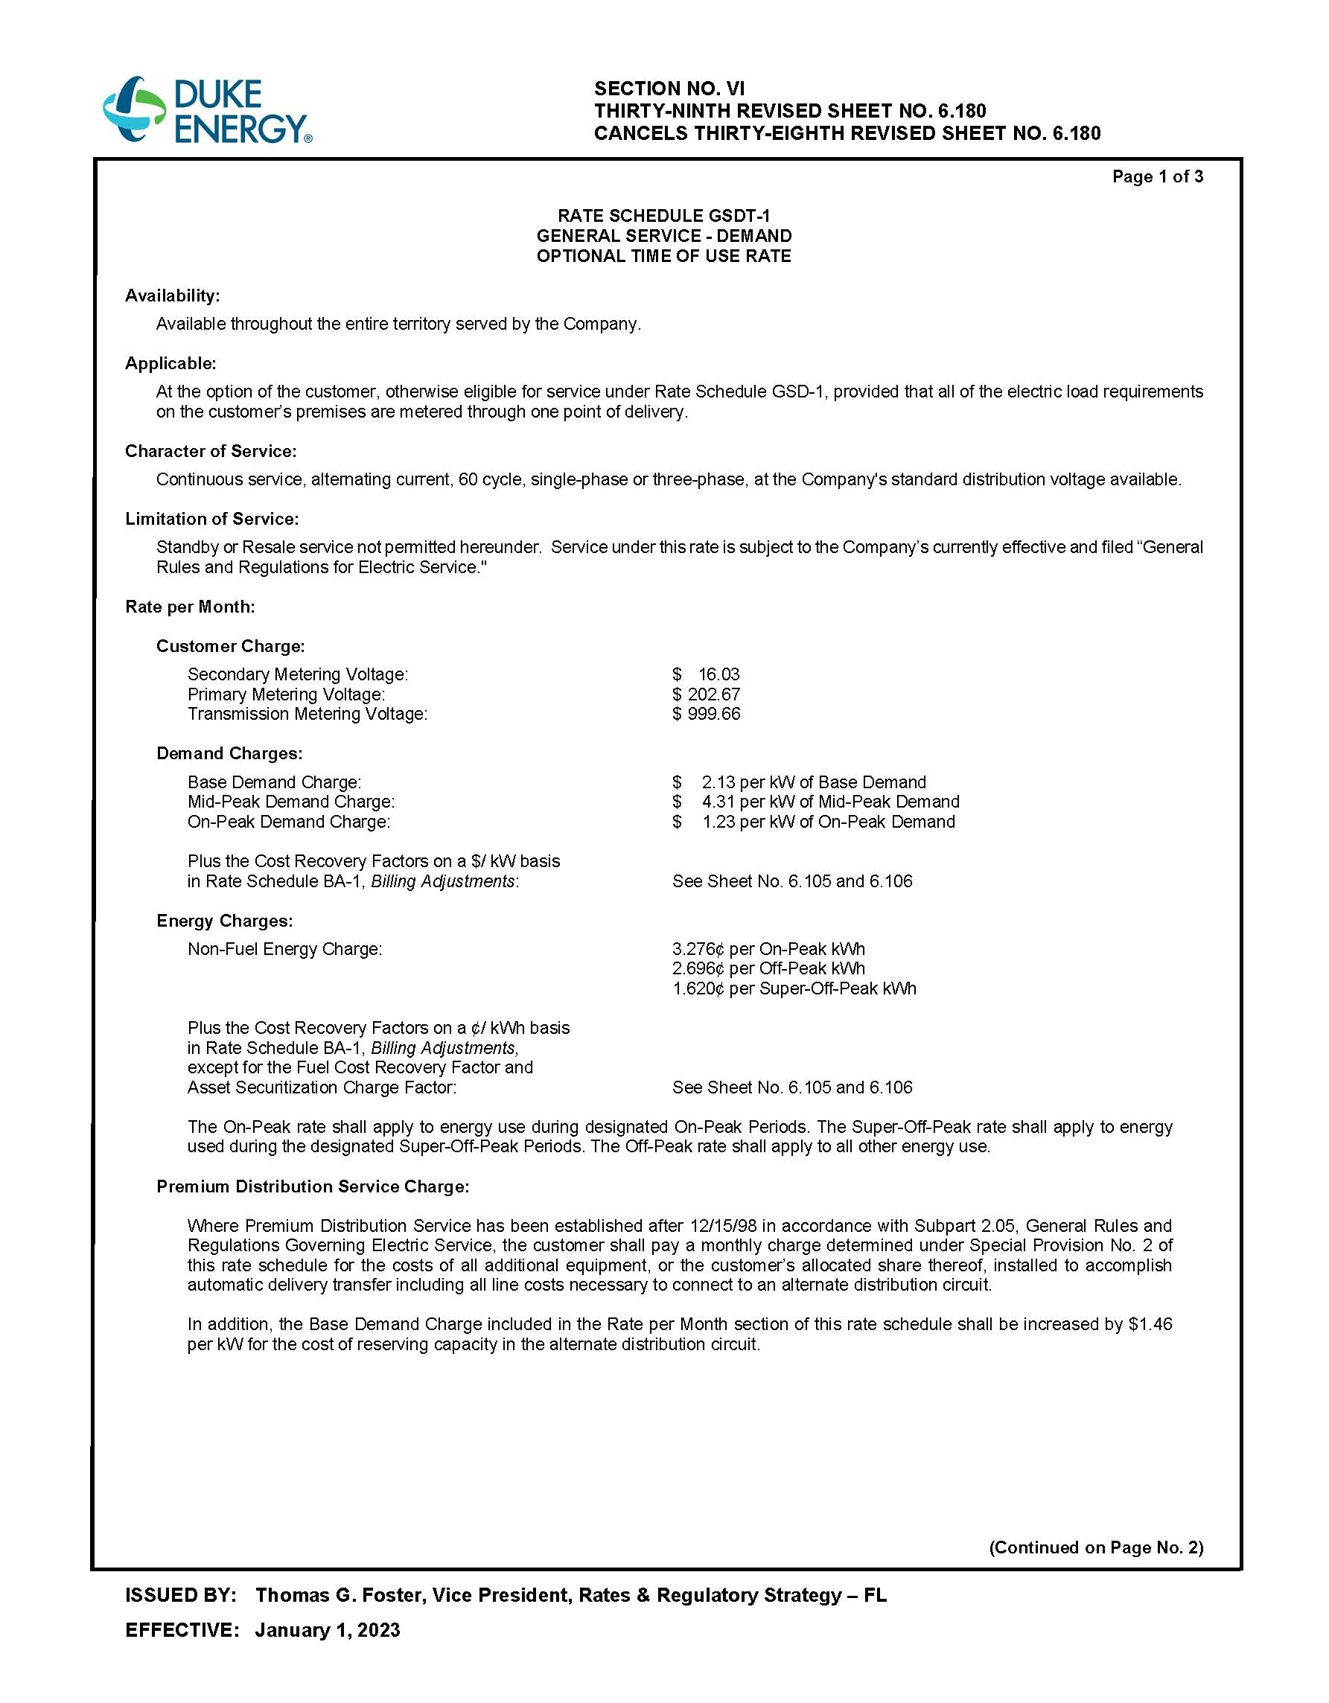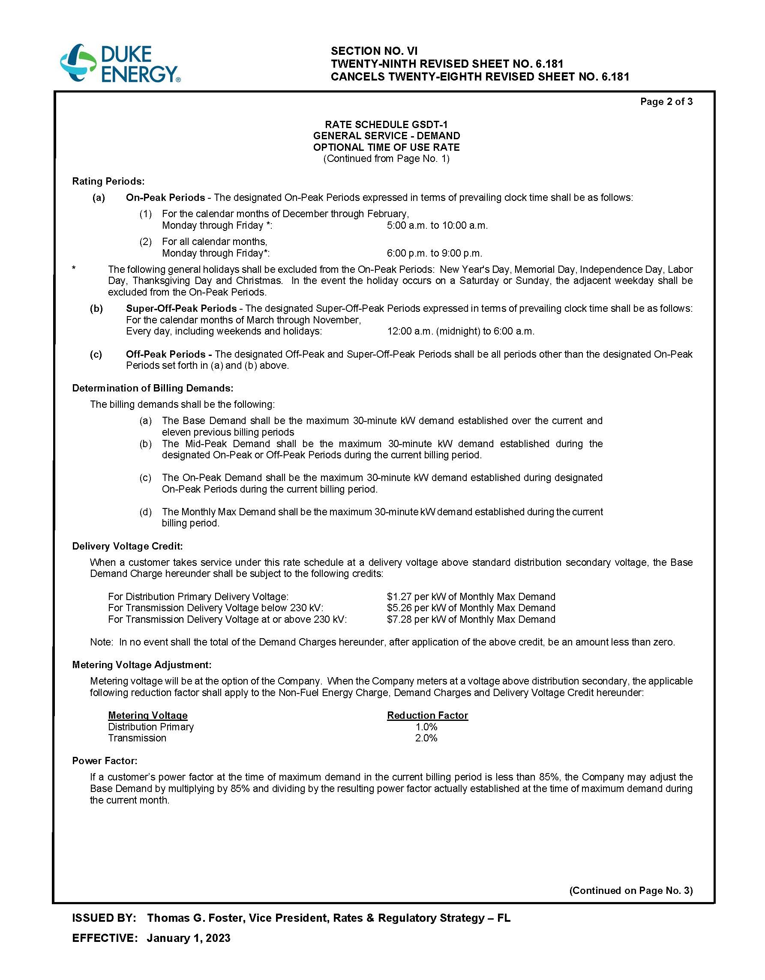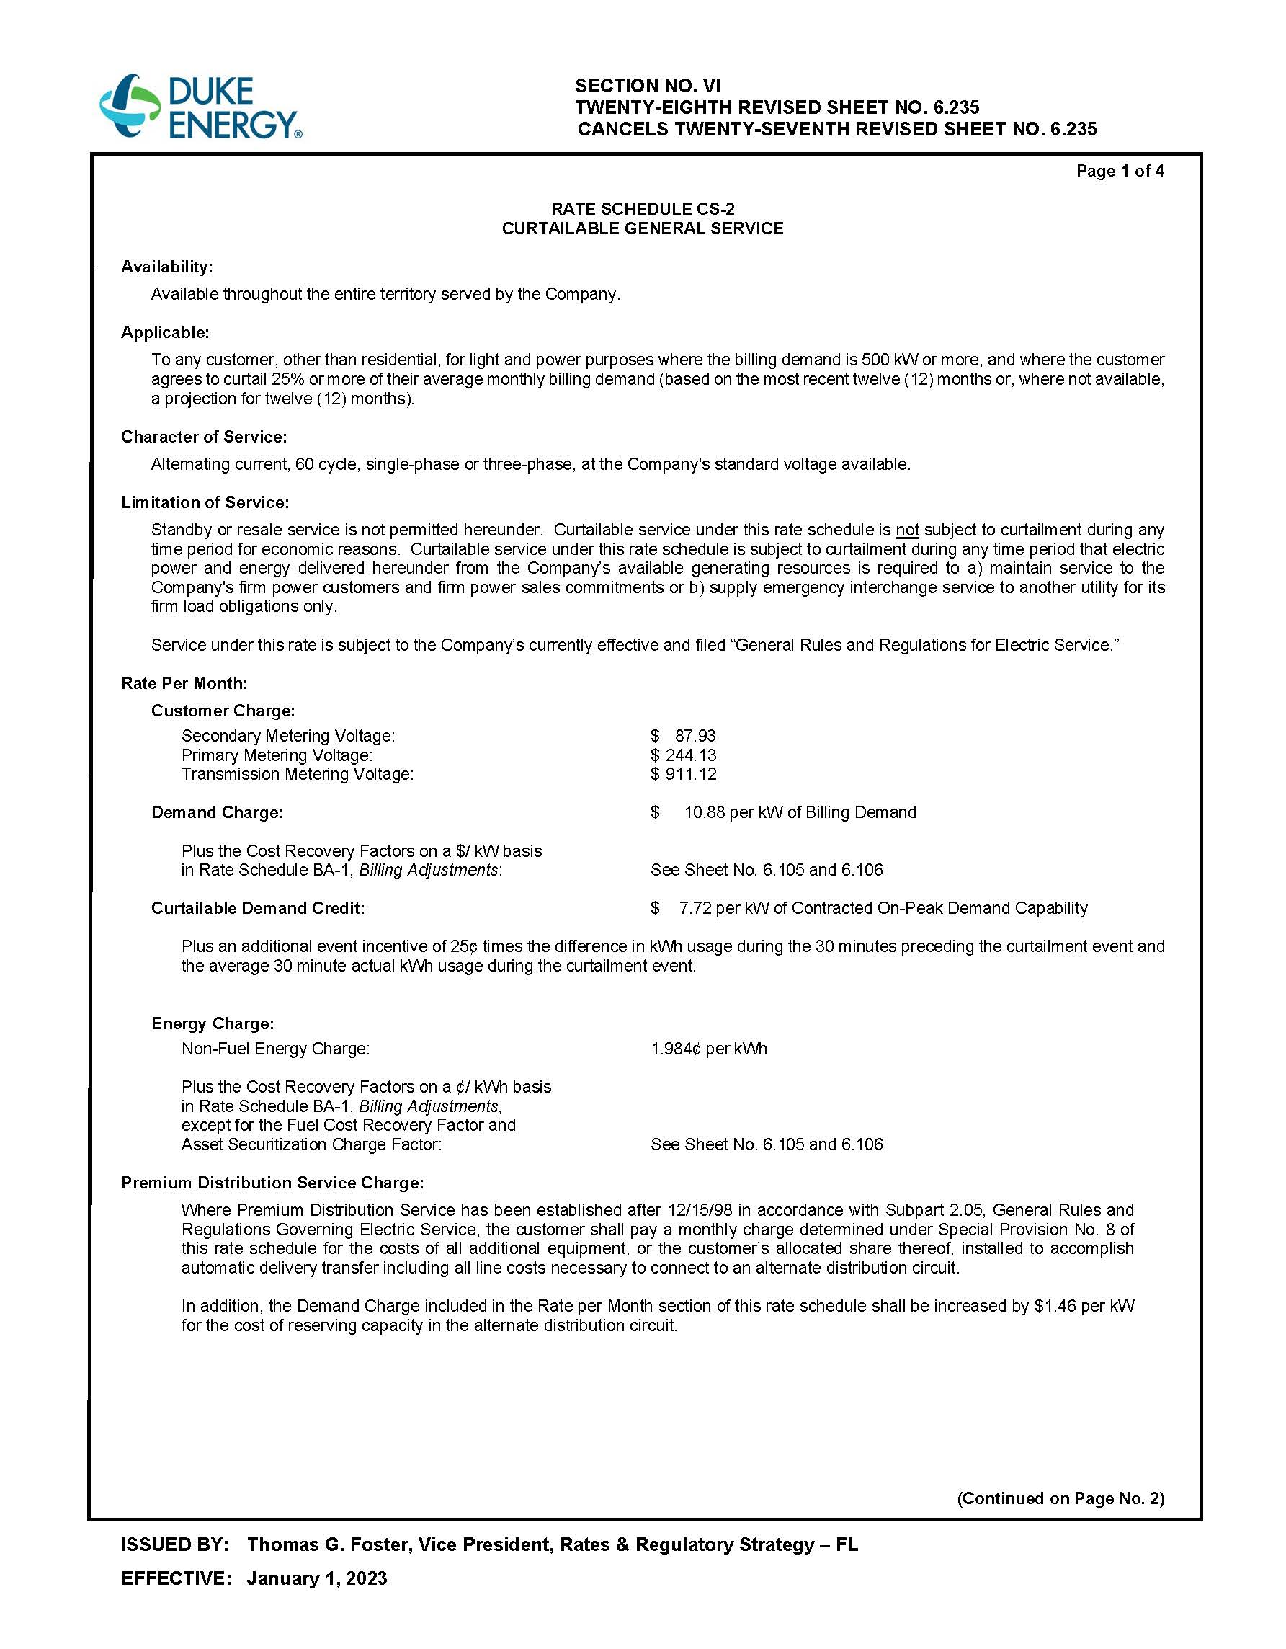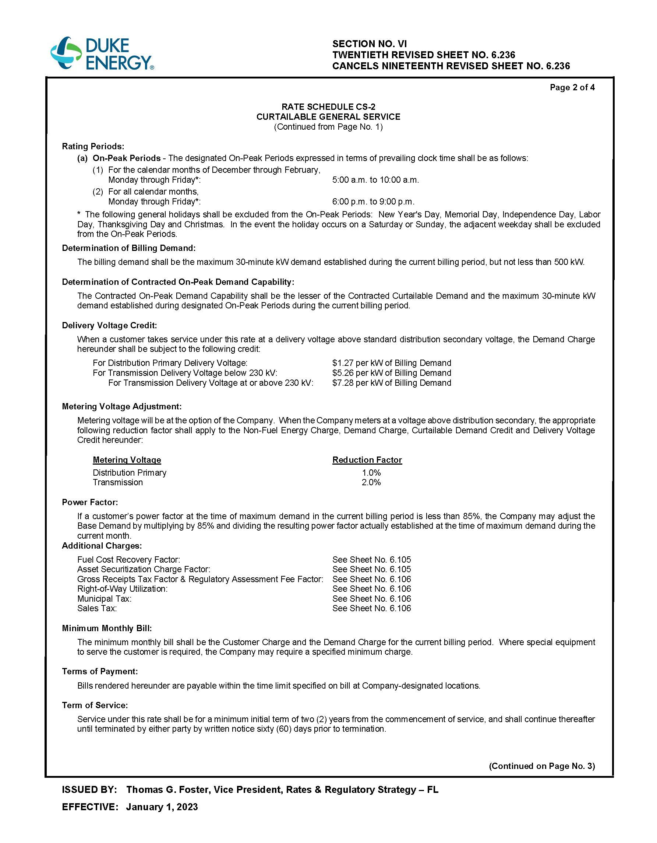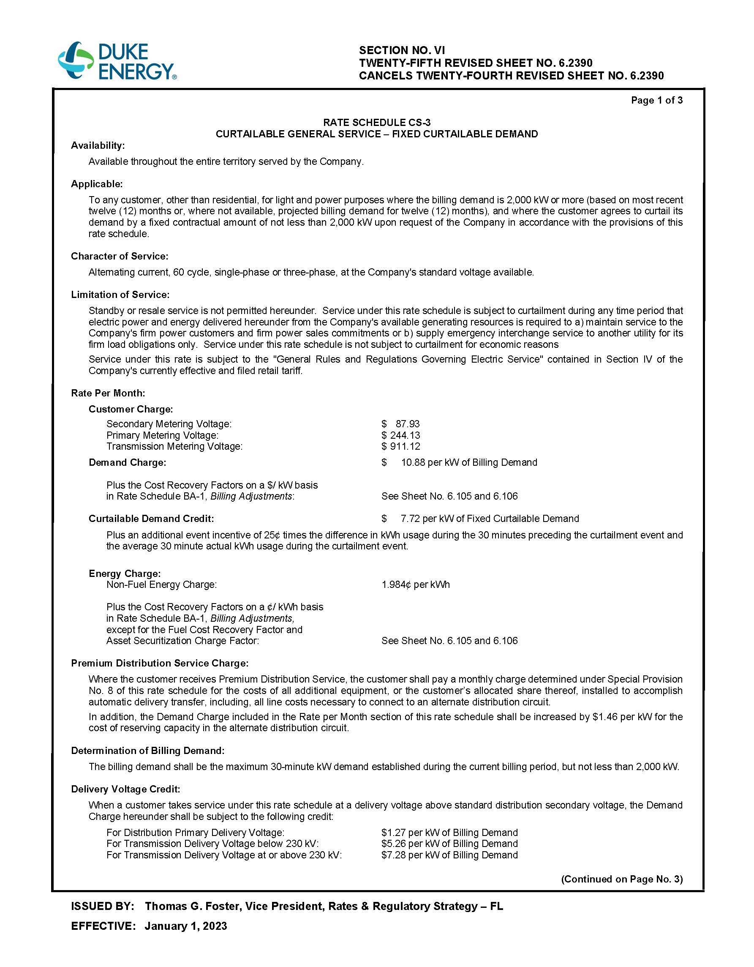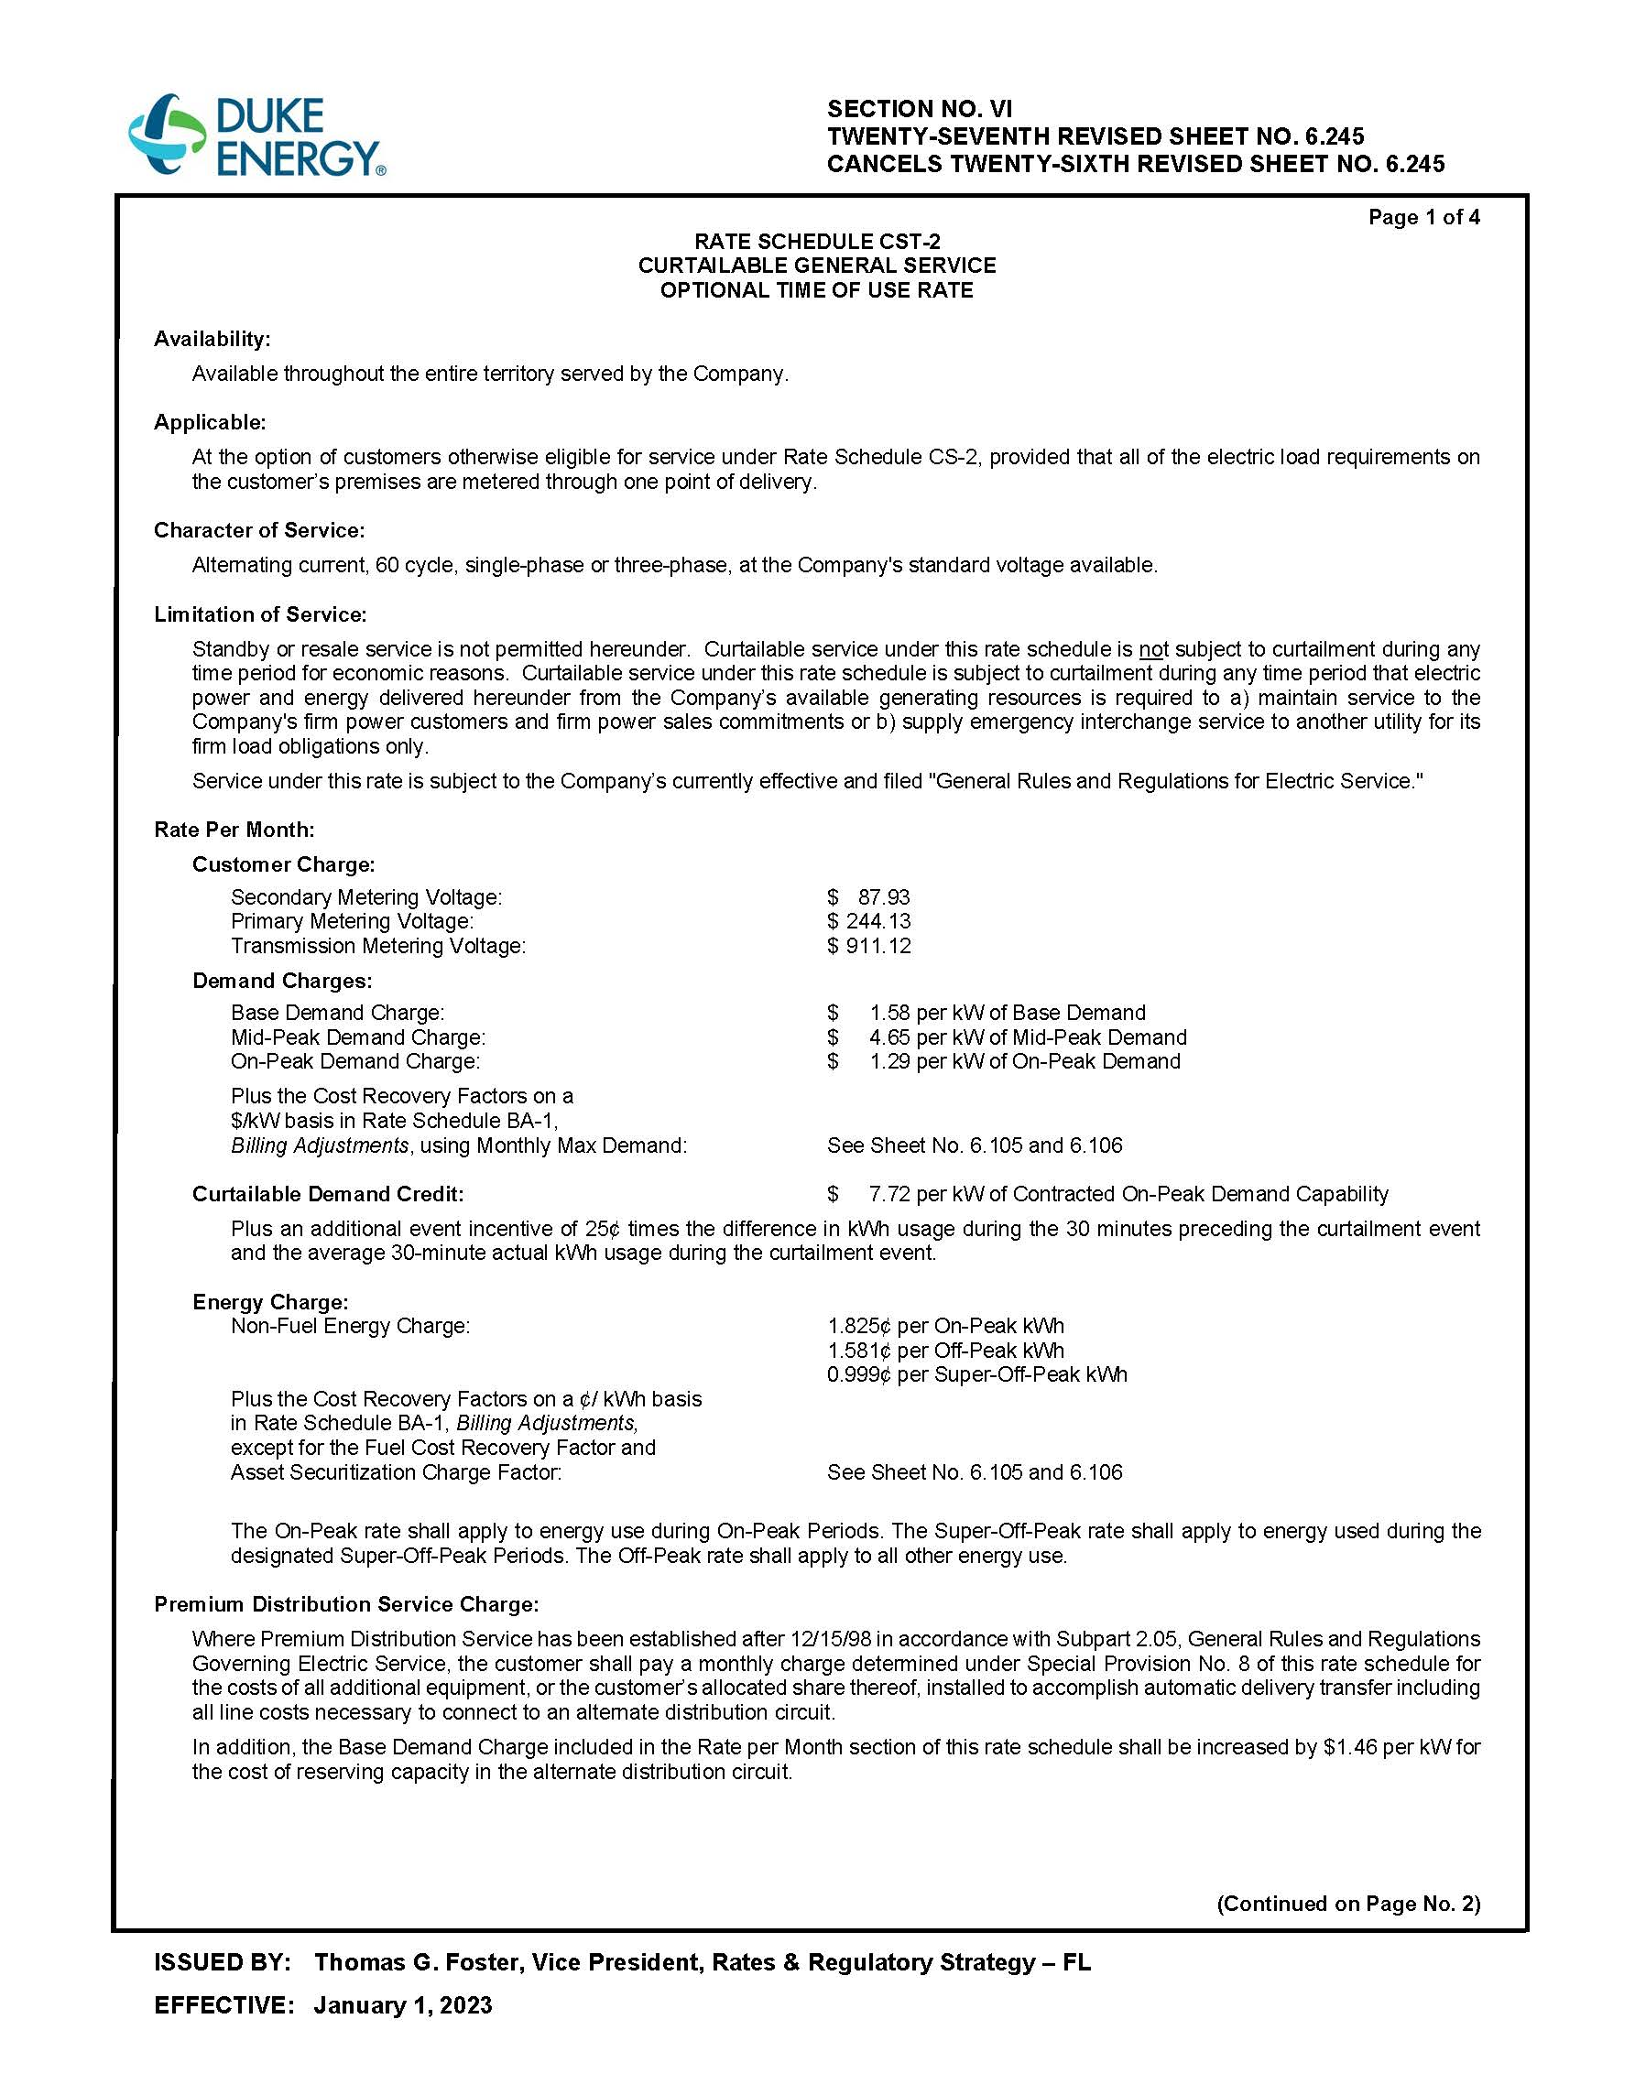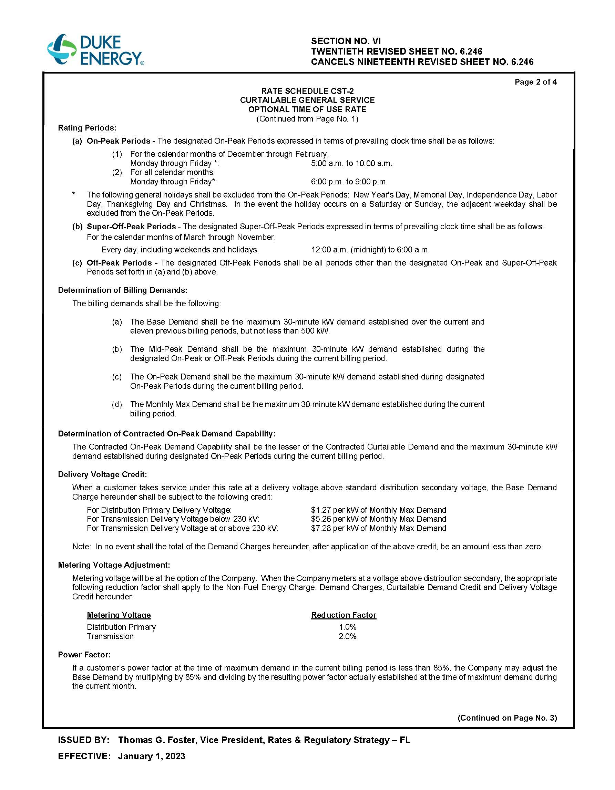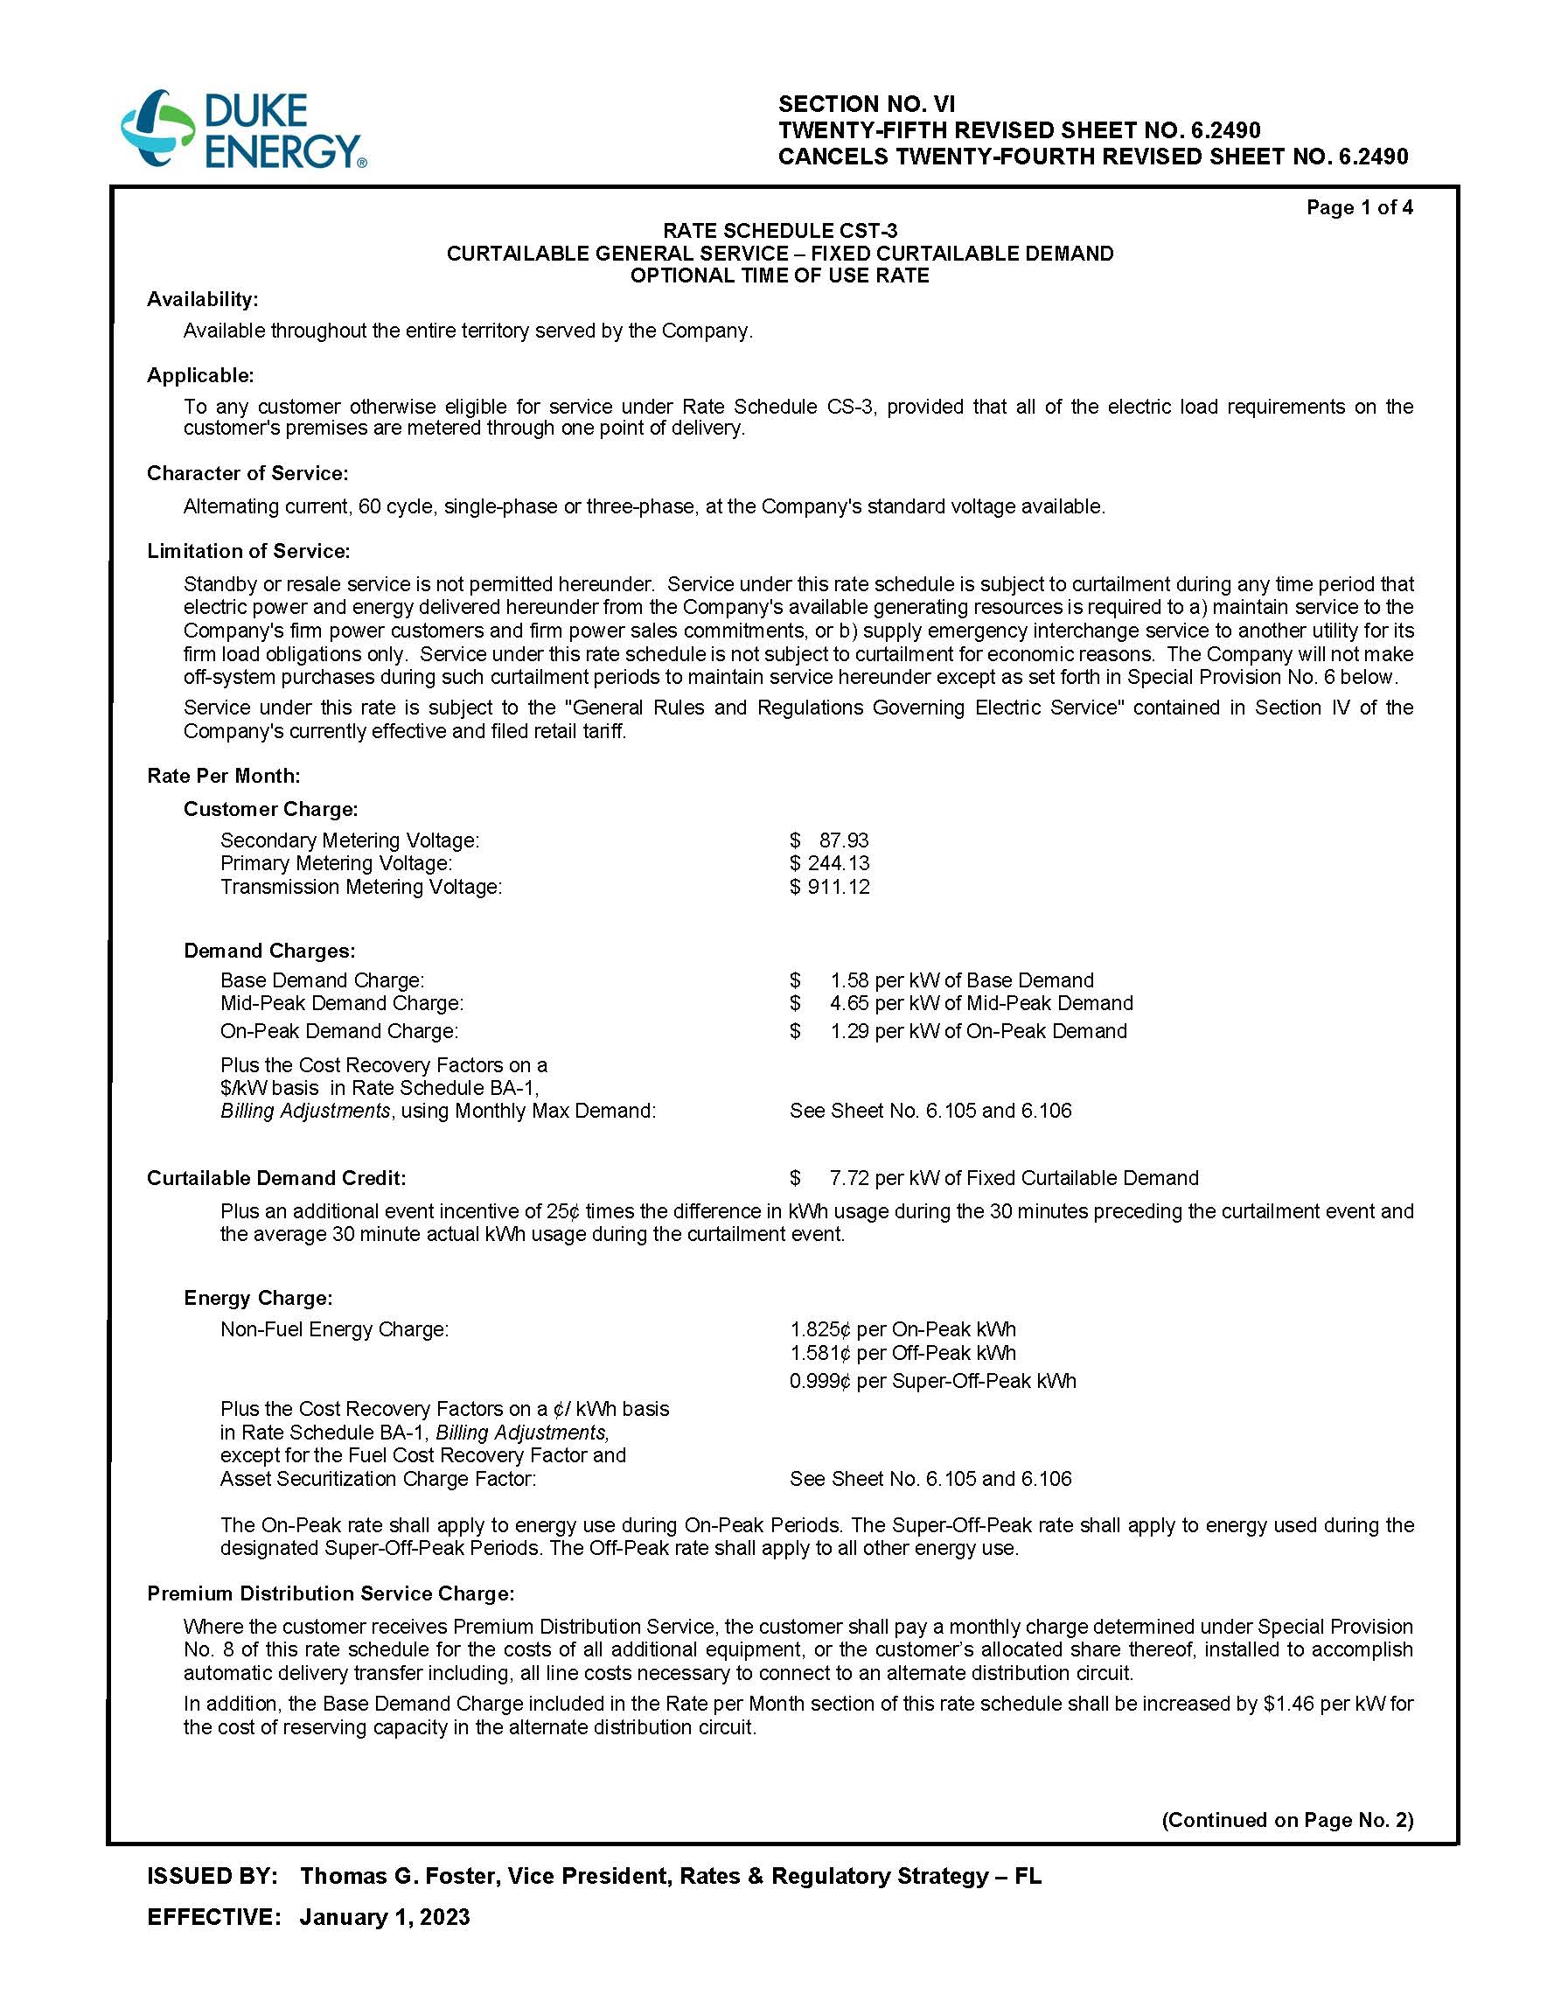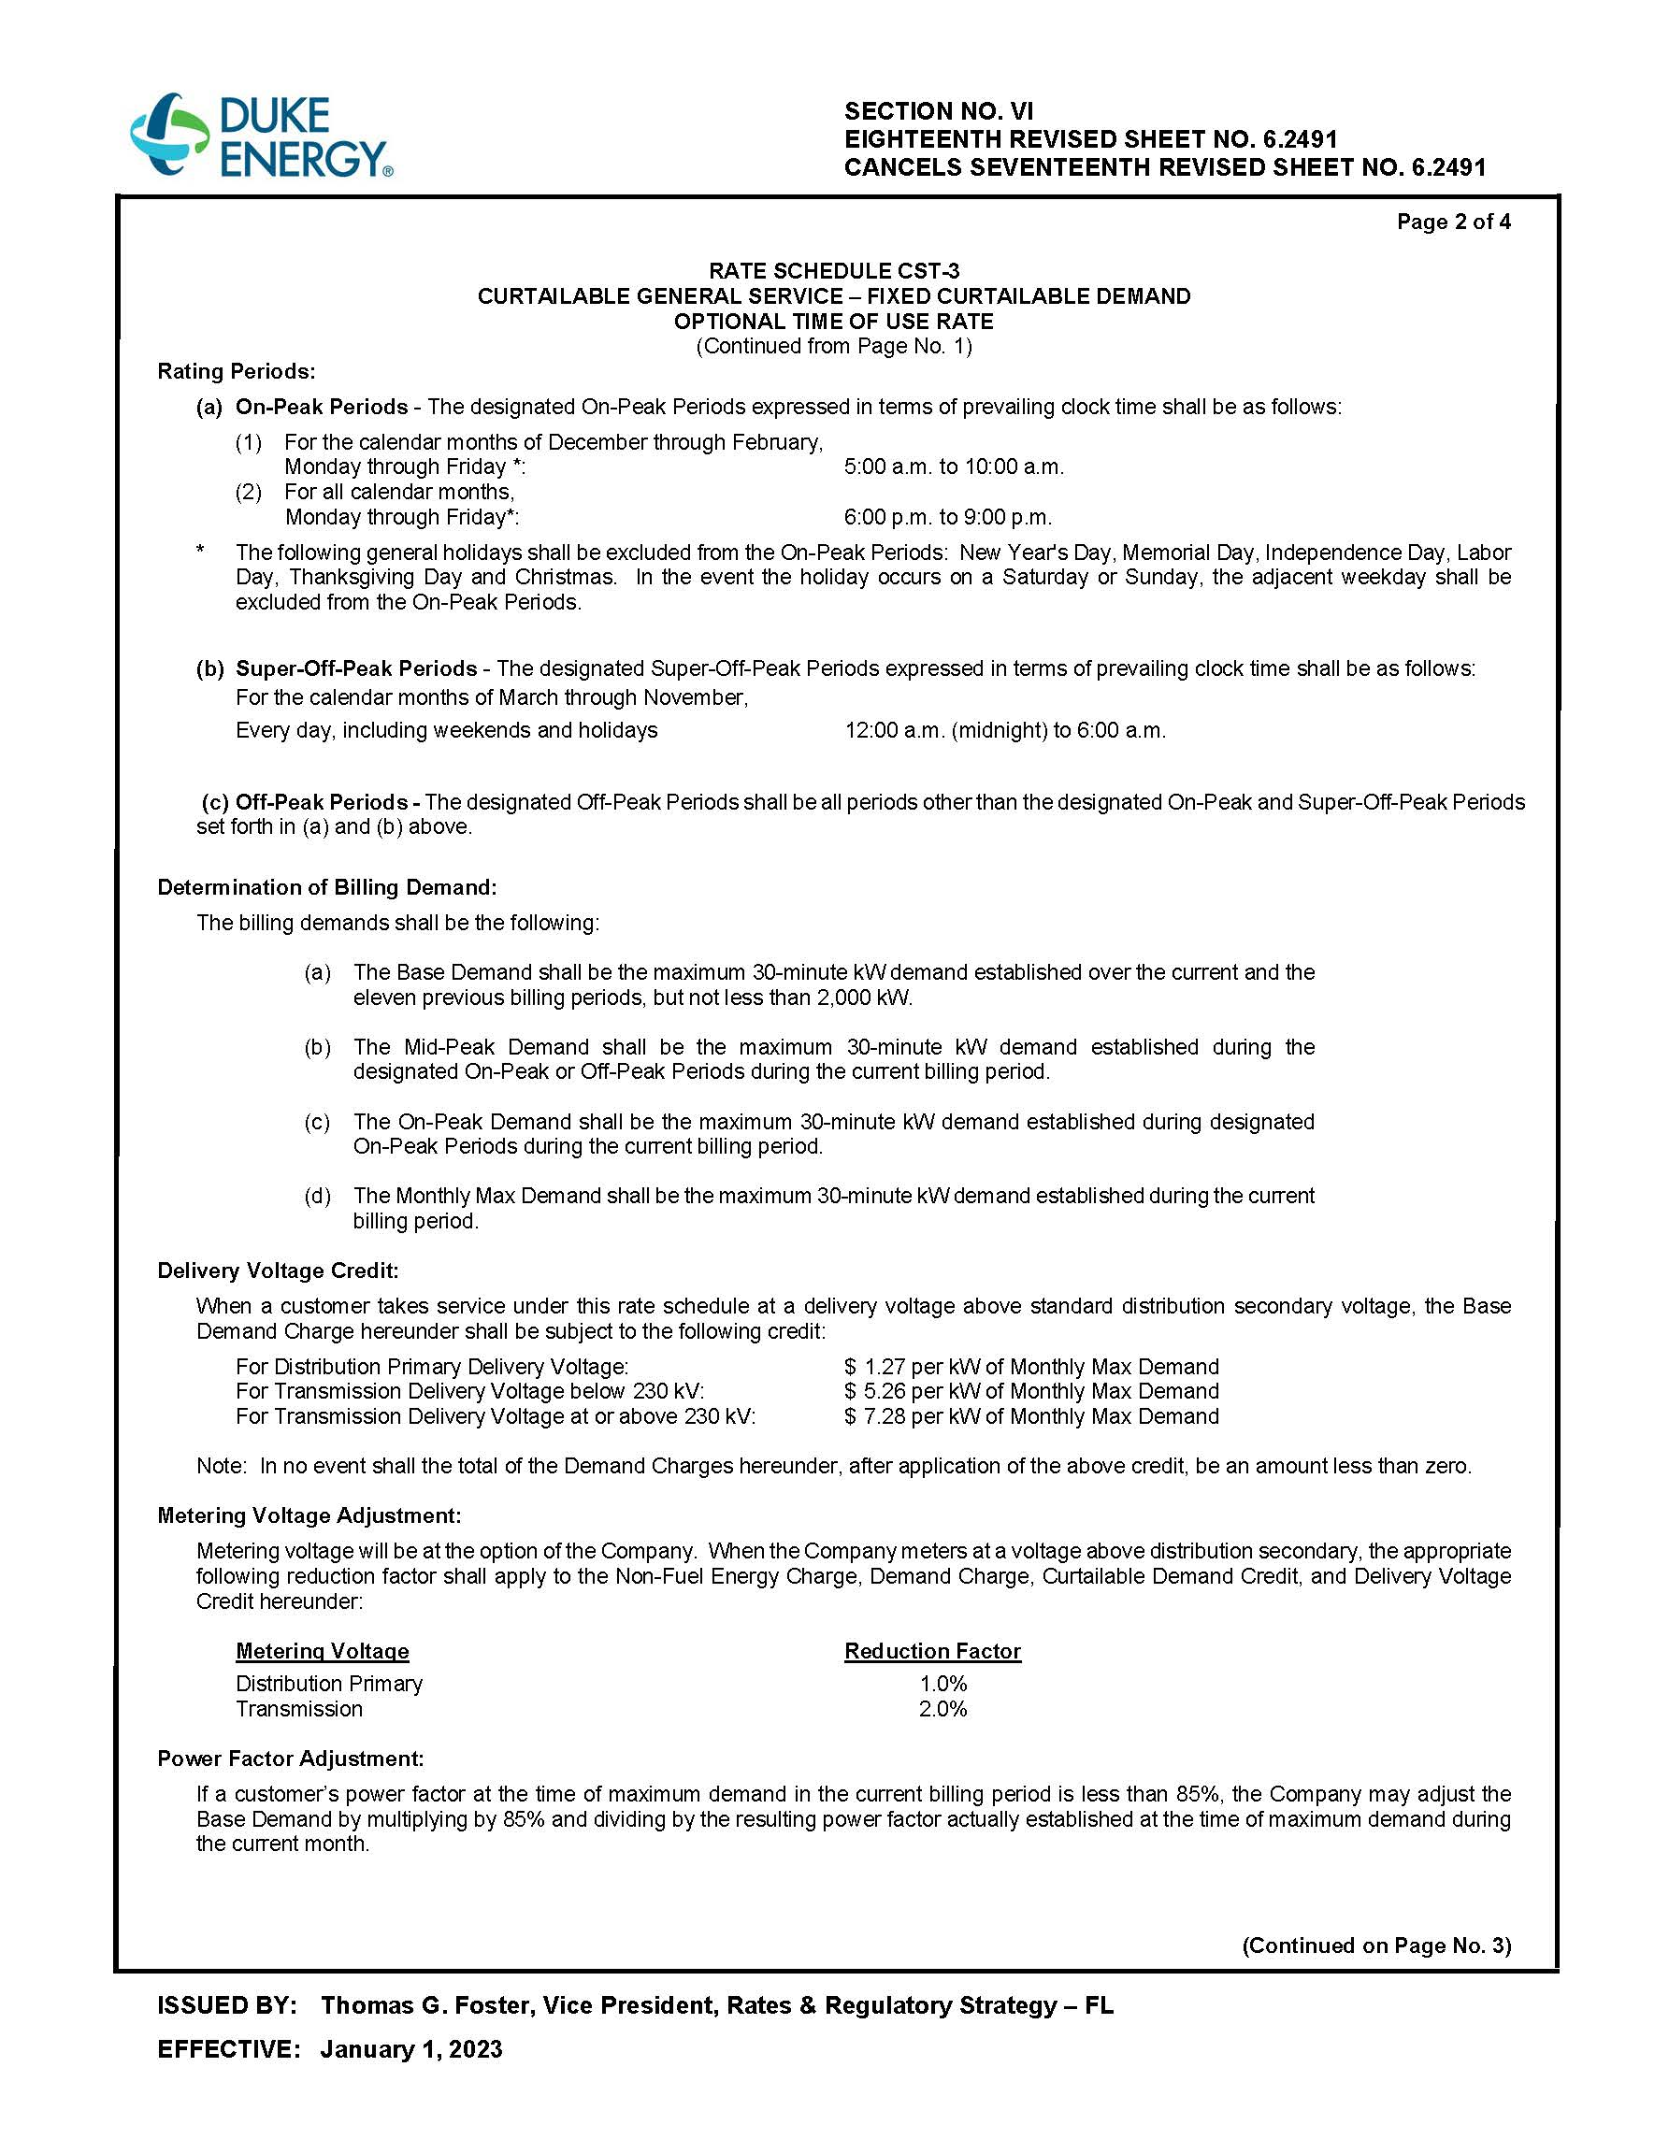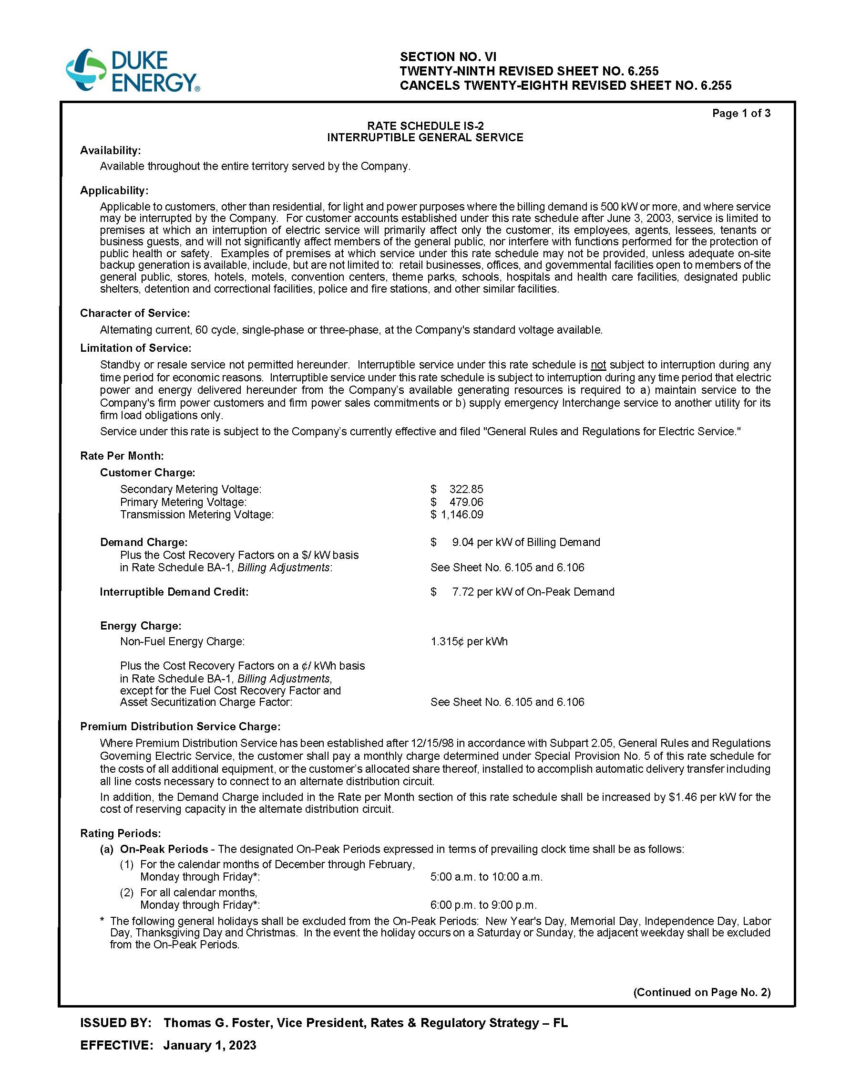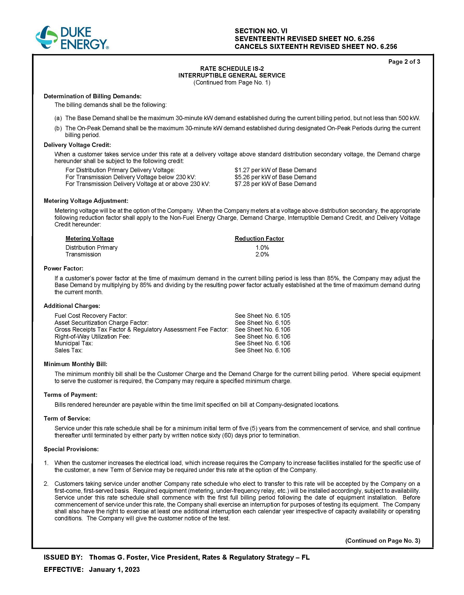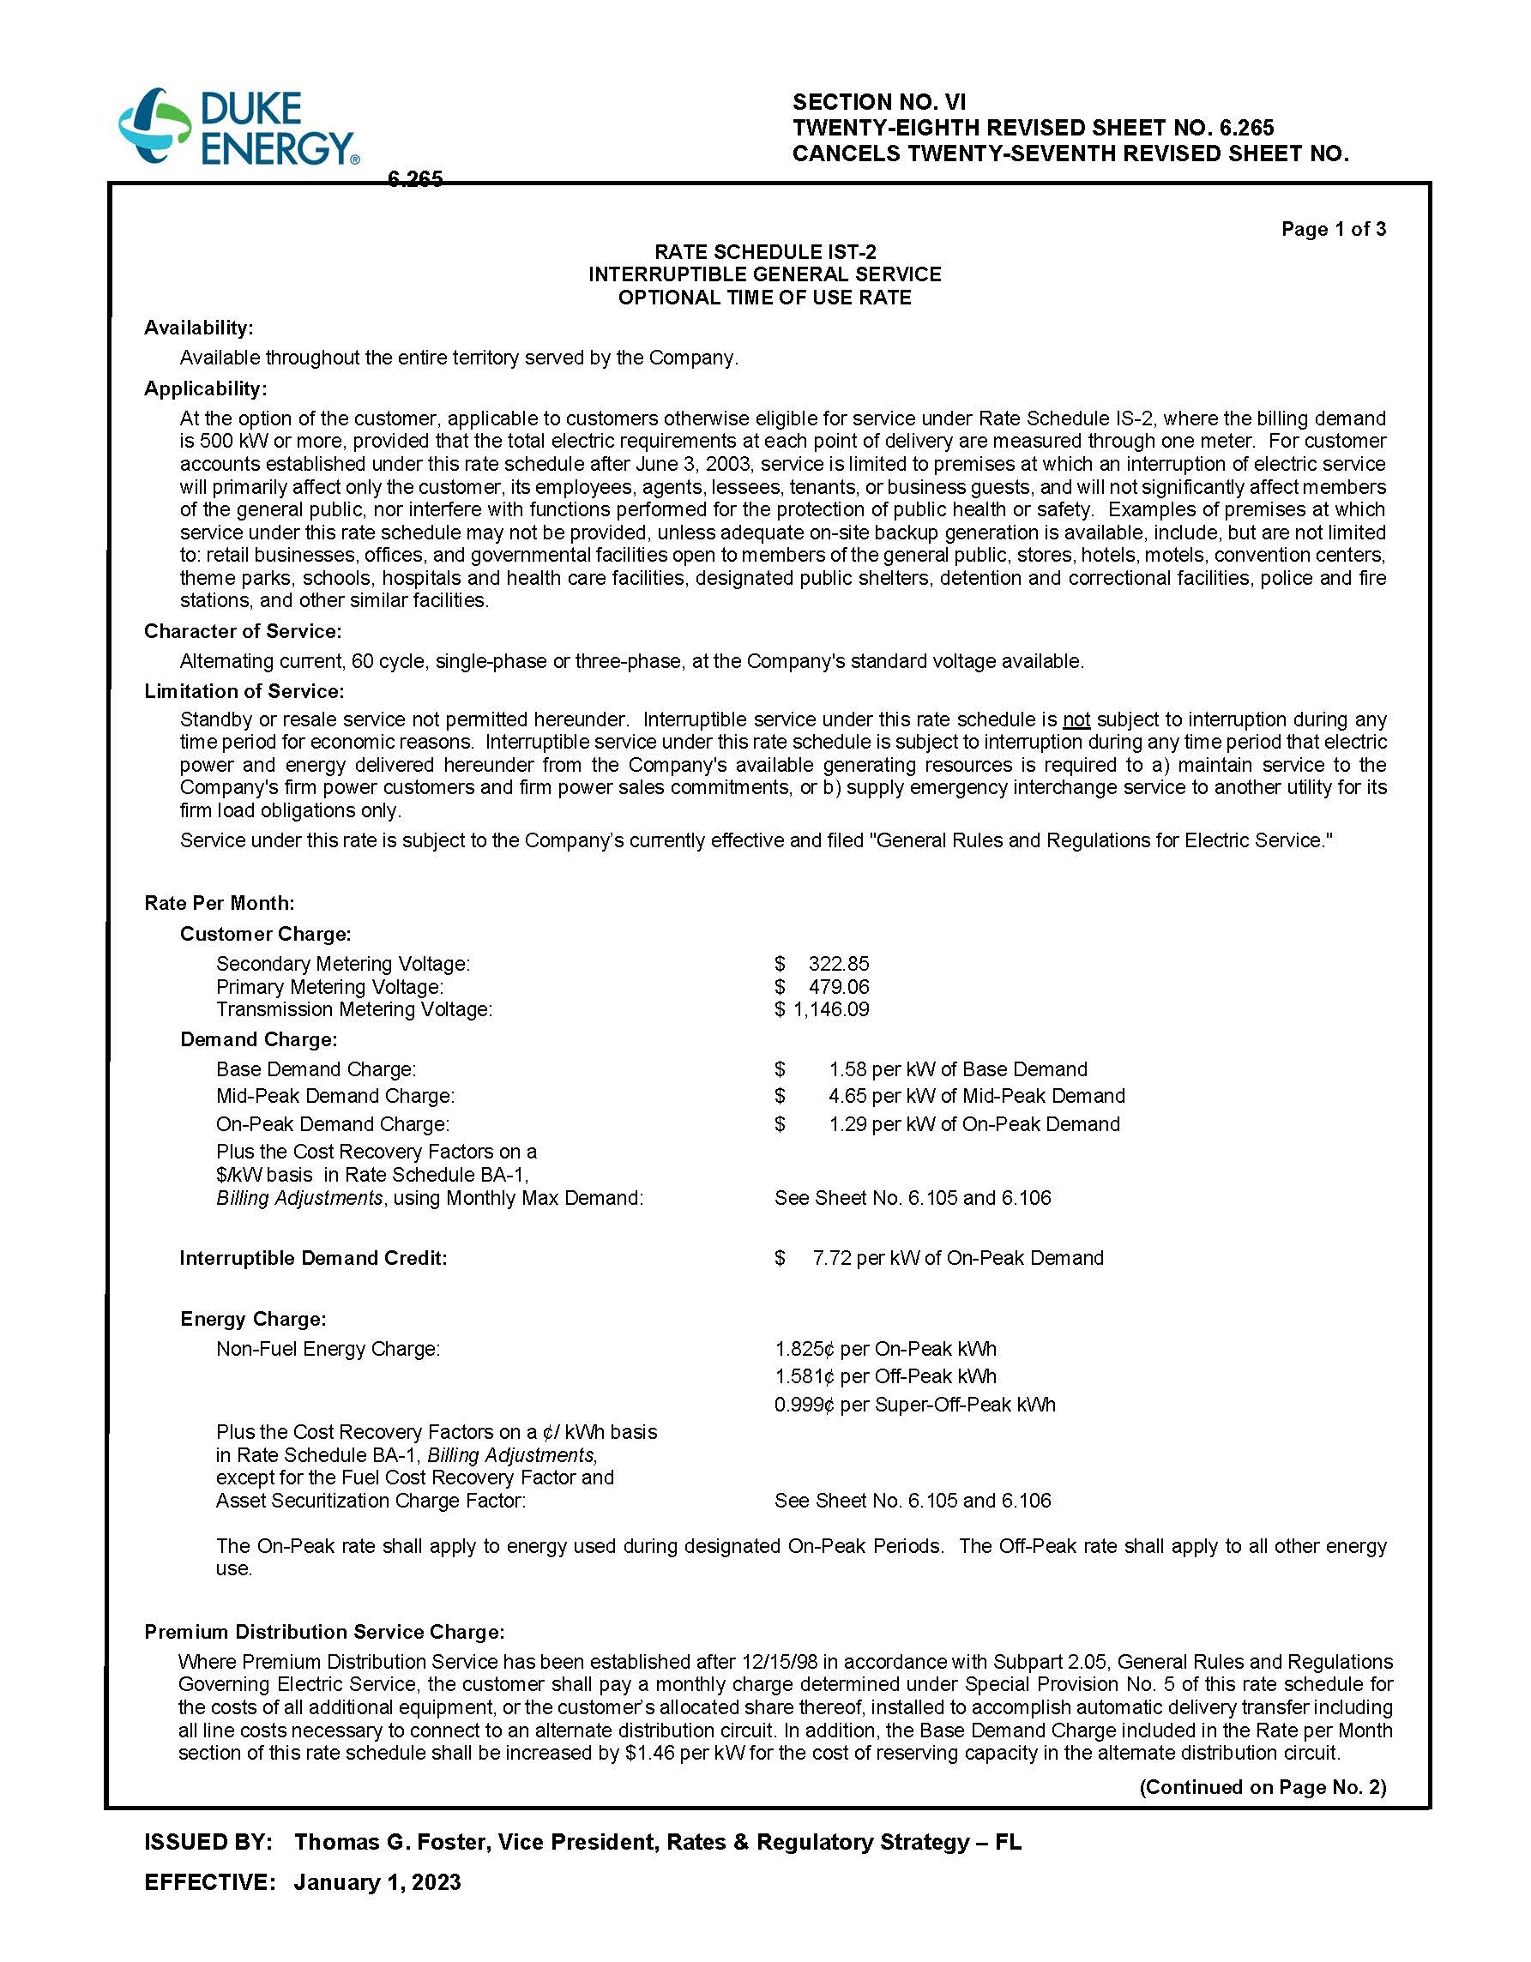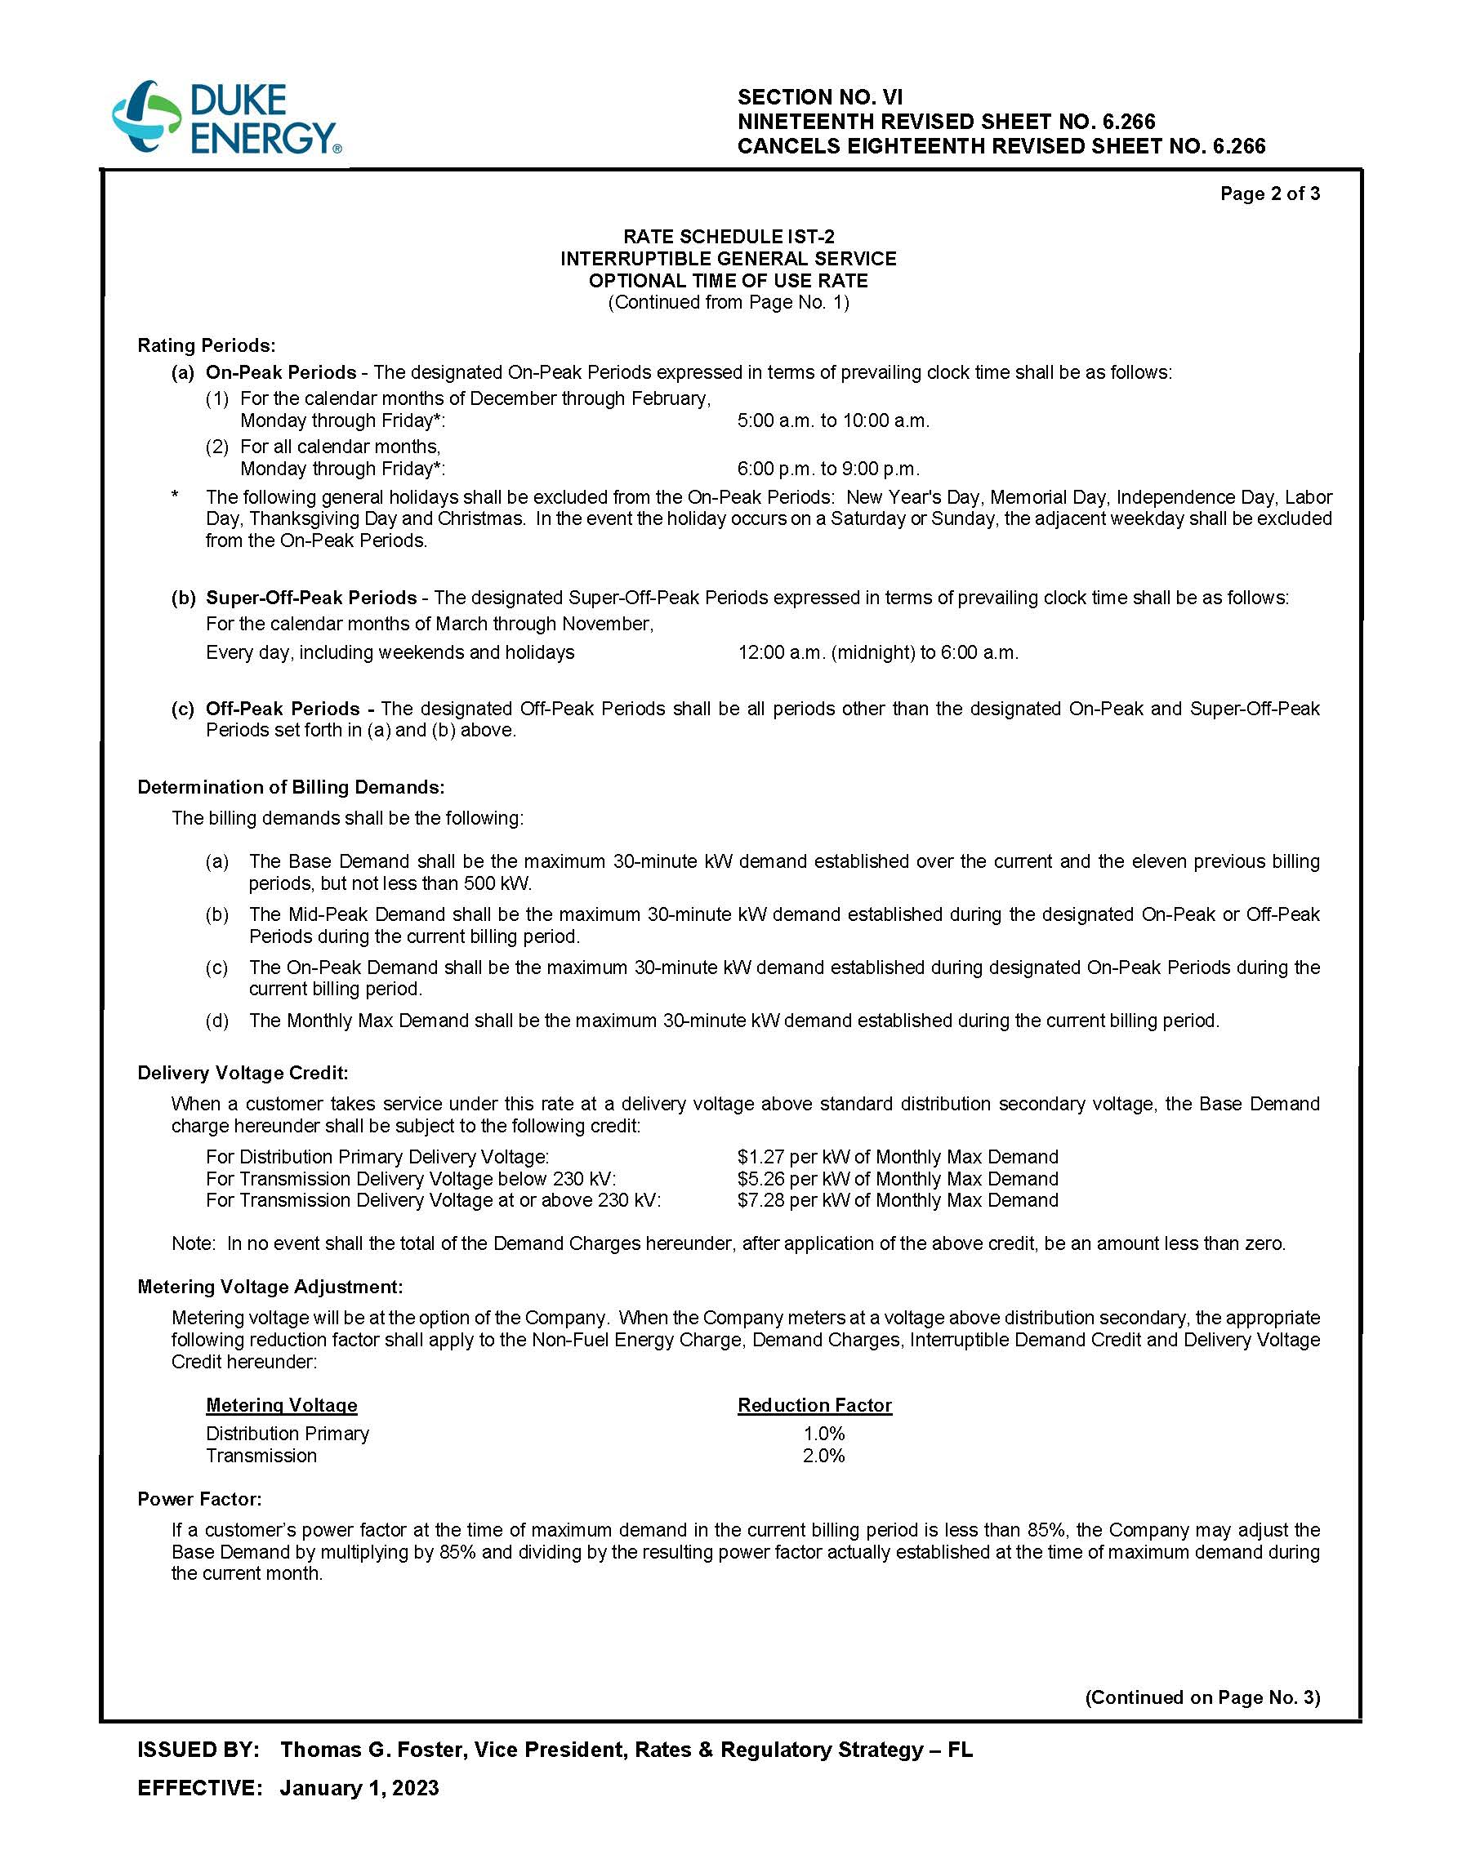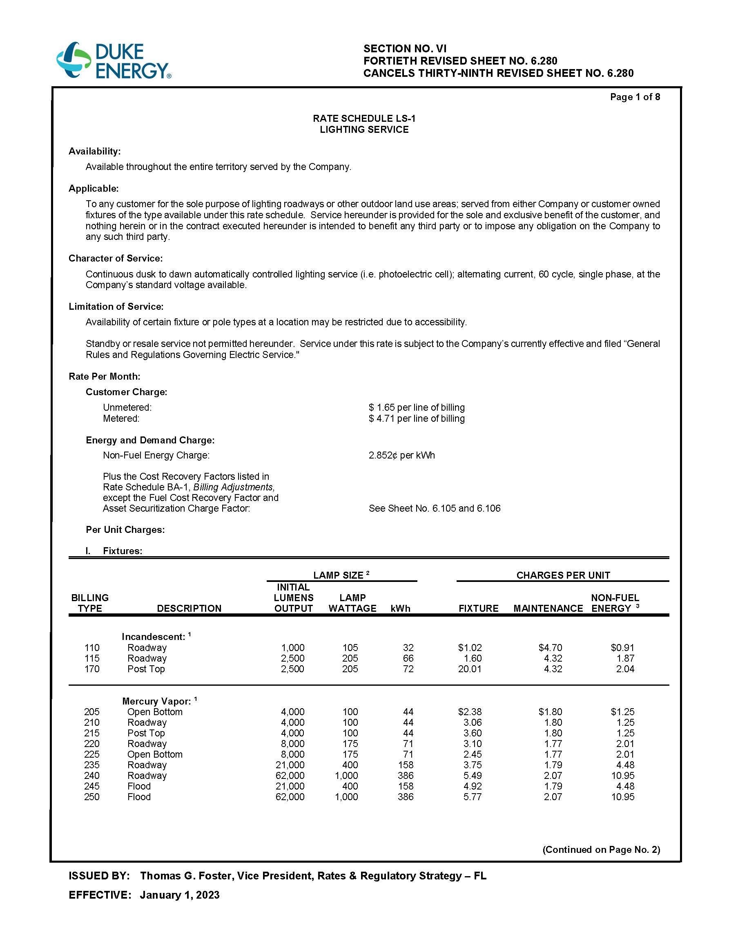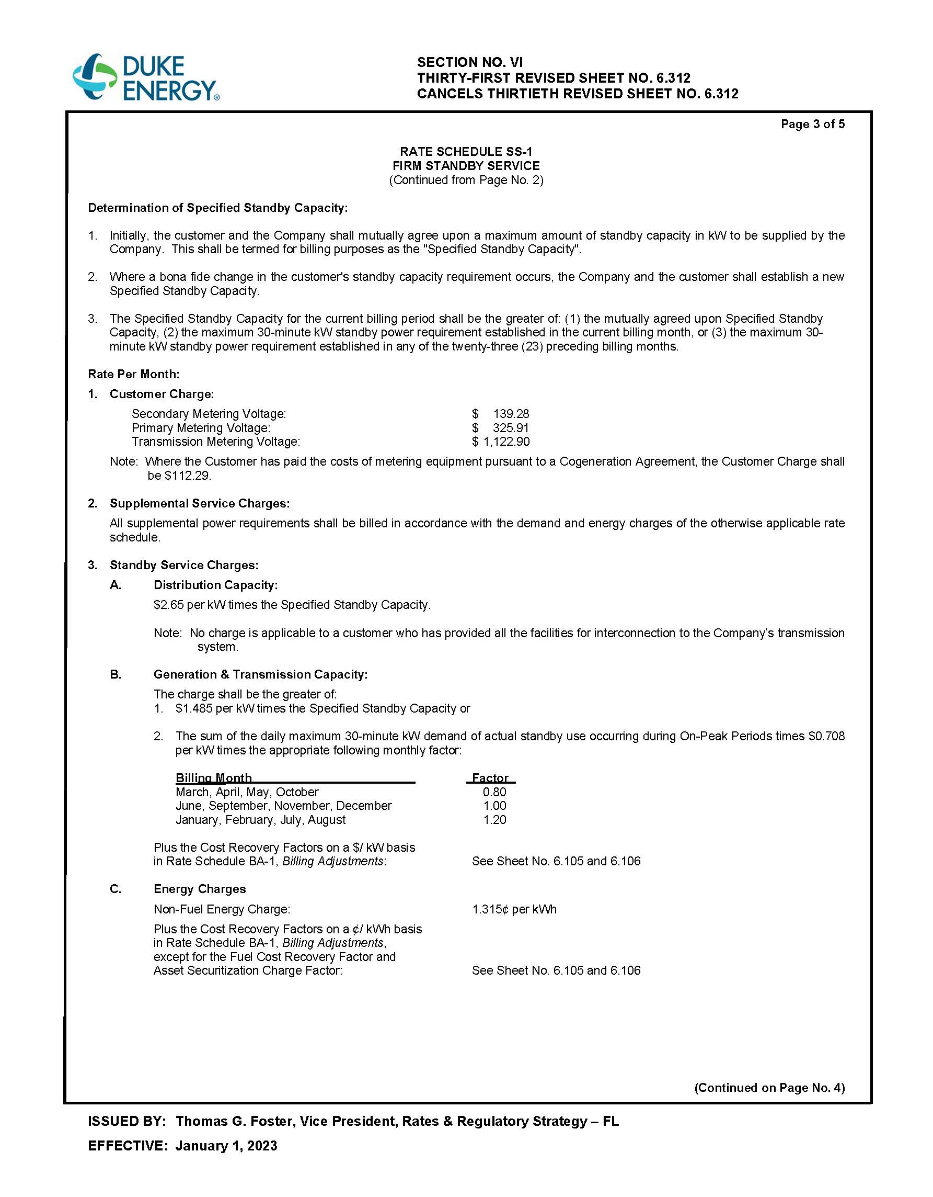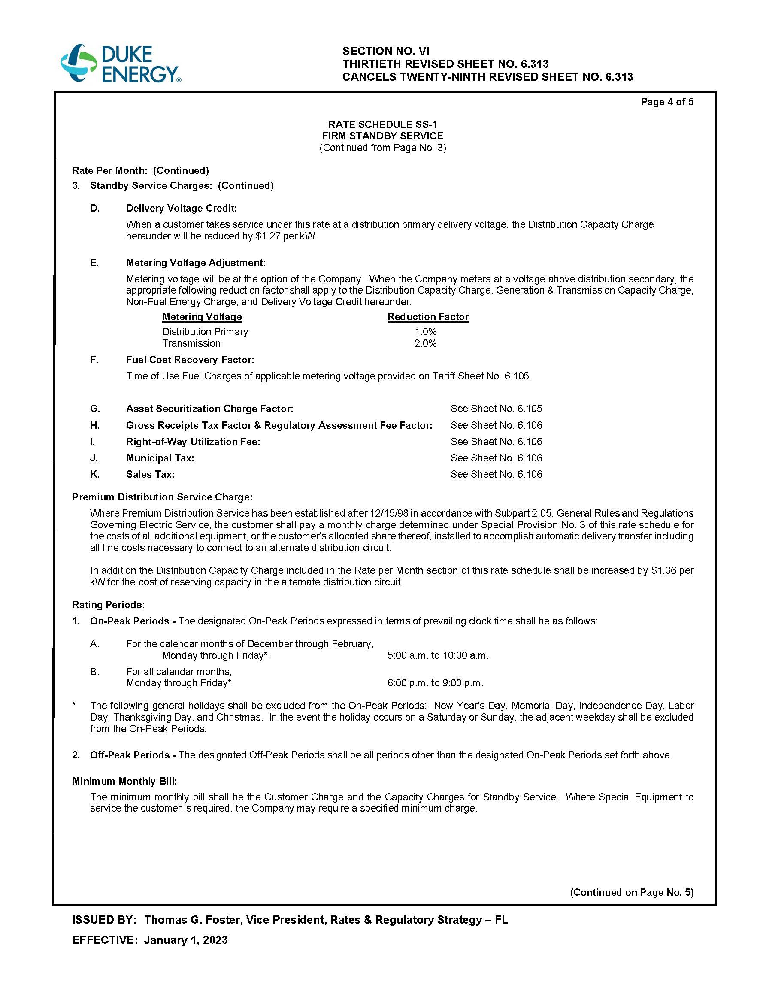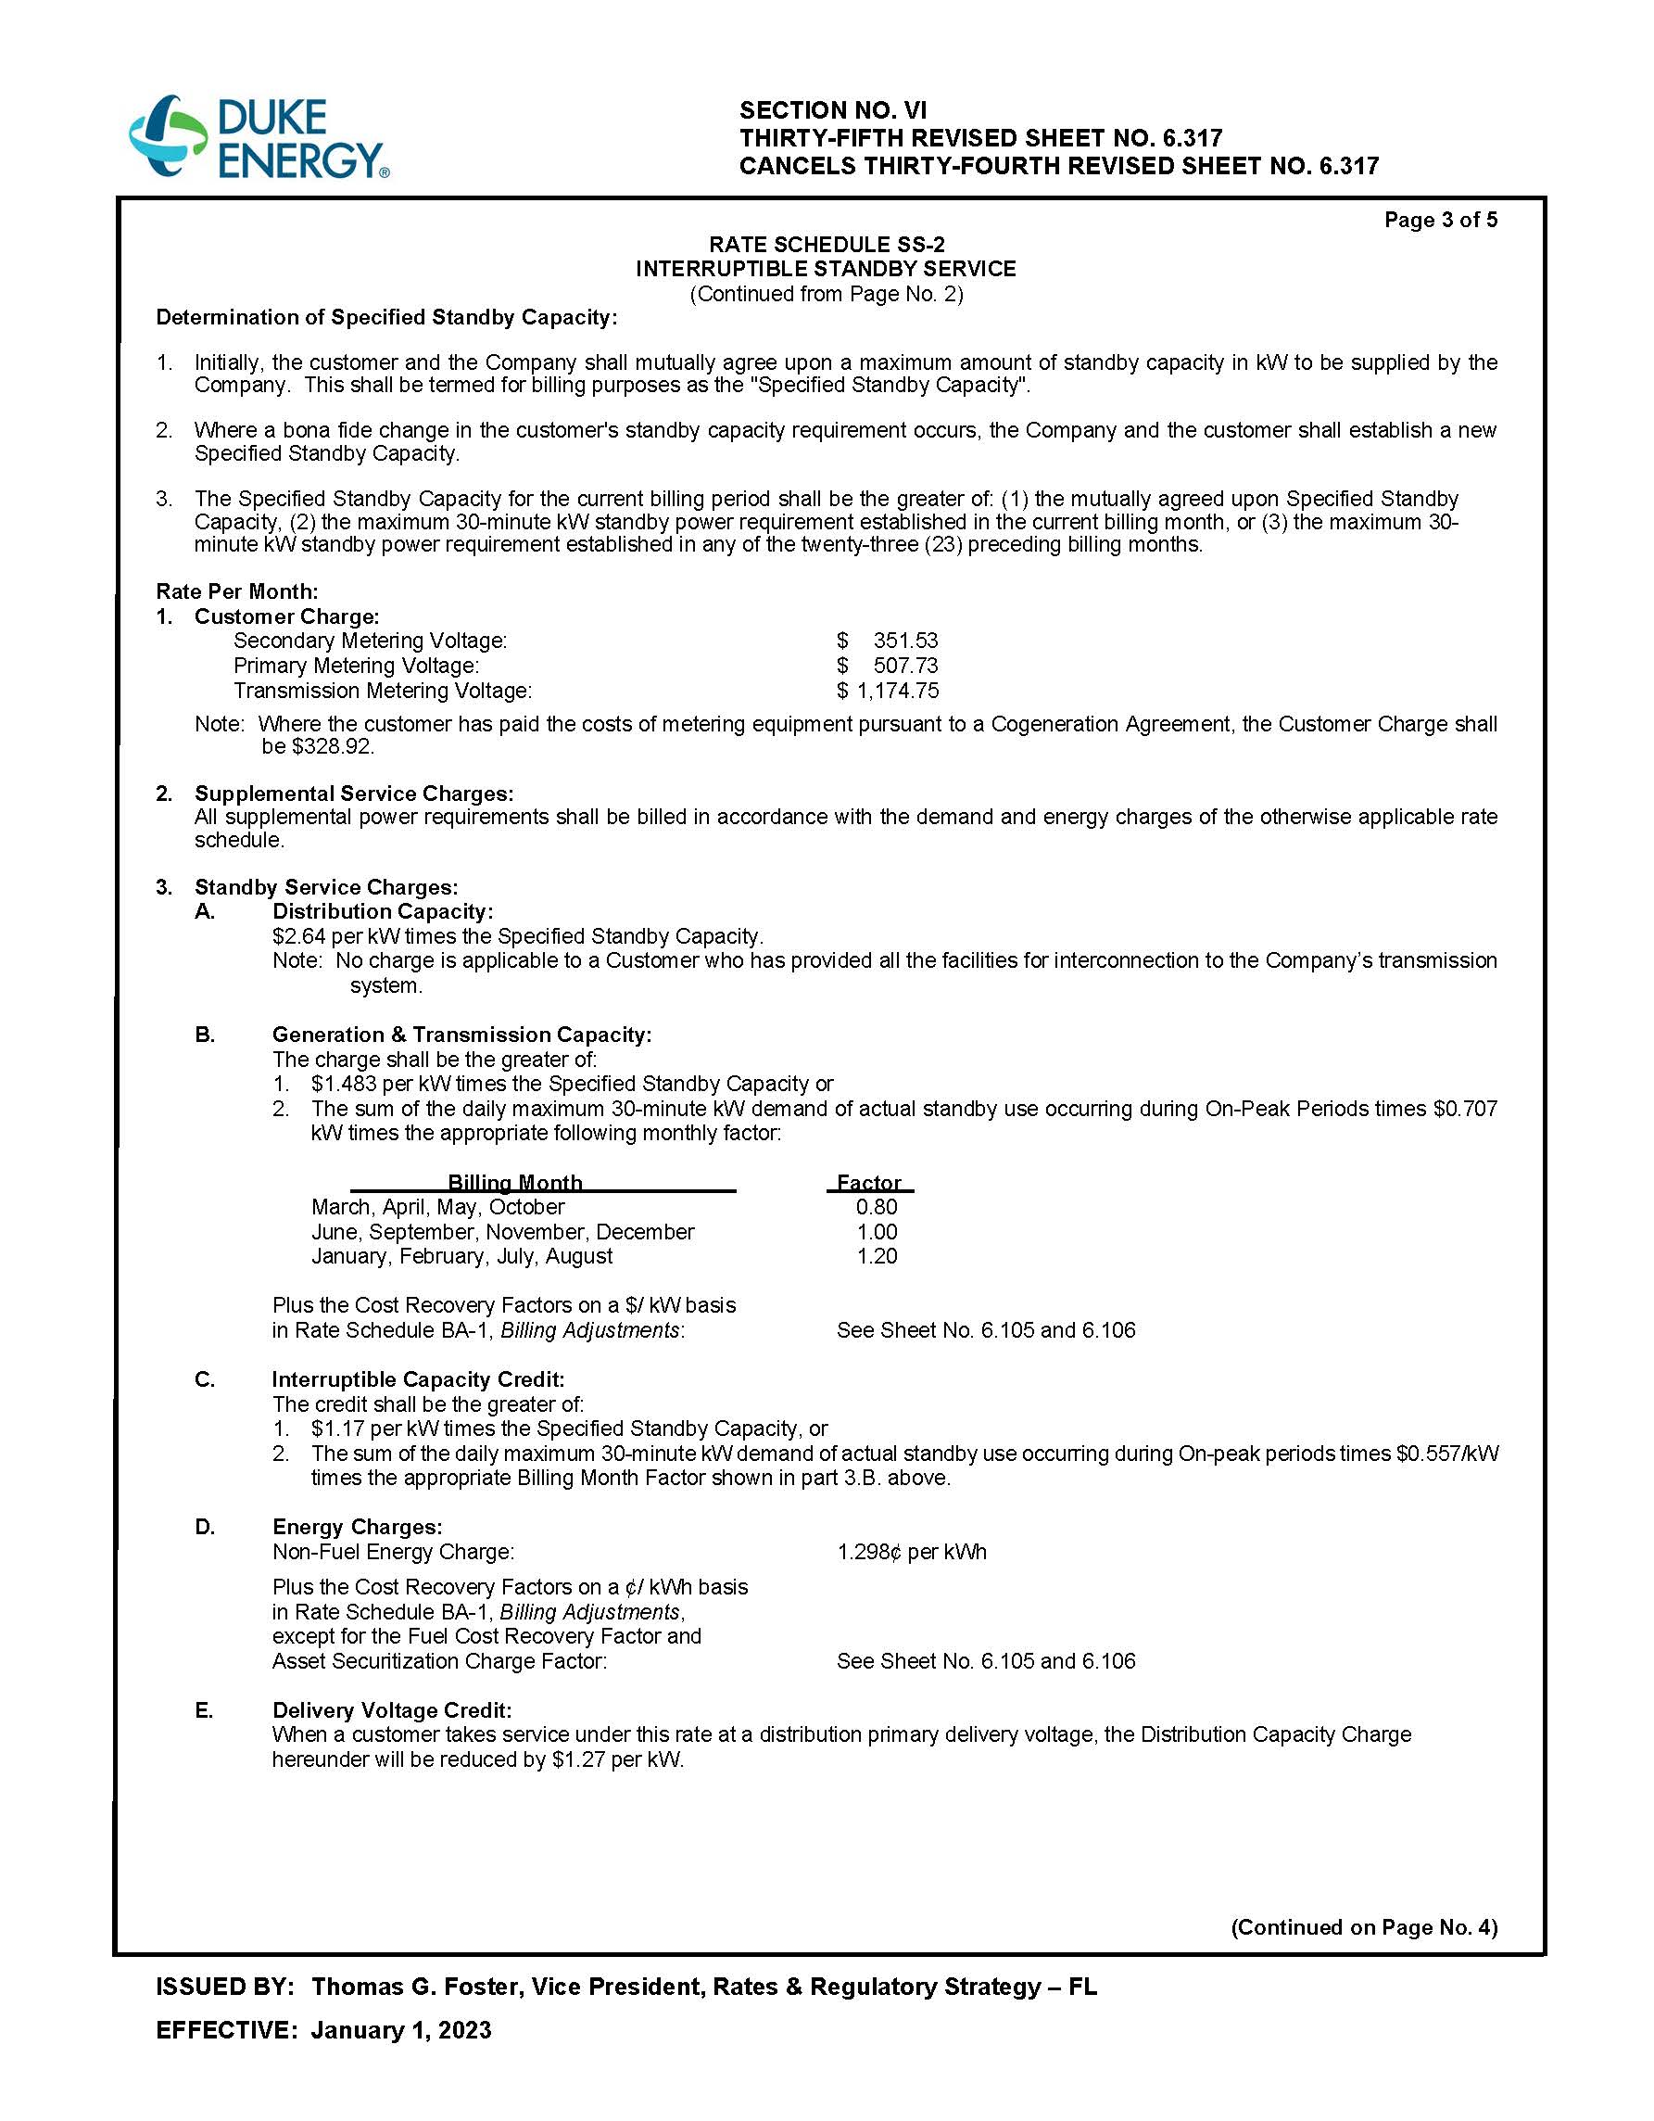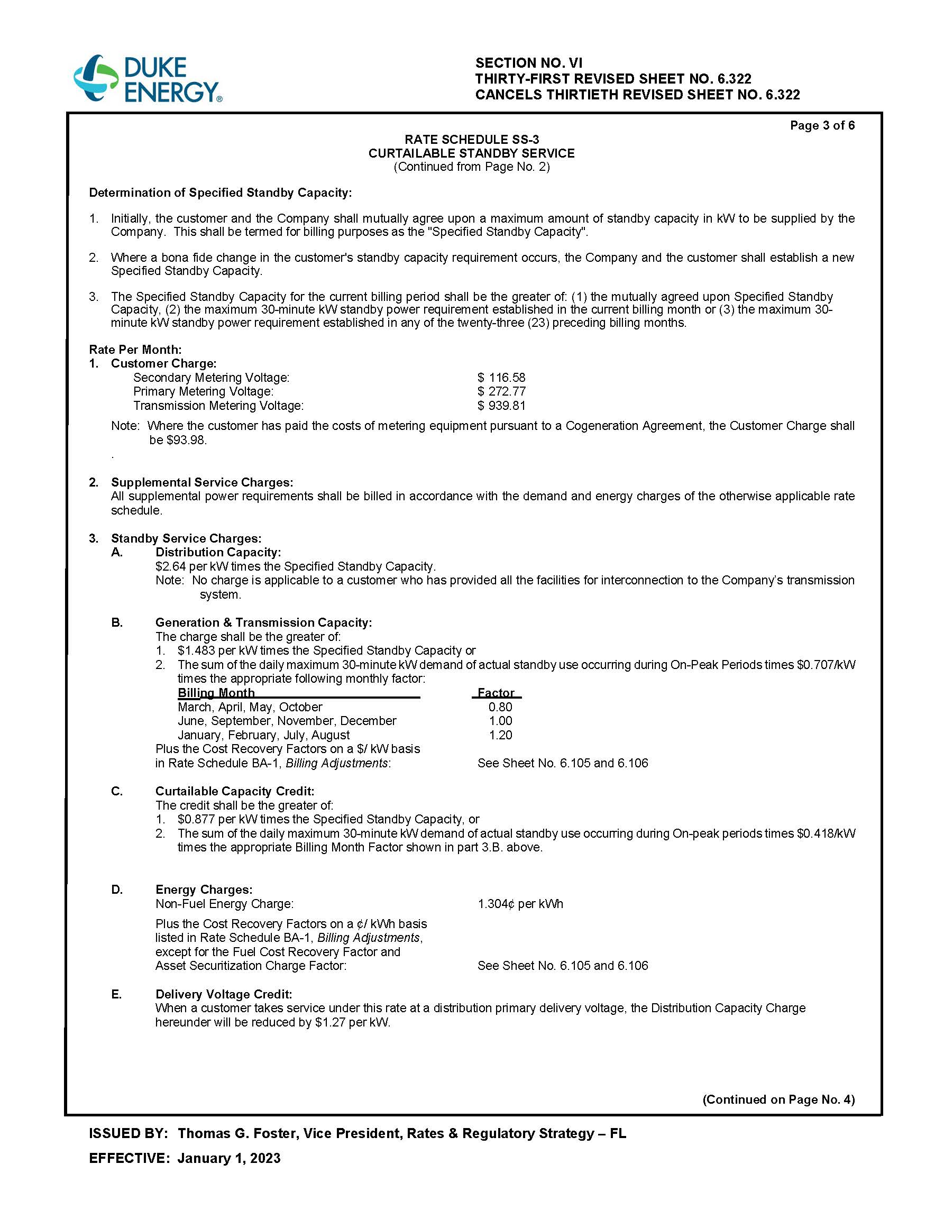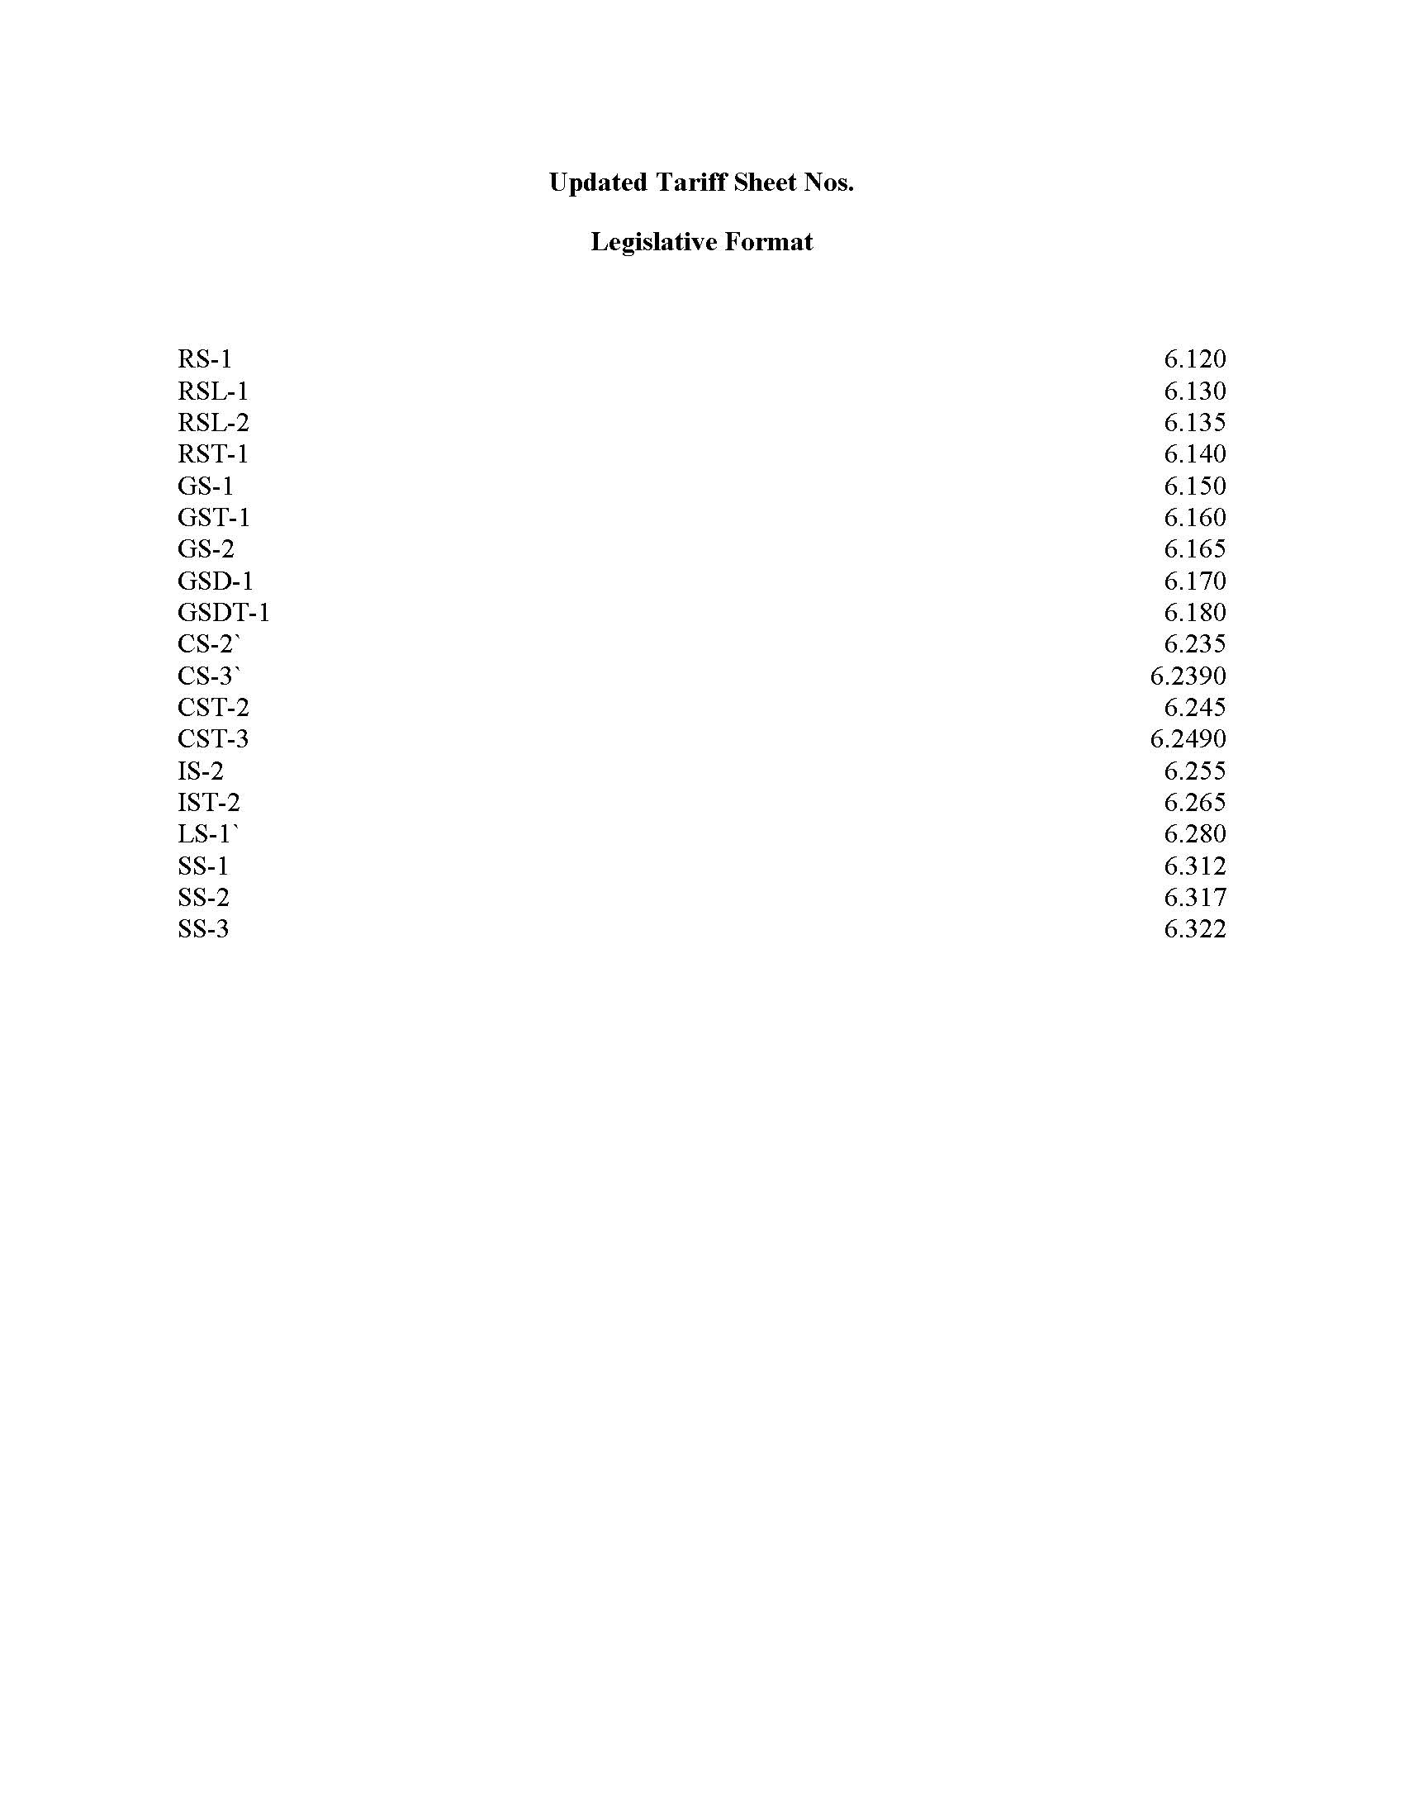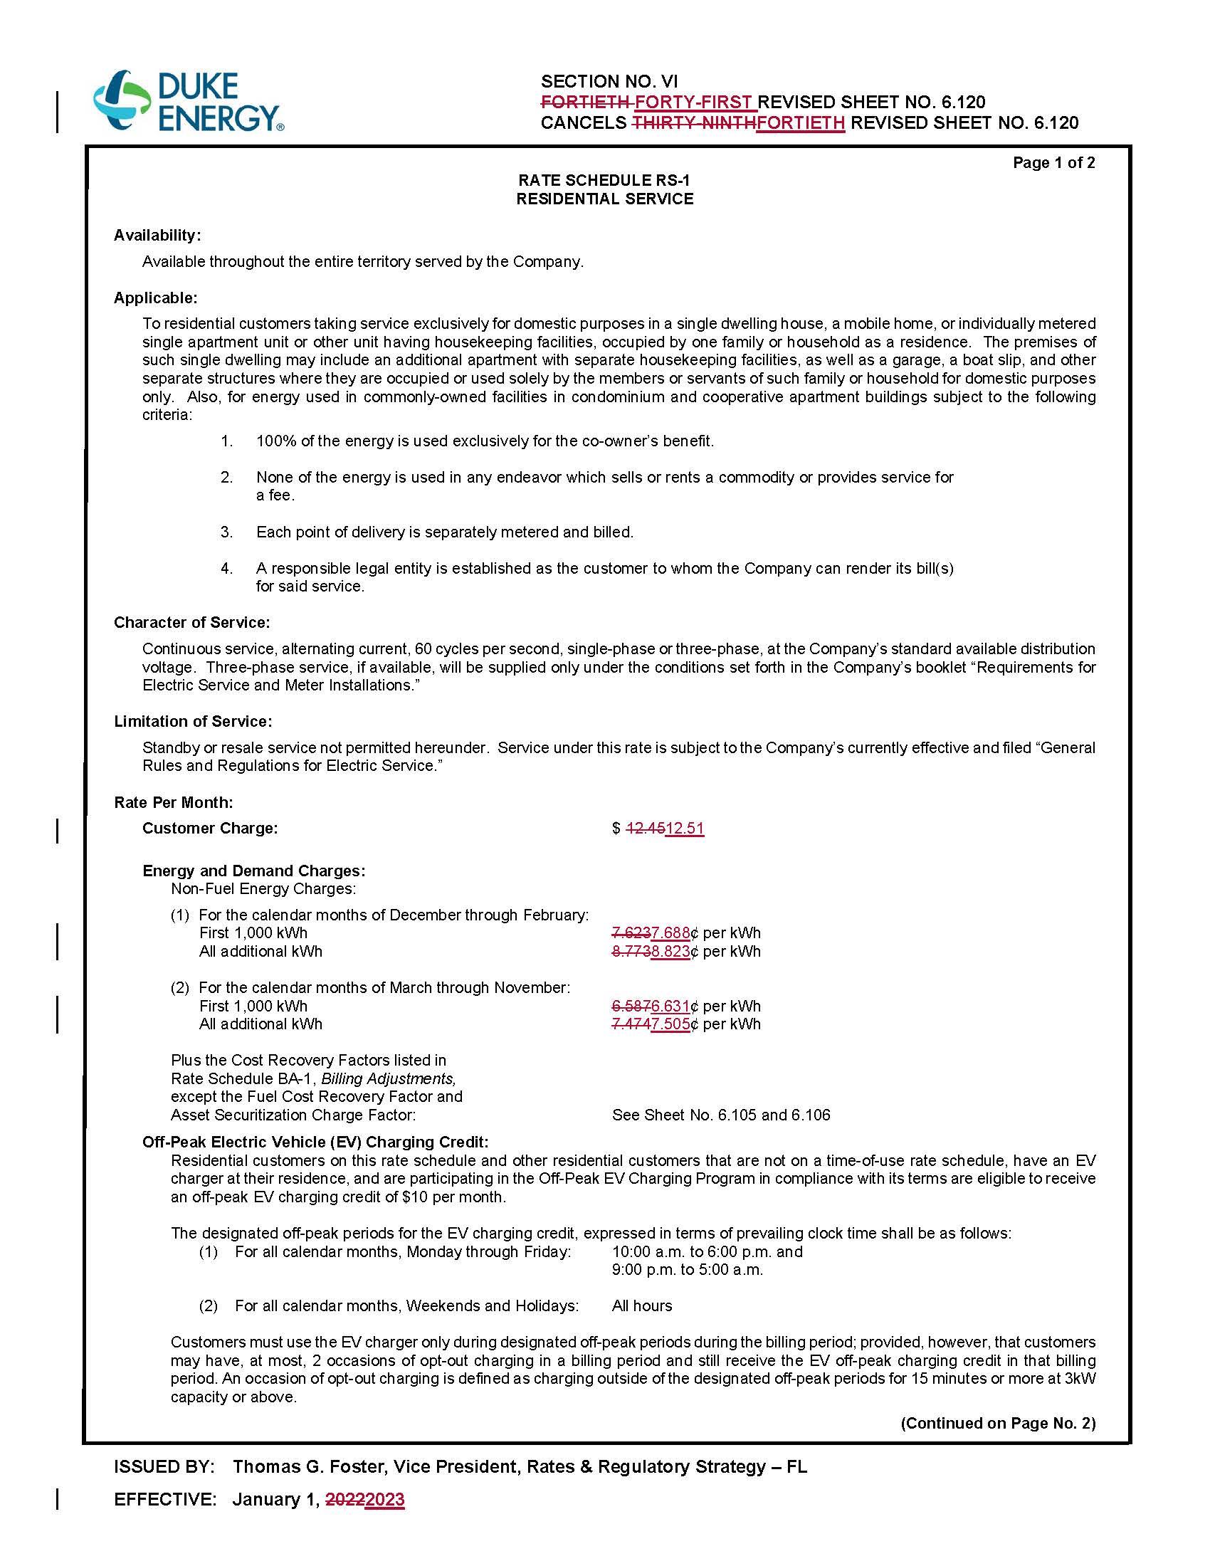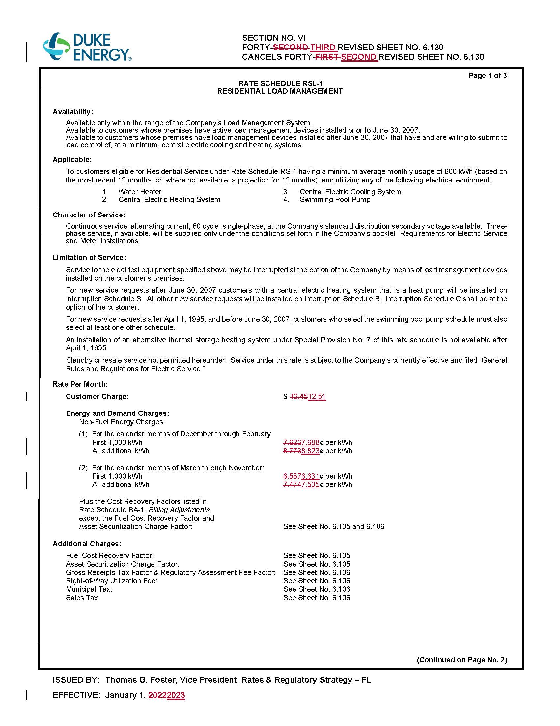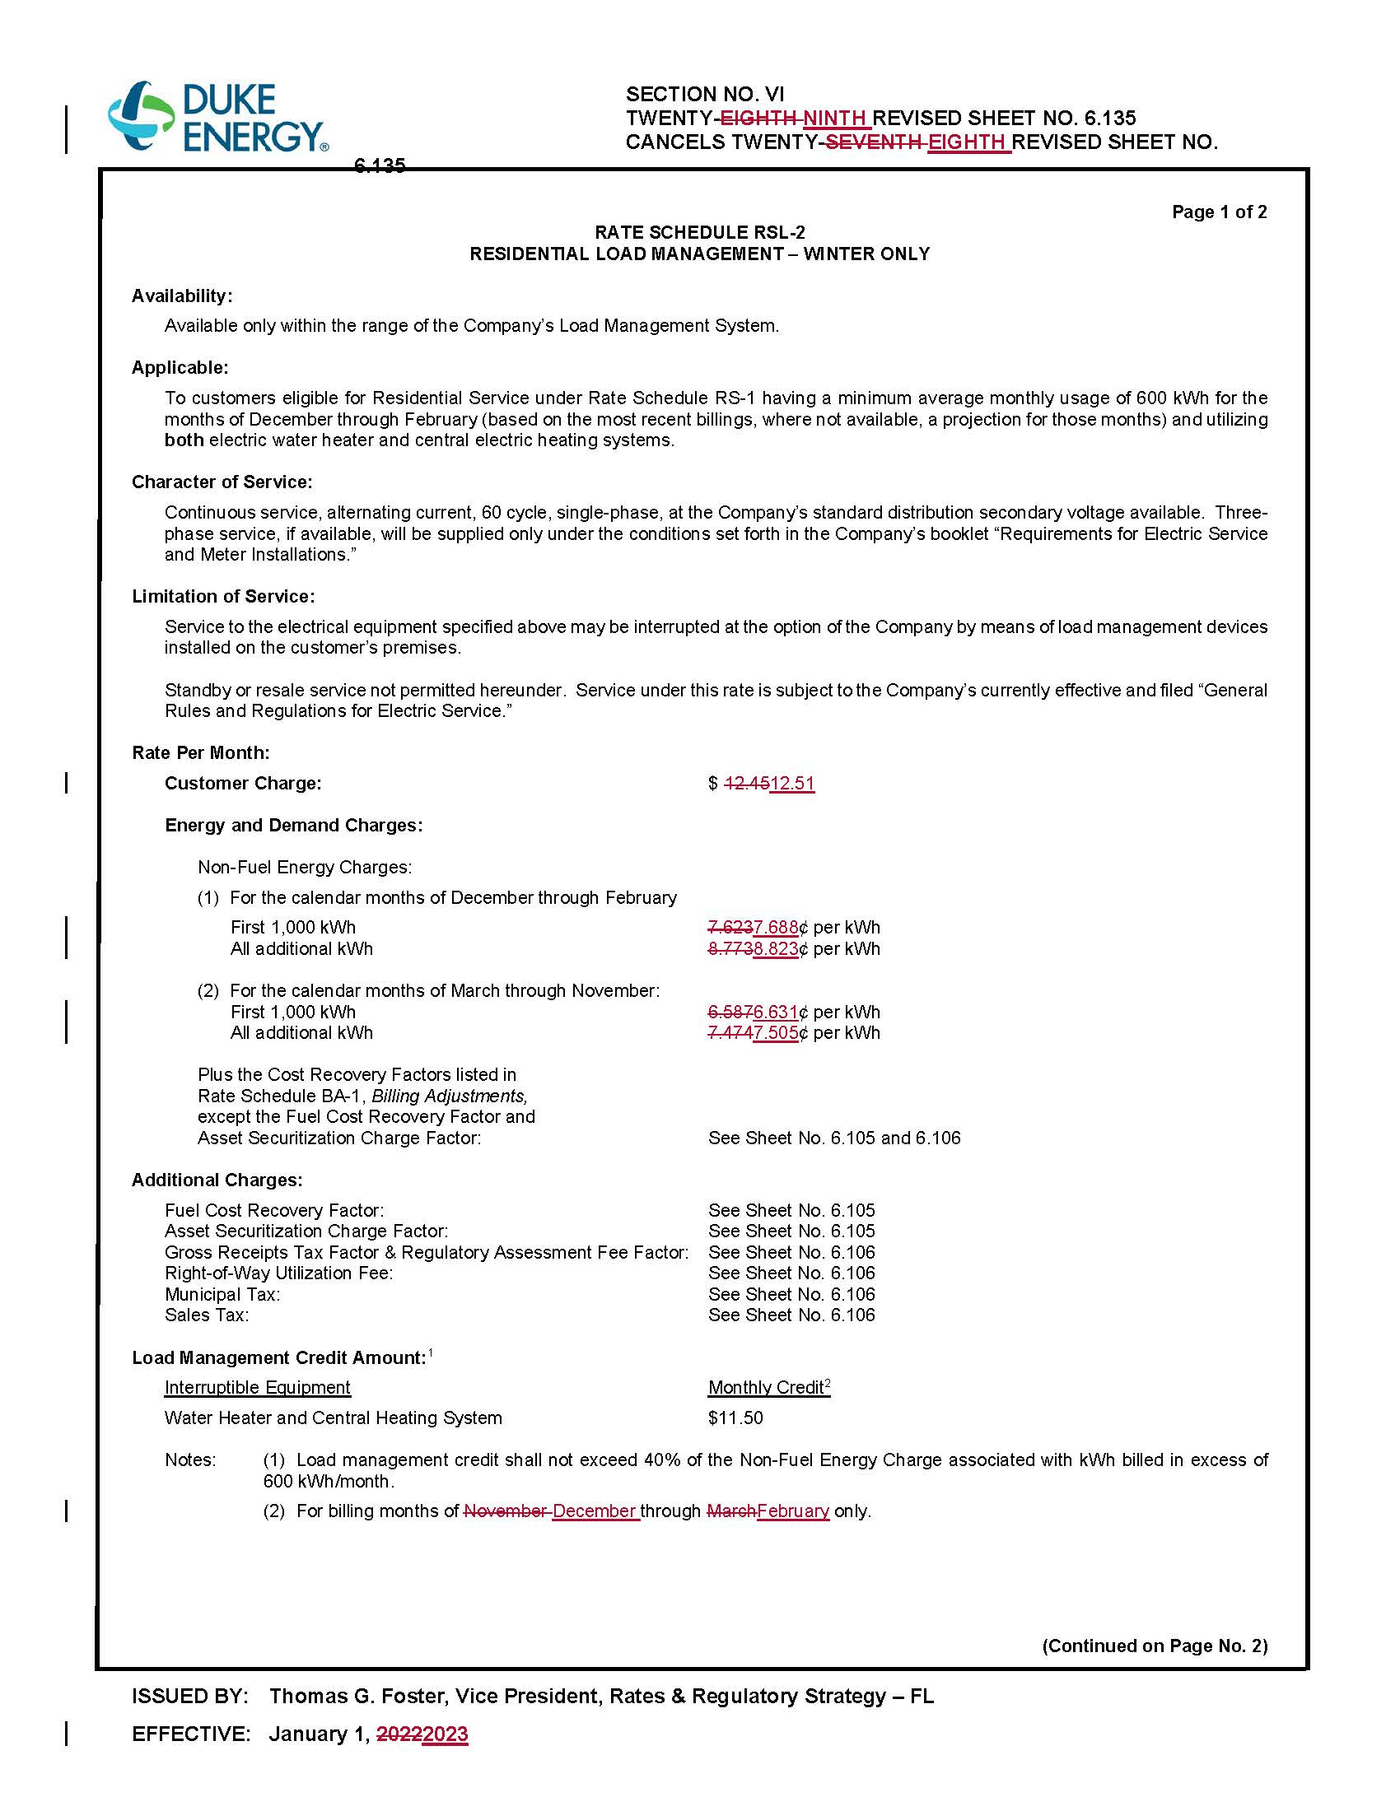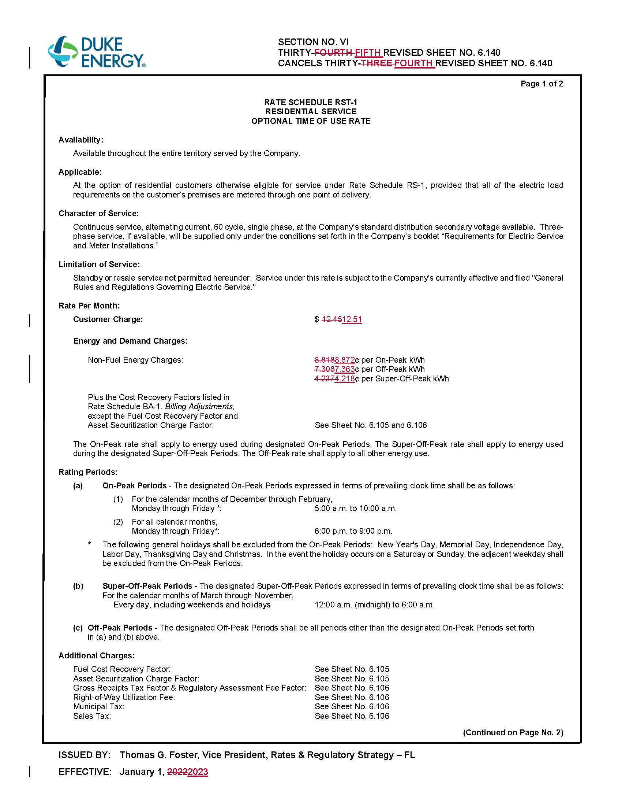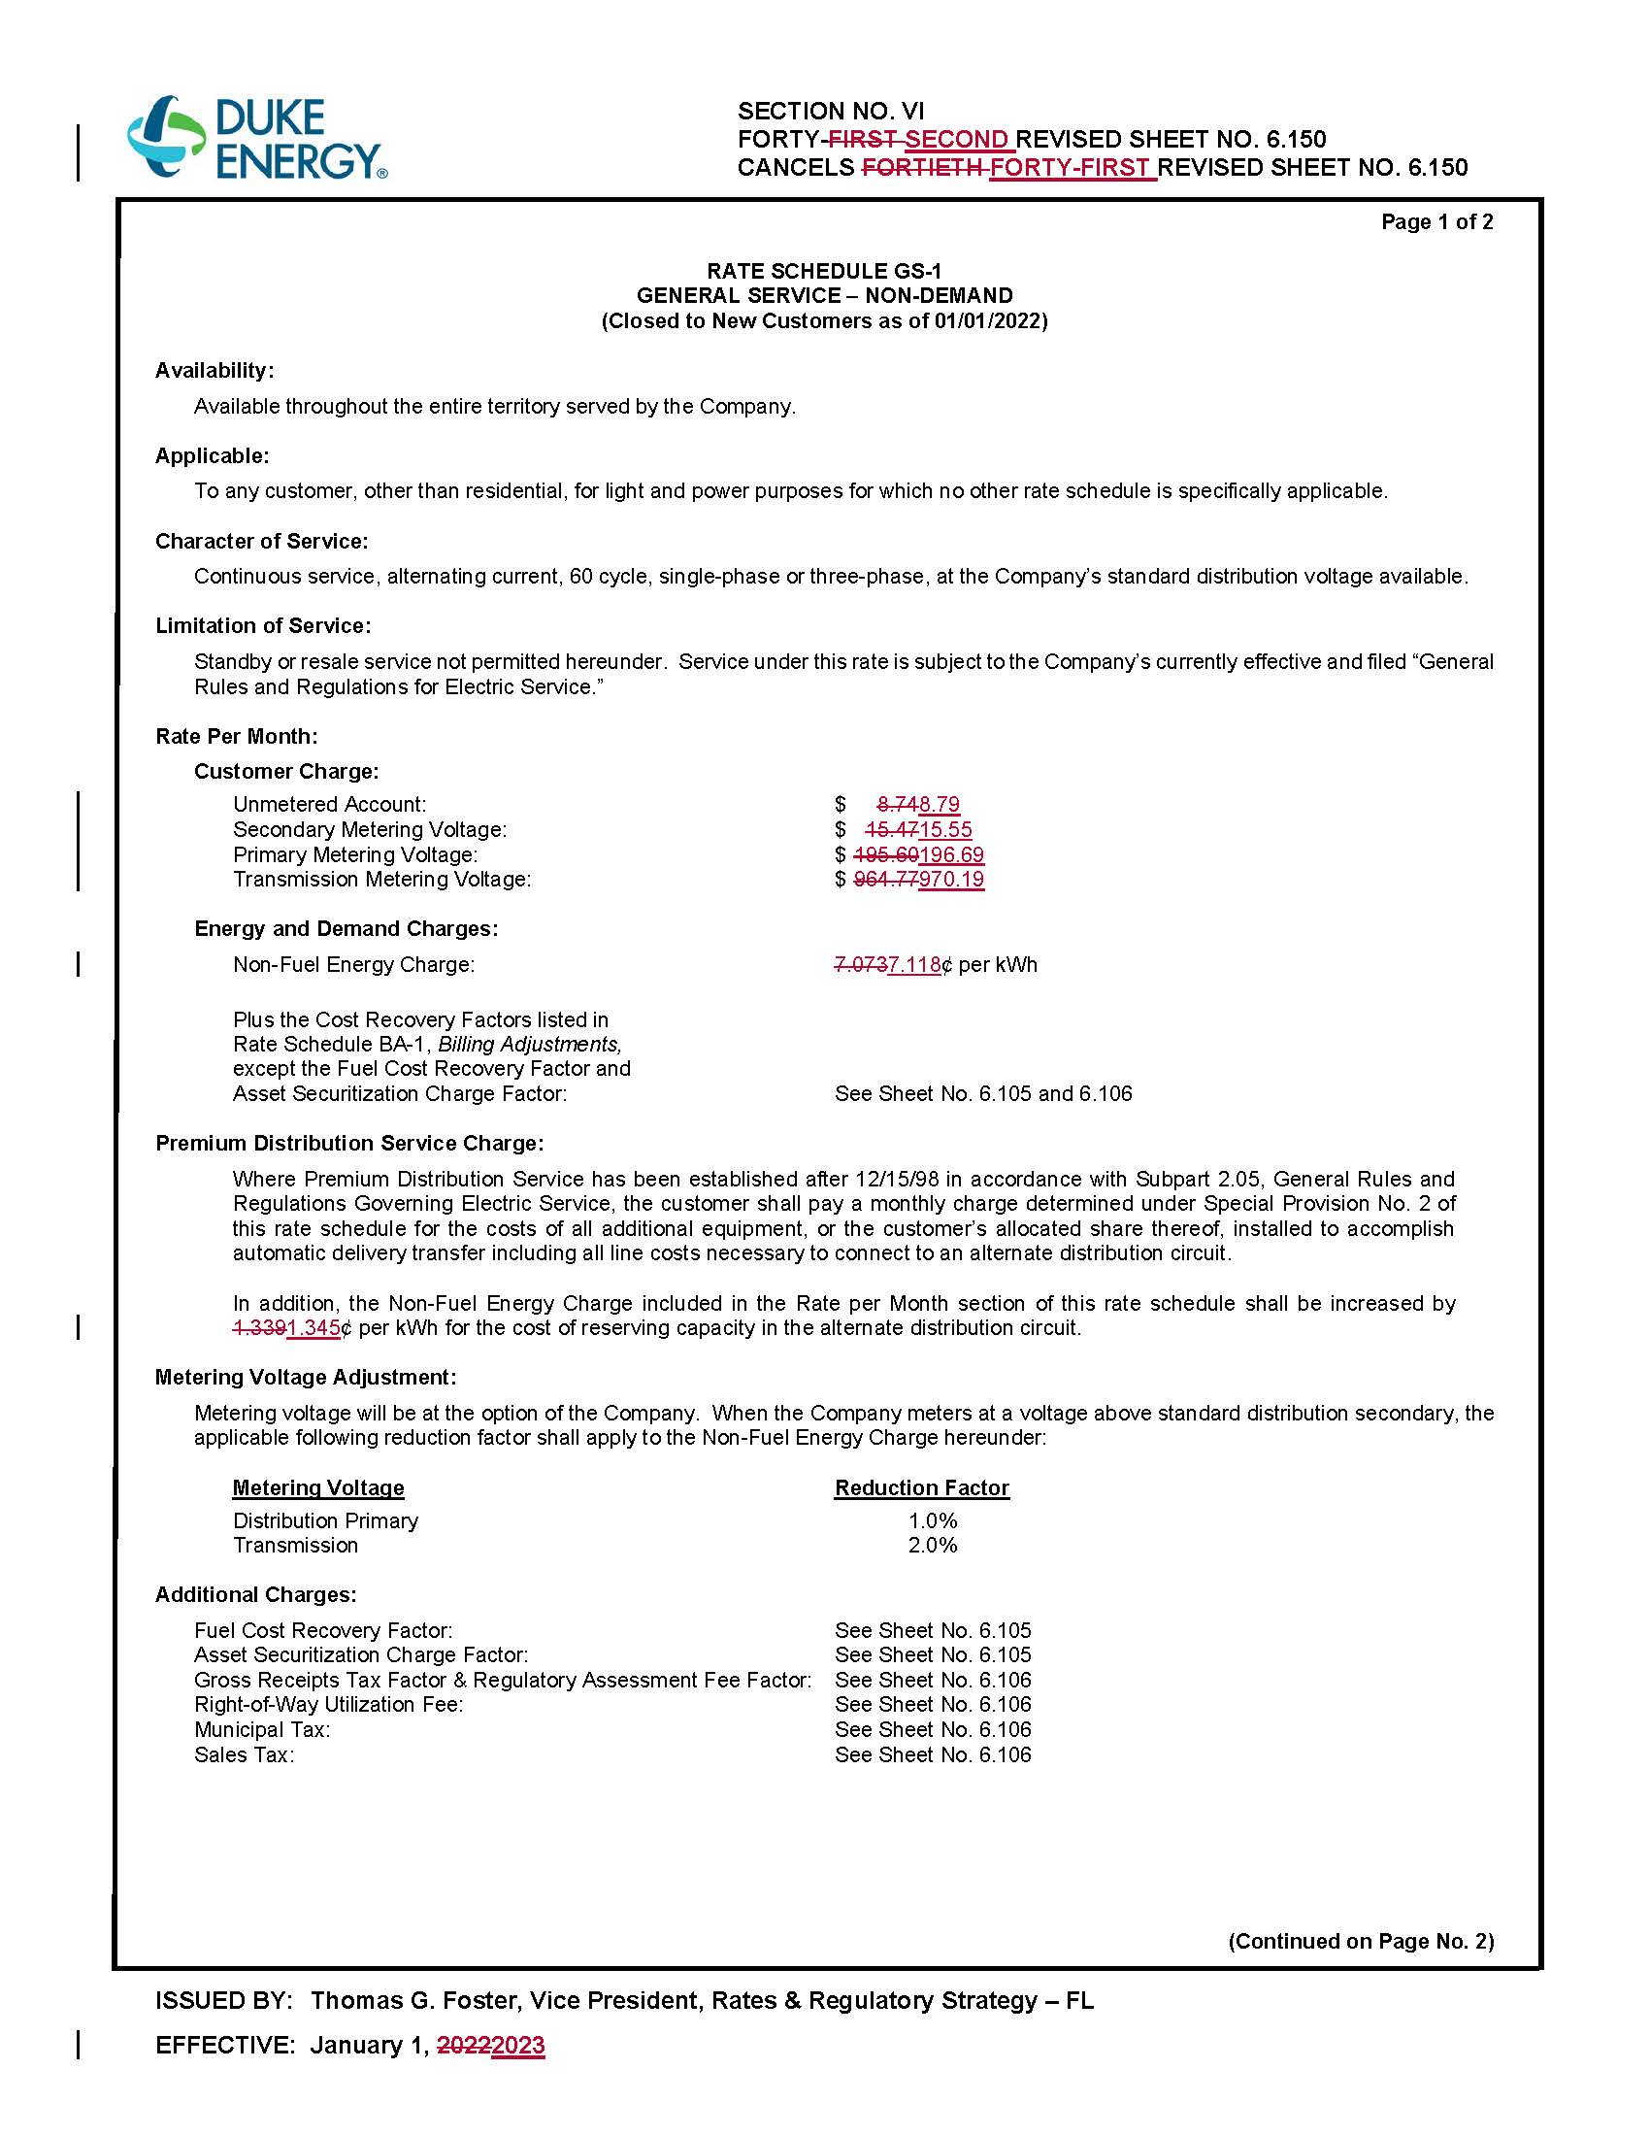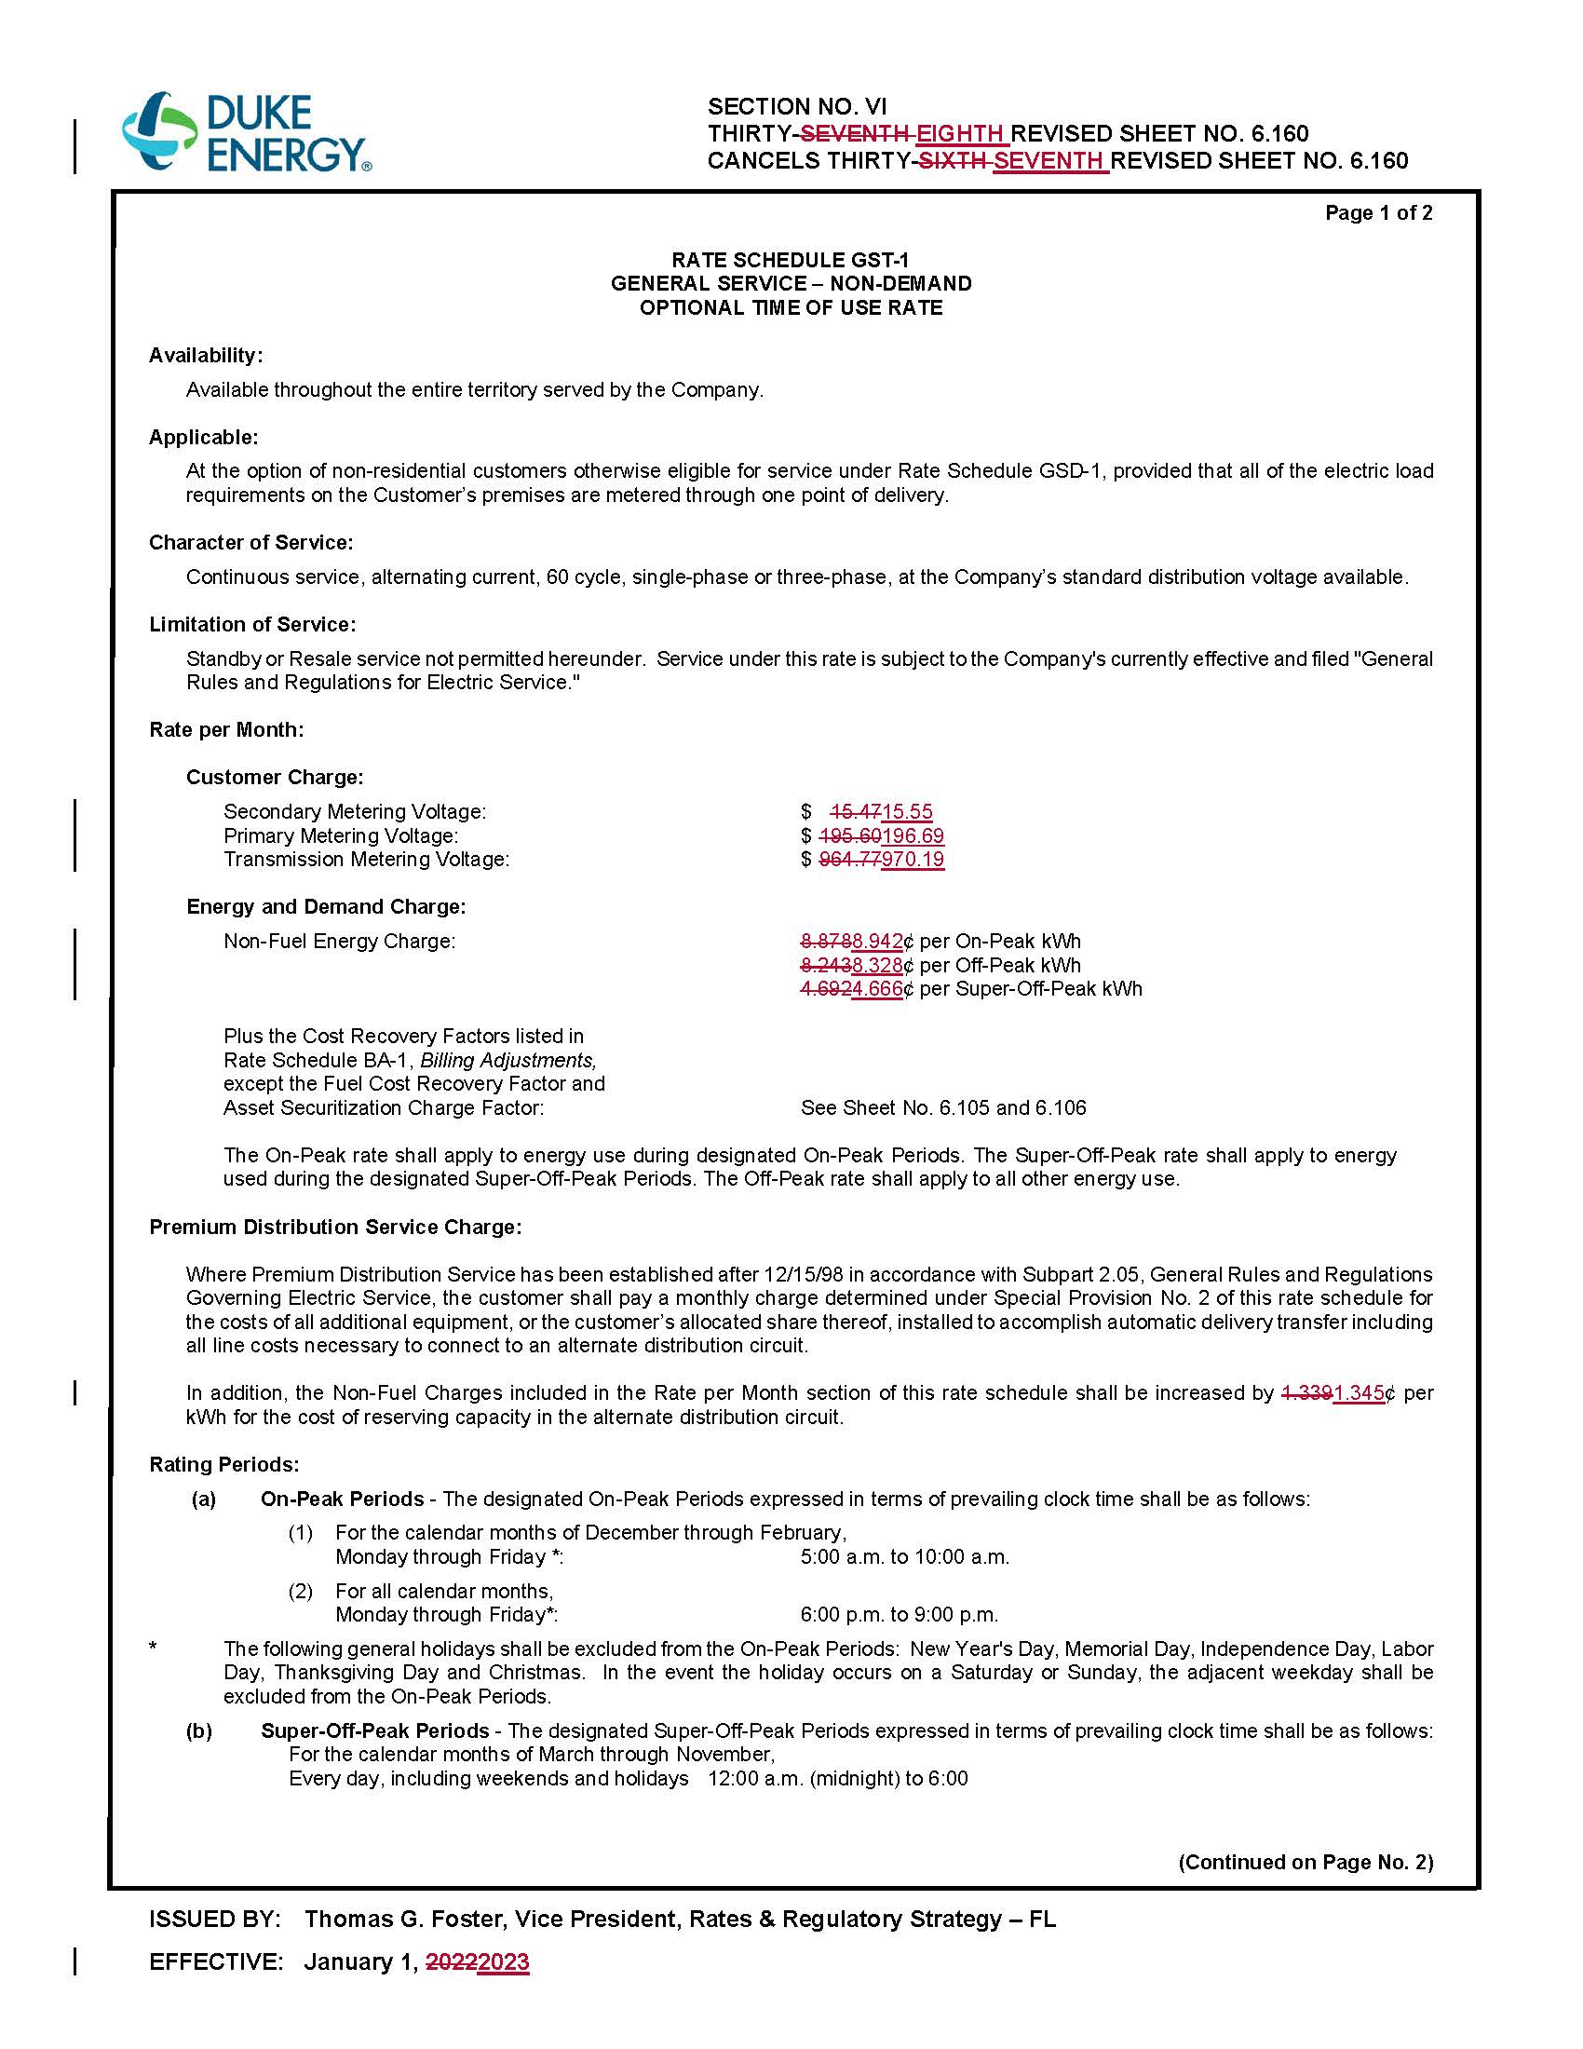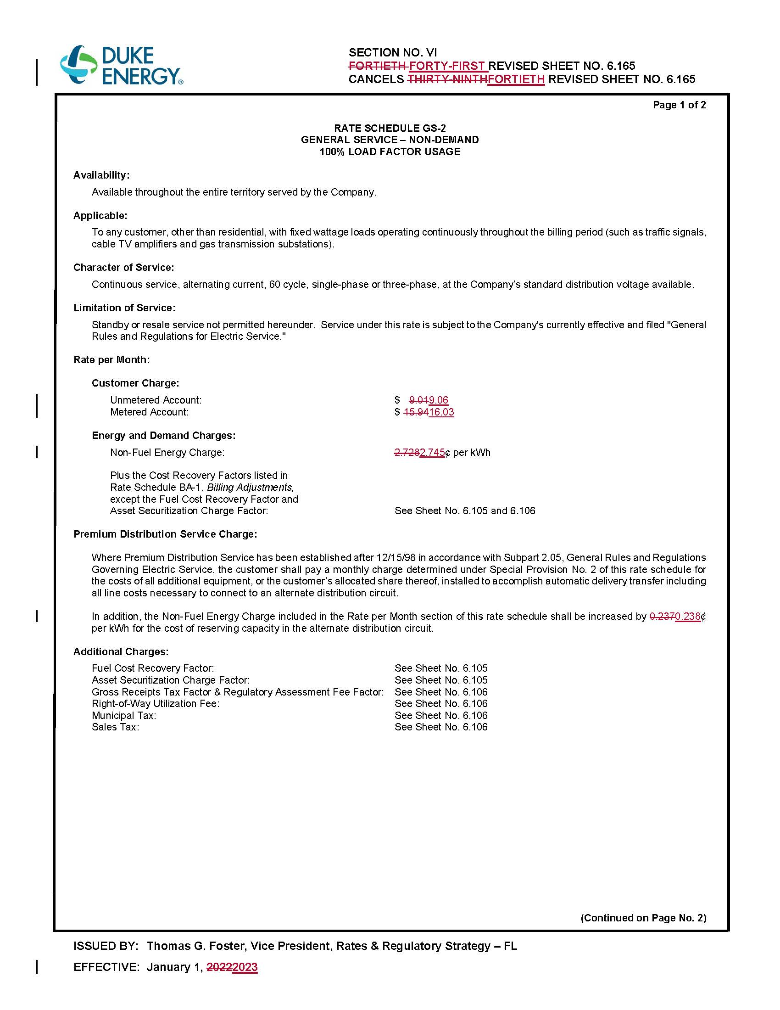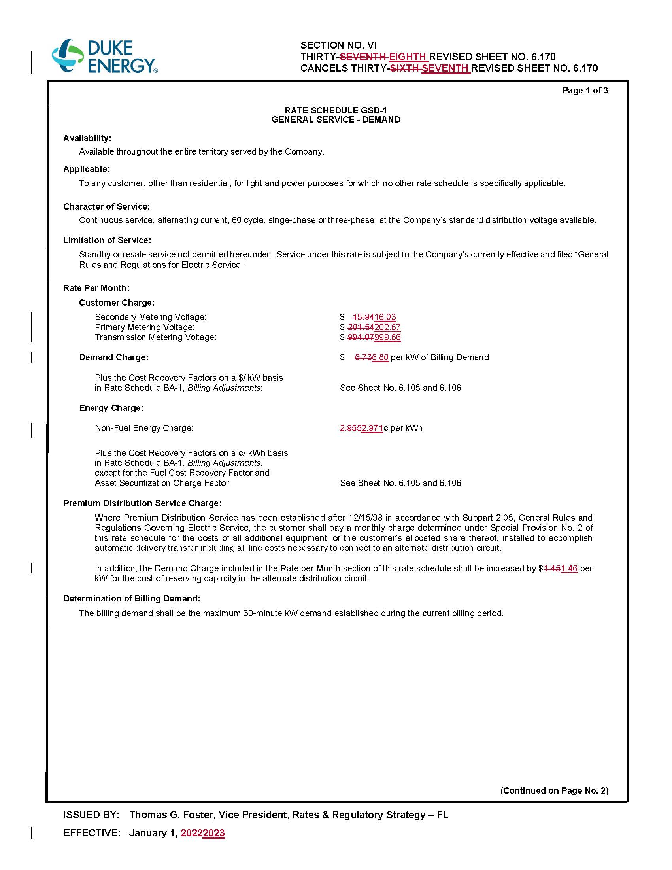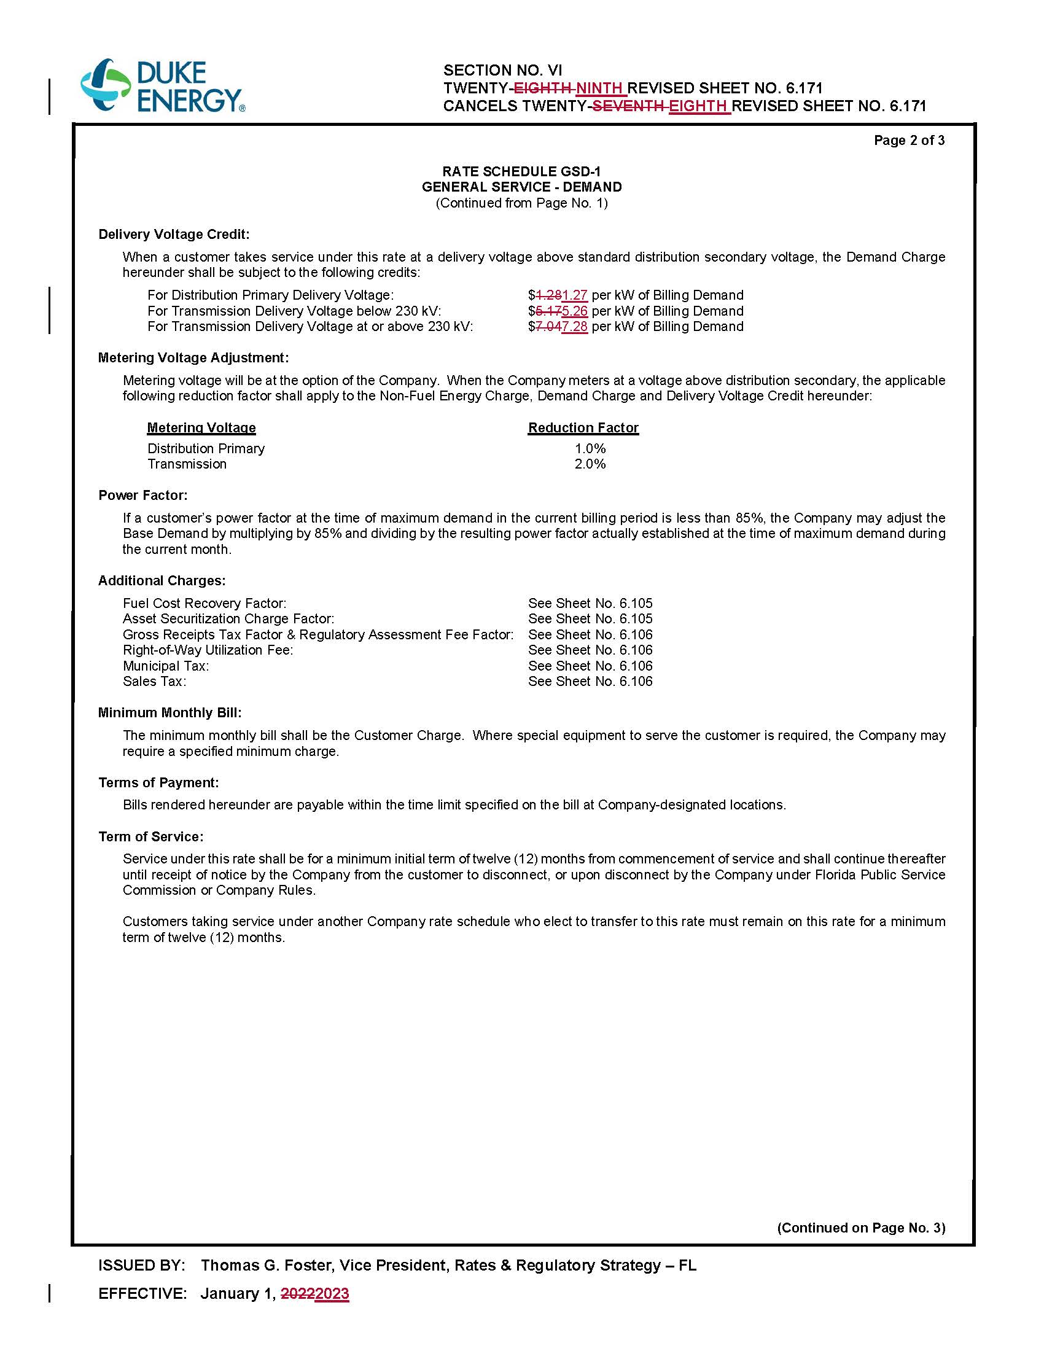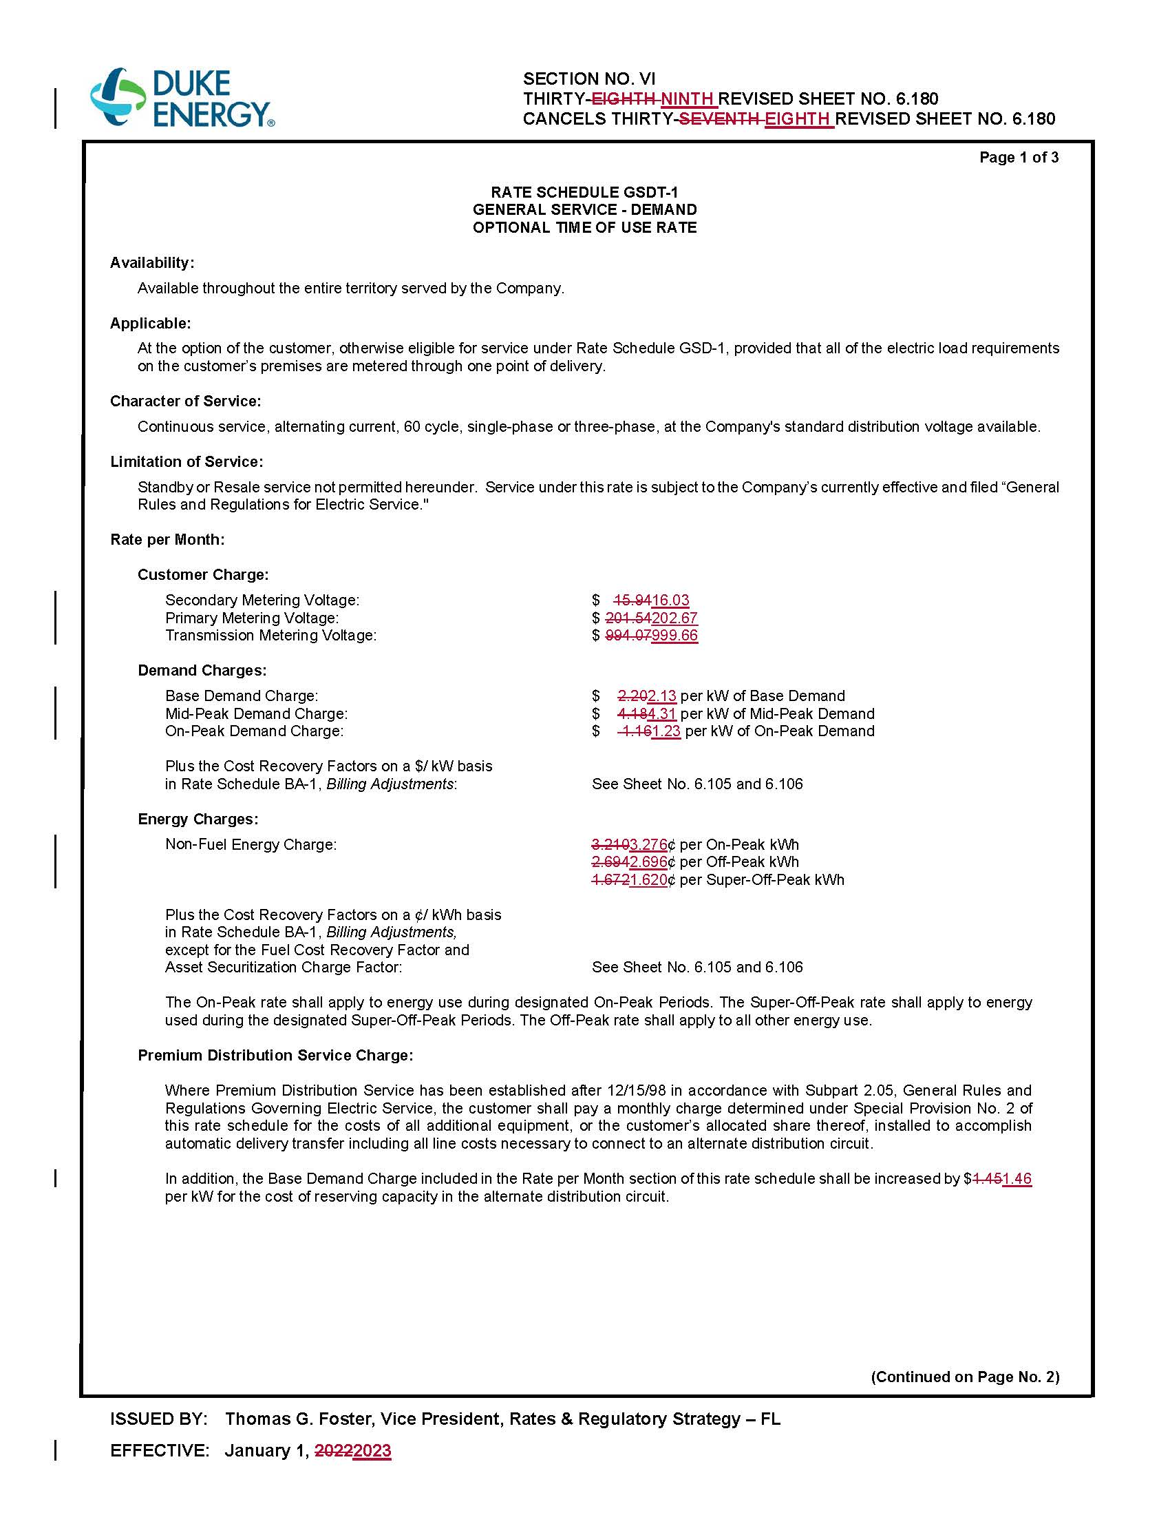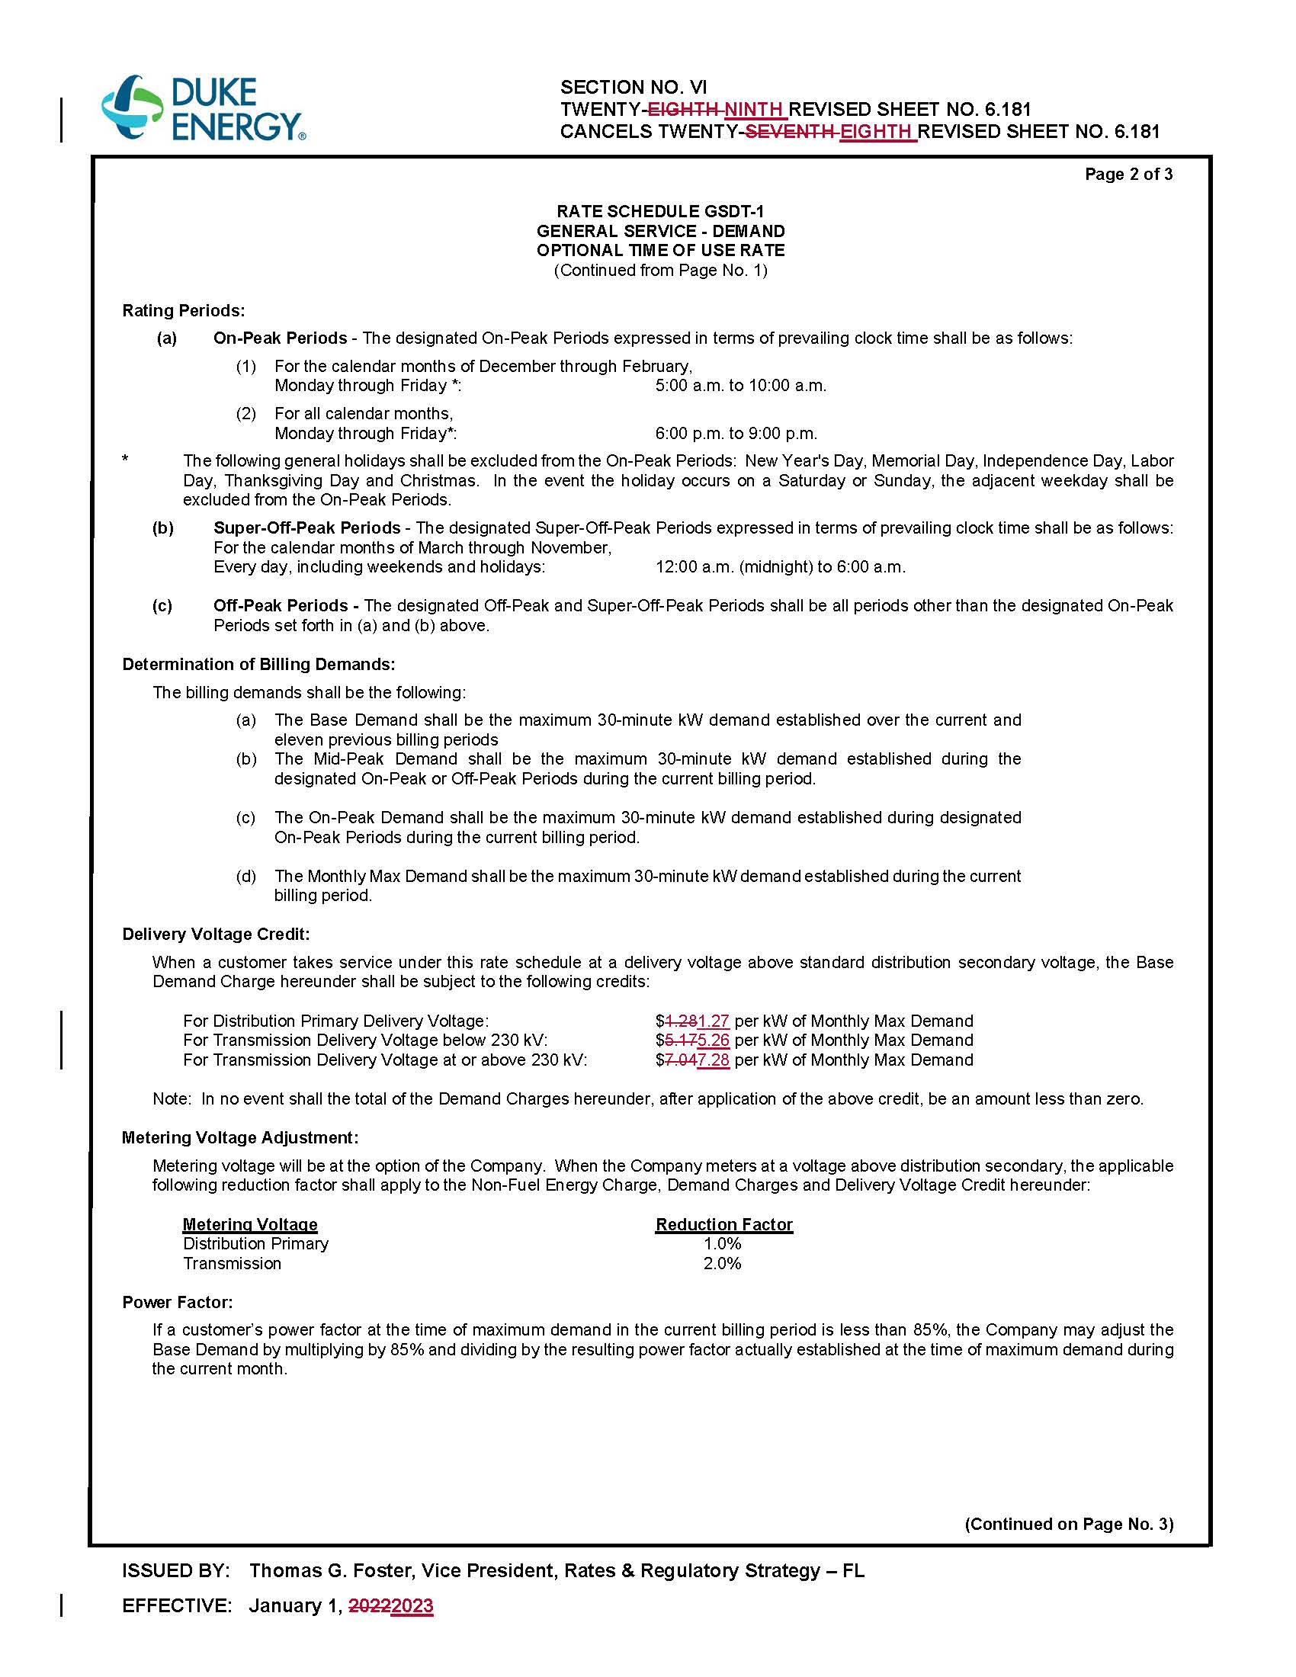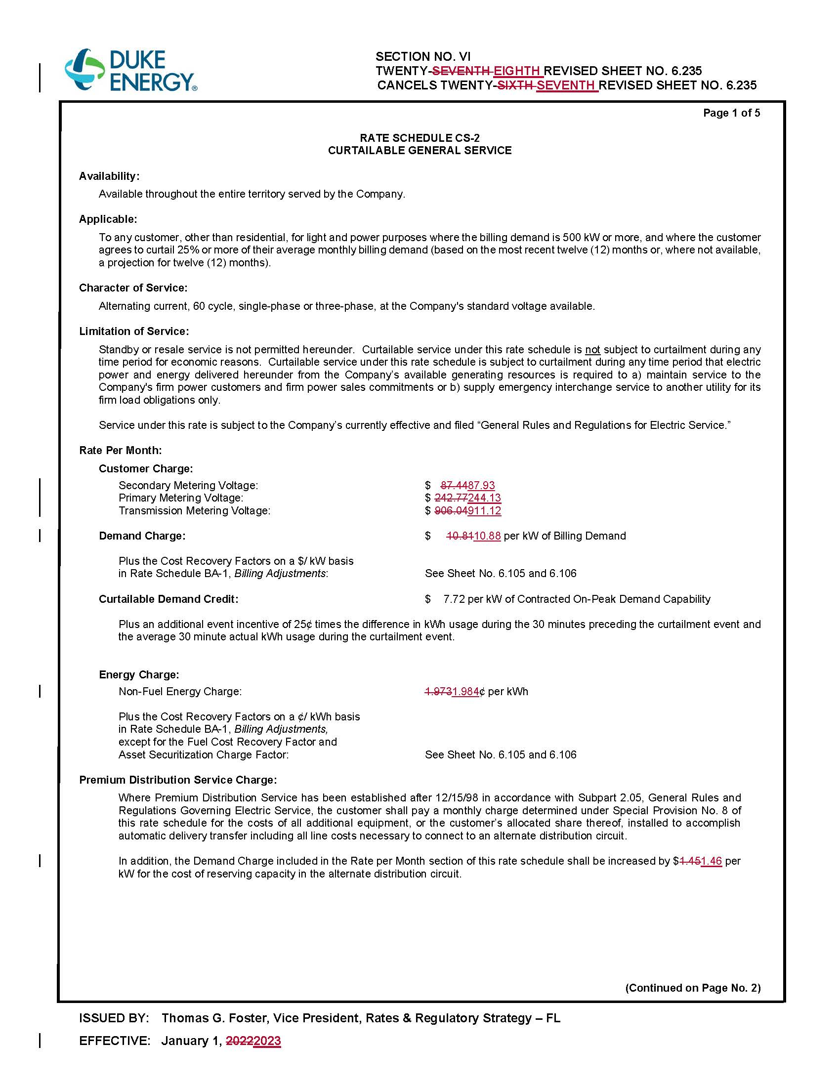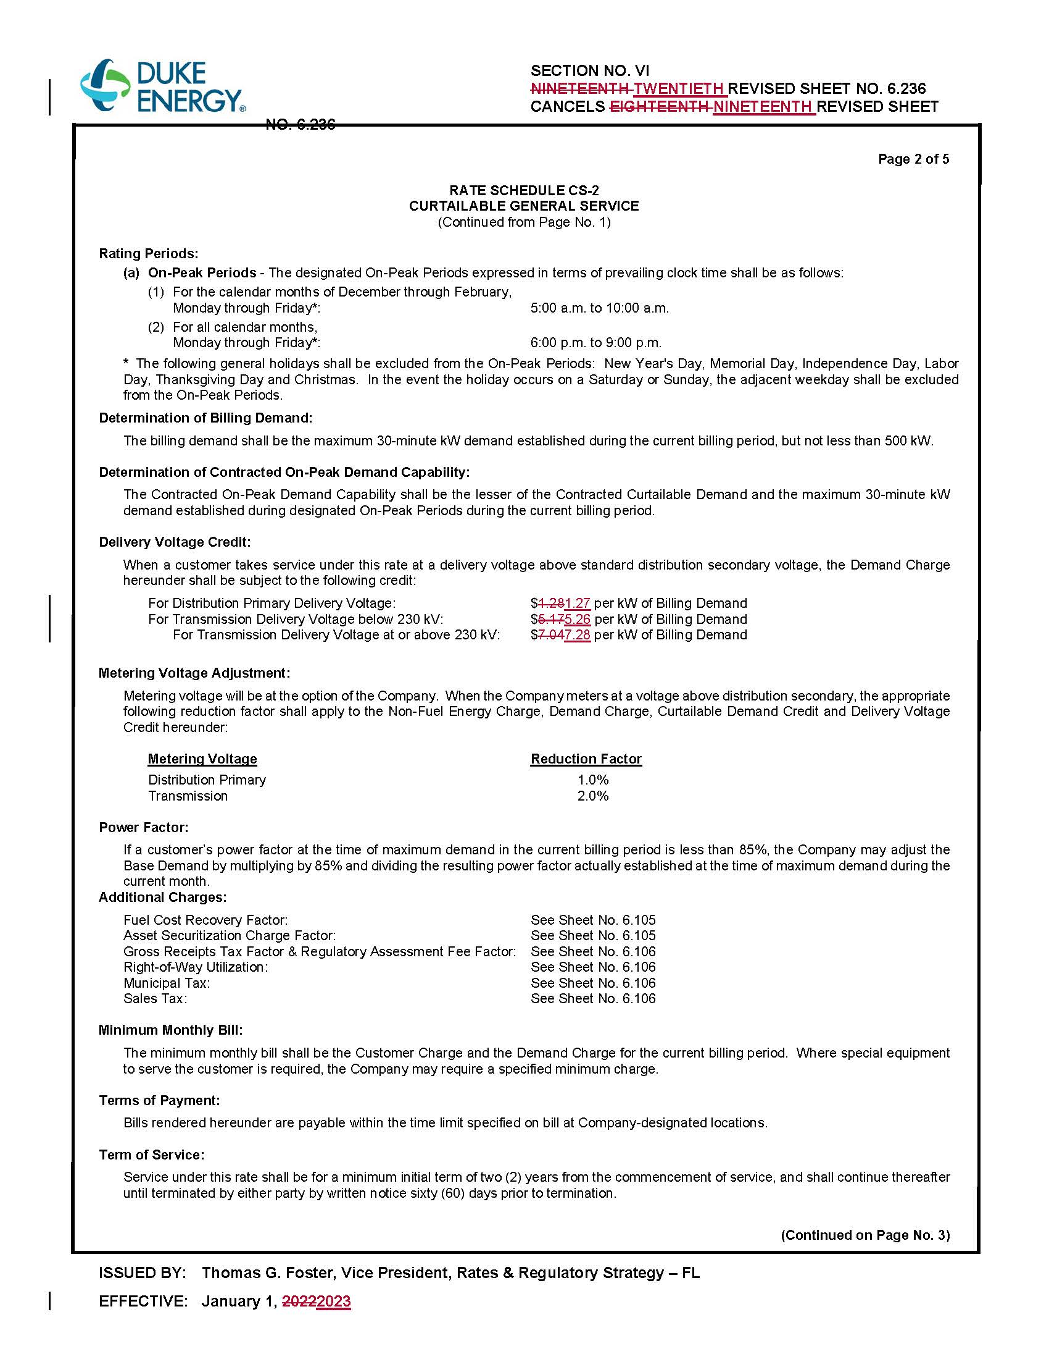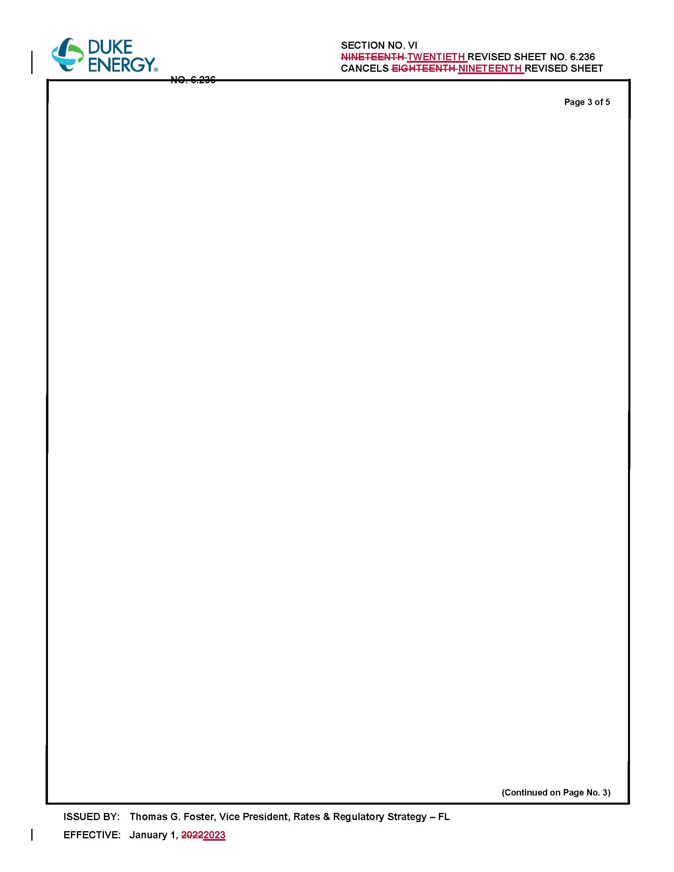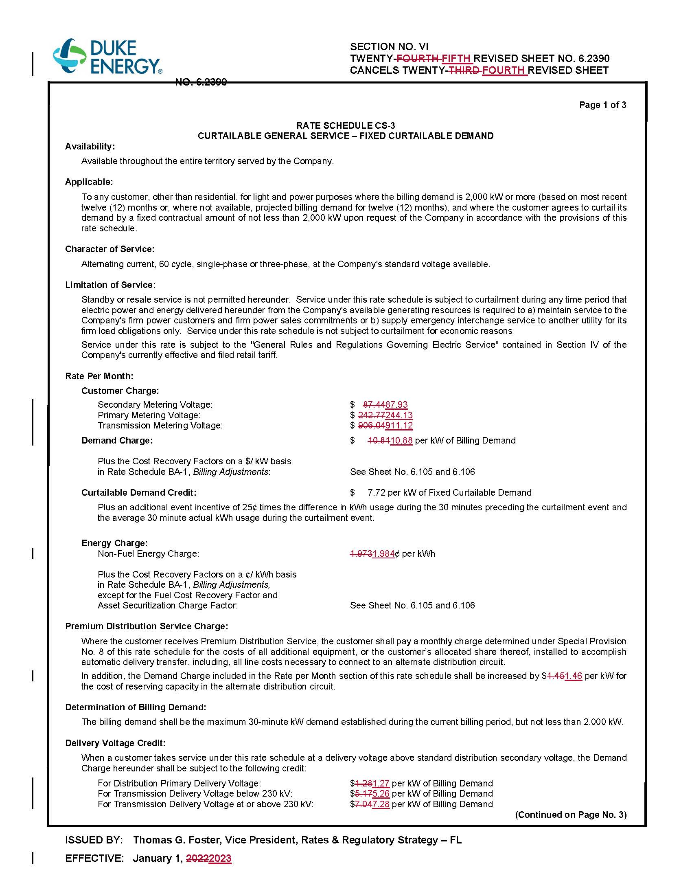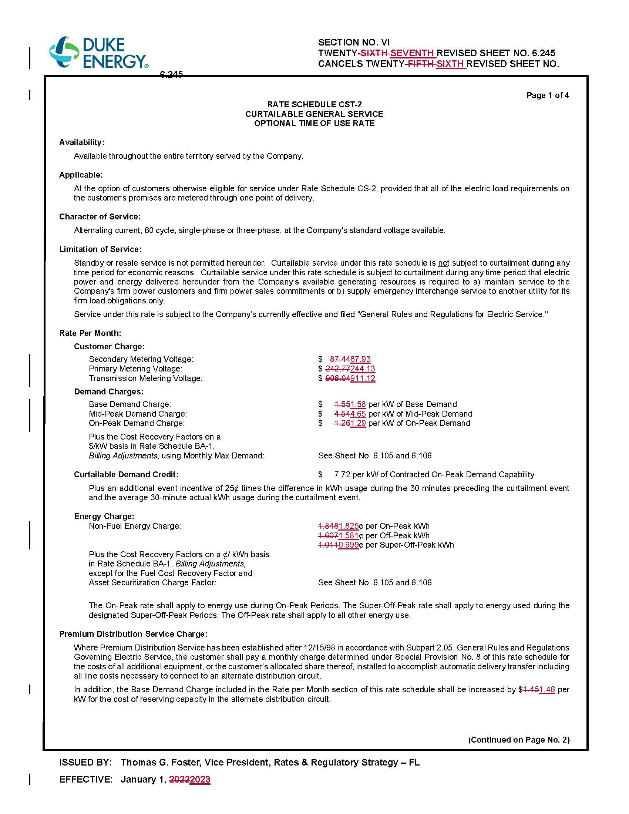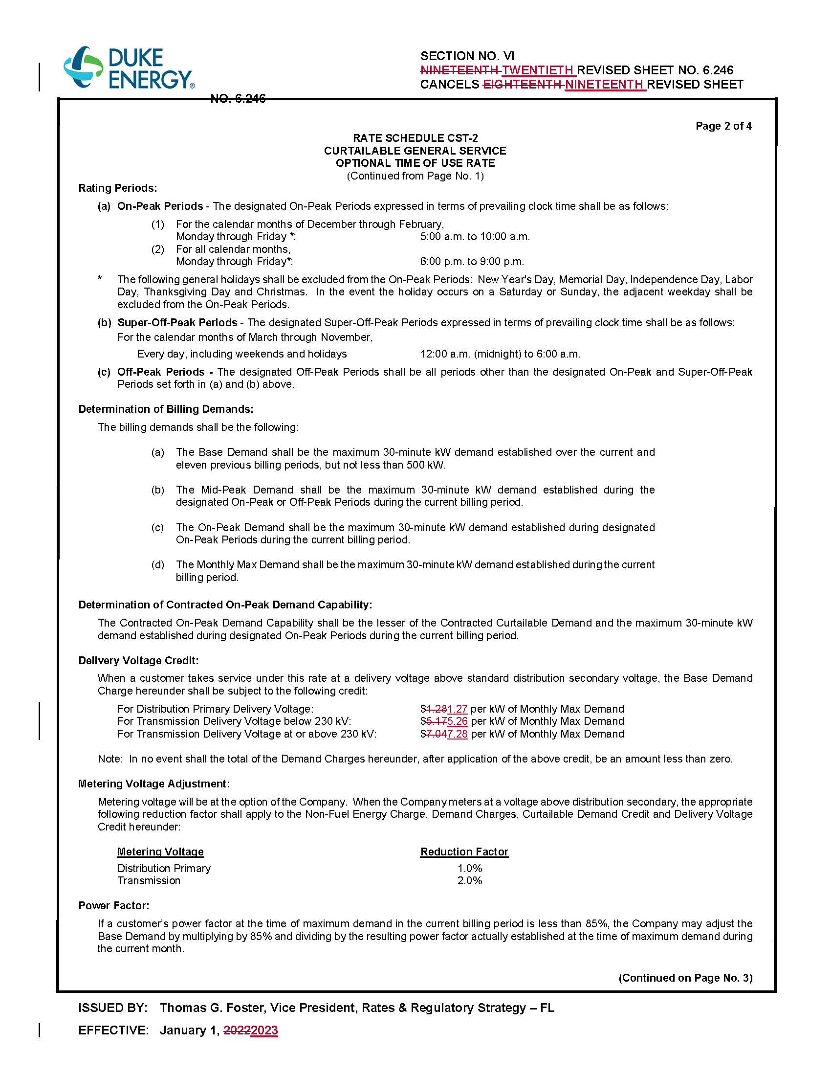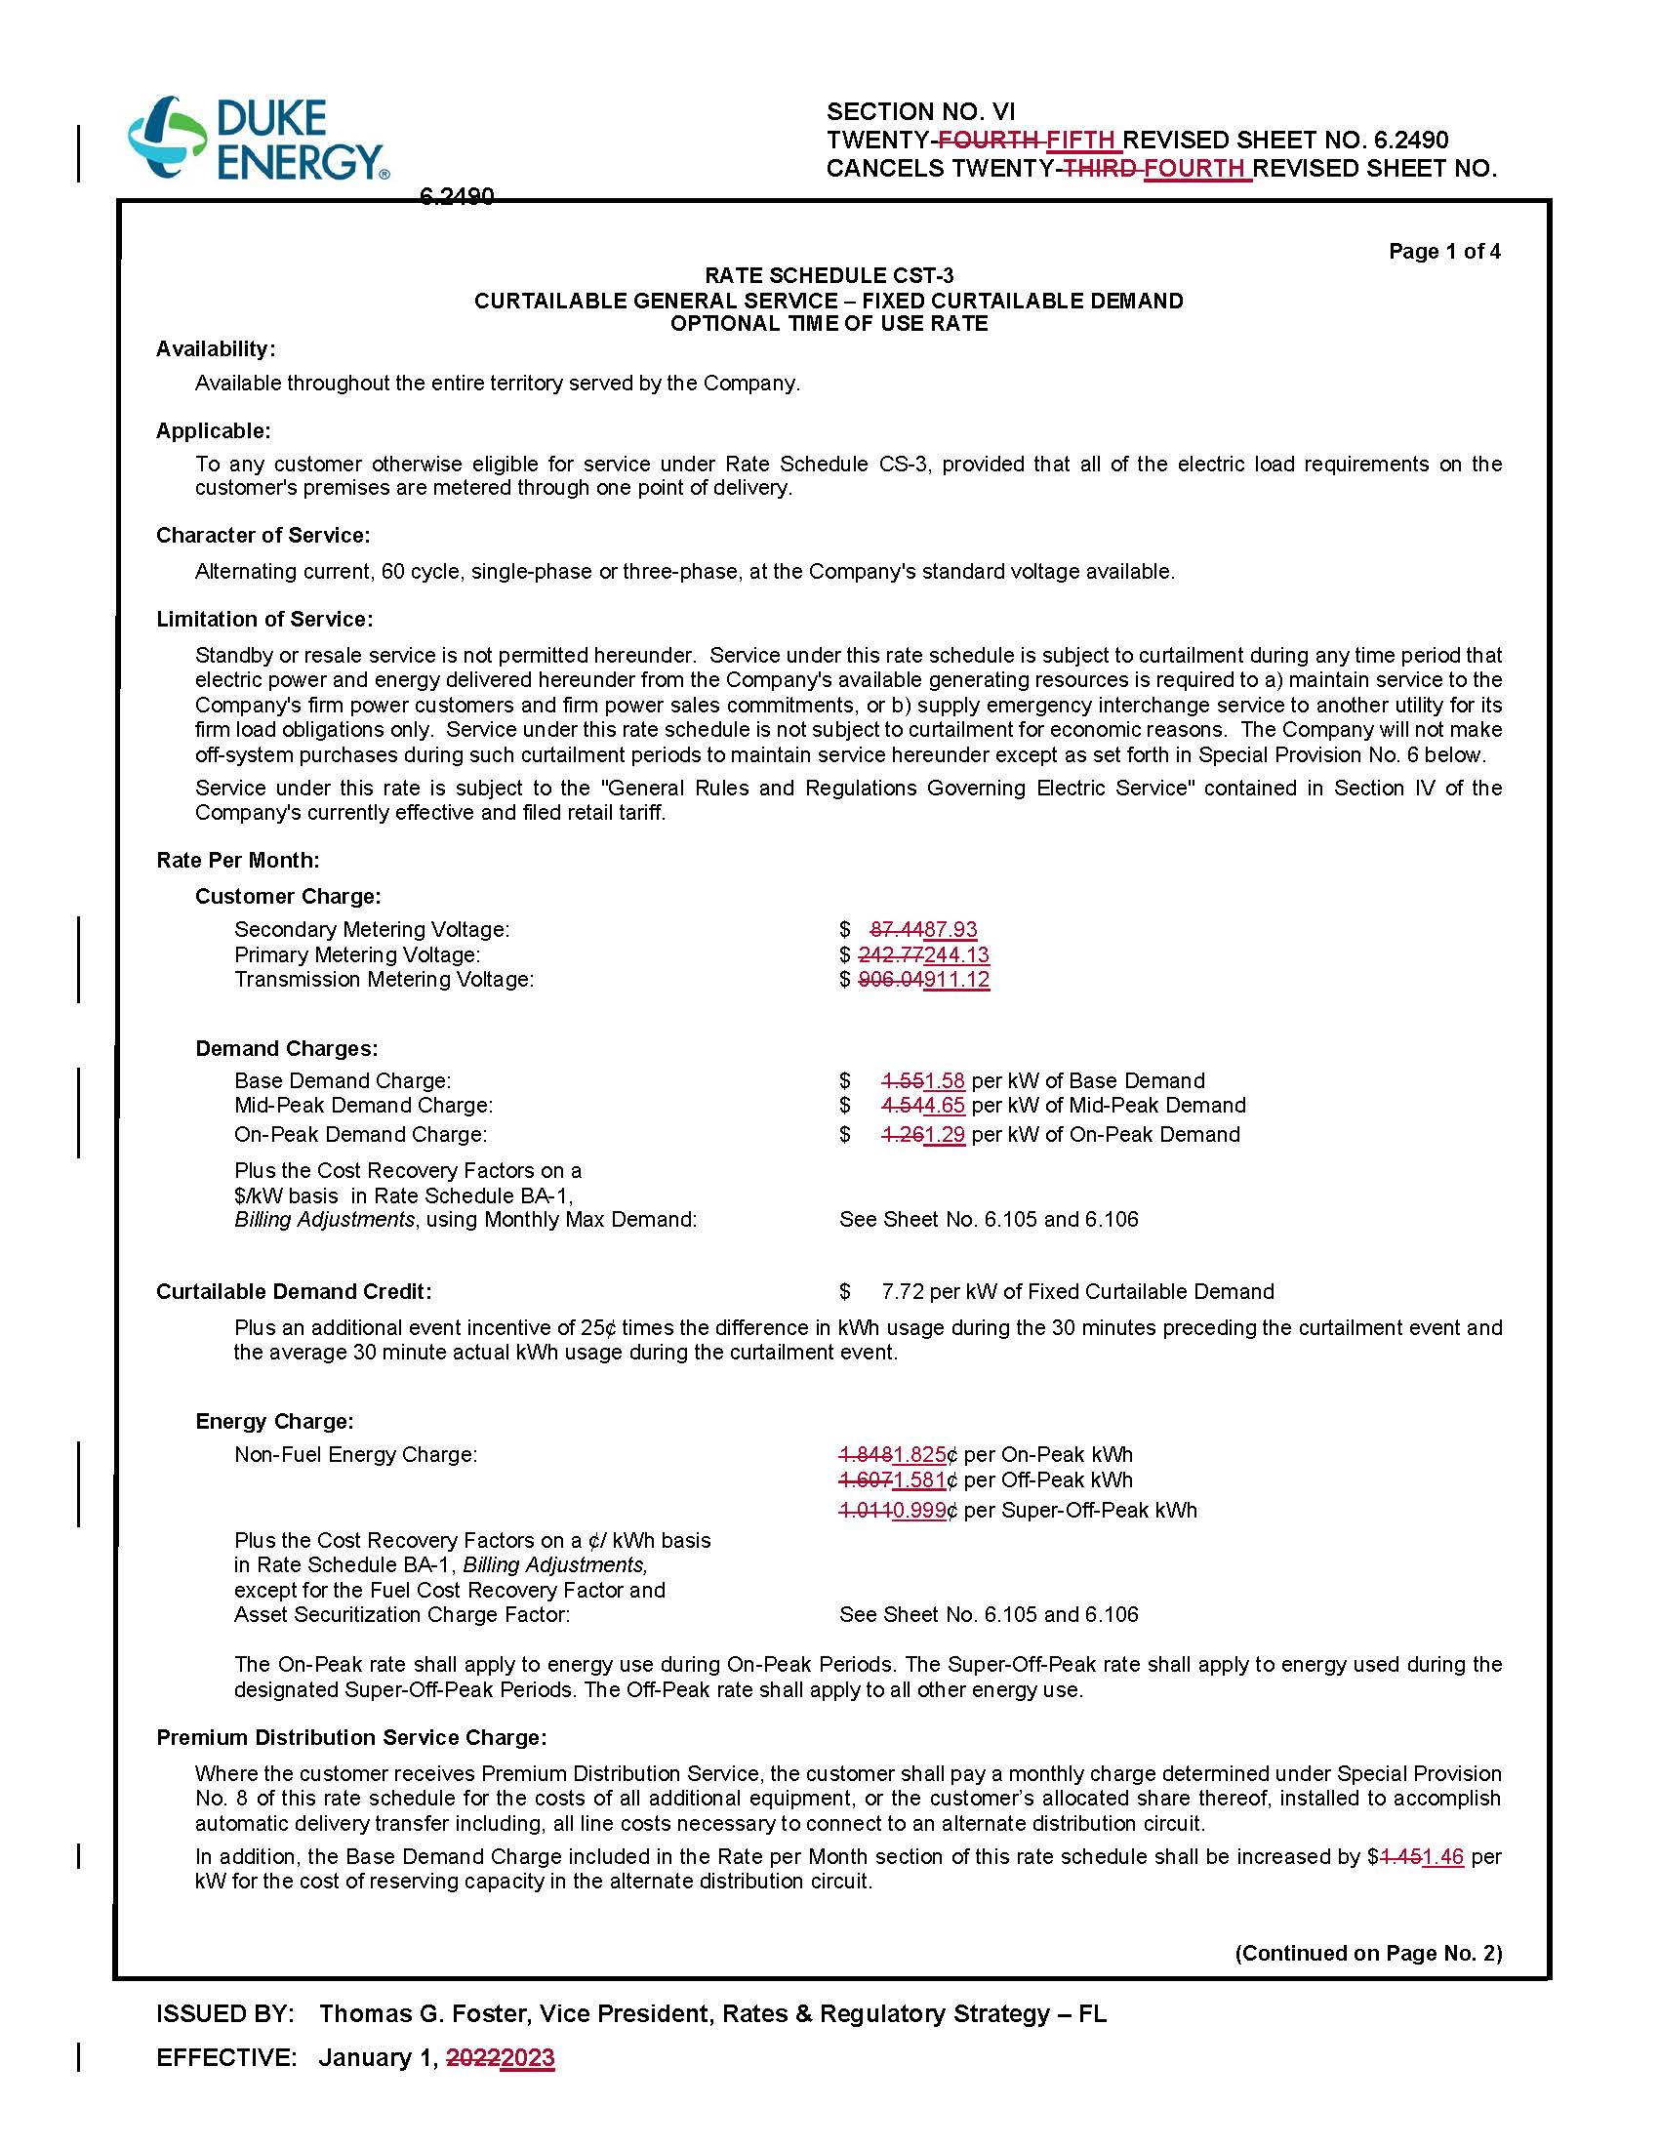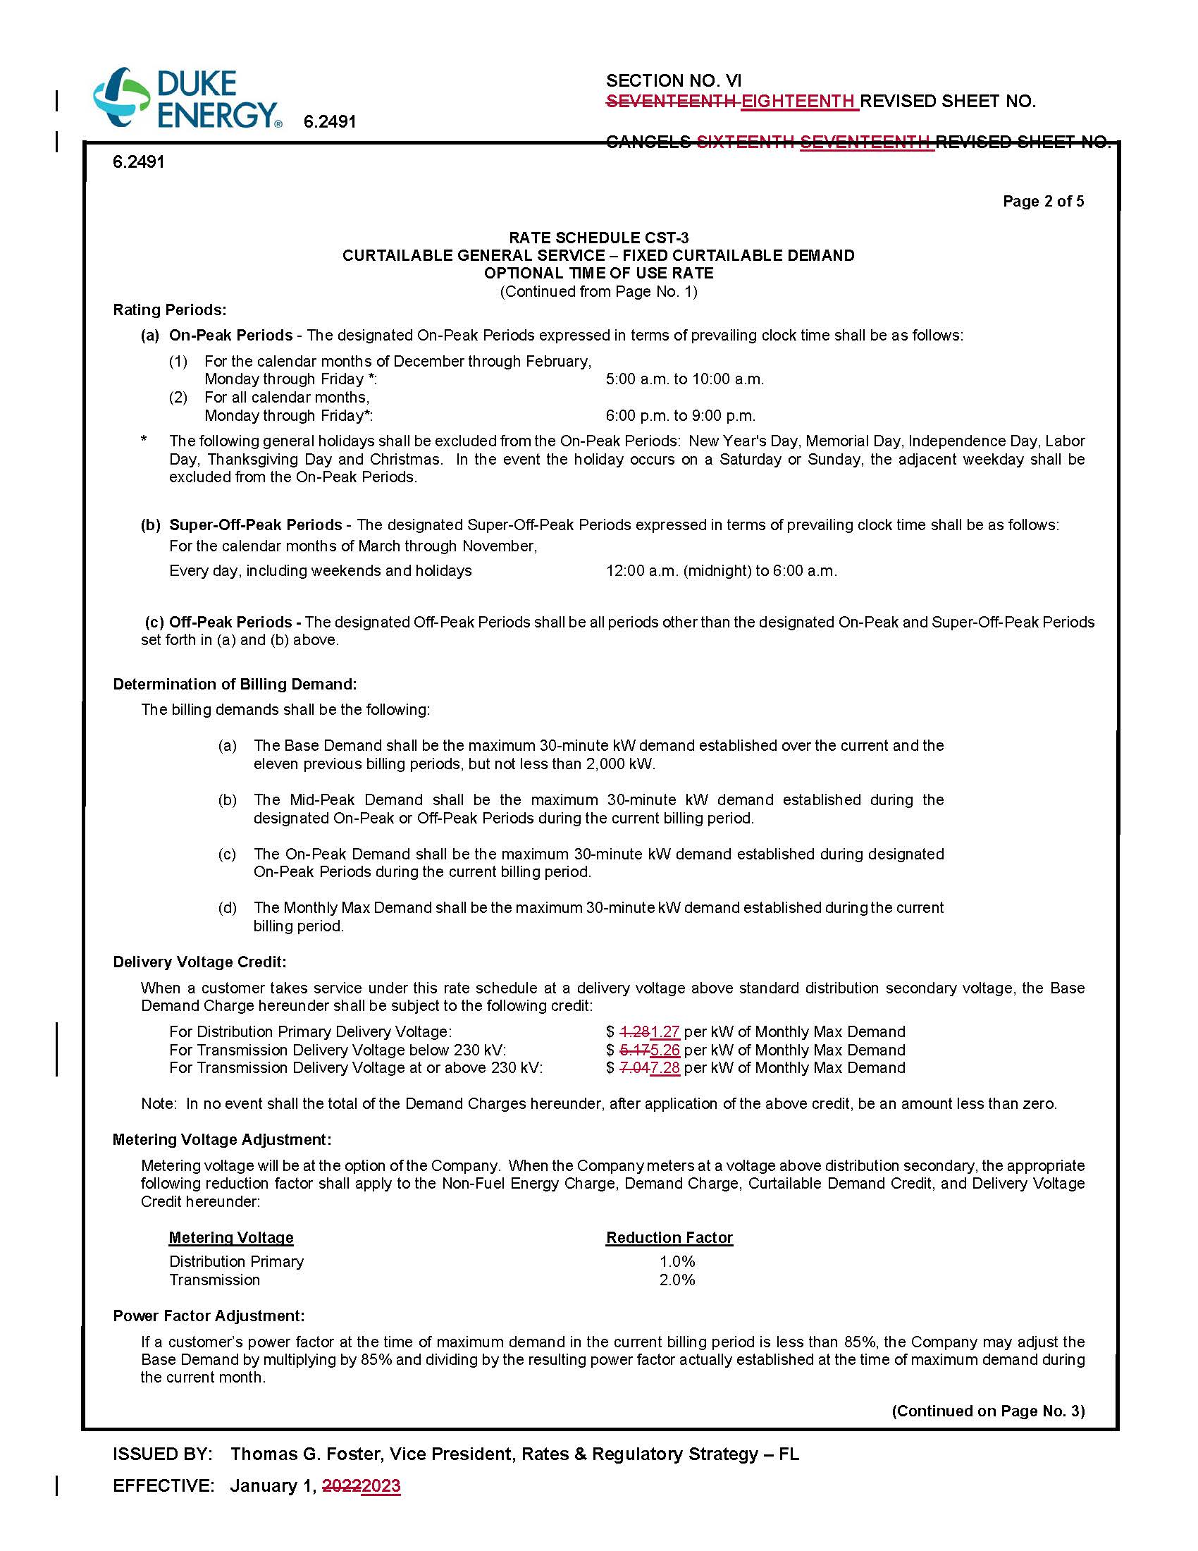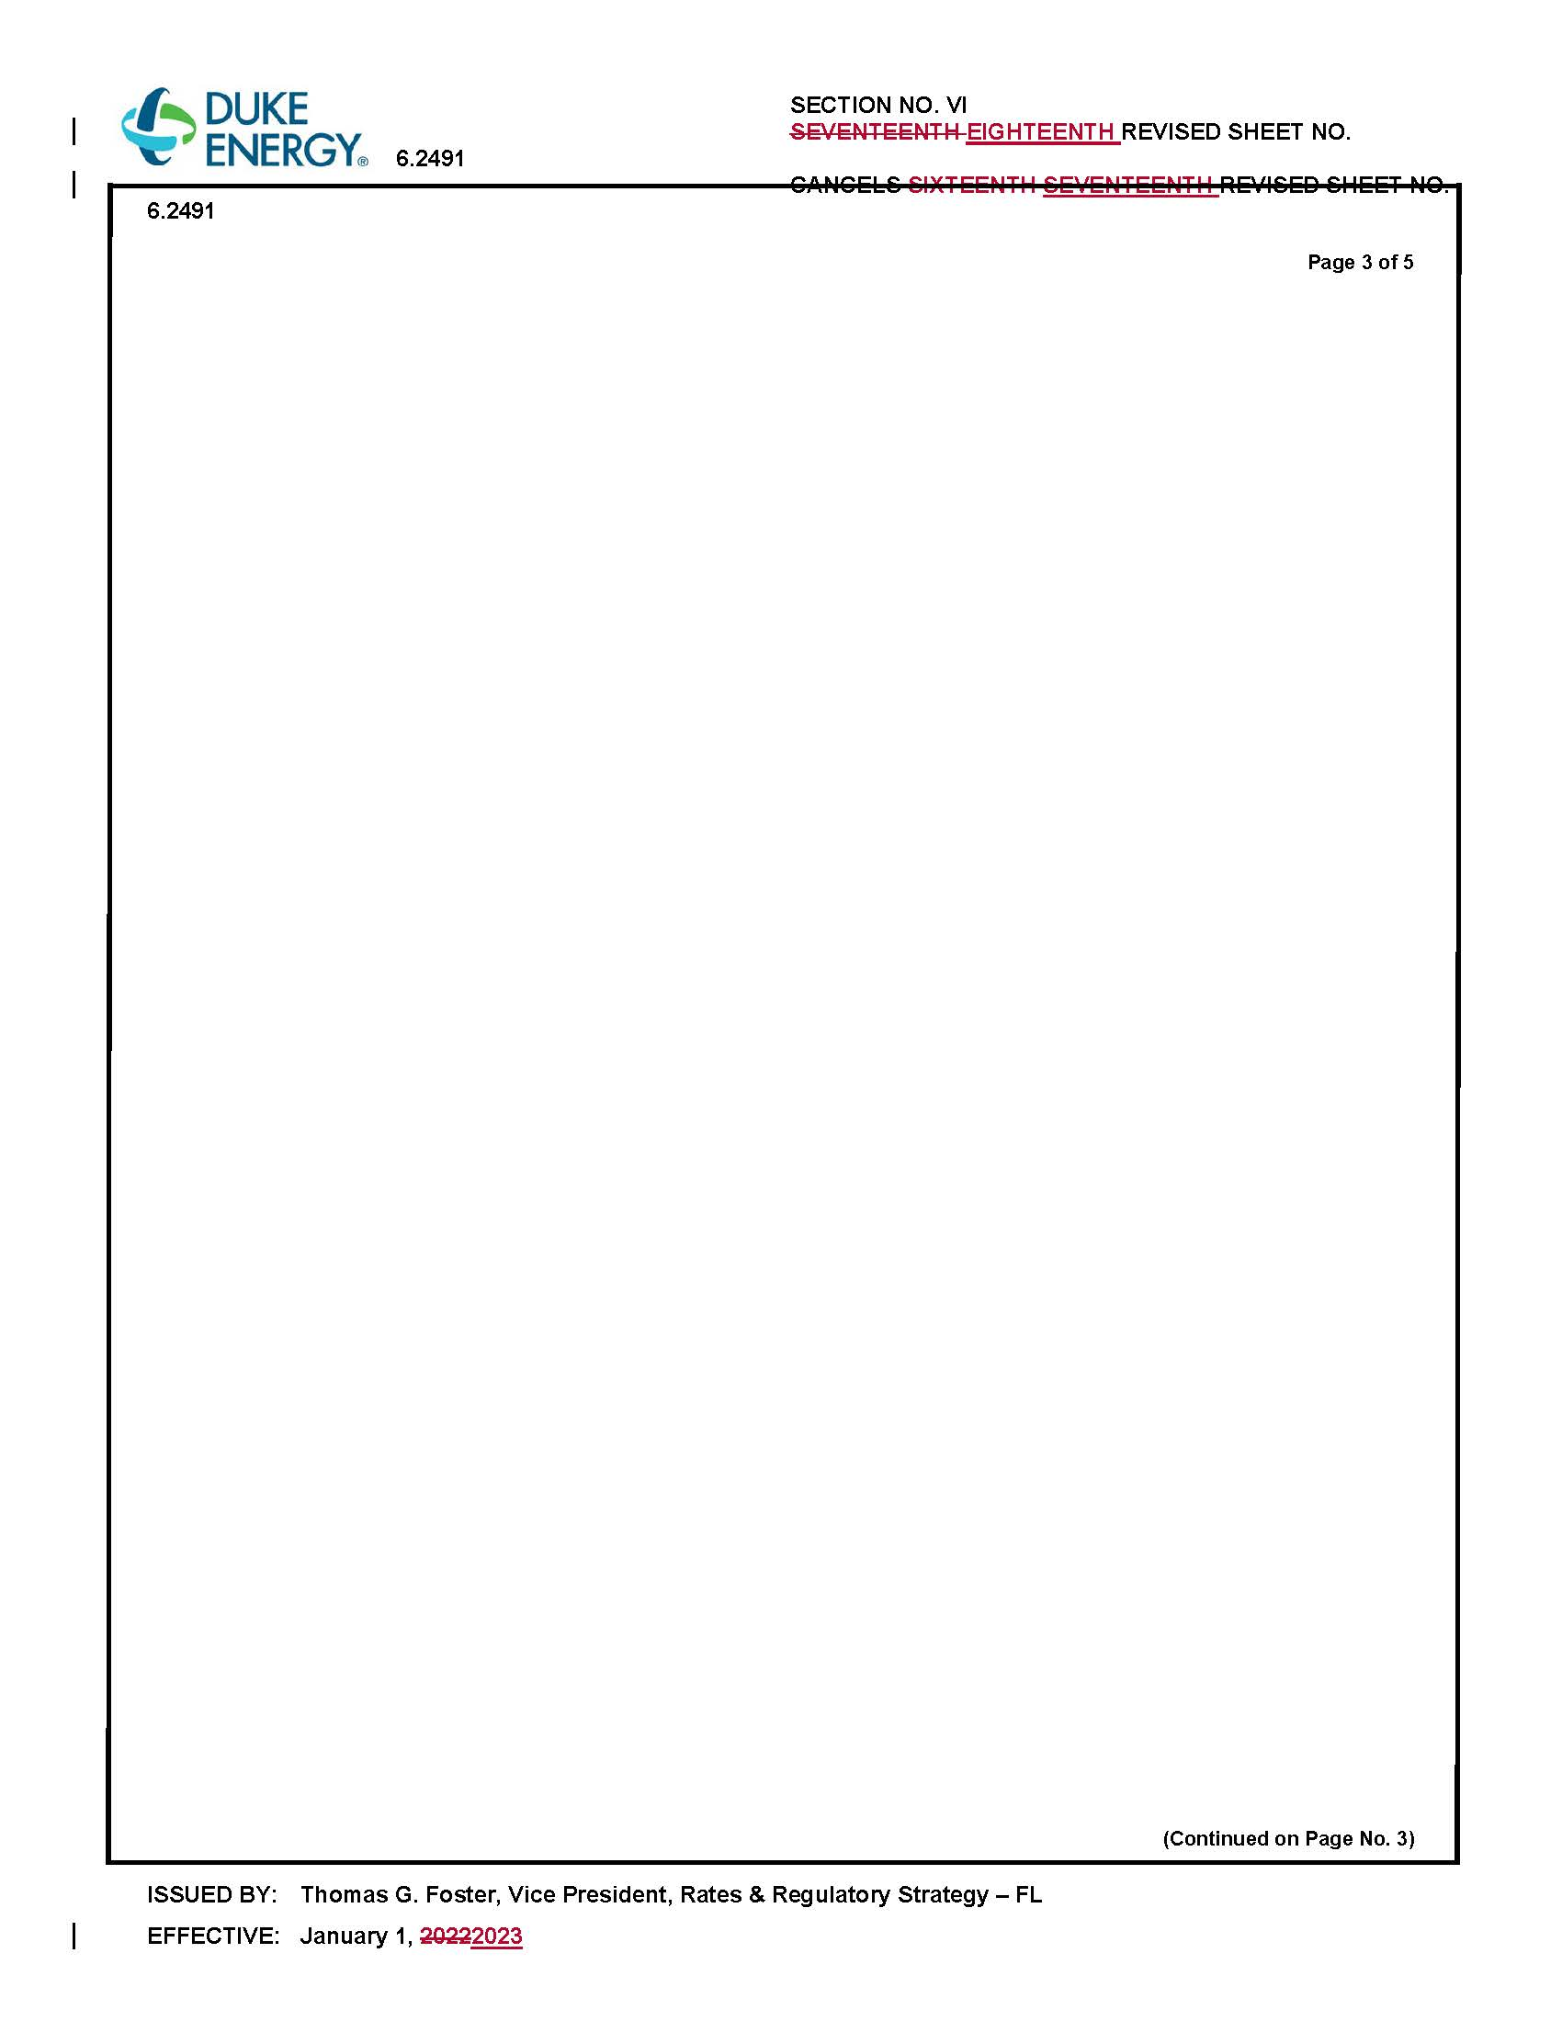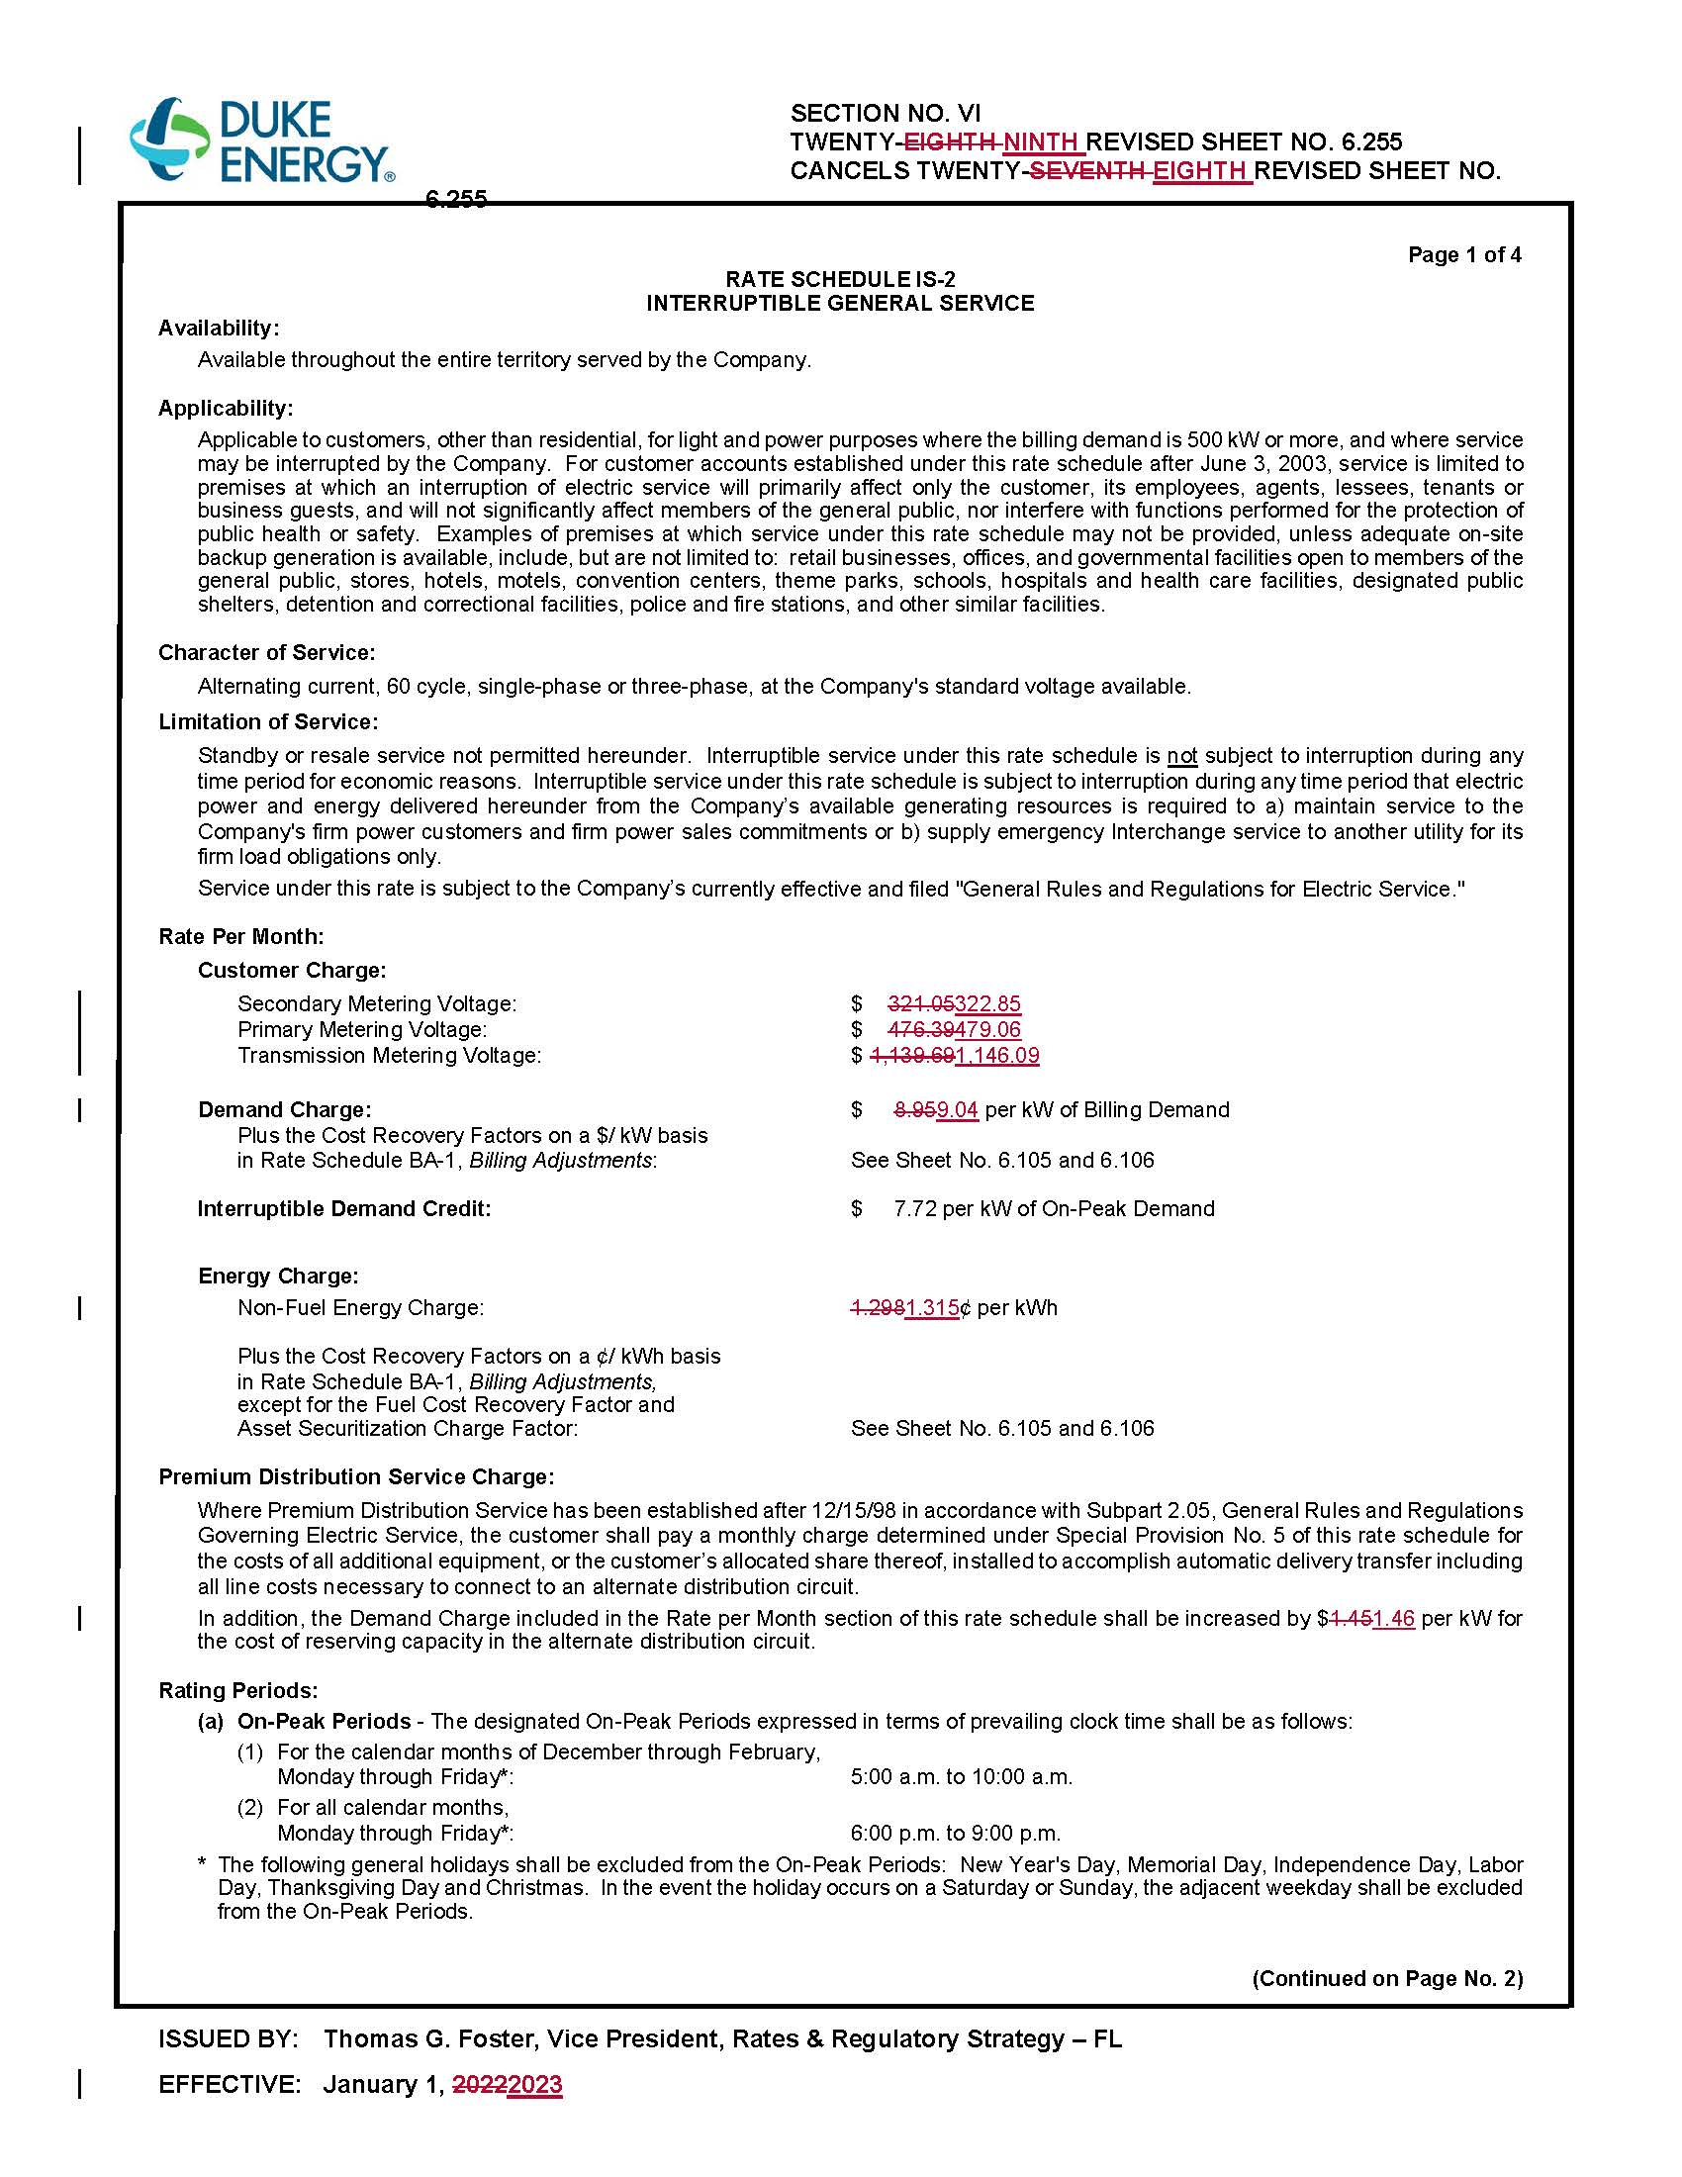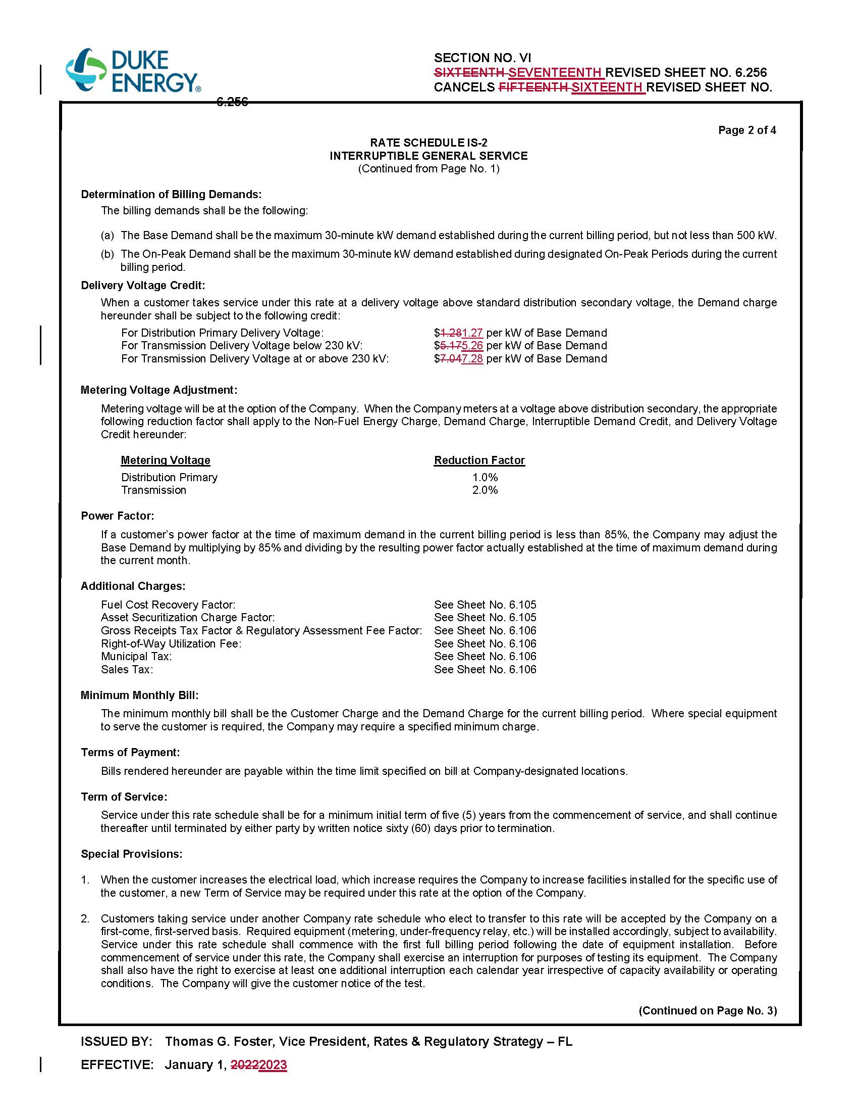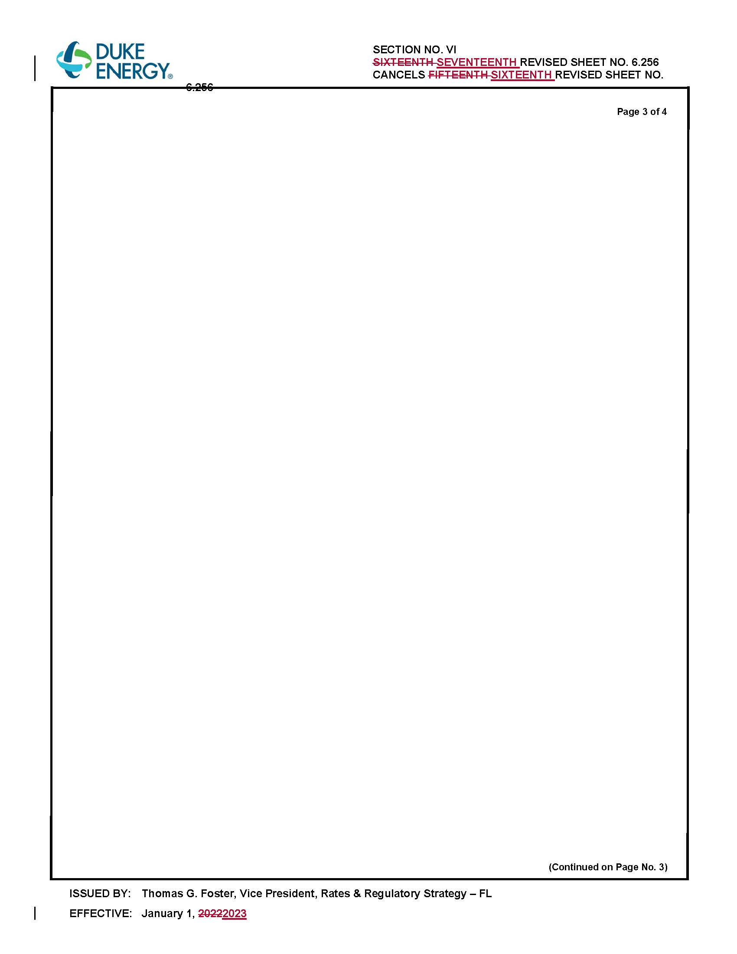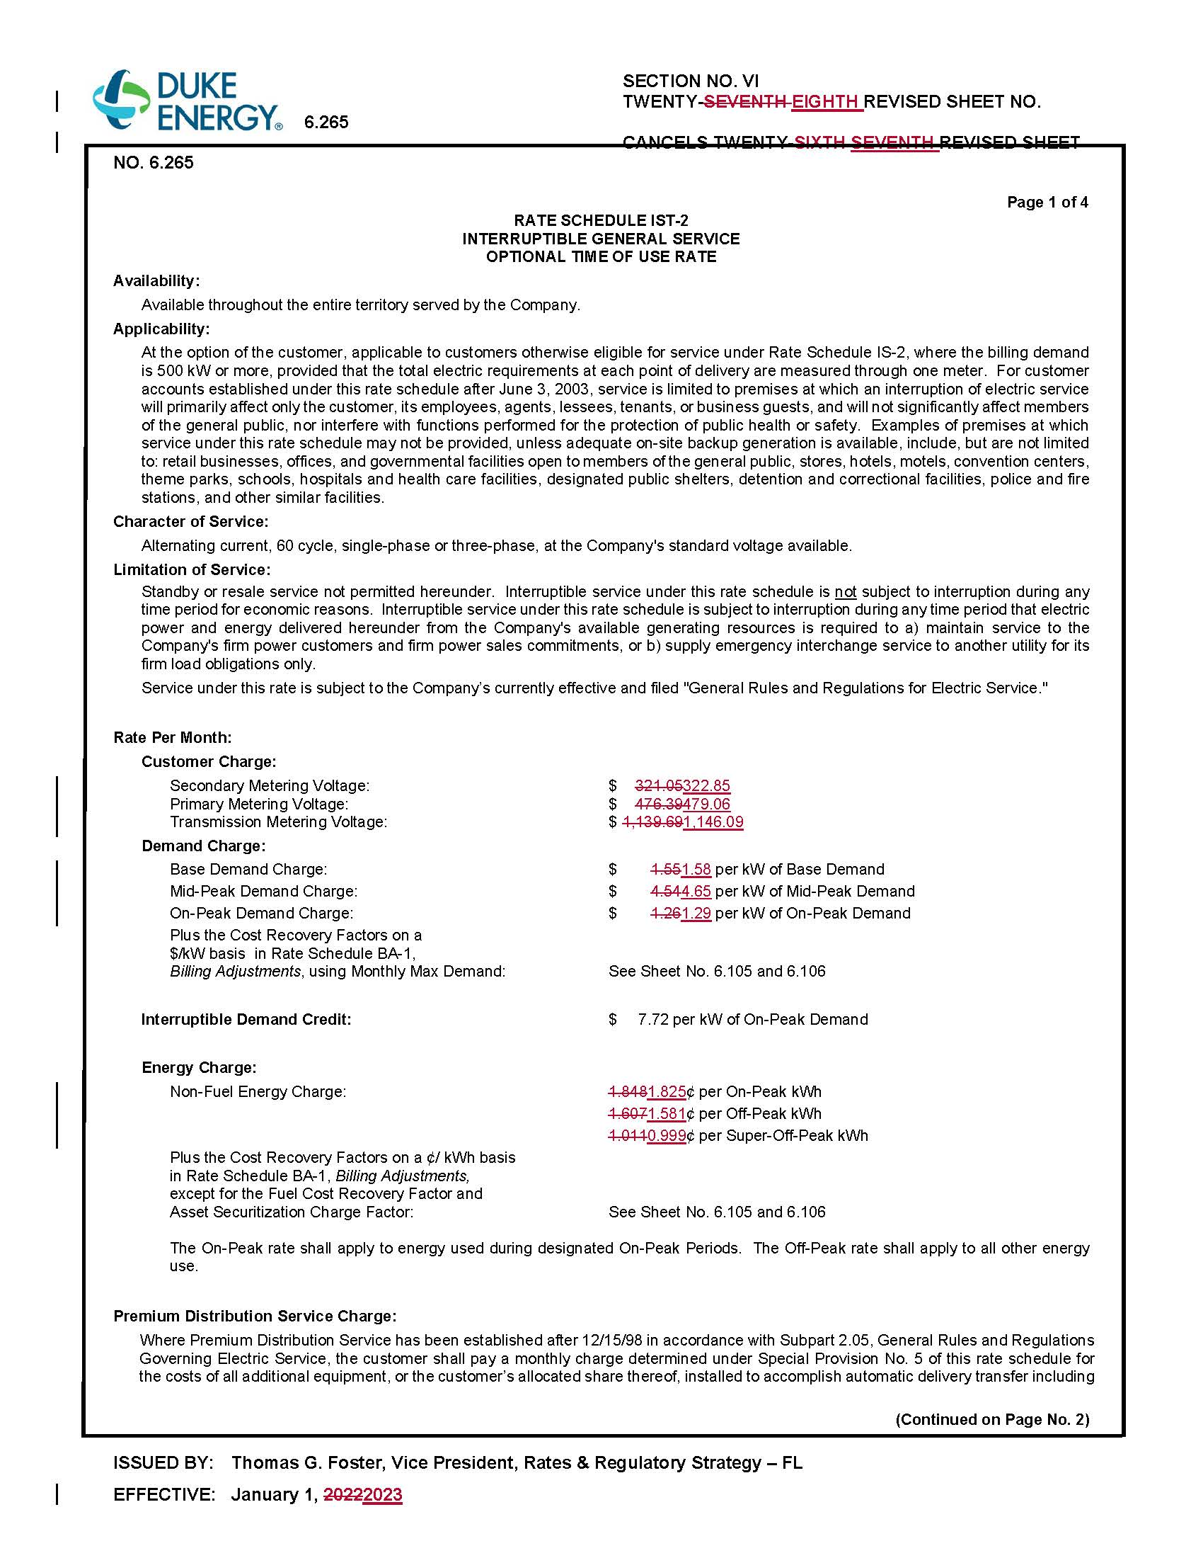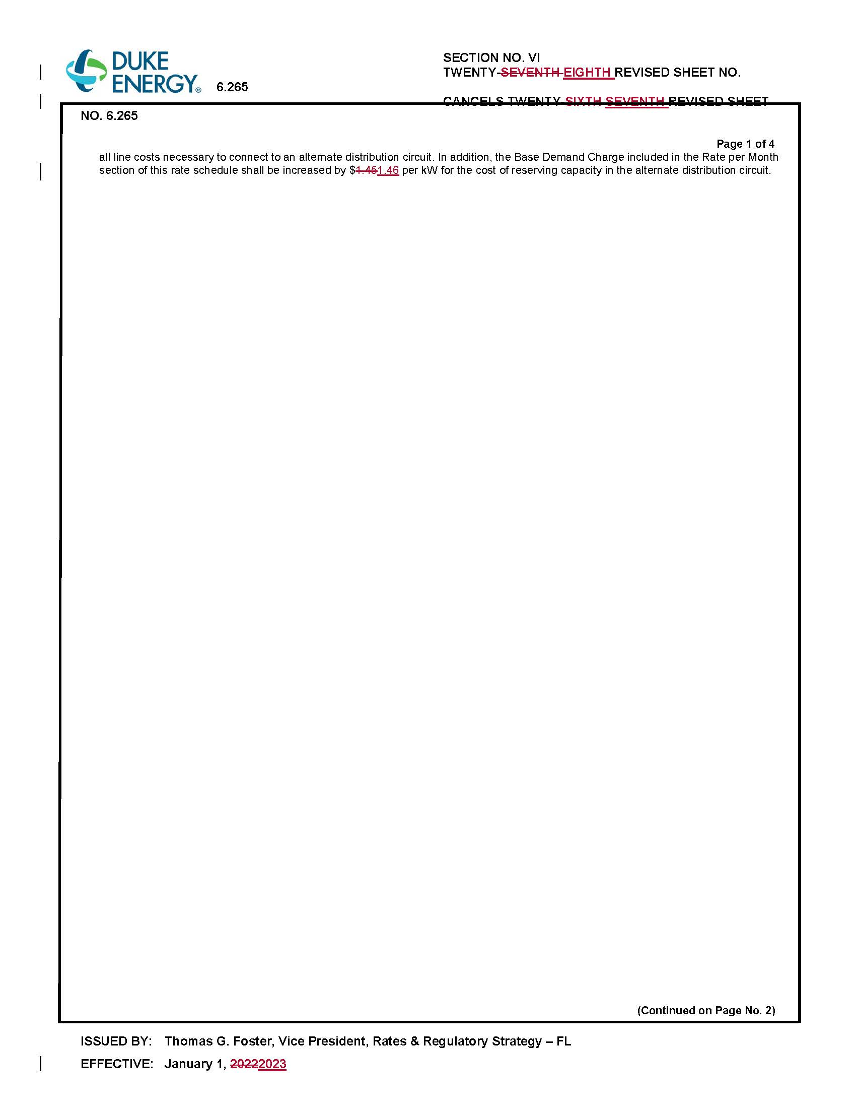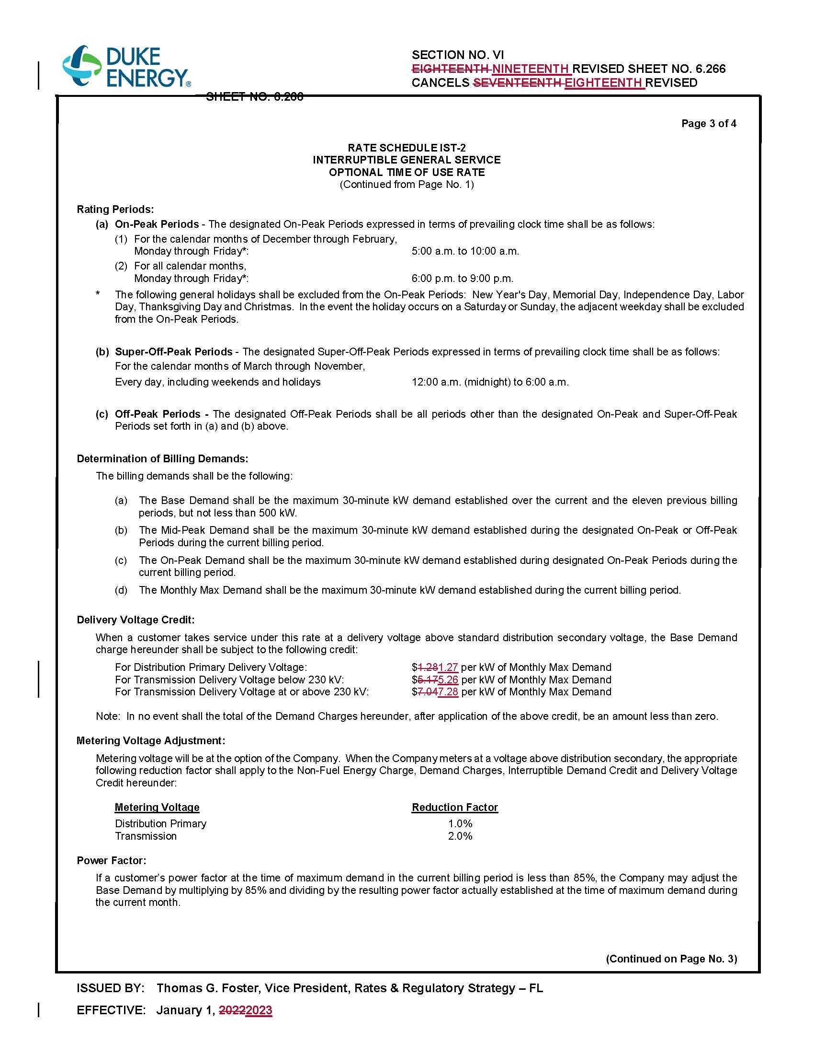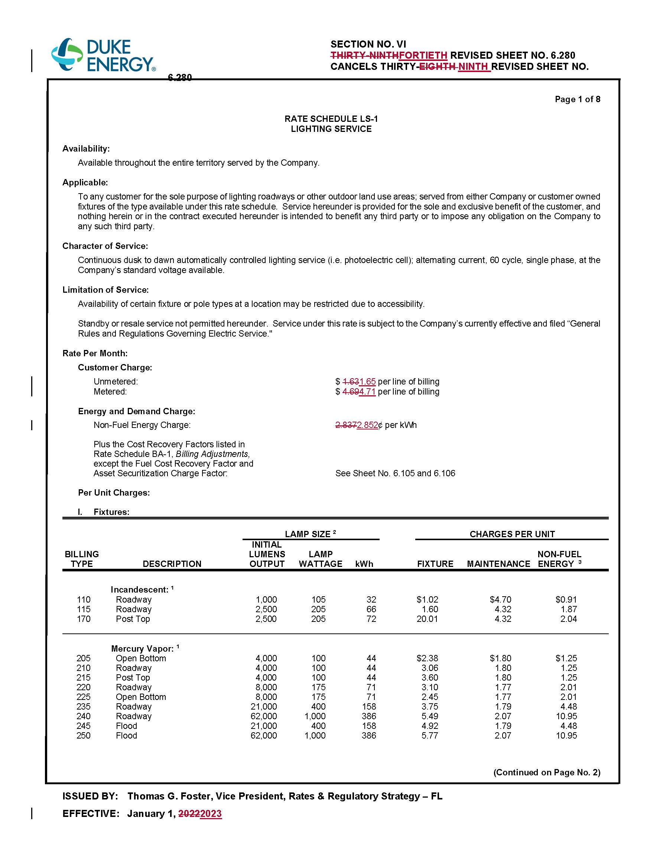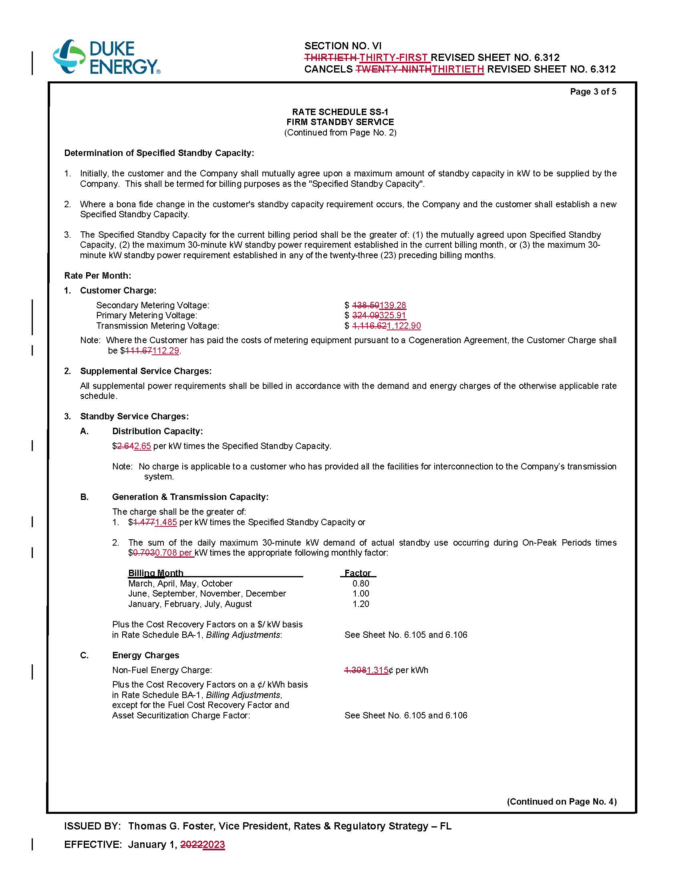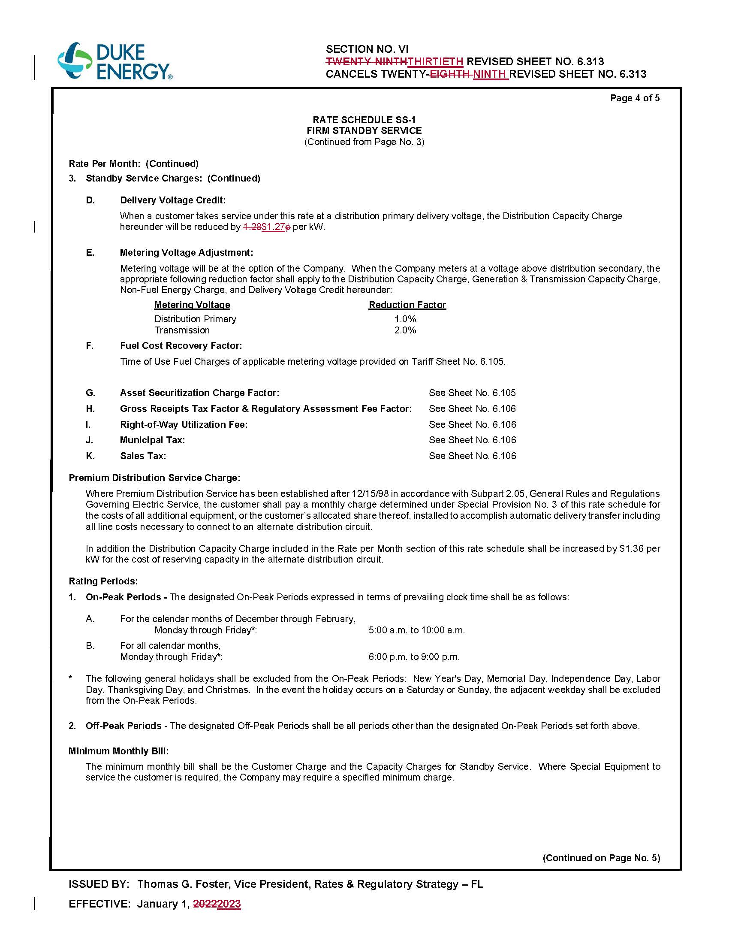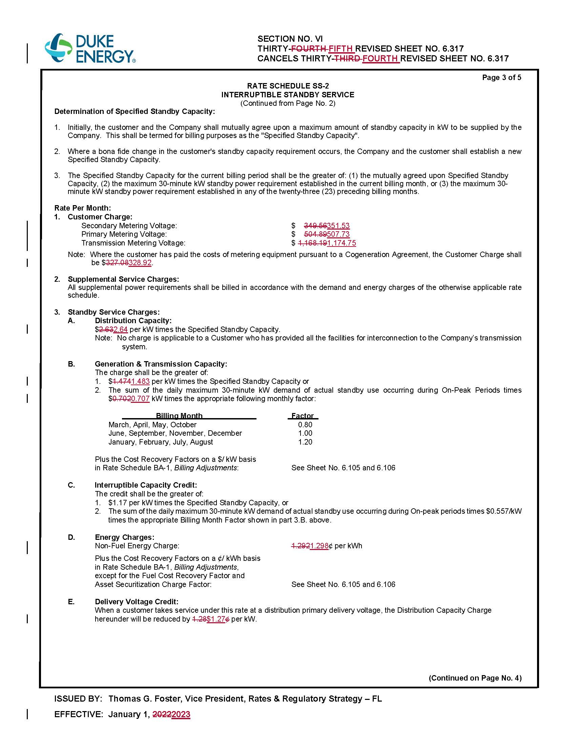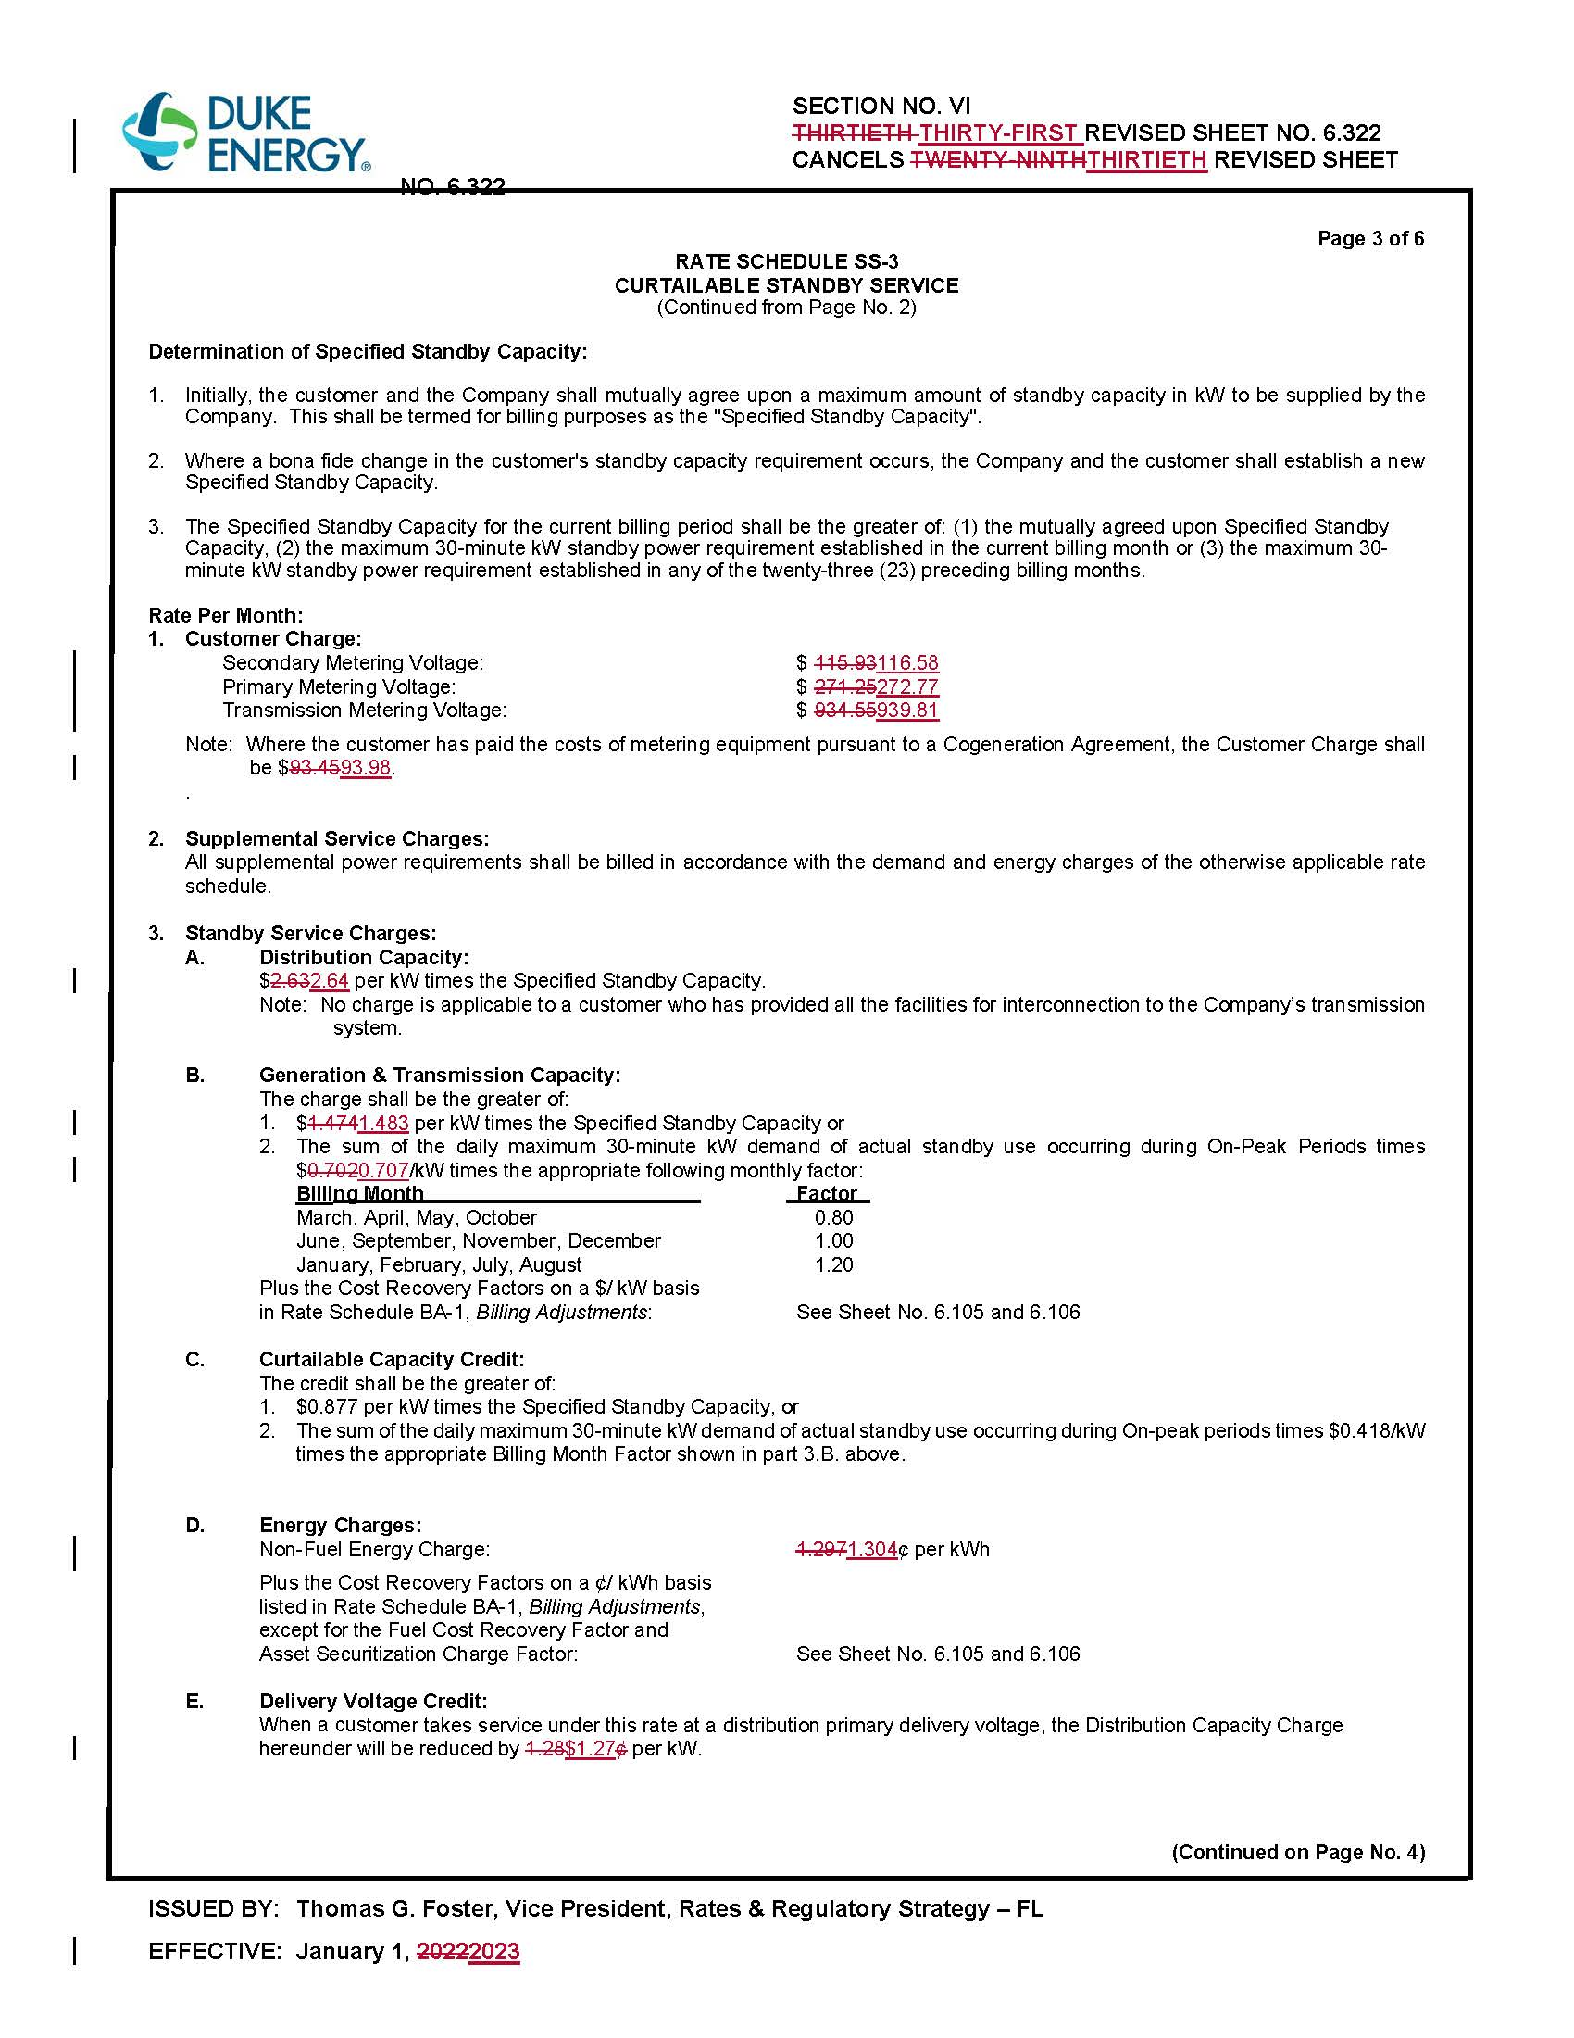

Order No. PSC-2021-0202A-AS-EI, issued June 28, 2021, in Docket No. 20210016-EI, In re: Petition for limited proceeding to approve 2021 settlement agreement, including general base rate increases, by Duke Energy Florida, LLC.
Id.
Order No. PSC-2021-0202A-AS-EI, issued June 28, 2021, in Docket No. 20210016-EI, In re: Petition for limited proceeding to approve 2021 settlement agreement, including general base rate increases, by Duke Energy Florida, LLC.
Order No. PSC-2017-0451-AS-EU, issued November 20, 2017, in Docket No. 20170183-EI, In re: Petition for limited proceeding to approve 2017 second revised and restated settlement agreement, including certain rate adjustments, by Duke Energy Florida, LLC.
See Document No. 09522-2022, filed on October 17, 2022, in Docket No. 20220000-OT.
Order No. PSC-2022-0357-FOF-EI, issued October 21, 2022, in Docket No. 20220143-EI, In re: Petition for limited proceeding to implement return on equity trigger provision of 2021 settlement agreement, by Duke Energy Florida, LLC.

