State of Florida |  | Public Service Commission  Capital Circle Office Center ● 2540 Shumard Oak Boulevard  Tallahassee, Florida 32399-0850  -M-E-M-O-R-A-N-D-U-M-
DATE: | November 22, 2022
TO: | Office of Commission Clerk (Teitzman)
FROM: | Division of Economics (Ward, Draper, Hampson)  Office of the General Counsel (Brownless)
RE: | Docket No. 20220106-EI – Petition for approval of new my energy bill+ program with income qualified component, by Duke Energy Florida, LLC.
AGENDA: | 12/06/22 – Regular Agenda – Tariff Filing – Interested Persons May Participate
COMMISSIONERS ASSIGNED: |  |  | All Commissioners
PREHEARING OFFICER: |  |  | Administrative
CRITICAL DATES: |  |  | 02/03/23 (8-Month Effective Date)
SPECIAL INSTRUCTIONS: |  |  | None

Case Background
On June 3, 2022, Duke Energy Florida, LLC (Duke or utility) filed a petition requesting approval of a new flat bill tariff titled My Energy Bill+ program. The My Energy Bill+ program was originally conceptualized in a Memorandum of Understanding between Duke, Vote Solar, the CLEO Institute, and the Southern Alliance for Clean Energy, which was filed in Docket No. 20210016-EI. In this memorandum, Duke stated its intention to seek Commission approval of a flat bill offering that would leverage controllable customer devices and target low-income customers. This program would be an optional program that is similar in structure to Duke’s currently-approved Your FixedBill tariff and would include an income qualified component.
Duke’s current Your FixedBill (FB-1) tariff is a flat bill program that allows participating customers to receive a fixed monthly bill for 12 months, which is calculated using the prior 12 months of actual usage data, applying weather normalization, plus an additional risk and usage adder. The FB-1 tariff was first approved in 2017 by Commission Order No. PSC-2017-0451-AS-EU and became effective on March 1, 2018. The Order approving the FB-1 tariff states that the difference between the calculated amount customers would have otherwise paid under residential rates and what customers are actually billed under the FixedBill program will be treated as a below-the-line revenue or expense, along with any costs to implement and maintain the program. This regulatory treatment is designed to hold non-participants harmless and not subsidize or be subsidized by the FB-1 tariff participants.
In Order No. PSC-2021-0082-TRF-EI, the Commission approved modifications to Duke’s FB-1 tariff. These modifications included the implementation of a pilot program which allows the utility to control the heating, ventilation, and air conditioning (HVAC) thermostats of participating customers taking service under the FB-1 tariff in exchange for a one-time $50 prepaid gift card. The customer enrollment period for the pilot program ended in September 2022. Currently, approximately 53,000 customers are enrolled in the FixedBill Program, with approximately 2,000 of said customers participating in the pilot program.
This is staff’s recommendation on Duke’s proposed new My Energy Bill+ program. The proposed tariffs are shown in Attachment A to the recommendation. In Order No. PSC-2022-0304-PCO-EI, the Commission suspended the proposed tariff pursuant to Section 366.06(3), Florida Statutes (F.S.). Staff issued two data requests in this docket on July 8, 2022, and August 24, 2022, with responses received on July 21, 2022, and September 6, 2022, respectively. The Commission has jurisdiction over this matter pursuant to Sections 366.04, 366.05, and 366.06, F.S.

Discussion of Issues

Issue 1:
Should the Commission approve Duke’s proposed My Energy Bill+ program and the associated tariffs?

Recommendation:
Yes, the Commission should approve Duke’s proposed My Energy Bill+ program and the associated tariff sheet Nos. 6.415-6.417 effective on the date of the Commission vote. The proposed program will allow Duke to achieve peak demand reductions. Participating customers will benefit by receiving a fixed bill with a reduced risk adder and the general body of ratepayers will benefit by any demand reductions realized. Furthermore, the program’s regulatory treatment is designed to hold the general body of ratepayers harmless. (Ward, Hampson)

Staff Analysis:

Proposed My Energy Bill+ Program
Duke is proposing to establish a new, voluntary fixed bill program that would allow the utility to have limited control of participating customers’ thermostats. Under the My Energy Bill+ program, the utility would be allowed to control customers’ thermostats by adjusting the temperature within a specified range during specified demand response events. In exchange, participating customers would pay a fixed monthly bill for a full year with no true-up costs regardless of usage, with a lower risk adder (4 percent) compared to Duke’s currently-approved FB-1 tariff that includes a 6 percent risk adder. Currently, Duke estimates approximately 2,700 customers would enroll in the My Energy Bill+ program within the first year, with no cap for enrollment.
In response to staff’s first data request, Duke explained that the frequency, duration, thermostat adjustment, and notification associated with demand response events would be the same as the current pilot program. In Exhibit C to its petition, Duke stated that there will be an average of four demand response events each month in the summer season (June-September) and an average of three events each month in the winter season (October-May). Duke also explained that these events shall have a duration of 1-3 hours and thermostat temperature adjustments shall be between 1-4 degrees Fahrenheit. Duke stated that customers will receive at least one notice when an event is beginning using customer information provided during enrollment. Duke stated in its petition that the current pilot program has run peak usage management events at the monthly system peak time in seven out of nine months.
Customers may override an event by making changes to their thermostat at any time during an ongoing event. However, proposed tariff sheet No. 6.417 states that customers may be removed from the proposed program due to excessive demand response event opt outs. Furthermore, the utility would notify customers in advance if they are at risk of being removed from the program due to excessive opt outs. Participating customers may also be removed from the proposed program if their actual energy usage increases above expected usage by 30 percent for at least three months. Again, Duke would notify customers in advance if they are at risk from being removed from the program due to excessive energy usage.

Income Qualified Program Component
Pursuant to the Memorandum of Understanding, Duke is proposing to offer 1,000 income qualified customers who participate in the proposed program a free smart thermostat. Duke stated that beyond the first 1,000 income qualified customers, the thermostats will be heavily discounted, through collaboration with thermostat partners, although the final cost to income qualified customers has not yet been determined. For the purpose of the proposed program, Duke defines customers as income qualified if they earn less than 200 percent of the Federal Poverty Guidelines. Duke explained that eligibility for income qualified customers would be determined by customers presenting documentation which shows participation in certain government programs. In its petition, Duke explained that it conducted a survey of customers and the utility found that there was interest among income qualified customers in a fixed bill program and in receiving a smart thermostat. Duke stated that the costs for income qualified thermostats will be accounted for as below-the-line.
In response to staff’s first data request, Duke stated that no ratepayer money will be used to fund the free smart thermostats. Instead, the thermostats would be partially funded through Duke’s Share the Light fund, as well as thermostat donations from partners. Customers and employees can contribute to the Share the Light fund and Duke works with agencies to distribute these funds to qualifying customers in order to pay their energy bills.

Program Eligibility
To be eligible to enroll in the My Energy Bill+ program, the proposed tariff requires customers to take service under the standard residential rate schedule, to have lived in their current residence for the past 12 months, to have a load profile that can be modeled with reasonable predictability, to be current on their bill payments, and to have an eligible thermostat that is active, installed, and connected to Wi-Fi. In response to staff’s second data request, Duke stated that eligible thermostats are defined by the utility as those with a make and model that is on the list of thermostats that the Demand Response Management System can communicate with.
Furthermore, to be eligible for the proposed program, within the last 12 months customers may not have defaulted on a payment arrangement, entered into a multi-month payment arrangement, had a payment that was not honored by a financial institution, or been disconnected for non-payment of electric service. However, the proposed tariffs allow Duke to waive some or all of these four requirements for income qualified customers.
Customers who enroll in the My Energy Bill+ program would need to enter into a Service Agreement with Duke for a term of 12 months. Prior to end of the 12-month term, Duke would calculate a new fixed monthly bill amount for the following year and would notify the customer of the new monthly bill amount. The customer would be automatically renewed at the new monthly bill amount for the following year unless the customer notifies Duke of their intent to be removed from the program.

Fixed Monthly Bill Calculation
Eligible customers who enroll in the proposed program would have their fixed monthly bill calculated starting with 12 months of actual energy usage data, applying weather normalization and any applicable usage and risk adders. Fixed monthly bills for the proposed program would be calculated using the same method as Duke’s currently-approved FB-1 tariff.
Specifically, proposed tariff sheet No. 6.415 provides the formula Duke would use to calculate a customer’s fixed monthly bill for the year. Duke would begin by multiplying a customer’s predicted weather normalized monthly kilowatt hour (kWh) usage by the expected non-fuel energy charge (including expected cost recovery factors, expected fuel cost recovery factor, and expected asset securitization charge). Duke would then multiply this amount by the risk adder, deduct any expected applicable credits, and add the expected monthly customer charge. Applicable taxes and other charges, such as service charges, lighting, and non-regulated services are not included in the fixed monthly bill calculation, but will be applied and included in the total amount due.
Duke stated in its proposed tariffs that the risk adder is used to compensate the utility for the risk associated with weather-related consumption and non-weather-related impacts. The initial risk adder would be applied annually and would be capped at 4 percent. Furthermore, the risk adder may be lowered based on a participating customer’s individual load profile and behavioral responses. Duke’s currently-approved FB-1 tariff uses a risk adder that is capped at 6 percent. In response to staff’s second data request, Duke stated that it considered various factors in the decision to reduce the risk adder offered in the proposed program. Duke also explained that the proposed 4 percent risk adder was the best balance in garnering customer interest in participation and the risk borne by the utility to effectively control customer demand.
Similar to the current FB-1 tariff, during a customer’s first year participating in the proposed program, an additional usage adder would be applied to the customer’s predicted weather normalized (based on the utility’s historical seasonal heating and cooling degree days) monthly kWh usage. Duke stated in its proposed tariffs that the usage adder would be used to compensate the utility for the risk associated with increased usage by the customer in their first year of participating in the proposed program not associated with the weather. The usage adder would be capped at 6 percent.
As with the current FB-1 tariff, the difference between the amount the customer would have paid under the residential rates and the fixed bill amount will be treated as a below-the-line revenue or expense. This regulatory treatment is designed to hold non-participants harmless and not subsidize or be subsidized by the participants in the proposed program. In addition, as with the current FB-1 tariff, administrative and operating costs such as enrollment processing costs and marketing costs, will be accounted for as below-the-line to hold the general body of ratepayers harmless from the optional program.

Conclusion
Having reviewed the petition and staff data request responses, staff recommends that the Commission should approve Duke’s proposed optional My Energy Bill+ program and associated tariff sheet Nos. 6.415-6.417 effective on the date of the Commission vote. The proposed program will allow Duke to achieve peak demand reductions. Participating customers will benefit by receiving a fixed bill with a reduced risk adder and the general body of ratepayers will benefit by any demand reductions realized. Furthermore, the program’s regulatory treatment is designed to hold the general body of ratepayers harmless.

Issue 2:
Should this docket be closed?

Recommendation:
Yes. If Issue 1 is approved and a protest is filed within 21 days of the issuance of the order, the tariff should remain in effect pending resolution of the protest. If no timely protest is filed, this docket should be closed upon the issuance of a consummating order. (Brownless)

Staff Analysis:
If Issue 1 is approved and a protest is filed within 21 days of the issuance of the order, the tariff should remain in effect pending resolution of the protest. If no timely protest is filed, this docket should be closed upon the issuance of a consummating order.
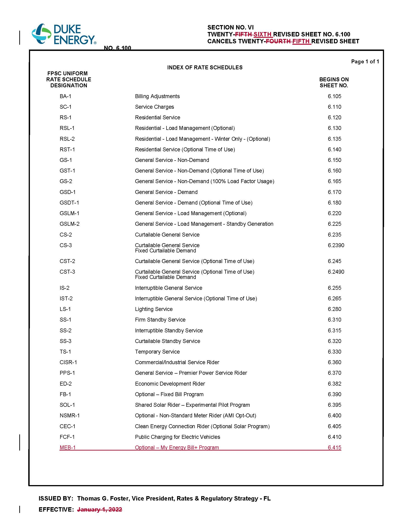
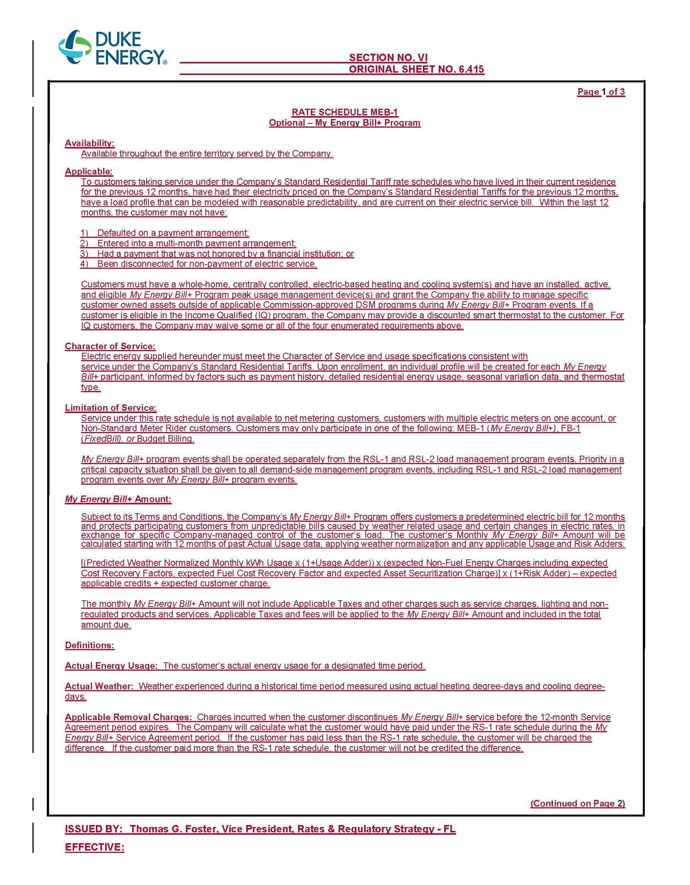
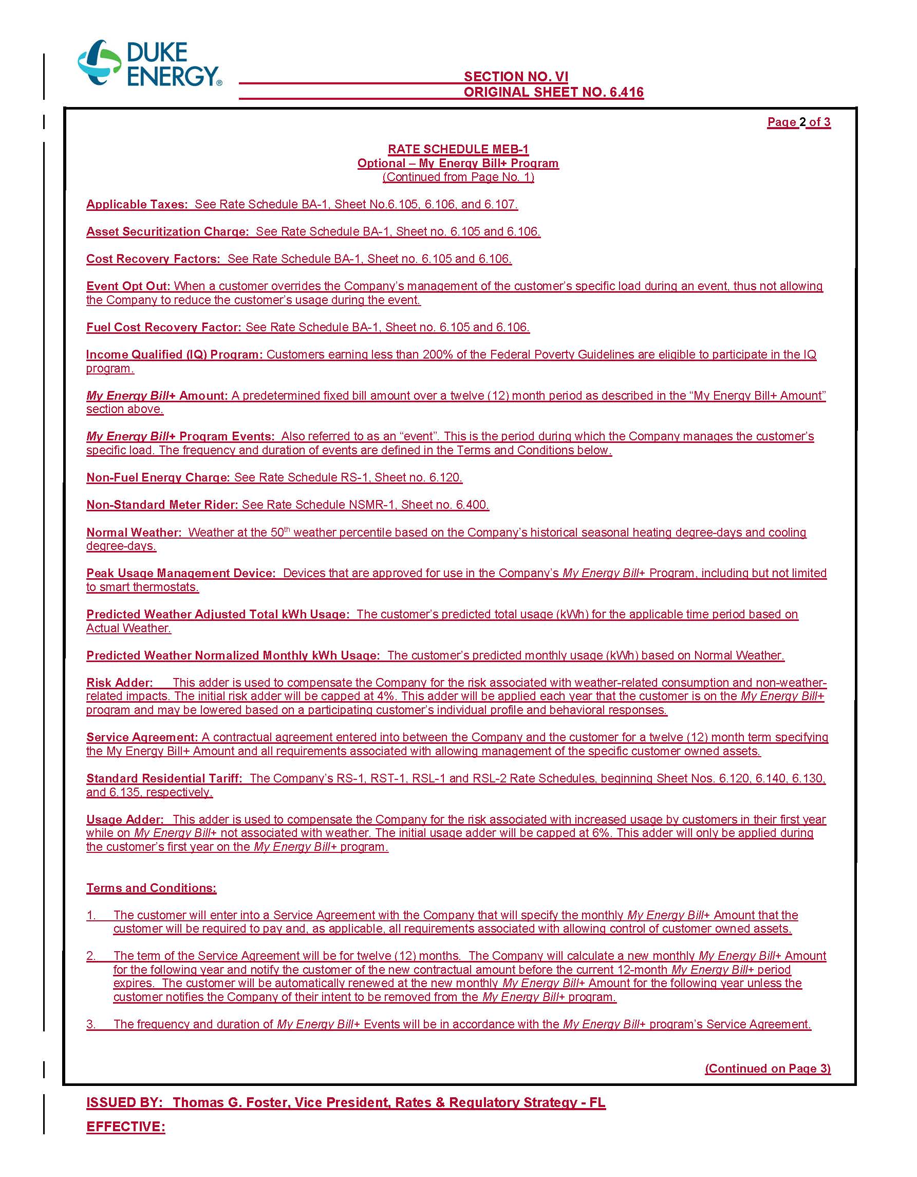
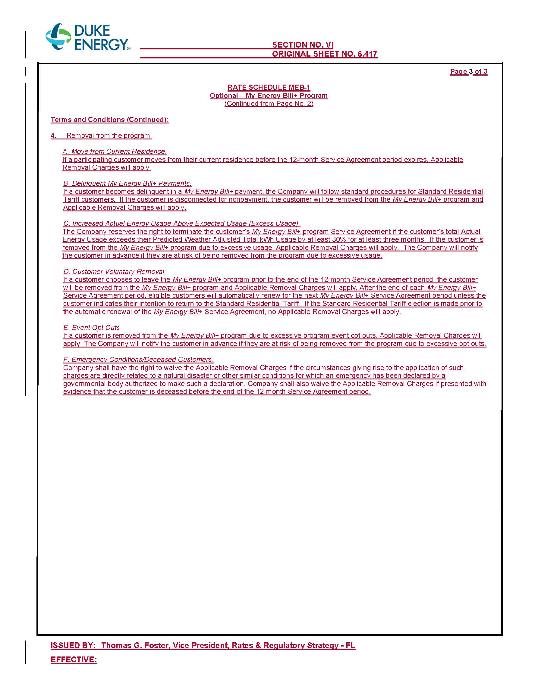

Document No. 03685-2021, in Docket No. 20210016-EI, In re: Duke Energy Florida, LLC’s Petition for Limited Proceeding to Approve 2021 Settlement Agreement, Including General Base Rate Increases.
Order No. PSC-2017-0451-AS-EU, issued November 20, 2017, in Docket No. 20170183-EI, In re: Application for limited proceeding to approve 2017 second revised and restated settlement agreement, including certain rate adjustments, by Duke Energy Florida, LLC.
See Page 50 of Order No. PSC-2017-0451-AS-EU.
Order No. PSC-2021-0082-TRF-EI, issued February 17, 2021, in Docket No. 20200222-EI, In re: Petition for approval of modifications to rate schedule FB-1, FixedBill program by Duke Energy Florida, LLC.
Order No. PSC-2022-0304-PCO-EI, issued August 17, 2022, in Docket No. 20220106-EI, In re: Petition for Approval of Duke Energy, LLC’s New My Energy Bill+ Program with Income Qualified Component.
Responses to Staff’s First Data Request, No. 4 (DN 04896-2022); Responses to Staff’s Second Data Request, No. 5 (DN 06023-2022)
Responses to Staff’s First Data Request, No. 12 (DN 04896-2022)
Responses to Staff’s Second Data Request, No. 1 (DN 06023-2022)
This process would be similar to how Duke currently determines if customers are eligible as low-income participants in the Clean Energy Connection optional solar program.
Responses to Staff Second Data Request No. 11 (DN 06023-2022)
Responses to Staff’s First Data Request, No. 5 (DN 04896-2022)
Responses to Staff’s Second Data Request, No. 4 (DN 06023-2022)
Responses to Staff’s Second Data Request, No. 14 (DN 06023-2022)

