BEFORE THE FLORIDA PUBLIC SERVICE COMMISSION

In re: Petition for limited proceeding to approve rate reductions associated with the Inflation Reduction Act of 2022, by Duke Energy Florida, LLC. | DOCKET NO. 20220172-EI  ORDER NO. PSC-2022-0425-TRF-EI  ISSUED: December 14, 2022

The following Commissioners participated in the disposition of this matter:

ANDREW GILES FAY, Chairman
ART GRAHAM
GARY F. CLARK
MIKE LA ROSA
GABRIELLA PASSIDOMO

ORDER APPROVING DUKE ENERGY FLORIDA, LLC’S
rate reductions associated WITH THE
Inflation Reduction Act of 2022

BY THE COMMISSION:

Background
Duke Energy Florida, LLC (DEF or Company) is an investor-owned utility providing service to approximately 1.9 million retail customers in Florida. On October 17, 2022, DEF filed a petition requesting our approval of a refund and rate reduction resulting from the Inflation Reduction Act (IRA or Tax Reform) that was signed into law on August 16, 2022. The Company’s request is being made pursuant to Paragraph 18 of the 2021 Settlement Agreement (2021 Settlement) that was approved on June 28, 2021, in Docket No. 20210016-EI. Paragraph 18(b) of the 2021 Settlement requires, in part, that the impacts of any tax reform on base revenue requirements be adjusted for retail customers within 120 days of the effective date of the tax reform. We have jurisdiction over this matter pursuant to Sections 366.05 and 366.06, Florida Statutes.

Decision
Effective January 1, 2022, the IRA expanded federal income tax benefits for renewable energy by allowing owners of solar projects which begin construction before 2025 the option to elect to receive Production Tax Credits (PTCs) instead of Investment Tax Credits (ITCs). DEF has elected to use PTCs instead of ITCs because it provides a greater tax benefit and greater customer savings. The application of PTCs to DEF’s solar facilities results in net tax savings of $56 million. The net tax savings is comprised of $34.7 million from the generation of PTCs, $7.0 million from the net change in DEF’s weighted average cost of capital (WACC) due to replacing ITCs with PTCs, and $14.3 million from applying the revenue expansion factor.
There are two adjustments to DEF’s WACC as a result of replacing the ITCs with PTCs: 1) the removal of the ITCs and 2) the addition of a deferred tax asset (DTA). DEF has proposed to flow back the full value of PTCs generated in 2023 but will not have sufficient income to be able to use these credits to reduce its taxes payable until sometime in the future, currently estimated to be no sooner than 2027. Consequently, DEF has recorded a DTA in the amount of the 13-month average balance of the accumulated PTCs. We have reviewed DEF’s calculations in the direct testimony of Witness Olivier filed on October 17, 2022, in the instant docket, and find that they are reasonable and appropriate. Based on the aforementioned, we approve DEF’s calculations of net tax savings of $56 million for 2023 resulting from the Company’s election to use PTCs instead of ITCs as allowed by the IRA.

DEF’s application of PTCs has reduced its 2023 jurisdictional adjusted revenue requirement by $56 million. Pursuant to Paragraph 18(b) of the 2021 Settlement, DEF is obligated to adjust base rates within 120 days of the latter of the enactment date or effective date of a change in tax law. The IRA was effective August 16, 2022, and December 16, 2022 is 120 days from the effective date. DEF proposes to adjust base rates with the first billing cycle for January 2023 so that the tax savings base rate change will be effective with the first billing cycle of the month and to align the tax savings base rate change with other changes that will be occurring January 2023. The PTC change in the IRA is retroactive to January 1, 2022. Consequently, DEF proposes to credit customers for the actual 2022 tax savings in its next Capacity Cost Recovery (CCR) Clause filing (expected in March 2023). This is consistent with Paragraph 18(b) of the 2021 Settlement which states:
Any effects of tax reform on retail revenue requirements from the effective date through the date of the base rate adjustment shall be flowed back or collected from customers through the CCR Clause on the same basis used in any rate adjustment.
Based on our review of the Company’s calculation of the net tax savings from the IRA, we approve a base rate reduction of $56 million starting with the first billing cycle of January 2023. DEF shall credit customers for the actual 2022 tax savings impact in the next CCR Clause filing (expected in March 2023).

In its petition, DEF requested that we give our staff authority to administratively approve tariffs reflecting base rates for all customer classes to be effective January 2023. On October 27, 2022, DEF filed tariffs in this docket that reflect previous Commission-approved base rate changes and implement the proposed IRA base revenue decrease at issue in this docket. These tariffs are appended to this Order as Attachment A. Witness Olivier, in her direct testimony, discusses and summarizes in Exhibit MJO-3 the four base rate changes effective January 2023.
We have previously approved several base rate changes effective January 2023. First, in Order No. PSC-2021-0202A-AS-EI, we approved a 2023 multi-year base rate increase of $48.9 million in DEF’s base rates. Second, consistent with our approval in Order No. PSC-2017-0451-AS-EU, DEF calculated adjusted base rates to reflect the Duette Solar Base Rate Adjustment (SoBRA) true-up. The SoBRA true-up results in a $1.1 million decrease in base rates. Finally, in Order No. PSC-2022-0357-FOF-EI, we approved an annual base revenue increase of $24.4 million to reflect the ROE trigger provisions of the 2021 Settlement Agreement.
The calculation of the IRA adjustment factor of (2.095) percent is shown in Exhibit MJO-2 of the petition and the adjustment factor has been applied in a uniform manner to the base rates for all rate classes. The IRA adjustment factor was calculated by dividing the $56 million reduction by the 2023 projected $2,671.1 million retail base revenue sales of electricity.
We grant our staff the authority to administratively approve DEF’s revised tariffs which reflect and implement the multi-year base rate increase, ROE trigger, SoBRA (Duette) true-up, and the IRA base revenue decrease effective January 2023, consistent with our decisions as stated in the body of this Order.

Based on the foregoing, it is

ORDERED by the Florida Public Service Commission that Duke Energy Florida, LLC’s rate reductions associated with the Inflation Reduction Act of 2022 are approved. It is further

ORDERED that our staff shall have the authority to administratively approve DEF’s revised tariffs which reflect and implement the multi-year base rate increase, ROE trigger, SoBRA (Duette) true-up, and the IRA base revenue decrease effective January 2023, upon confirming that the tariffs are consistent with our decisions as stated in the body of this Order. It is further

ORDERED that if a protest is filed within 21 days of issuance of the Order, the tariffs shall remain in effect with any charges held subject to refund pending resolution of the protest. It is further

ORDERED that if no timely protest is filed, this docket shall be closed upon the issuance of a Consummating Order.

By ORDER of the Florida Public Service Commission this 14th day of December, 2022.

/s/ Adam J. Teitzman
ADAM J. TEITZMAN
Commission Clerk
Florida Public Service Commission
2540 Shumard Oak Boulevard
Tallahassee, Florida 32399
(850) 413-6770
www.floridapsc.com

Copies furnished: A copy of this document is provided to the parties of record at the time of issuance and, if applicable, interested persons.

SPS

NOTICE OF FURTHER PROCEEDINGS

The Florida Public Service Commission is required by Section 120.569(1), Florida Statutes, to notify parties of any administrative hearing or judicial review of Commission orders that is available under Sections 120.57 or 120.68, Florida Statutes, as well as the procedures and time limits that apply. This notice should not be construed to mean all requests for an administrative hearing or judicial review will be granted or result in the relief sought.

Mediation may be available on a case-by-case basis. If mediation is conducted, it does not affect a substantially interested person's right to a hearing.

The Commission's decision on this tariff is interim in nature and will become final, unless a person whose substantial interests are affected by the proposed action files a petition for a formal proceeding, in the form provided by Rule 28-106.201, Florida Administrative Code. This petition must be received by the Office of Commission Clerk, 2540 Shumard Oak Boulevard, Tallahassee, Florida 32399-0850, by the close of business on January 4, 2023.

In the absence of such a petition, this Order shall become final and effective upon the issuance of a Consummating Order.

Any objection or protest filed in this docket before the issuance date of this order is considered abandoned unless it satisfies the foregoing conditions and is renewed within the specified protest period.

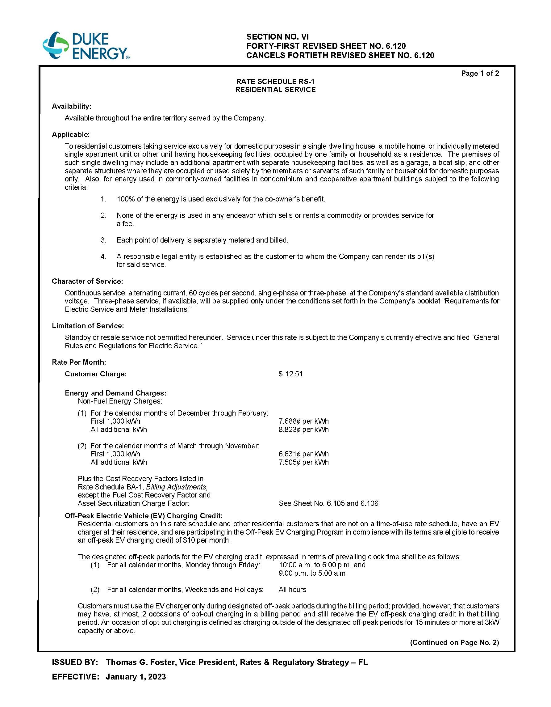

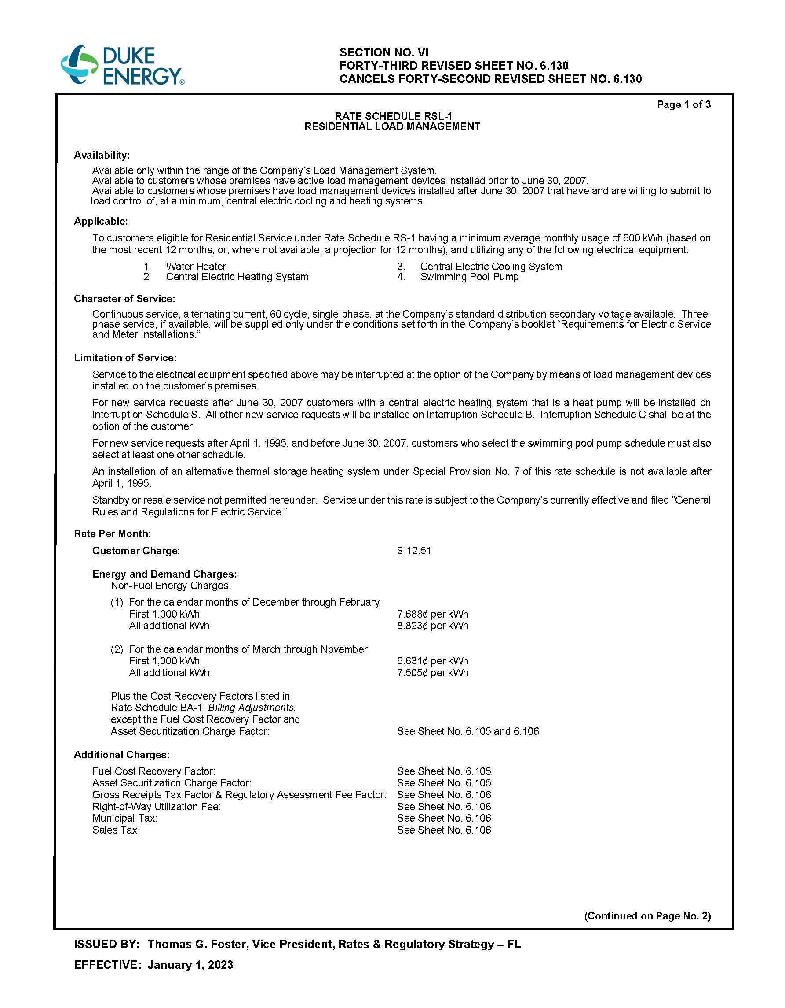
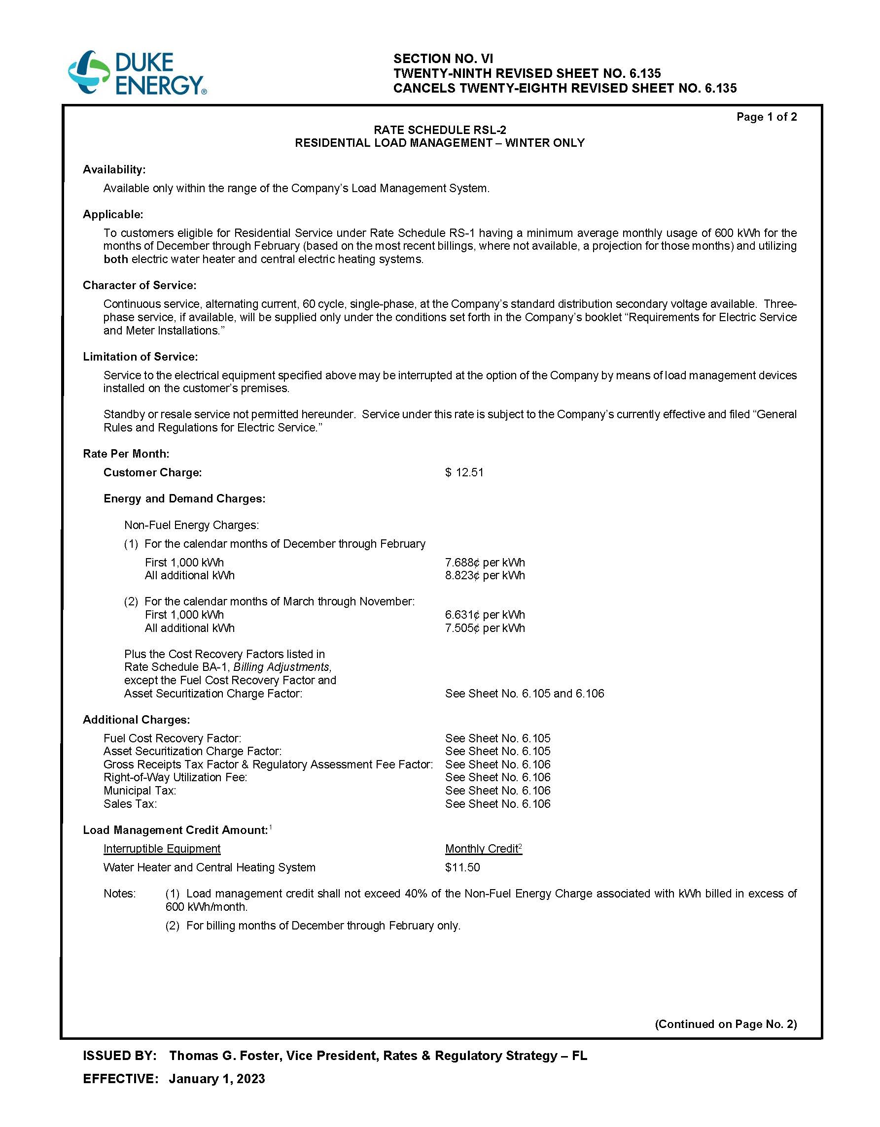
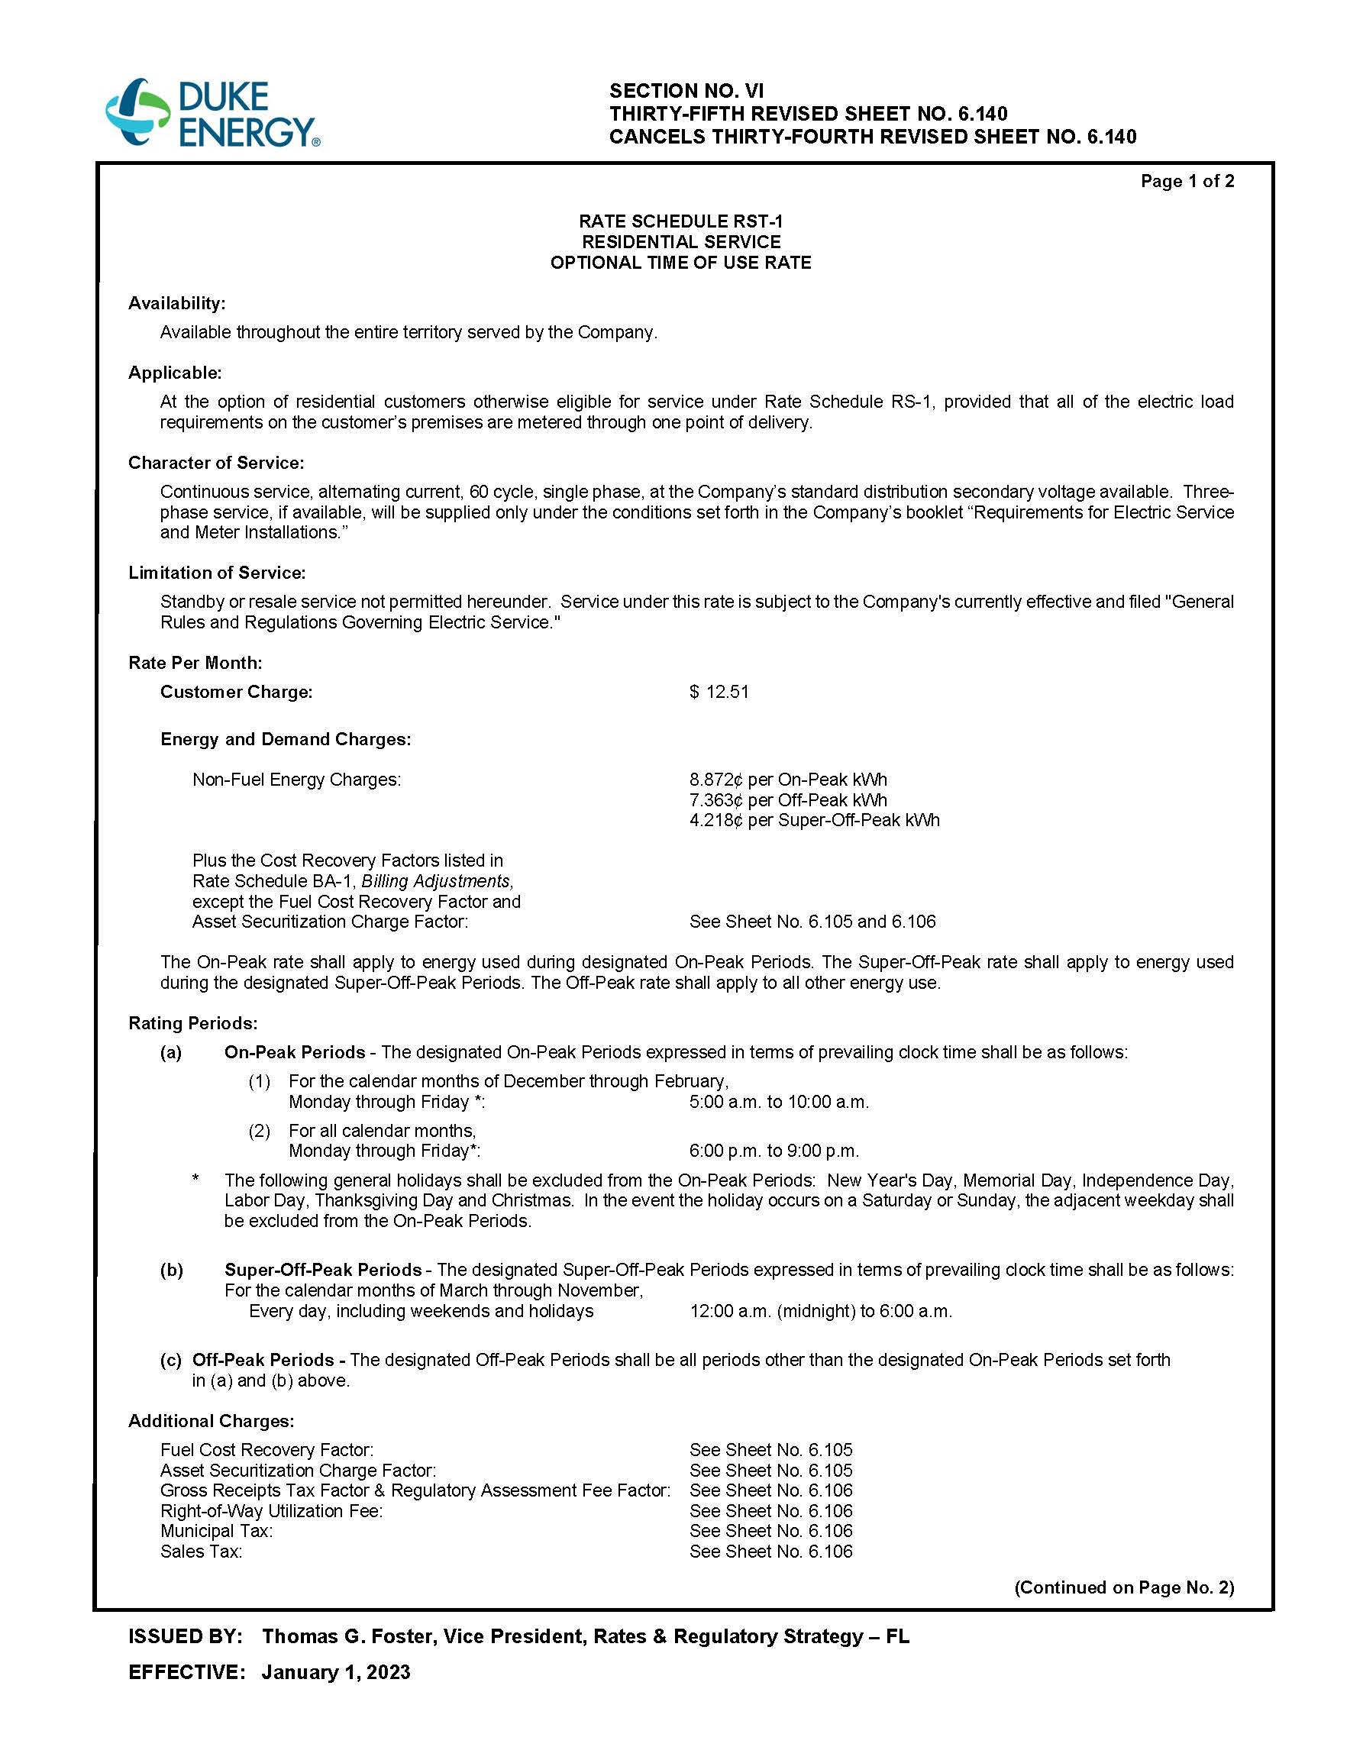
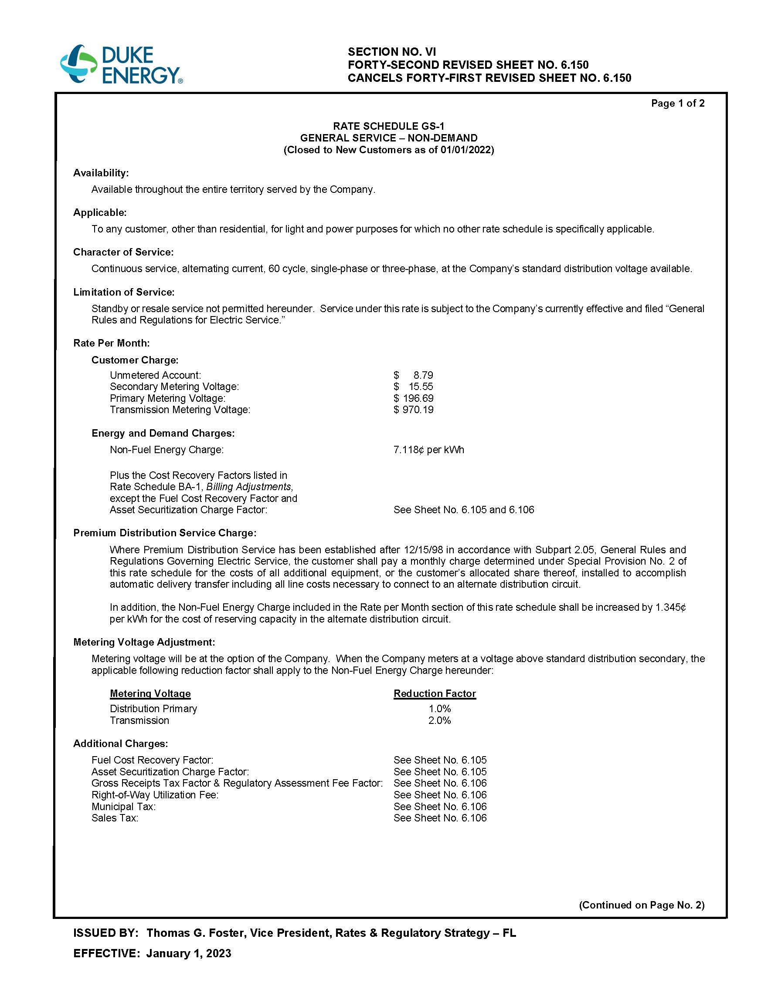
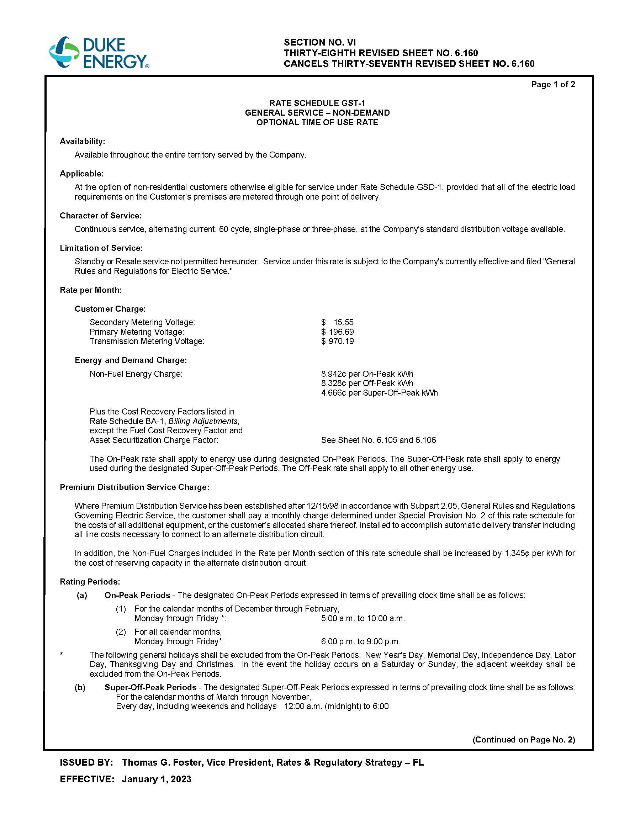
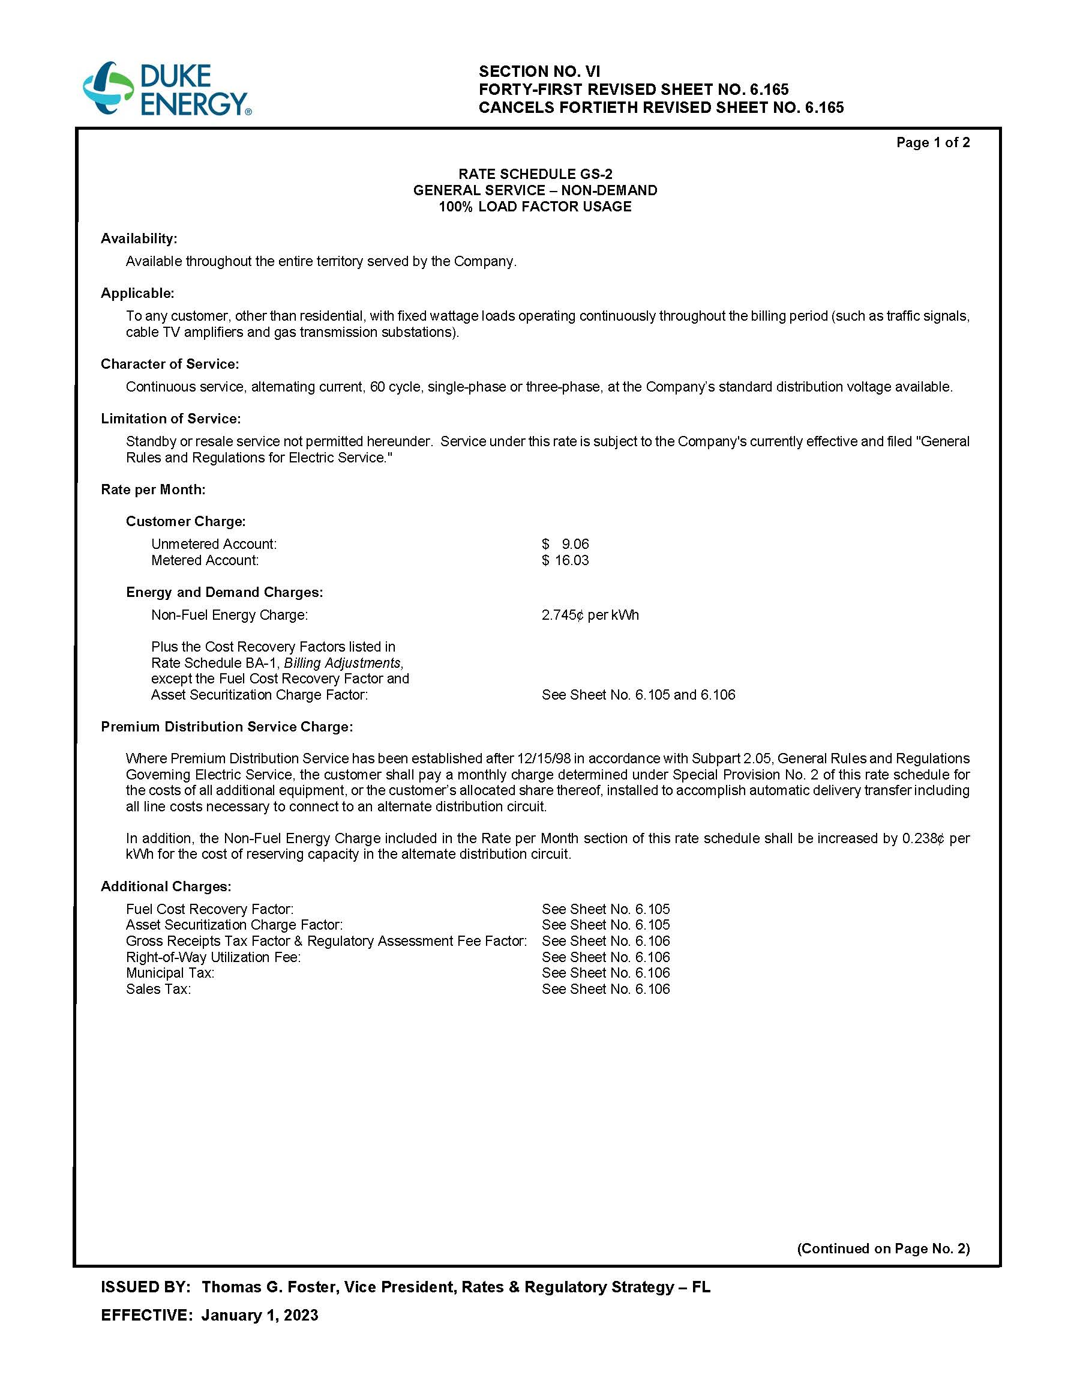
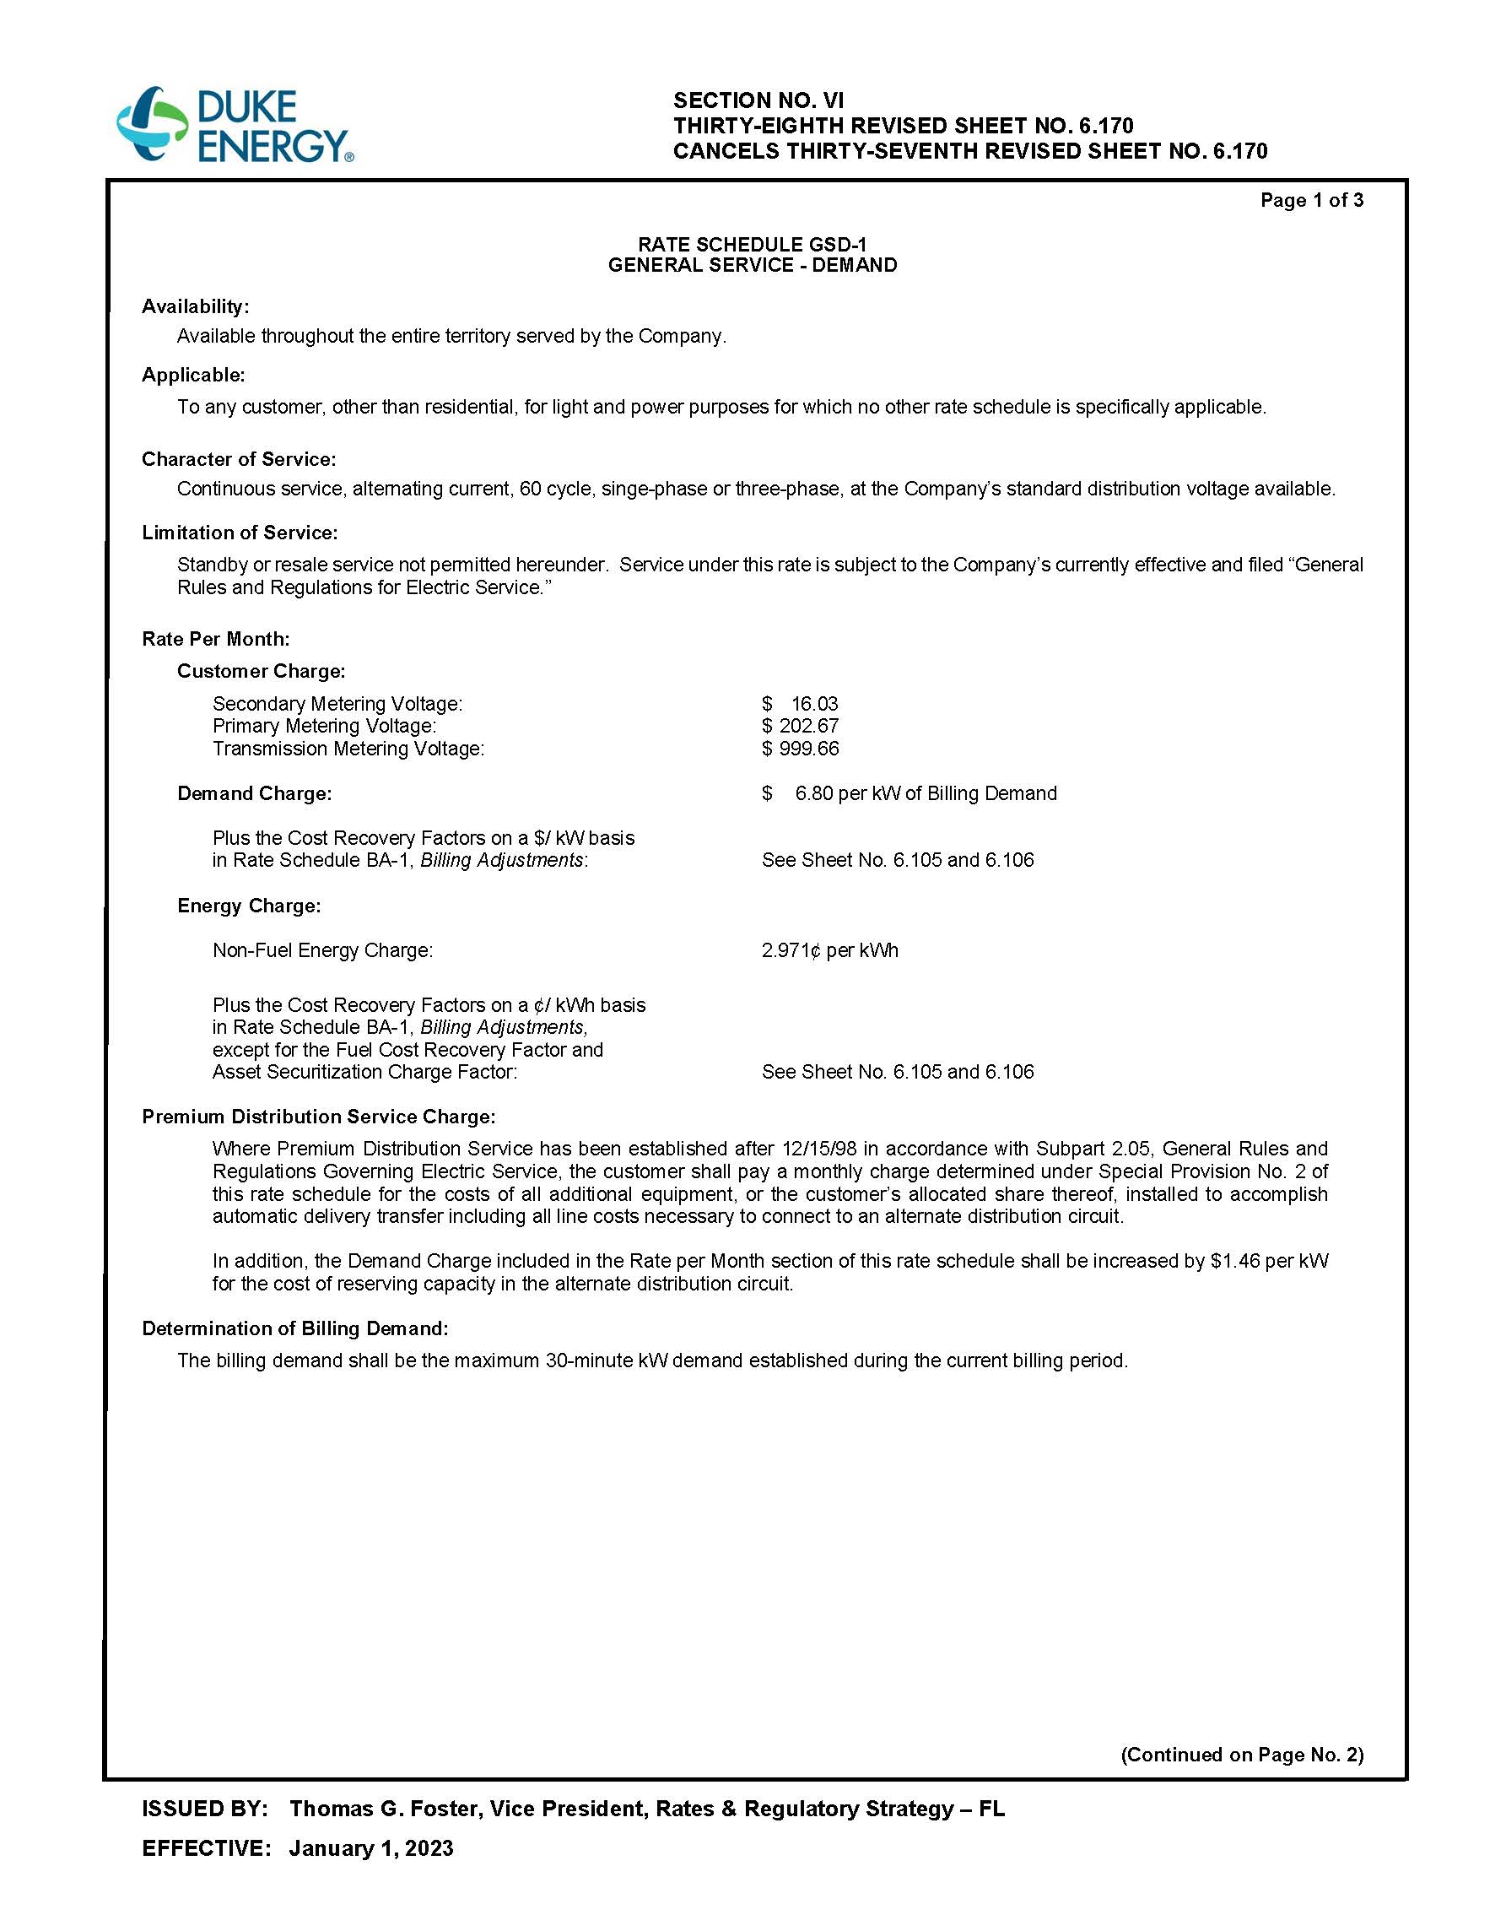
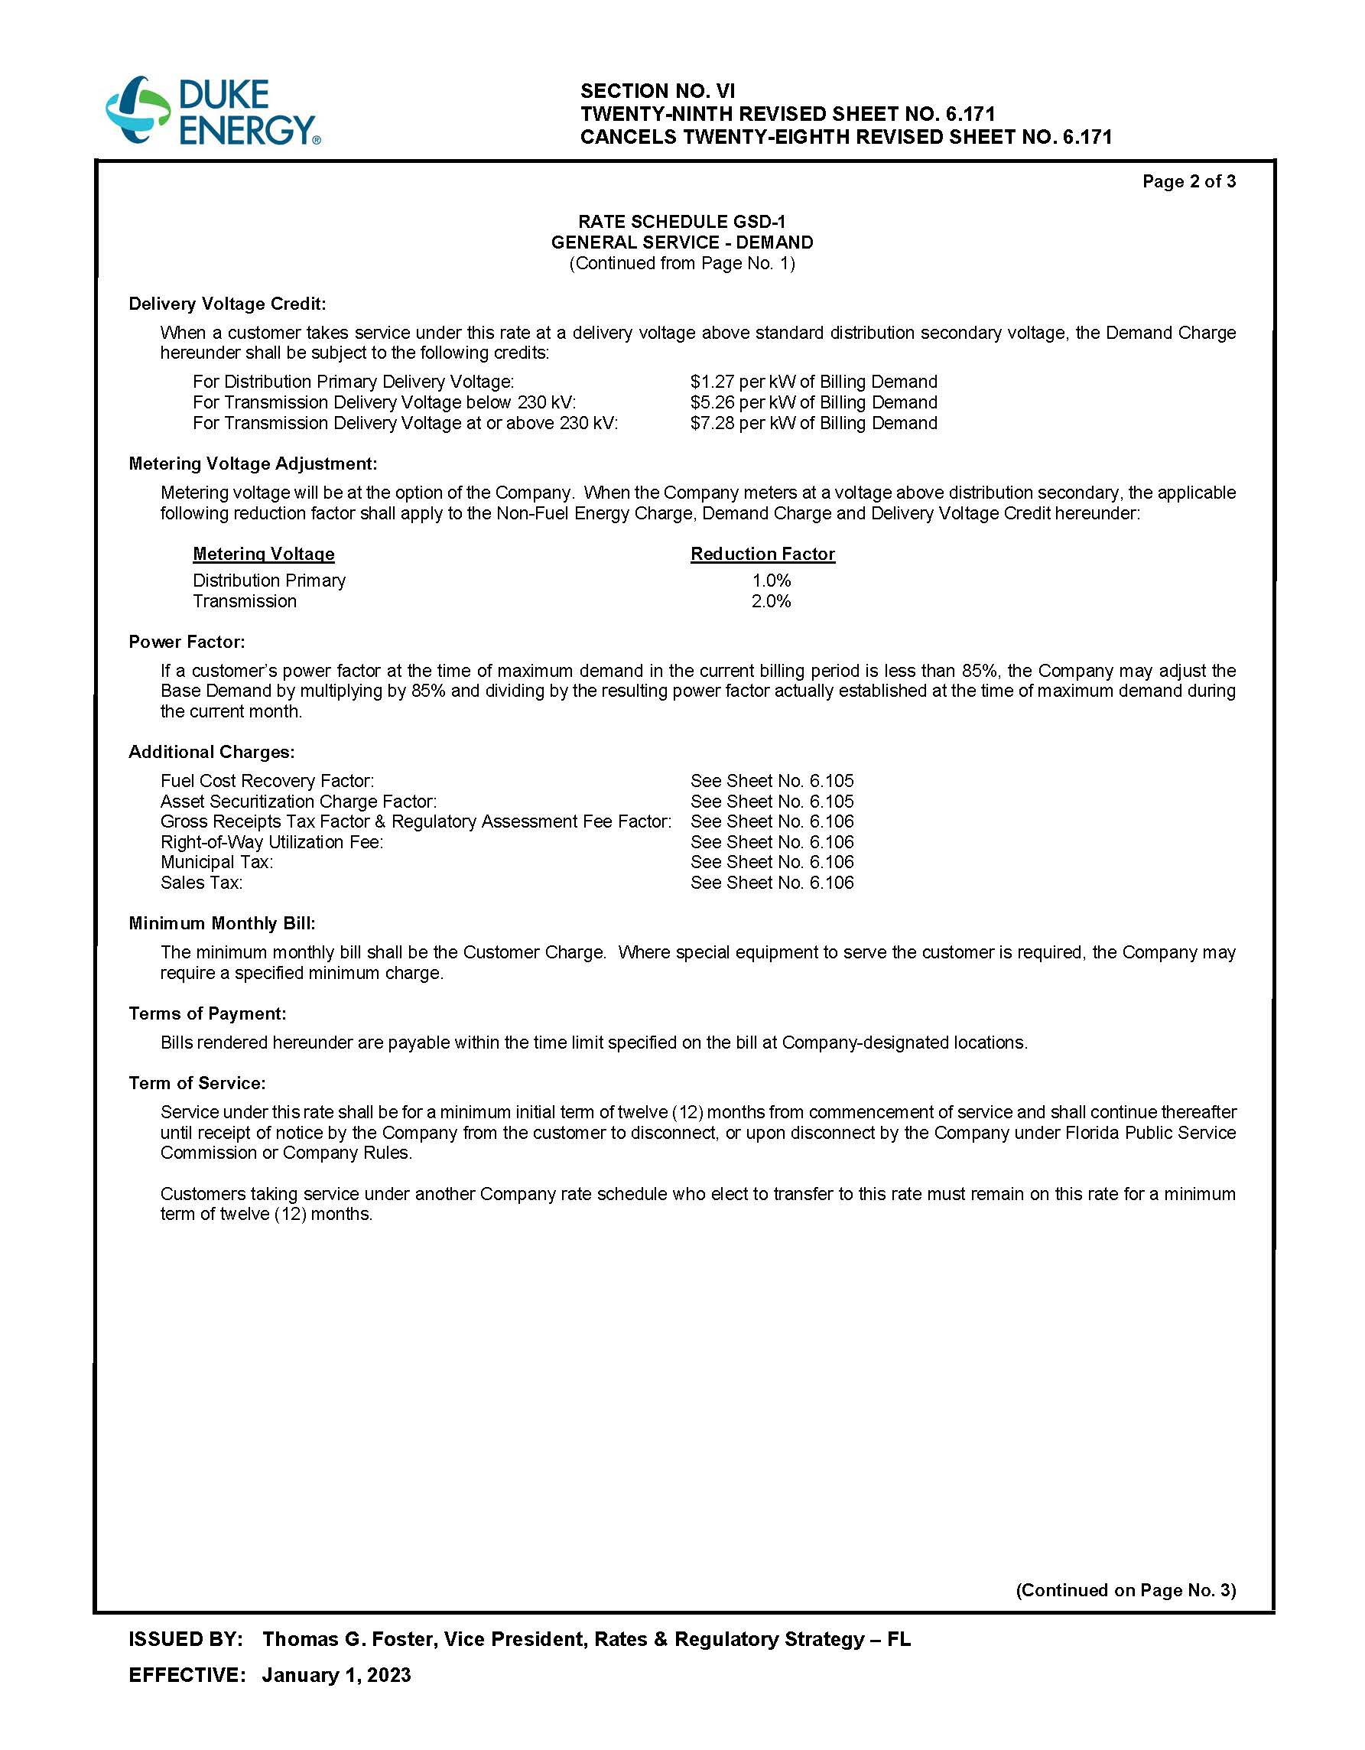
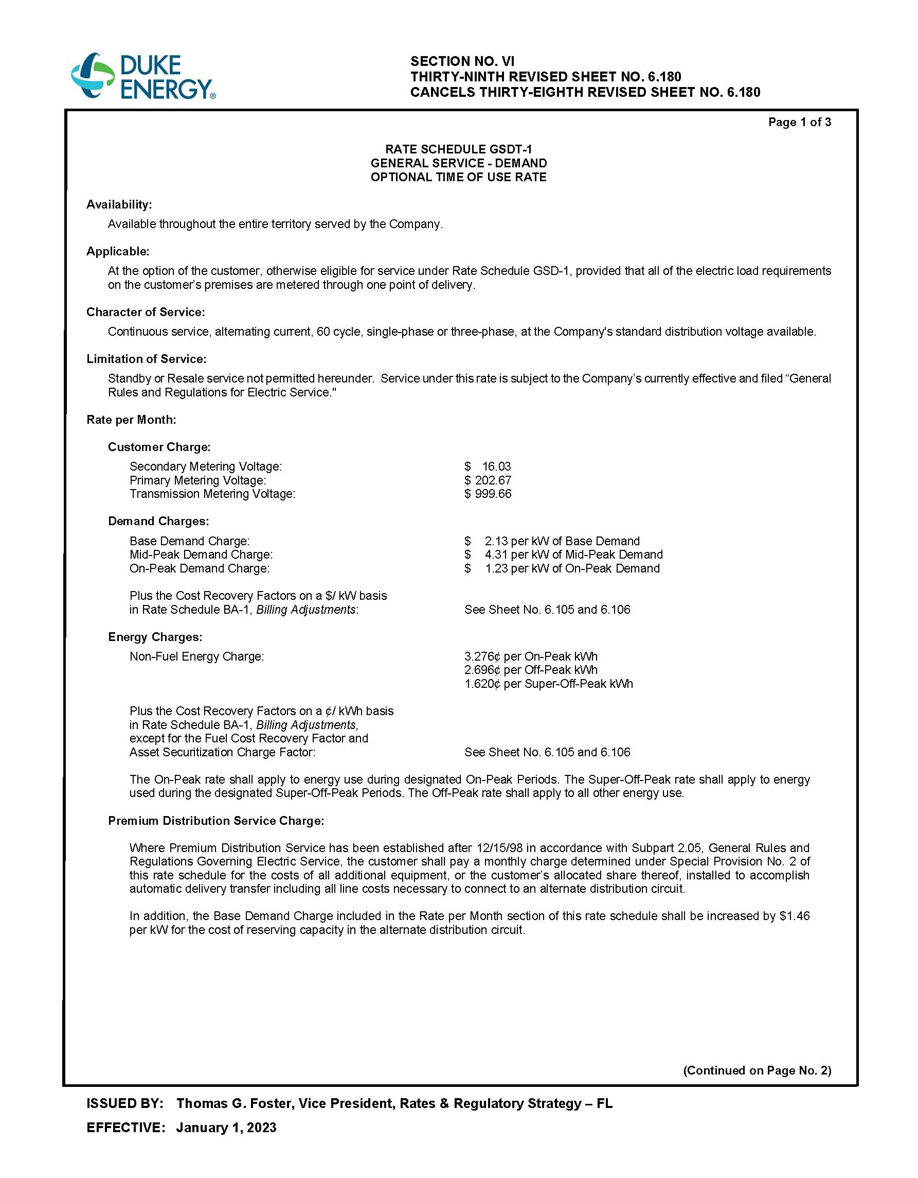
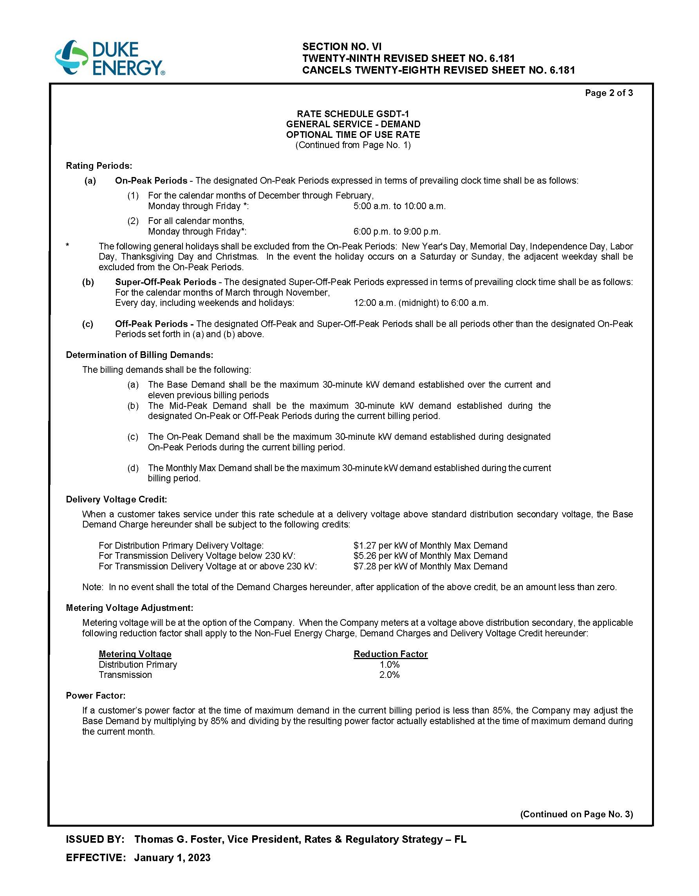
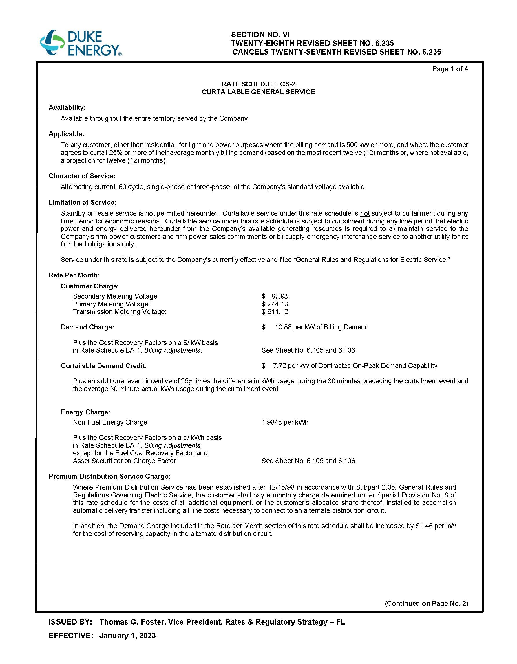
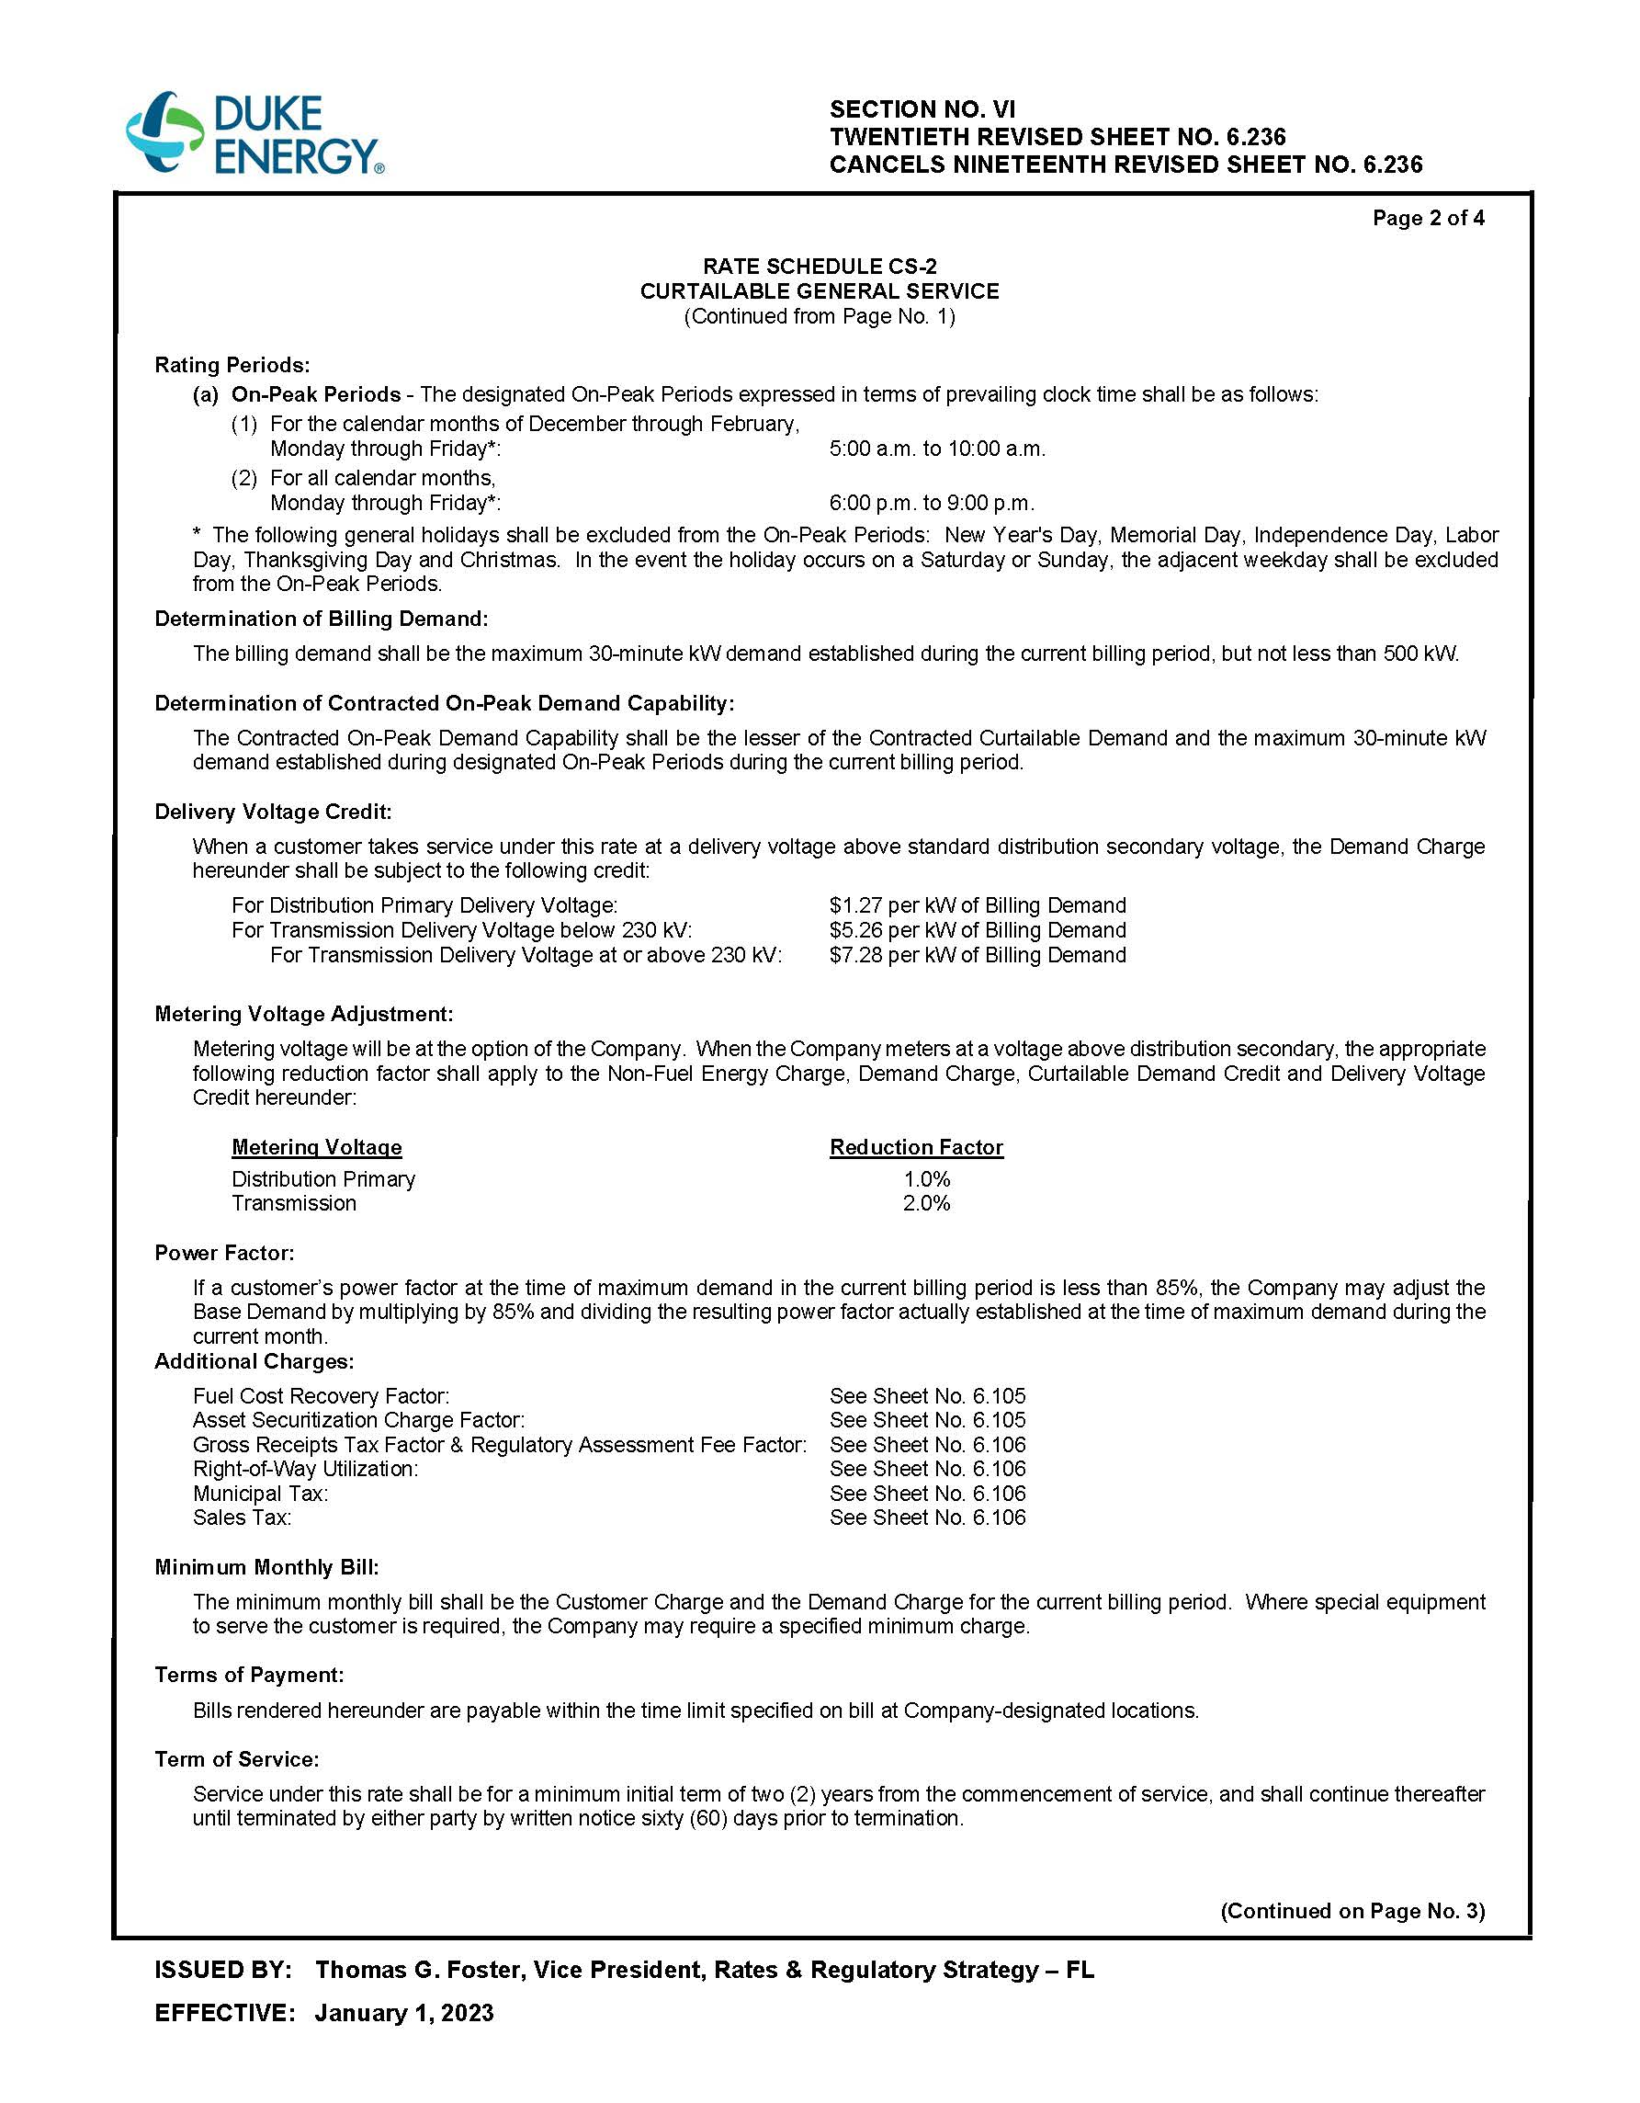
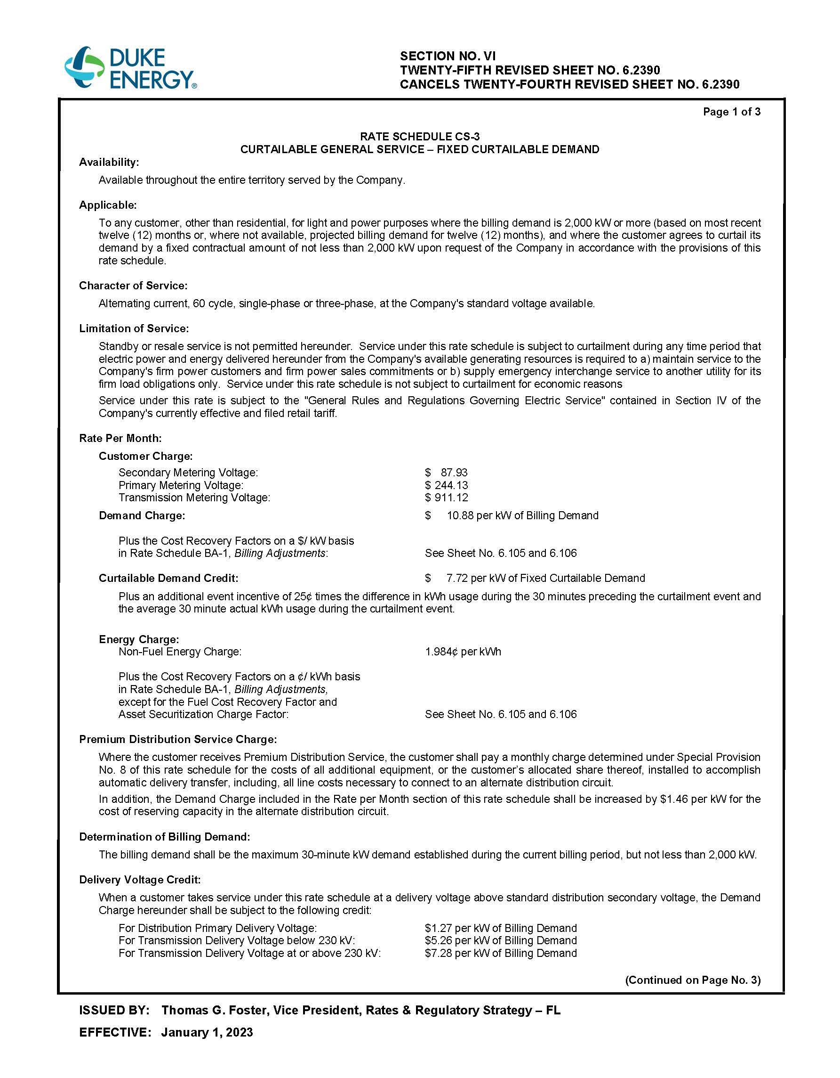
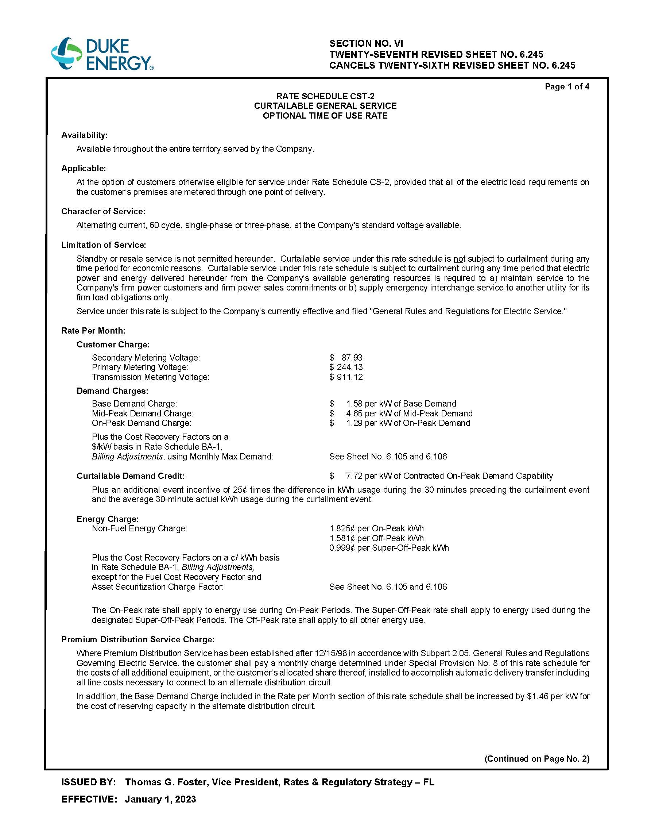
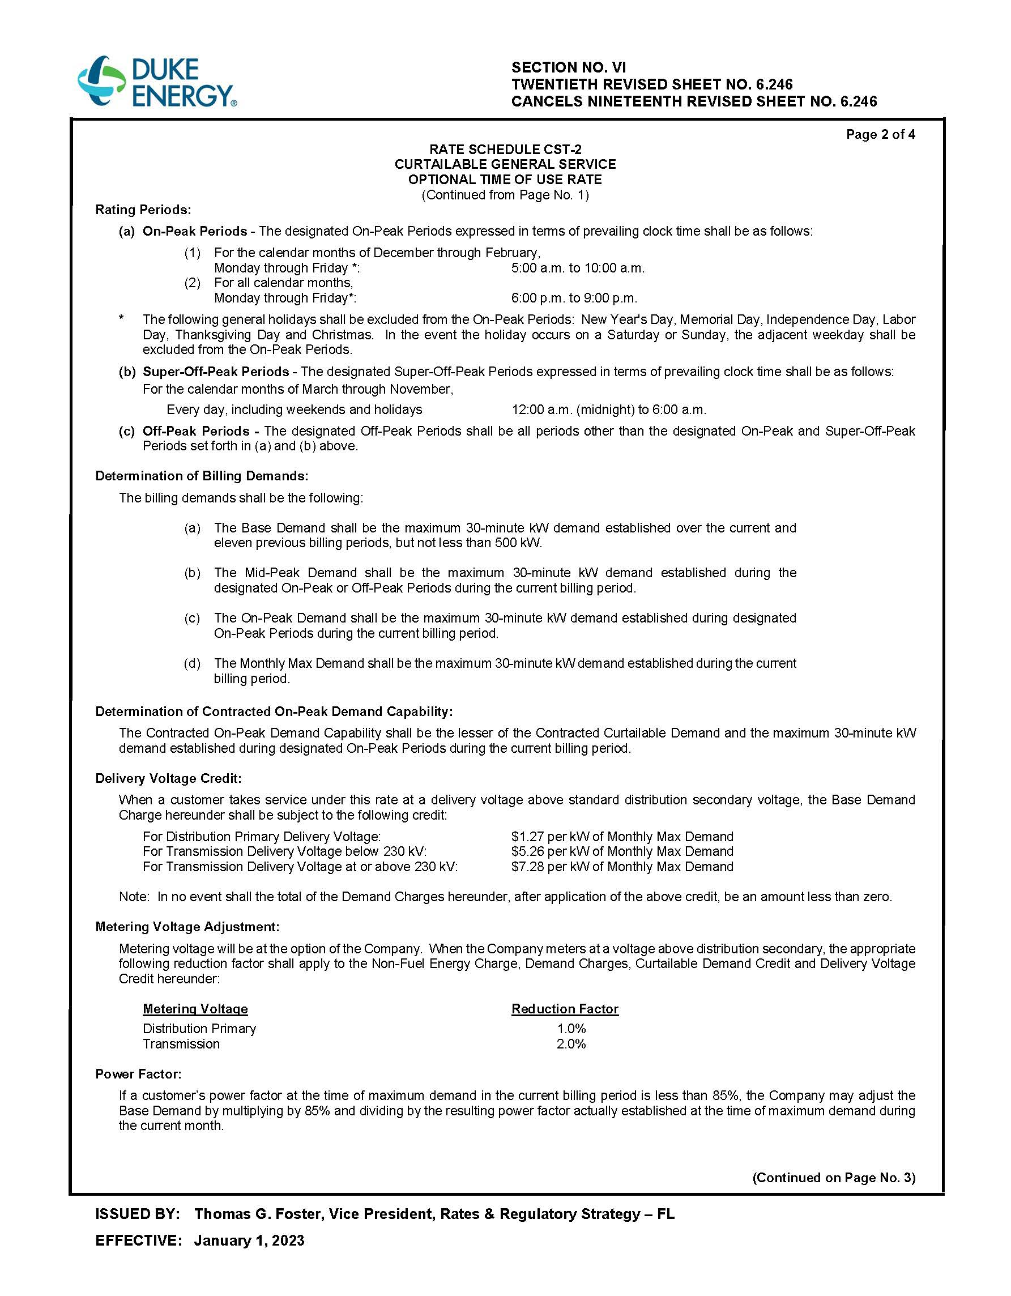
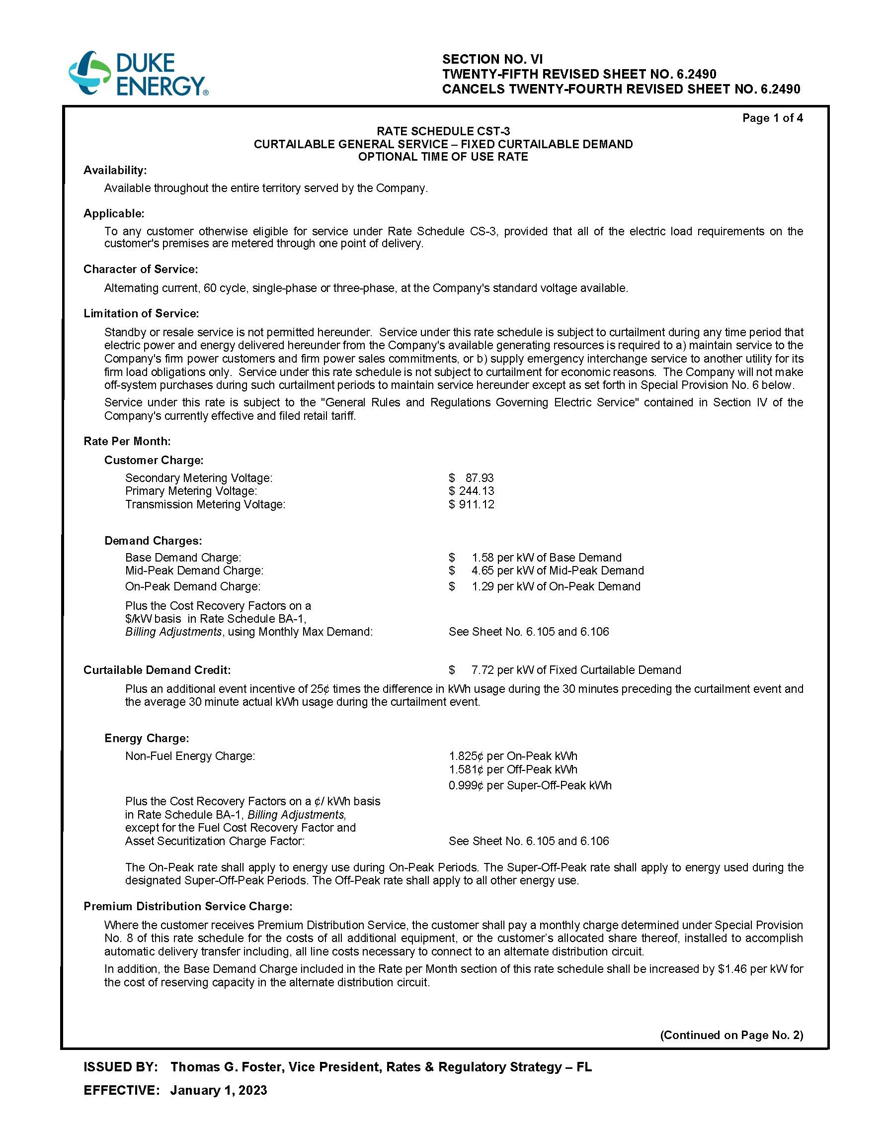
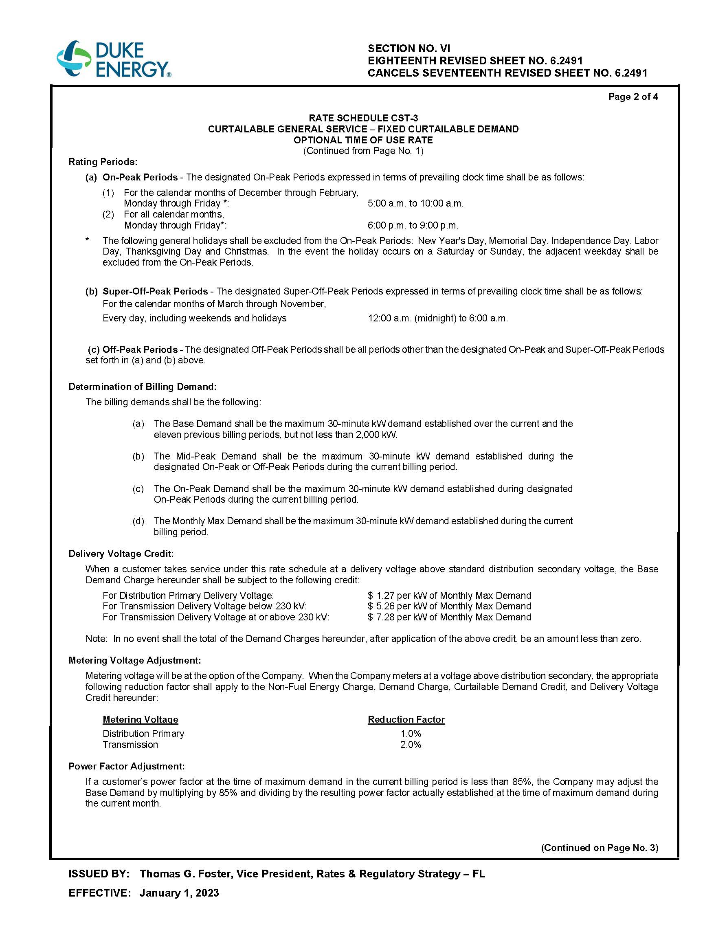
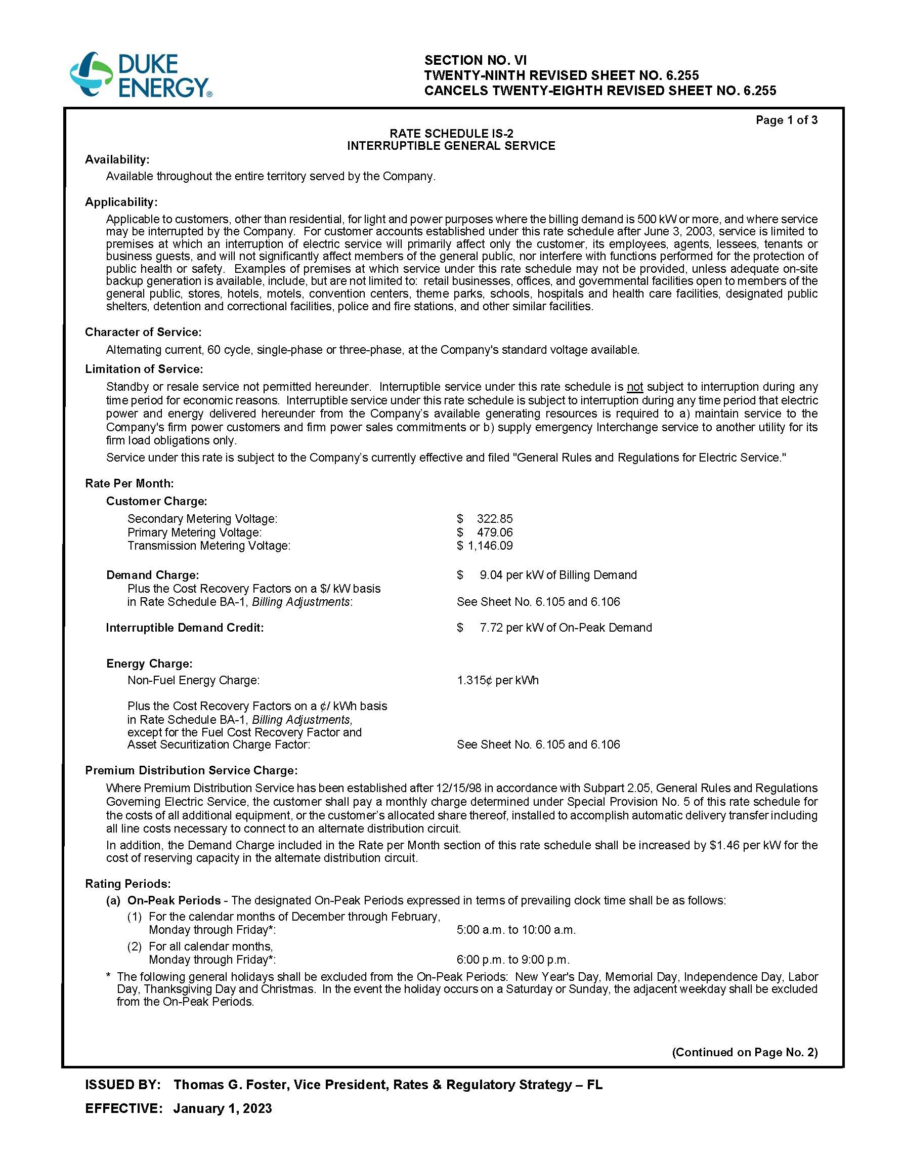
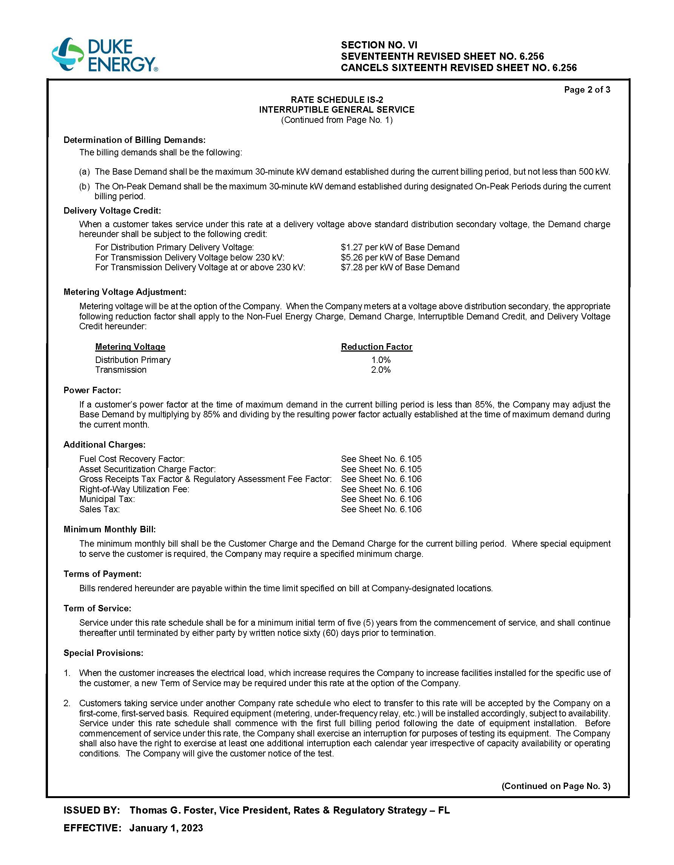
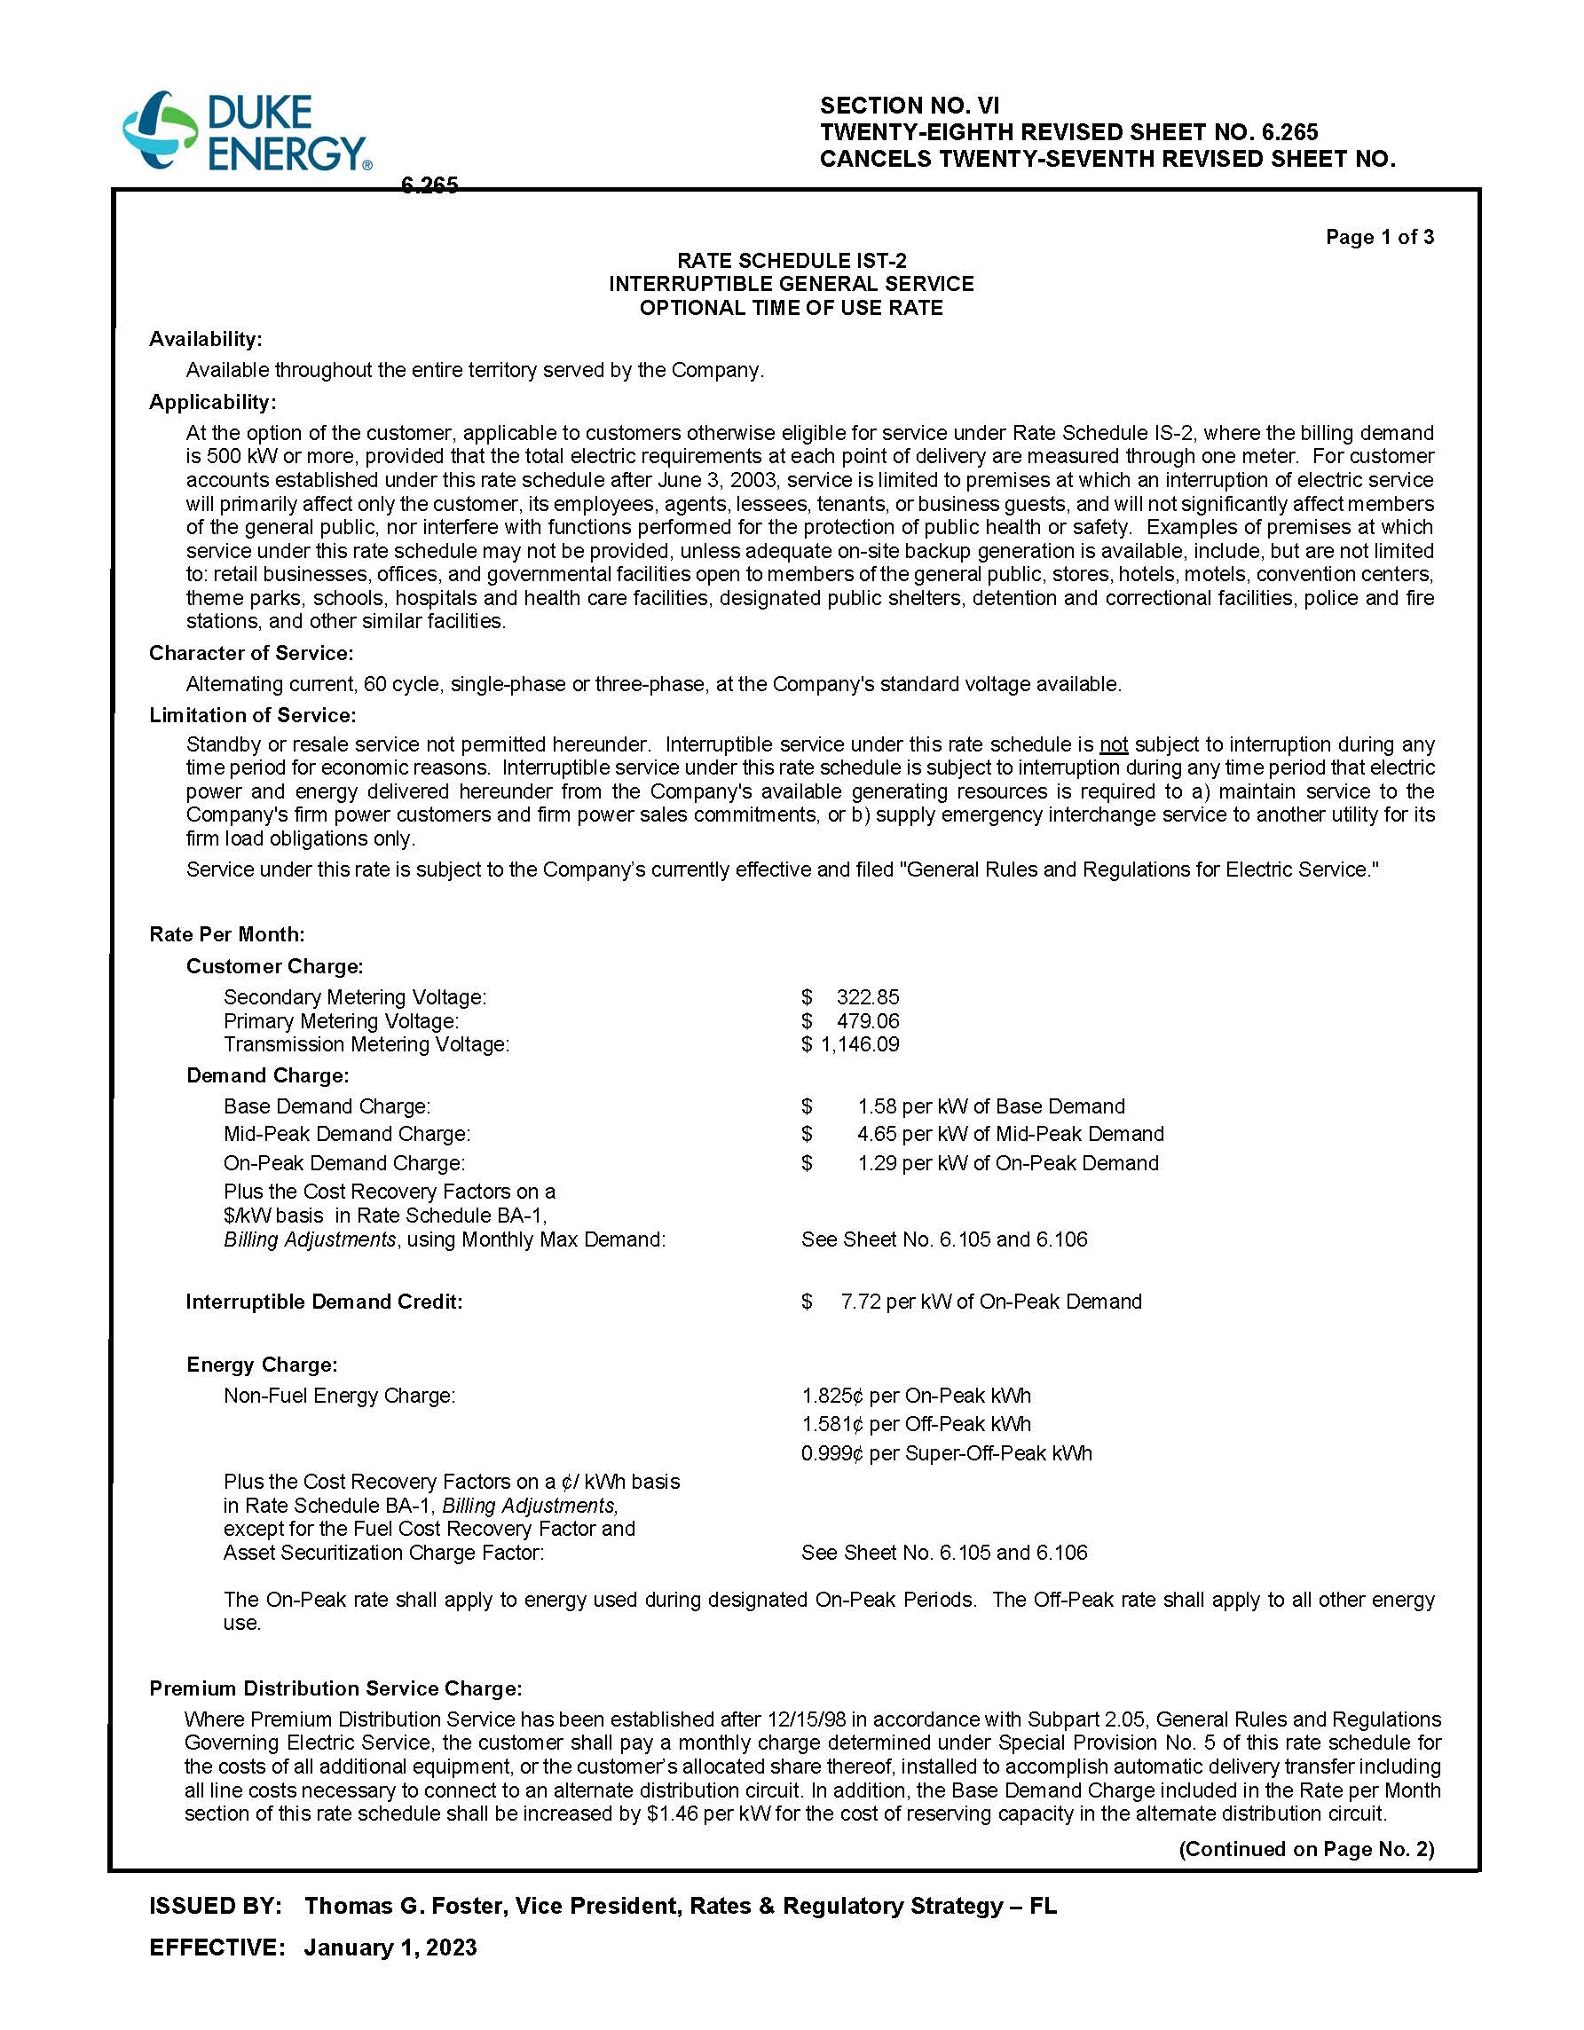
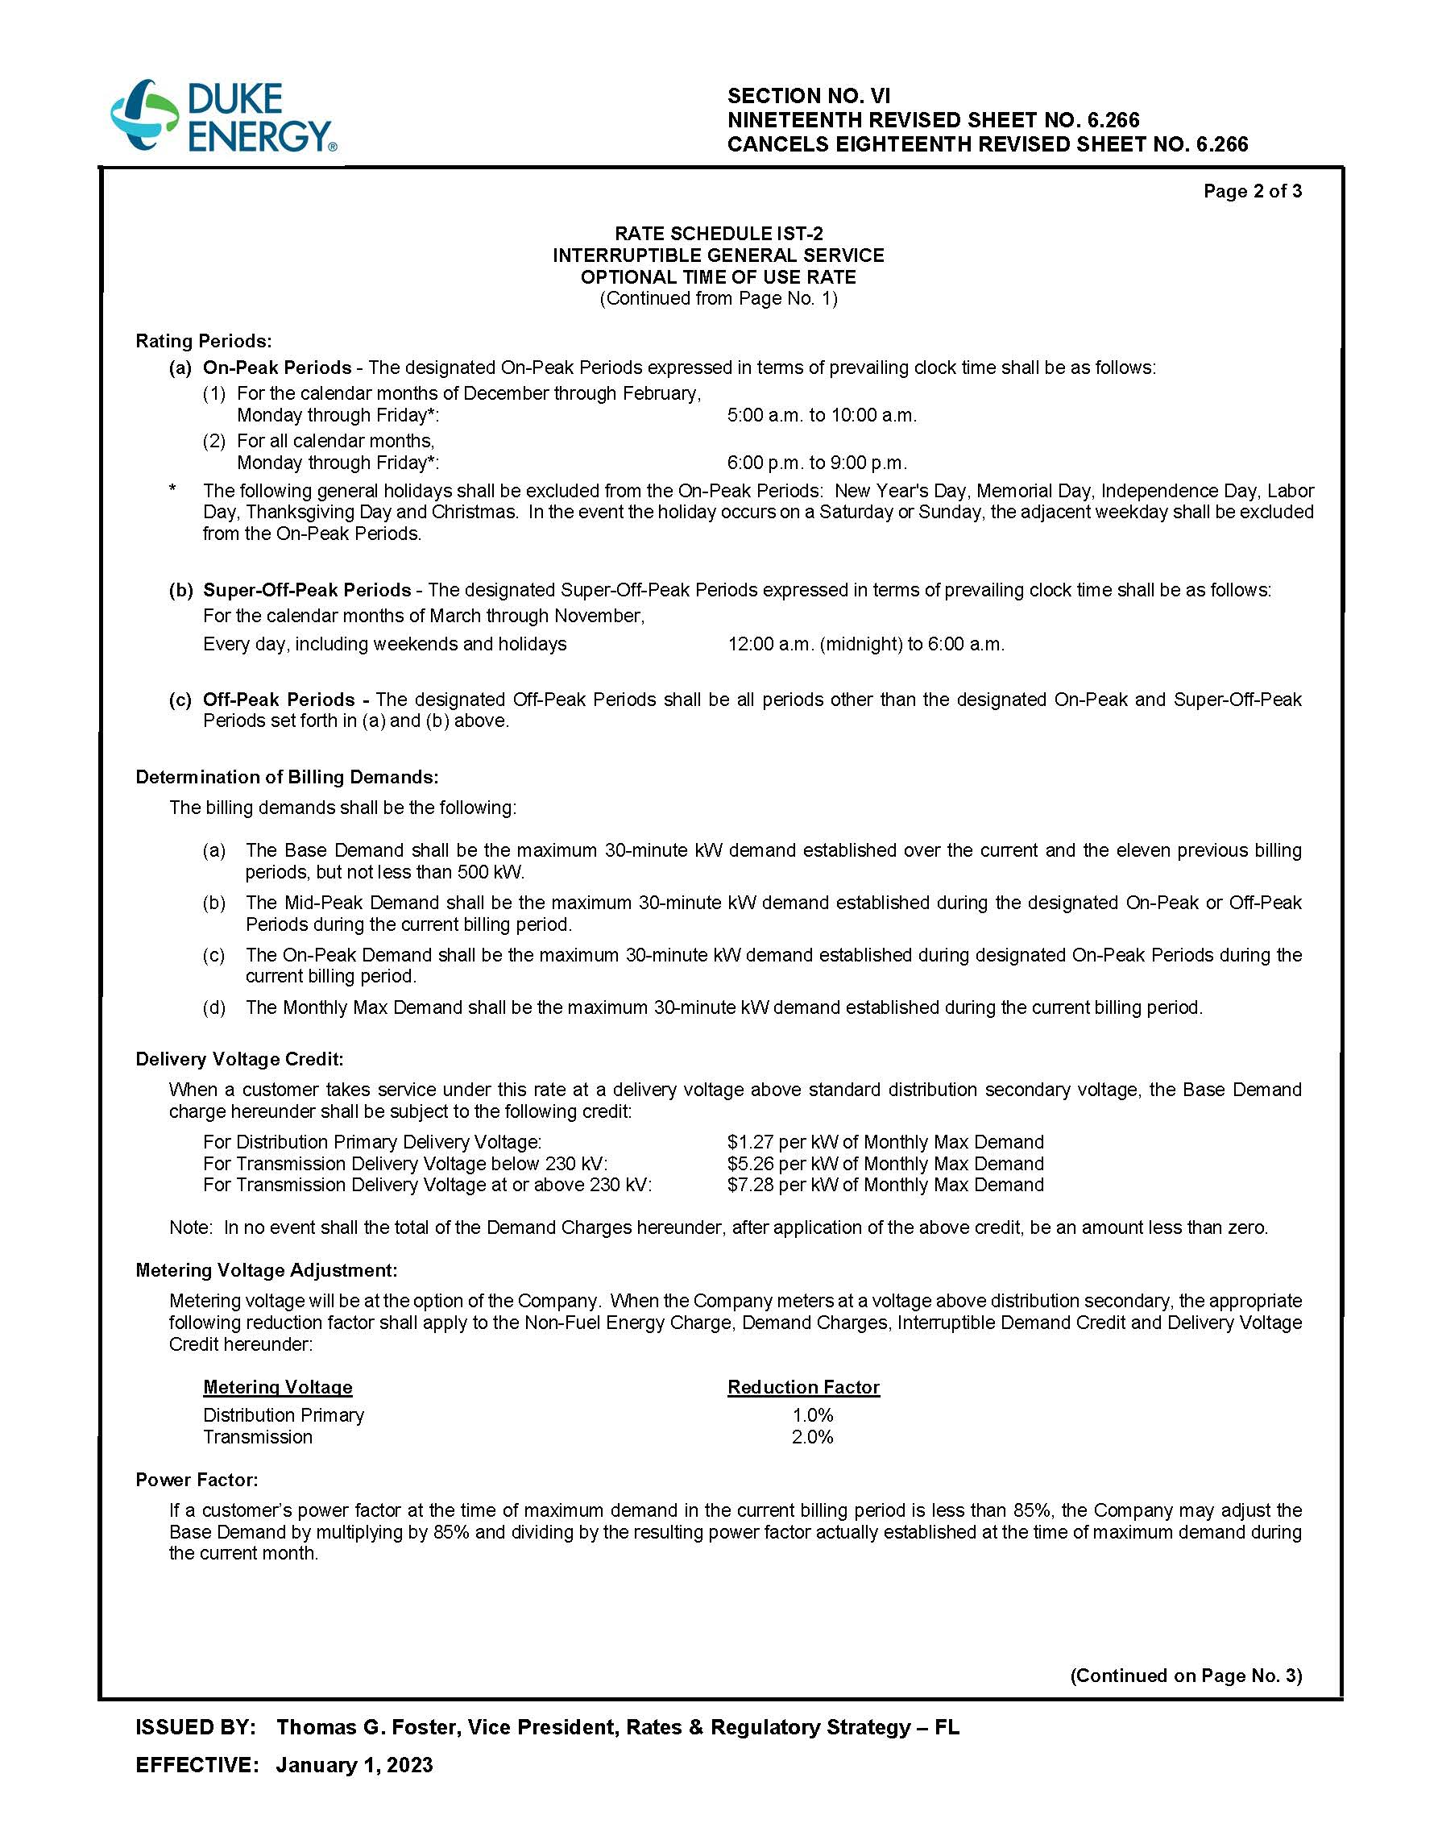
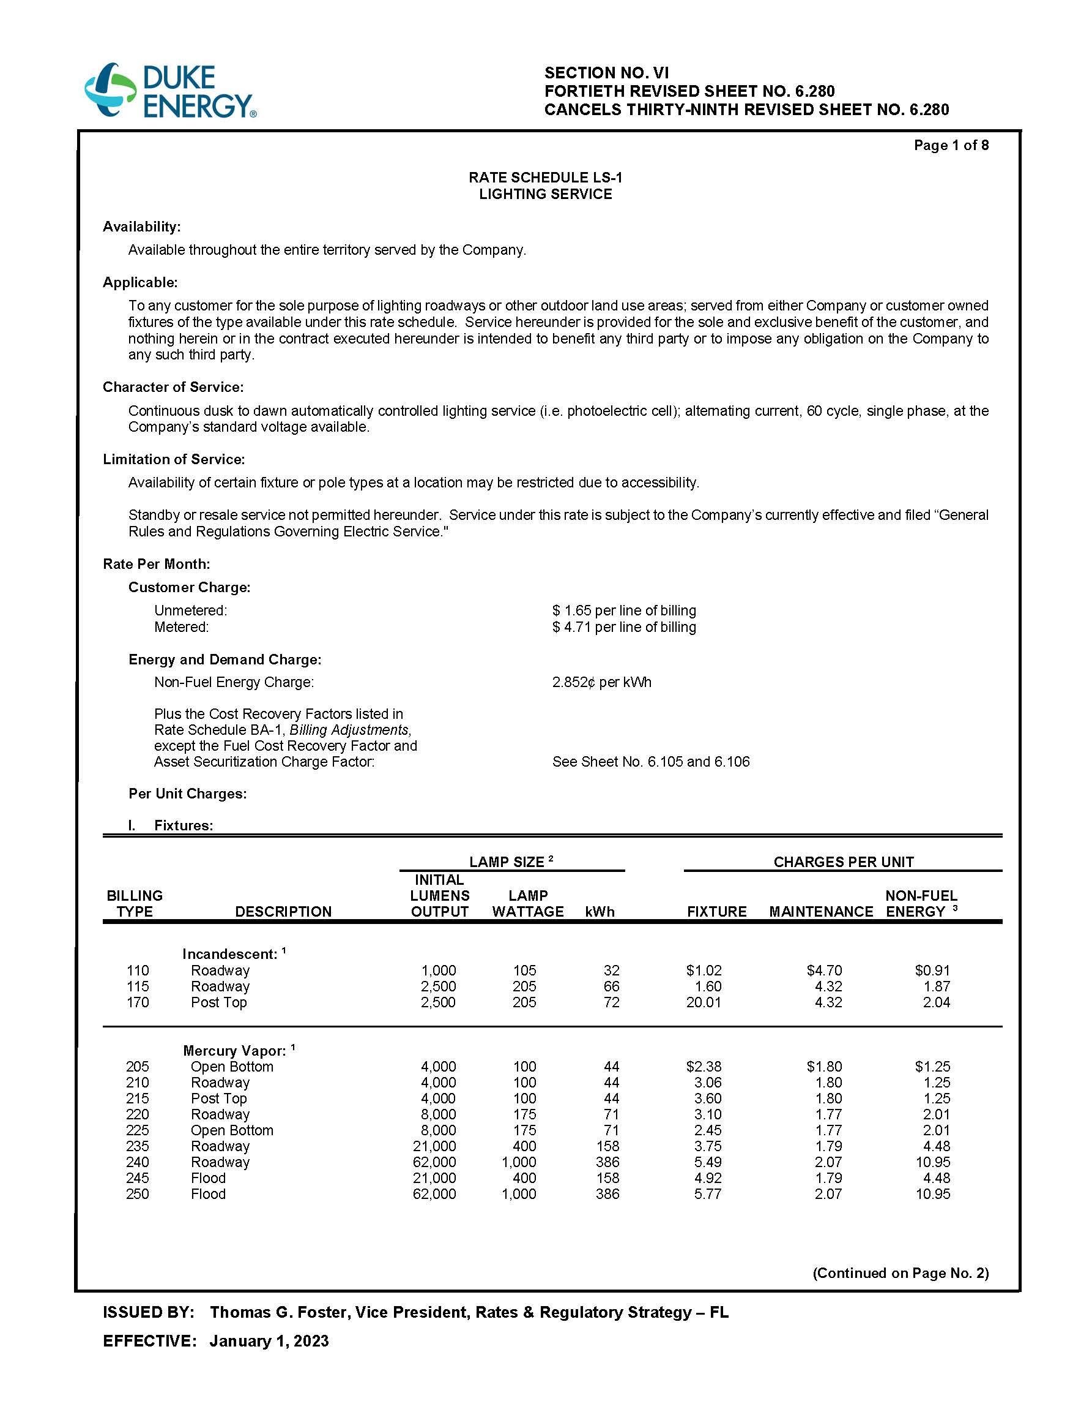
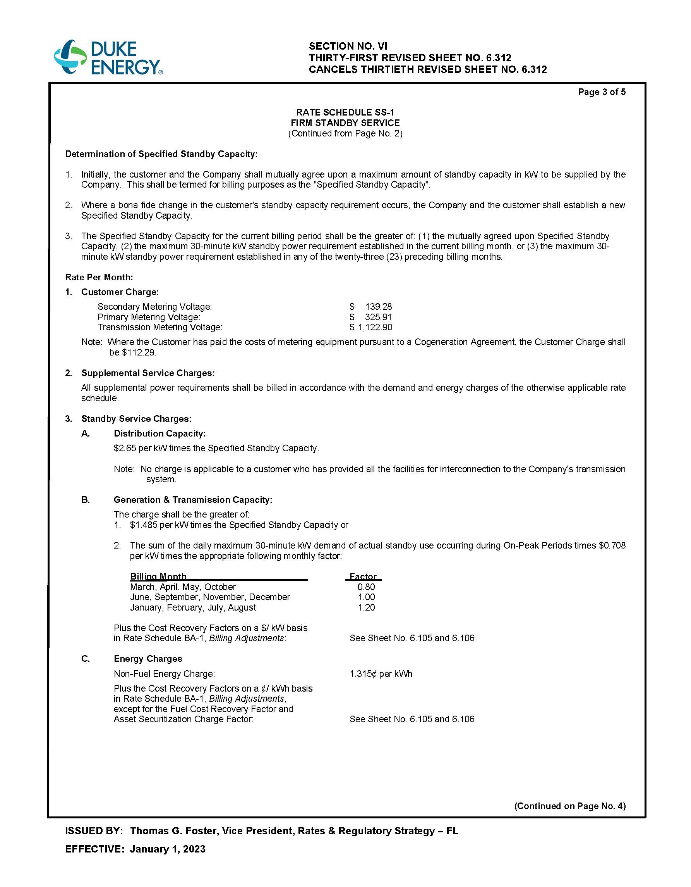
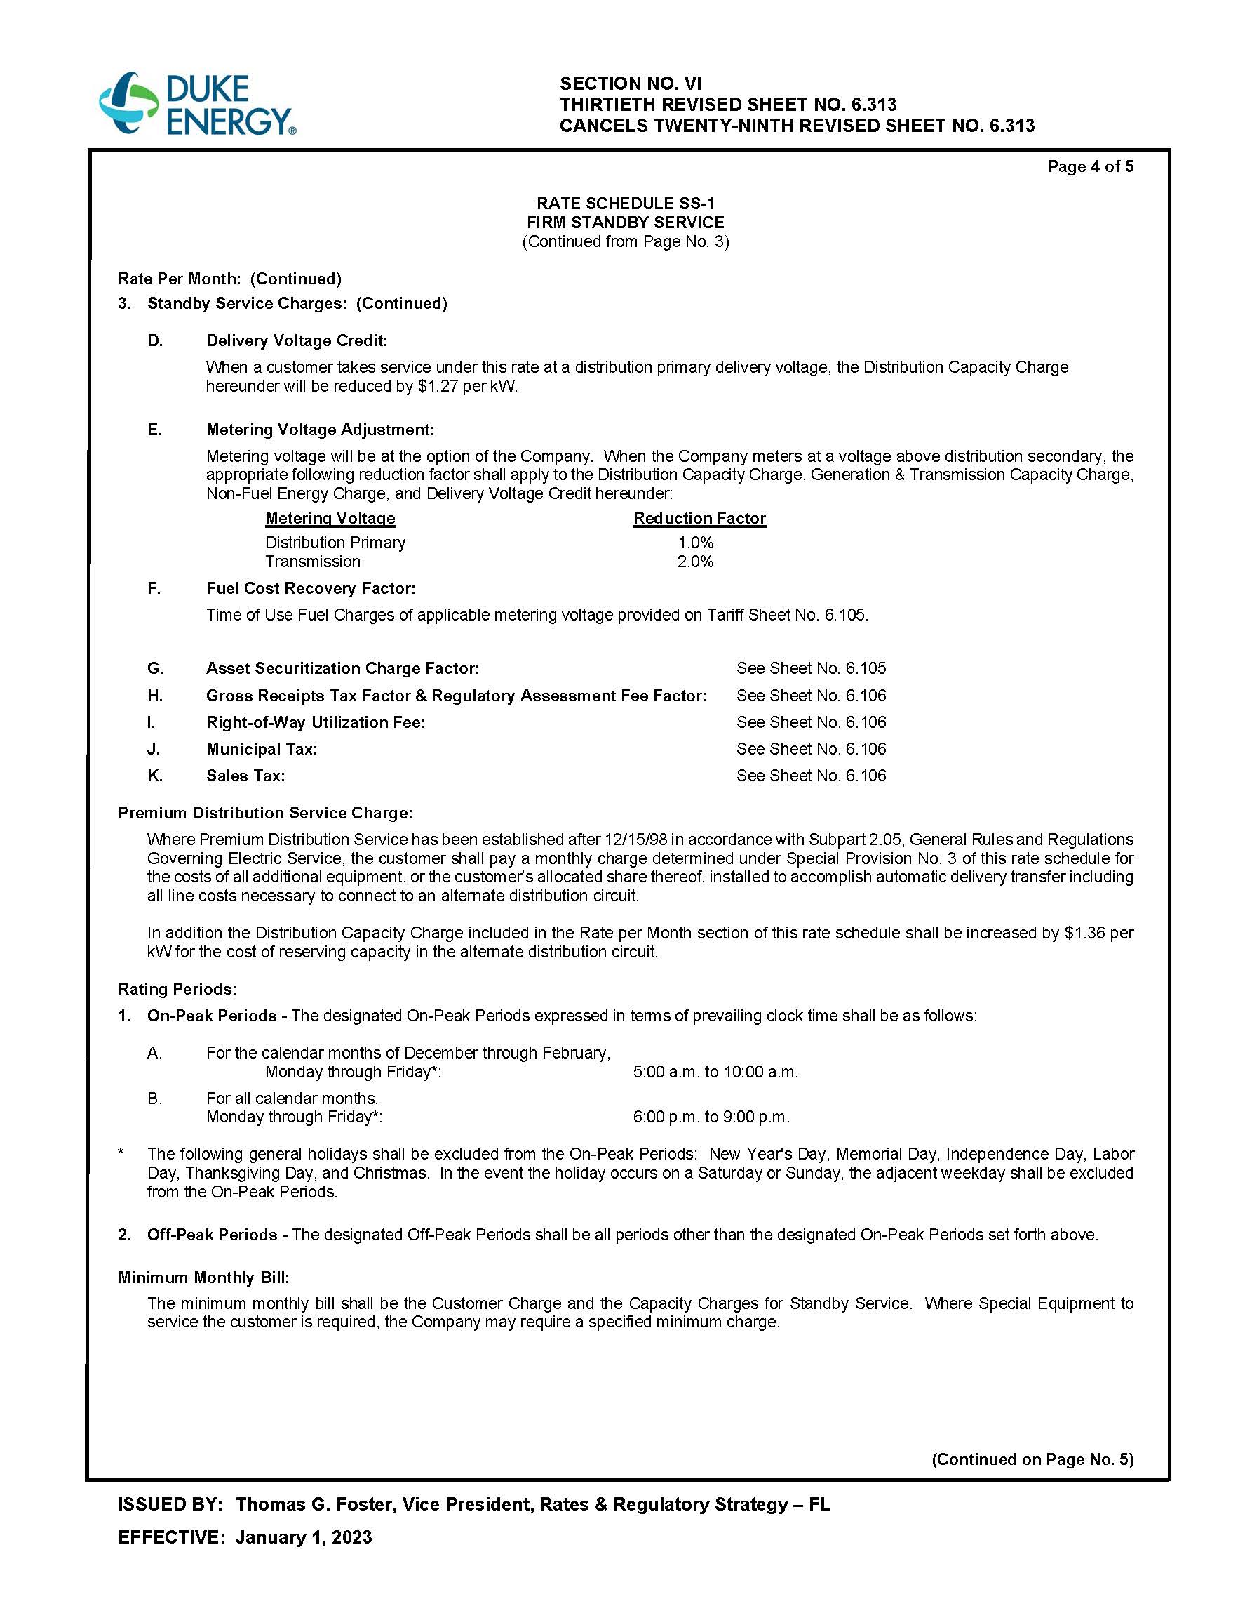
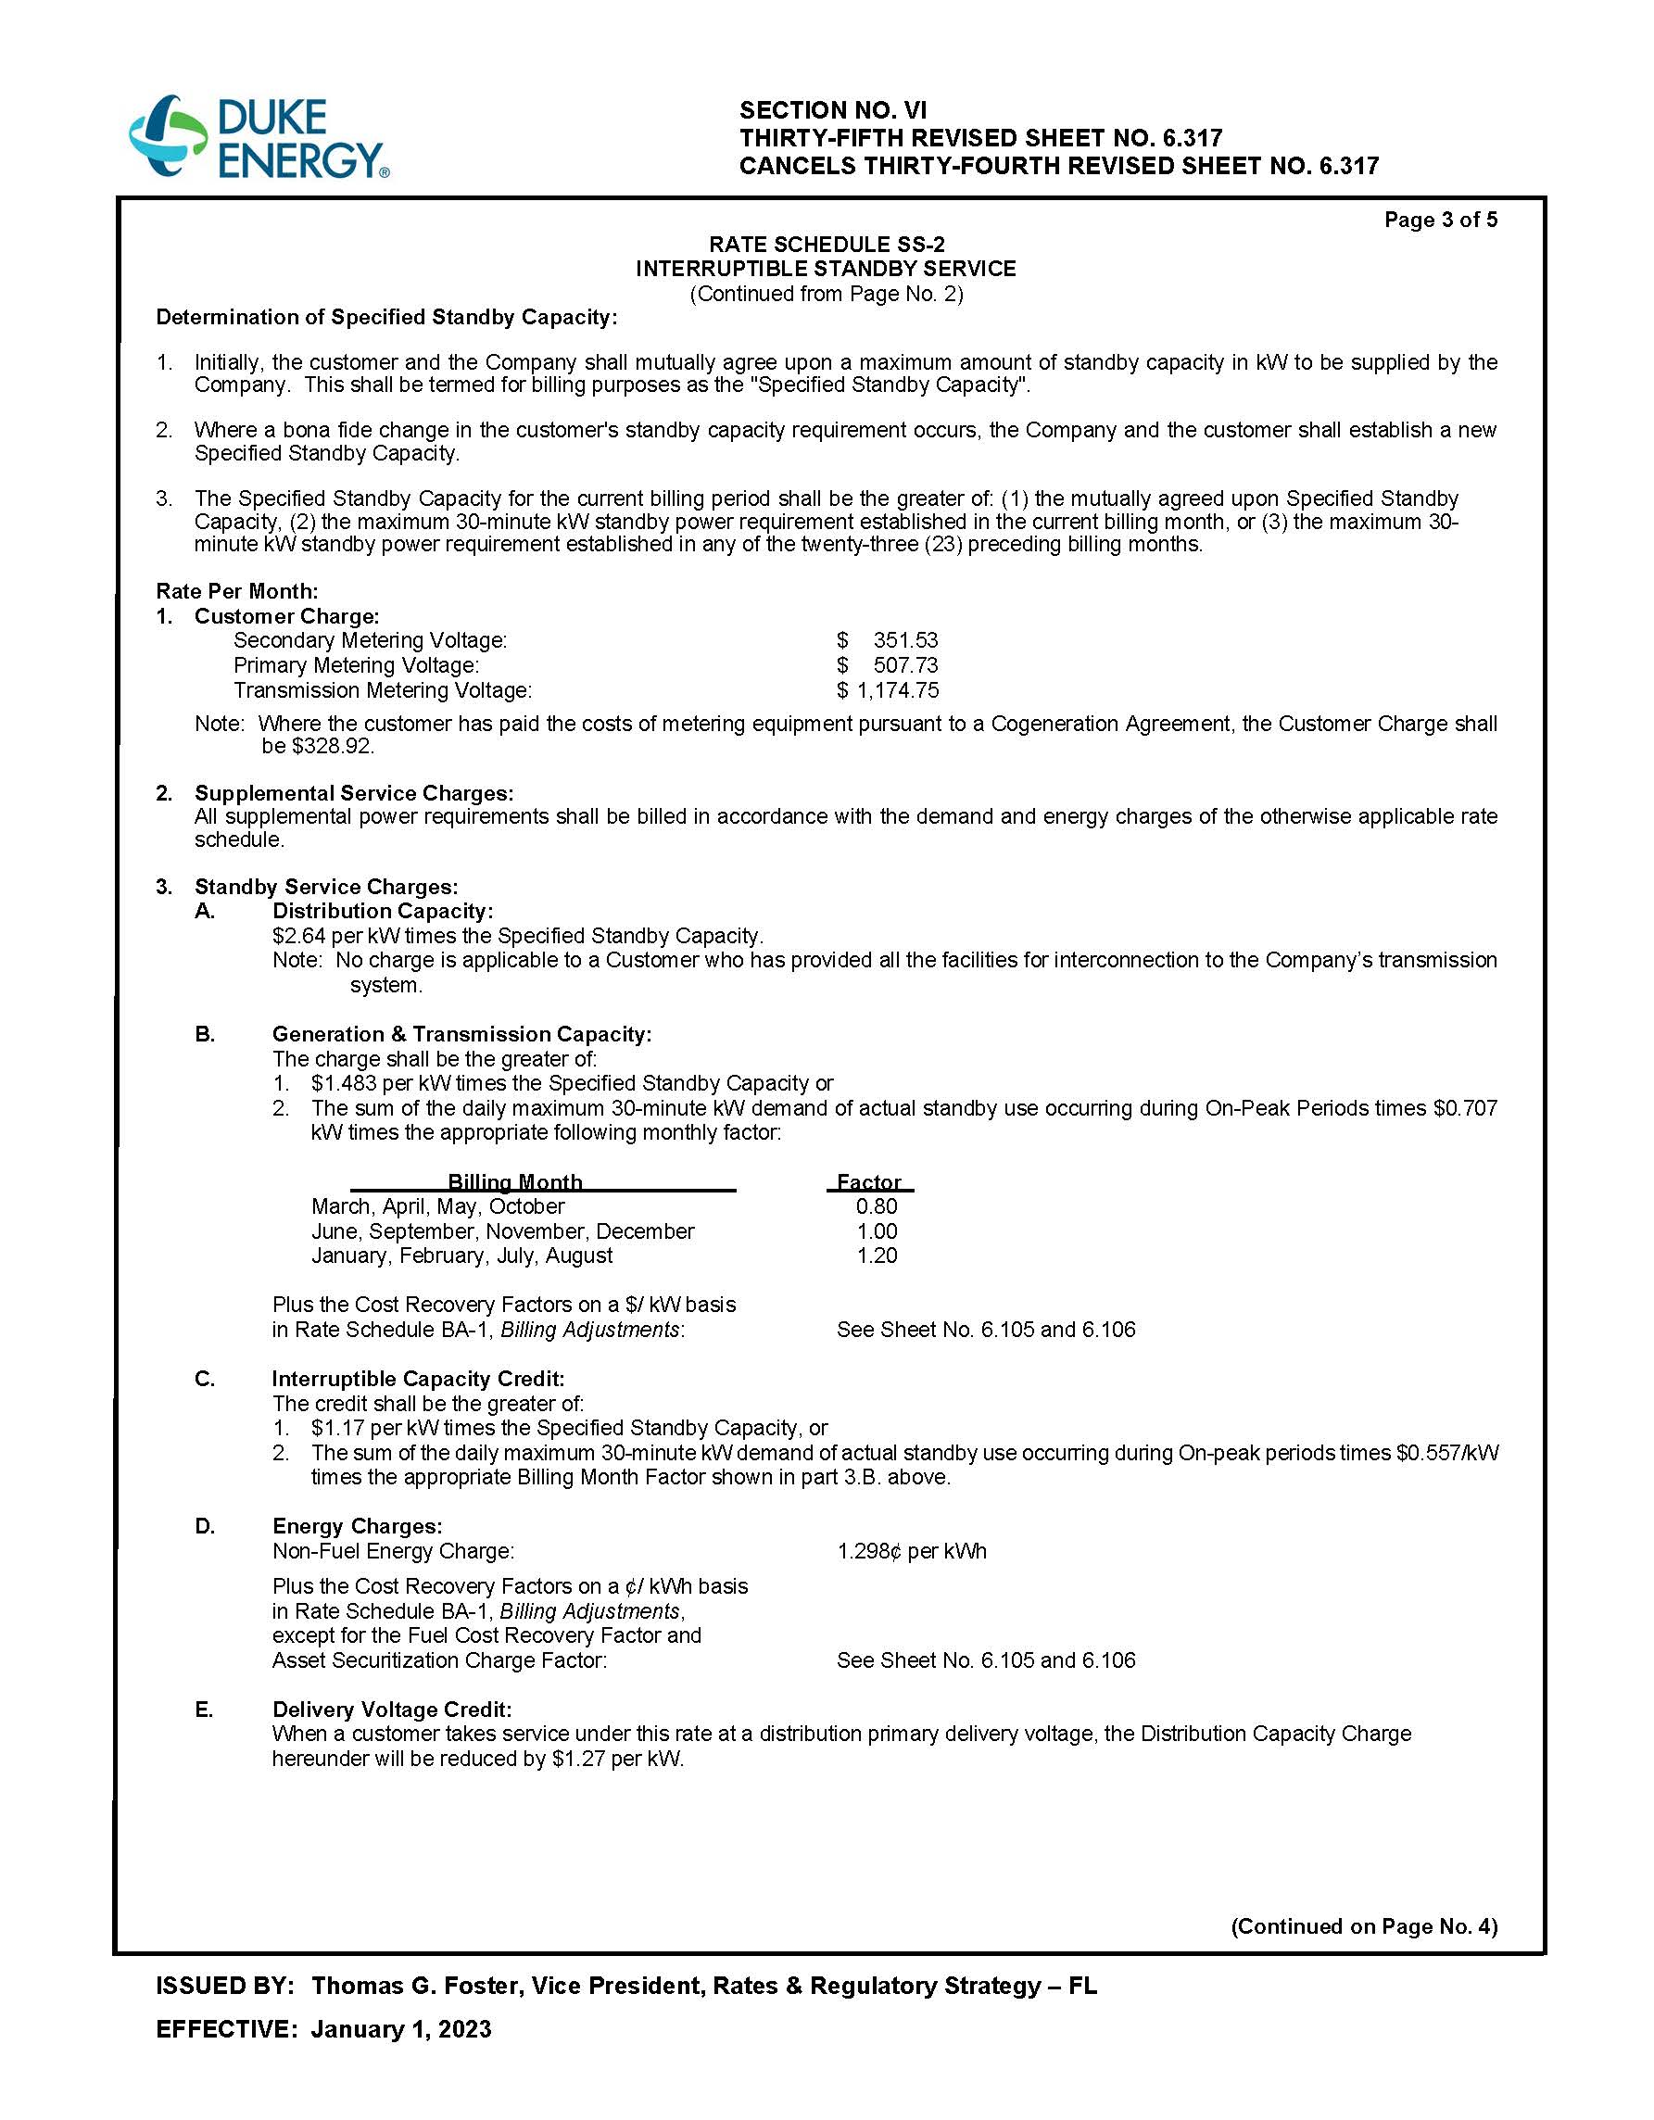
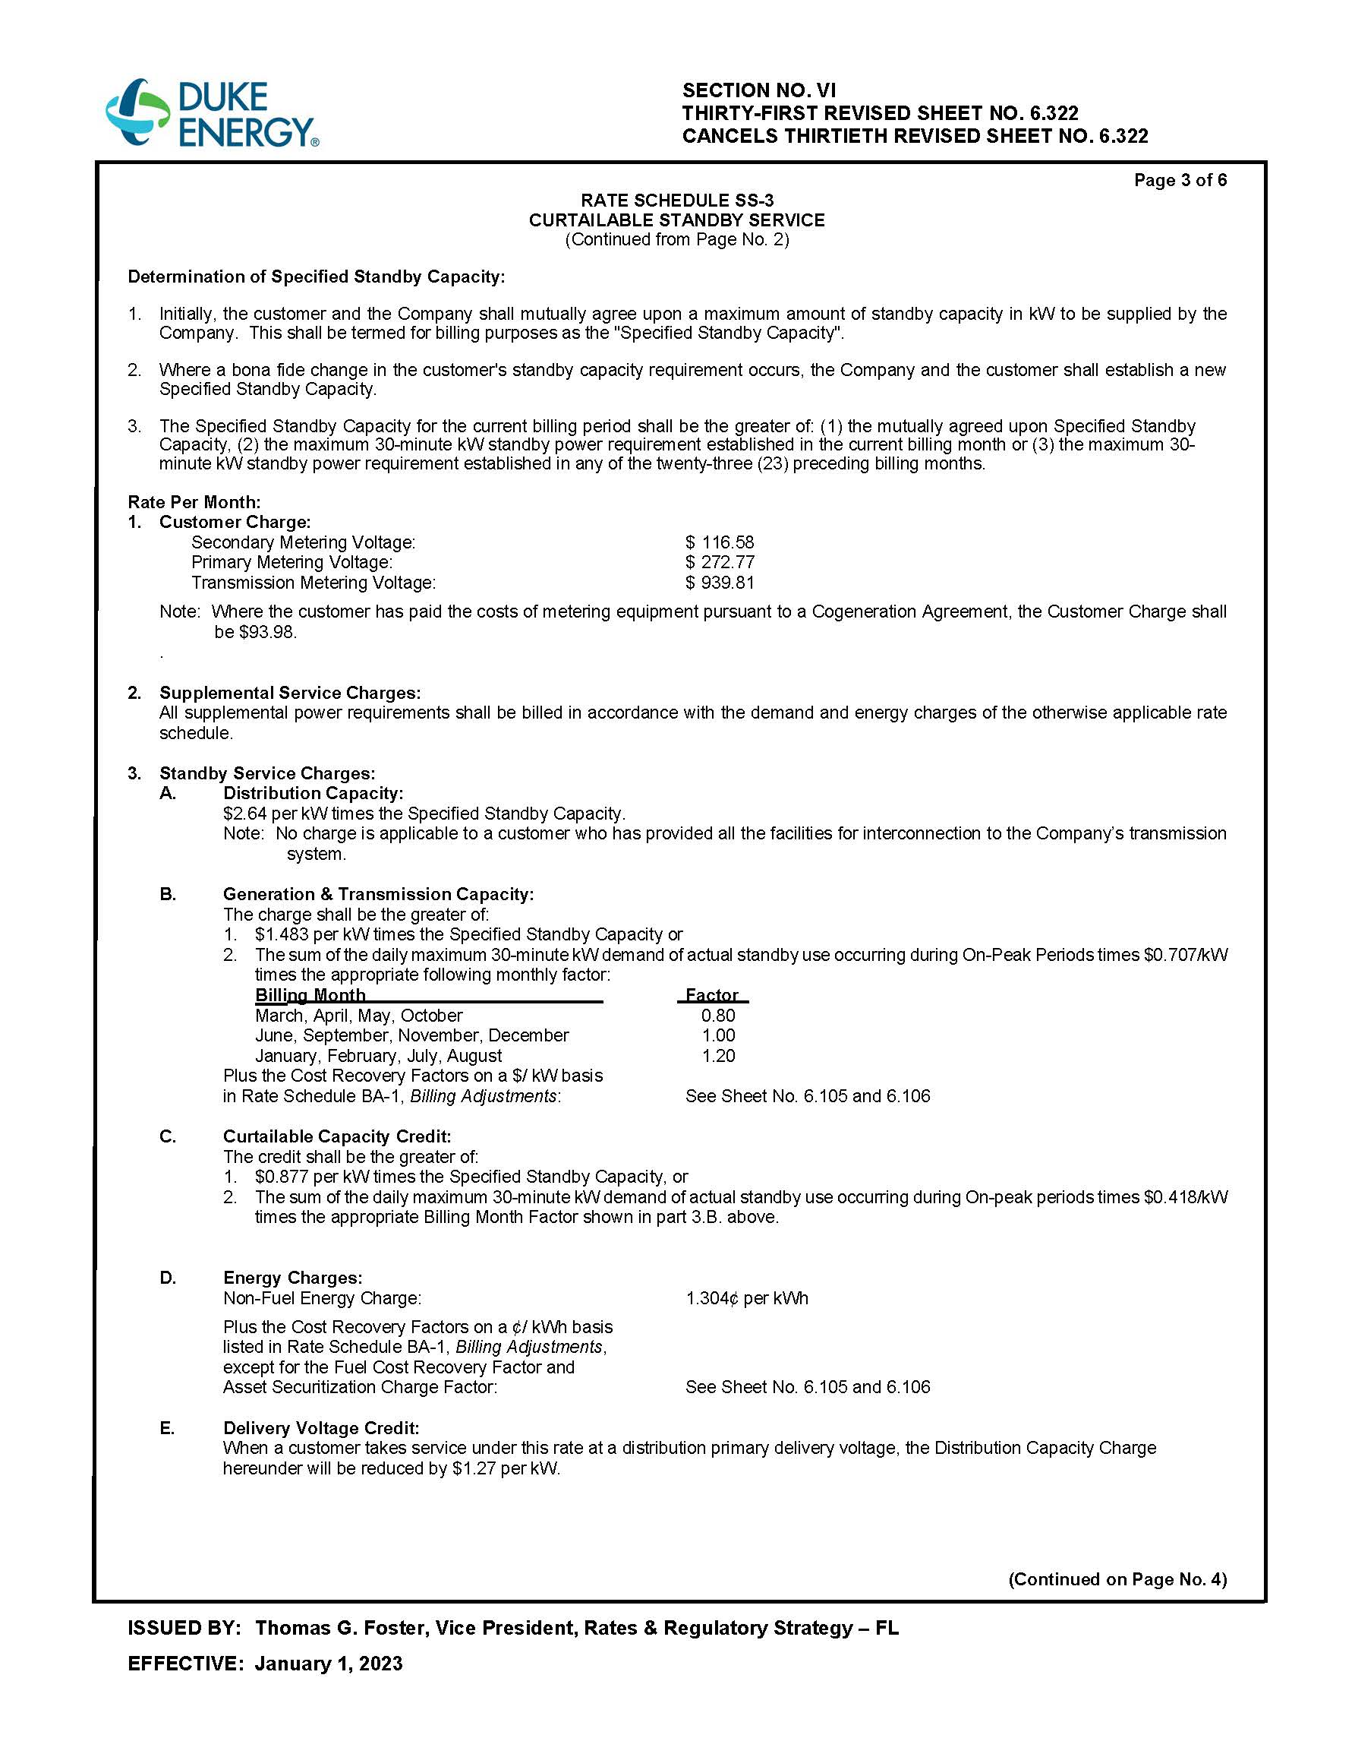
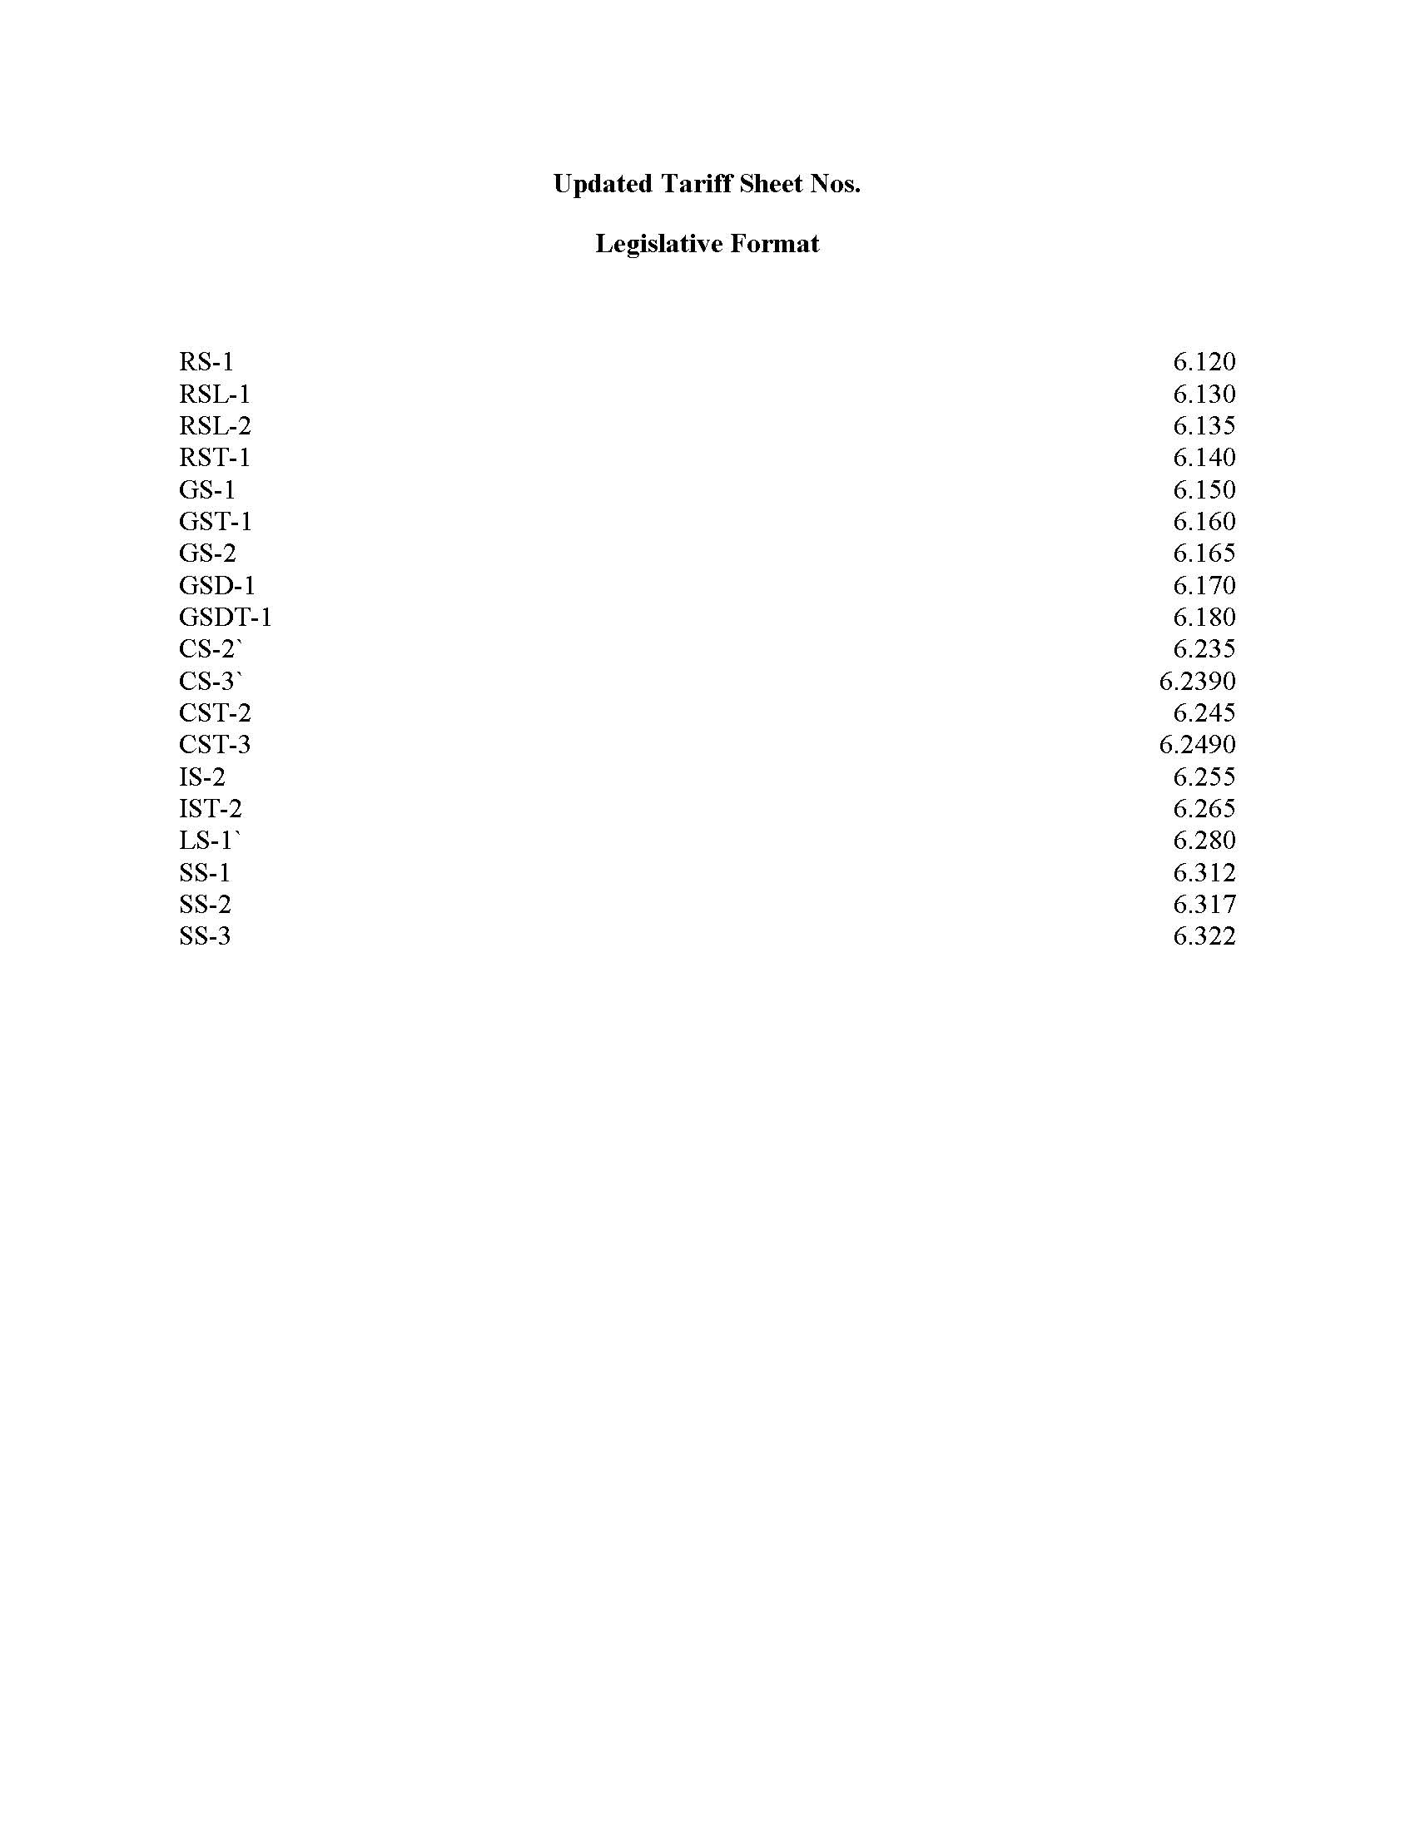
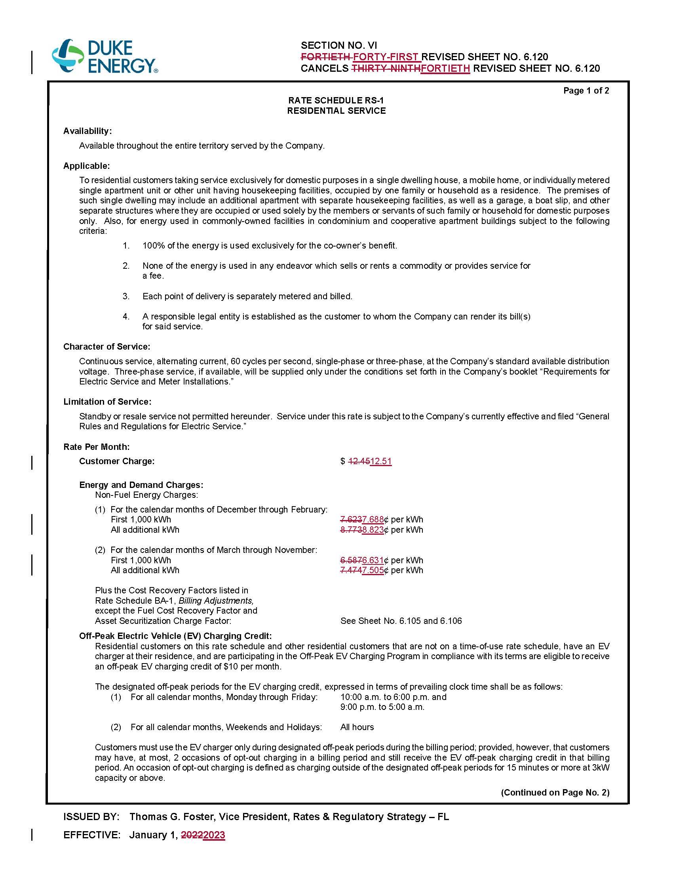
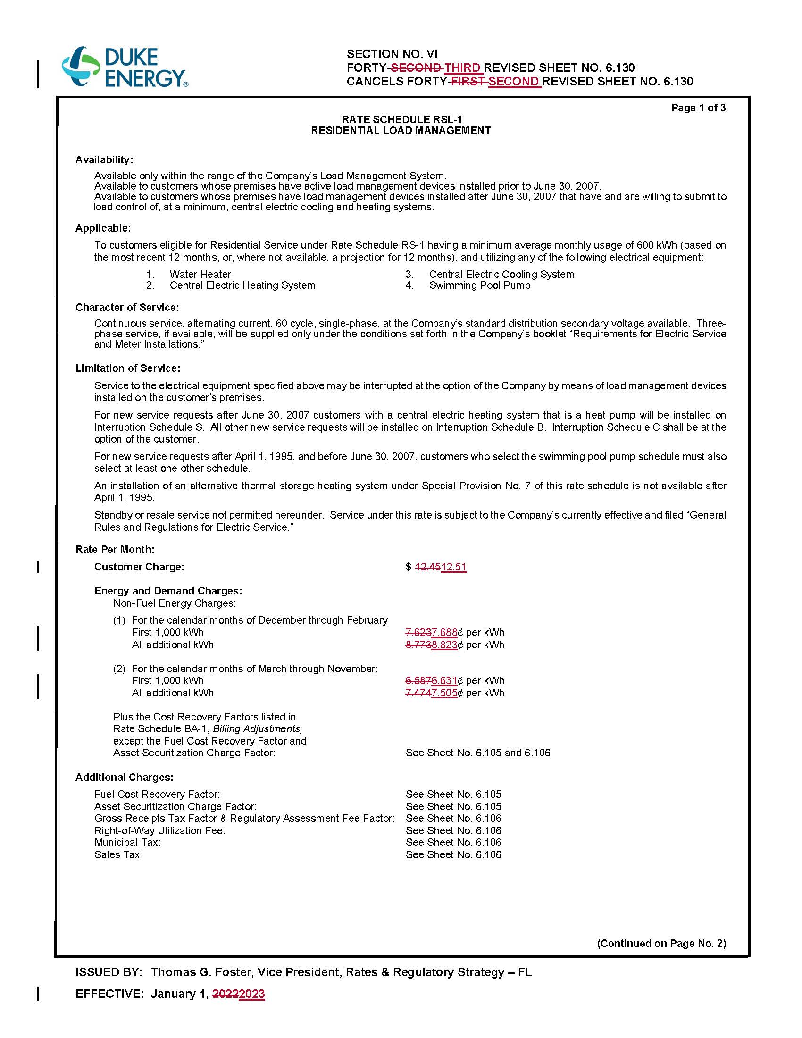
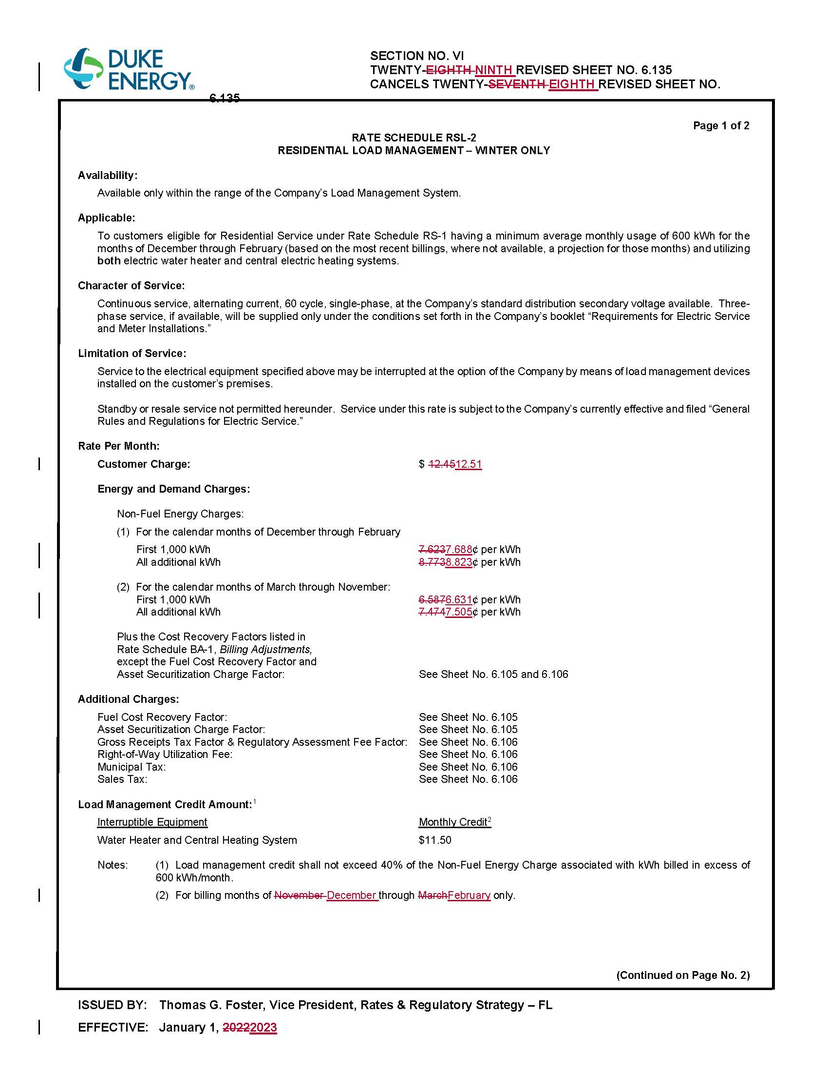
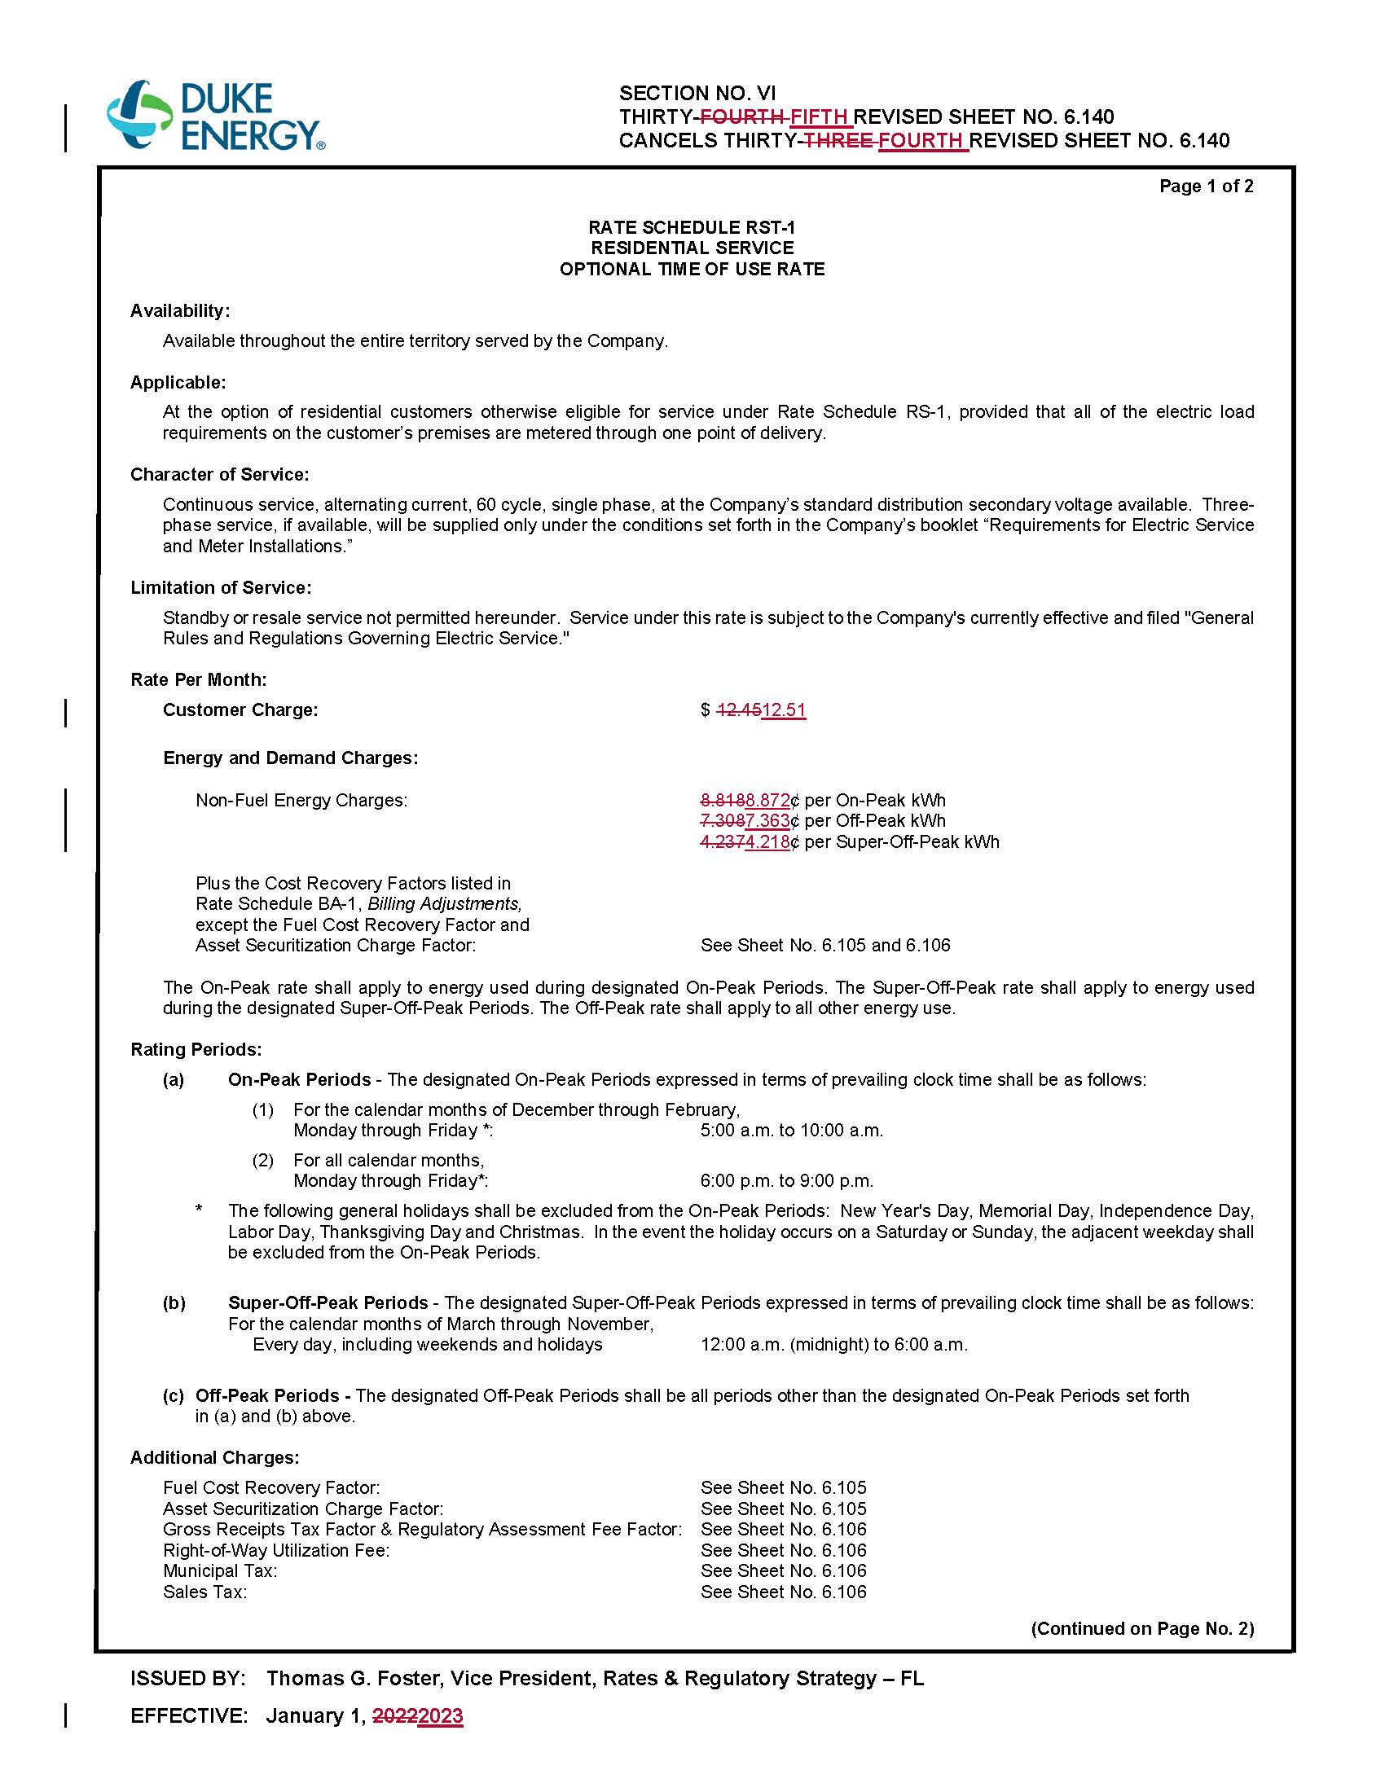
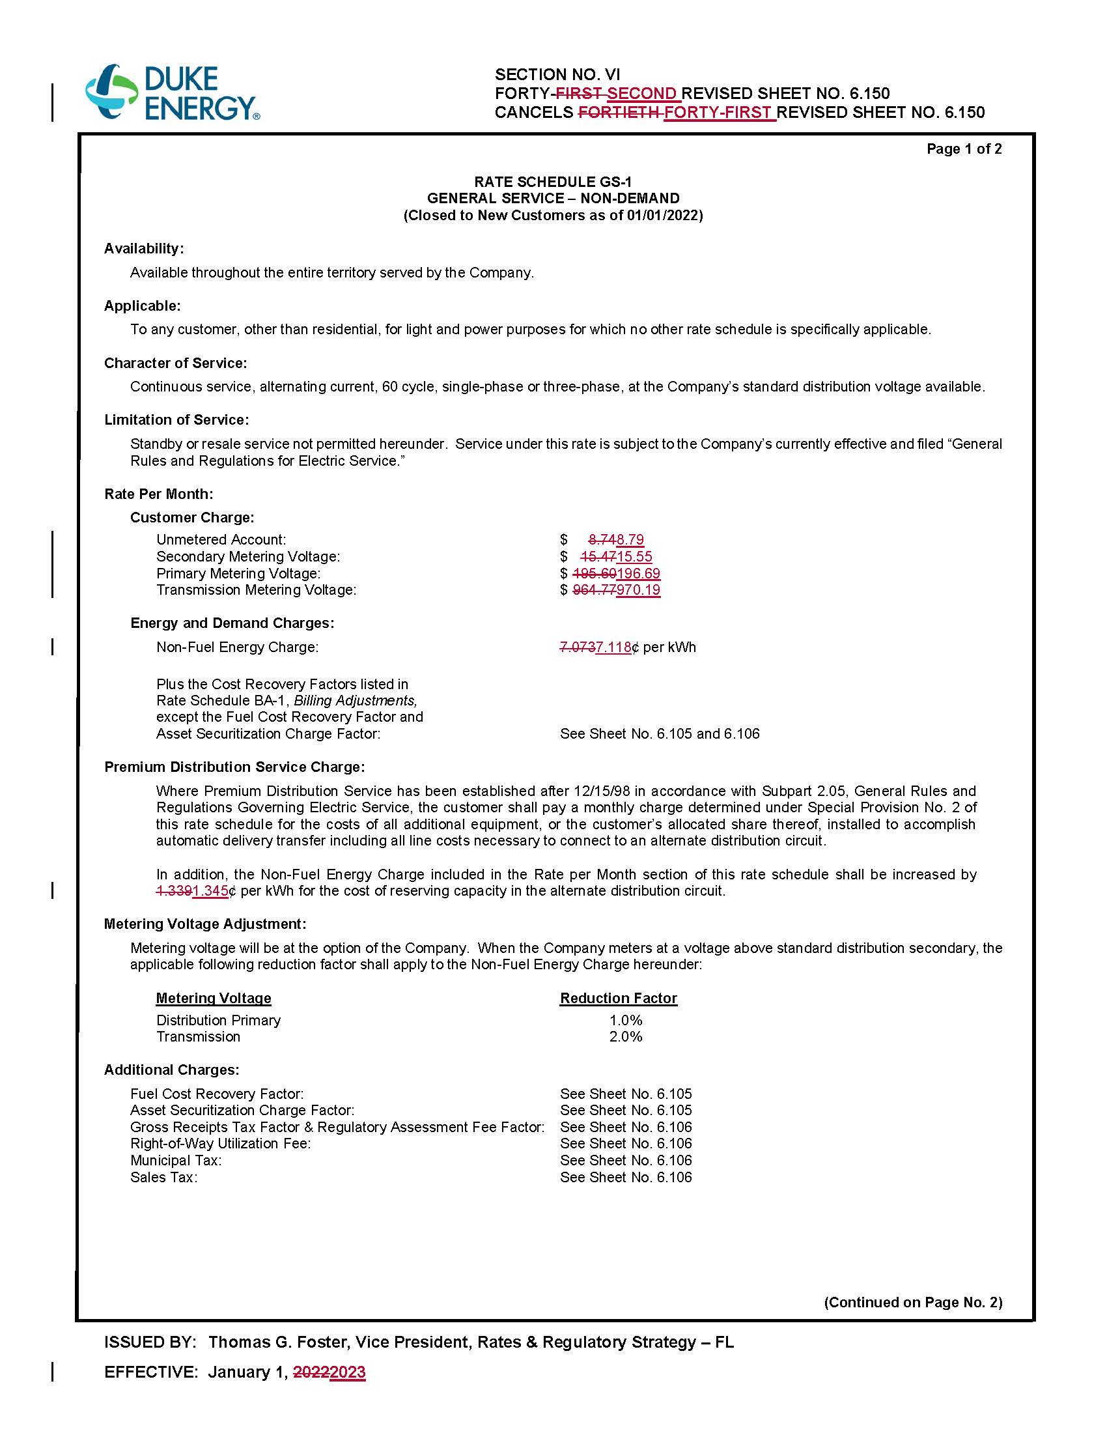
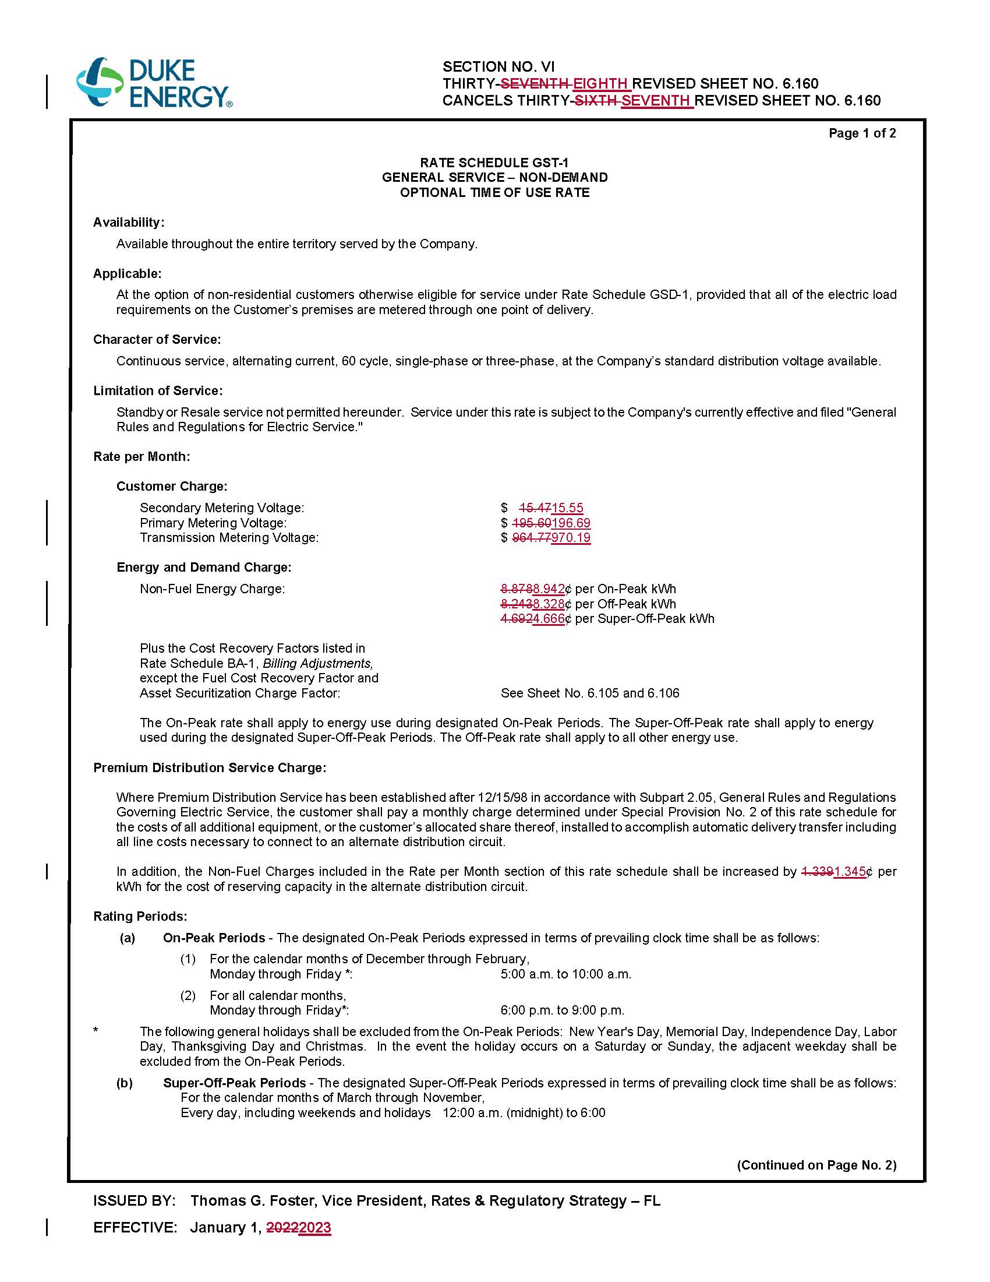
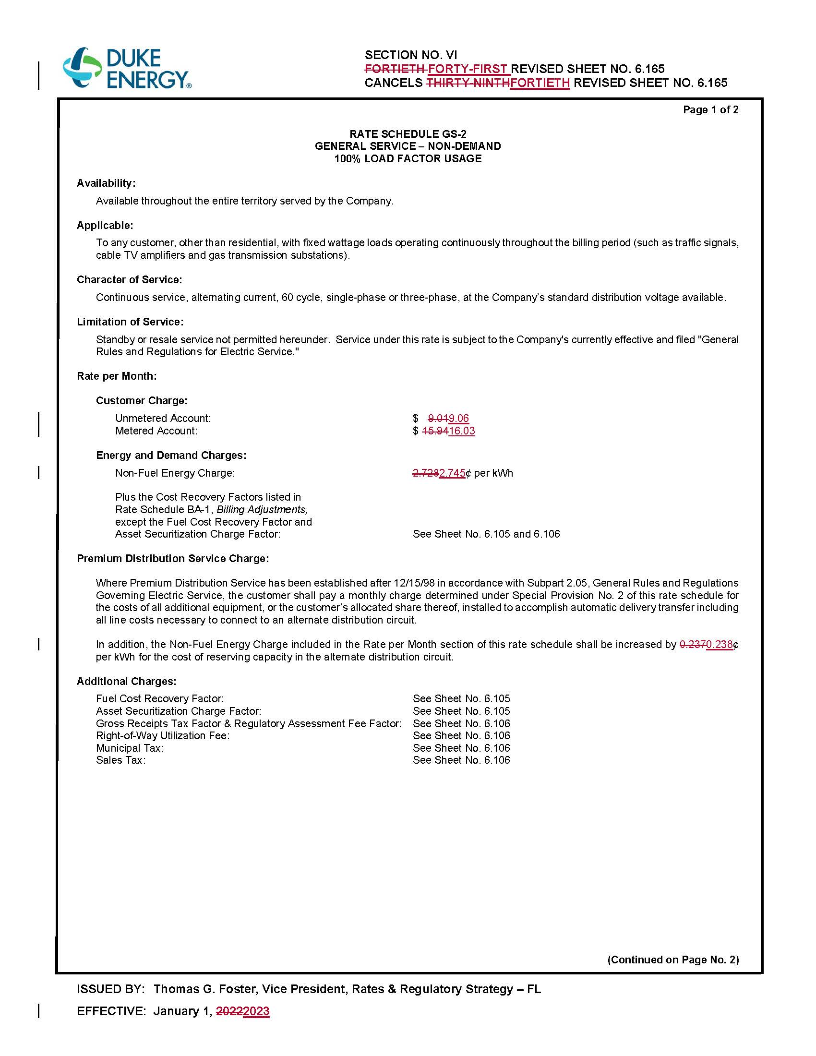
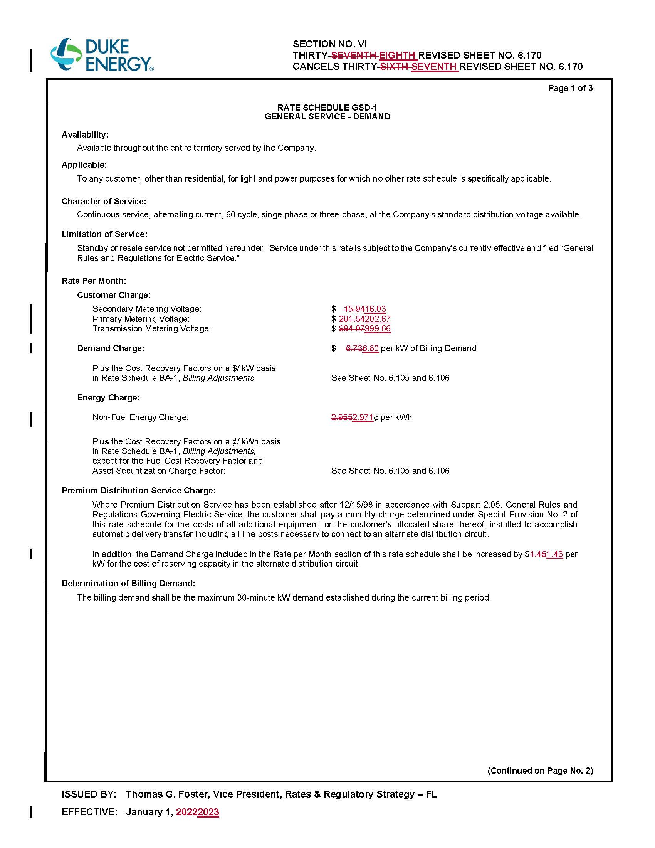
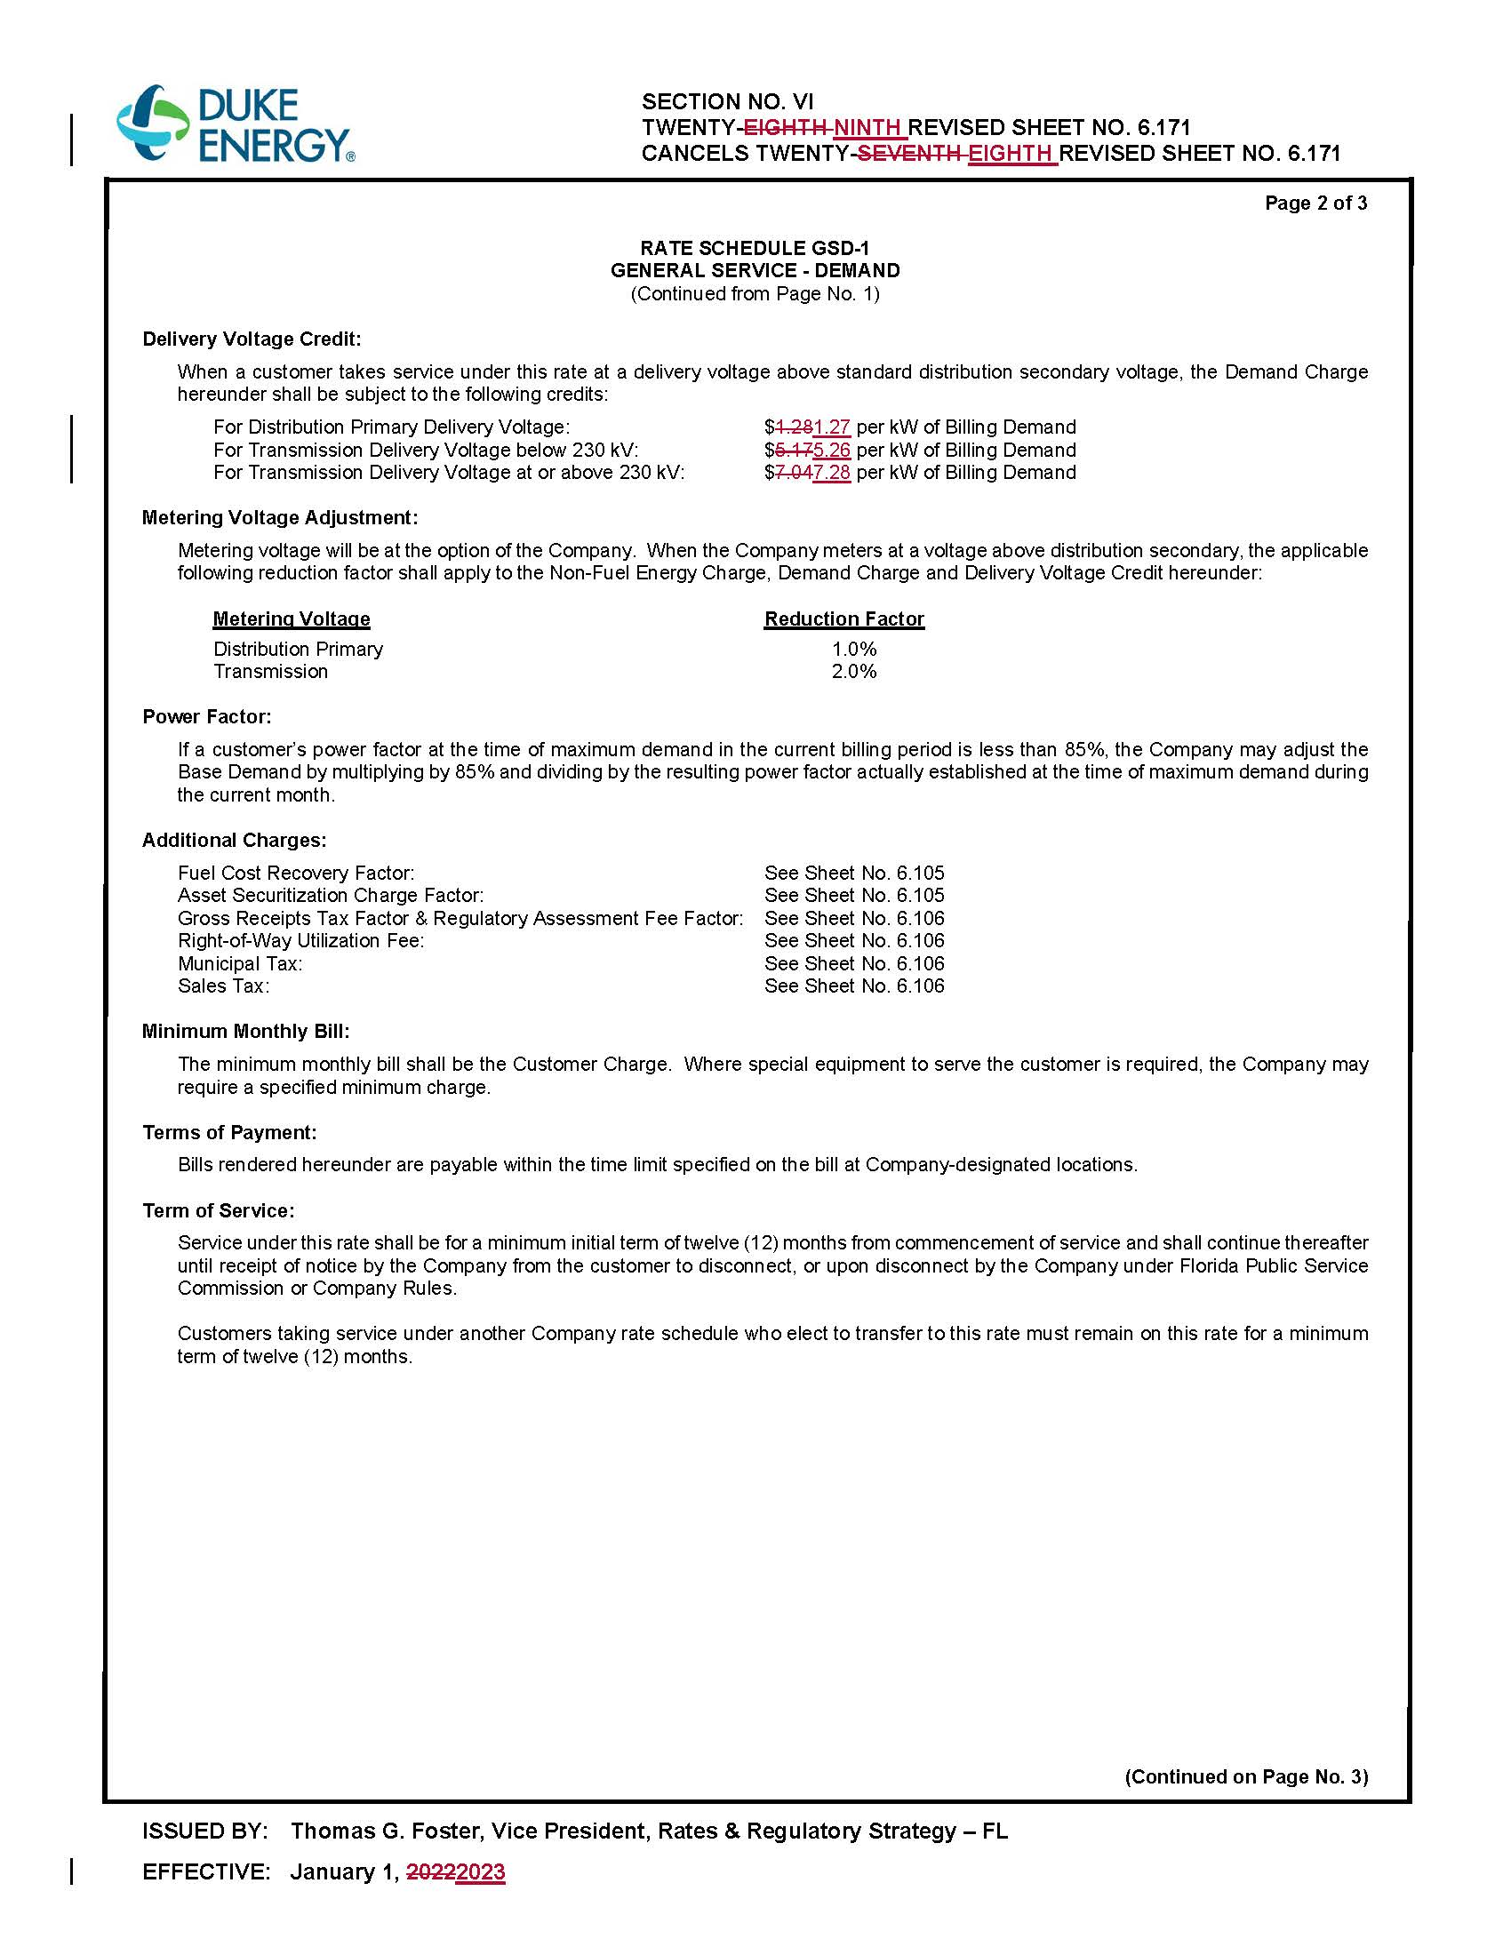
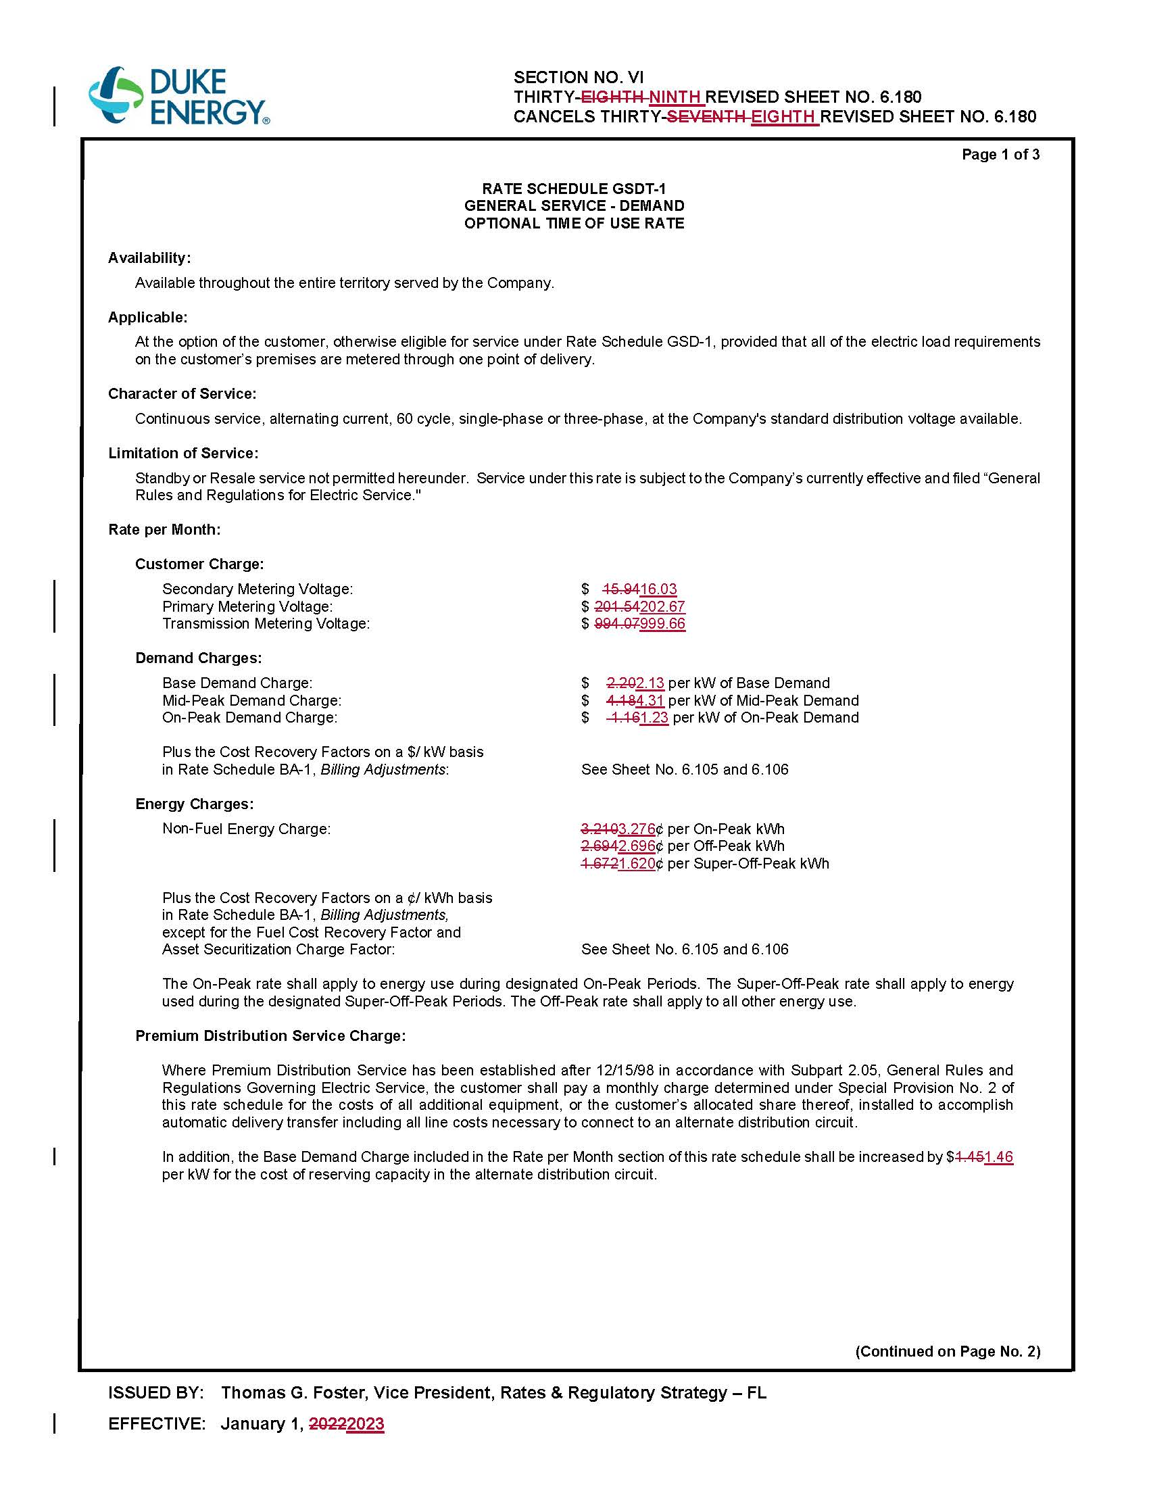
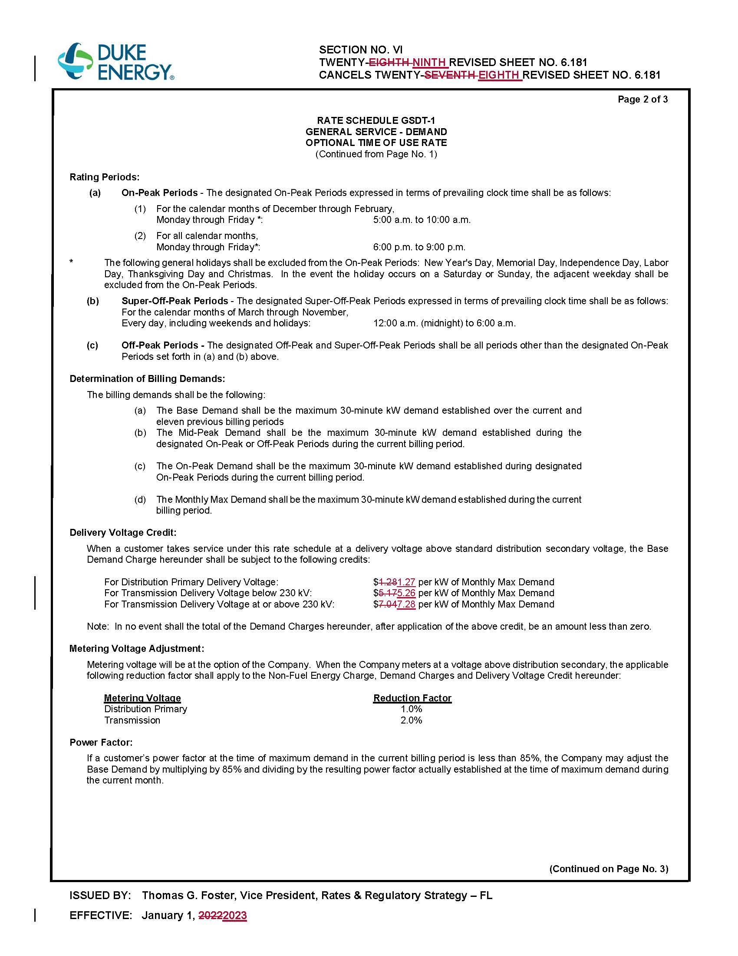
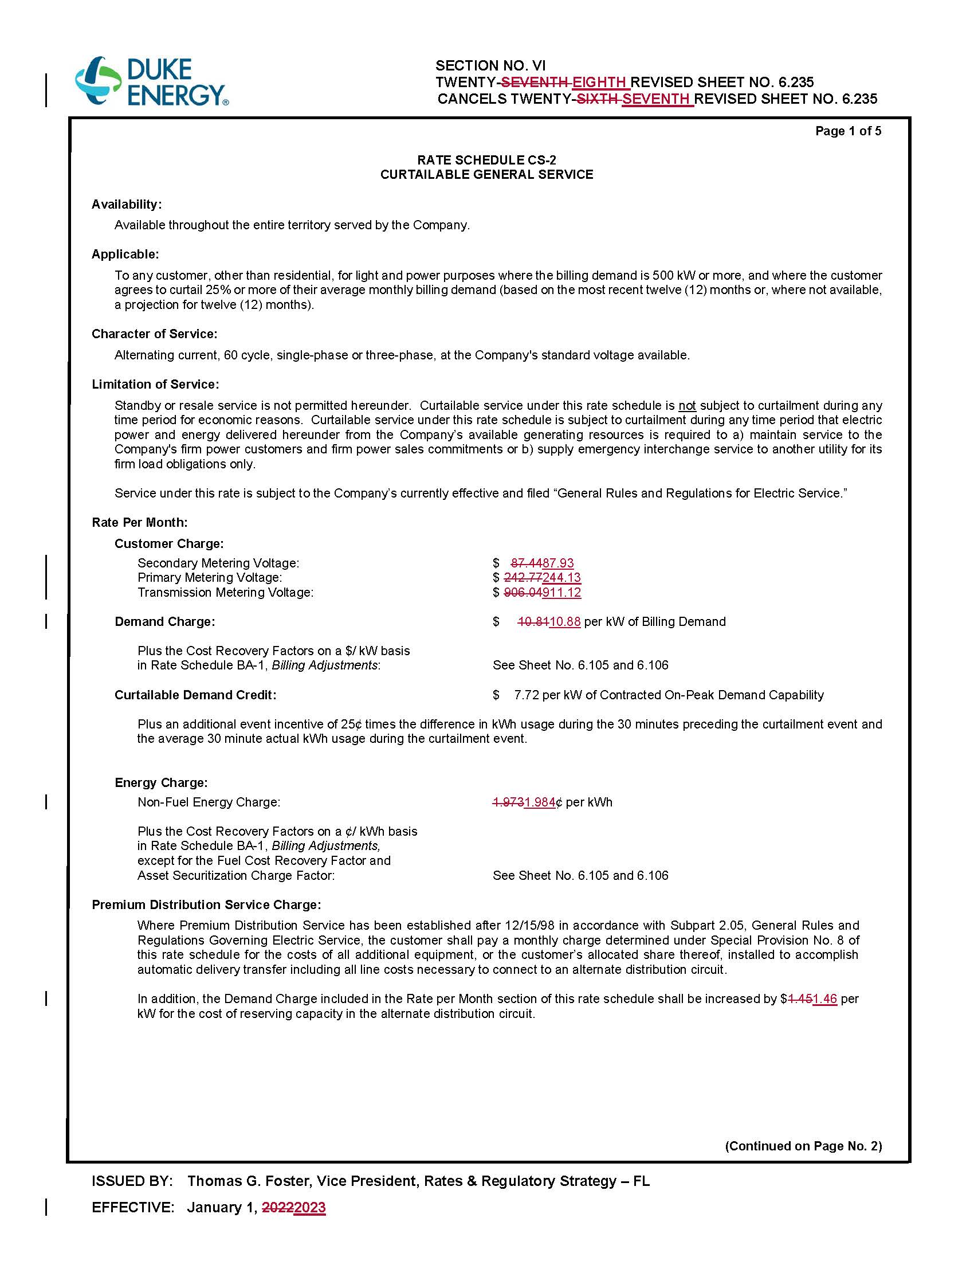
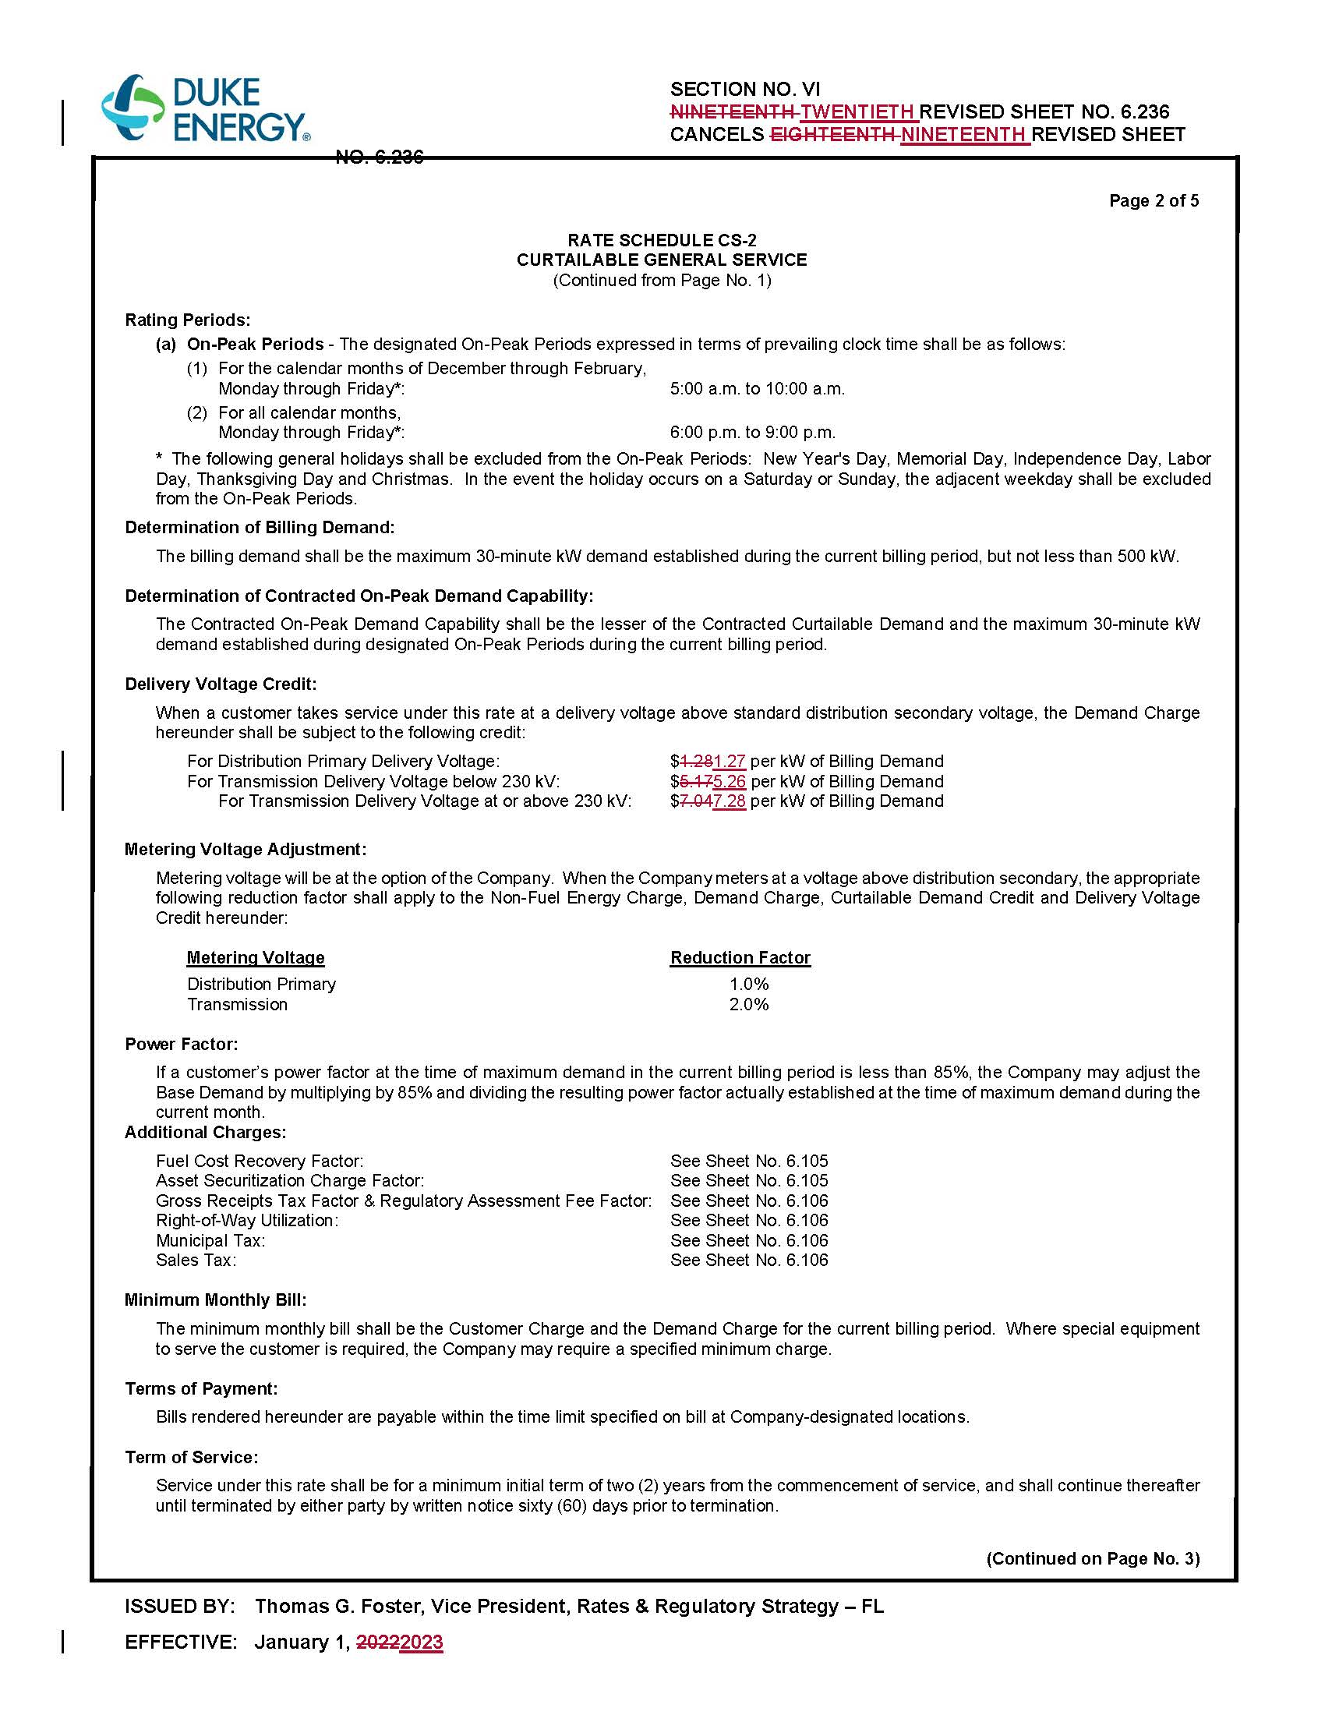
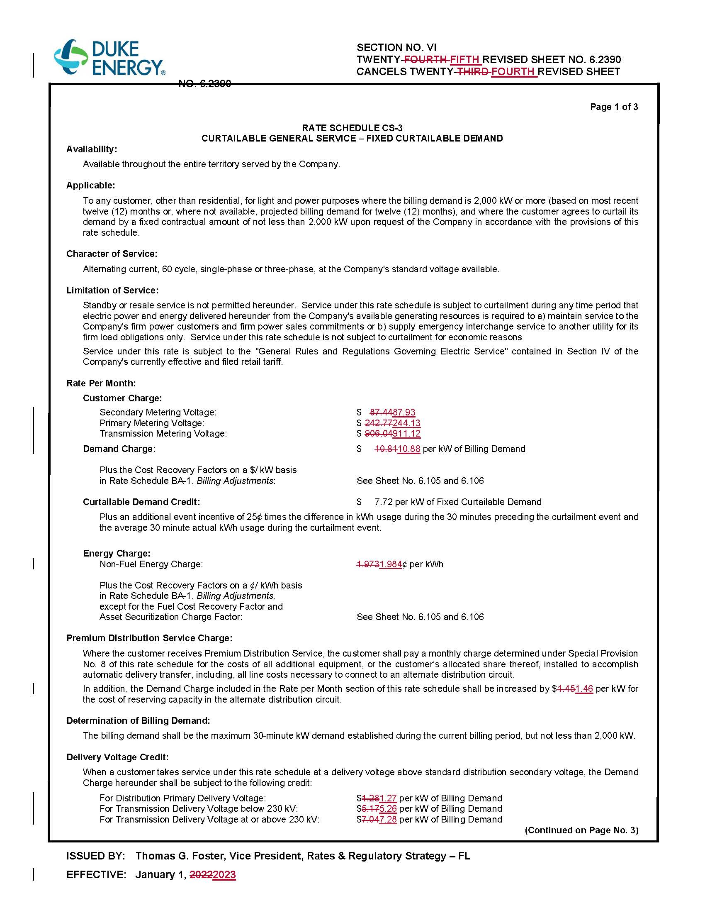
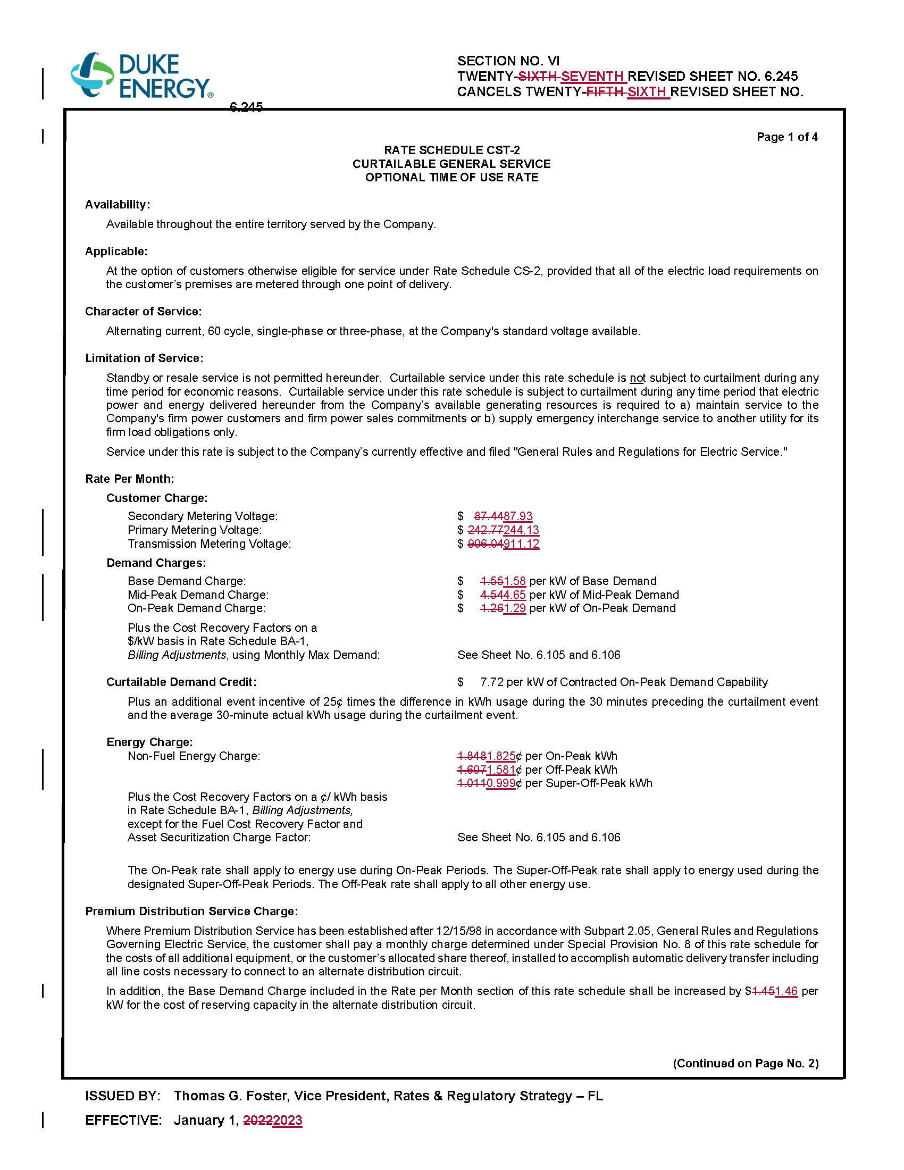
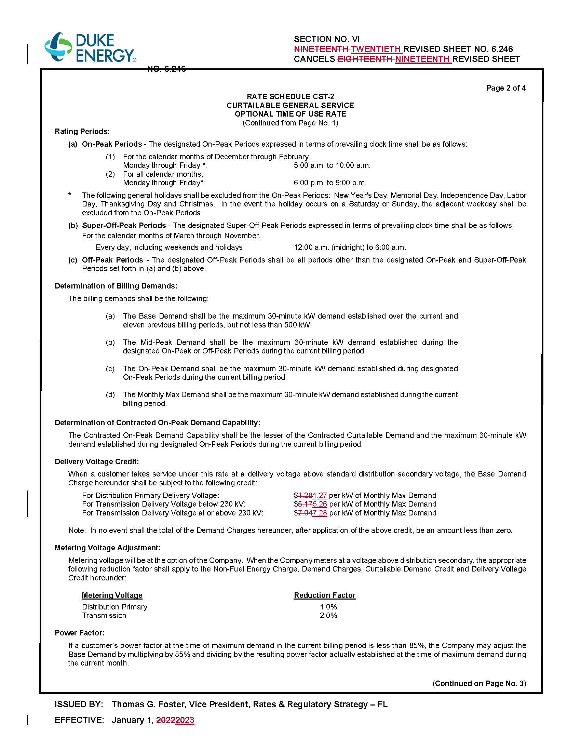
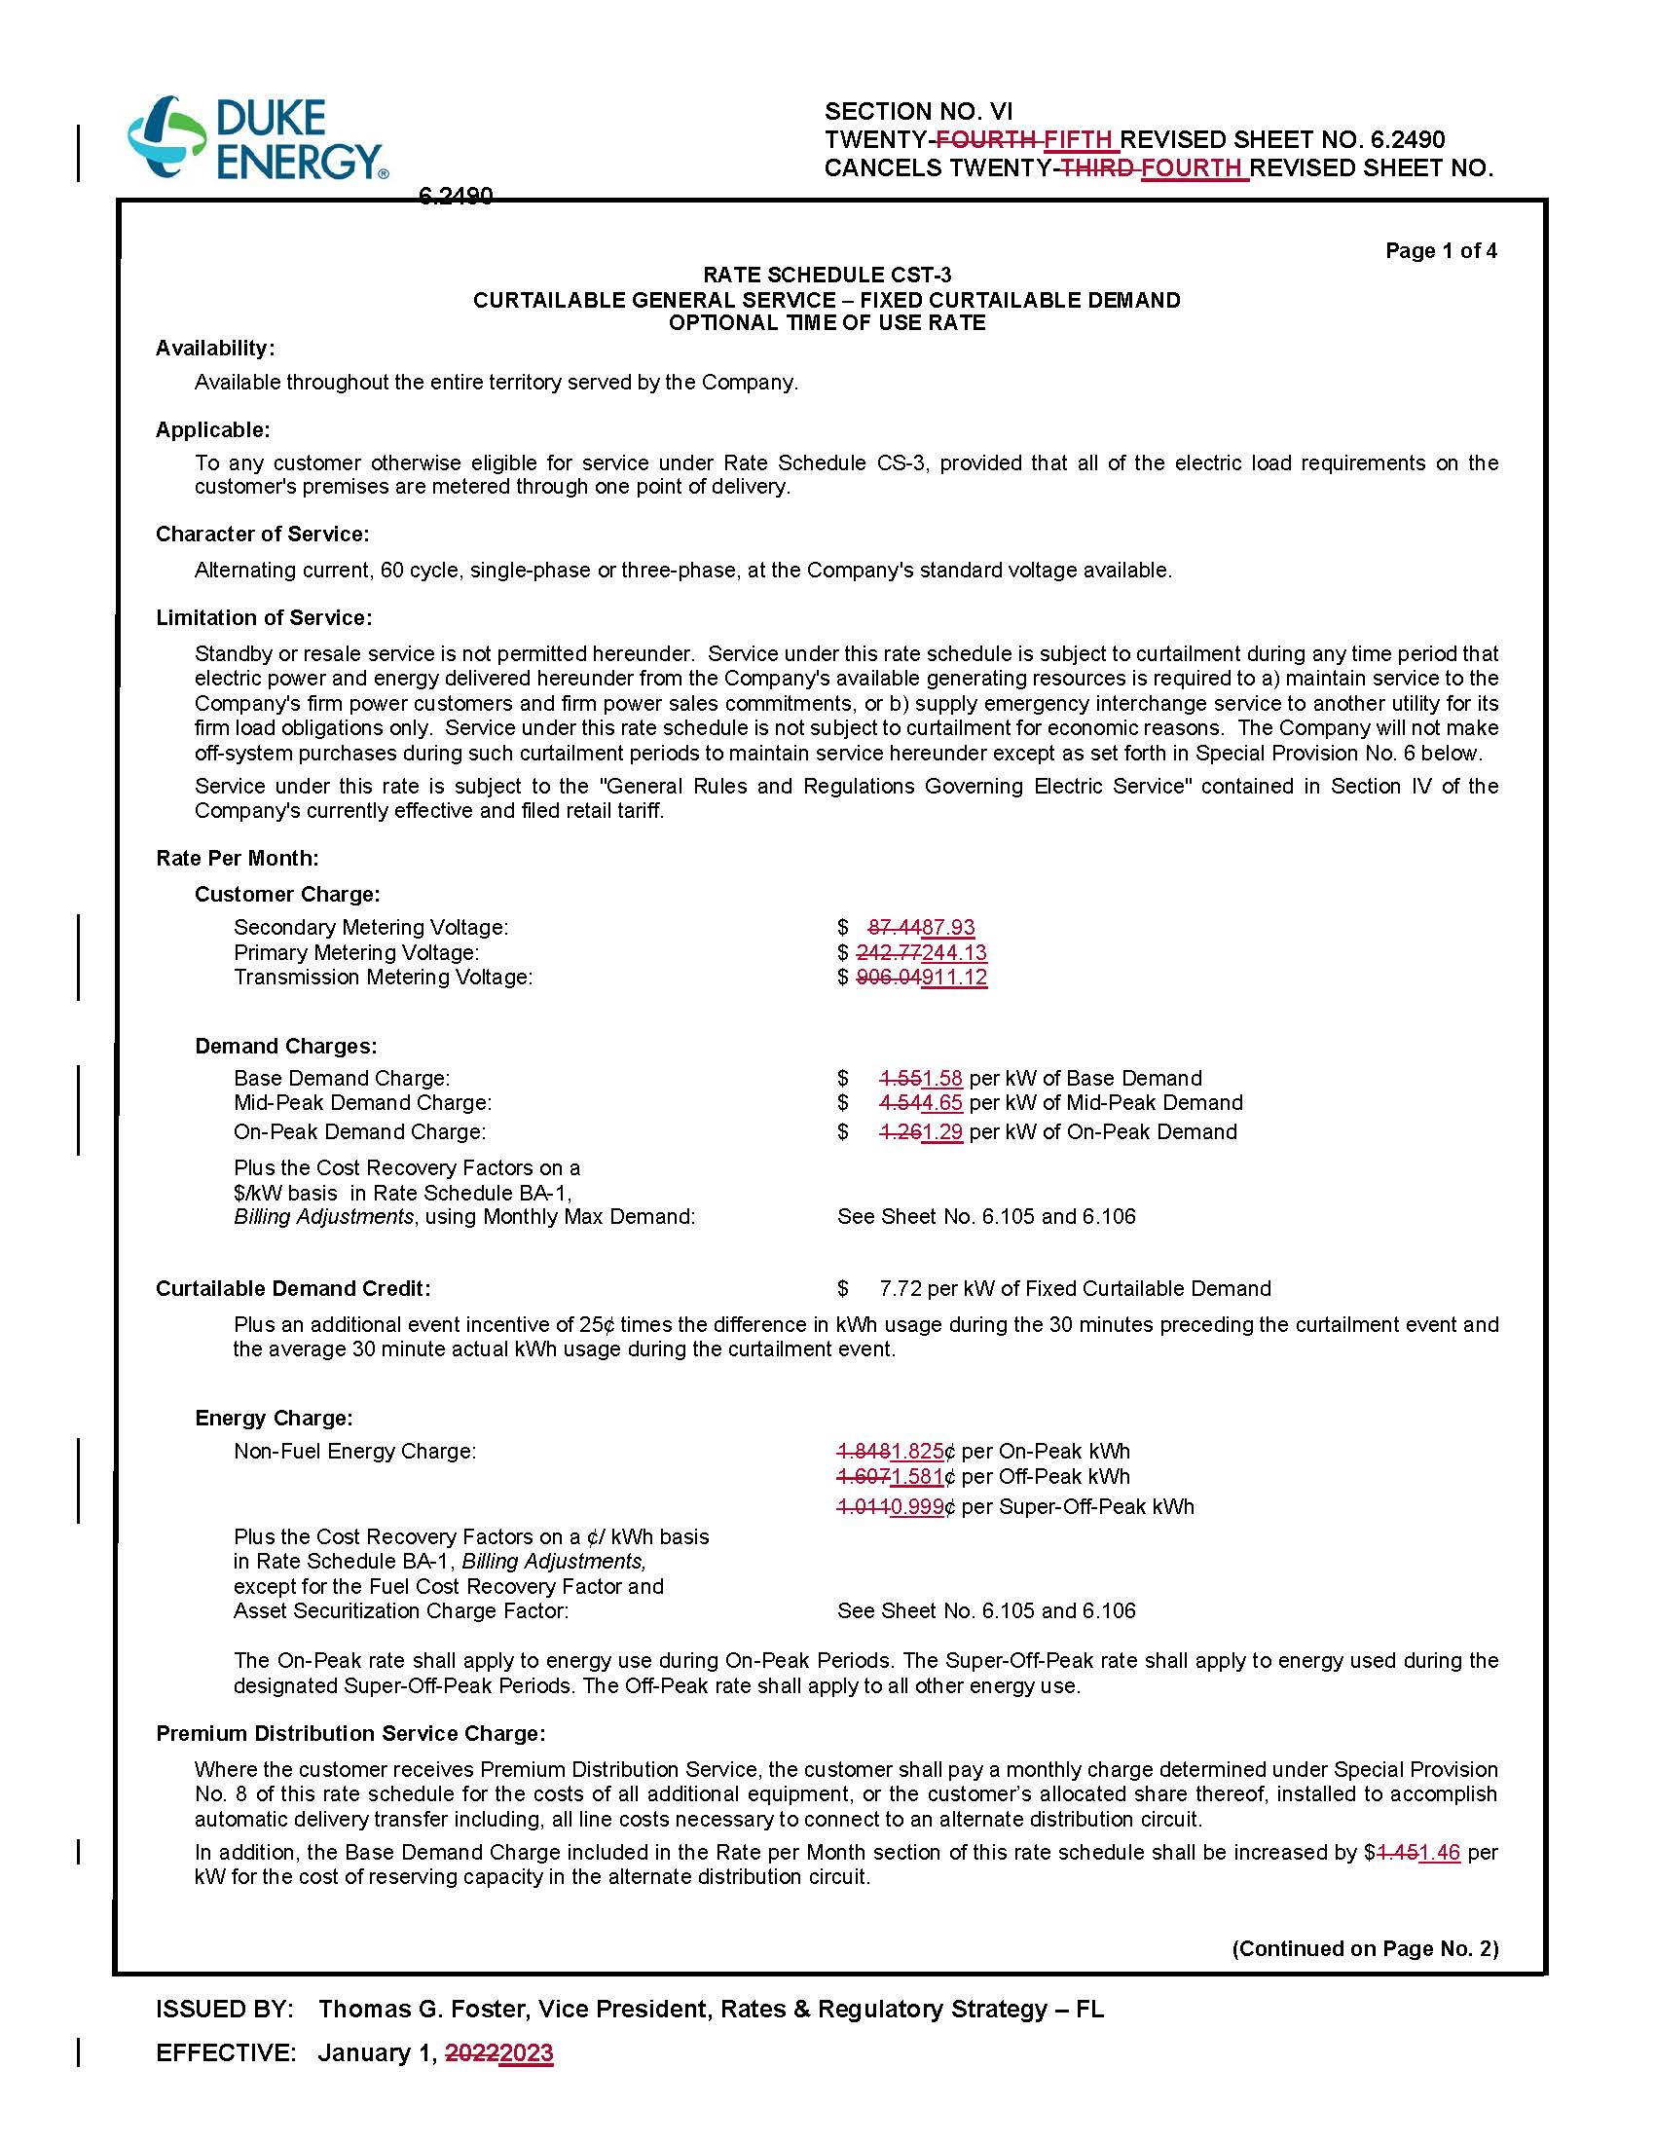
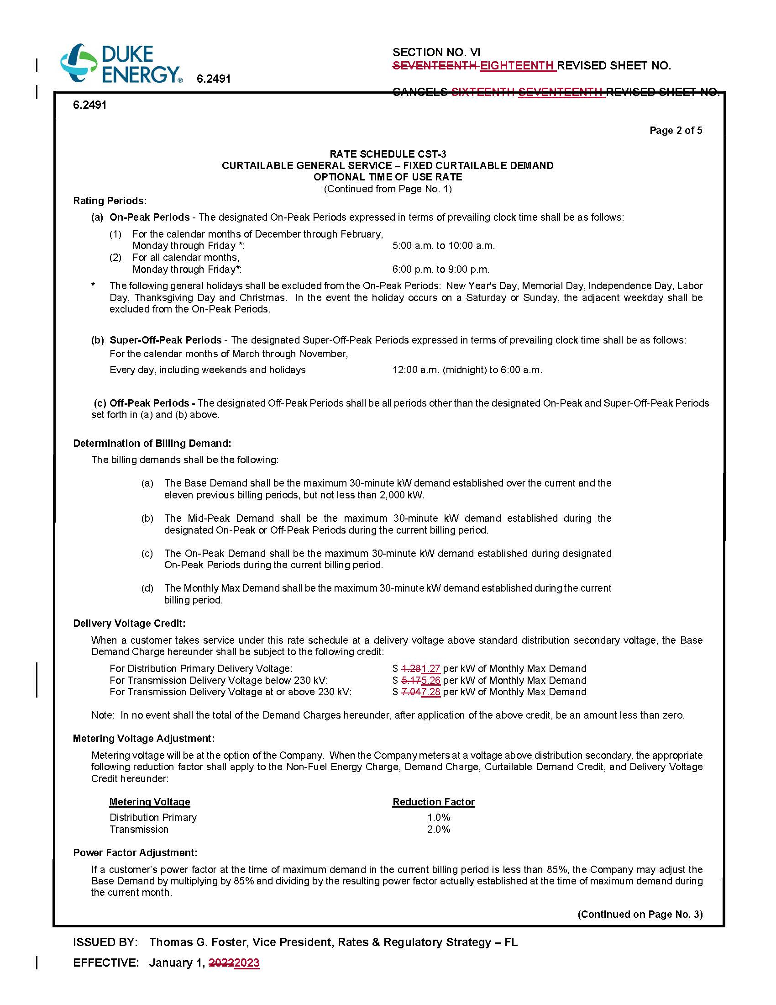
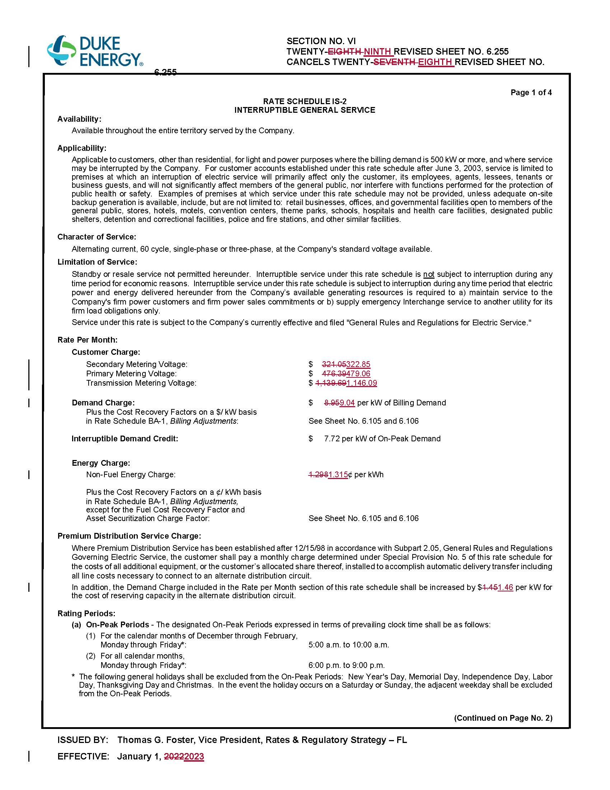
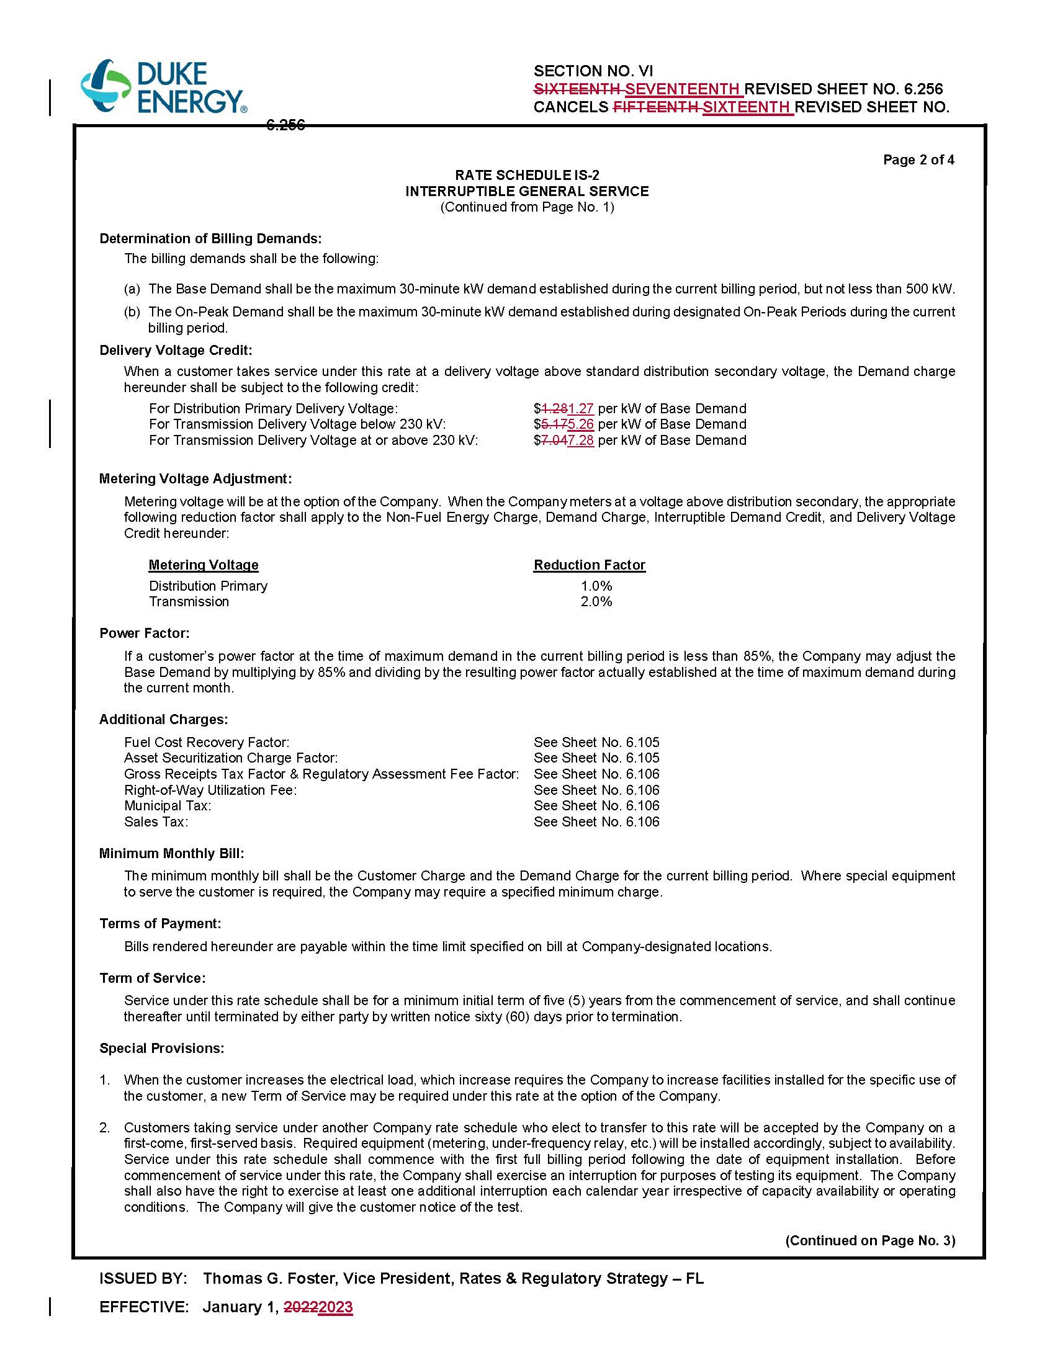
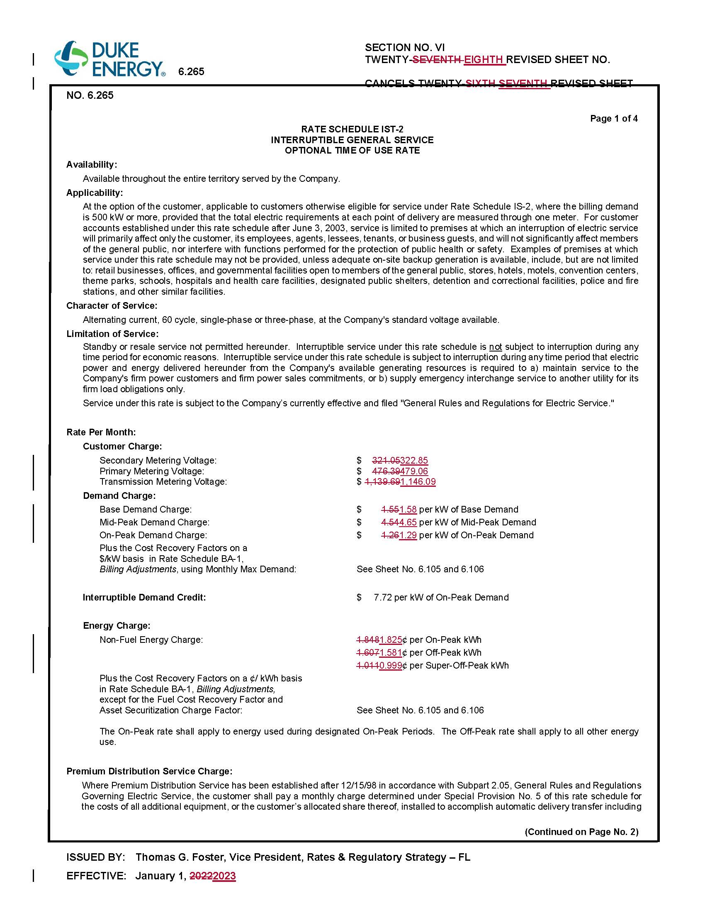
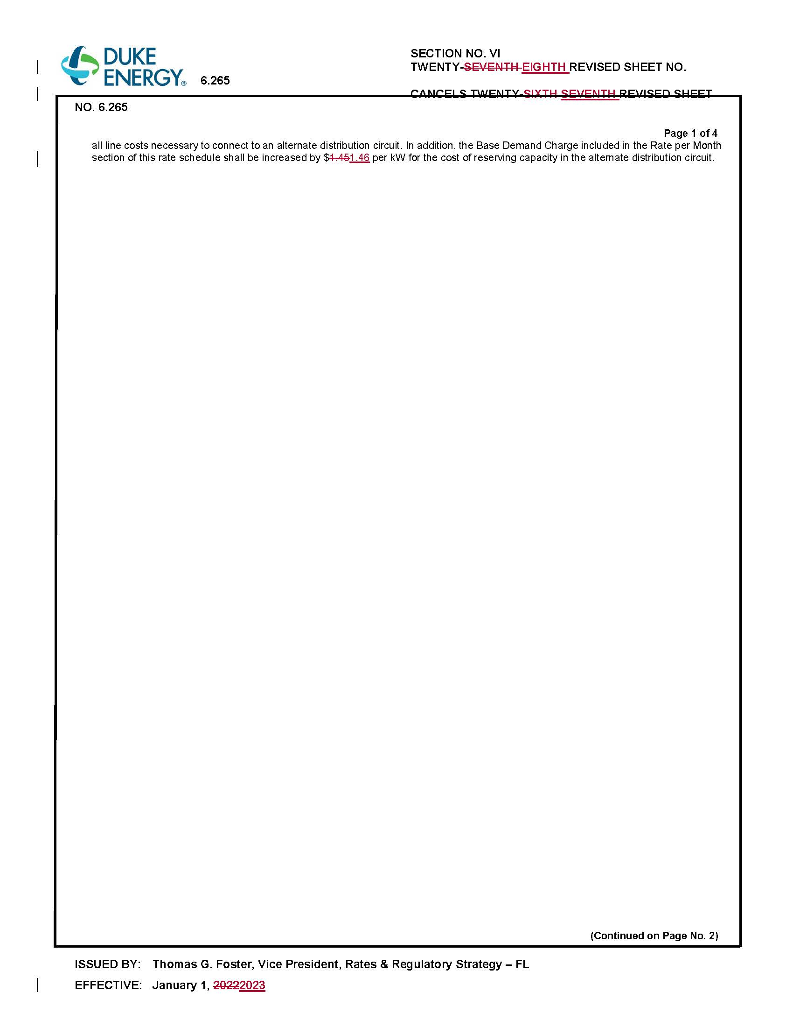
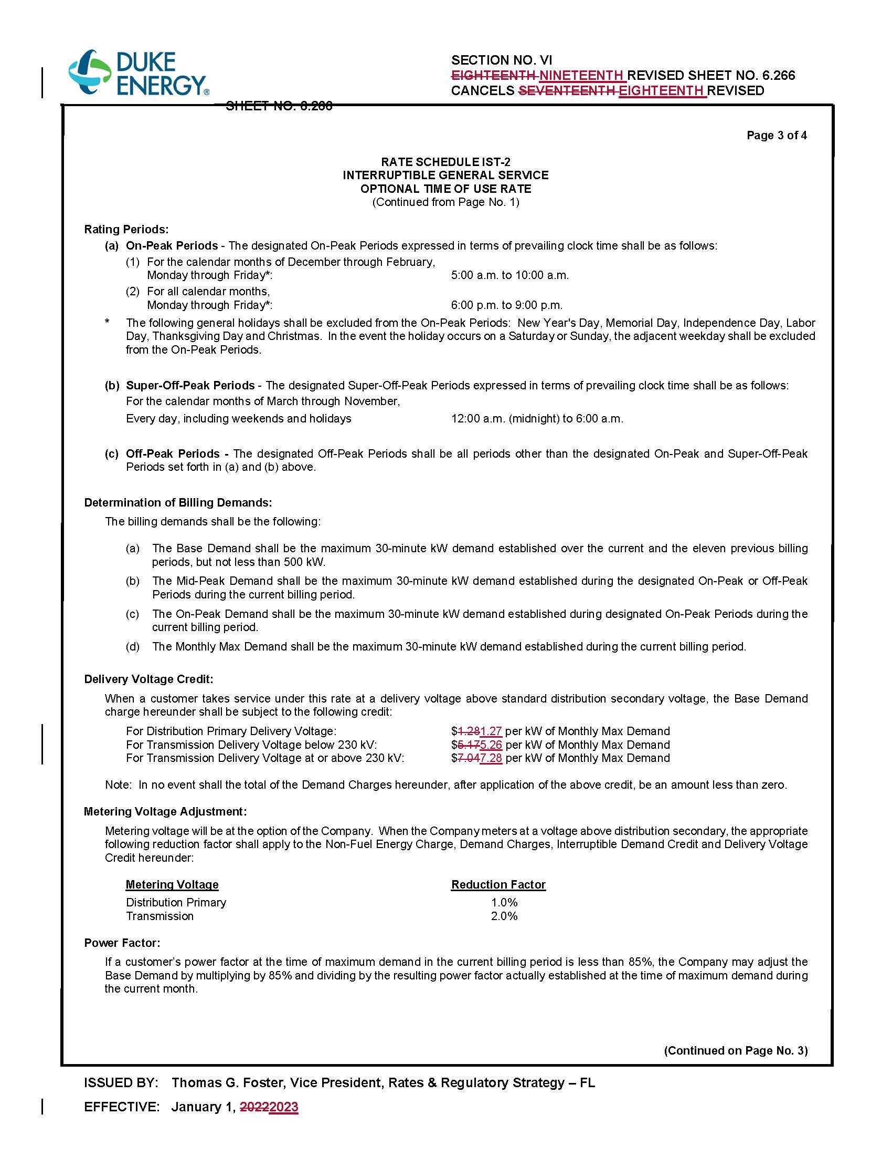
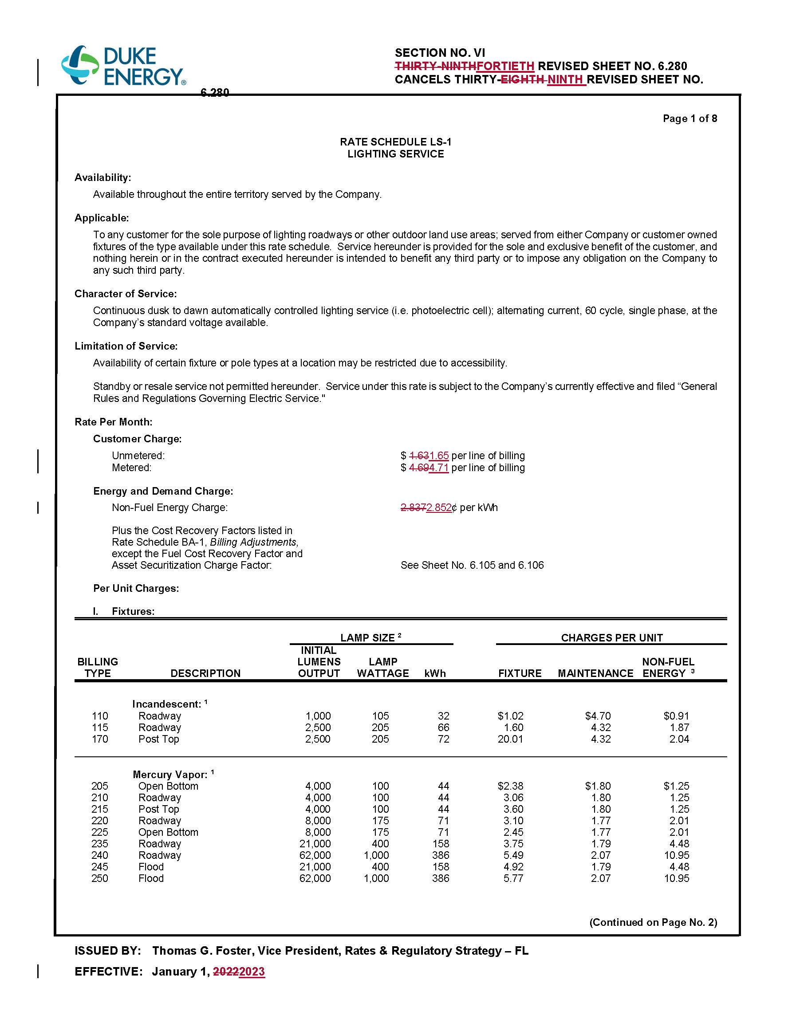
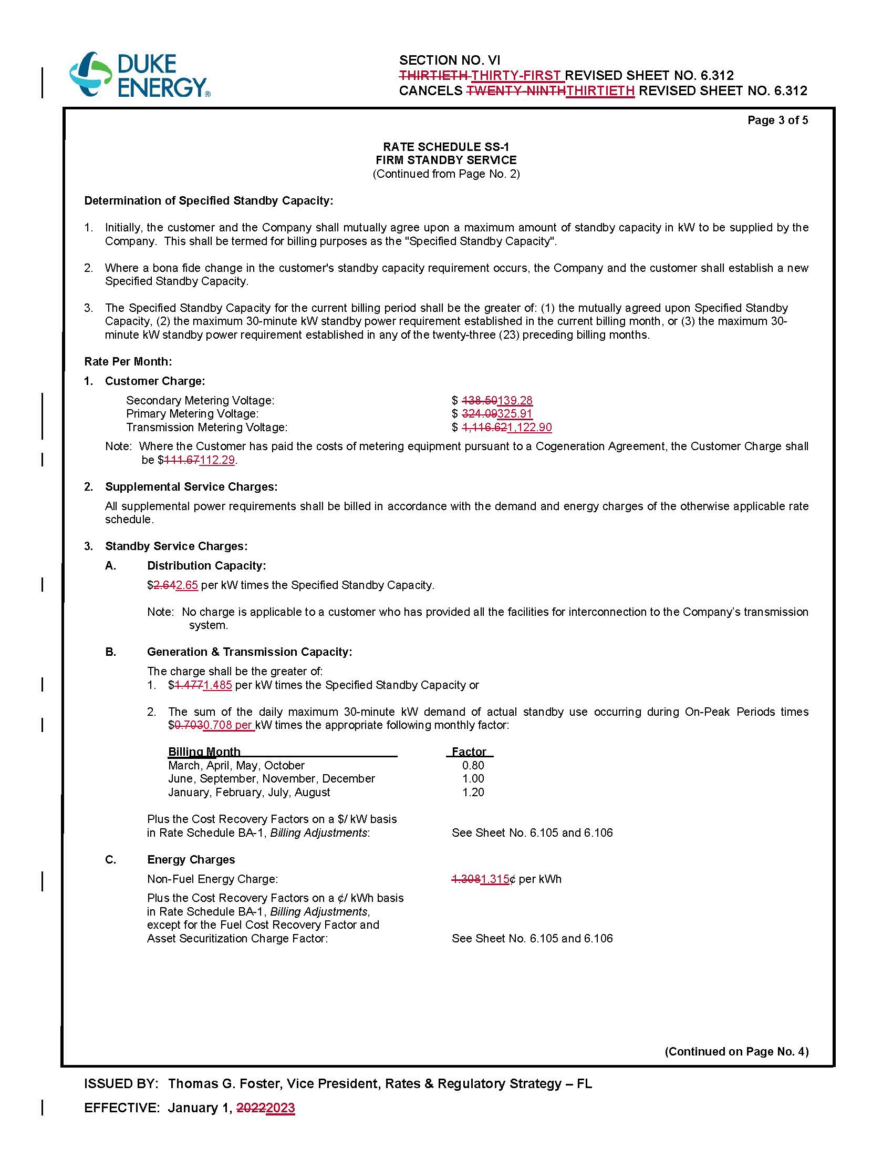
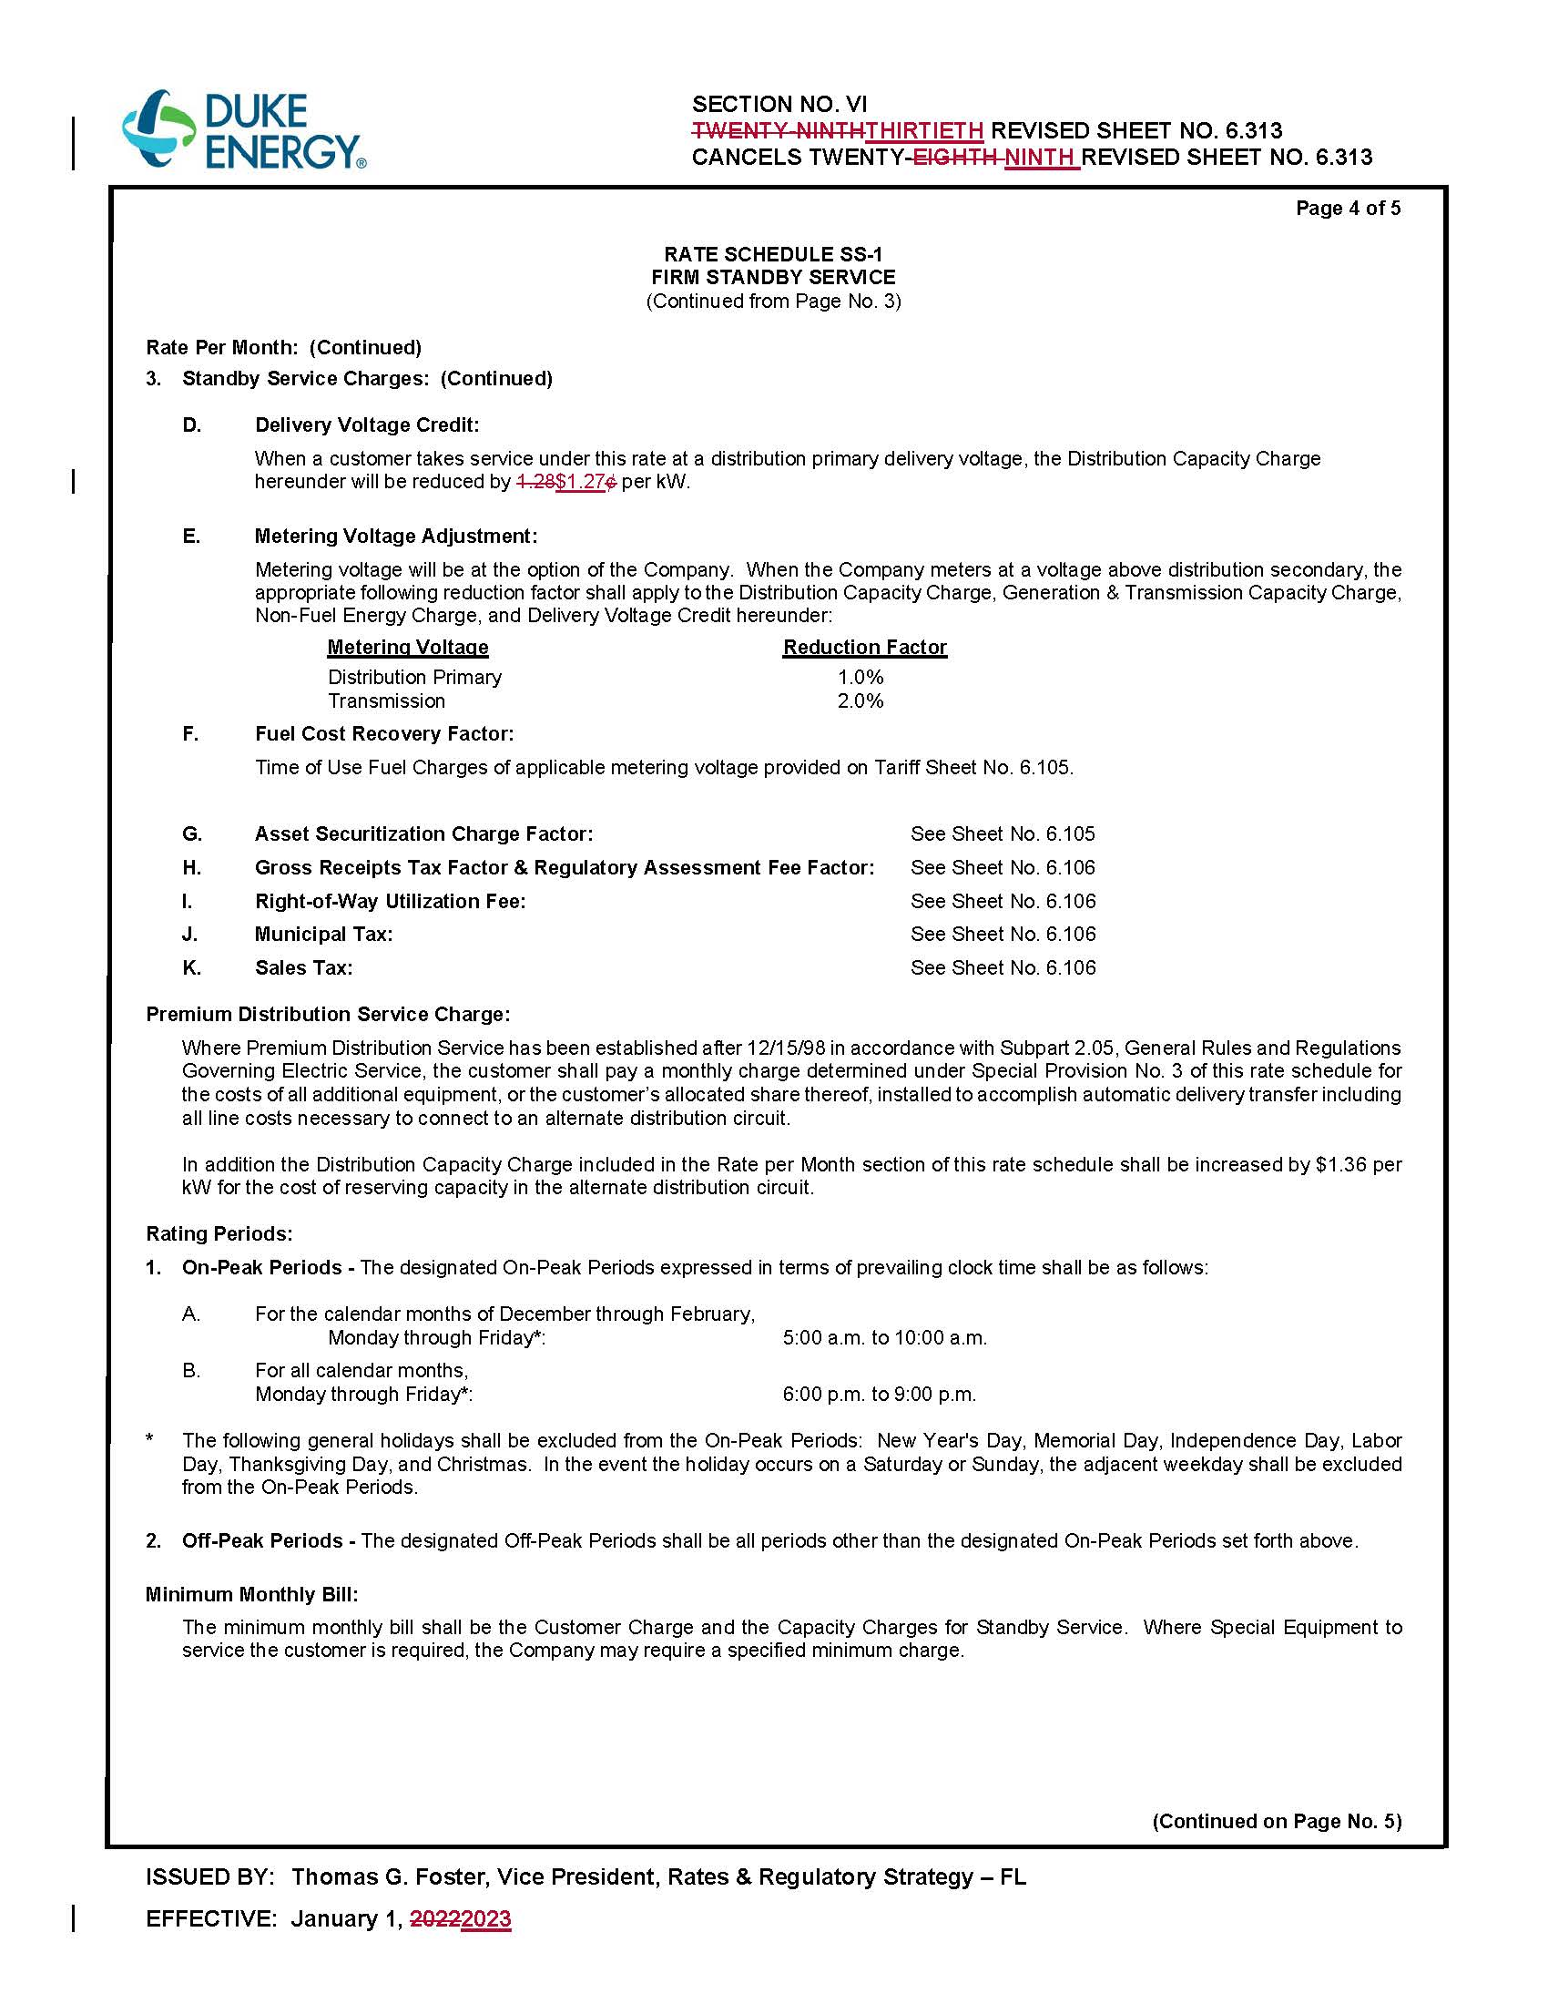
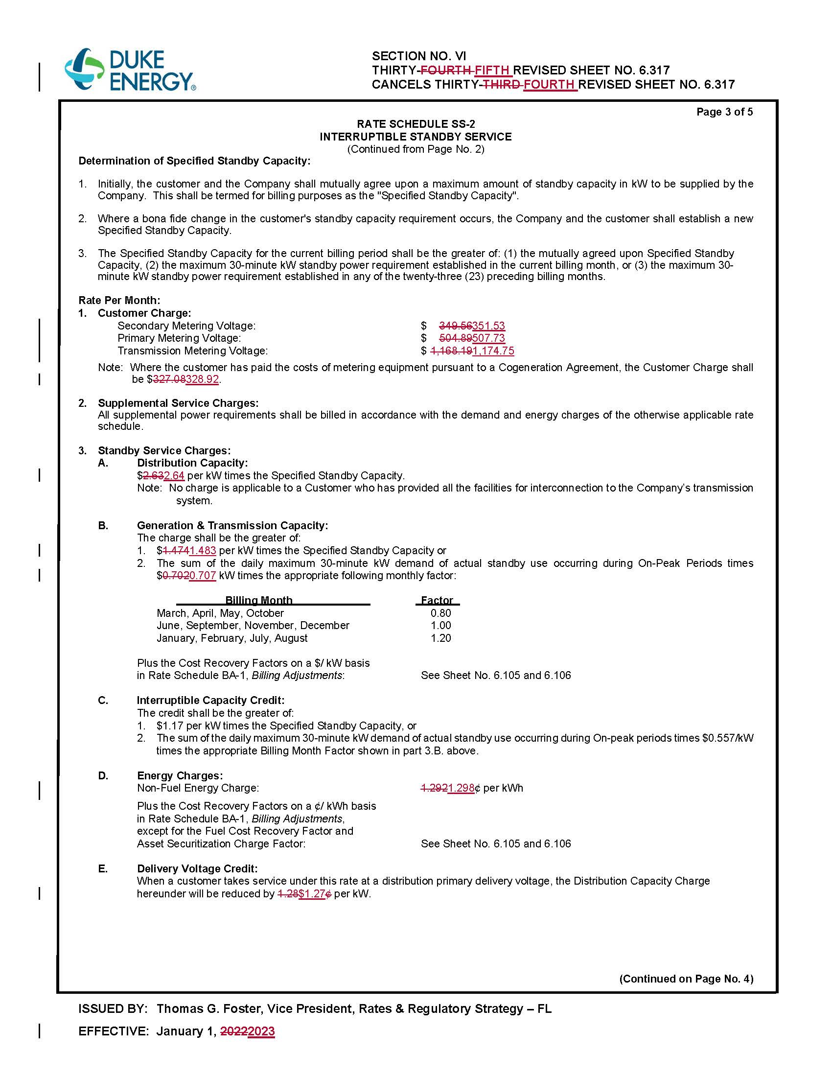
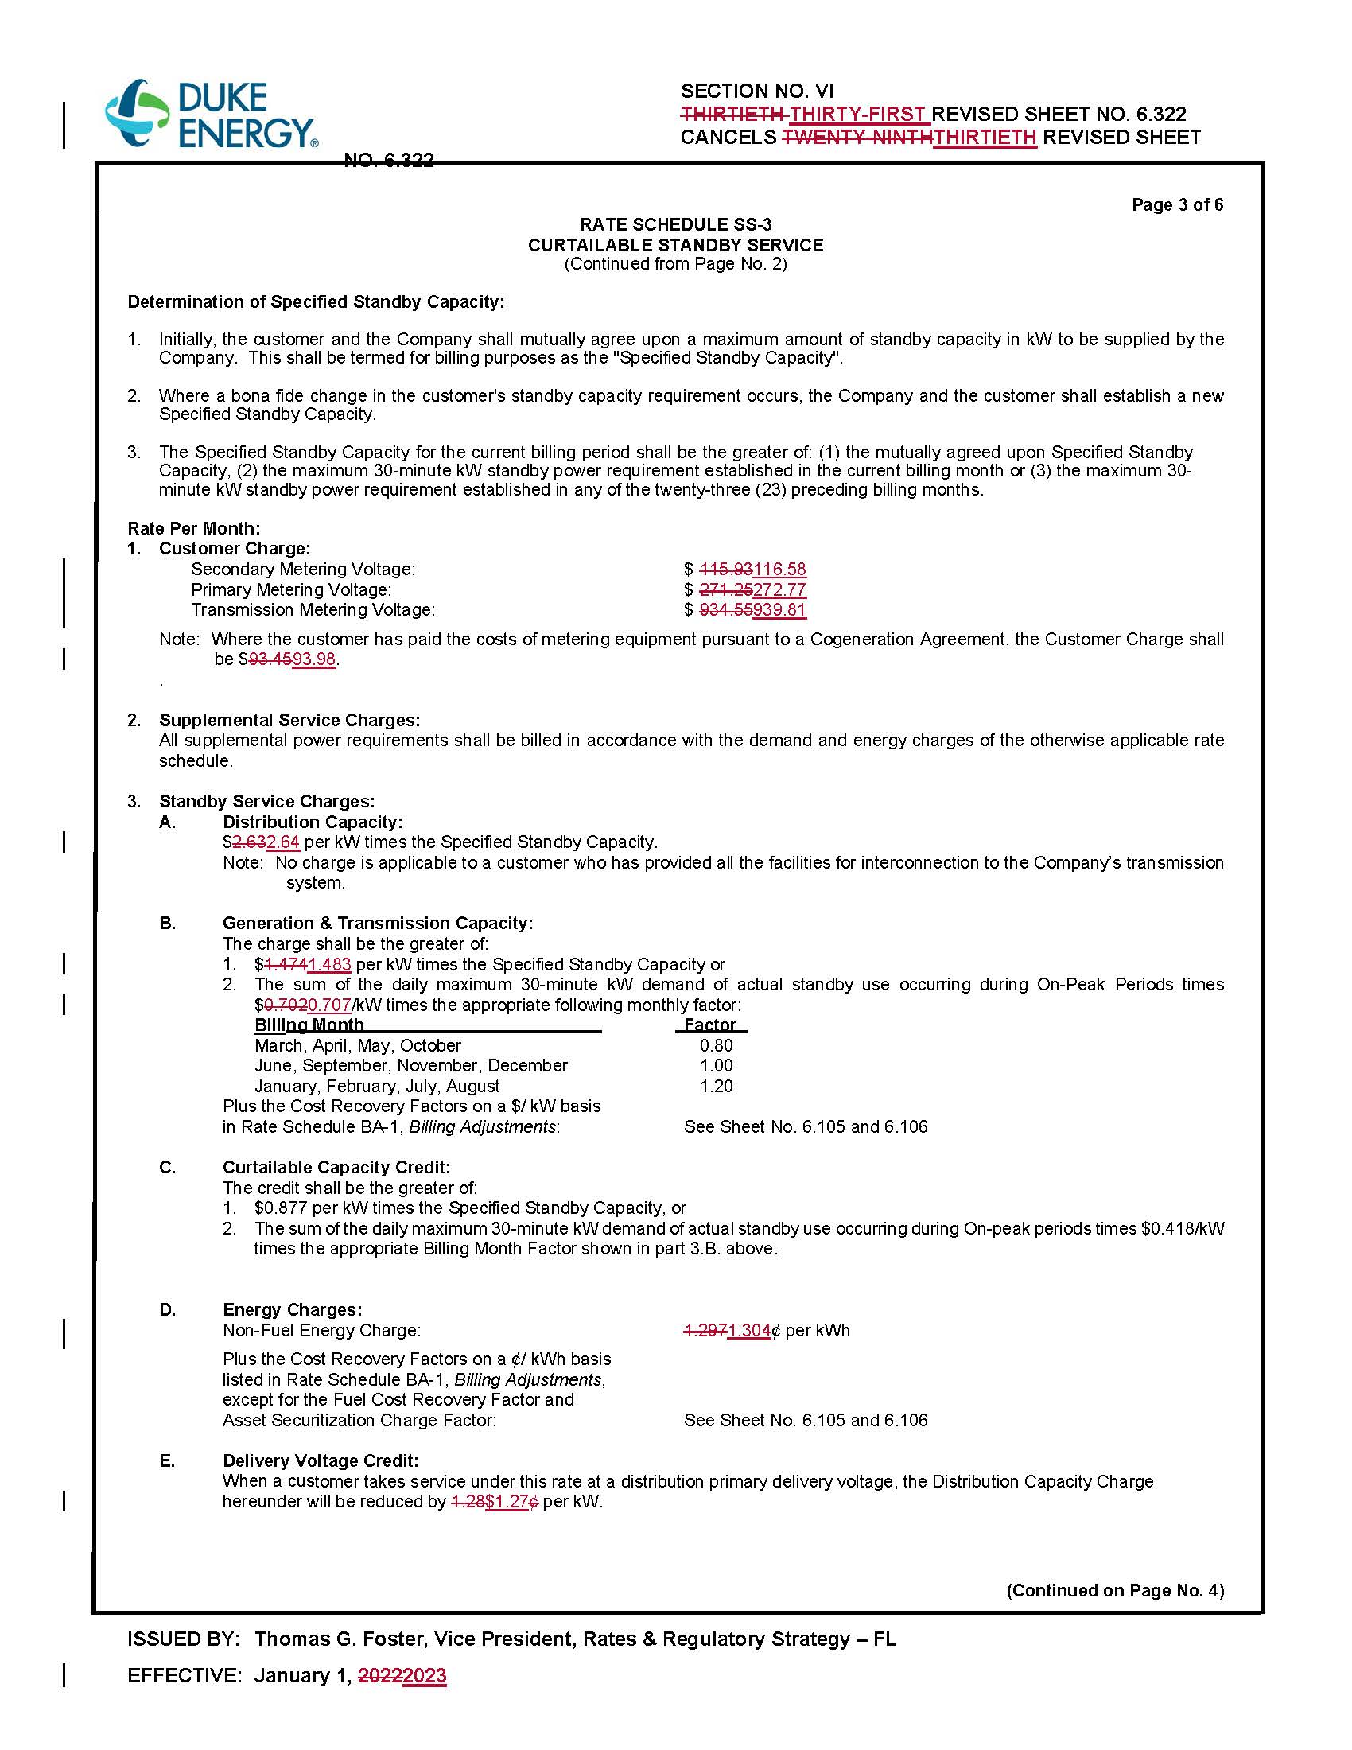

Order No. PSC-2021-0202A-AS-EI, issued June 28, 2021, in Docket No. 20210016-EI, In re: Petition for limited proceeding to approve 2021 settlement agreement, including general base rate increases, by Duke Energy Florida, LLC.
Id.
Order No. PSC-2021-0202A-AS-EI, issued June 28, 2021, in Docket No. 20210016-EI, In re: Petition for limited proceeding to approve 2021 settlement agreement, including general base rate increases, by Duke Energy Florida, LLC.
Order No. PSC-2017-0451-AS-EU, issued November 20, 2017, in Docket No. 20170183-EI, In re: Petition for limited proceeding to approve 2017 second revised and restated settlement agreement, including certain rate adjustments, by Duke Energy Florida, LLC.
See Document No. 09522-2022, filed October 17, 2022, in Docket No. 20220000-OT, Undocketed filings for 2022.
Order No. PSC-2022-0357-FOF-EI, issued October 21, 2022, in Docket No. 20220143-EI, In re: Petition for limited proceeding to implement return on equity trigger provision of 2021 settlement agreement, by Duke Energy Florida, LLC.

