BEFORE THE FLORIDA PUBLIC SERVICE COMMISSION

In re: Petition for limited proceeding to approve refund and rate reduction resulting from implementation of Inflation Reduction Act, by Florida Power & Light Company. | DOCKET NO. 20220165-EI  ORDER NO. PSC-2022-0433-TRF-EI  ISSUED: December 21, 2022

The following Commissioners participated in the disposition of this matter:

ANDREW GILES FAY, Chairman
ART GRAHAM
GARY F. CLARK
MIKE LA ROSA
GABRIELLA PASSIDOMO

ORDER APPROVING FLORIDA POWER & LIGHT COMPANY’S
IMPLEMENTATION OF THE INFLATION REDUCTION ACT
PROVISIONS

BY THE COMMISSION:

BACKGROUND

Florida Power & Light Company (FPL or Company) is an investor-owned utility providing electric service to approximately 5.8 million customers in Florida. On September 23, 2022, FPL filed a petition requesting Commission approval of a refund and rate reduction resulting from the Inflation Reduction Act (IRA or Tax Reform) that was signed into law on August 16, 2022. Subsequently, on November 14, 2022, the Company filed an amended petition which corrected an error in the calculation of the 2022 impact of the IRA. Subsequent to the filing of our staff’s recommendation on October 20, 2022, the Company made us aware of an error in its petition and asked that the item be deferred from our November 1, 2022 Agenda Conference. The Company’s request is being made pursuant to Paragraph 13 of its 2021 Settlement Agreement (2021 Settlement) approved on December 2, 2021, in Docket No. 20210015-EI. Paragraph 13 of the 2021 Settlement requires, in part, that the impacts of any tax reform on base revenue requirements be adjusted for retail customers within 90 days of when the tax reform becomes law. We have jurisdiction over this matter pursuant to Sections 366.05 and 366.06, Florida Statutes (F.S.).

DECISION

Effective January 1, 2022, the IRA expanded federal income tax benefits for renewable energy by allowing owners of solar projects which begin construction before 2025 the option to elect to receive Production Tax Credits (PTCs) instead of Investment Tax Credits (ITCs). FPL has elected to use PTCs instead of ITCs because it provides a greater tax benefit and customer savings. The application of PTCs to FPL’s six rate base solar facilities results in a tax savings of $31,195,561. In comparison, the amortization of ITCs is $1,773,277 per year. The ITC amortization, and a $7,548,582 adjustment to account for the impact to the capital structure due to a net decrease of unamortized ITCs and increase in accumulated deferred income taxes (ADITs), is netted against the PTC balance. In addition, state income tax expense and other non-jurisdictional adjustments increased by $1,223,010 due to the removal of the ITCs and is also offset against PTC tax savings. In total, the net change in FPL’s jurisdictional adjusted base revenue requirement is a reduction of $35,747,856. We have reviewed FPL’s calculations in its amended petition filed on November 14, 2022, and find that they are reasonable and appropriate. FPL’s calculations are summarized in Table 1. For these reasons, we hereby approve FPL’s calculations of net tax savings of $35,747,856 for 2022 resulting from the Company’s election to use PTCs instead of ITCs as allowed by the IRA.

TABLE 1
CALCULATION OF PTC IMPACT ON 2022 REVENUE REQUIREMENT

Production Tax Credits | $31,195,561
ITC Amortization Removal | (1,773,277)
State Income Tax Expense and Other Non-Jurisdictional Adjustments | (1,223,010)
ITC Capital Structure Impact | 7,548,582
Net Reduction in 2022 Revenue Requirement | $35,747,856
Source: DN 11040-2022.

FPL’s application of PTCs has reduced its 2022 jurisdictional adjusted revenue requirement by $35,747,856. Paragraph 13(a) of its 2021 Settlement states: “[a]ny effects of tax reform on the retail revenue requirements (but no earlier than January 1, 2022) through the date of the base rate adjustment shall be flowed back to, or collected from, customers through the Capacity Cost Recovery Clause (CCR) on the same basis as used in any base rate adjustment.”
The impact of this refund on the capacity cost portion of a 1,000 kilowatt-hour (kWh) residential bill for January 2023 will be a credit of $1.97 on the 1,000 kWh residential bill. The Company believes applying the entire 2022 refund to a single month, with a commensurate one-month rate impact, will provide a more noticeable reduction to customers’ bills than spreading the refund over a full twelve-month period. After January, or from February through December 2023, the proposed residential capacity charge will be $2.12 per 1,000 kWh. We have reviewed the Company’s calculation of the net tax savings from the effective date of the IRA, through the base rate adjustment, and hereby approve a refund of $35,747,856 in January 2023 through a one-time reduction to FPL’s CCR factors.
FPL has selected the option to receive PTCs instead of ITCs as allowed by the IRA. The application of PTCs to FPL’s ten solar facilities results in a tax savings of $82,432,142, which is offset by a reduction to the ITC amortization balance of $12,688,682, for a net tax savings of $69,743,460. The incremental change in 2023 jurisdictional adjusted base revenue requirement is a reduction of $33,995,604, in addition to the 2022 net tax savings of $35,747,856, for a total reduction in base revenue requirement of $69,743,460. FPL will not finalize its 2023 Forecast Earnings Surveillance Report until early 2023, and consequently, did not take into account the impacts to the capital structure. FPL did not include the 2023 state income tax impact which may also slightly decrease the tax savings similar to its effect on the 2022 calculation. The effects of the IRA on the Company’s capital structure and overall weighted average cost of capital should be taken into account. We find that FPL shall be required to file updated information within 90 days of when the 2023 Forecast Earning Surveillance Report is filed with this Commission. Any necessary adjustments will be addressed in a future proceeding. The projected change in FPL’s base revenue requirements is comprised of a $82.4 million reduction due to lower operating income tax expense resulting from the inclusion of PTCs associated with the Company’s base rate solar plants, offset by a $12.7 million increase due to the removal of ITC amortization associated with the 2022 and 2023 solar plants. FPL’s calculations are summarized in Table 2. We have reviewed FPL’s calculations in its amended petition filed on November 14, 2022, and find them to be reasonable and appropriate. Therefore, we approve FPL’s calculations of net tax savings of $69,743,460 for 2023 resulting from the Company’s election to use PTCs instead of ITCs as allowed by the IRA.

TABLE 2
Table 3-1

CALCULATION OF PTC IMPACT ON 2023 REVENUE REQUIREMENT
Production Tax Credits | $82,432,142
ITC Amortization Removal | (12,688,682)
Net Reduction in 2023 Revenue Requirement | 69,743,460
Decrease in 2022 Revenue Requirement | (35,747,856)
Incremental Reduction in 2023 Revenue Requirement | $33,995,604
Source: DN 11040-2022.
The Company’s election to utilize PTCs instead of ITCs under the IRA has resulted in a projected net tax savings of approximately $69.7 million. Under the provisions of Paragraph 13 of its 2021 Settlement, the Company is required to quantify the impacts of federal or state tax reform on its jurisdictional base revenue requirement as projected in its Forecast Earnings Surveillance Report and adjust its jurisdictional base revenue requirement through a uniform percentage decrease or increase to customer, demand, and energy base rates for all retail customer classes. We have reviewed the Company’s revised calculation of the projected net tax savings associated with the IRA and the proposed method to flow back those tax savings to customers and find that the proposed permanent reduction in jurisdictional base rates is consistent with the terms of FPL’s 2021 Settlement and are approved.
FPL’s petition includes the proposed tariff sheets (Exhibit B-4 to the amended petition) and the calculation of the IRA adjustment factor of (0.775) percent (Exhibit B-3, Part 2 at page 1 of 48, of the amended petition). The IRA adjustment factor was calculated by dividing the $69.7 million reduction to the 2023 base revenue requirement by the 2023 projected retail base revenue from sales of electricity ($8,999.9 million). The IRA adjustment factor was applied to the base rates for all rate classes (Exhibit B-3, Part 2 pages 3-48 to the amended petition).
In Order No. PSC-2021-0446-S-EI, we approved an increase of $560 million in FPL’s base rates effective January 2023. This Commission-approved increase is also reflected in the revised tariffs, as both the previously approved $560 million base rate increase and the proposed IRA base revenue decrease are effective January 2023.
A residential customer who uses 1,000 kWh per month currently pays $75.82 on the base rate portion of their monthly bill. Without the IRA adjustment, the base rate portion on the 1,000 kWh residential bill would be $80.73 effective January 2023. As a result of the IRA adjustment, the base rate portion of the 1,000 kWh residential bill will be $80.11 effective January 2023, an increase of $4.29 from the current $75.82.
We have reviewed FPL’s tariff sheets and supporting documentation. The calculations are accurate. For that reason, we hereby approve FPL’s revised tariffs implementing the IRA base revenue decrease, as shown on Attachment A to this order, effective January 2023,

Based on the foregoing, it is

ORDERED by the Florida Public Service Commission that Florida Power & Light Company’s Amended Petition for approval of refund and rate reduction resulting from implementation of Inflation Reduction Act is hereby approved as stated in the body of this order. It is further

ORDERED that the tariff sheets found in Attachment A to this order shall become effective January 1, 2023. It is further

ORDERED that at the conclusion of the protest period, if no protest is filed this docket shall be closed upon the issuance of a Consummating Order. If a protest is filed within 21 days of the issuance of this order, the tariffs shall remain in effect, subject to adjustment, pending the resolution of the protest.

By ORDER of the Florida Public Service Commission this 21st day of December, 2022.

/s/ Adam J. Teitzman
ADAM J. TEITZMAN
Commission Clerk
Florida Public Service Commission
2540 Shumard Oak Boulevard
Tallahassee, Florida 32399
(850) 413-6770
www.floridapsc.com

Copies furnished: A copy of this document is provided to the parties of record at the time of issuance and, if applicable, interested persons.
SBr

NOTICE OF FURTHER PROCEEDINGS

The Florida Public Service Commission is required by Section 120.569(1), Florida Statutes, to notify parties of any administrative hearing or judicial review of Commission orders that is available under Sections 120.57 or 120.68, Florida Statutes, as well as the procedures and time limits that apply. This notice should not be construed to mean all requests for an administrative hearing or judicial review will be granted or result in the relief sought.

Mediation may be available on a case-by-case basis. If mediation is conducted, it does not affect a substantially interested person's right to a hearing.

The Commission's decision on this tariff is interim in nature and will become final, unless a person whose substantial interests are affected by the proposed action files a petition for a formal proceeding, in the form provided by Rule 28-106.201, Florida Administrative Code. This petition must be received by the Office of Commission Clerk, 2540 Shumard Oak Boulevard, Tallahassee, Florida 32399-0850, by the close of business on January 11, 2023.

In the absence of such a petition, this Order shall become final and effective upon the issuance of a Consummating Order.

Any objection or protest filed in this docket before the issuance date of this order is considered abandoned unless it satisfies the foregoing conditions and is renewed within the specified protest period.

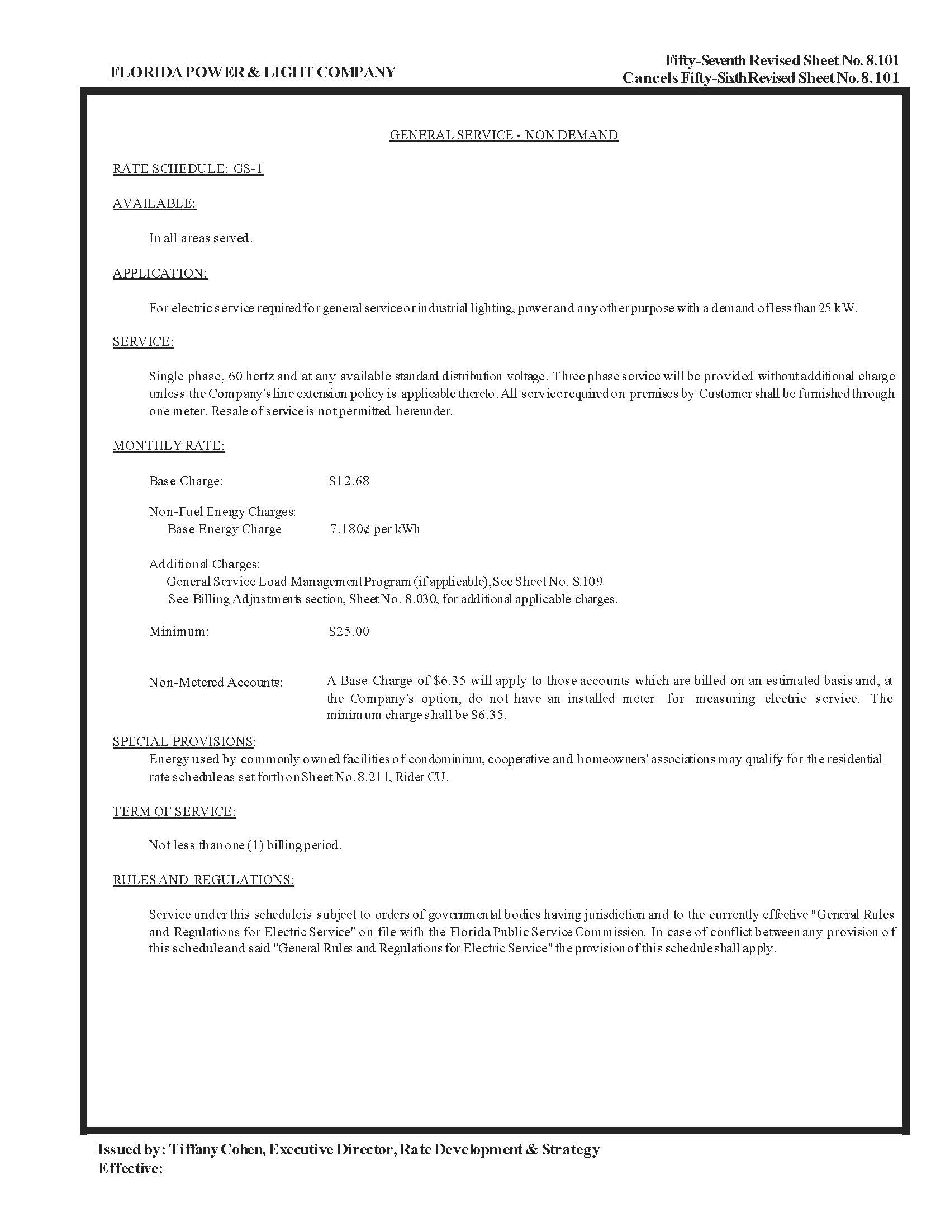
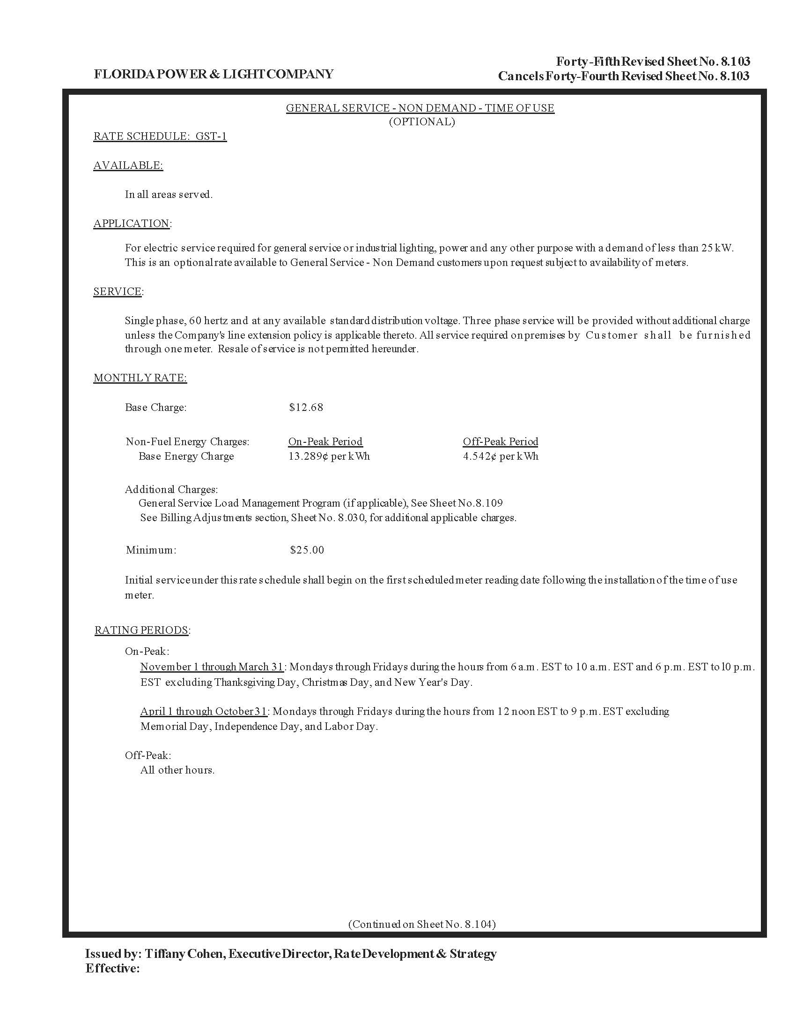
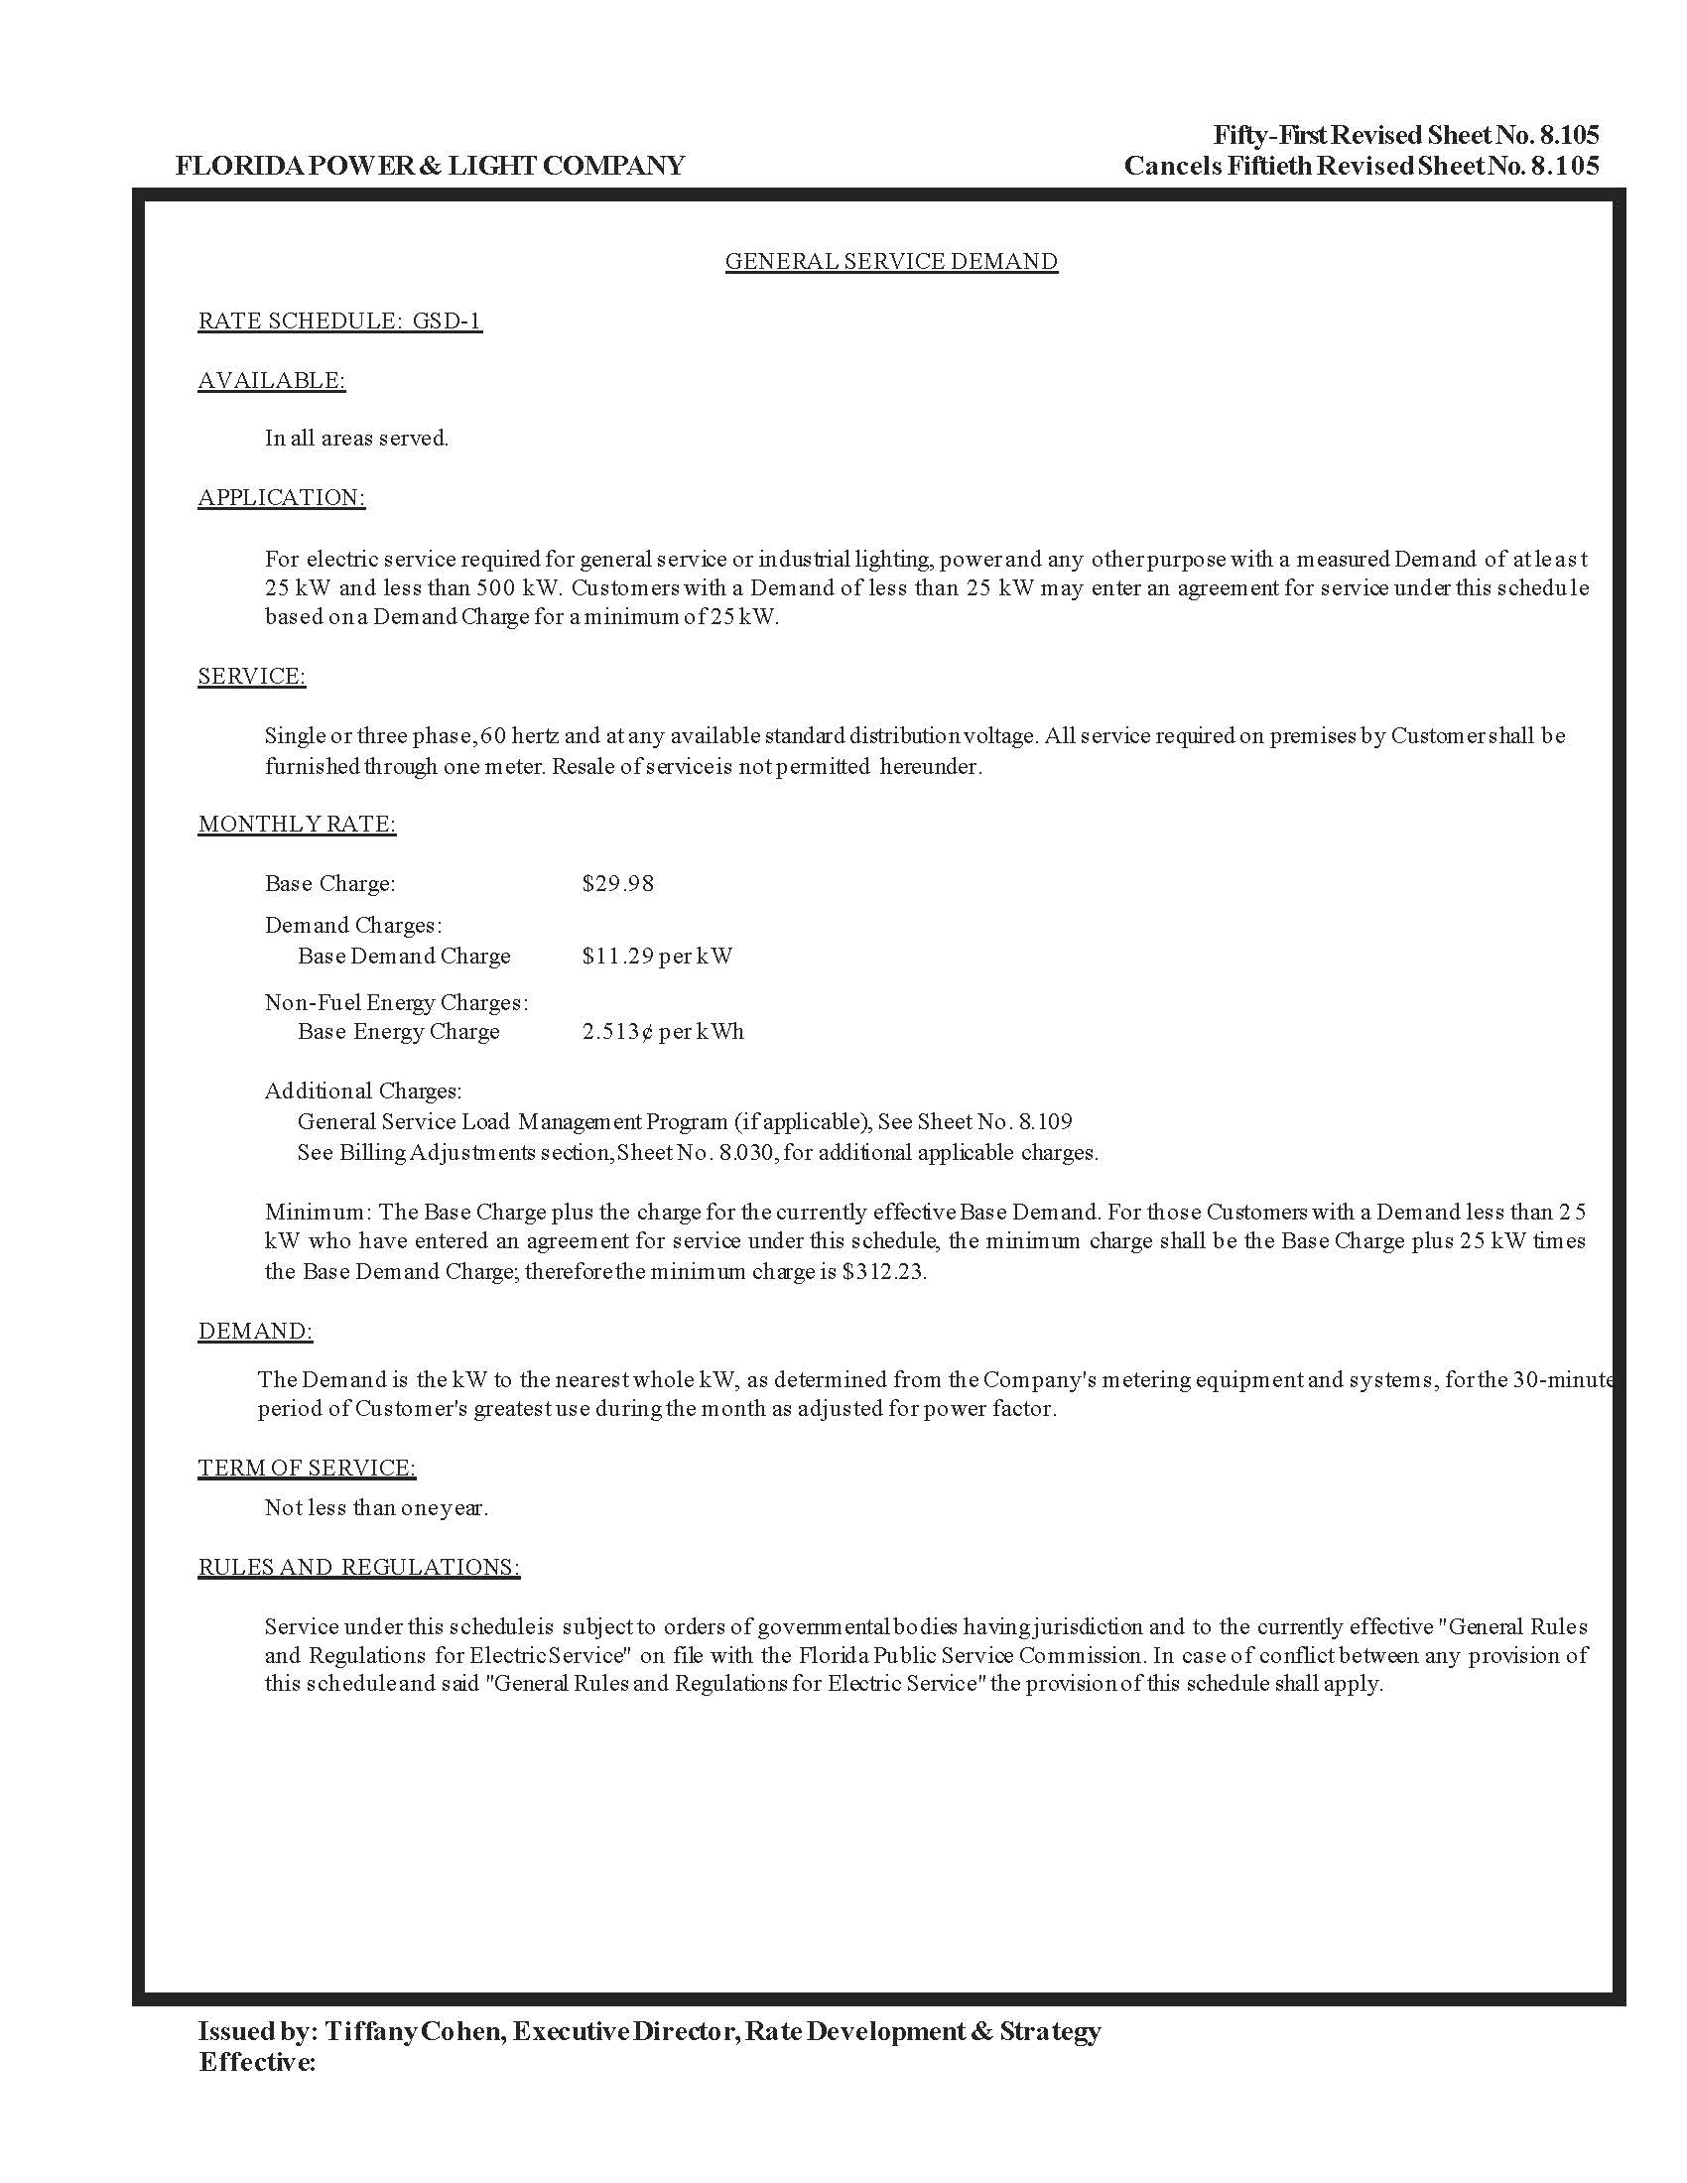
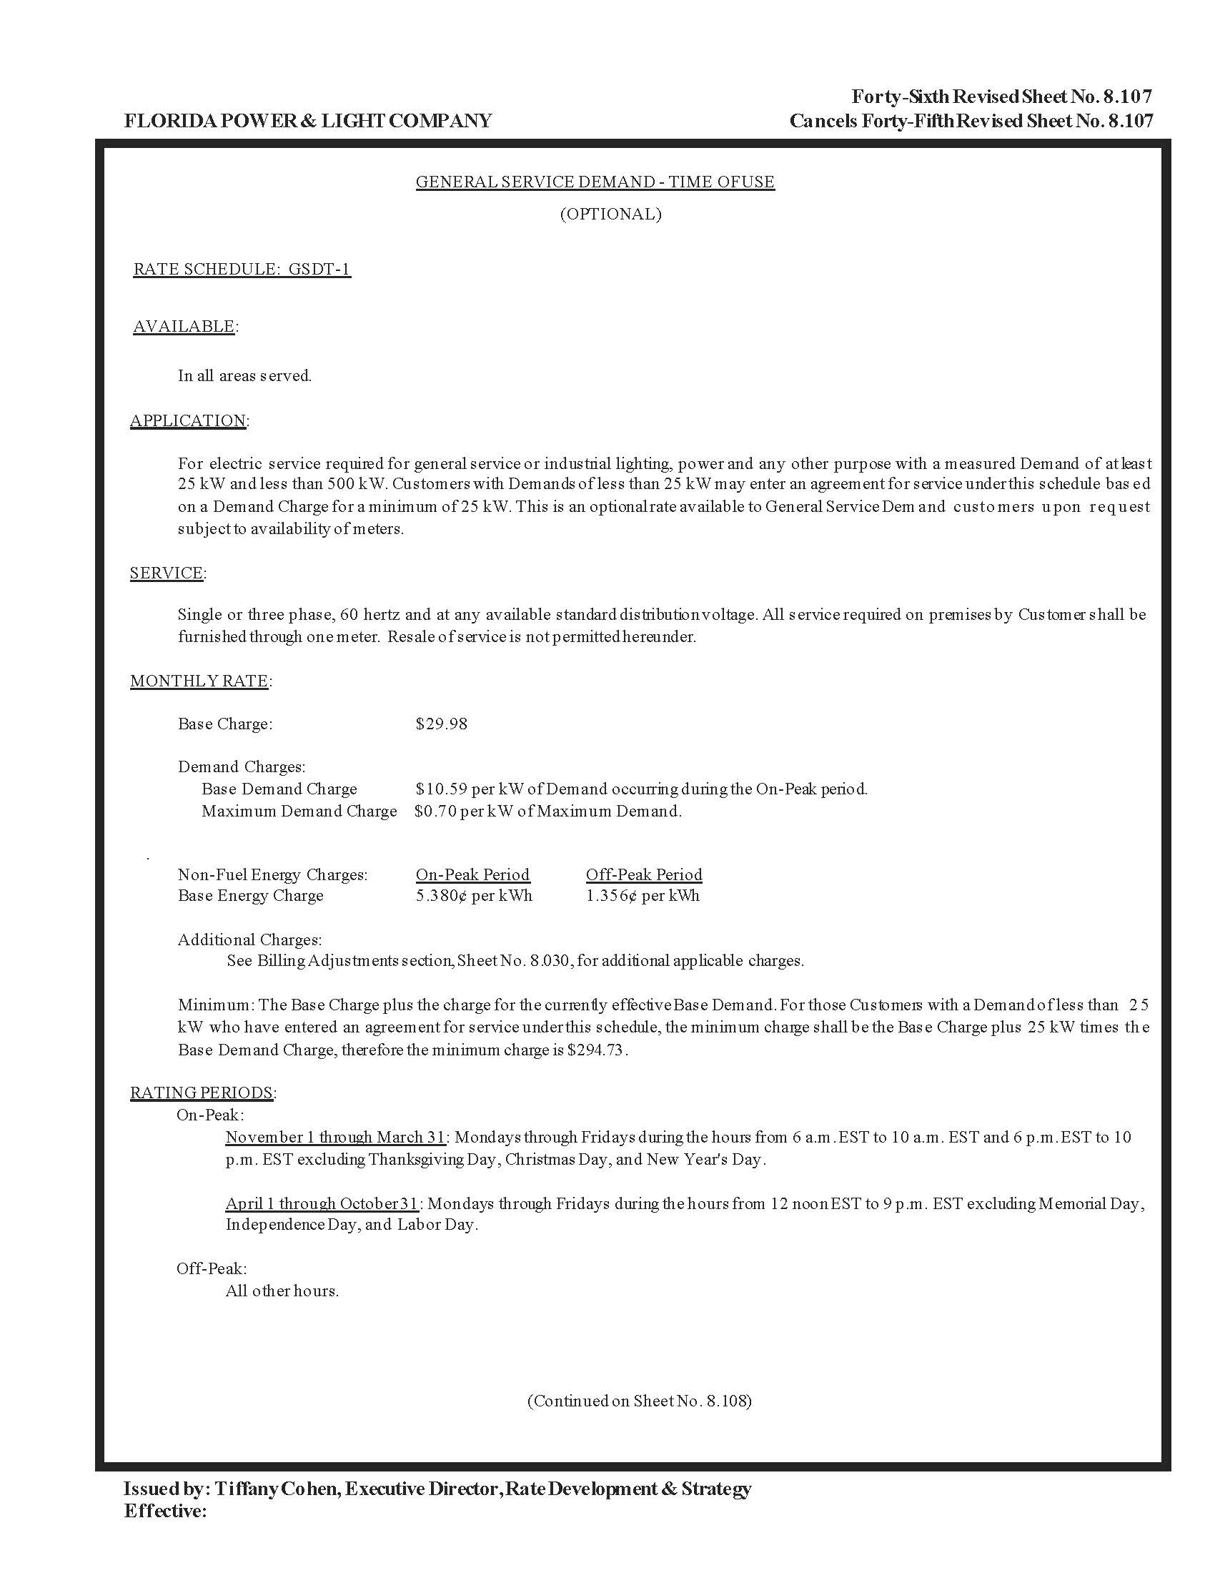
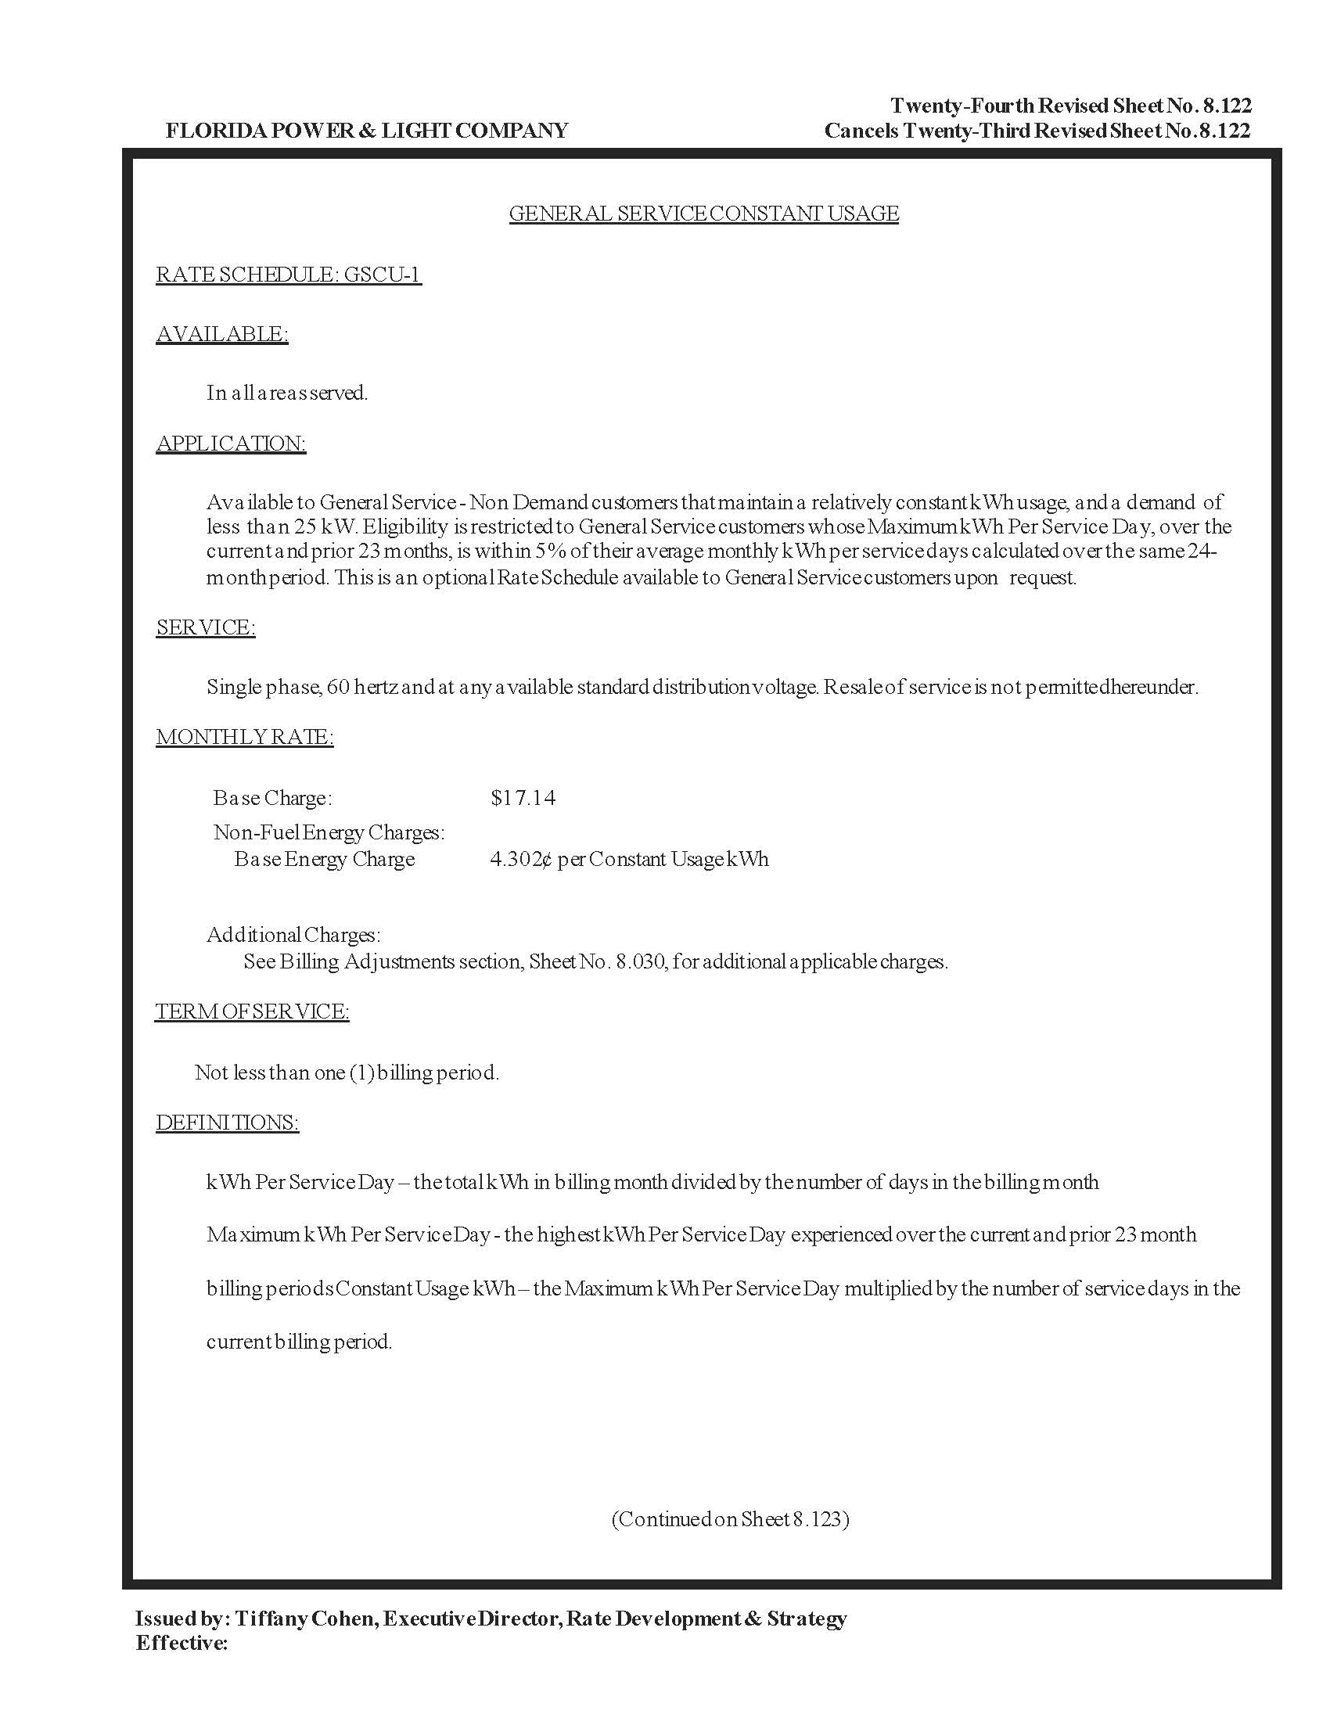
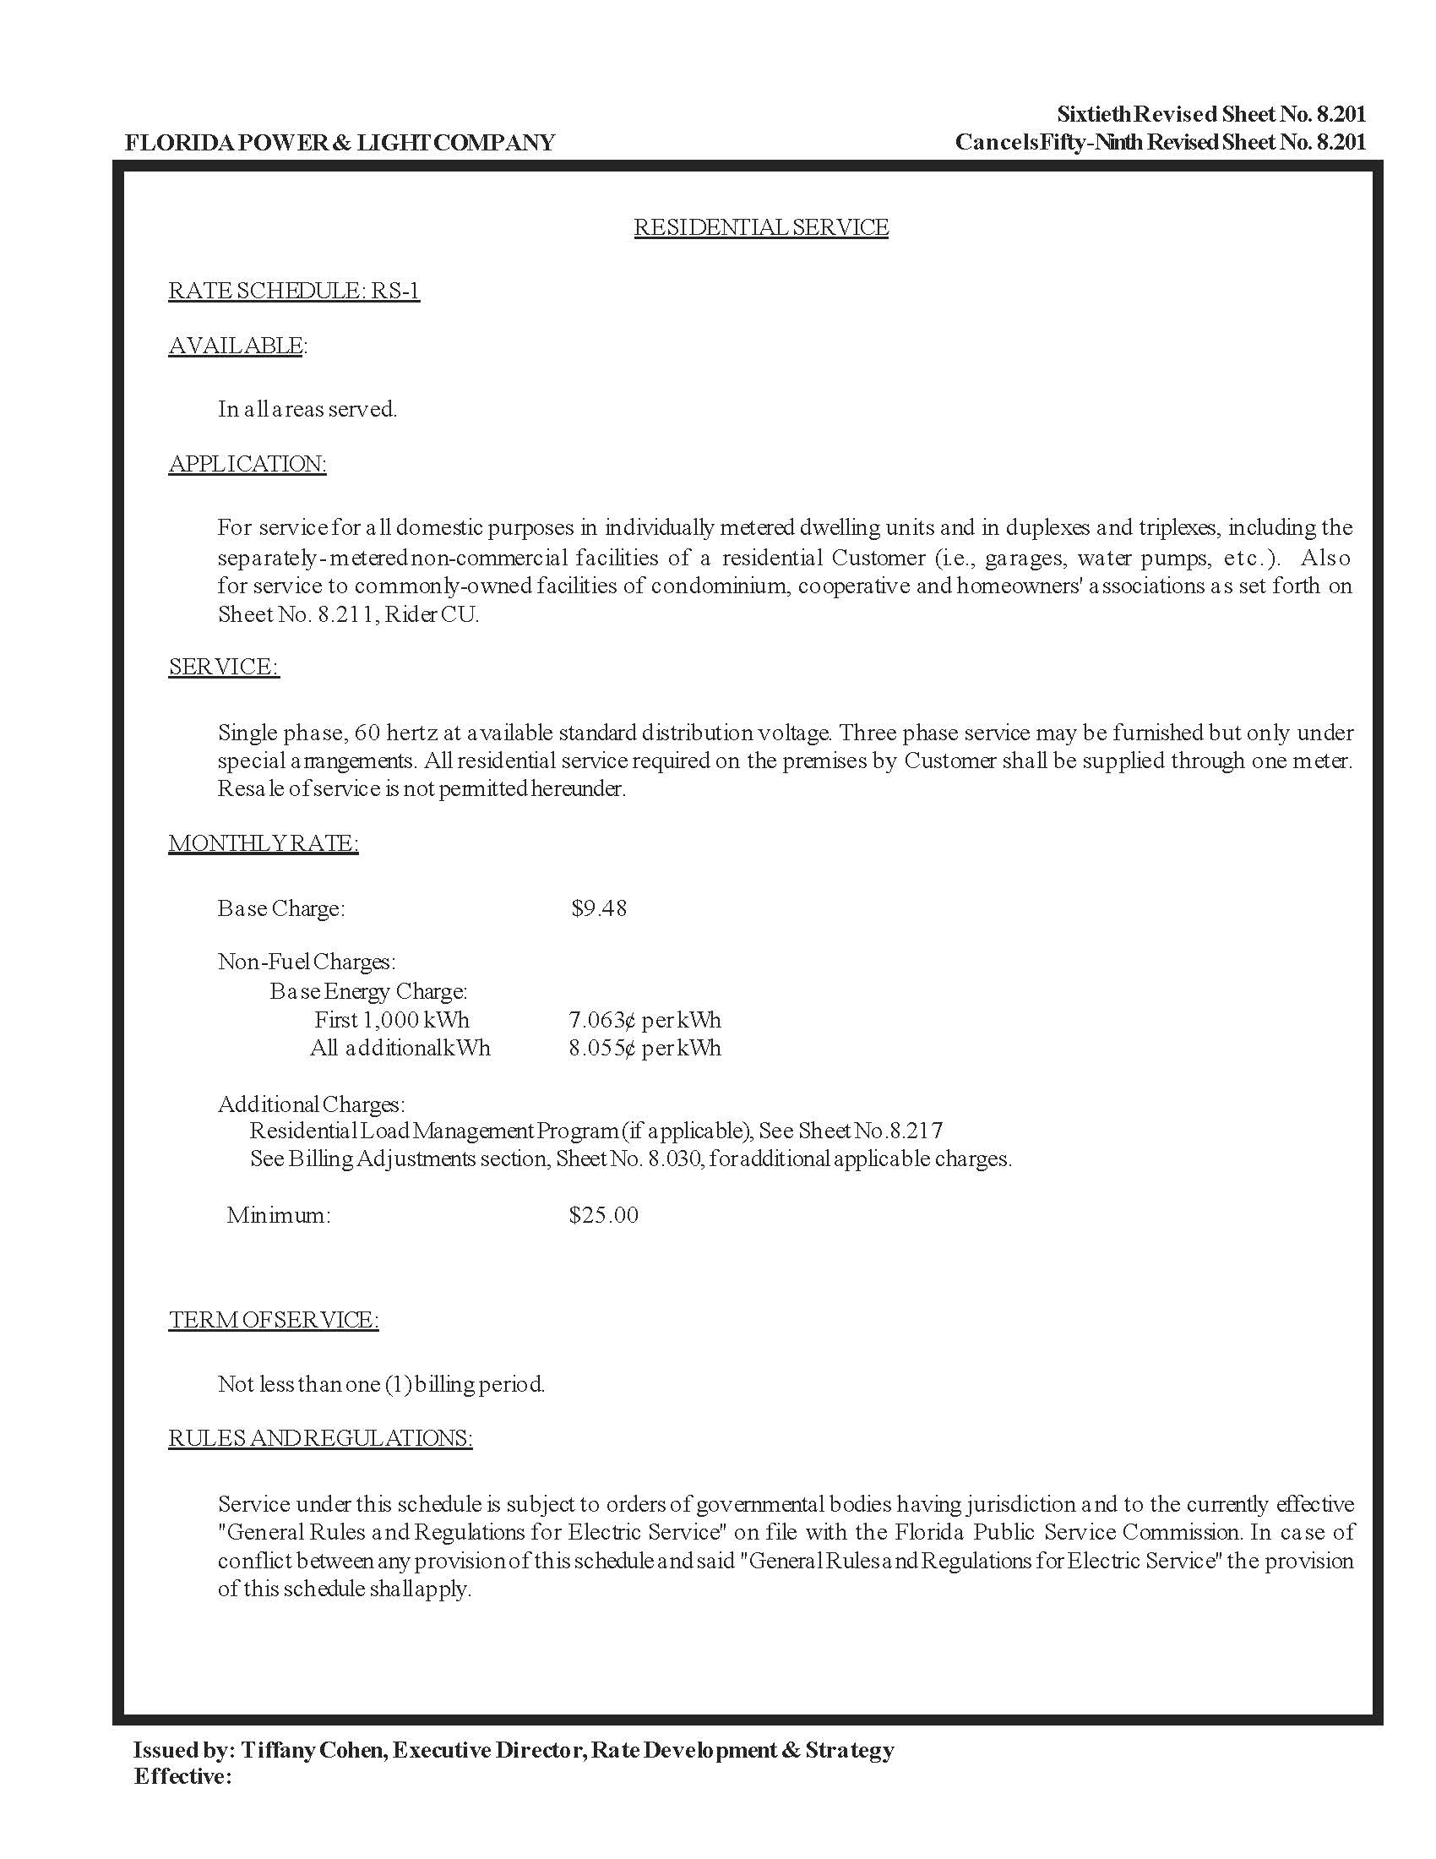
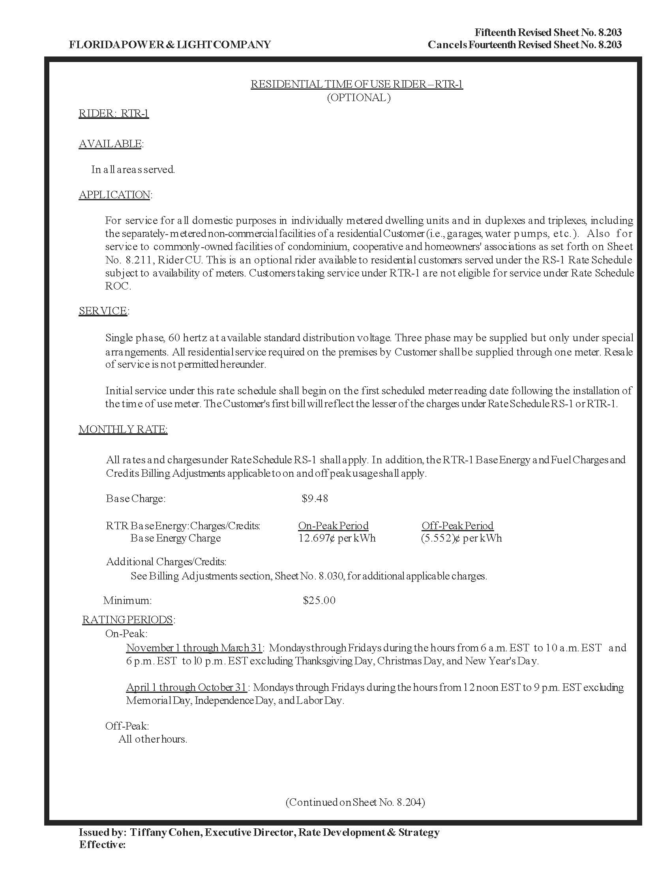
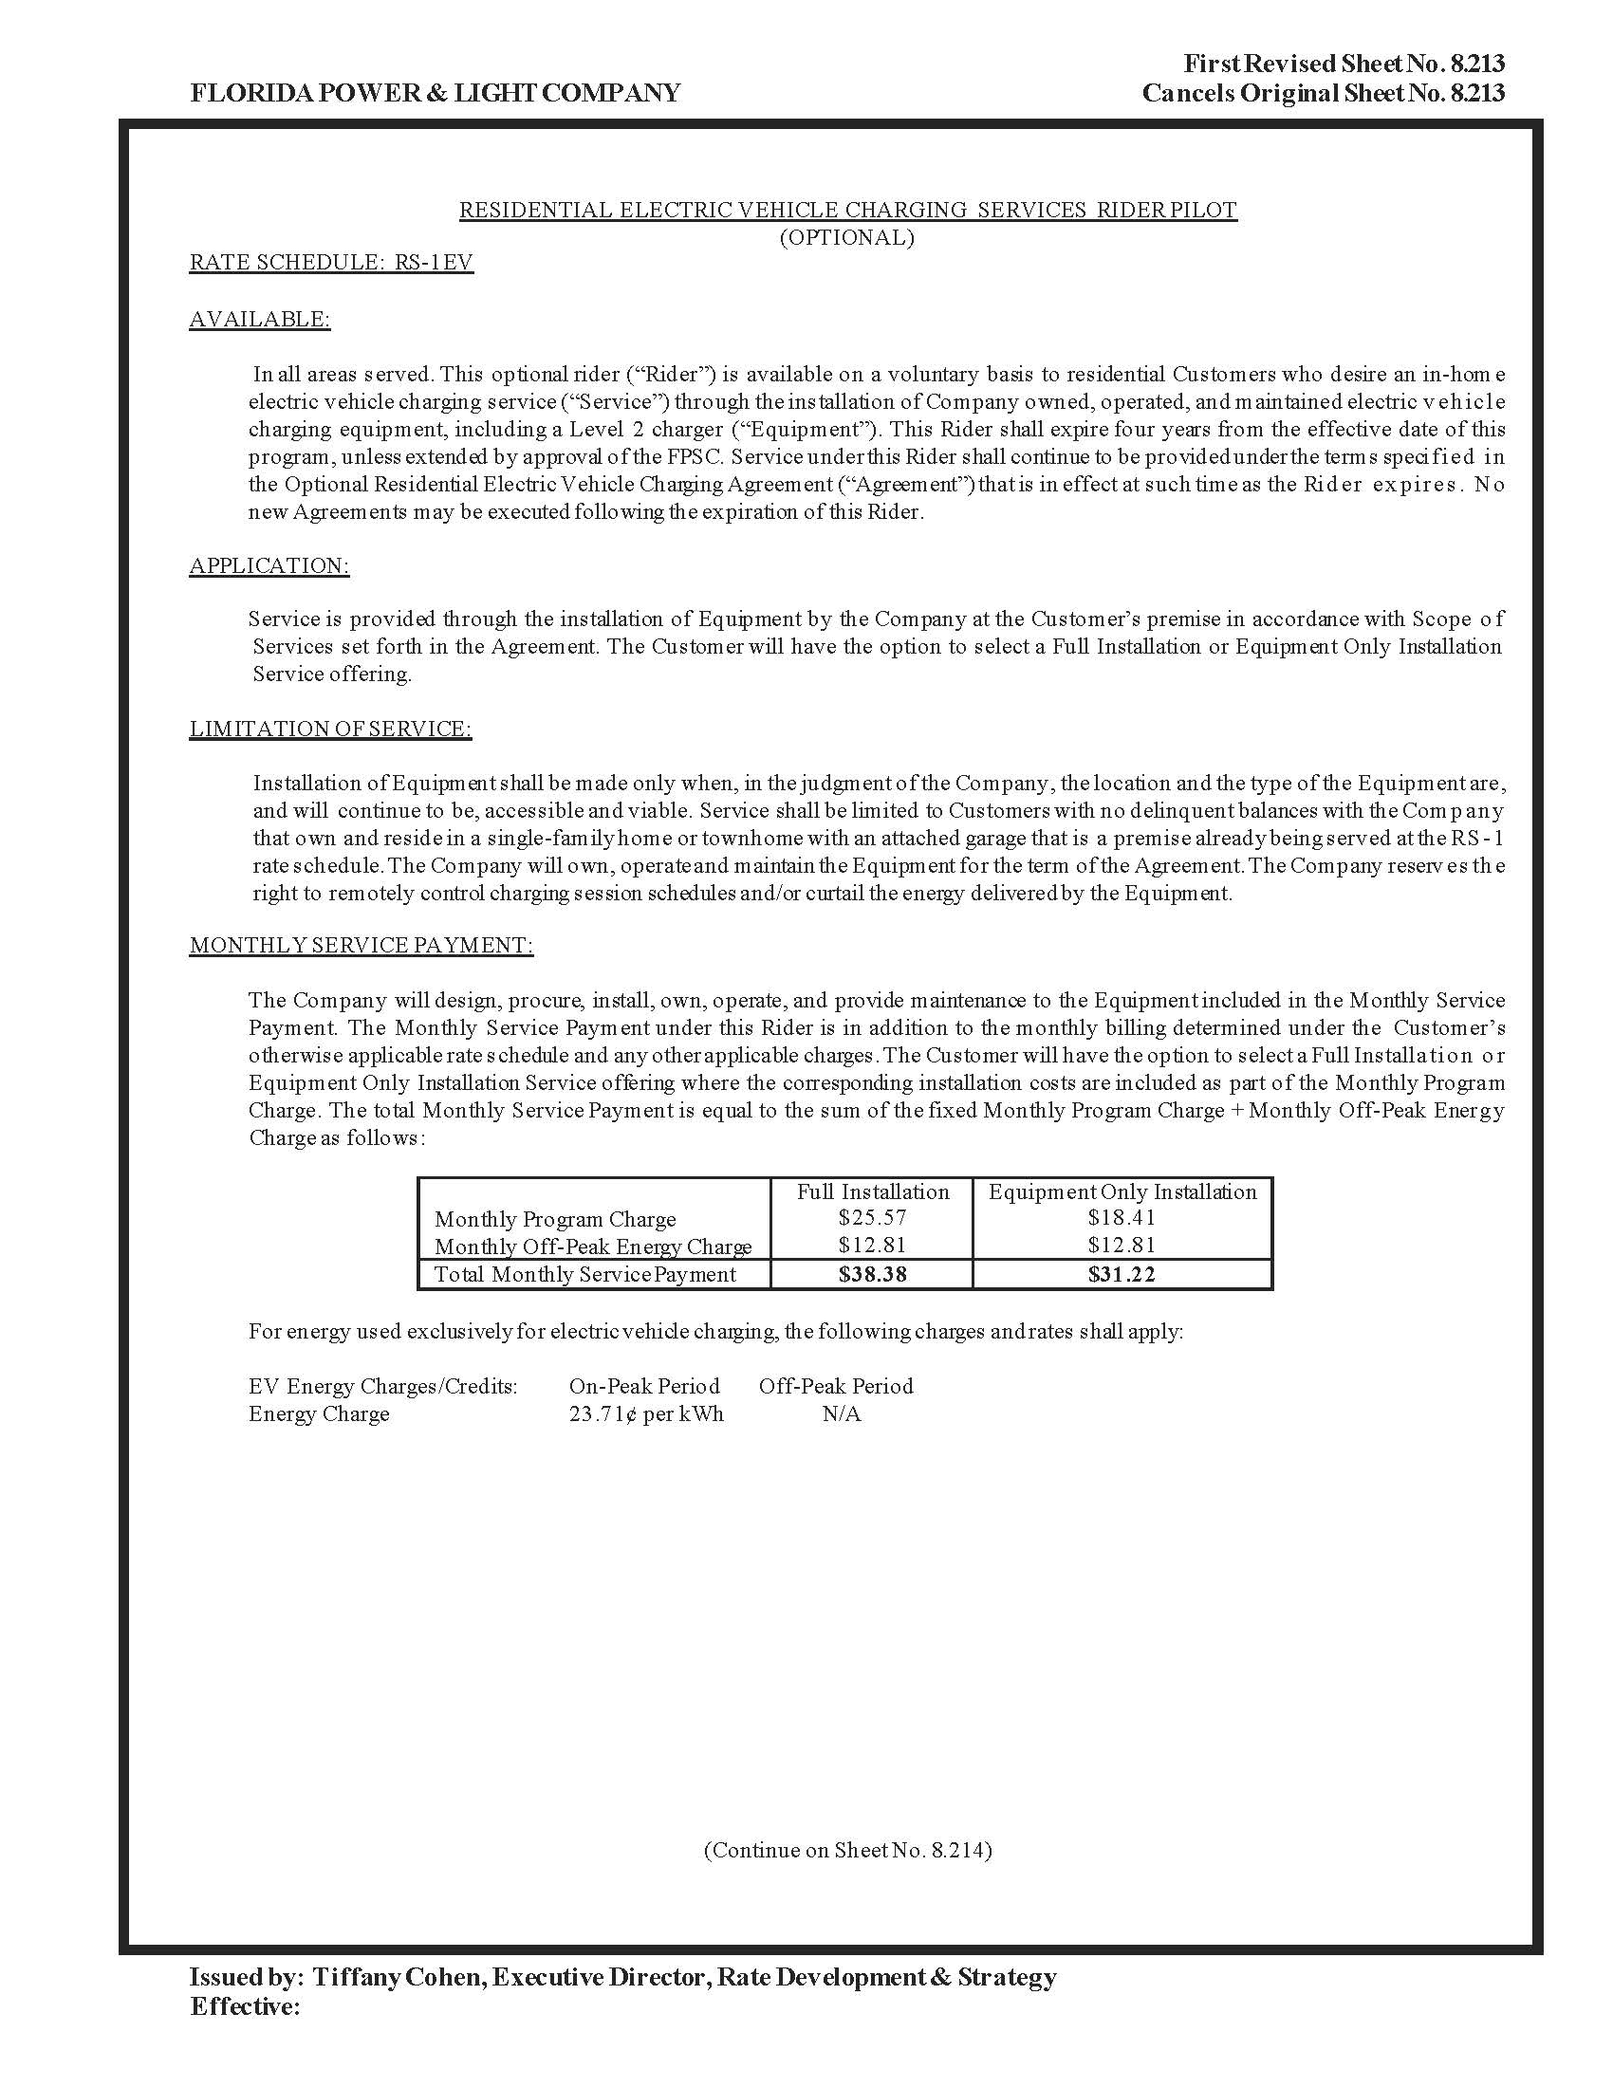
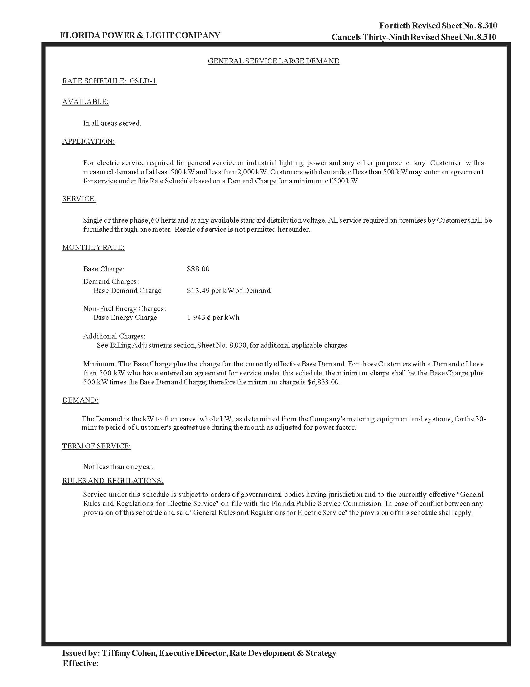
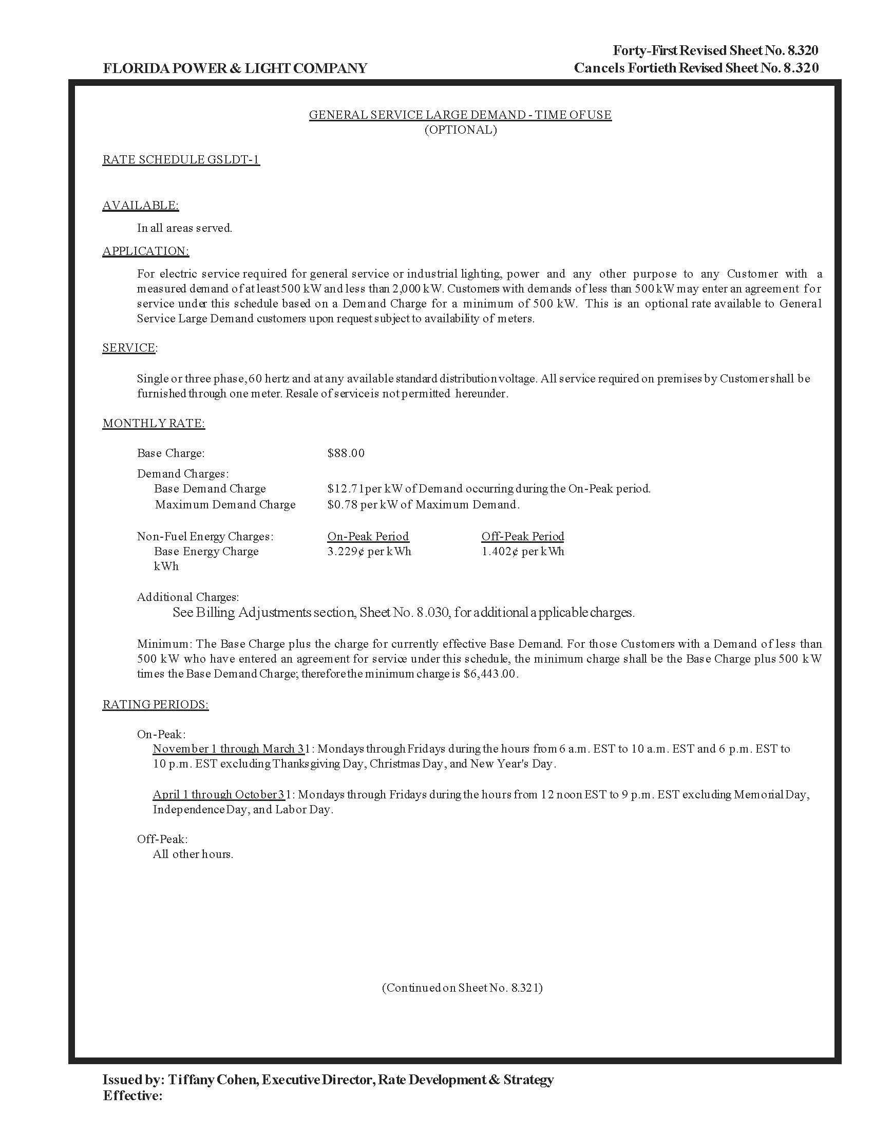
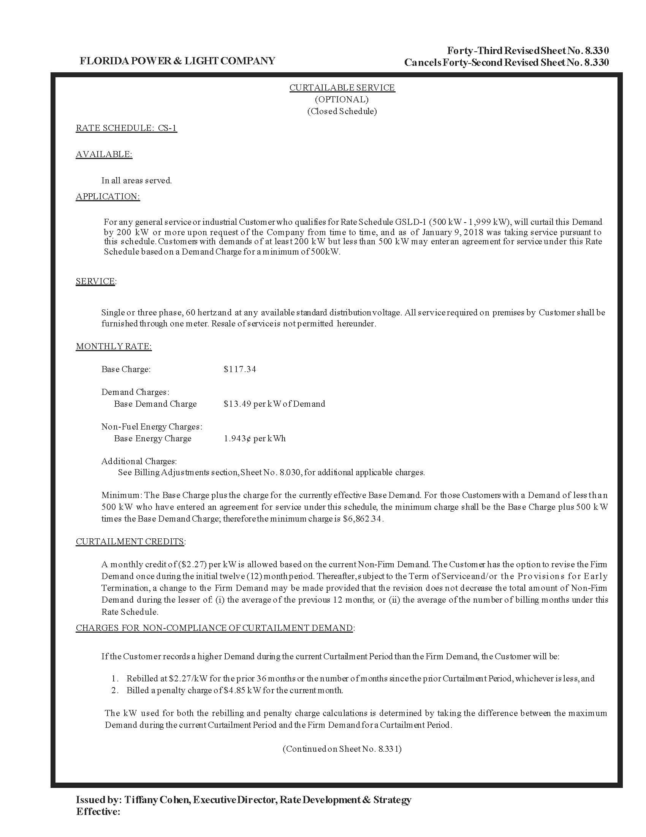
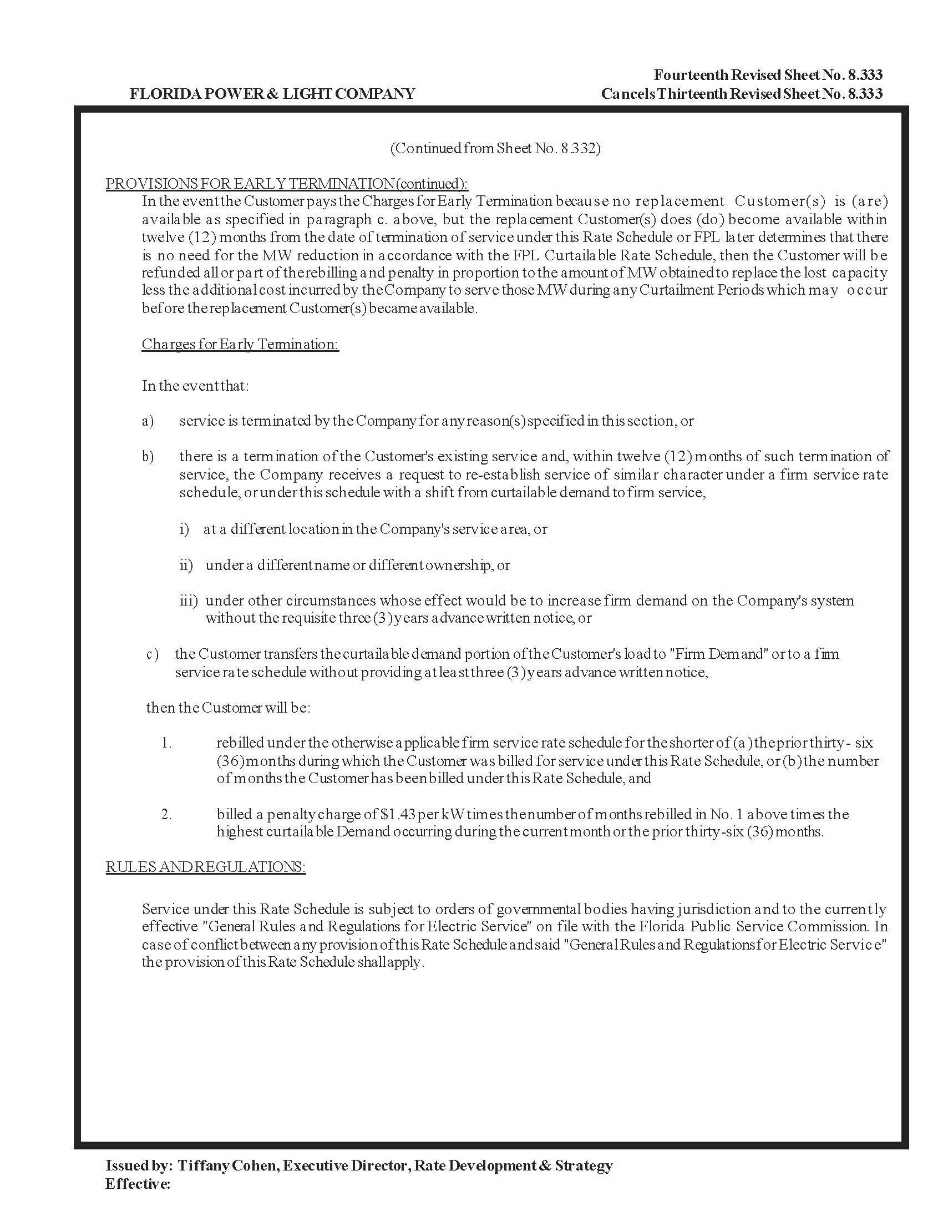
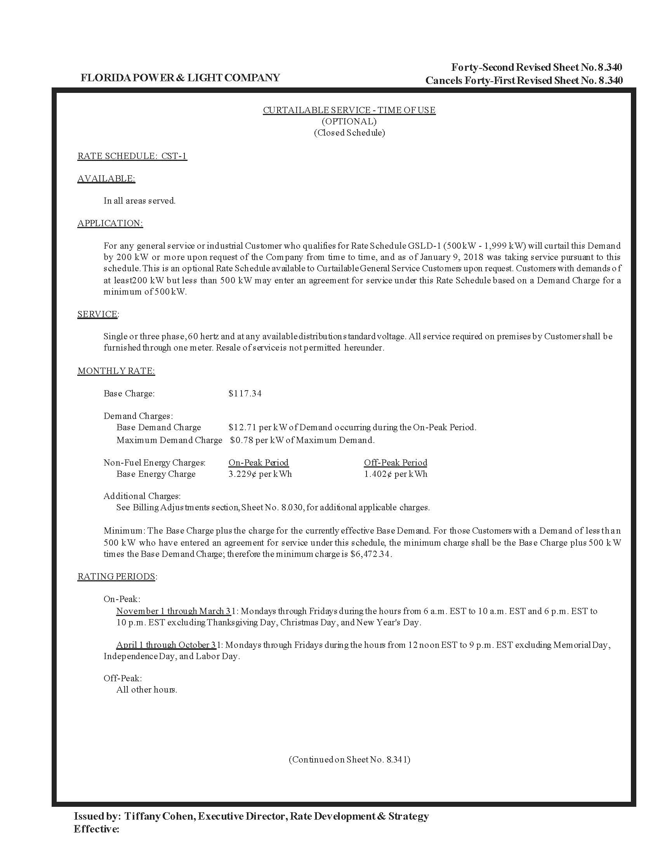
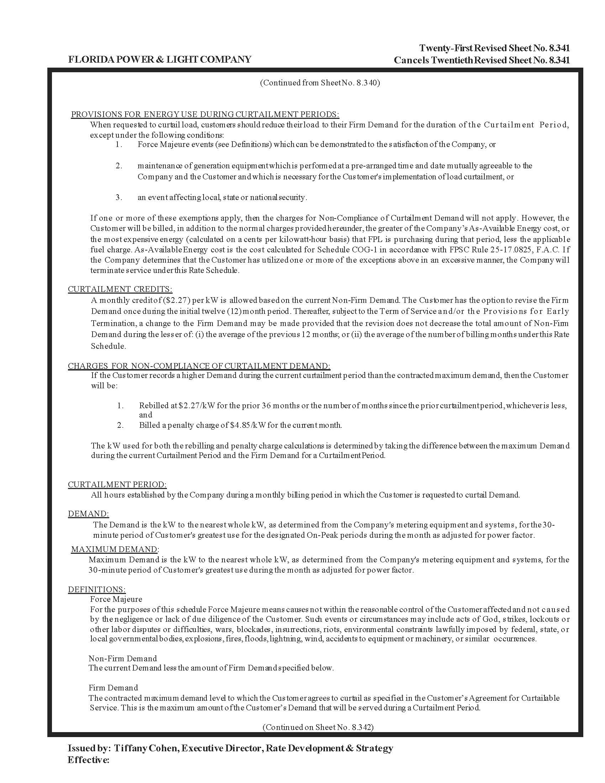
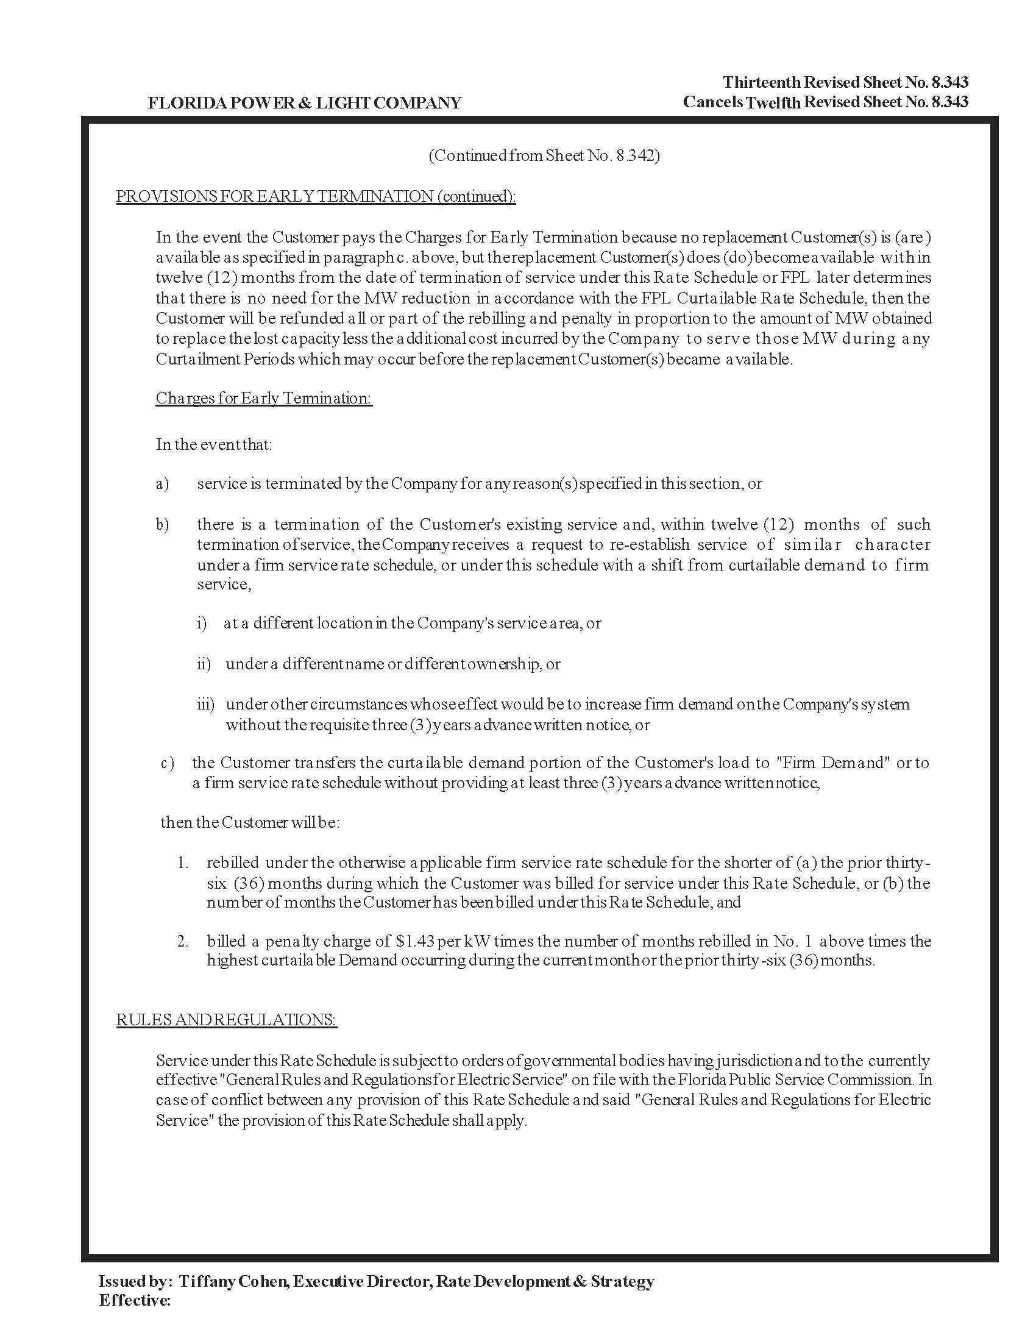
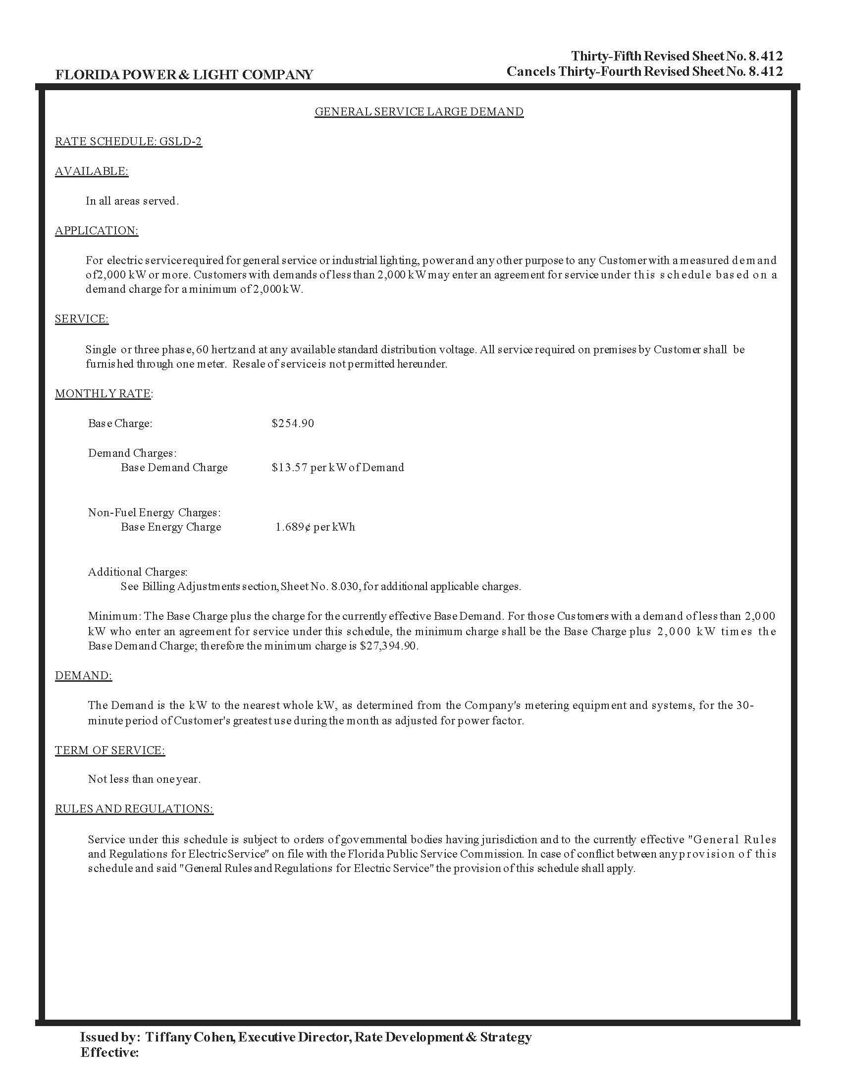
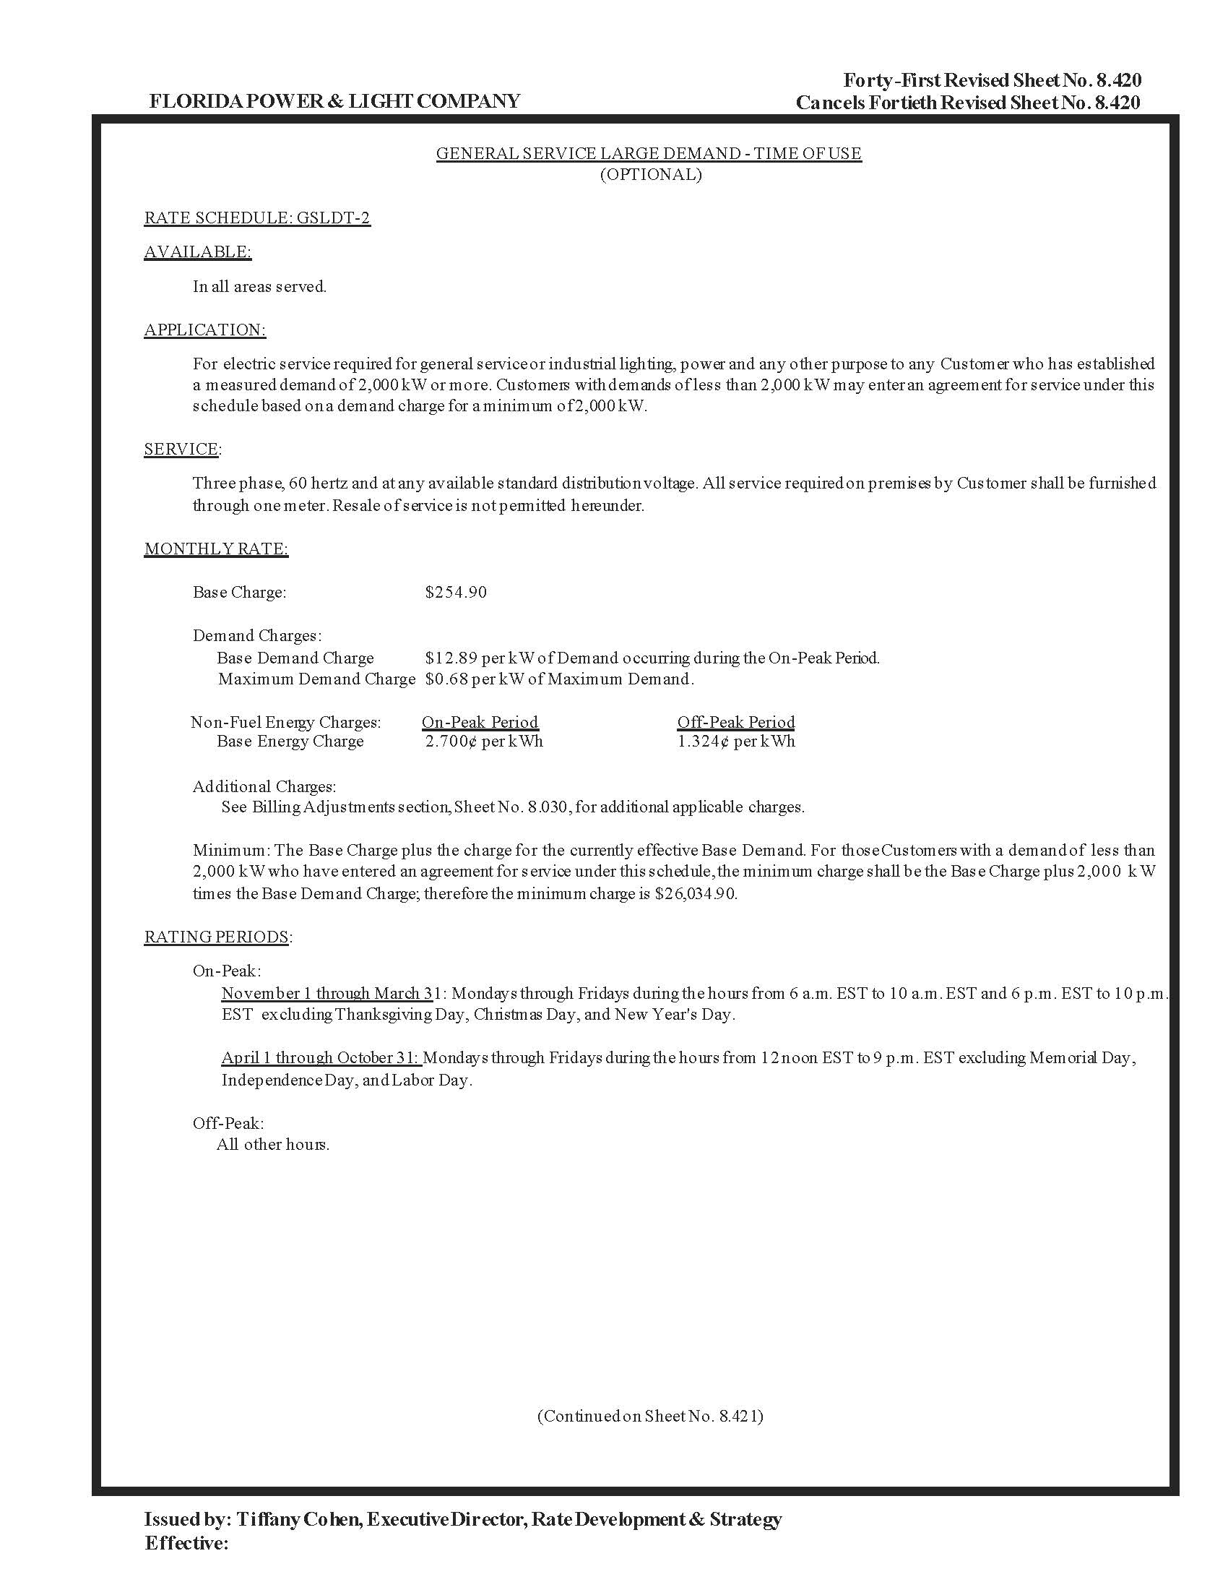
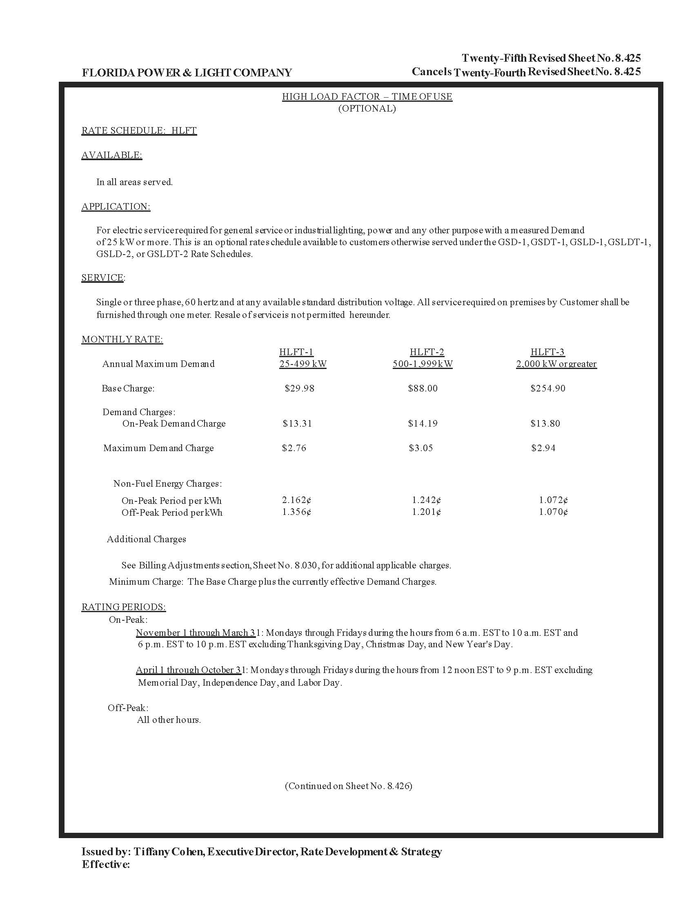
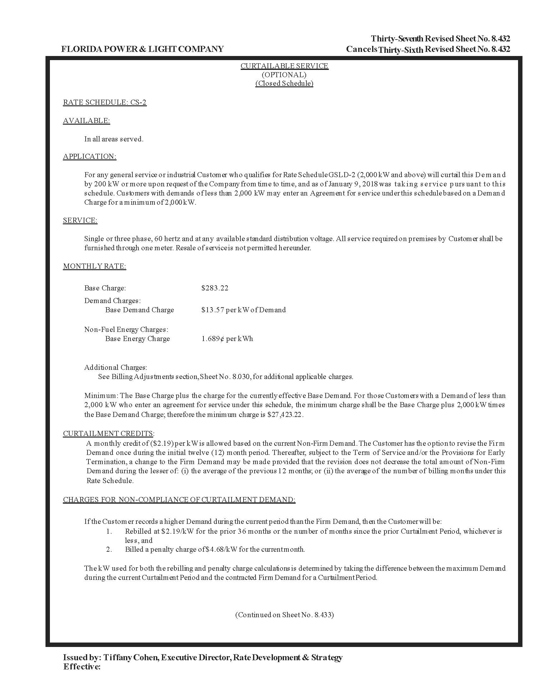
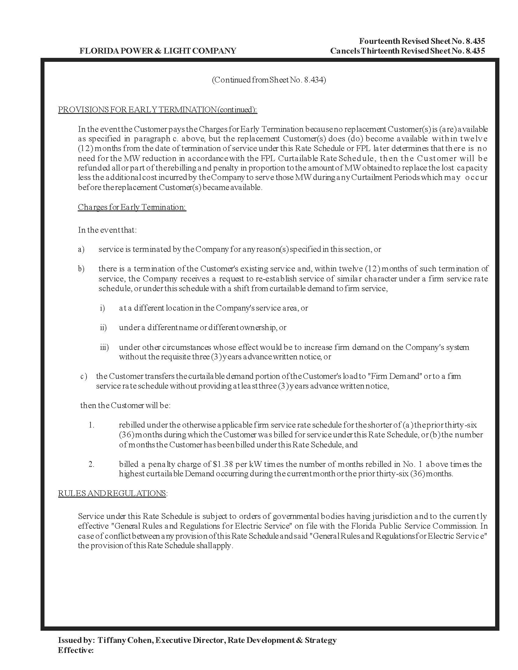
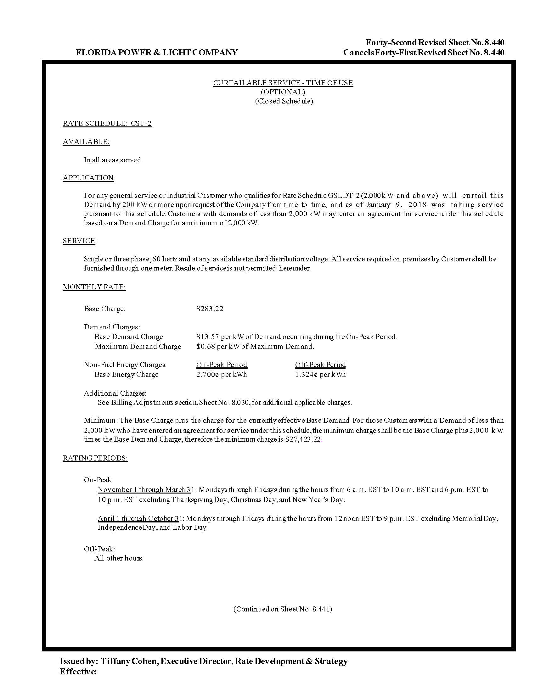
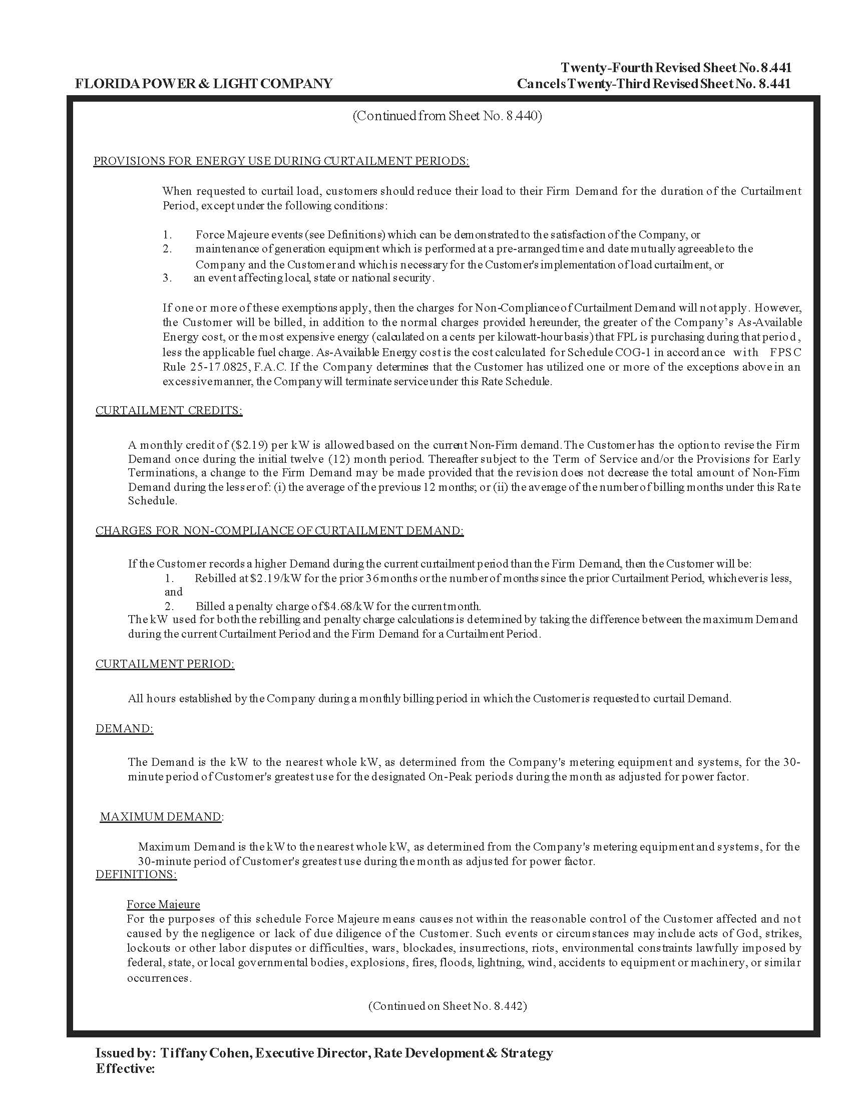
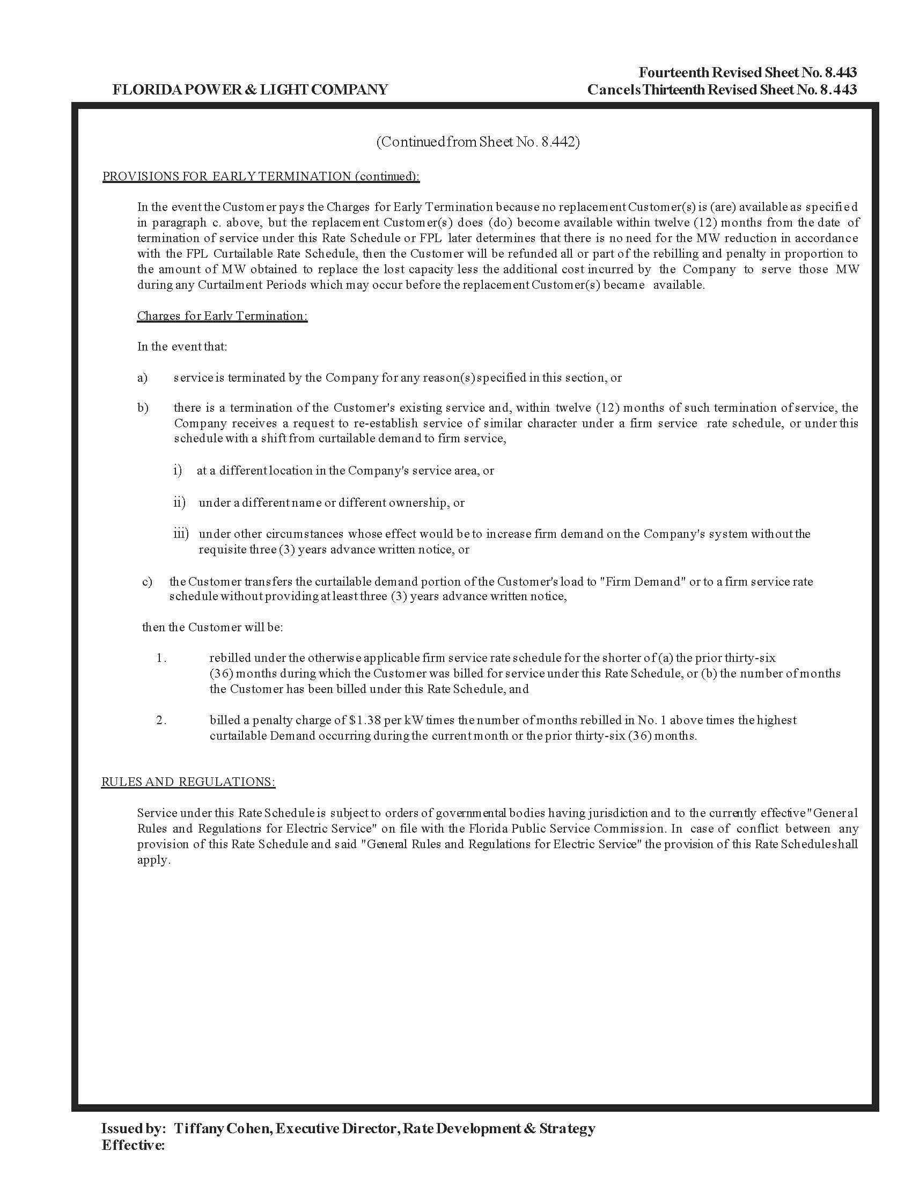
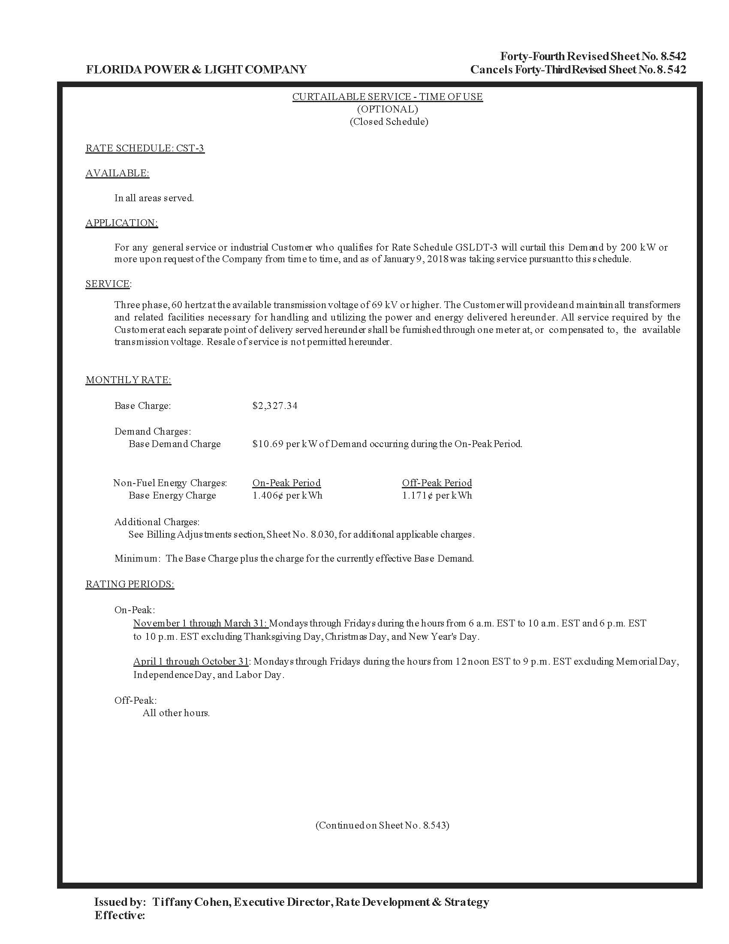
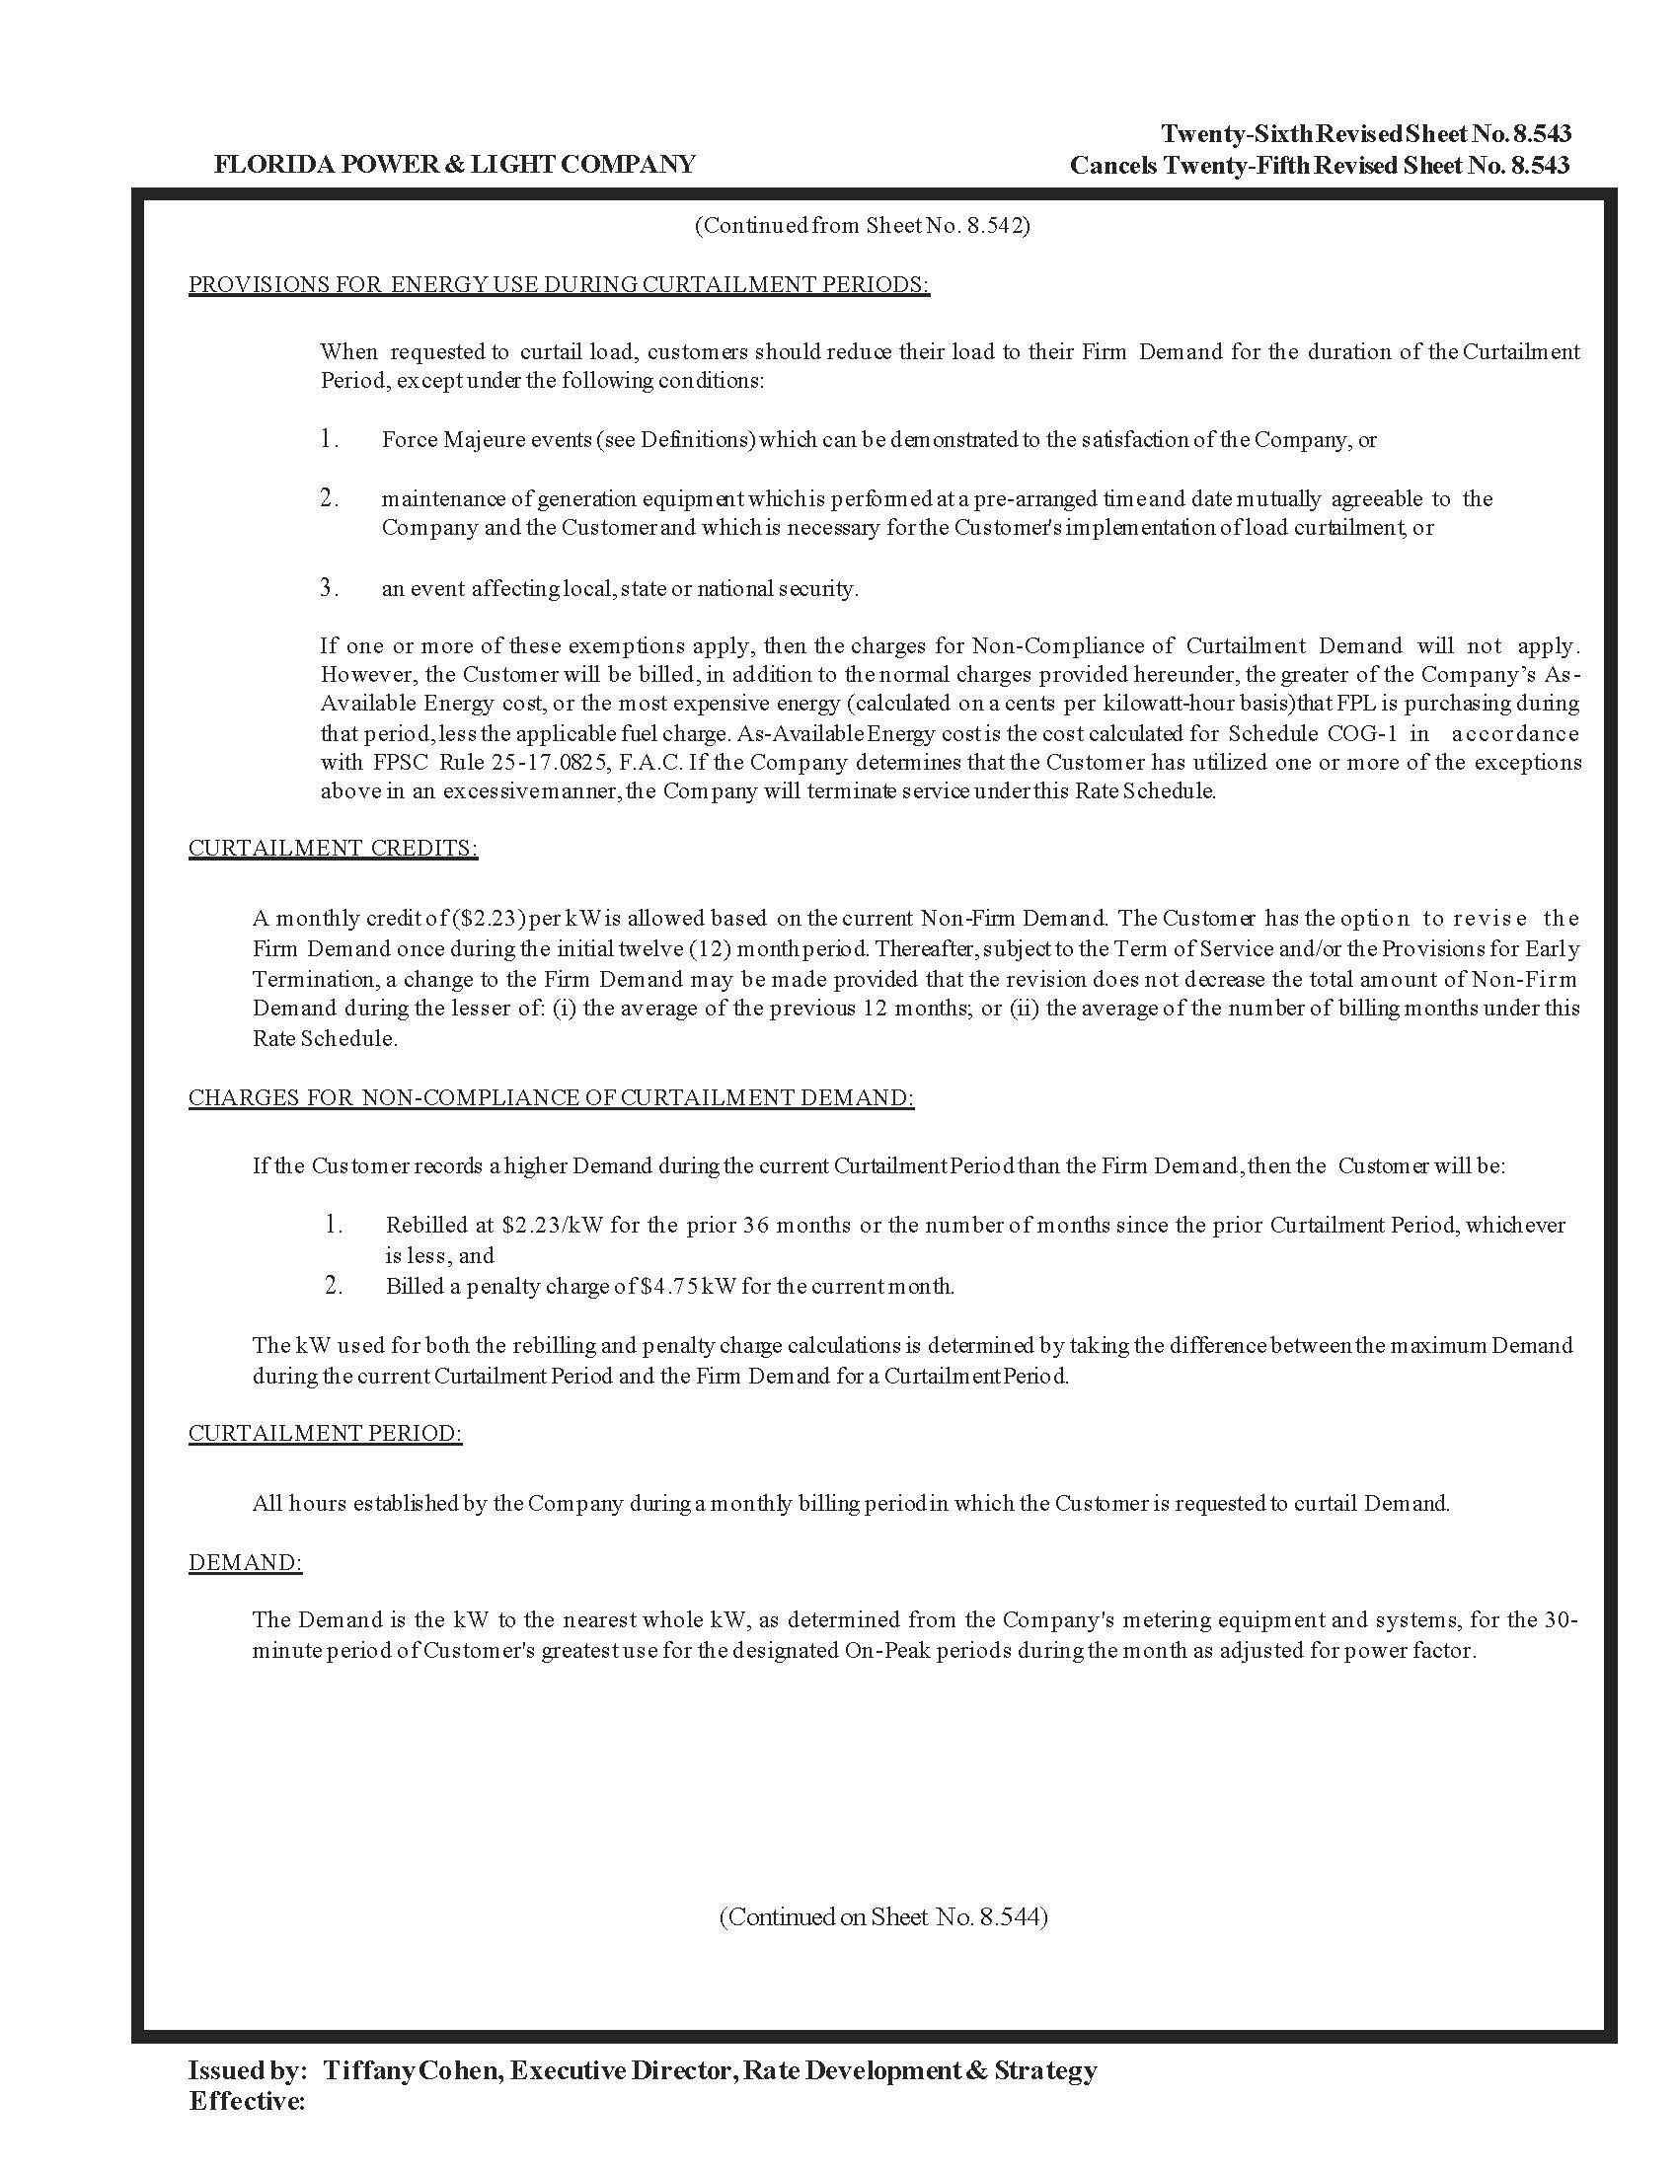
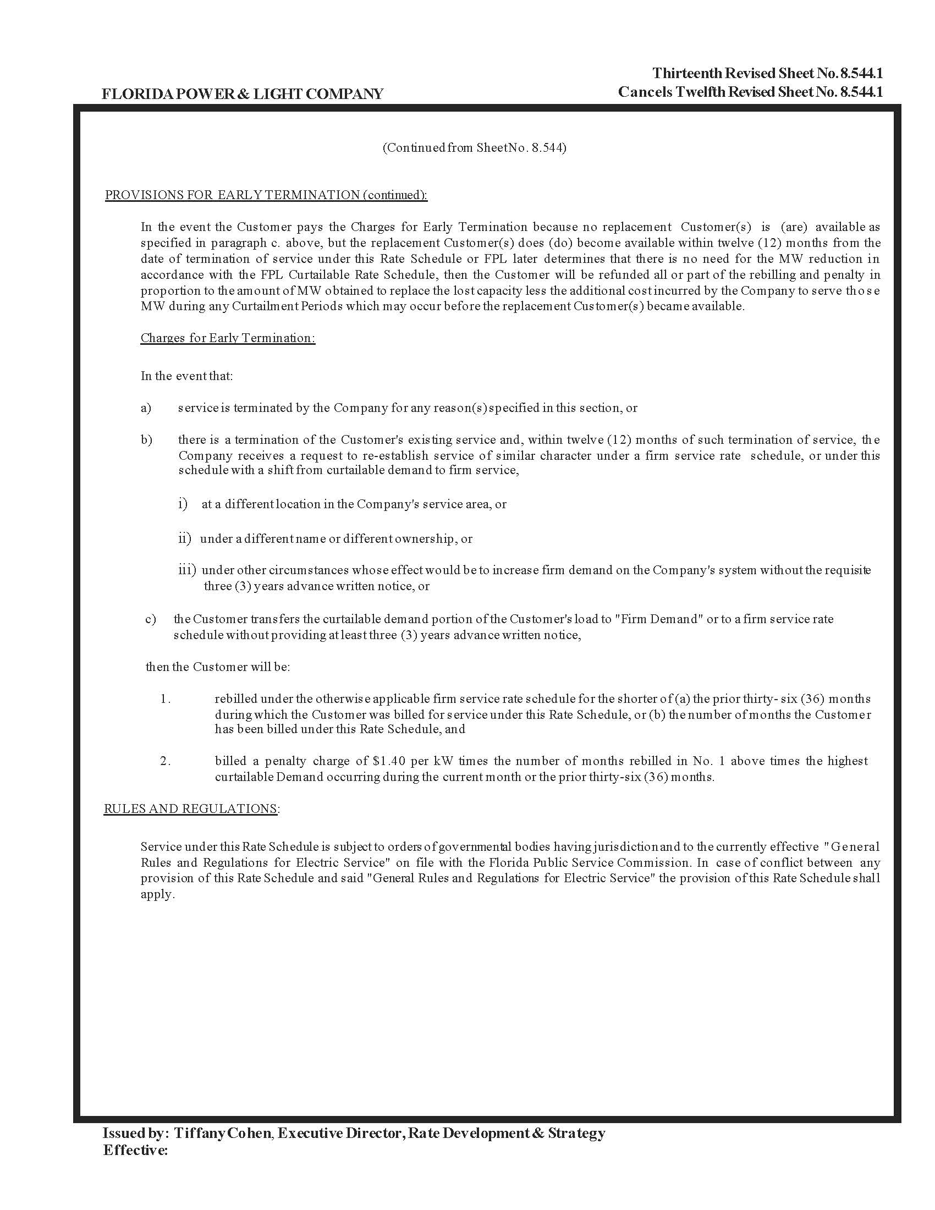
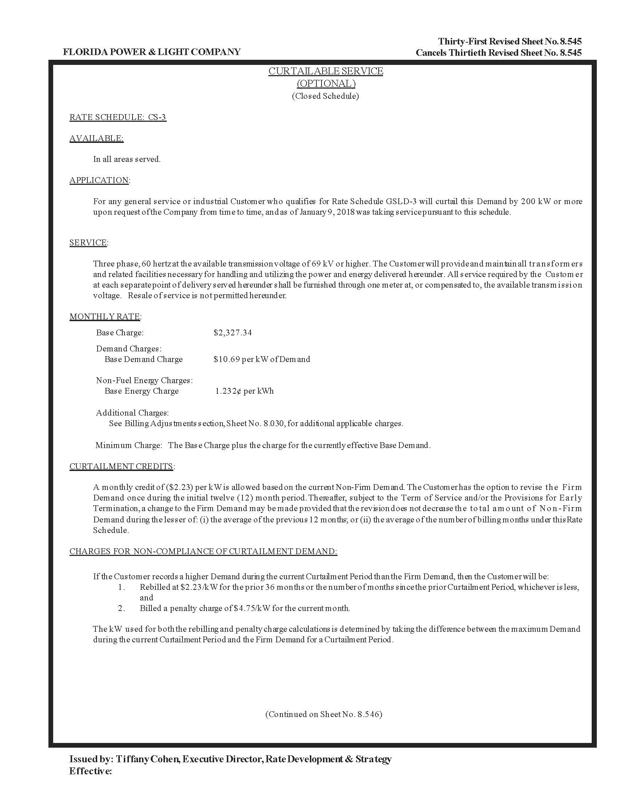
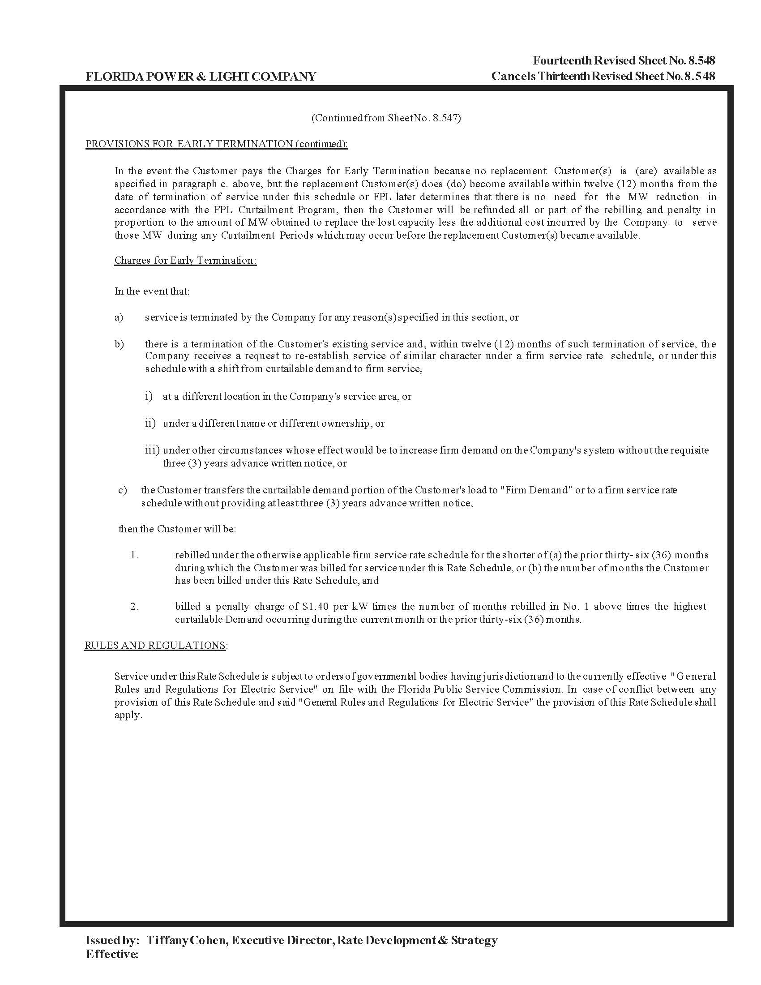
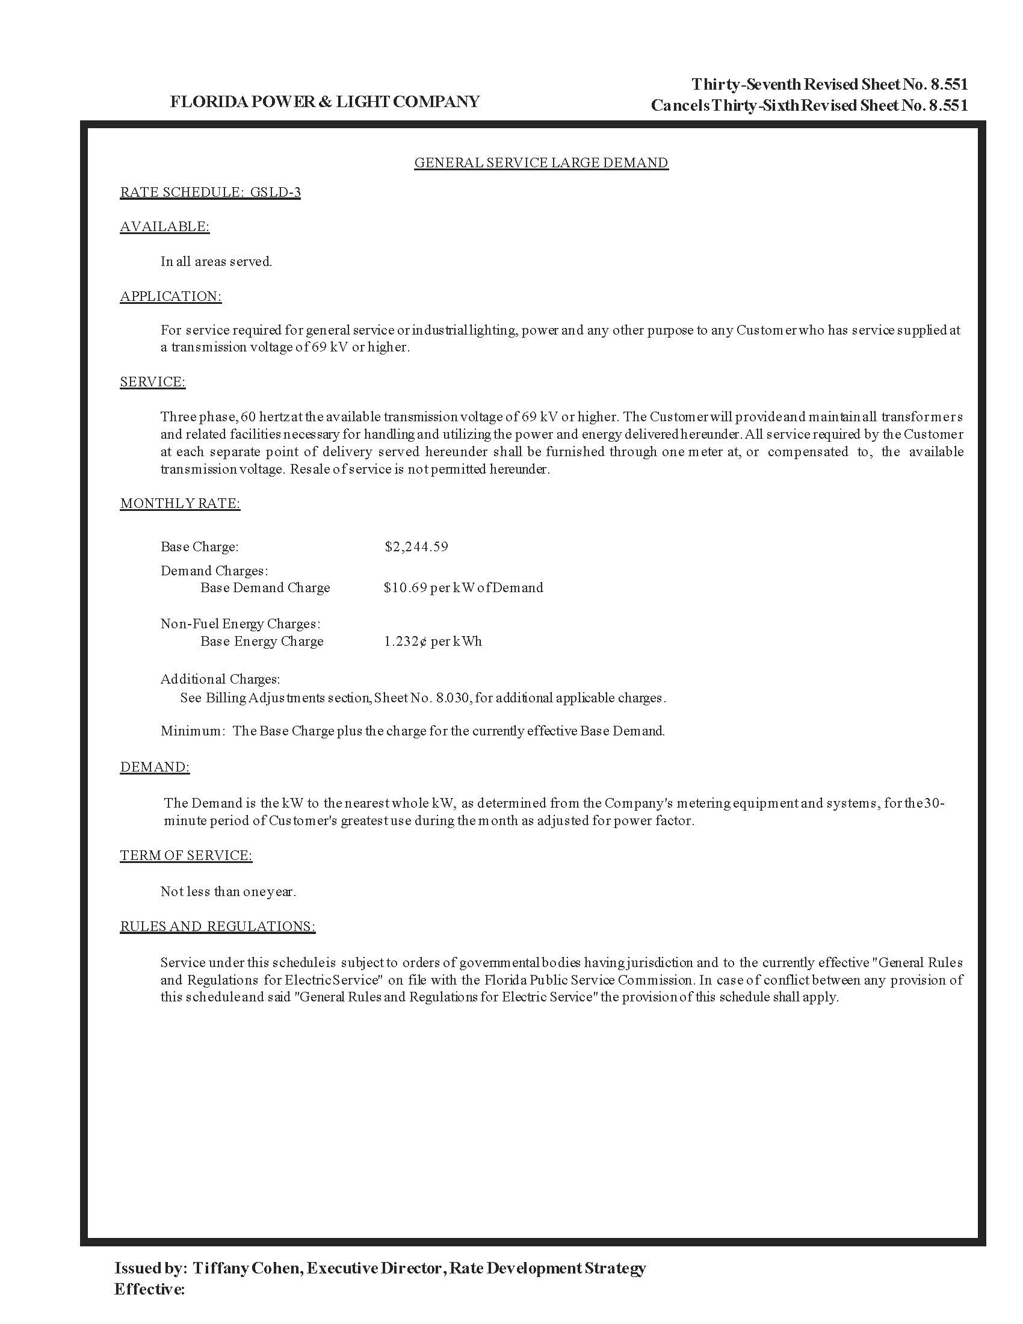
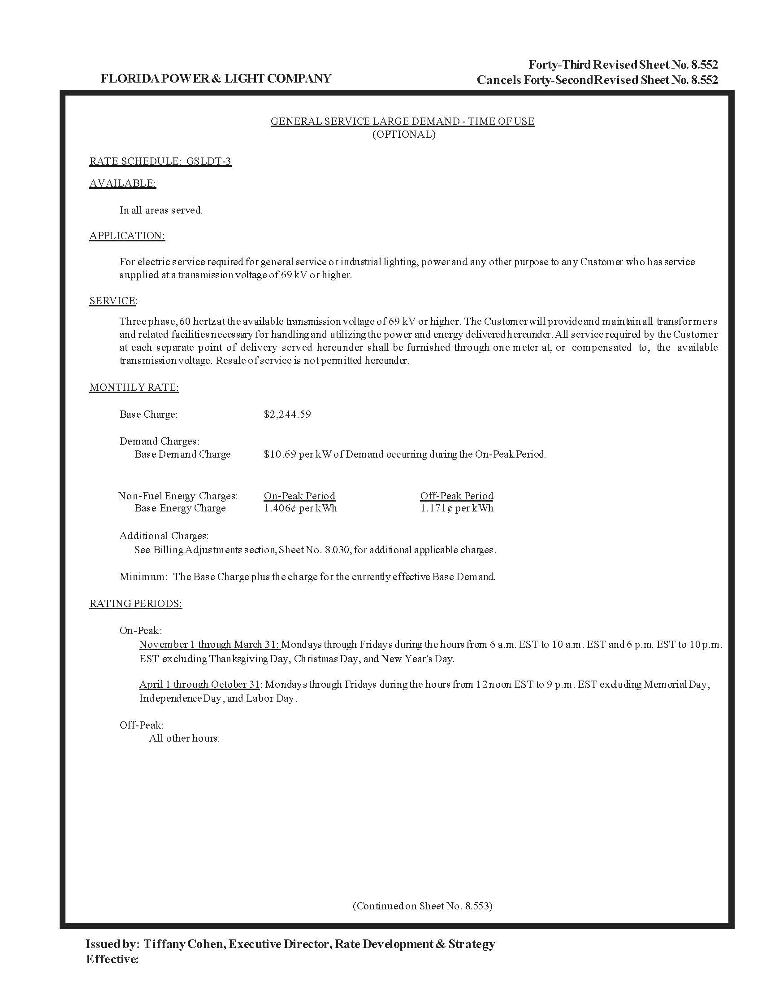
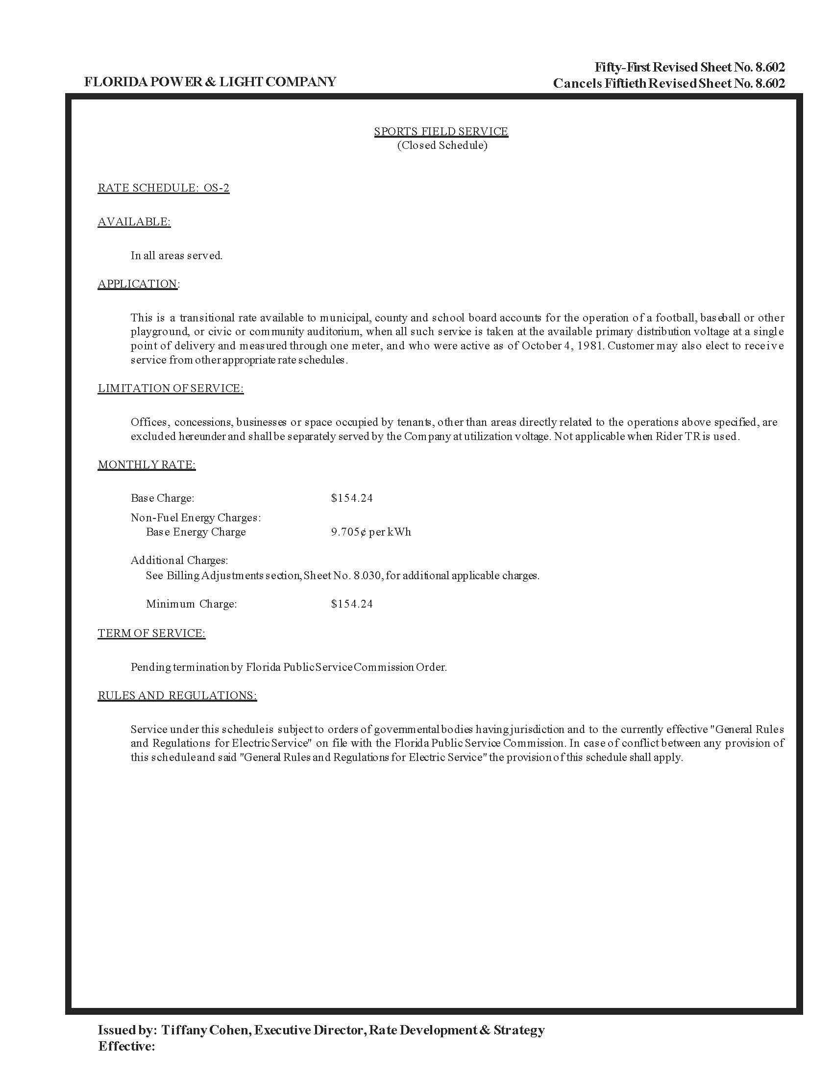
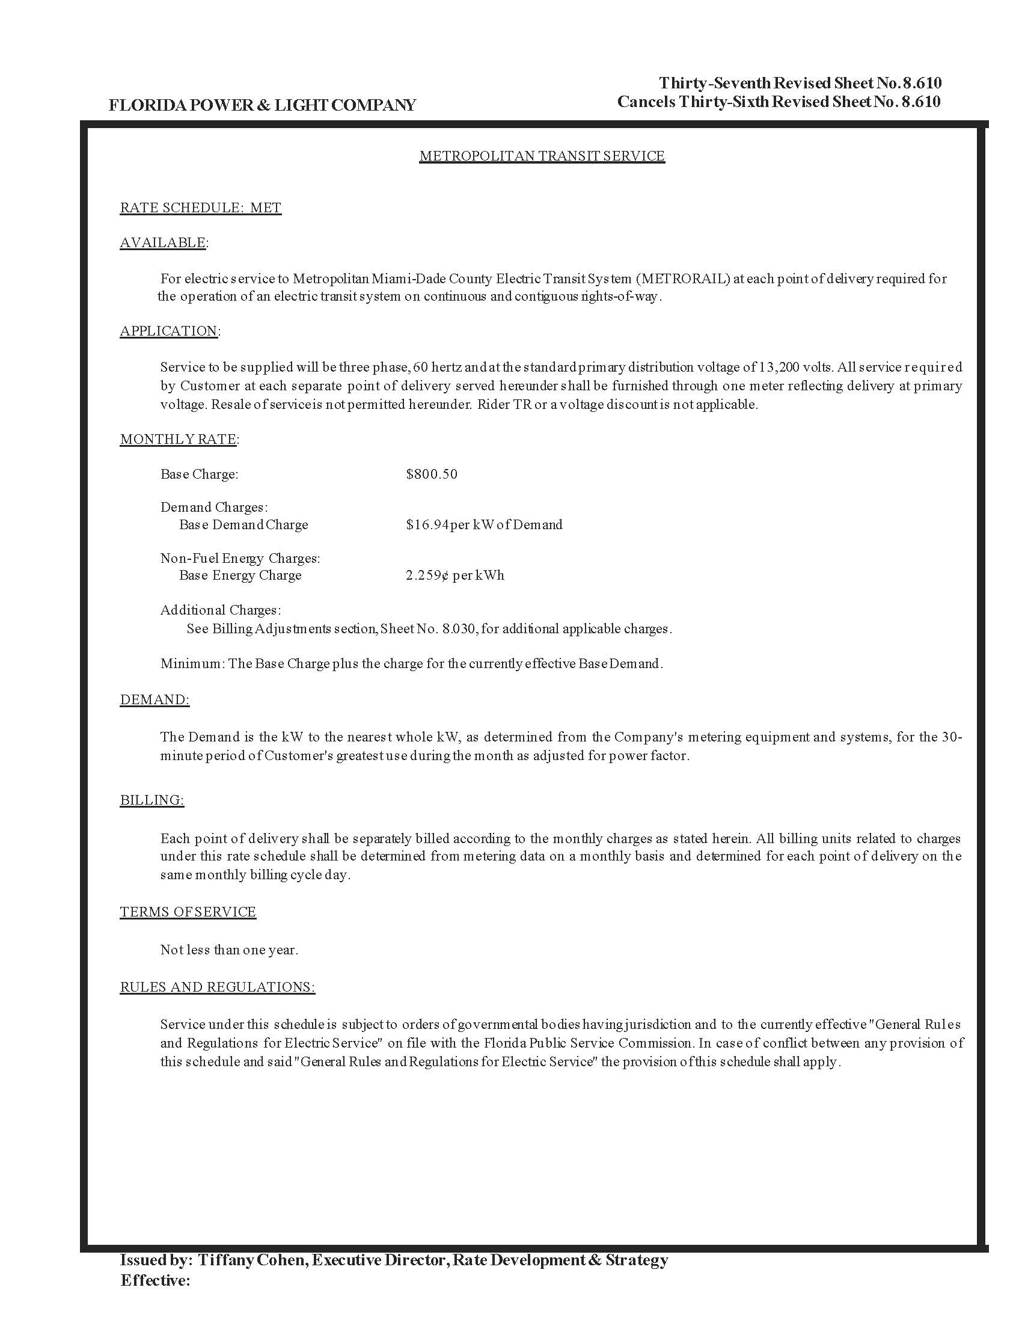
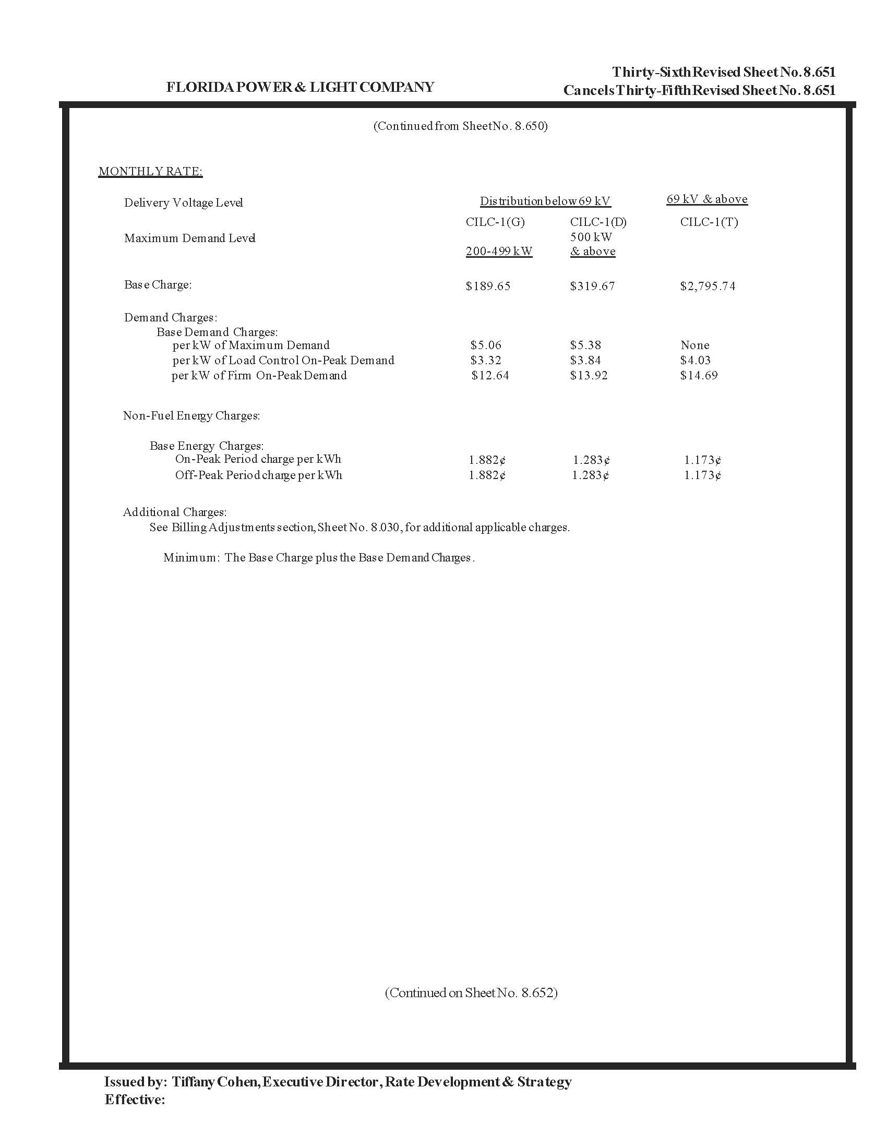
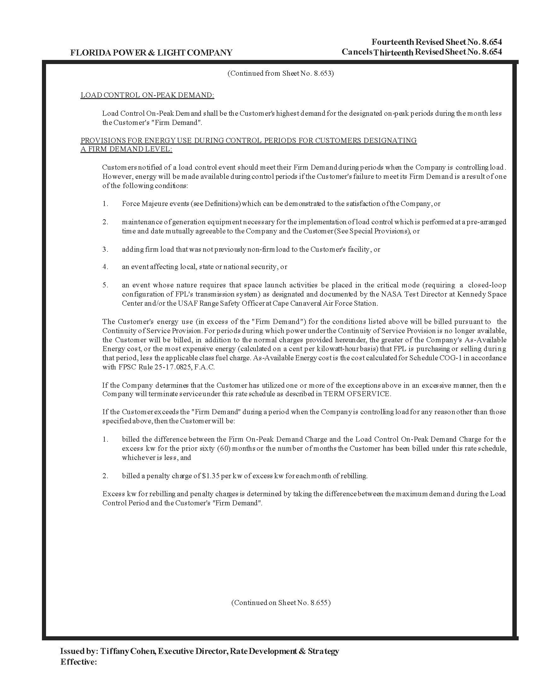
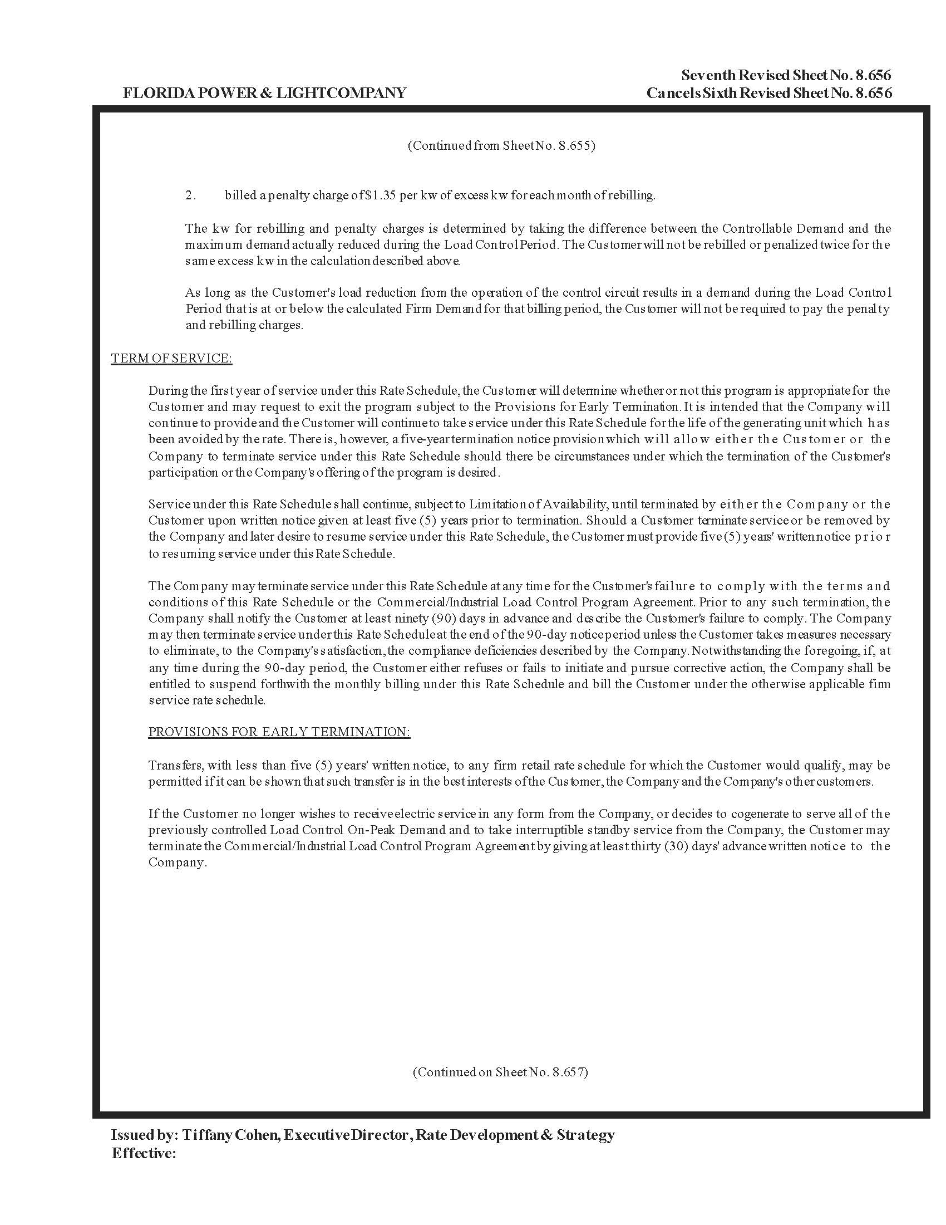
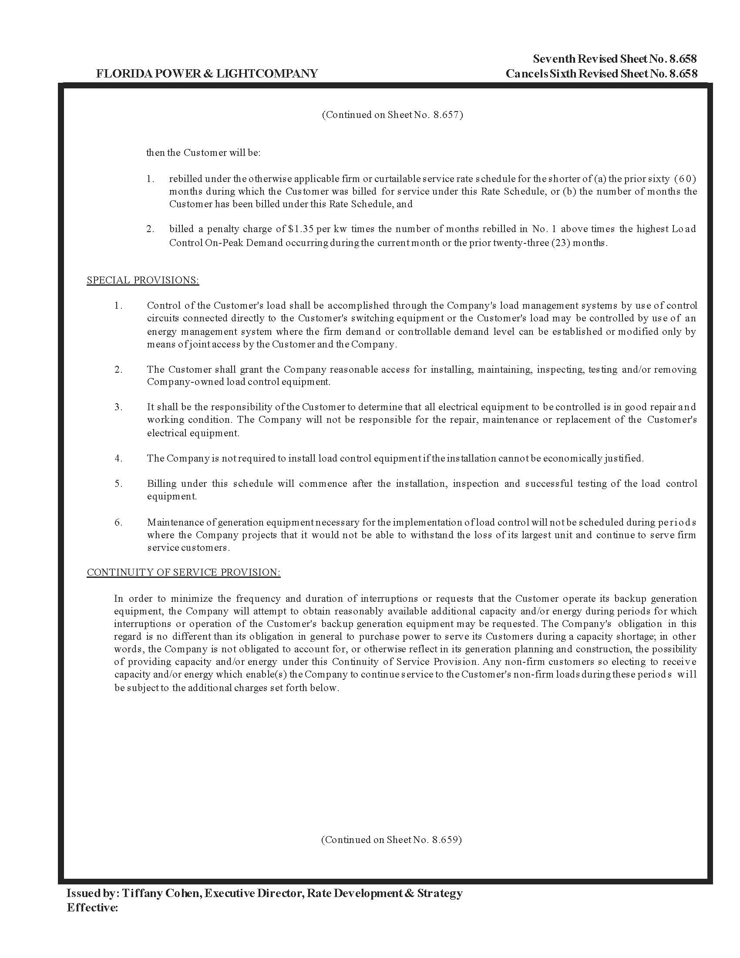
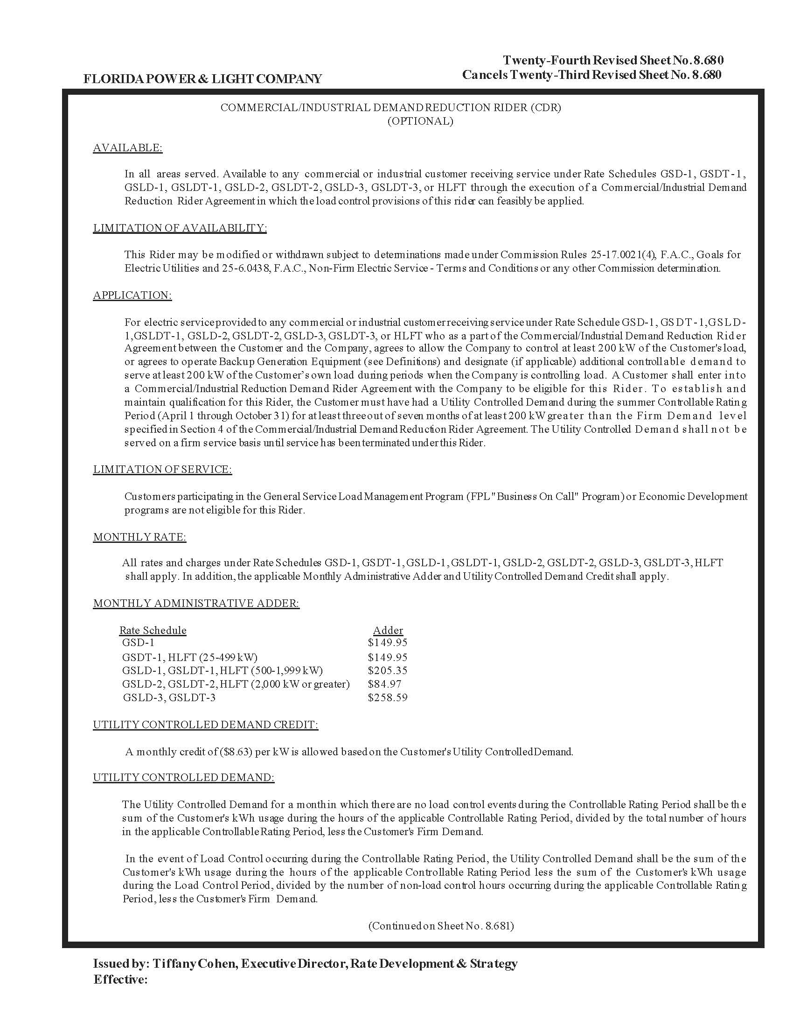
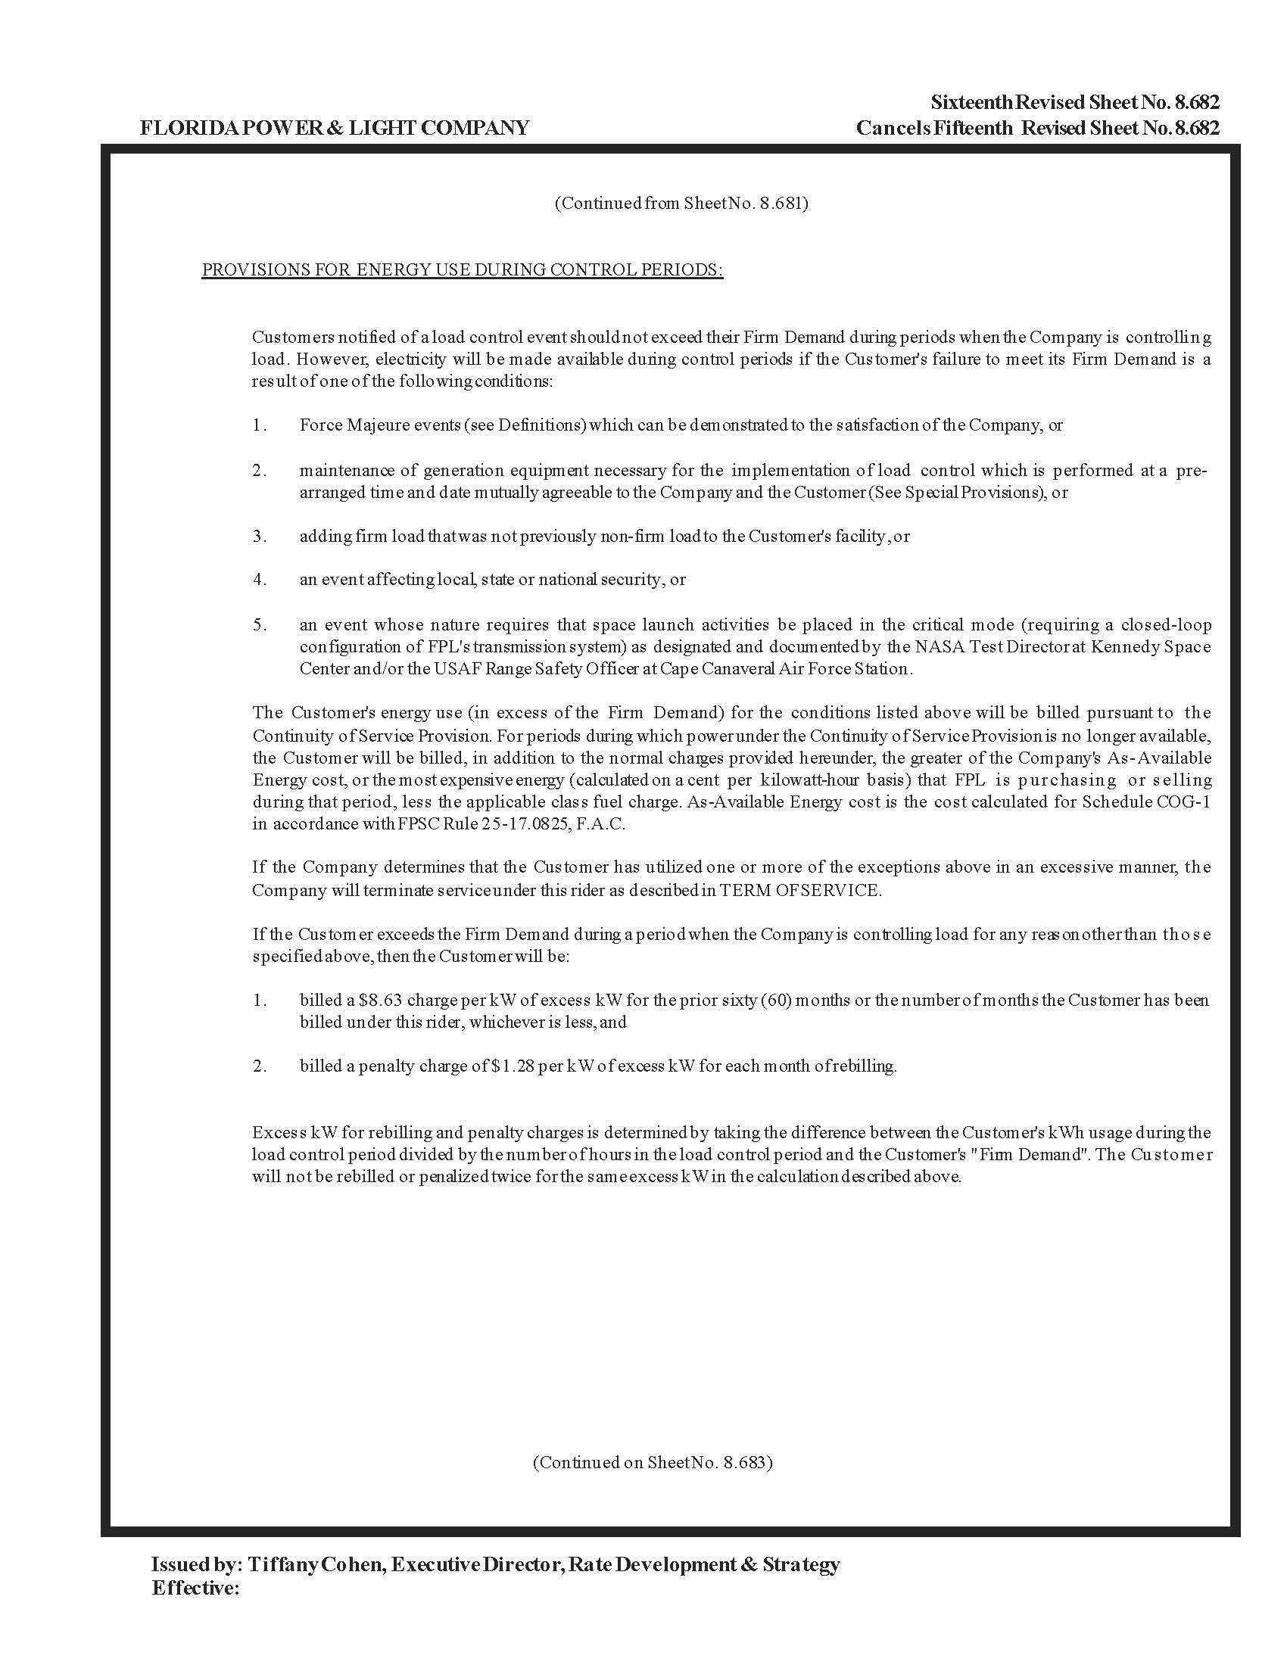
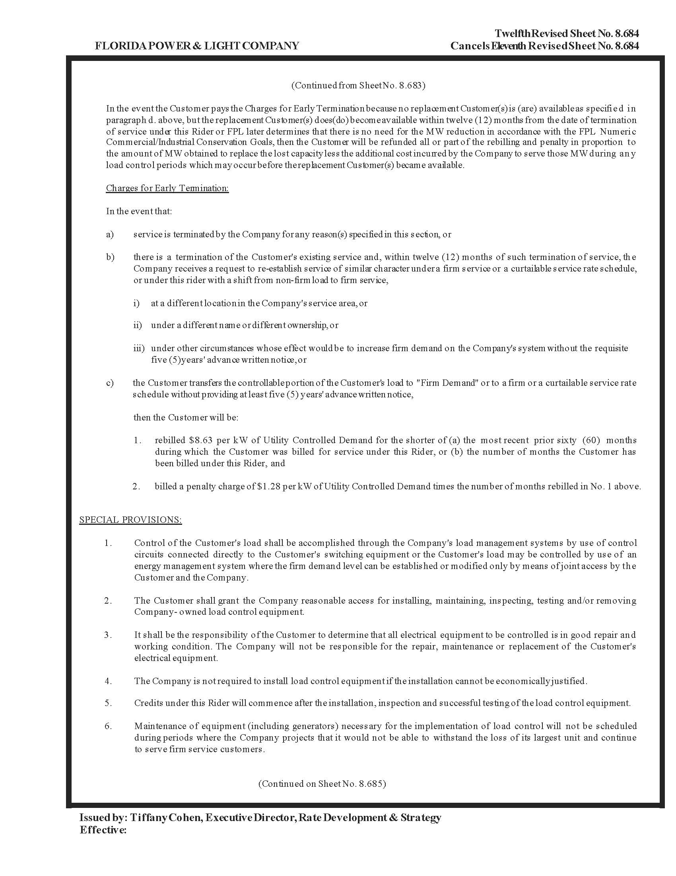
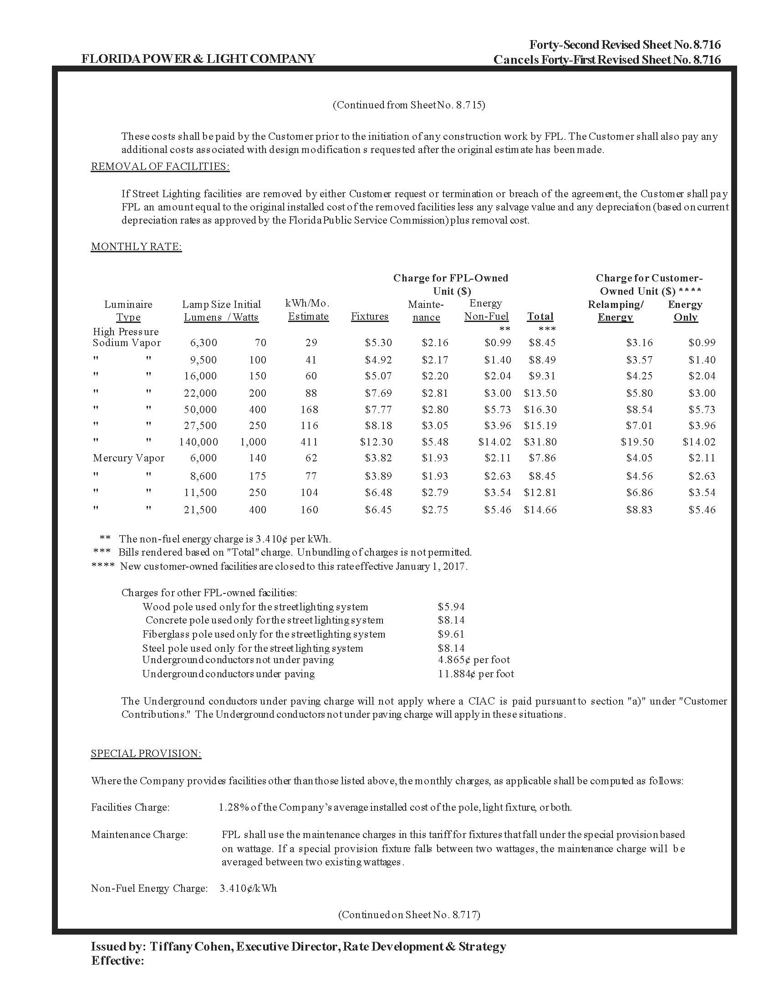
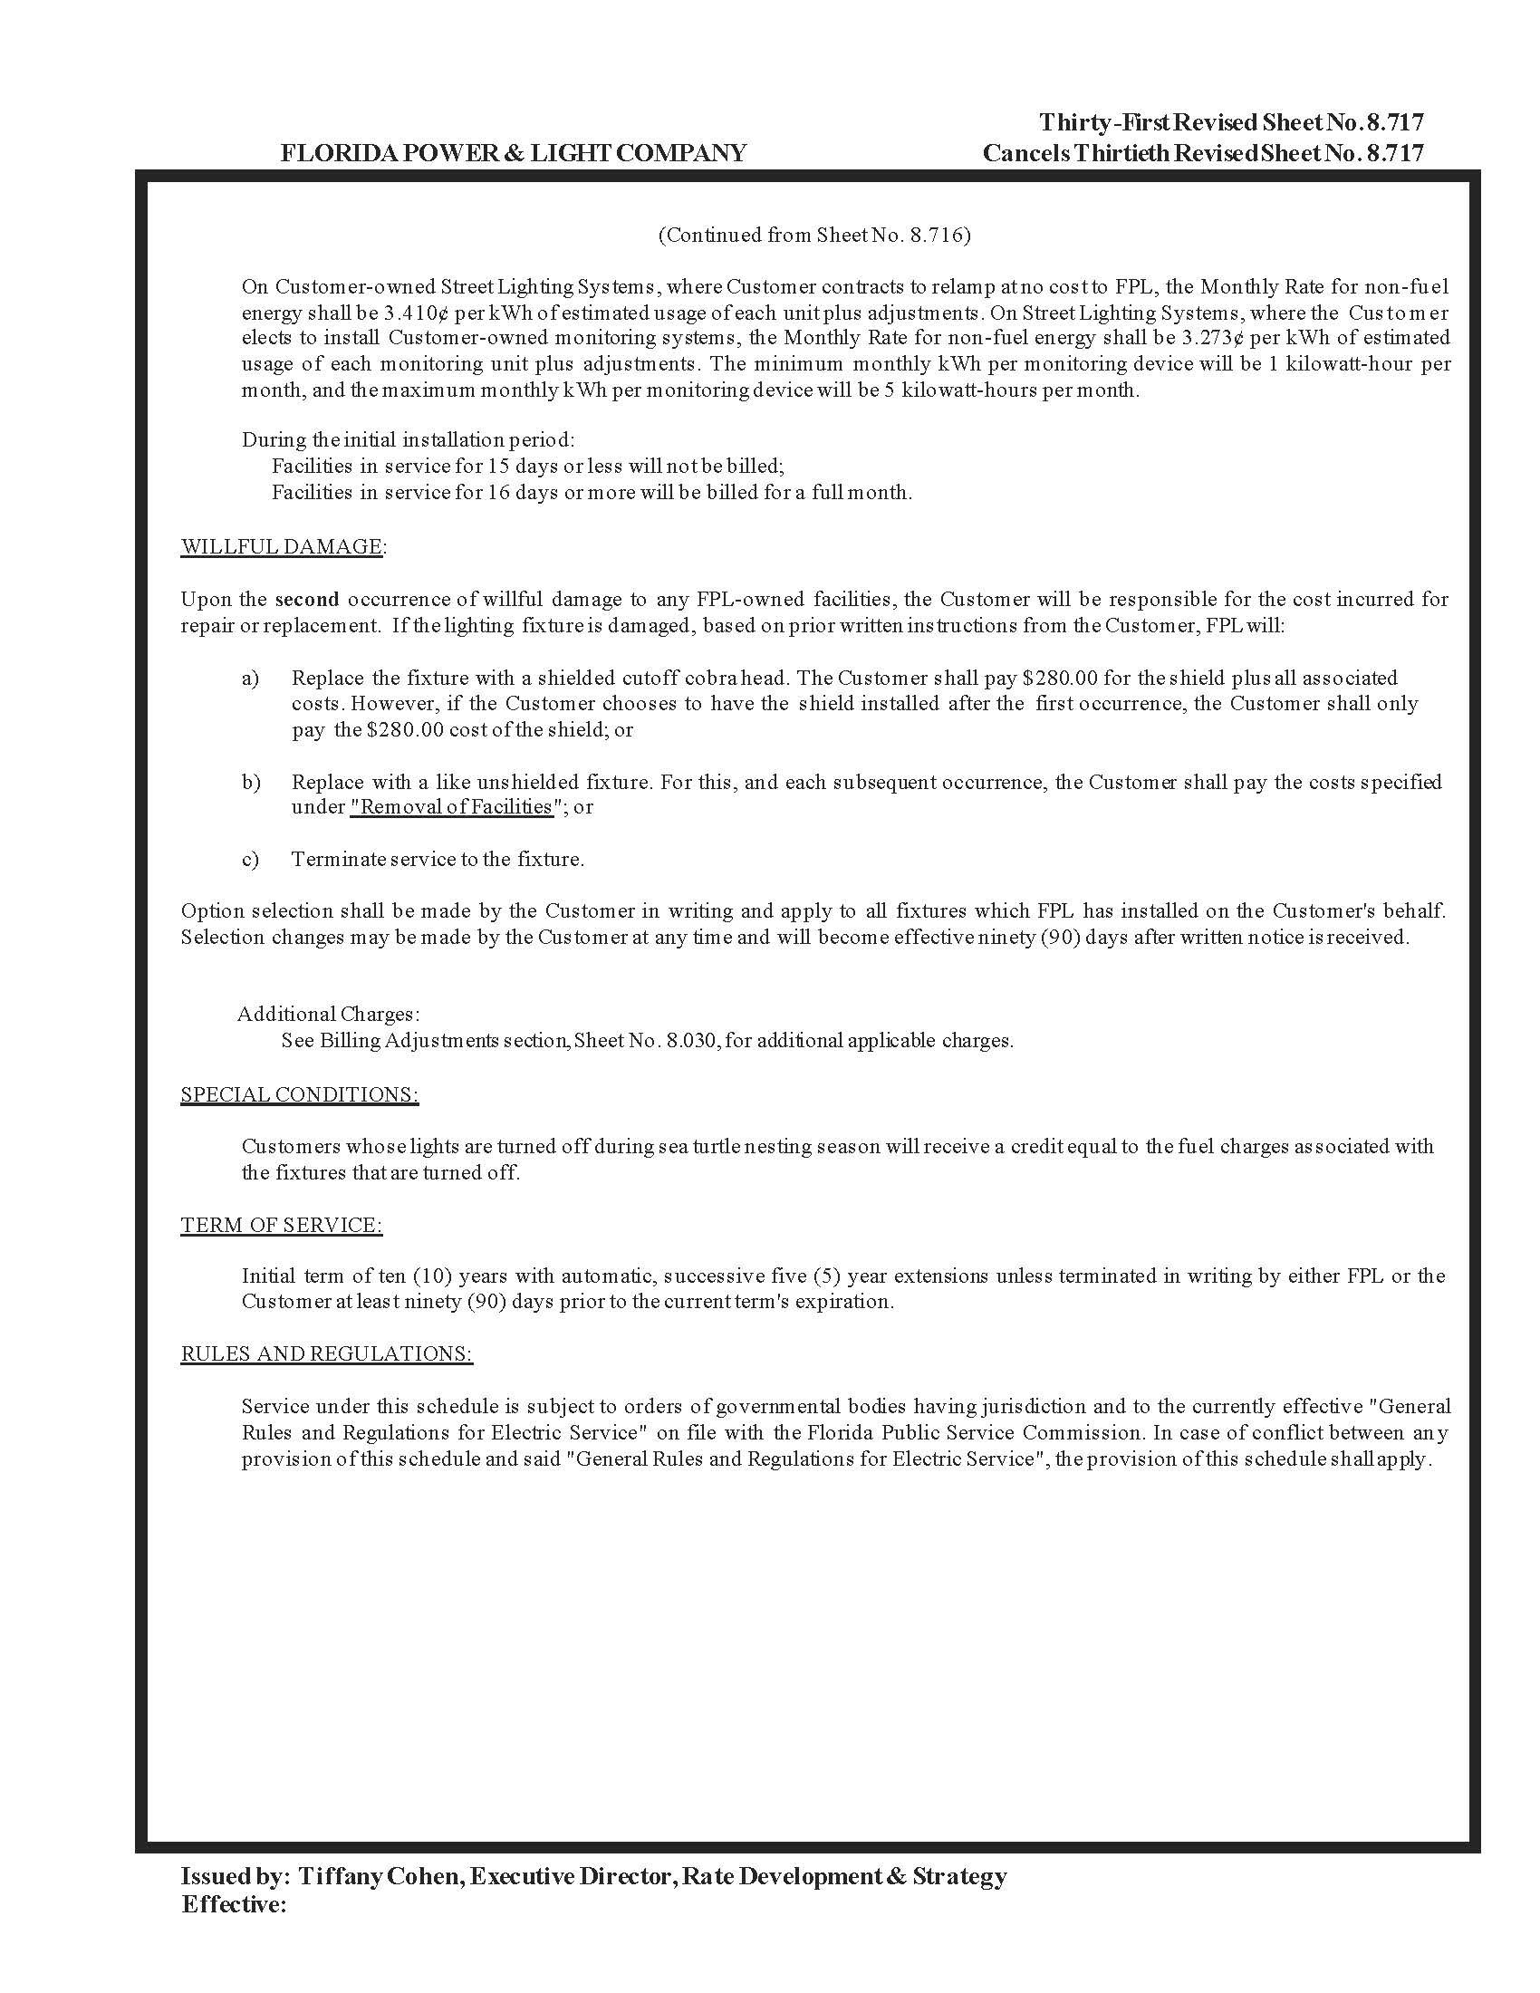
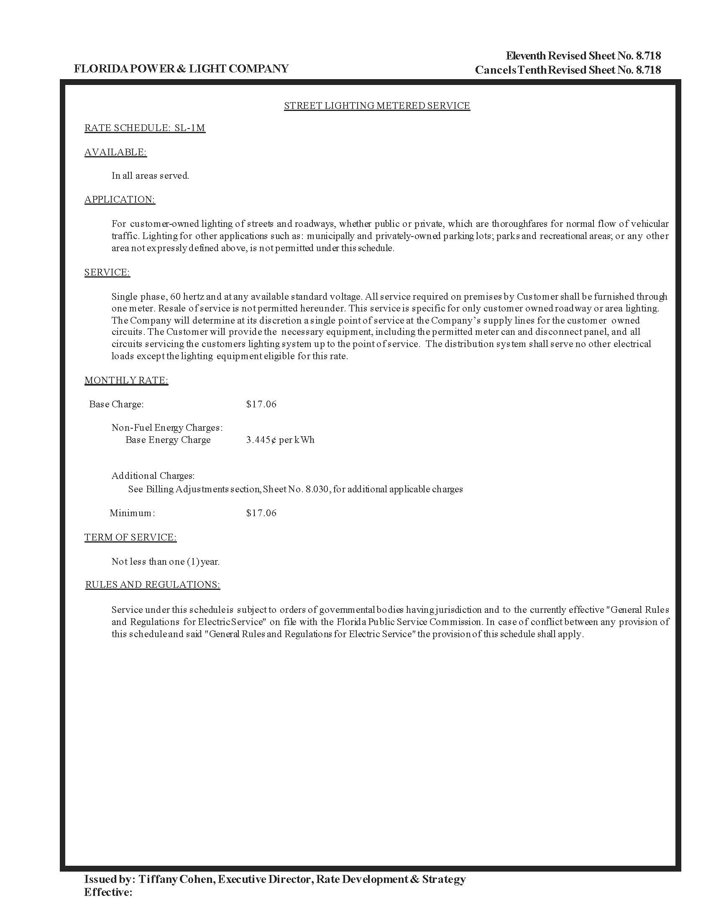
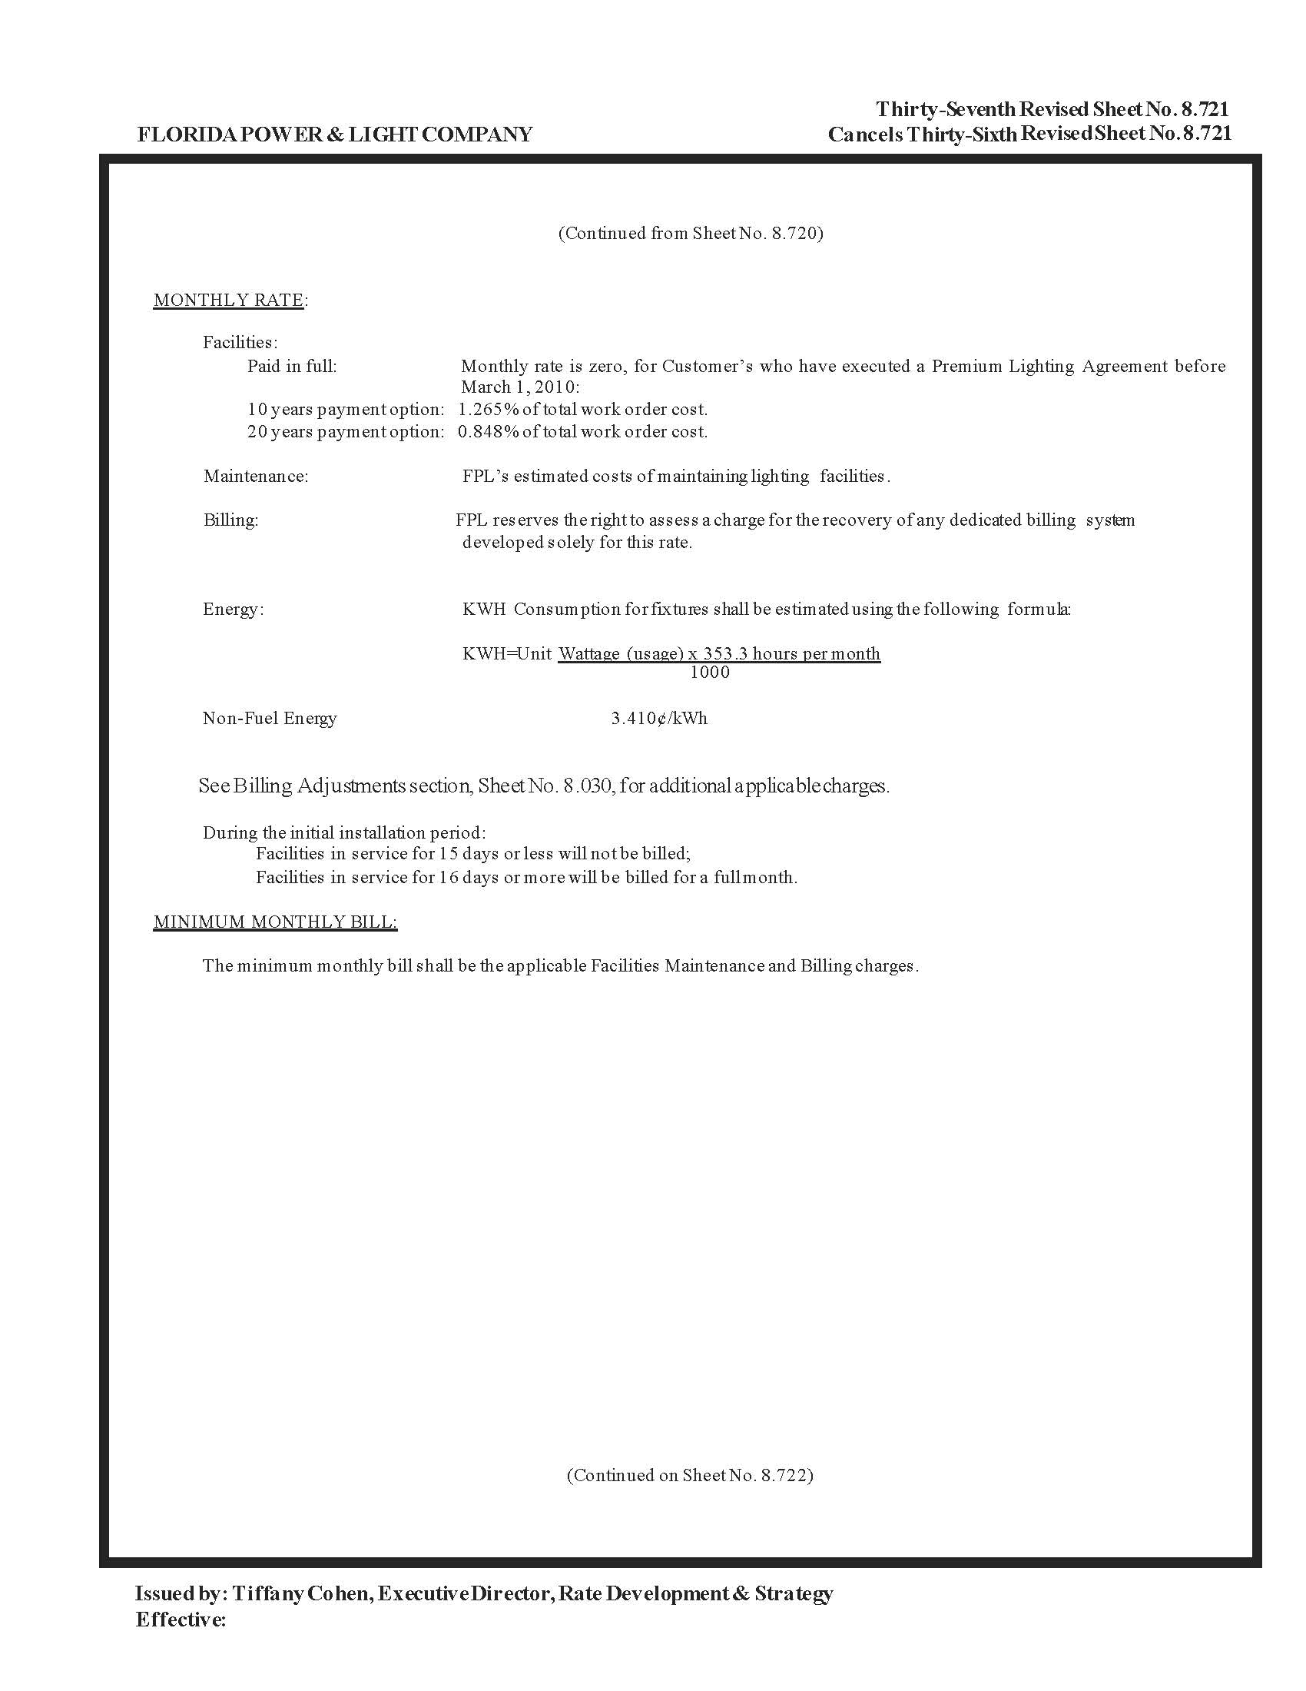
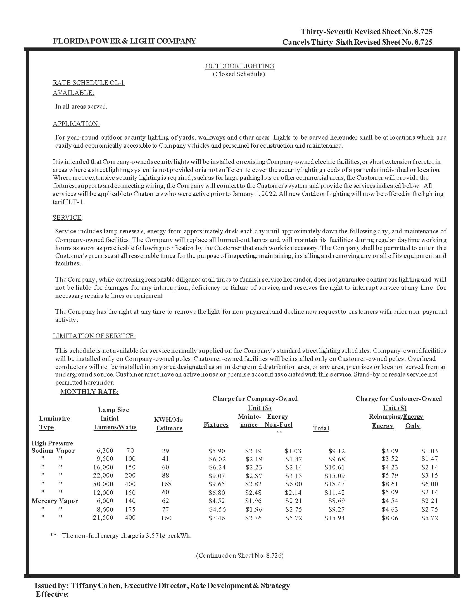
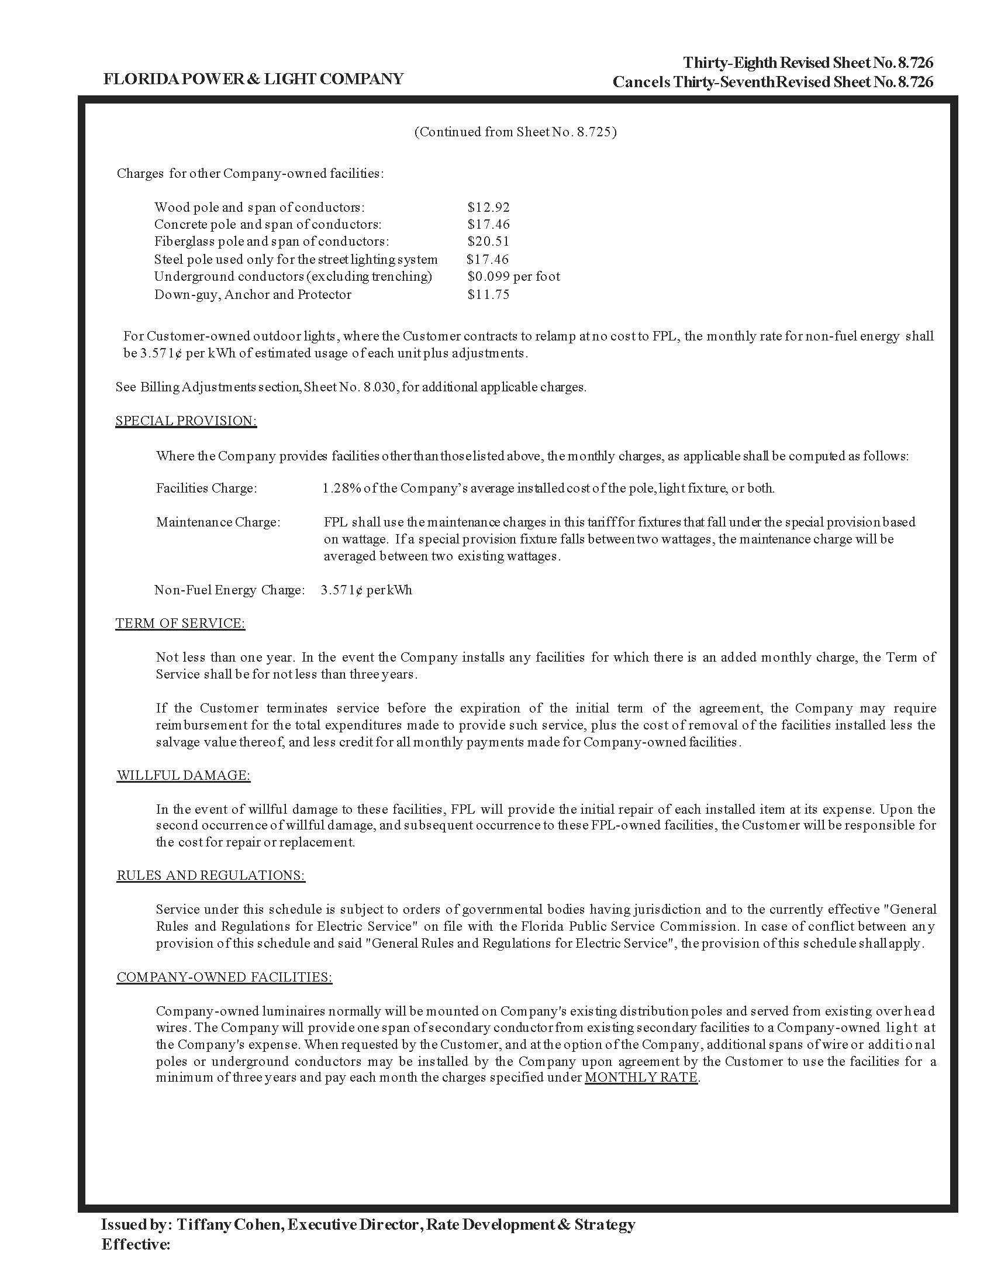
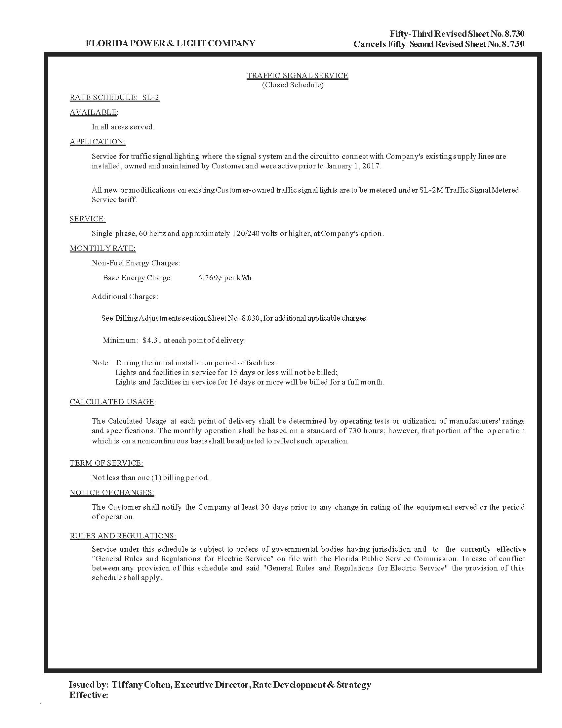
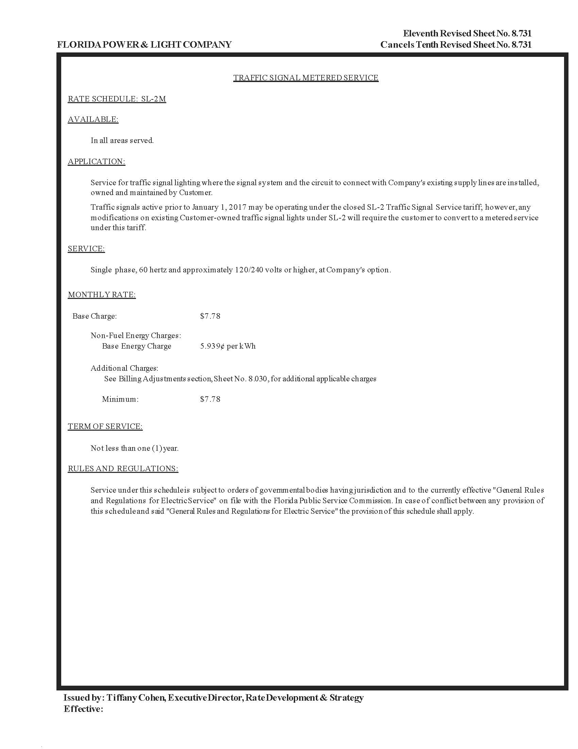
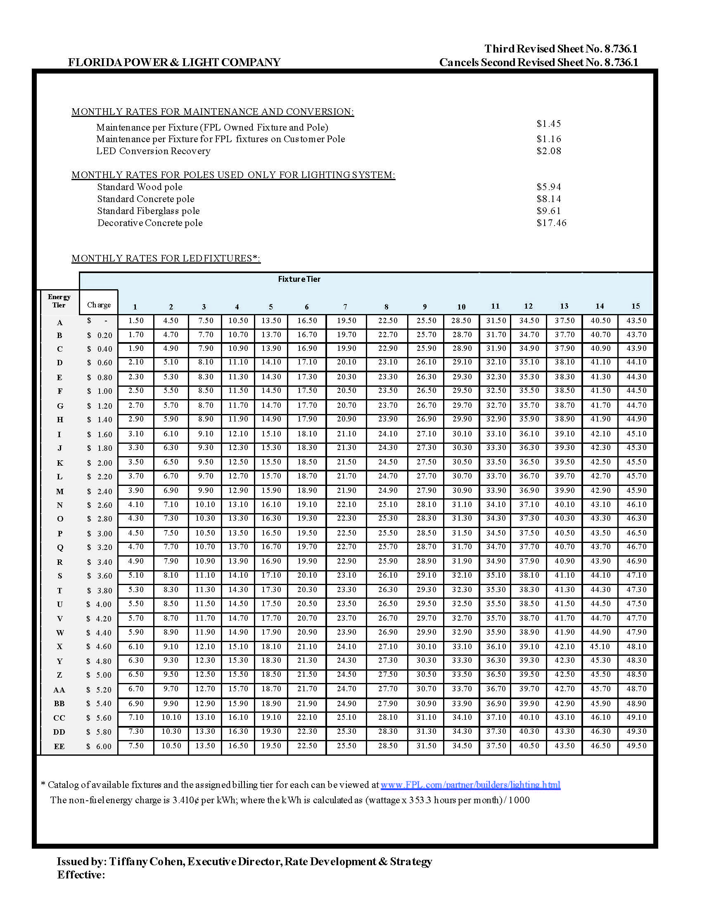
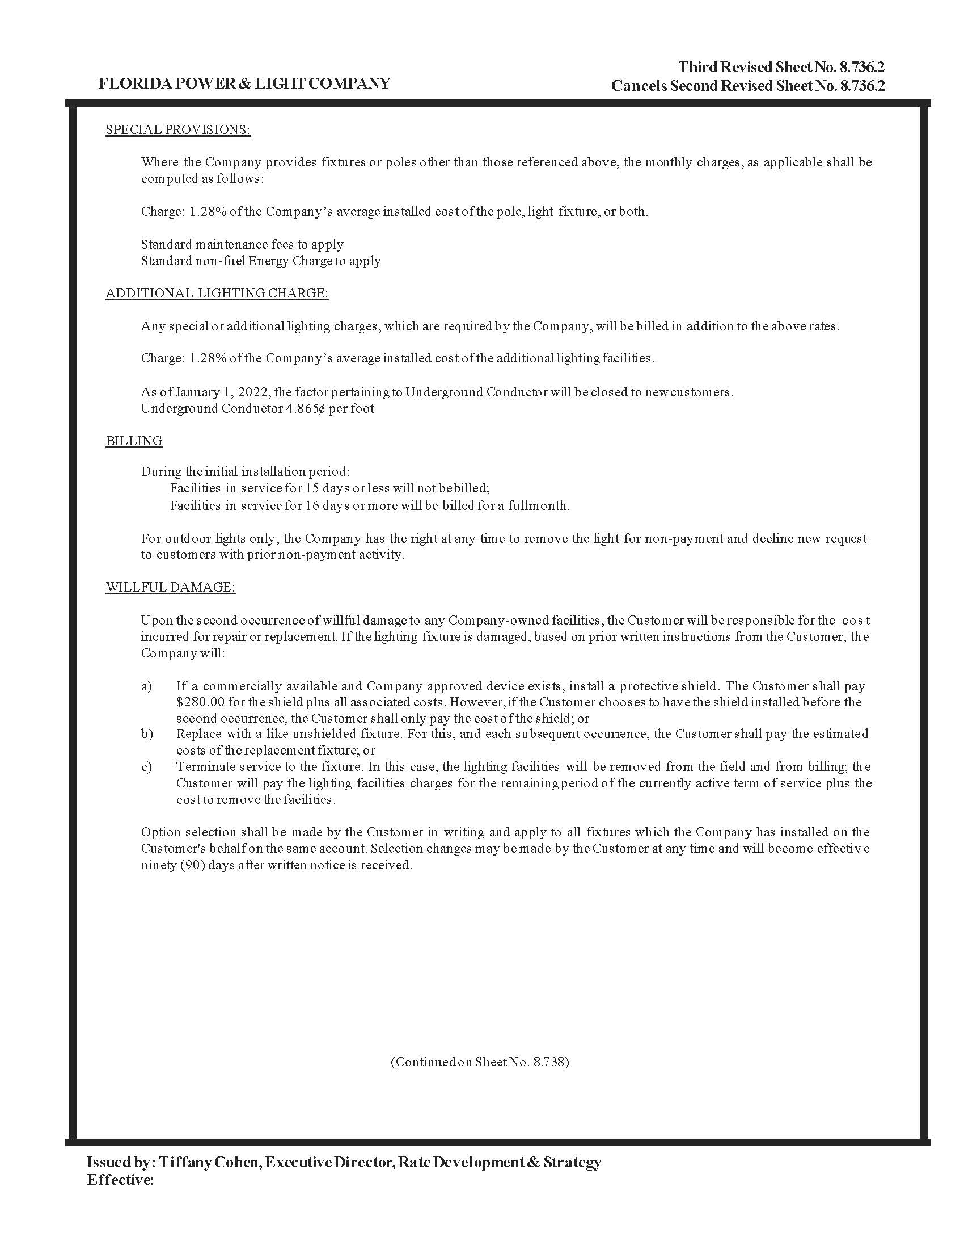
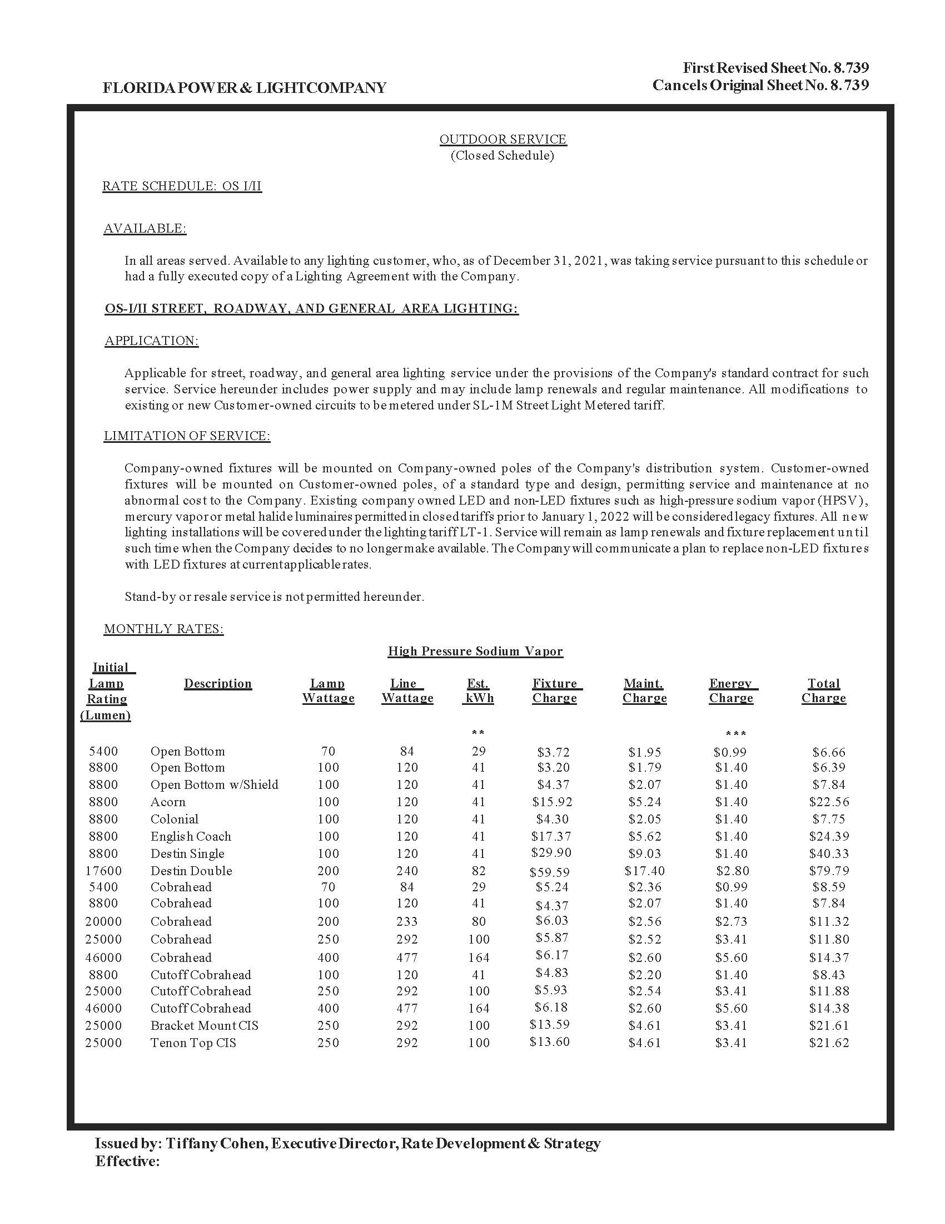
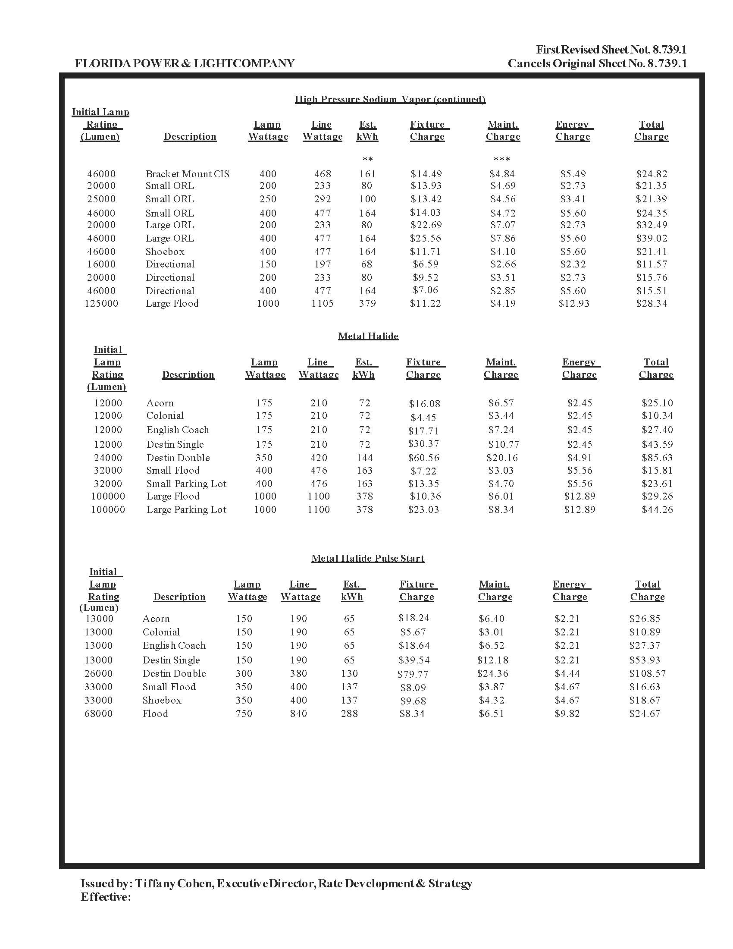
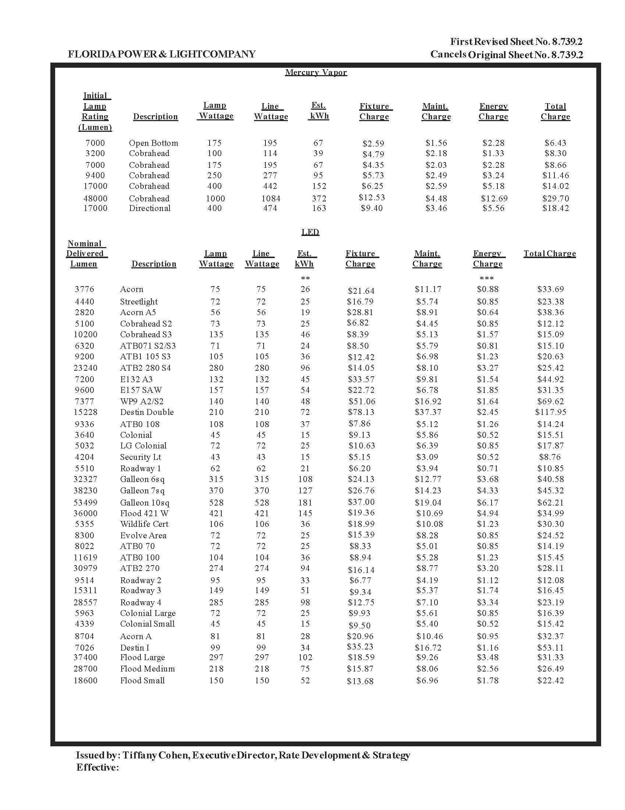
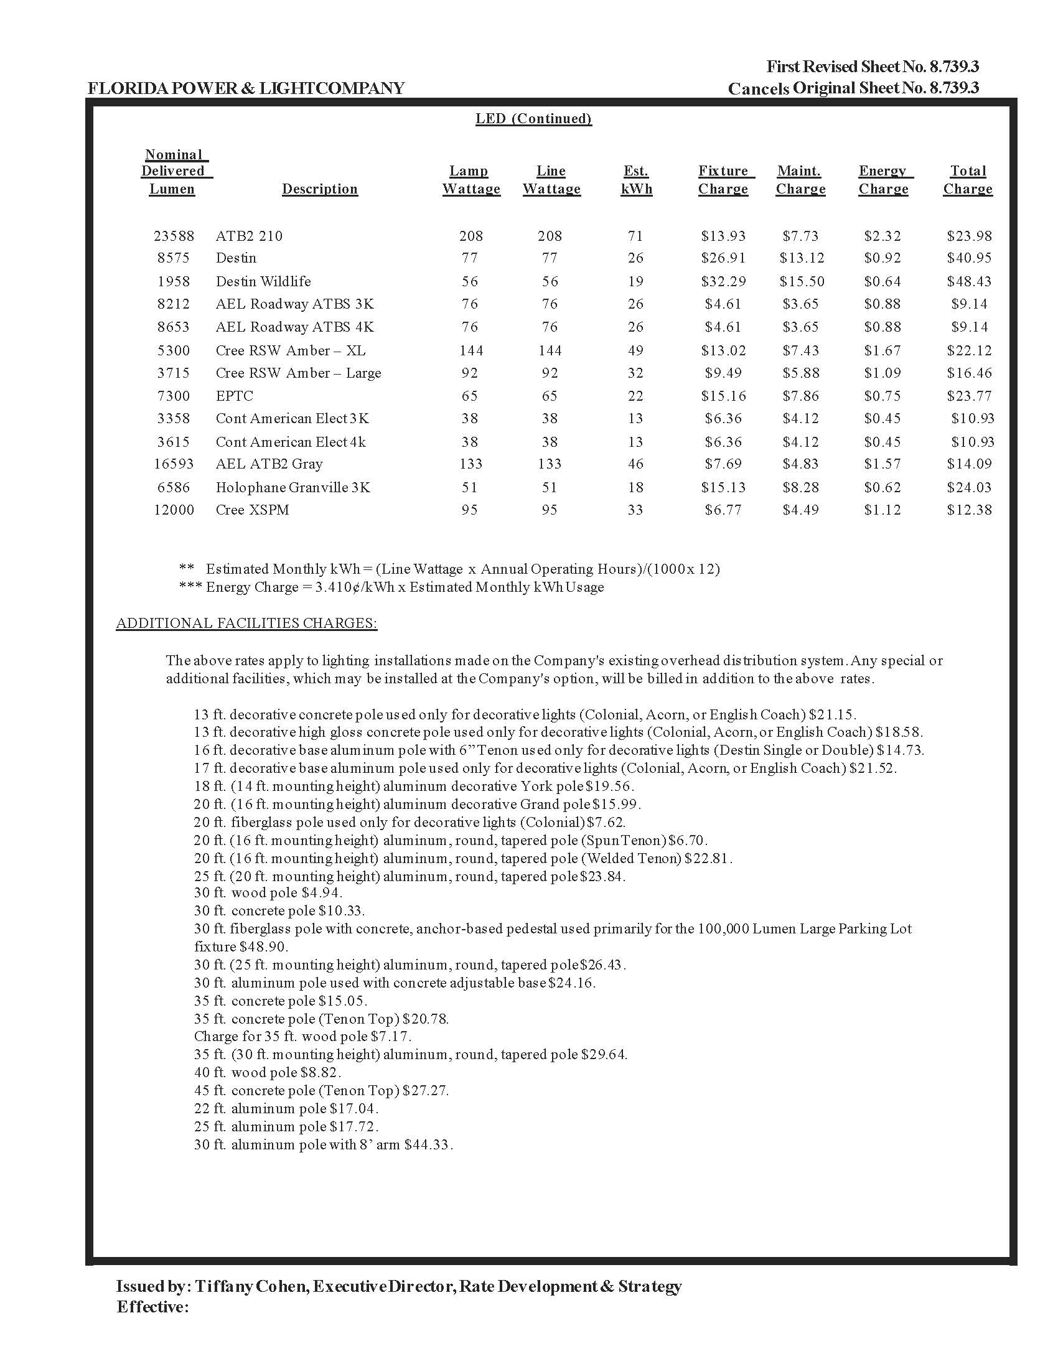
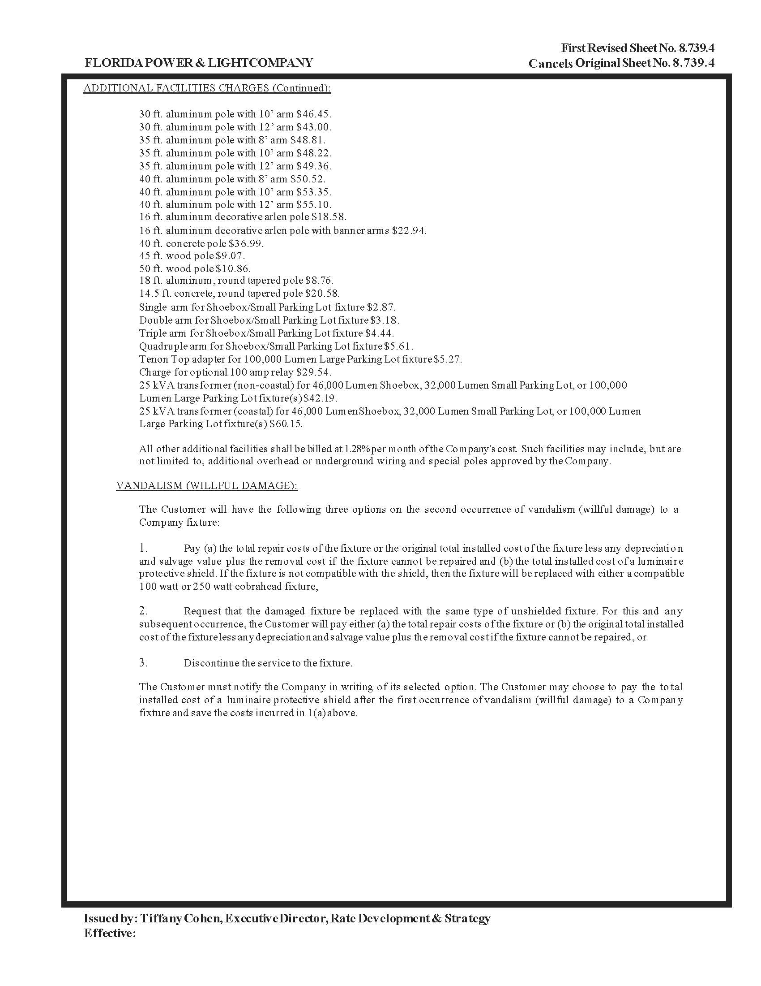
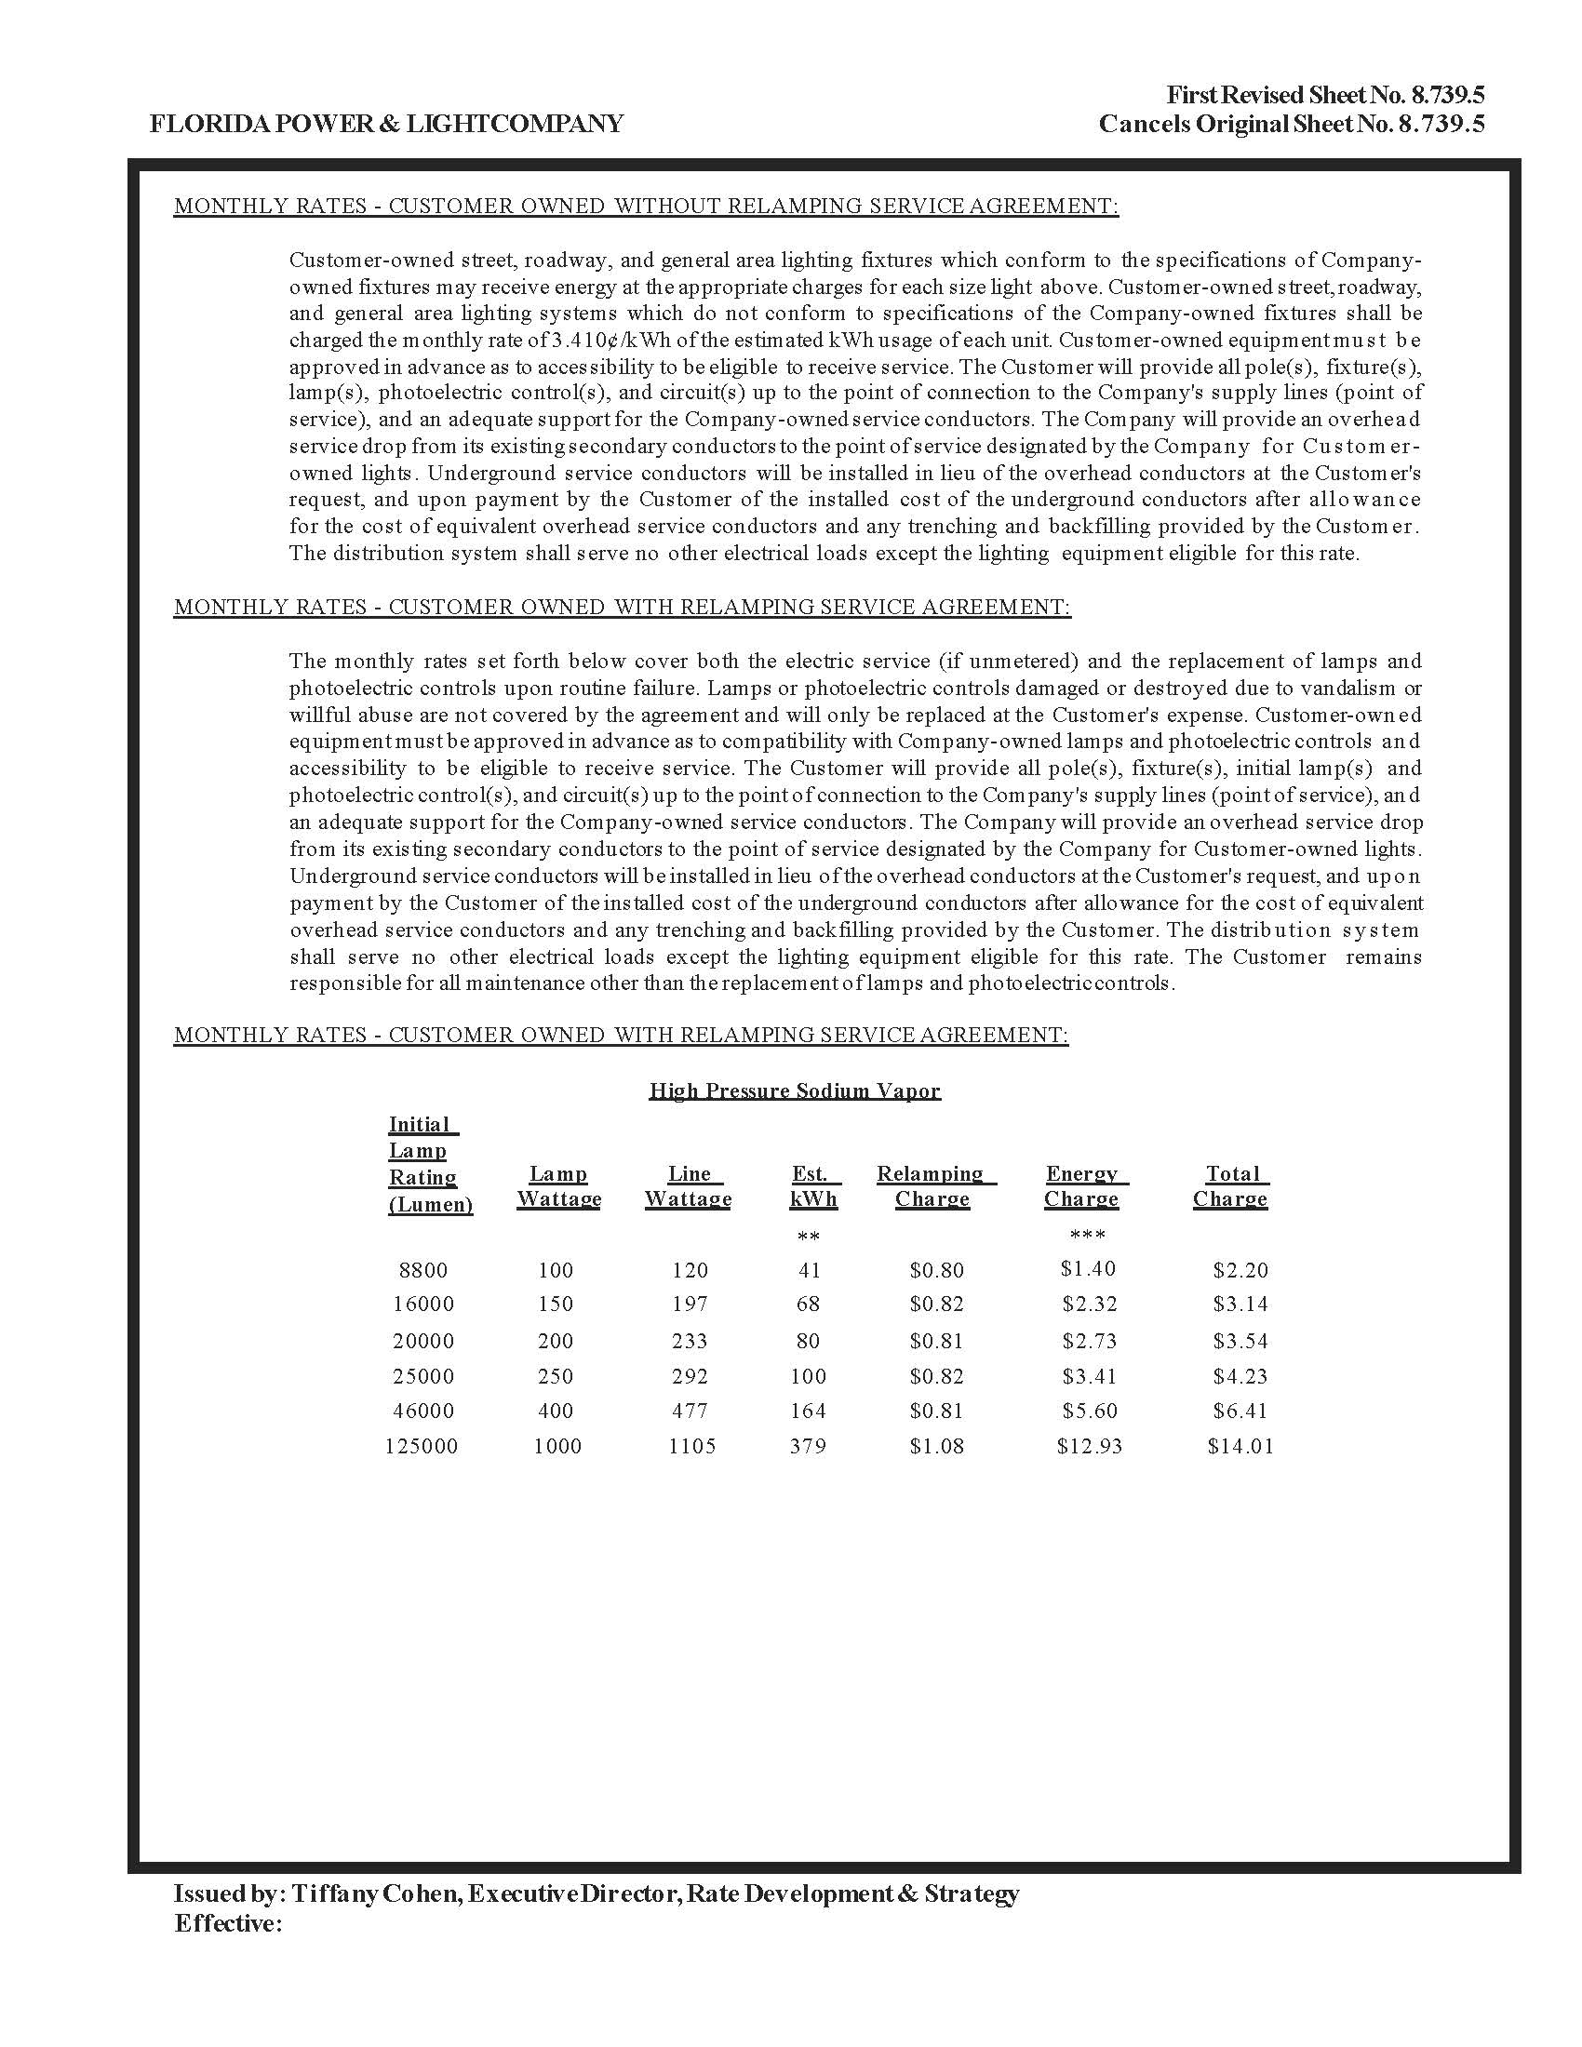
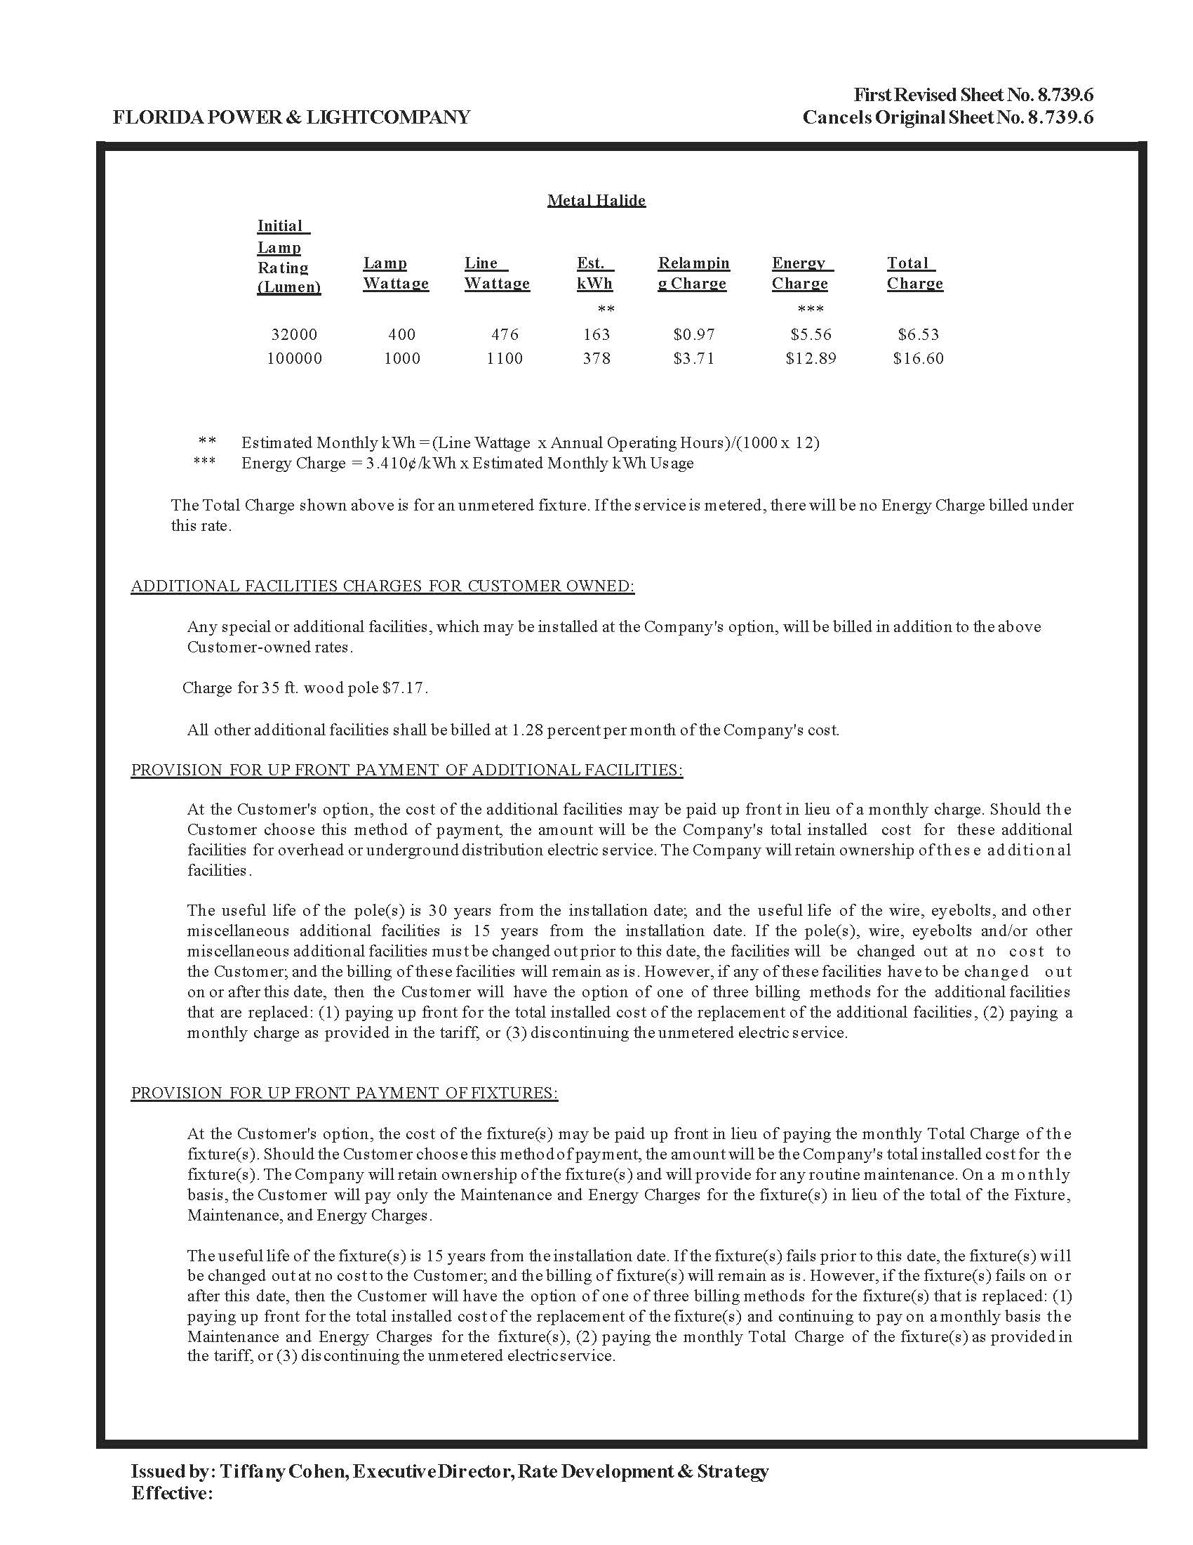
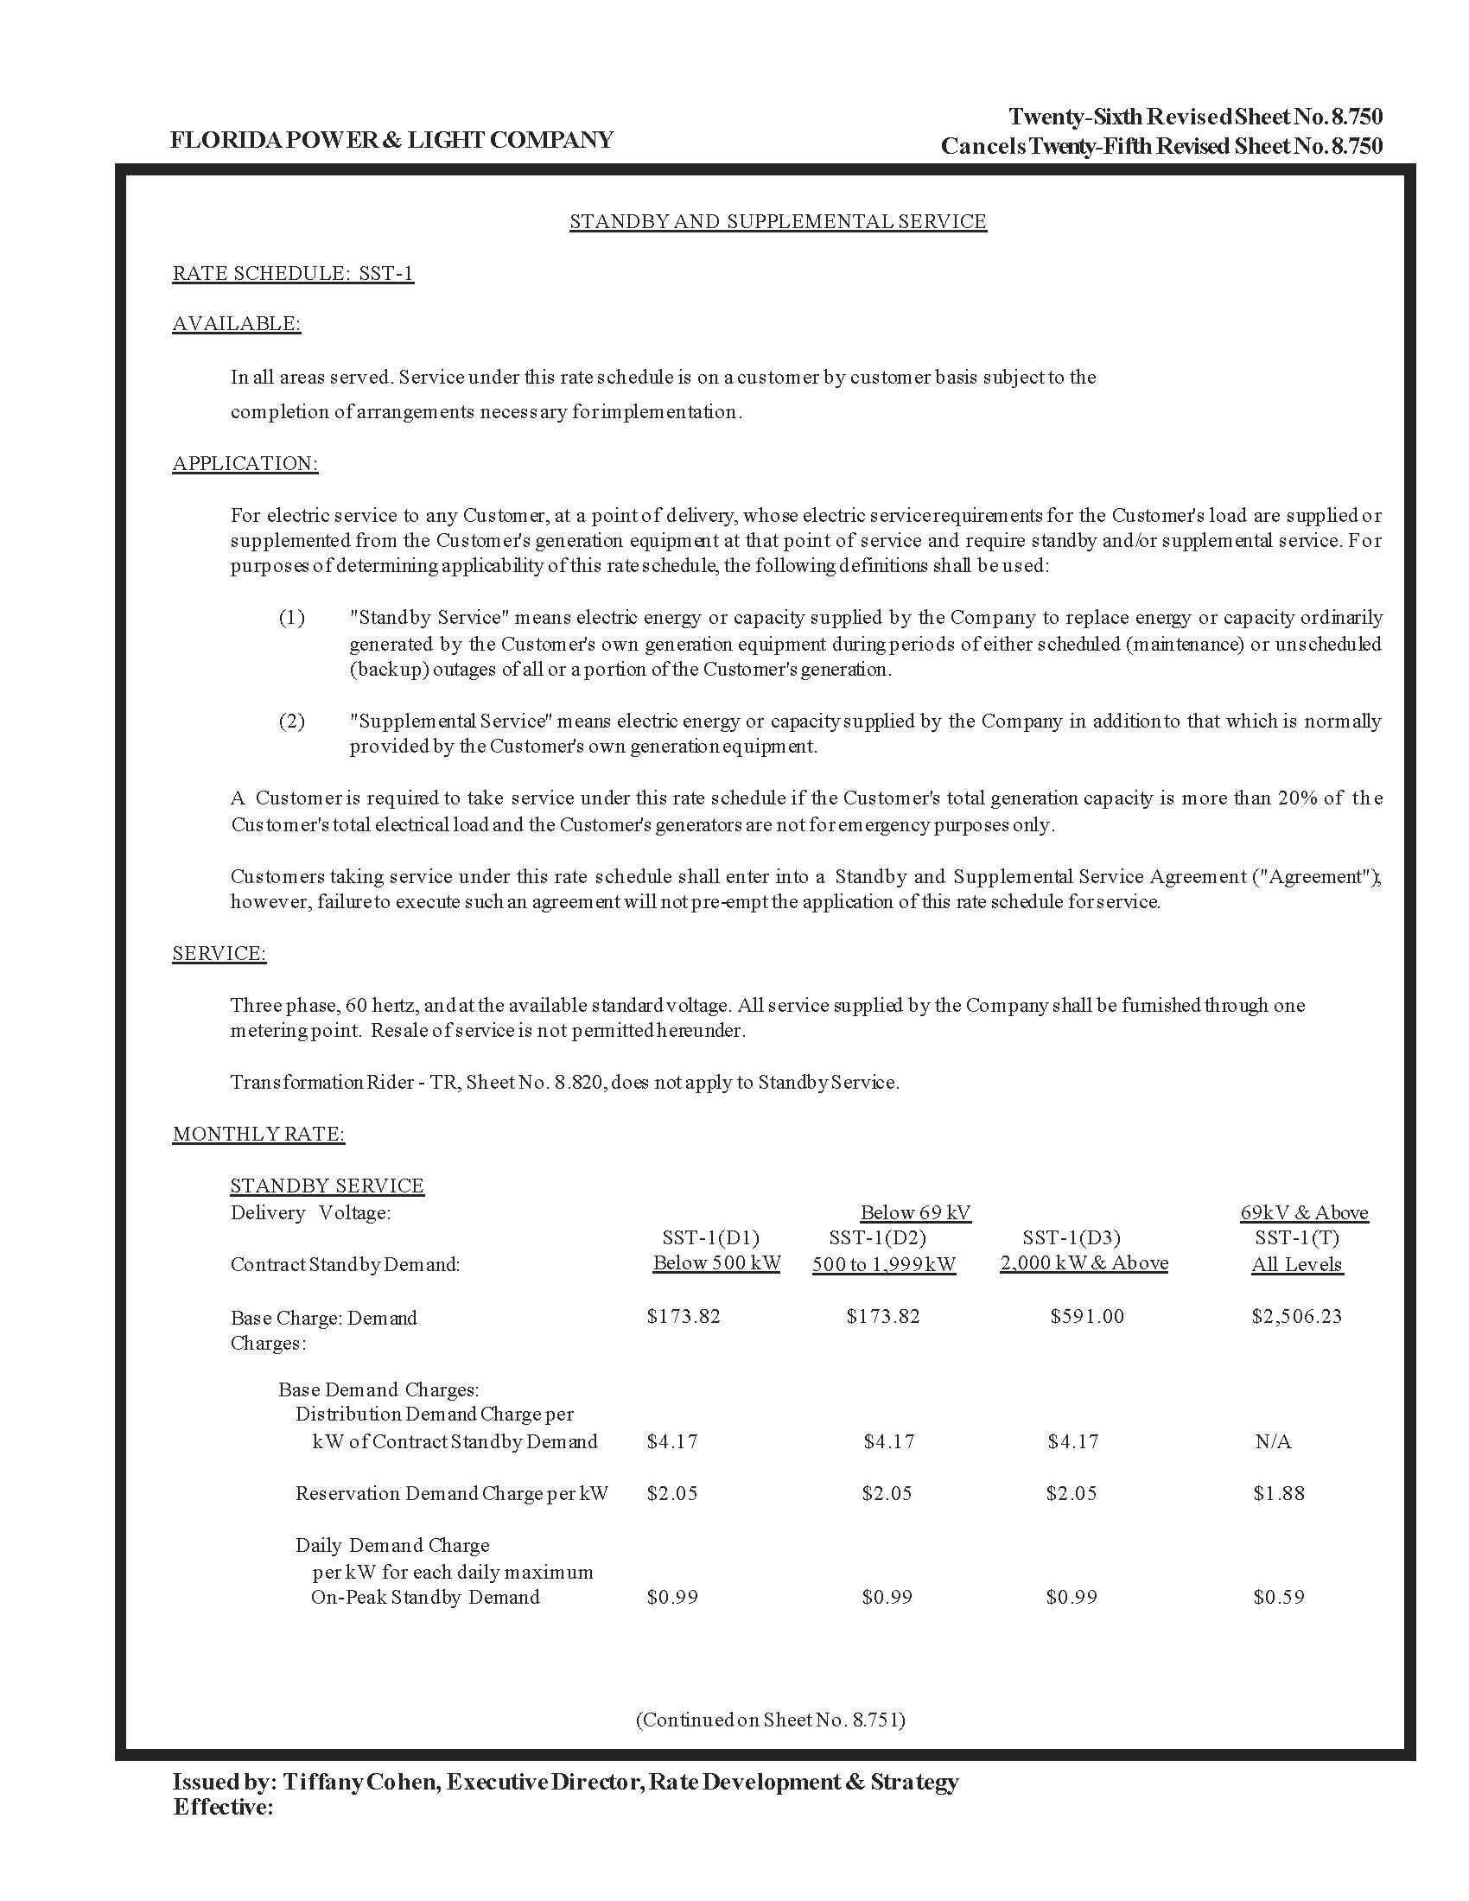
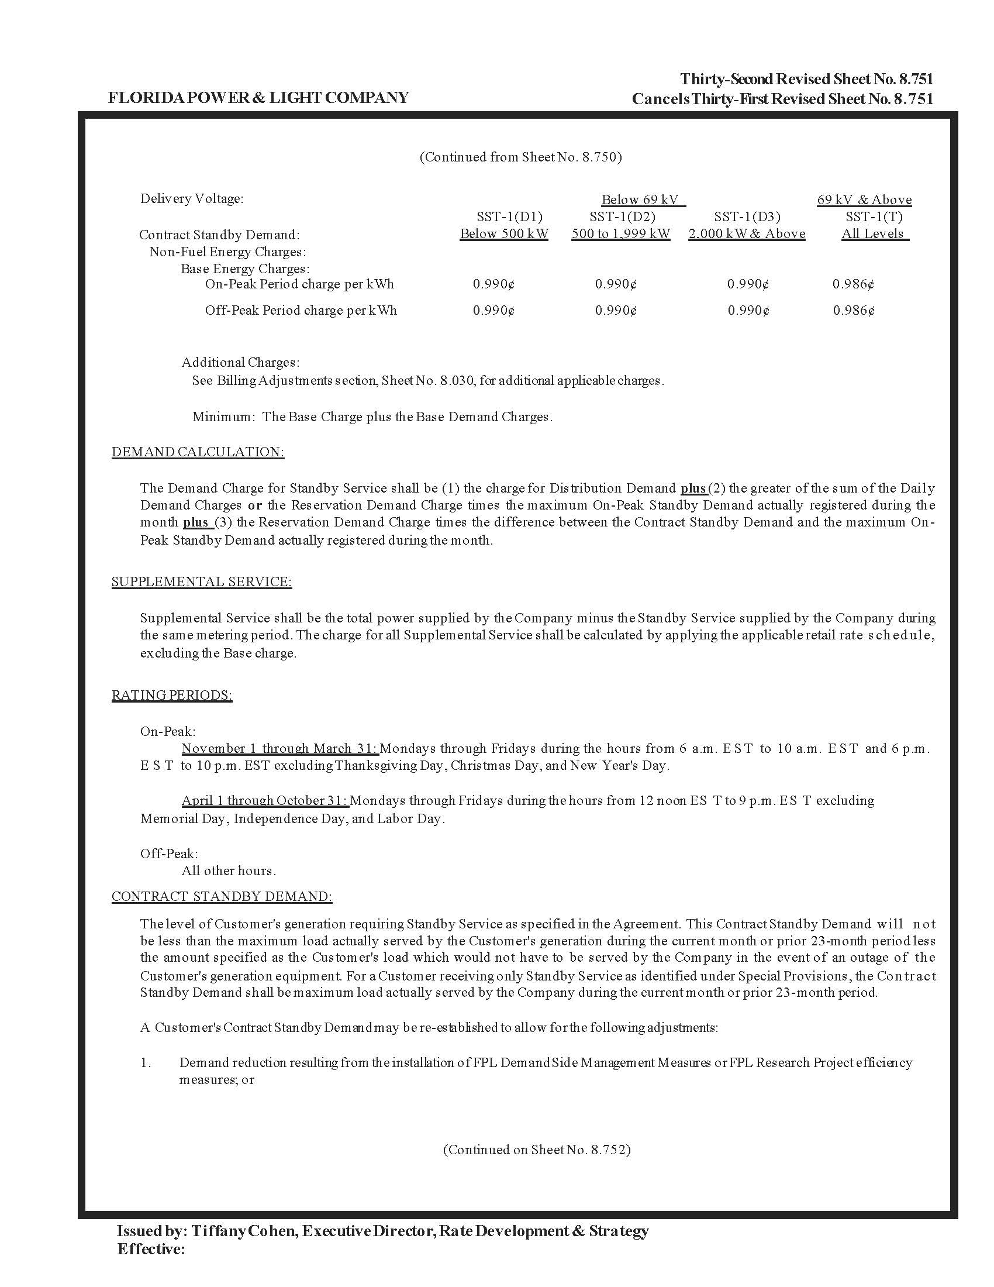
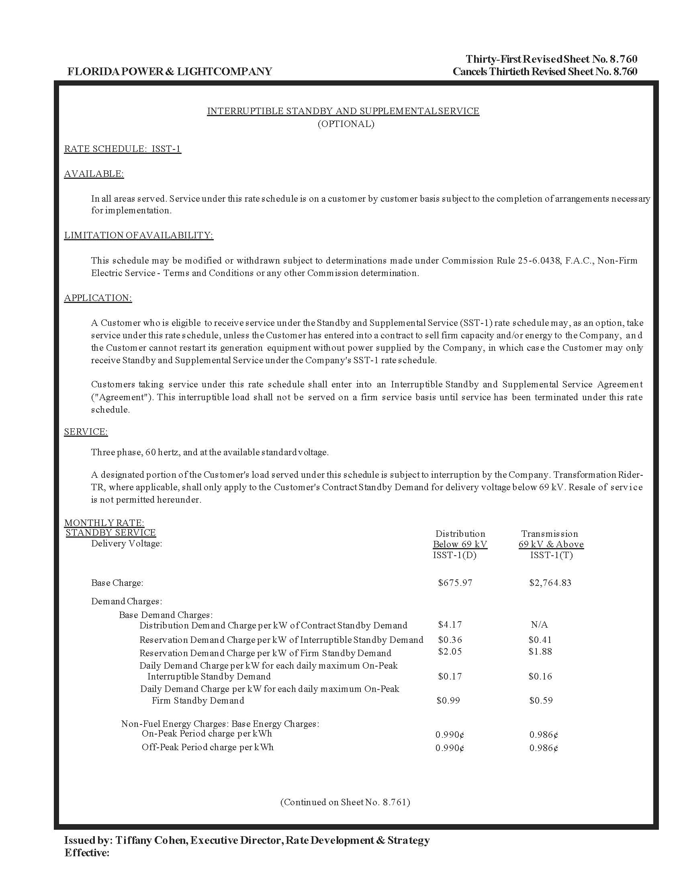
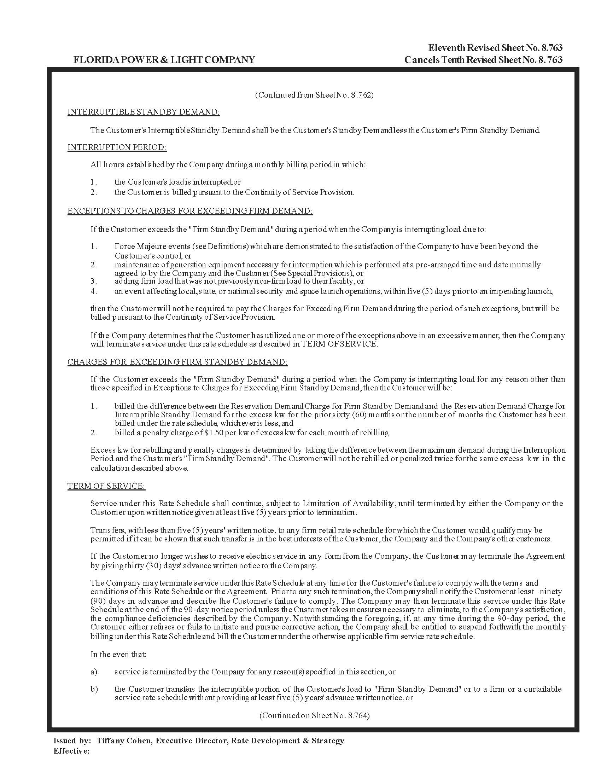
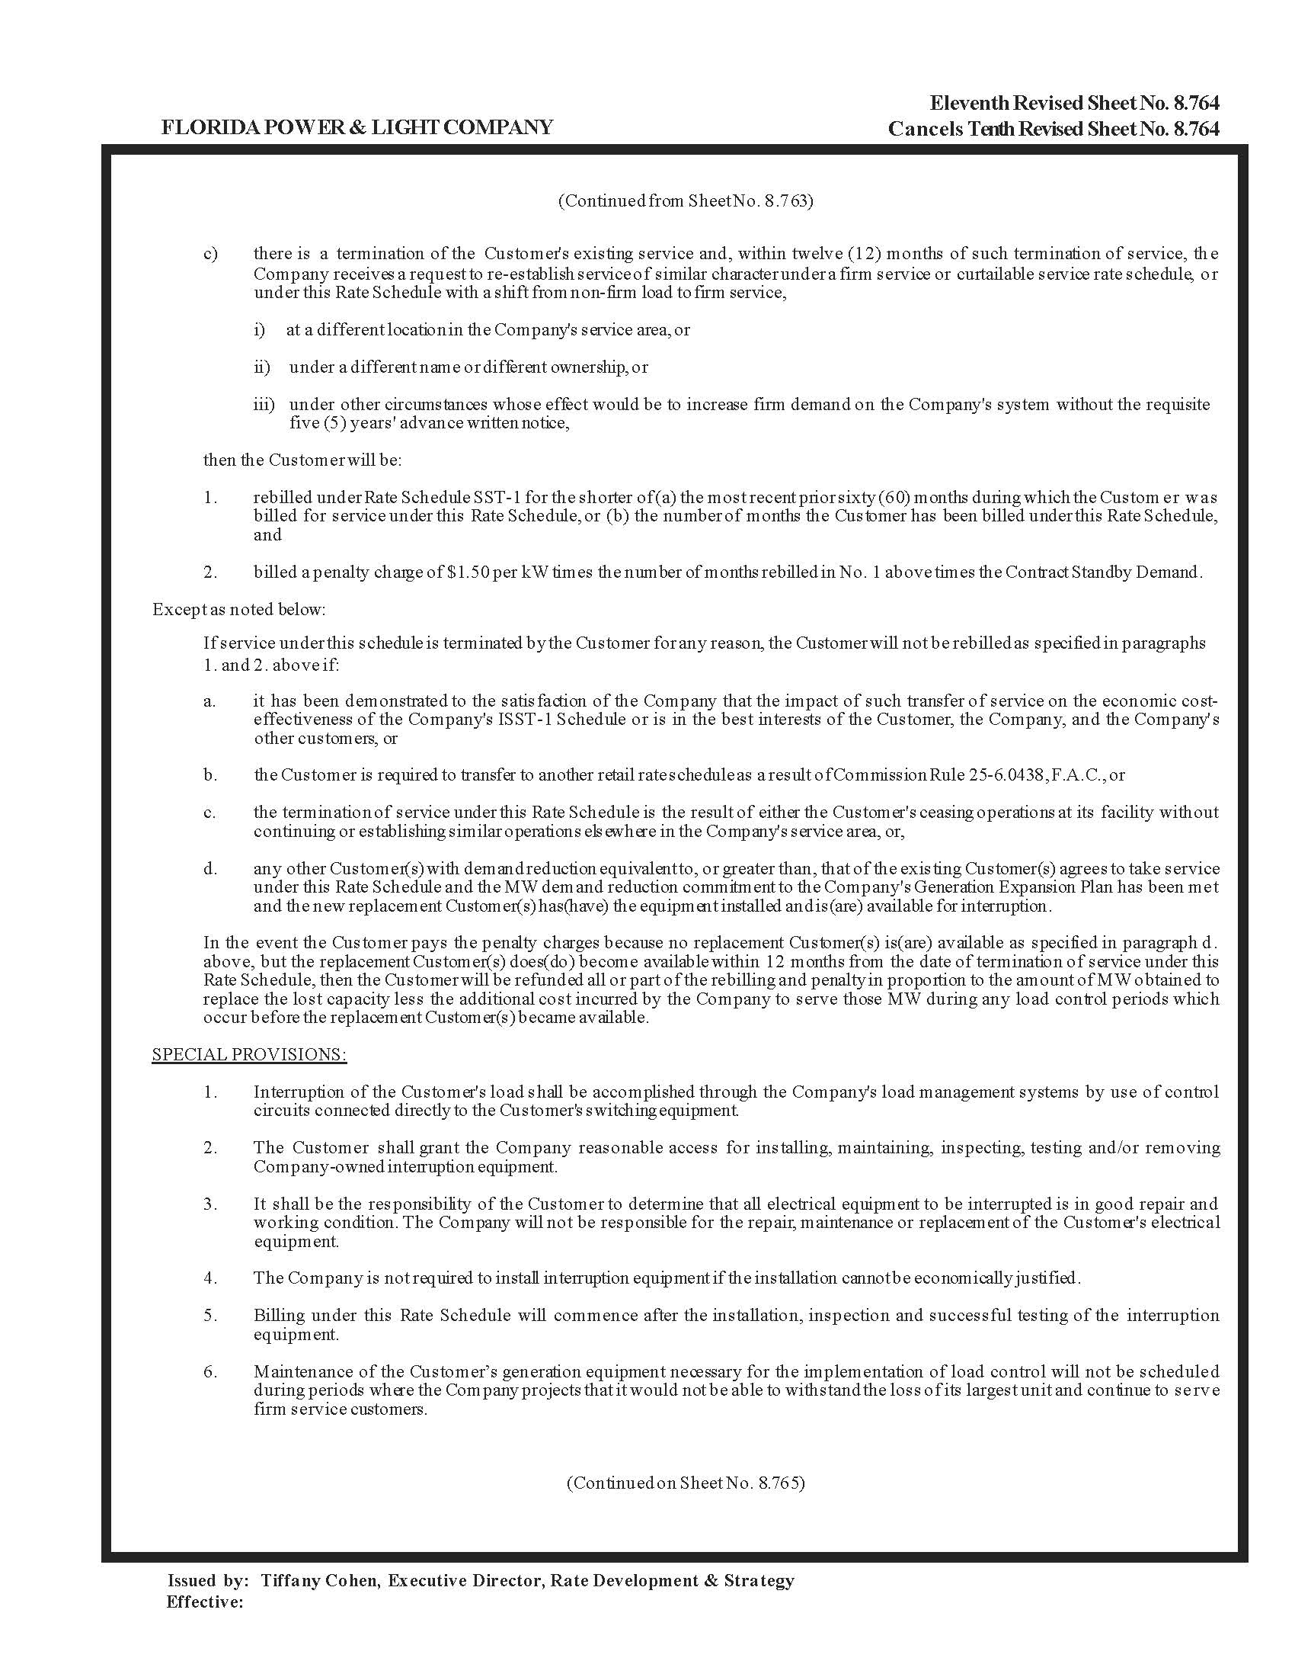
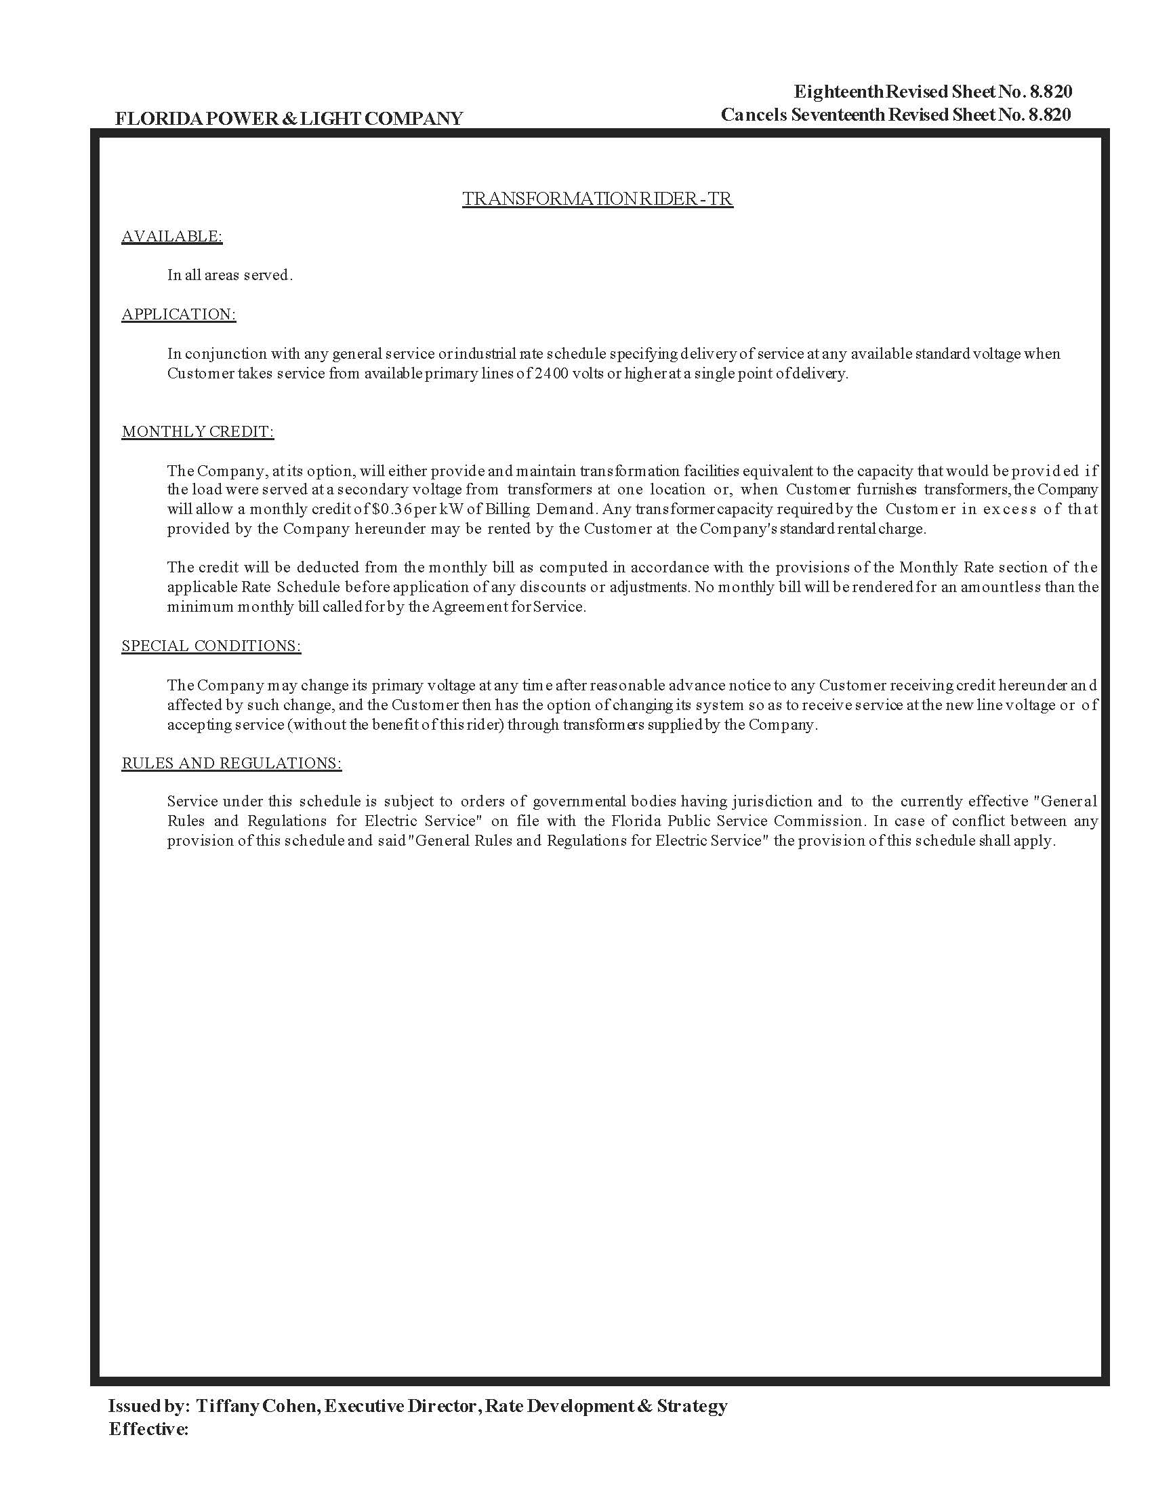
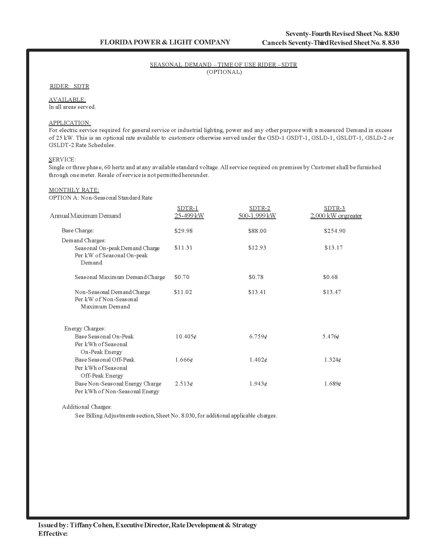
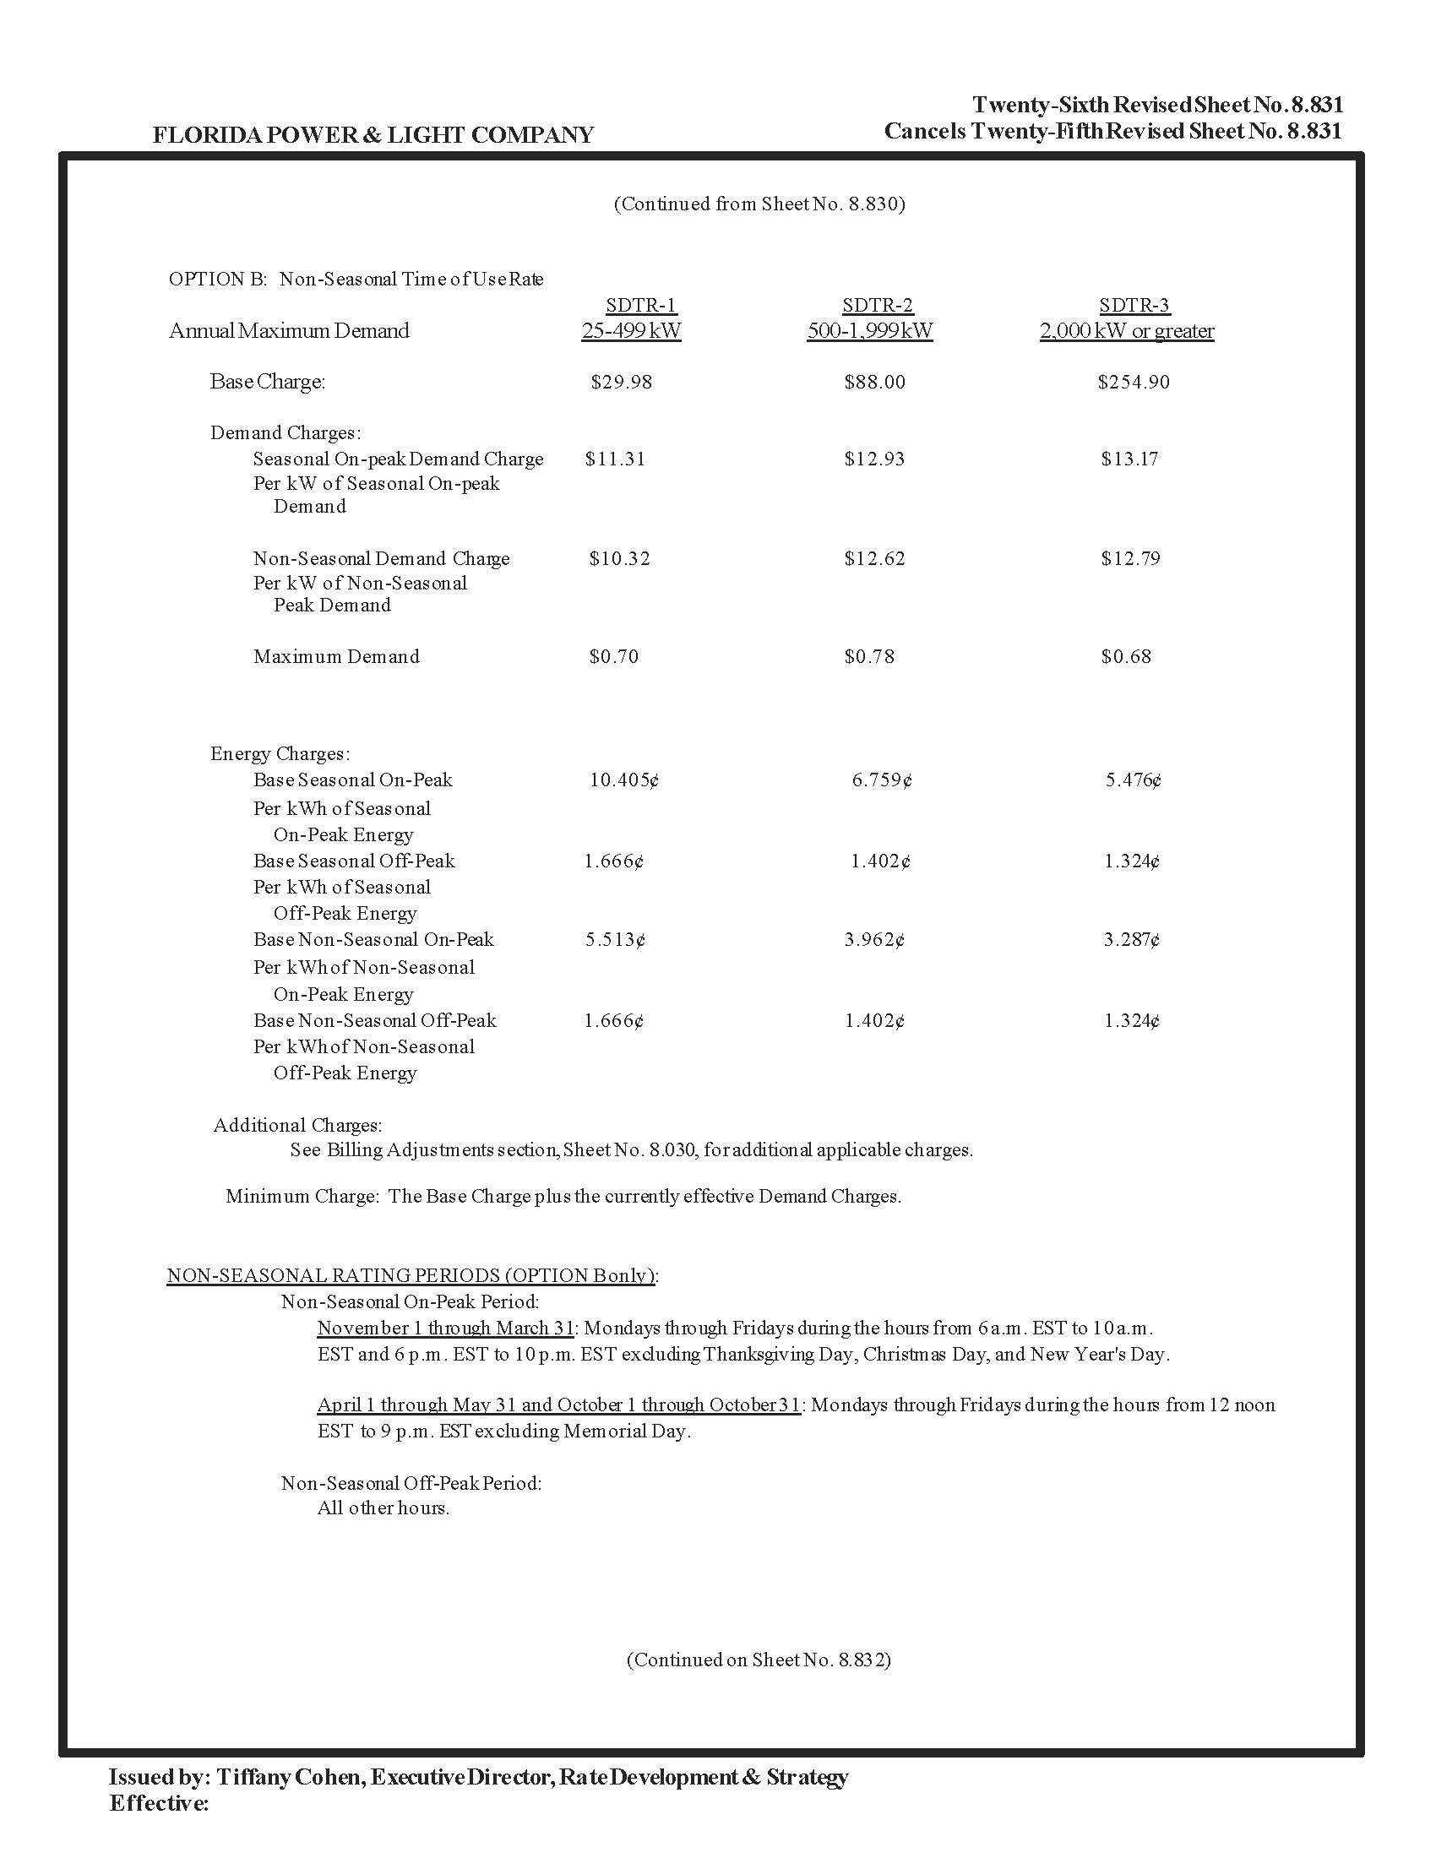

Order No. PSC-2021-0446-S-EI, issued December 2, 2021, in Docket No. 20210015-EI, In re: Petition for rate increase by Florida Power & Light Company; and Order No. PSC-2021-0446A-S-EI, issued December 9, 2021, in Docket No. 20210015-EI, Petition for rate increase by Florida Power & Light Company.
Document No. 11040-2022, Exhibit A-5, page 1 of 1, Line 5.
Order No. PSC-2021-0446-S-EI, issued December 2, 2021, in Docket No. 20210015-EI, In re: Petition for rate increase by Florida Power & Light Company; and Order No. PSC-2021-0446A-S-EI, issued December 9, 2021, in Docket No. 20210015-EI, Petition for rate increase by Florida Power & Light Company.
Proposed in Docket No. 20220001-EI.
Document No. 11040-2022, Exhibit A-6, page 1 of 1, Line 3.

