|  |  |  |  |
| --- | --- | --- | --- |
| State of Florida  pscSEAL | | Public Service Commission  Capital Circle Office Center ● 2540 Shumard Oak Boulevard Tallahassee, Florida 32399-0850  -M-E-M-O-R-A-N-D-U-M- | |
| DATE: | December 28, 2022 | | |
| TO: | Office of Commission Clerk (Teitzman) | | |
| FROM: | Division of Economics (Guffey)  Office of the General Counsel (Dose, Crawford) | | |
| RE: | Docket No. 20220158-GU – Joint petition for approval of territorial agreement in Santa Rosa County, by the City of Gulf Breeze and the Okaloosa Gas District. | | |
| AGENDA: | 01/10/23 – Regular Agenda – Proposed Agency Action – Interested Persons May Participate | | |
| COMMISSIONERS ASSIGNED: | | | All Commissioners |
| PREHEARING OFFICER: | | | Graham |
| CRITICAL DATES: | | | None |
| SPECIAL INSTRUCTIONS: | | | None |

Case Background

On September 9, 2022, the City of Gulf Breeze (Gulf Breeze) and the Okaloosa Gas District (District), collectively the parties, filed a joint petition seeking Commission approval of a new Territorial Agreement (Agreement) delineating their respective portions of service boundaries in southern Santa Rosa County. Presently, both Gulf Breeze and the Gas District provide retail natural gas service to customers in contiguous areas of southern Santa Rosa County.

The parties currently do not have a Commission-approved territorial agreement. The purpose of the proposed Agreement is to define the parties’ respective service areas in southern Santa Rosa County pursuant to amended Chapter 2021-262, Laws of Florida, and to comply with the legislative directive that the Disputed Area be determined by a final Order of the Commission. The Agreement and composite maps depicting the dividing line between Gulf Breeze and the District service areas in southern Santa Rosa County are shown in Attachment A and Chapter 2021-262, Laws of Florida, is shown in Attachment B to this recommendation.

The redrawing of the subject boundary will transfer one Gulf Breeze residential customer and associated infrastructure to the District. The customer has been notified of the transfer.

Staff issued a data request to the parties for which the responses were received on November 22, 2022. The Commission has jurisdiction over this matter pursuant to Section 366.04, Florida Statutes (F.S.).

Discussion of Issues

Issue :

 Should the Commission approve the proposed new Territorial Agreement between the City of Gulf Breeze and the Okaloosa Gas District in southern Santa Rosa County?

Recommendation:

 Yes, the Commission should approve the proposed new Territorial Agreement between the City Gulf Breeze and the Okaloosa Gas District in southern Santa Rosa County. The proposed Agreement will define the parties’ respective service areas in southern Santa Rosa County pursuant to the amended Chapter 2021-262, Laws of Florida, and comply with the legislative directive that the Disputed Area be determined by a final order of the Commission. Additionally, the proposed Agreement will avoid duplication of service and mitigate the potential for future disputes. (Guffey)

Staff Analysis:

 Pursuant to Section 366.04(3)(a), F.S., and Rule 25-7.0471, Florida Administrative Code (F.A.C.), the Commission has the jurisdiction to approve territorial agreements between natural gas utilities. For purposes of this subsection, Section 366.04(3)(c), F.S., defines natural gas utility to include municipalities and gas districts. Unless the Commission determines that the Agreement will cause a detriment to the public interest, it should be approved.[1]

Gulf Breeze is a Florida municipal corporation which owns and operates a natural gas distribution system and has been providing natural gas service since 1964. Its service area includes portions of Escambia and Santa Rosa counties and currently provides retail natural gas service to 4,780 customers in Santa Rosa County.

The District is an independent special district created by the Florida Legislature in 1953 to own and operate natural gas transmission and distribution systems in Okaloosa County.[2] In 2000, the Legislature expanded in Chapter 2000-443, Laws of Florida, the District’s service area to include portions of Santa Rosa and Walton counties. The District provides natural gas service to 50,994 residential, commercial, and industrial customers, as well as military installations, within its entire service area.[3] As stated in paragraph 4 of the petition, the District currently serves 4,798 customers in Santa Rosa County. The District’s member municipalities are Crestview, Niceville, Valparaiso, and Fort Walton Beach.

In 2021, the Florida Legislature again expanded the service area of the District to include all of Santa Rosa County with two defined areas excluded. The first excluded area is:

The area within the corporate limits of the City of Gulf Breeze and the area from the eastern boundary of the corporate limits of the City of Gulf Breeze extending easterly approximately 11 miles to the line defined as the eastern boundary of Sections 4, 9, 16, 21, and 28 of Township 2 South, Range 27 West, which extends north and south from Santa Rosa Sound to East Bay.

The second excluded area (Disputed Area) is:

The area from the line defined as the eastern boundary of Sections 4, 9, 16, 21, and 28 of Township 2 South, Range 27 West, which extend north and south from Santa Rosa Sound to East Bay, and extending easterly to the line starting at the intersection of US Highway 98 and Shannon Drive, going due south to Santa Rosa Sound, thence turning due north continuing to Manatee Road; thence turning west until the intersection of Basswood Drive; thence turning north until intersecting the Tom King Bayou tributary south of Cove Road; thence following this branch northwest to Tom King Bayou, thence north to East Bay is presently claimed as a service area by the District and by the City of Gulf Breeze and shall not be deemed to be included or excluded as a service area for the District. The service rights for this area shall be determined by a final nonappealable order of the Florida Public Service Commission or any successor agency.

Chapter 2021-262, Laws of Florida 2021 (emphasis added).

In response to staff’s data request, the joint petitioners explained that historically the service areas of the two parties have been geographically dispersed such that an agreement was not necessary.[4] However, over the years, as a consequence of natural growth, portions of the parties’ service areas have begun to converge in southern Santa Rosa County near the Dividing Line as defined in the proposed Agreement (separating Gulf Breeze and the District’s service area).

With respect to the Disputed Area referenced in Chapter 2021-262, Laws of Florida, the parties explained that after discussions among the parties and members of the local legislative delegation, the Disputed Area was excluded from the service area determination in recognition of the fact that the City and the District both provided service to the area and claimed certain rights. Therefore, resolution of service rights was reserved for determination by the Commission.[5]

Proposed Territorial Agreement

The proposed Agreement defines the Parties’ respective service territories in the Disputed Area by establishing a “Dividing Line” that transects the Disputed Area. The Dividing Line is shown on composite Exhibit B of Attachment A to the recommendation (page 10 of 10 of Attachment A). The joint petitioners assert that the proposed new Agreement will formalize the Dividing Line, comply with the legislative directive, eliminate duplication of service and expenditures, and avoid the potential for future disputes. The joint petitioners also assert that the proposed boundary modification will not decrease service reliability to their existing or future customers.

The proposed Agreement will become effective on the day the Commission Order becomes final and will continue in effect until termination or modification is approved by the Commission or mandated by a government entity. In response to staff’s data request, the parties confirmed that there is no specified termination date for the proposed Agreement.[6]

Infrastructure and Customer Transfer and Notification

The Parties explained in the petition that the Dividing Line in the Agreement has been drawn to avoid the need to transfer any customers or utility facilities, with the exception of one residential customer of Gulf Breeze. Pursuant to Section 4(b) of the Agreement, the customer will be transferred following the effective date of this Agreement and upon written notification from the District stating it is prepared to provide service to the transferred customer. On August 17, 2022, Gulf Breeze notified the customer of the transfer and provided rate comparisons. Pursuant to the customer notification, the District will waive the $55 service activation fee and Gulf Breeze will credit the customer’s $50 deposit towards any outstanding amounts due and refund the remainder.[7] The parties assert that they have not received a response or objections from the customer.

Along with the customer transfer, approximately 1,200 feet of pipeline and associated infrastructure will be transferred to the District. The District will pay $24,163.05, representing the depreciated value of the infrastructure to Gulf Breeze.

Conclusion

After review of the joint petition and the petitioners’ joint responses to Commission staff’s data request, staff believes that the proposed Agreement is in the public interest and will enable Gulf Breeze and the District to serve their current and future customers efficiently. The proposed Agreement will define the parties’ respective service areas in southern Santa Rosa County pursuant to the amended Chapter 2021-262, Laws of Florida, and comply with the legislative directive that the Disputed Area be determined by a final order of this Commission. Additionally, the proposed Agreement will avoid duplication of service and mitigate the potential for future disputes. Therefore, staff recommends that the Commission should approve the proposed Territorial Agreement between the City Gulf Breeze and the Okaloosa Gas District in southern Santa Rosa County.

Issue :

 Should this docket be closed?

Recommendation:

 If no protest is filed by a person whose substantial interests are affected within 21 days of the issuance of the Order, this docket should be closed upon the issuance of a Consummating Order. (Dose)

Staff Analysis:

 If no protest is filed by a person whose substantial interests are affected within 21 days of the issuance of the Order, this docket should be closed upon the issuance of a Consummating Order.

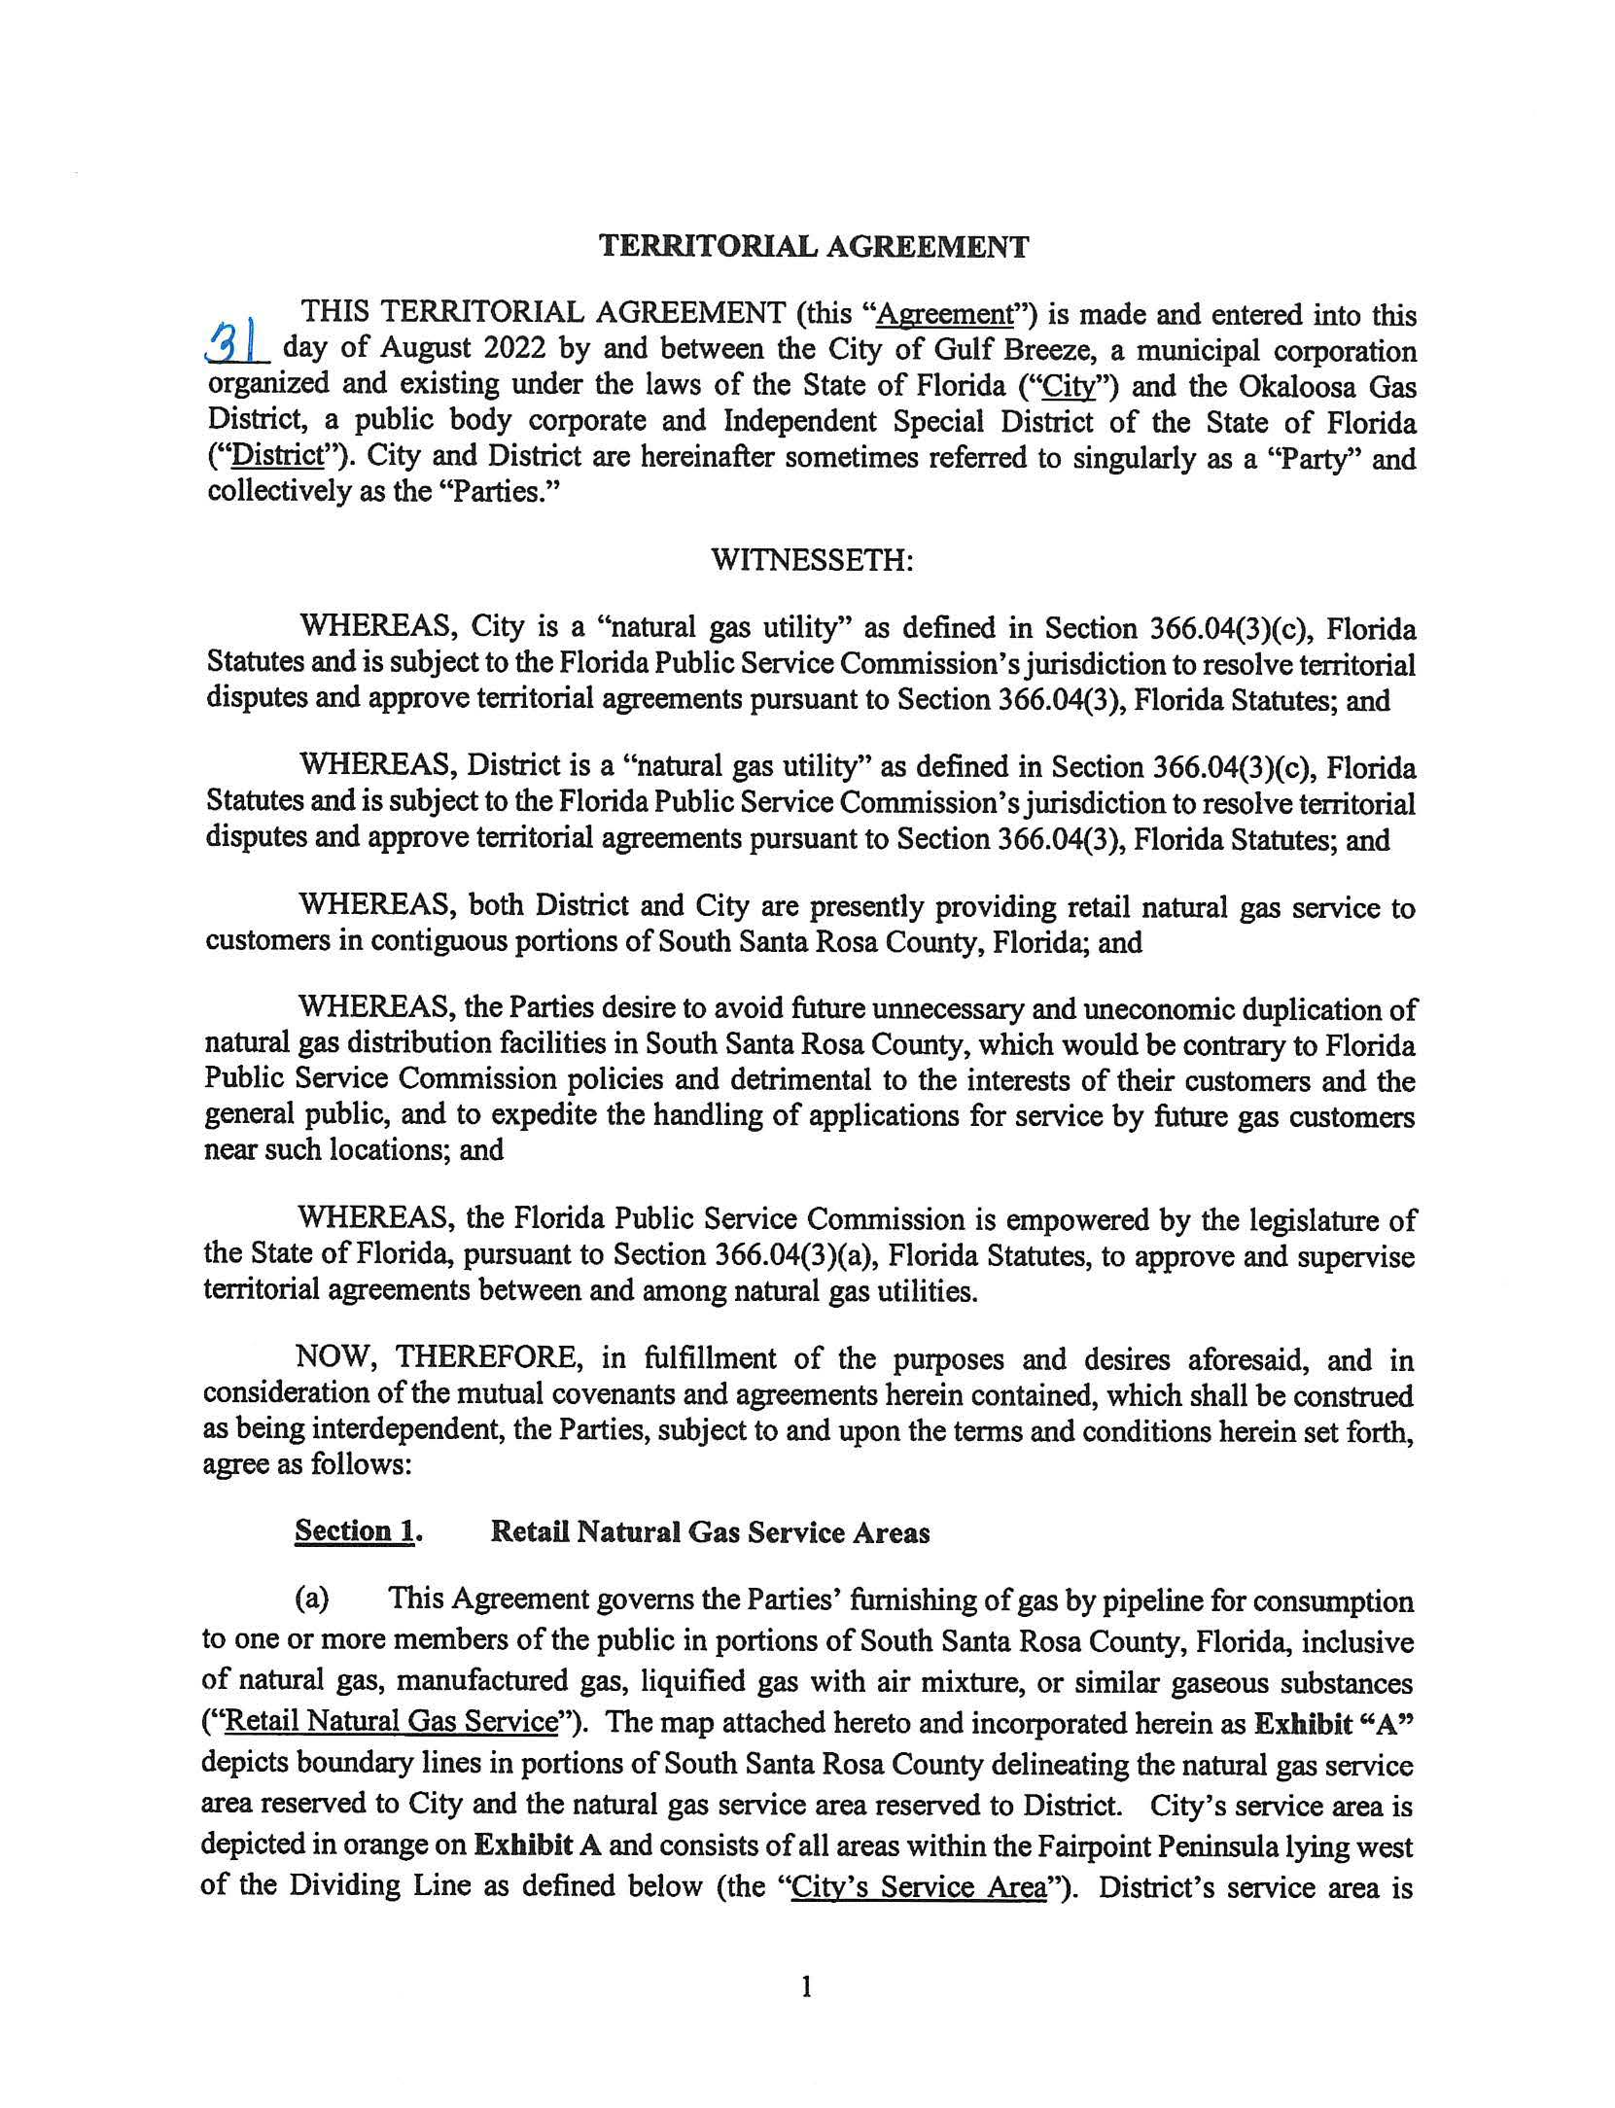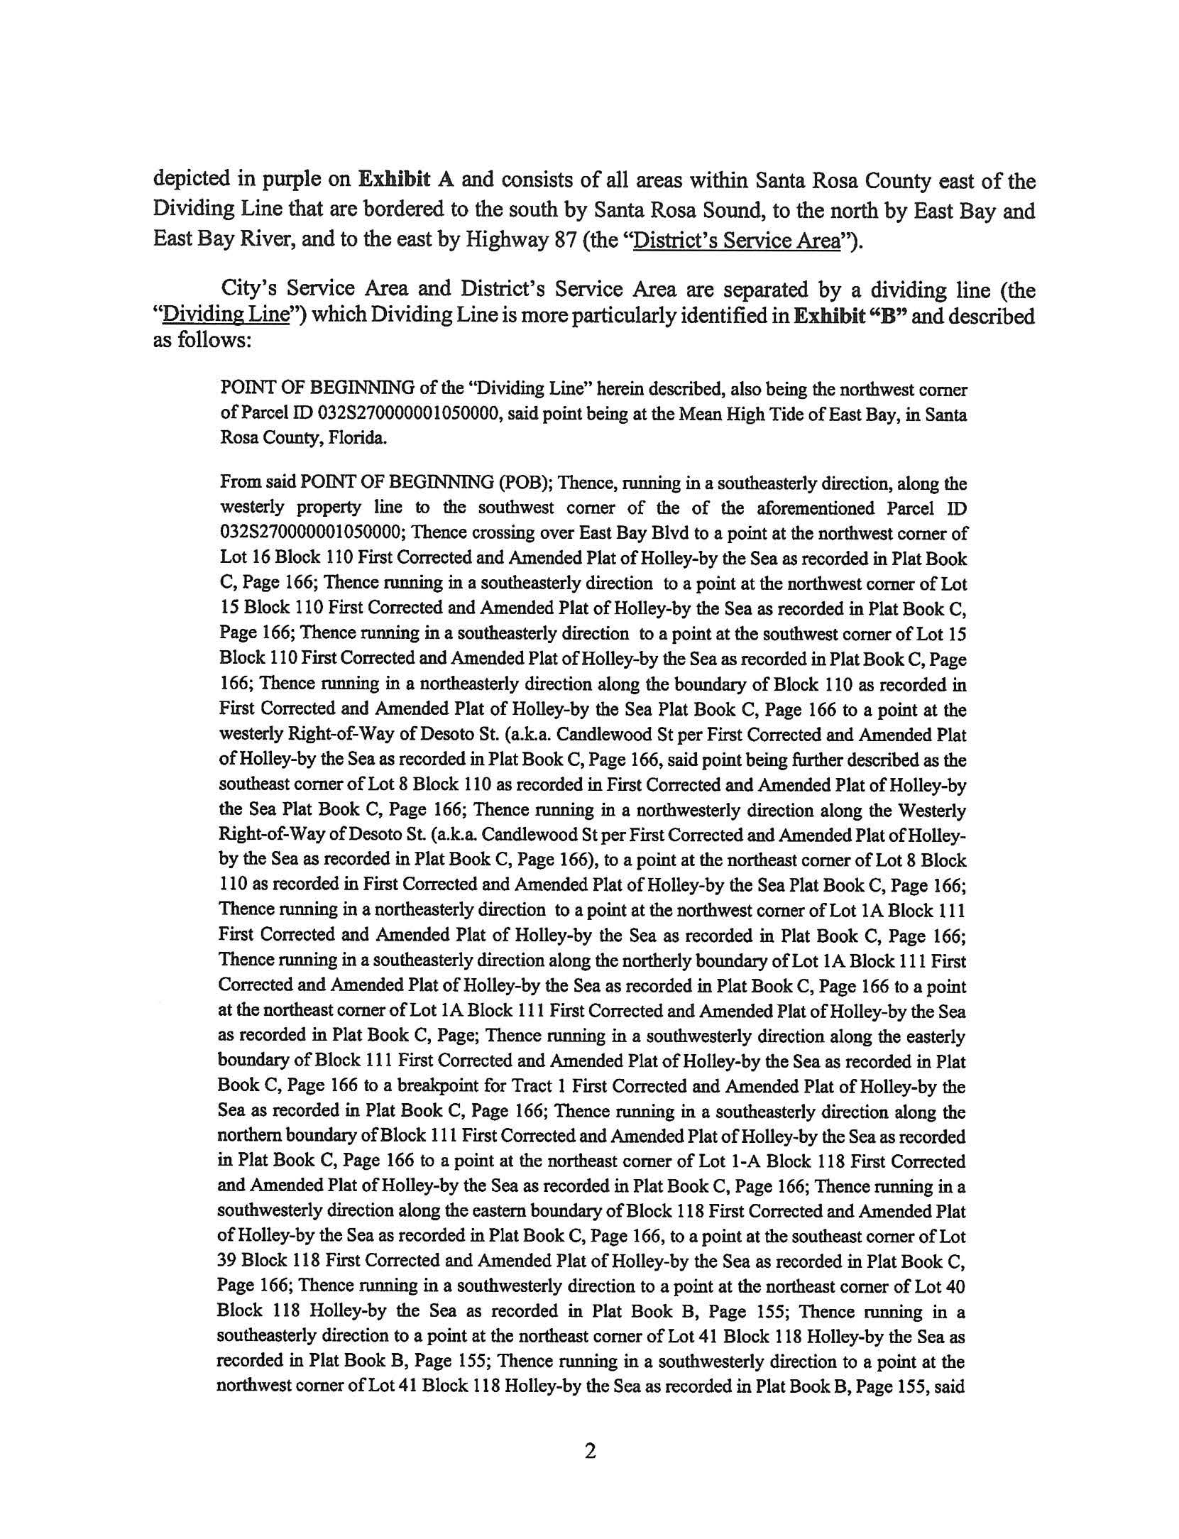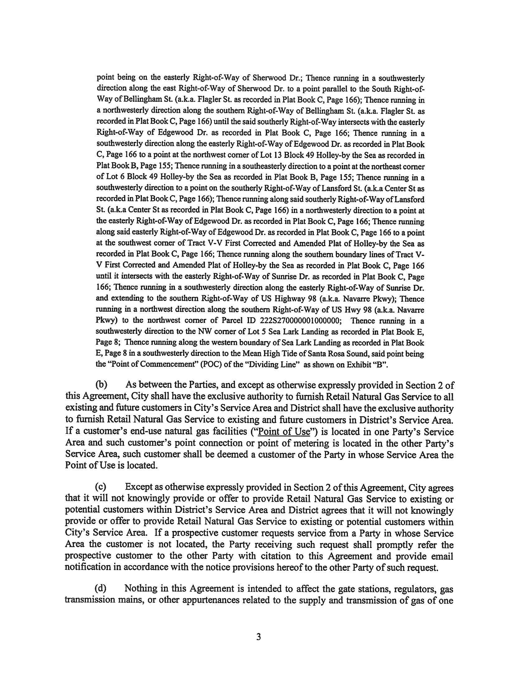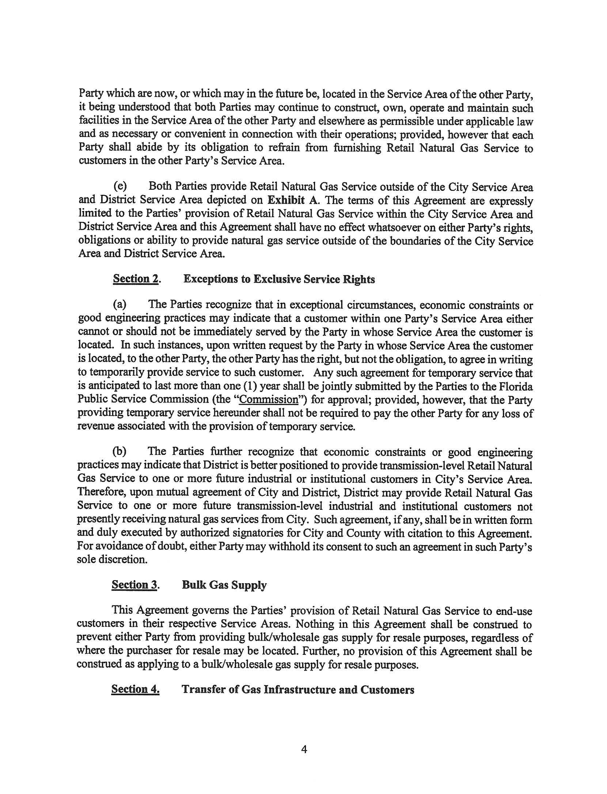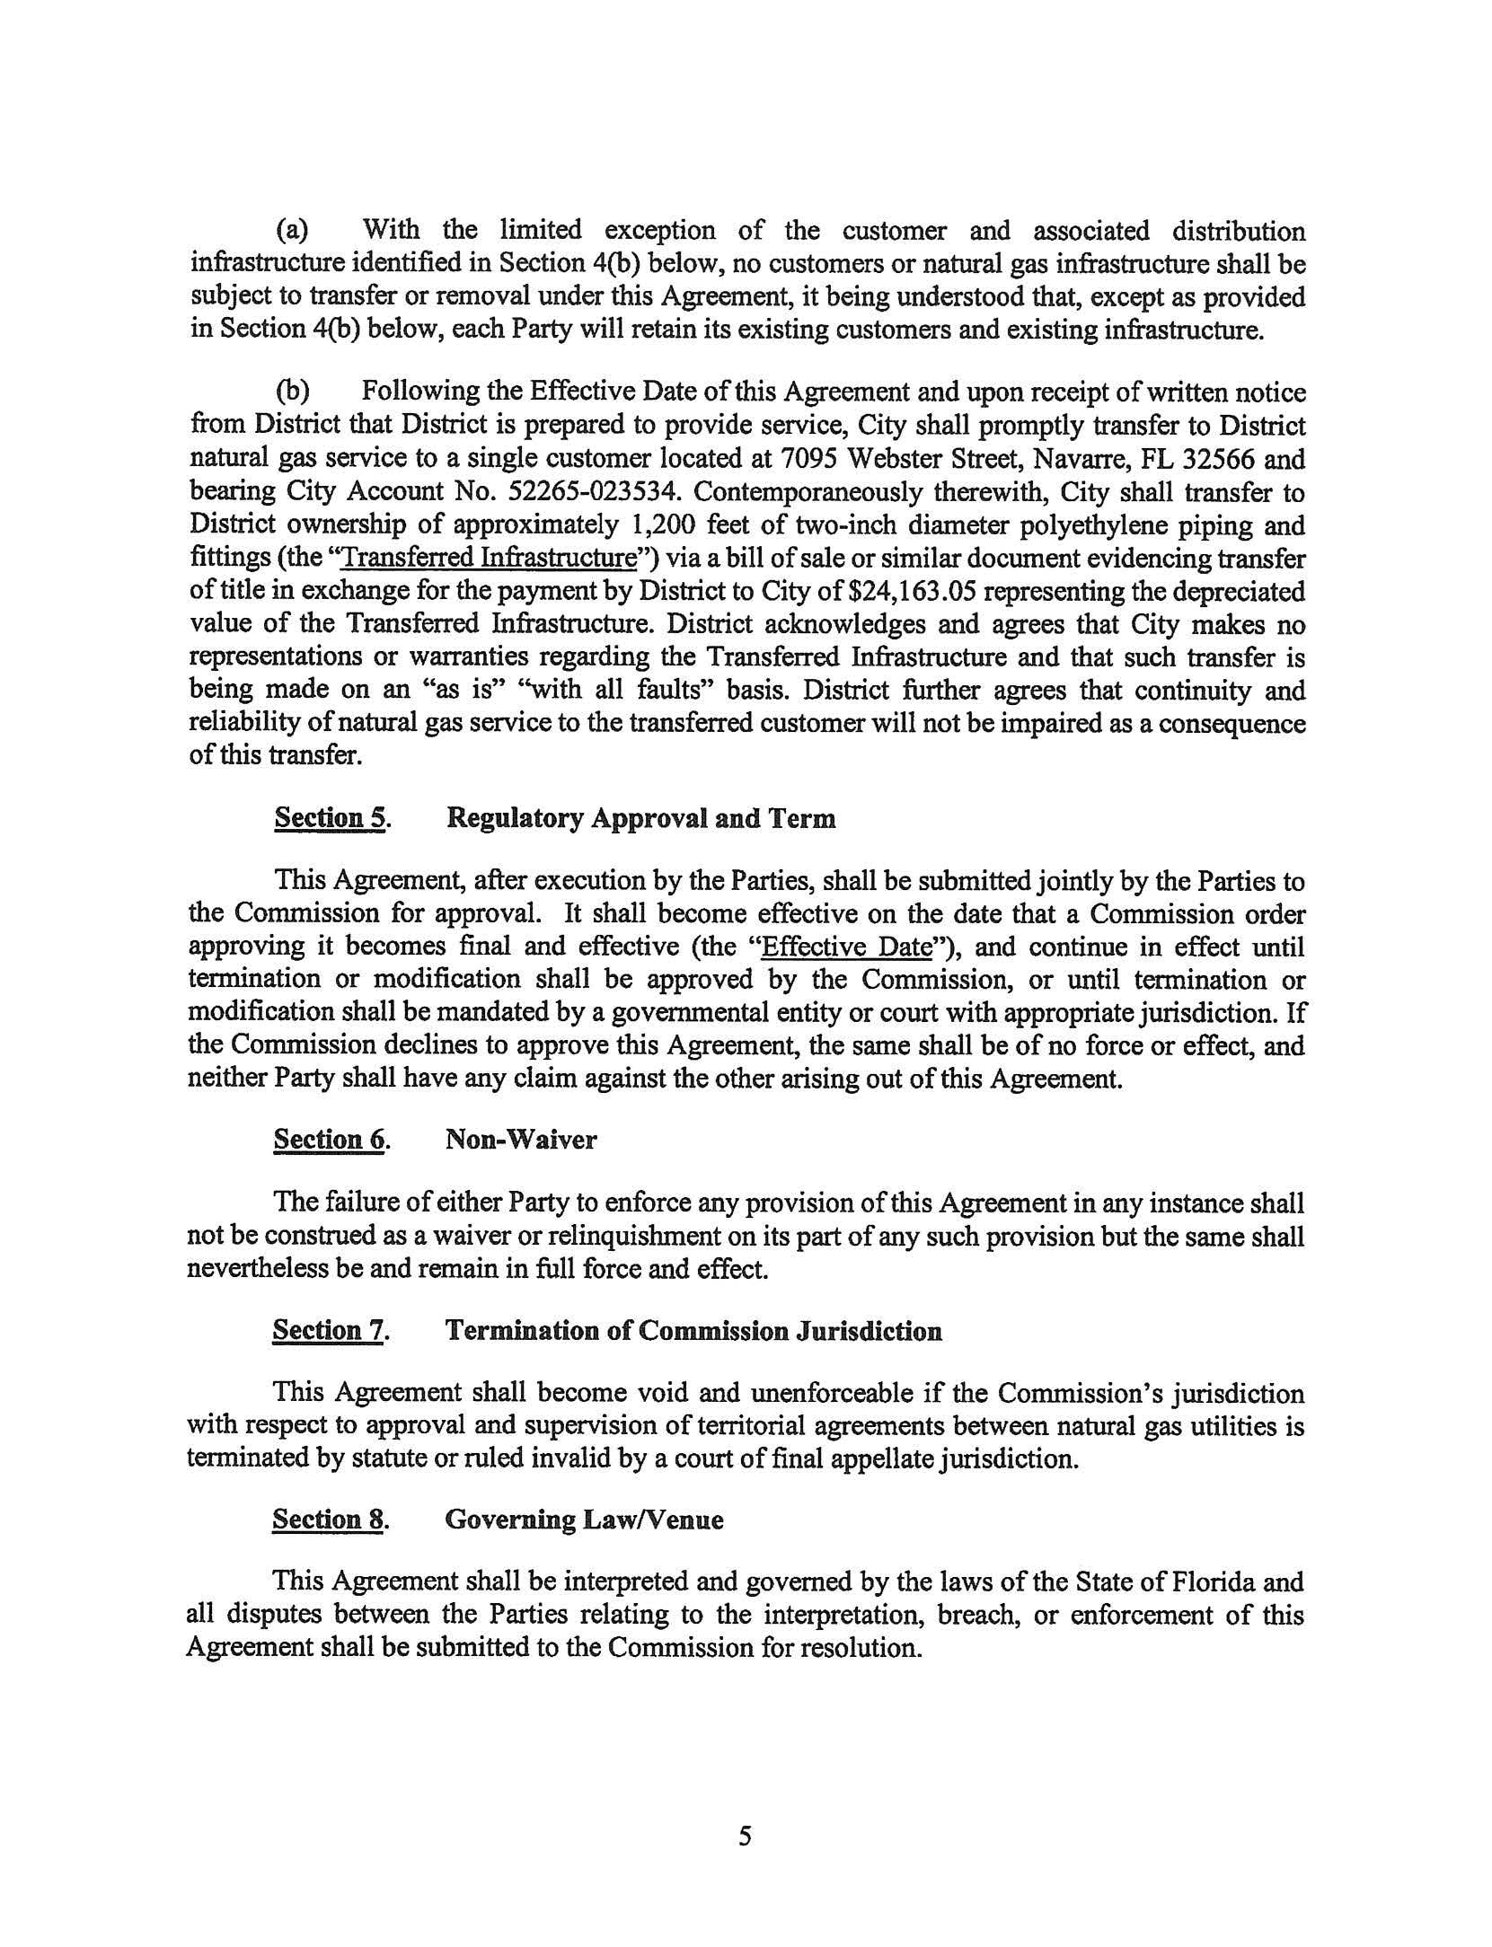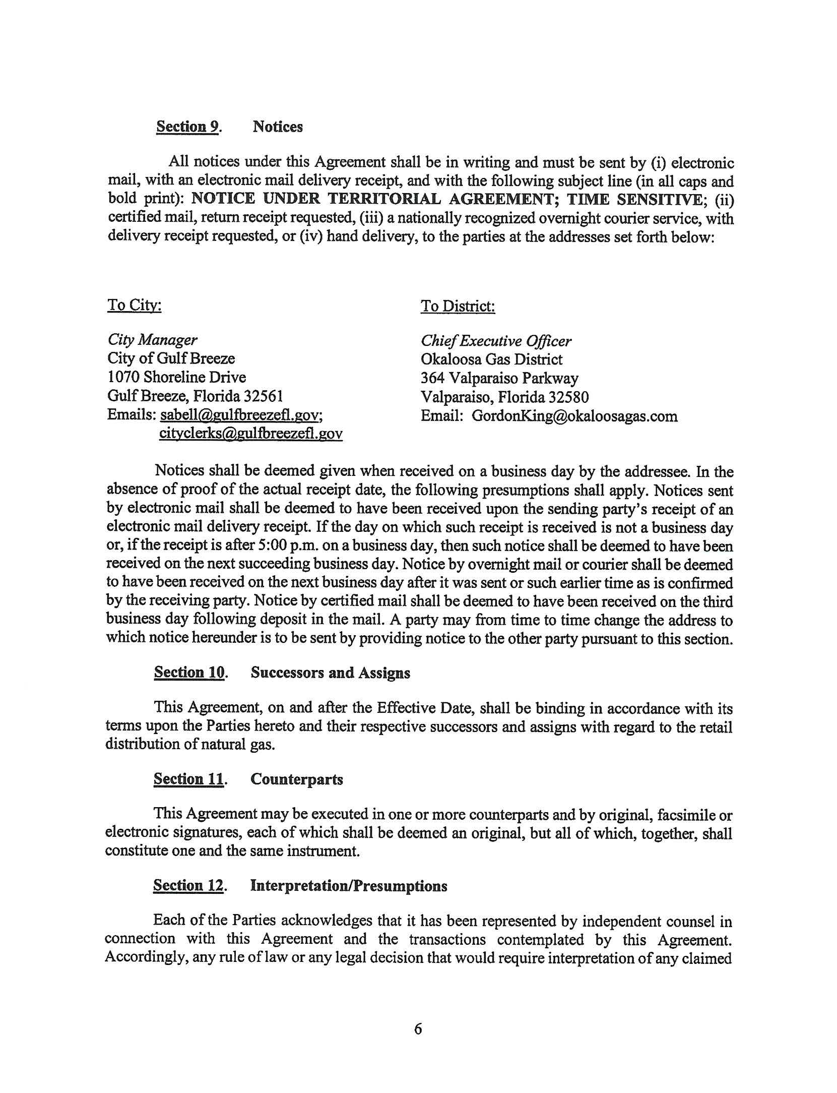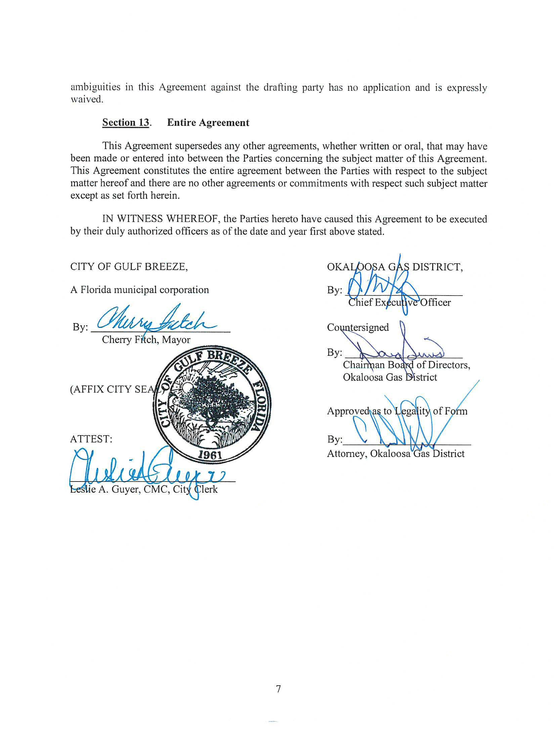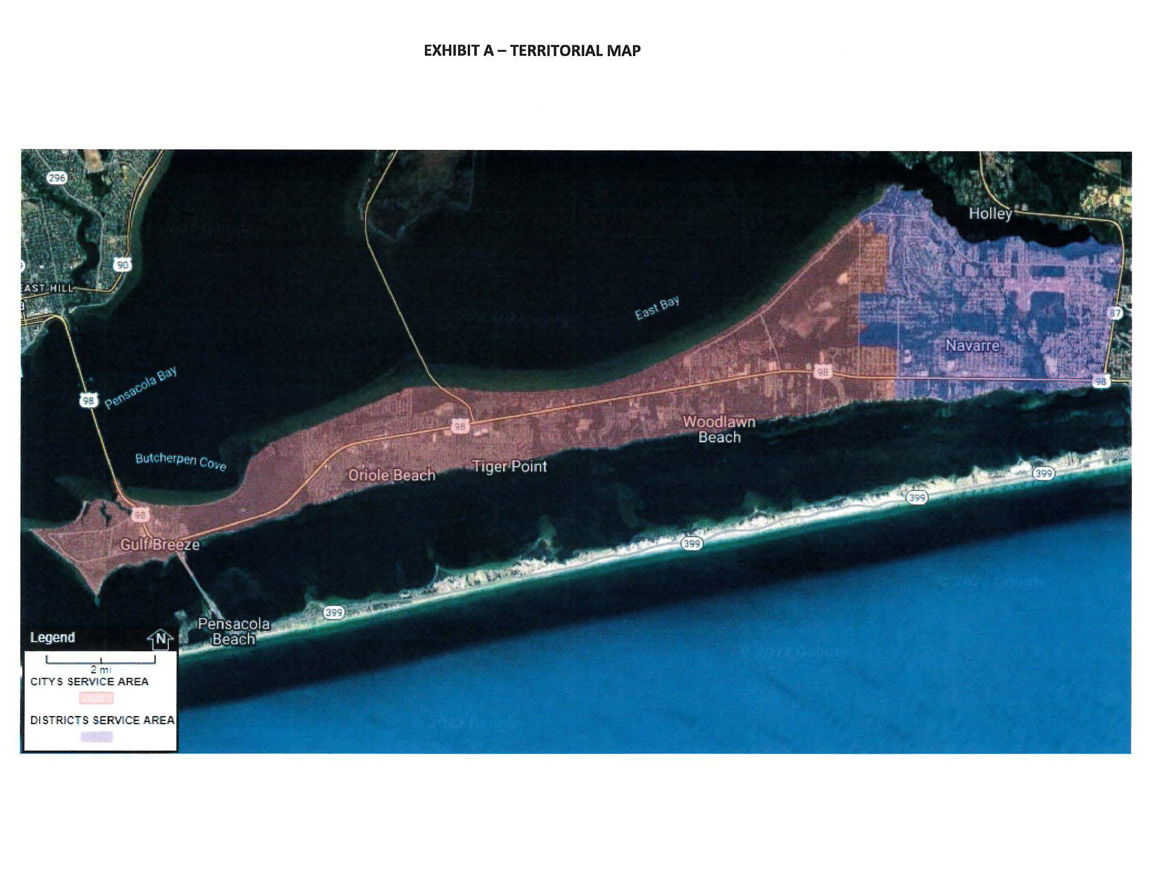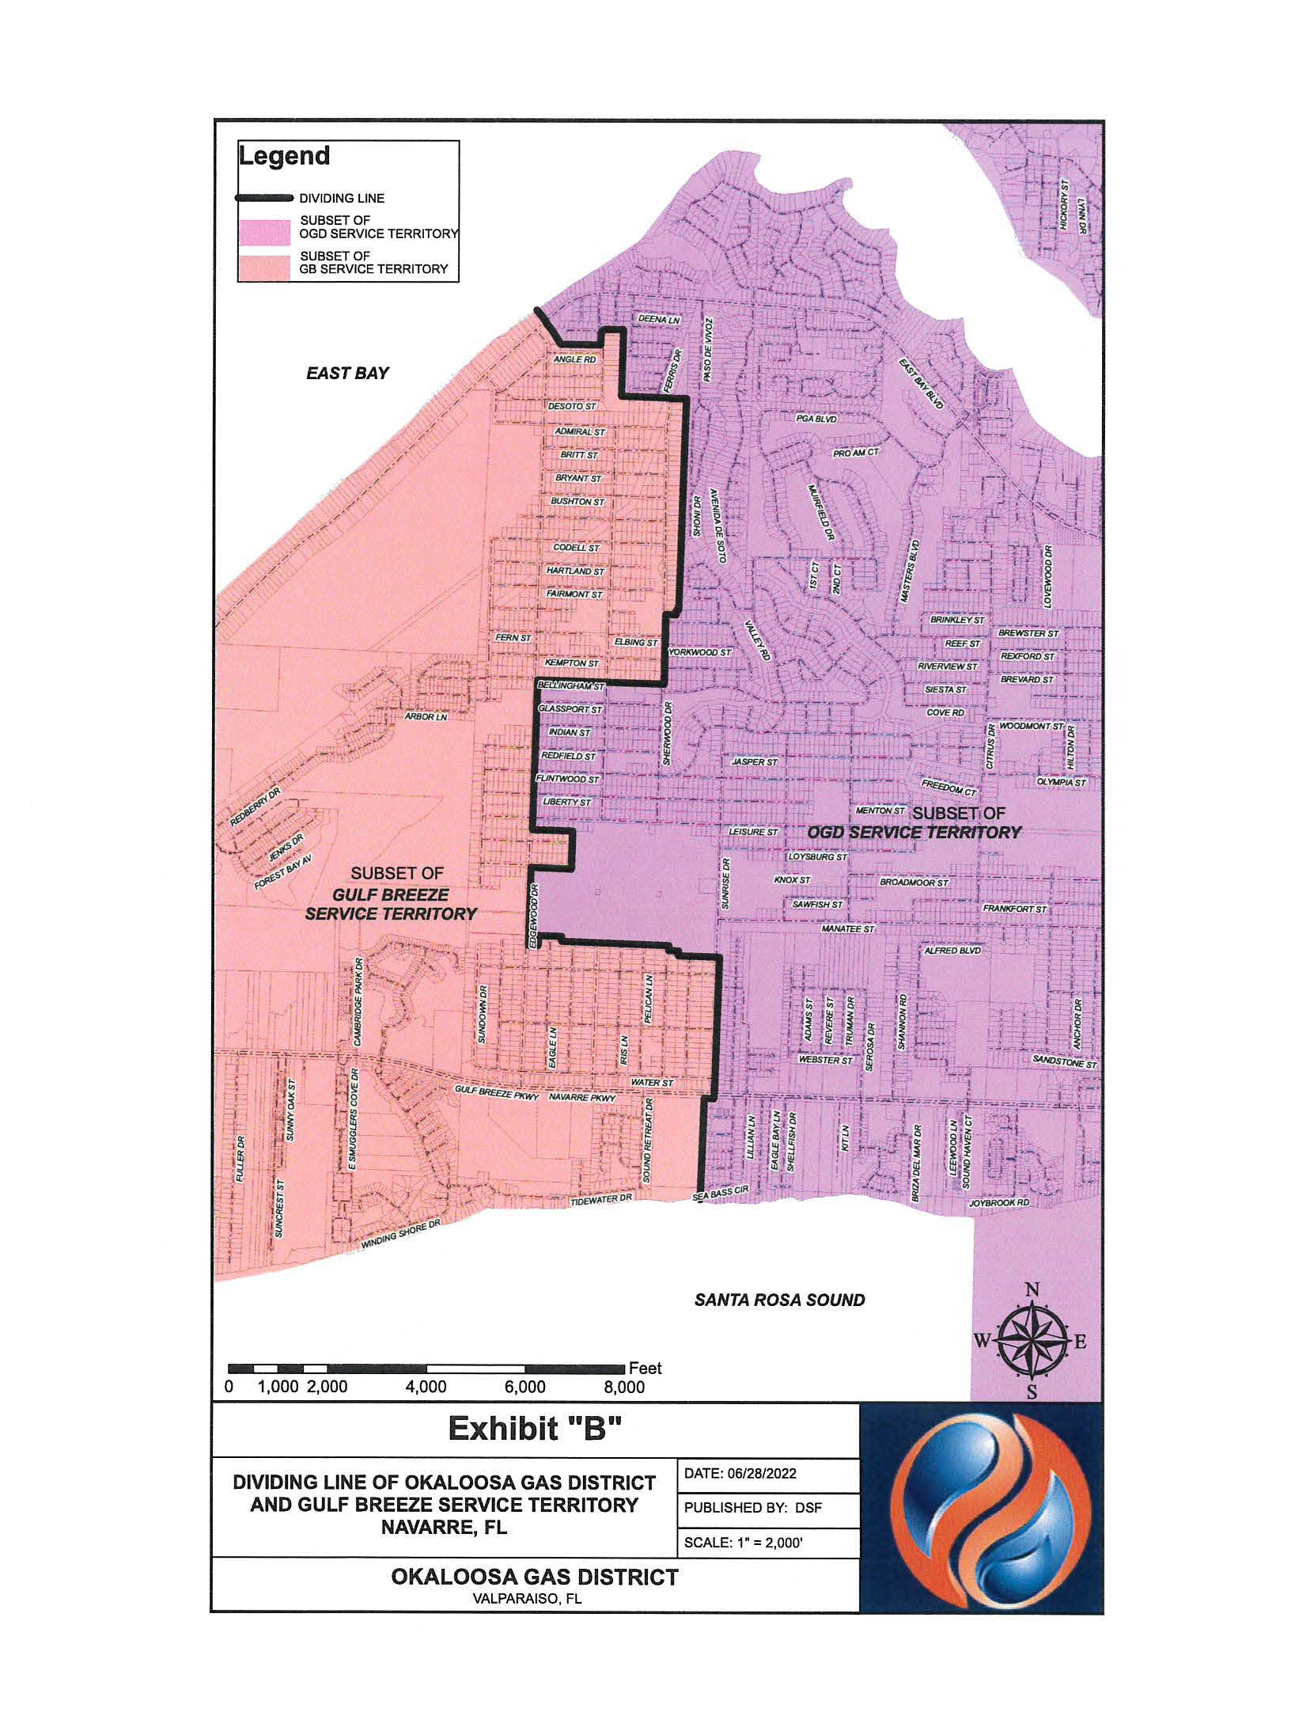

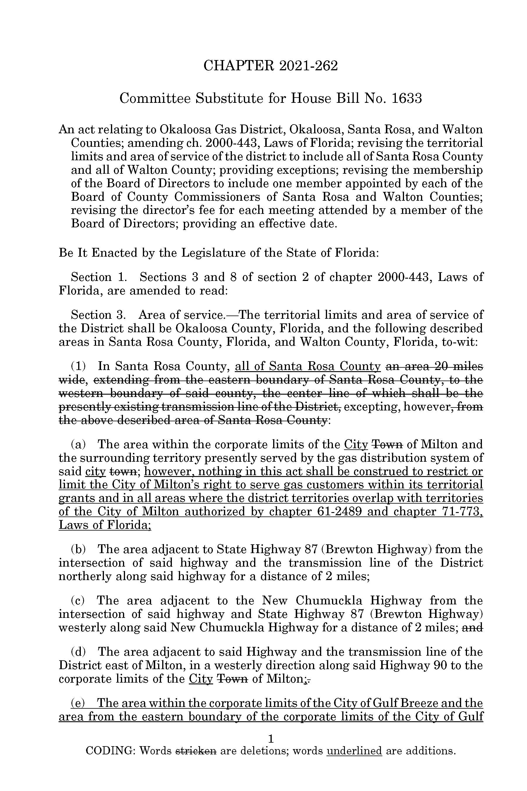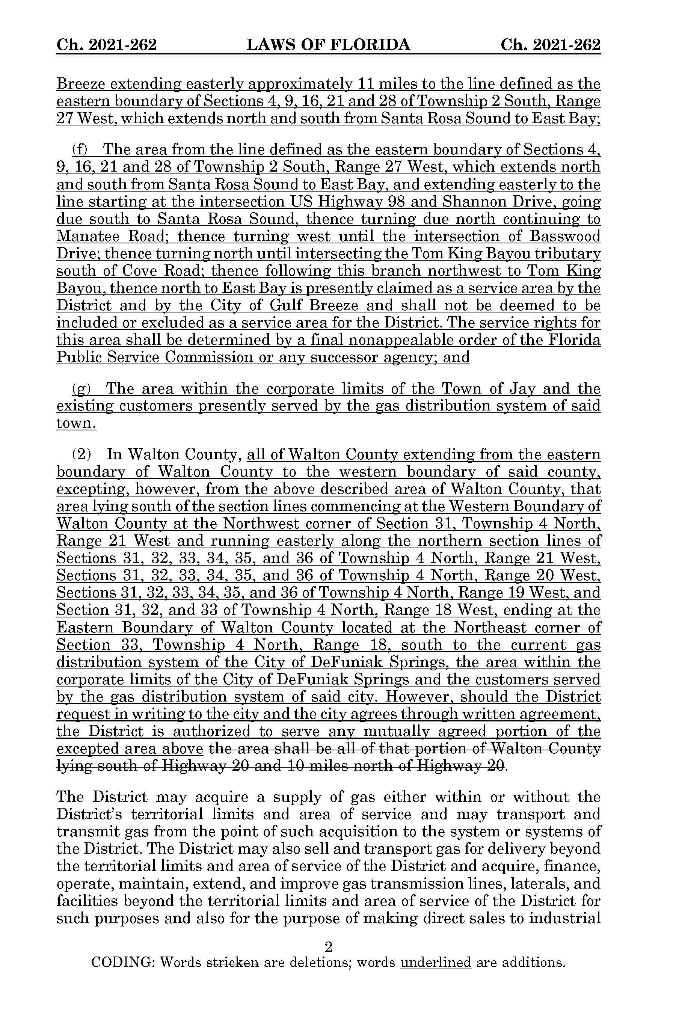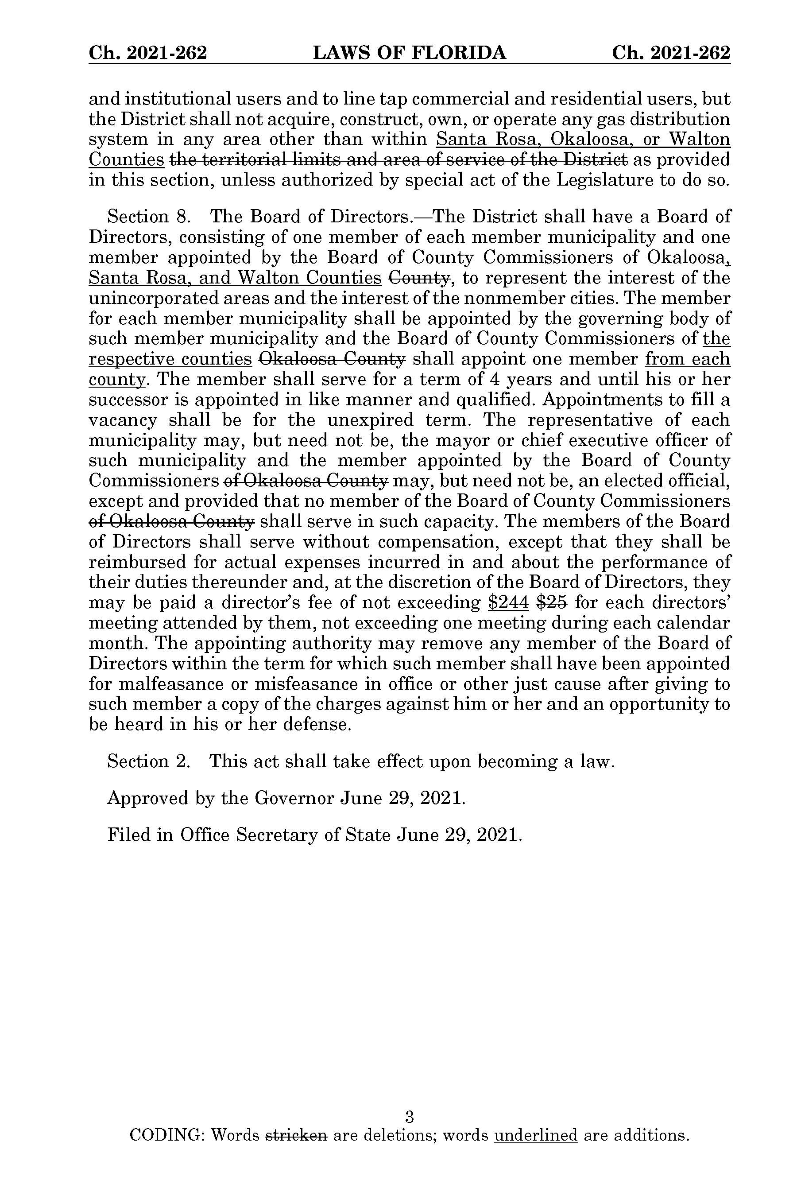

1. *Utilities Commission of the City of New Smyrna Beach v. Florida Public Service Commission*, 469 So. 2d 731 (Fla. 1985).
2. Chapter 29334, Laws of Florida.
3. Response 2 in Staff’s First Data Request, Document No. 11563-2022.
4. Response No. 3 in Staff’s First Data Request, Document No. 11563-2022.
5. Response No. 6 in Staff’s First Data Request, Document No. 11563-2022.
6. Response No. 4 in Staff’s First Data Request, Document No. 11563-2022.
7. Response No. 5 in Staff’s First Data Request, Document No. 11563-2022.