|  |  |  |  |
| --- | --- | --- | --- |
| State of Florida  pscSEAL | | Public Service Commission  Capital Circle Office Center ● 2540 Shumard Oak Boulevard Tallahassee, Florida 32399-0850  -M-E-M-O-R-A-N-D-U-M- | |
| DATE: | February 23, 2023 | | |
| TO: | Office of Commission Clerk (Teitzman) | | |
| FROM: | Division of Accounting and Finance (Andrews, D. Buys, Norris)  Division of Economics (Draper, Hampson)  Office of the General Counsel (Stiller, Dose) | | |
| RE: | Docket No. 20230017-EI – Petition for limited proceeding for recovery of incremental storm restoration costs related to Hurricanes Ian and Nicole, by Florida Power & Light Company. | | |
| AGENDA: | 03/07/23 – Regular Agenda – Interested Persons May Participate | | |
| COMMISSIONERS ASSIGNED: | | | All Commissioners |
| PREHEARING OFFICER: | | | Graham |
| CRITICAL DATES: | | | 03/24/23 (60-Day Interim Deadline) |
| SPECIAL INSTRUCTIONS: | | |  |

Case Background

On January 23, 2023, Florida Power & Light Company (FPL or Company) filed a petition for a limited proceeding seeking authority to implement an interim storm restoration recovery charge to recover $1.3 billion for the incremental restoration costs related to Hurricanes Ian and Nicole and to replenish the storm reserve. This amount includes $18.8 million in interest.

FPL has also presented an alternate storm charge calculation in its petition, which combines the recovery of incremental storm costs associated with Hurricanes Ian and Nicole with the remaining amounts to be collected for Hurricanes Michael, Sally, and Zeta, which have been previously approved by the Commission for Gulf Power Company (GPC).[1] This alternate calculation estimates a total of $1.5 billion for incremental restoration costs related to Hurricanes Michael, Sally, Zeta, Ian, and Nicole and to replenish the storm reserve. This amount includes $21.6 million in interest.

FPL filed its petition pursuant to the provisions of the 2021 Settlement Agreement (2021 Settlement) approved by the Commission in Order No. PSC-2021-0446-S-EI.[2] Pursuant to the 2021 Settlement, the Company can recover storm costs on an interim basis beginning 60 days following the filing of a petition for recovery. FPL has proposed interim storm restoration charges applicable to all rate classes over a 12-month recovery period, effective with the first billing cycle of April 2023, subject to a final true-up.

The Commission has jurisdiction over this matter pursuant to Sections 366.04, 366.05, 366.06, and 366.076, Florida Statutes.

Discussion of Issues

Issue 1:

 Should the Commission authorize FPL to implement an interim storm restoration recovery charge?

Recommendation:

 Yes. The Commission should authorize FPL to implement an interim storm restoration recovery charge, subject to refund. Once the total actual storm costs are known, FPL should be required to file documentation of the storm costs for Commission review and true up of any excess or shortfall. (Andrews)

Staff Analysis:

 As stated in the Case Background, FPL filed a petition for a limited proceeding seeking authority to implement an interim storm restoration recovery charge to recover an estimated total of $1.3 billion for incremental restoration costs related to Hurricanes Ian and Nicole and to replenish the storm reserve. In its petition, FPL requested to replenish the storm reserve to the pre-storm level of $219.9 million.

The petition was filed pursuant to the provisions of the 2021 Settlement approved by the Commission in Order No. PSC-2021-0446-S-EI. Storm restoration costs for Ian and Nicole were incurred during the term of the 2021 Settlement. Pursuant to Paragraph 10 of the 2021 Settlement, FPL can begin recovery of storm costs 60 days following the filing of a petition for recovery.

FPL also prepared an alternate storm charge calculation seeking authority to implement an interim storm restoration recovery charge to recover an estimated total of $1.5 billion which combines the incremental restoration costs related to Hurricanes Ian and Nicole with the remaining amounts to be collected for Hurricanes Michael, Sally, and Zeta, which have been previously approved by the Commission for GPC, and to replenish the storm reserve.[3]

In its petition, FPL asserted that it incurred total retail recoverable costs of approximately $1.5 billion as a result of Hurricanes Michael, Sally, Zeta, Ian, and Nicole. The Company further asserted that this amount was calculated in accordance with the Incremental Cost and Capitalization Approach methodology prescribed in Rule 25-6.0143, Florida Administrative Code.

The approval of an interim storm restoration recovery charge is preliminary in nature and is subject to refund pending further review once the total actual storm restoration costs are known. After the actual costs are reviewed for prudence and reasonableness, and are compared to the actual amount recovered through the interim storm restoration recovery charge, a determination will be made whether any over/under recovery has occurred. The disposition of any over/under recovery, and associated interest, will be considered by the Commission at a later date.

Based on a review of the information provided by FPL in its petition, staff recommends the Commission authorize the Company to implement an interim storm restoration recovery charge subject to refund. Once the total actual storm costs are known, FPL should be required to file documentation of the storm costs for Commission review and true-up of any excess or shortfall.

Issue 2:

 What is the appropriate security to guarantee the funds collected subject to refund through the interim storm restoration charge?

Recommendation:

 The appropriate security to guarantee the funds collected subject to refund is a corporate undertaking. (D. Buys)

Staff Analysis:

 Staff recommends that all funds collected subject to refund be secured by a corporate undertaking. The criteria for a corporate undertaking include sufficient liquidity, ownership equity, profitability, and interest coverage to guarantee any potential refund. FPL requested a 12-month collection period from April 2023 through March 2024 for Interim Storm Cost Recovery Charges of $1.5 billion related to Hurricanes Michael, Sally, Zeta, Ian and Nicole. Staff reviewed FPL’s three most recent annual reports filed with the Commission (2021, 2020, and 2019) to determine if the Company can support a corporate undertaking to guarantee the funds collected for recovery of incremental storm restoration costs related to the weather events. FPL’s financial information demonstrates the Company has acceptable levels of liquidity, ownership equity, profitability, and interest coverage to support a potential refund of $1.5 billion. Moreover, it is improbable FPL will be required to refund the entire requested amount.

Staff believes FPL has adequate resources to support a corporate undertaking in the amount requested. Based on this analysis, staff recommends that a corporate undertaking of $1.5 billion is acceptable. This brief financial analysis is only appropriate for deciding if the Company can support a corporate undertaking in the amount proposed and should not be considered a finding regarding staff’s position on other issues in this proceeding.

Issue 3:

 Should the Commission approve FPL's proposed interim storm restoration recovery charge tariff?

Recommendation:

 No. The Commission should deny FPL’s proposed interim storm restoration recovery charge tariff sheet No. 8.030.7. The Commission should approve FPL’s alternate storm charge calculation and associated tariff sheet as shown in Attachment A to this recommendation, effective with the first billing cycle of April 2023. Furthermore, effective with the first billing cycle of April 2023, tariff sheet Nos. 8.030.4, 8.030.5, and 8.030.6 should be cancelled, as shown in Attachment A to the recommendation. The alternate storm charge calculation avoids significant disparities in surcharges among customers of one, consolidated utility, reduces regulatory lag and interest payments, and mitigates the potential for overlapping storm recovery charges in the future. The interim storm restoration recovery charge should be subject to a final true-up. (Hampson, Draper, Stiller)

Staff Analysis:

 FPL is seeking approval of interim storm cost recovery surcharges associated with Hurricanes Ian and Nicole as shown in proposed tariff sheet No. 8.030.7 (Appendix F to the petition). The surcharges would be applicable to all rate classes and customers served by FPL including customers previously served by Gulf Power Company (GPC or FPL’s Northwest Florida).

Currently, bills for FPL’s Northwest Florida customers include surcharges for Hurricanes Michael, which equates to $8 on the residential 1,000 kilowatt-hour (kWh) bill, and Sally ($3/1,000 kWh). The Hurricane Michael surcharge went into effect in July 2019 and was approved to terminate in October 2023. Once the Hurricane Michael surcharge terminates, the Commission approved that the $3/1,000 kWh residential Hurricane Sally surcharge would increase to $10/1,000 kWh. Once recovery of Hurricane Sally is complete in October 2024, the Commission approved the recovery of Hurricane Zeta ($9.34/1,000 kWh) for the months of November and December 2024. These hurricanes impacted GPC’s service territory prior to the merger of FPL and GPC. Tariff sheet Nos. 8.030.4, 8.030.5, and 8.030.6 show the currently approved surcharges for Michael, Sally, and Zeta, applicable to FPL’s Northwest Florida customers. FPL indicated in its calculations in Appendix A of the petition that the storm costs associated with the Hurricane Michael surcharge are expected to be fully recovered by March 31, 2023.

For the reasons discussed below, staff is recommending approval of FPL’s alternate storm charge calculation and associated tariff sheets which were provided in Appendix H to the petition. The alternate storm charge calculation combines the recovery of incremental storm costs associated with Hurricanes Ian and Nicole with the remaining amounts to be collected for Hurricanes Michael, Sally, and Zeta, which have previously been approved by the Commission. Accordingly, the alternate proposal cancels the current Hurricanes Michael, Sally, and Zeta tariff sheets effective April 2023, that are applicable to FPL’s Northwest Florida customers only, and provides instead the proposed “2022 consolidated interim storm restoration recovery” tariff sheet No. 8.030.7 (alternate storm tariff). The alternate storm tariff, which staff recommends the Commission approve, is designed to recover the incremental storm-related costs related to Hurricanes Michael, Sally, Zeta, Ian, and Nicole from all FPL customers.

The current storm surcharges for Sally and Zeta applicable to FPL’s Northwest Florida customers were established in 2022 by Final Order of the Commission following a disputed fact hearing.[4] Testimony filed by FPL in 2021 in its rate case indicated that FPL’s Northwest Florida legacy[5] storm restoration costs and surcharges associated with Hurricanes Michael and Sally were to remain applicable to only those customers.[6] Final orders of the Commission are generally afforded administrative finality and are not subject to subsequent modification.[7] The issue of maintaining the current surcharge in place for FPL’s Northwest Florida customers only until full recovery was not specifically litigated or a material issue in either the prior storm recovery or FPL rate case docket. Staff is not persuaded that finality is attached to this issue. Moreover, administrative finality does not apply where there has been a substantial change in circumstances or a demonstrated public interest.[8] Staff believes both are present in this docket and, accordingly, the Commission has the legal authority to unify the charges.[9]

Hurricanes Ian and Nicole affected only FPL Peninsular customers, i.e., customers served by FPL prior to the merger with GPC. The proposal to apply the surcharge for this storm recovery to all current FPL customers, including FPL’s Northwest Florida customers who were not impacted, is a substantial change in circumstances from the prior approach of segregating costs based on impacts. Staff believes that spreading costs evenly across customers for all storms no matter the location of impacts is the appropriate reaction to these changed circumstances.[10]

The alternate storm charge calculations project a 12-month recovery period (April 2023 through March 2024), subject to a final true-up. Under the currently-approved recovery schedule, recovery of Hurricanes Sally and Zeta costs are projected to be complete in December 2024. In response to staff’s data request, FPL stated that this accelerated recovery of storm costs would “benefit FPL and its general body of customers by reducing the amount of interest recovered from customers and regulatory lag, while also mitigating the potential for overlapping storm recovery charges in the future.”[11] As to whether the alternative is preferable, FPL stated in its response that it “views both as being potentially appropriate options for storm cost recovery.”[12]

FPL explained that it has allocated the storm cost recovery amount to the rate classes consistent with the rate design approved in the 2021 Settlement.[13] Staff reviewed the storm cost recovery allocation and calculation of rates, for FPL’s proposal and the alternate calculations, and it appears that FPL has calculated rates in accordance with the 2021 Settlement, using the most recent load research study and projected billing determinants for the recovery period. If approved by the Commission, the storm cost recovery surcharge would be included in the non-fuel energy charge on customer bills, which FPL states is consistent with its standard practice.

For residential customers, the staff-recommended alternate surcharge would be 1.530 cents per kWh, which would equate to $15.30 on a 1,000 kWh residential bill. Under FPL’s proposed tariff, for residential customers, the surcharge would be 1.384 cents per kWh, which would equate to $13.84 on a 1,000 kWh residential bill. Under FPL’s proposal, FPL’s Northwest Florida customers would pay the proposed $13.84/1,000 kWh while continuing to pay the approved Hurricanes Sally and Zeta surcharges. Staff notes that FPL’s Northwest Florida customers will have paid for all the Hurricane Michael costs by March 31, 2023.

Under the alternate tariff, the FPL Peninsular customers would pay a storm recovery surcharge that is $1.46 ($15.30-$13.84) higher than FPL’s proposal on the 1,000 kWh bill for a 12-month period. However, FPL’s Northwest Florida customers would save monthly between $11 (Hurricanes Michael and Sally surcharges) to $9.34 (Hurricane Zeta surcharge) on the 1,000 kWh bill for a 21-month period. Staff believes that the savings to FPL Northwest Florida customers, in addition to the reasons discussed above, outweigh the incremental $1.46/1,000 kWh for the FPL Peninsular customers, when comparing the two storm recovery options.

CONCLUSION

The Commission should deny FPL’s proposed interim storm restoration recovery charge tariff No. 8.030.7. The Commission should approve FPL’s alternate storm charge calculation and associated tariff sheet as shown in Attachment A to this recommendation, effective with the first billing cycle of April 2023. Furthermore, effective with the first billing cycle of April 2023, tariff sheet Nos. 8.030.4, 8.030.5, and 8.030.6 would be cancelled, as shown in Attachment A to the recommendation. The alternate storm charge calculation avoids significant disparities in surcharges among customers of one, consolidated utility, reduces regulatory lag and interest payments, and mitigates the potential for overlapping storm recovery charges in the future. The interim storm restoration recovery charge should be subject to a final true-up.

Issue 4:

 Should this docket be closed?

Recommendation:

 No. This docket should remain open pending final reconciliation of actual recoverable storm costs with the amount collected pursuant to the interim storm restoration recovery charge and the calculation of a refund or additional charge if warranted. (Stiller)

Staff Analysis:

 No, this docket should remain open pending final reconciliation of actual recoverable storm costs with the amount collected pursuant to the interim storm restoration recovery charge and the calculation of a refund or additional charge if warranted.

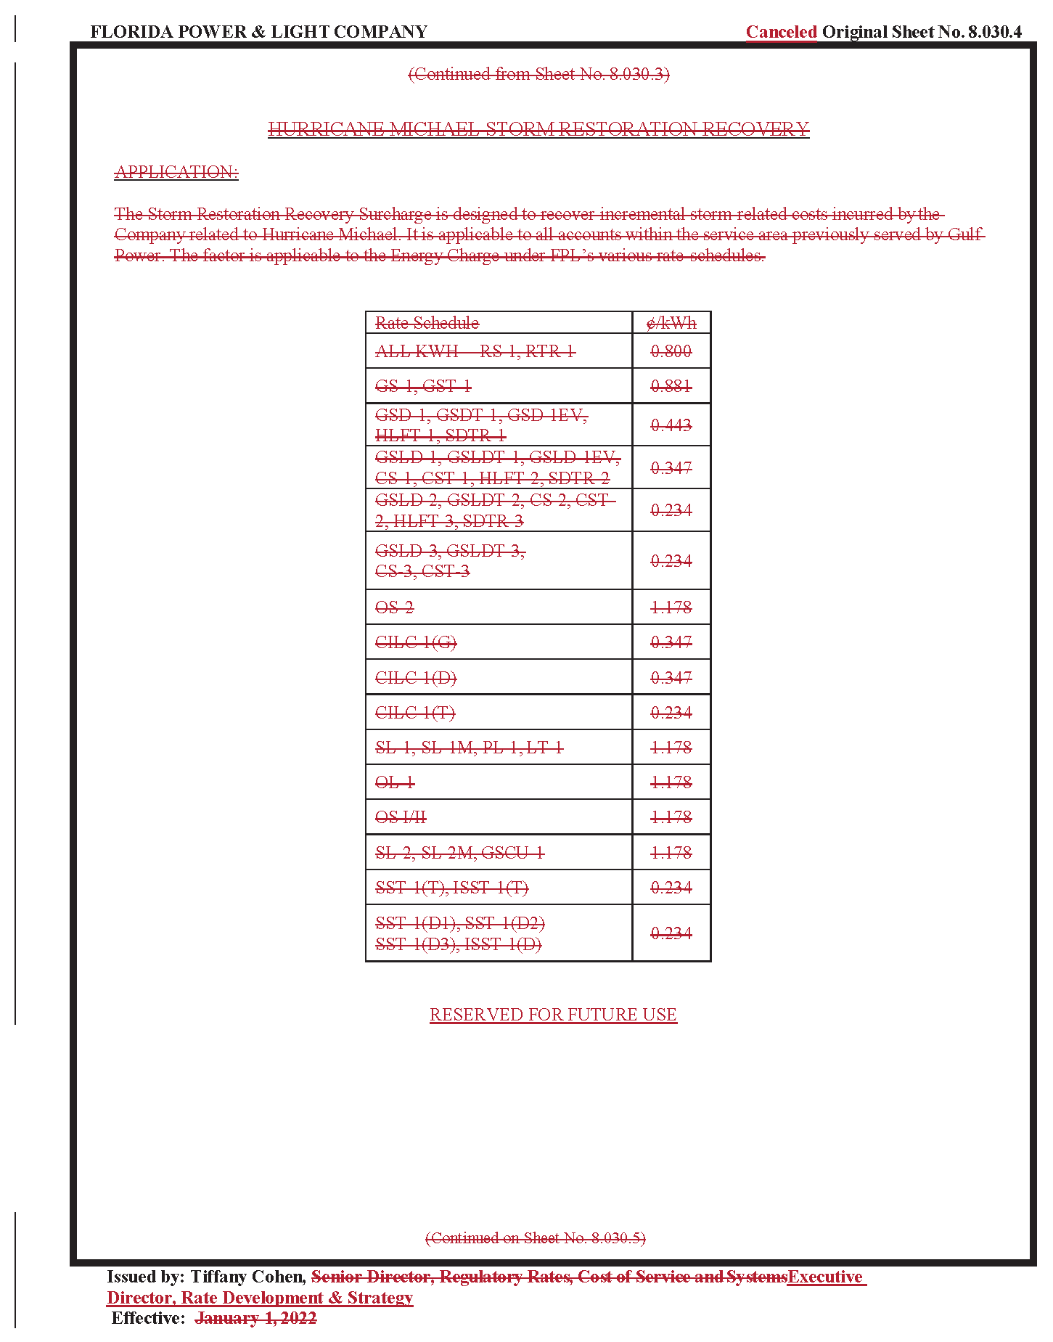

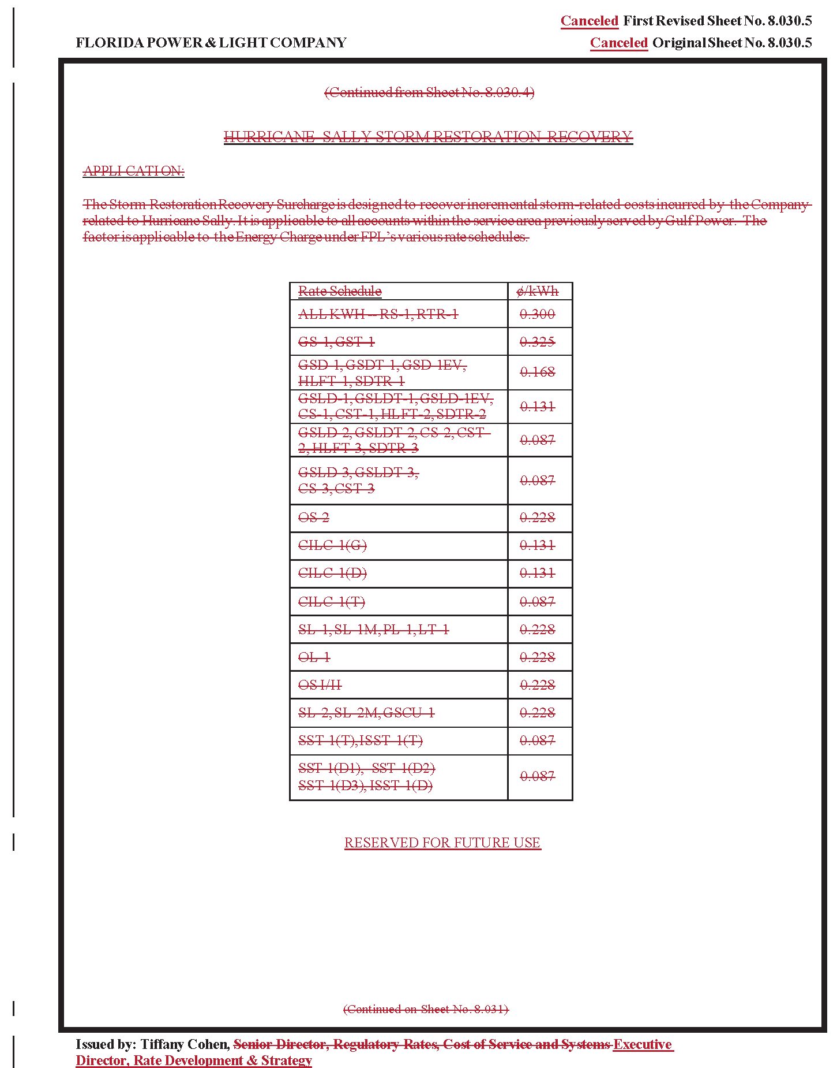

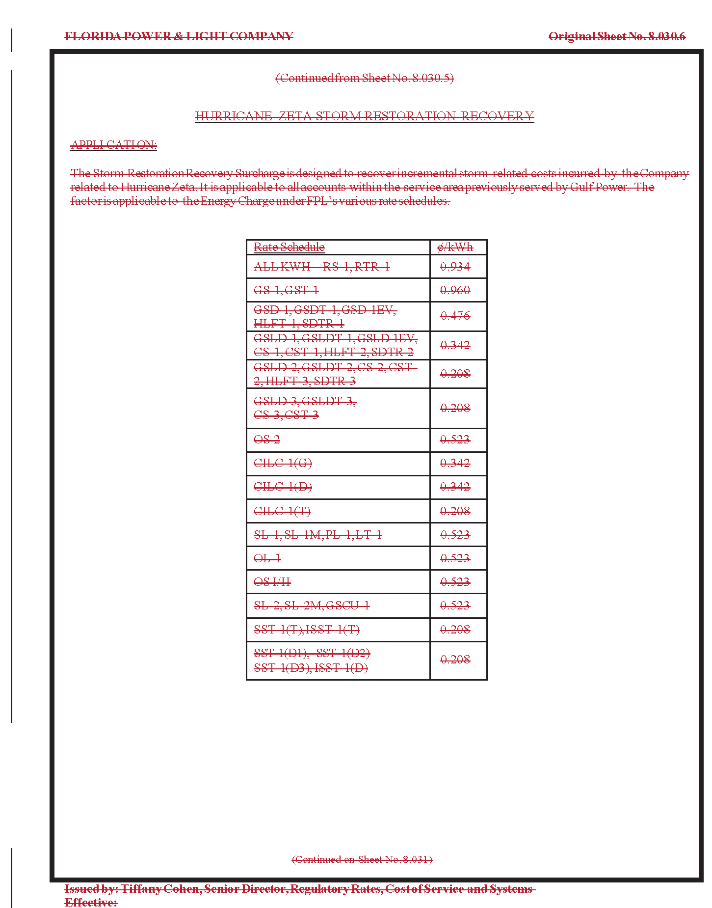

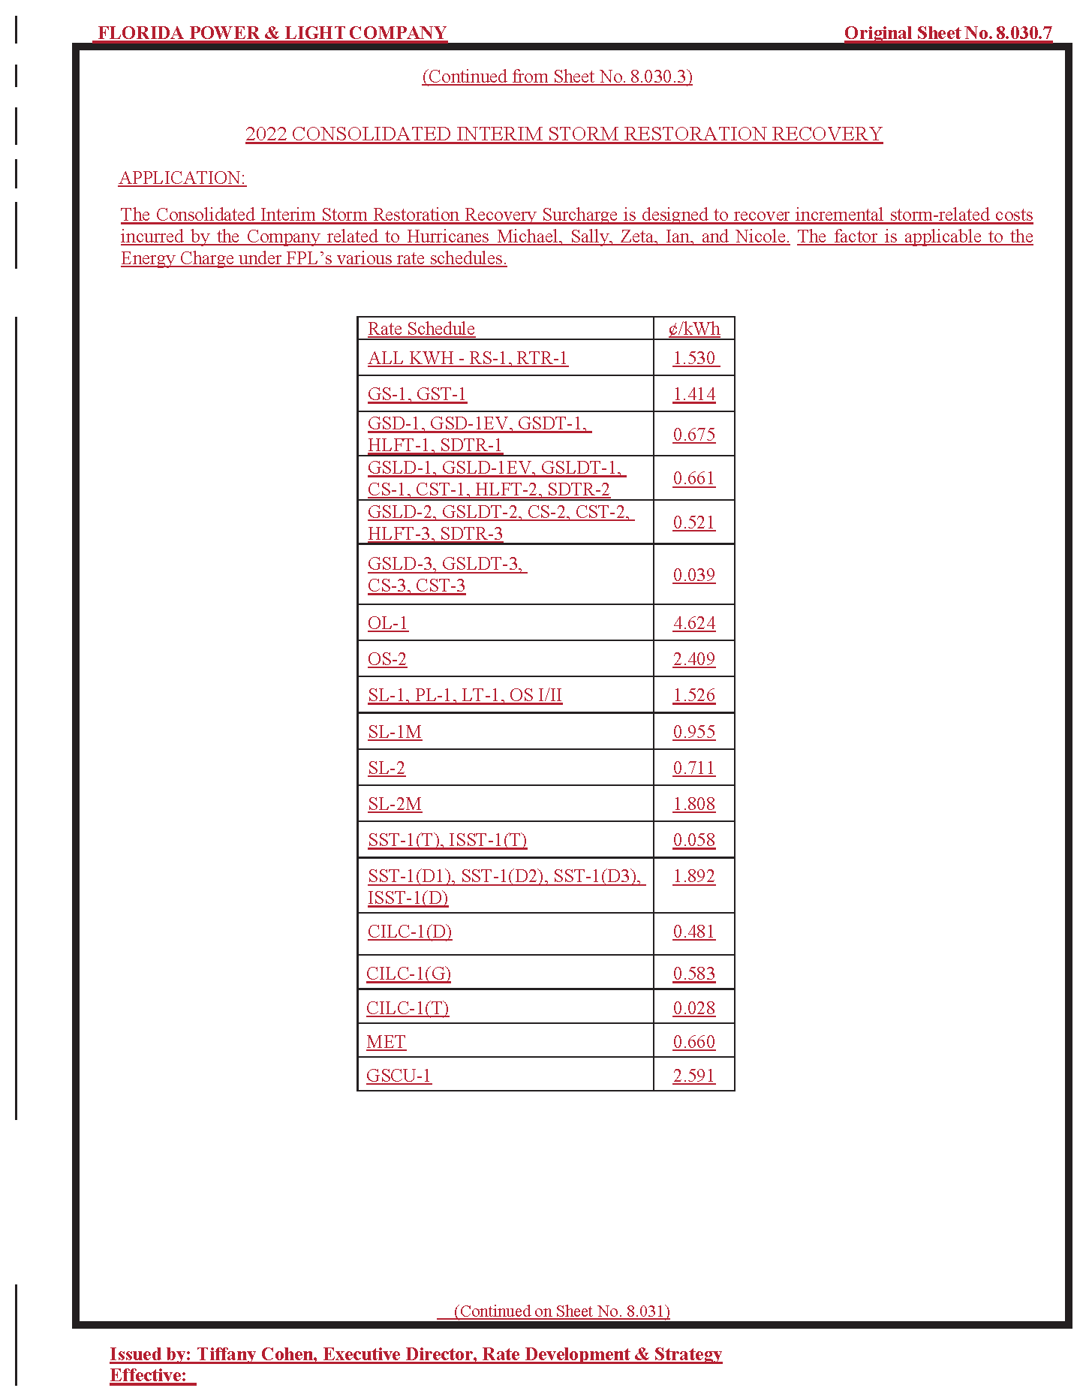

1. Order No. PSC-2019-0221-PCO-EI, issued June 3, 2019, in Docket No. 20190038-EI, *In re: Petition for limited proceeding for recovery of incremental storm restoration costs related to Hurricane Michael, by Gulf Power Company*; and Order No. PSC-2022-0406-FOF-EI, issued November 21, 2022, in Docket No. 20200041-EI, *In re: Petition for limited proceeding for recovery of incremental storm restoration costs related to Hurricane Sally, by Gulf Power Company.*
2. Order No. PSC-2021-0446-S-EI, issued December 2, 2021, in Docket No. 20210015-EI, *In re: Petition for rate increase by Florida Power & Light Company.*
3. Order Nos. PSC-2019-0221-PCO-EI; and PSC-2022-0406-FOF-EI*.*
4. Order No. PSC-2022-0406-FOF-EI, issued on November 21, 2022, in Docket Nos. 20200241-EI, 20210178-EI, and 20210179-EI, in *In re: Petition for limited proceeding for recovery of incremental storm restoration costs related to Hurricane Sally, In re: Petition for evaluation of Hurricane Isaias and Tropical Storm Eta storm costs, by Florida Power & Light Company,* and *In re: Petition for limited proceeding for recovery of incremental storm restoration costs and associated true-up process related to Hurricane Zeta, by Gulf Power Company.*
5. FPL and GPC were separate ratemaking entities until the end of 2021.
6. Document No. 02776-2021 in Docket No. 20210015-EI, Direct Testimony of Tiffany Cohen, p. 30 lns. 9-15.
7. *Peoples Gas System, Inc. v. Mason*, 187 So. 2d 335, 339 (Fla. 1966) (“orders of administrative agencies must eventually pass out of the agency’s control and become final and no longer subject to modification”).
8. *Delray Medical Center, Inc. v Agency for Health Care Admin.*, 5 So. 3d 26, 29 (Fla. 4th DCA 2009).
9. In response to a data request from staff, FPL concurred that there is no legal prohibition on the Commission imposing a uniform storm surcharge on all current FPL customers. Document No. 01037-2023.
10. *See Mason*, 187 So. 2d at 339 (“actions of administrative agencies are usually concerned with deciding issues according to a public interest that often changes with shifting circumstances and passage of time”).
11. *Id.*
12. *Id.*
13. Order No. PSC-2021-0446-S-EI, issued December 2, 2021, in Docket No. 20210015-EI, *In re: Petition for rate increase by Florida Power & Light Company.*