|  |  |  |  |
| --- | --- | --- | --- |
| State of Florida  pscSEAL | | Public Service Commission  Capital Circle Office Center ● 2540 Shumard Oak Boulevard Tallahassee, Florida 32399-0850  -M-E-M-O-R-A-N-D-U-M- | |
| DATE: | March 23, 2023 | | |
| TO: | Office of Commission Clerk (Teitzman) | | |
| FROM: | Division of Economics (Ward, Hampson)  Office of the General Counsel (Dose) | | |
| RE: | Docket No. 20230012-EU – Joint petition for approval of first amendment to a territorial agreement, by Tampa Electric Company and City of Bartow, Electric Department. | | |
| AGENDA: | 04/04/23 – Regular Agenda – Proposed Agency Action – Interested Persons May Participate | | |
| COMMISSIONERS ASSIGNED: | | | All Commissioners |
| PREHEARING OFFICER: | | | Graham |
| CRITICAL DATES: | | | None |
| SPECIAL INSTRUCTIONS: | | | None |

Case Background

On January 9, 2023, Tampa Electric Company (TECO) and the City of Bartow, Electric Department (Bartow), collectively the joint petitioners, filed a petition seeking Commission approval of an amendment to their current territorial agreement in Polk County (the proposed amendment). TECO serves retail customers in Hillsborough County and in portions of Polk, Pinellas, and Pasco Counties. Bartow serves retail customers within and adjacent to the City of Bartow, Polk County, Florida.

In 1985, the Commission approved the original territorial agreement between TECO and Bartow.[1] The instant petition seeks to amend the territorial boundaries to accommodate development within the Ranches at Lake McLeod subdivision (Ranches at Lake McLeod or subdivision), as shown in Attachment B to the recommendation. All other terms and conditions of the current agreement, shown in Attachment A, would remain in place.

During the review of this joint petition, staff issued one data request to the joint petitioners on March 1, 2023, for which responses were received on March 10, 2023. The Commission has jurisdiction over this matter pursuant to Section 366.04, Florida Statutes (F.S).

Discussion of Issues

Issue :

 Should the Commission approve the joint petition by TECO and Bartow to amend their territorial agreement related to the boundaries in Polk County?

Recommendation:

 Yes, the Commission should approve the joint petition by TECO and Bartow to amend their territorial agreement related to the boundaries in Polk County. The approval of this amendment would enable TECO and Bartow to redefine their existing service boundary to better serve future customers in Polk County and will not be a detriment to the public interest. Furthermore, it appears that the proposed territorial amendment eliminates any potential uneconomic duplication of facilities and will not cause a decrease in the reliability of electric service. (Ward)

Staff Analysis:

 Pursuant to Section 366.04(2)(d), F.S., and Rule 25-6.0440(2), Florida Administrative Code (F.A.C.), the Commission has the jurisdiction to approve territorial agreements between and among rural electric cooperatives, municipal electric utilities, and other electric utilities. Unless the Commission determines that the amendment to the territorial agreement will cause a detriment to the public interest, the amendment should be approved.[2]

Proposed Amendment to the 1985 Territorial Agreement

A new residential subdivision, known as Ranches at Lake McLeod, is currently under development in Polk County. A section of the existing service boundary runs through the planned subdivision. The joint petitioners explained that the current service boundary runs through proposed home lots, across planned streets, and without regard to future utility easement areas in the subdivision.

The joint petitioners stated that they had discussions for the provision of electric service to the new subdivision, which led to a mutual agreement between TECO and Bartow regarding the most efficient, reliable provision of electricity to the new subdivision. Under this agreement, the revised boundary lines would follow planned streets and along lot lines within the subdivision. The joint petitioners assert that this proposal would allow both utilities to have sufficient access to the areas to be served. Furthermore, the joint petitioners assert that the proposed territorial amendment would not cause a decrease in the reliability of electric service to the existing and future ratepayers of either utility and would prevent the uneconomic duplication of facilities. Pursuant to Rule 25-6.0440(1)(f), F.A.C., the joint petitioners provided a map depicting the proposed boundary line of the subdivision. The map is shown in Attachment B to this recommendation.

Pursuant to Rule 25-6.0440(1)(b), F.A.C., the joint petitioners provided the original 1985 territorial agreement, shown in Attachment A to the recommendation. In paragraph 26 of the petition, the joint petitioners explained that the terms and conditions of the original 1985 territorial agreement remain in effect; the only proposed change is to modify the boundary line within the new subdivision. Furthermore, the joint petitioners explained that the 1985 territorial agreement continues to remain in effect until terminated or modified by the joint petitioners.

Under the proposed division of the development, TECO would serve 541 lots, including 140 in the North Ranch segment of the subdivision, and Bartow would serve 469 lots. In paragraph 19 of the petition, the joint petitioners explained that the North Ranch segment of the subdivision is wholly within TECO’s service area and was not part of the negotiations leading to this boundary line amendment. Aside from the unaffected North Ranch segment, this subdivision has not yet been developed. Therefore, there are no current customers or facilities to be transferred as a result of the proposed territorial amendment. Similarly, there are no affected customers to be notified as required by Rule 25-6.0440(1)(d), F.A.C.

Conclusion

After review of the petition, the proposed territorial amendment, and the joint petitioners’ responses to staff’s data request, staff recommends that the Commission should approve the proposed amendment to the territorial agreement between TECO and Bartow in Polk County. Staff believes that the proposed territorial amendment will enable TECO and Bartow to redefine their existing service boundary to better serve future customers in Polk County and will not cause a detriment to the public interest. Furthermore, it appears that the proposed territorial amendment eliminates any potential uneconomic duplication of facilities and will not cause a decrease in the reliability of electric service.

Issue :

 Should this docket be closed?

Recommendation:

 Yes. If no protest is filed by a person whose substantial interests are affected within 21 days of the issuance of the Order, this docket should be closed upon the issuance of the Consummating Order. (Dose)

Staff Analysis:

 If no protest is filed by a person whose substantial interests are affected within 21 days of the issuance of the Order, this docket should be closed upon the issuance of the Consummating Order.

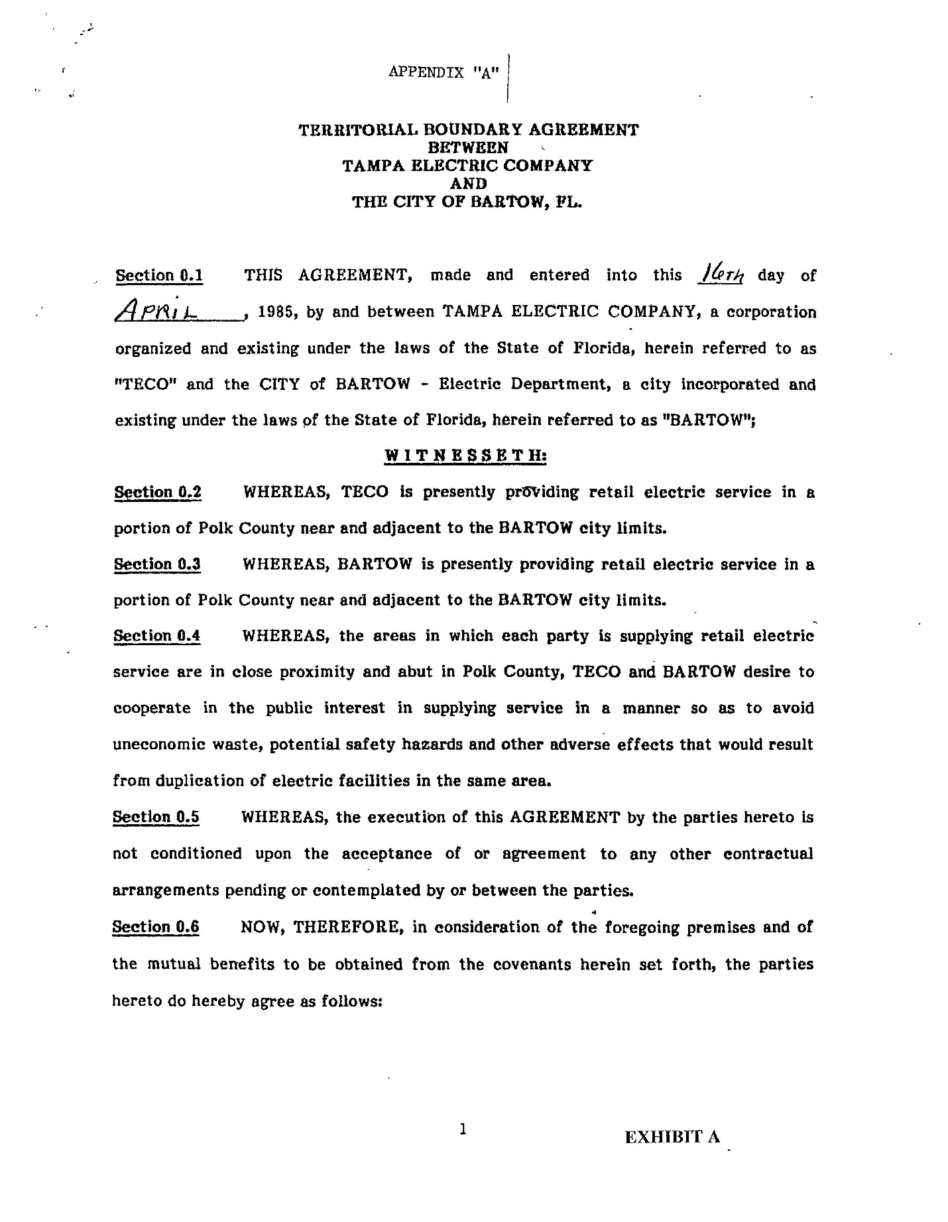

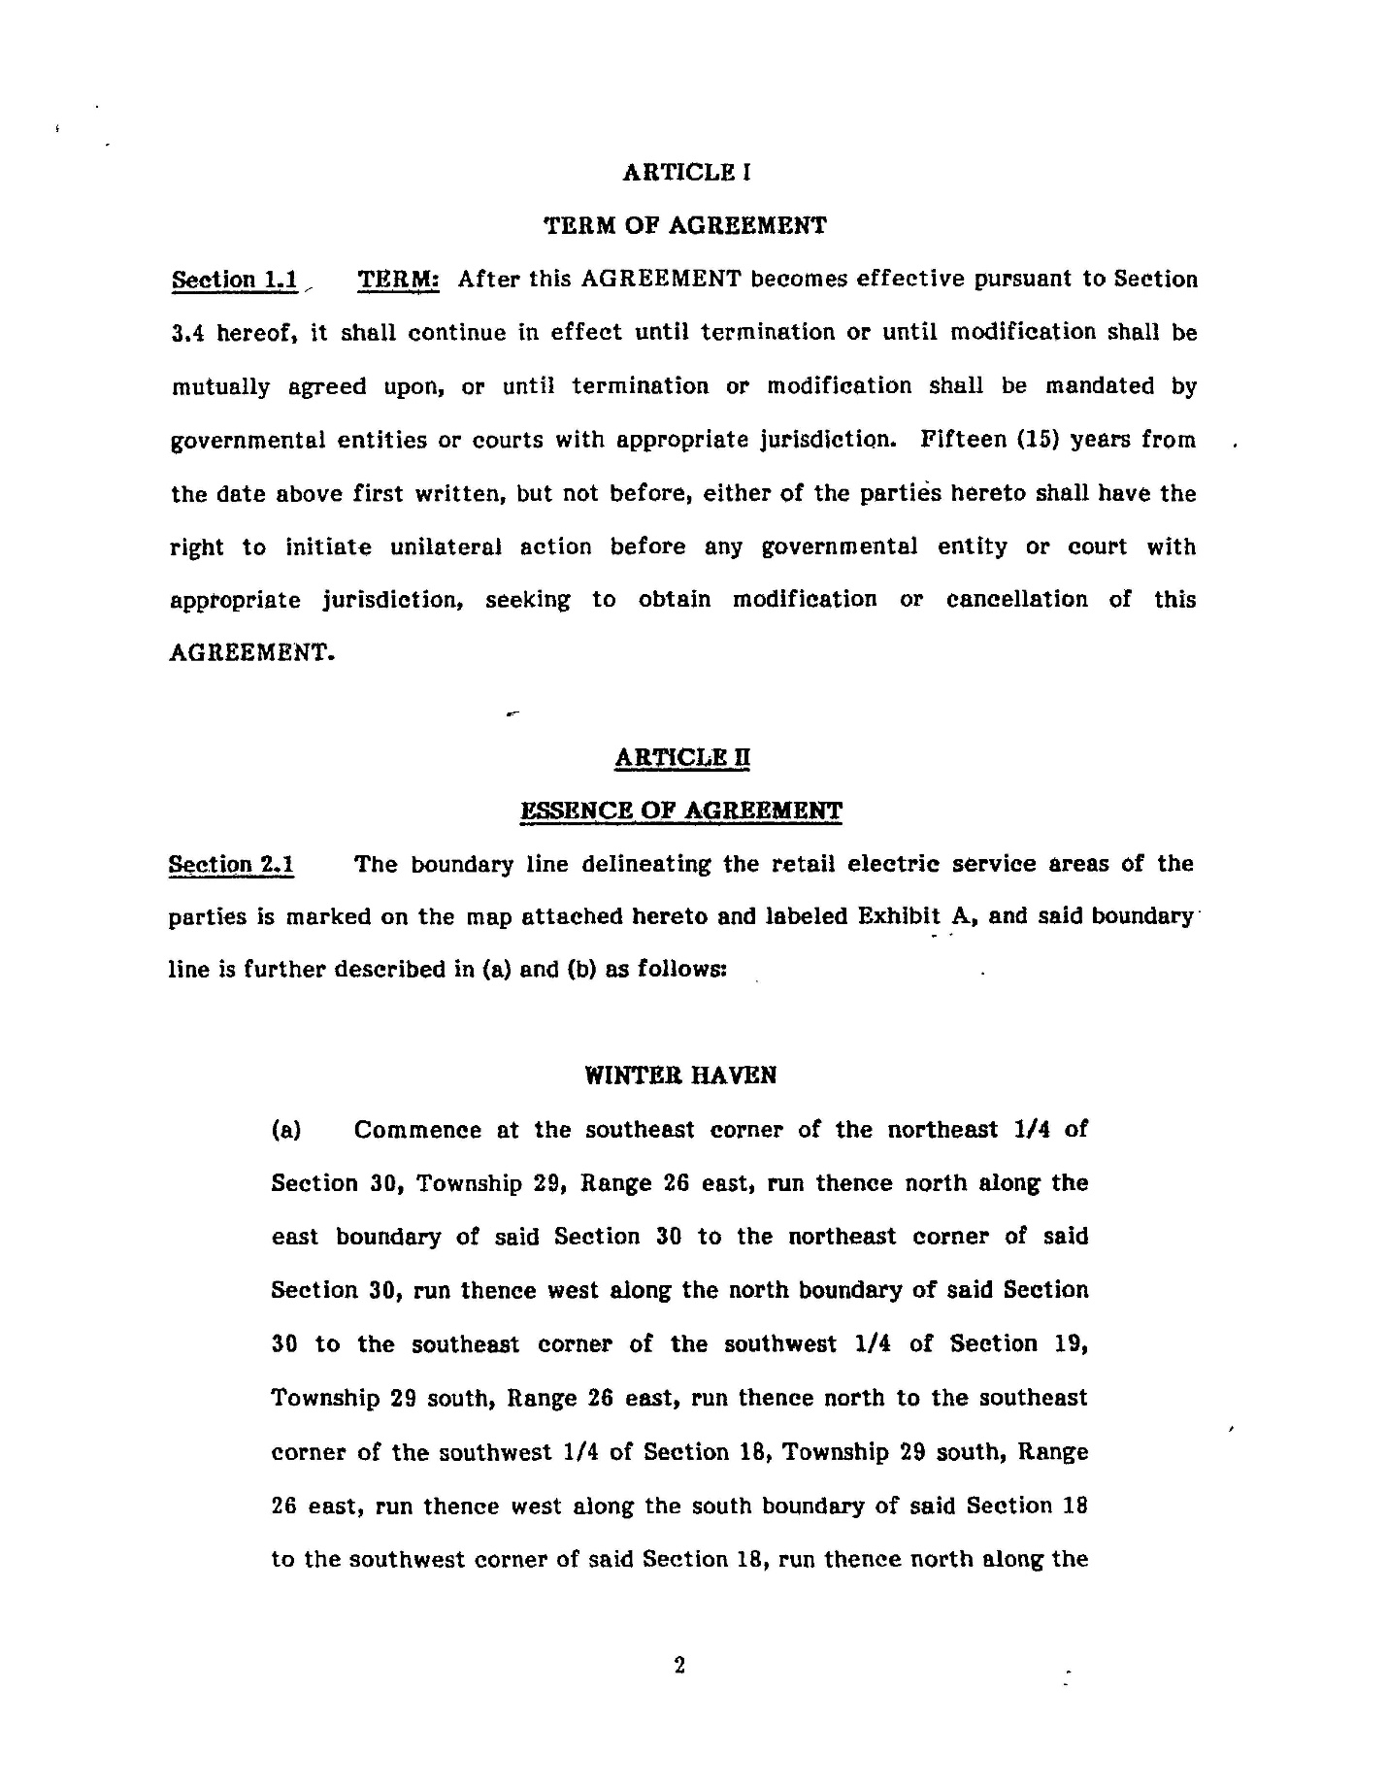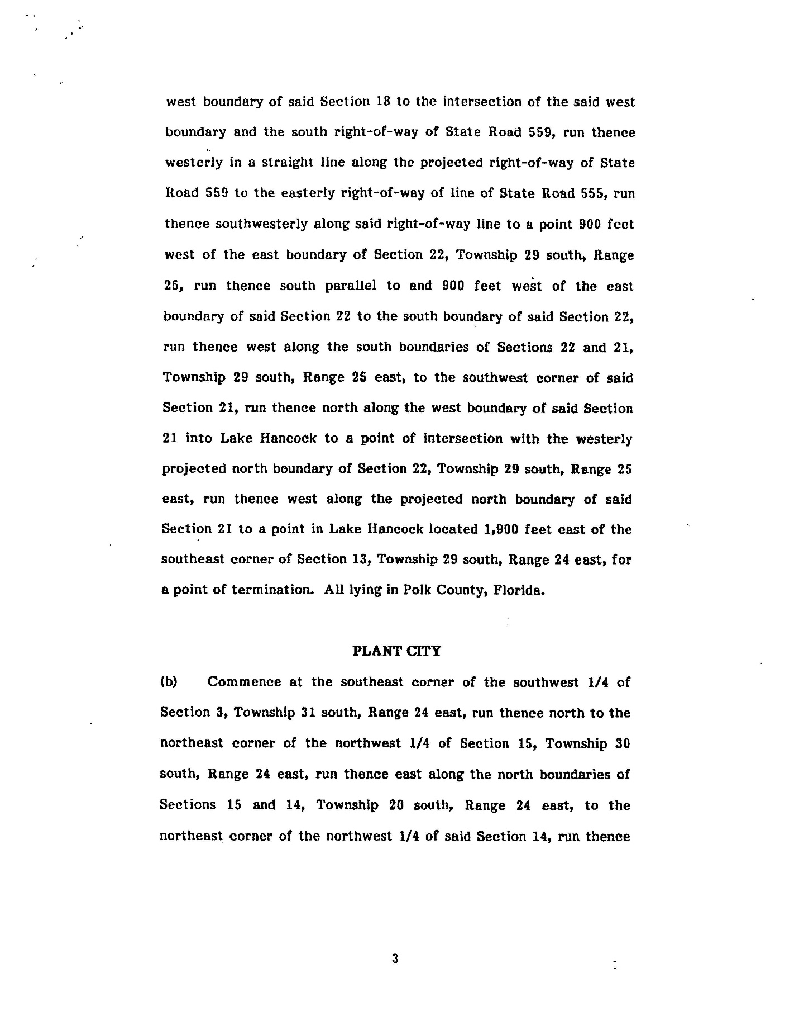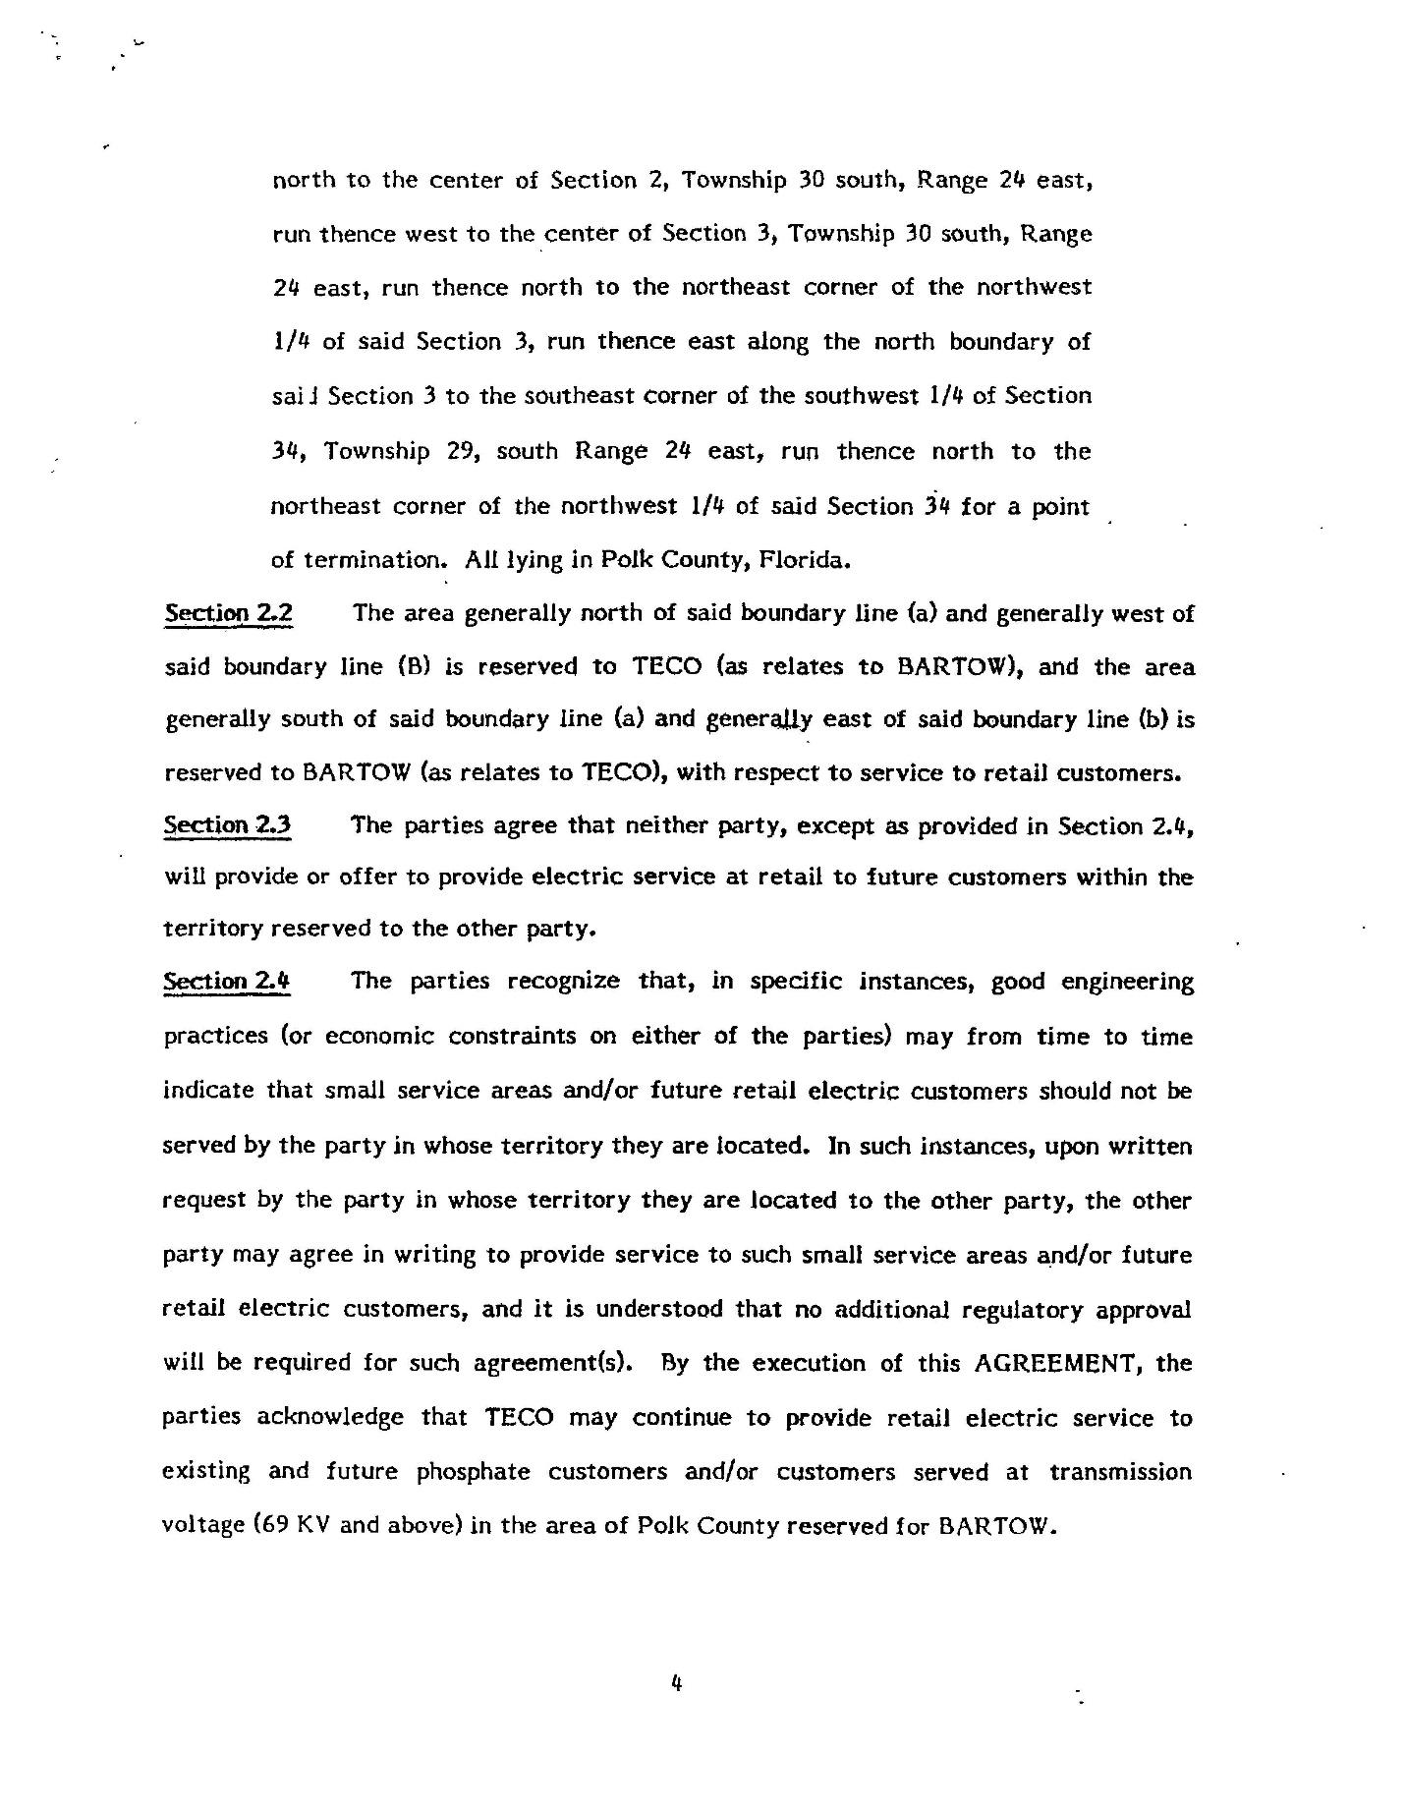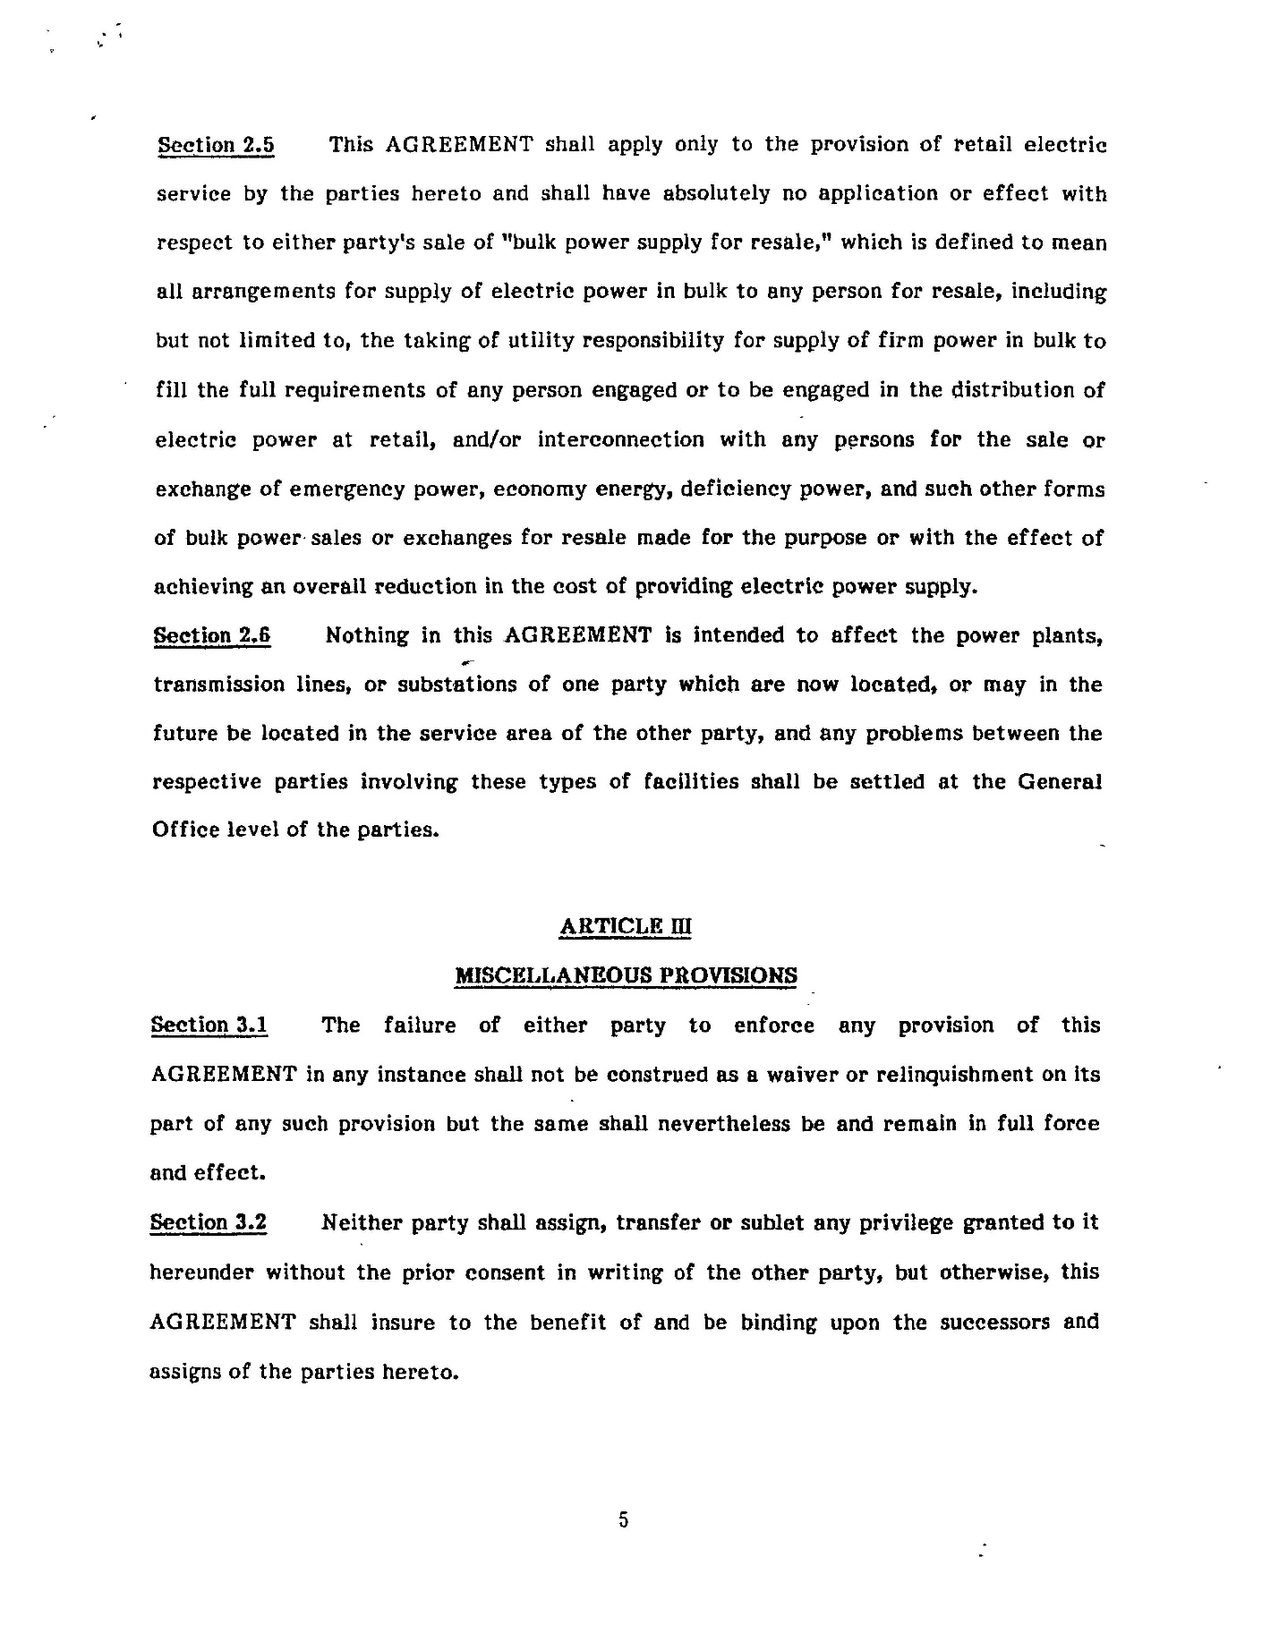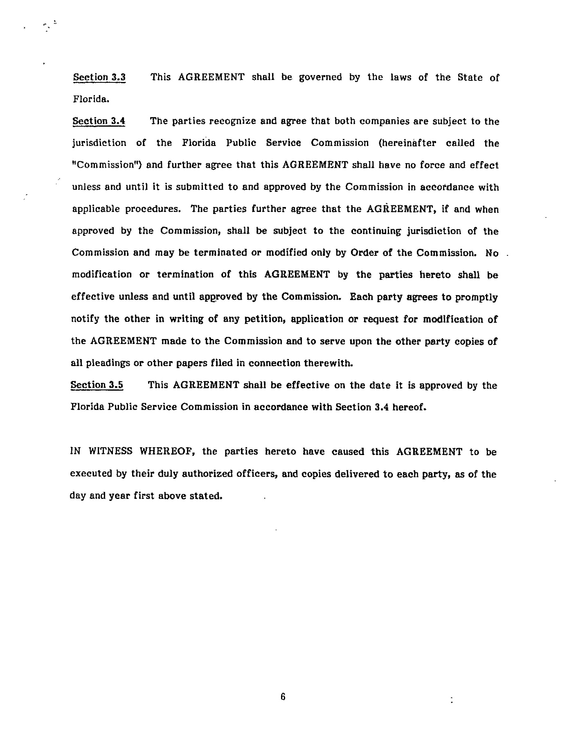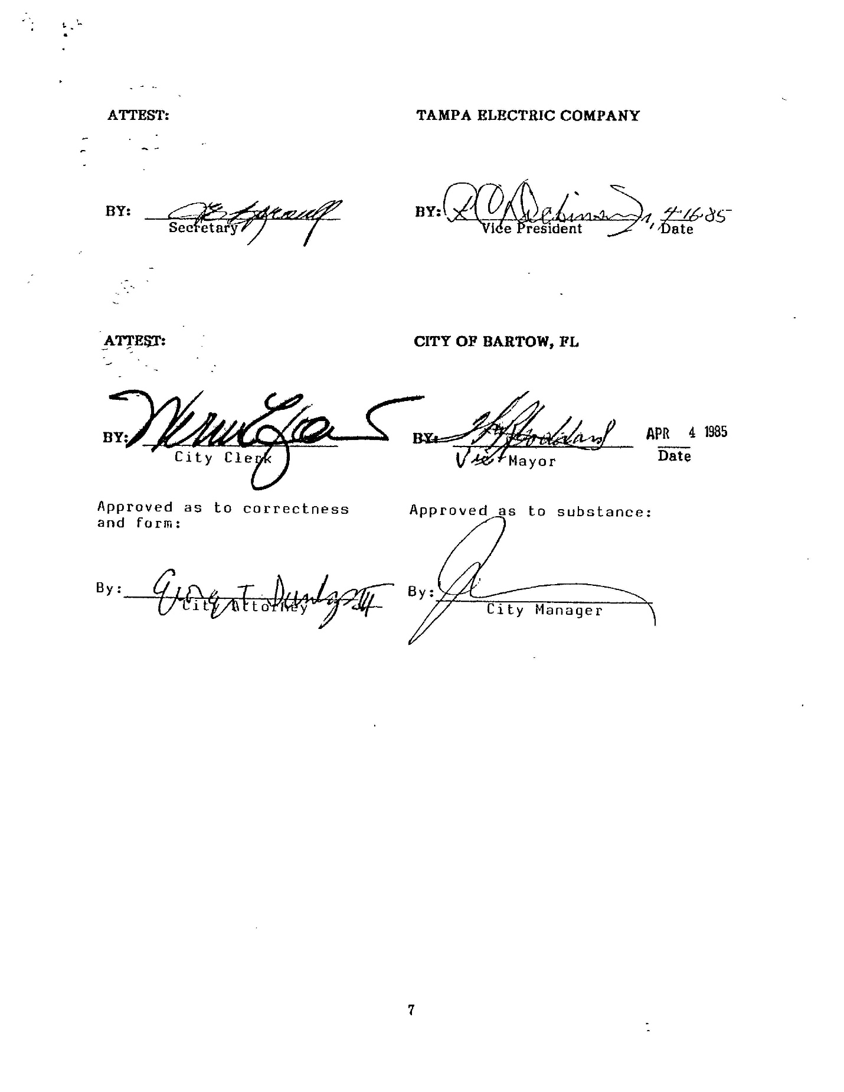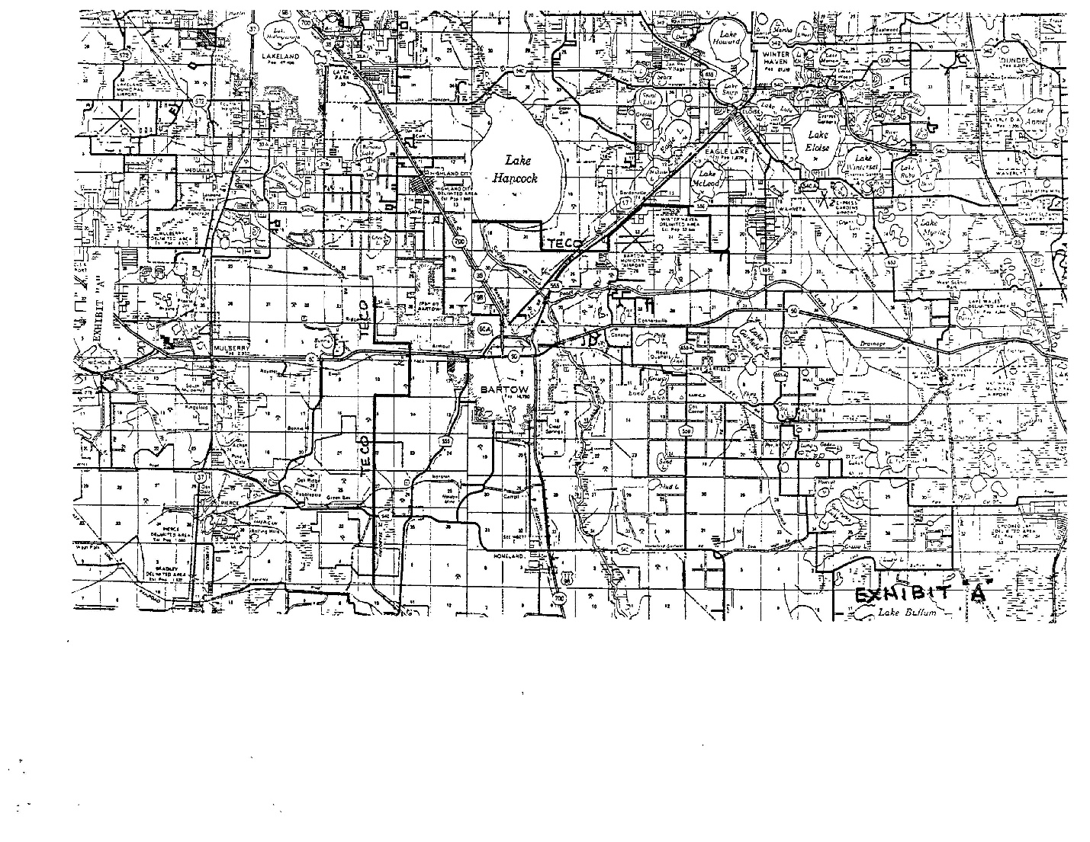

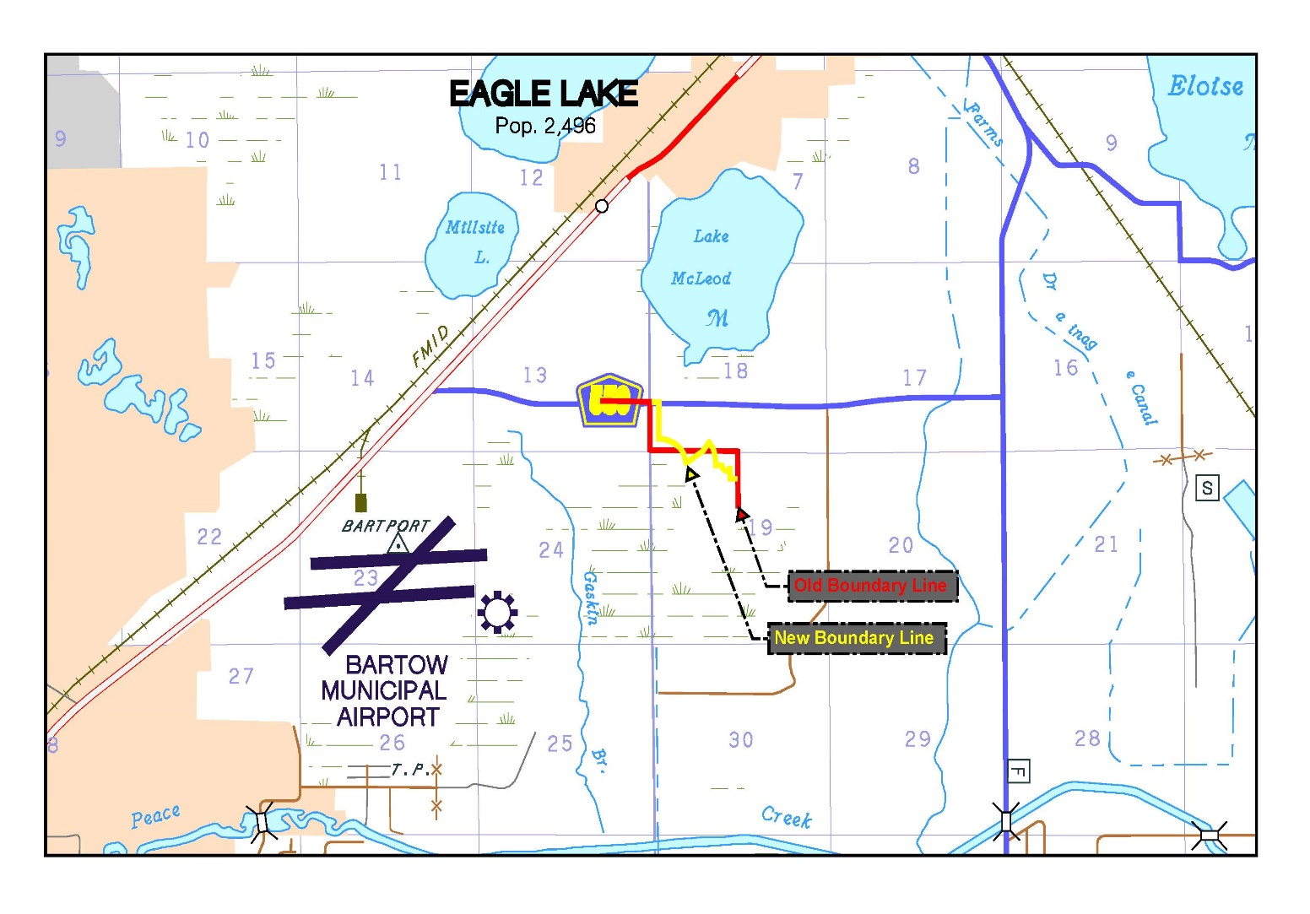

1. Order No. 15437, issued December 11, 1985, in Docket No. 19850148-EU, *In re: Joint petition for approval of territorial agreement between City of Bartow and Tampa Electric Company.* 
2. *Utilities Commission of the City of New Smyrna Beach v. Florida Public Service Commission*, 469 So. 2d 731 (Fla. 1985).