BEFORE THE FLORIDA PUBLIC SERVICE COMMISSION

|  |  |
| --- | --- |
| In re: Joint petition for approval of first amendment to a territorial agreement, by Tampa Electric Company and City of Bartow, Electric Department. | DOCKET NO. 20230012-EU  ORDER NO. PSC-2023-0141-PAA-EU  ISSUED: April 24, 2023 |

The following Commissioners participated in the disposition of this matter:

ANDREW GILES FAY, Chairman

ART GRAHAM

GARY F. CLARK

MIKE LA ROSA

GABRIELLA PASSIDOMO

NOTICE OF PROPOSED AGENCY ACTION

ORDER APPROVING AMENDMENT OF TERRITORIAL AGREEMENT

BY THE COMMISSION:

NOTICE is hereby given by the Florida Public Service Commission that the action discussed herein is preliminary in nature and will become final unless a person whose interests are substantially affected files a petition for a formal proceeding, pursuant to Rule 25-22.029, Florida Administrative Code (F.A.C.).

Background

On January 9, 2023, Tampa Electric Company (TECO) and the City of Bartow, Electric Department (Bartow), collectively the joint petitioners, filed a petition seeking our approval of an amendment to their current territorial agreement in Polk County (the proposed amendment). TECO serves retail customers in Hillsborough County and in portions of Polk, Pinellas, and Pasco Counties. Bartow serves retail customers within and adjacent to the City of Bartow, Polk County, Florida.

In 1985, we approved the original territorial agreement between TECO and Bartow.[1] The instant petition seeks to amend the territorial boundaries to accommodate development within the Ranches at Lake McLeod subdivision (Ranches at Lake McLeod or subdivision), as shown in Attachment B to this order. All other terms and conditions of the current agreement, shown in Attachment A, would remain in place.

During the review of this joint petition, our staff issued one data request to the joint petitioners on March 1, 2023, for which responses were received on March 10, 2023. We have jurisdiction over this matter pursuant to Section 366.04, Florida Statutes (F.S).

Decision

Pursuant to Section 366.04(2)(d), F.S., and Rule 25-6.0440(2), F.A.C., we have jurisdiction to approve territorial agreements between and among rural electric cooperatives, municipal electric utilities, and other electric utilities. Unless we determine that the amendment to the territorial agreement will cause a detriment to the public interest, the amendment should be approved.[2]

1. Proposed Amendment to the 1985 Territorial Agreement

A new residential subdivision, known as Ranches at Lake McLeod, is currently under development in Polk County. A section of the existing service boundary runs through the planned subdivision. The joint petitioners explained that the current service boundary runs through proposed home lots, across planned streets, and without regard to future utility easement areas in the subdivision.

The joint petitioners stated that they had discussions for the provision of electric service to the new subdivision, which led to a mutual agreement between TECO and Bartow regarding the most efficient, reliable provision of electricity to the new subdivision. Under this agreement, the revised boundary lines would follow planned streets and along lot lines within the subdivision. The joint petitioners assert that this proposal would allow both utilities to have sufficient access to the areas to be served. Furthermore, the joint petitioners assert that the proposed territorial amendment would not cause a decrease in the reliability of electric service to the existing and future ratepayers of either utility and would prevent the uneconomic duplication of facilities. Pursuant to Rule 25-6.0440(1)(f), F.A.C., the joint petitioners provided a map depicting the proposed boundary line of the subdivision. The map is shown in Attachment B to this order.

Pursuant to Rule 25-6.0440(1)(b), F.A.C., the joint petitioners provided the original 1985 territorial agreement, shown in Attachment A to the order. In paragraph 26 of the petition, the joint petitioners explained that the terms and conditions of the original 1985 territorial agreement remain in effect; the only proposed change is to modify the boundary line within the new subdivision. Furthermore, the joint petitioners explained that the 1985 territorial agreement continues to remain in effect until terminated or modified by the joint petitioners.

Under the proposed division of the development, TECO would serve 541 lots, including 140 in the North Ranch segment of the subdivision, and Bartow would serve 469 lots. In paragraph 19 of the petition, the joint petitioners explained that the North Ranch segment of the subdivision is wholly within TECO’s service area and was not part of the negotiations leading to this boundary line amendment. Aside from the unaffected North Ranch segment, this subdivision has not yet been developed. Therefore, there are no current customers or facilities to be transferred as a result of the proposed territorial amendment. Similarly, there are no affected customers to be notified as required by Rule 25-6.0440(1)(d), F.A.C.

1. Conclusion

After review of the petition, the proposed territorial amendment, and the joint petitioners’ responses to our staff’s data request, we find that the proposed amendment to the territorial agreement between TECO and Bartow in Polk County shall be approved. We find that the proposed territorial amendment will enable TECO and Bartow to redefine their existing service boundary to better serve future customers in Polk County and will not cause a detriment to the public interest. Furthermore, it appears that the proposed territorial amendment eliminates any potential uneconomic duplication of facilities and will not cause a decrease in the reliability of electric service.

Based on the foregoing, it is

ORDERED by the Florida Public Service Commission that the joint petition for amendment to the territorial agreement between Tampa Electric Company and the City of Bartow shall be approved. It is further

ORDERED that the provisions of this Order, issued as proposed agency action, shall become final and effective upon the issuance of a Consummating Order unless an appropriate petition, in the form provided by Rule 28-106.201, Florida Administrative Code, is received by the Commission Clerk, 2540 Shumard Oak Boulevard, Tallahassee, Florida 32399-0850, by the close of business on the date set forth in the “Notice of Further Proceedings” attached hereto. It is further

ORDERED that in the event this Order becomes final, this docket shall be closed.

By ORDER of the Florida Public Service Commission this 24th day of April, 2023.

|  |  |
| --- | --- |
|  | /s/ Adam J. Teitzman |
|  | ADAM J. TEITZMAN  Commission Clerk |

Florida Public Service Commission

2540 Shumard Oak Boulevard

Tallahassee, Florida 32399

(850) 413‑6770

www.floridapsc.com

Copies furnished: A copy of this document is provided to the parties of record at the time of issuance and, if applicable, interested persons.

DD

NOTICE OF FURTHER PROCEEDINGS OR JUDICIAL REVIEW

The Florida Public Service Commission is required by Section 120.569(1), Florida Statutes, to notify parties of any administrative hearing that is available under Section 120.57, Florida Statutes, as well as the procedures and time limits that apply. This notice should not be construed to mean all requests for an administrative hearing will be granted or result in the relief sought.

Mediation may be available on a case-by-case basis. If mediation is conducted, it does not affect a substantially interested person's right to a hearing.

The action proposed herein is preliminary in nature. Any person whose substantial interests are affected by the action proposed by this order may file a petition for a formal proceeding, in the form provided by Rule 28-106.201, Florida Administrative Code. This petition must be received by the Office of Commission Clerk, 2540 Shumard Oak Boulevard, Tallahassee, Florida 32399-0850, by the close of business on May 15, 2023.

In the absence of such a petition, this order shall become final and effective upon the issuance of a Consummating Order.

Any objection or protest filed in this/these docket(s) before the issuance date of this order is considered abandoned unless it satisfies the foregoing conditions and is renewed within the specified protest period.

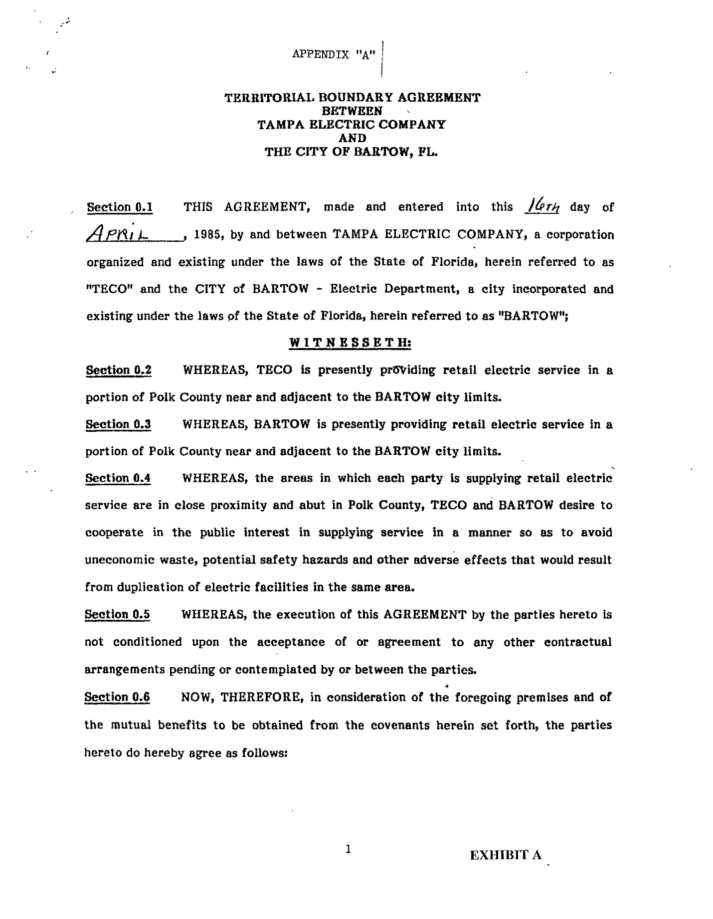

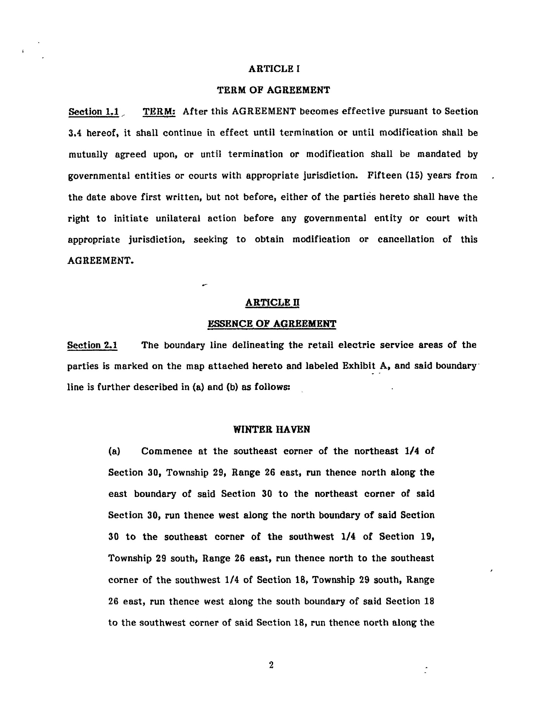

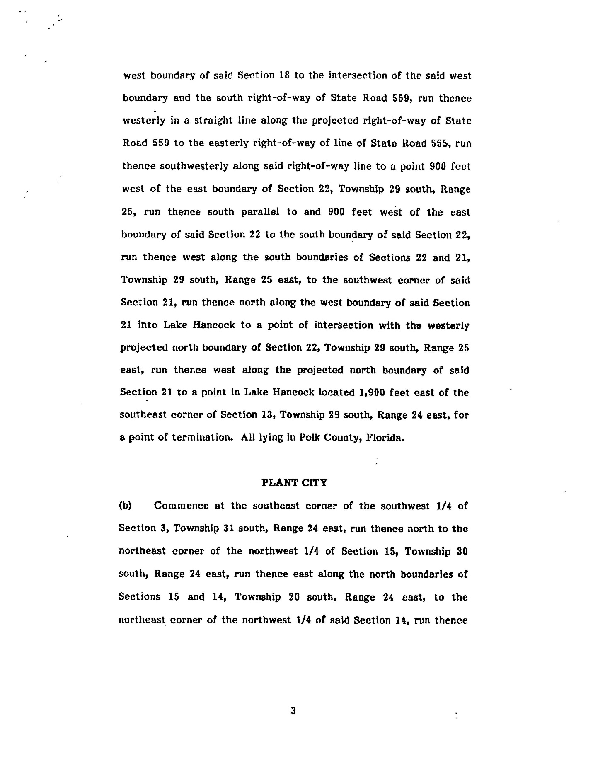

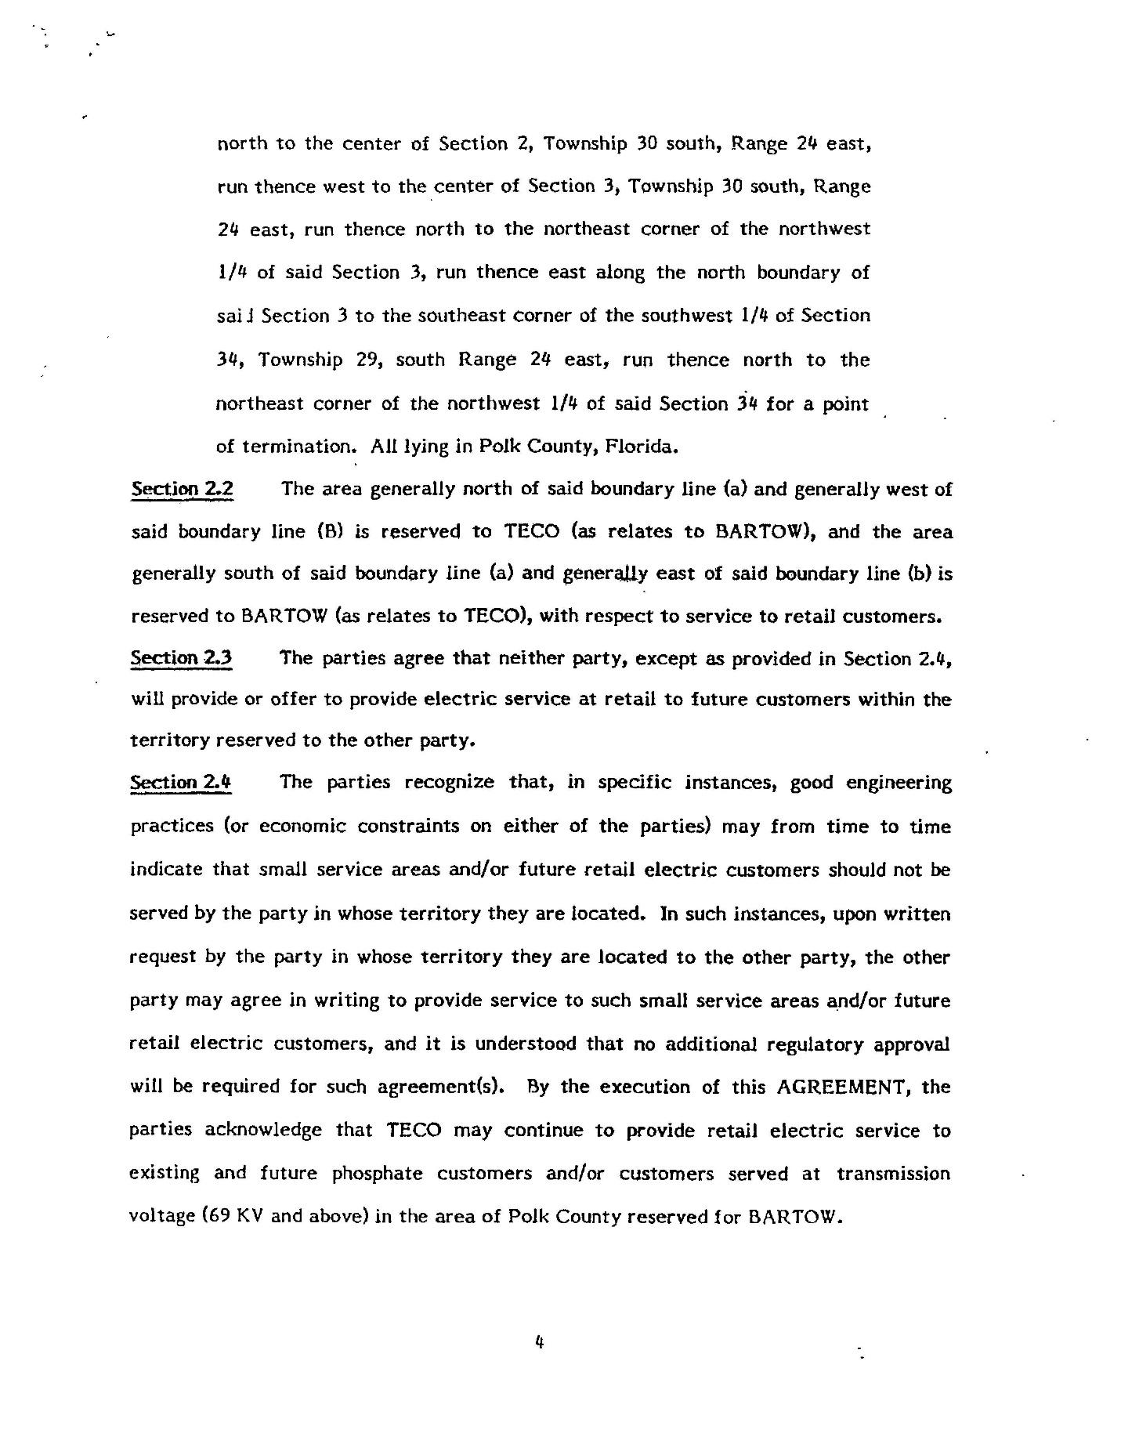

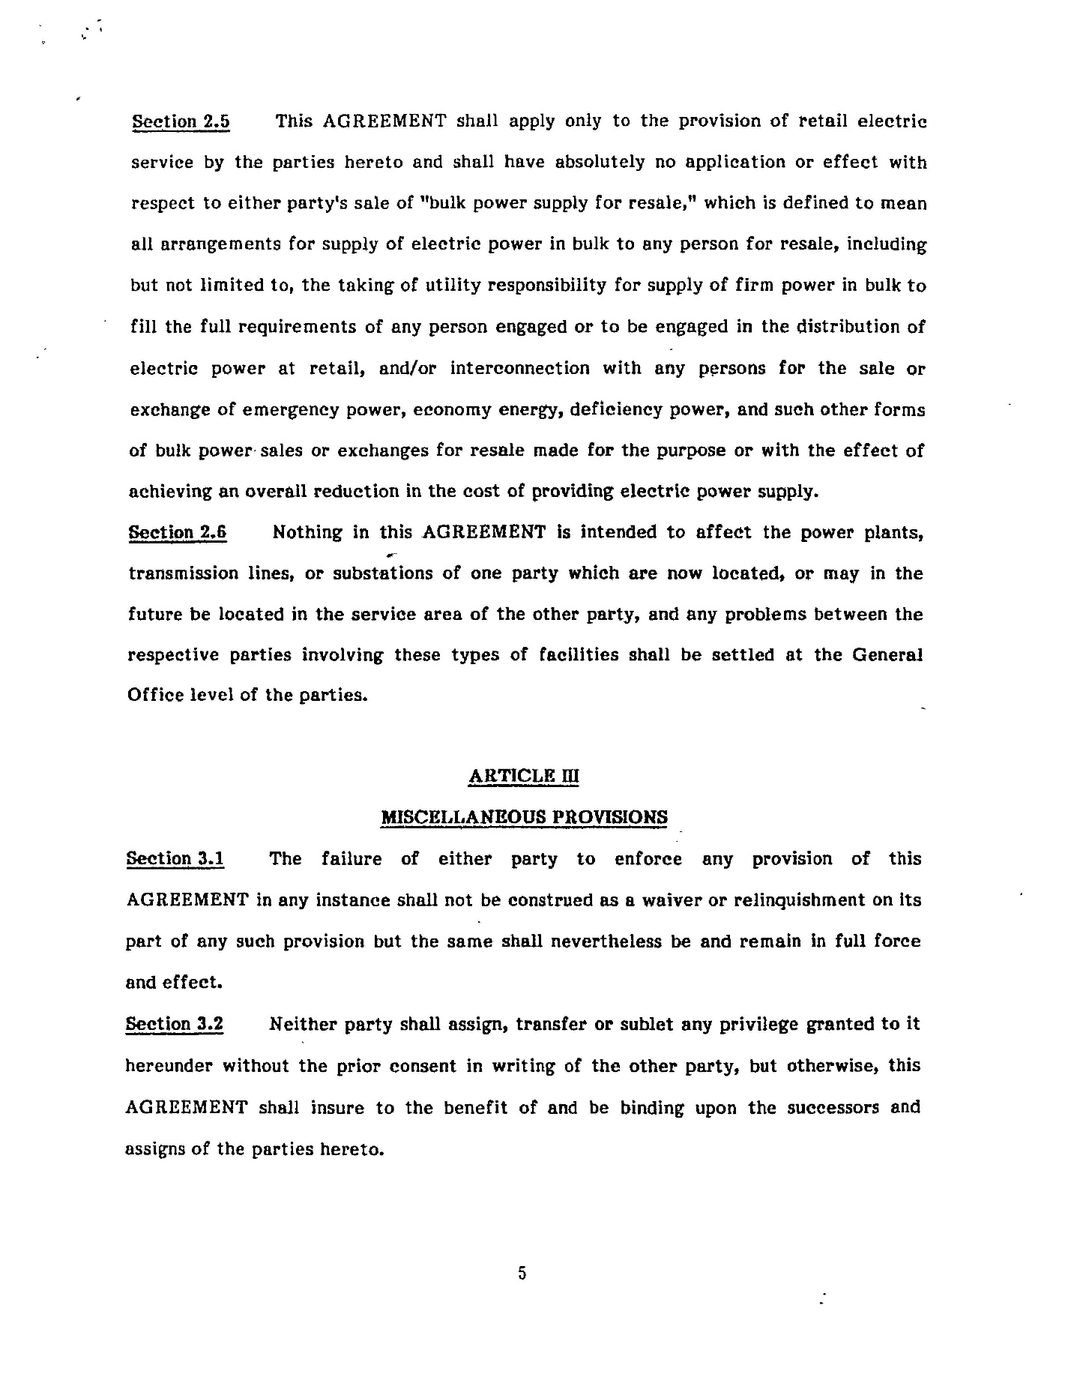

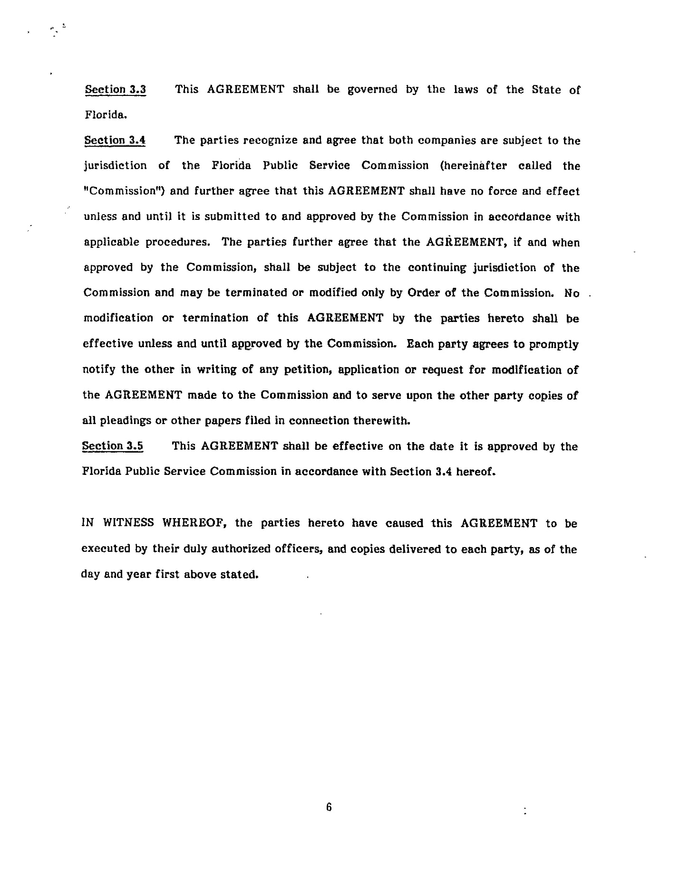

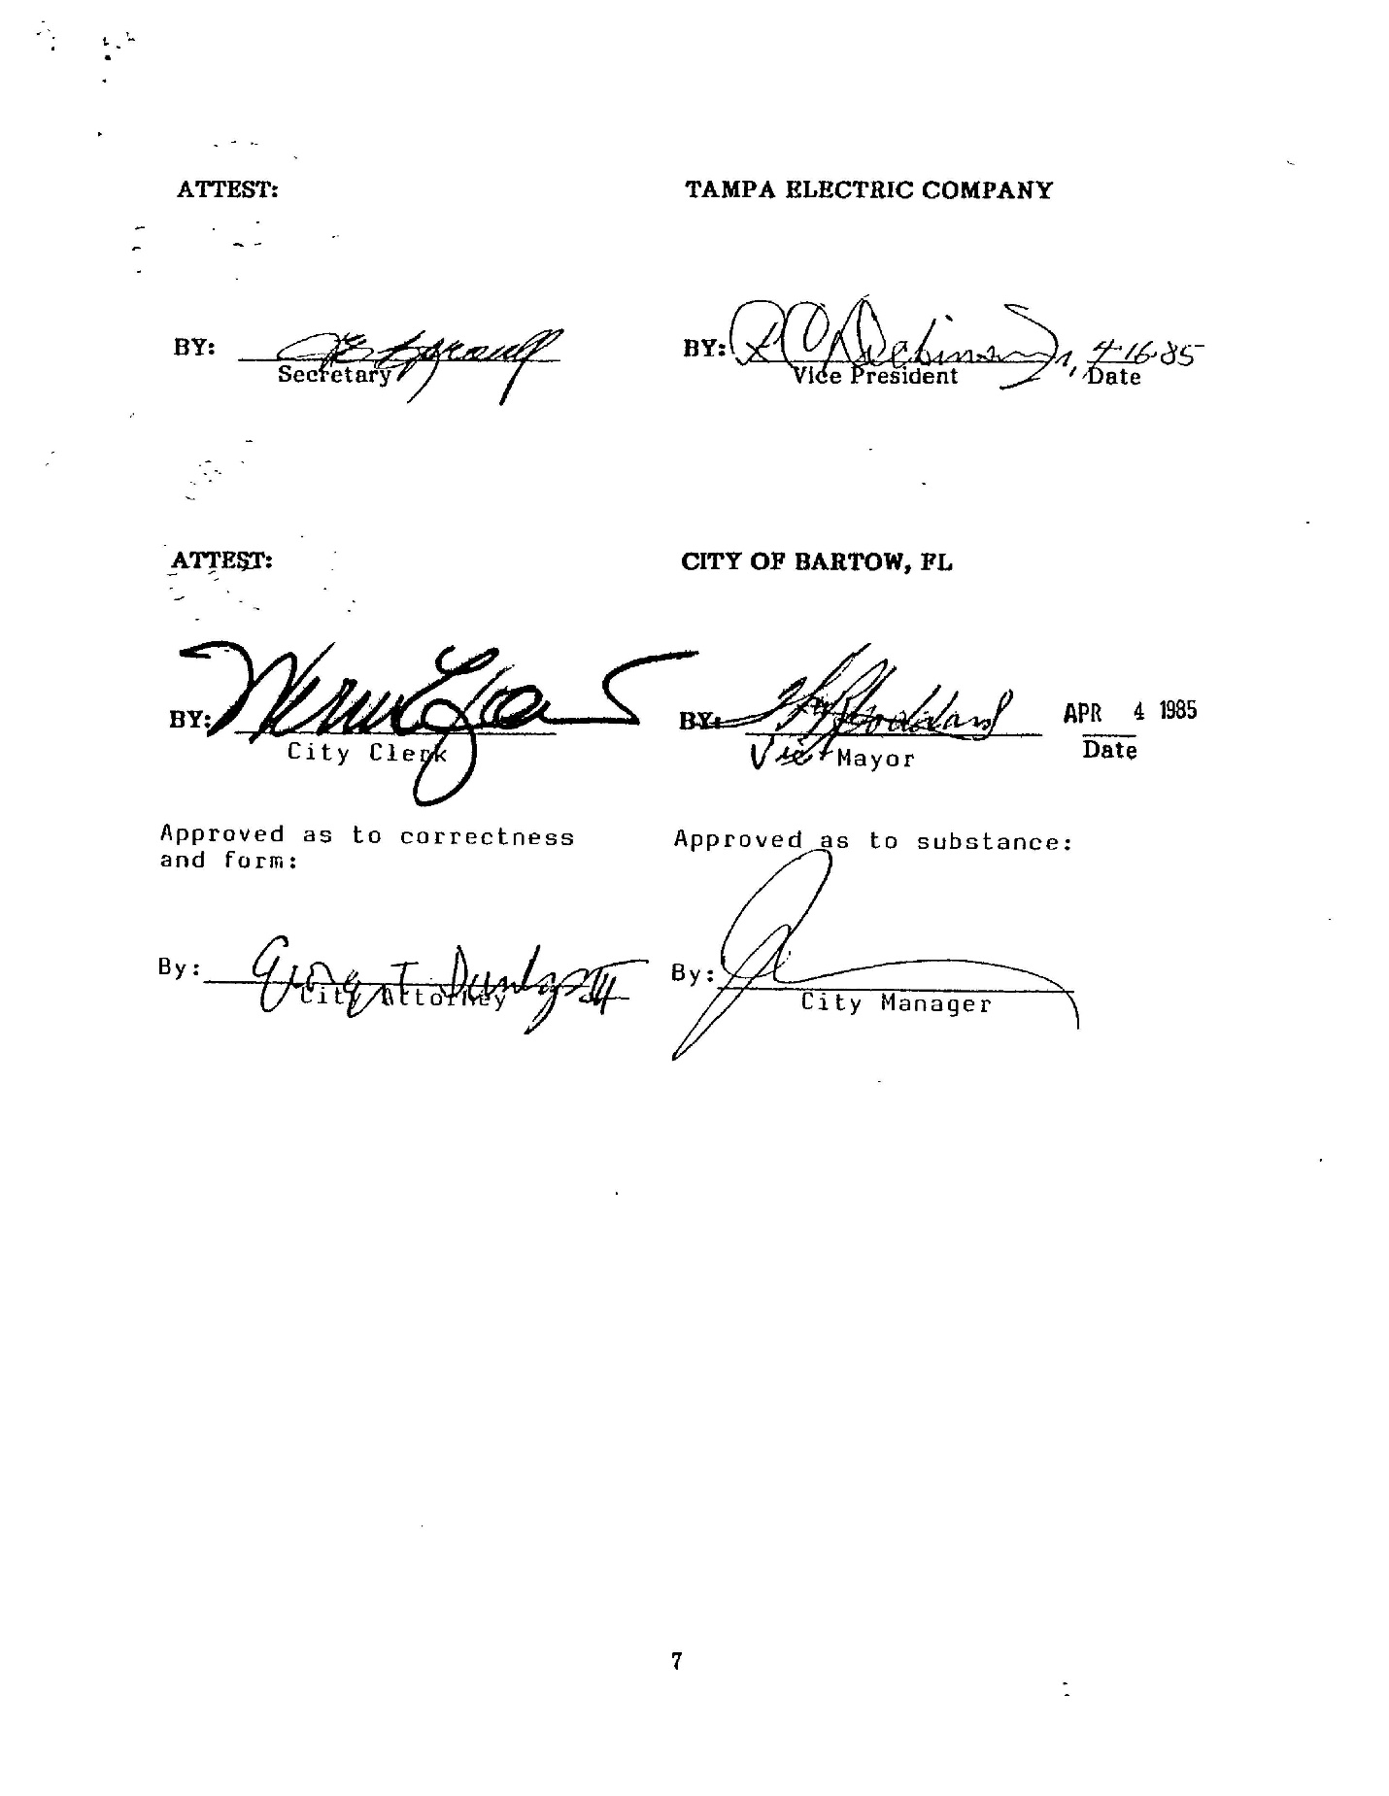

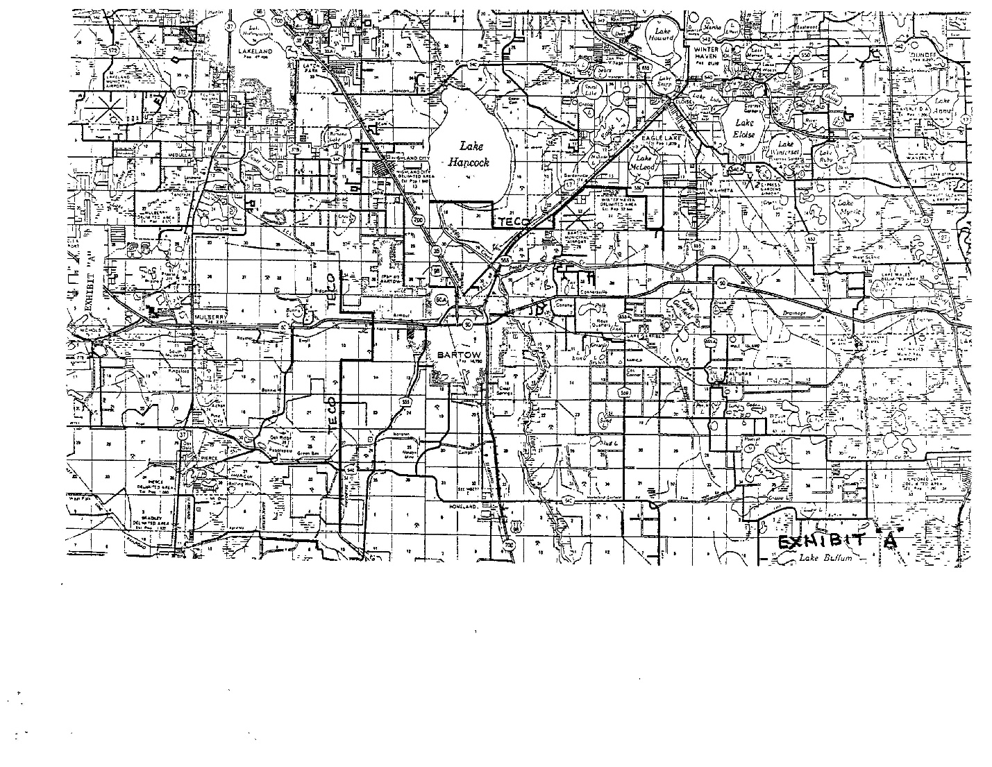

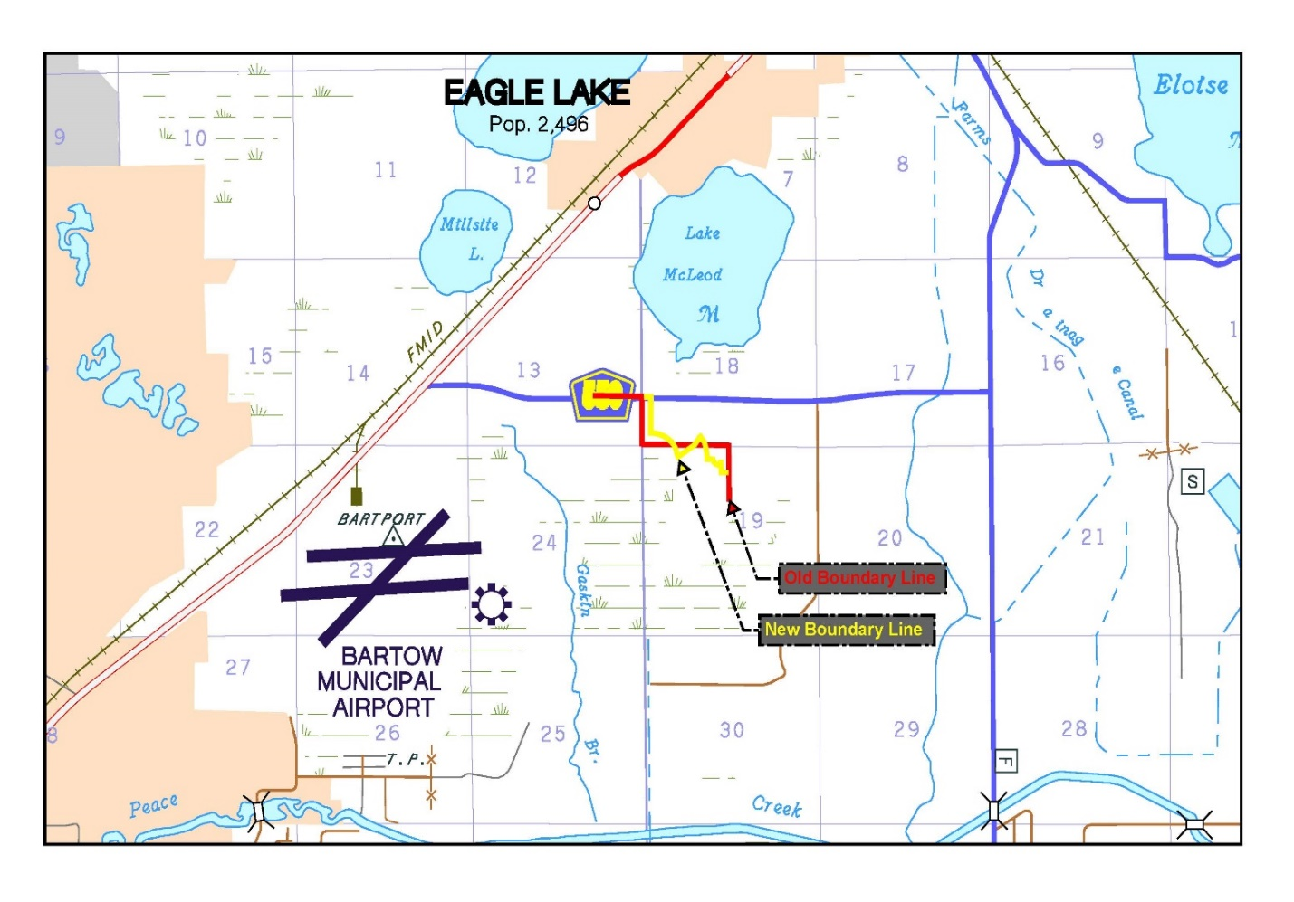

1. Order No. 15437, issued December 11, 1985, in Docket No. 19850148-EU, *In re: Joint petition for approval of territorial agreement between City of Bartow and Tampa Electric Company.* 
2. *Utilities Commission of the City of New Smyrna Beach v. Florida Public Service Commission*, 469 So. 2d 731 (Fla. 1985).