BEFORE THE FLORIDA PUBLIC SERVICE COMMISSION

In re: Petition for approval of modifications to rate schedule tariff sheet Nos. 2.0, 2.7, 6.383, and 7.500, by Duke Energy Florida, LLC. | DOCKET NO. 20230036-EI  ORDER NO. PSC-2023-0193-TRF-EI  ISSUED: July 5, 2023

The following Commissioners participated in the disposition of this matter:

ANDREW GILES FAY, Chairman
ART GRAHAM
GARY F. CLARK
MIKE LA ROSA
GABRIELLA PASSIDOMO

ORDER MODIFYING TARIFF

BY THE COMMISSION:

Background
On March 22, 2023, Duke Energy Florida, LLC (Duke or utility) filed a petition for approval of modifications to Tariff Sheet Nos. 2.0, 2.7, 6.383, and 7.500. Tariff Sheet No. 2.0 is an index that describes the sheets contained within section II of the tariff. Tariff Sheet No. 2.7 sets out the process and charges required under the optional Load Profiler Online Service (LPO) available to commercial customers requesting detailed consumption data. The utility is seeking to eliminate the monthly and weekly report options available under this program while lowering the cost of the daily option. Tariff Sheet No. 6.383 lists the economic development bill reduction factors and terms of service under the Economic Development Rider. Duke is seeking to add additional criteria for determining the benefit of new or expanded load under this program. Tariff Sheet No. 7.500 is the standard service agreement for customers who participate in the Economic Development Rider. The utility is seeking to make non-substantive changes to this standard service agreement, including adding a line to display the customer’s percent discount offered under the Economic Development Rider.
We originally approved the optional LPO service in Order No. PSC-04-0405-TRF-EI for Duke (formerly Progress Energy Florida, Inc.). The Economic Development Rider was approved in Duke’s most recent rate case. In response to staff’s first data request, Duke stated that there is currently one customer taking service under the Economic Development Rider, with one other expected to take service in the second quarter of 2024.
In Order No. PSC-2023-0158-PCO-EI, we suspended Duke’s proposed modifications to Tariff Sheet Nos. 2.0, 2.7, 6.383, and 7.500 to allow Commission staff time to gather additional data. On April 10, 2023, staff issued its first data request, to which Duke responded on April 24, 2023. Staff issued a second data request on May 9, 2023, to which Duke responded on May 16, 2023. The proposed tariffs are included in this Order as Attachment A. We have jurisdiction over this matter pursuant to Sections 366.03, 366.04, 366.05, and 366.06, Florida Statutes (F.S.).

Discussion

Load Profiler Online Service
The LPO service is an optional service available to certain commercial customers who wish to review reports of their historic consumption data. In response to our staff’s second data request, Duke explained that the LPO service offers more functionality than the Advanced Metering Infrastructure (AMI) program that encompasses smart meters. Examples of the additional information available under the LPO service include various graphs and charts, historical comparisons, as well as more data export formats. Currently, data is available to customers under the LPO tariff on a monthly, weekly, or daily basis.
In its petition, Duke explained that its deployment of the AMI program has made data for daily reports available at a lower cost. Duke is proposing to eliminate the monthly and weekly options while reducing the monthly cost of the daily option from $45 to $20 to reflect Duke’s lower costs to administer an LPO account. In response to staff’s first data request, Duke stated that out of the 772 accounts currently on LPO, there are 714 accounts registered for the daily option. The remaining accounts currently pay $25 per month to receive monthly or weekly reports. Additionally, Duke is proposing to change the name of the LPO service to Energy Profiler Online Service. The utility stated in its petition that the proposed name better reflects the nature of the service.
We find that the proposed changes to the LPO service are reasonable. Lowering the cost of the daily option will lower costs for all customers using the service. We have reviewed the cost support provided by Duke and find that this change will more accurately reflect the cost of the program to the utility.

Economic Development Rider

Duke’s Economic Development Rider (ED-2) is an optional program that provides qualifying customers with an economic development bill reduction factor for new load. New load as defined by the tariff is load being established after the date of the original issue of the tariff sheet (January 1, 2022) by a new business or the expansion of an existing business. The percentage discount offered under the tariff is currently determined by five criteria. Duke is proposing to add two additional criteria to the tariff: geographic location benefits and economic multiplier.
In its petition, Duke stated that it has identified the additional criteria after gaining experience through implementing the ED-2 program. In response to staff’s first data request, Duke explained that geographic location benefits refers to customers locating in areas perceived to be less desirable or in areas of distress. Examples of these areas include opportunity zones, brownfields, and rural areas of opportunity. Duke also explained that economic multiplier refers to research that allows the utility to identify the impact that specific industry types could have on a community. The utility stated that it uses the input/output economic multiplier model from the labor market software Lightcast to quantify this. In response to staff’s second data request, Duke stated that each aforementioned geographic category is determined by a source independent of Duke.
Duke is proposing two additional changes to the ED-2 tariff. First, the utility is proposing to revise the language of the tariff to allow Duke to adjust the discount rather than just discontinue it, if at any time the customer violates the terms and conditions of the ED-2 tariff. Second, Duke is proposing to extend the effective date of service under the ED-2 tariff from 18 months to two years to allow for additional time, if needed, to accommodate for potential delays in the customer’s construction or expansion project.
The utility is also proposing changes to the Economic Development Rider standard service agreement. In its petition Duke stated that these changes are intended to add additional information for clarity and ease of reference. The proposed changes include adding a line that displays the customer’s monthly percentage discount.
We find that the proposed changes to the ED-2 tariff are reasonable. The two proposed criteria will give the utility additional ways to offer the discount to customers, which could incentivize economic development. The additional changes to the language of the ED-2 tariff are appropriate and benefit both the utility and the customer. The proposed changes to the Economic Development Rider standard service agreement are reasonable and will provide clarity to customers.

Conclusion

Having reviewed the petition and staff data request responses, we find that the proposed tariff changes are reasonable and appropriate. Therefore, we approve Duke’s proposed Tariff Sheet Nos. 2.0, 2.7, 6.383, and 7.500 effective on the date of our vote.

Based on the foregoing, it is

ORDERED by the Florida Public Service Commission that Duke Energy Florida’s proposed changes to Tariff Sheet Nos. 2.0, 2.7, 6.383, and 7.500 are approved, effective the day of Commission vote. It is further

ORDERED that if a protest is filed within 21 days of issuance of the Order, the tariff shall remain in effect with any charges held subject to refund pending resolution of the protest. It is further

ORDERED that if no timely protest is filed, this docket shall be closed upon the issuance of a Consummating Order.

By ORDER of the Florida Public Service Commission this 5th day of July, 2023.

/s/ Adam J. Teitzman
ADAM J. TEITZMAN
Commission Clerk
Florida Public Service Commission
2540 Shumard Oak Boulevard
Tallahassee, Florida 32399
(850) 413-6770
www.floridapsc.com

Copies furnished: A copy of this document is provided to the parties of record at the time of issuance and, if applicable, interested persons.

MRT

NOTICE OF FURTHER PROCEEDINGS

The Florida Public Service Commission is required by Section 120.569(1), Florida Statutes, to notify parties of any administrative hearing or judicial review of Commission orders that is available under Sections 120.57 or 120.68, Florida Statutes, as well as the procedures and time limits that apply. This notice should not be construed to mean all requests for an administrative hearing or judicial review will be granted or result in the relief sought.

Mediation may be available on a case-by-case basis. If mediation is conducted, it does not affect a substantially interested person's right to a hearing.

The Commission's decision on this tariff is interim in nature and will become final, unless a person whose substantial interests are affected by the proposed action files a petition for a formal proceeding, in the form provided by Rule 28-106.201, Florida Administrative Code. This petition must be received by the Office of Commission Clerk, 2540 Shumard Oak Boulevard, Tallahassee, Florida 32399-0850, by the close of business on July 26, 2023.

In the absence of such a petition, this Order shall become final and effective upon the issuance of a Consummating Order.

Any objection or protest filed in this docket before the issuance date of this order is considered abandoned unless it satisfies the foregoing conditions and is renewed within the specified protest period.

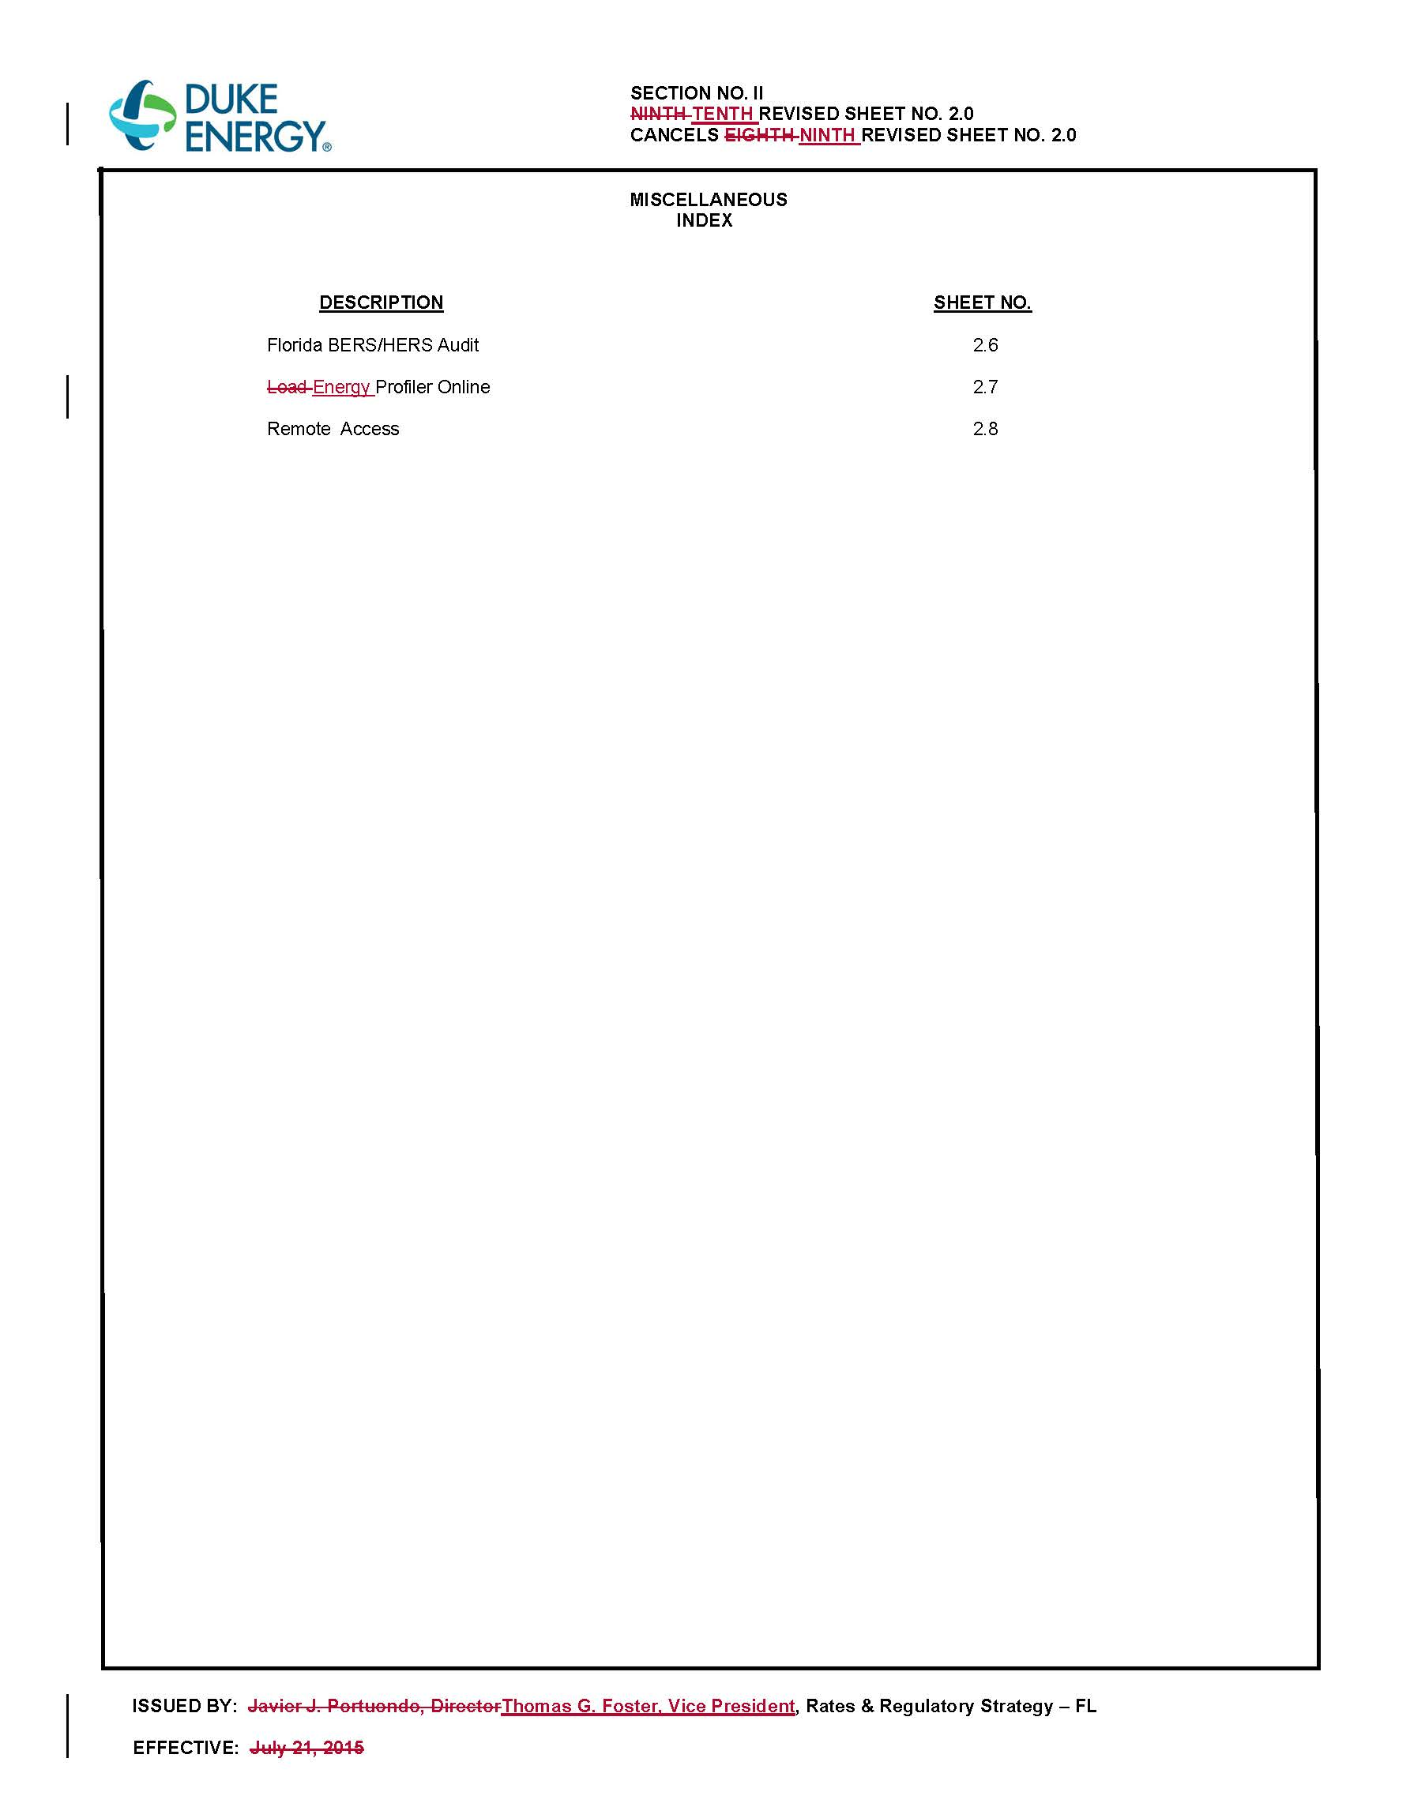
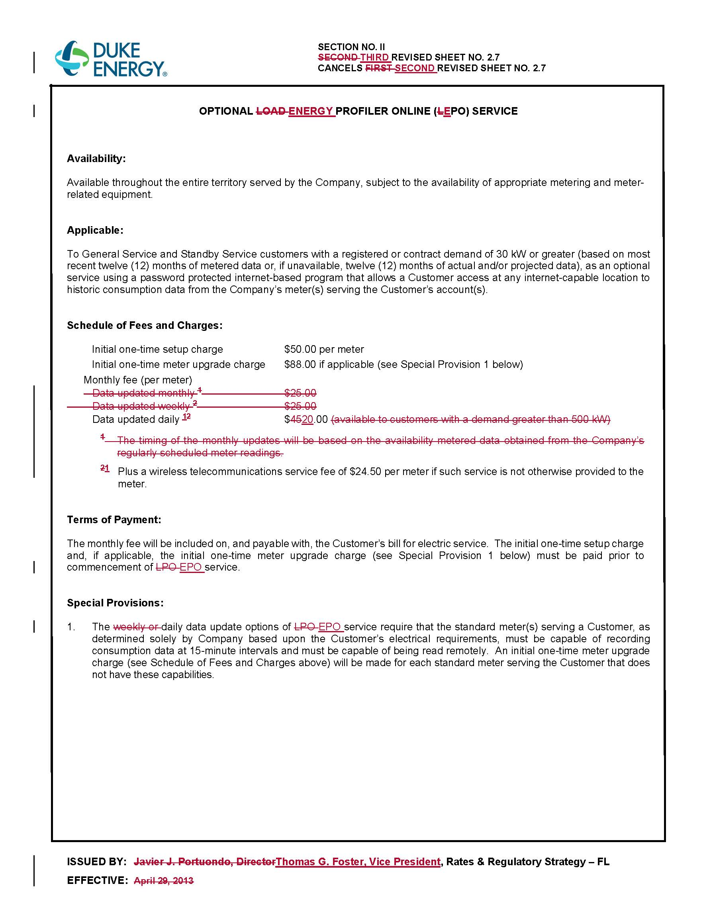
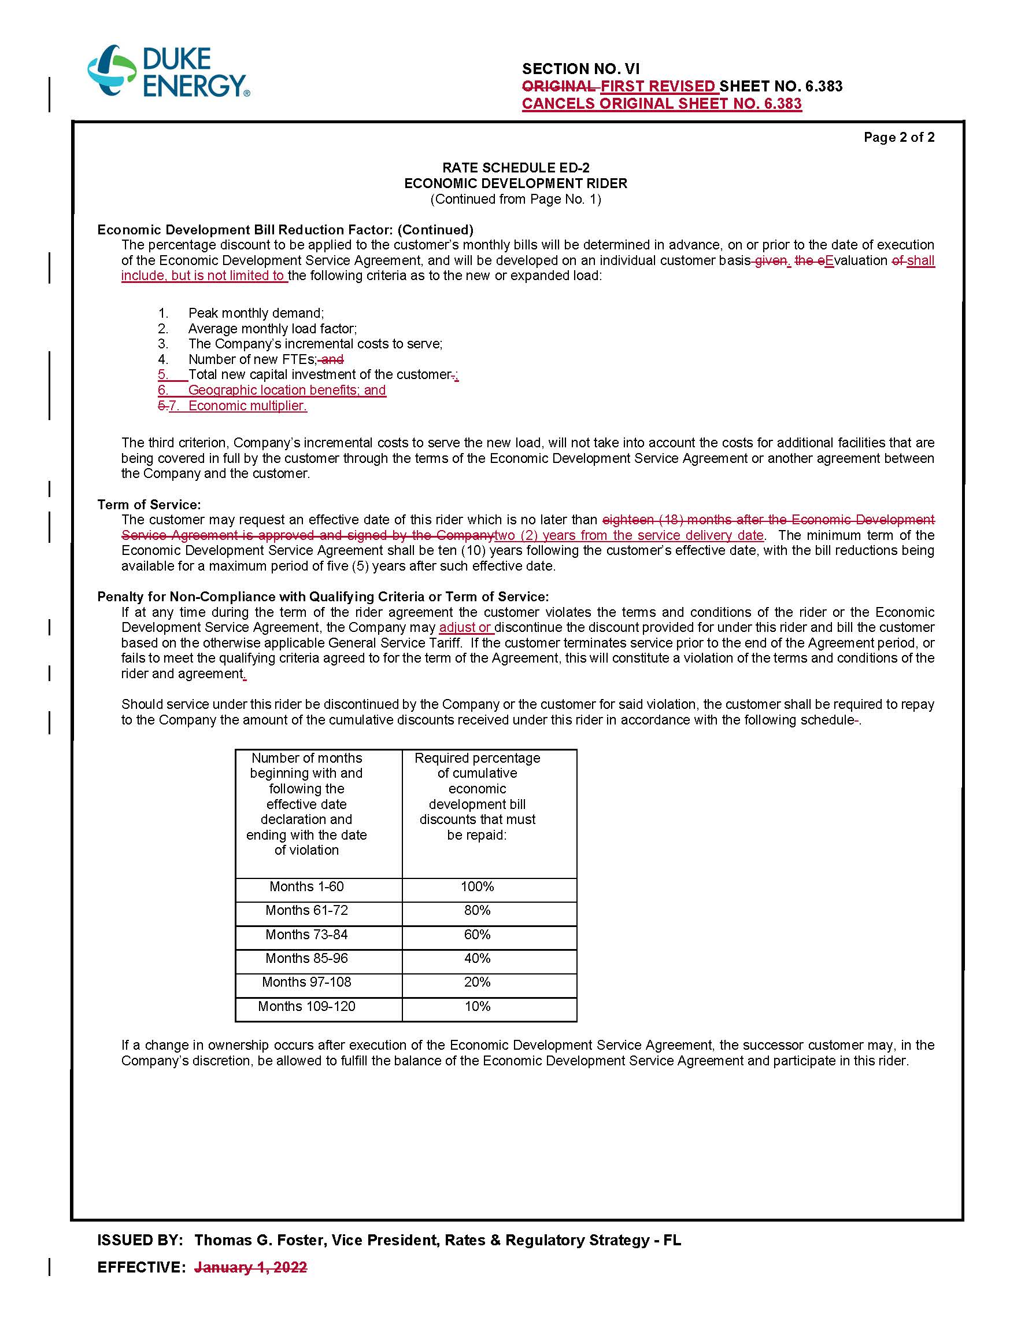
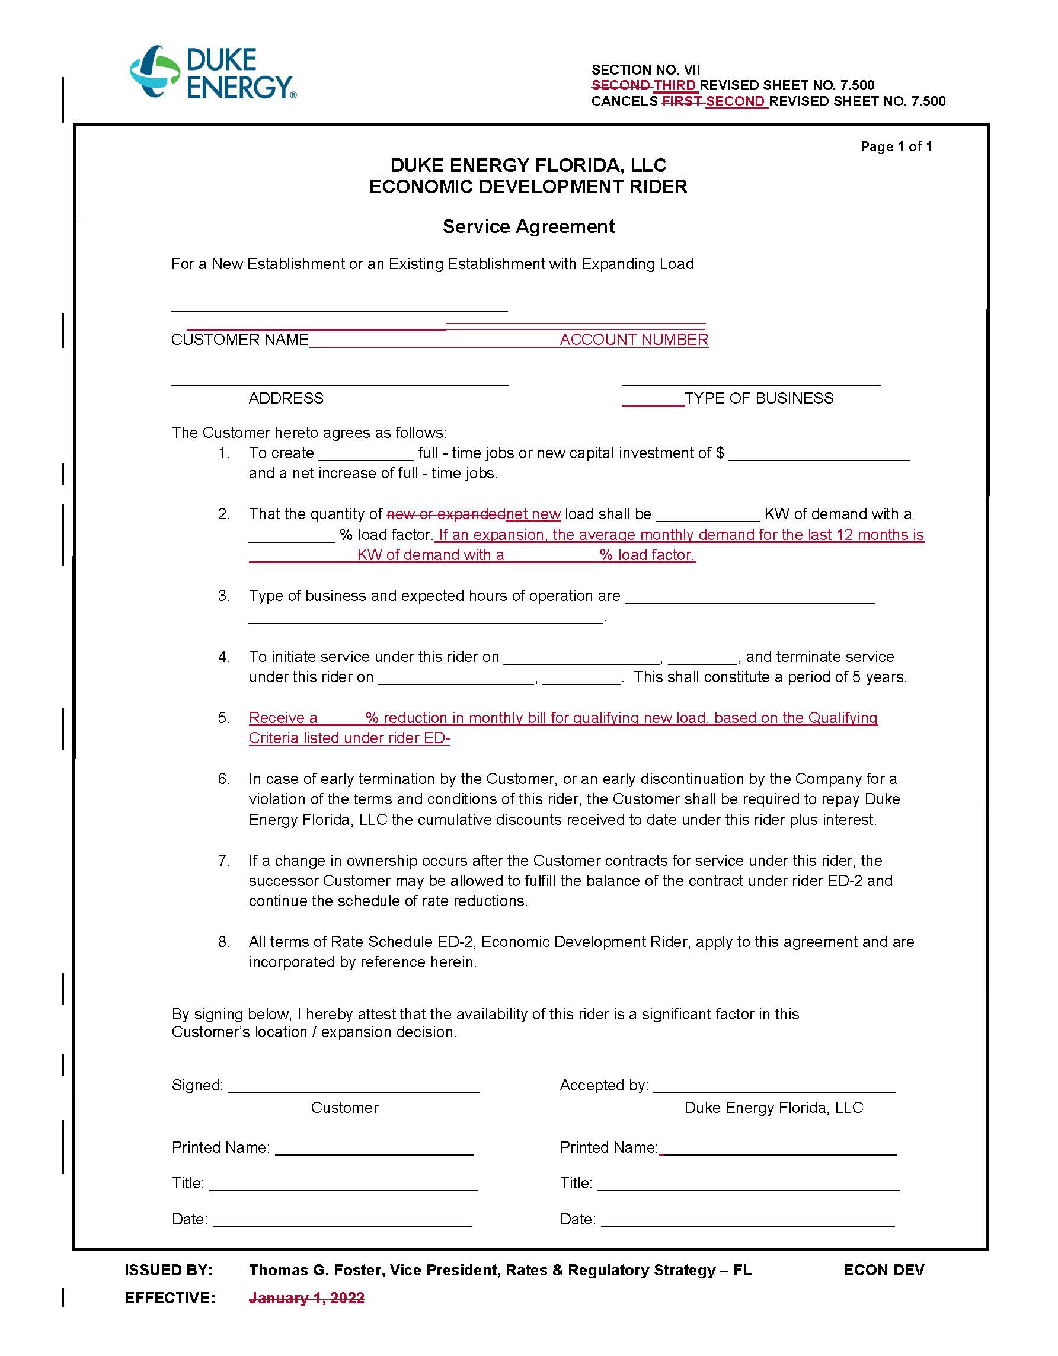

Order No. PSC-04-0405-TRF-EI, issued April 19, 2004, in Docket No. 20031100-EI, In re: Petition for approval of tariffs offering energy profiler online service and remote access service by Progress Energy Florida, Inc.
Order No. PSC-2021-0202A-AS-EI, issued June 28, 2021, in Docket No. 20210016-EI, In re: Petition for limited proceeding to approve 2021 settlement agreement, including general base rate increases, by Duke Energy Florida, LLC.
Order No. PSC-2023-0158-PCO-EI, issued May 15, 2023, in Docket No. 20230036-EI, In re: Petition for approval of modifications to rate schedule tariff sheet Nos. 2.0, 2.7, 6.383, and 7.500, by Duke Energy Florida, LLC.

