|  |  |  |  |
| --- | --- | --- | --- |
| State of Florida  pscSEAL | | Public Service Commission  Capital Circle Office Center ● 2540 Shumard Oak Boulevard Tallahassee, Florida 32399-0850  -M-E-M-O-R-A-N-D-U-M- | |
| DATE: | July 20, 2023 | | |
| TO: | Office of Commission Clerk (Teitzman) | | |
| FROM: | Division of Economics (Draper, Hudson)  Office of the General Counsel (Sandy) | | |
| RE: | Docket No. 20230050-GU – Petition for approval of Amendment No. 1 to Escambia County firm gas transportation service agreement with Florida Public Utilities Company to reflect construction of additional delivery point, by Peninsula Pipeline Company, Inc. | | |
| AGENDA: | 08/01/23 – Regular Agenda – Proposed Agency Action - Interested Persons May Participate | | |
| COMMISSIONERS ASSIGNED: | | | All Commissioners |
| PREHEARING OFFICER: | | | Clark |
| CRITICAL DATES: | | | None |
| SPECIAL INSTRUCTIONS: | | | None |

Case Background

On April 12, 2023, Peninsula Pipeline Company, Inc. (Peninsula) filed a petition seeking approval of amendment No. 1 to Escambia County firm transportation service agreement (amendment) between Peninsula and Florida Public Utilities Company (FPUC) (collectively, the parties).

The purpose of the amendment is to revise certain provisions of the firm transportation service agreement, dated January 1, 2018, to reflect the construction of an additional point of delivery on the original project and to revise the monthly reservation charge to include the new point of delivery. Peninsula operates as an intrastate natural gas transmission company as defined by Section 368.103(4), Florida Statutes (F.S).[1] FPUC is a local distribution company (LDC) subject to the regulatory jurisdiction of the Commission pursuant to Chapter 366, F.S.

The firm transportation agreement was approved by the Commission in 2018 and provided for Peninsula to construct an interconnection between Peninsula and Florida Gas Transmission’s (FGT) interstate pipeline at the northernmost edge of Escambia County.[2] From the interconnection with FGT, the pipeline constructed by Peninsula extends approximately 33 miles south and delivers natural gas to FPUC’s distribution system. The pipeline was constructed to provide transportation service to an industrial customer, Pensacola Energy, and provide FPUC opportunities to serve additional customers. Pensacola Energy is a municipal natural gas utility and provides natural gas service to the City of Pensacola and certain other areas in Escambia County.

The 2018 firm transportation service agreement was executed between Peninsula and the Florida Division of Chesapeake Utilities Corporation. In the recent rate case Docket No. 20220067-GU, the Commission approved the consolidation of four natural gas utilities, including the Florida Division of Chesapeake Utilities Corporation, into one utility operating under the name FPUC.[3] As a result of the consolidation, FPUC assumed the 2018 firm transportation service agreement. Due to the timing of the consolidation approved in the rate case, the proposed amendment included in the petition was not dated and signed. On July 17, 2023, the parties filed a fully executed amendment that was dated and signed.[4]

The proposed amendment, as filed on July 17, 2023, and project map are shown as Attachments A and B to this recommendation. During the evaluation of the petition, staff issued a data request to the parties for which responses were received on May 11, 2023. The Commission has jurisdiction over this matter pursuant to Sections 366.05(1), 366.06, and 368.105, F.S

Discussion of Issues

Issue 1:

 Should the Commission approve the proposed amendment No. 1 to firm transportation agreement dated January 8, 2018, between FPUC and Peninsula?

Recommendation:

 Yes, the Commission should approve the proposed amendment No. 1 to firm transportation agreement dated January 8, 2018, between FPUC and Peninsula. The proposed amendment is reasonable and meets the requirements of Section 368.105, F.S. (Draper, Hudson)

Staff Analysis:

  The parties explained that Pensacola Energy has requested an additional point of delivery to enhance their gas service in the area. Specifically, the proposed project will begin by installing a tap to the existing Peninsula pipeline near the intersection of US 29 and Champion Drive. From this tap, Peninsula will install 510 feet of two-inch pipeline to the new point of delivery. Peninsula states that construction will commence in July 2023 and be completed by September 2023.

The 2018 transportation agreement contains a negotiated monthly reservation charge that reflects Peninsula’s cost to construct and maintain the pipeline constructed in 2018 in Escambia county. The proposed amendment includes the reservation charge approved in the 2018 transportation agreement and an additional amount related to Peninsula’s costs to construct the facilities necessary in response to Pensacola Energy’s request for the additional point of delivery.

The parties stated that the amount associated with the increase in the reservation charge will be solely paid by Pensacola Energy and will not impact FPUC’s general body of ratepayers. Staff believes that is appropriate as Pensacola Energy requested the additional point of delivery. The parties confirmed that Pensacola Energy has been informed of the construction costs and its responsibility to pay FPUC for the additional point of delivery. Finally, the parties assert that the negotiated rates in the amendment meet the requirements of Section 368.105(3), F.S., and are consistent with a market rate in that they are within the range of the rates set forth in similar agreements.

Staff recommends that the Commission should approve the proposed amendment No. 1 to firm transportation agreement dated January 8, 2018, between FPUC and Peninsula. The proposed amendment is reasonable and meets the requirements of Section 368.105, F.S.

Issue 2:

 Should this docket be closed?

Recommendation:

 Yes. If no protest if filed by a person whose substantial interests are affected within 21 days of the issuance of the Order, this docket should be closed upon the issuance of a Consummating Order. (Sandy)

Staff Analysis:

 If no protest if filed by a person whose substantial interests are affected within 21 days of the issuance of the Order, this docket should be closed upon the issuance of a Consummating Order.

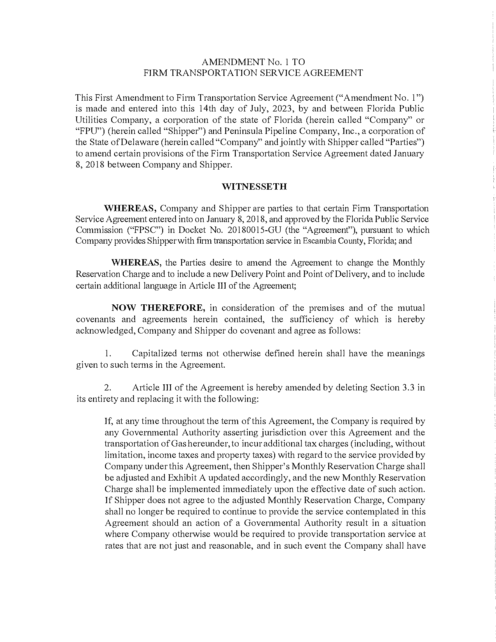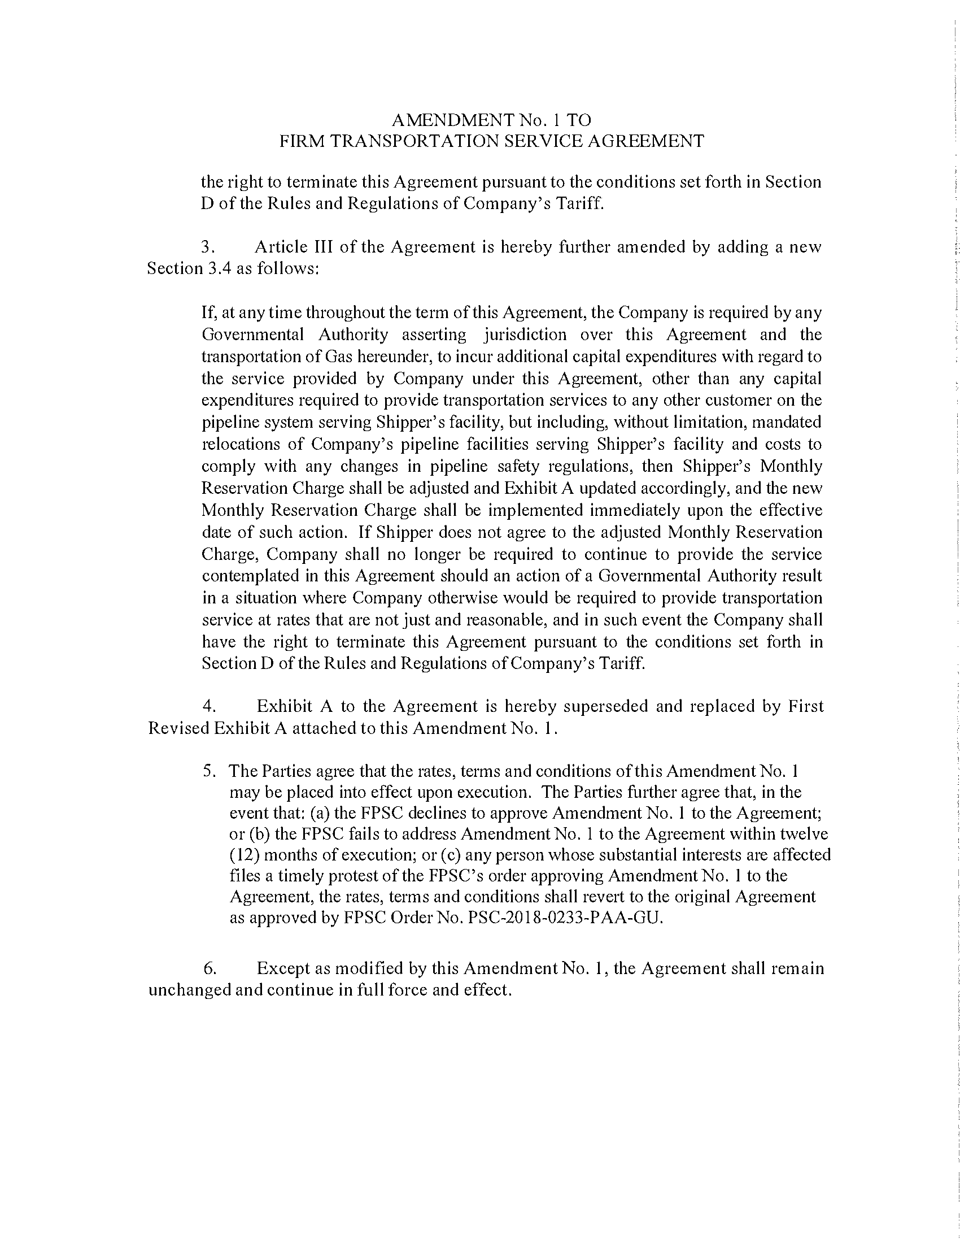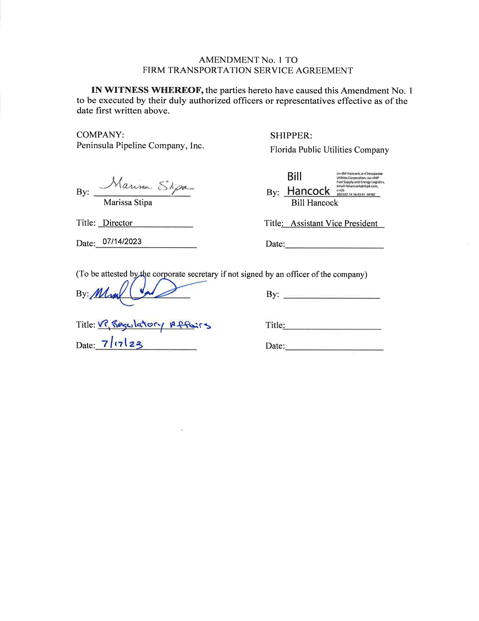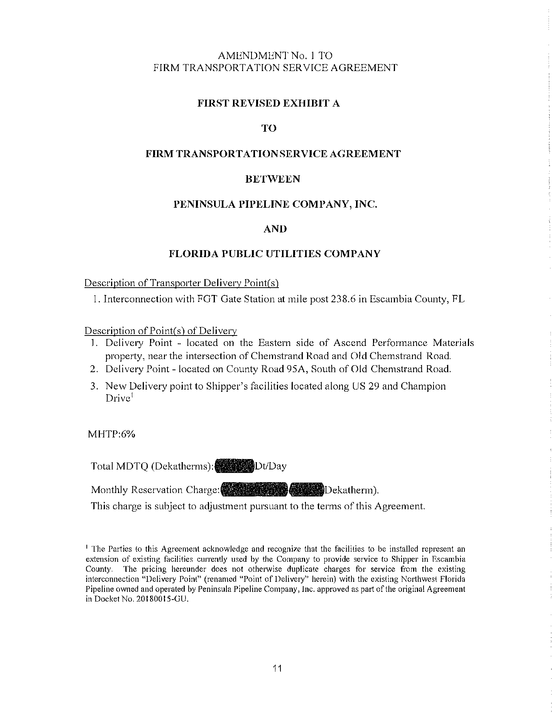

Project Map

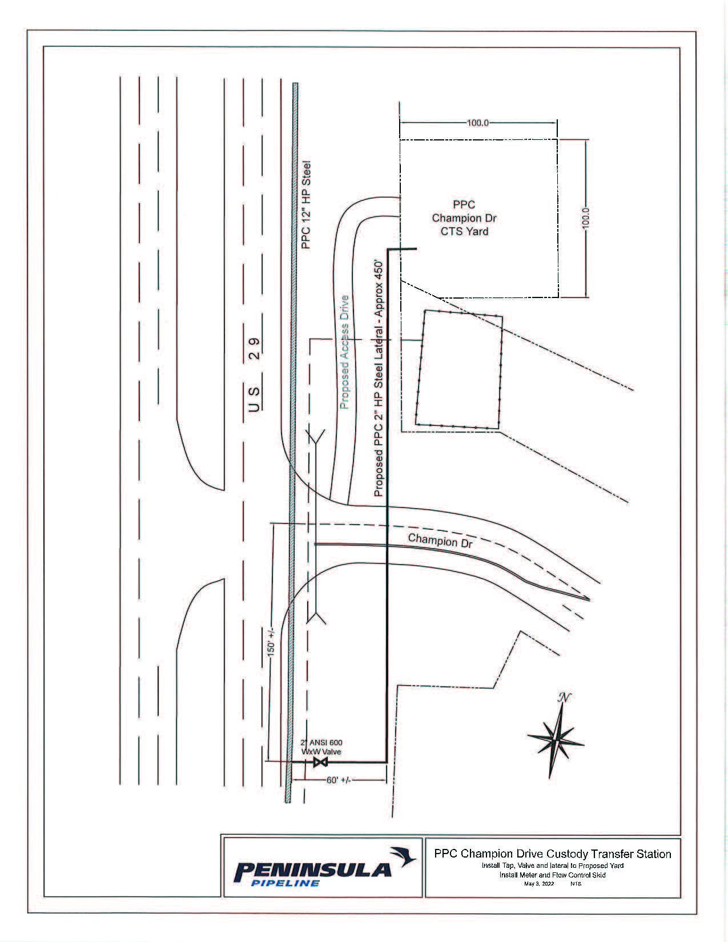

1. Order No. PSC-06-0023-DS-GP, issued January 9, 2006, in Docket No. 050584-GP, *In re: Petition for declaratory*

   *statement by Peninsula Pipeline Company, Inc. concerning recognition as a natural gas transmission company*

   *under Section 368.101, F.S., et seq.*
2. Order No. PSC-2018-0233-PAA-GU, issued May 8, 2018, in Docket No. 20180015-GU, *In re: Petition for approval of transportation service agreement with Florida Division of Chesapeake Utilities Corporation, by Peninsula Pipeline Company, Inc.*
3. Order No. PSC-2023-0103-FOF-GU, issued March 15, 2023, in Docket No. 20220067-GU, *In re: Petition for rate increase by Florida Public Utilities Company, Florida Division of Chesapeake Utilities Corporation, Florida Public Utilities Company - Fort Meade, and Florida Public Utilities Company - Indiantown Division.*
4. Document No. 04101-2023.