|  |  |  |  |
| --- | --- | --- | --- |
| State of Florida  pscSEAL | | Public Service Commission  Capital Circle Office Center ● 2540 Shumard Oak Boulevard Tallahassee, Florida 32399-0850  -M-E-M-O-R-A-N-D-U-M- | |
| DATE: | July 20, 2023 | | |
| TO: | Office of Commission Clerk (Teitzman) | | |
| FROM: | Division of Economics (Ward, Hampson)  Division of Engineering (Knoblauch)  Office of the General Counsel (Thompson) | | |
| RE: | Docket No. 20230045-EI – Petition for approval of revisions to underground residential tariff, underground commercial differential tariff, and overhead to underground conversion tariff, by Florida Power & Light Company. | | |
| AGENDA: | 08/01/23 – Regular Agenda – Tariff Filing – Interested Persons May Participate | | |
| COMMISSIONERS ASSIGNED: | | | All Commissioners |
| PREHEARING OFFICER: | | | Administrative |
| CRITICAL DATES: | | | 11/30/23 (8-Month Effective Date) |
| SPECIAL INSTRUCTIONS: | | | None |

Case Background

On March 31, 2023, Florida Power & Light Company (FPL or utility) filed a petition for approval of revisions to its underground residential differential (URD) and underground commercial differential (UCD) tariffs. The URD and UCD tariffs apply to new residential and commercial developments and represent the additional costs, if any, FPL incurs to provide underground distribution service in place of overhead service. FPL is also requesting approval of revisions to its overhead to underground conversion tariff and associated underground facilities conversion agreement.

Based on current costs, including the net present value of long term operational costs, FPL does not incur any additional costs to provide residential underground service; therefore, the proposed URD differentials are $0. The proposed (legislative version) URD and UCD tariffs are contained in Attachment A to the recommendation. The proposed revisions to FPL’s overhead to underground conversion tariff and associated underground facilities conversion agreement are also contained in Attachment A to the recommendation. FPL’s current URD and UCD tariffs were approved by Order No. PSC-2019-0360-TRF-EI (2019 Order).[1]

FPL was granted a temporary waiver to defer its next revised URD tariff filing until April 1, 2023, by Order Nos. PSC-2022-0062-PAA-EI and PSC-2022-0191-FOF-EI.[2] The Commission granted the temporary waiver to allow FPL to defer its URD filing from April 2022 to April 2023 to use combined FPL and Gulf Power Company (Gulf) operational cost data resulting from the merger between FPL and Gulf.

The Commission suspended FPL’s proposed tariffs in Order No. PSC-2023-0159-PCO-EI.[3] FPL responded to staff’s first data request on May 25, 2023. The Commission has jurisdiction over this matter pursuant to Sections 366.03, 366.04, 366.05, and 366.06, Florida Statutes (F.S.).

Discussion of Issues

Issue 1:

 Should the Commission approve FPL's proposed URD tariffs and associated charges?

Recommendation:

 Yes. The Commission should approve FPL’s proposed URD tariffs and associated charges as shown in Attachment A, effective 30 days after the Commission vote. (Ward)

Staff Analysis:

 The URD tariffs provide standard charges for underground service in new residential subdivisions and represent the additional costs, if any, the utility incurs to provide underground service in place of overhead service. The cost of standard overhead construction is recovered through base rates from all ratepayers. In lieu of overhead construction, customers have the option of requesting underground facilities. Typically, the developer of a new residential subdivision would be the utility customer utilizing the URD tariffs. FPL’s proposed URD tariffs are provided on pages 1 through 7 of Attachment A.

Traditionally, three standard model subdivision designs have been the basis upon which each investor-owned utility submits URD tariff changes for Commission approval: low density, high density, and a high density subdivision where dwelling units take service at ganged meter pedestals (groups of meters at the same physical location). Examples of this last subdivision type include mobile home and recreational vehicle parks. While actual construction may differ from the model subdivisions, the model subdivisions are designed to reflect average overhead and underground subdivisions.

In its petition, the utility updated its cost calculations and supporting documentation for the three subdivision models cost differentials. The currently approved cost differentials are $0.00 for all three subdivision models. As shown on Table 1-1, FPL's proposed URD differential charges remain zero for all three subdivision models. A zero URD differential charge is typically the result of the avoided storm restoration costs associated with underground facilities, offsetting any higher labor and material costs associated with underground construction.

Table 1-1

Comparison of Differential per Service Lateral

|  |  |  |
| --- | --- | --- |
| **Types of Subdivision** | **Current URD Differential** | **Proposed URD Differential** |
| Low Density | $0 | $0 |
| High Density | $0 | $0 |
| Meter Pedestal | $0 | $0 |

Source: 2019 Order and FPL’s 2023 filing.

Two primary factors impacted the calculation of FPL’s proposed URD charges which are discussed in greater detail below: (1) updated labor and material costs and (2) updated operational costs.

Updated Labor and Material Costs

The installation costs of both underground and overhead facilities include the labor and material costs to provide primary, secondary, and service distribution lines as well as transformers. The costs of poles are specific to overhead service while the costs of trenching and backfilling are specific to underground service. Table 1-2 compares the currently approved 2019 costs and 2023 costs for underground and overhead labor and material for the three subdivision models.

Table 1-2

Labor and Material Costs

|  |  |  |  |
| --- | --- | --- | --- |
| **Low Density** | **2019 Costs** | **2023 Costs** | **Difference** |
| Underground Labor/Material Costs | $2,558.39 | $3,452.54 | $894.15 |
| Overhead Labor/Material Costs | $2,347.86 | $2,543.92 | $196.06 |
| Per Service Lateral Differential | $210.53 | $908.62 | $698.09 |
| **High Density** | | | |
| Underground Labor/Material Costs | $1,767.54 | $2,317.97 | $550.43 |
| Overhead Labor/Material Costs | $1,773.71 | $1,921.50 | $147.79 |
| Per Service Lateral Differential | ($6.17) | $396.47 | $402.64 |
| **Meter Pedestal** | | | |
| Underground Labor/Material Costs | $1,125.49 | $1,485.47 | $359.98 |
| Overhead Labor/Material Costs | $1,397.83 | $1,533.74 | $135.91 |
| Per Service Lateral Differential | ($272.34) | ($48.27) | $224.07 |

Source: 2019 Order and FPL’s 2023 filing.

While both overhead and underground labor and material costs increased, underground costs increased at a higher rate, resulting in an increase in the differential. In response to staff’s data request the utility explained that the higher overhead and underground construction costs are primarily driven by increased material costs.

Updated Operational Costs

Rule 25-6.078(4), F.A.C., provides that the differences in net present value of operational costs between overhead and underground systems, including average historical storm restoration costs over the life of the facilities, be included in the URD charge. Operational costs include operations and maintenance costs and capital costs. The inclusion of the operational costs is intended to capture longer term costs and benefits of undergrounding. In response to staff’s data request, FPL stated that the current URD petition incorporates costs from hurricane events Ian and Nicole. FPL's methodology to calculate the operational costs was approved in Order No. PSC-08-0774-TRF-EI and remains the same in the instant docket.[4]

Table 1-3 presents the pre-operational (shown in Table 1-2), non-storm operational, and the avoided storm restoration cost differentials between overhead and underground systems. The proposed differential is $0 when the calculation results in a negative number.

Table 1-3

Components of the URD Charges

|  |  |  |  |  |
| --- | --- | --- | --- | --- |
| **Type of Subdivision** | **Pre-Operational Costs (A)** | **Non-Storm Operational Costs (B)** | **Avoided Storm Costs (C)** | **Proposed URD Differentials (A)+(B)+(C)** |
| Low Density | $908.62 | ($2,208) | ($1,387) | $0 |
| High Density | $396.47 | ($1,878) | ($1,388) | $0 |
| Meter Pedestal | $0.00 | ($1,878) | ($1,388) | $0 |

Source: FPL’s 2023 filing.

Conclusion

Staff has reviewed FPL’s proposed changes to its URD tariffs and associated charges, the accompanying work papers, and responses to staff’s data request. Staff believes FPL’s proposed URD tariffs and associated charges as filed in the petition are cost-based and recommends approval of the tariffs shown in Attachment A. Staff recommends that the tariffs be made effective 30 days after the Commission vote.

Issue 2:

 Should the Commission approve FPL's UCD tariffs and associated charges?

Recommendation:

 Yes. The Commission should approve FPL’s proposed UCD tariffs and associated charges as shown in Attachment A, effective 30 days after the Commission vote. Staff reviewed FPL's supporting documentation for the UCD charges and believes the charges are cost based and reasonable. (Ward)

Staff Analysis:

 Utilities are not required to file UCD tariffs pursuant to Rule 25-6.078, F.A.C.; however, as in prior URD petitions, FPL included proposed UCD tariffs in its petition. The UCD tariffs apply to small commercial or industrial customers (applicant) that request the installation of underground electric distribution facilities for a new building. The requested underground distribution facilities consist of underground service conductors, placed in conduit, and associated equipment that is installed from overhead feeder mains (or overhead termination point) to the designed point of delivery (where the utility's wires are connected to those of the customer). FPL’s proposed UCD tariffs are provided on pages 8 through 10 of Attachment A.

The UCD charges represent the differential costs for underground commercial facilities and their equivalent overhead design. The calculations provided by FPL in its petition employ FPL's standard engineering design criteria and are based on actual 2022 labor and material costs. Unlike the URD calculations, the UCD calculations do not include long term operational and avoided storm restoration costs. In addition, the UCD tariffs provide credits that apply if the applicant provides trenching, backfilling, or installs FPL provided conduit or a concrete pad for a pad-mounted transformer.

Staff reviewed FPL's supporting documentation for the UCD charges and believes the charges are cost based and reasonable. Staff recommends that the UCD tariffs and associated charges be approved, effective 30 days after the Commission vote.

Issue :

 Should the Commission approve FPL's proposed revisions to Tariff Sheet Nos. 6.300 and 9.722?

Recommendation:

 Yes. The Commission should approve FPL’s proposed revisions to Tariff Sheet Nos. 6.300 and 9.722 as shown in Attachment A, effective 30 days from the Commission vote. Furthermore, staff recommends approval of FPL’s request to include the waived existing facilities cost for all non-hardened overhead distribution facilities in net plant in service. (Ward, Knoblauch)

Staff Analysis:

 Tariff Sheet No. 6.300 provides the terms under which applicants are to pay a contribution-in-aid-of-construction (CIAC) for the conversion of existing overhead distribution facilities to underground. The CIAC is intended to cover the incremental costs FPL incurs resulting from a conversion, over and above the cost of serving the conversion area with overhead facilities. Typically, municipalities request a conversion from overhead to underground facilities. The formula to calculate CIAC is defined in Rule 25-6.115(8), F.A.C., and in FPL’s Tariff Section 12.1 of Sheet No. 6.300. FPL’s proposed revisions to Tariff Sheet Nos. 6.300 and 9.722 are provided on pages 11 and 12 of Attachment A.

Paragraph (12) of Rule 25-6.115, F.A.C., allows a utility to waive all or any portion of the cost for providing underground facilities. If the utility waives any charge, the utility is required to reduce net plant in service unless this Commission determines that there is a quantifiable benefit to the general body of ratepayers commensurate with the waived charge.

In Order No. PSC-2018-0050-TRF-EI, the Commission approved FPL’s revised Tariff Sheet No. 6.300 to exclude the cost of the existing facilities from the CIAC calculation for underground conversions of existing non-hardened overhead feeder facilities and to include the waived existing facilities cost in net plant in service pursuant to Rule 25-6.115, F.A.C.[5]

In this filing, FPL seeks to revise Tariff Sheet No. 6.300 to clarify that the costs for all existing non-storm hardened distribution facilities costs, which include both feeders and laterals, from the calculation of CIAC. The current tariff, as approved in Order No. PSC-2018-0050-TRF-EI, only refers to feeders. FPL further requests that the Commission determine that there are quantifiable benefits to excluding the existing costs for all non-hardened overhead distribution facilities, i.e., both feeders and laterals.

FPL also proposes to modify existing language and include additional language to its Underground Facilities Conversion Agreement, on Tariff Sheet No. 9.722. The proposed tariff modifications state that all facilities within the project must be converted to underground. In its petition, FPL stated that the proposed revisions are not a substantive change, but rather intended to clarify the scope of the underground conversion project and avoid or reduce customer confusion.

**Storm Protection Plan and Cost Recovery**

In February 2020, Rules 25-6.030, F.A.C., Storm Protection Plan (SPP), and 25-6.031, F.A.C., Storm Protection Plan Cost Recovery Clause (SPP Clause), were codified to implement Section 366.96, F.S. The SPPs cover the immediate 10-year planning period and are filed with the Commission at least every three years. The plans must explain the systematic approach the utility will follow to achieve the objectives of reducing restoration costs and outage times associated with extreme weather events and enhancing reliability. The SPP Clause allows the utility to seek recovery from the general body of ratepayers for prudently incurred SPP costs through an annual proceeding. On April 11, 2022, FPL filed its proposed SPP for the period 2023-2032 for Commission approval, which was approved with modification by Order No. PSC-2022-0389-FOF-EI.[6]

**Benefits to the General Body of Ratepayers**

Order No. PSC-2018-0050-TRF-EI lists the benefits FPL provided to support excluding existing facilities costs from the calculation of CIAC for underground conversions of the existing non-hardened overhead facilities, that otherwise would be subject to hardening. In the instant petition, FPL listed similar benefits to the general body of ratepayers that the proposed revision to Tariff Sheet No. 6.300 would provide. First, FPL affirmed that the general body of ratepayers would pay no additional costs for the undergrounding conversions as the costs would have been included as a part of FPL’s SPP to harden all overhead distribution facilities. Further, FPL asserted that due to the converting customer accelerating the timeline of when FPL would have hardened the facilities, the general body of ratepayers would receive the benefits of such hardening sooner. FPL stated that even in instances where facilities would have been kept overhead but hardened according to its SPP, undergrounding provides greater storm resiliency and day-to-day reliability, which benefits all customers. Additionally, voluntary underground conversions would help to mitigate the need for storm restoration work in the converted area and thus result in those resources being utilized elsewhere. Finally, FPL asserted that the proposed revision to Tariff Sheet No. 6.300 could further incentivize customers to voluntarily pay for the conversion of non-hardened facilities and this would reduce the number of hardening projects that the general body of customers would pay for through the SPP Clause. A similar tariff was approved for Duke Energy Florida, LLC. in 2022.[7]

Conclusion

Staff recommends that the Commission approve FPL’s revisions to Tariff Sheet Nos. 6.300 and 9.722, effective 30 days after the Commission vote. Furthermore, staff recommends approval of FPL’s request to include the waived existing facilities cost for all non-hardened overhead distribution facilities in net plant in service.

Issue :

 Should this docket be closed?

Recommendation:

 If a protest is filed within 21 days of the issuance of the order, the tariffs should remain in effect, with any revenues held subject to refund, pending resolution of the protest. If no timely protest is filed, this docket should be closed upon the issuance of a consummating order. (Thompson)

Staff Analysis:

 If a protest is filed within 21 days of the issuance of the order, the tariffs should remain in effect, with any revenues held subject to refund, pending resolution of the protest. If no timely protest is filed, this docket should be closed upon the issuance of a consummating order.

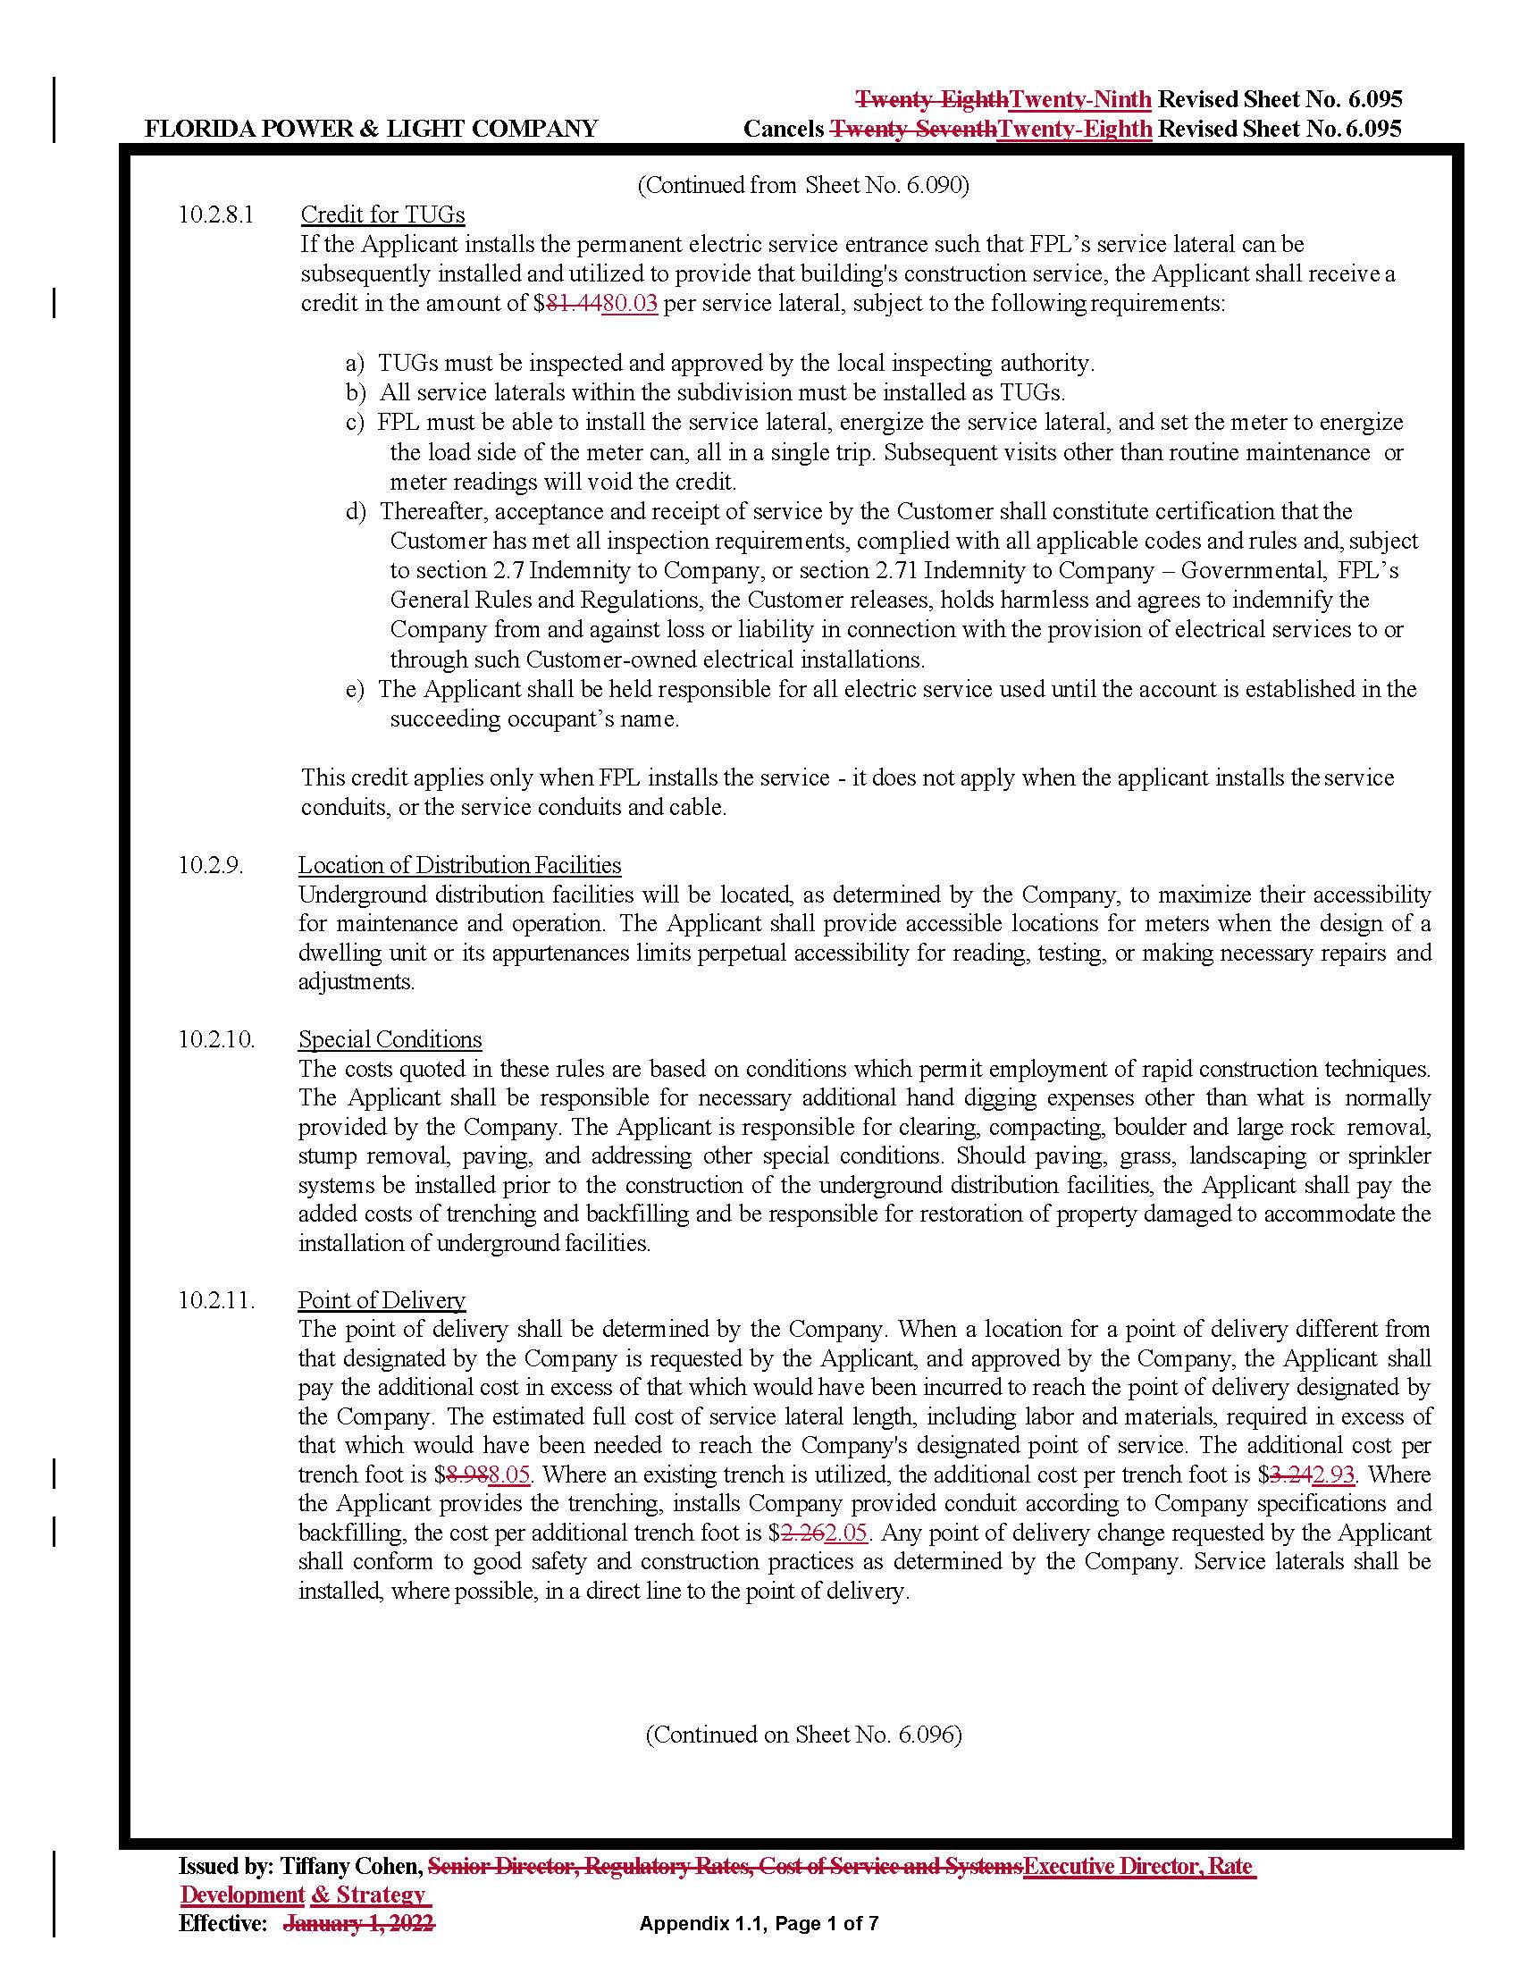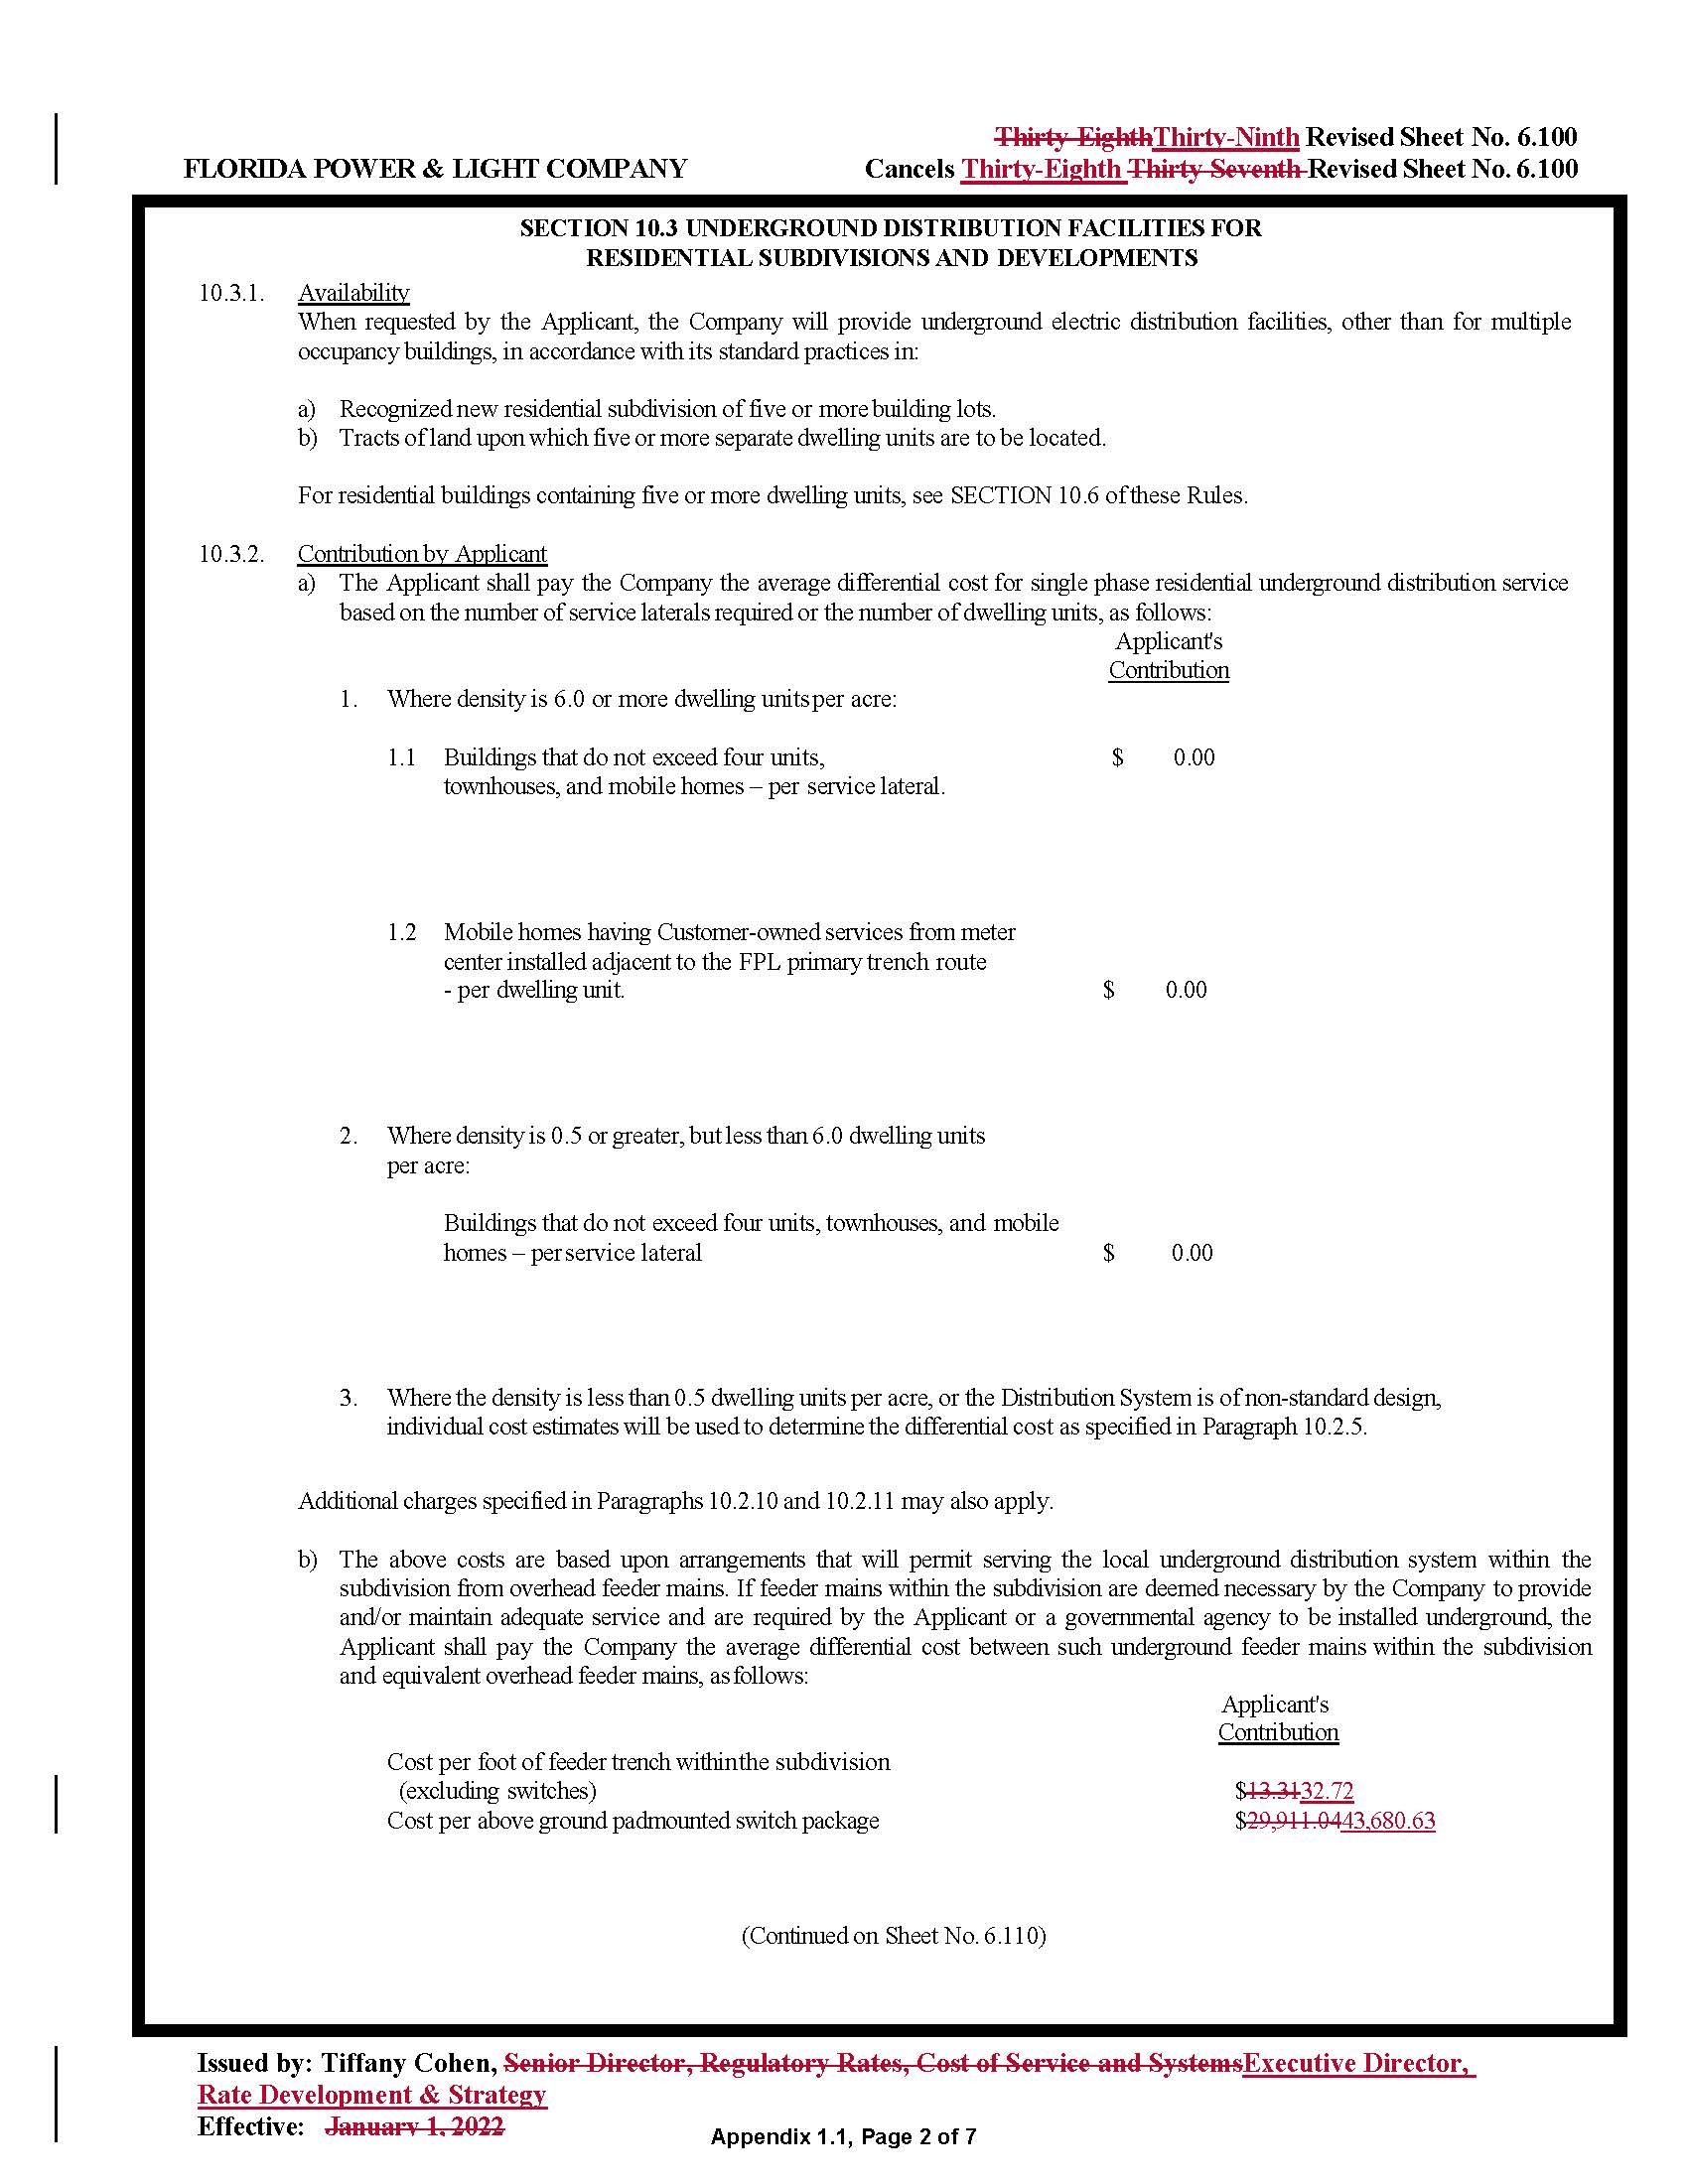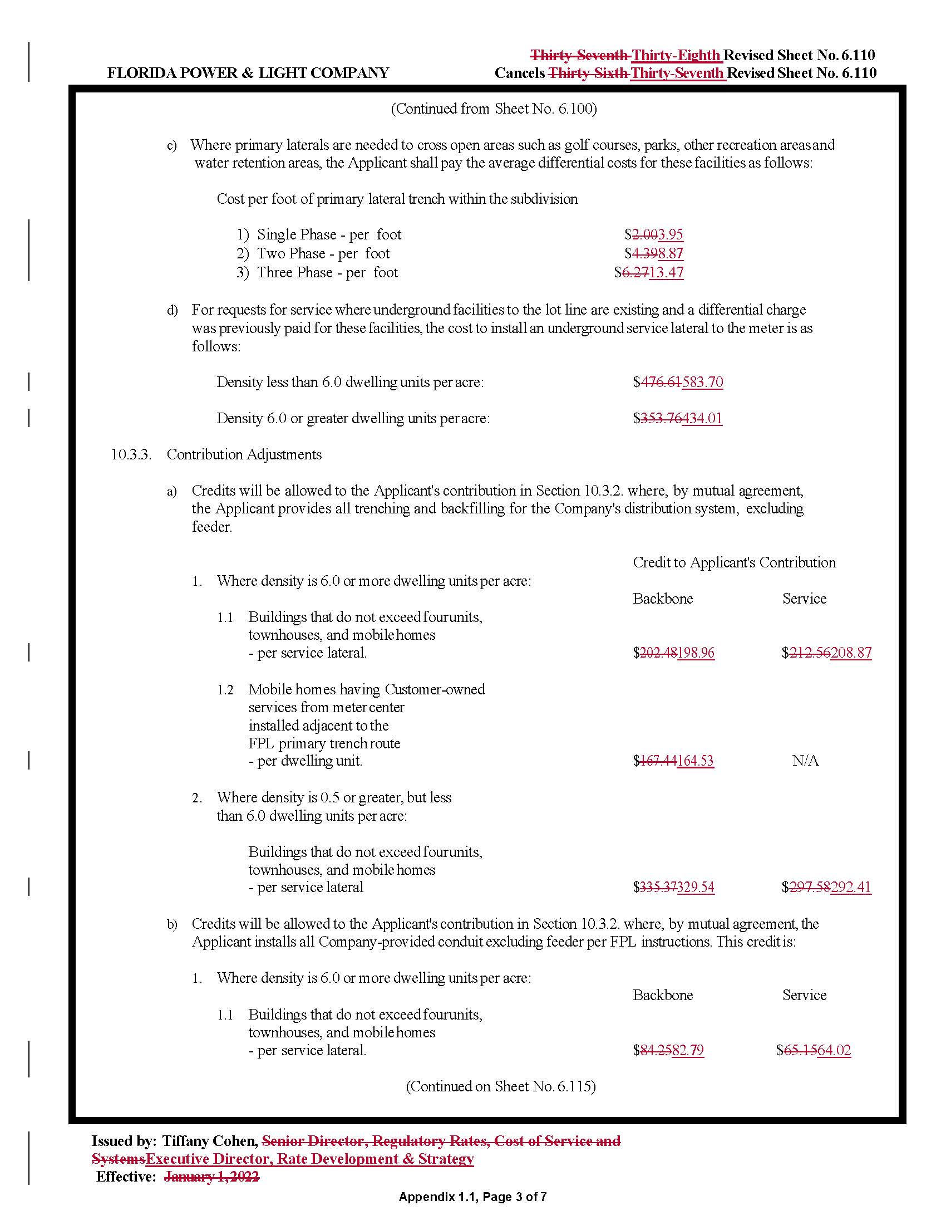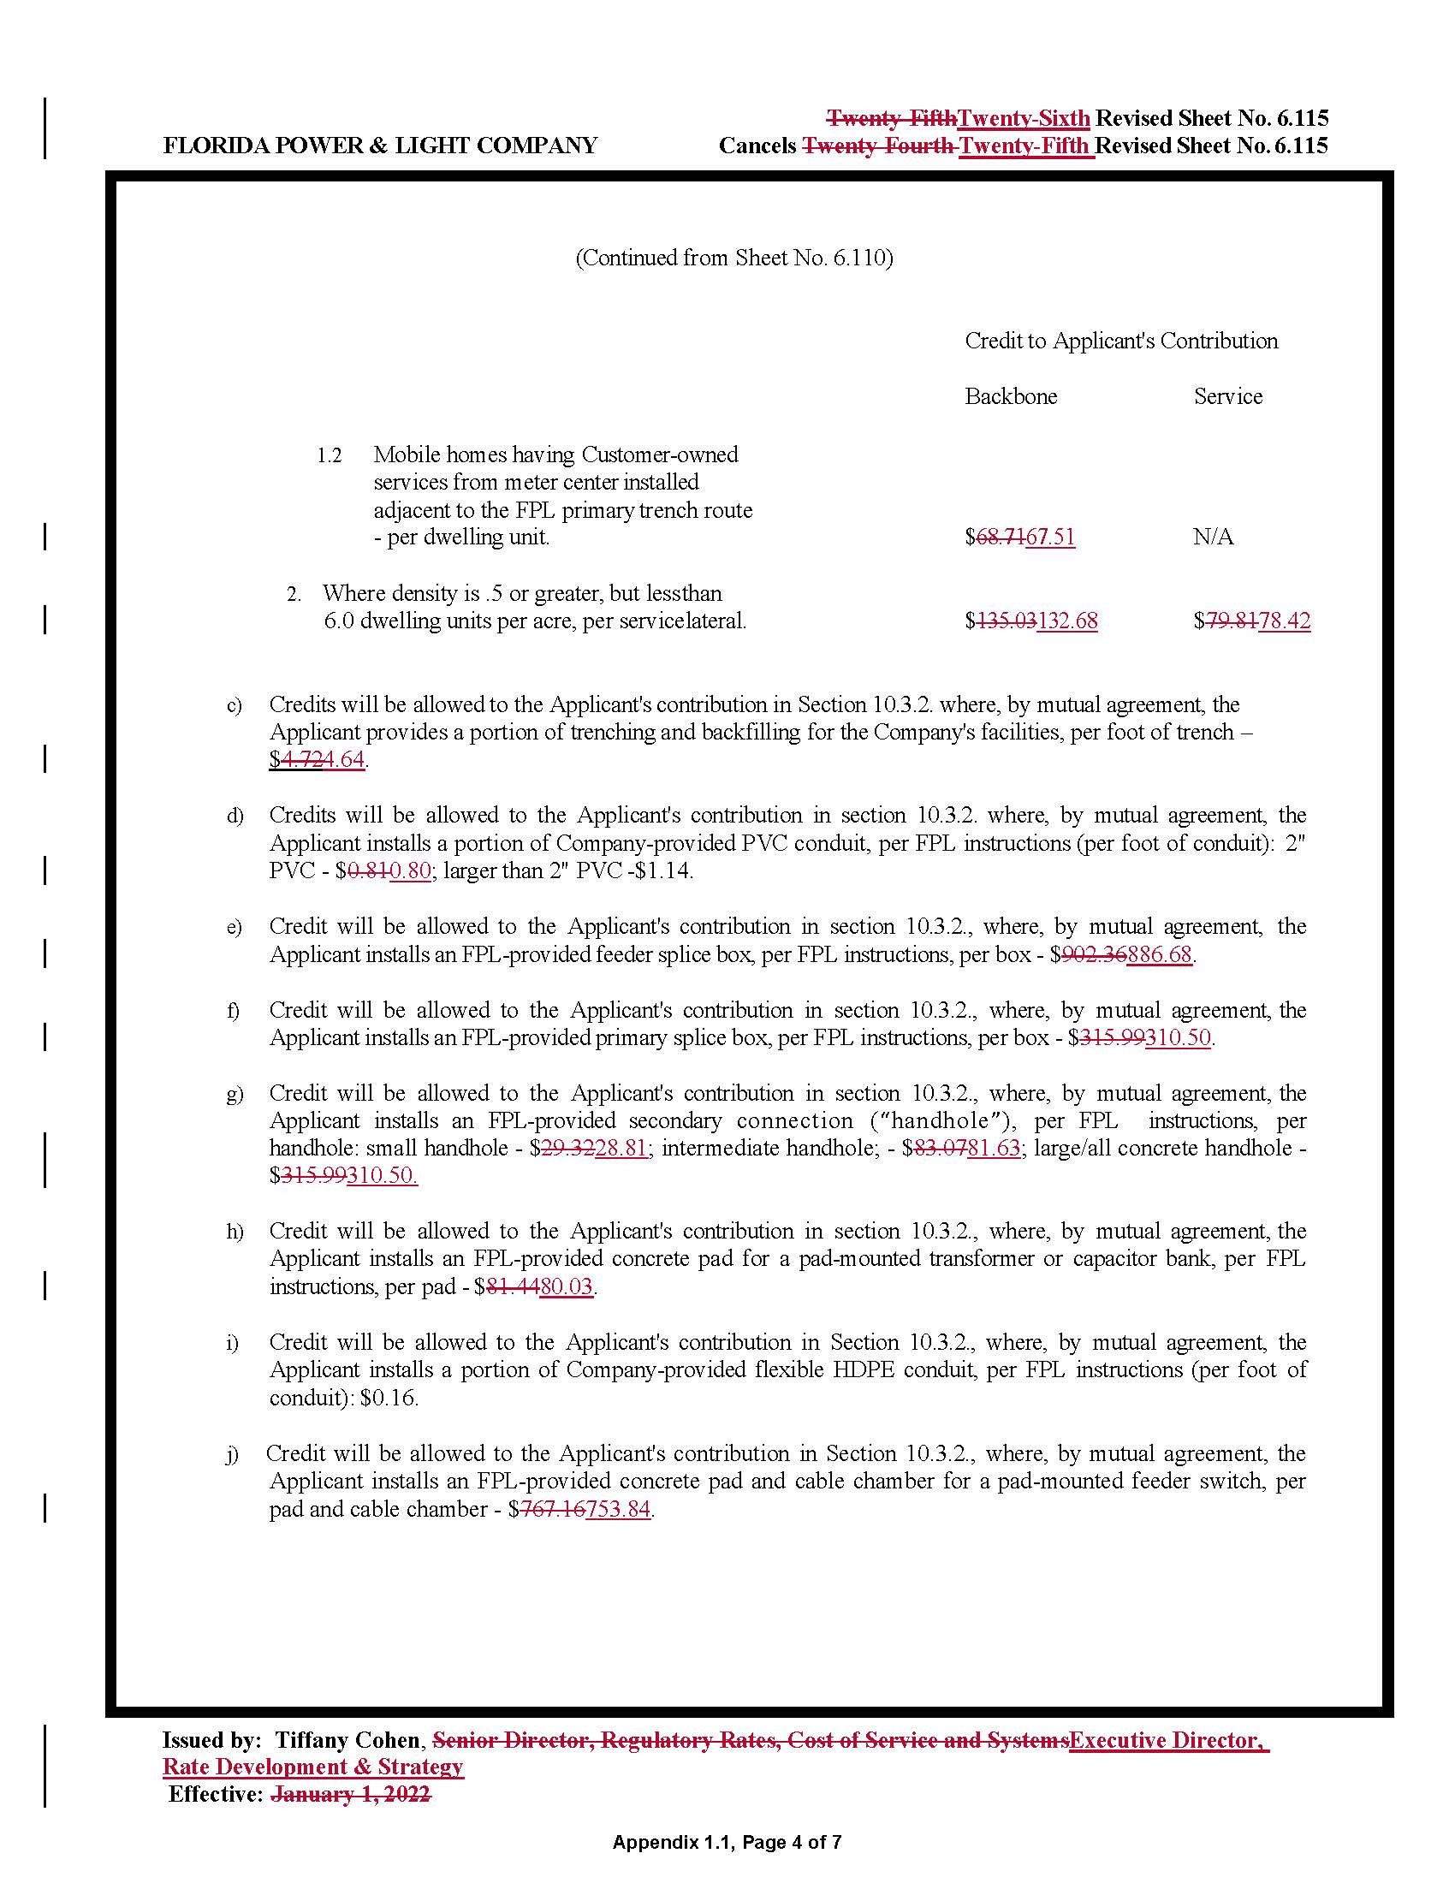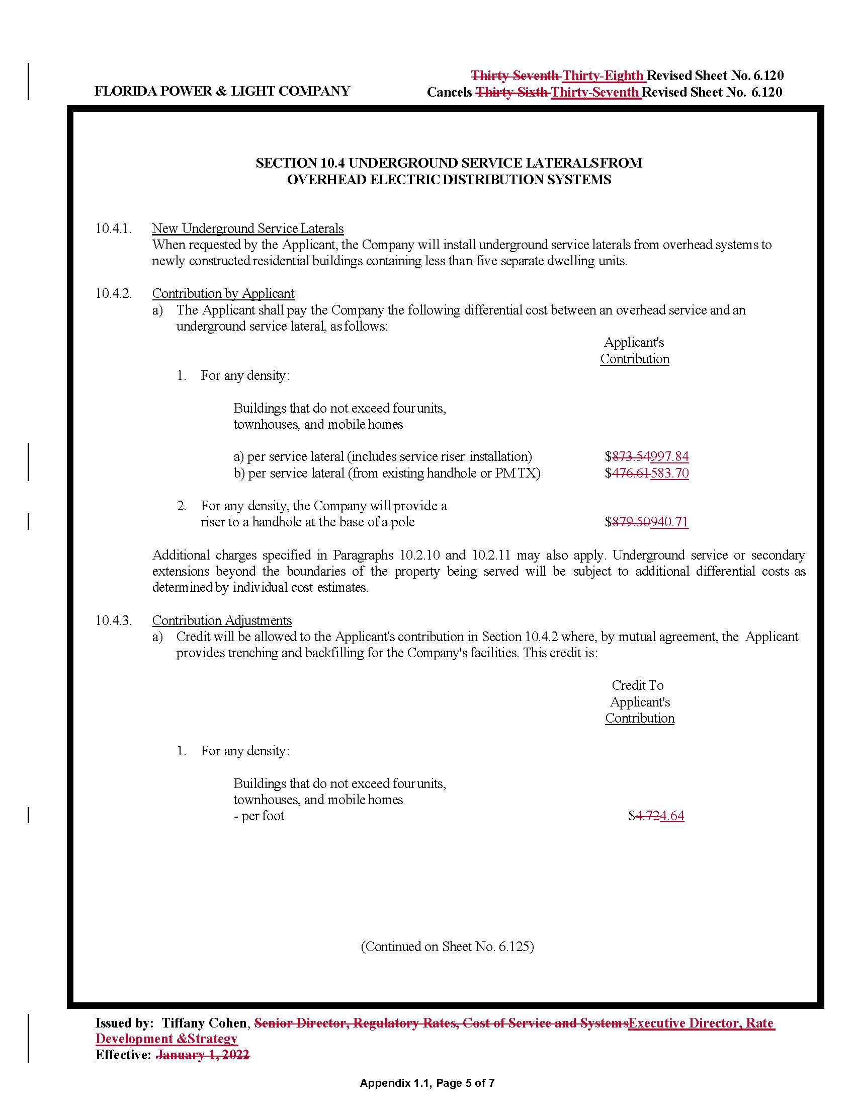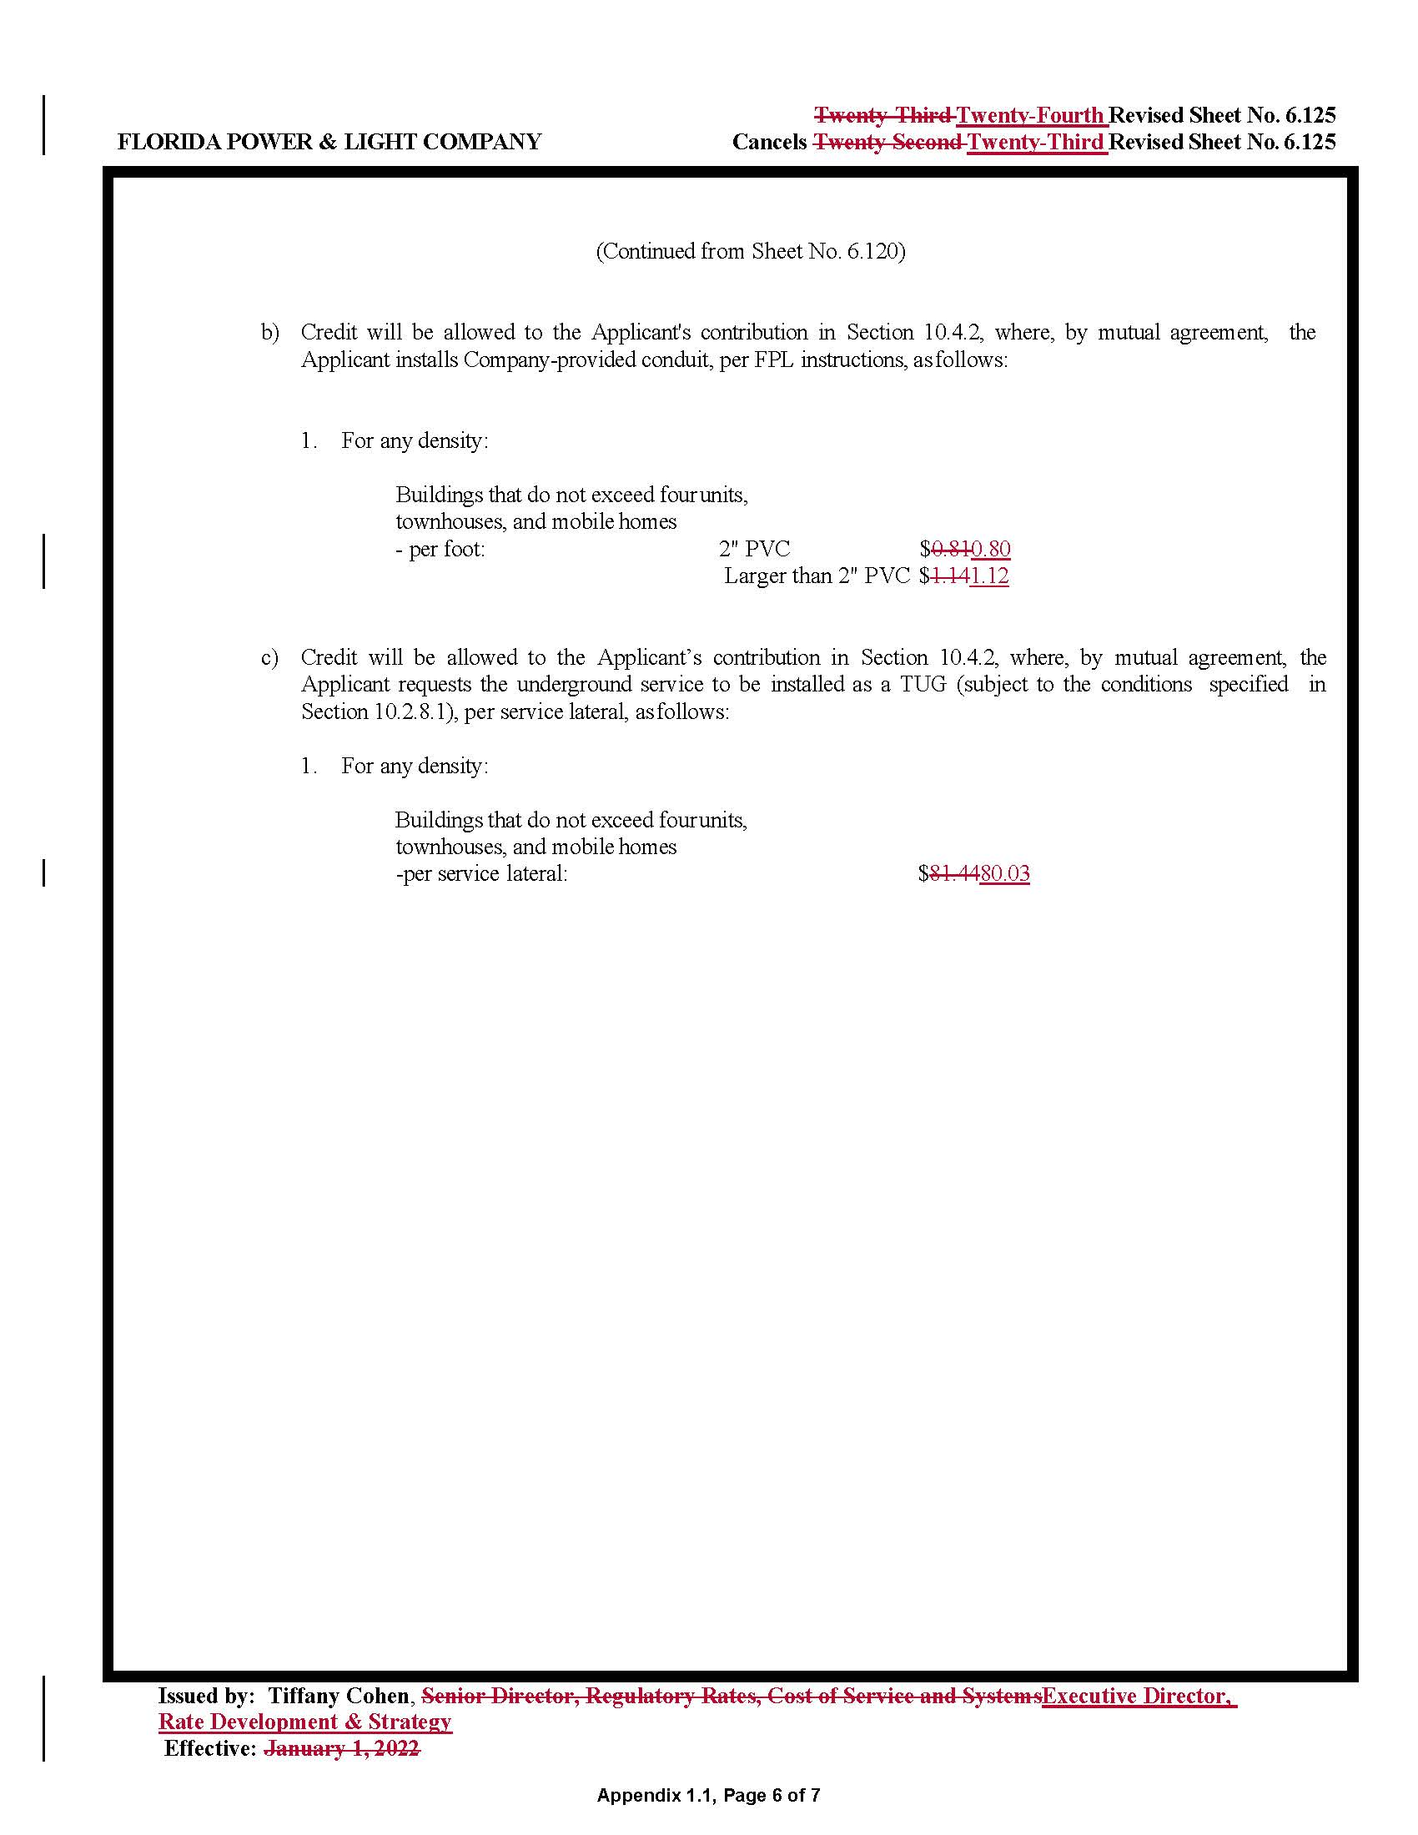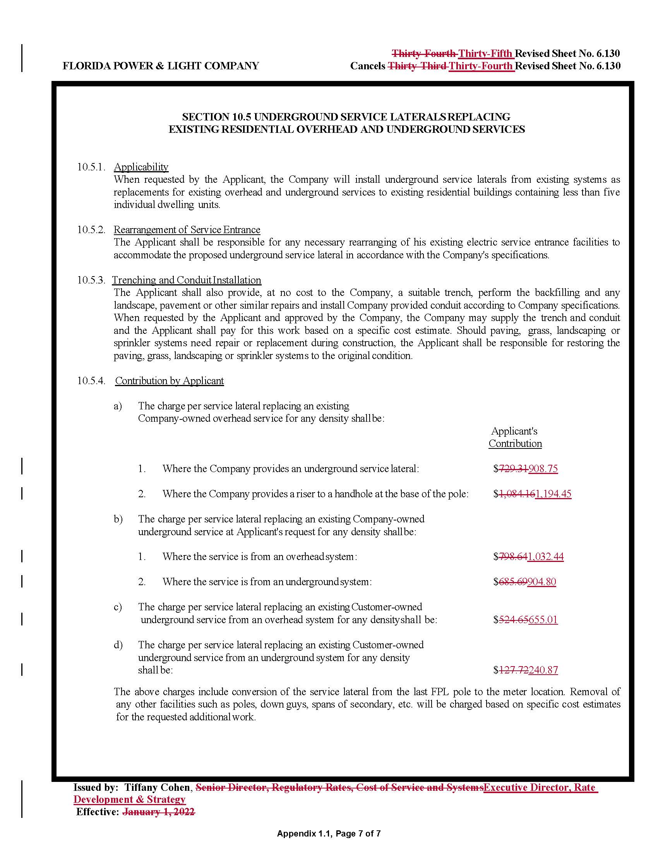

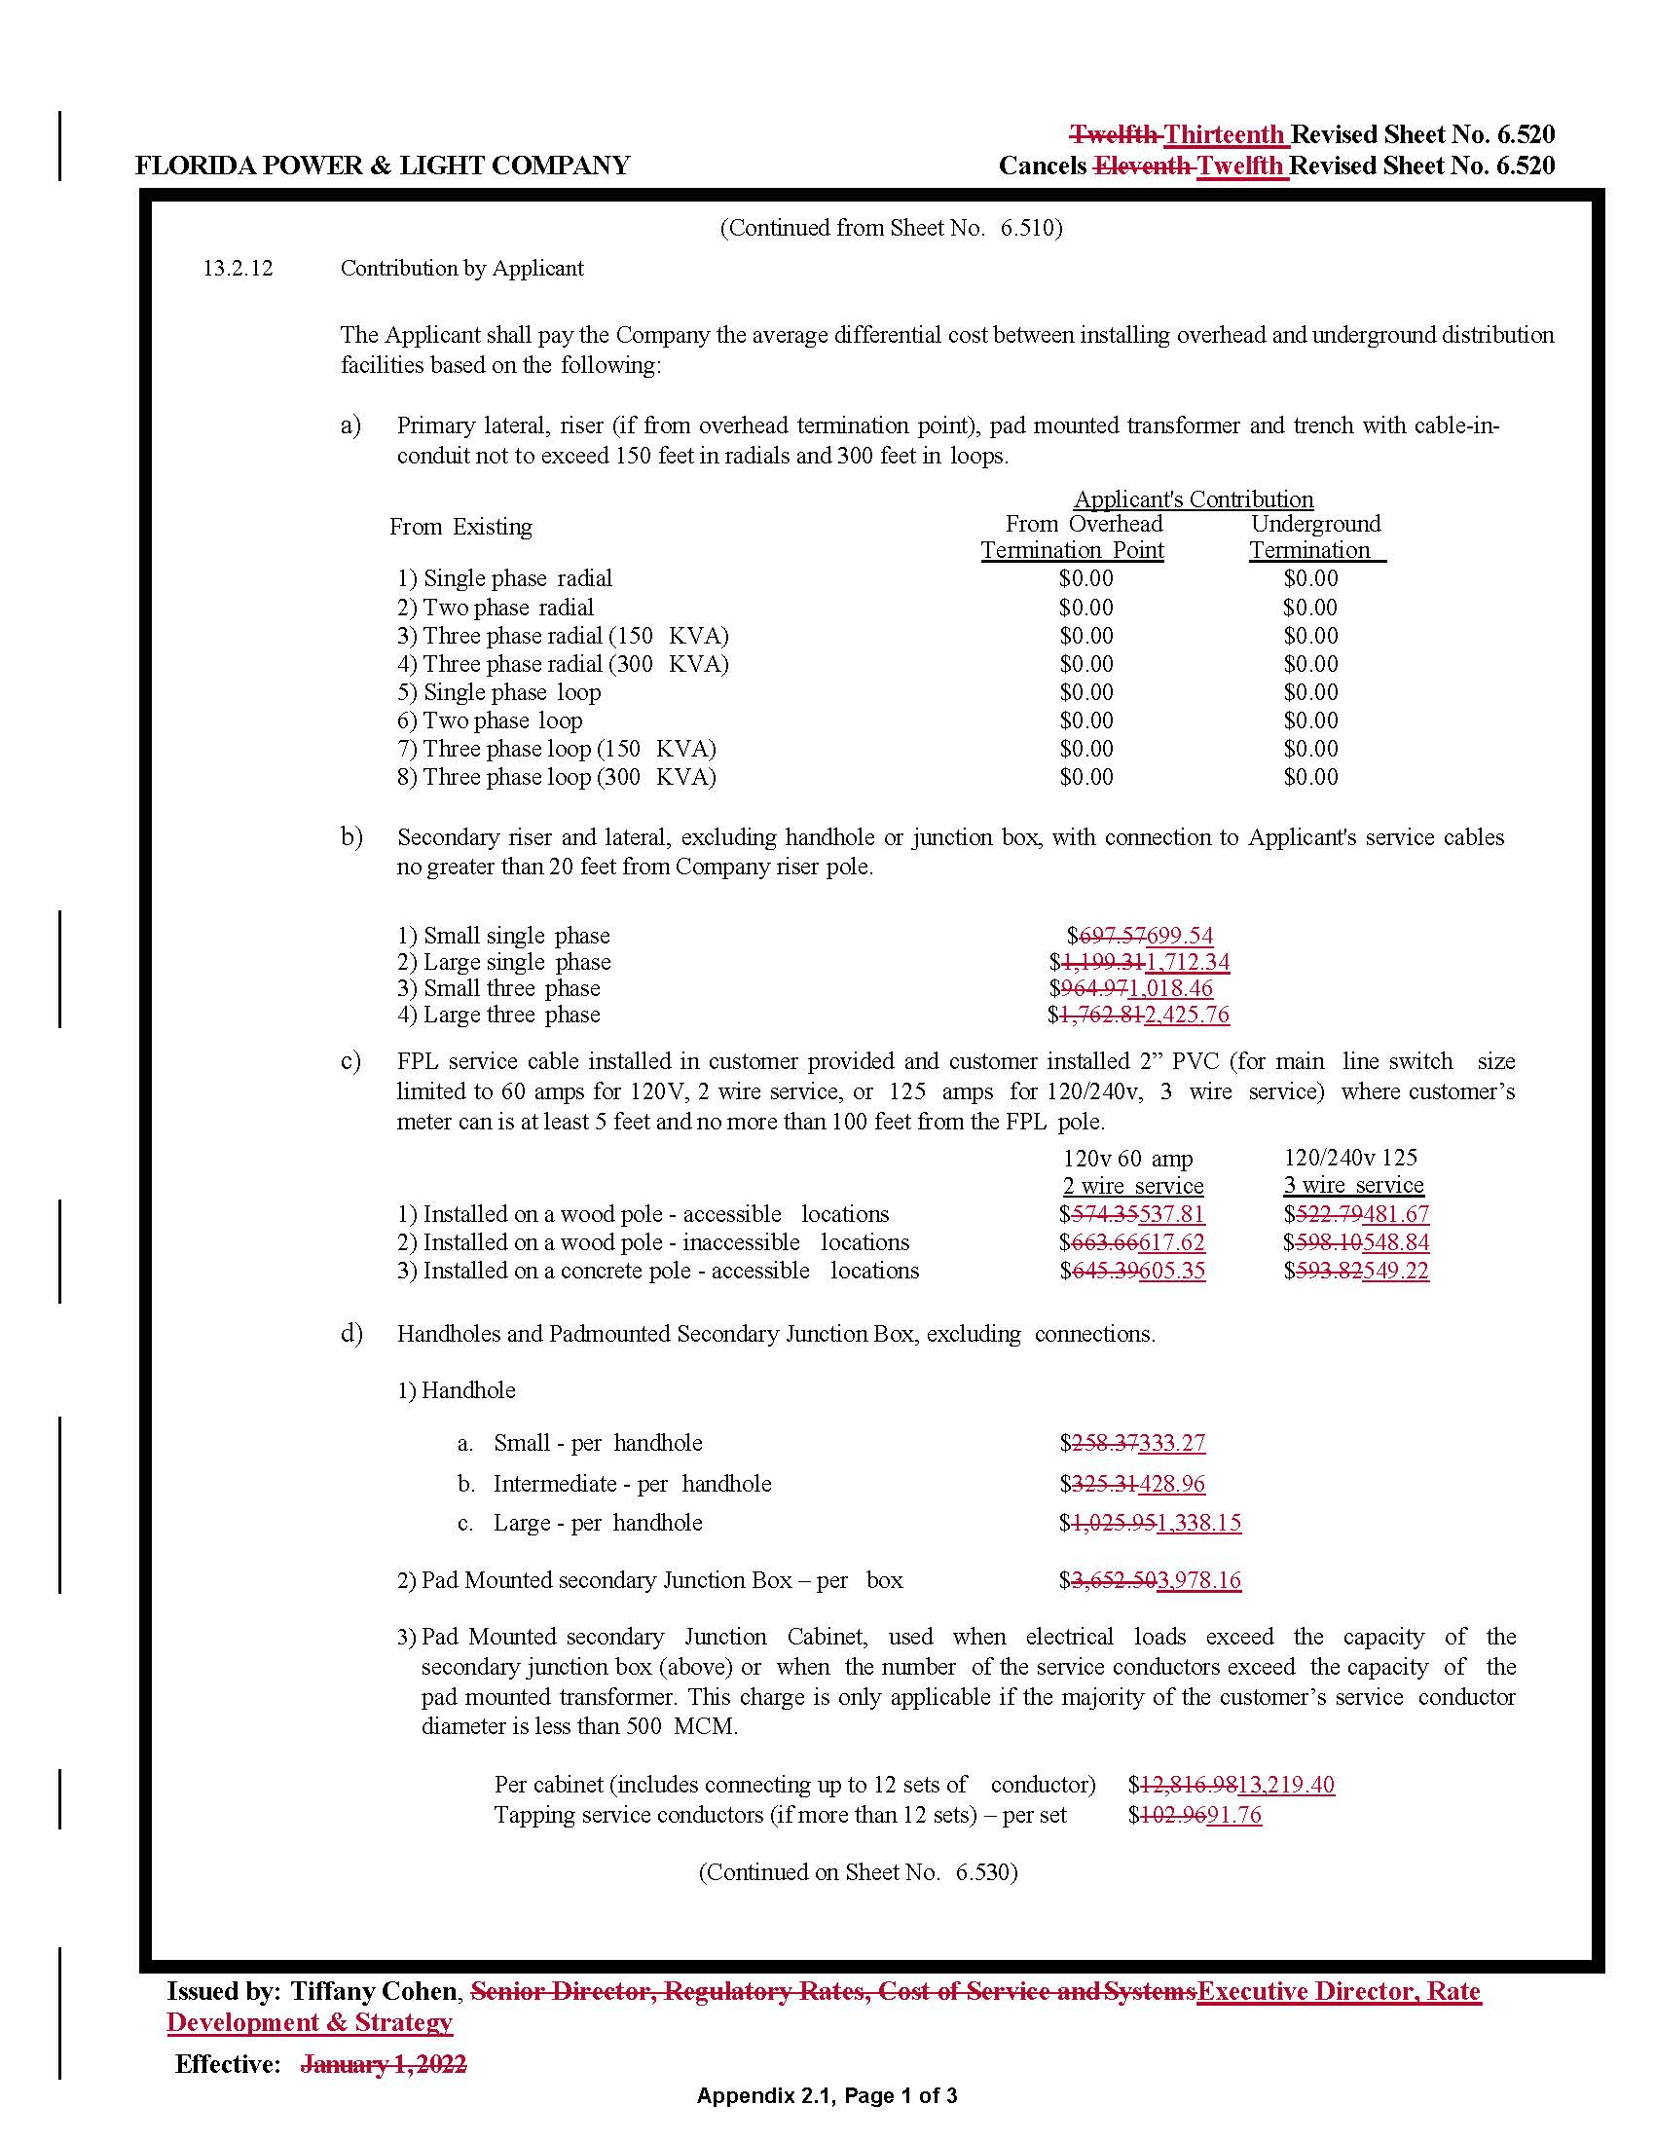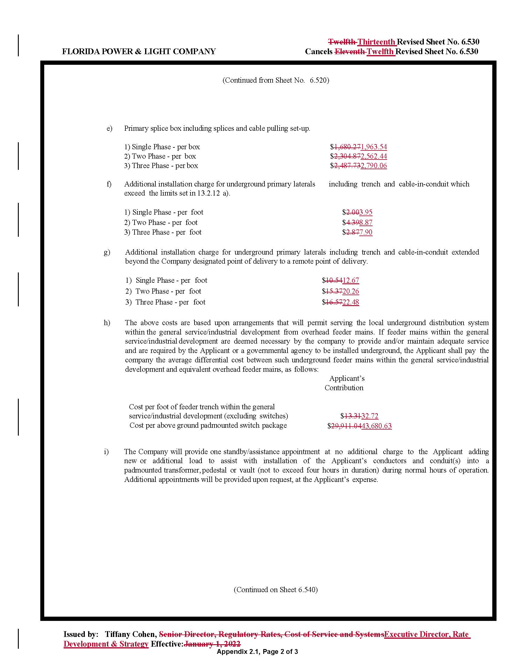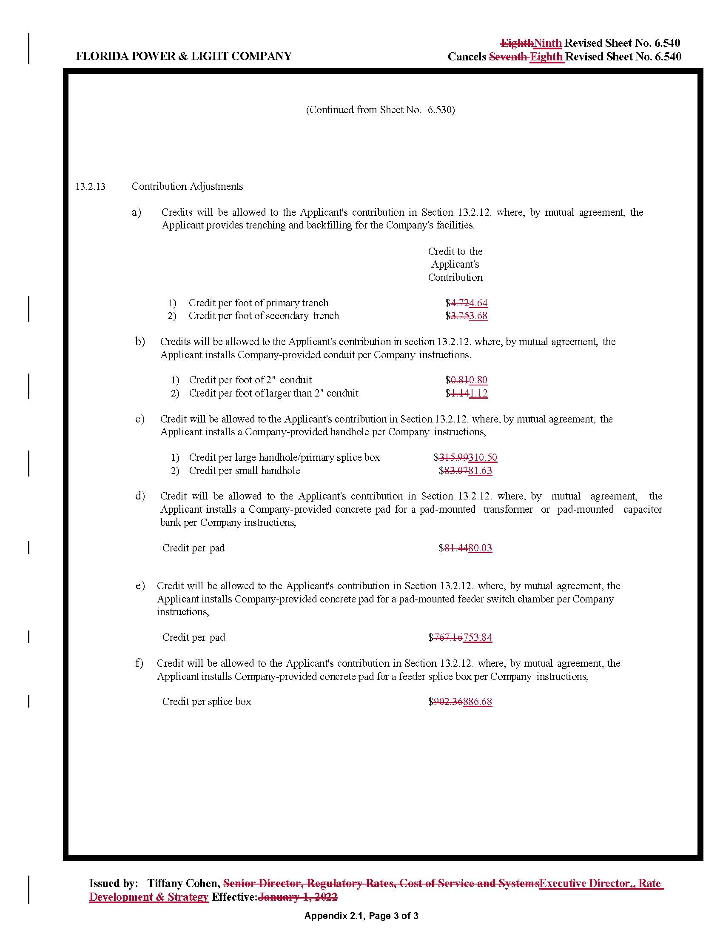

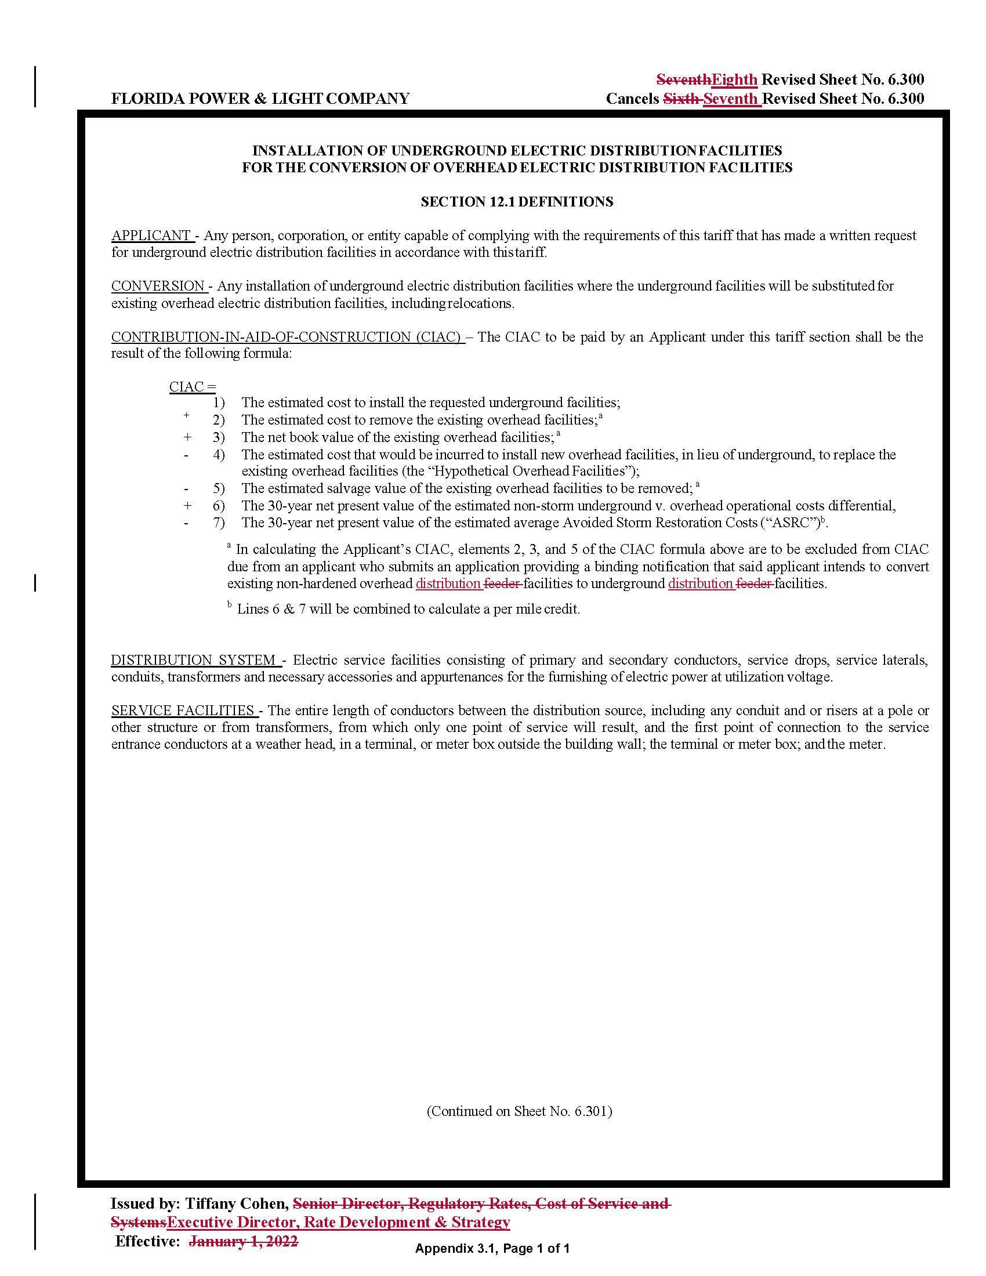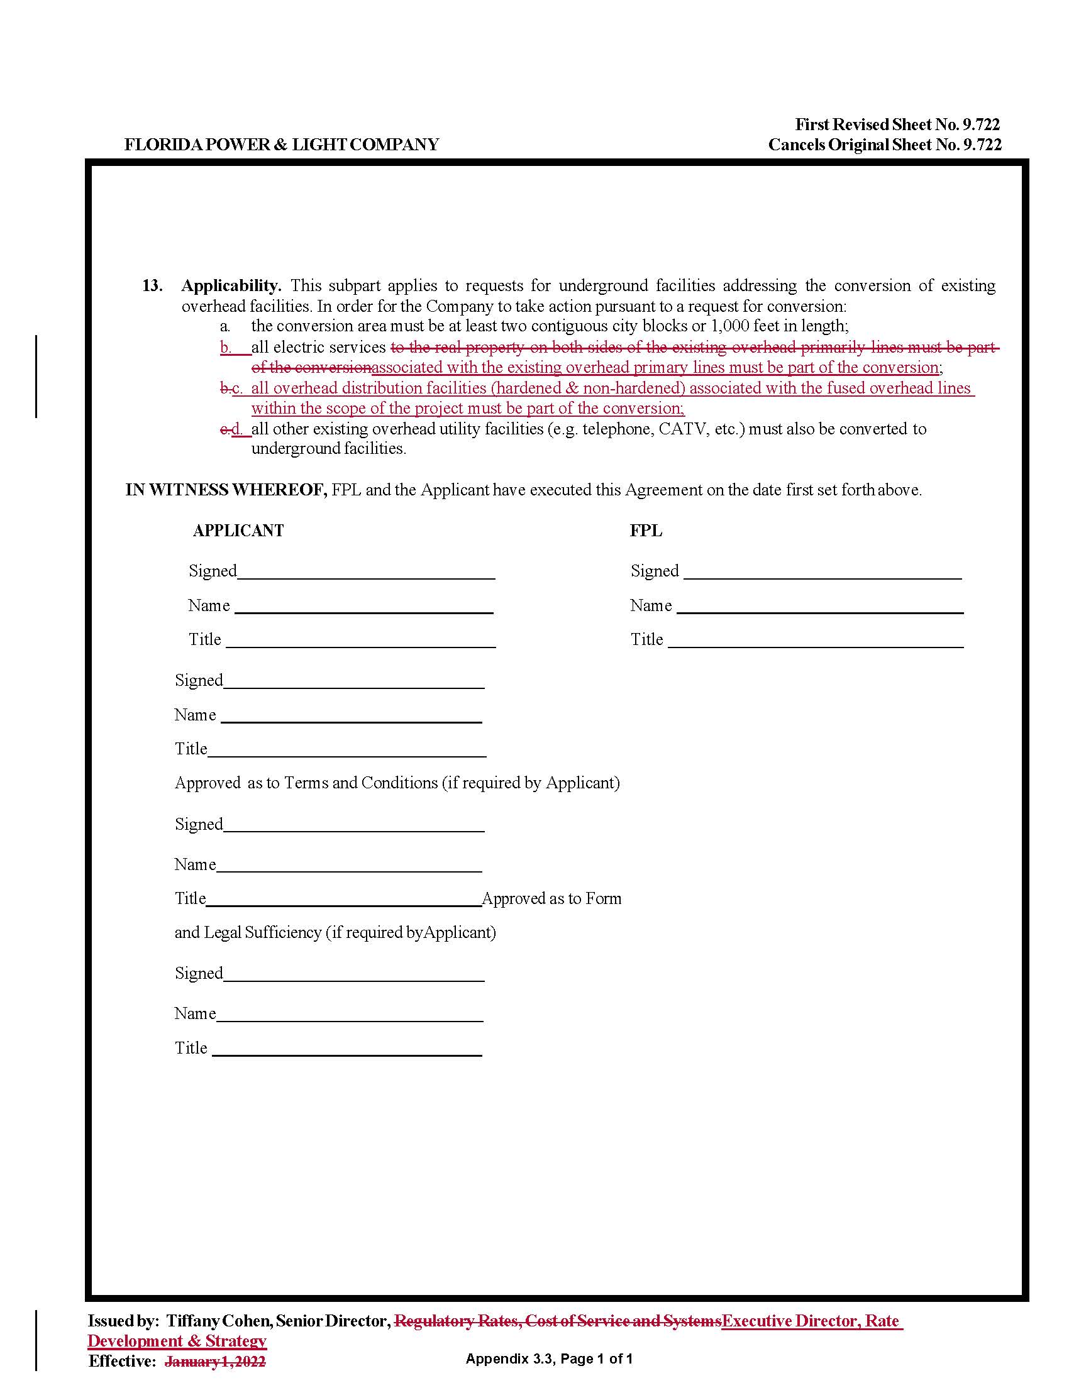

1. Order No. PSC-2019-0360-TRF-EI, issued August 26, 2019, in Docket No. 20190081-EI, *In re: Petition for approval of 2019 revisions to underground residential and commercial differential tariffs, by Florida Power & Light Company.*
2. Order No. PSC-2022-0062-PAA-EI, issued February 17, 2022, and Order No. PSC-2022-0191-FOF-EI, issued May 23, 2022, in Docket No. 20220012-EI, *In re: Petition for temporary waiver of Rule 25-6.078(3), F.A.C., by Florida Power & Light Company.*
3. Order No. PSC-2023-0159-PCO-EI, issued May 15, 2023, in Docket No. 20230045-EI, *In re: Petition for approval of revisions to underground residential tariff, underground commercial differential tariff, and overhead to underground conversion tariff, by Florida Power & Light Company.*
4. Order No. PSC-08-0774-TRF-EI, issued November 24, 2008, in Docket No. 20070231-EI, *In re: Petition for approval of 2007 revisions to underground residential and commercial distribution tariff, by Florida Power & Light Company.*
5. Order No. PSC-2018-0050-TRF-EI, issued January 22, 2018, in Docket No. 20170148-EI, *In re: Petition for determination under Rule 25-6.115, F.A.C., and approval of associated revised tariff sheet 6.300, by Florida Power & Light Company.*
6. Order No. PSC-2022-0389-FOF-EI, issued November 10, 2022, in Docket No. 20220051-EI, *In re: Review of Storm Protection Plan, pursuant to Rule 25-6.030, F.A.C., Florida Power & Light Company.*
7. Order No. PSC-2022-0336-TRF-EI, issued September 28, 2022, in Docket No. 20220089-EI, *In re: Petition for approval of modifications to rate schedule tariff sheet No. 4.122 and determination under Rule 25-6.115(12), F.A.C., by Duke Energy Florida, LLC.*