BEFORE THE FLORIDA PUBLIC SERVICE COMMISSION

Notice of Staff Workshop

TO

All WATER AND WASTEWATER UTILTIES

AND

OFFICE OF PUBLIC COUNSEL

AND

ALL OTHER INTERESTED PERSONS

UNDOCKETED

IN RE: AMENDMENT OF RULE 25-30.0371, FLORIDA ADMINISTRATIVE CODE, ACQUISITION ADJUSTMENTS

ISSUED: September 11, 2023

NOTICE is hereby given that a staff rule development workshop will be held at the following time and place:

September 25, 2023 at 1:30 p.m.

Room 148, Betty Easley Conference Center

4075 Esplanade Way

Tallahassee, FL 32399-0850

The draft rules and the agenda for the workshop are attached. One or more Commissioners may be in attendance and participate in the workshop. The person to be contacted regarding this rule development workshop is Douglas D. Sunshine, Office of the General Counsel, at (850) 413-6224 or dsunshin@psc.state.fl.us.

In accordance with the Americans with Disabilities Act, persons needing a special accommodation to participate at this workshop should contact the Office of Commission Clerk no later than five days prior to the workshop at 2540 Shumard Oak Boulevard., Tallahassee, Florida 32399-0850 or 850-413-6770 (Florida Relay Service, 1-800-955-8770 Voice or 1-800-955-8771 TDD). Assisted Listening Devices are available upon request from the Office of Commission Clerk, Gerald L. Gunter Building, Room 152.

EMERGENCY CANCELLATION OF THE WORKSHOP

If a named storm or other disaster requires cancellation of the workshop, notice of cancellation will be provided on the Commission’s website ([http://www.psc.state.fl.us](http://www.psc.state.fl.us/)) under the Hot Topics link found on the home page. Cancellation can also be confirmed by calling the Office of the General Counsel at (850) 413-6199.

By DIRECTION of the Florida Public Service Commission this 11th day of September, 2023.

|  |  |
| --- | --- |
|  | /s/ Adam J. Teitzman |
|  | ADAM J. TEITZMAN  Commission Clerk |

Florida Public Service Commission

2540 Shumard Oak Boulevard

Tallahassee, Florida 32399

(850) 413-6770

www.floridapsc.com

Copies furnished: A copy of this document is provided to the parties of record at the time of issuance and, if applicable, interested persons.

DDS

**25-30.0371 Acquisition Adjustments.**

(1) Purpose. The purpose of this rule is to establish the process by which utilities may petition the Commission to determine whether to approve a positive acquisition adjustment for inclusion in rate base and an amortization period.

(2)~~(1)~~ Definitions ~~Definition~~. For the purpose of this rule, the following definitions apply: ~~an acquisition adjustment is defined as the difference between the purchase price of utility system assets to an acquiring utility and the net book value of the utility assets. A positive acquisition adjustment exists when the purchase price is greater than the net book value. A negative acquisition adjustment exists when the purchase price is less than the net book value.~~

(a) “Acquisition adjustment” means the difference between the purchase price of utility system assets to an acquiring utility and the net book value of the utility’s assets.

(b) “Filing date” means the date the purchasing utility files a petition requesting Commission approval of the transfer of the certificate of authorization from the acquired utility to the purchasing utility.

(c) “Positive acquisition adjustment” means the purchase price is greater than the net book value.

(d) “Negative acquisition adjustment” means the purchase price is less than the net book value.

(e) “Non-viable utility” means a utility that meets the criteria in either of the following subparagraphs:

1. A utility that is projected to be unable to provide and maintain safe and adequate service and facilities to its customers over the 5-year period following the filing date due to:

a. An ongoing pattern of enforcement or compliance actions by federal, state, or local regulatory agencies based on violations of primary or secondary water quality standards or other health, safety, and environmental standard; and

b. Insufficient investment, repair, or maintenance that has caused or resulted in an inability to acquire and maintain adequate managerial, operational, financial, or technical capabilities to ensure safe and reliable service to its customers; or

2. A utility that is insolvent, i.e., unable to pay debts as they become due in the regular course of business.

(f) “Viable utility” means all utilities that are not non-viable as defined in paragraph (2)(e) of this rule.

(g) “Good cause” means a showing of financial hardship, unforeseen events, or other events outside the utility’s control but does not include reasons such as management oversight.

(3) A utility that purchases another utility may petition the Commission to establish an acquisition adjustment under either subsection (4) or subsection (5) of this rule to include some or all of a positive acquisition adjustment in the purchasing utility’s rate base. A utility may seek approval of a positive acquisition adjustment at the time the utility seeks approval to transfer the certificate of authorization or within 3 years of the issuance date of the Commission order approving the transfer of the certificate of authorization. The utility may request an extension of the 3-year period, which must include a statement of good cause.

(4)~~(2)~~ Positive Acquisition Adjustments for Non-Viable Utility. ~~A positive acquisition adjustment shall not be included in rate base absent proof of extraordinary circumstances. Any entity that believes a full or partial positive acquisition adjustment should be made has the burden to prove the existence of extraordinary circumstances. In determining whether~~ ~~extraordinary circumstances have been demonstrated, the Commission shall consider evidence provided to the Commission such as anticipated improvements in quality of service,~~ ~~anticipated improvements in compliance with regulatory mandates, anticipated rate reductions or rate stability over a long-term period, anticipated cost efficiencies, and whether the purchase was made as part of an arms-length transaction. Amortization of a positive acquisition adjustment shall be pursuant to paragraph (4)(a) below.~~

(a) Application. The purchasing utility must file the following information with its petition:

1. The amount of the acquisition adjustment requested;

2. The amortization period requested;

3. Primary water quality test results of the acquired utility submitted to the Florida Department of Environmental Protection from the past 10 years from the filing date;

4. Secondary water quality test results of the acquired utility submitted to the Florida Department of Environmental Protection from the past 10 years from the filing date;

5. Any notices of violation, consent decrees or other regulatory actions issued by a federal, state, regional, or local agency regarding the provision of the acquired utility’s water or wastewater service over the past 10 years from the filing date;

6. The acquired utility’s annual capital investments and operations and maintenance expenses over the past 10 years from the filing date;

7. A description of the managerial, operational, financial, and technical capabilities of the ownership and management of the acquired utility;

8. A description of the ability of the acquired utility to furnish and maintain safe and adequate service and facilities over the next 5 years from the filing date;

9. The extent to which the acquired utility is insolvent or unable to service its debt obligations;

10. The purchasing utility’s planned infrastructure additions and maintenance to improve the acquired utility’s quality of service and compliance with environmental regulations;

11. An explanation of the extent to which the acquisition was made as part of an arms-length transaction;

12. The contract of sale, including the estimated cost of the fees and transaction closing costs to be incurred by the purchasing utility;

13. All engineering studies or appraisals the purchasing utility procured pertaining to the purchase of the acquired utility;

14. The 5-year projected rate impact on the customers of the utility system being acquired, which must include the rate impact of any cost efficiencies expected to result from the acquisition transaction and the impact of the acquisition adjustment; and

15. A calculation of the net book value of the acquired utility including the composite remaining life of the assets purchased.

(b) A full or partial positive acquisition adjustment will be allowed for inclusion in the purchasing utility’s rate base if the purchasing utility demonstrates that the acquired utility is a non-viable utility and that customers will benefit if a full or partial positive acquisition adjustment is allowed. In determining whether the acquired utility meets the definition of a non-viable utility in paragraph (2)(e), the Commission will consider information filed with the application in paragraph (4)(a). In determining whether customers will benefit from a full or partial acquisition adjustment, the Commission will consider whether the anticipated improvements in the acquired utility will lead to the likelihood of an improvement in quality of service, quality of facilities, or compliance with primary and secondary water quality standards or wastewater regulatory requirements over the 5 years following the date of acquisition; the amount of anticipated rate impacts over the 5 years following the date of acquisition; and whether the purchase was made as part of an arms-length transaction.

~~(3) Negative Acquisition Adjustments. If the purchase price is greater than 80 percent of net book value, a negative acquisition adjustment will not be included in rate base. When the purchase price is equal to or less than 80 percent of net book value, a negative acquisition adjustment shall be included in rate base and will be equal to 80 percent of net book value less the purchase price. Amortization of a negative acquisition adjustment shall be pursuant to subparagraph (4)(b)1. or (4)(b)2. below.~~

(5) Positive Acquisition Adjustments for Viable Utility.

(a) Application. The purchasing utility must file the following information with its petition:

1. The amount of the acquisition adjustment requested;

2. The amortization period requested;

3. A cumulative present value of the revenue requirements analysis (CPVRR) in the form of a spreadsheet. Form PSC XXX (XX/23), entitled “Water and/or Wastewater Utilities Cumulative Present Value of the Revenue Requirements for Acquisition Adjustment Worksheet,” which is incorporated by reference in this rule and is available at [hyperlink], is an example CPVRR that may be completed and included in the purchasing utility’s application to comply with this paragraph. The form may also be obtained from the Commission’s website, www.floridapsc.com;

4. An Excel spreadsheet with the data and information included in the CPVRR analysis with the spreadsheet formulas intact;

5. All supporting data and assumptions used in the CPVRR spreadsheet;

6. A description of the anticipated improvements in the acquired utility’s quality of service;

7. A description of anticipated improvements in the acquired utility’s compliance with regulatory requirements;

8. Projected annual rate impacts over the 5 years following the filing date, which must include the rate impact of any cost savings expected to result from the acquisition transaction and the impact of the acquisition adjustment;

9. A description, including any supporting data, of the anticipated cost savings resulting from the acquisition;

10. An explanation of the extent to which the acquisition was made as part of an arms-length transaction;

11. The contract of sale, including the estimated cost of fees and transaction closing costs to be incurred by the purchasing utility;

12. All engineering studies or appraisals the purchasing utility procured pertaining to the purchase of the acquired utility; and

13. A calculation of the net book value of the acquired utility including the composite remaining life of the assets purchased.

(b) A full or partial positive acquisition adjustment will be allowed for inclusion in rate base if the purchasing utility demonstrates that the transaction incorporating the full or partial positive acquisition adjustment is projected to provide a positive CPVRR customer benefit over a 5-year period from the date of acquisition. If the CPVRR does not result in a positive customer benefit over a 5-year period, a full or partial positive acquisition adjustment will be allowed if the purchasing utility demonstrates that the following factors outweigh the lack of a positive CPVRR customer benefit:

1. Anticipated improvements in quality of service and compliance with water or wastewater regulatory requirements;

2. Anticipated rate reductions or 5 years of rate stability following the date of acquisition;

3. Anticipated cost savings over the 5 years following the date of acquisition;

4. Increased ability to attract capital;

5. Lower overall cost of capital;

6. Additional professional and experienced managerial, financial, technical, and operational resources; and

7. The purchase was made as part of an arms-length transaction.

~~(4) Amortization Period.~~

~~(a) In setting the amortization period for a Commission approved positive acquisition adjustment pursuant to subsection (2), above, the Commission shall consider evidence such as the composite remaining life of the assets purchased and the condition of the assets purchased. Amortization of the acquisition adjustment shall begin on the date of issuance of the order approving the transfer of assets.~~

~~(b) The appropriate period over which to amortize a Commission approved negative acquisition adjustment pursuant to subsection (3), above, shall be determined as follows:~~

~~1. If the purchase price is greater than 50 percent of net book value, the negative acquisition adjustment shall be amortized over a 7-year period from the date of issuance of the order approving the transfer of assets. In this case, the negative acquisition adjustment shall not be recorded on the books for ratemaking purposes or used for any earnings review unless the purchaser files for a rate increase pursuant to Section 367.081(2), 367.0814, 367.0817 or 367.0822, F.S., that will be effective during the amortization period.~~

~~2. If the purchase price is 50 percent of net book value or less, the negative acquisition adjustment shall be amortized from the date of issuance of the order approving the transfer of assets as follows:~~

~~a. 50 percent of the negative acquisition adjustment shall be amortized over a 7-year period; and~~

~~b. 50 percent of the negative acquisition adjustment shall be amortized over the remaining life of the assets.~~

(6) Amortization Period for a Positive Acquisition Adjustment. The Commission will set the amortization period in the order approving the positive acquisition adjustment. Amortization of the acquisition adjustment will begin on the date of issuance of the order approving the positive acquisition adjustment.

(7)~~(5)~~ Subsequent Review ~~Modification~~ of a Positive Acquisition Adjustment. ~~Any full or partial positive acquisition adjustment, once made by the Commission pursuant to subsection (2), above, may be subsequently modified if the extraordinary circumstances do not materialize or subsequently are eliminated or changed within 5 years of the date of issuance of the order approving the transfer of assets.~~

(a) Any full or partial positive acquisition adjustment, once made by the Commission pursuant to either subsection (4) or (5) of this rule will be reviewed by the Commission in the utility’s next rate proceeding or in a proceeding initiated by the utility within 5 years from the issuance date of the Commission order approving the acquisition adjustment, whichever date is earlier. The utility may request an extension of the 5-year review period, which must include a statement of good cause.

(b) The utility must file in the rate proceeding or in the proceeding initiated by the utility under paragraph (7) an explanation of how the anticipated customer benefits that were the basis for the Commission’s approval of the positive acquisition adjustment materialized or did not materialize.

(c) The Commission’s review under this subsection will be to determine if the full or partial positive acquisition adjustment should be subsequently reduced or eliminated. In making this determination, the Commission will consider whether the anticipated customer benefits did not materialize or subsequently changed within 5 years of the date of issuance of the order approving the positive acquisition adjustment.

(8) Negative Acquisition Adjustment. A negative acquisition adjustment will not be included in rate base.

*Rulemaking Authority 350.127(2), 367.121(1)(f) FS. Law Implemented 367.071(5), 367.081(2)(a), 367.121(1)(a), (b) FS. History–New 8-4-02, Amended 11-22-10*, ______

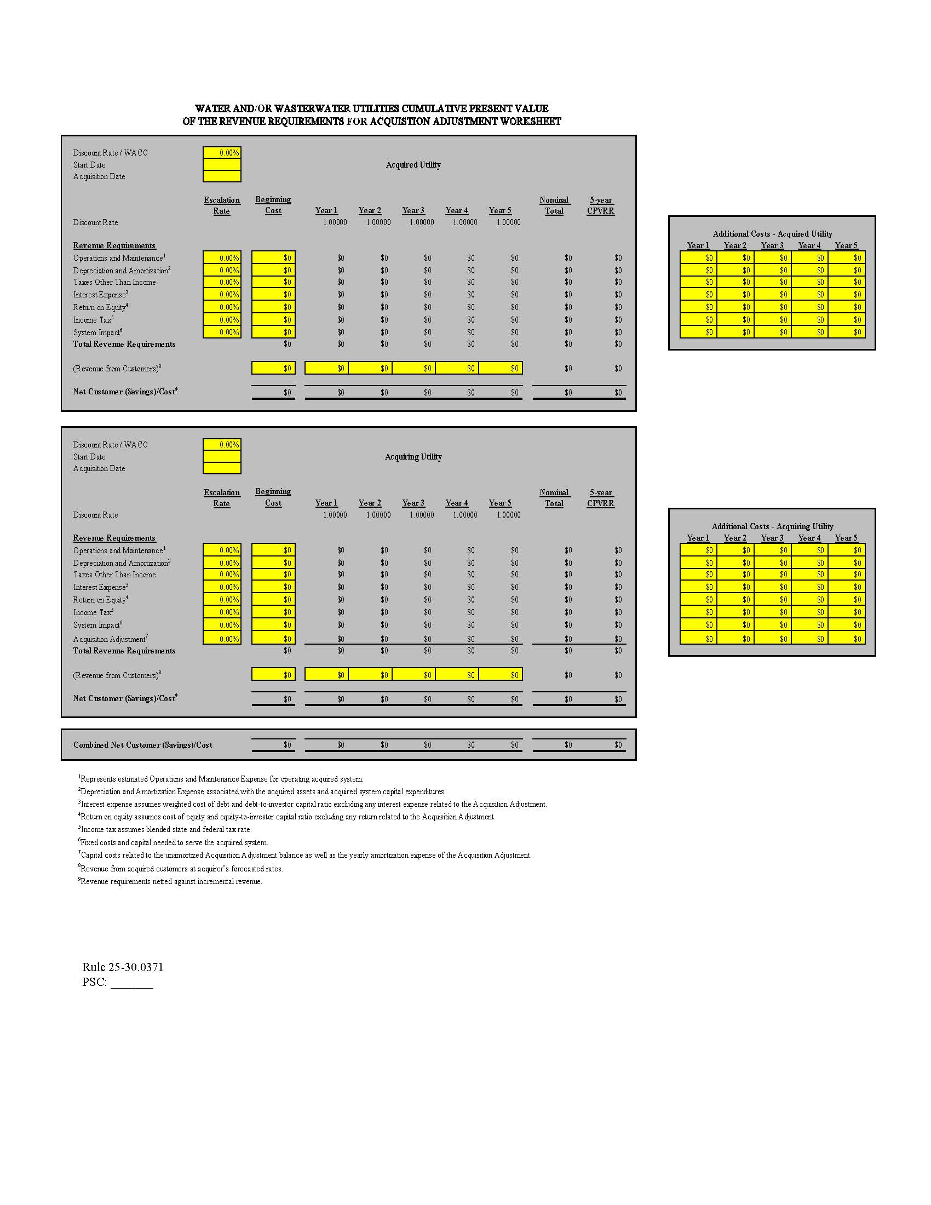

WORKSHOP AGENDA

1. Staff Welcome and Overview of draft Rule 25-30.0371, F.A.C., Acquisition Adjustments

2. Stakeholder comments

3. Discussion of next steps

4. Adjournment