BEFORE THE FLORIDA PUBLIC SERVICE COMMISSION

Notice of DEVELOPMENT OF RULEMAKING

TO

ALL ELECTRIC UTILITIES

OFFICE OF PUBLIC COUNSEL

AND

ALL OTHER INTERESTED PERSONS

UNDOCKETED

IN RE: AMENDMENT OF RULE 25-6.0131, F.A.C., REGULATORY ASSESSMENT FEES; INVESTOR-OWNED ELECTRIC COMPANIES, MUNICIPAL ELECTRIC UTILITIES, RURAL ELECTRIC COOPERATIVES.

ISSUED: September 12, 2023

NOTICE is hereby given pursuant to Section 120.54, Florida Statutes, that the Florida Public Service Commission staff has initiated rulemaking to amend Rule 25-6.0131, Florida Administrative Code, pertaining to regulatory assessment fees paid to the Commission by investor-owned electric companies, municipal electric utilities, and rural electric cooperatives.

A staff rule development workshop will be held at the following time and place:

September 27, 2023 at 9:30 a.m.

Betty Easley Conference Center, Room 148

4075 Esplanade Way

Tallahassee, FL 32399-0850

The draft rule, materials incorporated into the draft rule by reference, and the agenda for the workshop are attached. One or more Commissioners may be in attendance and participate in the workshop. The person to be contacted regarding the rule development is Jon Rubottom, Office of the General Counsel, at (850) 413-6191 or [jrubotto@psc.state.fl.us](mailto:jrubotto@psc.state.fl.us).

In accordance with the Americans with Disabilities Act, persons needing a special accommodation to participate at this workshop should contact the Office of Commission Clerk no later than five days prior to the workshop at 2540 Shumard Oak Boulevard., Tallahassee, Florida 32399-0850 or 850-413-6770 (Florida Relay Service, 1-800-955-8770 Voice or 1-800-955-8771 TDD). Assisted Listening Devices are available upon request from the Office of Commission Clerk, Gerald L. Gunter Building, Room 152.

The workshop will be available to view via livestream on the Commission’s website at <https://www.psc.state.fl.us/watch-archive-psc-events>.

EMERGENCY CANCELLATION OF THE WORKSHOP

If a named storm or other disaster requires cancellation of the workshop, notice of cancellation will be provided on the Commission’s website ([http://www.psc.state.fl.us](http://www.psc.state.fl.us/)) under the Hot Topics section found on the home page. Cancellation can also be confirmed by calling the Office of the General Counsel at (850) 413-6199.

By DIRECTION of the Florida Public Service Commission this 12th day of September, 2023.

|  |  |
| --- | --- |
|  | /s/ Adam J. Teitzman |
|  | ADAM J. TEITZMAN  Commission Clerk |

Florida Public Service Commission

2540 Shumard Oak Boulevard

Tallahassee, Florida 32399

(850) 413-6770

www.floridapsc.com

Copies furnished: A copy of this document is provided to the parties of record at the time of issuance and, if applicable, interested persons.

JR

**25-6.0131 Regulatory Assessment Fees; Investor-owned Electric Companies, Municipal Electric Utilities, Rural Electric Cooperatives.**

(1) As applicable and as provided in Section 350.113, F.S., and Section 366.14, F.S., each company, utility, or cooperative shall remit to the Commission a fee based upon its gross operating revenue. This fee shall be referred to as a regulatory assessment fee. Regardless of the gross operating revenue of a company, utility, or cooperative, a minimum annual regulatory assessment fee of $25 shall be imposed.

(a) Each investor-owned electric company shall pay a regulatory assessment fee in the amount of 0.000848 ~~.00072~~ of gross operating revenues derived from intrastate business, excluding sales for resale between investor-owned electric companies ~~public utilities~~, municipal electric utilities, and rural electric cooperatives or any combination thereof.

(b) Each municipal electric utility and rural electric cooperative shall pay a regulatory assessment fee in the amount of 0.00009905 ~~0.00015625~~ of its gross operating revenues derived from intrastate business, excluding sales for resale between investor-owned electric companies ~~public utilities~~, municipal electric utilities, and rural electric cooperatives or any combination thereof.

(2) Regulatory assessment fees are due each January 30 for the preceding period or any part of the period from July 1 until December 31, and on July 30 for the preceding period or any part of the period from January 1 until June 30.

(3) If the due date falls on a Saturday, Sunday, or a holiday, the due date is extended to the next business day. If the fees are sent by registered mail, the date of the registration is the United States Postal Service’s postmark date. If the fees are sent by certified mail and the receipt is postmarked by a postal employee, the date on the receipt is the United States Postal Service’s postmark date. The postmarked certified mail receipt is evidence that the fees were delivered. Regulatory assessment fees are considered paid on the date they are postmarked by the United States Postal Service or received and logged in by the Commission’s Division of Administrative and Information Technology Services in Tallahassee. Fees are considered timely paid if properly addressed, with sufficient postage and postmarked no later than the due date.

(4) Commission Form PSC/AFD 68 (11/23) ~~(01/99)~~, entitled “Investor-Owned Electric Utility Regulatory Assessment Fee Return,”~~;~~ is available at [new hyperlink] ~~http://www.flrules.org/Gateway/reference.asp?No=Ref-02610~~; Form PSC/AFD 69 (11/23) ~~(07/96)~~, entitled “Municipal Electric Utility Regulatory Assessment Fee Return,” is available at [new hyperlink] ~~http://www.flrules.org/Gateway/reference.asp?No=Ref-02611~~; and Form PSC/AFD 70 (11/23) ~~(07/96)~~, entitled “Rural Electric Cooperative Regulatory Assessment Fee Return,” is available at [new hyperlink] ~~http://www.flrules.org/Gateway/reference.asp?No=Ref-02612~~. These forms are incorporated into this rule by reference and may be also be obtained from the Commission’s Division of Administrative and Information Technology Services. The failure of a company, utility, or cooperative to receive a return form shall not excuse the company, utility, or cooperative from its obligation to timely remit the regulatory assessment fees.

(5) Each company, utility, or cooperative shall have up to and including the due date in which to:

(a) Remit the total amount of its fee; or

(b) Remit an amount which the company, utility, or cooperative estimates is its full fee.

(6) Where the company, utility, or cooperative remits less than its full fee, the remainder of the full fee shall be due on or before the 30th day from the due date and shall, where the amount remitted was less than 90 percent of the total regulatory assessment fee, include interest as provided by paragraph (8)(b) of this rule.

(7) A company, utility, or cooperative may request either a 15-day or a 30-day extension of its due date for payment of regulatory assessment fees or for filing its return form by submitting to the Division of Administrative and Information Technology Services Commission Form PSC/AIT 124 (12/11), entitled “Regulatory Assessment Fee Extension Request,” which is incorporated into this rule by reference and is available at: http://www.flrules.org/Gateway/reference.asp?No=Ref-02620. This form may also be obtained from the Commission’s Division of Administrative and Information Technology Services.

(a) The request for extension must be received by the Division of Administrative and Information Technology Services at least two weeks before the due date.

(b) The request for extension will not be granted if the company, utility, or cooperative has any unpaid regulatory assessment fees, penalties, or interest due from a prior period.

(c) Where a company, utility, or cooperative receives an extension of its due date pursuant to this rule, the entity shall remit a charge as set out in Section 350.113(5), F.S., in addition to the regulatory assessment fee.

(8) The delinquency of any amount due to the Commission from the company, utility, or cooperative pursuant to the provisions of Section 350.113, F.S., and this rule, begins with the first calendar day after any date established as the due date either by operation of this rule or by an extension pursuant to this rule.

(a) A penalty, as set out in Section 350.113(4), F.S., shall apply to any such delinquent amounts.

(b) Interest at the rate of 12 percent per annum shall apply to any such delinquent amounts.

*Rulemaking Authority 350.127(2), 366.05 FS. Law Implemented 350.113, 366.14 FS. History–New 5-18-83, Amended 2-9-84, Formerly 25-6.131, Amended 6-18-86, 10-16-86, 3-7-89, 2-19-92, 7-7-96, 1-1-99, 5-7-13, .*

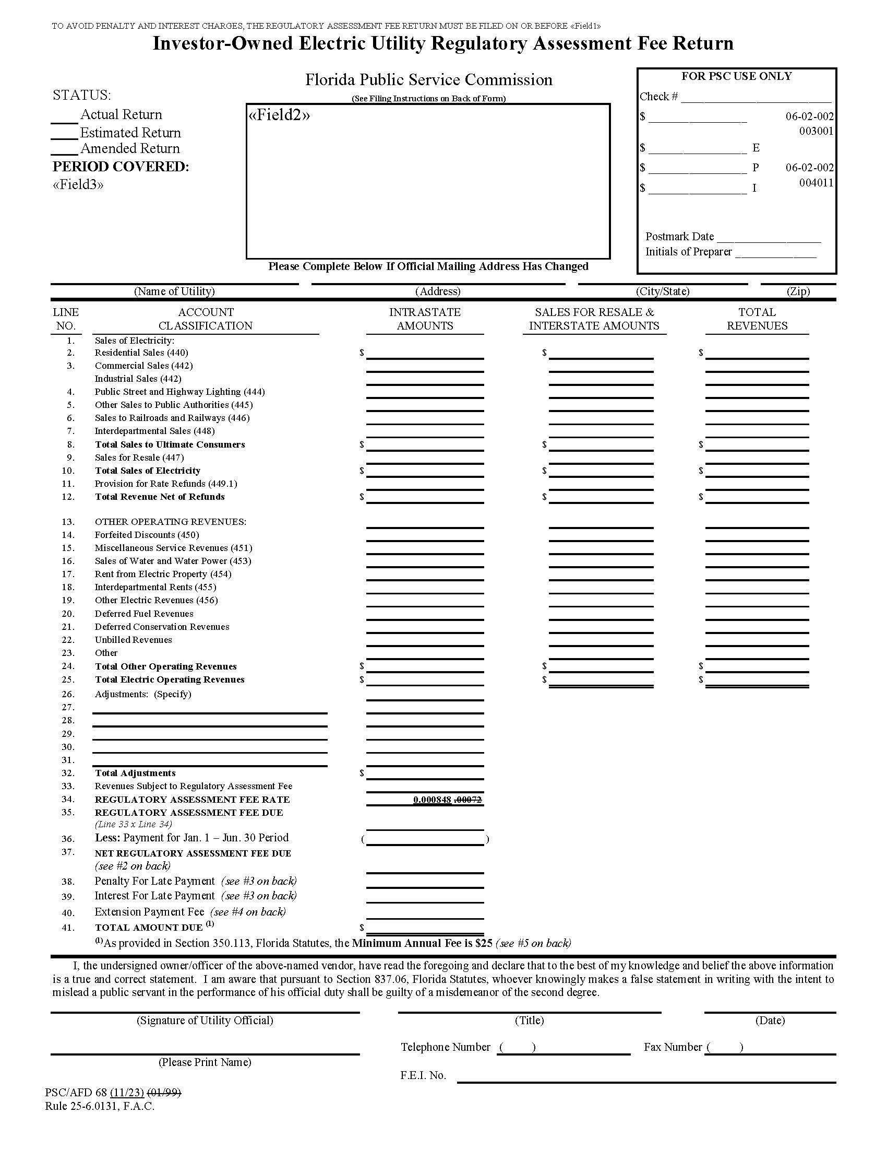

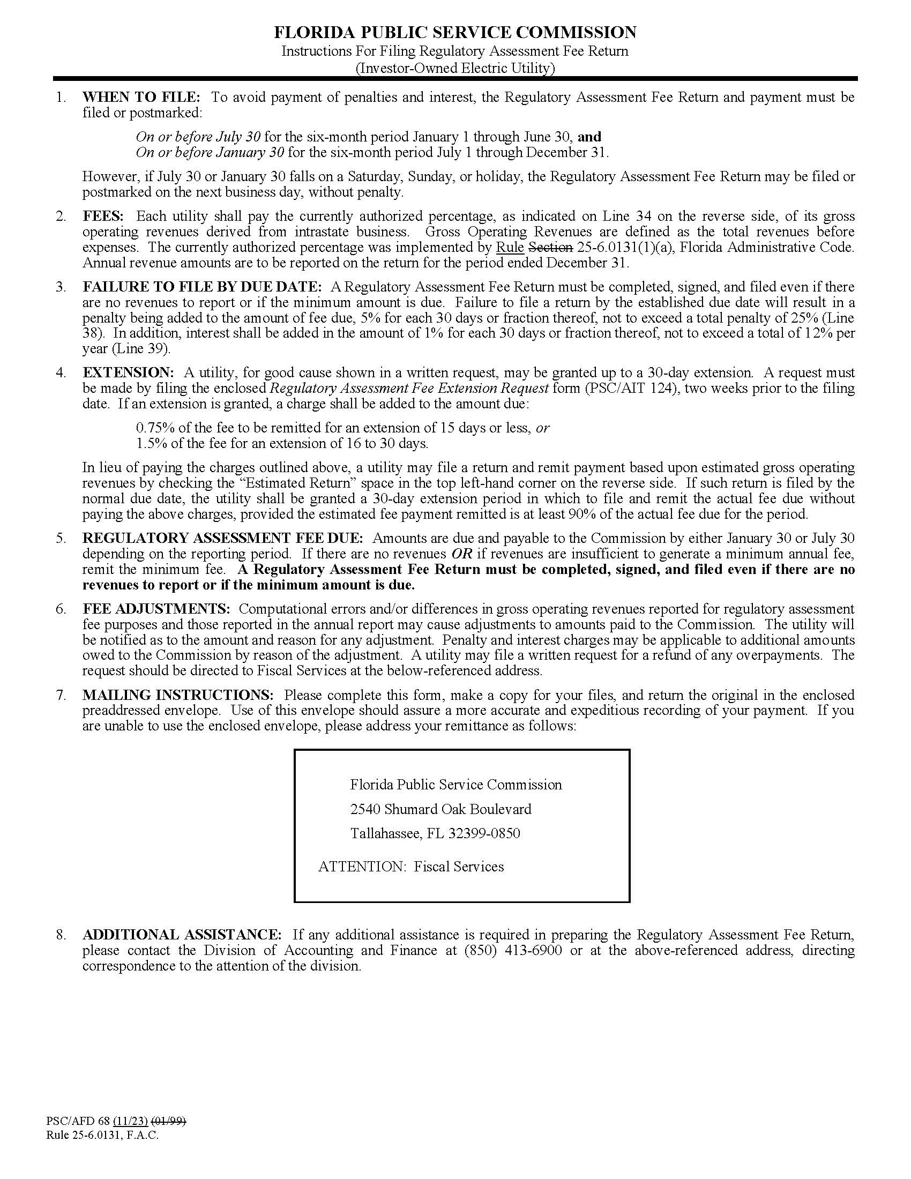

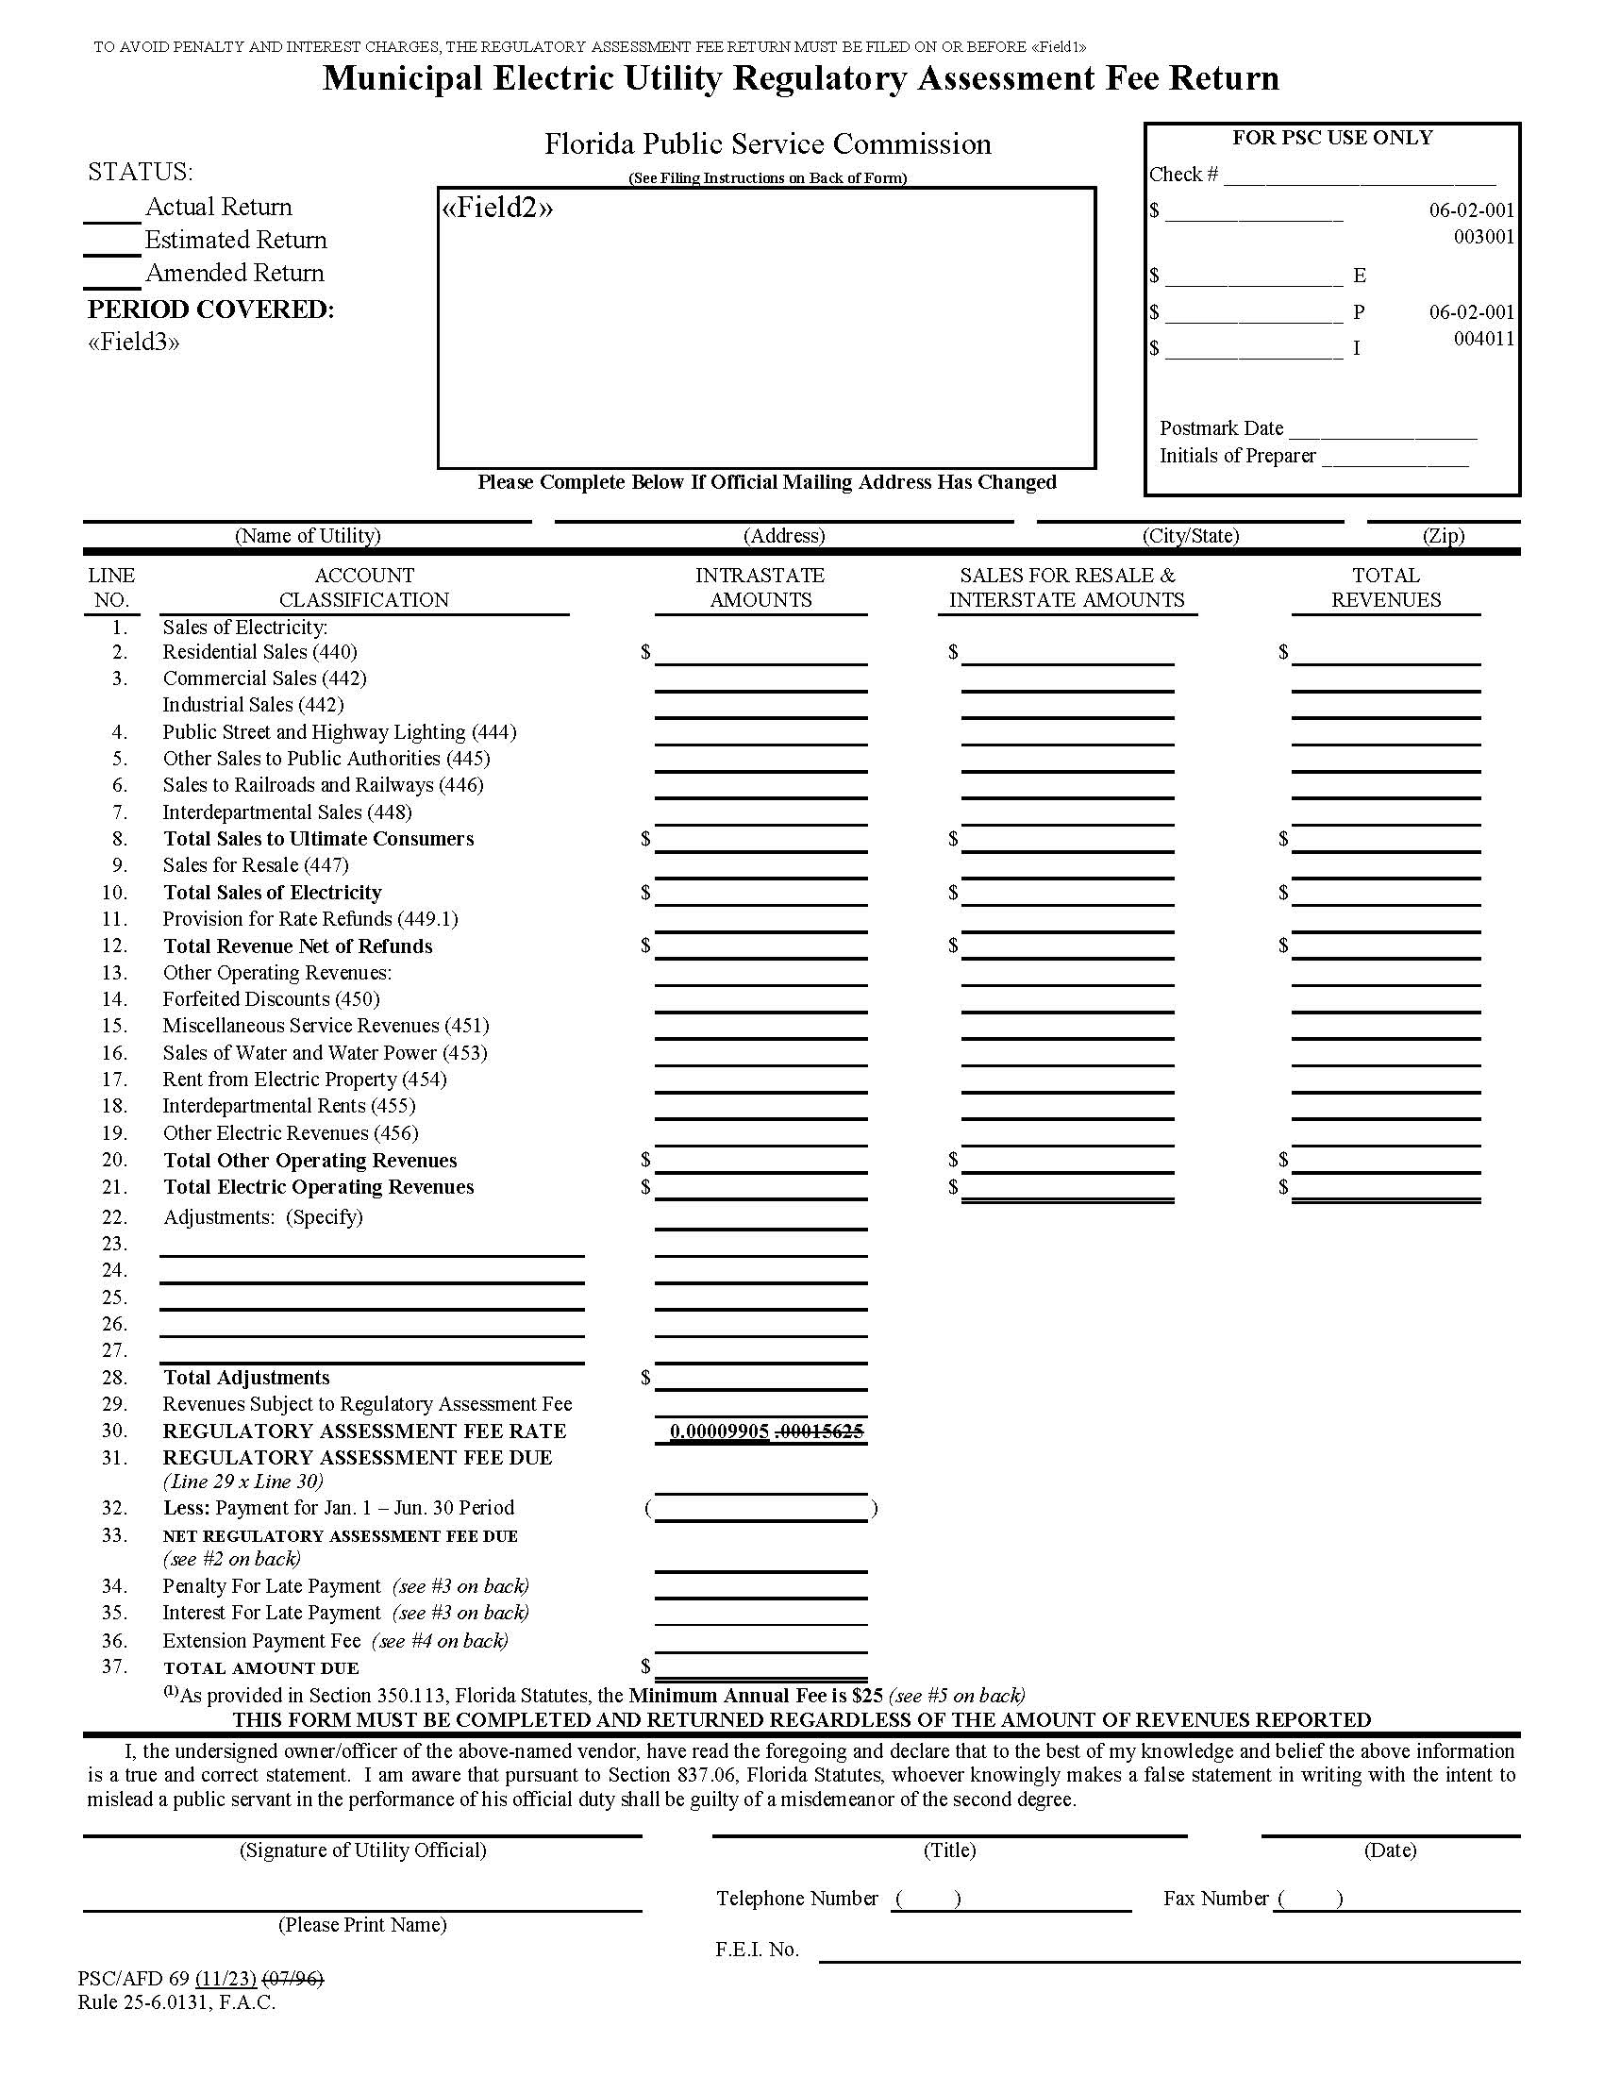

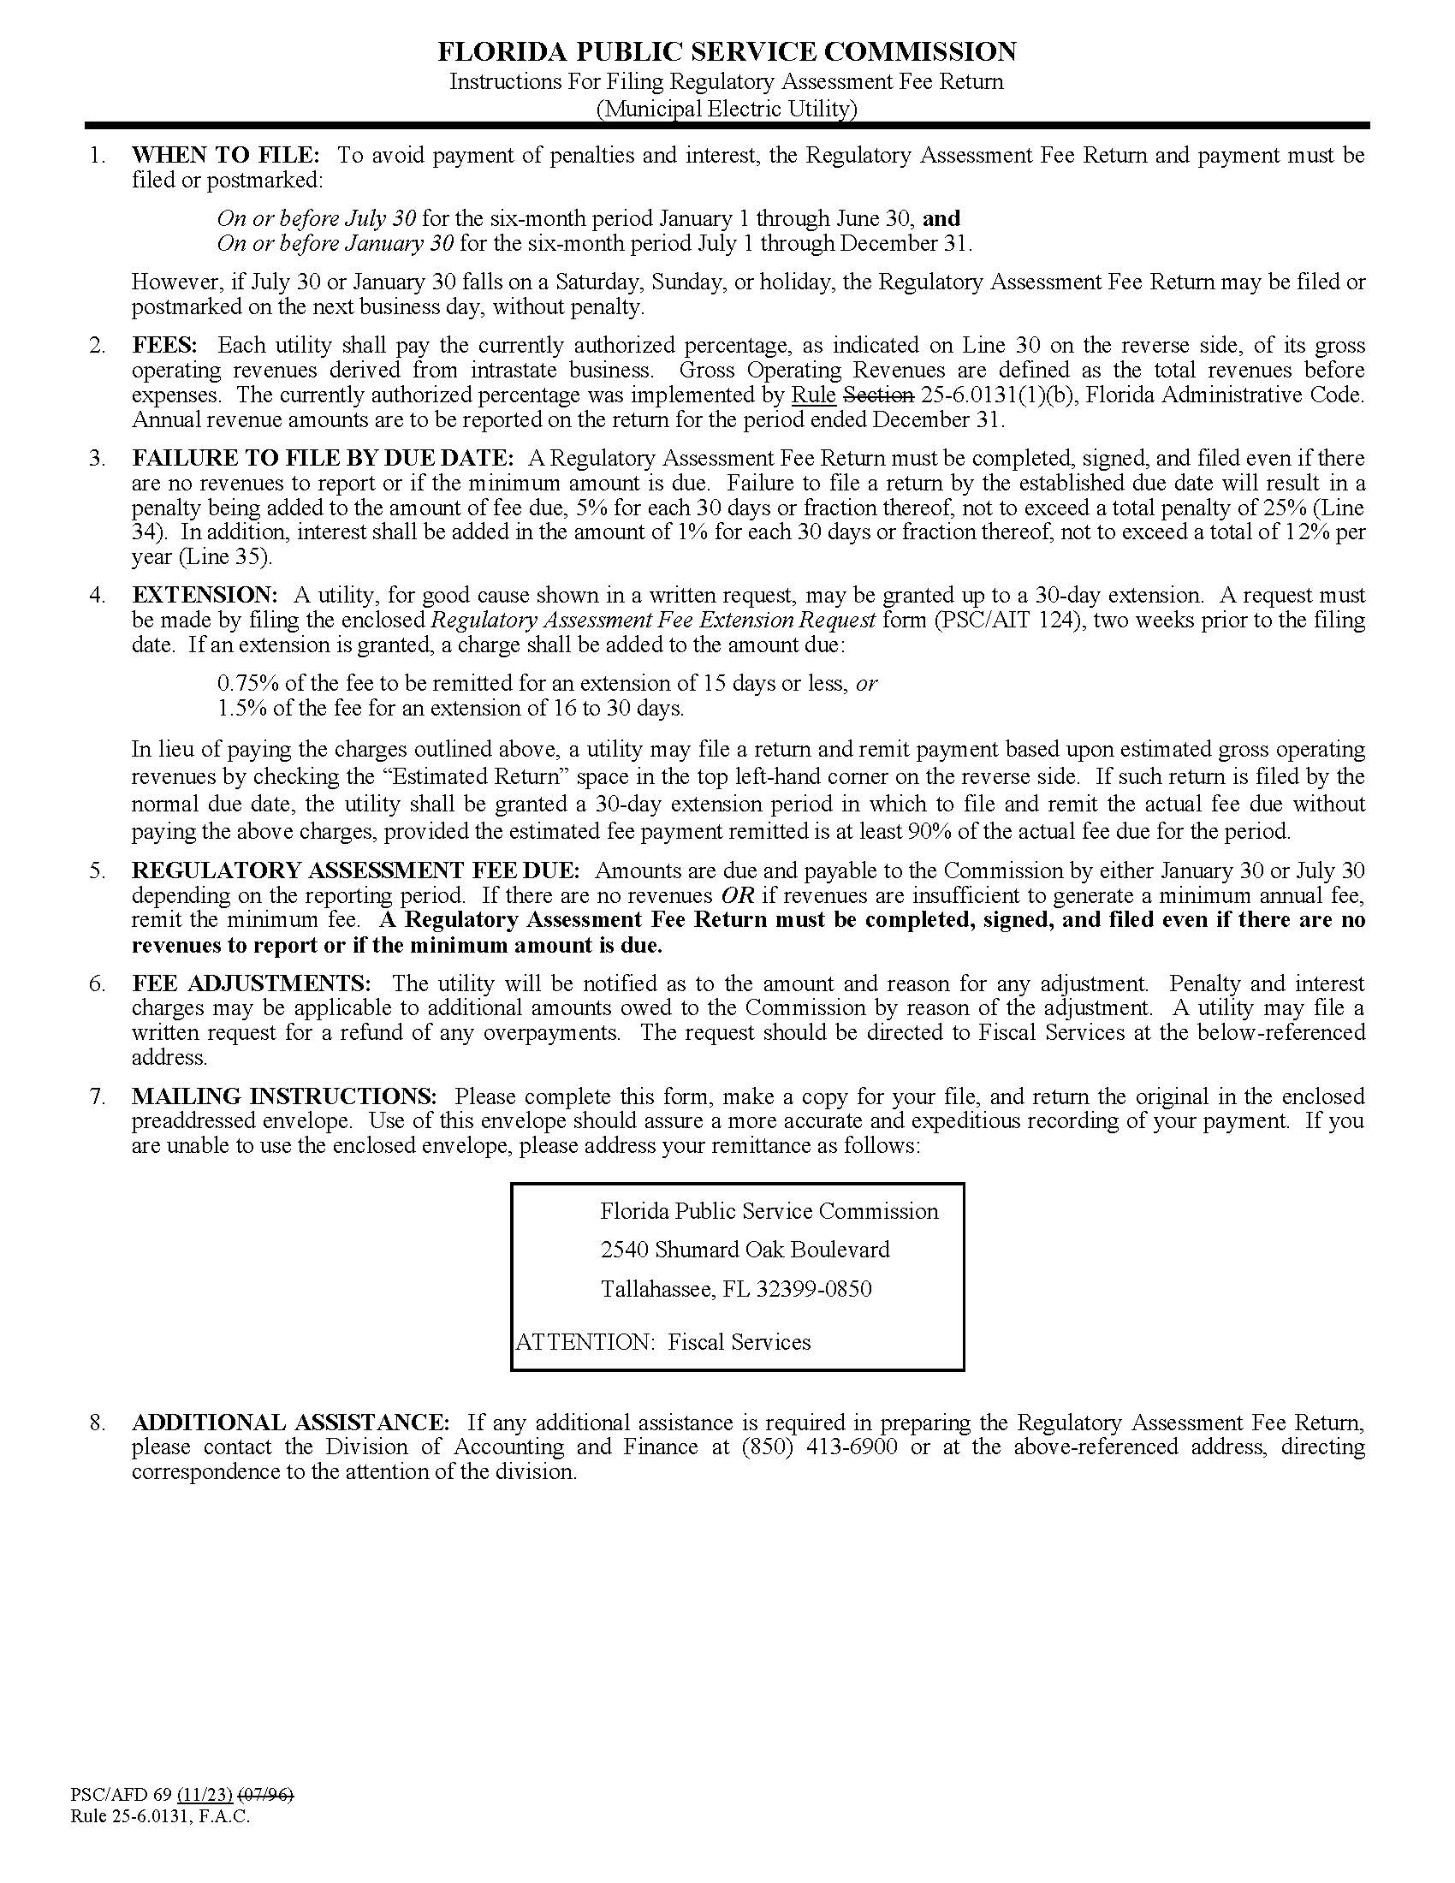

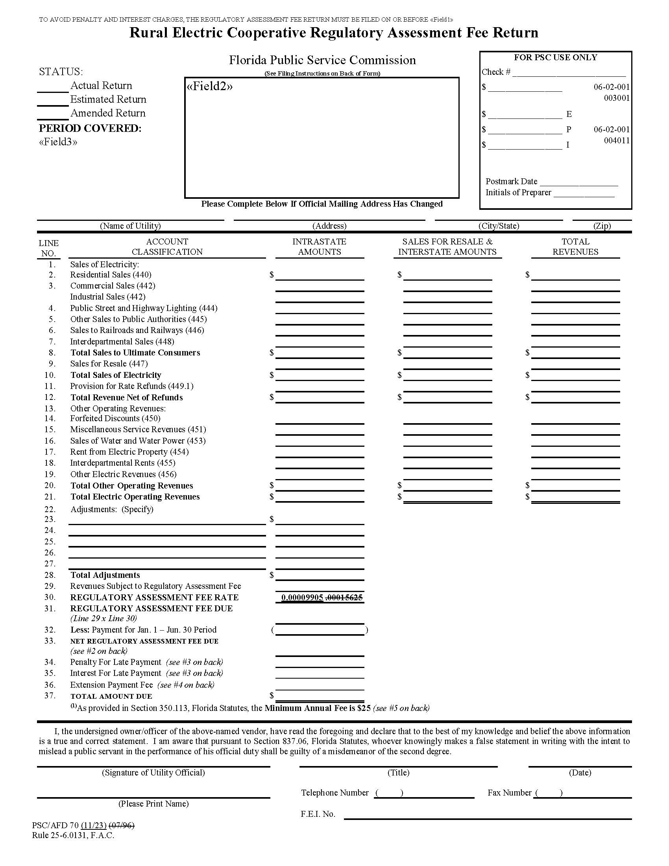

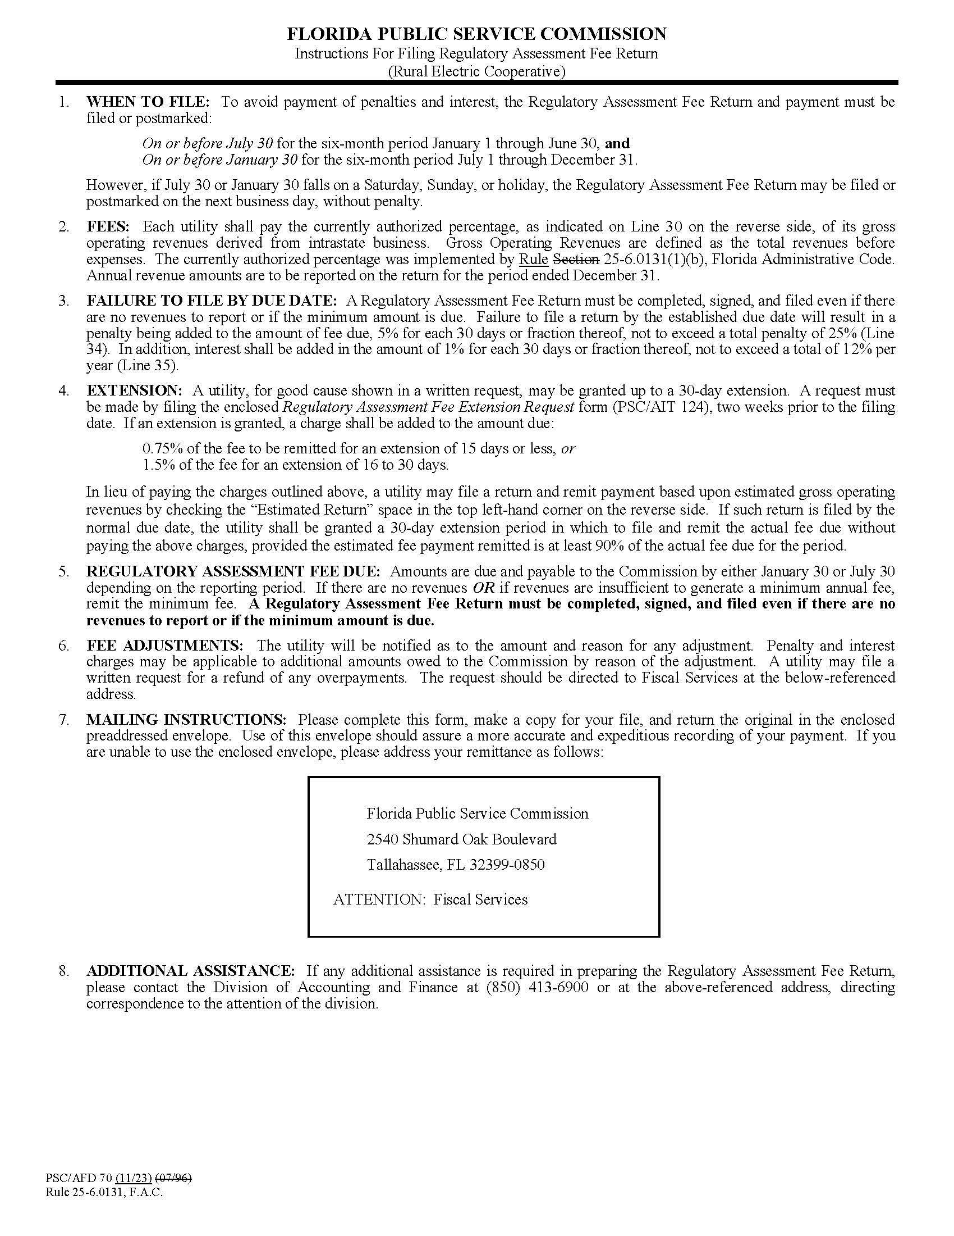

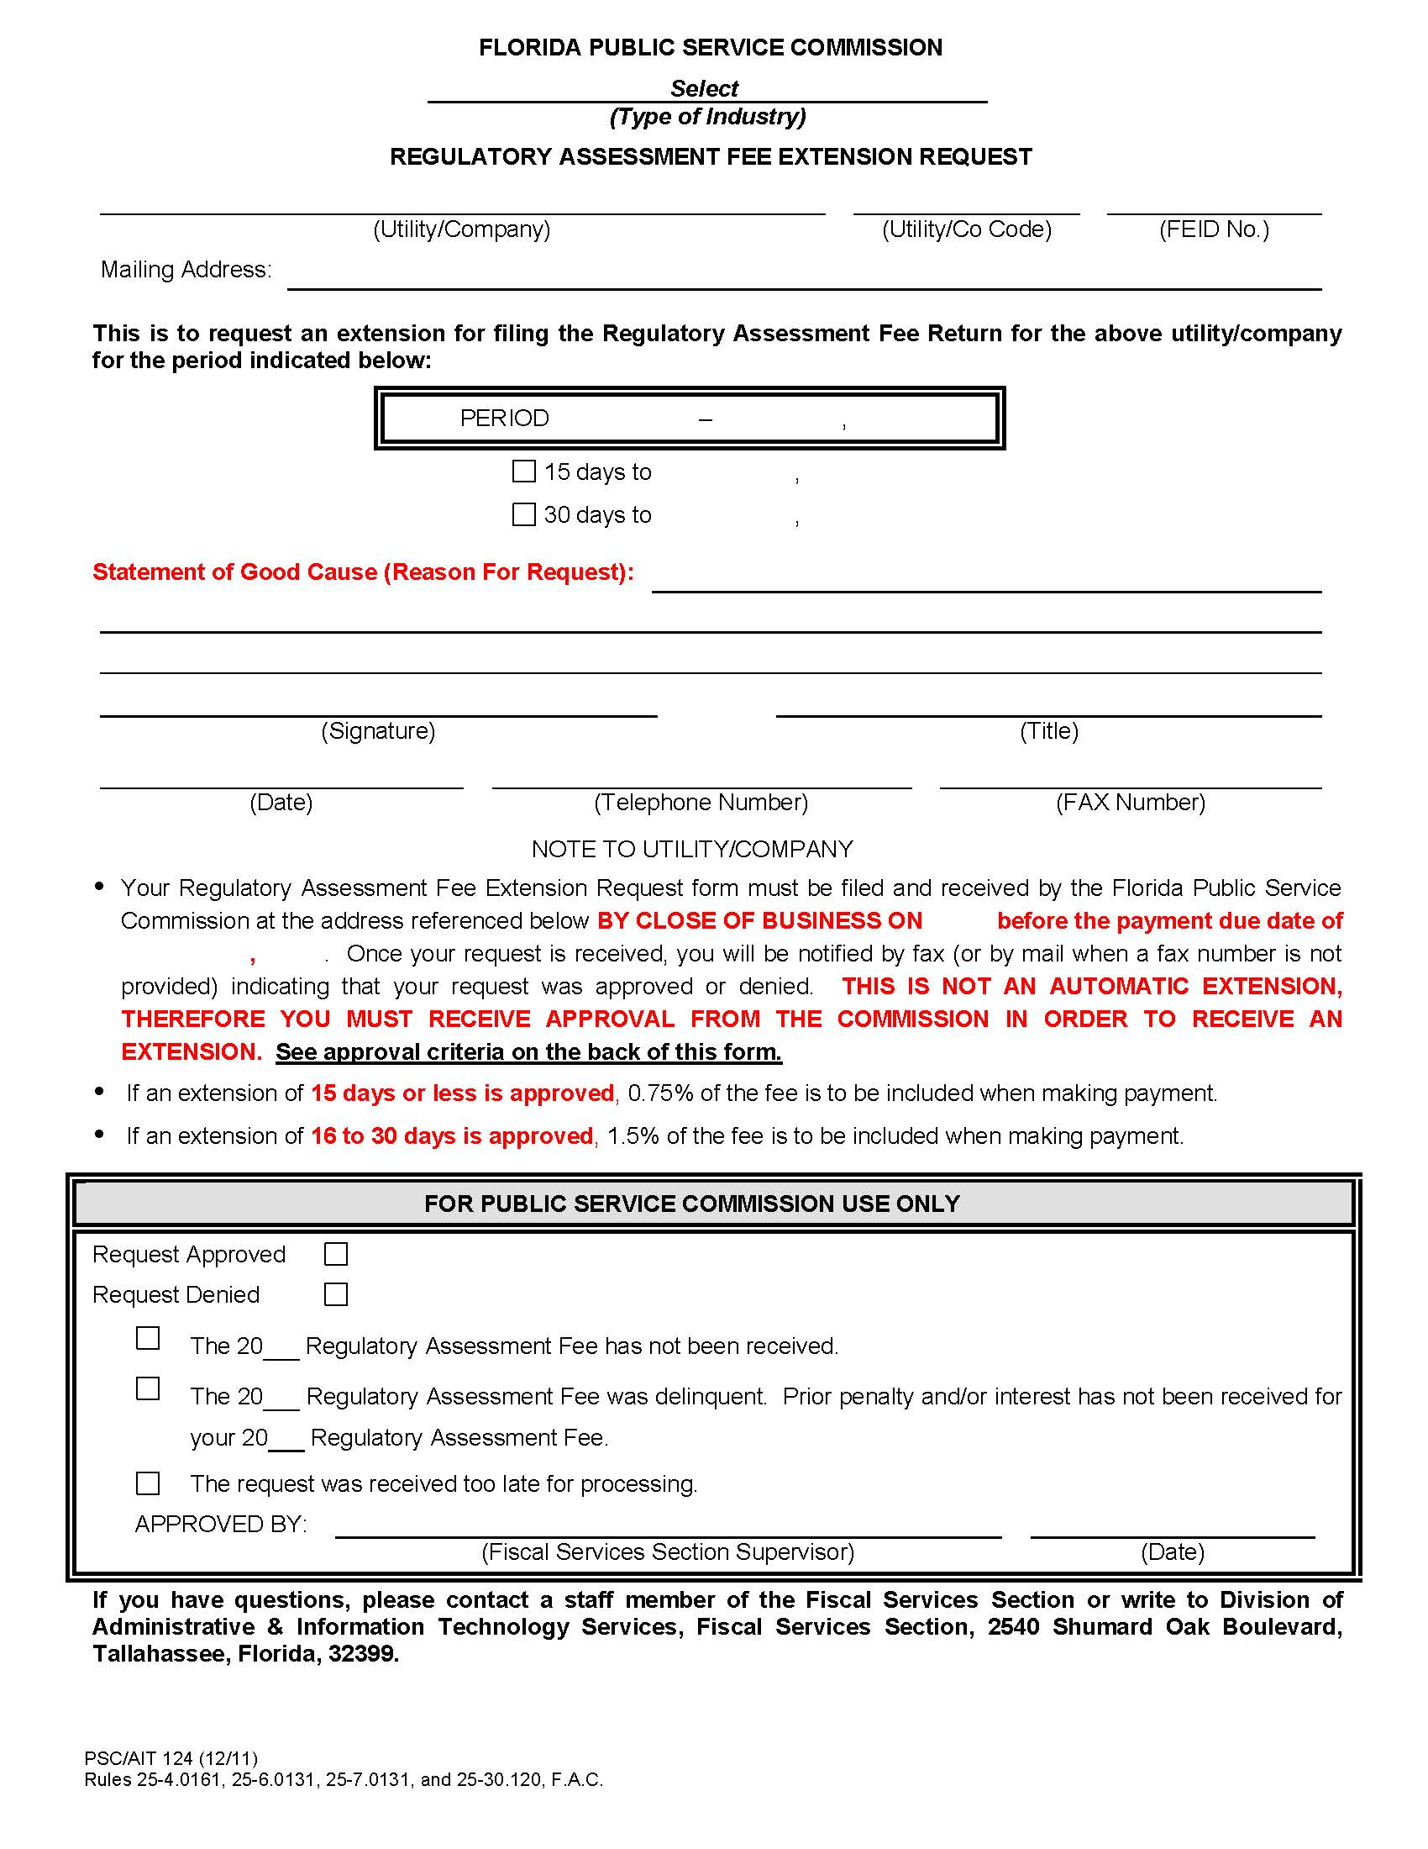

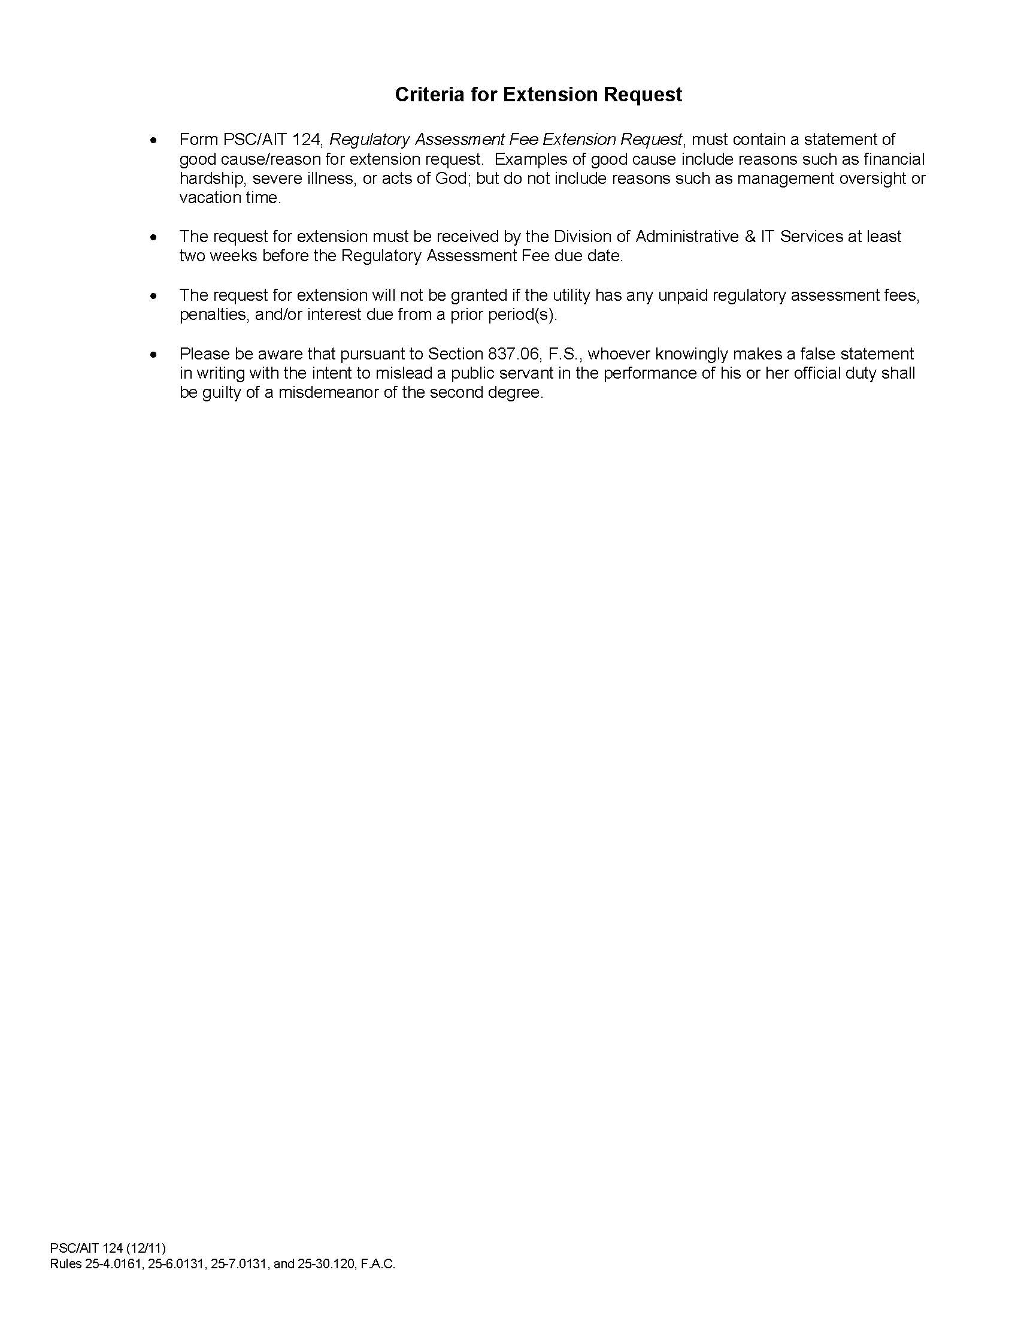

WORKSHOP AGENDA

1. Staff Welcome
2. Staff Overview of Draft Rule 25-6.0131, F.A.C., Regulatory Assessment Fees; Investor-owned Electric Companies, Municipal Electric Utilities, Rural Electric Cooperatives.
3. Stakeholder Comments on Draft Rule
4. Discussion of Next Steps
5. Adjourn